Define average speed

What is the difference between distance and displacement?

State examples of scalars and vector quantities.
What is the difference between a vector and a scalar?

Vectors & Scalars
Describe how to calculate the resultant of two vectors at right angles
Define instantaneous speed

Define velocity

Units of distance and displacement
Relationship for velocity, displacement and time
Relationship for speed, distance and time
Relationship for average velocity, displacement and time

Describe an experiment to measure instantaneous speed
Units of speed & velocity
Describe an experiment to measure average speed

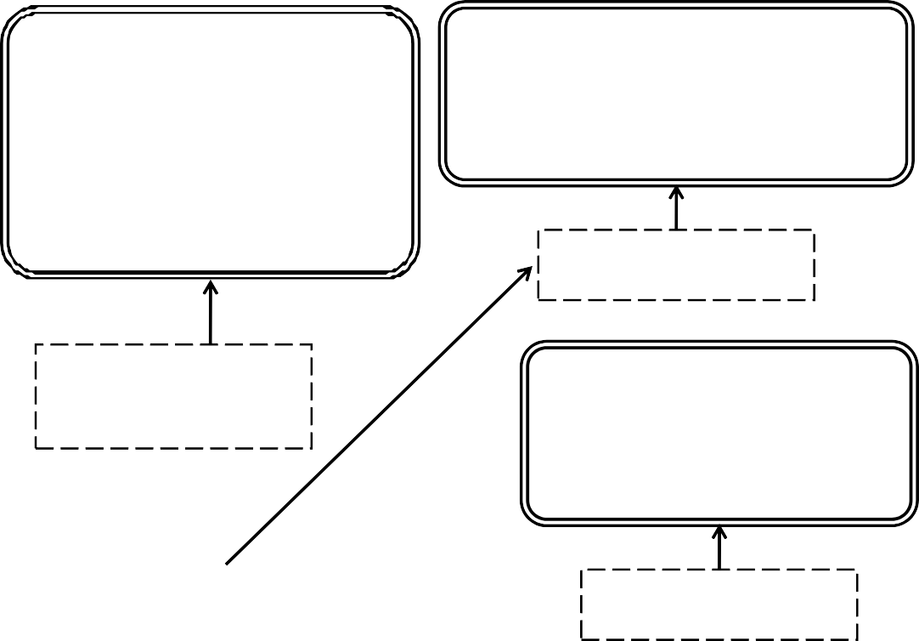

Relationship to calculate acceleration
Units of acceleration

Define acceleration
Describe an experiment to measure acceleration

Acceleration &
Describe how to determine the distance travelled from a v-t
graph
v-t graphs

Sketch a v-t graph for an object with a constant speed

Sketch a v-t graph for an object with a constant deceleration

Describe how to determine acceleration from a v-t graph
Sketch a v-t graph for an object with a constant acceleration

Weight

What can forces change about an object?
State Newton’s First Law of motion
Units of force

Gravitational field strength
Mass

Define Relationship to calculate weight

State the relationship for Newton’s Second Law of motion

Newton’s Laws
What is the gravitational field strength on Earth?

What is freefall? Explain it using Newtons laws

State Newton’s Third Law of motion

What is friction?
What is terminal velocity? Explain it using Newtons laws

Describe the motion of an object when forces are unbalanced

Describe the motion of an object when forces are balanced

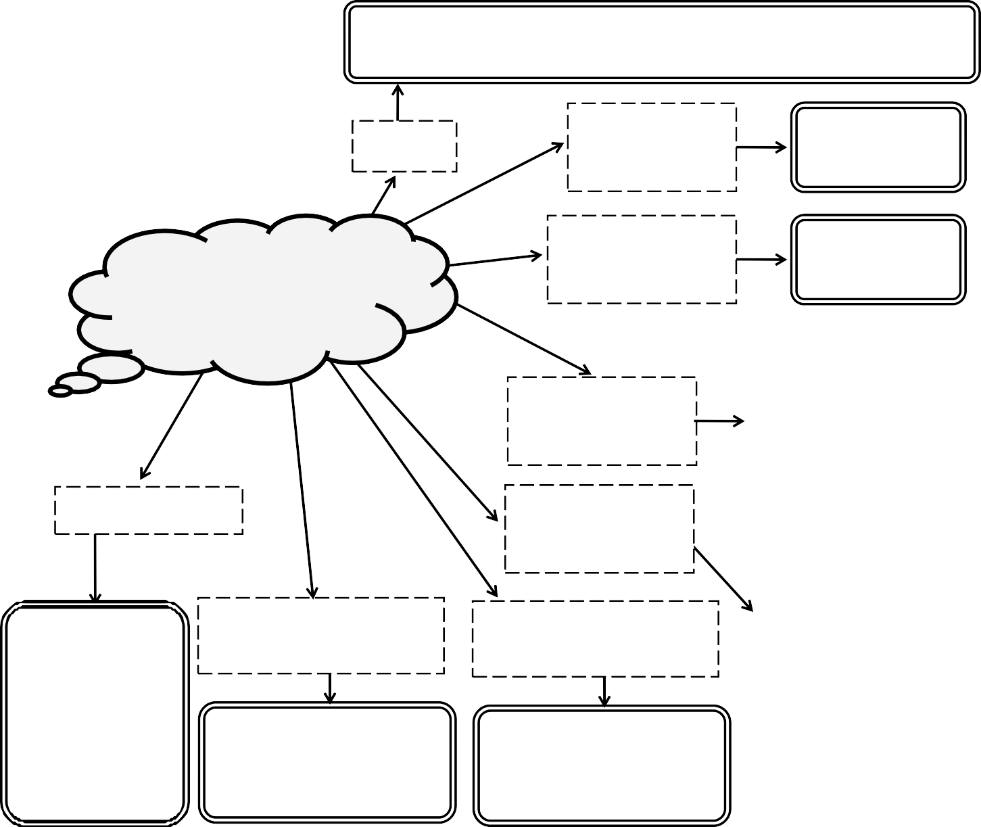
Give an example of Newton’s Third Law of motion

Work Done

Gravitational Potential Energy

Kinetic Energy

State the Law of
Describe and explain the vertical motion of a projectile
Describe and explain the horizontal motion of a projectile
Conservation of Energy
Define

Sketch a v-t graph of the horizontal motion of a projectile

Projectiles &
Energy

Units of Energy
Sketch a v-t graph of the vertical motion of a projectile

State the relationship for...
Work Done

Relationship required to calculate the distance travelled by a projectile
Sketch the shape of the path of a projectile
Describe how to calculate the vertical height of a projectile
Kinetic Energy

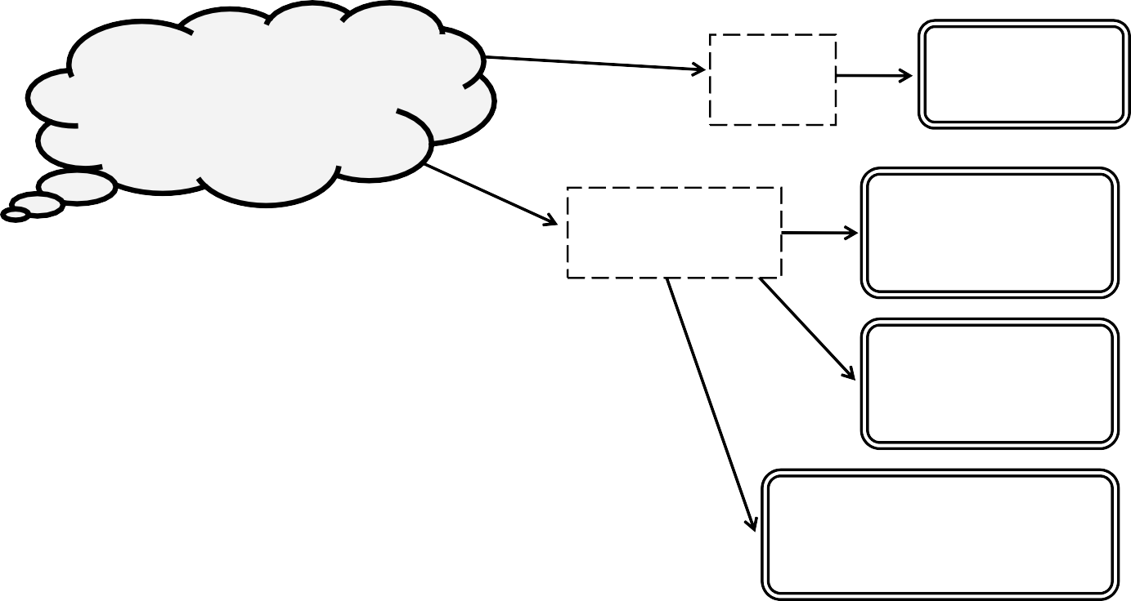
Gravitational Potential Energy

Relationship required to calculate the final vertical speed of a projectile

