Nat 5: Projectile Questions

1. What is a projectile? (a) What is special about its motion?
2. ) Jordan the goalkeeper punches a football which has been kicked across his goal mouth. The football leaves his glove with a horizontal velocity of 11.5 m/s to the right and takes 0.80 s to land on the pitc

.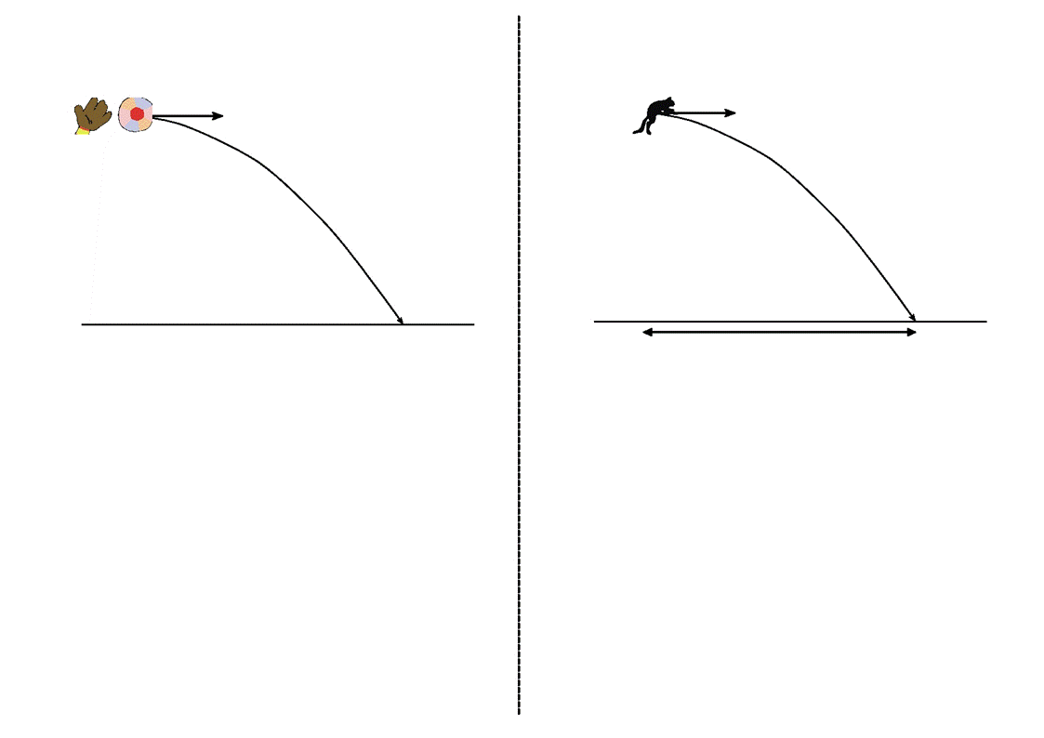 pitch

(a) Describe the horizontal velocity of the football from the instant it is punched to the instant it lands.

(b) Show, by calculation involving horizontal motion, that the horizontal displacement travelled by the football during the 0.8 s is 9.2 m to the right

(c) At the instant the football leaves Jordan's hand, the downward vertical velocity of the football is 0 m/s. Calculate the downward vertical velocity of the football as it lands.

(d) How far did the ball fall after it was punched?

1. 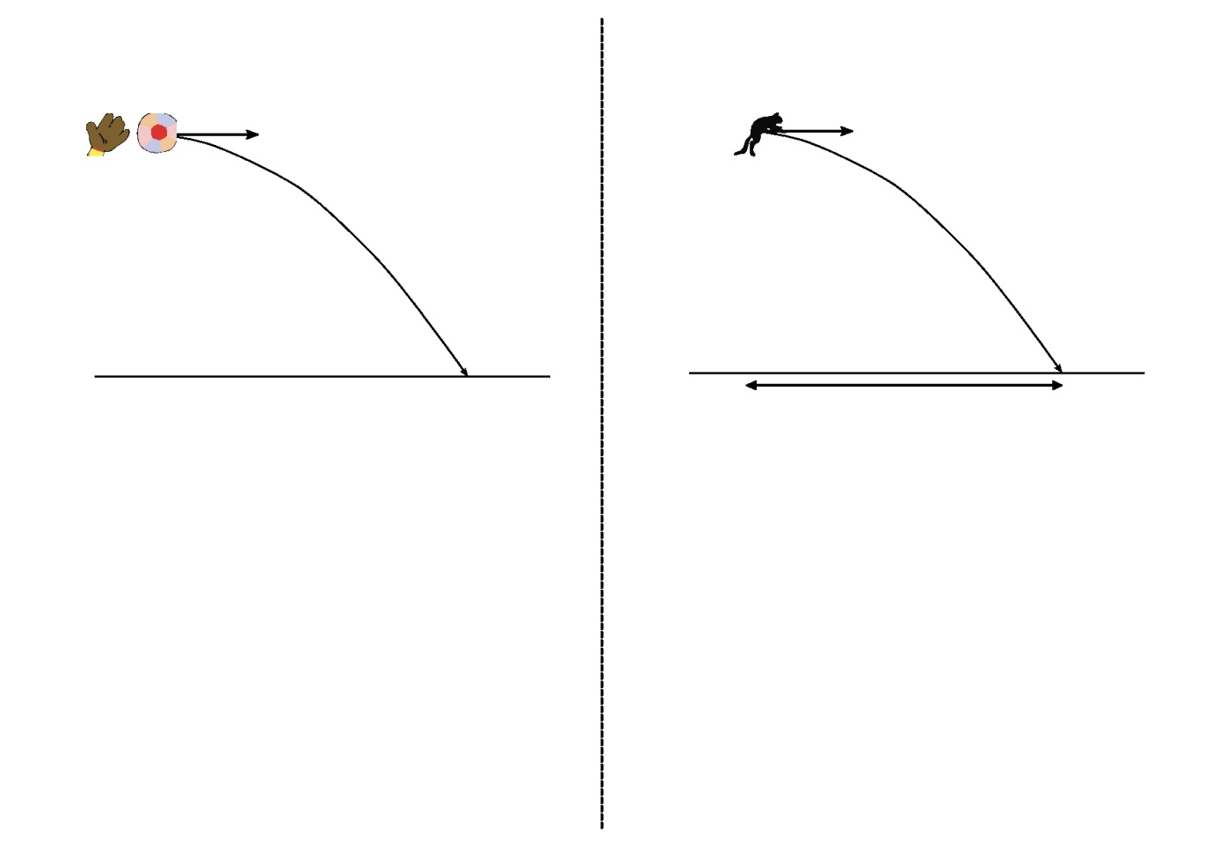 The Physics Department's pet cat jumps horizontally to the right from a window ledge. The cat lands on the floor 0.36 s later. Its horizontal displacement is 1.8 m to the right.

(a) During the jump, does the horizontal velocity of the cat increase, decrease or remain constant?

(b) Show, by calculation involving horizontal motion, that the

horizontal velocity of the cat just before landing is 5 m/s to the right

(c) At the instant the cat jumps from the window ledge,

its downward vertical velocity is 0 m/s.

Calculate the downward vertical velocity of the cat as it lands.

1. Ellen's hand hits a volleyball from a point directly above the central net.

The volleyball leaves Ellen's hand with a horizontal velocity of 8.4 m/s to the right.

On leaving her hand, the volleyball follows a curved path, hitting the floor when its horizontal displacement is 6.3 m to the right.

volleyball

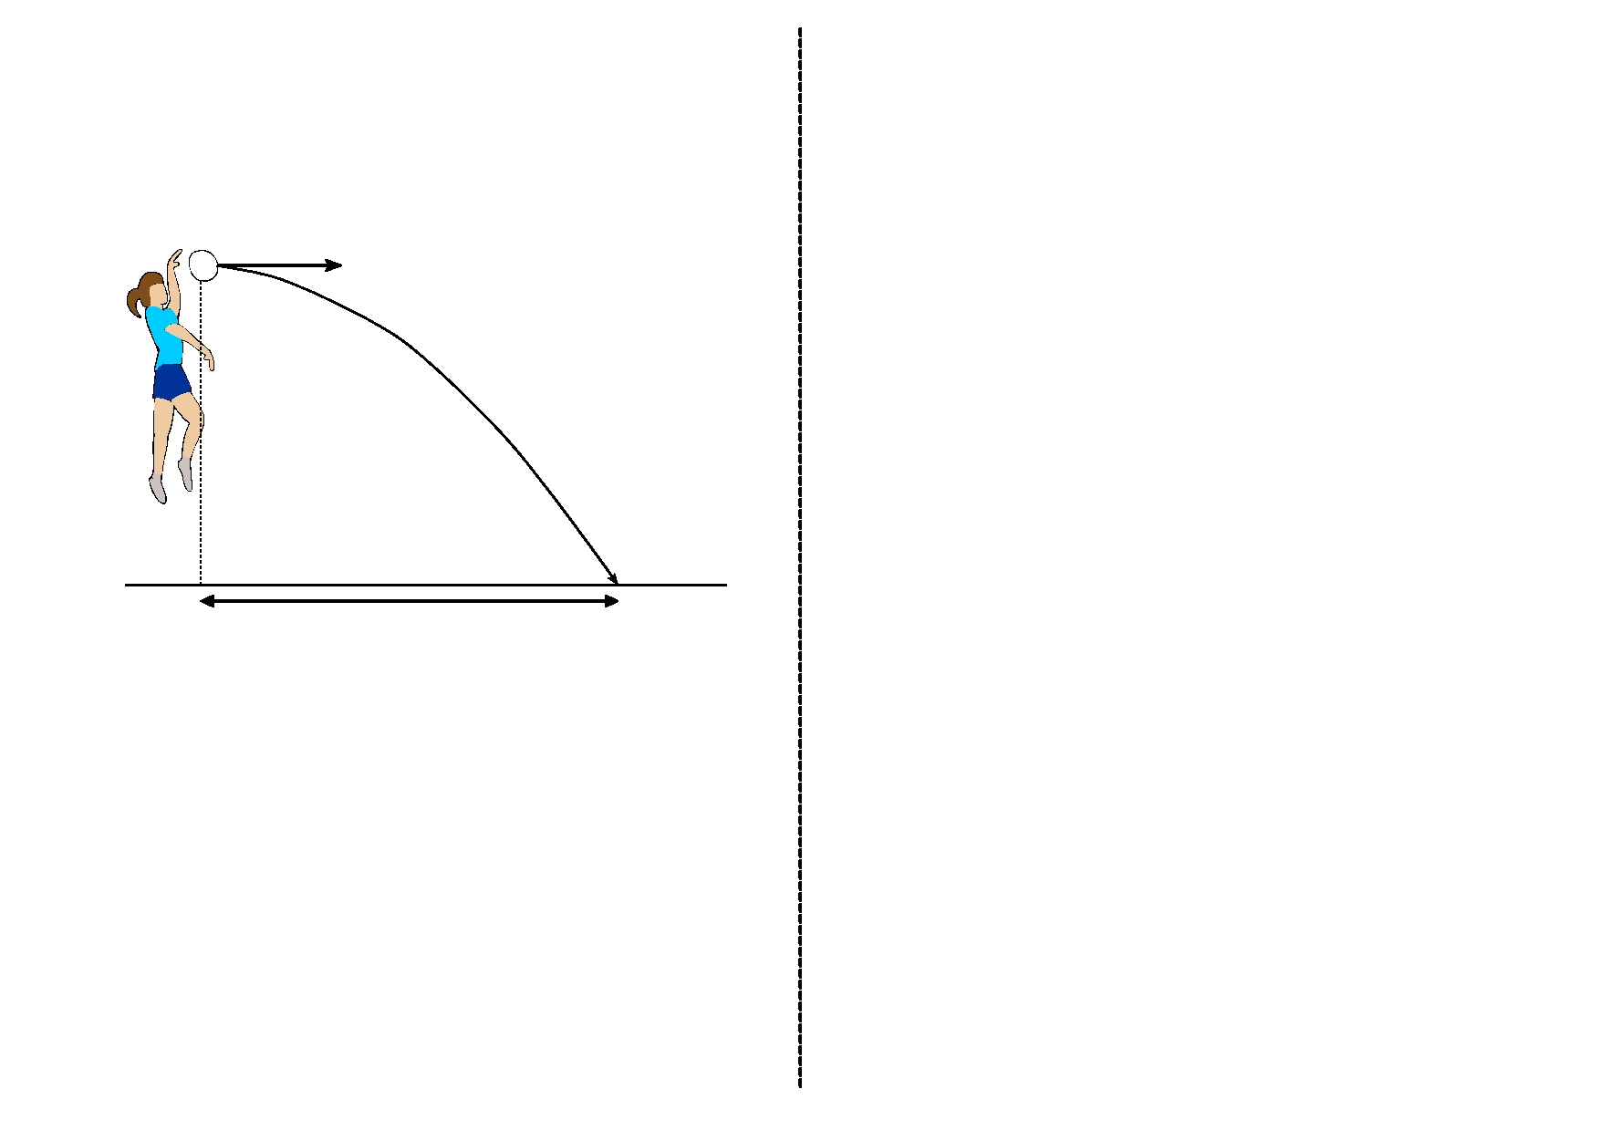horizontal velocity = 8.4 m/s

Ellen

6.3 m

floor

1. Show, by calculation involving horizontal motion, that the time taken for the volleyball to travel from Ellen's hand to the floor is 0.75 s.
2. At the instant the volleyball leaves Ellen's hand,the downward vertical velocity of the volleyball is 0 m/s. Calculate the downward vertical velocity of the volleyball as it reaches the floor.
3. What is the final resultant velocity of the ball as hits the floor (magnitude and angle required)

5)` A rocket is fired horizontally from a cliff top at 40 m/s to the right.

The rocket hits the sea below after 4 s.

(a) What will be the rocket's horizontal component of velocity just before it hits the sea?

(b) What will be the rocket's range (horizontal displacement)?

(c) What will be the rocket's vertical component of velocity just before it hits the sea?

(d) Sketch the velocity-time graph for the rocket's vertical motion.

(e) Use the graph to determine the rocket's vertical displacement (the height of the cliff).

6) Betty fires an arrow horizontally at 25 m/s to the right. The arrow hits the ground after 0.4 s.

(a) What will be the arrow's horizontal component of velocity just before it hits the ground?

(b) What will be the arrow's range (horizontal displacement)?

(c) What will be the arrow's vertical component of velocity just before it hits the ground?

(d) Sketch the velocity-time graph for the arrow's vertical motion.

(e) Use the graph to determine the arrow's vertical displacement (the height it was fired from).

7) Fred kicks a football off a cliff with a horizontal velocity of 5 m/s to the right. The football lands on ground below the cliff 2.5 s later.

(a) What will be the ball's horizontal component of velocity just before it hits the ground?

(b) What will be the ball's range (horizontal displacement)?

(c) What will be the ball's vertical component of velocity just before it hits the ground?

(d) Sketch the velocity-time graph for the ball's vertical motion.

(e) Use the graph to determine the ball's vertical displacement (the height of the cliff).

8) Barney pushes a coin off a staircase. The coin's initial horizontal velocity is 0.5 m/s to the right. It hits the floor after 1.2 s.

(a) What will be the coin's horizontal component of velocity just before it hits the floor?

(b) What will be the coin's range (horizontal displacement)?

(c) What will be the coin's vertical component of velocity just before it hits the floor?

(d) Sketch the velocity-time graph for the coin's vertical motion.

(e) Use the graph to determine the coin's vertical displacement (the height of the staircase).

9) Wilma throws a dart horizontally at 8 m/s to the right. The dart hits the floor after 0.6 s.

(a) What will be the dart's horizontal component of velocity just before it hits the floor?

(b) What will be the dart's range (horizontal displacement)?

(c) What will be the dart's vertical component of velocity just before it hits the floor?

(d) Sketch the velocity-time graph for the dart's vertical motion.

(e) Use the graph to determine the dart's vertical displacement (the height it was thrown from).

10) (a) A projectile is fired horizontally at 100m/s.

(i) How long will it take it to travel a horizontal distance of 50m?

(ii) What will its vertical velocity be when it hits the ground?

(iii) What will be its average vertical speed?

(iv) How far will it fall in the 50m?

11) A ball rolls along a flat roof at 2m/s and rolls off the edge.

(i) How long will it take it to fall 12m to the ground?

(ii) How far away from the base of the building will it land?

12) (a) In 1971, a lunar module carrying two astronauts landed on the Moons surface. The gravitational field strength on the Moon is different from that on Earth.

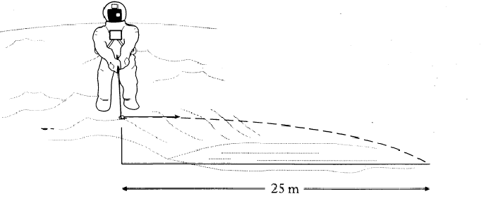

(i) What is meant by “gravitational field strength”? (1)

(ii) The gravitational field strength at the surface of the Moon is 1.6 N/kg.

What is the value of the acceleration due to gravity at the surface of the Moon? (1)

(b) One of the astronauts played golf on the moon. The golf ball was struck horizontally from the edge of a steep crater. It landed 2 seconds later, 25 m away as shown in the diagram below.

(ii) Calculate the vertical speed of the ball on landing. (2)

iii) How would the horizontal distance travelled by a ball projected with the same horizontal speed from the same height on Earth compare with that on the Moon? Explain your answer. (3)

13) A stone thrown horizontally from a cliff lands 24 m out from the cliff after 3 s. Find:

a) the horizontal speed of the stone

b) the vertical speed at impact.

14) . An aircraft flying horizontally at 150 m/s, drops a bomb which hits the target after 8 s. Find:

a) the distance travelled horizontally by the bomb

b) the vertical speed of the bomb at impact

c) the distance travelled horizontally by the aircraft as the bomb fell

d) the position of the aircraft relative to the bomb at impact.

15) A ball is thrown horizontally from a high window at 6 m/s and reaches the ground after 2 s. Calculate:

a) the horizontal distance travelled

b) the vertical speed at impact.

16) A ball is projected horizontally at 15 m/s from the top of a vertical cliff. It reaches the ground 5 s later. For the period between projection until it hits the ground, draw graphs with numerical values on the scales of the ball’s

a) horizontal velocity against time

b) vertical velocity against time

c) From the graphs calculate the horizontal and vertical distances travelled.

17) . In the experimental set-up shown below, the arrow is lined up towards the target.

As it is fired, the arrow breaks the circuit supplying the electromagnet, and the target falls downwards from A to B.



a) Explain why the arrow will hit the target.

b) Suggest one set of circumstances when the arrow would fail to hit the target (you must assume it is always lined up correctly).

18) . An archer fires an arrow horizontally at the centre of a target 30 metres away. The arrow leaves the bow with a speed of 150 m/s

a) Calculate the time taken for the arrow to reach the centre of the target.

b) What was the vertical component of the speed of the arrow just before it hit the target?

c) What was the average component of the speed of the arrow during its flight?

d) Use your answers to (a) and (c) to calculate by how far the arrow missed the centre of the target.

e) What adjustment should the archer make in order to hit the centre of the target?

19) . An osprey flying horizontally at a speed of 15m/s drops the fish it is carrying into the lake below, silly bird! The fish hits the water 2 seconds later.

a) Sketch the path taken by the fish after it had been dropped.



b) At what height was the osprey flying when it dropped the fish?

c) Assuming the osprey does not change it speed or direction, where is it in relation to the fish when the fish hits the water?

20) Martin kicks a football into the air at an angle of 30° to the ground. The ball hits the ground after 2 seconds.

a) At what time did the ball reach its greatest height?

b) What was the vertical component of the speed of the ball as it left Martin’s foot?

c) At what angle did it hit the ground?

d) Sketch the path of the ball if it had a large air resistance.