Define a light year
What is the Big Bang Theory?
State evidence for the Big Bang Theory
State the approximate
age of the Universe
Show how to calculate one light year in metres
What can a line spectra tell us about a star?

Cosmology
What is a continuous spectrum? How can it be produced?

What is the Solar system?
Name the following types of spectra

What is a star?

List the following in order of decreasing size: planet, dwarf planet, moon, sun, asteroid, solar system, star, exoplanet, galaxy, universe.

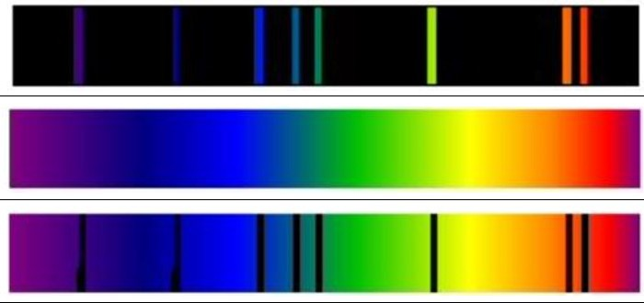

What is a galaxy?

Give some uses of satellites placed in orbit above the Earth
Explain how the force of gravity keeps a satellite in orbit

What is a geostationary satellite
How are the altitude and period of satellites related?

Define the period of a satellite

Space
Exploration

State the altitude and period of geostationary satellites

Describe some of the challenges on space travel

Describe risks associated with manned space exploration
Describe methods to travel large distances in space

At take off In zero gravity
During flight
During re-entry

