Nat
5

National 5 Assignment
Acceleration on a slope: Guide Sheet A

Variation of angle of slope with acceleration.

Apparatus
Runway, light gate(s), interface and computer, mask (single or double), rule, protractor, or metre stick.

Instructions:

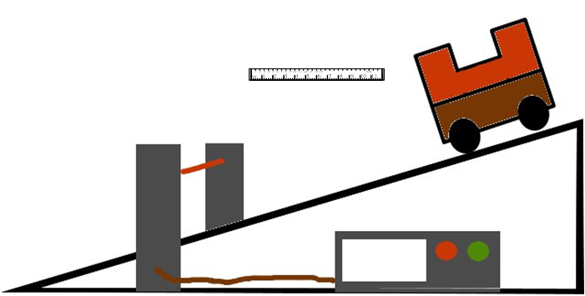
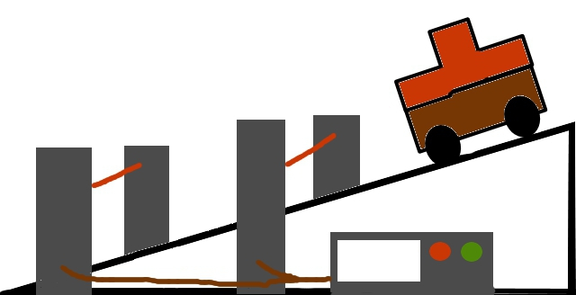

- Organise the light gates and interface to measure the acceleration of the vehicle as the vehicle passes through the light gate(s). This can be using one light gate and a double mask or two light gates and a single mask.
- Set the runway up at an angle.
- Measure the angle of the slope.
- Place the light gate so that the mask cuts the beam as the vehicle passes.
- Release the vehicle and measure the acceleration as it passes through the light gate(s).
- Change the angle of the slope, often books can be useful to achieve this.
- Present your results.

Risk Assessment
- Placing a buffer at the end of the ramp or something soft for the trolley to land in is suggested so not to damage equipment.
- Do an electrical safety check by observing all the wires of the interface and light gates.
- Make sure the vehicle cannot become a trip hazard or land on feet, toes etc.
- Be observant to those around you.
- Do not block exits with the apparatus

Mrsphysics takes no responsibility for any health and safety. It is the responsibility of the teacher and student to risk assess any practical activity they complete!
Sept 2023

