Nat
5

National 5 Assignment
Boyles Law: Guide Sheet A

Variation of pressure and volume for a fixed mass of gas

Apparatus
Boyles law apparatus, pump, safety goggles,
Instructions:
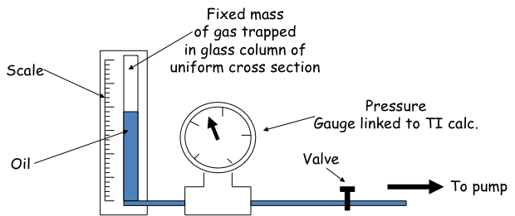
Bourdon gauge

- A sample of dry air is confined in a tall, wide glass tube by a piston of oil. The volume is indicated by the length of the air column as it has a constant cross sectional area.
- The pressure is read from a Bourdon gauge connected to the air over the oil reservoir.
- The foot pump is attached to the oil reservoir and is used to change the pressure.
- The pump is used to increase the pressure on the column of trapped air which makes the oil rise in the column, and the valve is used to seal the apparatus when the pressure is high.
- The length of the trapped air column and the corresponding pressure are noted.
- Slowly change the volume of the air, so the temperature remains constant and take readings of volume (length) and pressure.

Risk Assessment
- It has been known for the glass tube to fly upwards when the gas is at maximum pressure. To prevent this, check the compression joint holding the tube and any tube supports before use.
- Do not reduce the volume beyond what your teacher advises.
- Wear safety googles when carrying out this experiment.
- Mrsphysics takes no responsibility for any health and safety. It is the responsibility of the teacher and student to risk assess any practical activity they complete!
- Sept 2023

