Nat
5

National 5 Assignment
Boyles Law: Guide Sheet B
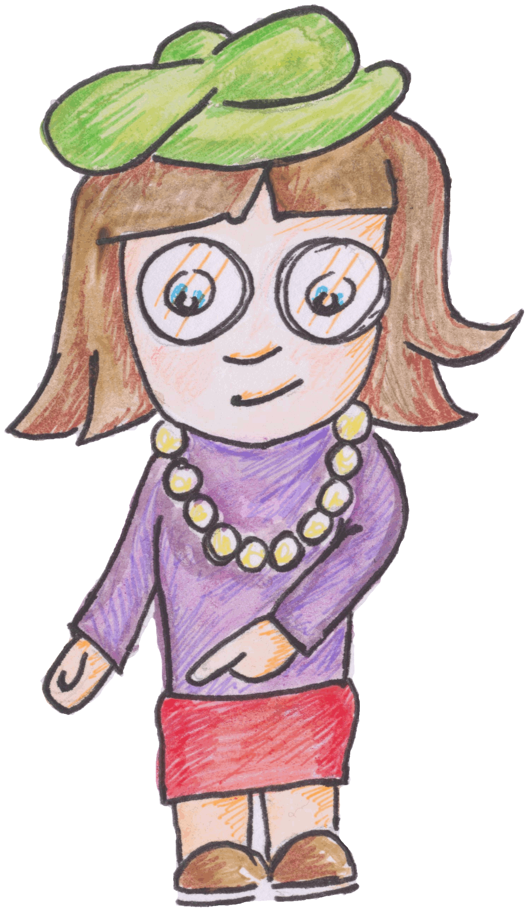

Variatrion of pressure and volume for a fixed mass of gas

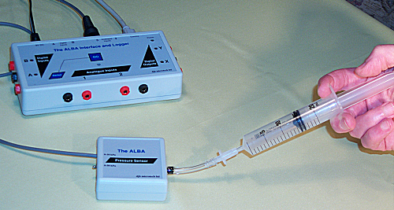
Apparatus
ALBA, and power lead, ALBA Pressure Sensor, plastic tubing and connector, syringe, barometer (optional)., safety goggles.

Background
A small black device protrudes from the right hand side of the ALBA Pressure sensor. This is the pressure transducer and it converts pressure into a voltage. The voltage that it produces is very small and it is amplified before ALBA reads it.
The greater the pressure, the greater the voltage.
Suppose that you pull the plunger of the syringe out so that the volume of air is 20 ml. Since the air in the syringe is not being squeezed it must be at atmospheric pressure. If you now squeeze the syringe the pressure sensor will indicate the pressure due to the squeezing – this is called gauge pressure. To obtain the total pressure the gauge pressure must be added to the atmospheric pressure.

Instructions
- Connect the ALBA Pressure Sensor to either channel 3 or 4 on the ALBA Interface and Logger.
- Switch the pressure sensor to the 0 – 50 kPa range.
- Ensure that the syringe is not connected to the plastic tubing.
- Connect the plastic tubing to the pressure sensor.
- Pull out the plunger of the syringe.
- Push the end of the syringe into the tubing taking care not to move the plunger.
- Record the pressure for different volumes of gas (air). If you do not have a barometer then assume that it is normal air pressure i.e. 101.3 kPa.
- Do not decrease the volume below 13 ml as the pressure sensor stops responding.
- Take care to position the plunger accurately – especially at smaller volumes.
Risk Assessment
- Wear safety googles when carrying out this experiment.
- Do not push the syringe lower than 13ml
- Do not reduce the volume beyond what your teacher advises.
- Ensure the connecting tubes are tight.
- Mrsphysics takes no responsibility for any health and safety. It is the responsibility of the teacher and student to risk assess any practical activity they complete!
- Sept 2023

