Nat
5

National 5 Assignment
Charles’ Law: Guide A

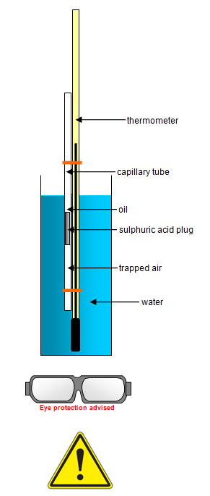
Variation of volume with temperature for a fixed mass of gas
Apparatus
- Charles’ Law apparatus, thermometer open-ended capillary tube with trapped air, water, a tall 1 litre beaker
Background
According to the kinetic theory, the average speed of the gas particles increases with increasing temperature. The hotter the gas, the faster the gas particles are moving and so require to take up more space. Why should the temperature be increased slowly?

Instructions
- Fill your beaker with cold water.
- Fix the glass capillary tube to the thermometer with the rubber bands with the open end at the top.
- Put the thermometer and tube in the water, the open end of the tube should be just above water level. Record the water temperature.
- Record the volume of the trapped air in the tube, you should record this as length, as there is a constant cross sectional area.
- Light the bunsen and heat the water to boiling slowly, or use a water bath.
- Take readings of the volume of the air with temperature and record them.
- When the water boils turn off the bunsen.
- If you wish replace the water with ice to reduce the temperature and take readings of volume (length) and temperature.

Risk Assessment
- Wear safety googles when carrying out this experiment.
- The water can be hot, be careful with hot equipment and always move the hot water from the kettle to the beaker. Do not attempt to move hot beakers.
- The capillary tube contains a plug of sulphuric acid sealed in with oil. Do not open the lower end of the tube.
- Only heat the capillary tube when it is immersed in the water
- Secure all equipment so it cannot fall.
- Do not heat the air directly, it must be in a water bath.
- Mrsphysics takes no responsibility for any health and safety. It is the responsibility of the teacher and student to risk assess any practical activity they complete!
- Sept 2023

