Nat
5

National 5 Assignment
Hookes Law: Guide Sheet A

Investigating the extension of a spring while changing the load (force).

Apparatus: spring, retort stand, bosshead, clamp, metre stick or rule, load masses, weight for the base of the retort stand.

Instructions:
READ THE METHOD BELOW AND MAKE SURE THAT YOU UNDERSTAND IT. 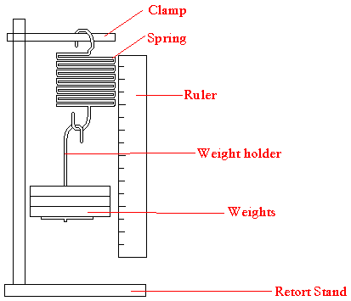
Weight to stabilise the retort stand
- Fix a clamp with its point in the boss on the stand.
- Hang a spring from it and secure it so that it does not come off when stretched.
- Clamp the metre stick / rule vertically alongside the spring.
- Measure the length of the spring with the metre stick/ rule and record this.
- Hang a mass hanger from the bottom of the spring and record the new length of the spring and the mass added.
- Add further masses to the end of the spring.
- Measure and record the new length of the spring.
- Repeat for further masses but do not stretch the spring beyond its elastic limit as the spring will break.
- Use your data to find the relationship between extension and load.
Risk Assessment
- Clamp or weigh down the clamp stand to the bench to prevent it from toppling.
- Students must wear eye protection.
- Eyes may be at the same level as clamp
- Springs store energy and can come off their supports.
- Mrsphysics takes no responsibility for any health and safety. It is the responsibility of the teacher and student to risk assess any practical activity they complete!
- Sept 2023

