National 5 Assignment

LDR and lamp voltage Guide Sheet: B

Nat
5

Investigating LDR and voltage across the light source

Equipment:
LDR, multi-meter (to use as an ohmmeter), ammeter, voltmeter, 12 V filament lamp in holder , power supply, leads/wires, black card, scissors, Sellotape.
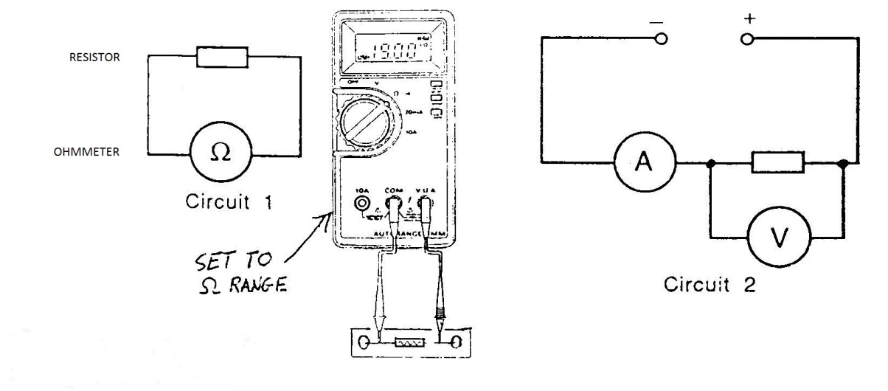

Instructions:
- Make a light box by rolling black card into a tube and seal this with Sellotape.
- Set up a 12 V lamp on the bench to act as a light source. Connect a voltmeter across the lamp and ammeter in series.
- Connect the multimeter to the LDR and adjust it to a suitable resistance range.
- Place the LDR and ohmmeter at one end of the black tube and the lamp and power supply at the other. Ensure they are all aligned.
- Place the lamp into the tube and set the lamp onto 1V on the power supply
- Record the voltage across the lamp and the resistance of the LDR.
- Change the power supply voltage without changing the distance between the lamp and LDR and record the new resistance of the LDR and voltage across the lamp.

Risk Assessment
- Check all the wires and ensure that the wires are not frayed
- The lamp being used may get hot, do not touch a hot lamp.
- Care should be taken to let it cool before packing away.
- Switch off the equipment when it is not in use.
- Do not make the black tube so tight that air cannot get in to cool the lamp.

Mrsphysics takes no responsibility for any health and safety. It is the responsibility of the teacher and student to risk assess any practical activity they complete!
Sept 2023

