National 5 Assignment

LDR and light level Guide Sheet: C

Nat

5



**Calibrating an LDR**

**Equipment:**

LDR, multi-meter (to use as an ohmmeter), 12 V filament lamp in holder , power supply, leads/wires, black card, scissors, sellotape, light level/ lux mete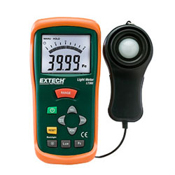

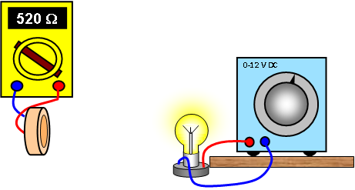

**Instructions**:

* Make a light box by rolling black card into a tube and seal this with Sellotape.
* Set up a 12 V lamp on the bench to act as a light source.
* Connect the multimeter to the LDR and adjust it to a suitable resistance range.
* Place the LDR and ohmmeter at one end of the black tube and the lamp and power supply at the other. Ensure they are all aligned.
* Place the lamp into the tube and set the lamp onto 1V on the power supply.
* Take a reading of the resistance of the LDR.
* Replace the LDR with the light sensor ensuring the light level meter’s sensor is in exactly the same place where the LDR was and take a reading of the light level.
* Change the power supply voltage without changing the distance between the lamp and LDR and record the new resistance of the LDR and the light level from the light level meter when it is replaces the LDR.
* To change the light level you could keep the voltage across the lamp the same and change the distance between the lamp and the light level meter.

**Risk Assessment**

* Check all the wires and ensure that the wires are not frayed
* The lamp being used may get hot, do not touch a hot lamp.
* Care should be taken to let it cool before packing away.
* Switch off the equipment when it is not in use.
* Do not make the black tube so tight that air cannot get in to cool the lamp.

*Light level meter image from* [*https://www.cunybpl.org/handheld-light-level-meter-lt-300/*](https://www.cunybpl.org/handheld-light-level-meter-lt-300/)

**Mrsphysics takes no responsibility for any health and safety. It is the responsibility of the teacher and student to risk assess any practical activity they complete!**

**Sept 2023**