National 5 Assignment
Ohm’s Law–Ohmic conductor: Guide A

Nat
5

Variation of current with voltage (resistor)

Equpment: Multimeters with settings for resistance, current and voltage, or ohmmeter, voltmeter, ammeter, resistor (between 3 and 100 Ω) leads, power supply.

Instructions:
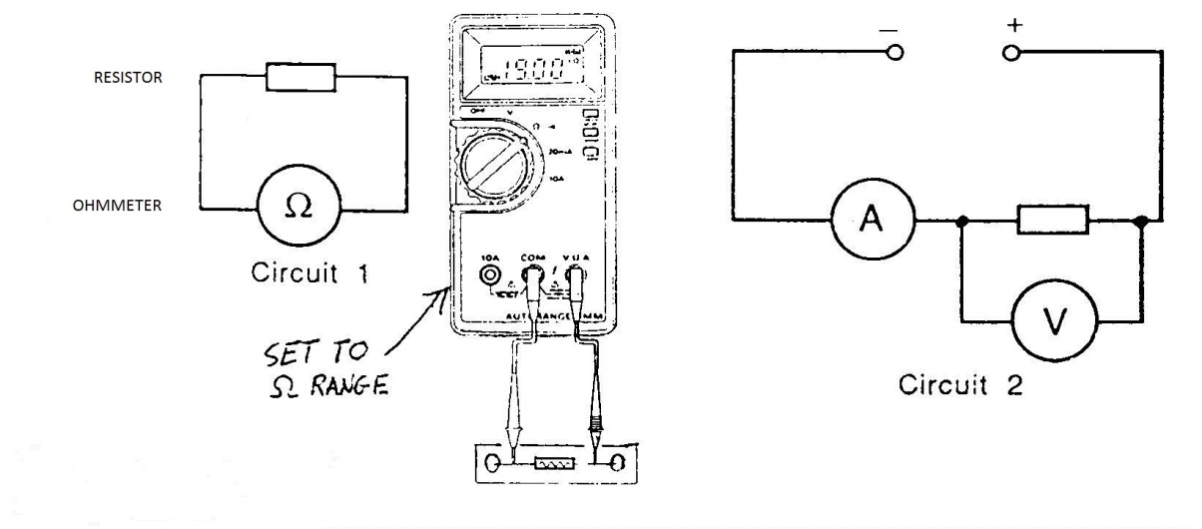
- Measure the resistance of the resistor with an ohmmeter.
- Connect the resistor to the power supply and connect an ammeter in series and voltmeter in parallel with the resistor.
- Set the power supply to 1 V and read the current and voltage readings from the ammeter and voltmeter respectively.
- Change the power supply voltage taking current and voltage readings from the ammeter and voltmeter.

Risk Assessment
- Check all the wires and ensure that the wires are not frayed
- The resistor could get hot, so avoid contact with this.
- Switch off the equipment when it is not in use.
- Do not plug the ohmmeter into a circuit with a power supply
- Na
Mrsphysics takes no responsibility for any health and safety. It is the responsibility of the teacher and student to risk assess any practical activity they complete!
Sept 2023

5

