Nat
5

National 5 Assignment
Ohm’s Law – non Ohmic conductor: Guide Sheet B

Variation of current with voltage (lamp)

Equipment: 12V lamp, variable power supply, ammeter, voltmeter, leads

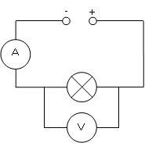
Instructions:
- Set up the circuit as in the diagram.
- Connect the 12V lamp to the power supply and connect an ammeter in series and a voltmeter in parallel across the lamp in the circuit.
- Set the power supply to 1 V and read the current and voltage readings from the ammeter and voltmeter respectively.
- Record the current through, and voltage across the lamp in your table.
- Increase the voltage of the power supply, taking current and voltage readings for each power supply setting.

Risk Assessment
- Check all the wires and ensure that the wires are not frayed
- The lamp could get hot, so avoid contact with this.
- Switch off the equipment when it is not in use.
- Ensure the ammeter and voltmeter are on the correct settings, check with your teacher before switching on your circuit.
- Allow the lamp to cool before putting it away.

Mrsphysics takes no responsibility for any health and safety. It is the responsibility of the teacher and student to risk assess any practical activity they complete!
Sept 2023

