National 5 Assignment  
Solar Cell- angle: Guide Sheet A

Nat

5

**Investigating Solar Cells (Angle).**

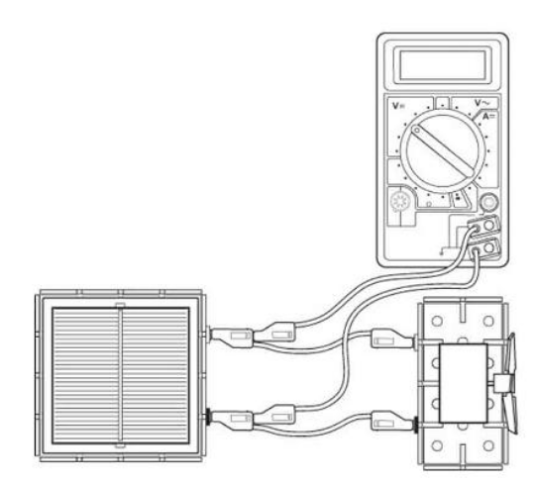

**Apparatus (angle)**

Solar cell unit, small motor unit (or other load), desk lamp (40 or 60 W tungsten lamp), digital multimeters (ammeter and/or voltmeter), 4 mm leads, metre rule, protractor, clamp stand

**Instructions:**

* Connect a solar cell to an electric motor.
* Connect a voltmeter across the solar cell also connect an ammeter in series in the circuit (not shown).
* The voltmeter and/ or ammeter can be used to get an idea about the output of the solar cell or the power can be determined.
* Shine a desk lamp onto the solar cell so that the motor turns, other loads can be used.
* Measure the angle between the lamp and the solar cell, and the corresponding current and voltage from the ammeter and voltmeter respectively.
* Adjust the angle between the lamp and solar cell, tilting the solar cell backwards and forwards ensuring you are clear about which angle you are measuring.

**Risk Assessment**

* Check all electrical wiring.
* Desk lamps with metal shades can get very hot. Take care when moving them.
* Be careful if considering other types of lamp such as halogen lamp and fluorescents because they can emit significant UV.

**Mrsphysics takes no responsibility for any health and safety. It is the responsibility of the teacher and student to risk assess any practical activity they complete!**

**Sept 2023**