National 5 Assignment
Solar Cell- distance: Guide Sheet B
Nat
5

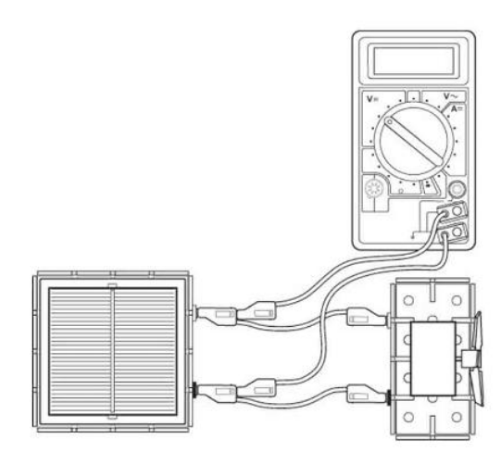
Investigating Solar Cells (distance).

Apparatus
Solar cell unit, small motor unit (or other load), desk lamp (40 or 60 W tungsten lamp), digital multimeters (ammeter and/or voltmeter), 4 mm leads, metre stick, piece of cardboard, clamp stand, protractor

Instructions:
- Make a cardboard tube so that it removed background light. Connect a solar cell to an electric motor.
- Shine a desk lamp through the cardboard tube onto the solar cell so that the motor turns, other loads can be used.
- Connect a voltmeter across the solar cell also connect an ammeter in series in the circuit.
- The voltmeter and/ or ammeter can be used to get an idea about the output of the solar cell or the power can be determined.
- Adjust the distance between the lamp and solar cell moving the lamp closer and further away from the solar cell.
- Maintain the angle between the solar cell and the lamp.

Risk Assessment
- Check all electrical wiring.
- Desk lamps with metal shades can get very hot. Take care when moving them.
- Be careful if considering other types of lamp such as halogen lamp and fluorescents because they can emit significant UV.

Mrsphysics takes no responsibility for any health and safety. It is the responsibility of the teacher and student to risk assess any practical activity they complete!
Sept 2023

