National 5 Assignment
Solar Cell- cloudy days: Guide Sheet C
Nat
5

Investigating Solar Cells (translucent).
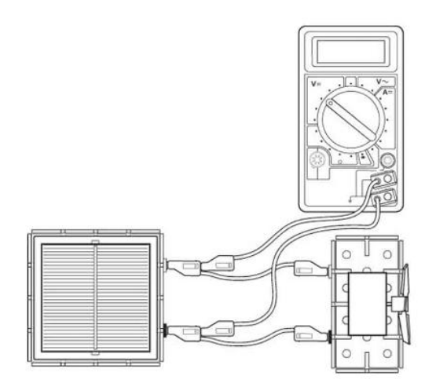
Apparatus (for cloudy days)
Solar cell unit, small motor unit (or other load), desk lamp (40 or 60 W tungsten lamp), digital multimeters (ammeter and/or voltmeter), 4 mm leads, metre stick, piece of cardboard, translucent sheets (e.g. tracing paper) cut a suitable size to cover the solar cell, protractor, clamp stand

Instructions:
- Connect a solar cell to an electric motor. Shine a desk lamp on the solar cell so that the motor turns, other loads can be used.
- The voltmeter and/ or ammeter can be used to get an idea about the output of the solar cell or the power can be determined.
- Connect a voltmeter across the solar cell also connect an ammeter in series in the circuit (not shown).
- Place a translucent sheet between the lamp and the solar cell, take a voltage and/ or current reading.
- Place another translucent sheet on top of the first and take further readings of the number of sheets of translucent paper and ammeter and voltmeter readings.

Risk Assessment
- Check all electrical wiring.
- Desk lamps with metal shades can get very hot. Take care when moving them.
- Be careful if considering other types of lamp such as halogen lamp and fluorescents because they can emit significant UV.

Mrsphysics takes no responsibility for any health and safety. It is the responsibility of the teacher and student to risk assess any practical activity they complete!
Sept 2023

