National 5 Assignment
Speed of Sound: Guide Sheet A
Nat
5

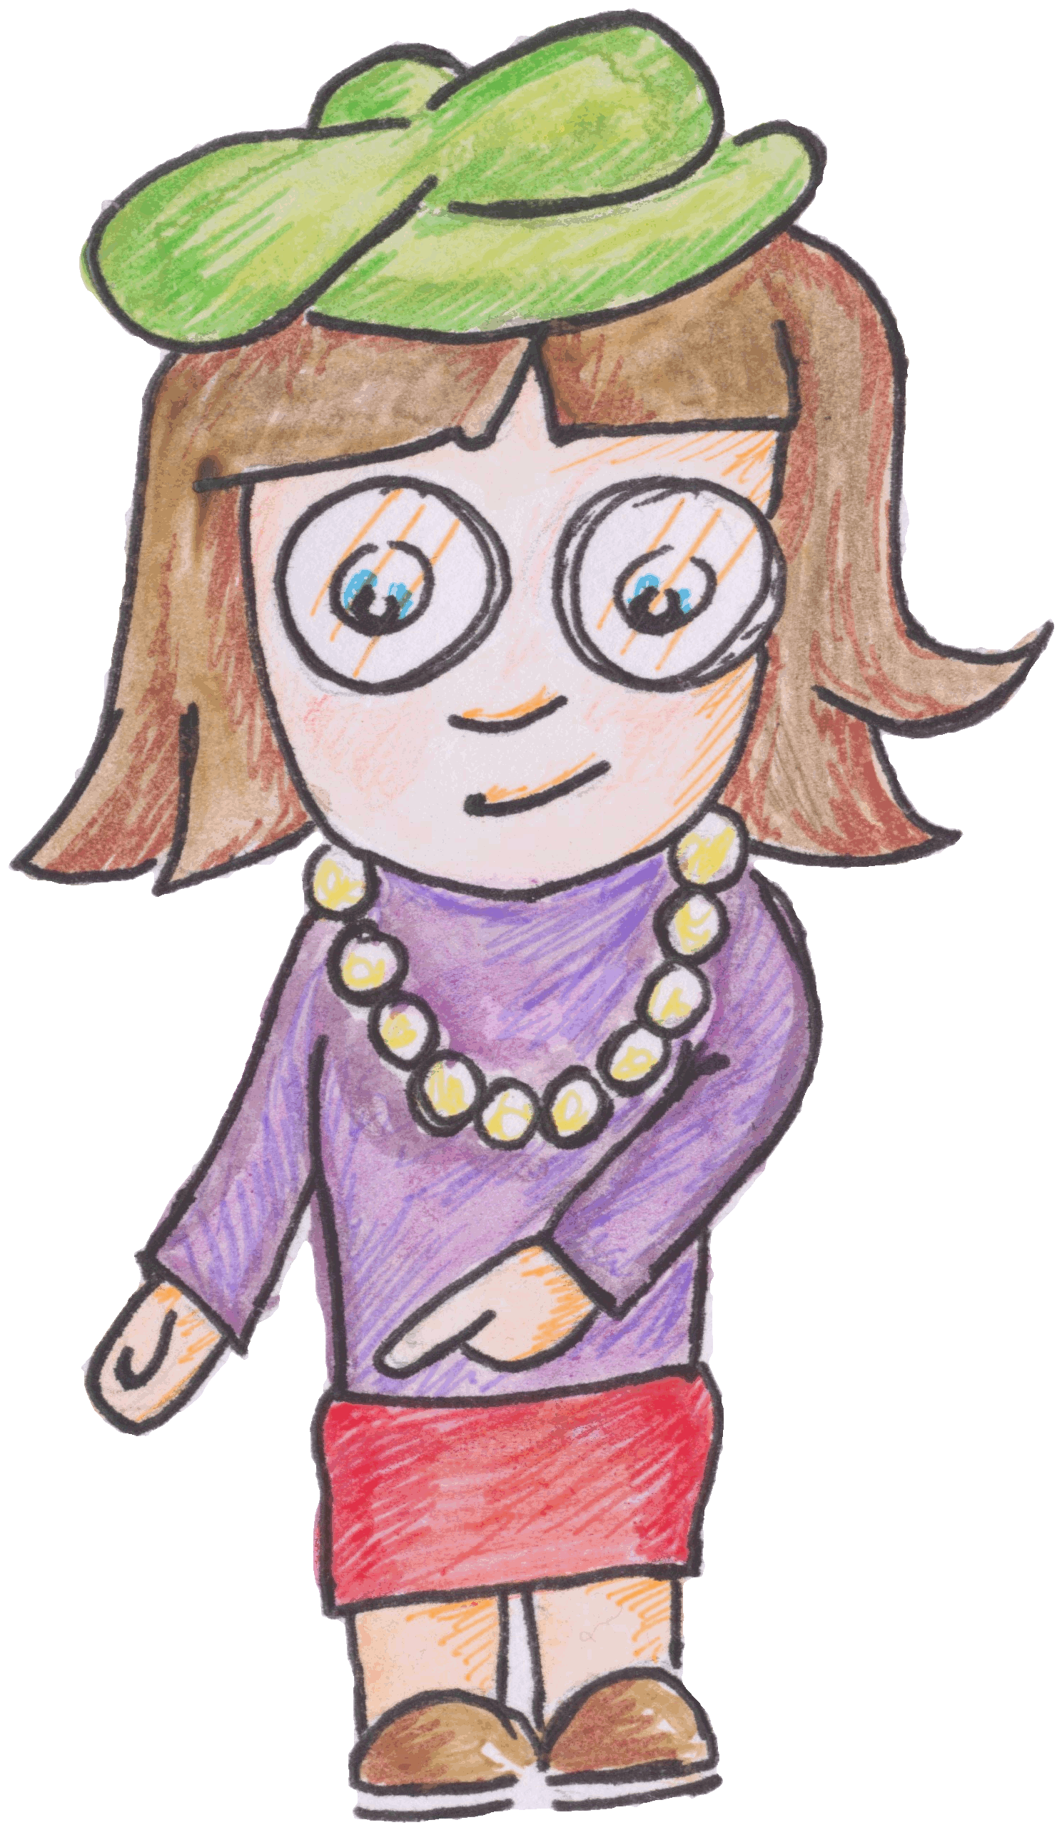

Investigating the speed of sound.

Apparatus
Sound switches, ALBA or other interface, computer, tape measure, two wooden blocks to make a short sharp sound.
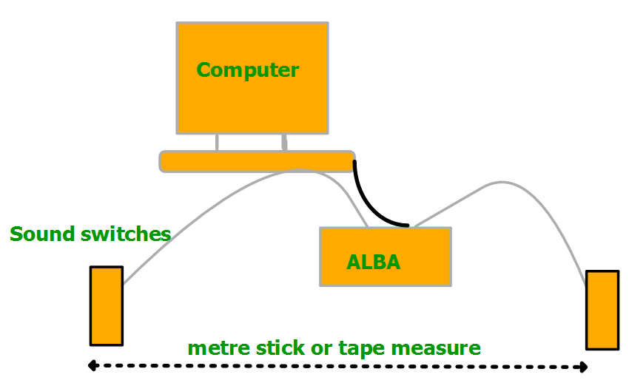
INTERFACE
Instructions:
- Connect two sound switches to the ALBA and the ALBA to a computer.
- Set the sound switches a known distance apart, record this distance.
- Make a loud short, sharp sound to the side of one of the sound switches.
- Record the distance between the sound switches and the time for the sound to travel between the sound switches.
- Adjust the distance between the sound switches and take another reading for the distance and time.

Risk Assessment
- Check all electrical wiring.
- Do not exceed 80 dB when making the sound, a short clap will suffice.
- Do not trap fingers between the two wooden blocks

Mrsphysics takes no responsibility for any health and safety. It is the responsibility of the teacher and student to risk assess any practical activity they complete!
Sept 2023

