Nat
5

National 5 Assignment
Stopping Distance: Guide Sheet A

Variation of stopping distance with speed of the vehicle.

Apparatus
Runway, vehicle, light gate(s), interface and computer, mask (single or double), rule, protractor, tape measure /metre stick

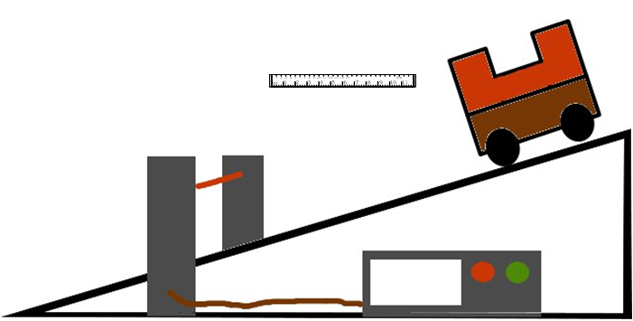
Instructions:

- Organise the light gates and interface to measure the speed of the vehicle as the vehicle passes through the light gate. This can be using one light gate and a single mask.
- Set the runway up at an angle.
- Place the light gate so that the mask cuts the beam as the vehicle passes.
- Release the vehicle from near the bottom of the slope and record the speed as it passes the light gate.
- Let the vehicle run along until it stops at the bottom. Measure the stopping distance from the light gate to where the vehicle comes to rest.
- Release the vehicle further up the slope.

Risk Assessment
- Masses may be heavy so care must be taken to not drop them.
- Do an electrical safety check by observing all the wires.
- Make sure the vehicle cannot become a trip hazard or land on feet, toes etc.
- Be observant to those around you.
- Run the trolley away from students and not across the room.
- Do not block exits with the apparatus.
- Mrsphysics takes no responsibility for any health and safety. It is the responsibility of the teacher and student to risk assess any practical activity they complete!
- Sept 2023

