Nat

5

National 5 Assignment  
Stopping Distance: Guide Sheet B

**Variation of stopping distance with height of release up the slope.**

**Apparatus**

Runway, vehicle , protractor, tape measure /metre stick

**Instructions:**



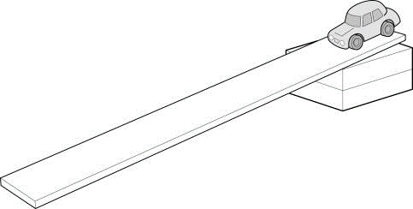

* Set the runway up at an angle.
* Arrange the runway vehicle and books to get a reasonable height and from a few cm from the runway release the vehicle and see how far it travels.
* Repeat this by releasing the vehicle from the top of the slope. Check that the vehicle does not travel too far across the lab, or not far enough so that the different distances cannot be noted. If the vehicle travels too far either lower the runway or change the surface that the car will be stopping on.
* Ensure the vehicle isn’t slowed too much as it leaves the end of the runway. A joiining piece may need to provide a smooth interface between the slope and floor.
* Release the vehicle from near the bottom of the slope and note the vertical release height.
* Let the vehicle run along until it stops at the bottom. Measure the stopping distance from the bottom of the slope to where the vehicle comes to rest.
* Release the vehicle further up the slope.

**Risk Assessment**

* Make sure the vehicle cannot become a trip hazard or land on feet, toes etc.
* Be observant to those around you.
* Run the trolley away from students and not across the room.
* Do not block exits with the apparatus.

**Mrsphysics takes no responsibility for any health and safety. It is the responsibility of the teacher and student to risk assess any practical activity they complete!**

**Sept 2023**