National 5 Assignment
Projectile launch angle Guide Sheet: A

Nat

5

Variations of range a projectile with launch angle
Equipment
Ball, projectile launcher, protractor, metre stick or tape measure, sand, tray, or carbon paper.
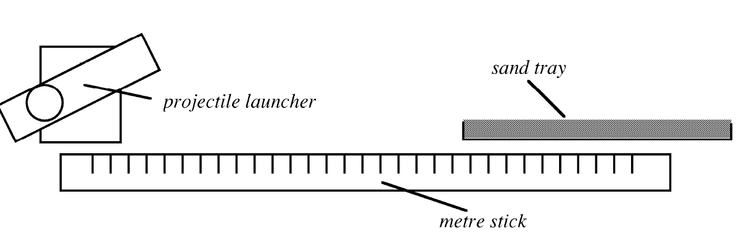
Instructions
- Set up the apparatus as shown in the diagram above.
- Set the projectile launcher to the initial angle to the horizontal
- Fire the ball from the launcher.
- Adjust the position of the sand tray or carbon paper so that the ball lands in the sand or on the carbon paper and leaves a clear mark.
- Fire the ball a second time from the initial angle and repeat the measurement. Record the range and angle.
- Set the projectile launcher to larger angles and measure the range of the ball for each angle.
Risk Assessment
- Check that the launch area is free of people who could get hit.
- Ensure no projectile is left unattended where it could become a trip hazard.
- Wear safety goggles as the projectiles are likely to be smaller than the eye socket, and may not always be very well aimed!

Mrsphysics takes no responsibility for any health and safety. It is the responsibility of the teacher and student to risk assess any practical activity they complete!
Sept 2023

