National 5 Assignment
Latent heat of vaporisation Guide Sheet: B
Nat
5

To determine the specific latent heat of vaporisation of water.
This experiment is only suitable if a graph can be plotted.
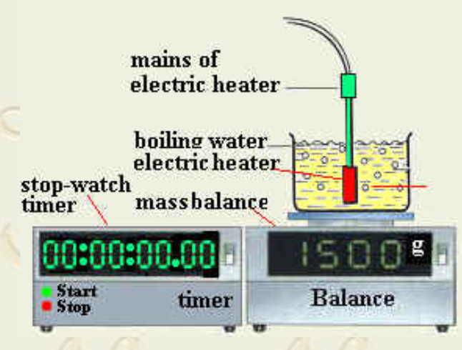
Apparatus
Beaker, water, lagging, electric heater
stopwatch, balance.

Instructions:

- Sent up the apparatus as shown in the diagram.
- Place a quantity of water in the container.
- Measure and record the mass of the water and container.
- Place the electric heater in water placed in container.
- Switch on the heater
- Turn on the stop-watch when the water is boiling.
- Regularly note the time and record the mass of water and container "
- Repeat these steps.
- Find the mass of the evaporated water.
- Use your data to determine the specific latent heat of vaporisation of water.
- The energy required to evaporate 1 kg of boiling water is the specific latent heat of vaporisation of water.

Risk Assessment
- Safety googles must be worn.
- Electrical wiring must be checked.
- Do not move the equipment when once set up.
- Have access to the plug so that the heater can be switched off.
- Check with SSERC that this experiment is suitable.
- The heater could be connected to a joulemeter and the energy recorded every few minutes and the mass lost recorded.
- Do not allow too much water to boil so that the heater breaks.

Diagram from
http://ramadan.50megs.com/IGC_Exp_2Y_HeatOfVaporization.htm#:~:text=Turn%20on%20the%20stop%2Dwatch,of%20water%20as%20%22M2%22&text=Find%20the%20mass%20of%20the,vaporization%20from%20Lv%3Dpt%2Fm

Mrsphysics takes no responsibility for any health and safety. It is the responsibility of the teacher and student to risk assess any practical activity they complete!
Sept 2023

