National 5 Assignment
Specific Heat Capacity: Guide Sheet A
Nat
5

Specific Heat Capacity for a substance.

Apparatus
Block of known mass (insulated), balance, thermometer, insulation, 12 V immersion heater (typically 60 W), power supply, 0 – 12 V rated to supply 6 A, 4 mm leads, two digital multimeters (ammeter/ voltmeter), stopwatch

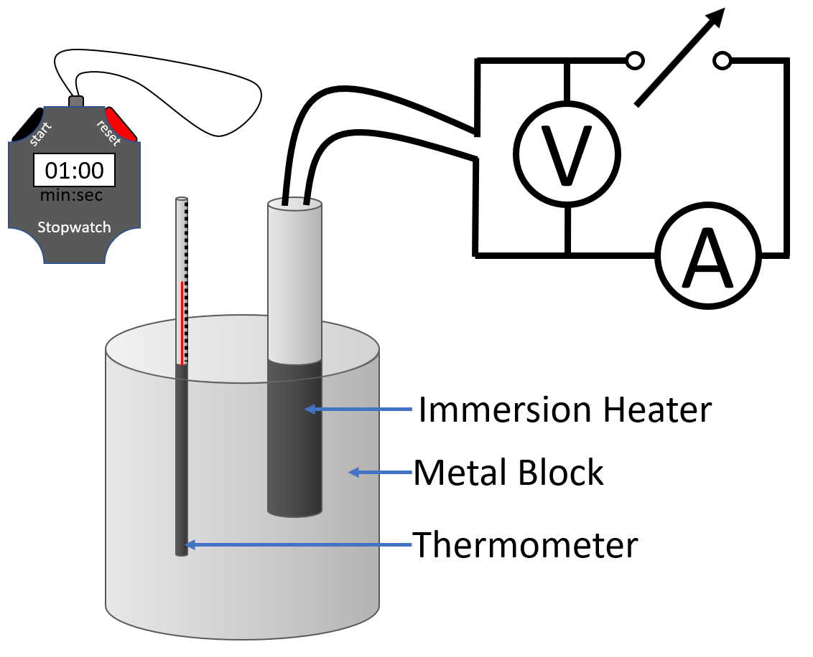
Instructions:
- Insert a thermometer and the immersion heater into their respective holes in the block. You may wish to drop a small amount of oil into the thermometer hole.
- Allow the thermometer to reach thermal equilibrium.
- Set up a suitable circuit that will enable you to measure the energy input to the heater.
- Turn on the power supply, noting the time if you are measuring energy using an ammeter and a voltmeter to record power.
- Monitor and note the meter readings as the energy is supplied.
- Allow the block to heat up by about 10 °C.
- The temperature at the turn-off time is not the appropriate final temperature to record.

Risk Assessment
- Check all electrical wiring.
- Check the seals on the immersion heaters before use. Reject any that are obviously defective. In doubtful cases, any water which has entered during a precious activity can be removed by placing the heater in an oven for an hour at about 80 °C.
- Avoid running the immersion heaters outside the blocks, and not to cool them in water when hair-line cracks will draw water inside.
- Wear goggles when completing this experiment and when setting and clearning up.
- Do not use a mercury thermometer.
- ALL EQUIPMENT could get hot, please beware

Image:
https://keystagewiki.com/index.php/GCSE_Physics_Required_Practical:_Determining_Specific_Heat_Capacity#/media/File%3ARequiredPracticalSHC2.png

Mrsphysics takes no responsibility for any health and safety. It is the responsibility of the teacher and student to risk assess any practical activity they complete!
Sept 2023

