National 5 Assignment
Specific Heat Capacity: Guide Sheet B
Nat
5

Specific Heat Capacity for a substance.

Apparatus
Block of metal (insulated), top pan balance, thermometer, insulation, 12 V immersion heater (typically 60 W), power supply, 0 – 12 V rated to supply 6 A, 4 mm leads, joulemeter, stopwatch

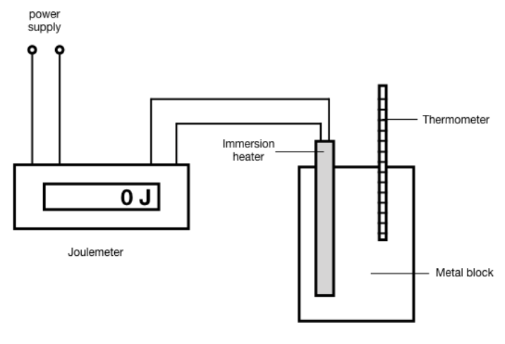
Instructions:
- Insert a thermometer and the immersion heater into their respective holes in the block. You may wish to drop a small amount of oil into the thermometer hole.
- Allow the thermometer to reach thermal equilibrium.
- Set up the joulemeter to determine the energy input to the heater.
- Take readings of the energy and the temperature of the block.
- Do not allow the block to heat up too much.
- The temperature at the turn-off time is not the appropriate final temperature to record.

Risk Assessment
- Check all electrical wiring.
- Check the seals on the immersion heaters before use. Reject any that are obviously defective. In doubtful cases, any water which has entered during a precious activity can be removed by placing the heater in an oven for an hour at about 80 °C.
- Avoid running the immersion heaters outside the blocks, and not to cool them in water when hair-line cracks will draw water inside.
- Wear goggles when completing this experiment and when setting and clearning up.
- Do not use a mercury thermometer.
- ALL EQUIPMENT could get hot, please beware

Mrsphysics takes no responsibility for any health and safety. It is the responsibility of the teacher and student to risk assess any practical activity they complete!
Sept 2023

