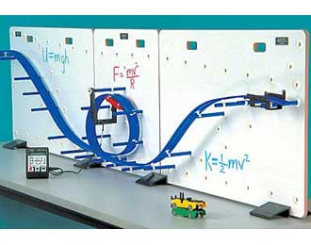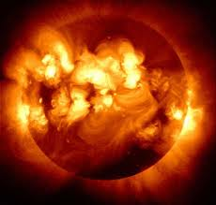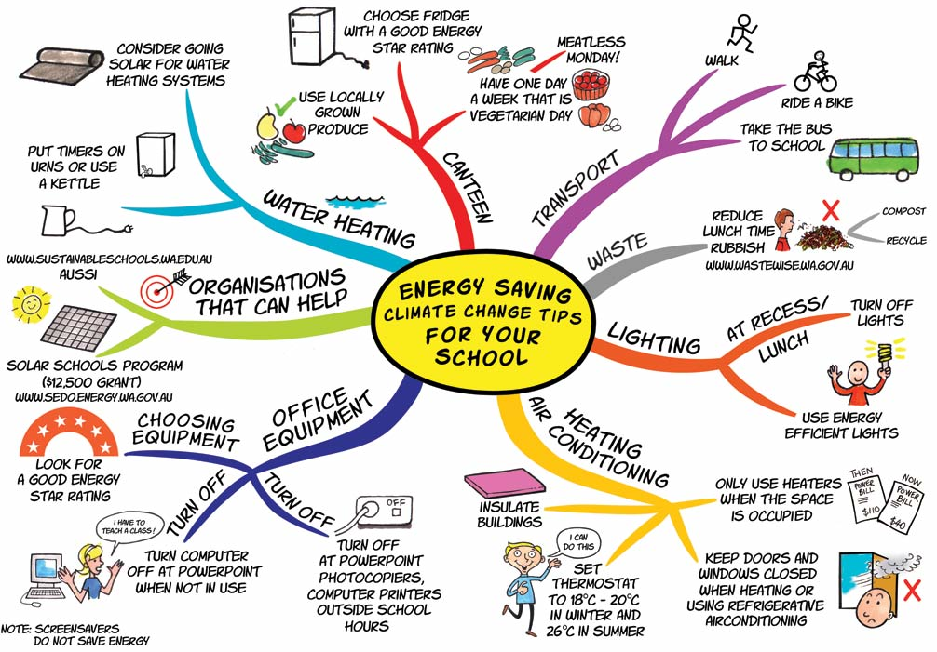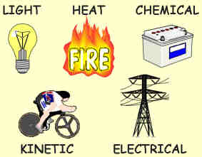
 | N5 Energy and Electricity
Name:

Class:
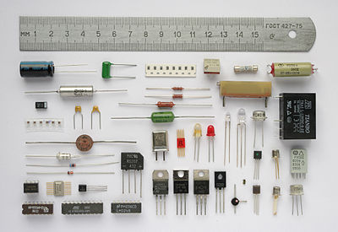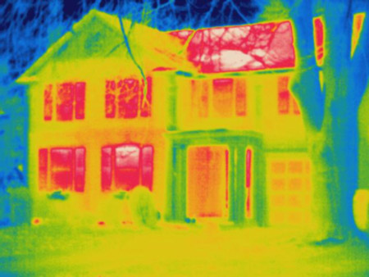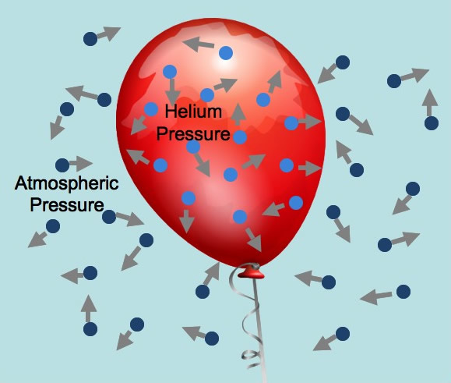

National 5 Physics: Energy and Electricity

Essential Knowledge

I know what the principle of ‘conservation of energy’ means where energy is transferred between stores (lesson
I can identify and explain the ‘loss’ of energy where energy is transferred (lesson
I can perform calculations with potential and kinetic energy in situations involving conservation of energy (lesson
I understand the definition of electric charge in terms of negative and positive (lesson
I know that electrical current is the flow of electric charges and can define it as the electrical charge transferred per unit time (lesson
I can use the appropriate relationship(s) of I = Q/t to carry out calculations involving charge, current and time (lesson
I can state and explain the difference between alternating current (A.C.) and direct current (D.C.) (lesson
I can describe the effect of an electric field on a charge (lesson
I know that the potential difference (voltage) of a supply is a measure of the energy given to the charge carrier in a circuit (lesson
I have investigated practical electrical and electronic circuits (lessons
I have measured current, voltage and resistance using appropriate meters in complex circuits (lessons
I have investigated the function and application of standard electrical and electronic components including cell, battery, lamp, switch, resistor, variable resistor, voltmeter, ammeter, LED, motor, loudspeaker, photo voltaic cell, fuse, diode, capacitor, thermistor, LDR (lessons
I have investigated the relationships of current and voltage in a parallel circuit (lesson
I can use an appropriate relationship to calculate the resistance of resistors in series and in parallel circuits (lesson
I have investigated the relationship between current and voltage and can use a V-I graph to determine the resistance of a component (lesson
I can use an appropriate relationship to calculate potential difference (voltage), current and resistance (lesson
I have investigated the relationship between temperature and resistance of a conductor (lesson
I know that Power is equal to Energy / Time (lesson
I am able to use the Power relationship in calculations involving energy, power and time (lesson
I can use an appropriate relationship to determine the power, voltage, current and resistance in electrical circuits (lesson
I have developed my knowledge of heat (thermal energy) (lesson
I understand that the same mass of different materials requires different quantities of heat to raise the temperature of unit mass by one degree Celsius. This is known as the specific heat capacity of a material (lesson
I have investigated the specific heat capacities of different materials (lesson
I know that the temperature of a substance is a measure of the mean kinetic energy of its particles (lesson
I can explain the connection between temperature and heat energy (lesson
I can use appropriate relationships to carry out calculations involving mass, heat energy, temperature change and specific heat capacity (lessons
I can use conservation of energy to determine heat transfer (lesson
I have developed my understanding of the gas laws and kinetic model of a gas (lessons
I know that Pressure is the force per unit area exerted on a surface (lesson
I can use an appropriate relationship to calculate pressure, force and area (lesson
I can explain the relationship between the volume, pressure and temperature of a fixed mass of gas using qualitative kinetic theory (lessons
I can use an appropriate relationship to calculate the volume, pressure and temperature of a fixed mass of gas (lesson
I know the relationship between Kelvin, degrees Celsius and absolute zero of temperature (lesson

Ensure you date your work in your jotter for each lesson. As we complete each section you can add the dates of the lessons into the table above and assess your learning by highlighting the smiley faces!
Section 1: Conservation of Energy

Learning intentions: we are going to revise the different forms of energy, identify energy transfers and efficiency and learn that the total amount of energy in a system always stays the same – this is the principle of the conservation of energy.

Electricity is a form of energy associated with stationary or moving charges in a material.
Electricity is the general name we give to the supply of ___________ energy.

Electrical energy is carried (or transferred) around a circuit by tiny particles called ___________.

Think about a lamp and a switch connected by wires to a battery. When the switch is closed, the lamp lights up – negative charges called electrons from the negative side (terminal) of the battery move through the wires and the lamp to the positive terminal of the battery. This movement, or flow, of negative charges is called an electrical current (or current for short). A current is a movement of electrons. As the electrons move through the lamp, some of their electrical energy is changed into heat and light.

There are many different types of energy, we have covered some of these before – a wise Scot should help you remember:

M ____________________ this is also known as kinetic energy
A ____________________ this is also known as nuclear energy
C ____________________ this is the source of energy in a battery

H ____________________ you can feel this type of energy
E ____________________ we are investigating this energy in this topic
L ____________________ also known as solar energy
P ____________________ also known as stored energy
S ____________________ you can hear this type of energy

The principle of the Conservation of Energy states that energy cannot be created or destroyed – it can only change from one form of energy to another. Energy is conserved – the total amount of energy present stays the same before and after any changes.

The pendulum is a good example, showing the principle of conservation of energy in action.

Gravitational potential energy is converted to kinetic energy and back, over and over again, as the pendulum swings.

The diagram shows a pendulum in three positions. It shows the two ends of its swing and the position it will be in as it passes through the middle point.

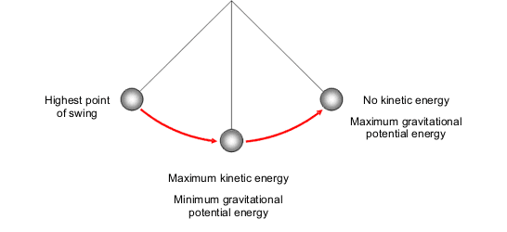

When the pendulum bob is at the start of its swing it has no kinetic energy because it is not moving. However, its gravitational potential energy (GPE) is at a maximum, because it is at the highest point.

As the bob swings downwards it loses height. Its gravitational potential energy (GPE) decreases. The work done on the bob by the gravitational force (weight) pulling it downwards increases its kinetic energy (KE). The loss of GPE = the gain in KE.

At the bottom of its swing, the bob’s kinetic energy is at a maximum and its gravitational potential energy is at a minimum - because it is at its lowest point.

As the bob swings upwards it slows down. Its kinetic energy decreases as work is done against its weight. As it gains height, the gravitational potential energy increases again.

At the very top of its swing it stops for a moment. It once again has no kinetic energy, but its gravitational potential energy is at a maximum.

At all points during the swing, the total (GPE + KE) is constant.

Note that in a real pendulum, the bob’s swing will become slightly lower with each swing, because some energy is lost, or wasted, through heating. This is due to air resistance.

The idea of conservation of energy can be applied to a range of energy transfers, e.g. crash barriers or footballs being kicked. In an exam you may be expected to apply this knowledge to unfamiliar situations.

We often say that the type of energy we are after is the ‘useful’ energy and that any other forms of energy that our energy store is transferred into are ‘wasted’ energy. For example, electrical energy in a light bulb is transferred into light (useful energy) and heat (wasted energy).

The more ‘useful’ energy we get when we change from one form of energy to another, the more efficient the process is. We can write equations for how efficient energy and power transformations are below:

% Energy efficiency = (useful E_{out} /E_{in}) x 100%

% Power efficiency = (useful P_{out} / P_{in}) x 100%

The highest possible efficiency of a system is ______% This means that all of the energy or power we put into a system is transferred into useful energy or power out.
The higher the percentage efficiency of a system, the better!

We can calculate gravitational potential energy by using the following formula:

$${\text{E}}_{\text{p}}\text{= }\text{m} \text{×} \text{g} \text{×} \text{h}$$

Where E_{p} is the gravitational potential energy in Joules
m is the mass of the object in kg
g is the gravitational field strength = 10 m/s²
h is the height of the object in metres

We can calculate the kinetic energy of moving objects by using the following formula:

$${\text{E}}_{\text{k}} \text{=}\frac{\text{1}}{\text{2}}\text{m} \text{×} {\text{v}}^{\text{2}}$$

where E_{k} is the kinetic energy in Joules
m is the mass of the object in kg
v is the velocity of the object in metres per second, m/s

Worked example:
A crane lifts a crate of mass of 60kg to a height of 60m.
(a) calculate the gravitational potential energy gained by the crate
(b) if the cable of the crane snaps once it has completed lifting the crate , calculate the maximum velocity of the crate just as it reaches the ground (ignoring air resistance)

a) Using the equation ${\text{E}}_{\text{p}} \text{= }\text{m} \text{×} \text{g} \text{×} \text{h}$  E_{p} = 60 x 10 x 25  E_{p} = 15,000 J | Mass, m = 60 kg  Height, h = 25 m  Gravitational field strength, g = 10 m/s²

b) If the crate falls, all of its potential energy will be transformed into kinetic energy. We are told to neglect air resistance – this means we can ignore any loss of energy to heat.

We can say that the gravitational potential energy, E_{p} is equal to the kinetic energy, E_{k}, therefore:

E_{p} = E_{k} = 15,000 J as worked out previously

Using the equation ${\text{E}}_{\text{k}} \text{=}\frac{\text{1}}{\text{2}}\text{m} \text{×} {\text{v}}^{\text{2}}\text{ = 15,000 J}$

15,000 = ½ x 60 x v²

$${\text{v}}^{\text{2}}\text{ = }\frac{\text{15,000 × 2}}{\text{60}}\text{ = 500}$$

v = 22.36 m/s

Questions:

1. Calculate the gravitational potential energy of a student of mass 50kg that has climbed 7 metres
2. If an object has a mass of 10kg and a gravitational potential energy of 45,000J how high is it?
3. An object at a height of 25m has a gravitational potential energy of 100J, calculate its mass
4. A car travelling at 10 m/s has a mass of 1,500 kg calculate its kinetic energy
5. A bullet of mass 100g has a kinetic energy of 50,000J, calculate its speed
6. A bumblebee is flying at 10 m/s and has a kinetic energy of 0.025 J, calculate its mass
7. State and explain the principle of the conservation of energy
8. A stone falls from a cliff, which is 80 m high
a. If air resistance can be ignored, calculate the speed at which it enters the water at the bottom of the cliff
b. If air resistance cannot be ignored, what effect will this have on the speed of the stone as it enters the water?
c. In practice, not all of the initial gravitational energy is transformed into kinetic energy. Other than kinetic energy, what is the main form of energy produced?
9. a. What type of energy does a spacecraft have because of its movement?
b. What is this energy changed into when the spacecraft re-enters the Earth’s atmosphere from space?
c. What causes this energy transformation?
10. Show that, if air resistance can be ignored, the speed of a falling object is independent of its mass and depends only on the height through which it moves.

Experiment! Investigate energy transfers and losses in the generation of electricity, motion down a hill, etc. using model car ‘stunt sets’.

Homework: Write a short (1/2 page A4 maximum) account of current solar panels, detailing what the energy transfers are, the benefits and drawbacks of this technology and how efficient these devices are.
Section 2. Electrical Charge Carriers and Electric Fields

Learning intentions: We are going to review the definition of electric charge, investigate electrical current and the difference between alternating and direct current.

One of the fundamental properties of materials is that of charge.

Electrostatics is the study of charges at rest. Simple electrostatics experiments that we have performed in S1/S2 helped us to establish the following facts:

(i) There are two types of charge: positive and negative. The names have no significance other than as labels for the two types of charge.
(ii) All materials are made up of atoms that normally contain equal numbers of positively and negatively charged particles. When there is no excess charge of either type, the material is said to be uncharged, or neutral. Some types of materials can be charged, either positively or negatively, by rubbing (causing friction). Since electrons are defined as carrying negative charge, if electrons are rubbed onto a material it becomes negatively charged, while if a material loses electrons it becomes positively charged.
(iii) Electrons in a conductor are free to move and so conductors can not be easily charged since the charge normally flows away as soon as it is placed on the conductor.
(iv) Like, or similar, charges exert forces which make them repel each other. Unlike charges exert forces which make them attract each other.

When electrical charges move around a circuit (a continuous loop of conducting material), they form an electrical current. An electrical current is a flow of charges, usually negative charges carried by electrons.

The symbol for electrical charge is Q

The unit that is used to measure electrical charge is the coulomb (C)

Six million million million (6x10¹⁸) electrons is about -1C (note the negative value)
Six million million million (6x10¹⁸) protons is about +1C

The symbol for electrical current is I. The unit that is used to measure electrical current is the Ampere (A).

Electrical current is defined as the electrical charge transferred per unit time, we can write this as:

Q = I x t  Or alternatively  I = Q/t | Where Q is the charge in Coulombs, C  I is the current in Amperes, A  t is the time in seconds

Worked example:
Calculate the charge transferred in a circuit which has a current of 0.25 A for 1 hour.

Solution:
Q = I x t  Q = 0.25 x 3,600  Q = 900 C | Current, I = 0.25 A  Charge, Q = ?  Time, t = 1 hour = 60 x 60s = 3,600 s

Question:
Calculate the current in a circuit when a charge of 180C is transferred in 1 minute.

Experiment! Investigate the interaction of charged objects, for example, metallised polystyrene spheres attracted and repelled, Van de Graaff generator discharged through micro ammeter.

The diagrams below will help you to think about what is going on when we connect an electrical circuit to a power supply.

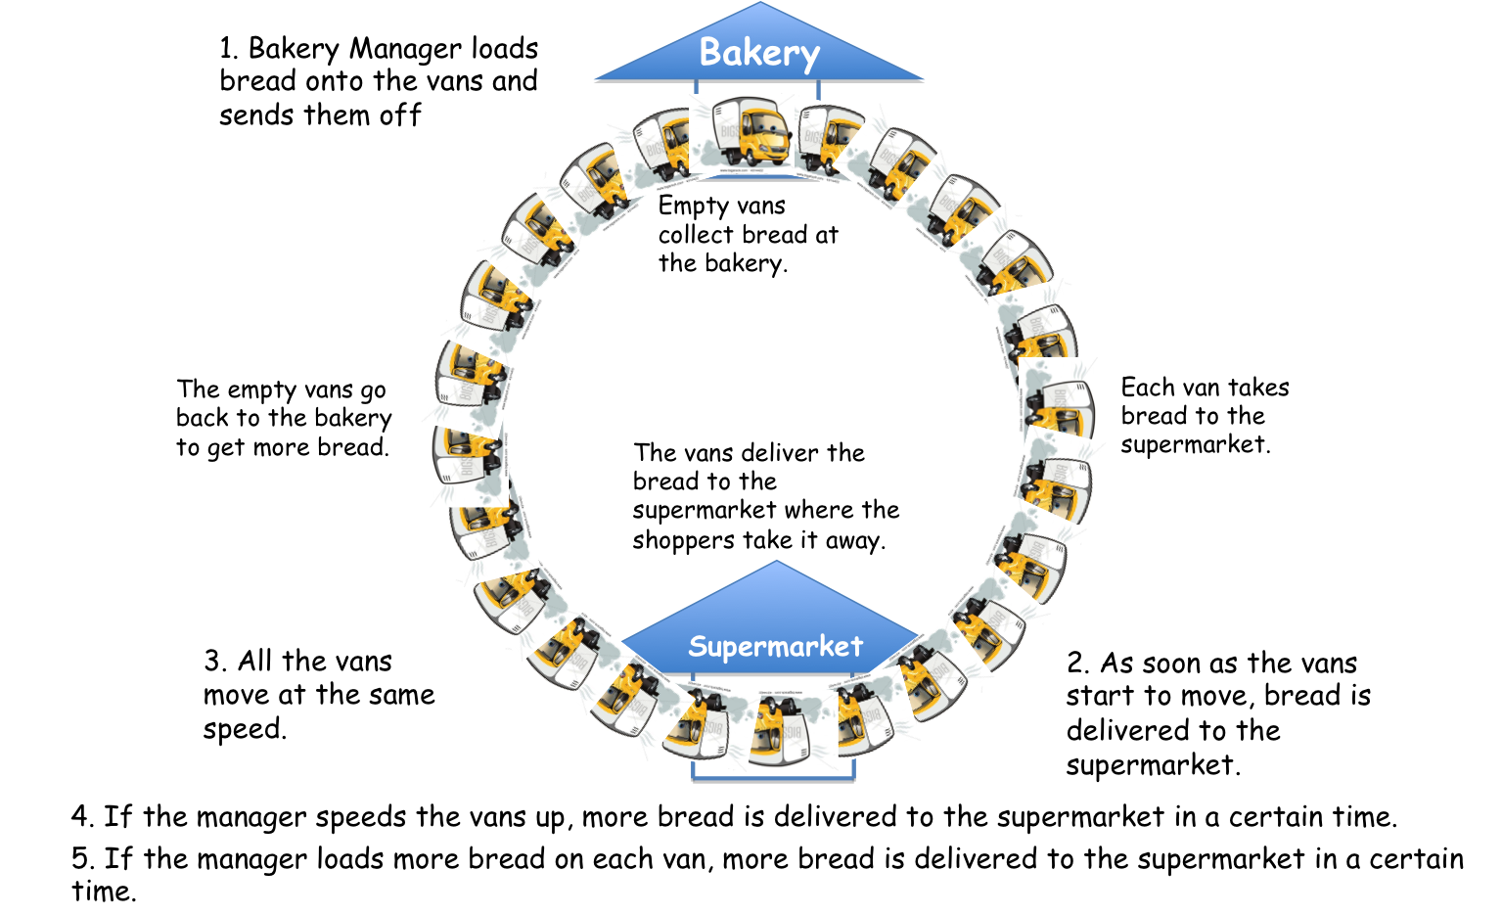

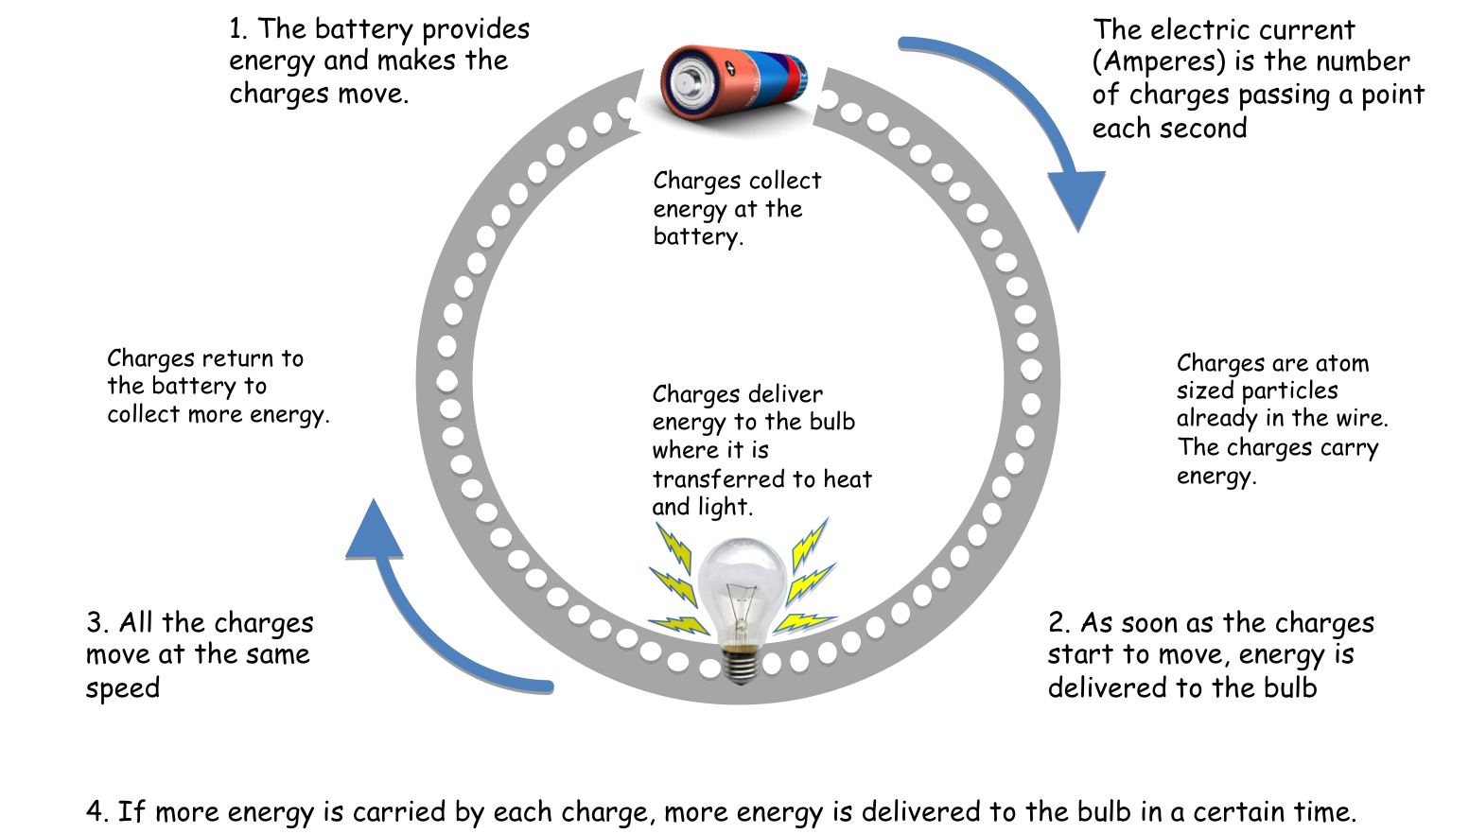

What happens when a battery or power supply runs out of energy?

Direct Current (D.C.)
When a circuit is connected to a battery, the electrons always flow round the circuit in the ______ __________ from ___________ to ____________. This is called direct current (d.c.).

What is the battery supplying to the electrons?

What happens when the battery is ‘flat’ – will the electrons move and create a current?

Alternating Current (A.C.)

With an alternating current, the charges are continually changing direction, moving backwards and forwards many times every second. In the U.K. the A.C. current has a frequency of 50 Hz – this means the current cycles between positive and negative 50 times each second.

Alternating current shows a distinctive sinusoidal waveform when viewed on an ascilloscope:
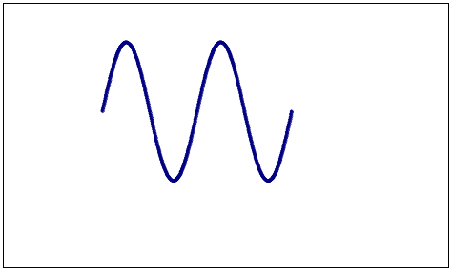
This picture shows two complete cycles of the pattern. Each cycle has a positive half-cycle and a negative half-cycle. During the positive half-cycle the current is in one direction; during the negative half-cycle the current is reversed.

Experiment! Use an oscilloscope/data logging software to compare alternating and direct current sources.

Research: Discuss and research two of the uses of electrostatics, for example: laser printers, paint spraying, cling film, forensic science, removal of dust, electrostatic precipitators or electrostatic separators.
Research the definition of current and its historical context.
Section 3. Potential difference: Voltage

Learning intentions: We are going to learn about electric fields and investigate the effect of an electric field on a charged particle. We will learn that the potential difference (voltage) of an electrical supply is a measure of the energy given to charge carriers in a circuit.

Electric Fields

From the last section we know that charged bodies exert a force on each other: some are pulled towards each other and some are pushed away from each other. This is because there are two types of charge – we call them positive and negative. Their action can be summarised as

Like charges repel, unlike charges attract

The electrostatic forces between the charges in materials are responsible for the strength and all their mechanical and electrical properties!

A very important property of these electrostatic forces is that they act at a distance (non-contact force). For example, if you rub a balloon on your jumper and then place it near your hair what happens? The hair on your head is attracted to the balloon.

Any charged body in the space around another charged body is acted on by an electric field, and will ‘feel’ a force. The direction of the force depends on whether the charges are alike or unalike. The size (or strength) of the force depends on the size of the charges and their distance apart.

The behaviour of electric fields is very similar to those of magnetic and gravitational fields. In an electric field, a charge experiences a force. In a gravitational field a mass experiences a force.

An electric field applied to a conductor causes any free electric charges to move.

We can draw electric field lines to show the direction of a force acting on an imaginary positive charge placed in the electric field.

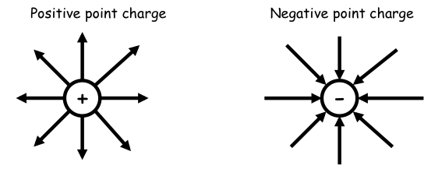
Notice how the imaginary positive charge would be forced away from the positive charge on the left (since like charges repel) but would be attracted to the negative charge on the right (since unalike charges attract).

We can show what happens when two charges are brought close together - these produce radial fields:

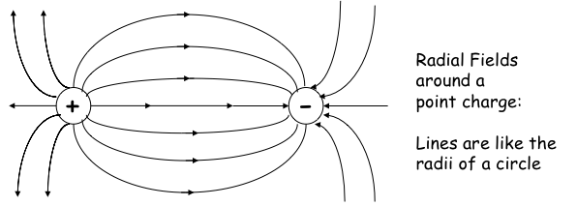

Note how the arrows move away from the positive charges and towards the negative charges. As you move further away from the charges the field strength decreases.

You may well have seen this pattern before… can you remember where?

If we place two parallel plates together we can create a uniform electric field:

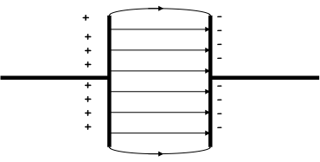

Note that the field lines are equally spaced between the two parallel plates. This means that the field strength is constant. This is called a uniform electric field. Near the edges of the plates the field is no longer uniform.

Experiment! Demonstration of electric fields using Teltron tubes, olive oil and seeds with high tension supply, Van de Graaff generator, parallel plates and suspended pith ball.

The strength of the field is defined as the force on each Coulomb of charge:

Electric field strength = force in Newtons on a charge of 1 Coulomb

Units of electric field strength are Newtons per Coulomb, N/C

Now let’s consider what happens if we try to move a charge in an electric field.

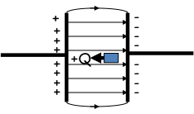
Here a positive charge, Q, is being pushed from the negative plate towards the positive plate. Why would we need to push it?

When the positive charge is moved against the direction of the electric field’s force, energy is stored as electrical potential energy. This is very similar to squashing a spring! What happens when you release a spring?

What do you think would happen if we released the positive charge Q?

Experiment! Use of computer simulations to investigate the behaviour of charges in an electric field.

Potential difference

When a charge Q is moved in an electric field, work W is done.
When work is done to push a charge against a field, the charge gains potential energy.
When the field does work on the charge, the charge accelerates and gains kinetic energy.
If one Joule of work is done moving one Coulomb of charge between two points in an electric field, the potential difference between the two points is one Volt.
We can say that

The potential difference (Voltage) of a supply is the measure of the energy given to the charge carriers in a circuit.

Note the similarities and differences between the two terms potential difference and voltage. Both relate to the energy carries by the charges in a circuit.
Voltage is the term used to describe the energy given to the charges by the cell, battery or power source.
Potential difference refers to the difference in energy levels of the charges across a component and so describes the energy changed to other forms as the charges pass through the component.

Experiment! Carry out practical investigations to measure potential differences across components in series circuits. Describe the energy transfers and show that although there is a transfer of energy in the circuit the law of conservation of energy still applies.
Section 4. Ohm’s Law

Learning intentions: We are going to learn why moving charges lose energy as they pass through materials. We are going to investigate the change in current through, and voltage across, components in a simple circuit and use a graph of Voltage versus Current to calculate resistance. We are going to make use of an appropriate relationship to calculate potential difference (voltage), current and resistance. We are going to investigate the relationship between the temperature and the resistance of a conductor.

Introducing resistance.

Why is energy transferred when charge flows through an electrical component such as a bulb or a speaker? Why does the current get smaller as more lamps are connected in a series circuit? These questions can be answered by looking at a property of a material called resistance.

Resistance is the electrical property of a material that makes the moving charges deplete their energy

Resistance restricts the flow of charge, so a resistance makes the current smaller.
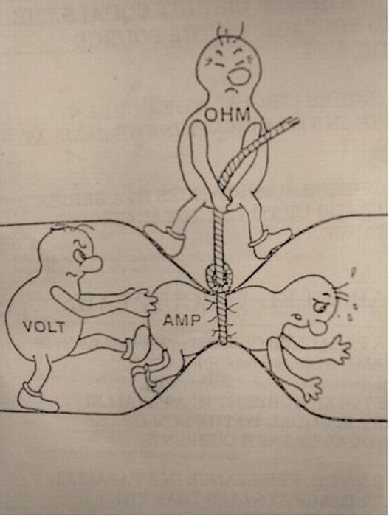

Experiment! Conducting Georg Ohm’s experiment.

Set up a simple series circuit with a labpack and a component called a resistor given out by your teacher. By varying the voltage using a labpack, measure the current through and the voltage across the component. Write your results in the table below.

Current (Amperes) | Voltage (Volts) | V / I

Now, in the third column, work out a value for the voltage divided by the current.
What do you notice about these results?

Plot V versus I. Use graph paper, pencil and a ruler, choose scales to make your graphs fit the page as large as practicable so you can plot your results as accurately as possible! Ask your teacher for help if you are stuck.

We find that we get a constant value (a straight line on our graphs) and we can write a relationship (an equation), which links V and I;

Potential difference (voltage) across a conductor | = current through conductor x a constant
V = I x R
We can re-write this as:

$$\text{R} \text{= }\frac{\text{V}}{\text{I}}$$

The constant, R, is known as the resistance of the conductor.
This is known as Ohm’s law after the famous Physicist, Georg Simon Ohm who discovered this relationship in 1826.

The units of resistance are named after him: Ohms
The symbol for resistance (Greek letter Omega) is Ω

We find that 1Ω = 1V/1A

All materials oppose current passing through them. Note that wires / components with low resistance are generally termed conductors; those with high R are generally termed insulators.

A resistor is an electrical component that opposes the flow of charge around the circuit.

Quick Knowledge Check!
Resistance is a measure of the opposition to the flow of current.

An ______________________ is used to measure resistance

Resistance is measured in _________

An _________________ in the resistance in a circuit leads to a ____________ in the current in the circuit.

It is important to note that not all conductors obey Ohm’s law. Those that do are called ohmic conductors and those that do not are called non-ohmic conductors. Let’s investigate a non-ohmic conductor…

Experiment! The relationship between temperature and resistance of a conductor.
Conduct the same experiment as before, except replace the resistor with a ray-box. Take various readings of voltage across the lamp and current through the lamp and plot a Voltage versus Current graph as before.

What do you notice about the graph this time?

We find that resistance can vary with temperature. As a higher potential difference is applied across the lamp a higher current flows and the filament in the lamp heats up. As the temperature increases this affects the resistance of the filament bulb.

If we look at a conducting wire the resistance depends on several factors:
- Length – the longer the wire, the greater the resistance
- Thickness – the larger the cross-sectional area of a wire the smaller its resistance:
- Material from which the wire is made (e.g. copper wires have low resistance and are used as connecting wires)

Worked examples:
Can you work out (using R = V/I) what the resistance is for the values given below?

1. V = 3V, I = 1A

2. V = 18V, I = 6A

3. V = 24V, I = 2A

4. V = 0.1V, I = 0.05A

5. V = 5.5V, I = 0.2A

Can you work out what the current is (using I = V/R) for the values given below?

6. R = 30Ω, V = 30V

7. R = 180Ω, V = 30V

8. R = 100Ω, V = 10V

9. R = 0.5Ω, V = 3V

10. R = 0.66Ω, V = 1.8V

Can you work out what the voltage is (using V = I x R) for the values given below?

11. R = 30Ω, I = 3A

12. R = 180Ω, I = 2A

13. R = 100Ω, I = 1A

14. R = 0.5Ω, I = 0.5A

15. R = 0.66Ω, I = 1.5A
Section 5. Practical electrical and electronic circuits

Learning intentions: We are going to review the measurement of current, voltage and resistance, using appropriate meters in complex circuits.
We are going to investigate the function and application of standard electrical and electronic components including cell, battery, lamp, switch, resistor, variable resistor, voltmeter, ammeter, LED, motor, microphone, loudspeaker, photo voltaic cell, fuse, diode, capacitor, thermistor, LDR, relay and transistor.
We will investigate current and voltage relationships in both series and parallel circuits and define rules for each.
We will investigate resistors and make use of an appropriate relationship to calculate the resistance of resistors in series and in parallel circuits and circuits with a combinations of series and parallel resistors

Current
Electrical current is a flow of negative charges called electrons. Electrons will flow through a conductor if there is a potential difference, i.e. if there is a power supply.

Electrical current is given the symbol I and is measured in Amperes (A).

Voltage
Think about a lamp connected to a battery. The battery changes chemical energy (from the materials inside it) into electrical energy. This electrical energy is carried by the charges (electrons) that move around the circuit and is given up as heat and light as they pass through the wire of the lamp.

The voltage supplied to a circuit is a measure of the electrical energy given to each electron in a circuit. When the supply voltage is increased, a larger current flows through the circuit.
Voltage is measured in Volts (V).

Investigate! Reviewing placement of ammeter, voltmeter and ohmmeter in circuits.

Using Ammeters and Voltmeters
We use an Ammeter to measure ___________ in Amperes.
We use a Voltmeter to measure ____________ in Volts.

When an ammeter is connected in a circuit to measure the current through a component, it is connected in series with the component. Remember, we have to ‘break’ the circuit to insert the ammeter.

An ideal ammeter has a zero resistance so that it does not does not affect the current, only measure it. However, real ammeters do have a small resistance, which should be as small as possible – much smaller than the resistance in the circuit.

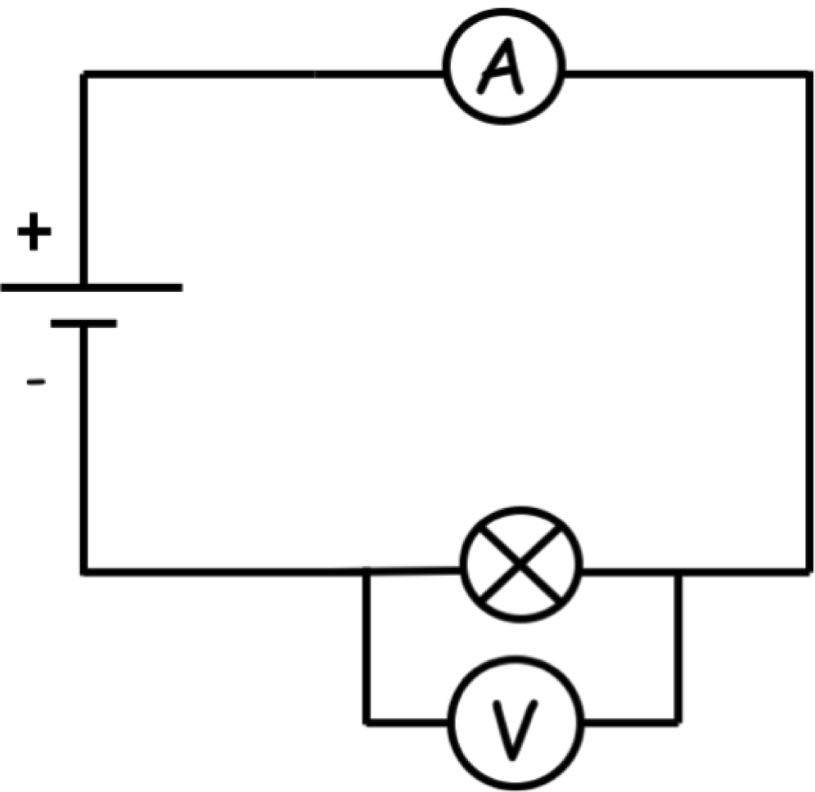

When a voltmeter is connected in a circuit to measure the voltage across a component, it is connected in parallel with the component. Remember, we do not break the circuit; we simply attach the voltmeter across the component we are measuring.

An ideal voltmeter should have such a high resistance that it would draw no current at all. The very high resistance electronic digital voltmeters approach this, using a negligible current. In practice, however, a voltmeter must draw some current; otherwise it wouldn’t work!

Reviewing series and parallel circuits.

Series Circuits  In a series circuit there is only one path for the current to flow. | Parallel Circuits  In a parallel circuit there is more than one path (called a branch) for the current to flow.
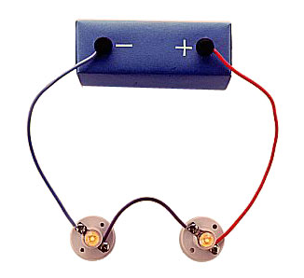 | 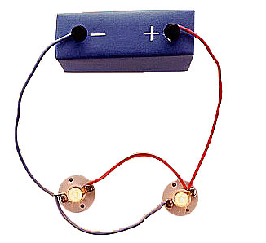

Circuit symbols
Electrical circuits are built by joining up components such as lamps, cells, motors and switches. It is useful to draw these circuits. To make this easier we use simple symbols to represent various components. These circuit symbols are the same all over the world.

See if you can remember what each of these symbols represent:

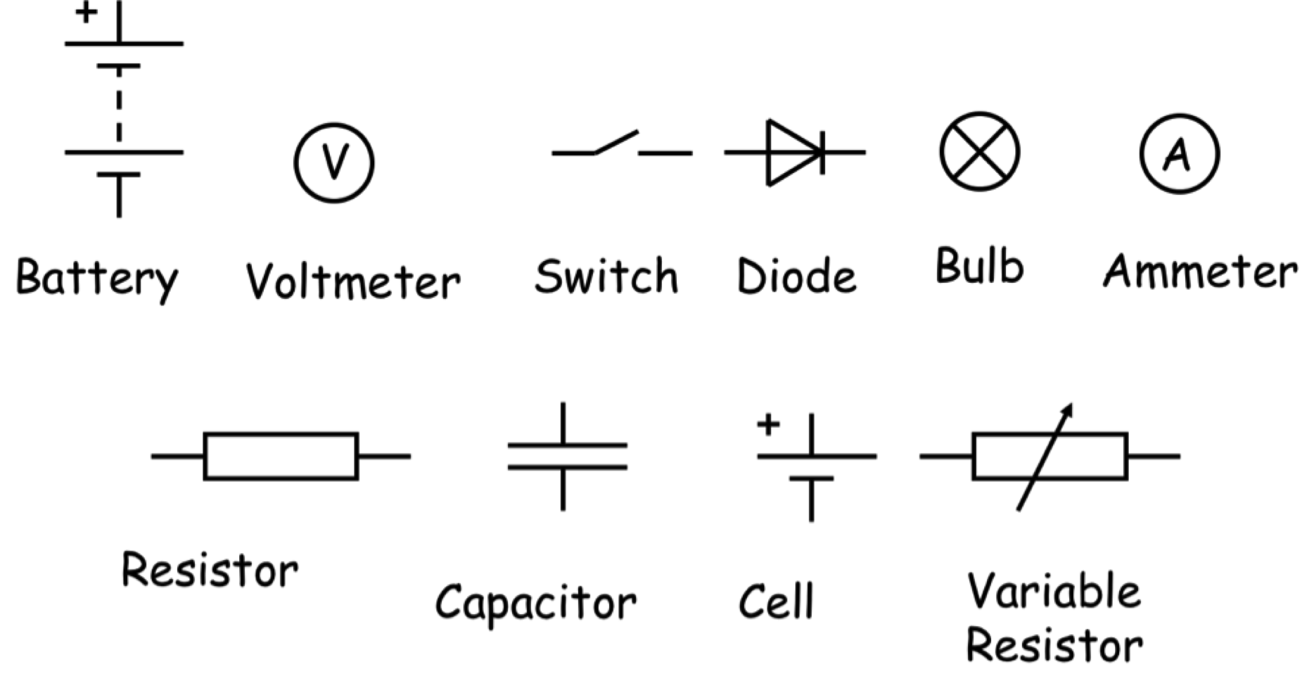
Draw in the circuit symbols for the components below:

LED  Motor  Microphone  Loudspeaker  Photovoltaic (solar) cell | Fuse  Thermistor  LDR  Relay  Transistor

Investigating series and parallel circuits.

Learning intention: We are going to investigate simple series and parallel circuits. We are going to work out the current and voltage rules for both a series circuit and a parallel circuit.

Electrical components, such as lamps, can be connected in series or parallel.

Series Circuits
Investigate! Build a simple series circuit using a cell and a lamp (shown below). Notice that there is only one electrical path from the negative terminal to the positive terminal of the battery.

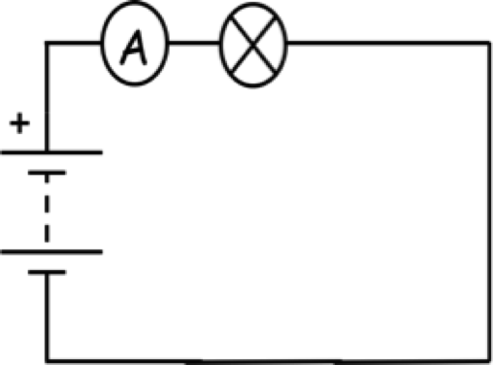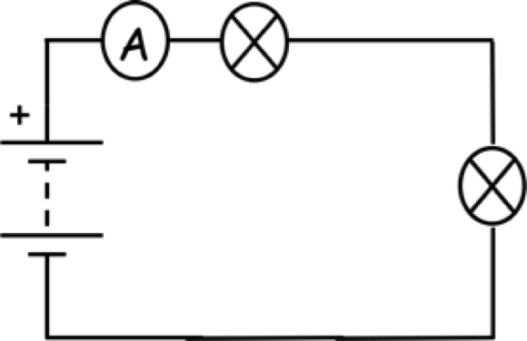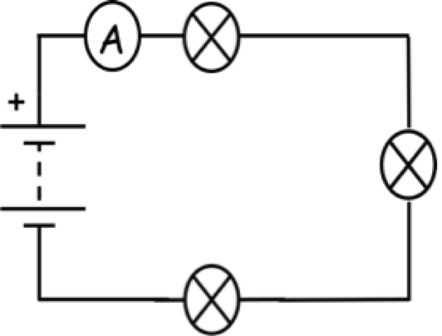

Measure the current through the circuit. Add in a second lamp and repeat the measurement. Add in a third lamp and repeat the measurement. Record your results in the table below.

What happens to the current reading?

Number of bulbs | Current (A)
1
2
3

What happens to the brightness of the bulbs?

Is there a link between the current and the brightness of the bulbs?

What happens if you unscrew one of the bulbs?

Get two resistors, measure the current at the three different positions shown and record your results in the table below.

Position 1 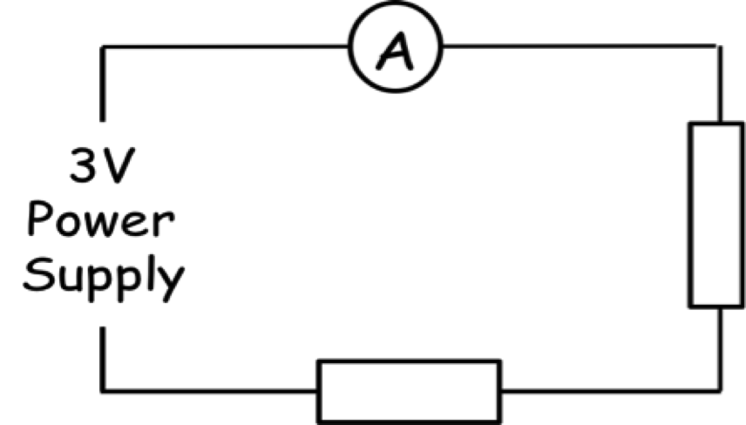
Position 2 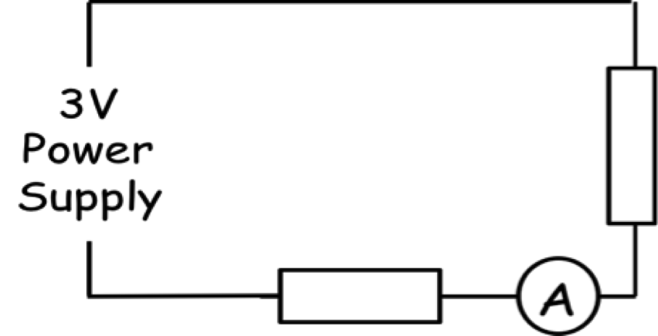
Position 3 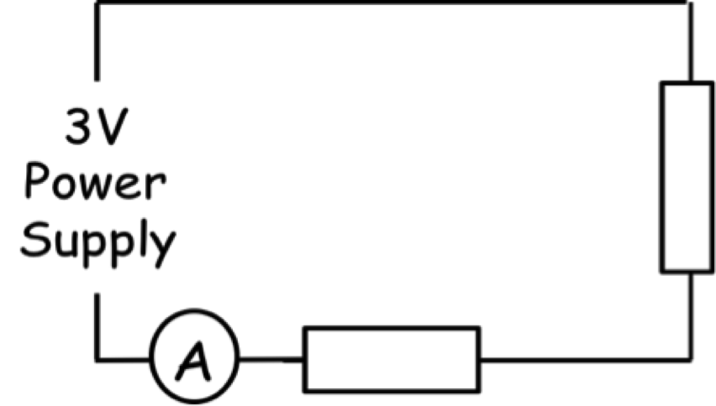

Position of Ammeter | Current (A)
1
2
3

What do you notice about the current at different points in the series circuit?

Now set up the following simple circuit and using a Voltmeter (or Multimeter) measure the voltage of the supply and the voltage across both resistors and record your results in the table below.

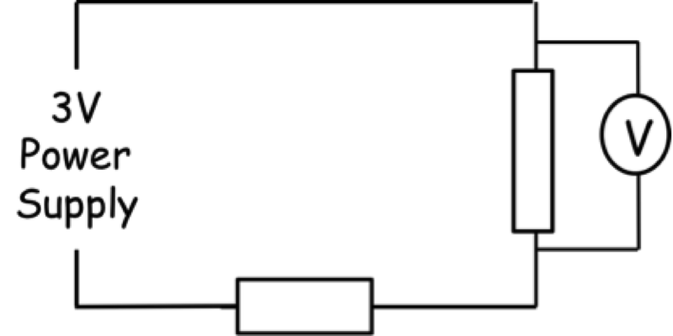

Component | Voltage (V)
Voltage of power supply
Voltage across resistor 1
Voltage across resistor 2

What do you notice about the voltage across the resistors and the power supply?

Can you think of a rule that describes what is happening to the Voltage in this circuit?

Parallel Circuits
Investigate!
Now set up the following circuits in turn and connect a bulb to the 3V power supply (lab pack), one at a time, as shown below.

Notice that there is more than one electrical path from the negative terminal to the positive terminal of the battery. These different paths are called branches.

Is there a significant change in the brightness of each bulb as more bulbs are added?

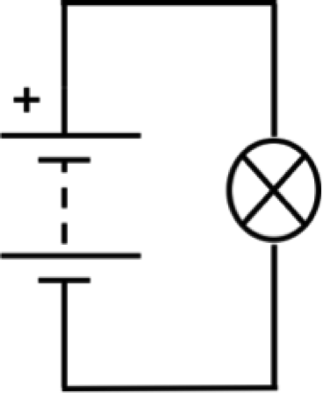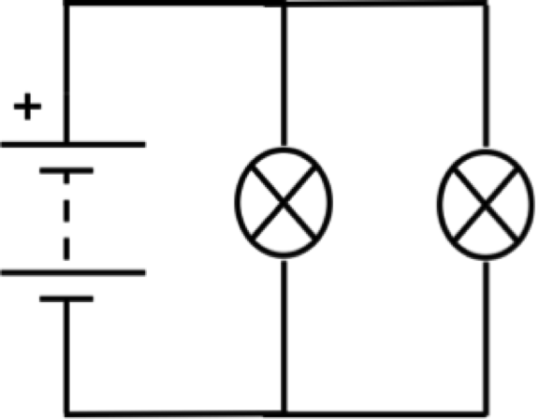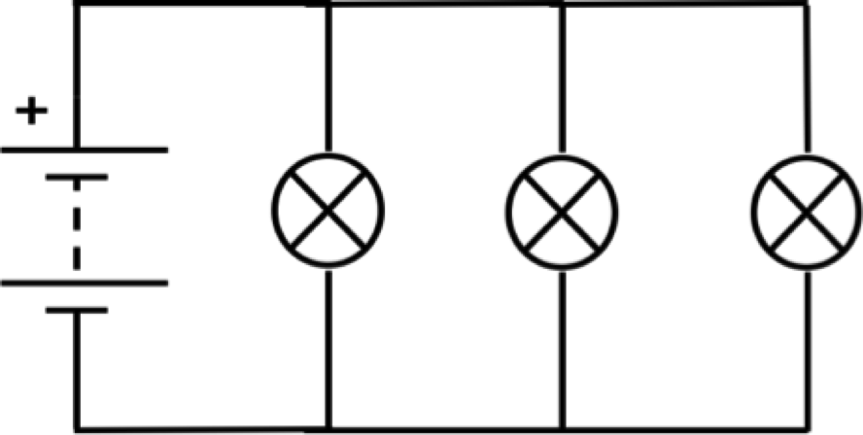

What happens if you unscrew one of the bulbs?

Put the bulb back in and note what happens – do this with the other two bulbs. What happens?

Measure the supply voltage, Vs, for the supply then measure the Voltage across each branch, V₁, V₂, V₃, etc. (i.e. each bulb). Write your results below…

What do you notice about the voltage values?

Now, using an ammeter, measure the current immediately from the power supply, I_{s}, and then in each of the individual branches, I₁, I₂, I₃ etc.. Write your results below…

What do you notice about the current values?

We can write the Series circuit rules as:
I_{s} = I₁ = I₂ = I₃ = I₄...

Where I_{s} is equal to the total current of the supply – in a series circuit, the current is the same at ALL points in the circuit.

V_{s} = V₁ + V₂ + V₃...

Where V_{s} is equal to the voltage of the supply – the Voltage of the supply is split across the different components in the circuit.

We can write the Parallel circuit rules as:

V_{s} = V₁ = V₂ = V₃ = V₄...

Where V_{s} is equal to the supply voltage – in a parallel circuit, the voltage is the same across all branches in the circuit.

I_{s} = I₁ + I₂ + I₃...

Where I_{s} is equal to the supply current – the supply current is split across the different branches in the circuit.

Standard electrical and electronic components

Cell 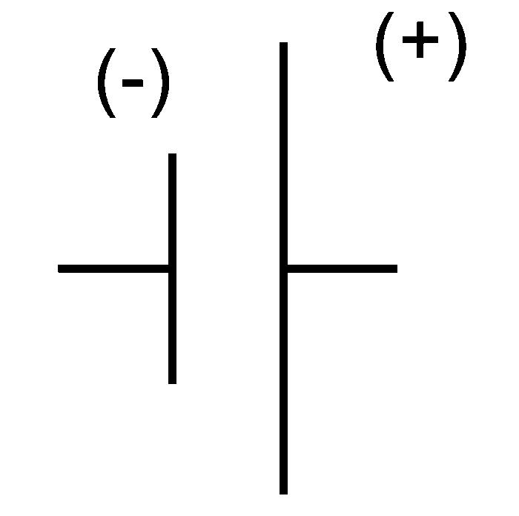
Converts chemical energy into electrical energy. Provides energy to electrons to move through a circuit.

Battery 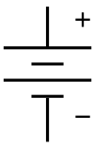
Two or more cells connected together (negative to positive) so that the potential difference (voltage) produced is greater.

Lamp 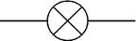
In a lamp, electrical energy is transformed into light and heat
In a filament lamp this takes place in a resistance wire

Switch 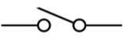
Switch allows you to open a circuit (as shown), which will turn the circuit (or that part of it) off. When the switch is closed, the circuit will function.
- When switch is open = ∞ (infinite) resistance
- When switch is closed = 0 (zero) resistance
- Is this an analogue or digital device?

Resistor 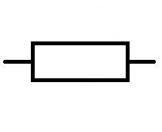
A resistor restricts the current flowing through a circuit. It changes the electrical energy into heat.

Variable resistor 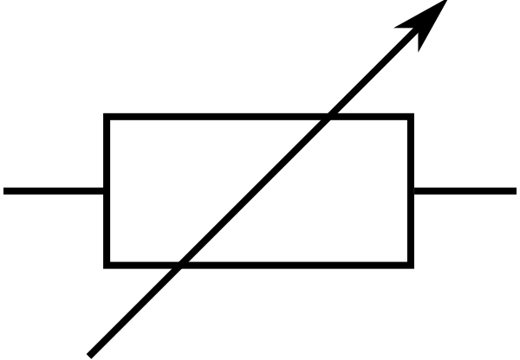
A variable resistor is a resistor whose resistance can be changed. The resistance is normally changed by altering the length of the wire in the resistor (the longer the wire, the higher the resistance). Variable resistors are often used a volume or brightness controls on televisions, hi-fi systems or dimmer switches for lights.
A variable resistor changes the value of resistance in a circuit.

Voltmeter 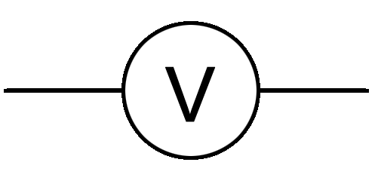
Voltmeters measure the potential difference (unit: Volt) across components.

Ammeter 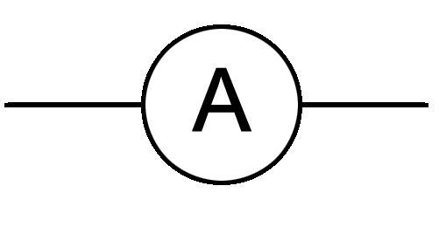
Ammeters measure the current through the circuit (unit: Amperes). They essentially ‘count’ the electrons as they pass through the ammeter.

LED: Light Emitting Diode 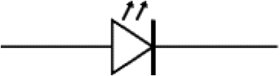

What are the differences between the lamp and the LED?
The LED does not light if the connections to the d.c. power supply are reversed. It requires only a small current to operate. It is a digital output device i.e. it is either on or off.
What are the advantages of the LED over a filament lamp?
The LED requires only a small current to operate. It does not get hot in operation.
- Why is it necessary to use a resistor in series with an LED?
- A LED will work only is connected to the power supply the right way round.
- In a circuit diagram, the arrow of the diode must be pointing towards the negative connection of the battery.

LEDs are commonly used in 7-segment displays, mobile phones and televisions.
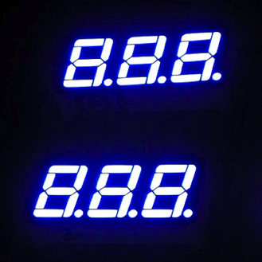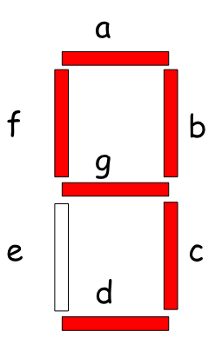

Motor 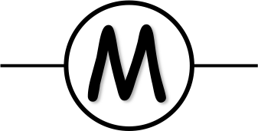
The electric motor converts electrical energy into kinetic energy. They can be found in many household appliances such as food mixers, DVD players, and washing machines. Increasing the voltage applied to a motor increases its speed, changing the polarity changes the direction of rotation.

Microphone 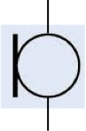
The microphone converts sound energy into an electrical signal.
Everyday uses of microphones?
Are these an analogue or digital device?

Loudspeaker 
The loudspeaker transforms electrical energy into sound energy.
This is an analogue device.

Photovoltaic (solar) cell 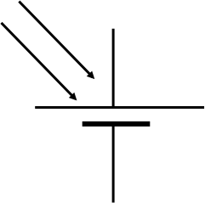
A solar cell converts light (solar) energy into electrical energy
As brighter light shines on the solar cell, what happens to the voltage output?
Where would you find these devices?
They are used not only on the roofs of buildings, but as power sources for satellites and calculators and as light meters on cameras!

Fuse 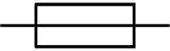
A fuse is a safety device. It is a sacrificial device, designed to break if too high a current for a circuit flows through it thereby preventing damage to other parts of the circuit.

Diode 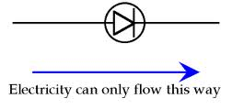
A diode is a semiconductor device that only allows current to flow one way through (called the diode’s forward direction) a circuit. It acts like a valve in a circuit and is often used to convert alternating current to direct current (a process called rectification).

Capacitor 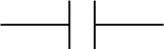
A capacitor stores electric charge on its plates.
As the charge increases, the voltage increases.
A capacitor takes time to charge up.
The capacitor acts as a time delay input.
Capacitance, C is measured in Farads, F.

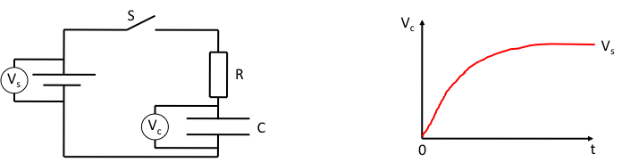

When switch S is closed, charge flows into the capacitor through the resistor R.
The voltage shown by the voltmeter will slowly increase.
When fully charged the voltage across the capacitor remains steady and is equal to the supply voltage.
The larger the value of R, the longer it takes to charge C.
The larger the value of C, the longer it takes to charge C.
In each case, the voltage will rise more slowly.

The product R x C is called the Time Constant of the circuit - the greater the value of RC, the greater the time taken to charge the capacitor.
By changing the value of R or C, the time taken for a voltage to build to a certain value can be altered. This type of circuit is used in timing such as: time delay circuit for pedestrian crossings, photo enlargers, and automatic doors.
By connecting one side of the capacitor directly to the other, the capacitor can be discharged quickly – this technique is often used to RESET a timing circuit.
A switch connected in parallel with the capacitor can also be used to discharge it (by closing the switch) – this is the reset switch in a timing circuit:

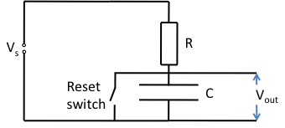
Thermistor 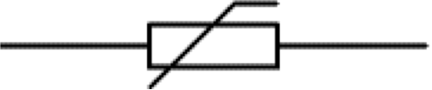
We find that heating a thermistor causes its resistance to decrease (the opposite of a resistor).
It must be connected in a circuit with a voltage supply.
Used in temperature measuring devices where, for example, a rise in temperature causes a drop in resistance and therefore a rise in current.
Is the thermistor analogue or digital?
We can use the acronym TURD to remember what happens to the resistance as temperature changes:
Temperature
Up
Resistance
Down

Thermocouple 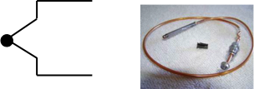
The thermocouple converts heat energy into an electrical signal.
The hotter the temperature, the higher the reading on the voltmeter.
The colder the temperature, the lower the reading on the voltmeter.
Can be used in devices to measure very large temperatures – e.g. furnaces in steelworks.
Output voltage is variable – the thermocouple is an analogue device.
Example: A thermocouple has a sensitivity of 40 micro Volts per degree Celsius: 40 µV / °C.
When placed in a beaker of hot water its output is 2000µV (2mV). If the room temperature is 21°C, what is the temperature of the water?
Solution: For every degree above room temperature the voltmeter reading increases by 0.00004 V
Temperature increase = 2000/40 x1 = 50°C
Water temperature = room temperature + 50°C =21 + 50 = 71°C

LDR: Light dependent resistor 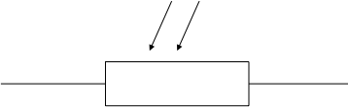
We find that increasing light intensity causes an LDR’s resistance to decrease.
It must be connected in a circuit with a voltage supply.
If the LDR is placed in the dark, its resistance will increase causing the current to fall.
Useful in circuits for automatic street / car lighting, burglar alarms, smoke detectors.
Is this device analogue or digital?
We can use the acronym, LURD, to remember what happens to the resistance as the light level changes:
Light
Up
Resistance
Down

Relay 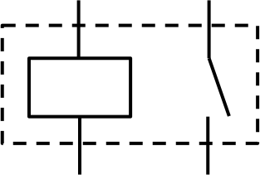
The relay switch is a magnetically operated switch
The relay switch is a switch operated by an electromagnet. It allows the safe switching of a circuit with a high current by closing a switch in a circuit with a low current.
When the switch in the circuit with the low voltage supply is closed, the current through the coil of wire creates a magnetic field. This closes the switch contact in the second circuit, completing the second circuit and allowing the high power circuit to operate.
Relays are used in cars to switch on and off various electronic components, e.g. starter motors and door locks. They are also found in switching apparatus in older telephone exchanges.

Transistor 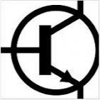
Experiment! Investigate the use of the transistor as a switch.
The transistor is made from p- and n- type semiconductor materials sandwiched together – n-type, p-type and n-type.

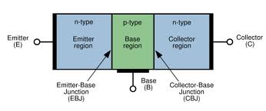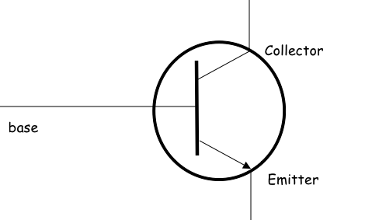

Current arises from the movement of electrons and vacancies called holes.
It is also possible to make a pnp transistor.

The transistor can be used as an electronic switch with no moving parts.
It is either conducting or non conducting i.e. on or off.
Is it a digital or an analogue device?
The transistor is a digital process device!
When the switch is ON, current flows between the emitter and the collector.
Whether the switch is on or off depends on the voltage across the base and emitter.
When the base-emitter voltage is less than 0.7 V then no current can flow and the switch is off.
When the base-emitter voltage reaches 0.7 V the switch is on and current flows between the emitter and the collector.
The transistor is a voltage-controlled switch.

Investigating resistance in series and parallel circuits

Experiment! Measure various resistances, using an Ohmmeter or a Multimeter on the resistance setting, individually and then together in series. What do you notice about these values?

Draw the circuit diagrams for each of these circuits and note your resistance readings below:

R₁ Ω | R₂ Ω | R₃ Ω | R_{total} Ω

Can you think of a rule to help you work out what total resistance would be when we link resistors together in series?

Experiment! Measure various resistances, using an Ohmmeter or a Multimeter on the resistance setting, individually and then together in parallel. What do you notice about these values?

Draw the circuit diagrams for each of these circuits and note your resistance readings below:

R₁ Ω | R₂ Ω | R₃ Ω | R_{total} Ω

Can you think of a rule to help you work out what total resistance would be when we link resistors together in parallel?

Resistor Laws

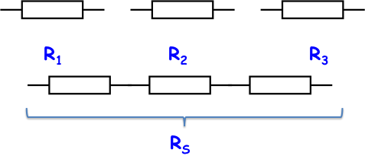

If we join components in series we increase the resistance of the circuit
The current will decrease
The total resistance in series is equal to the sum of the individual resistances:
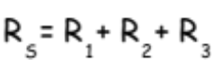

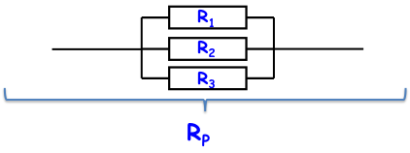
If we join components in parallel, we decrease the resistance of the circuit
The current will increase
The combined resistance in parallel is equal to:
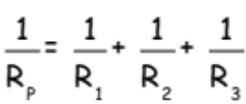

Worked examples:

In series:
R₁ Ω | R₂ Ω | R_{total} Ω
100 | 200
200 | 200
300 | 300

In parallel:
R₁ Ω | R₂ Ω | R_{total} Ω
100 | 200
200 | 200
300 | 300
100 | 200
100 | 300
200 | 300

Series and Parallel resistor combinations:
Combine the parallel resistances first, and then add together with those in series:

Worked example:

Work out the total resistance of the combination shown below:

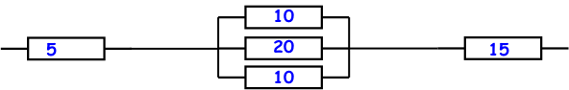

We work out the parallel resistance first:

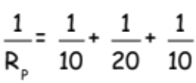
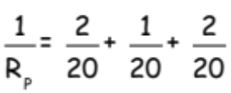

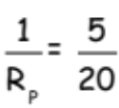

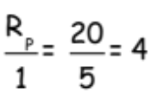

Now add the parallel combination to the resistors in series:

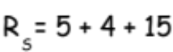

Therefore the total resistance is 24Ω.

Investigating practical series and parallel circuits.
Series circuits are often used in lighting circuits, continuity testers, old style Christmas lights: benefits (simple to construct) and drawbacks (one component fails, the whole circuit breaks).

Here are some examples of useful series circuits:

Stair lighting uses two or more 2-way switches in series:

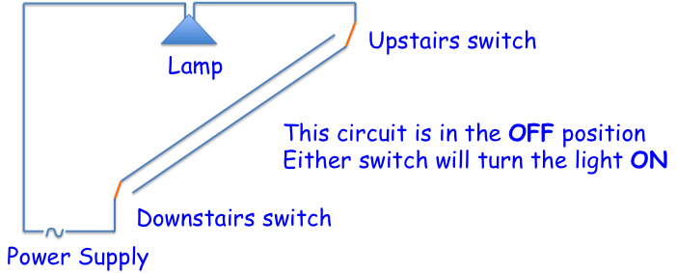

Continuity testers:
Simple conductors can be tested for continuity by trying to pass a current through them in series with some indicator device (bulb, buzzer, ammeter)
If there is a current, the series circuit is complete
If there is no current, there is a break in the circuit.
Never use a continuity tester with any equipment connected to the mains supply!!!

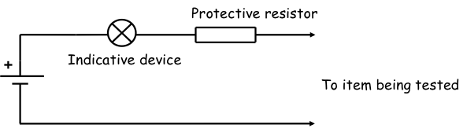

Parallel circuits are often used in new style Christmas lights, car lighting circuits, and household ring circuit: benefits (one component fails only that branch is broken) and drawbacks (more complex).

Car lighting circuit:
If one bulb blows, the rest of the lights must stay on
Sidelights should come on first and together; headlamps come on after side lamps
Car often uses the car chassis as a ‘return’ instead of wire
Positive is the live and the negative is attached to chassis for return

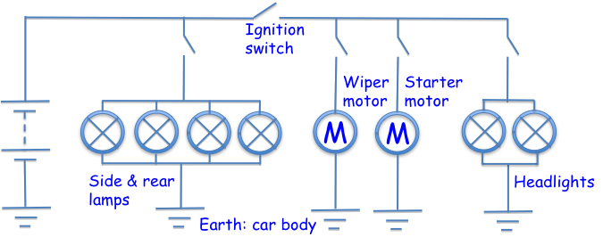

Homework: Research and discuss the benefits of a ring circuit (house power circuit) over a standard parallel circuit. Draw a diagram of a ring circuit below:

Electronic systems and Digital and Analogue signals.

What do electronic systems do? In their simplest form they respond to an input, process this information in some way and then provide a response (an output). We can draw a block diagram like this to represent any electronic system:

How many electronic systems can you think of? List 5 examples below:

1.

2.

3.

4.

5.

Input devices generally change some type of physical quantity (light, heat, sound, touch) into an electrical signal.
Process devices take these electrical signals and change them in some way.
Output devices turn this electrical signal into something that we can use or react to; for instance sound, light, heat, movement, etc.
There are two types of signals used by electronic systems: Analogue and Digital.

Analogue signals can have _________ value:

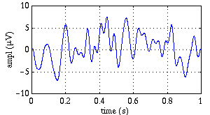

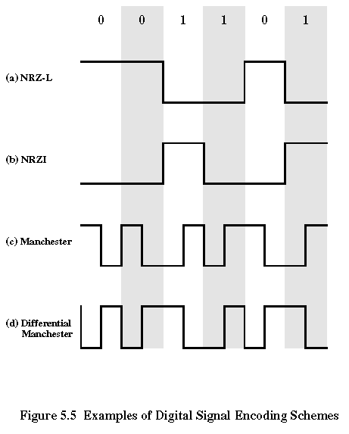
Digital signals can only have ___________ possible values:

These are:

Maximum (ON): called logic _______ or logic _________

Minimum (OFF): called logic _______ or logic _________

Digital versus Analogue signals:

Digital signals carry more ___________________ per second than analogue signals.

Digital signals maintain their _____________ over distances far better than analogue signals.
Looking at electronic components: Input Devices.

Investigate the input devices in the lab and then add circuit symbols and descriptions to the table below:

Name | Circuit symbol | Description
Switch

Microphone

Light dependent resistor (LDR)

Thermistor

Thermocouple

Capacitor

Movement sensor
(light gate)

Solar cell

Looking at electronic components: Output Devices.

In our last lesson we looked at input devices, today we are looking at output devices – they do essentially the opposite job!

Can you list 4 different output devices?

1.

2.

3.

4.

Investigate various output devices: lamp, LED, loudspeaker, buzzer, motor, solenoid, 8 segment displays.

Add circuit symbols and descriptions to the table below:

Name | Circuit symbol | Description
Lamp

Light Emitting Diode (LED)

Loudspeaker

Buzzer

Motor

Solenoid

7-segment display

Glossary:
Component – a part of an electrical circuit
Input device – something we use to send or control a signal to an electronic circuit
Output device – something we use to take some kind of information or signal from an electronic circuit
Parallel circuit – a circuit where components are connected so there is more than one path for the current to flow
Resistance – an electrical property of a material, a measure of its opposition to the flow of charges (current)
Resistor – a component with a measured resistance
Series circuit – a circuit where components are connected to make one path (a continuous loop) for the current to flow.

Section 6. Electrical Power

You may well have heard people talking about how much Power an electrical appliance uses.

We can define Power as: Energy used (E) per unit time (t)

We can write this as an equation: 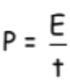

When we talk about electrical power we mean how much electrical energy is transferred every second. If the units of energy are measured in Joules and the time is measured in seconds, then we give the unit of Watts (W) for Power.

We can rearrange (change) the equation above to show that:

Energy used = Power x time
or
E = P x t

Worked Example:
How much electrical energy is converted into heat and light energy when a 60W bulb is turned on for 5 minutes?

E = P x t  = 60 x 300  = 18,000J or 18kJ | E = ?  P = 60W  t = 5 minutes = 5 x 60 = 300 seconds

Work out how much Power (using P = E/t) is used in Watts below:

1. E = 1000 Joules; t = 60 seconds

2. E = 1 Joule; t = 3 minutes

3. E = 180 Joules; t = 0.5 seconds

4. E = 3kJ; t = 10 seconds

5. E = 2.5 MJ; t = 1000 seconds

Work out how much energy (using E = P x t), is used in Joules below:

6. P = 240W; t = 60 seconds

7. P = 0.25W; t = 0.1 seconds

8. P = 37 kW; t = 370 seconds

9. P = 1.8MW; t = 30 minutes

10. P = 10mW; t = 5 seconds

Work out how long the energy change is (using t = E/P) in seconds below

11. E = 240J; P = 60W

12. E = 1000J; P = 10W

13. E = 50mJ; P = 50W

14. E = 38MJ; P = 1.9kW

15. E = 42kJ; P = 75W

A 12V, 24W lamp draws a current of 2A
A 12V, 36W lamp draws a current of 3A
The product VxI calculates the energy transformed each second:

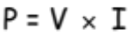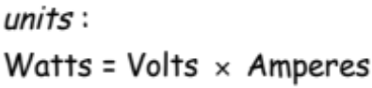

We can combine our equations for Power with Ohm’s Law – giving us 4 equations for power:

We know that P = I x V and we know that V = I x R.
We can then rewrite this as P = I x V = I x (I x R) so:
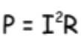

We know that V = I x R, so we can re-write this as I = V/R
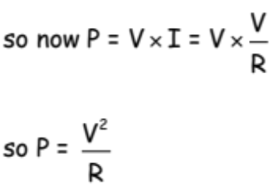

The Power Equations:

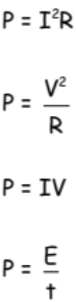 | 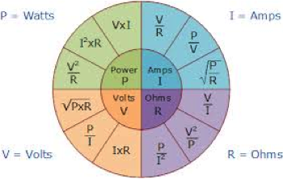

Worked example:
Calculate the current taken from the 230V mains supply by a 920W television:

Solution:
P = I x V  920 = I x 230  I = 4A | V = 230V  P = 920W  I = ?

Questions:
- A torch bulb takes a current of 0.25A when operated by a 3V battery. Calculate its power rating
- Calculate the total amount of electrical energy transformed into other forms of energy every second in a 10kΩ resistor when the current in it is 5mA.
- A car sidelight bulb is marked 5W, 12V. Calculate the resistance of its filament.
- A floodlight with a resistance of 92Ω is connected to a 230V mains supply. Calculate the current drawn from the mains supply.
- For how long must a 600W bulb be switched on to receive 2400J of electrical energy?
- What is the power rating of a hairdryer, which uses 64,000J of electrical energy in 2 minutes and 40 seconds?
- Howe much electrical energy will be supplied to a 1kW electric fire if it is switched on for 3 hours?
- If electricity is supplied to a school along a cable of total resistance 0.2Ω and the maximum current is 80A. What is the maximum power dissipated in the cable?
- What is the maximum current that should be passed through resistors marked in the following way, if they are not damaged by overheating?
  - 100Ω 1W
  - 64Ω 4W
  - 25kΩ 0.1W
- How much power should each of the following resistors be able to dissipate in order to carry the stated currents?
  - 1A 0.5Ω
  - 1mA 3Ω
  - 0.2A 75Ω
- A 1000W stage spotlight operates on a 250V supply. What current flows through the lamp and what is its resistance?
- How much energy must pass through a 12V heater each second to give a power input of 54W?
- A 240V motor drives a circular saw. Calculate the power when the saw runs freely and the current is 0.2A
- An electrical generator provides 90,000,000J of energy every minute to the mains supply. It works at a voltage of 40kV
  - Calculate the power of the generator
  - Calculate the resistance of the generator
  - Calculate the current through the generator
- A kettle has a resistance of 20Ω and a current passing through it of 12A
  - Calculate the power of the kettle
  - What voltage does it require?
  - How long will it take to produce 3MJ of energy?

Investigate! Measure and compare the power of various electrical devices.
Investigate the relationship between power and fuses for household appliances.
Investigate power loss using model power transmission lines.
Carry out a survey into household/educational establishment energy consumption.

Glossary
Watt: unit of Power named after James Watt (1736-1819)
Nanowatt, nW: 1x10⁻⁹: 0.000000001 Watts
Microwatt, μW: 1x10⁻⁶: 0.000001 Watts
Milliwatt, mW: 1x10⁻³: 0.001 Watts
Kilowatt, kW: 1x10³ = 1,000 Watts
Megawatt, MW: 1x10⁶ = 1,000,000 Watts
Gigawatt, GW: 1x10⁹ = 1,000,000,000 Watts
Terawatt, TW: 1x10¹² = 1,000,000,000,000 Watts

Section 7. Specific Heat Capacity

Learning intentions: We are going to learn that the same mass of different materials requires different quantities of heat to raise the temperature of unit mass by one degree Celsius.
We will learn that the temperature of a substance is a measure of the mean kinetic energy of its particles.
We will explain the connection between temperature and heat energy.
We will confidently use appropriate relationships to carry out calculations involving mass, heat energy, temperature change and specific heat capacity.
We will apply our knowledge of the conservation of energy to determine heat transfer.

We often talk about heat and temperature as if they were the same thing – they are not! In this section we will investigate the link between the two terms.

Heat is a name given to thermal energy. We would define heating as transferring thermal energy from one body at a high temperature to one at a lower temperature.

Temperature is a measure of the thermal energy of an object.

For example, consider an Olympic swimming pool at 27 degrees C and a kettle of boiling water (100 degrees C).
Which has the greatest amount of heat energy?

Which is the highest temperature?

What would happen if you accidently splashed boiling water on your hand?

Would the temperature of the swimming pool change dramatically if you poured in the full kettle of boiling water?

We can transfer thermal energy in three ways:
- Conduction
  - Hot particles vibrate more rapidly than colder ones. Vibrations are passed from particle to particle so the heat travels through the substance.
- Convection
  - A hot gas or liquid is less dense than a colder one, so the heated substance rises as the cold substance falls – this is a convection current.
- Radiation
  - Energy in the form of (infra-red) waves travels in all directions from a hot body. They do not need solid, liquid or gas to carry them and can travel through a vacuum. This is how the Sun heats our planet.

Heat (thermal energy) has the ability to change the temperature or the state of a substance

Heat is the (thermal) energy supplied

Investigate! Look at heating different masses of water, predict which would reach boiling point first and explain the reasons for your prediction.
Carry out experiments to compare the heat energy stored in different materials of the same mass when heated to the same temperature.

Consider an atom in a solid – what would happen to it if you gave it additional thermal energy? It would vibrate more and push further away from the atoms nearest to it – this is why solids expand when they are heated. The same is true in the liquid and gas states – if the atoms are given more energy they move about faster and faster. We find that:
Temperature is how hot an object becomes and is a measure of the mean kinetic energy of its particles.

From our experiments you will have found that the same mass of different materials requires different quantities of heat to raise the temperature of unit mass by one degree Celsius. From experience (i.e. boiling a kettle) we know that different masses take longer to heat up and that more energy is required to heat things up by a larger degree.

We can write these facts down:
The amount of heat energy required to raise the temperature of a substance:
- Varies with the change in temperature required (E ∝ Δt);
- Varies with the mass being heated (E ∝ m);
- Varies with the specific heat capacity of the material being heated (E ∝ c)

We call c the specific heat capacity – this is the amount of heat energy (in Joules) required to changes the temperature of 1kg of a substance by 1 degree C.
- This is also the energy 1kg of a substance can store for each degree.
- Water has a very high specific heat capacity: c = 4180 J/kg°C
- It takes a lot of heat to make water hot. Water can store a lot of heat.

Specific heat capacity can be calculated using the formula:

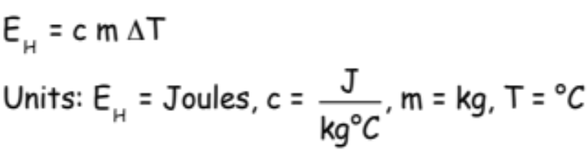

We can re-arrange this formula to give:

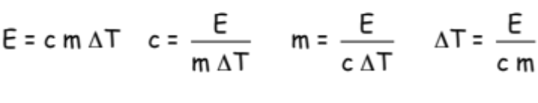

Quick check: Knowing what you do about heat, temperature and specific heat capacity can you explain why some foods seem much warmer on the tongue than others when cooked, e.g. tomatoes in a cheese and tomato toastie?

Worked example:
When a kettle containing 2kg of water (specific heat capacity 4200J/kg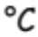) cools from 40 to 20 , calculate the heat energy given out by the water.

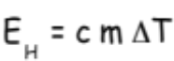  E_{H} = 4200 x 2 x 20  E_{H} = 168,000 or 168kJ | c = 4200 J/kg  m = 2kg  T₂ = 40  T₁ = 20  therefore 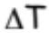 = T₂ – T₁ = 20  E_{H} = ?

We can apply our knowledge of the conservation of energy to heat problems. Remember, energy is neither created nor destroyed, it is just transferred from one form to another. The total amount of energy remains constant (equal) during energy transfers.

Worked Example:
A piece of brass of mass 2kg is dropped onto a hard surface without rebounding, resulting in a temperature rise of 1. Calculate the speed with which the brass hits the surface.

We are going to assume that all of the brass’ kinetic energy is changed on impact to heat (thermal energy) in the brass.

Therefore kinetic energy lost by the brass = Heat energy produced in the brass

$$\frac{\text{1}}{\text{2}}\text{m}{\text{v}}^{\text{2}} \text{=} \text{c} \text{m}\text{ ΔT}$$  we see that m can be deleted from both sides of the equation leaving:  $$\frac{\text{1}}{\text{2}}{\text{v}}^{\text{2 }}\text{=} \text{c}\text{ ΔT}$$  v² = 2 x 370 x 1  v² = 740  v = 27.2 m/s | m = 2kg  c = 370 J/kg  = 1  v = ?

Investigate!
Research clothing used for specialist jobs — fire fighter, NASA, outside environmental wear, etc.
Design a heating system for example heat pump, solar-heat traps, ground-storage systems, etc.
Design a central-heating boiler to be as ‘efficient’ as possible and to explain how they plan to reduce heat energy dissipation through the walls of the boiler.

Questions:
- 10,000J of heat energy raises the temperature of 1kg of liquid by 2°C. How much energy will be required to raise the temperature of 4kg of the liquid by 1°C?
- The specific heat capacity of concrete is about 800J/kg°C. How much heat is stored in a storage heater containing 50kg of concrete when it is heated up to 100°C?
- 1.344MJ of heat energy are used to heat water from 20°C to 100°C. Calculate the mass of water if the specific heat capacity of water is 4200J/kg°C.
- 9600J of heat energy is supplied to 1kg of methylated spirit in a polystyrene cup. Calculate the rise in temperature produced. Take the specific heat capacity of methylated spirit to be 2300 J/kg°C.
- When 2x10¹⁴J of heat is supplied to 4kg of paraffin at 10°C in a container, the temperature increases to 14°C.
  - Calculate the specific heat capacity of paraffin
  - Explain why the result in part a) is different to the theoretical value of 2200J/kg°C
- If a kettle containing 2kg of water cools from 40°C to 25°C, calculate the heat given out by the water.
- The temperature of a 0.8kg metal block is raised from 27°C to 77°C when 4200J of energy is supplied. Find the specific heat capacity of the metal.
- The tip of a soldering iron is made of copper with a mass of 30g. Calculate how much heat energy is required to heat the tip by 400°C given the specific heat capacity of copper is 380J/kg°C.
- If 200g of water at 40°C is mixed with 100g of water at 10°C and no energy is lost, what is the final temperature of the mixture? Specific heat capacity of water is 4200 J/kg°C.
- If an immersion heater heats 300g of water for 2 minutes and the temperature of water rises by 30°C, find the power rating of the heater in Watts.
- A 350W element is used to boil 300g of water in a cup, The initial temperature of the water is 20°C.
  - How long will it take to reach 100°C?
  - State any assumptions made
- Meteors are small pieces of matter made mostly of iron. Few meteors hit the surface of the Earth because of the Earth’s atmosphere. Assuming all of the kinetic energy of the meteor changes to heat energy in the meteor, if a 0.001kg meteor travelling at 30,000 m/s crashes into the Earth’s atmosphere resulting in a change in temperature of 20,000°C, calculate the specific heat capacity of iron.
- If a copper ball is dropped on a hard surface the ball is deformed, and we can assume all of the kinetic energy is transferred into internal heat energy in the ball. From what height must the ball be dropped to raise its temperature by 2°C. State any assumptions you make. Specific heat capacity of copper = 380J/kg°C.
- An electric shower has a 1.5kW heating element.
  - How much heat energy can it give out in five minutes?
  - If the element is used to heat 5kg of water for 5 minutes, what would the rise in temperature be?
- A 200g bun us put in a 600W microwave for one minute. If the temperature rises from 15°C to 45°C, what is the specific heat capacity of the bun?

Section 8. Gas laws and the kinetic model

Learning intentions:
We are going to learn that Pressure is the force per unit area exerted on a surface.
We will describe how the kinetic model accounts for the pressure of a gas.
We will confidently use an appropriate relationship to calculate pressure, force and area.
We will be able to explain the pressure-volume, pressure-temperature and volume-temperature laws qualitatively in terms of a kinetic model.
We will confidently use an appropriate relationship to calculate the volume, pressure and temperature of a fixed mass of gas.
We will investigate the relationship between Kelvin, degrees Celsius and absolute zero of temperature.

When we say something is under pressure, what do we mean? How could we increase the pressure on something? What does pressure depend on?
Would you rather an elephant stood on your foot or a lady in stiletto heels?

Experiment! Force and Pressure: determine the relationship between Force and Pressure using gas syringe and masses.

Pressure is the force per unit area, when the force acts normal (at right angles) to the surface
$$\text{Pressure} \text{= }\frac{\text{Force}}{\text{Area}}$$
i.e.
$$\text{p}\text{ = }\frac{\text{F}}{\text{A}}$$

Where Force, F, is measured in Newtons (N) and Area, A, is measured in m².

The units of pressure, p, are Nm⁻² or Pascals (Pa).

One Pascal is one Newton per square metre.
1 Nm⁻² = 1 Pa

Now, back to that elephant or stiletto – which would you rather stood on your foot?!!!

Let’s consider a balloon or a bicycle inner tube. How would you blow up the balloon or inflate the inner tube? Simple – put some air in it! But how does the air we put in expand the balloon / inflate the inner tube and create pressure?

We know that atoms in a solid vibrate but do not move around. In a liquid, atoms or molecules can tumble over each other but they only change their mean positions slowly (remember the diffusion experiments back in S1?). However, gas atoms or molecules have lots of energy – they are free to move around quickly over large distances. There is no pattern to their movement – we say it is random.

As gas atoms (or molecules) speed around, they crash off the walls of their container. As these atoms rebound off the walls, there is a change in their momentum.
Each atom exerts a small force on the walls of the container over a very short time. All of these small forces add up so that a large number of these collisions produce a total average force on the wall that is measurable.

If we assume that the atoms are moving equally in all directions, the force per unit area of wall will be the same over all the walls of the container. This force per unit area is pressure exerted by the gas and is equal in all directions.

Gas Pressure is the result of many millions of gas molecules colliding with a surface and exerting a force on a given area.

Experiment! Kinetic theory of gases. Study of Brownian motion in a smoke cell or microspheres.

Experiments!
We are going to look at 3 different experiments, which were used to define the gas laws.

1: Boyle’s Law:
Aim: to find the relationship between pressure and volume for a fixed mass of gas at a fixed (steady) temperature.

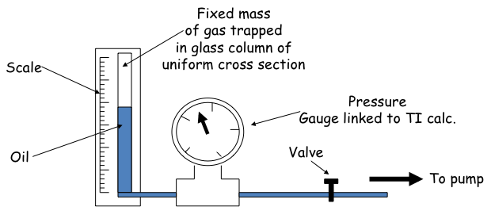

The pump is used to increase the pressure on the column of trapped air which makes the oil rise in the column, and the valve is used to seal the apparatus when the pressure is high.
The length of the trapped air column and the corresponding pressure are noted.
N.B. As the reading on the scale is ‘directly proportional’ to volume, the results can be recorded as length and pressure.
The pressure is altered using the valve, and values of length and corresponding pressure are noted for a range of values.
Graphs of pressure against volume and pressure against 1/volume are plotted, and a relationship obtained.

Results:
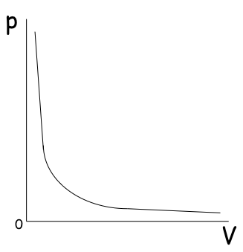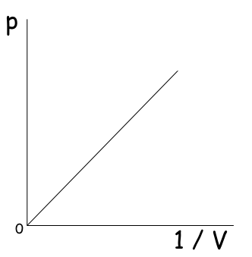

Conclusions:
The 2nd graph shows that pressure is directly proportional to 1/V.

p = constant x 1/V
pV = constant

p₁V₁ = p₂V₂ Boyle’s Law

The above law is only true for a constant temperature and a fixed mass of gas.

2: The Pressure Law:
Aim: to find a relationship between the pressure and temperature of a fixed mass of gas at a fixed volume.

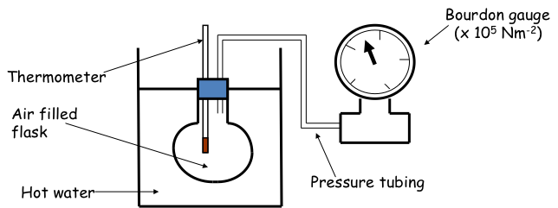

Boiling water was added to the beaker, and the temperature and corresponding pressure noted.
The flask was removed from the beaker and allowed to cool to room temperature.
As the air cooled, a set of corresponding values for temperature and pressure was obtained.
Graphs of pressure against temperature (ºC) and pressure against temperature (K) were plotted.

Results:

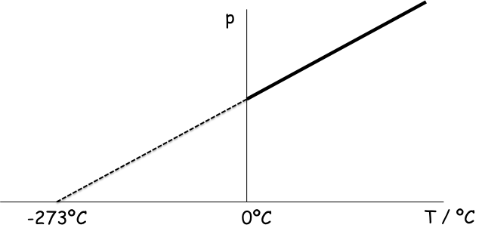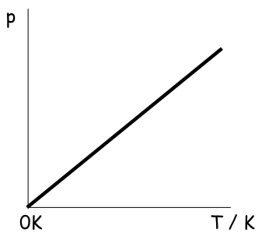

Looking at the graph on the left, we see that pressure is proportional to temperature (in ºC) since we have a straight line. However, it is not directly proportional to temperature (in ºC) since it does not pass through the origin.

If we convert our temperature measurements into a new unit of temperature, called the Kelvin, K (notice no º sign!), then the graph passes through the origin – see the graph on the right.

Conclusion:
Pressure is directly proportional to the temperature in Kelvin, as this is a straight line through the origin.
p / T = constant (where T is in K)

We can say then that for pressure p₁ at temperature T₁ and for pressure p₂ at temperature T₂ we have p₁ / T₁ is equal to a constant, then p₂ / T₂ is also equal to the same constant - this gives rise to the Pressure Law:

$$\frac{{\text{p}}_{\text{1}}}{{\text{T}}_{\text{1}}}\text{= }\frac{{\text{p}}_{\text{2}}}{{\text{T}}_{\text{2}}}$$

This is only true for a fixed volume, in this case provided by the rigid flask.

This law is also known as Gay-Lussac’s Law.

The Kelvin Temperature Scale

Temperature can be measured in degrees Celsius (ºC) and Kelvin (K).
They are related using the formula:
Kelvin temp. = Celsius temp. + 273
Celsius temp. = Kelvin temp. – 273
Note that a temperature difference of 1ºC is the same as a temperature difference of 1 K.
0K = -273ºC

At absolute zero, the particles do not move and have no kinetic energy, E_{k}. 0 Kelvin is the lowest possible temperature at which all matter has stopped moving. You cannot have negative values of temperature in Kelvin!

3: Charles’ Law

Aim: To find the relationship between volume and temperature of a fixed mass of gas at a fixed pressure.

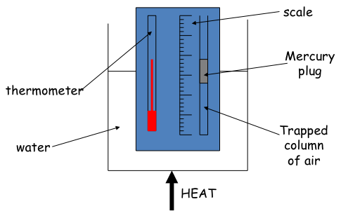

The apparatus was set up as shown, and the water was boiled.
Note that the mercury tube is open at one end to ensure that the experiment is completed at a fixed pressure.
The temperature and corresponding length of the trapped air column were noted.
The heat was removed and the apparatus allowed to cool.
As the column of air cooled, a set of corresponding values of temperature and length of trapped air column was obtained.
Note that volume is proportional to length, and so the length scale can be used for measuring volume.
The relationship between volume and temperature of a gas at a constant pressure was displayed graphically.

Results:

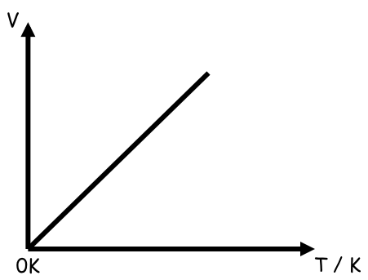
Conclusions:

Volume is directly proportional to Temperature (in Kelvin).
V / T = constant (T in K)

So we can say

$$\frac{{\text{V}}_{\text{1}}}{{\text{T}}_{\text{1}}}\text{= }\frac{{\text{V}}_{\text{2}}}{{\text{T}}_{\text{2}}}$$

This is Charles’ Law and it is only true for a fixed pressure, with a fixed mass of gas.

Note:
- In all gas law calculations where temperature is a variable, the temperature must be converted from ºC to K.
- The size of the degree Celsius and the Kelvin is exactly the same – i.e. a temperature change of 20 ºC will be equal to a temperature change of 20 K.
- Negative Kelvin temperatures do not exist!

The Ideal Gas Laws

If we now consider an ideal gas we can combine all of these laws together. An ideal gas is purely theoretical (i.e. it does not exist in nature). In such a gas, each particle is considered to be point-like and collides with adjacent particles elastically – this means both momentum and energy are conserved.

If we consider a situation where a gas exists at a standard temperature and pressure*
Then we can combine the three gas laws to formulate a simplified equation, called the ideal gas equation:

$$\frac{{\text{p}}_{\text{1}}{\text{V}}_{\text{1}}}{{\text{T}}_{\text{1}}}\text{= }\frac{{{\text{p}}_{\text{2}}\text{V}}_{\text{2}}}{{\text{T}}_{\text{2}}}$$

* the most common standards are:
International Union of Pure Applied Chemistry (T ≈ 273 K, p ≈ 0.986 atm)
National Institute of Standards & Technology (T ≈ 293 K, p ≈ 1 atm)

Worked example:
At what temperature will a litre of trapped gas have its volume doubled if it was at -20ºC?

Solution:

Using Charles’ Law we know that  $$\frac{{\text{V}}_{\text{1}}}{{\text{T}}_{\text{1}}}\text{= }\frac{{\text{V}}_{\text{2}}}{{\text{T}}_{\text{2}}}$$  $$\frac{\text{1}}{\text{253}}\text{= }\frac{\text{2}}{{\text{T}}_{\text{2}}}$$  T₂ = 506K  New temperature = 233ºC | V₁ = 1 litre  V₂ = 2 litres  T₁ = -20ºC = 253K  T₂ = ?

Remember: Temperature must always be in Kelvin.
Various pressure and volume units can be used in calculations provided they are not mixed in a single calculation – i.e. use the same units on each side of the equation!

Questions:
- A syringe has a piston with a cross-sectional area of 2 cm². The piston is pushed with a force of 12N. Calculate the pressure.
- A drawing pin has a sharp point with an area of 0.01mm². What is the pressure exerted by the point when the head is pushed with a force of 8N?
- In an experiment the temperature of a fixed mass of gas is kept constant. The pressure is altered and various readings of pressure and volume are taken. These are listed below. Plot a graph of pressure against volume. What is the relationship between pressure and volume?
Pressure (kPa) 101 116 122 135 180 210 250
Volume (cm3) 45 39 37 34 25 22 18
- A fixed mass of gas is kept at constant temperature but the pressure is increased from 1.01x10⁵ Pa to 3.00x10⁵ Pa. If the original volume was 0.2m³, determine the final volume.
- The pressure of a fixed mass of gas is 200kPa at 40ºC and the volume is 1.5m³. The temperature is increased to 100ºC but the volume remains the same. What is the new pressure?
- Explain why the use of large tyres helps to prevent a tractor from sinking into soft ground.
- If you want to rescue someone who has fallen through ice on a pond, would it be easier to walk or crawl across the ice towards him? Explain why.
- An elephant exerts a force of 5000N by pressing his foot on the ground. If the area of his foot is 0.02m², calculate the pressure exerted by his foot.
- A tank contains 1000kg of water. If the base of the tank has an area of 20m², calculate the pressure exerted by the water on the base.
- The pressure of air in a car tyre is 2.5x10⁵ Pa at a temperature of 27ºC. After a motorway journey the pressure has risen to 3.0x10⁵ Pa. Assuming the volume of air in the tyre has not changed,
  - Calculate the resulting temperature of air in the tyre
  - Explain the change in pressure in terms of the motion of air particles in the tyre.
- Change the following Celsius temperatures into Kelvin temperatures
  - -273ºC b. -150ºC c. 500ºC
- Change the following Kelvin temperatures into Celsius temperatures
  - 0K b. 272K c. 500K
- A weather balloon contains 100m3 of helium when atmospheric pressure is 90 kPa. If the atmospheric pressure changes to 100 kPa calculate the new volume of helium at the same temperature.

Explaining the Gas Laws using the Kinetic Model of Gases
The Pressure Law (p-T Law):

Consider a gas contained in a rigid container of volume V₁ at a pressure P₁ and Temperature T₁.
The temperature of the gas is now increased to T₂.
Increasing the temperature causes the particles to speed up and strike the walls harder and more often.
Since the walls cannot move, the pressure exerted on them by the gas particles increases.

Boyle’s Law (p-V Law):

Now consider a gas in a non-rigid container (e.g. a balloon) of volume V₁ at pressure P₁ and Temperature T₁.
The balloon is now compressed into a smaller volume V₂.

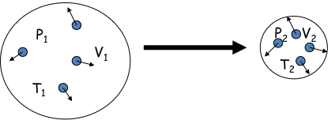

Reducing the volume of the balloon means that the particles take less time between collisions with the walls and strike the walls more often (but not harder).
This means that the pressure exerted on the walls by the gas particles increases.

Charles’ Law (V-T Law):

If temperature increases, the particles have more kinetic energy and their velocity increases.
The particles hit the container walls with more force but less often as the volume increases to keep pressure constant.
If the volume increases, the surface area also has to increase.
The pressure p is constant (p = F/A).
F increases and A increases

Investigate:
Research the role of Lord Kelvin and the determination of the absolute scale of temperature.
Research and discuss the limitations of the behaviour of real gases.

Glossary:
Compress – to squeeze together
Fluids – materials that can flow or move
Kinetic Theory – a way of describing the behaviour of gases
Pressure – Force applied over an area

______________________________________________________________

Feedback:
Don’t forget to review this course!

Please provide your feedback online on SurveyMonkey!

Access via the internal school website / surveys / Physics / S4

______________________________________________________________

Outcome and Assessment standards

Appendix 1: Assessment information for candidates
This section gives some information on the activities that you will undertake and the knowledge and skills that you will need to pass all of the Units in the Course. As you work through each Unit, the evidence that you gather should be checked by your assessor before being placed in your portfolio of evidence. This assessment applies to the following Units/Outcomes and Assessment Standards:

Unit title(s)
Physics: Electricity and Energy (National 5)
Physics: Waves and Radiation (National 5)
Physics: Dynamics and Space (National 5)

Outcomes and Assessment Standards

These are common to each of the Units.
Outcome 1
The candidate will:
1 Apply skills of scientific inquiry and draw on knowledge and understanding of the key areas of this Unit to carry out an experiment/practical investigation by:
1.3 Planning an experiment/practical investigation
1.4 Following procedures safely
1.3 Making and recording observations/measurements correctly
1.4 Presenting results in an appropriate format
1.5 Drawing valid conclusions
1.6 Evaluating experimental procedures

Outcome 2
The candidate will:
2 Draw on knowledge and understanding of the key areas of this Unit and apply scientific skills by:
2.1 Making accurate statements
2.2 Describing an application
2.3 Describing a physics issue in terms of the effect on the environment/society
2.4 Solving problems

To pass this assessment you will have to show that you have met these Outcomes and Assessment Standards.
Your assessor will let you know how the assessment will be carried out and any required conditions for doing it.
Evidence that you have met the Assessment Standards can be produced in a wide variety of ways and should be kept in your portfolio.
You might produce evidence during learning activities that shows you have met the Assessment Standards. Your assessor will look out for work you have done independently that shows you have met the Assessment Standards.
Alternatively, your assessor might give you instructions for an assessment activity or activities.
Your assessor will tell you what to do when you have produced evidence that you think meets the Assessment Standards. You might be asked to put it in your portfolio and record it. Your assessor will help you to do this and will check that your evidence does meet the Assessment Standards. Your assessor may ask you questions about your work, or ask you to do more work to show that you have met the Assessment Standards.
You might want to keep your own record of progress, using the table below.

