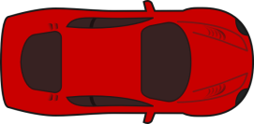


To
Be A Crash Test Investigator
Welcome to “Be A Road Crash Investigator”
Your Task is to determine the cause of a Road Traffic Accident. You must carefully use science techniques to collect the evidence to find out the cause of the accident, who was responsible, and were any traffic offences committed.
The Science Techniques you are to use are:
- Observation
- Hypothesising
- Recording/ Noting
- Measuring
- Calculating
- Concluding
- Evaluating
Observing
Look at the scene carefully; some of the details are very hard to see. Look at the big scene in front of you but also look for those tiny clues.
Hypothesising
From the scene, what are your first impressions of what occurred?
Recording
Record what you see, and any data that you collect during your measuring phase. You will need this as evidence in any court case so ensure you understand what you write and make sure all units are clearly given. This might include taking some photographs of the scene.
Measuring
Measure carefully and use any scale factors you will need. Look for tiny details too and record these.
Calculating
Use your measurements to calculate the distance it took the car to stop etc. and then find the speed of the car when the driver observed the accident.
Concluding
You should now be in a position to decide what exactly happened during the Road Traffic Accident and conclude if any traffic laws have been broken.
Evaluating
Finally you need to look over all your calculations, measurements, the scene etc and decide which measurements you are confident about and which might be interpreted differently. A defence lawyer will be picking up on things if you don’t so you will need to be well prepared.

But before you start you need to secure the scene, so that none of the evidence is damaged (compromised).
Welcome to “B
Be A Crash Test Investigator
RECORD SHEET
Name ___________________________________________ Class ___________
Group ________________________
- Initial Observations (on a separate sheet of paper include a diagram and mark on it your measurements. Do not forget to add your name at the top).

- Initial Hypothesis

- Measurements (include the scale factors). On the back of this sheet show your calculations.
Welcome to “B
Be A Crash Test Investigator
Welcome to “B
WITNESS STATEMENTS 2
D. Bell, (62yrs), 14 Jardine Way, Dumfries.
States;-
About 10.20pm on Saturday 2 November, I was walking along the pavement in Calder Place just at its junction with North Street, Dumfries.
I remember it was a cold dark night and it was raining heavily. Although it was dark there was street lighting on and you could see most things around you because of that.
I had just been to the pub and was heading home. I was on my own.
As I said I was walking along Calder Place and had just reached North Street. I saw a man come out of the Red Lion pub which is just on the opposite side of the junction from where I was walking.
He was wearing dark clothing and looked as if he had been drinking too much. He was staggering about on the pavement when I first saw him.
He immediately stepped off the pavement and on to Calder Place as if he was going to cross the road to the opposite side. I don’t think he looked to see if there was anything coming.
I saw a car approaching him from the west. It had its headlights on so he must have been able to see it but he just continued crossing. The car looked to me as if it was going quite slow and really the pedestrian should have stopped what he was doing and walked back onto the pavement where he came from. The thing is he did not he just continued. The car also continued on its way. I think the driver of the car must have thought that the guy would stop crossing but he didn’t. Then all I heard was a bang and saw the pedestrian being thrown into the air. The pedestrian landed on the ground on his back.
The car stopped but the guy who was driving it got out of the car and ran away down the street. He looked to be a fairly young chap. He was wearing jeans and a bright red coloured hoodie. He ran back in the direction he came from. He was running too fast for me to catch him. I can’t imagine why the driver ran away because I did not think he was doing anything wrong. He certainly did not seem to be speeding to me.
I ran over to the pedestrian and was joined by another car driver who had also seen the collision.
I did some first aid and the other guy phoned for the emergency services. I think the pedestrian was to blame for crossing the road when a car was coming.

Be A Crash Test Investigator
RECORD SHEET
Name ___________________________________________ Class ___________
Group ________________________
- Conclusions What do you think happened now that you ought to have all the evidence? Was a traffic offence committed?

- Evaluation Do you think that your evidence is reliable? Would you be able to argue your case in court?

Be A Crash Test Investigator
SCALING Expert Version
Obviously our scene is not full size. Everything about the scene is scaled down but you need to find out by how much. The best way to do this is to measure two identical parts, the real thing and the model. You can then work out a “scale factor”
Task
- Copy the table below.
- Transfer the figures from the diagram of the car into the table.
- Measure the equivalent values from the model.
- Record the model measurements in the table.
- Find the scale factor by dividing the real value by the scale model value.
- Record the scale factors in the table.
Here are the measurements of Mr McCondichie’s car.

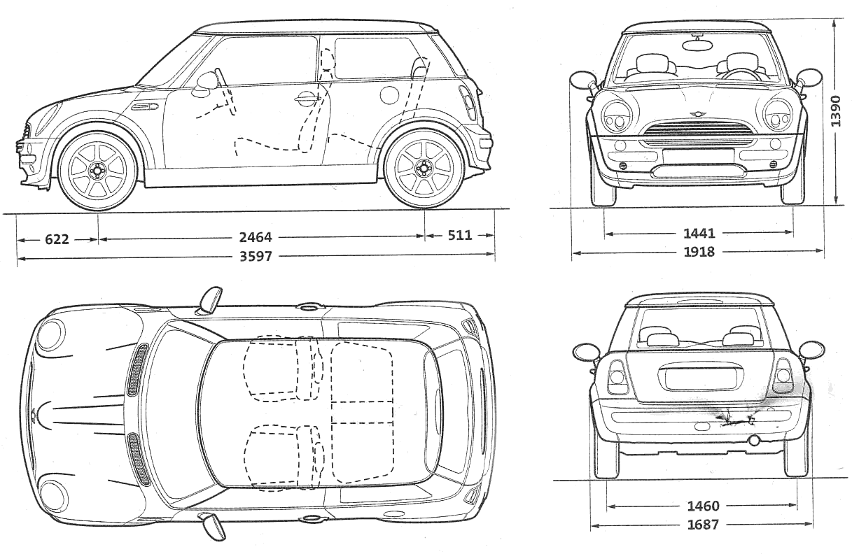

Dimension | Real Mini | Model Mini | Scale Factor  (real/model)

Welcome to “B
Be A Crash Test Investigator
SCALING –with help! Page 1
Obviously our scene is not full size. Everything about the scene is scaled down but you need to find out by how much. The best way to do this is to measure two identical parts, the real thing and the model. You can then work out a “scale factor”
Task
- Copy the table below.
- Transfer the figures from the diagram of the car into the table.
- Measure the equivalent values from the model.
- Record the model measurements in the table.
- Find the scale factor by dividing the real value by the scale model value.
- Record the scale factors in the table..
Here are the measurements of Mr McCondichie’s car

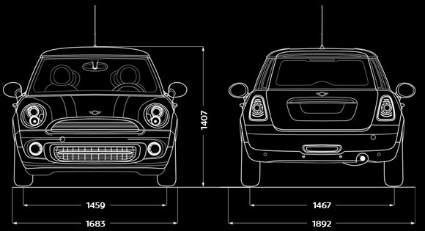

SCALING –with help! Page 2

Dimension | Real Mini  (mm) | Model Mini  (mm) | Scale Factor  (real/model)
Front Bumper to middle of wheel | 622 | 260
Back bumper to rear wheel | 511 | 225
Mid wheel to mid wheel | 2464 | 610
Total length | 3597 | 1100
Wheel to wheel widths (front) | 1441 | 530
Total width | 1918 | 685
Total height | 1390 | 545
Wheel to wheel widths (back) | 1460 | 535
 | 1683 | 545

Be A Crash Test Investigator
Be A Crash Test Investigator
Be A Crash Test Investigator
Welcome to “B
WITNESS STATEMENTS
Below are two witness statements. You will need to decide if their story is all true, or whether the witness got confused in some of the detail. It is (an offence IS IT) to give wrong information but we are very bad at recalling every detail
WITNESS STATEMENT 1
Jane Brabham, (23 yrs), 48 St Steven Street, Dumfries.
States; -
About 10.20pm on Saturday 2 November, 2012, I was driving my jeep motor car, Reg. mark ROY 50C west in Calder Place, Dumfries. I was alone in my vehicle and returning to my home address.
I remember that it was dark and raining heavily at the time of the crash, I had my headlights on and my wipers were going at full speed. The street lighting was on and general visibility was quite good.
I was driving west at about 30mph. About 100metres in front of me I saw a pedestrian who was dressed in black. He looked as if he had just come from the Red Lion pub in Calder Place. He was standing on the pavement on the opposite side of the road to me and I got the impression he was about to cross the road. He was staggering slightly.
At that time there was nothing coming from the east and so he stepped out into the road and started to cross the road from my right.
All of a sudden, out of nowhere, a car approached him at high speed. It had its headlights on so the driver must have been able to see him. The car was going in the opposite direction to me. It never seemed to slow down at all and just hit him and threw him high into the air. He did a kind of somersault and then landed on the road.
The other car stopped but the driver of it got out and ran away in the opposite direction from me. He was wearing jeans and a red hoodie. He looked to be in his late 20’s. I think I would recognise him again if I saw him.
I got out of my car immediately and did my best to give the guy first aid.
I phoned for the ambulance and Police and they arrived a short time later.
There were other people nearby who must have seen the same thing as I did.
I think the driver of the car was to blame as they were going far too fast for the road conditions that night.

Be A Crash Test Investigator
Calculations for the crash scene involving cars A and B (advanced version)
In all serious collisions where Collision investigation is carried out ‘Skid Testing’ is carried out to ascertain the coefficient of sliding friction between in this case the road surface and the tyres.
Skid Testing is carried out in ideal conditions using the actual vehicle involved in the collision, but more normally a similar vehicle (normally a Police ‘Panda’ car), due to the damage sustained to the vehicles involved.
Skid testing is then carried out using a vehicle fitted with a ‘Skidman’ (brand name) accelerometer. The test vehicle is driven at a speed of approximately 40mph in the same direction as that travelled by the collision vehicle and in the same road and weather conditions.
The test is then carried out and the driver applies the brakes fully and quickly (like an emergency stop) with a view to locking all 4 road wheels and bringing the vehicle to a stop. If the vehicle is fitted with an Anti Lock braking system then it is disabled prior to the skid test.
Two of these tests are carried out and if the results are within 10% of each other they are considered suitable for carrying forward for further calculations.
The lowest result is used for any subsequent calculations as this gives the lowest resultant speed for any calculations made. This is done in fairness to the driver involved.

Conservation of Linear Momentum
When two or more bodies act upon one another, their total momentum remains constant, providing no external forces are acting upon them.

Be A Crash Test Investigator
Calculations for the crash scene involving cars A and B (advanced version)

The ‘Skidman’ provides a deceleration figure in metres per second per second or ms⁻².
The results for this scenario are as follows:-
(1) -6.87ms⁻²
(2) -6.99ms⁻²
The other values that are required that are not on the plan drawing are as follows
Mass of Car A = 1200 kg
Mass of Car B = 1400 kg
The formula for the tyre skid marks is v² = u² +2as
Where v = final velocity (ms⁻¹)
u= initial or starting velocity (ms⁻¹)
a= acceleration (ms⁻²)
s =displacement

For our scene use a scale factor of 3:1 that is the real items would all be 3x bigger than the model
Be A Crash Test Investigator
Be A Crash Test Investigator
SCALE FACTORS
Converting between metres per second and miles per hour

Speed | Speed | Scale factor
(mph) | (m/s)
20 | 9.0
30 | 13.5
40 | 18.0
50 | 22.5
60 | 27.0
70 | 31.5

Be A Crash Test Investigator

Be A Crash Test Investigator
Be A Crash Test Investigator
Calculations for the crash scene involving car A and a pedestrian (easier version)
If a serious collision happens then the Collision investigators carry out ‘Skid Testing’ to find a value for the friction between sliding tyres and road surface.

Skid Testing . In ideal conditions a skid test would be carried out using the actual vehicle involved in the collision, but usually a similar vehicle (normally a Police ‘Panda’ car) is used. This is because the vehicle involved in the collision is usually badly damaged.
Skid testing is then carried out using a vehicle fitted with a ‘Skidman’ (brand name) accelerometer. The test vehicle is driven at a speed of approximately 40mph in the same direction as that travelled by the collision vehicle and in the same road and weather conditions.

The test is then carried out and the driver applies the brakes fully and quickly (like an emergency stop) with a view to locking all 4 road wheels and bringing the vehicle to a stop. If the vehicle is fitted with an Anti Lock braking system then it is disabled prior to the skid test.

Two of these tests are carried out and if the results are within 10% of each other they are considered suitable for carrying forward for further calculations.

The lowest result is used for any subsequent calculations as this gives the lowest resultant speed for any calculations made. This is done in fairness to the driver involved.

SCALING SHEET
Obviously we have had to scale our scene to fit in to the hall with the cars that we have, so that you will need to multiply up all of your measurements

 | Measured | Real | Scale factor
Length of car
Tyre tracks

Be A Crash Test Investigator
Calculations for the crash scene involving car A and a pedestrian (advanced version)
In all serious collisions where Collision investigation is carried out ‘Skid Testing’ is carried out to ascertain the coefficient of sliding friction between, in this case, the road surface and the tyres.

Skid Testing is carried out in ideal conditions using the actual vehicle involved in the collision, but more normally a similar vehicle (normally a Police ‘Panda’ car), due to the damage sustained to the vehicles involved.

Skid testing is then carried out using a vehicle fitted with a ‘Skidman’ (brand name) accelerometer. The test vehicle is driven at a speed of approximately 40mph in the same direction as that travelled by the collision vehicle and in the same road and weather conditions.

The test is then carried out and the driver applies the brakes fully and quickly (like an emergency stop) with a view to locking all 4 road wheels and bringing the vehicle to a stop. If the vehicle is fitted with an Anti Lock braking system then it is disabled prior to the skid test.

Two of these tests are carried out and if the results are within 10% of each other they are considered suitable for carrying forward for further calculations.

The lowest result is used for any subsequent calculations as this gives the lowest resultant speed for any calculations made. This is done in fairness to the driver involved.

Calculations for the crash scene involving car A and a pedestrian (with help)
The ‘Skidman’ provides a deceleration figure in metres per second per second or ms⁻².
The results for this scenario are as follows:
(1) -6.80 ms⁻² (2) -7.01 ms⁻²
Question 1 - What speed was the car traveling at when it started to skid?
To first calculate the velocity or speed of the car when it started to skid we use the formula v² = u² +2as.
Where
v = Final velocity = 0
u = Initial velocity = ?
a = acceleration = -6.80 ms⁻² (- figure due to it being a deceleration obtained from skid test results)
s = displacement = (total length of the tyre skid mark)

Question 2 - What speed was the car doing when it collided with the pedestrian?
To calculate the velocity or speed of the car when it collided with the pedestrian we use the same formula v² = u² +2as.
To find the point of collision with the pedestrian we have to measure from the centre of the front wheels back to where the skid mark deviates slightly indicating where the contact took place.
Where
v = Final velocity = 0
u = Initial velocity = ?
a = acceleration = -6.80 ms⁻² (- figure due to it being a deceleration obtained from skid test results)
s = displacement = (Length of skid mark after collision with pedestrian)

Question 3 - If the car had been travelling at the speed limit of 30mph would the car have still collided with the pedestrian?
Again using the same formula v² = u² +2as
Where
v = Final velocity = 0
u = Initial velocity = (30mph)
a = acceleration = -6.80 ms⁻² (- figure due to it being a deceleration obtained from skid test results)
s = displacement =
Be A Crash Test Investigator
SCALING SHEET
Obviously we have had to scale our scene to fit in to the hall with the cars that we have, so that you will need to multiply up all of your measurements

 | Measured | Real | Scale factor
Length of car
Tyre tracks

Be A Crash Test Investigator
Calculations for the crash scene involving car A and a pedestrian (advanced version)
The ‘Skidman’ provides a deceleration figure in metres per second per second or ms⁻².
The results for this scenario are as follows:
(1) -6.80 ms⁻² (2) -7.01 ms⁻²
Question 1 - What speed was the car traveling at when it started to skid?
To first calculate the velocity or speed of the car when it started to skid we use the formula v² = u² +2as.
Where
v = Final velocity = 0
u = Initial velocity = ?
a = acceleration = -6.80 ms⁻² (- figure due to it being a deceleration obtained from skid test results)
s = displacement = (total length of the tyre skid mark)

Question 2 - What speed was the car doing when it collided with the pedestrian?

Question 3 - If the car had been travelling at the speed limit of 30mph would the car have still collided with the pedestrian?

Be A Crash Test Investigator

PEDESTRIAN COLLISIONS
Direct frontal impacts are those in which the pedestrian is struck by any part of the front of the vehicle, other than the corners.
In this type of impact, the pedestrian is accelerated to close to the speed of the vehicle. The direction in which the pedestrian is projected depends on a variety of factors including:
- the point of impact on the vehicle
- the shape of the vehicle
- the pre-impact speed and direction of the pedestrian
- the speed of the vehicle.
Firstly, let's look at the case of an impact involving a car or light goods vehicle.
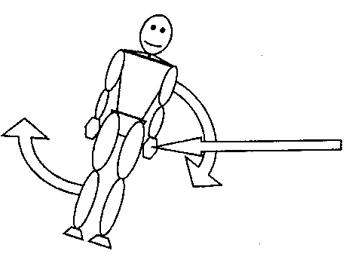
Pedestrians are not normally 'run over', but are 'run under'.
If the first point of contact with the vehicle is below the pedestrian's centre of gravity (usually about the navel), the body is thrown upwards and the vehicle passes under the pedestrian. Therefore it can be said that the pedestrian was 'run under'.

If however the initial contact strikes the pedestrian above their centre of gravity the pedestrian would be pushed downwards and would be 'run over' by the vehicle.
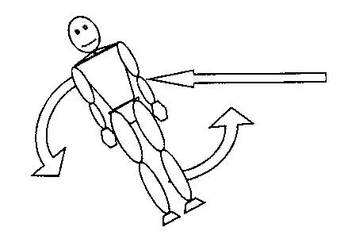
'Run over' situations are comparatively rare with cars and small vans unless the pedestrian is a child, small in stature, or is lying in the road before impact.

The final resting place of the casualty in respect to the vehicle can assist in determining whether or not there was braking at impact.

Page 1

Be A Crash Test Investigator

At impact, the pedestrian is accelerated up to the speed of the vehicle. If it wasn't, the vehicle would have to pass straight through the pedestrian – not the case. Should there be braking during the impact, and this is the most common situation, the pedestrian first matches velocity with the vehicle and then, as the vehicle slows at a higher rate than the pedestrian (the vehicle is subject to braking, the pedestrian is not), the pedestrian flies through the air in advance of the slowing vehicle before being brought to rest after striking the ground.

If, however, there is no braking during the collision, or braking does not occur until a very late stage, the pedestrian may pass over the top or down the side of the vehicle rather than being projected in front of it. Each of these separate contacts with the vehicle and ground may, and frequently do, cause injury.

The struck pedestrian finally comes to rest some distance from the point of impact and this distance is commonly known as the 'throw distance'. This distance has been found to be a function of the location of the pedestrian's initial contact with the vehicle, the impact speed of the vehicle and the vehicle deceleration during the time that the pedestrian is in contact with the vehicle.

Now let's examine the case of the vehicle being a lorry or a bus. Due to the shape of the vehicle, the pedestrian is most likely going to gain the full speed of the vehicle – there is no route for the pedestrian to be thrown off, other than in the direction of travel of the vehicle.

If the vehicle is undergoing braking, the pedestrian will be projected forward and will land some distance in front of the vehicle. If there is no braking, or insufficient braking, the vehicle will likely 'catch up' with the pedestrian who will probably be run over.

Page 2

Be A Crash Test Investigator

DAMAGE INDICATING PEDESTRIAN DIRECTION
The line of damage would not normally be as obvious as this, but could still indicate a possible direction of travel for the pedestrian, when added to other evidence such as injuries to the person or the resting position after the collision for example. 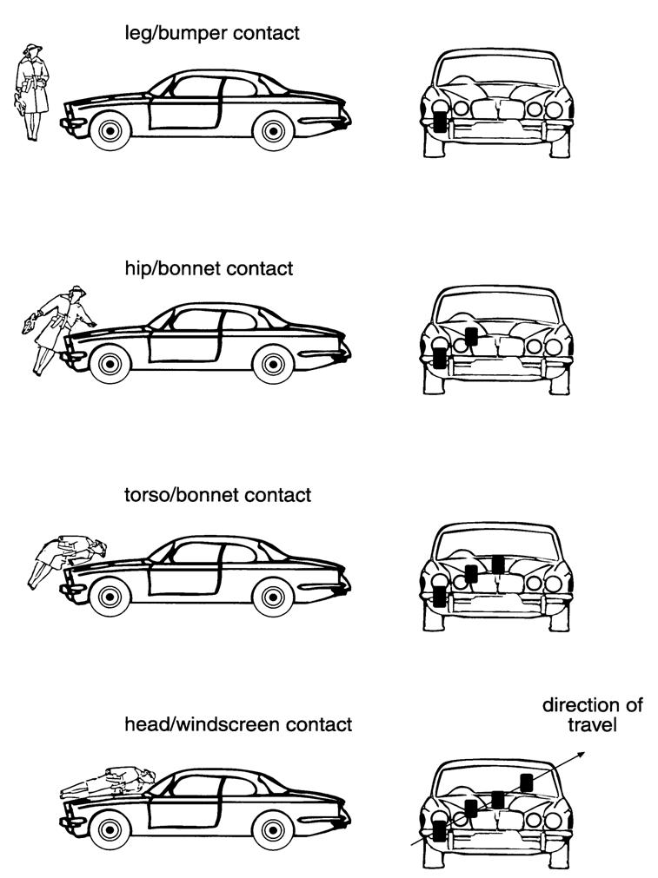

Be A Crash Test Investigator

STAGES OF BRAKING (NON ABS SYSTEM)

When the driver of a vehicle applies the brakes in an 'emergency' situation, the wheels, although under maximum braking effort, do not lock immediately. Hence tyre marks are not visible on the surface of the road in the initial stages. Braking under these conditions should be considered in four stages:-
- Driver's foot strikes the brake pedal and pressurises the braking system causing maximum braking effort to the rotating wheels. Peak braking efficiency is obtained, the speed of the vehicle begins to reduce without tyre marks being left on the road surface.

- Braking system is still pressurised and the vehicle continues to reduce speed. Maximum braking effort is maintained but the friction material in the brake linings brings the wheel to a state approaching 'lock-up'. Tyre marks are still not visible on the road surface at this stage.

- Braking system is still pressurised. The brake linings have succeeded in preventing the wheel from revolving. It is now locked and the tyre is sliding over the road surface. Due to the friction between the surfaces, heat begins to be generated which begins to melt the surface of the road resulting in 'shadow' marks being left on the road surface. Vehicle speed continues to decrease.

- Braking system is still pressurised and the wheel continues to be locked, sliding over the road surface.

The frictional temperature increases to a point, where depending on the composition of the road surface, bold, dark tyre marks will be left. As the vehicle continues to slide the speed will decrease and tyre marks will continue to be left until either the vehicle slides to a stop or the driver releases/reduces pressure on the brake pedal.

Page 1

STAGES OF BRAKING (NON ABS SYSTEM)(page 2)
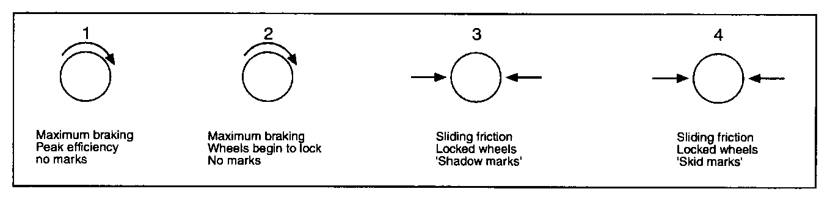
Be A Crash Test Investigator
The composition of the road surface will determine at which point the tyre marks become visible. For example some road surfaces have a high bitumen content. Bitumen has a relatively low melting point, considerably lower than that of tyre rubber compounds and therefore marks will be left earlier on a bituminous surface than on a concrete one.

The start of the tyre mark, in particular 'shadow' marks, can be difficult to establish. Therefore it is necessary to look closely at the road surface from various angles - on hands and knees if necessary - in order to determine the point at which they start.

In a collision scenario where a vehicle has skidded to a halt, and the start and finish of the tyre marks have been established by the Collision Investigator, any speed calculated from these marks will be a MINIMUM speed, as it is based solely on stages 3 and 4 of the 'Stages of Braking'.

The amount of speed lost by a vehicle in Stages 1 and 2 varies with the type and efficiency of the braking system and the type and condition of the road surface.

Page 2

