
2024
J. A. Hargreaves
Mrs Physics
February 2024


Higher

PARTICLES AND WAVES Part 1

CONTENT
CONTENT 2
CHAPTER 1: PARTICLES & WAVES BACKGROUND 5
Revision of Waves 5
Describing waves 5
Reflection 6
Refraction 7
Diffraction 7
Tutorial 1: Phase and Coherence 9
Coherent Sources 9
Interference of water waves 10
Revision of Atoms 10
Tutorial Answers 11
Phase and Coherence 11
CHAPTER 2: THE STANDARD MODEL 12
Summary of Content 12
The Standard Model 12
Orders of Magnitude 12
TASK-Powers of 10 graph 13
The Smallest Particles 15
Particle Physics 15
Particle Cosmology 15
The Standard Model of Particle Physics 15
What is the world made of? 15
Elements: the simplest chemicals 16
The periodic table – order out of chaos 16
The discovery of the electron 16
The structure of atoms 16
The Rutherford alpha scattering experiment 17
A Little Chemistry to update you 18
Experiment The Scattering Experiment 19
The Standard Model 22
The Particle Zoo 23
Fundamental particles 24
Quark Cupcakes A Delicious Way to Classify Particles 24
Forces and Bosons 27
Standard model summary 31
And what’s this Higgs Particle? 32
Classification of particles 32
Beta decay and the antineutrino 32
Research Activity 35
The standard model /Tutorials 35
Tutorial 1: Orders of magnitude 35
TUTORIAL 2 FUNDAMENTAL PARTICLES AND INTERACTIONS 36
Exam Questions 38
Tutorial Answers - STANDARD MODEL 40
Cupcake Crib sheet 40
Exam Questions 41
CHAPTER 3 FORCES ON CHARGED PARTICLES 42
Summary of Content 42
Electric Fields compared to Gravitational Fields. 42
Fields 43
Movement of charge in an electric field, p.d. and electrical energy 46
Comparison between gravitational and electrostatic potential energy 47
Definition of potential difference and the volt 48
Potential Gradients 49
Applications of electric fields 50
Charged Particles in Magnetic Fields 53
Moving charges create magnetic fields 54
Left Hand Grip Rule 54
Movement of a negative charge in a magnetic field 55
Tutorial 1- Movement in a Magnetic Field 60
Particle Accelerators 62
Introducing a new energy unit 64
Tutorial 2 Forces on charged particles 66
electric fields 66
Charged particles in a magnetic field 68
Particle Accelerators 69
Exam Questions 72
Forces on Charged Particle Tutorial Answers 75
Tutorial 1 – Motion in Fields 75
Tutorial Answers 76
EXAM PAPER ANSWERS 77
CHAPTER 4: NUCLEAR REACTIONS 79
SUMMARY OF CONTENT 79
Radioactive decay 80
Nuclear Radiation 81
α-particles 81
β-particles 81
γ radiation 82
Neutron 82
Equations for nuclear radiation 82
SUMMARY 83
NUCLEAR FISSION & FUSION 83
Fission 84
Containing the Fission Reaction 86
Fusion 86
Cookie Fusion 87
Nuclear fusion: energy of the future? 89
Nuclear Fusion Reactors 90
Tokamak 92
NUCLEAR REACTIONS/TUTORIAL 1 94
Tutorial 2 (SCET) Nuclear reactions 94
Fission and fusion 94
TUTORIAL 3 Exam Questions 96
Tutorial Answers: 99
Tutorial 1 Answers 99
Tutorial 2 Answers Fission and fusion 99
Tutorial Answers Nuclear reactions 100
Tutorial Answers Exam Questions 100

http://www.educationscotland.gov.uk/highersciences/physics/animation/hadrons.asp
NB It can make more sense to complete the following chapters in a different order.
Chapter 9 (Spectra) before Chapter 5 (Wave Particle Duality)
Chapter 7 (Refraction) is generally easier than Chapter 6 (Interference and Diffraction)

CHAPTER 1: PARTICLES & WAVES BACKGROUND

Revision of Waves

Describing waves
- All waves transfer energy away from their source.
- The amplitude A, is an indication of the energy of a wave.
- The amplitude of curved water waves decreases as they spread out, since the total energy of the wave is spread out over a larger wavefront.
- Frequency is the number of waves produced (or passing a point) per second. It is measured in Hertz (Hz)
- Period is the time for one wave. It is measured in seconds.

Example: Find the period of a wave with a frequency of 40 Hz.
Period T = = 0.025 s.
crest
trough
Zero position
time
-
+

The amplitude, A of a wave is the maximum displacement of a particle way from its zero position. Amplitude is measured in metres (m). The larger the amplitude the more energy the wave has.

The wavelength λ of the wave is the minimum distance in which the wave repeats itself. This equals the distance between two adjacent compressions in a longitudinal wave or the distance between two adjacent crests in a transverse wave. Wavelength is measured in metres (m).
The frequency, f of the wave is the number of wavelengths produced by its source each second or the number of wavelengths passing a point each second. It measured in hertz (Hz).

If N is the number of wavelengths passing a point in time t then frequency is given by:
And period
The period, T of a wave is the time it takes for one complete wavelength to be produced by a source or the time for one complete wavelength to pass a point. It is measured in seconds (s).
The speed v of the wave is the distance travelled by any part of the wave each second. It is measured in metres per second (m s⁻¹).
All waves exhibit four properties: reflection; refraction; diffraction and interference and polarization, although the test for a wave is interference.

FREQUENCY IS UNAFFECTED BY REFLECTION, REFRACTION etc. IT REMAINS THE SAME AS THE SOURCE PRODUCING IT.

Reflection
Speed, frequency and wavelength all stay the same on reflection.

Plane reflector
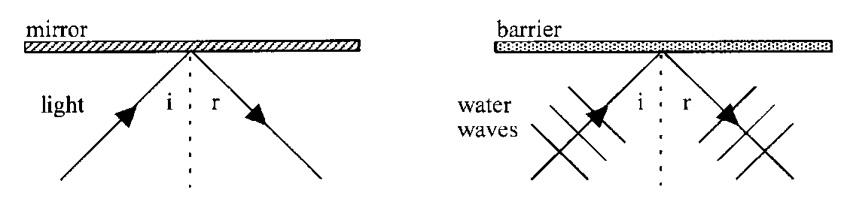

normal
angle of incidence
incident ray
angle of reflection
reflected ray
mirror

During reflection the angle of incidence always equals the angle of reflection.
angle of incidence  θi | =  = | angle of reflection  θr

Concave curved reflector
The law of reflection still applies

Refraction
When waves travel from one medium to another, they are refracted. This happens because the speed of the wave changes on entering the new medium. If the waves enter the medium at an angle to the normal, then their direction also changes. The greater the change in speed, the greater the change in direction. Never say that refraction causes bending.

A decrease in speed means the direction moves towards the normal, and vice versa.

The frequency of the wave never changes and is determined by the source. It can only be altered at source.

Diffraction
Diffraction is the bending of waves around obstacles or barriers.
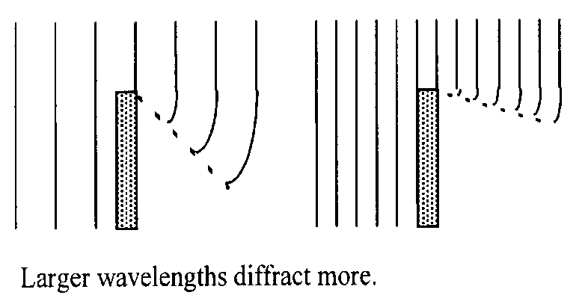
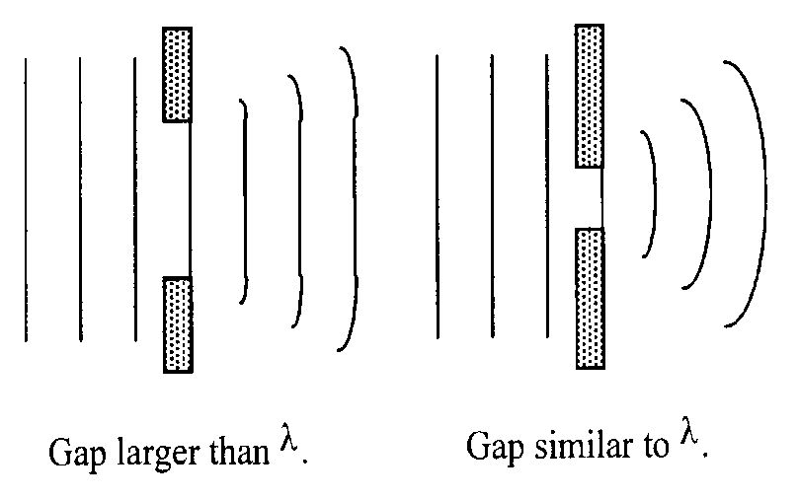
λ
λ

Draw the corresponding pattern of the waves as they pass around the barriers

Tutorial 1: Phase and Coherence

Phase
Two points on a wave that are vibrating in exactly the same way, at the same time, are said to be in phase, e.g. two crests, or two troughs.
IN PHASE ⇒ two sources with the same frequency and wavelength that have their maximum displacement at the same moment.

Two points that are vibrating in exactly the opposite way, at the same time, are said to be exactly out of phase, or 180º out of phase, e.g. a crest and a trough.

Out of phase ⇒ two sources with the same frequency and wavelength. One has a crest at a point where the other source has a trough (completely out of phase).
v
A
B
C
D
E
F
G
H

Points ___ & ___ or ___ & ___ are in phase.
Points ___ & ___ or ___ & ___ or ___ & ___ are exactly out of phase.
Points ___ & ___ or ___ & ___ or ___ & ___ are 90° out of phase.
Points ___ and ___ are at present stationary.
Points ___, ___ and ___ are at present rising.
Points ___, ___ and ___ are at present dropping.

Coherent Sources

Two sources that are oscillating with a constant phase relationship are said to be coherent. This means the two sources also have the same frequency. Interesting interference effects can be observed when waves with a similar amplitude and come from coherent sources meet.

COHERENT ⇒ coherent sources have:
- the same frequency
- constant phase relationship
- similar amplitude.

Interference of water waves
If two point sources produce two sets of circular waves, they will overlap and combine to produce an interference pattern.
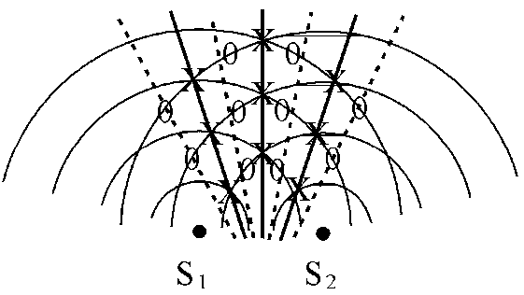 | The semi-circular lines represent crests; the troughs are between the crests.  S₁ and S₂ are coherent point sources, i.e. the waves are produced by the same vibrator.  X = point of constructive interference.  O = point of destructive interference.  ____ = line of constructive interference  ⁻ ⁻ ⁻ ⁻ = line of destructive interference.
The points of constructive interference form waves with larger amplitude and the points of destructive interference produce calm water.

The positions of constructive interference and destructive interference form alternate lines which spread out from between the sources. As you move across a line parallel to the sources, you will therefore encounter alternate large waves and calm water.
https://www.physicsclassroom.com/class/light/Lesson-3/The-Path-Difference

Revision of Atoms
An atom consists of a positive nucleus and outer electrons
The nucleus contains protons, which have a positive charge and neutrons, which are neutral
Neutron has zero charge
Electron has negative charge
Proton has positive charge

NOT TO SCALE

Remember -
- Electrons in outer shells, permanently moving
- Electrons = electrons, negative, distinct energy levels.
- Nucleus = protons and neutrons. Massive, neutrons no charge protons positive charge and hence positive nucleus. Protons and neutrons are made of quarks. Protons = uud, neutrons =ddu
- Most of the atom is empty space.
- In an atom the number of protons equals the number of electrons
- Most of the mass is concentrated in the nucleus (1 proton ≈ mass of 1 neutron ≈ mass of approximately 1850 electrons.
- Electrons stay in their orbits as they are bound by the positive nucleus (cf. us and the Earth).
- Energy must be added to remove an electron from the atom.
We say that zero energy is taken as being when the electron is outside the “field” of the atom. Therefore, electrons in the atom have negative energy because they are bound.

Tutorial Answers

Phase and Coherence

Points A & E, B & H are in phase
Points A& C, D & G, C&E are exactly out of phase
Points A& G, C & D, D & E, E & G are 90° out of phase
Points D & G are at present stationary
Points A, E and F are at present rising
Points B, C, & H are at present dropping

CHAPTER 2: THE STANDARD MODEL

Summary of Content

No | CONTENT
Standard Model
 | I know that the Standard Model is a model of fundamental particles and interactions.
 | I can describe the Standard Model in terms of types of particles and groups
 | I can use orders of magnitude and am aware of the range of orders of magnitude of length from the very small (sub-nuclear) to the very large (distance to furthest known celestial objects).
 | I know that evidence for the existence of quarks comes from high-energy collisions between electrons and nucleons, carried out in particle accelerators.
 | I know that in the Standard Model, every particle has an antiparticle.
 | I know that the production of energy in the annihilation of particles is evidence for the existence of antimatter
 | I know that beta decay was the first evidence for the neutrino.
 | I know the equation for β- decay above (β+ decay not required) ${}_{1}^{1}n→{}_{1}^{1}p+{}_{-1}^{0}{e+\overline{ν_{e}}}$
 | I know that fermions, the matter particles, consist of quarks (six types: up, down, strange, charm, top, bottom) and leptons (electron, muon and tau, together with their neutrinos).
 | I know that hadrons are composite particles made of quarks.
 | I know that baryons are made of three quarks.
 | I know that mesons are made of quark–antiquark pairs.
 | I know that the force-mediating particles are bosons: photons (electromagnetic force), W- and Z-bosons (weak force), and gluons (strong force).

The Standard Model

Orders of Magnitude

Physics is the most universal of all sciences. It ranges from the study of particle physics at the tiniest scales of around 10⁻¹⁸ m to the study of the universe itself at a scale of 10²⁹ m.

Often, to help us grasp a sense of scale, newspapers compare things to everyday objects: heights are measured in double decker buses, areas in football pitches etc. However, we do not experience the extremes of scale in everyday life so we use scientific notation to describe these. Powers of 10 are referred to as orders of magnitude, i.e. something a thousand times larger is three orders of magnitude bigger. The table below gives examples of distances covering 7 orders of magnitude from 1 metre to 10 million metres (10⁷ m).

1 m | Human scale – the average British person is 1.69 m tall
10 m | The height of a house
100 m | Length of the school car park /100 m running track
10³ m | Approximate distance between Lockerbie Academy and Tesco. The distance you could walk in 10 to 12 minutes
10⁴ m | Approximate distance between Lockerbie and Ecclefechan
10⁵ m | Approximate distance between Moffat and Glasgow
10⁶ m | North – South length of Great Britain mainland
10⁷ m | Diameter of Earth

As big as this jump is, you would need to repeat this expansion nearly four times more to get to the edge of the universe (at around 10²⁸ m) Similarly we would need to make this jump more than twice in a smaller direction to get to the smallest particles we have discovered so far. These magnitudes are generally outside our comprehension.
https://www.youtube.com/watch?v=0fKBhvDjuy0
https://www.youtube.com/watch?v=bhofN1xX6u0
https://www.youtube.com/watch?v=EMLPJqeW78Q
https://www.youtube.com/watch?v=AC7yFDb1zOA

TASK-Powers of 10 graph

In your groups on one sheet of flipchart paper make up your own Powers of 10 line going from the smallest known particle diameter to the size of the Universe.

These scales are shown in the following table.
Size | Powers of 10 | Examples
 | 10^{–18} m | Size of an electron/quark?
1 fm (femto) | 10^{–15} m | Size of a proton
 | 10^{–14} m | Atomic nucleus
1 pm (pico) | 10^{–12} m
1Å (Angstrom) | 10^{–10} m | Atom
1 nm (nano) | 10^{–9} m | Glucose molecule
 | 10^{–8} m | Size of DNA
 | 10^{–7} m | Wavelength of visible light. Size of a virus.
1 μm (micro) | 10^{–6} m | Diameter of cell mitochondria
 | 10^{–5} m | Red blood cell
 | 10^{–4} m | Width of a human hair. Grain of salt
1 mm (milli) | 10^{–3} m | Thickness of a credit card
1 cm (centi) | 10^{–2} m | Diameter of a pencil. Width of a pinkie finger!
 | 10^{–1} m | Diameter of a DVD
1 m | 10⁰ m | Height of door handle
 | 10¹ m | Width of a classroom
 | 10² m | Length of a football pitch
1 km (kilo) | 10³ m | Central span of the Forth Road Bridge
 | 10⁴ m | 10km race distance. Cruising altitude of an aeroplane
 | 10⁵ m | Height of the atmosphere
1 Mm (mega) | 10⁶ m | Length of Great Britain
 | 10⁷ m | Diameter of Earth Coastline of Great Britain
1 Gm (giga) | 10⁹ m | Moon’s orbit around the Earth, The farthest any person has travelled. The diameter of the Sun.
 | 10¹¹ m | Orbit of Venus around the Sun
1 Tm (tera) | 10¹² m | Orbit of Jupiter around the Sun
 | 10¹³ m | The heliosphere, edge of our solar system?
 | 10¹⁶ m | Light year. Distance to nearest star Proxima Centauri,
 | 10²¹ m | Diameter of our galaxy
 | 10²³ m | Distance to the Andromeda galaxy
 | 10²⁹ m | Distance to the edge of the observable universe

The Smallest Particles

Particle Physics
Particle physics is the study of the smallest particles of matter in the universe (called quarks* and leptons) and of the forces between them. It is carried out using huge machines that accelerate particles to close to the speed of light before smashing them together. By studying the debris from large numbers of such collisions physicists can learn about the particles and forces.
These same forces govern the behaviour of everything in the universe from the earliest times in the Big Bang. Thus there are strong links between particle physics and cosmology, currently two of the most fundamental and exciting areas of research in physics.

*Quarks https://www.youtube.com/watch?v=HVxBdMxgVX0
https://www.youtube.com/watch?v=WGWlT8SqXLM (above what you need!)

https://www.youtube.com/watch?v=39LVI5BGMdQ
good but no longer available

Particle Cosmology
Cosmology is the study of the origin of the universe. Particle cosmologists understand the development of the very early universe using knowledge gained from the collisions observed at particle accelerators. From an event recorded by a bubble chamber in 1970 to a finding the Higgs boson in the ATLAS detector in 2012, more discoveries are continuously being made.
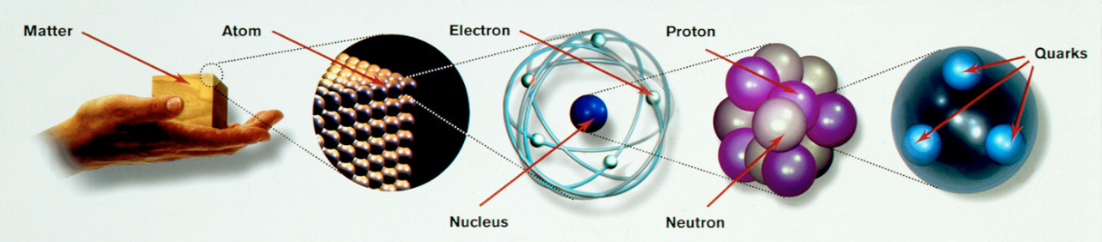
Courtesy CERN CERN-DI-9501005

Thomson (1897): Discovers electron
Rutherford (1909): Nuclear Atom (proton)
Chadwick (1932): Discovers neutron
SLAC (1968): Quarks in neutrons and protons

The Standard Model of Particle Physics
The current Standard Model of particle physics is constantly changing and being updated and improved as new experimental evidence is found.

What is the world made of?
The ancient Greeks believed the world was made of 4 elements (fire, air, earth and water). Democritus used the term ‘atom’, which means “indivisible” (cannot be divided) to describe the basic building blocks of life, so he got that wrong then! Other cultures including the Chinese and the Indians had similar concepts.

Elements: the simplest chemicals
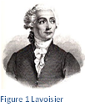
In 1789 the French chemist Lavoisier discovered through very precise measurement that the total mass in a chemical reaction stays the same. He defined an element as a material that could not be broken down further by chemical means, and classified many new elements and compounds. His work was so admired that at the age of 50 he was guillotined during the French Revolution for his aristocratic background.

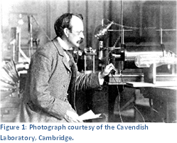
The periodic table – order out of chaos
In 1803 Dalton measured very precisely the proportion of elements in various materials and reactions. He discovered that they always occurred in small integer multiples. This is considered the start of modern atomic theory.
In 1869 Mendeleev noticed that certain properties of chemical elements repeat themselves periodically and he organised them into the first periodic table.

The discovery of the electron
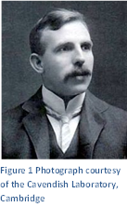
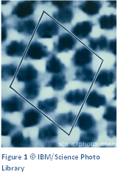
In 1897 J.J. Thomson discovered the electron and the concept of the atom as a single unit ended. This marked the birth of particle physics.
Although we cannot see atoms using light which has too large a wavelength, we can use an electron microscope. This fires a beam of electrons at the target and measures how they interact. By measuring the reflections and shadows, an image of individual atoms can be formed. We cannot actually see an atom using light, but we can create an image of one. The image shows a false-colour scanning tunnelling image of silicon.

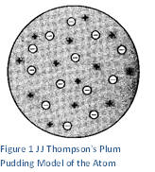
The structure of atoms
At the start of modern physics at the beginning of the 20th century, atoms were treated as semi-solid spheres with charge spread throughout them. J.J. Thompson’s model of the atom (1904) suggested that the positive charge was distributed evenly throughout the atom and the negative charges were fixed throughout; like fruit through a Christmas pudding, hence the model was known as the Plum Pudding Model.

This model fitted in well with experiments that had been done by then, but a new experiment by Ernest Rutherford in 1909 would soon change this. This was the first scattering experiment – an experiment to probe the structure of objects smaller than we can actually see by firing something at them and seeing how they deflect or reflect. According to the Plum Pudding Model, if charged particles were fired at the atoms you would only expect the charges to deflect slightly.

The Rutherford alpha scattering experiment
This experiment was actually done by Rutherford’s students Geiger and Marsden (1911). They fired alpha particles at a thin gold foil. This was carried out in a vacuum to avoid the alpha particles being absorbed by the air.
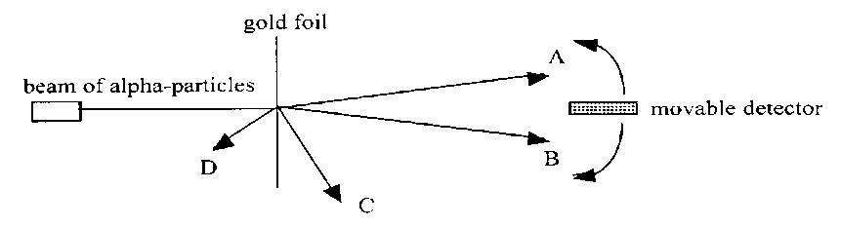
Figure 1: HSDU Material 2000

C large deflection
D
deflected back
no deflection
B small deflection
A small deflection
alpha particles

Results | Conclusion
most alpha particles went straight through the foil with little or no deflection detected between positions A and B.  a small fraction of the particles were scattered through very large angles e.g. to position C,  and a very small number were even deflected backwards, e.g. to position D. | The atoms contain more open space than explained by the plum-pudding model and was mainly open space. The foil, which was at least 100 atoms thick, suggesting the atom must be mostly empty space!  Strong forces are needed to achieve this (alpha particles were travelling at about 10 ⁶ m s ⁻¹).  This suggested a concentration of atomic charge. The alpha particles must be encountering something of very large mass and a positive charge.
1 : 8000
Relative sizes: a nucleus the size of a pea would result in the atom being the size of a football pitch (if drawn to the same scale).

The discovery of the neutron
Physicists realised that there must be another particle in the nucleus to stop the positive protons exploding apart, and to account for the additional mass scientists had determined was in atoms. This is the neutron which was discovered by Chadwick in 1932. This explained isotopes – elements with the same number of protons but different numbers of neutrons.

A Little Chemistry to update you
Each element, and hence the way it behaves, has a set number of protons, e.g. Hydrogen always has just 1 proton, and Carbon has 6 protons. In all atoms the number of protons in the nucleus is equal to the number of electrons surrounding the nucleus, (if not then the particle is an ion and not an atom).
The number of neutrons in the nucleus of any element can vary. We call these isotopes, e.g. carbon usually has 6 neutrons but can have 8. Larger atoms usually have many more isotopes.

We can represent each type of atom in the following way
where
A = mass number (no. of protons +neutrons) ie nucleons
Z = atomic number (no.of protons)
X = symbol to represent the atom, either 1 capital letter or one capital followed by 1 lower case letter.

You can work out the number of neutrons by subtracting the atomic number from the mass number
eg no. of neutrons = A-Z
PRACTICE
Name of the element using a Periodic Table, say how many protons, neutrons and electrons there are in each atom. Highlight the isotopes shown in the table (although most atoms have isotopes)

Symbol | Name | Protons | Neutrons | Electrons | Is there an isotope of the element in this table?
 |  | 1 | 0 | 1
 |  | 6 | 8 | 6
 |  | 6 | 6 | 6
 |  | 79 | 118 | 79
 |  | 92 | 143 | 92
 |  | 92 | 146 | 92
 |  | 88 | 132 | 88
 |  | 86 | 136 | 86
Science now had an elegant theory which explained the numerous elements using only three particles: the proton, neutron and electron. However this simplicity did not last long.

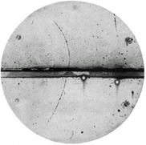
Matter and antimatter
In 1928, Paul Dirac found two solutions to the equations he was developing to describe electron interactions. The second solution was identical in every way apart from its charge, which was positive rather than negative. This was named the positron, and experimental proof of its existence came just four years later in 1932. (The positron is the only antiparticle with a special name – it means ‘positive electron’.)

The experimental proof for the positron came in the form of tracks left in a cloud chamber. The rather faint photograph on the right shows the first positron ever identified. The tracks of positrons were identical to those made by electrons but curved in the opposite direction. (You will learn more about cloud chambers and other particle detectors later in this unit.)
Figure 2 http://francis.naukas.com/2012/06/24/paul-a-m-dirac-y-el-descubrimiento-del-positron/

Almost everything we see in the universe appears to be made up of just ordinary protons, neutrons and electrons. However high-energy collisions revealed the existence of antimatter. Antimatter consists of particles that are identical to their counterparts in every way apart from charge, e.g. an antiproton has the same mass as a proton but a negative charge. It is believed that every particle of matter has a corresponding antiparticle.
The following Experiment is reproduced from the work from GUZLED- thank you.

Experiment The Scattering Experiment
Aim:
To recreate Rutherford’s experiment to develop a deeper understanding of the Rutherford model of the atom.
Theory
In 1911, Rutherford carried out an alpha particle scattering experiment, which prompted him to suggest a new model of the atom.
In this experiment his assistants fired alpha particles at a very thin gold foil and monitored the trajectories of alpha particles as they passed through. It was expected that most alpha particles would pass through without deflection, due to the “plum pudding” model of the atom which was accepted at the time.
Rutherford made the following observations:
- About 99% of the alpha particles pass straight through the foil, without deflection.
- Some of the alpha particles are deflected through small angles
- A very small number (1 in every 8000) of the alpha particles rebound off the gold foil and deflected by more than 90°.
Based on these observations, he made the following conclusions about the structure of the atom:
- Most of the atom is made up of free space, if most particles pass through undeflected.
- The nucleus of the atom is positive, if the positive alpha particles were deflected by repulsion.
- Most of the mass of the atom is concentrated in the very small nucleus, if the force of collision is enough to cause a rebound of the alpha particle.
Required Resources
- 12 x 100g Masses
- 2 x Metre sticks
- Small Ramp
- Small Ball Bearing
Experiment Procedure
Diagram
1. Set up the apparatus shown. This apparatus models the gold foil used in Rutherford’s scattering experiment. The 100g masses emulate the gold atom nuclei and it is only a few atoms thick.
2. The small ball bearing acts as the alpha particles being fired at the “gold foil”.
3. Roll the ball bearing towards the “gold foil”
4. Record, using a tally mark in the table below, the direction the ball bearing travelled.
5. Repeat this and launch the ball from different positions between the two metre sticks.
6. Take at least 100 readings to ensure a large enough sample size.
Data
Direction of Ball Bearing Number of Ball Bearings
Passes straight through, without deflection
Experiences deflection, to the left
Experiences deflection, to the right
Experiences complete rebound

Graph
Plot a pie chart (the only time allowed in this course) to represent the data

Conclusion
1. What conclusion can be made from the data?
2. Do these results match the conclusions made by Earnest Rutherford?

Evaluation
1. What could be changed about this scattering experiment to more closely emulate Rutherford’s experiment, using school laboratory equipment.

The Standard Model

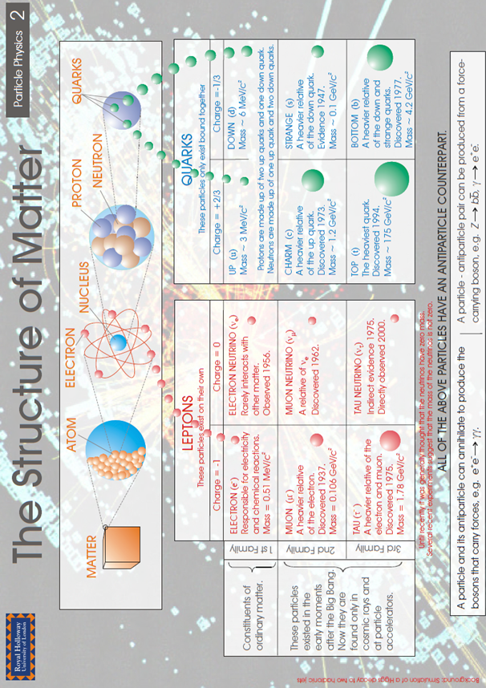

Annihilation
When a matter particle meets an anti-matter particle they annihilate, giving off energy. Often a pair of high energy photons (gamma rays) are produced but other particles can be created from the conversion of energy into mass (using E = mc²). Antimatter has featured in science fiction books and films such as Angels and Demons. It is also the way in which hospital PET (Positron Emission Tomography) scanners work (see later). By 2011 antimatter particles (antihydrogen) had been trapped and retained by CERN for sixteen minutes.

The Particle Zoo
The discovery of anti-matter was only the beginning. From the 1930s onwards the technology of particle accelerators greatly improved and nearly 200 more particles have been discovered. Colloquially this was known as the particle zoo, with more and more new species being discovered each year. A new theory was needed to explain and try to simplify what was going on. This theory is called the Standard Model.
http://www.particlezoo.net/
The standard model represents our best understanding of the fundamental nature of matter. It proposes 12 fundamental matter particles, fermions, organised in three generations. The first generation includes the electron, the neutrino and the two quarks that make up protons and neutrons, i.e. the normal matter of our universe. The other generations are only found in high-energy collisions in particle accelerators or in naturally occurring cosmic rays. Each has a charge of a fraction of the charge on an electron (1.60 × 10^{–19} C).

 | First generation | Second generation | Third generation
Quarks | up (⅔) | charm (⅔) | top (⅔)
Quarks | down (–⅓) | strange (–⅓) | bottom (–⅓)
Leptons | electron (–1) | muon (–1) | tau (–1)
Leptons | (electron) neutrino (0) | muon neutrino (0) | tau neutrino (0)

These particles also have other properties, such as spin, colour, quantum number and strangeness, which are not covered by this course.

Leptons
The term ‘lepton’ (light particle - from the Greek, leptos) was proposed in 1948 to describe particles with similarities to electrons and neutrinos. It was later found that some of the second and third generation leptons were significantly heavier, some even heavier than protons.

Quarks
In 1964 Murray Gell-Mann proposed that protons and neutrons consisted of three smaller particles which he called ‘quarks’ (named after a word in James Joyce’s book Finnegan’s Wake). Quarks have never been observed on their own, only in groups of two or three, called ‘hadrons’.
There are 6 types of quarks in three generations

Hadrons
Particles which are made up of quarks are called hadrons (heavy particle – from the Greek, hadros).
There are two different types of hadron, called baryons and mesons which depend on how many quarks make up the particle.
Baryons are made up of 3 quarks. Examples include the proton and the neutron.
The charge of the proton (and the neutral charge of the neutron) arise out of the fractional charges of their inner quarks. This is worked out as follows:

A proton consists of 2 up quarks and a down quark. Total charge=+1 ($\frac{2}{3}+\frac{2}{3}+-\frac{1 }{3 }$ = 1).
A neutron is made up of 1 up quark and 2 down quarks. No charge ($\frac{2}{3}+-\frac{1}{3} + - \frac{1}{3}$ = 0).

Mesons are made up of 2 quarks. They always consist of a quark and an anti-quark pair.
An example of a meson is a negative pion (π– = ū d). It is made up of an anti-up quark and a down quark: This gives it a charge of $-\frac{2}{3}+-\frac{1}{3}$ = -1.

Note: A bar above a quark represents an antiquark e.g. ū is the anti-up quark (this is not the same as the down quark.) The negative pion only has a lifetime of around 2.6 x 10⁻⁸ s

Fundamental particles
The 6 types of quarks and 6 leptons are all believed to be fundamental particles. That is physicists believe that they are not made out of even smaller particles. It is possible that future experiments may prove this statement to be wrong, just as early 20th Century scientists thought that the proton was a fundamental particle.

Quark Cupcakes A Delicious Way to Classify Particles

The following activity was produced by GUZLED

Required Resources
- Cupcakes -
- Coloured sweets - (e.g. m&m’s or Smarties)
- Table of quark, baryon and meson properties

Feast your eyes on the array of cupcakes! Each colour of sweet represents a diﬀerent type of quark, u , d, s, ū, $\overline{d}$ and $\overline{s.}$

 | Colour | Corresponding Quark
 | Yellow | Up
 | Red | Down
 | Green | Strange
 | Orange | Anti-Up
 | Blue | Anti-Down
 | Brown | Anti-Strange

Instructions

- Your teacher will provide you cupcakes and a hadron (mesons or baryon) to model.
- Use the table and specific colour of sweet to decorated your cake to represent your specific meson or baryon.
- Using the arrangement of sweets on the cupcakes to complete the table below. An example is shown:

2 or 3 “quarks”? | Baryon or Meson | Quark  Composition | Name of particle | Baryon Number | Charge
3 | Baryon | uud | proton | 1 | +(2/3)+2/3)-(1/3) = 1

BARYOn
Baryon | Symbol | Baryon No. | Charge | Strangeness | Quark Structure
Neutron | nº | 1 | 0 | 0 | udd
Proton | P⁺ | 1 | +1 | 0 | uud
Delta plus | Δ⁺ | 1 | +1 | 0 | uud
Delta zero | Δ⁰ | 1 | 0 | 0 | udd
Delta minus | Δ⁻ | 1 | -1 | 0 | ddd
Lambda | Λ | 1 | 0 | -1 | uds
Sigma plus | Σ⁺ | 1 | +1 | -1 | uus
Sigma zero | Σ⁰ | 1 | 0 | -1 | uds
Sigma minus | Σ⁻ | 1 | -1 | -1 | dds
Each baryon has a corresponding anti-baryon, with opposite charge and quark structure.
Meson
Meson | Symbol | Meson No. | Charge | Strangeness | Quark Structure
Kay plus | K⁺ | 0 | 0 | 1 | $$u\overline{s.}$$
Proton | K⁰ | 0 | +1 | 1 | d$\overline{s.}$
Kay minus | K⁻ | 0 | +1 | 1 | sū
Phi | φ⁰ | 0 | 0 | 0 | s$\overline{s.}$
Pi- minus | π⁻ | 0 | +1 | 0 | dū
Pi-zero | π | 0 | 0 | 0 | uū or d$\overline{d}$
Pi plus | π⁺ | 0 | -1 | 0 | u$\overline{d}$
Each meson has a corresponding anti-baryon, with opposite charge and quark structure.

Question
Some baryons have the same quark structure, baryon number and charge (e.g. neutron ( n ) and delta-zero (Δ⁰ )).
Investigate what other property makes these particles independent of each other

Forces and Bosons

Why does the nucleus not fly apart? If all the protons within it are positively charged then electrostatic repulsion should make them fly apart. There must be another force holding them together that, over the short range within a nucleus, is stronger than the electrostatic repulsion. This force is called the strong nuclear force. As its name suggests, it is the strongest of the four fundamental forces but it is also extremely short range in action. It is also only experienced by quarks and therefore by the baryons and mesons that are made up from them.
The weak nuclear force is involved in radioactive beta decay. It is called the weak nuclear force to distinguish it from the strong nuclear force, but it is not actually the weakest of all the fundamental forces. It is also an extremely short-range force.

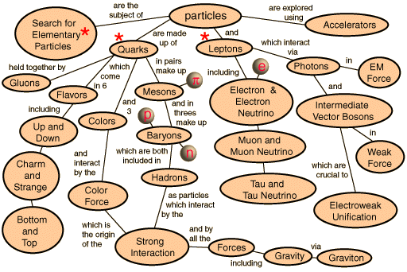
Figure 3 Hyperphysics.com

The final two fundamental forces are gravitational and electromagnetic forces, the latter being described by James Clerk Maxwell’s successful combination of electrostatic and magnetic forces in the 19th century. Both these forces have infinite range.

This is the current understanding of the fundamental forces that exist in nature. It may appear surprising that gravity is, in fact, the weakest of all the fundamental forces when we are so aware of its effect on us in everyday life. However, if the electromagnetic and strong nuclear forces were not so strong then all matter would easily be broken apart and our universe would not exist in the form it does today.

Force | Range  (m) | Relative strength | Approximate  decay time (s) | Example effects
Strong nuclear | 10^{–15} | 10³⁸ | 10^{–23} | Holding neutrons in the nucleus
Weak nuclear | 10^{–18} | 10²⁵ | 10^{–10} | Beta decay; decay of unstable hadrons
Electromagnetic | ∞ | 10³⁶ | 10^{–20}–10^{–16} | Holding electrons in atoms
Gravitational | ∞ | 1 | Undiscovered | Holding matter in planets, stars and galaxies

At an everyday level we are familiar with contact forces when two objects are touching each other. Later in this unit you will consider electric fields as a description of how forces act over a distance. At a microscopic level we use a different mechanism to explain the action of forces; this uses something called exchange particles. Each force is mediated through an exchange particle or boson. Consider a macroscopic analogy. The exchange particles for the four fundamental forces are given in the table below and most of these form part of the standard model. Much work has been done over the last century to find theories that combine these forces (just like Maxwell showed that the same equations could be used to describe both electrostatic and magnetic forces). There has been much success with quantum electrodynamics in giving a combined theory of electromagnetic and weak forces. Much work has also been done to combine this with the strong force to provide what is known as a grand unified theory. Unfortunately, gravity is proving much more difficult to incorporate consistently into current theories, to produce what would be known as a ‘theory of everything (T.O.E)’, therefore gravity is not included in the standard model. So far this has not caused significant problems because the relative weakness of gravity and the tiny mass of subatomic particles means that it does not appear to be a significant force within the nucleus.
Force | Exchange particle
Strong nuclear | Gluon
Weak nuclear | W and Z bosons
Electromagnetic | Photon
Gravitational | Graviton*

*Not yet verified experimentally.

Many theories postulated the existence of a further boson, called the Higgs boson after Peter Higgs of Edinburgh University. The Higgs boson is not involved in forces but is what gives particles mass. The discovery of a particle, or particles, matching the description of the Higgs boson was announced at CERN on 4th July 2012.

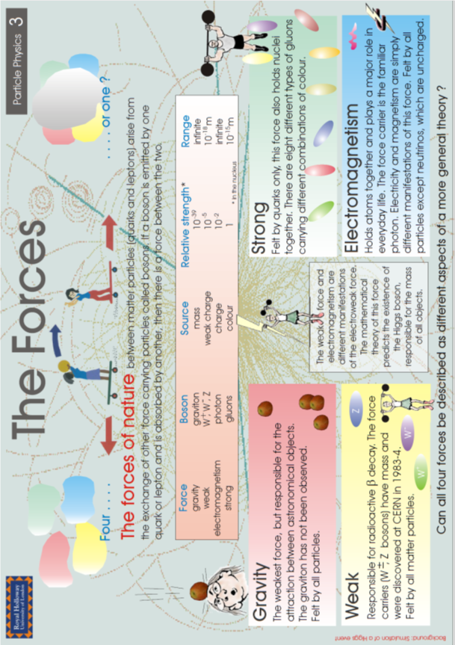

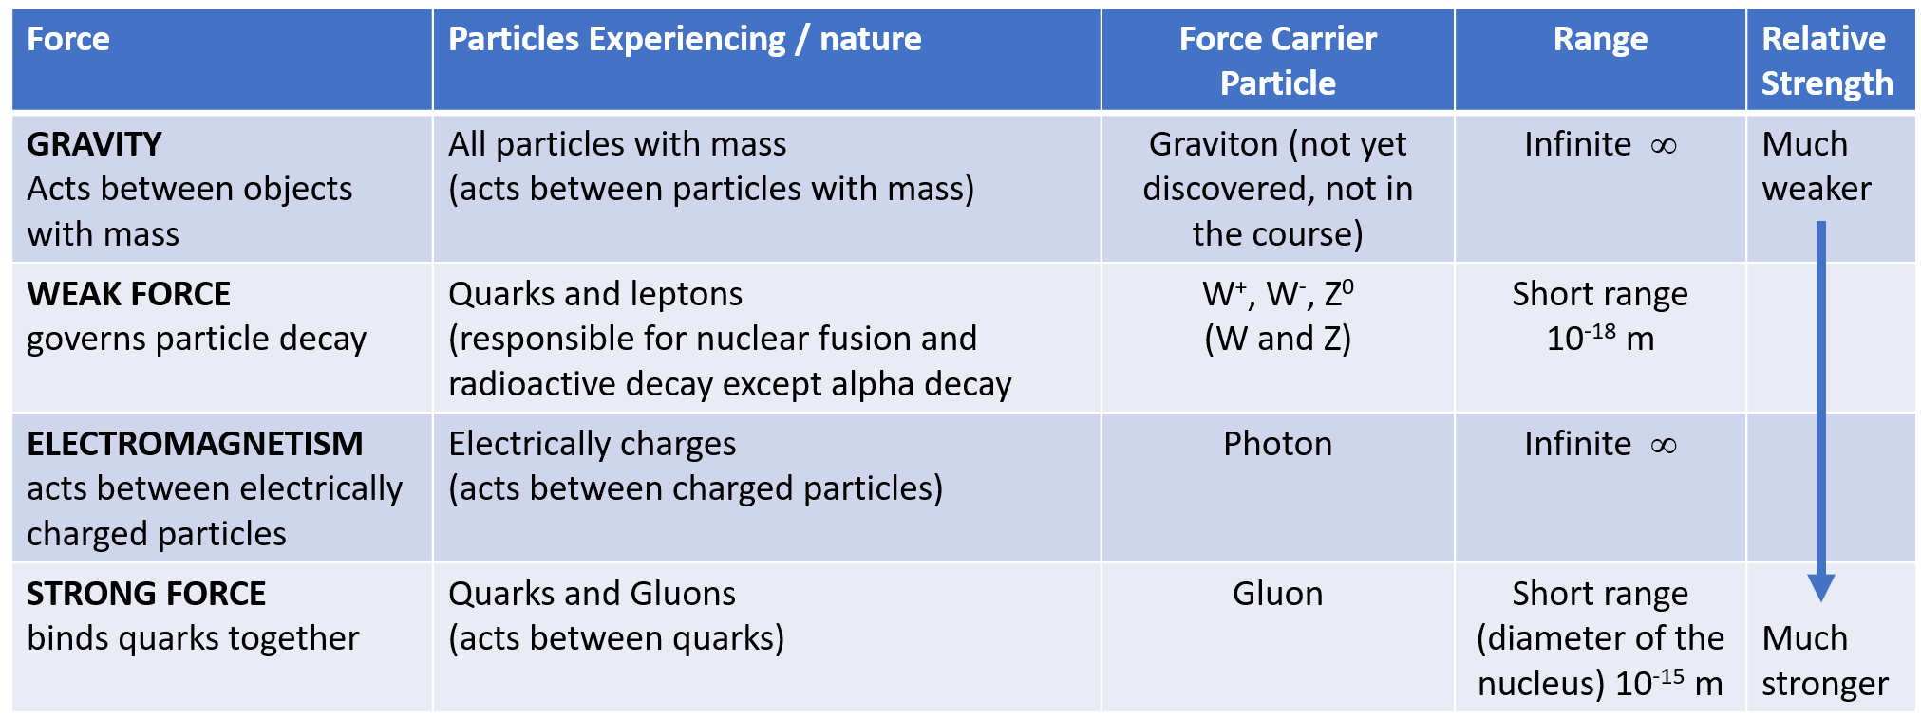

Standard model summary
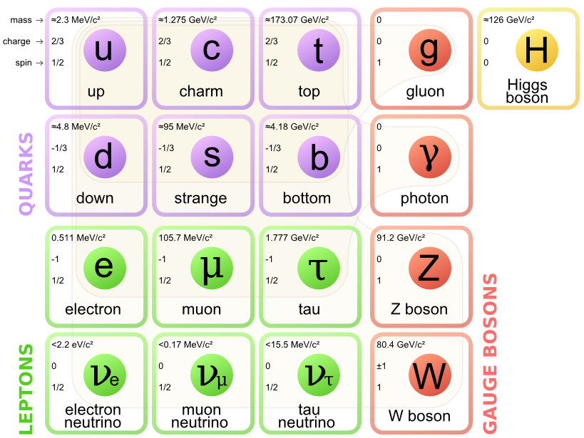
Figure 4""Standard Model of Elementary Particles" by MissMJ - Own work by uploader, PBS NOVA [1], Fermilab, Office of Science, United States Department of Energy, Particle Data Group. Licensed under CC BY 3.0 via Commons - https://commons.wikimedia.org/wiki/File:Standard_Model_of_Elementary_Particles.svg#/media/File:Standard_Model_of_Elementary_Particles.svg:
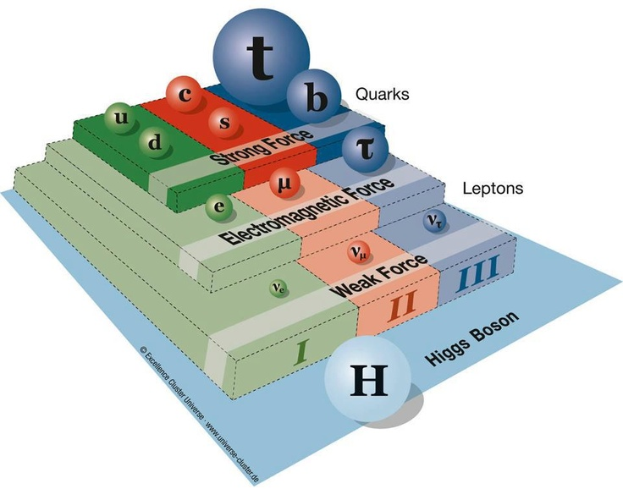
This gives a 3D image of the Standard Model giving size comparisons
Figure 5 https://s-media-cache-ak0.pinimg.com/736x/5f/b9/54/5fb954c0c0317e85878fff02a6716c20.jpg

And what’s this Higgs Particle?
https://vimeo.com/41038445

http://htekidsnews.com/higgs-boson-huh/

Classification of particles
BOSONS
HADRONS
FERMIONS
photon, W, Z, gluon,
Higgs
Mesons (pions, kaons, )
Baryons (proton, neutron,)
Leptons (electron, neutrino,)

For example, a proton is both a fermion (a matter particle) and a hadron (a particle made up of quarks), Bosons are called the Exchange particles.

Beta decay and the antineutrino
Neutrinos were first discovered in radioactive beta decay experiments.

In beta decay, a neutron in the atomic nucleus decays into a proton and an electron (at a fundamental level, a down quark decays into an up quark through the emission of a W⁻ boson). The electron is forced out at high speed due to the nuclear forces. This carries away kinetic energy (and momentum). Precise measurement of this energy has shown that there is a continuous spread of possible values.
This result was unexpected because when alpha particles are created in alpha decay they have very precise and distinct energies. This energy corresponds to the difference in the energy of the nucleus before and after the decay.
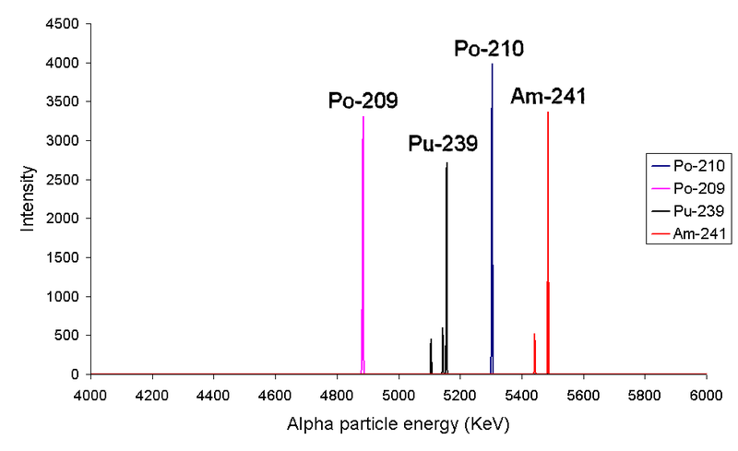
The graph show the energy of alpha particles emitted by the alpha decay of protactinium-231 and the energy of electrons emitted by beta decay of bismuth-210.

It is clear that the process that creates the beta decay electrons is different from alpha decay. The electrons in beta decay come out with a range of energies up to, but not including the expected value.

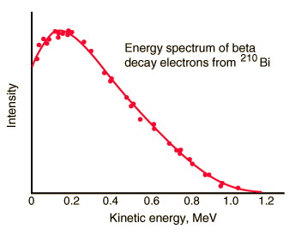
To solve this problem, it was proposed that there must be another particle emitted in the decay which carried away with it the missing energy and momentum. Since this had not been detected, the experimenters concluded that it must be neutral and highly penetrating. This was the first evidence for the existence of the neutrino. (In fact, in beta decay an anti-neutrino is emitted along with the electron as lepton number is conserved in particle reactions. There is another type of beta decay, β⁺, which has a certain symmetry with the β– decay above. In this process a proton decays into a neutron, and a positron and a neutrino are emitted.)

Interesting fact about the Neutrino
More than 50 trillion (50 × 10¹²) solar neutrinos pass through an average human body every second while having no measurable effect. They interact so rarely with matter that detectors consisting of massive tanks of water, deep underground and therefore screened from cosmic rays, are required to detect them.

Practical uses of antimatter: positron emission tomography (PET) scanning
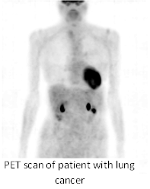
Positron emission tomography (PET) scanners use antimatter annihilation to obtain detailed 3-D scans of body function. Other imaging techniques called computed tomography (CT) which use X-rays and magnetic resonance imaging (MRI) can give detailed pictures of the bone and tissue within the body but PET scans give a much clearer picture of how body processes are actually working.

A β⁺ tracer with a short half-life is introduced into the body attached to compounds normally used by the body, such as glucose, water or oxygen. When this tracer emits a positron it will annihilate nearly instantaneously with an electron. This produces a pair of gamma-ray photons of specific frequency moving in approximately opposite directions to each other. (The reason it is only an approximately opposite direction is that the positron and electron are moving before the annihilation event takes place.) The gamma rays are detected by a ring of scintillators, each producing a burst of light that can be detected by photomultiplier tubes or photodiodes. Complex computer analysis traces tens of thousands of possible events each second and the positions of the original emissions are calculated. A 3-D image can then be constructed, often along with a CT or MRI scan to obtain a more accurate picture of the anatomy alongside the body function being investigated.

http://www.insidestory.iop.org/pet.html http://insidestory.iop.org/insidestory_flash1.html

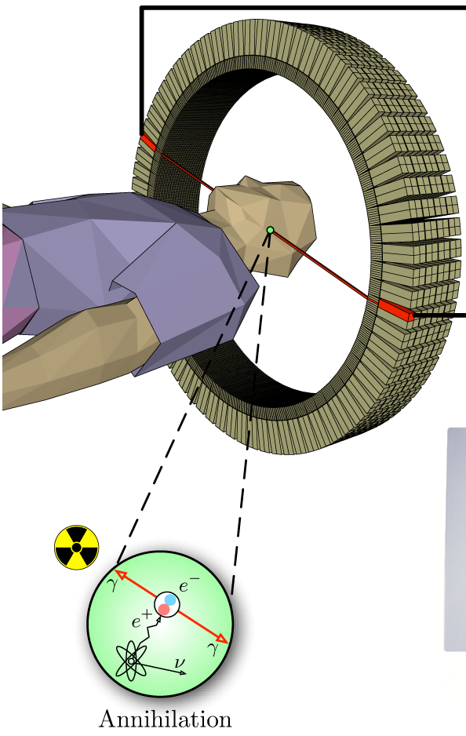
Figure 6: http://rlv.zcache.com/pet_scan_anyone_positron_emission_tomography_napkin-r81e900df0efc427295a7d4a5bbac83bd_2cf00_8byvr_512.jpg

Tracing the use of glucose in the body can be used in oncology (the treatment of cancer) since cancer cells take up more glucose than healthy ones. This means that tumours appear bright on the PET image. Glucose is also extremely important in brain cells, which makes PET scans very useful for investigation into Alzheimer’s and other neurological disorders. If oxygen is used as the tracking molecule, PET scans can be used to look at blood flow in the heart to detect coronary heart disease and other heart problems.

The detecting equipment in PET scanners has much in common with particle detectors and the latest developments in particle accelerators can be used to improve this field of medical physics.
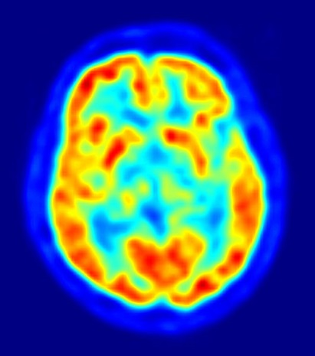
When the isotope undergoes beta decay it emits a positron. As this positron travels through the tissue it loses energy. Once sufficient energy is lost it annihilates with a nearby electron that is typically one millimetre away. When this occurs two gamma rays are emitted. In the reference frame of the photons they are emitted in exactly opposite directions. However, due to special relativity, there is a slight offset in angle depending on the velocity of the centre of mass. This offset is called noncolinearity. Typically in PET scans the two photons are 0.25 degrees off from being a perfect 180 degrees apart.
Figure 7: https://upload.wikimedia.org/wikipedia/commons/c/c6/PET-image.jpg

Research Activity
A PET scanner works using the phenomenon of particle and anti-particle annihilation. Produce a short presentation including the following points:
- A labelled diagram of the PET Scanner
- An explanation of how it works: specifically how it incorporates particle and anti-particle annihilation;
- Why the device is useful and what is it used for;
- A real life example of where you may find this device.

2. Choose an appropriate form of presentation to deliver this information to your fellow students. This could take the form of:
- A digital presentation (e.g. Powerpoint, Keynote, Prezi, etc)
- An information booklet
- A mind map
- A short video

- End the presentation with a couple of questions to assess your fellow students understanding of the PET scanner, based on your presentation.

The standard model /Tutorials

Tutorial 1: Orders of magnitude

1. The diagram shows a simple model of the atom.
Match each of the letters A, B, C and D with the correct word from the list below.

electron neutron nucleus proton

2. In the following table the numbers or words represented by the letters A, B, C, D, E, F and G are missing.

Order of magnitude/m | Object
10⁻¹⁵ | A
10⁻¹⁴ | B
10⁻¹⁰ | Diameter of hydrogen atom
10⁻⁴ | C
10⁰ | D
10³ | E
10⁷ | Diameter of Earth
10⁹ | F
10¹³ | Diameter of solar system
10²¹ | G

Match each letter with the correct words from the list below.

diameter of nucleus | diameter of proton | diameter of Sun
distance to nearest galaxy | height of Ben Nevis | size of dust particle

TUTORIAL 2 FUNDAMENTAL PARTICLES AND INTERACTIONS

- Name the particles represented by the following symbols.
(a) p (b) $\overline{p}$ (c) e (d)
(e) n (f) $\overline{n}$ (g) v (h) $\overline{ν}$

- A particle can be represented by a symbol where M represents the mass number, A the atomic number and X identifies the type of particle, for example a proton can be represented by . Give the symbols, in this form, for the following particles.
(a) $\overline{p}$ (b) e (c) $\overline{e}$ (d) n (e) $\overline{n}$

- Copy and complete the table by placing the fermions in the list below in the correct column of the table.
bottom charm down electron electron neutrino
muon muon neutrino strange tau
tau neutrino top up

Quarks | Leptons

  - State the difference between a hadron and a lepton in terms of the type of force experienced by each particle.
  - Give one example of a hadron and one example of a lepton.

- Information on the sign and charge relative to proton charge of six types of quarks (and their corresponding antiquarks) is shown in the table.

Quark name | Charge relative to size of proton charge | Antiquark name | Charge relative to size of proton charge
Up | +2/3 | antiup | –2/3
charm | +2/3 | anticharm | –2/3
top | +2/3 | antitop | –2/3
down | –1/3 | antidown | +1/3
strange | –1/3 | antistrange | +1/3
bottom | –1/3 | antibottom | +1/3

Calculate the charge of the following combinations of quarks:
- two up quarks and one down quark
- one up quark and two down quarks
- two anti-up quarks and one anti-down quark
- one anti-up quark and two anti-down quarks.

- Neutrons and protons are considered to be composed of quarks.
(a) How many quarks are in each neutron and in each proton?
(b) Comment briefly on the different composition of the neutron and proton.

(a) Briefly state any differences between the ‘strong’ and ‘weak’ nuclear forces.
(b) Give an example of a particle decay associated with the weak nuclear force.
(c) Which of the two forces, strong and weak, acts over the greater distance?
Use information from the diagram and your knowledge of physics to answer the following questions.
(a) Explain why particles such as leptons and quarks are known as Fundamental Particles.

(b) A particle called the sigma plus ( Σ+) has a charge of +1. It contains two different types of quark. It has two up quarks each having a charge of +2/3 and one strange quark.
What is the charge on the strange quark?

(c) Explain why the gluon cannot be the force mediating particle for the gravitational force.

Exam Questions
SQA NH 2018
8. How many types of quark are there?
A 8
B 6
C 4
D 3
E 2

9. An electron is a
A boson
B hadron
C baryon
D meson
E lepton.

SQA NH 2017 Q7
The following diagram gives information on the Standard Model of fundamental particles.
(a) Explain why the proton and the neutron are not fundamental particles.

(b) An extract from a data book contains the following information about three types of sigma (Σ) particles. Sigma particles are made up of three quarks.

Particle | Symbol | Quark Content | Charge | Mean lifetime (s)
sigma plus | Σ+ | up up strange | +1 e | 8·0 × 10⁻¹¹
neutral sigma | Σ0 | up down strange | 0 7· | 4 × 10⁻²⁰
sigma minus | Σ− | down down strange | −1e | 1·5 × 10⁻¹⁰

(i) A student makes the following statement.
All baryons are hadrons, but not all hadrons are baryons.
Explain why this statement is correct.

(ii) The charge on an up quark is 2+ 3 e.
Determine the charge on a strange quark.

(c) (i) State the name of the force that holds the quarks together in the sigma (Σ) particle.

(ii) State the name of the boson associated with this force.

(d) Sigma minus (Σ−) particles have a mean lifetime of 1·5 ⋅ 10−10 s in their frame of reference.
Σ− are produced in a particle accelerator and travel at a speed of 0·9c relative to a stationary observer.
Calculate the mean lifetime of the Σ− particle as measured by this observer.

Tutorial Answers - STANDARD MODEL

Cupcake Crib sheet
This one doesn’t really work in B&W!

Orders of magnitude
1. A= electron; B = proton; C = nucleus; D = neutron

2. A = diameter of proton; B = diameter of nucleus; C = size of dust particle; D = your height; E = height of Ben Nevis; F = diameter of Sun; G = distance to nearest galaxy

The standard model of fundamental particles and interactions

1. (a) proton (b) antiproton (c) electron (d) positron
(e) neutron (f) antineutron (g) neutrino (f) antineutrino

2. (a) (b) (c) ${}_{+1}^{0}e$ (d) ${}_{1}^{0}n$ (e)

3. Quarks: bottom, charm, down, strange, top, up
Leptons: electron, electron neutrino, muon, muon neutrino, tau, tau neutrino

4. (a) Leptons are particles that are acted on by the weak nuclear force but not by the strong nuclear force. Hadrons are particles that are acted on by the weak and strong nuclear force.
(b) Leptons – any one of electron, electron neutrino, muon, muon neutrino, tau and tau neutrino. Hadron – any one of up, down, charm, strange, top and bottom.

5. (a) +e
(b) 0
(c) −e
(d) 0

6. (a) 3
(b) For the neutron the three quarks must give a charge of zero. For the proton the three quarks must give a charge of +e.

7. (a) Strong force has a range of less than 10⁻¹⁴ m; weak force has a range of less than 10⁻¹⁷ m.
(b) Beta decay
(c) Strong force.

        - These particles cannot be broken down into other sub atomic particles
(KEY POINT) it is not that they can be used to make bigger things but rather that they are not made from smaller things

(b) For the sigma plus particle
2 × (+ $\frac{2}{3}$) + q_{s} = +1
q_{s} = - - $\frac{1}{3}$
Charge on the strange quark = - $\frac{1}{3}$

(c ) Strong force (associated with the gluon) acts over a very short distance, the gravitational force extends over very large / infinite distances

Exam Questions
2018 Q8 B
2018 Q9 E
2017 Q7
7a) They are composed of other particles/quarks, (fundamental particles are not).
Accept they are composite particles
  - (i) Baryons are (hadrons as they are) composed of (three) quarks. 1
Mesons/some hadrons are made from a quark - anti-quark pair so are not baryons. 1
(For first mark, a correct statement that baryons consist of quarks.)
For second mark, a correct statement that there are other hadrons that have a different quark-count from baryons. Accept two quarks in place of quark-anti-quark pair.
(ii) -1/3(e)
(c ) strong (nuclear force)
(ii) gluon
(d)

CHAPTER 3 FORCES ON CHARGED PARTICLES

Summary of Content

No | CONTENT
Forces on charged particles
 | $W=QV$ $E_{k}=\frac{1}{2}mv^{2}$
 | I know that charged particles experience a force in an electric field.
 | I know that electric fields exist around charged particles and between charged parallel plates.
 | I can sketch electric field patterns for single-point charges, systems of two-point charges and between two charged parallel plates (ignore end effects).
 | I can determine the direction of movement of charged particles in an electric field.
 | I can define voltage (potential difference) as the work done moving unit charge between two points
 | I can solve problems involving the charge, mass, speed, and energy of a charged particle in an electric field and the potential difference through which it moves.
 | I know that a moving charge produces a magnetic field.
 | I can determine the direction of the force on a charged particle moving in a magnetic field for negative and positive charges using the slap rule or other method.
 | I know the basic operation of particle accelerators in terms of acceleration by electric fields, deflection by magnetic fields and high-energy collisions of charged particles to produce other particles.

In Physics, a field means a region where an object experiences a force. Magnets are surrounded by magnetic fields, electric charges are surrounded by an electric field . Electric Fields are quite difficult to visualise and hence understand. If however we compare it to something that is familiar then we have a better chance of visualising an abstract concept. We are therefore going to start by comparing gravitational and electric fields

Electric Fields compared to Gravitational Fields.
Anything that has a mass causes an attraction between it and other masses. You are currently attracted to this page, the bench, and your teacher. Don’t worry though as you saw in the gravitation topic the size of the attraction is tiny because the masses involved are small. However, if the mass is large (e.g. the Earth), then we feel this attraction and it causes an acceleration. We call this force, weight. Weight pulls other masses towards it. Obviously when you are in the Southern Hemisphere you are still pulled towards the centre of the earth. If we release an object close to a large mass the object will be attracted towards it. There is a force acting on the object. We call the area around the large mass in which another mass experiences this force a gravitational field. The strength of this field is called the gravitational field strength. On the surface of the Earth it has a value of approximately 9.8 Nkg⁻¹, although this varies depending on where you are on the surface. Why?
As you get further away from the mass the strength of the field gets weaker. The strength of the field can be shown using field lines. These do not really exist (look out of the window!) but they do show a concept that is real. (This is also similar to magnetic field lines when you draw the direction that a compass will point around a magnet , isobars on a weather chart and contour lines on a map) These field lines are a convenient, fictional concept that represents a real field.
Gravitational field strength at a point is a measure of the gravitational force acting on a mass of 1 kg at that point
If you have not tried this before complete the practical on field lines around magnets.


Over short distances the gravitational field can be considered uniform. This is shown in the diagram of a sports pitch.

Notes on field lines

- Field lines hit the surface at 90 degrees.
- The tangent to a field line gives the direction of the field at that point.
- The no. of field lines per cross sectional area is proportional to the magnitude of the field at that point.
- Field lines go from positive to negative (electric field) or North to South (magnetic field), towards the mass (gravitational field).
- Field lines never cross.
- If they are close together the field is strong
- If they are far apart the field is weak
- If they are parallel/ equally spaced the field is uniform.
- As you move along a field line your potential is decreasing.

Fields
GRAVITATIONAL FIELD
A gravitational field is the region around a mass where another mass experiences a force.
The size of the field is given by:
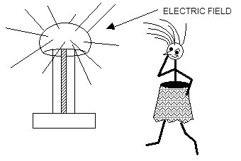
ELECTRIC FIELDS
When we approach a Van de Graaff generator, we can tell whether it is charged by the feel of our hair as we get closer since a charged sphere attracts hairs from a considerable distance away. We describe this situation by saying that the sphere of the Van de Graaff has an electric field around it: -

Obviously this description is insufficient so we take it further and define an electric field by saying that an electric field is the region around a charge where another charge experiences a force.

Or An electric field is said to exist at a point if a force of electrical origin is exerted on a test charge placed at that point.
From our experiences of a gravitational field we can predict the shape of the electric field We must remember there are two types of charge so a charge can be attracted or repelled. The direction of an electric field is the direction of the force that a positive charge experiences in the field. We can map out by using the force it exerts on some small positive test charge.:-

+

-

These are examples of radial fields. The lines are like the radii of a circle. The strength of the field decreases further away from the charge.
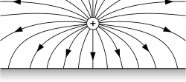
The fields around single charges are symmetrical. We get the directions of the force arrows by always using a positive test charge.
Bring two electric fields together and we get their single resultant field. The one drawn below is the field between a single positive charge and a negatively charged plate. It shows how the lines of force that map out the field always connect positive and negatively charged objects. The most obvious uses of this type of map stem from the fact that its force lines show the paths followed by any electrically charged object that is free to move in the field.

Further combinations of electric fields can be shown below

Unlike point charges: Like point charges:
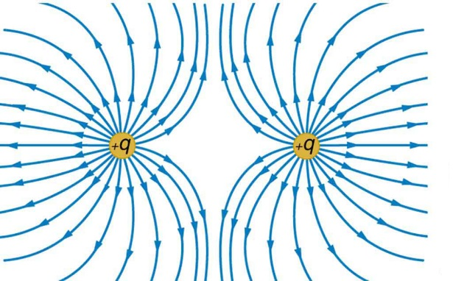
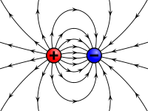+
+
+
Like charges repel (i.e. +/+ or -/-). Opposite charges attract (i.e. +/- or -/+). For the charges to experience a change in motion, they must experience an unbalanced force.

Also like gravitational fields the field between two parallel opposite charged plates is uniform
+
+
+
+
++
-
-
-
-
-
-
The electric field between parallel charged plates is uniform. The strength of the electric field does not vary and this is represented by the parallel, equally spaced field lines.

Similar to gravitational fields the size of the electric field is given by:
So using the information about gravitational fields has helped us with our definition of an electric field. There are other similarities too which we will look at later.

Field type | cause of the field | definition of field strength | Units | Inverse square law
gravitational | m
Electric | Q

Both obey the inverse square law, in other words as you double the distance from the cause of the force you quarter the size of the force.
Notes on Electric charge and electric fields
- Electric charge has the symbol Q and is measured in coulombs (C).
- The charge on a proton is 1.60 × 10^{–19} C.
- The charge on an electron has the same magnitude but is opposite in sign,
i.e. -1.60 × 10^{–19} C.
- Electric Field Strength, E, is a vector quantity just like g.
- E is measured in NC⁻¹ but can also be measured in Vm⁻¹, compare with g which has units of ms⁻² and Nkg⁻¹.
- Q must be small enough so that it does not itself affect the field.

Movement of charge in an electric field, p.d. and electrical energy
Before we look at the movement of charge in an electric field, let’s revise what we know about gravitational fields as this makes our understanding of electrical fields easier.

Movement of a mass in a gravitational field
If a tennis ball is released in a gravitational field such as on Earth, a force is exerted on it. The force acts in the direction of the gravitational field and as a result the ball accelerates downwards. Close to the surface of the Earth, the acceleration (and therefore the unbalanced force on the ball) is constant. The gravitational field is therefore described as a uniform field.

Just like the force of gravity causes a mass to accelerate, so an electric force will cause a charge to accelerate. Again we see similarities between gravity and electric phenomena.
F

Movement of a charge in an electric field
The electric field is a uniform field. This is shown by the uniform spacing of the straight field lines. The unbalanced force is therefore constant. Consider a small, positively charged particle released in this field, the effect will be to cause a uniform acceleration on the charge towards the negative plate.
+ + + + + + + + + + +
+
F

If the charge is negative in the uniform field the charge will still accelerate but this will be against the field line and towards the positive plate.
+ + + + + + + + + + + +
-
F
If the charges also have a horizontal motion then the charges take a parabolic path through the field, just as we have seen in the projectiles section of the course for masses in a gravitational field.

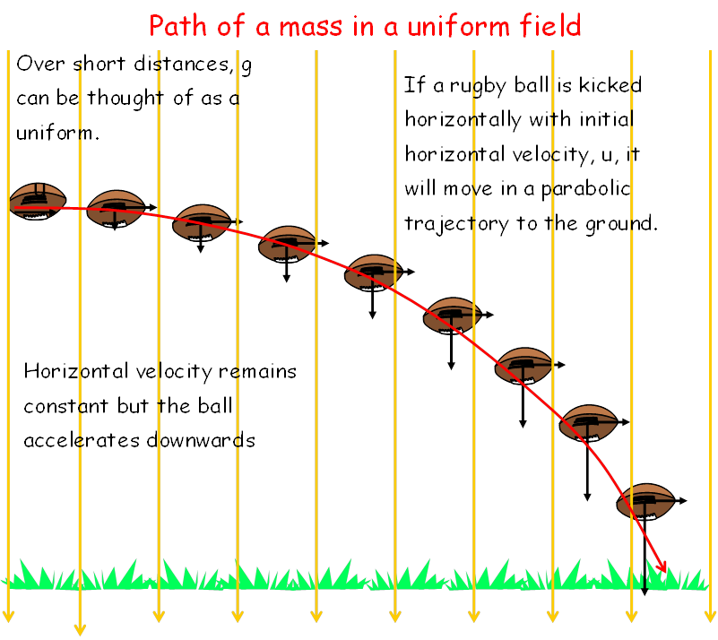

Comparison between gravitational and electrostatic potential energy

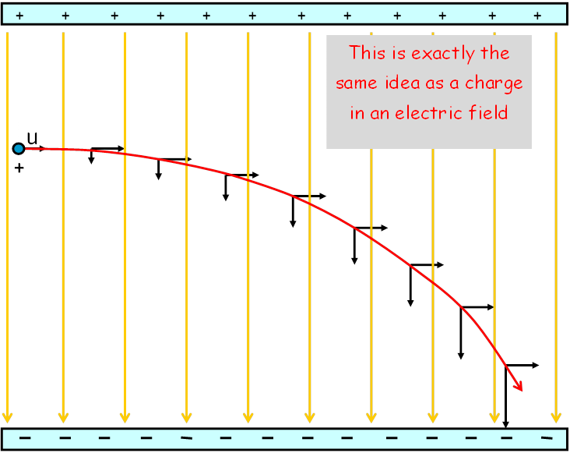
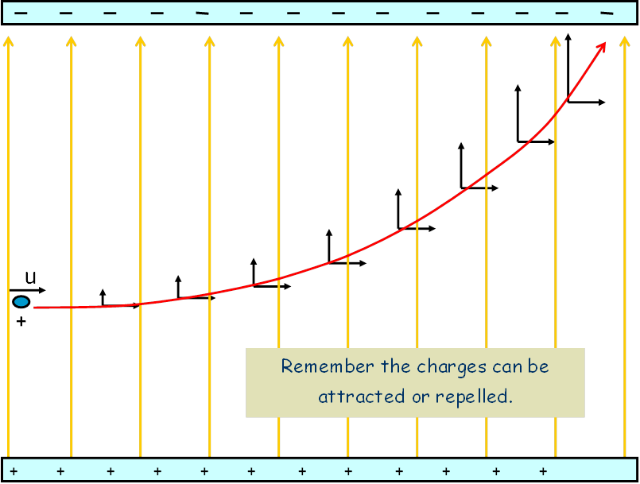

Gravitational potential energy
Work must be done to raise an object against the direction of the gravitational force and this energy is stored in the gravitational field as gravitational potential energy.

work done lifting the ball against the field = the gain in gravitational potential energy
If the ball is released there is a transfer of this potential energy to kinetic energy, i.e. the ball moves. The kinetic energy of the ball can be calculated by using the conservation of energy.
ΔE_{P} = ΔE_{K}
Δmgh = Δ½mv²
⇒mgh = ½mv²
⇒2gh =v²

Electrostatic potential energy
Consider the small positive charge moved against the field as shown.
+
−
+
+
−
−
+

This is equivalent to lifting a tennis ball against the gravitational field. Work must be done to move the charge against the direction of force. When held in place, the small positive charge is an electrostatic potential store of energy.

work done moving the charge against the field = the gain in electrical potential energy

Definition of potential difference and the volt
Potential difference (p.d.) is defined to be a measure of the work done in moving one coulomb of charge between two points in an electric field. Potential difference (p.d.) is often called voltage. This gives the definition of the volt.

There is a potential difference of 1 volt between two points if 1 joule of energy is required to move 1 coulomb of charge between the two points, 1 V = 1 J C⁻¹.

This relationship can be written mathematically: E_{w} = QV or

where E_{w} is energy (work done) in joules (J), Q is the charge in coulombs (C) and V is the potential difference (p.d.) in volts (V).

If the small positive charge, above, is released there is a transfer of energy to kinetic energy, i.e. the charge moves. Again, using the conservation of energy means that:
E_{w} = E_{K}
QV = ½mv²

NB It is important to remember that this is a different equation to the one for capacitance where the energy stored on a capacitor is given by $E=\frac{1}{2}QV$

Potential Gradients
+++
+++
+++
+++
-
-
-
-
-
-
-
-
+

+

+
-

-

-

A small amount of work has to be done moving the charge from one plate to the other. This creates a very weak electric field. | The more charges are moved the more work has to be done. The electric field becomes stronger. | Work is done moving the charge and this is stored in the system.  As one plate becomes positive and one plate becomes negative the potential difference between the plates increases.
The amount of work done is given by:-
+++
+++
+++
+++
-
-
-
-
-
-
-
-

If positively charge Q is moved from the negative to the positive plate work has to be done against the field.

As the field is uniform there is a constant force F on Q. The work done depends on the distance moved.

F
A
B
−
+
−
−
+
+
+

2.0 kV

Example: A positive charge of 3.0 µC is moved from A to B. The potential difference between A and B is 2.0 kV.
(a) Calculate the electric potential energy gained by the charge–field system.
(b) The charge is released. Describe the motion of the charge.

(c) Determine the kinetic energy when the charge is at point A.

(d) The mass of the charge is 5.0 μg. Calculate the speed of the charge.

Solution:
(a) | Q = 3.0 μC = 3.0 × 10⁻⁶ C  V = 2.0 kV = 2.0 × 10³ V  E_{w} = ?  E_{w} = QV  E_{w} = 3.0 × 10⁻⁶ × 2.0 × 10³  E_{w} = 6.0 × 10⁻³ J | (b) | The electric field is uniform so the charge experiences a constant unbalanced force. The charge accelerates uniformly towards the negative plate A.
(c) | By conservation of energy,  E_{K} = E_{w} = 6.0 × 10⁻³ J | (d) | m = 5.0 μg = 5.0 × 10⁻⁹ kg  E_{K} = 6.0 × 10⁻³ J  v = ?
E_{K} = ½mv² 6.0 × 10⁻³ = 0.5 × 5.0 × 10⁻⁹ × v²
v² = 2.4 × 10⁻³
v= 49 m s⁻¹

Applications of electric fields

Cathode ray tubes
https://www.youtube.com/watch?v=zj91VO7WJgU

The cathode ray tube (CRT) was invented in the 1800s but formed the basis of the majority of the world’s new television technology until the end of the twentieth century. The cathode ray tube continues to be the basis for some scientific equipment such as the oscilloscope and radar systems. In the CRT an “electron gun” fires electrons at a screen.
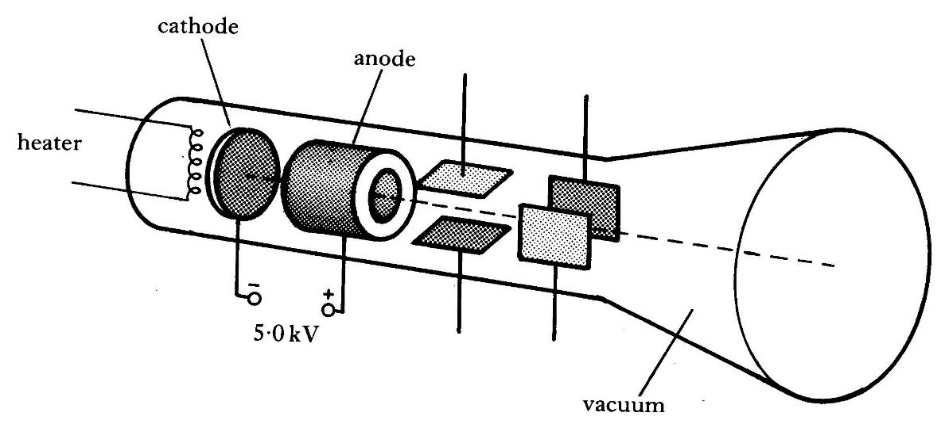
A cathode ray tube in an oscilloscope
Electrons, excited by heat energy from the filament, are emitted by the cathode and are accelerated forwards through a large potential difference towards the anode. The electrons pass through the cylindrical anode and a beam is formed. The grid is negative with respect to the cathode and some of the electrons are repelled back towards the cathode. It is made more negative by moving the variable resistor control towards A, more electrons will be repelled and so the beam becomes less intense and the spot dimmer.

Potential differences applied to pairs of parallel plates are used to deflect the electron beam to different points on the screen. For the spot to be deflected to point T then plate Y_{B} must be more positive than plate Y_{A} and plate X_{B} must be more positive than plate X_{A}.

We can use this to calculate the speed of an electron within the electron gun as shown in the following example.

Example:
- An electron is accelerated from rest through a potential difference of 200 V. Calculate:
(a) the kinetic energy of the electron;
(b) the final speed of the electron.
(Note: in an exam, the mass and charge of the electron can be found on the data sheet.)
Solution:

(a) | Q = 1.60 × 10⁻¹⁹ C  V = 200 V  W=?  E_{K} = W by the electric field  E_{K} = QV  E_{K} = 1.60 × 10⁻¹⁹ × 200  E_{K} = 3.20 × 10⁻¹⁷ J | (b) | m = 9.11 × 10⁻³¹ kg  E_{K} = 3.20 × 10⁻¹⁷ J  v = ?  E_{K}= ½mv²  3.20 × 10⁻¹⁷ = 0.5 × 9.11 × 10⁻³¹ × v²  v² = 7.025 × 10¹³  v = 8.38 × 10⁶ m s⁻¹
- Electrons released from the hot cathode are accelerated by a p.d. of 5.0 kV between the cathode and anode.
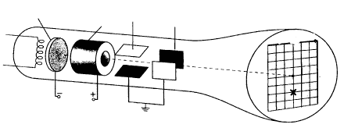
(a) i) Assuming that an electron starts from rest at the cathode, calculate its speed just before it reaches the anode. (You may have to refer to the Science Data Booklet.)
ii) What is the effect on the speed of the electron just before it reaches the anode if the p.d. between the cathode and anode is halved? Show your reasoning.

(b) If the electron beam current is 15mA, how many electrons leave the cathode each second? (You may have to refer to the Science Data Booklet.)

Solution:
(a )
(i)
(a )  (ii) | If the pd is halved the E_{k} will halve, however E_{k} is directly proportional to v² so v² will also halve this means that v will be a quarter of the original value. Completing a calculation is good exam practice if you’ve time!
(b)

3. The electrons which are emitted from the cathode start from rest and reach the anode with a speed of 4.2 ×10⁷ m s⁻¹
a) i) Calculate the kinetic energy in joules of each electron just before it reaches the anode.
ii) Calculate the p.d. between the anode and the cathode.

b) Describe how the spot at the centre of the screen produced by the electrons can be moved to position X.
Your answer must make reference to the relative sizes and polarity (signs) of the voltages applied to plates P and Q.
(a)  (i) |  | (ii)
(b) | 2nd set of plates (Vertical plates) move the beam left and right. These should be uncharged as there is no movement of the beam in this plane  1st set of plates (Horizontal plates) move the beam up and down. The electrons will be attracted to the positive plate so the lower horizontal plate should be positive compared to the top plate and to move the beam two squares down requires double the pd than to move it one square down.

Paint spraying
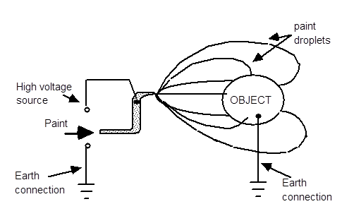
Conducting objects, such as metal stool frames, bike frames and car bodies, can be painted efficiently by charging the paint spray so that most paint is attracted to the conductor. This method can even be used to paint the back of the conductor.

In electrostatic painting, the paint particles are charged by the high voltage attached to the spray head. This causes them to be attracted to the object being sprayed which is kept at zero volts by connection to the earth. The paint droplets then follow the field lines and wrap round the object to get more than 90% of them onto the surface.
This is a very similar method to crop spraying where the crops are dusted to produce charged leaves and then the spray is given the opposite charge when ejected from the spray nozzle.

http://www.passmyexams.co.uk/GCSE/physics/uses-of-static-electricity.html

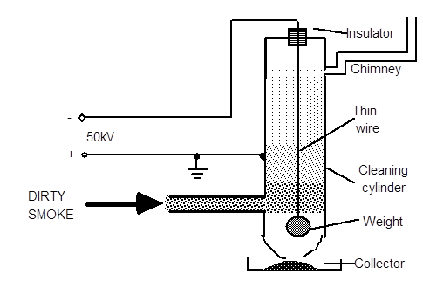
Electrostatic precipitation
Another use of electric fields is electro-precipitation. The particles are given an electric charge which causes them to follow the field lines to an oppositely charged surface which is out of the gas flow.

This is the process by which solid or liquid particles can be removed from a gaseous carrying medium by giving them an electric charge and then precipitating them on to a suitable receiving surface in an electric field. The 'dirt' picks up a negative charge from the wire and travels the field lines to the walls of the cleaning cylinder. Liquid 'dirt' runs down the walls into the collector while a regular mechanical tapping on the tube knocks off solid material. This process is used to remove "fly-ash" from power station flues.
The chimney is approximately 3m long with a 0.2m diameter tube. The recovered material is deposited in the collector where it is removed as waste and dumped.

Charged Particles in Magnetic Fields
The discovery of the interaction between electricity and magnetism, and the resultant ability to produce movement, must rank as one of the most significant developments in physics in terms of the impact on everyday life.

This work was first carried out by Michael Faraday whose work on electromagnetic rotation in 1821 gave us the electric motor. He was also involved in the work which brought electricity into everyday life, with the discovery of the principle of the transformer and generator in 1831. Not everyone could see its potential. William Gladstone (1809–1898), the then Chancellor of the Exchequer and subsequently four-time Prime Minister of Great Britain, challenged Faraday on the practical worth of this new discovery – electricity. Faraday’s response was ‘Why, sir, there is every probability that you will soon be able to tax it!’ The Scottish physicist, James Clark Maxwell (1831–1879), built upon the work of Faraday and wrote down mathematical equations describing the interaction between electric and magnetic fields. The computing revolution of the 20th century could not have happened without an understanding of electromagnetism.
The last section introduced the idea that an electric field surrounds a stationary electric charge. This section answers the following questions:
- What happens when a charged particle is on the move?
- How does a motor work?

Moving charges create magnetic fields
In 1820 the Danish physicist Oersted discovered that a magnetic compass was deflected when an electrical current flowed through a nearby wire. This was explained by saying that when a charged particle moves a magnetic field is generated. In other words, a wire with a current flowing through it (a current-carrying wire) creates a magnetic field.

The magnetic field around a current-carrying wire is circular. For electron flow, the direction of the field can be found by using the left-hand grip rule.

Left Hand Grip Rule
On a current carrying wire the magnetic field is circular around the wire. The direction of the field is dependent on the direction of the current. To find the direction of the current use the left hand grip rule (or the right hand screw rule for conventional current)
How it works! Point the thumb in the direction of electron flow, curl up your fingers around the thumb. The direction in which the fingers point indicates the direction of the magnetic field lines.
For the Left Hand Grip Rule:
Thumb = direction of electron flow
Fingers =direction of the magnetic field
Moving charges experience a force in a magnetic field

Summary
A stationary charge creates an electric field.
A moving charge also creates a magnetic field

result for ELECTRON CURRENT result for CONVENTIONAL CURRENT

The dot means out of the page, the cross means into the page.

A magnetic field surrounds a magnet. When two magnets interact, they attract or repel each other due to the interaction between the magnetic fields surrounding each magnet.

A moving electric charge behaves like a mini-magnet as it creates its own magnetic field. This means it experiences a force if it moves through an external magnetic field (in the same way that a mass experiences a force in a gravitational field or a charge experiences a force in an electric field.)

Simple rules can be used to determine the direction of force on a charged particle in a magnetic field.

Movement of a negative charge in a magnetic field
One common method to determine the direction of force on a charged particle is known as the Right-Hand Motor Rule.
Where:
First Finger is the magnetic Field
seCond Finger is the Current (eleCton flow)
ThuMb is the Motion
Right Hand Motor Rule

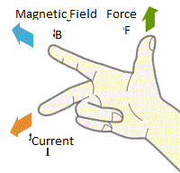

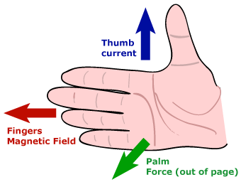
Alternatively, the Left-hand Slap Rule where the four fingers of the left point in the direction of the magnetic field B and the thumb points in the direction of the electron current I, the direction of slapping would be the direction of force F on the conductor.
Figure 8 Or use the SLAP Method, this will be with your LEFT HAND

Movement of a positive charge in a magnetic field

Using conventional Current or for a positive charge eg an alpha particle in a magnetic field we can use Fleming’s left-hand rule.
http://www.zazzle.com/right_hand_rule_cross_product_physics_gang_sign_tshirt-235664761452991961

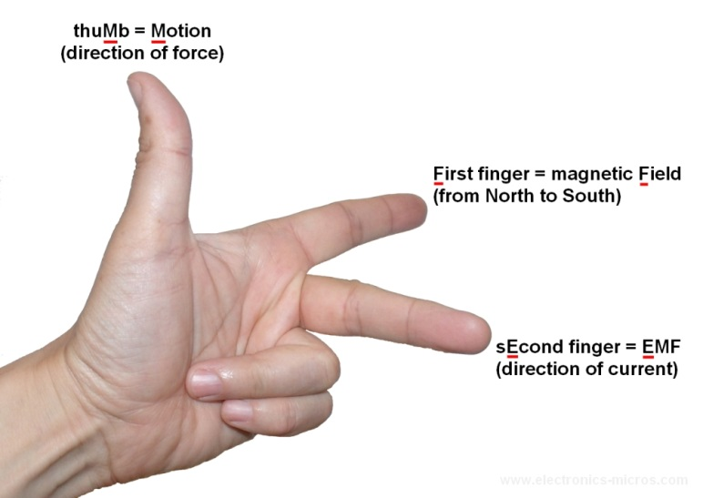
Where LEFT HAND
First Finger is the magnetic Field
seCond Finger is the Conventional Current
ThuMb is the Motion

Conventional
Current /
positive charges
Figure 9: http://physicsf45spm.blogspot.co.uk/2012/08/force-on-current-carrying-conductor-in.html

Or you can just stick to one rule and reverse the direction of your fingers to show that it will be the opposite for a positive charge. This is usually the easiest. Stick to the method that you find easiest and ignore all the others. They are all determining the same thing.

How are examples of the motor rule represented on paper?
As we are working on 2D paper for a 3D model we have to show the extra dimension of going in and coming out of the paper. To distinguish these we use the arrow model. If an arrow was coming towards you, you would see the point. A great big dot (duck)! If the arrow was going away from you, you would notice the feathers arranged as a cross.

Figure 10: Arrow used to show third dimension


Figure 12: arrow coming towards you (out of the page)
Figure 12b: arrow going away from you (into the page)

v
F
magnetic field perpendicularly into the page
negative charge
path of
negative charge
× × × × ×

× × × × ×

× × × × ×

The motor rules are also used to determine the direction of spin of the coil in an electric motor

The new method I will use is the Stewart K, Hargreaves R (2016) method

Amy ought to have drawn a dot to represent the force as it is out of the page. She drew this before we’d finished talking about dots and crosses.
Particle
motion
Fingers
Magnetic Field
Palm = Force
(out of the page)
Magnetic Field
Palm gives the force on a negative particle.
Backhand gives the force on a positive particle, and it’s more painful on the backhand

Let’s do the Fool Proof System of Remembering with LEFT HAND
Right the Right System of Remembering
Particle
motion
Palm gives the force on a positive particle.
Backhand gives the force on a negative particle

CHOOSE ONE OF THESE METHODS AND STICK TO IT! YOU OUGHT TO BE ABLE TO CHOOSE RATHER THAN HAVE YOUR TEACHER FORCE THE METHOD ON YOU!

The Electric Motor
When a current-carrying wire is placed between the poles of a permanent magnet, it experiences a force. The direction of the force is at right-angles to:
- the direction of the current in the wire;
- the direction of the magnetic field of the permanent magnet.
field magnet
coil of wire
brush
split ring commutator
N
direction of rotation
S
field magnet

An electric motor must spin continuously in the same direction. Whichever side of the coil is nearest the north pole of the field magnets above must always experience an upwards force if the coil is to turn clockwise. That side of the coil must therefore always be connected to the negative terminal of the power supply. Once the coil reaches the vertical position the ends of the coil must be connected to the opposite terminals of the power supply to keep the coil turning. This is done by split ring commutator.

In order for the coil to spin freely there cannot be permanent fixed connections between the supply and the split ring commutator. Brushes rub against the split ring commutator ensuring that a good conducting path exists between the power supply and the coil regardless of the position of the coil.

Tutorial 1- Movement in a Magnetic Field

            - Copy the diagrams below and describe the movement of the particle in the magnetic field.
  - Using the same magnetic fields as shown above replace each of the particles with an alpha particle. Describe the motion of the alpha particle due to the force from each field.

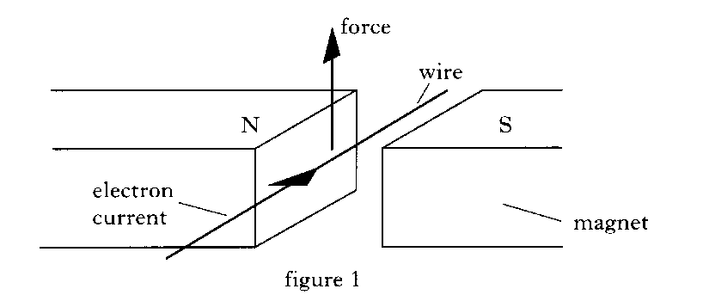
- 1996 Credit Physics Paper
        - A current carrying wire is placed between the poles of a magnet. The direction of the electron current in the wire is as indicated in Figure 1. The conductor experiences an upward force as shown in Figure 1.

Draw a diagram to show the rule that determines the direction of the Force on this wire.

        - Figures 2 and 3 show other current carrying wires placed between the poles of the magnets. In each case, copy out the diagrams and indicate on figures 2 and 3 the direction of the force on the wire.
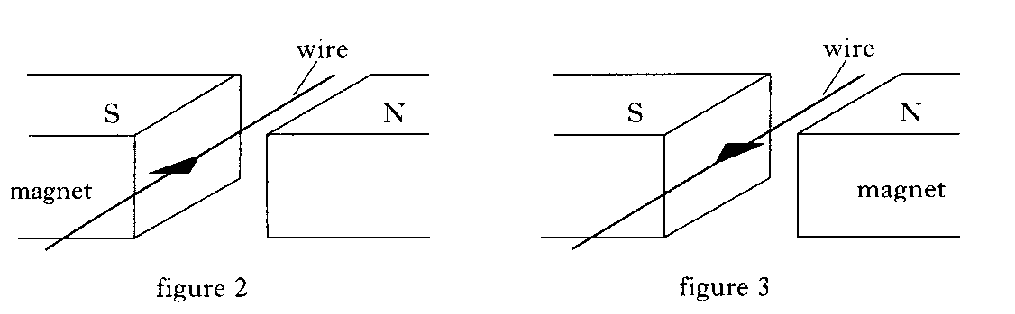

        - Figure 4 shows a simple electric motor with a coil WXYZ free to spin about a shaft PQ.
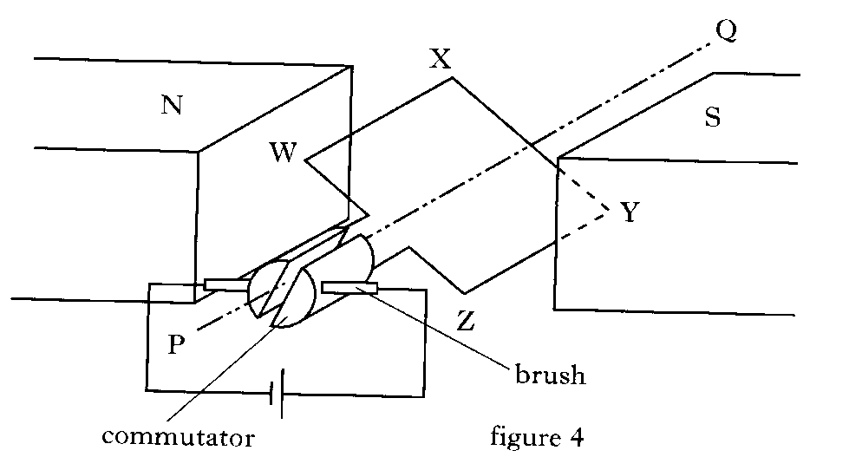
          - By looking at the diagram and using the conclusions you reached in part b) copy out the diagram and mark on your Figure 4
            - The direction of the electron current in the coil;
            - The directions of the forces on the coil;
            - The direction of the rotation of the coil.
        - In commercial motors, explain why;
          - More than one rotating coil is used;
          - Field coils rather than permanent magnets are used

- An electron travels from west to east and passes into in a horizontal magnetic field directed towards the north.
        - Draw a labelled sketch to show this situation from above.
        - State the direction of the force on the electrons in the wire.

- An electron is directed at 90° (right-angles) to the magnetic field lines of a horseshoe magnet .
The diagram shows the view from above the magnet. State the direction of the magnetic force.
- The diagram shows from above a 0.1 m straight, horizontal length of metal wire which has been placed perpendicular (at 90°) to a horizontal magnetic field.

State the direction of the force on the electrons in the wire
6. An electron travels from south to north in a horizontal magnetic field directed from east to west.
(a) Draw a labelled sketch to show this situation from above.
(b) State the direction of the force.

- A proton is placed parallel to a horizontal magnetic field.
  - Draw a diagram of the set up
  - State the direction of the force which acts on the proton.

Particle Accelerators

Particle accelerators are used to probe matter. They have been used to determine the structure of matter and investigate the conditions soon after the Big Bang. Particle accelerators are also used produce a range of electromagnetic radiations which can be used in many other experiments.
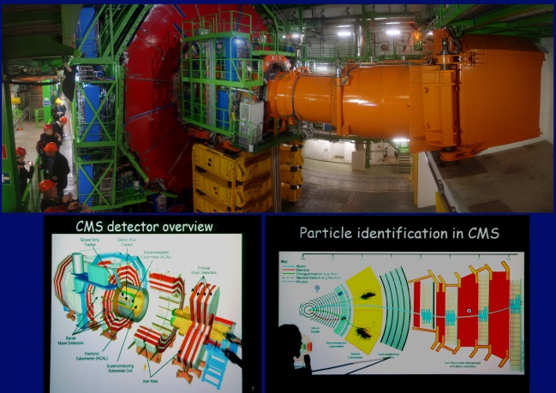
There are three main types of particle accelerators:
- linear accelerators
- cyclotrons
- synchrotrons

Regardless of whether the particle accelerator is linear or circular, the basic parts are the same:

- a source of particles (these may come from another accelerator)
Accelerators using electrons use thermionic emission in the same way as a cathode ray tube. At the Large Hadron Collider (LHC) at CERN the source of particles is simply a bottle of hydrogen gas. Electrons are stripped from the hydrogen atoms leaving positively charged protons. These are then passed through several smaller accelerator rings before they reach the main beam pipe of the LHC.

- beam pipes (also called the vacuum chamber)
Beam pipes are special pipes which the particles travel through while being accelerated. There is a vacuum inside the pipes which ensures that the beam particles do not collide with other atoms such as air molecules.

- accelerating structures (a method of accelerating the particles)
As the particles speed around the beam pipes they enter special accelerating regions where there is a rapidly changing electric field. At the LHC, as the protons approach the accelerating region, the electric field is negative and the protons accelerate towards it. As they move through the accelerator, the electric field becomes positive and the protons are repelled away from it. In this way the protons increase their kinetic energy and they are accelerated to almost the speed of light.

- a system of magnets (electromagnets or superconducting magnets as in the LHC)
Newton’s first law states that an object travels with a constant velocity (both speed and direction) unless acted on by an external force. The particles in the beam pipes would go in a straight line if they were not constantly going past powerful, fixed magnets which cause them to travel in a circle. There are over 9000 superconducting magnets at the LHC in CERN. These operate best at temperatures very close to Absolute Zero, (0 K), and this is why the whole machine needs to be cooled down. If superconducting magnets were not used, they would not be able to steer and focus the beam within such a tight circle and so the energies of the protons which are collided would be much lower.

- a target
In some accelerators the beam collides directly with a stationary target, such as a metal block. In this method, much of the beam energy is simply transferred to the block instead of creating new particles. In the LHC, the target is an identical bunch of particles travelling in the opposite direction. The two beams are brought together at four special points on the ring where massive detectors are used to analyse the collisions.

Notice CERN has a whole lot of particle accelerators, linear accelerators, cyclotrons and synchrotrons. To find out more connect to the links below:
https://home.cern/about/physics and do a search for particle accelerators
https://www.energy.gov/articles/how-particle-accelerators-work
https://www.youtube.com/watch?v=b6CqmHREE1I

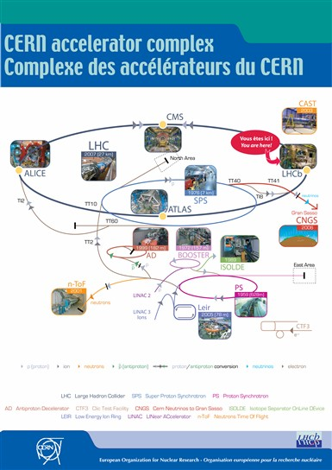
Figure 13: Courtesy of CERN

Introducing a new energy unit
In the physics of the everyday we measure energy in the SI units of joules. Often in large-scale industries we result in use of, mega- or terajoules. In particle physics, the energies involved are tiny in comparison and would be difficult to manage so it is traditional to use a different unit, known as the ‘electronvolt’, or eV. From the formula, E=QV, if we accelerate an electron, which is electrically charged by a potential difference of one-volt, it will gain an energy of 1.6 × 10⁻¹⁹ J. This is what we define as 1 electronvolt. The latest experiments at CERN particle accelerators are generating energies that are entering the ‘tera’ or 10¹² eV, 1 TeV, region, (but remember this is still only approximately 10⁻⁷ J, and a packet of crisps contains approximately 0.5MJ).
Einstein’s famous equation E = mc² tells us that energy can be exchanged for mass, and vice versa, the ‘exchange rate’ being c². The electron has a mass of 9 × 10⁻³¹ kg. Once again such numbers are messy and so we use E = mc² to quantify mass and energy which gives about 0.5 MeV for the energy of a single electron at rest; we traditionally state its mass as 0.5 MeV/c². The mass of a proton in these units is 938 MeV/c², which is nearly 1 GeV/c².

1 eV = 1.6 × 10⁻¹⁹ J

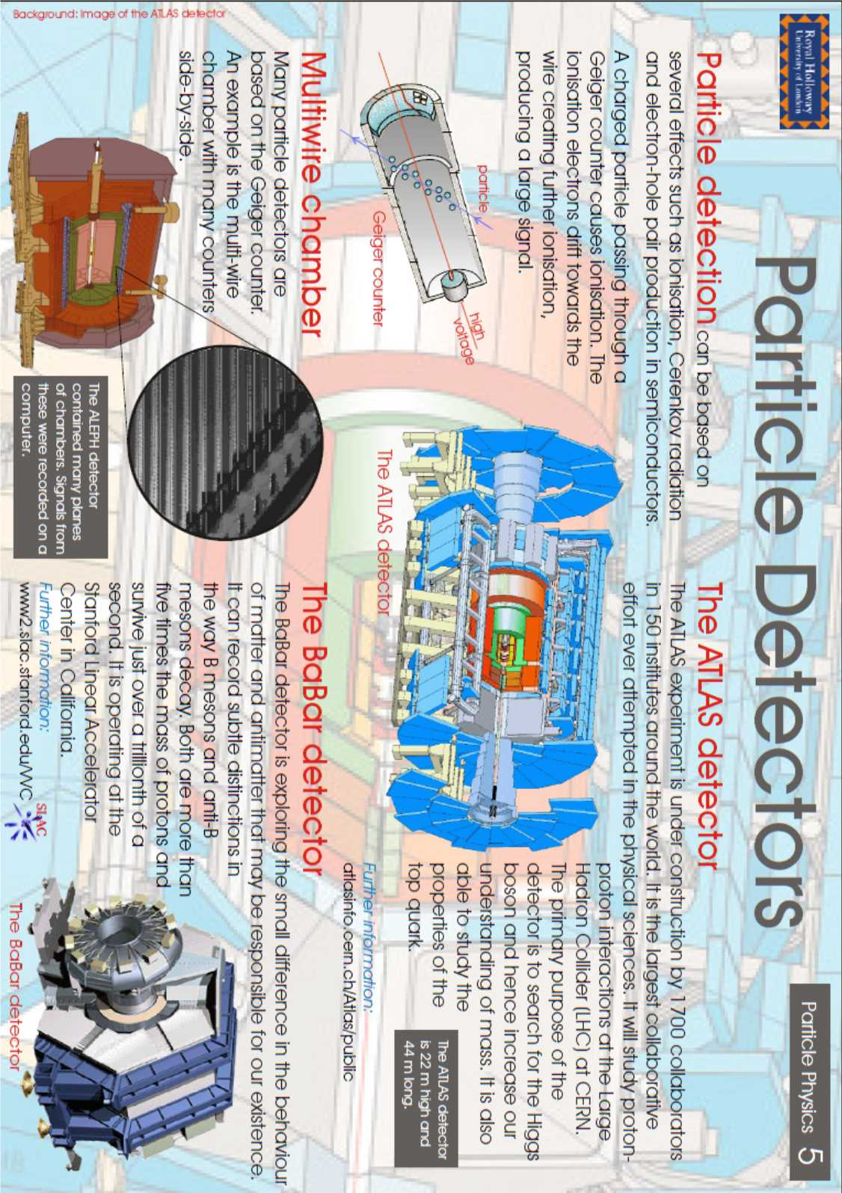

Tutorial 2 Forces on charged particles
In the following questions, when required, use the following data:
Charge on electron = –1·60 × 10⁻¹⁹ C Mass of electron = 9·11 × 10⁻³¹ kg
Charge on proton = 1·60 × 10⁻¹⁹ C Mass of proton = 1·67 × 10⁻²⁷ kg

electric fields

1. Draw the electric field pattern for the following point charges and pair of charges:
(a) (b) (c)

2. Describe the motion of the small positive test charges in each of the following fields.
(a) (b)

(c) (d)

3. An electron volt (eV) is a unit of energy. It represents the change in potential energy of an electron that moves through a potential difference of 1 V. What is the equivalent energy of 1 eV in joules?
4. An electron has energy of 5 MeV. Calculate its energy in joules.

5. The diagram shows an electron accelerates between two parallel conducting plates A and B.
The p.d. between the plates is 500 V.

(a) Calculate the electrical work done in moving the electron from plate A to plate B.
(b) How much kinetic energy has the electron gained in moving from A to B?
(c) What is the speed of the electron just before it reaches plate B?

6. Electrons are ‘fired’ from an electron gun at a screen.
The p.d. across the electron gun is 2000 V.
The electron gun and screen are in a vacuum.
After leaving the positive plate the electrons travel at a constant speed to the screen.
Calculate the speed of the electrons just before they hit the screen.

7. A proton is accelerated from rest across a p.d. of 400 V. Calculate the increase in speed of the proton.

8. In an X-ray tube electrons forming a beam are accelerated from rest and strike a metal target.
The metal then emits X-rays. The electrons are accelerated across a p.d. of 25 kV. The beam of electrons forms a current of 3·0 mA.
(a) (i) Calculate the kinetic energy of each electron just before it hits the target.
(ii) Calculate the speed of an electron just before it hits the target.
(iii) Find the number of electrons hitting the target each second.
- What happens to the kinetic energy of the electrons?

9. Sketch the paths which
(a) an alpha-particle, (b) a beta-particle, (c) a neutron
would follow if each particle, with the same velocity, enters the electric fields shown in the diagrams.

Charged particles in a magnetic field
1. An electron travelling with a constant velocity enters a region where there is a uniform magnetic field. There is no change in the velocity of the electron. What information does this give about the magnetic field?

2. The diagram shows a beam of electrons as it enters the magnetic field between two magnets.
The electrons will:
A be deflected to the left (towards the N pole)
beam of
electrons
N
S
S
N
B be deflected to the right (towards the S pole)
C be deflected upwards
D be deflected downwards
E have their speed increased without any change in direction.

3. The diagrams show particles entering a region where there is a uniform magnetic field.

Use the terms: up, down, into the paper, out of the paper, left, right, no change in direction to describe the deflection of the particles in the magnetic field.

(a)
electron
magnetic field
(b)
magnetic field
alpha particle
(c)
neutron
magnetic field
(d)
proton
magnetic field
electron
magnetic field
(e)
proton
magnetic field
(f)
electron
x

x
x
x

x
x

x
x
x
x
x

x
x
x
x
x

x
x
x
x
x

x
x
x
x
magnetic field
(g)
proton
x

x

x

x

x

x

x

x

x

x

x

x

x

x

x

x

x

x

x

x

x

x

x

x

x

magnetic field
(h)

4. An electron enters a region of space where there is a uniform magnetic field. As it enters the field the velocity of the electron is at right angles to the magnetic field lines.
The energy of the electron does not change although it accelerates in the field.
Use your knowledge of physics to explain this effect.

Particle Accelerators
1. In an evacuated tube, an electron initially at rest is accelerated through a p.d. of 500 V.
(a) Calculate, in joules, the amount of work done in accelerating the electron.
(b) Calculate the kinetic energy gained by the electron.
(c) Calculate the final speed of the electron.

2. In an electron gun, electrons in an evacuated tube are accelerated from rest through a potential difference of 250 V.
(a) Calculate the energy gained by an electron.
(b) Calculate the final speed of the electron.

3. Electrons in an evacuated tube are ‘fired’ from an electron gun at a screen. The p.d. between the cathode and the anode of the gun is 2000 V. After leaving the anode, the electrons travel at a constant speed to the screen. Calculate the maximum speed at which the electrons will hit the screen.

4. A proton, initially at rest, in an evacuated tube is accelerated between two charged plates A and B. It moves from A, where the potential is 10 kV, to B, where the potential is zero.
Calculate the speed of the proton at B.

5. A linear accelerator is used to accelerate a beam of electrons, initially at rest, to high speed in an evacuated container. The high- speed electrons then collide with a stationary target. The accelerator operates at 2·5 kV and the electron beam current is 3 mA.
(a) Calculate the gain in kinetic energy of each electron.
(b) Calculate the speed of impact of each electron as it hits the target.
(c) Calculate the number of electrons arriving at the target each second.
(d) State a reason for accelerating particles to high speed and allowing them to collide with a target.

6. The power output of an oscilloscope (cathode-ray tube) is estimated to be 30 W. The potential difference between the cathode and the anode in the evacuated tube is 15 kV.
(a) Estimate the number of electrons striking the screen per second.
(b) Calculate the speed of an electron just before it strikes the screen, assuming that it starts from rest and that its mass remains constant.

7. In an oscilloscope electrons are accelerated between a cathode and an anode and then travel at constant speed towards a screen. A p.d. of 1000 V is maintained between the cathode and anode. The distance between the cathode and anode is 5·0 × 10⁻³ m. The electrons are at rest at the cathode and attain a speed of 1·87 × 10⁷ m s⁻¹ on reaching the anode. The tube is evacuated.
(a) (i) Calculate the work done in accelerating an electron from the cathode to the anode.
(ii) Show that the average force on the electron in the electric field is 3·20 × 10⁻¹⁵ N.
(iii) Calculate the average acceleration of an electron while travelling from the cathode to the anode.
(iv) Calculate the time taken for an electron to travel from cathode to anode.
(v) Beyond the anode the electric field is zero. The anode to screen distance is 0·012 m. Calculate the time taken for an electron to travel from the anode to the screen.
(b) (i) Another oscilloscope has the same voltage but a greater distance between cathode and anode. State whether the speed of the electrons be higher, lower or remain at 1·87 × 10⁷ m s⁻¹? Explain your answer.
(ii) State whether the time taken for an electron to travel from cathode to anode be increased, decreased or stay the same as in (a) (iv)? Explain your answer.

8. In an X-ray tube a beam of electrons, initially at rest, is accelerated through a potential difference of 25 kV. The electron beam then collides with a stationary target. The electron beam current is 5 mA.
(a) Calculate the kinetic energy of each electron as it hits the target.
(b) Calculate the speed of the electrons at the moment of impact with the target assuming that the electron mass remains constant.
(c) Calculate the number of electrons hitting the target each second.
(d) What happens to the kinetic energy of the electrons?

9. Copy the diagram below and sketch the path that (a) an electron, (b) a proton and (c) a neutron would follow if each particle entered the given electric fields with the same velocity. Label each path.
Path of particles
+ + + + + + + + + + +
− − − − − − − − − − −
10. In the following examples identify the charge of particle (positive or negative) which is rotating in a uniform magnetic field. (X denotes magnetic field into page and • denotes magnetic field out of page.)
(a)

X
X
X
X
X
X
X
X
X
X
X
X
X
X
X
X

(a)
(b)
(c)
(d)
X
X
X
X
X
X
X
X
X
X
X
X
X
X
X
X
11. Answer the following question in your notes jotter as a summary of particle accelerators. In the following descriptions of particle accelerators, some words and phrases have been replaced by the letters A to R. Choose the correct word or phrase from the list given for each letter.

In a linear accelerator bunches of charged particles are accelerated by a series of ____A____. The final energy of the particles is limited by the length of the accelerator.
This type of accelerator is used in ____B____ experiments.
In a cyclotron the charged particles are accelerated by ____C____. The particles travel in a ____D____ as a result of a ____E____, which is ____F____ to the spiral. The radius of the spiral increases as the energy of the particles ____G____. The diameter of the cyclotron is limited by the ____H____ of the magnet. The resultant energy of the particles is limited by the diameter of the cyclotron and by ____I____.
This type of accelerator is used in ____J____ experiments.
In a synchrotron bunches of charged particles travel in a ____K____ as a result of C shaped magnets whose strength ____L____. The particles are accelerated by ____M____.
As the energy of the particles increases the strength of the magnetic field is ____N____ to maintain the radius of the path of the particles. In synchrotron accelerators the particles can have, in theory, an unlimited series of accelerations as the particles can transit indefinitely around the ring. There will be a limit caused by ____O____.
In this type of accelerator particles with ____P____ mass and ____Q____ charge can circulate in opposite directions at the same time before colliding. This increases the energy of impact. This type of accelerator is used in ____R____ experiments.
From the table below choose the correct words or phrases to replace the letters.
Letter | List of replacement word or phrase
A, C, E, M | constant magnetic field, alternating magnetic fields, alternating electric fields, constant electric fields
B, J, R | colliding-beam, fixed-target
D, K | spiral of decreasing radius, spiral of increasing radius, circular path of fixed radius
F | perpendicular, parallel
G | decreases, increases
H | physical size, strength
I, O | gravitational effects, relativistic effects
L | can be varied, is constant
N | decreased, increased
P, Q | the same, different

Exam Questions
NQ Specimen Paper
Q13 The diagram represents the electric field around a single point charge.
A student makes the following statements about this diagram.
I The separation of the field lines indicates the strength of the field.
II The arrows on the field lines indicate the direction in which an electron would move if placed in the field.
III The point charge is positive.

Which of these statements is/are correct?
A I only
B II only
C I and III only
D II and III only
E I, II and III

8. A linear accelerator is used to accelerate protons.
The accelerator consists of hollow metal tubes placed in a vacuum.
The diagram shows the path of protons through the accelerator.
Protons are accelerated across the gaps between the tubes by a potential difference of 35 kV.
(a) The protons are travelling at 1∙2 x 10⁶ m s⁻¹ at point R.
(i) Show that the work done on a proton as it accelerates from R to S is 5∙6 x 10⁻¹⁵ J.
(ii) Calculate the speed of the proton as it reaches S.
        - Suggest one reason why the lengths of the tubes increase along the accelerator.

SQA 2017 Q8
X-ray machines are used in hospitals. An X-ray machine contains a linear accelerator that is used to accelerate electrons towards a metal target.

The linear accelerator consists of hollow metal tubes placed in a vacuum.
Electrons are accelerated across the gaps between the tubes by an alternating supply.
(a) (i) Calculate the work done on an electron as it accelerates from P to Q.
(ii) Explain why an alternating supply is used in the linear accelerator.
        - The electron beam is then passed into a “slalom magnet” beam guide.
The function of the beam guide is to direct the electrons towards a metal target.
Inside the beam guides R and S, two different magnetic fields act on the electrons.
Electrons strike the metal target to produce high energy photons of radiation.
(i) Determine the direction of the magnetic field inside beam guide R.
(ii) State two differences between the magnetic fields inside beam guides R and S.
(c) Calculate the minimum speed of an electron that will produce a photon of energy 4·16 ⋅ 10⁻¹⁷ J.

SQA 2018 Q10
A proton enters a region of magnetic field as shown.
On entering the magnetic field the proton
A deflects into the page
B deflects out of the page
C deflects towards the top of the page
D deflects towards the bottom of the page
E is not deflected.

Q6 An experiment is set up to demonstrate a simple particle accelerator.

Electrons are accelerated from rest between the cathode and the anode by a potential difference of 1·6 kV.

(i) Show that the work done in accelerating an electron from rest is 2·6 × 10⁻¹⁶ J.
(ii) Calculate the speed of the electron as it reaches the anode.
        - As the electrons travel through the vacuum towards the fluorescent screen they spread out. In the path of the electrons there is a metal cross, which is connected to the positive terminal of the supply. The electrons that hit the cross are stopped by the metal. Electrons that get past the metal cross hit a fluorescent screen at the far side of the tube.
When electrons hit the fluorescent screen, the screen glows.
The potential difference between the anode and the cathode is now increased to 2∙2 kV. This changes what is observed on the screen. Suggest one change that is observed.
(c ) A student builds a model of a particle accelerator. The model accelerates a small ball on a circular track. A battery-operated motor accelerates the ball each time it passes the motor. To cause a collision a plastic block is pushed onto the track. The ball then hits the block.

Forces on Charged Particle Tutorial Answers

Tutorial 1 – Motion in Fields
1
- (i) The electron will curve out of the page. (ii) The electron will curve to its right. (to the left as we look at it) (iii) There will be no change in the direction of the particle as the neutron has no charge.
- (i) The alpha particle will curve into the page (ii) The alpha particle will curve to its left (to the right as we look at it). (iii) the alpha particle will move upwards
2.
(a) This obey’s the Right hand motor rule or the left hand slap rule
(b) In figure 2 the force should be drawn acting vertically downwards, in figure 3 the force should be drawn acting vertically upwards.
(c) 1 The electron current should be shown in the directions of WXYZ round the coil.
2 The force on WX is drawn acting vertically upwards. The force on YZ is drawn acting vertically downwards.
3. When viewed along the direction PQ the coil rotates in a clockwise direction.
(d,ii) More coils allows for smoother rotation, (ii) Allows for the motor to work on a.c.

3 (a)
(b)
B
e-
The force is directed into the page.

4. Out of the page
5. into the page
6.

B
e-

        - Into the page

B
p+

There will be no force on the alpha particle as it is travelling parallel to the magnetic field.

Tutorial Answers
Electric fields
3. 1·6 × 10⁻¹⁹ J
4. 8·0 × 10⁻¹³ J
5. (a) 8·0 × 10⁻¹⁷ J , (b) 8·0 ×10⁻¹⁷ J, (c) 1·3 × 10⁷ m s ^{−1 ¶}
6. 2·65 × 10⁷ m s ⁻¹
7. 2·76 × 10⁵ m s ⁻¹
8. (a) (i) 4·0 × 10¹⁵ J , (ii) 9·4 × 10⁷ m s⁻¹ , (iii) 1·9 × 10¹⁶
Charged particles in a magnetic field
1. Magnetic field is in the same plane and in the same or opposite direction to the velocity of the electron.
2. C: be deflected upwards
3. (a) no change in direction, (b) out of the paper , (c) into the paper
(d) no change in direction (e) up, (f) left
(g) left , (h) down
Particle accelerators
1. (a) 8 × 10⁻¹⁷ J , (b) 8 × 10⁻¹⁷ J , (c) 1·33 × 10⁷ m s ⁻¹
2. (a) 4 × 10⁻¹⁷ J , (b) 9·37 × 10⁶ m s ⁻¹
3. 2·65 × 10⁷ m s ⁻¹
4. 1·38 × 10⁶ m s ⁻¹
5. (a) 4 × 10⁻¹⁶ J , (b) 2·96 × 10⁷ m s ⁻¹ , (c) 1·88 × 10¹⁶
6. (a) 1·25 × 10¹⁶ , (b) 7·26 × 10⁷ m s ⁻¹
7. (a) (i) 1·6 × 10⁻¹⁶ J
(iii) 3·51 × 10¹⁵ m s ⁻²
(iv) 5·34 × 10⁻⁹ s
(v) 6·42 × 10⁻⁹ s
(b) (i) Same since Q and V same
(ii) Longer since acceleration is smaller
8. (a) 4·0 × 10⁻¹⁵ J , (b) 9·37 × 10⁷ m s ⁻¹, (c) 3·12 × 10¹⁶
(d) Heat and X-rays are produced
9. (a) Electron accelerated towards positive plate
(b) Proton accelerated towards negative plate but less curved than that of electron
(c) Neutron straight through.
10. (a) Negative , (b) Positive , (c) Positive, (d) Negative
11. A = alternating electric fields; B = fixed-target; C = alternating electric fields; D = spiral of increasing radius; E = constant magnetic field; F = perpendicular; G = increases; H = physical size; I = relativistic effects; J = fixed-target; K = circular path of fixed radius; L = can be varied; M = alternating magnetic fields; N = increased; O = relativistic effects; P = the same; Q = opposite; R = colliding beam.

EXAM PAPER ANSWERS
NQ Specimen Paper Q13 C
NQ Specimen Paper Q8

SQA H 2017 Q8
8. | (a) | (i) | W or EW = QV  = 1·60 × 10⁻¹⁹ × 2·50 × 10³  = 4·00 ×10⁻¹⁶ J | 3 | Suspend significant figure rule and accept J. Ignore negative sign for charge.

(ii) | Particle (always) accelerates in the same direction/forwards  OR  Force on particle/electron is always in same direction  OR  Ensure the direction of the electric field is correct when particle/ electron passes between (alternate) gaps |  |  |  | 1 | Candidate must make some implication of ‘same direction’.
(b) | (i) |  | Out of page | 1 |  |  | Do not accept:  ‘upwards’ on its own, OR  ‘out of the page’ with other comments such as ‘circular’ ‘clockwise’.
(ii) | (Magnetic fields are in) opposite directions  (Magnetic field in) S is stronger than (field in) R |  |  |  | 2 | Independent marks  Or consistent with (b)(i) for first mark as long as a linear field is described.  Accept statement referring to direction of (magnetic field in) S alone ONLY if (b)(i) has been answered.  Do not accept:  ‘different directions’  ‘force in S is opposite to force in R’ alone.
(c) |  | $$E_{K} =\frac{1}{2}mv^{2}$$  4·16 × 10⁻¹⁷ = ½ × 9·11 x 10⁻³¹ × v²  v = 9·56 × 10⁶ ms⁻¹

SQA 2018 Q10 C
SQA 2018 Q6
2 4 10 m s-1 Accept: 2, 2·39, 2·389
(b) Screen will be brighter/increase glow. (1) Electrons will gain more energy/move faster.
OR Increase in number of electrons per second. (1)

CHAPTER 4: NUCLEAR REACTIONS

SUMMARY OF CONTENT

No | CONTENT
Nuclear reactions
 | $$E=mc^{2}$$
 | I can use nuclear equations to describe radioactive decay, fission (spontaneous and induced), with reference to mass and energy equivalence.
 | I can use nuclear equations to describe fusion reactions, with reference to mass and energy equivalence.
 | Use of an appropriate relationship to solve problems involving the mass loss and the energy released by a nuclear reaction. $E=mc^{2}$
 | I know that nuclear fusion reactors require charged particles at a very high temperature (plasma) which have to be contained by magnetic fields.

http://www.world-nuclear.org/info/inf66.html

Before we can work on fusion and fission equations we must learn some terms. Some of these were covered in the standard model notes.

Nucleon A nucleon is a particle in a nucleus, i.e. either a proton or a neutron.
Atomic Number The atomic number, Z, equals the number of protons in the nucleus. In a chemical symbol for an element it is written as a subscript before the element symbol.
Decay The process of emitting radiation
Isotope Isotopes are nuclides of the same atomic number but different mass numbers, i.e. nuclei containing the same number of protons but different numbers of neutrons.
Mass Number The mass number, A, is the number of nucleons in a nucleus. In a chemical symbol for an element it is written as a superscript before the element symbol.
Radioactive decay The breakdown of a nucleus to release energy and matter from the nucleus. This is the basis of the word ‘nuclear’. The release of energy and/or matter allows unstable nuclei to achieve stability.
Radioisotopes or radionuclides. Unstable nuclei

Radioactive decay
Many nuclei are unstable. In order to achieve stability, they can emit nuclear radiation: alpha, beta or gamma, neutrons etc.
The following is a summary of the nature and symbols for types of nuclear radiation. Notice that gamma radiation has zero mass and zero charge.
Radiation | Nature | Symbol
Alpha particle | Helium nucleus | α
Beta particle | Fast electron | β / β-
Positron | The antiparticle of an electron | β+
Gamma ray | High frequency electromagnetic wave | γ

The mass numbers, charges and symbols for protons, neutrons and electrons and positrons are given below.

Particle | Mass number | Charge | Symbol
Proton | 1 | +1
Neutron | 1 | 0
Electron | 0* | -1
Positron | 0* | +1

* mass of electron = 1/1840 mass of proton. The mass number is given in terms of the mass of a proton where one proton is given the number 1. In reality a proton has a mass of 1.67262158 × 10⁻²⁷ kilograms, a neutron a mass of 1.674929 x 10⁻²⁷ kg

Each element has a set number of protons, eg Hydrogen always has just 1 proton, Carbon always 6. Usually the number of protons is equal to the number of electrons, (if no.p ≠ no.e then it is an ion - but that is chemistry!)

The number of neutrons in the nucleus of any element is usually the same but can sometimes vary. We call these isotopes, eg carbon usually has 6 neutrons but can have 8.
In small nuclei, no. of protons is often = no. of neutrons
In larger nuclei no. of protons < no. of neutrons

We can represent each type of atom in the following way
where
A = mass number (no. of protons +neutrons)
Z = atomic number (no.of protons)
X = symbol to represent the atom, either 1 capital letter or one capital followed by 1 lower case letter.
You can work out the number of neutrons by subtracting the atomic number from the mass number

eg no. of neutrons = A-Z

Nuclear Radiation
Nuclear Radiation e.g. α particles, β particles, γ radiations and neutrons and neutrinos originate from the nucleus. Like chemical reactions, nuclear reactions can be recorded in the form of equations. The mass and atomic number must be conserved.

α-particles
An α particle comprises 2 protons and 2 neutrons, so it is equivalent to a helium nucleus and can be written. They travel at approximately 1/10th c. The α particle is therefore the most massive type of nuclear radiation.
http://www.atomicarchive.com/Physics/Physics1.shtml

β-particles
A β particle is equivalent to an electron. It is not one of the electrons in the outer shell. There are two types of beta decay, beta plus and beta minus. In beta plus a positron is emitted and a neutrino and in beta minus decay a beta particle and an antineutrino is released. Beta decay is evidence for the neutrino. In beta decay an electron is emitted from the nucleus. How can this be when there are no electrons in the nucleus? A neutron decays to a proton and an electron is emitted. This means the atomic number of the nucleus increases by one (therefore creating a new nucleus and element) but the mass number stays the same, since the nucleus contains the same number of nucleons. Beta decay also involves the emission of an anti-neutrino. There are two types of beta decay known as beta minus and beta plus. After beta minus (β−) decay there is one less neutron in the atom and one additional proton is formed: the process produces an electron and electron antineutrino, whilst beta plus (β+) decay results in one less proton and an additional neutron form: the process produces a positron and electron neutrino; β+ decay is thus also known as positron emission.

NEUTRON → PROTON + ELECTRON (OR β particle) ANTINEUTRINO
±
+
+
−
+

$${}_{0}^{1}{n → {}_{1}^{1}{p + {}_{-1}^{0}e} +{}_{0}^{0}{\overline{υ}} } OR {}_{0}^{1}{n → {}_{1}^{1}{p + {}_{-1}^{0}e} +\overline{ν} }$$

A β-particle can be represented by. It has a negligible effect on the atomic mass. β-particles can travel up to 9/10th the speed of light. Note that the mass number remains unaltered but the atomic number increases by 1. As the anti-neutrino is neutral its release does not affect the balancing of the equation. Neutrinos are written with 0 mass number and 0 atomic number. Rutherford discovered beta decay in 1899, but the neutrino was not discovered until the 1960s.
With positron emission the mass number stays the same and the atomic number goes down by 1. Positron decay involves the emission of a neutrino which does not affect the equation.$${}_{1}^{1}{p → {}_{0}^{1}{n + {}_{+1}^{0}e} +{}_{0}^{0}υ OR {}_{1}^{1}{p → {}_{0}^{1}{n + {}_{+1}^{0}e} +ν } }$$
An example of electron emission (β− decay) is the decay of carbon-14 into nitrogen-14:
$${}_{6}^{14}C→{}_{7}^{14}{N+{}_{-1}^{0}{e+ }{}_{0}^{0}{\overline{υ}}}$$
An example of positron emission (β+ decay) is the decay of carbon-11 into boron-11:
$${}_{6}^{11}C→{}_{5}^{11}{B+{}_{+1}^{0}{e+{}_{0}^{0}υ }}$$
http://www.atomicarchive.com/Physics/Physics7.shtml

γ radiation
Changes in the internal structure of a nucleus can cause the release of large quantities of electromagnetic radiation. This radiation has a high frequency and is called γ-radiation. γ radiation has no mass and is part of the electromagnetic spectrum.
http://www.atomicarchive.com/Physics/Physics8.shtml

Neutron
Neutrons can be emitted from the nucleus and are represented by the symbol , they carry no charge but are slightly heavier than the proton at 1.675 ×10⁻²⁷ kg compared to
1.673 ×10⁻²⁷ kg

Equations for nuclear radiation
When a nucleus decays, it often undergoes several disintegrations until it becomes stable, e.g. Uranium 238 decays to Thorium 234 emitting α and γ radiation. The thorium then decays to protactinium-234 emitting β & γ.

+ antineutrino

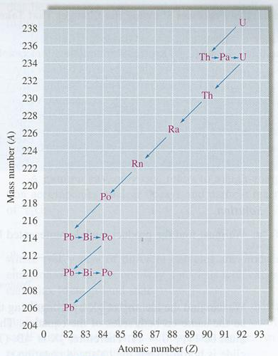
These processes are taking place at the same time with the same bit of Uranium-238
The decay series of a number of nuclei can be represented on a graph of A against Z (mass number against atomic number) Alpha particle emission is seen on the graph as a line from the right to left in a downwards direction; beta is a zero gradient from left to right. Gamma, as energy in the form of a wave has no effect on either the mass or atomic number so will not be indicated on this graph.
This decay series, of U (uranium) to Pb (lead) consists of the following
αββααααα
ββαββα

SUMMARY
These nuclear reactions can be summarised in the table.
Particle | Symbol | Changes to  Mass No, A. | Changes to  Atomic No. Z
α |  | -4 | -2
- / β- |  | 0 | +1
β+ |  | 0 | -1
γ | γ | 0 | 0
 |  | -1 | 0

NUCLEAR FISSION & FUSION

The emission of α, β and γ radiations from radioactive nuclei occurs in a random manner and is a natural process over which scientists have no control. Earlier in the twentieth century physicists found they could “break up” atomic nuclei by bombarding them with other particles.

Fission
http://www.atomicarchive.com/Physics/Physics9.shtml

One experiment involved bombarding lithium nuclei with hydrogen nuclei (protons).
proton
lithium nucleus
bombardment produces unstable beryllium nucleus
unstable nucleus divides into two α-particles moving apart at high speed

The splitting of the nucleus in this way is called nuclear fission.
The fission of the lithium nucleus can be represented as follows:
A nucleus of large mass number splits into two nuclei (called daughter products) of small mass numbers along with several neutrons. This process may be spontanteous (left) or induced (see below) by neutron bombardment.
http://www.atomicarchive.com/Fission/Fission1.shtml
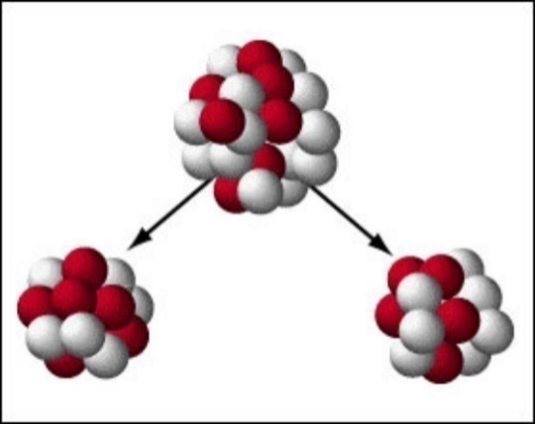
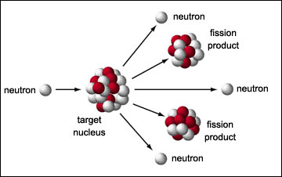
Figure 14: Spontaneous fission
Figure 15: Induced fission

eg

Physicists, using a piece of apparatus called a mass spectrometer, are able to measure the masses of the particles involved in the reaction very accurately. It is found that the mass of the particles after the reaction is less than the mass of the particles before the reaction.

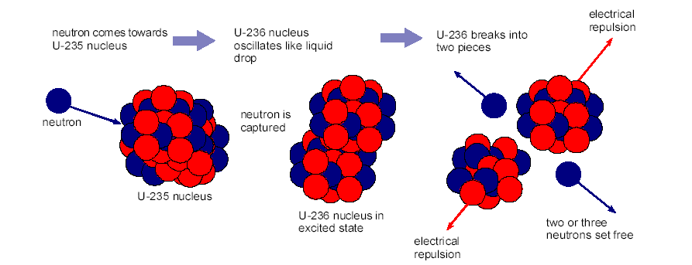

We can investigate the masses of the particles involved in a decay using accurate values for the atomic masses.
Looking at one of the examples from above
Mass Before | Mass after
3.90088×10⁻²⁵ kg | 1.6249×10⁻²⁵ kg
1.6749×10⁻²⁷ kg | 2.2556×10⁻²⁵ kg
Total 3.917629×10⁻²⁵ kg | 3.3498×10⁻²⁷ kg
 | 3.32×10⁻³⁰ kg
 | Total 3.914031×10⁻²⁵ kg
Mass is not conserved mass is lost and since mass has been lost and kinetic energy has been gained we conclude that the mass has been converted into energy. The kinetic energy of the products is found to be much greater than the initial kinetic energy of the reactants. The loss of mass has been accompanied by a huge increase in energy.
In our example
mass change = mass before – mass after
mass change = 3.917629×10⁻²⁵ kg - 3.914031×10⁻²⁵ kg
mass change = 3.598×10⁻²⁸ kg
For each nucleus that splits following this equation 3.24×10⁻¹¹ Joules of energy are released. This is a very small amount of energy but remember that this is for one individual nucleus.
Notice that when the splits it releases 2 further neutrons. These in turn can split two further . This leads to a chain- reaction.

Example for you to try:
How much energy is released when a radium nucleus decays to Radon releasing an alpha particle?
Radium = 3.8520 ×10⁻²⁵ kg
Radon = 3.6855×10⁻²⁵ kg
Helium Nucleus = 16.6443×10⁻²⁷ kg
(answer = 5.70×10⁻³⁰ kg, 5.13×10⁻¹³J)

Containing the Fission Reaction
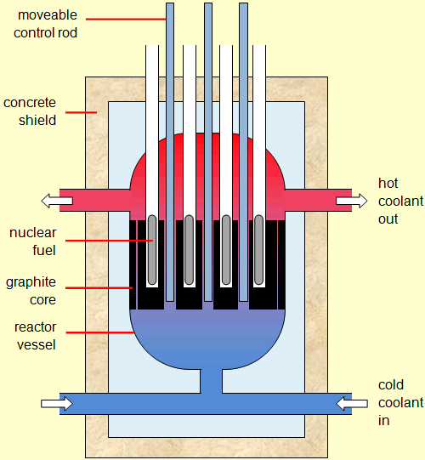
Controlled fission reactions take place in nuclear reactors. The neutrons released are fast moving. A moderator, e.g. graphite, is used to slow them down and increase the chance of further fissions occurring. These slow (thermal) neutrons cause a chain reaction so that more fission reactions occur.
Figure 16: www.edulink.networcs.net/sites/teachlearn/science/Image%20Library/Forms/DispForm.aspx?ID=49
Control rods, e.g. boron, absorb some of the slow neutrons and keep the chain reaction under control. The energy of the moving fission products is transferred by heating in the reactor core. A coolant fluid (liquid or gas) is required to avoid the core overheating and in addition it can act as a moderator. The hot fluid is then used to produce steam which drives turbines to generate electricity.
Fission reactors require containment within reinforced concrete and lead-lined containers to reduce contamination.

Task
Using your prior knowledge of specific latent heat, you should be able to explain why turning the fluid into steam cools the reactor core.

Fusion
Two light nuclei combine to form a nucleus of larger mass number. This occurs when the nuclei are small. The diagram illustrates the fusion of deuterium and tritium.
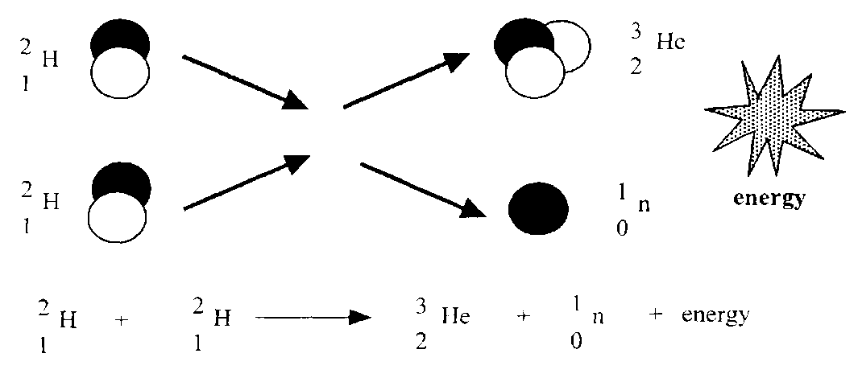
When these fusion reactions occur, although the equation always balances, the mass before the reaction is always more than the mass of the products after the reaction. There is a MASS DIFFERENCE. This missing mass is converted to energy according to Einstein Equation, E=mc²
The nuclear reaction can be represented by:
deuterium + tritium α-particle + neutron + energy
Once again it is found that the total mass after the reaction is less than the total mass before. This reduction in mass appears as an increase in the kinetic energy of the particles.
Mass before fusion (m₁): | deuterium | 3·345 × 10⁻²⁷ kg
 | tritium | 5·008 × 10⁻²⁷ kg
 | Total | 8·353 × 10⁻²⁷ kg
Mass after fusion (m₂): | α-particle | 6·647 × 10⁻²⁷ kg
 | neutron | 1·675 × 10⁻²⁷ kg
 | total | 8·322 × 10⁻²⁷ kg
Loss of mass (m₁ - m₂): | Δm | 0·031 × 10⁻²⁷ kg
Energy released |  | E =Δmc²
 |  | =0·031 × 10⁻²⁷ × (3·0 × 10⁸)²
 |  | =2·8 × 10⁻¹² J
Large quantities of energy can be released only if millions of nuclei are fused at once. The sun releases its energy through vast numbers of hydrogen nuclei fusing into helium every second.

Cookie Fusion
This activity was provided by GUZLED
Aim: To replicate a nuclear fusion reaction, using cookie dough.
Theory
Nuclear Fusion | Cookie Fusion
Two equally-sized protons are brought together by providing heat from electromagnetic waves in a fusion reactor. | Two equally-sized lumps of cookie dough are brought together by providing heat from electromagnetic waves in a microwave.
The nuclear reaction results in a mass loss, which is converted to heat energy. | The cookie reaction results in a mass loss, which is carried away as water
Apparatus Required
- Cookie dough
- Greaseproof paper
- Electronic balance
- Microwave
Method
            - Cut two squares of cookie dough, each about 2cm²
            - Place them on the greaseproof paper, about 1cm apart.
            - Place the cookie dough squares and the greaseproof paper on the electronic balance. Record their mass in the table below.
            - Place you cookie dough in the microwave for about 1 minute (until you see them “fuse” together).
            - Let your cookie cool until they can be safely removed from the microwave.
            - Place the fused cookie and the greaseproof paper onto the electronic balance. Record the mass in the table below.
            - Calculate the mass released in this cookie reaction.
Data
 | Mass Before Cooking (g) | Mass After Cooking (g)
Cookie Square 1 (Proton1)
Cookie Square 2 (Proton 2)
Fused Cookie (New Element)

Questions
- Use the data in the table above to calculate the mass loss in this fusion reaction.
- State the similarities and difference between cookie fusion and nuclear fusion.

Nuclear fusion: energy of the future?
TASK
Watch the following short talk ‘Fusion is energy’s future’ by physicist Steven Cowley, chief executive officer of the United Kingdom Atomic Energy Authority and head of the EURATOM/CCFE Fusion Association at http://www.ted.com/talks/lang/eng/steven_cowley_fusion_is_energy_s_future.html
Read the article at
http://www.guardian.co.uk/commentisfree/2010/jul/16/fusion-power-research-funding
Fusion powers the Sun and stars as hydrogen atoms fuse together to form helium, and matter is converted into energy. Hydrogen, heated to very high temperatures, changes from a gas to a plasma in which the negatively charged electrons are separated from the positively charged atomic nuclei (ions). Normally, fusion is not possible because the strongly repulsive electrostatic forces between the positively charged nuclei prevent them from getting close enough together for fusion to occur. However, if the conditions are such that the nuclei can overcome the electrostatic forces to the extent that they can come within a very close range of each other then the attractive nuclear force (which binds protons and neutrons together in atomic nuclei) between the nuclei will outweigh the repulsive (electrostatic) force, allowing the nuclei to fuse together. Such conditions can occur when the temperature increases, causing the ions to move faster and eventually reach speeds high enough to bring the ions close enough together. The nuclei can then fuse causing a release of energy.
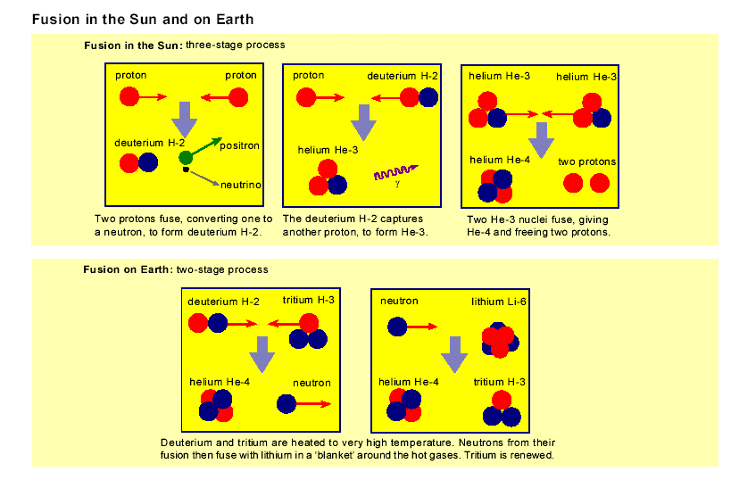
In the Sun massive gravitational forces create the right conditions for fusion, but on Earth they are much harder to achieve. Fusion fuel – different isotopes of hydrogen – must be heated to extreme temperatures of the order of 100 million degrees Celsius and must be kept dense enough, and confined for long enough, to allow the nuclei to fuse. Currently a research programme is hoping to achieve 'ignition', which occurs when enough fusion reactions take place for the process to become self-sustaining, with fresh fuel then being added to continue it.

With current technology the reaction most readily feasible is between the nuclei of the two heavy forms (isotopes) of hydrogen – deuterium (D) and tritium (T). Each D-T fusion event releases 17.6 MeV (2.8 x 10⁻¹² joule, compared with 200 MeV for a U-235 fission). Deuterium occurs naturally in seawater, which makes it very abundant relative to other energy resources. Tritium does not occur naturally and is radioactive, with a half-life of around 12 years. It can be made in a conventional nuclear reactor or, in the present context, bred in a fusion system from lithium. Lithium is found in large quantities in the Earth's crust and in weaker concentrations in the sea.

Nuclear Fusion Reactors
Fusion is the energy of the stars and if it can be managed on Earth would deliver on vastly available source of energy for future generations. It is the joining together of small atomic nuclei to make larger ones and it is the mechanism by which all the heavier elements in the universe are made.

Fusion can only happen at very high temperatures because it is the forcing together of particles that would usually be very far apart. Nuclei are all positively charged particles, so they naturally have a tendency to repel each other. The only way to join them is to heat them up to very high temperatures (over a hundred million Kelvin) and at these temperatures the electrons break away from their nuclei and leave a soup of very fast moving charged particles called plasma. This plasma has to be confined and maintained for long enough for fusion to occur.

At present, two main experimental approaches are being studied: magnetic confinement and inertial confinement. The first method uses strong magnetic fields to contain the hot plasma. The second involves compressing a small pellet containing fusion fuel to extremely high densities using strong lasers or particle beams.

The main hope for magnetic fusion is centred on Tokamak reactors which magnetically confine a deuterium-tritium plasma. A tokamak (toroidal chamber magnetic coils). is a toroidal or ring doughnut shaped vessel with magnetic coils that make a trap for the plasma. The plasma is heated using microwaves or powerful particle injectors (think of it a bit like steam heating the milk for a cappuccino) and it has to be stabilised by carefully controlling the shape of the magnetic field.
https://www.youtube.com/watch?v=NuiQTDanHx0
The Joint European Torus (JET), in Oxfordshire, is Europe’s largest fusion device. In this device, deuterium–tritium fusion reactions occur at over 100 million Kelvin.
To sustain fusion there are three conditions, which must be met simultaneously:
- plasma temperature (T): 100–200 million kelvin
- energy confinement time (t): 4–6 seconds
- central density in plasma (n): 1–2 × 10²⁰ particles m^{–3}
(approx. 1 mg m^{–3}, i.e. one millionth of the density of air).
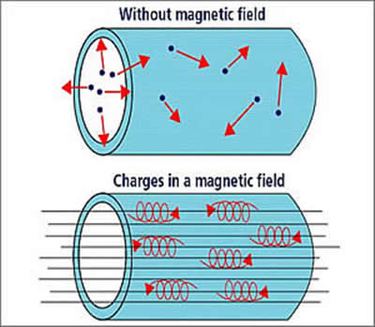
https://www.youtube.com/watch?v=gJbBYxT-ND4
In a fusion reactor, the concept is that neutrons generated from the D-T fusion reaction will be absorbed in a blanket containing lithium which surrounds the core. The lithium is then transformed into tritium (which is used to fuel the reactor) and helium. The blanket must be thick enough (about 1 metre) to slow down the high-energy (14 MeV) neutrons. The kinetic energy of the neutrons is absorbed by the blanket, causing it to heat up. The heat energy is collected by the coolant (made up of water, helium or Li-Pb) flowing through the blanket and, in a fusion power plant, this energy will be used to generate electricity by conventional methods. If insufficient tritium is produced some supplementary source must be employed such as using a fission reactor to irradiate heavy water or lithium with neutrons, and extraneous tritium creates difficulties with handling, storage and transport.
In any case, the challenge is to apply the heat to human needs, primarily generating electricity. Fusion will never supply the same energy for a given volume as fission, which means that any fusion reactor needs to be larger and therefore more costly than a fission reactor of the same power output. In addition, nuclear fission reactors use solid fuel which is denser than a thermonuclear plasma, so the energy released is more concentrated.

Tokamak
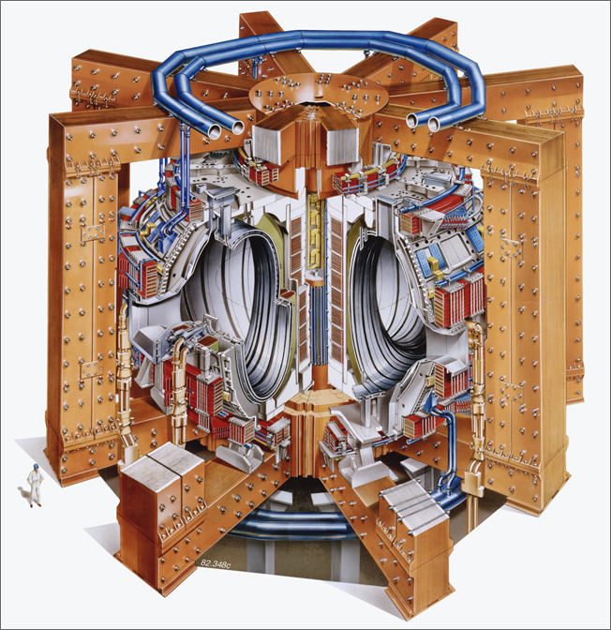
https://www.youtube.com/watch?v=gJbBYxT-ND4

The basic components of the Tokamak’s magnetic confinement system are:
The toroidal field – which produces a field around the torus. This is maintained by magnetic field coils surrounding the vacuum vessel. The toroidal field provides the main mechanism to confine the plasma particles.

The poloidal field – which produces a field around the plasma cross-section. It pinches the plasma away from the walls and maintains the plasma’s shape and stability. The poloidal field is induced both internally, by the current driven in the plasma (one of the plasma heating mechanisms), and externally, by coils that are positioned around the perimeter of the vessel.

The main plasma current is induced in the plasma by the action of a large transformer. A changing current in the primary winding or solenoid (a multi-turn coil wound onto a large iron core in JET) induces a powerful current (up to 5 million amperes on JET) in the plasma, which acts as the transformer secondary circuit.
One of the main requirements for fusion is to heat the plasma particles to very high temperatures or energies. Methods used to heat the plasma – all of them are employed on JET – include:
- Ohmic heating and current drive
- Neutral beam heating
- Radio-frequency heating

Self-heating of plasma
When fusion power output just equals the power required to heat and sustain plasma then breakeven is achieved. However, only the fusion energy contained within the helium ions heats the deuterium and tritium fuel ions (by collisions) to keep the fusion reaction going. When this self-heating mechanism is sufficient to maintain the plasma temperature required for fusion the reaction becomes self-sustaining (i.e. no external plasma heating is required). This condition is referred to as ignition. In magnetic plasma confinement of the deuterium–tritium fusion reaction, the condition for ignition is approximately six times more demanding (in confinement time or in plasma density) than the condition for breakeven.

SUMMARY
FUSION
The mass of the constituent components (bits before!) of the nuclei before the reaction is greater than the mass of the nuclei after the reaction. There is a mass difference. This mass difference is converted into energy according to Einstein’s equation E=mc².

FISSION
The mass of the reactants is greater than the mass of the products. There is a mass difference during this reaction. This difference in mass is converted into energy according to Einstein’s equation E=mc².

NUCLEAR REACTIONS/TUTORIAL 1
- Explain why swallowing an alpha particle source is more dangerous than a gamma ray source since alpha particles are less penetrating than gammas?
- Using a Periodic Table, put the following nuclear equations into words:-
- State the name of the particles emitted in each of the following disintegrations:-
- State the missing numbers in each of the following, and in each case, identify element X?
- The atomic mass of is 23.252x10⁻²⁷ kg and the sum of the atomic masses of and is 23.265x10⁻²⁷ kg. State if gives out energy. You must justify your answer.

Tutorial 2 (SCET) Nuclear reactions

Fission and fusion
- Use a periodic table to identify the elements that have these atomic numbers:
(a) 6 (b) 25 (c) 47 (d) 80 (e) 86 (f) 92
- The list shows the symbols for six different isotopes.
(i) (ii) (iii)
(iv) (v) (vi)
For each of the isotopes state:
(a) the number of protons
(b) the number of neutrons.

- The incomplete statements below illustrate four nuclear reactions.

Identify the missing particles or nuclides represented by the letters A, B, C and D.

- Part of a radioactive decay series is represented below:
Identify the particle emitted at each stage of the decay.
Such a series does not always give a complete picture of the radiations emitted by each nucleus. Give an explanation why the picture is incomplete.

- For a particular radionuclide sample 8 × 10⁷ disintegrations take place in 40 s. Calculate the activity of the source.

- How much energy is released when the following ‘decreases’ in mass occur in various fission reactions?
(a) 3·25 × 10⁻²⁸ kg (b) 2·01 × 10⁻²⁸ kg (c) 1·62 × 10⁻²⁸ kg
(d) 2·85 × 10⁻²⁸ kg

- The following statement represents a nuclear reaction involving the release of energy.
The masses of these particles are given below.
Mass of = 5·00890 × 10⁻²⁷ kg
Mass of = 3·34441 × 10⁻²⁷ kg
Mass of = 6·64632 × 10⁻²⁷ kg
Mass of = 1·67490 × 10⁻²⁷ kg

(a) Explain, using E=mc², how this nuclear reaction results in the production of energy.
Calculate the decrease in mass that occurs when this reaction takes place.
(b) Calculate the energy released in this reaction.
(c) State the name given to this type of nuclear reaction.
(d) Calculate the number of reactions required each second to produce a power of 25 MW.

- Plutonium can undergo the nuclear reaction represented by the statement below:
The masses of the nuclei and particles involved in the reaction are as follows.
Particle | n | Pu | Te | Mo
Mass/kg | 1·675 × 10⁻²⁷ | 396·741 × 10⁻²⁷ | 227·420 × 10⁻²⁷ | 165·809 × 10⁻²⁷

(a) State the type of reaction is represented by the statement above.
(b) State the mass number and atomic number of the nuclide Te in the reaction.
(c) Calculate the decrease in mass that occurs in this reaction.
(d) Calculate the energy released in this reaction.
- Neon has two main isotopes, and , and has a relative atomic mass of 20.2. State what this indicates about the relative abundance of each isotope?

TUTORIAL 3 Exam Questions
- A certain nuclear reaction can be described as:
Which line in the list below correctly describes the reaction?
 | Particle X | Type of nuclear reaction.
A. | beta | fission
B. | neutron | fusion
C. | beta | fusion
D. | neutron | fission
E. | alpha | fission

- The following statement represents a nuclear reaction which may form the basis of a nuclear power station in the future.
  - Explain, using E=mc², how this nuclear reaction results in the production of energy.

  - Using the information given below, and any other data required from the data sheet, calculate the energy released in the above nuclear reaction.
Mass of = 5.00890 × 10 ^{–27} kg
Mass of = 3.34441 × 10 ⁻²⁷ kg
Mass of = 6.64632 × 10 ⁻²⁷ kg
Mass of = 1.67490 × 10 ⁻²⁷ kg

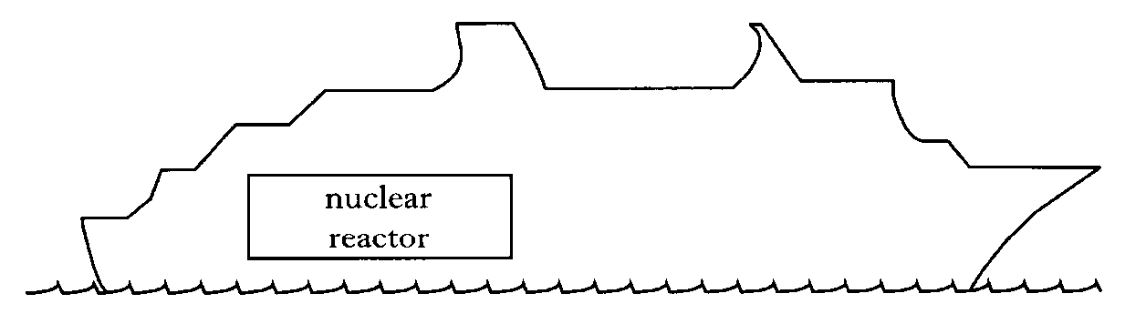
- A ship is powered by a nuclear reactor.
One reaction that takes place in the core of the nuclear reactor is represented by the statement below.
  - The symbol for the Uranium nucleus is .
What information about the nucleus is provided by the following numbers?

    - 92
    - 235

  - Describe how neutrons produced during the reaction can cause further nuclear reactions.

  - The masses of particles involved in the reaction are shown in the table.
Particles | Mass/kg
 | 390·173 x 10⁻²⁷
 | 232·242 x 10⁻²⁷
 | 155·884 x 10⁻²⁷
 | 1·675 x 10⁻²⁷
 | negligible
Calculate the energy released in the reaction.
- Radium (Ra) decays to Radon (Rn) by the emission of an alpha particle.
Some energy is also released by this decay.
The decay is represented by the statement shown below.
The masses of the nuclides involved are as follows.
Mass of
Mass of
Mass of

    - State the values of x and y for the nuclide ?
    - Why is energy released by this decay?
    - Calculate the energy released by one decay of this type.

  - The alpha particle leaves the radium nucleus with a speed of 1·5 x 10⁷ m s⁻¹.
The alpha particle is now accelerated through a potential difference of 25 kV.
Calculate the final kinetic energy, in joules, of the alpha particle.

Tutorial Answers:

Tutorial 1 Answers
1. The swallowed a source causes a lot of damaging ionisation in its vicinity and at the same time manages to conceal its location from the helpful surgeons because the emitted α's are absorbed before they get through the skin and reach the detectors used for pin-pointing their location.
2. (a) Protactinium 234 decays to uranium 234 by emitting a β particle and γ radiation.
(b) The 238 isotope of uranium disintegrates by giving out an α particle and γ radiation to leave thorium 234.
(c) Radon 222 emits an α particle to leave polonium 218 as its daughter product.
3. (a) A β-particle.
(b) α
(c) β
4. (a)
(b)
5. yes

Tutorial 2 Answers Fission and fusion
2. (i) (a) 3 (b) 4
(ii) (a) 30 (b) 34
(iii) (a) 47 (b) 62
(iv) (a) 54 (b) 77
(v) (a) 94 (b) 145
(vi) (a) 103 (b) 154
3. A is or α
B is
C is or β
D is
4. α then β then α
5. A = 2 × 10⁶ Bq
6. (a) 2·93 × 10⁻¹¹ J
(b) 1·81 × 10⁻¹¹ J
(c) 1·46 × 10⁻¹¹ J
(d) 2·57 × 10⁻¹¹ J
7. (a) 3·209 × 10⁻²⁹ kg
(b) 2·89 × 10⁻¹² J
(d) 8·65 × 10¹⁸
8. (b) mass number 136, atomic number 52
(c) 1·62 × 10⁻²⁸ kg
(d) 1·46 × 10⁻¹¹ J

Tutorial Answers Nuclear reactions
4. i) 3, 4 ii) 30, 34 iii) 47, 62 iv) 54, 77 v) 94, 145 vi) 103, 154.
- α, β, α.
8. 2.0 × 10⁶ Bq.
- 1/8th.
- 6c.p.s.
11. a) 2.925 × 10⁻¹¹ J b) 1.809 × 10⁻¹¹ J c) 1.458 × 10⁻¹¹ J
d) 2.565 × 10⁻¹¹ J.
- a) 0.025 × 10⁻²⁷ kg b) 2.25 × 10⁻¹² J.
- a) mass no. 137 atomic no. 52
b) 0.162×10⁻²⁷ kg
c) 1.458×10⁻¹¹J

Tutorial Answers Exam Questions
- D
- The mass of the reactants is more than the mass of the products. During this reaction mass is lost, this mass is converted to energy according to the equations E=mc²

  - 2.88×10⁻¹²J

- a) i) 92 = number of protons (in nucleus) (1)
ii) 235 = protons + neutrons (in nucleus)
OR total number of nucleons in nucleus. (1)
OR 92p + 143 n
  - When a nucleus undergoes fission it releases neutrons that can go on to cause further fission reactions by interactions with other nuclei. If there is a sufficient concentration of suitable nuclei, the process becomes self-sustaining.
  - 3.35×10⁻¹¹J
4.

    - Atomic Number y = 86, Mass Number x = 222

    - E=3.35×10⁻¹³J
  - E=7.559×10⁻¹³J

