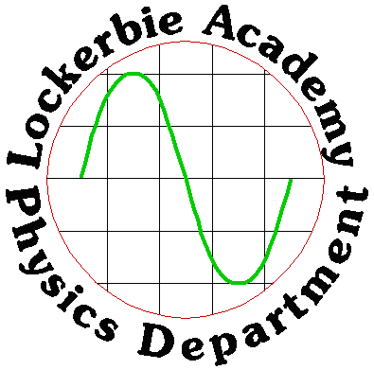

WORKSHOP-2018

NAT 5 PHYSICS COURSE
J. A. Hargreaves

On TUESDAY 8th MAY 2018 the SQA Physics exams at all levels take place. When you enter the examination room or hall you need to be prepared technically with the correct tools and mentally with confidence in your ability to competently answer the problems in the paper.
Make sure your revision plan is realistic by setting up a calendar showing when your exams are and working out when you can give up time to studying physics.
Once you have your plan, assemble your materials like recent past papers and a clock to pace yourself – and get stuck in!

PART ONE- THE EXAM
- DATE 8th MAY 2018 TUESDAY, in the ASSEMBLY HALL (D006)
- The Question paper is out of 135 marks and is worth 80% of your overall mark.
- Understand the structure of the EXAM,
- Section 1 (objective test) has 25 marks; i.e 25 multiple choices questions (A to E).
- Section 2 contains restricted and extended response questions and has 110 marks. This is scaled to 75 marks.
- Section 2 approx. 15-20 long questions usually between 3 and 15 marks
- Answer the m/c on the grid in the front of the answer booklet, which also contains section 2
- Take time to read the instructions
- Page 2 of the section 1 will contain the data sheet,
- You’ll have a Relationships Sheet (have it open and use it, let’s look it over)
- Experimental Question (likely to plot a graph or go through an experiment). It is clear in the compendium which experiments you could be tested on, so make sure you know which is which
- 2 open ended questions
- The majority of marks are awarded for demonstrating and applying knowledge and understanding. The other marks are awarded for applying scientific inquiry and analytical thinking skills.

PART TWO- SOME THINGS TO REMEMBER
- IT IS VITAL THAT YOUR CALCULATORS ARE ON YOUR SIDE
- IF YOU SUFFER FROM CALCULATOR DIARRHOEA THEN “FIX” IT!
- SET IT UP TO FIX AT SAY TWO DECIMAL PLACES ONLY. BUT DON’T ROUND TOO FAR!
- ONLY ROUND UP AT THE END OF THE QUESTION
- Get a PROTRACTOR ALWAYS MEASURE ANGLES FROM THE NORMAL
- Be careful about your writing, Some pupils letters & numbers can be confused e.g 4 9 5 S
- Include units on all answers except.......radiation weighting factor, no. ...
- Don’t give more answers than needed, you could start to lose marks
- Significant figures, you will start to lose marks for your answer if you give too many or too few significant figures. +3 too many, -2 too few, You lose the mark for your answer
- SPELLING DIFFRACTION, REFRACTION, REFLECTION, FUSION, FISSION
- READ THE QUESTION CAREFULLY
- UNDERLINE ANYTHING THAT IS SIGNIFICANT, use a highlighter if possible but get used to using it first
- For example if a vehicle is travelling at constant speed..FORCES MUST BE BALANCED
- TRY TO WORK OUT TO WHICH CONTENT STATEMENT THE QUESTION RELATES
- When giving an explanation always try to link it to the formulae associated with the question eg.....
- What causes pressure? Pressure is caused by the force of particles on the walls of the container, ie F/A
- For a FIXED MASS OF GAS at CONSTANT TEMPERATURE pressure is inversely proportional to the volume P₁V₁ = k
- For a FIXED MASS OF GAS at CONSTANT PRESSURE temperature (kelvin) is proportional to the volume V₁ / T(K)₁ = k
- For a FIXED MASS OF GAS at CONSTANT VOLUME temperature (kelvin) is proportional to the pressure P₁ / T(K)₁ = k
- KINETIC THEORY All particles are moving. Pressure is caused when the particles collide with the container walls The higher the temperature the faster the particles move, the faster they move the more often and more violent the collisions with the walls, greater impulse therefore greater force.
- If the volume is less they will collide more often as there is a shorter distance between the container walls
- What causes buoyancy forces? The buoyancy force is caused by the difference in water pressure acting on the bottom and top surface of the object. This produces a NET upwards force equal to the weight of water displaced.
- What causes buoyancy forces? The water pressure on the bottom surface is greater than the top surface. There is an greater upward force on the bottom of the object than on the top. This difference produces a NET upwards force equal to the weight of water displaced.
- What is the effect of replacing with sea water? The sea water is more DENSE than ordinary water so the buoyancy force produced by the sea water is greater. Float higher, accelerate faster or other options!!!
- Since the buoyancy force equals the weight of the water displaced and the of fresh water is LESS, then the weight of fresh water displaced will be less than the weight of the sea water
- What is the effect of lowering the object further underwater? There is NO EFFECT. The upthrust is due to the DIFFERENCE in pressure between the bottom surface than the top surface. Although the pressures are different at each surface the DIFFERENCE is still the same.
- It might be advisable to ALWAYS convert TEMPERATURE into KELVIN
- ^{O}C = K + 273 K = ^{O}C – 273 There is NO SUCH THING AS -K
- TAKE THE VALUE OF “g” ON THE EARTH AS 9.8 m s⁻² , 9.8 N kg⁻¹, Unless otherwise stated,!
- What is the average annual dose equivalent which a person in the UK receives due to background radiation? 2mSv
- FREQUENCY REMAINS UNCHANGED, On refraction, On interference, on amplification
- Always try to link it to the formulae associated with the question eg..... Why do seat belts protect a person? An object will continue to move in a straight line...according to Newton’s 1st Law of motion...
- Average or Instantaneous Speed, MEASURE DISTANCE, USING TAPE MEASURE (or ruler), MEASURE TIME, USING A STOPWATCH (or light gates and a fast timer), USE THE FORMULA SPEED=DISTANCE/TIME
- INSTANTANEOUS SPEED This is your average speed over a VERY SMALL DISTANCE, v=l/t
- SCALARS & VECTORS Scalars - size only, Vectors - size and direction
- Vectors - Force, Displacement, Velocity, Acceleration, momentum, field strength, CHECK IF YOU NEED CLARIFICATION ON THIS
- A FORCE can cause a change in: SHAPE, SPEED (really velocity), & DIRECTION, of an object
- MASS v WEIGHT Mass is a measure of the amount of matter in an object, Weight is the FORCE of gravity on an object, Mass is measured in Kilograms, weight is measured in Newtons
- FORCE=mass x acceleration
- If F is constant and m is increased, then a DECREASES. If m is constant and F is increased then a INCREASED
- ONE NEWTON is the force that is needed to accelerate a mass of 1 kilogram at one metre per second squared.
- Equal but opposite forces are called BALANCED FORCES
- decreasing friction: Lubricants, smooth surfaces, wheels, balls High speeds Streamlining, curvy shapes
- increasing friction: Rough, dry, square, sharp surfaces
- Streamlining reduces friction by: Reducing frontal area, Making the front more conical than flat. This makes the air flow easily over the shape and stops air turbulence
- PROJECTILES, 2 MOTIONS, Horizontally the speed is constant, Vertically the object accelerates at 9.8 ms⁻²
- Don’t get caught out! Separate out the horizontal and vertical component of velocity. Always use the subscript H and V to distinguish Don’t forget an angle Don‘t put them back together UNLESS they ask for the resultant! RESULTANT IS THE COMPONENTS TOGETHER AGAIN
- SPEEDS?
- The speed of SOUND in AIR ≅340 ms⁻¹
- The speed of LIGHT in AIR = 3 x 10 ⁸ ms⁻¹
- The speed of SOUND in AIR is VERY MUCH SLOWER than the speed of LIGHT in AIR
- The speed of LIGHT in GLASS = 2 x 10 ⁸ ms⁻¹
- The speed of an ELECTRICAL SIGNAL is CLOSE TO 3 x 10 ⁸ ms⁻¹ (≅2 x 10 ⁸ ms⁻¹)
- TAKE THE VALUE OF “g” ON THE EARTH AS, 9.8 ms⁻², 9.8 N/kg
- What is gravitational field strength “g”? g is the weight per unit mass
- LOOK OUT FOR ECHOES! the distance travelled is TWICE the depth, so either halve the time (to get to the bottom), or halve the distance that you calculate at the end. check your answer is sensible!.... In ultrasound problems, In depth of sea problems, In sound transmission And any others I haven’t thought of……
- Watch out for ECHO The distance is doubled
- Temperature is how hot or cold something is Heat is the amount of energy an object has
- The two are related but not the same! Think of 2 beakers one containing more water and heated for the same length of time. They've had the same heat but one will be hotter at the end of the experiment!
- Idea of Universe,
- Universe – sum total of all that exists
- Galaxy – a collection of stars, gas and dust etc. all held together by the force of gravity.
- Solar System- one or more stars surrounded by planets, moons, comets etc.
- Star and/or Sun- a star is a hot ball of burning plasma, all suns are stars not all stars are sun. A sun is a star with planets surrounding it.
- Planet – a relatively large object orbiting one or more stars
- Exoplanet- a planet outside out solar system.
- Moon- an natural satellite of a planet.
- + comet, meteor, meteorite etc
- you consider the growing population and dwindling resources of our home planet, some scientists believe that finding exo planets capable of sustaining life should be a top priority.
- Scientists need to consider the basic needs of life and if these needs can be delivered by an exo planet
- The basic needs for human life are: Oxygen, Water, Food, Shelter, Warmth.
- To sustain life a planet will need liquid WATER.
- In our search for a new home scientists need to identify an exoplanet which has: A similar atmosphere to ours, The potential to build shelter, The potential to grow and nurture a sustainable food source. The next problem once the exo planet has been identified is how to get there!
- Light Year Contrary to the name, a light year is a measure of distance and not time. 1 light year is the distance light travels in 1 year.
- Light Year Light is an electromagnetic wave which travels at a speed of 300 000 000 ms⁻¹.
- Question How far does light travel in one year?
- d = ? d = v t
- v = 300 000 000 ms⁻¹ d = 300 000000 x 31 536 000
- t = 1 x 365 x 24 x 60 x 60 = 31 536 000 s d = 9 460 800 000 000 000 m = 9.46 ×10¹⁵ m
- As the distances in the universe are very large we need to use the term light year instead of metres or even miles.
- Approximate distance from Earth to:
- The Sun – 0.000016 light years (or 8.3 light minutes)
- Proxima Centauri (nearest star outside the solar system) – 4.2 light years
- Canis Major Dwarf (nearest galaxy to the Milky Way) – 25000 light years
- The edge of the known Universe – 46 billion light years.
- Evidence from various telescopes can give us an idea of the age of the Universe
- The Big Bang Theory’, it is stated that Physicists thought that at one second old, stable particles called protons and neutrons started to form. These particles form our model of the nucleus of the atom. However, something was missing from that model called the Higgs Boson. Professor Higgs, a British physicist wrote in 1969 that the Higgs Boson's role is to give the particles that make up atoms their mass. Without this mass, they would zip around the cosmos, unable to bind together to form the atoms that make stars and planets – and people.
- On 4th July 2012, Physicists working at CERN at the world’s largest particle accelerator – The Large Hadron Collider – announced the discovery of the Higgs Boson – further evidence to support our understanding of the universe.
- The Big Bang Theory (The Theory of the Origin of the Universe)
- Most astronomers believe the Universe began in a Big Bang about 14 billion years ago. At that time, the entire Universe was inside a bubble that was thousands of times smaller than a pinhead. It was hotter and denser than anything we can imagine.
- As the Universe expanded and cooled, energy changed into particles of matter and antimatter. These two opposite types of particles largely destroyed each other. But some matter survived. More stable particles called protons and neutrons started to form when the Universe was one second old.
- Contrary to the name, astronomers believe that there was no explosion. The ‘bubble’ began to expand and the Universe that we know was born. Time, space and matter all began with the Big Bang. In a fraction of a second, the Universe grew from smaller than a single atom to bigger than a galaxy and it kept on growing at a fantastic rate. It is still expanding today
- Over the next three minutes, the temperature dropped below 1 billion degrees Celsius. It was now cool enough for the protons and neutrons to come together, forming hydrogen and helium nuclei.
- After 300 000 years, the Universe had cooled to about 3000 degrees Celsius. Atomic nuclei could finally capture electrons to form atoms. The Universe filled with clouds of hydrogen and helium gas.
- As the Universe expanded and cooled, energy changed into particles of matter and antimatter. These two opposite types of particles largely destroyed each other. But some matter survived. More stable particles called protons and neutrons started to form when the Universe was one second old.
- Evidence to Support the Big Bang Theory
- Scientists are reasonably certain that the universe had a beginning. This is the basis of the Big Bang Theory. To support this argument scientists have discovered that:
- Galaxies appear to be moving away from us at speeds proportional to their distance. This observation supports the expansion of the universe and suggests that the universe was once compacted.
- If the universe was initially very, very hot as the Big Bang suggests, we should be able to find some small remains of this heat. In 1965, Radio astronomers discovered Cosmic Microwave Background radiation (CMB) which spread throughout parts of the observable universe. This is thought to be the small remains which scientists were looking for.
- Finally, the abundance of the "light elements" Hydrogen and Helium found in the observable universe are thought to support the Big Bang model of origins.
- ELECTRONS ARE FREE TO MOVE IN A CONDUCTOR A CURR ENT IS A FLOW OF ELECTRONS
- Ammeters measure current
- Voltmeters measure voltage
- ohmmeters measure resistance, resistance is measured in ohms
- VOLTAGE IS A MEASURE OF THE ELECTRICAL ENERGY GIVEN TO THE CHARGES IN A CIRCUIT
- d.c- direct current, current only flows in ONE direction, (although its size may differ)
- a.c- alternating current, current flows first in one direction and then in another.
- the quoted voltage of an a.c supply is LESS THAN the peak voltage. This is means that the QUOTED a.c voltage provides the SAME POWER as the d.c supply.
- INPUT DEVICES: Change some energy (signal) into an electrical signal.
- OUTPUT DEVICES: Change an electrical signal into some other energy (signal).
- LAMPS The Energy Change in a FILAMENT lamp occurs in the FILAMENT. The Energy Change in a DISCHARGE TUBE occurs in the GAS
- What is the declared voltage and frequency of the MAINS? 230V, 50Hz
- Place a 3A fuse in most appliances between 0W and 720W, 13A fuse above 720W (to a maximum of 3kW)
- 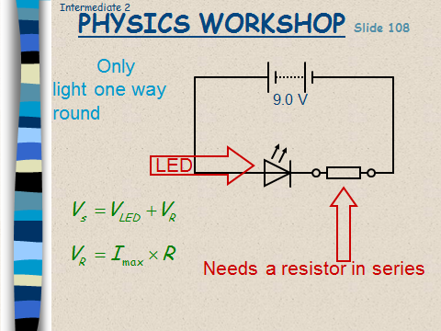
- Resistance in series with an LED. Use V_{s} = V_{R} + V_{led,} then V_{R} =I_{max} × R
- 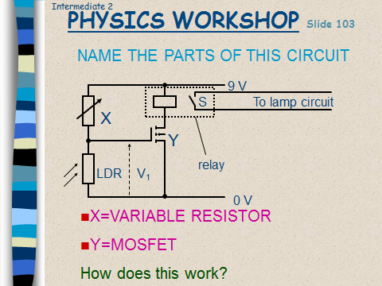
- NPN TRANSISTORS: A transistor can act as a switch, 0.7V across the base and emitter is the voltage needed to "turn on" a transistor
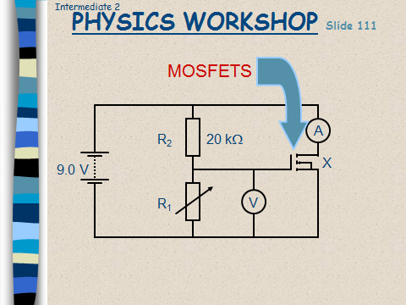
- A MAGNETIC FIELD EXISTS AROUND A Current carrying WIRE
- A voltage is induced in a conductor if a magnetic field and a wire move in relation to each other
- The size of the induced voltage depends on:-the strength of the magnetic field, the number of turns of the coil, the speed of the movements
- Definition of electric charge in terms of positive and negative
- Electrical current as the electrical charge transferred per unit time
- Use appropriate relationship to carry out calculations involving charge, current and time
- Difference between alternating and direct current
- E M SPECTRUM: RADIO & TV, Microwaves, Infra-red, Visible, Ultra-violet, X-rays, Gamma
- E M SPECTRUM THE VISIBLE BIT: RED, ORANGE, YELLOW, GREEN, BLUE, INDIGO, VIOLET
- 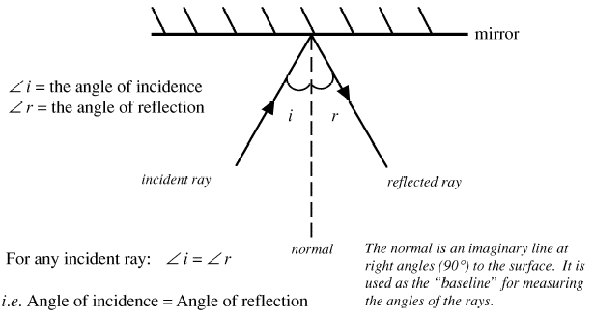
The higher the frequency of the em radiation the greater the energy it possess.

- Alpha: a helium nucleus, a few cm in air, stopped by paper, most ionising
- Beta: an electron, from the nucleus, a few metres in air, stopped by Al
- Gamma: an em wave, not stopped by air, stopped by a few mm of Pb, least ionising
- 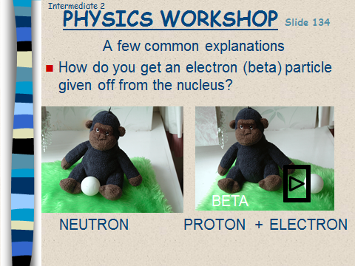
- Safety Precautions? MONITOR- keep a log of exposure times wear film badges, SHIELD- keep layers of absorber between you & source, DISTANCE- keep at a safe distance or use tongs. Also don’t eat or drink
- The risk of biological harm of exposure to radiation depends on: the absorbed dose, the kind of radiation, the body organ or tissue exposed
- To avoid wasting time and losing marks you need to take great care in reading questions thoroughly and ensuring that the instructions in questions are followed precisely. If it asks you to state something, then state it: you do not need to explain it. If a question says “with the aid of a diagram”, assume you must draw a diagram.
- Key words to look for are: describe, state, show, explain, draw and “find the relationship”.
- Remember you may need to use, state or derive expressions that are not listed in the data booklet,
- Always label your data and write your answers clearly. This makes it easier for the marker to find your marks, makes it easier for you to check the logic of your answers and improves the marker’s mood, hopefully making it more likely you will get the benefit of doubt when professional judgement is needed.
- If you are asked to show something is true you need to write down any suitable equation followed by appropriate substitutions and calculations in well laid out logical manner.
- In the gas laws you may be asked to write out descriptions or explanations. These need to be clear. The principal assessor gave an example in this year’s report: “a candidate saying that an increase in temperature causes ‘molecules to collide more’, means very little. A more precise description would be ‘molecules collide with the container walls harder and more frequently.”
- Always put a direction in vector problems.
- Students seem to be poor at putting in the correct sign in negative acceleration and velocity questions. You don’t just lose half a mark for getting this wrong; markers are told it is wrong physics so they stop marking the question.
- Graphs require some thought –many students do not label the origin and axes on sketch graphs
- When a graph is a straight line through the origin you can state that the quantity on the vertical axis is directly proportional to the quantity on the horizontal axis. This is why we switch temperatures scales from Celsius to Kelvin in gas laws graphs of P vs T and V vs T.
- The area under the line of a graph is important. For example, under a velocity-time graph the area is the displacement and the area under a force time graph is the impulse or change of momentum during a collision.
- The gradients of graphs are also important sources of information, for example the gradient of a displacement-time graph is the velocity, the gradient of a velocity-time graph is the acceleration.
- Make sure you know the prefixes needed for the course. Your data sheet will not include these and you will lose marks every time one is wrong. Similarly, practice using an appropriate number of significant figures in problems and do not round up during a question. Do so at the end of a question if it is appropriate.
- Watch for integrative questions where theory from other units is part of what looks like a Dynamics and space question, for example equating energy to kinetic energy, ½ mv²
- Main questions to look out for: addition of vectors, projectiles, gas laws experiments and kinetic theory.
- Do as many past paper questions as you can manage.
- You should study the content statements for the Physics course so that you can give definitions of terms, for example the definition of potential difference.
- Make sure that your calculator is set to scientific notation and not radians.
- Learn rules for circuit behaviour, for example all branches of a circuit in parallel have the same voltage; adding branches in parallel reduces total resistance of a circuit; the total resistance of a parallel circuit is less than the resistance of one branch of the circuit; and if all branches of a parallel circuit are the same then total resistance is found by dividing the resistance of one branch by the number of branches.
- Do remember the data sheet at the start of the exam paper has important information on physical quantities.
- Learn the electromagnetic spectrum off by heart and know the order of increasing wavelength.
- In problems where you need to show a relationship using all the data, you must use all the data, don’t stop when it’s obvious what the answer is.
- And remember the most important tip of all: practice as many exam type questions as possible.
- VOLTAGE DIVIDER CIRCUITS- HOW TO WORK OUT HOW THEY WORK
  - Identify the INPUT device.
  - Set the conditions
  - Work out what happens to the resistance across the component
  - Work out the voltage across the component
  - Find out Voltage out (if different from 4)
  - Find the effect on the transistor (does it switch on or off?)
  - Find the effect on the output device

PART THREE EXPERIMENTAL QUESTIONS
- For each measurements give a piece of equipment to make the measurement and how it will be used
- Give any formula or formulae to find the value
- If it is a graph check if something with give you a quantity for the gradient or the graph or the area under the graph, eg a graph of P against V² would give a gradient of ___________ . a graph of P against I² would give a gradient of ___________
- Check for energy changes like the prelim h is proportional to v², as E_{h}=mgh and E_{k}= ½ mv²
- If you need to use ALL the data, for example in a light irradiance or pressure law question make sure you do the calculation for each point.
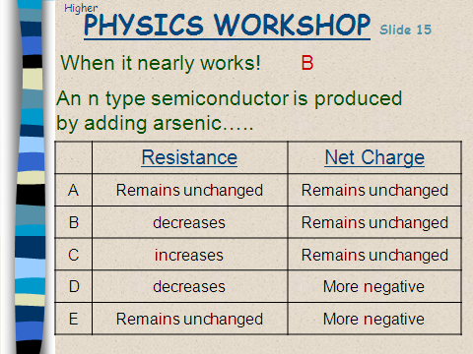

PART FOUR- MULTIPLE CHOICE QUESTION
- It is really important to read the question carefully.
- Underline important information
- DRAW a DIAGRAM for ALL FORCE QUESTIONS
- Try to cancel out definite wrong answers
- Don’t choose or not choose on the basis of how many of a certain letter you have already had!
- Look out for clues IF YOU ARE STUCK
- Occasionally you can use your brains to have an EDUCATED guess
- Look for the most repetitive numbers....eg
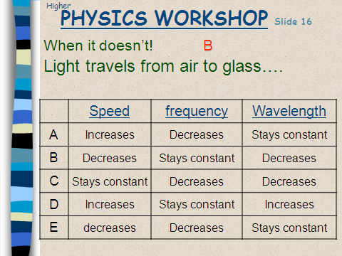
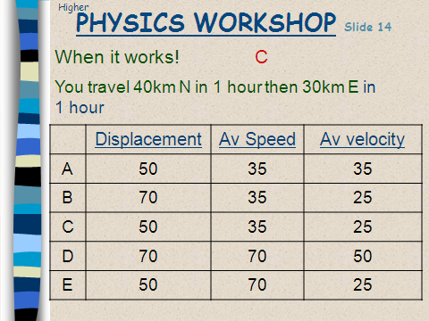
- Check that you HAVE to do a calculation before spending ages on a question
- READ THE QUESTION CAREFULLY
- UNDERLINE ANYTHING THAT IS SIGNIFICANT, For example if a vehicle is travelling at constant speed.., FORCES MUST BE BALANCED
- TRY TO WORK OUT TO WHICH CONTENT STATEMENT THE QUESTION RELATES

PART FIVE- ADDITIONS
Prefix | Symbol | Multiple | Multiple in full
Tera | T | x10¹² | x1 000 000 000 000
Giga | G | x10⁹ | x1 000 000 000
Mega | M | x10⁶ | x1 000 000
Kilo | k | x10³ | x1 000
Centi | c | x10⁻² | ÷100
Milli | m | x10⁻³ | ÷1 000
Micro | μ | x10⁻⁶ | ÷1 000 000
Nano | n | x10⁻⁹ | ÷1 000 000 000
Pico | p | x10⁻¹² | ÷1 000 000 000 000

$$E_{k}=\frac{1}{2}mv^{2}$$
$$E_{p}=mgh$$
$$E_{H}=mc∆T or ml$$
$$E=QV$$

PART SIX- Open Ended Questions

Strategy for Solving Open-Ended Questions.
Experience shows students find solving open-ended questions more difficult than the more familiar type of problem requiring a quantitative solution. Defining the problem is usually the cause of most difficulty so practising questions is vital.

You should:
- read the question - taking care not to skim read.
- reread the question.
- try to understand/define the problem situation and what is asked.
- visualise the situation.
- draw a diagram and include any relevant information such as speeds, velocities, forces, vector directions etc.
- determine and write down
  - relevant physics principles e.g. conservation of energy
  - note area/topic of physics involved in problem e.g. internal resistance of supplies
  - relationship relevant to variables in the problem.
- use knowledge of familiar quantities such as body mass, body height, length of running track to create estimated values as required.
- with the information noted previously solve the problem or do what can be done.
- reread the response to see if it makes sense and answers the question.
1. In a book in which he describes his childhood experiences, an author describes how he used to drop peanuts down the stairwell of a department store. This would annoy the shop owner “who would come flying up the stairs at about the speed that the peanut had gone down, giving you less than five seconds to scramble away to freedom”.
Using physics principles, comment on the way the author has compared the speed of the peanut and the shop owner. 3 marks
The following response was awarded 3 marks. Try to find out why!
The author has compared the speed of the peanut and the shop owner badly. For the peanut to take less than 5s to fall is very plausible as the peanut would fall at an acceleration of 9.8ms⁻² till it reached its terminal velocity. This would mean that the shop owner would have to be accelerating up the stairs at 9.8ms⁻² as well which would mean in 5s the shop owner will have almost reached (50mph??) and not even the top athletes can run that fast on the flat
- How many of the following questions are about g?
- How many of these questions are about collisions and Newton’s Laws?
- How many involve Energy conservation?
- How to tackle Questions involving estimating
This table might give you an idea of speeds etc. I am just using v=u+at and assumes no air resistance
time (s) | a (m/s²) | u from t=0 (m/s) | v at end of time period (m/s) | u for 1s interval (m/s) | average speed over previous second (m/s) | v at end of time period mph | equivalent average speed in mph
0 | 9.8 | 0 |  | 0
1 | 9.8 | 0 | 9.8 | 0 | 4.9 | 22 | 11
2 | 9.8 | 0 | 19.6 | 9.8 | 14.7 | 44 | 33
3 | 9.8 | 0 | 29.4 | 19.6 | 24.5 | 66 | 55
4 | 9.8 | 0 | 39.2 | 29.4 | 34.3 | 88 | 77
5 | 9.8 | 0 | 49 | 39.2 | 44.1 | 110 | 99
6 | 9.8 | 0 | 58.8 | 49 | 53.9 | 132 | 121
7 | 9.8 | 0 | 68.6 | 58.8 | 63.7 | 153 | 143
8 | 9.8 | 0 | 78.4 | 68.6 | 73.5 | 175 | 164
9 | 9.8 | 0 | 88.2 | 78.4 | 83.3 | 197 | 186
10 | 9.8 | 0 | 98 | 88.2 | 93.1 | 219 | 208
11 | 9.8 | 0 | 107.8 | 98 | 102.9 | 241 | 230

This is what the table looks like for the moon as a comparison
time (s) | a (m/s²) | u from t=0 (m/s) | v at end of time period (m/s) | u for 1s interval (m/s) | average speed over previous second (m/s) | v at end of time period mph | equivalent average speed in mph
0 | 1.6 | 0
1 | 1.6 | 0 | 1.6 | 0 | 0.8 | 4 | 2
2 | 1.6 | 0 | 3.2 | 1.6 | 2.4 | 7 | 5
3 | 1.6 | 0 | 4.8 | 3.2 | 4 | 11 | 9
4 | 1.6 | 0 | 6.4 | 4.8 | 5.6 | 14 | 13
5 | 1.6 | 0 | 8 | 6.4 | 7.2 | 18 | 16
6 | 1.6 | 0 | 9.6 | 8 | 8.8 | 21 | 20
7 | 1.6 | 0 | 11.2 | 9.6 | 10.4 | 25 | 23
8 | 1.6 | 0 | 12.8 | 11.2 | 12 | 29 | 27
9 | 1.6 | 0 | 14.4 | 12.8 | 13.6 | 32 | 30
10 | 1.6 | 0 | 16 | 14.4 | 15.2 | 36 | 34
11 | 1.6 | 0 | 17.6 | 16 | 16.8 | 39 | 38

Now let’s look at a few other helpful points
Mass of a small car (kg) | 1000 | Could go up to 1800
Mass of man (kg) | 100 | Approx. 16 stone
Mass of boy (kg) | 30 | This is 4 ½ stone and would be about right for a boy about 10 (obviously depends on no. of burgers)
Max speed limit in UK (m/s) | 32 | Conversion factor speed in mph is /0.447 of speed in m/s
Fast car acceleration (m/s²) | 5.4 | (0-60mph in 5s)
30 mph in m/s | 13
1 light year |  | 9.5 × 10¹⁵ m
Length of student foot | 0.25-0.30m | With show on approx. 0.30m
Width of student foot | 0.05-0.10m
Atmospheric Pressure | 10⁵ Pa
Yellow Bunsen flame | ∼800°C
Blue Bunsen flame | ∼1100°C
Geostationary orbit | 36 000 km | 3.6 × 10⁷ m

PART SEVEN -NOTES

