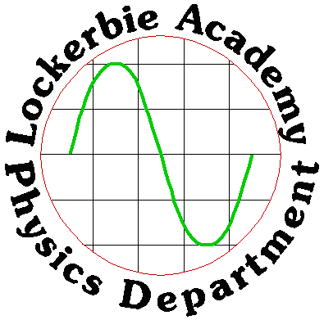
2018
Miss Horn
Lockerbie Academy
6/1/2018
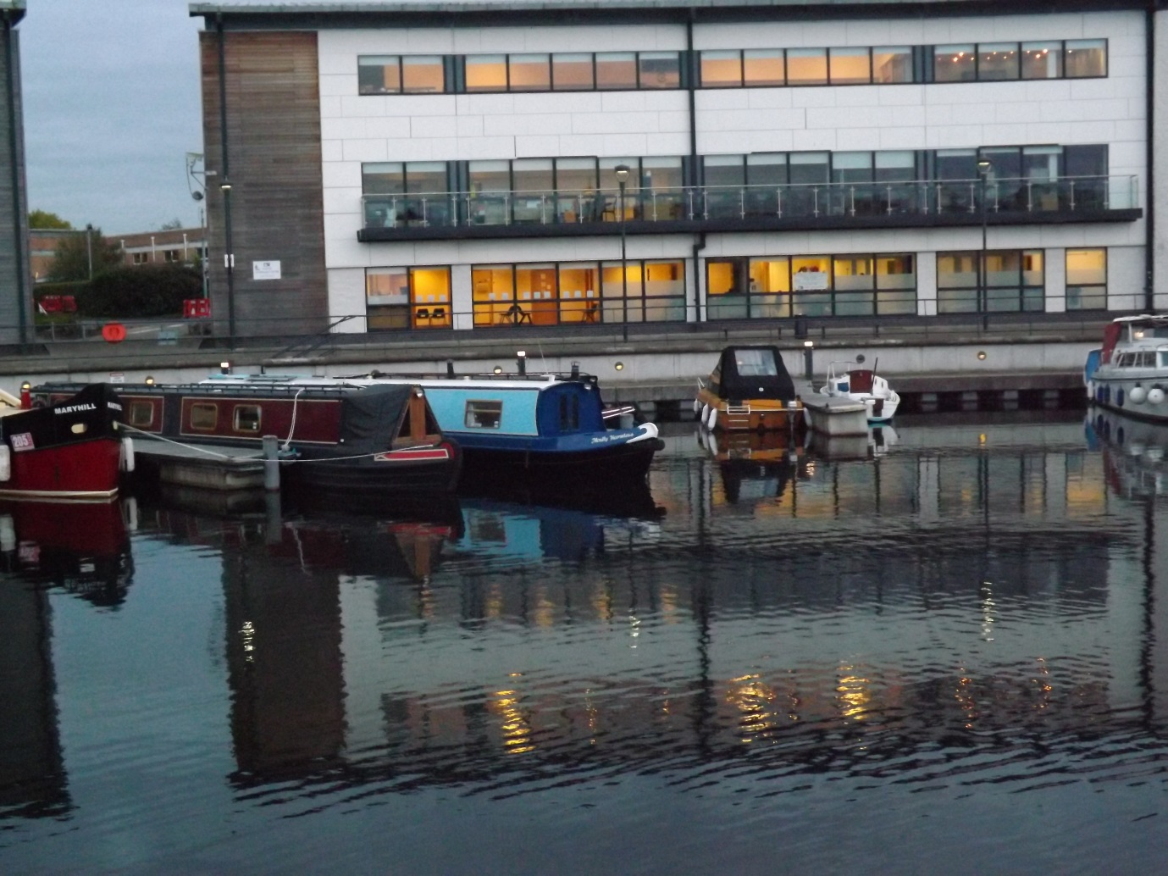
N5: Waves
Contents
N5 Physics Data Sheet 3
Relationships Sheet 4
Wave parameters and behaviours 5
Learning Intentions 5
Introduction 5
Transverse waves 5
Longitudinal waves 5
TUTORIAL QUESTIONS 7
Labelling waves 7
Wave Formulae 8
Wave Speed 8
Worked Examples 9
Frequency 9
TUTORIAL QUESTIONS 10
Thunder and Lightning 12
TUTORIAL QUESTIONS 13
Speed of Sound Questions 17
Diffraction 18
Sound 20
Ultrasound 20
Radio Waves 20
Light 21
TUTORIAL QUESTIONS 21
Success Criteria 22
Electromagnetic spectrum 22
Learning Intentions 22
Electromagnetic waves 23
Uses and sources 24
TUTORIAL QUESTIONS 25
Success Criteria 27
Light 27
Learning Intentions 27
Wave behaviour 27
Reflection 27
Refraction 28
Refraction and Frequency 29
Total Internal Reflection 30
Fibre Optics 30
TUTORIAL QUESTIONS 31
Success Criteria 32
Tutorial Exam style questions 33

N5 Physics Data Sheet
Speed of light in materials |  |  |  | Speed of sound in materials
Material |  | Speed in m s⁻¹ |  | Material | Speed in m s⁻¹
Air |  | 3·0 × 10⁸ |  | Aluminium | 5200
Carbon dioxide |  | 3·0 × 10⁸ |  | Air | 340
Diamond |  | 1·2 × 10⁸ |  | Bone | 4100
Glass |  | 2·0 × 10⁸ |  | Carbon dioxide | 270
Glycerol |  | 2·1 × 10⁸ |  | Glycerol | 1900
Water |  | 2·3 × 10⁸ |  | Muscle | 1600
 |  |  |  | Steel | 5200
Gravitational field strengths |  |  |  | Tissue | 1500
 | Gravitational field strength  on the surface in N kg⁻¹ |  |  | Water | 1500
Earth | 9·8
Jupiter | 23
Mars | 3·7
Mercury | 3·7
Moon | 1·6
Neptune | 11
Saturn | 9·0
Sun | 270
Uranus | 8·7
Venus | 8·9

Relationships Sheet
The formulae highlighted are those that are required for this unit.

Wave parameters and behaviours

Learning Intentions
- Knowledge that energy can be transferred as waves
- Determination of frequency, period, wavelength, amplitude and wave speed for longitudinal and transverse waves.
- Use of appropriate relationships to solve problems involving wave speed, frequency, period, wavelength, distance, number of waves and time.
- Awareness of the practical limitations of demonstrating diffraction.
- Comparison of long wave and short waves diffraction.

Introduction
Waves are used to transfer energy. The substance the wave travels through is known as the medium. The particles of the medium oscillate around a fixed position but the energy travels along the wave. For example, consider waves at the beach. Seawater will move up and down as a wave passes through it but as long as the wave does not “break” there is no overall movement of any water.
There are two different types of waves you will meet in this course, transverse waves and longitudinal waves

Transverse waves
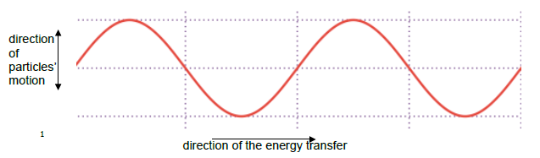
In transverse waves the particles oscillate (vibrate) at right angles to the direction of energy transfer
In a TRANSVERSE WAVE the particles of the medium vibrate at right angles to the direction of travel of the wave.

Longitudinal waves
In longitudinal waves the particles oscillate in the same direction as the motion of the wave.
Longitudinal waves vibrate parallel to the direction of travel.

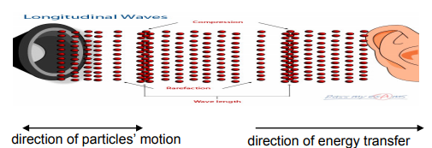
Sound is the most common example of a longitudinal wave — however there are others, such as seismic P-waves from earthquakes. With sound waves air particles are either squashed together to form a region of increased pressure or they are moved apart to make a region of decreased pressure.
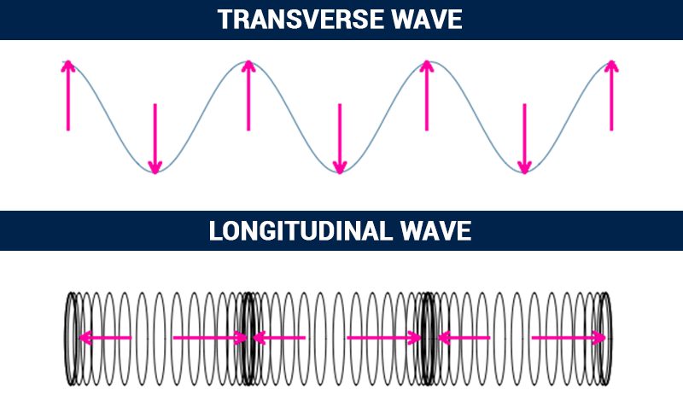
Direction of travel of the waves
Arrows show the direction of travel of the particles of the medium

Examples of Waves
Waves travel through some medium and as the wave travels it disturbs this medium through which it moves.

Mechanical Waves
Mechanical waves travel through a medium which is made up from some physical matter with particles (or molecules) in it. For example, when a water wave passes a particular point, some of the water bobs up and then down. For sound travelling through air it is the air particles that vibrate. The typical speed of a sound wave in air is 340 m/s although this varies a bit as the temperature and humidity of the air changes.

Electromagnetic Waves
Electromagnetic waves cause disturbances in the electric and magnetic fields that can exist in all space. They do not need any particles of matter in order to travel, which is why light can travel through a vacuum. Different examples of electromagnetic waves are gamma rays, X-rays, ultraviolet, visible light, infrared, microwaves, TV waves and radio waves. They all travel at the same speed in a vacuum (3·0 x 10⁸ ms⁻¹ or 300 million metres per second or 300 000 000 ms⁻¹). This is referred to as the speed of light and is given the symbol c. This very fast speed is the fastest that anything can travel. It is equivalent to about seven and a half times around the Earth each second.

Gravitational Waves
Research scientists are currently investigating a theory of gravity that involves gravitational waves. Scientists from Glasgow University helped prove the existence of gravitational waves in 2015.

TUTORIAL QUESTIONS
- Explain, using a diagram, the difference between a transverse and longitudinal wave.

- State whether the following are longitudinal or transverse waves:
  - sound waves
  - water waves
  - light waves
  - s-type seismic waves
  - p-type seismic waves.

- A football is stuck, floating, in the middle of a pond. The owner finds a stick and hopes to use it to retrieve the ball. He can’t decide whether to throw the stick at the ball, or use the stick to make waves in the water. State which method you would recommend. You must justify your answer.

- Explain why sound travels quicker in solids and liquids than gases.
(Hint – think about the arrangement of particles in solids and liquids compared to gases.)

- Explain why sound cannot travel through a vacuum, like outer space.

Labelling waves
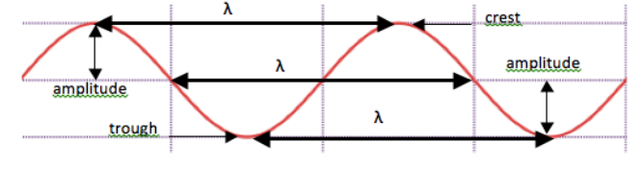

Wave property | Symbol | Definition | Unit | Unit symbol
Crest |  | highest point of a wave
Trough |  | lowest point of a wave
Wavelength | λ | horizontal distance between successive crests or troughs | metre | m
Amplitude | A | half the vertical distance between crest and trough | metre | m
Wave Speed | v | distance travelled per unit time | metres per second | ms⁻¹
Period | T | the time it takes one wave to pass a point | seconds | s
Frequency | f | number of waves produced in one second | hertz | Hz

Wave Formulae
Wave Speed
From maths and the speed topic you should know that
Speed = Distance ÷ Time or v = d/t
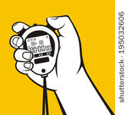
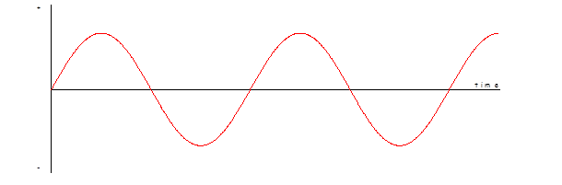This is the same for waves. If we take one peak of a wave and time how long it takes to travel a certain distance we can find the speed of the wave.
d
t
The distance travelled by a wave travelling at a constant speed can be calculate during:
$d = v t$
Symbol | Name | Unit | Unit Symbol
d | distance | metre | m
v | velocity or speed | metres per second | ms⁻¹
t | time | Seconds | s

Wave speeds can vary greatly from a few metres per second up to the speed of light. For example sound waves travel in air at around 340 ms⁻¹. The actual speed of a sound wave will depend on environmental factors like temperature and pressure. Light waves travel in air at 300, 000, 000 ms⁻¹ (or 3 x 10⁸ ms⁻¹). So light travels approximately 1 million times faster than sound in air.

Worked Examples
- The crest of a water wave moves a distance of 4.0 metres in 10 seconds. Calculate the speed of this wave.
$$d = v t$$
$$4 = v × 10$$
$$v = 4 / 10$$
$$v = 0.40 {ms}^{-1}$$

Frequency
Wave Frequency The frequency of a wave is defined to be: $frequency= \frac{number of waves }{time for the waves }$. In symbols this becomes $f= \frac{N }{t }$
Now consider the case for just one wave. The number of waves is one and the time taken is the Period. Hence; $frequency= \frac{1 }{Period }$. In symbols this becomes $f= \frac{1}{T }$
Symbol | Name | Unit | Unit symbol
f | Frequency | hertz | Hz
T | Period | seconds | s
N | Number of waves

Worked Examples
- A certain breed of bat emits ultrasounds with a period of 23 µs. Calculate the frequency of the ultrasound.

T = 23 x 10⁻⁶ s
f = ?
$$f= \frac{1}{T }$$
$$f= \frac{1}{\begin{aligned}23×{10}^{-6} \\ \end{aligned}}$$
$$f= 43∙5 kHz$$
- Given that a wave has a frequency of 50 Hz, calculate its period.
T = ?
f = 50 Hz
$$f= \frac{1}{T }$$
$$50= \frac{1}{T }$$
$$T=0.02s$$

TUTORIAL QUESTIONS
  - Calculate the frequency of the waves if 10 waves are produced in one second?
  - Determine the frequency if 500 waves are produced in one second.
  - If 10 waves are produced in 2.0 seconds, then 5 waves must be produced in 1.0 second. Calculate the frequency of the wave in this case.
  - 6000 waves are produced in 10 seconds. State the frequency of the source.
  - It takes 0.2s for a source to produce one wave. Calculate the frequency of the source.

Try this for the WAVES on the ANIMATIONS
- Adjust the markers so that X and Y are 200 mm apart.
- Time how long it takes for one wave to pass between the two markers.
- Record this time in your jotter
- Repeat two more times and take an average of the time it takes to move 200 mm
- Using the equation v=d/t find the speed of the waves.
Now we are going to show that another formula can be used to find the speed to the waves.
- Pause the wave and use the ruler to measure the wavelength of each wave.
- Measure more than one wave to check the wavelength.
Now we are going to find the frequency of the wave. Frequency is the number of waves per second. But to time the number of waves per second is too quick
- Time to find out how long it takes for 10 waves.
- 10 waves = X seconds so 10/X= no. of waves per second, which is the frequency. Find the frequency (number of waves per second).
- Now take the wavelength of the waves and multiply this by the frequency.
- Compare this to the wave speed found using v=d/t (they ought to be the same).
- Repeat for the other two waves.
- Repeat for the other two waves.
Period T, is the time for one wave Period is measured in seconds
Frequency is the number of waves produced per second or passing a point per second. Frequency is measured in Hertz (Hz)

The other main formula related to waves is derived from the relationship between distance, speed and time
distance = speed x time
For just one wave, the distance becomes one wavelength and time becomes one period.
wavelength = speed x period
As period = $\frac{1}{f}$,
therefore wavelength = speed (v) x $\frac{1}{f}$ or $λ= \frac{v}{f}$
This can be rearranged to give us the wave equation
$$v=fλ$$
Think of it like this:
What happens when we multiply these two quantities together?

Symbol | Name | Unit | Unit symbol
f | frequency | Hertz | Hz
v | velocity | metres per second | m/s or ms⁻¹
λ | wavelength | metres | m

Worked Example
Microwaves have a frequency of 9.4 GHz. Calculate their wavelength.
v = 3 x 10⁸ ms⁻¹ | $$v=fλ$$
f = 9.4 x 10⁹ Hz | $$3×10^{8}=9.4 × 10^{9}λ$$
λ = ? | $$λ=0.032m$$

Thunder and Lightning
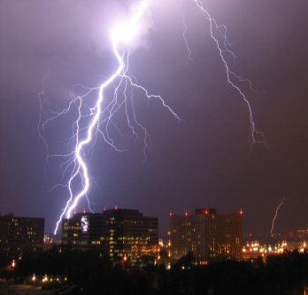
We hear thunder after we see lightning because the speed of sound in air is almost a million times slower than the speed of light in air. The thunder and lightning are created at the same time but the light reaches us first.
Sound travels with a speed of around 340 ms⁻¹ whereas light travels at 300 000 000 (300 million) metres per second in air.
Sound travels at different speed through different materials. It travels fastest through solids because the particles are closer together.
Calculations involving the speed of sound can be carried out using the equation:
$v=\frac{d}{t}$
d
v
t
Where: v is speed, measured in metres per second (m/s)
d is distance, measured in metres (m)
t is time, measured in seconds (s)

During a storm, lightning is seen in the distance and the thunder is heard 5 seconds later. How far away was the lightning strike?
d = ?
v = 340 ms⁻¹
t = 5 s
d = v t
d = 340 x 5
d =1700 m

TUTORIAL QUESTIONS

Wave speed
- During a physics experiment a pupil finds it takes a sound wave 0.005 s to travel 1.5 m. Calculate the speed of sound in air.
- If the time taken for light to travel 750 million metres is 2.5 s, calculate the speed of light.
- If the speed of sound in air is 340 m s^{–1}, calculate the time the sound takes to travel 5.1 km.
- If the speed of sound in water is 1500 m s^{–1}, calculate the time sound in water takes to travel 1.5 km.
- When tourists near Edinburgh Castle watch the 1 o’clock gun being fired they see the puff of smoke 5.0 s before they hear the bang. If the speed of sound is 340 m s⁻¹, determine the distance between the tourists and the castle.
- Explain why, during a thunder storm, you see the lightning before you hear the thunder. On a day when the speed of sound in air is 340 ms⁻¹, calculate the time taken for sound to travel a distance of 1.6 km.

- Thunder is heard 20 seconds after a lightning flash. If the speed of sound is 340 ms⁻¹, determine the distance from the storm.

- During a thunder storm it is noticed that the time interval between the flash of lightning and the clap of thunder gets less. Explain what this tells you about the position of the storm.

- Describe a method of measuring the speed of sound in air giving:
  - the apparatus used
  - the measurements taken
  - any equations used in the calculation.

- Ten pupils are standing on Calton Hill, looking at Edinburgh Castle. They measure the time difference between seeing the smoke from the one o’clock gun and hearing the bang. The measured times are
3.8 s, 4.2 s, 4.0 s, 3.8 s, 4.4 s, 3.8 s, 4.0 s, 4.2 s, 3.6 s, 4.2 s.

  - Calculate the average time for the group.
  - Calculate the distance from the Castle to Calton Hill if the speed of sound is 340 ms⁻¹.

- An explosion in Grangemouth could be heard in South Queensferry one minute later. Given they are 20 km apart, calculate the speed of sound in air.

- On a day when the speed of sound is 340 ms⁻¹, calculate the time the sound takes to travel a distance of 19.8 km?

- In a race the runners are at different distances away from the starter. They will hear the starting horn at different times. Using the speed of sound as 340 ms⁻¹, calculate the time difference in hearing the horn for two runners who are 5.0 m and 15.0 m from the starter.

- Calculate the time for light to travel from the Sun to the Earth, a distance of 1.49 x 10⁸ km.

- Determine the time it takes a radio signal to travel from Britain to Australia, a distance of 1.8 x 10⁴ km.

  - Explain, using a diagram, the difference between a transverse and longitudinal wave.
  - What type of waves are the following:
i) sound waves
ii) water waves
iii) light waves.

- Explain, using the particle model, why sound travels quicker in metals than gases.

- Explain why sound cannot travel through a vacuum.

Wave equations
- The diagram below represents a wave 0.2 s after it has started.

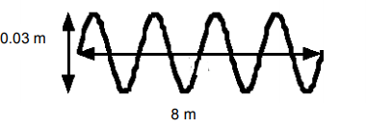
- Calculate the following quantities for this wave:
  - Wavelength
  - Amplitude
  - Frequency
  - speed.

- A swimming pool is to have a wave-making machine installed. The time taken for a wave to travel the length of the 50 m pool has to be 20 s and the wavelength has to be4 m.
  - Calculate the speed of the waves.
  - Calculate the required frequency of the waves.

- Wave A has a wavelength of 6.0 cm and a frequency of 50 Hz. Wave B travels 250 m in 1minute 40 seconds. Explain which wave travels faster and determine the difference in speed?

- 40 waves are found to pass a point in 20 s. If the waves have a wavelength of 0.015 m, calculate their speed.

- Calculate the wavelength of a wave of frequency 0.1 Hz and speed 5.0 ms⁻¹.

- State what is meant by the period of a wave.

- If the speed of a water wave is 0.6 m/s and the wavelength of each wave is 6.0 cm, calculate
  - the frequency
  - the period of the wave.

- Waves of wavelength 5.0 cm travel 120 cm in one minute. Determine their
  - Speed
  - Frequency
  - period.

- A sound generator produces 25 waves every 0.10 s. If the speed of sound is 340 ms⁻¹, calculate:
  - the frequency
  - the period of the waves
  - the wavelength of the sound.

- In the diagram below the distance between X and Y is 10 m.
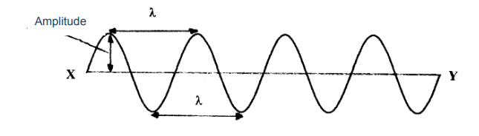
If 20 waves pass a particular point in 5 s, determine
  - the wavelength
  - the frequency and
  - the period of the wave.
Depth (metre) | Velocity (km/h) | Wavelength (km)
7000 | 943 | 282
4000 | 713 | 213
2000 | 504 | 151
200 | 159 | 48
50 | 79 | 23
10 | 36 | 10.6
- Tsunami is the name given to the very long waves on the o cean generated by earthquakes or other events which suddenly displace a large volume of water. The wave speed depends upon wavelength and the depth of the water for tsunamis at sea. Characteristic data is shown in the table. Find the largest and smallest frequency for these tsunami waves.

- Calculate the wavelength of sound with frequency 1 000 Hz which is passing through carbon dioxide gas. (Speed of sound in carbon dioxide = 270 ms⁻¹).

- Determine the speed of ultrasound in Glycerol given that a 40.0 kHz ultrasound pulse has a wavelength of 4·75 cm in Glycerol?

- An 8.0 MHz ultrasound pulse is transmitted into water. It has a wavelength of 0.000187 m in water, calculate its speed.

- A buzzer emitting sound of frequency 12.0 kHz is switched on. What is the wavelength of the sound waves in air where the speed of sound is 340 ms⁻¹.

- An ultrasound pulse of frequency 7.0 MHz is transmitted through 8 cm of muscle. The wavelength of the ultrasound in muscle is 2·29 x 10⁻⁴ m.
  - Calculate the speed of sound in muscle.
  - Calculate the time taken for the ultrasound to pass through the muscle.

- How far will radio waves travel in a) 2.0 ms b) 0.25 ms c) 1.00 ms.

- Calculate the wavelength of waves of frequency a) 5 GHz b) 4 MHz c) 200 GHz.

- Calculate the transmission frequency of Radio Scotland broadcasting on 370 m on the Medium waveband. Give your answer in MHz.

Speed of Sound Questions
- Calculate the missing values in the following table: You must still show your working below the table. (IESSUU)
 | Speed ( ms⁻¹) | Distance (m) | Time (s)
(a) |  | 15 000 | 5.0
(b) |  | 38.0 | 0·020
(c) | 1 500 |  | 0·25
(d) | 5 200 |  | 0·010
(e) | 340 | 17.0
(f) | 330 | 3 465

- The speed of sound in tissue is 1500 metres per second. Calculate the distance sound travels in tissue in a time of 0·0002 seconds.

- Sound in jelly can travel a distance of 0·435 metres in a time of 0·000 3 seconds. Calculate the speed of sound in jelly.

- Calculate the time taken for sound to travel 0·435 m through air if the speed of sound in air is 340 ms⁻¹.

- The speed of sound in muscle is 1 600 ms⁻¹. Calculate the distance sound travels in muscle in a time of 0·0005 seconds?

- Calculate the speed of sound in bone given that it takes 0·00005 s for sound to travel 0·15 m through bone.

- A boy is standing at a distance of 100 m from a large building. He shouts loudly and hears an echo.
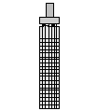
100 m

  - Determine the distance the sound travels between leaving the boy and returning to him as an echo?
  - If the speed of sound in air is 340 ms⁻¹, calculate the time taken for the sound to cover this distance.
- An ultrasound pulse is transmitted into an expectant mother’s womb and reflects from the baby. The pulse echo is detected 0·8 milliseconds after being transmitted. The speed of sound through the body tissue and fluid is 1500 ms⁻¹
  - Calculate the distance travelled by the pulse.
  - Determine the distance between the transmitter and baby.
  - Another pulse is reflected from the foot of the baby. If this reflected pulse is detected 0·15 milliseconds after being transmitted, calculate the distance from the transmitter to the baby’s foot.(1 millisecond = 0.001 seconds = 1x10⁻³ seconds)


- During an ultrasound scan, a baby’s forehead is situated 7·5 cm from the transmitter. The ultrasound pulse travelling at 1 500 ms⁻¹ is reflected from the baby’s forehead.
7·5 cm
  - Calculate the total distance travelled by the pulse.
  - Calculate the time elapses between the transmission of the pulse and the detection of the pulse echo.

- An ultrasound pulse is transmitted into the womb of an expectant mother and the pulse echo is detected after a time of 0·38 milliseconds. The pulse was reflected by one of the baby’s knees situated 28·5 cm from the transmitter. Show that the speed of sound in the womb is 1 500 ms⁻¹.

Diffraction
http://www.acoustics.salford.ac.uk/feschools/waves/diffract3.php
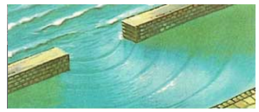
Waves can 'spread' in a rather unusual way when they reach a gap in a barrier or the edge of an object placed in the path of the wave - this is called diffraction.
Diffraction can be clearly observed with water waves as shown in the image to the right. Notice that the parallel crests of the water waves become circular as they spread out on passing through the gap between the two harbour walls.

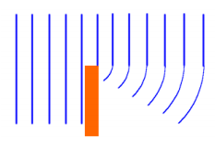
Sea waves incident on a breakwater are found to spread into the region behind the wall where we would expect the sea to be flat calm. This is an example of diffraction at an edge.
Diffraction is only significant if the size of the gap or object is matched to the size of the wavelength of the waves.

- When the size of the gap or object is much larger than the wavelength of the waves, the waves are only slightly diffracted.
- When the size of the gap or object is nearly the same as the wavelength of the waves, the diffraction effect is greatest
Diffraction is the name given to the bending of waves as they pass through a narrow gap or round an object is called diffraction. Diffraction is a property of all waves
Long waves diffract more than short waves
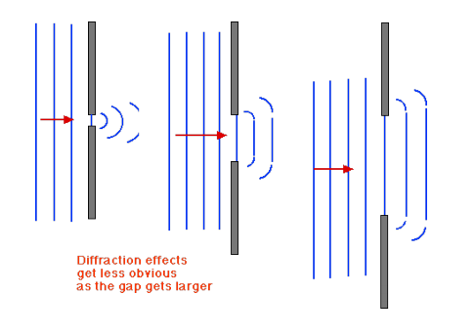
Waves other than water are also affected by diffraction

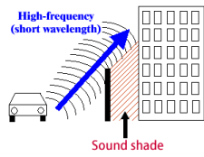
Sound
Sound can diffract through a doorway or around buildings. Lower pitched sounds travel better than high-pitched sounds. This is because low-pitched sounds have a long wavelength compared with the width of the gap, so they spread out more.

Ultrasound
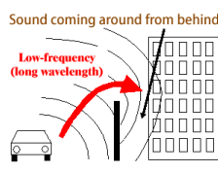
Ultrasound is sound with a high frequency. It has a very short wavelength compared with most structures in the body, so there is very little spreading. This makes sharp focusing of ultrasound easier, which is good for medical scanning.

Radio Waves
Long wave radio signals are much less affected by buildings and tunnels than short wave radio signals or VHF radio signals. Because of diffraction, long wave radio signals (e.g. Radio 4, λ=198 m) can sometimes be received in the shadow of hills when the equivalent VHF broadcast can not.
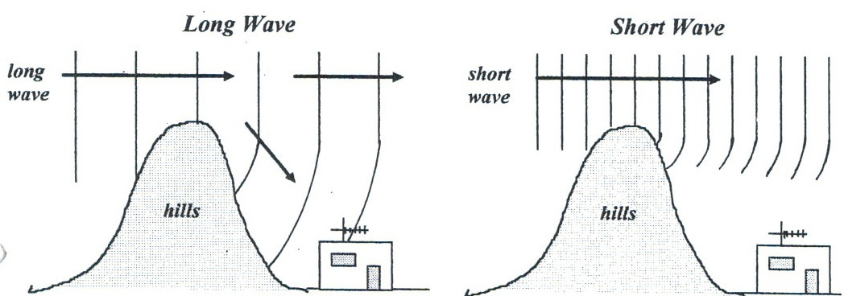

Light
Light has a very short wavelength compared with most everyday gaps such as windows and doors. There is little obvious diffraction, so it produces sharp shadows

TUTORIAL QUESTIONS
- Sketch the diffraction patterns formed in the following circumstances;
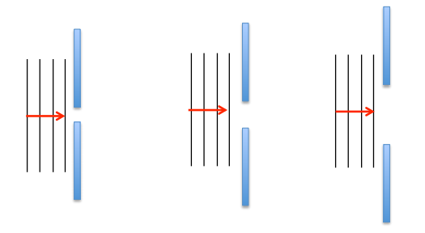
- Elephants can communicate with each other across distances of several kilometres, even when there is dense vegetation in the way and they cannot see each other. They do this by making low pitched noises. Explain how the sound get through. Explain why this would not work for high-pitched sounds.

- Can water waves bend around barriers?

- State whether water waves fill the space behind the barrier completely?

- Which wavelength produces the greatest diffraction?

- Do microwaves behave in a similar way to water waves?

- Draw diagrams to illustrate the differences between the diffraction of long and short wavelength waves.

Success Criteria
 | 17.1 | I can state that energy can be transferred as waves.
 | 17.2 | I can define transverse waves as waves where the particles of the medium vibrate at right angles to the direction of energy travels.
 | 17.3 | I can define longitudinal waves as waves where the energy travels along in the same plane as the particles vibrate.
 | 17.4 | I know that sound is an example of longitudinal waves and waves in the e-m spectrum are transverse waves.
 | 17.5 | I can determine the frequency, period, wavelength, amplitude and wave speed for longitudinal and transverse waves.
 | 17.6 | I can make use of the relationships between wave speed, frequency, wavelength, distance, number of waves and time (v = f λ) (d = vt)(f=1/T) (f=N/t) (λ=d/N.).
 | 17.7 | I can describe diffraction and associated practical limitations.
 | 17.8 | I can make comparisons of long wave and short-wave diffraction.
 | 17.9 | I know that diffraction occurs when waves pass through a gap or around an object.
 | 17.10 | I can comparison how long waves and short waves diffract.
 | 17.11 | I can draw diagrams using wave fronts to show diffraction when waves pass through a gap or around an object.

Electromagnetic spectrum

Learning Intentions
- Knowledge of the relative frequency and wavelength of bands of the electromagnetic spectrum with reference typical sources, detectors and applications.
- Knowledge of the qualitative relationship between the frequency and energy associated with a form of radiation.
- Knowledge that all radiations in the electromagnetic spectrum travel at the speed of light.

Electromagnetic waves
All Electromagnetic (EM) waves are transverse waves. Unlike many other types of waves (sound waves for example) they do not need particles to vibrate or to travel through. Instead EM waves oscillate an electrical and a magnetic field perpendicular to their direction of travel (hence the name). This allows EM waves to travel through a vacuum, something that other waves cannot do.
Electromagnetic waves travel at a very high speed. In a vacuum this speed is three hundred million metres per second – i.e. 300 000 000 ms⁻¹ or 3 x 10⁸ ms⁻¹. This is usually referred to as the speed of light and is given the symbol c. This is a universal speed limit – nothing can travel faster than c.
Remember that the wave equation states $v=fλ$ So if v is fixed, it is possible to have a whole family of electromagnetic waves whose frequencies are different but are always related by this equation, e.g. as f doubles, so λ halves such that the equation $c=fλ$ is always true. This family of waves is known as the electromagnetic spectrum and consists of Radio Waves, Microwaves, Infrared, Visible Light, Ultraviolet, X-Rays and Gamma Rays. The image below shows the spectrum arranged in order of increasing frequency (i.e. decreasing wavelength).
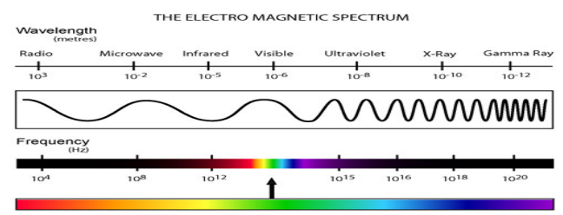
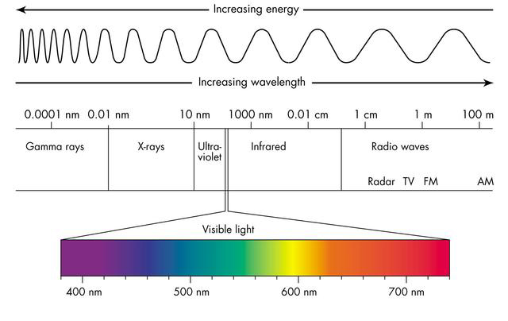

Notice how small the section is for visible light compared to the width of the whole spectrum. The colour order of the visible spectrum is expanded in the lowest section of the image and is shown in the decreasing wavelength or increasing frequency order
– Yellow – Green Red – Orange - Blue – Indigo - Violet (ROY G BIV)
The order of electromagnetic spectrum can be remembered by singing ‘The Electromagnetic Spectrum Song’ by Emerson Wong Yann
https://www.youtube.com/watch?v=JIQagFY9fco
or making up a mnemonic like
Randy Monkeys Invade Venezuela Using X-rated Gunships
Rude Men Ignore Very Ugly eX Girlfriends

Uses and sources

Each member of the electromagnetic spectrum transfers energy from source to receiver/detector and as such may be called electromagnetic radiation.
Type of radiation | Typical source | Application | Detector | Possible hazard
Radio & TV | Electrical antennae | Telecommunications | Aerial | Potential increased cancer risk
Microwaves | Cosmic sources, magnetron | Cooking, telecommunications | Diode probe | Heating of body tissues
Infra-red | Heat emitting objects | Thermograms | Phototransistor | Heating of body tissues
Visible light | Stars | Vision | CCDs, Retina, LDR | Intense light can damage retina
Ultraviolet | Sunlight | Treating skin conditions | Fluorescent paint | Skin cancer
X-rays | X-ray tube, cosmic sources | Medical imaging | Photographic plates | Destroys cells which can lead to cancer
Gamma rays | Nuclear decay | Treating tumours | Geiger-Muller tube and counter | Destroys cells which can lead to cancer

TUTORIAL QUESTIONS
            - Copy and complete the following paragraph.
The part of the electromagnetic spectrum with the longest wavelength is (a) Between X-ray and visible light in the electromagnetic spectrum is (b) Radiation. Some radioactive isotopes emit (c ) radiation. Signals can be sent from remote controls to a television by (d) Radiation.
- State a type of electromagnetic radiation that
  - is visible to the eye
  - is emitted by hot objects
  - is diffracted by hills
  - is used for imaging inside the body
  - causes tanning
  - kills bacteria
  - is used by mobile phones
  - can cook food
  - has the highest energy
  - has the lowest energy associated with it.

- Calculate the distance radio waves travel in a) 2 ms b) 0.25 ms c) 1.0 µs.

- Calculate the wavelength of the electromagnetic waves whose frequencies are
  - 5 GHz
  - 4 MHz
  - 200 GHz.

- Calculate the transmission frequency of Radio Scotland broadcasting on 810 m on the Medium waveband. Give your answer in MHz.

- State the speed of an electromagnetic wave in a vacuum.

- State what happens to the wavelength of electromagnetic waves as frequency increases.

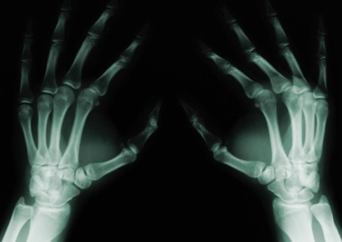
- State what happens to the energy of an electromagnetic wave as frequency increases.

- Describe an application of each of these types of electromagnetic radiation in medicine:

  - X-Rays.
  - Gamma Rays.
  - Infrared Radiation.
  - Ultraviolet Radiation.

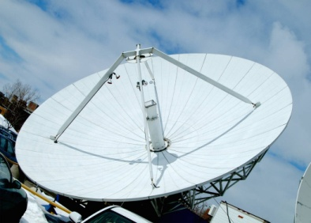
- Describe an application of each of these types of electromagnetic radiation in telecommunication:
  - Radio waves.
  - Microwaves.


- Describe an application of each of these types of electromagnetic radiation in the home
  - Infrared Radiation.
  - Microwaves.

- Explain why gamma rays are unsuitable for using in mobile phone communication. Give two reasons for your answer.

- Determine the time it takes visible light to travel through 250 km of water?
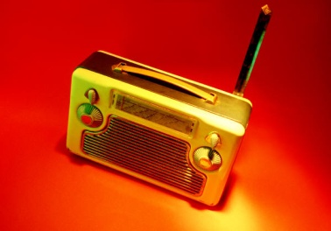
- A radio carrier wave is sent out from BBC Radio 1 in London with a frequency of 97.5 MHz. A student in Edinburgh (which is 670 km away) is listening to the broadcast. Calculate the wavelength of this radio wave.

- Calculate the time it takes the wave to travel from London to Edinburgh.

- Ultraviolet radiation is one of many types of radiation given off by the Sun. The ultraviolet radiation from the Sun takes 8 minutes to reach the Earth. Calculate the distance between the Earth and the Sun.
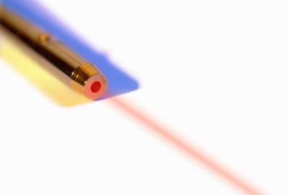
- State the type of electromagnetic radiation given off by a laser.

Success Criteria

 | 18.1 | I can state the relative frequency and wavelength bands of the electromagnetic spectrum.
 | 18.2 | I can make reference to typical sources, detectors and applications, of the electromagnetic spectrum.
 | 18.3 | I can state that all radiations in the electromagnetic spectrum are transverse.
 | 18.4 | I can state that all radiations in the electromagnetic spectrum travel at the same speed of light (3x10⁸ ms⁻¹) in air

Light

Learning Intentions
- In ray diagrams showing refraction, identification of the normal, angle of incidence and angle of refraction.
- Description of refraction in terms of change of wave speed, change of wavelength and change of direction (where the angle of incidence is greater than 0⁰)

Wave behaviour
It has already been shown that waves diffract, or spread out, when they meet a gap or edge of an object. In addition, waves can be shown to reflect and refract. The next two topics of this unit cover reflection and refraction. It is particularly useful to study the reflection and refraction of visible light waves, though any waves can exhibit these phenomena.

Reflection
The diagram below shows the path of a ray of light when reflected off a mirror. Some simple rules:
- A ray is a line with an arrow to show the wave direction.
- The normal is a dotted line drawn at 90o to the mirror at the point where the ray of light hits the mirror.
- All angles are measured between the ray and the normal.
- The incoming ray is called the incident ray and this makes the angle of incidence with the normal.
- The outgoing ray is called the reflected ray which travels at the angle of reflection to the normal.
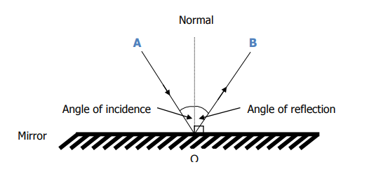

It is veryIt
It is important to always put arrows on any diagram that contains rays of light. Otherwise you would not be able to tell in which direction the light was travelling.

Refraction
All waves will refract, but the property is most commonly seen with visible light. The refraction of light is a change in speed, and sometimes direction, of a ray of light when it travels from one medium to another. For example when light travels from glass to air or air to water it will bend and refract. This is because when light enters a more dense material it slows down. This means that the speed of light in glass is not 3 × 10⁸ m s^{–1} (as it is in air). In fact the speed of light in glass is roughly 2 × 10⁸ m s^{–1}.
The wavelength of the light is also changed when the light is refracted. However frequency (which is related to energy) does not change when light is refracted. This means that when light slows down as it enters a material the wavelength of the light becomes shorter.
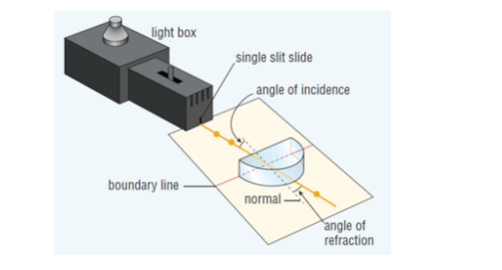
The wave speed depends on the medium in which the wave travels. When a wave changes medium its changes speed. This change of speed is called refraction. In the diagram below the incident light is shown passing from air into a semi-circular glass block.

In addition to changing speed the wave changes direction inside the glass block. This change of direction happens when the angle of incidence is anything other than zero, i.e. the incident ray is not along the normal; both of these changes are due to refraction.
Remember that the speed of light in a vacuum is the fastest speed possible. The speed of light in air is almost the same as in vacuum. The light slows down as it enters the glass and speeds up again as it leaves.
For refraction:
- greater speed = greater angle between the ray and the normal
- Smaller speed = Smaller Angle between the ray and the normal
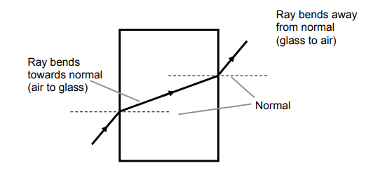
Ray moves away from the normal (glass to air)
Ray moves towards the normal (air to glass)

Refraction and Frequency
The splitting of white light into different colours happens because each colour has its own unique frequency. (All colours of light travel at the same speed) The amount of refraction (bending) depends on the frequency of the light and so each colour is bent by different amounts.

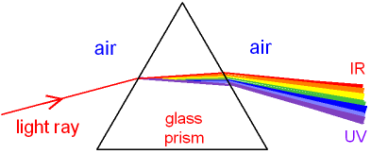

Red light has the lowest frequency and so is bent the least. Violet light has the highest frequency and so is bent the most.

Colour | Red | Orange | Yellow | Green | Blue | Indigo | Violet
Wavelength(nm) | 650 | 590 | 570 | 510 | 475 | 445 | 400
Frequency (THz) | 462 | 508 | 526 | 588 | 382 | 674 | 750
Speed (ms⁻¹) | 3 x 10⁸ | 3 x 10⁸ | 3 x 10⁸ | 3 x 10⁸ | 3 x 10⁸ | 3 x 10⁸ | 3 x 10⁸

Total Internal Reflection
There is a link between refraction and a phenomenon called Total Internal Reflection. It can be shown when:
- light travels from glass into air the direction of travel is changed (refracted) away from the normal.
- the angle of refraction is exactly 900 then the angle of incidence is known as the Critical Angle (θc ).
- the angle of incidence is less than the critical angle most of the light will be refracted out into the air and some will be reflected inside the glass.
- the angle of incidence is bigger than the critical angle the light does not pass into the air. All the light is reflected (not refracted) back into the glass.

Total Internal Reflection is used in optical instruments including periscopes, binoculars and fibre optics.
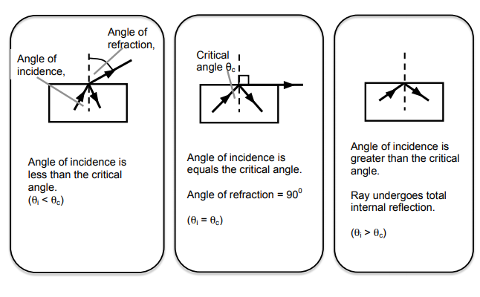

Fibre Optics
A fibre optic is a thin thread of glass. Light entering at one end always strikes the outer edges of the glass at large angles of incidence so that the light is always totally internally reflected back into the glass. Consequently the light never escapes and is trapped inside the glass fibre.
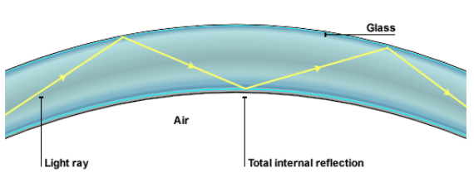
The fibre can be made pliable enough so that it can bend round corners. Thus, light inside the fibre optic can be made to bend round corners. This is extremely useful: • In medicine it is used in a “fibrescope” that allows a doctor to see inside a patient’s body without having to cut them open. • In telecommunications it is used to send pulses of laser light from one place to another, allowing enormous amounts of information to be transmitted very quickly.
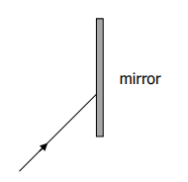
If fibre optics are used in telecommunications then the information transmitted along the fibres as pulses of light will lose much less energy than if the information was transmitted using cables. As a result booster stations are required less frequently

TUTORIAL QUESTIONS
- Copy and complete the diagram, labelling clearly
  - the angle of incidence
  - the angle of reflection
  - the normal.

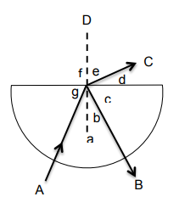
- The diagram shows the path of a ray of light. The direction of the ray was manipulated using mirrors, but these have been left out. Complete the diagram by placing the mirrors in exactly the correct position.

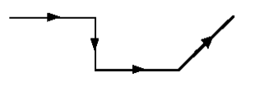
- Identify the following on the diagram shown.
- incident ray
- reflected ray
- refracted ray.
- normal.
- angle of incidence
- angle of refraction.
- angle of reflection.

- Complete the following diagrams to show how the rays would pass through the glass objects.
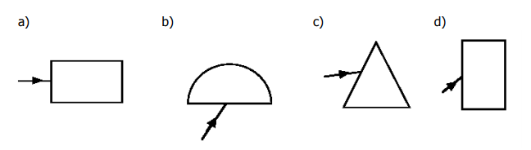
For d) above, describe how your diagram would be different if the ray was passing into a block filled with water rather than solid glass?

- Describe an experiment to demonstrate total internal reflection. You should include a list of apparatus, a diagram, and an explanation of how you would use the equipment.

- Explain, with the aid of a diagram, what is meant by ‘the critical angle’.

- Describe the principle of operation of an optical fibre transmission system.

- Optical fibre systems use repeater stations. State the purpose of repeater stations.

- Light signals travel through glass at a speed of 2 x 10⁸ ms⁻¹. Calculate the time it takes light to travel between two repeater stations which were 100 km apart?

Success Criteria

 | 19.1 | I know that refraction occurs when waves pass from one medium to another.
 | 19.2 | I can give a description of refraction in terms of change of direction (where angle of incidence is greater than 0°)for waves passing into both a more dense and a less dense medium.
 | 19.3 | I can describe the qualitative (info) relationship between the frequency and the energy associated with a form of radiation.
 | 19.4 | I can identify the normal, angle of incidence and angle of refraction in ray diagrams showing refraction.

Tutorial Exam style questions
1. Geologists use sound waves to help them to find out where oil is trapped under the ground. Pulses of sound waves from a generator are directed into the ground and are reflected from the layers of rock below. Microphones on the surface then detect the reflected sound.

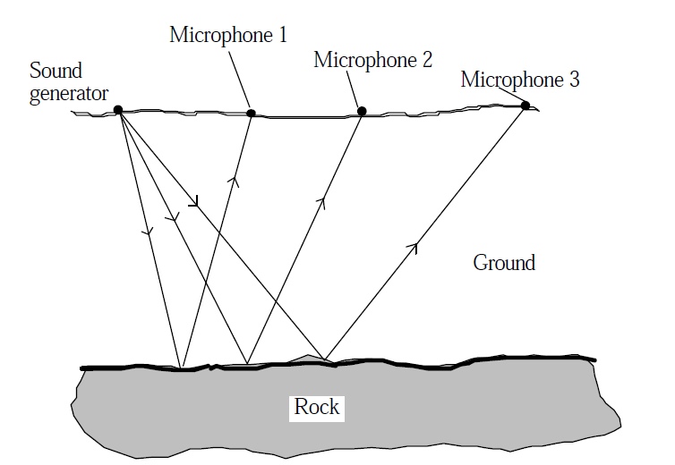
The diagram shows the path of some of the sound waves. The speed of the sound pulses through the ground is 1800 ms⁻¹.
- Which microphone will detect the reflected sound first? Explain your answer. (2)

- Microphone 1 detects the reflected sound after 0.45 seconds. What distance did the sound pulse have to travel through the ground? (3)

- The sound pulses will also travel through the air directly to the microphones at a speed of 340 ms⁻¹. Microphone 3 detects both the sound that travelled through the air and the reflected sound 0.8 seconds after the sound pulse was generated. State what additional distance did the sound have to travel through the ground compared to through the air? (4)

- In a telecommunication system, pulses of light are sent from a transmitter to a receiver using an optical fibre as shown.
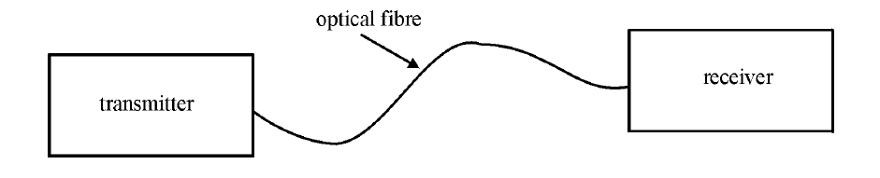
An enlarged part of the optical fibre is shown in the diagram below. The path followed by light travelling down the optical fibre is shown in the diagram.
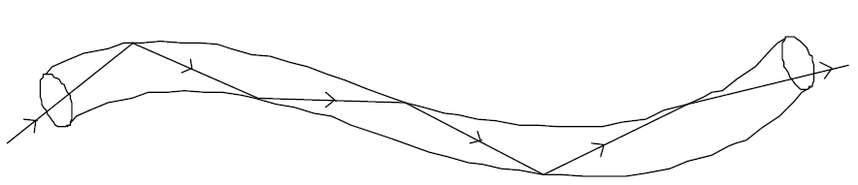
Light pulses travel along the optical fibre at a speed of 2 x 10⁸ms⁻¹.

- Explain why light in the optical fibre follows the path shown. (1)
- The distance travelled by light in the optical fibre is 20 km.
- Calculate the time taken for the light to travel this distance. (2)
ii) Some of the light energy produced by the transmitter is lost as the light travels through the fibre. For every kilometre travelled by the light, 0.5% of the energy from the transmitter is lost. If the energy of the light signal drops by 6%, a repeater has to be inserted into the fibre to amplify the signal. Explain why this length of optical fibre will require only one repeater. (2)

- Astronomers use radio telescopes to study parts of the universe which do not emit visible light. Radio telescopes are constructed with a large dish as shown below.
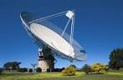
    - With the aid of a diagram explain why a dish is used in a radio telescope. (2)
    - A radio telescope detects radiation which has a frequency of 6.0 x 10⁹ Hz. Calculate the wavelength of this radiation? (2)
    - Radiation is received by the telescope from a source that is 15 light years away. A light year is the distance that light travels in one year. Determine this distance in metres, to the source of radiation. You must justify your answer. (3)

- An aircraft is flying between two fixed points that are 1000 m apart. The aircraft is being observed from a distant hill. The observer can both see and hear the aircraft.
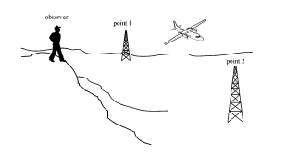

(a) Describe two differences between the sound waves and the light waves that travel from the aircraft to the observer. (2)
(b) The aircraft takes 4 seconds to travel between the two points. Explain using a calculation if the aircraft is travelling at a speed faster or slower than the speed of sound. (3)
c) The pilot of the aircraft transmits a radio signal to the observer. The radio signal has a frequency 110MHz. What is the wavelength of the radio signal? (2)

Check your Compendium and ensure you’ve covered all of the WAVES outcomes, complete past paper questions on this section and record the date of your assessment in your planner. Ask for help if your require tips on revision. Don’t leave it until after the first test.

