
2017
J.A.Hargreaves
www.mrsphysics.co.uk
6/5/2017
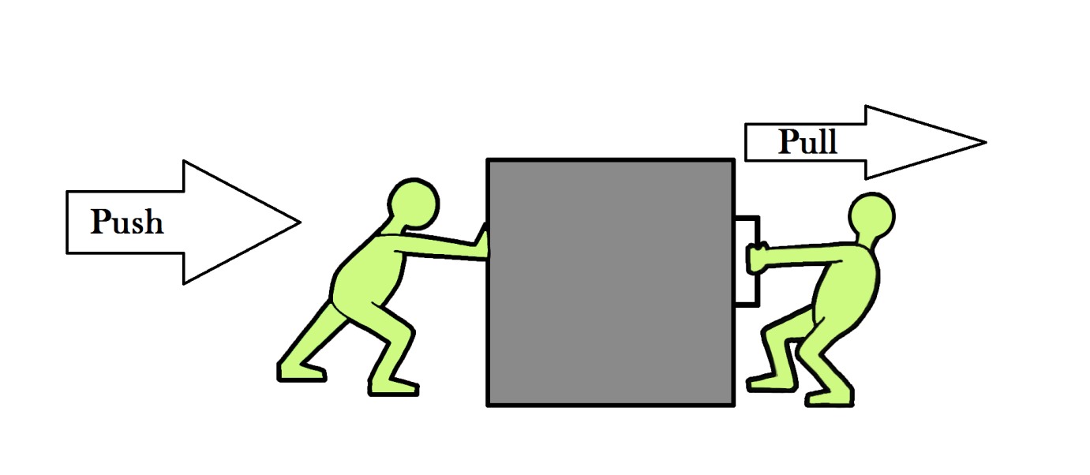
FORCES

S2 FORCES NEED TO KNOW SHEET

- Mass is a measure of the amount of matter in an object.
- Mass is measured in kilograms (kg).
- Mass stays the same wherever it is taken.
- Mass doesn't move unless forced to.
- Forces are invisible. Sometimes we can see what causes the force or the effect of the force. egs of forces are: pushing, pulling, squeezing, tearing are all ways
- For the effects of a force to be seen the forces must be unbalanced.
- A force is needed to change an objects
  - shape,
  - direction,
  - speed and
  - start an object moving.
- Weight is the force due to gravity on an object.
- An object with a very large mass, eg the Earth, the moon, pulls other objects eg humans, towards it. This pull is called the force of gravity.
- Any mass has a force of gravity but it is usually too small to measure
- Adding twice the force to the spring makes the spring stretch by twice as much.
- We say that force and extension are directly proportional.
- A spring balance or Newton balance is used to measure forces.
- The weight of a 100g mass is 1 Newton.
- The rougher the surface the bigger the force of friction.
- The heavier the object the bigger the friction force.
- Give examples where friction is useful
- Give examples where friction is not useful
- Give examples of ways to increase friction
- Give examples of ways to decrease friction
- Forces can be drawn by using scaled arrows
- Forces can be added by doing scale diagrams
- Balanced forces are when two are more forces cancel out to give the same result as if there was no force acting on an object.

FORCES

Course Plan

Homework
- Complete a title page called FORCES
- In the back of your jotter write a piece “What I learned about myself in S1 Science”.

This unit is about forces. Forces are important to us in everything we do but we often do not realise when forces are being applied because we are using them all the time. Opening jars, moving, and standing still all involve forces. We would not survive without forces.
We will start this unit by looking at mass. Mass is not a force but is important because forces act on mass. It is also important to start by considering mass because what scientists call mass is what the average person on the street calls weight. The notes then go on to find out what forces are and what they do. The unit examines two important forces, weight and friction.

MASS

INFORMATION
Anything that takes up space is matter.
You should know that matter can be in several states, solid, liquid, or gas (or plasma).
The amount of matter in an object stays the same, whether the object is on the Earth, floating in space or on the moon. It is the same object. Its mass remains the same.
Mass is a measure of the amount of matter in an object. Mass is caused by the number of particles in an object. Particles are too small to be seen so we deal with larger bundles called kilograms. Look back at your old notes if you have forgotten about particles.
Mass is measured in kilograms (kg). 1000 g = 1 kg
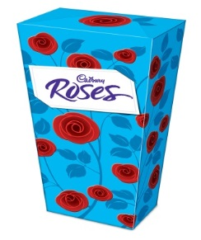
The Chemists often work in grams because of the small quantities that they use in their experiments.
The information that you have read tells us that if you had a big (400 g) box of Roses chocolates on the Earth the size and number of chocolates would be the same wherever you took those chocolates. They would still be a 400 g box of chocolates with the same number of mini dairy milks etc, providing that you don't eat the chocolates!
In the same way if a girl has a mass of 40 kg (about 6 stone 4 pounds) on the Earth, her mass is still 40 kg up in a plane, on the moon or out in space. Her mass stays the same.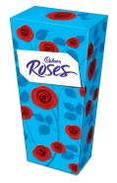MEASURING MASS.

TASK
- Answer the following questions in sentences in your jotter.
  - What would the mass of a 1 kg bag of sugar be on the moon?
  - What would be the mass of an astronaut on the moon, if his mass on Earth is 80 kg?
  - What would be the mass of a dog in space if its mass on the Earth is 12 kg?
- Find out your mass in kilograms using the scales provided. If you do not wish to find your mass assume it is 50 kg.
- State what your mass would be in the following situations:-
  - on the moon,
  - on Earth,
  - floating in space,
  - on the planet Mars (if you could get there).

Extension Task
Collect a lever balance and some of the masses provided. Plan an experiment to compare the masses. Try to find out which of the masses is heaviest and if any of the masses are the same, double etc.

Summary – write this in your jotter
Mass is a measure of the amount of matter in an object. Mass is measured in kilograms (kg).The magnitude (size) of the mass stays the same wherever it is taken.

MOVING MASS
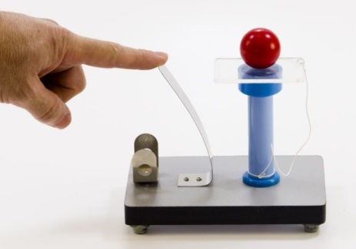
Solids prefer to stay put. They won't start to move about unless forced to. The bigger the mass the harder it is to move. Inertia is the tendency of an object to remain in a state of rest or uniform speed unless acted upon by an unbalanced force. That is, it is the resistance of an object to motion. Measurement of inertia is a way of measuring mass.

PROBLEMS
Answer the following questions in sentences in your jotter.
- Is it harder to knock over the Rector or a primary one pupil?
- Who has the bigger mass, the Rector or a primary one pupil?
- Which needs more effort to start it moving, a car, bike or a bus?
- Does a car, bike or bus have the bigger mass?
- Which needs more effort to stop moving, a bike, car or bus?
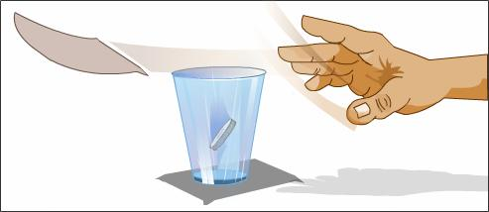
- Does the bike, car or bus have the bigger mass?

TASKS
- Collect a gas jar and put a sheet of paper over the top.
- Put a coin on the paper over the gas jar.
- Try to remove the paper so that the coin falls into the gas jar.
- Try to explain why this happens.
- Watch the demonstration:- Suspend two tin cans from the special clamp stands. Set them moving by giving them a push. Try stopping them both.
- What does this tell you about mass?
- Now try lifting up the heavier can with your little finger.
- Is this easier than moving it from side to side?
- Give a reason for your findings.

Summary
Mass doesn't move unless forced to.

FORCES

In groups write the heading FORCES in a bubble in the next page of your jotter. Write down all the things you can think of to do with FORCES. Can you identify what a Force is?
expess views
Forces

Now pair with a friend and see where you agreed and where you disagreed.
Now record some FORCE words in your jotter, for example: kick

Notes
A FORCE is a PUSH or a PULL. Forces can’t be seen, but the effect of a force can be seen. Forces are measured in newton – N. They always act in a certain direction. A Newton balance , spring balance or forcemeter is used to measure forces.
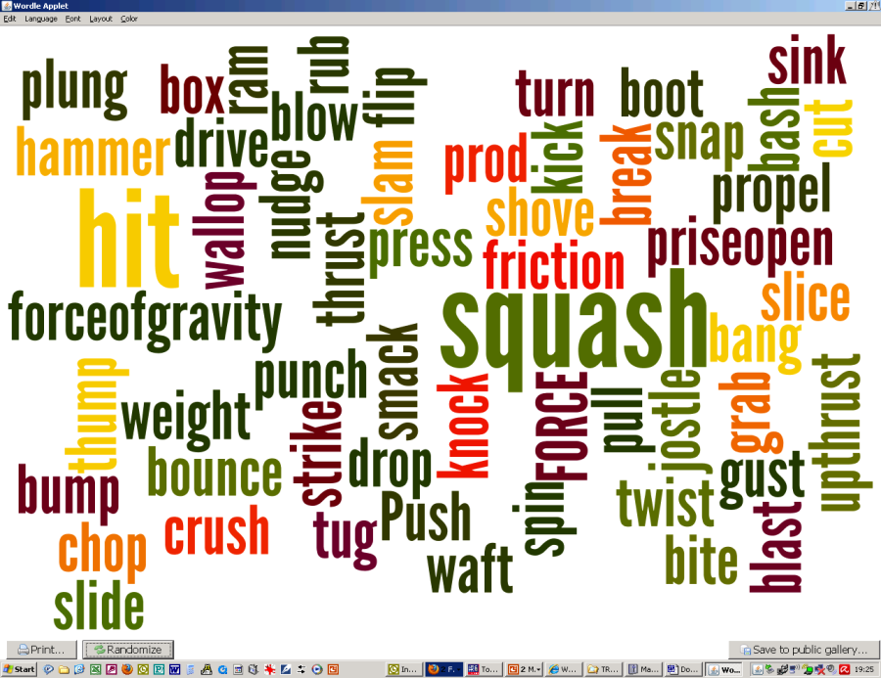
e

EFFECTS OF A FORCE?

What is a force? Forces are invisible. We cannot see the force. Sometimes we can see what causes the force or the effect of the force. You are going to discover what the effects of forces are in the next few experiments.
Planning/
working safely
PRACTICAL APPLYING FORCES 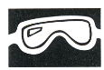
- BE CAREFUL DURING THIS EXPERIMENT, DO NOT DESTROY THE OBJECTS
- Copy the table headings into your jotter.
- Collect a piece of rubber tubing, foam, sponge, elastic, metal strip, springs etc.
- Take one of the objects from the tray and apply different FORCES to it. e.g. push, pull, squash, squeeze. Do not apply so much force that you permanently damage any object.
- List the force word that you would use to explain the force.
- Record the effect on the object.
- Fill in the table. You should include the object that you used, all the different forces that you applied to that object. Then you should record in the last column what effect the force had on the object. You will probably need more lines than are shown in the table.
- Repeat the experiment with five of the other objects
Object | Force | Effect

- Force open a clothes peg.
- How can it be kept open without touching it?
- Is there still a force on it?
- Tear a sheet of paper in two.
- Is the same force needed to tear a bundle of paper?
- Try it and see.
- Push a trolley to get it moving.
- How can you get the trolley to move without touching it?
- Is there still a force on it if you are not touching it?
- Why doesn't a wooden block move as far if you try to push it?
- Write a conclusion listing the effects of forces that you have met in these experiments.

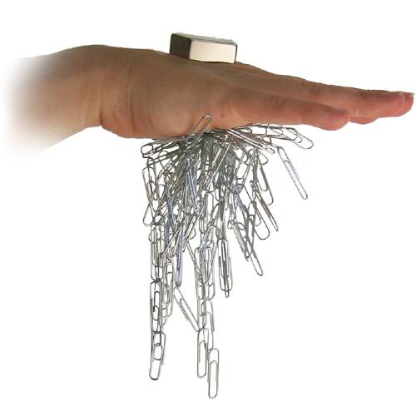
CHECKPOINT

TASKS
- Record the effects of the magnetic force in the following experiments.
- Collect a magnet. Make a list of 5 objects that the magnet attracts or repels and 5 objects which are not affected by the magnet. Try to find some objects that nobody else has chosen.
  - Which of these two groups of objects is having force applied to it by the magnet?
- Collect another magnet. Hold one of the magnets steady with one finger while a partner gently slides another towards it.
  - Try to say where the force or forces are acting in this situation.
- Slide one of the magnets across the desk without touching it.
  - Explain how you did this.
  - Is there any other way to do this? If there is describe how.
- Find out the maximum number of sheets of paper through which one magnet can still exert a force on the other.
  - Does the type of material affect the distance over which one magnet can still exert a force on another magnet?
- Place other materials between the magnets.
  - What does this tell you about the forces between the magnets?
  - Do you think the answer depends on the strength of the magnet?
- Ask your teacher to try it and see using the large magnet.
- Hop one magnet on top of the other on the inside of a plastic pen.
  - Say where the forces are acting and the effect of these forces. You may wish to draw a diagram to help you.
Make a list of any effects of a force that you have met so far.
CHECKPOINT Now have your work checked by a teacher.

EXTENSION MORE EFFECTS OF FORCES.
Using equipment,
Safety, Measuring
Observing
Object | Force | Prediction- what will happen? | Result
Moving table tennis ball | Blow (push) from back
Moving table tennis ball | Blow (push) from front
Moving table tennis ball | Blow (push) from side
Stationary table tennis ball | Blow (push)

- Copy the table into your jotter.
- Predict what you think will happen when you try the following experiments:-
- Take a table tennis ball and roll it along the table.
  - While it is rolling:
  - blow on it in the direction it is rolling; (push from the back)
  - blow on it in the opposite direction from which it is rolling; (push from the front).
  - blow on it from one side;
- Blow a table tennis ball which is not moving (stationary).
- Fill in the rest of the table.
- Get your teacher to try the experiments with a larger ball.
- Explain any differences in the force that you needed to apply from your results.
CHECKPOINT Now have your work checked by a teacher.
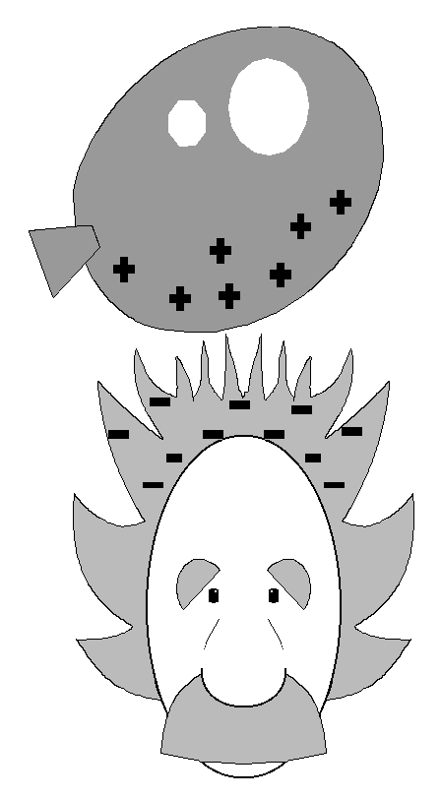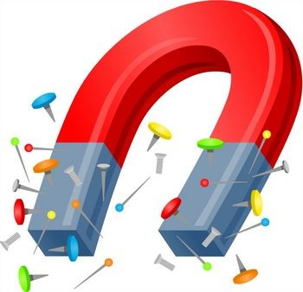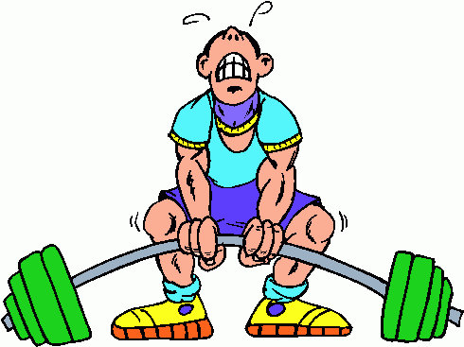
SUMMARY – write this in your jotter.
From the experiment we see that if a force is applied to an object one of the following things will happen.
            - The object will change ............. .
            - The moving object will change ............. .
            - The moving object will move ........... or ............... .
            - The stationary object will begin to .......... .
PROBLEMS
Look at the sketches below. Try to identify what is CAUSING the FORCE and what EFFECT the FORCE has.
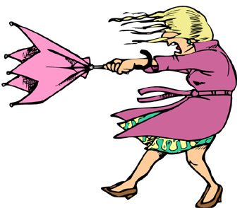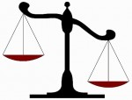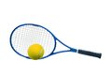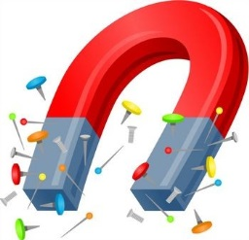
Presenting an Argument
CLASS DISCUSSION
Can you think of any other forces that you meet regularly? Say what these forces are and the effects that they cause.
As a class write a summary about some of the forces that you meet regularly.

HOMEWORK
Look over the work in your jotter. Then write a summary in your jotter.
You need a sentence or two saying what mass is and what units it is measured in.
You also need to write a sentence to say how you can tell when a force is acting on an object.
If you need help ask your teacher for help sheet 1.
CHECKPOINT At this point take your work to the teacher to have it checked.
EXTENSION
Answer the questions in sentences on pages 69 and 70 of Starting Science Book 2.

Note:
Forces cannot be the seen, but the effects of a force can be seen.
It seems amazing but you cannot see Forces. You can only see their effects.
Forces change an object’s
  - speed, (cause an acceleration)
  - shape,
  - direction of movement.

Write down some FORCES that act on a car when driving or in a car crash.

Go on a force walk with your teacher
- Make a table in your jotter and record when you come across a force, how do you know? What are the effects of this force?
What | Force | Effect | Comment
Flushing the loo | Push on handle

Has the forces walk made you more aware of forces around you?

Contact and Non-Contact Forces
Think
Pair
Share
We can divide forces into 2 groups
Contact Forces
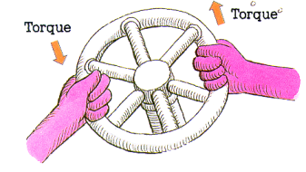
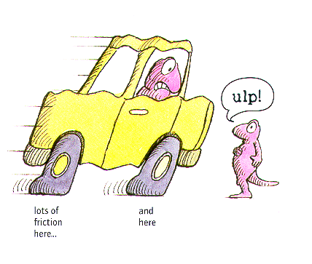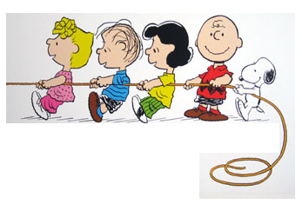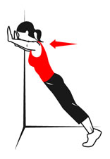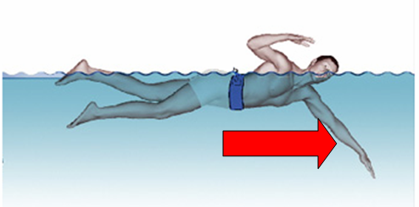
Friction
Tension (pull)
Spring Force (Twist)
Applied force (push)
Water resistance and pull
Air Resistance

Non Contact Forces
Air Resistance
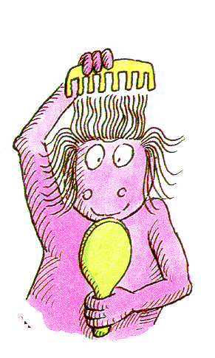
Weight Air resistance Pull Push Upthrust Friction Water resistance Electrical force magnetic force
Put the forces, indicated by the pictures into a table copied into your jotter, listing contact and non-contact forces.
Contact | Non-Contact
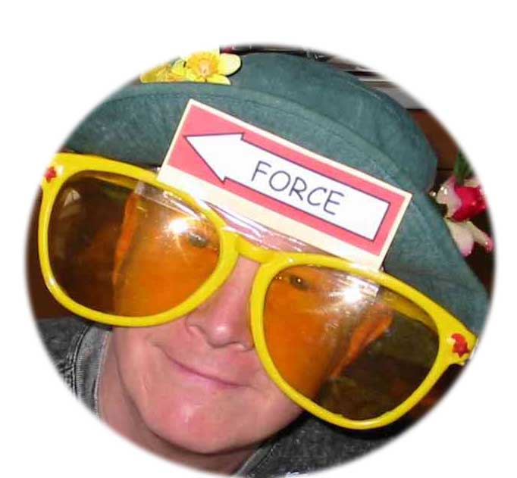
Forces are invisible. Sometimes we can see what causes the force or the effect of the force. So far we can see that pushing, pulling, squeezing, tearing are all ways of applying force.

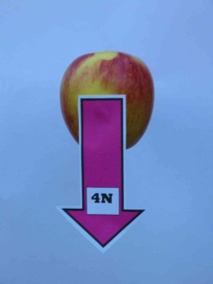
FORCE SPECS!
If forces came ready-labelled Science might be easier.

A shopper carries his shopping home. How does this situation appear through forces spectacles?
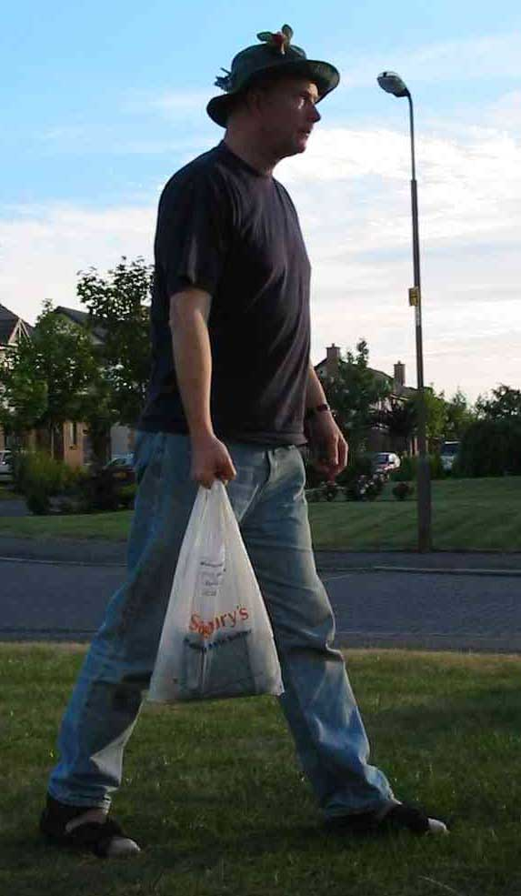
There are forces acting everywhere. Here are just a few of them
Let’s consider the forces acting on the hand.
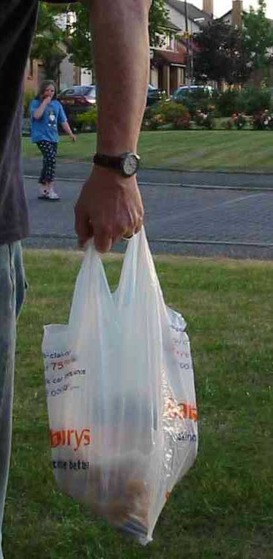
Can you identify the forces which act on the hand?
A support force from the arm muscles acts on the hand

A force (the weight of the bag) acts on the hand

Now consider the forces acting on the shopping
The stretched plastic bag supports the shopping with an upward force.
The Force of Gravity acts on the shopping with a downward force
The simplest model shows the shopping as a single mass.

Use Forces Specs and think of the forces for various actions
HOOKE’S LAW
INFORMATION
In Science we need to measure accurately. We would like to be able to measure forces. We know that the larger the force, the greater the effect of that force on the object. For example if you push very gently onto Plasticine then you will only slightly change the shape of the Plasticine. If you apply a big force then the Plasticine's shape will change more. This idea can therefore be used as one way to measure the size of a force. The following investigation is to show that a spring can be used to measure the size of a force.
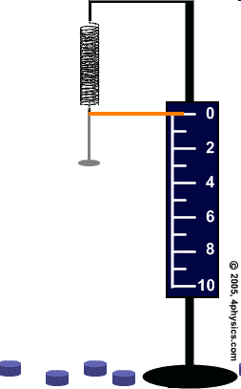
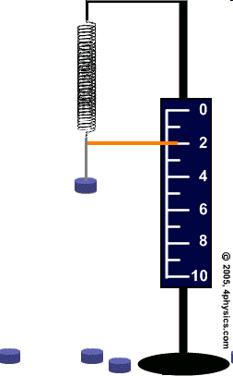
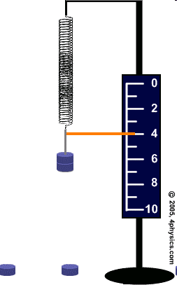
INVESTIGATION
You are going to investigate how increasing the force on a spring changes its length. You can also try a similar experiment with an elastic band. We want to know if doubling the force changes the length of a spring. We call this Hooke’s Law
For the experiment write down the following:-
- an AIM, (what you are trying to do),
- your PREDICTION,HYPOTHESIS (what you think will happen),
- use the METHOD to show you how to carry out the experiment,
Variables, Hypothesising, Planning
Equipment Handling, Safety, Measuring
Observing, Taking Readings (Including Using Alba), Processing Data, Excel Graphs
- DO the experiment
- RECORD your RESULTS
- make your CONCLUSION
- Evaluate your experiment.

READ THE METHOD BELOW AND MAKE SURE THAT YOU UNDERSTAND IT. Then set up the apparatus as shown in the diagram below.
            - Draw a table in your jotter like the one below.
            - Hang a spring vertically from a clamp stand and make sure it cannot fly off.

MASS  (kg) | Force (N)  (÷mass in g by 100) | LENGTH  (mm)  1 | LENGTH  (mm)  2 | LENGTH  (mm)  3 | Average  LENGTH  (mm) | INCREASE IN LENGTH  (EXTENSION) (mm)  (Length - start length)
0 | 0 |  |  |  |  | 0.0
            - Record the length of the spring without any load on the end.
            - Clamp the metre stick or rule vertically in the clamp, alongside the spring.
            - Record the metre stick or rule reading level with the bottom of the spring. The number of masses hanging from the spring is 0 and the extension of the spring is 0 cm.
            - Hang a mass hanger from the bottom of the spring. Record the new metre stick reading, the mass and the extension of the spring.
            - Add another load or hanger onto the spring.
            - Record the new length of the spring in your table.
            - Work out how much the spring has stretched. This is found by subtracting the length at the start of the experiment from the stretched spring length.(or Excel can work it out for you when you record your results into a spreadsheet.
            - Repeat stages 4 to 7.
            - BEWARE DO NOT STRETCH THE SPRING SO MUCH THAT IT DOESN'T GO BACK TO ITS ORIGINAL SHAPE.
            - On a piece of graph paper plot a graph of the results. The extension of the spring is the output (or dependent) variable and you should plot it on the vertical axis. Extension (y-axis) against weight force (x-axis) as below.

Extension
- Repeat the experiment with sweet laces and see if the experiment gives the same results.
- DO NOT EAT THE LACES!
- AVOID SUGAR COATED LACES

Homework
Collect a sheet of graph paper and plot both graphs on the same axes as shown in the example.
This data is in the homework sheets. Draw a graph using the data in this table so you will be able to compare the two springs.
Weight | Extension (cm)
(N) | Spring 1 | Spring 2
0 | 0.0 | 0.0
1 | 2.4 | 1.7
2 | 4.8 | 3.4
3 | 7.2 | 5.1
4 | 9.6 | 6.8
5 | 12.0 | 8.5
6 | 14.4 | 10.2
7 | 16.8 | 11.9
8 | 19.2 | 13.6
9 | 21.6 | 15.3
10 | 24.0 | 17.0


Use the helpsheet below to help you write up your investigations.

S2 Investigation –Help Sheet

http://www.wikihow.com/Write-up-a-Science-Experiment
Processing Data, Excel Graphs
Writing A Scientific Report Diagram

Title
- What is the title of your investigation? Make it clear and informative.
Aim
- What are you trying to find out (we call this your aim)
Hypothesis
- What do you expect to happen? Generally say As one thing increases the other things increases/decreases* (delete where applicable)
Apparatus
- What equipment will you need? (this is your apparatus list, and it can be a list)
Diagram
- Draw a diagram to show how you will set up. This should be at least half a page, drawn with a ruler and clearly labelled.
Variables
- What things will you keep the same in your experiment? (It generally is everything apart from what you change and what you will measure) These are called your control variables and will help make your experiment a fair test)
- What are you going to change? (what variable are you changing- remember to change only ONE thing) This is your independent variable, remember
“I change the Independent variable”
Method
- Now write a method of what you did. It should be like a step by step guide to what exactly you did. Give as much detail as possible. (Think of it like a recipe in HE. If there is not enough detail other people couldn’t cook the same meal.)
- Include in your method, what 2 things are you going to measure? What equipment will you use to measure this?
- How many readings will you take?
- How will you change your variable?
Safety
- What are the hazards? Is there anything that you need to do to keep safe?
Results
- Draw a table to show how you will record your results.
- Plot a line graph of your results, and draw a best fit line through it with a ruler.
Conclusion
- What do your results show? Does your independent variable increase as your dependent variable increases? Does your independent variable increase as your dependent variable decreases? Is it a straight line through the origin of the graph? (we like these in Physics!)
Evaluation
- Did you get the results that you expected?
- What could you have done differently to make the experiment better?
- Are there any points that don’t fit on the line?
- Did you take the readings properly?

REFER TO THE HELP SHEET FILES TO SHOW HOW TO ENTER RESULTS INTO EXCEL AND PLOT A GRAPH. This will form part of your assessment

Note
Adding twice the force to the spring makes the spring stretch by twice as much.
We say that force and extension are directly proportional.
INFORMATION
We can use the fact that the stretch of a spring depends on the force added to measure forces. The size of the force is measured in Newtons (N). This unit was named after Sir Isaac Newton.
The instrument used to measure the force is called a Newtonbalance, or Springbalance.
The springbalance works in the same way as the spring which you used in the last practical.
Adding twice the force to the spring makes the spring stretch by twice as much. If we add three times the weight force to the spring we cause the spring to stretch by three times as much. We say that force and extension are directly proportional.
EXTENSION
Answer the questions on pages 72, 73 and 75 of Starting Science Book 2 in sentences.

Questions
- Draw a diagram of the springbalance and include the scale.
- What is the maximum force that your springbalance can measure?
- What is inside the springbalance?
- If you put a 2 N force on a springbalance and it stretches by 1.5 cm how much would the springbalance stretch if the force was 4 N?
- How is a 1 N springbalance different from a 100 N springbalance? Try to give more than one difference.
MEASURING FORCES: USING A SPRINGBALANCE
PRACTICAL
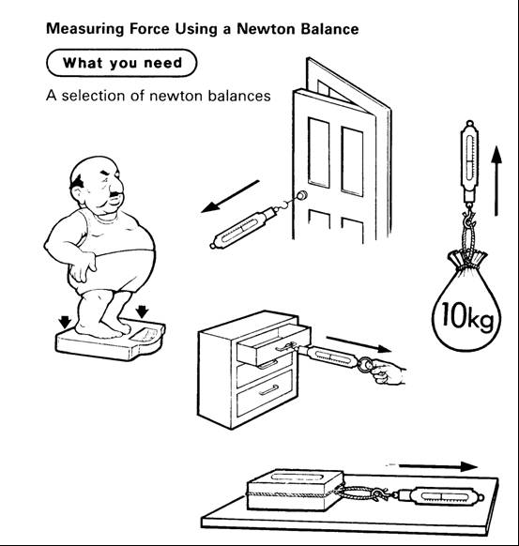
Measure the force needed for the following actions, and remember to record your answers in a table:-
Remember to choose the correct springbalance for each job.
Measure the force needed to:-
- lift your pen,
- open a door,
- open a drawer,
- stretch an elastic band to twice its length,
- lift your school bag
If you have time measure some other forces.
ADDITIONAL TASK
Record the value that you would expect each of the spring balances to read. Check your answers after you have made your predictions.
CHECKPOINT Now have your work checked by your teacher.

Mass and Weight

TASK
- Take a pen or pencil. Pick it up and let it go.
- Write down any words or phrases that come to mind when you drop a pen.
- Compare your answers with the rest of the class.
- Watch the Scientific Eye video on Gravity- it is 14 minutes long and is on CLICKVIEW.
- Answer the questions on the video.
- To where do all objects dropped on the earth fall?
- Who first did experiments on the force of gravity? When were they done?
- What happens to the speed of the blocks as they are dropped from the Tyne Bridge?
- How is the force of gravity on the moon different from that on the Earth?
- List some of the world records that could be broken if the Olympics were held on the moon.
- List 6 things in the last part of the video where the force of gravity is acting on an object.

TASK
Answer the following questions and then try them out and see if your predictions were correct.
- Do all objects fall to the ground because of the force of gravity?
- Do all objects fall at the same speed when dropped?
- Does the shape of the object affect the time to fall?
Ask your teacher to show you the "guinea and feather" experiment.
http://practicalphysics.org/guinea-and-feather.html
https://www.youtube.com/watch?v=zXDZWKmRxI0
https://www.youtube.com/watch?v=E43-CfukEgs
https://www.youtube.com/watch?v=KDp1tiUsZw8

Question
What can you learn about force of gravity just from the task that you have just done?
ADDITIONAL TASK /HOMEWORK
Write down your ideas about force of gravity. Try to include what you think it is and what you think might cause it.
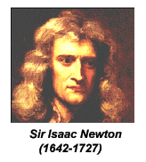
Read the following information carefully.
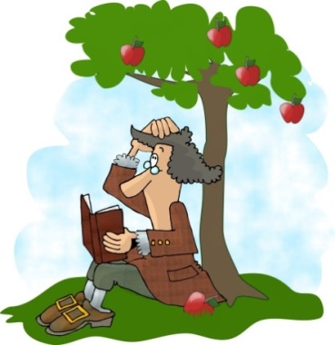
The story goes that Sir Isaac Newton did a similar experiment to the one that you have just done with the pen but he is supposed to have seen an apple fall to the ground. This happened around the year 1687. Sir Isaac Newton tried to explain what had happened. This led him to think out the theory and laws of the force due to gravity.

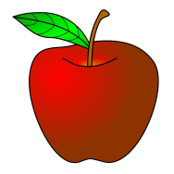
TASK
Answer the following questions in your jotter.
- Why does the apple fall?
- If an astronaut in space lets go of an apple suggest what you think happens to it?
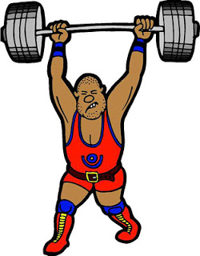
Wherever the apple tree is on Earth the apple always falls downwards. The force due to force of gravity always pulls the objects towards the centre of the Earth. This pull due to force of gravity is called weight. The bigger the amount of matter in an object, the bigger is the force due to gravity, and the bigger is the object's weight. This may seem hard to understand. It might help if we think of a weightlifter. Someone described weightlifting as a tug of war against the Earth. When a weightlifter lifts up his dumb-bells he is applying a force which is bigger than the force acting downwards (the force due to gravity). If the weightlifter lifts a very light mass off the ground then he finds this easy, as he is only applying a small force. If the mass is very large he has to apply a big force to pull the dumb-bells away from the Earth. Therefore the Earth must be "holding on tighter" or "pulling" the heavier mass more than the lighter one.
In space objects are not attracted so strongly towards the Earth. The force due to gravity gets smaller as you move away from the Earth.
RESEARCH
a) Find out about some aspect of space travel. For example training astronauts, eating in space etc.
OR
b) Find out more about force of gravity. For example, what causes it, does it change on other planets, what are black holes.
OR
c) Try to describe a room or an activity without force of gravity. (ignore the lack of air)

Notes:
- Weight is the force due to gravity on an object. An object with a very large mass, eg the Earth, the moon, pulls other objects eg humans, towards it. This pull is called force of gravity.

Practical- the link between mass and weight
Weight is a force and it is the pull of gravity acting on an object. It is measured in Newtons.
Experiment
- Collect a 20N spring balance and a set of 100 g masses. Take care of them. They are not toys. Do not stretch the balabces beyond the end of their scale.
- Predict the weight (force of gravity) on 100 g.
Mass (g) | Predicted Weight (N) | Actual Weight (N)
- Record this in the table.
- Test your answer and record the measured weight.
- Repeat for other masses until you can discover a relationship.
- Replace the 20 N spring balance with a 50 N spring balance and place 5 kg on the end.
- Record carefully the value of the weight.
- What conclusion can you draw about mass and weight?

Conclusion
From our experiment we have found out that the Earth pulls every 1kg with a force of ??N
TEST QUESTIONS
What would be the weight (force) of
a) 100g b) 1000g c) 250g d) 420g e) 1 kg f) 40 kg

Summary
Weight is a force and it is the pull of gravity acting on an object. It is measured in Newtons.

Extension
Instructions for experiment 2
Use the Newton balance as in Diagram 2 to lift each mass.
Compare the force required to
a) support the mass so that it is not moving
b) move the mass upwards at a steady speed
c) move the mass downwards at a steady speed.
Record your results in a table, recording the mass in kilograms (kg).
Extend your table, calculate the ratio of weight to mass; ie.
State the name given to this ratio.

Formula :
weight =mass × ??
This value of ?? Newtons per kilogram is called the GRAVITATIONAL FIELD STRENGTH, g
Weight =mass × gravitational field strength
W = m × g

Object | Mass (kg) | Weight (N)
A bag of sugar | 1 | 10
A bag of tatties | 5
A loaf of bread | 0.5
An apple |  | 1
A small car |  | 8000
A small pupil |  | 450
ME
Bag of crisps | 23g

Change 23g into kg =23 x 1/1000 = 0.023kg
“g” is the gravitational field strength. It is measured in NEWTONS PER KILOGRAM. It is the WEIGHT PER UNIT MASS (force of gravity on every kilogram)

My Weight on other planets
As the weight depends on what you are attracted to
Calculate your own weight on each of the planets.
Planet | g (N/kg) | m (kg) | W (N) =m x g
Mercury | 3.7
Venus | 8.8
Earth | 10.0
(Moon) | 1.6
Mars | 3.8
Jupiter | 26.4
Saturn | 11.5
Uranus | 11.7
Neptune | 11.8
Pluto | 4.2

i) Find out the distance of each of the planets from the Sun.
ii) Present the above information on ‘g’ on a drawing of the Solar System.

SUMMARY
Look back at the work in your jotter.
Write a summary about weight and weighing which includes:-
a) What happens to a spring when the force on the end is doubled,
b) The instrument for measuring force and the unit in which it is measured,
c) A brief description of weight.
If you need help ask your teacher for help sheet 2.
CHECKPOINT Now have your work checked by your teacher.
FRICTION: IS IT A FORCE?
READ
Another force that is important to us is the force of friction. This is the force caused when two surfaces are in contact. The force of friction tries to stop things moving. Friction is needed for brakes to work, and for tyres gripping the road. Friction is not always good, eg. friction wastes fuel when we are driving
TASK
In your groups, make a list of instances where friction is needed (useful), then make another list of instances where friction is not needed (a nuisance).
Play a game of shove penny with a partner. Then answer the following questions.
Q1. Why does the penny slow down?
Q2. a) What must be acting on the penny if it slows down and
b) in which direction is it acting?
Q3. How do you make it travel further?
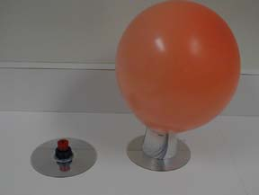
CHECKPOINT
Get your teacher to check your work.
INVESTIGATION
You are now going to do some practicals to investigate the force of friction. You will need a puck, balloon, sandpaper, block and a Newton balance.
            - Push the puck and let it slide along the bench top.
            - Record what you see.
            - Now predict what you think will happen if you
a) slide the puck along sandpaper
b) slide the puck on a layer of air
4. Then try the experiments.
5. Write a summary to show what have you learned about friction so far.
CHECKPOINT Get your teacher to check your work.

FRICTION: CAN IT BE MEASURED?
The only way for us to measure the friction force is to gradually increase the pull on the springbalance until the block just begins to move. This force is then just equal in size to the force of friction pushing backwards. See the diagram.
TASK
Aim: To use the Newton balance to pull and lift various known masses.
Apparatus: Newton balance
Selection of masses of known size
Instructions for experiment 1
Use the Newton balance as in Diagram 1 to pull each mass across the top of your desk.
Compare the force required to
a) start the mass moving
b) keep the mass moving slowly at a steady speed
c) keep the mass moving quickly at a steady speed.
Explain how the newton balance is used to measure force.
Copy the table below.
Mass on the top (kg) | Surface | Predicted force to move block (N) | Force to move the block (N) | Friction force (N)
0 | Wood
0 | Hardboard
0 | Denim
0 | Sandpaper
1 | Wood
1 | Hardboard
1 | Denim
1 | Sandpaper
2 | Wood
2 | Hardboard
2 | Denim
2 | Sandpaper

Tie a cord or a piece of string around the friction block.
Gently pull the block forwards, with the block's surface touching the bench, until it just starts to move.
Record the force needed to move the block. This is the force of friction for the surfaces.
Predict what you think would be the force of friction if the different surfaces of the block were touching the bench. Remember to record your predictions in the table.
Measure the force of friction of the other surfaces of the block. Record your answers in the table.
Add 1 kg to the top of the block. Find the new force of friction for the four surfaces.
Add 2 kg to the top of the block and find the force of friction for the four surfaces.

SUMMARY
Say how the type of surface and the mass of the object affects friction.

CHECKPOINT Now have your work checked by a teacher.
TASK/HOMEWORK
Find out where friction is important in some everyday situations.
The rougher the surface the bigger the force of friction. The heavier the object the bigger the friction force.

REDUCING FRICTION.
Read the following information carefully.
INFORMATION
Your results from the last experiment should have shown that the type of surface can affect the size of the force of friction. Sometimes it is important to try to make the force of friction as small as possible.

INVESTIGATION
Find out which of the following methods is best at reducing friction.
For the experiment write down the following:-
- an AIM, (what you are trying to do),
- your PREDICTION, (what you think will happen),
- use the METHOD to show you how to carry out the experiment,
- DO the experiment
- RECORD your RESULTS
- make your CONCLUSION.

The surfaces for you to try are:-
a smooth surface (the smoothest surface of your block),
wooden rollers or round coloured pencils,
wheels (place the block on a roller skate),
small beads (small polythene beads).

EXTENSION
Answer the questions on page 76 of Starting Science Book 2 in full sentences.
REDUCING FRICTION: LUBRICANTS.
READ
A lubricant is a slippery substance which reduces the force of friction.
It can fill the rough parts of the surface. This has the effect of making the surface smoother and reduces the force of friction. See the diagram on the next page.
Imagine pouring treacle into the gaps between the surfaces. Try to consider what a difference this would make.

Extension
Find out which of the following lubricants is best at reducing friction. The lubricants are soap (we will use this instead of oil which is messy), water, and French chalk. You may want to add some more of your own. Before starting the experiment make sure that you have your plan checked by your teacher.
Write up your experiment afterwards with an aim, method, results table and conclusion. Say how you made sure that your test was fair.
SUMMARY
Write a summary in your jotter about friction. It should include the following points.
              - What is friction?
  - How the size of friction can be measured.
  - How rough or smooth surfaces affect friction.
  - How friction can be reduced.
  - Examples in everyday life where friction can be helpful and examples where it is a nuisance and has to be reduced.
If you need help then ask your teacher for the summary helpsheet 3.
Read the following information carefully.
INFORMATION
Friction is a resistive force, which opposes the relative motion of two surfaces in contact.
This means that it acts in the opposite direction to the relative movement of the two surfaces.
Friction acts between any two surfaces in contact. When one surface moves over another, the force of friction acts between the surfaces and the size of the force depends on the surfaces, e.g. a rough surface will give a lot of friction.
Friction is a very common force.
Friction between two solid surfaces depends on two factors:
- how rough the two surfaces are
- the size of the force between the two surfaces [how hard they are pressed together.]
Friction increases the rougher the two surfaces are and the bigger the force between them.
If there is no friction between surfaces then the surfaces can move easily over each other.
This can be achieved by placing a layer of a different material between the surfaces.
An example of this is air being used in an air puck.
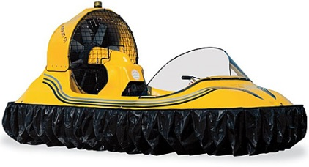
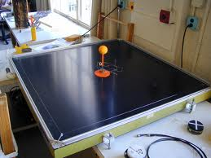

tsgphysics.mit.edu funcrate.com
Friction is a force which tries to stop things moving. Friction occurs between two solid surfaces. Friction can be good or a nuisance
Friction is helpful | Friction is unhelpful
braking | shooting (drag slows the bullet)
walking | sledging
space craft re-entry | skiing
running | ice skating
writing | snowboarding
sky-diving (drag) | putting on clothes (chaffing)
opening bottles | swimming
cutting things | wears down tyres
putting spin on an object | engines wear away
rock climbing | slide
steering wheel | F1 racing !!!!
striking matches | ceramic brakes!!!
cats using to drink | in space things don’t stop easily
slugs | boats
conveyor belts | rotating machinery slowed down and wears away
sports
sharpening knives
holding things
grip for tyres/shoes
A teardrop is a very streamlined shape. Air can flow over it without producing turbulence (little winds!) To reduce fuel consumption cars and lorries are made as close to this shape as possible, but with wheels, doors, mirrors etc the shape is compromised.

The force of air resistance can also be called DRAG. Drag is a force like friction which opposes motion. Drag occurs when a solid moves through a liquid or gas.
Ways of increasing Friction | Way of decreasing Friction
less aerodynamic | lubrication eg oil, wax, grease, soap
greater surface area | Streamlining
spoilers | more aerodynamic
increase mass | reduce mass
surface rough eg sand | rollers
gritting roads | layer of air
stickier surface | polystyrene beads
rougher tyres | smooth surface
 | ice
 | water on road
 | LORRIES BOARD

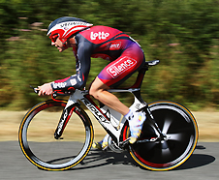
Air resistance
Figure 1 A streamlined racing cyclist
Bikes, cars and other vehicles experience air resistance as they move. Air resistance is caused by the frictional forces of the air against the vehicle. The faster the vehicle moves, the bigger the air resistance becomes. The top speed of a vehicle is reached when the force from the cyclist or engine is balanced by air resistance.

Streamlining
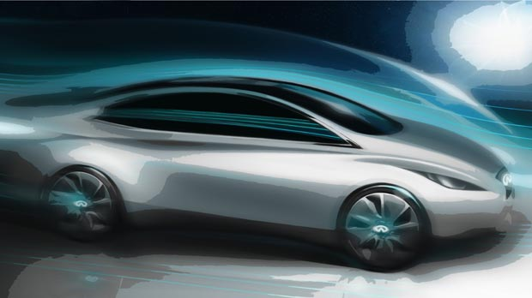
Racing cyclists crouch down low on their bikes to reduce the air resistance on them. This helps them to cycle faster. They also wear streamlined helmets. These have special, smooth shapes that allow the air to flow over the cyclist more easily. Modern cars are also streamlined. Their smooth shapes make the air resistance smaller, which allows them to travel further on the same amount of fuel.
Figure2:http://www.luxuriousmagazine.com/wp-content/uploads/2011/11/infiniti-electric-concept-1.jpg
When there is a lot of friction between moving parts, energy is lost to the surroundings as heat. Think of what happens when you rub your hands together quickly. The friction warms them up

Balanced forces

Force diagrams
We can show the forces acting on an object using a force diagram. In a force diagram, each force is shown as a force arrow. An arrow shows:
- the size of the force (the longer the arrow, the bigger the force)
- the direction in which the force acts.
The arrow is usually labelled with the name of the force and its size in newtons. Text books often show a force with a thick coloured arrow, but it is best if you just use a pencil and ruler to draw an arrow with a single line.

Balanced forces
When two forces acting on an object are equal in size but act in opposite directions, we say that they are balanced forces.
If the forces on an object are balanced (or if there are no forces acting on it) this is what happens:
- an object that is not moving stays still
- an object that is moving continues to move at the same speed and in the same direction
So notice that an object can be moving even if there are no forces acting on it.

Examples
Here are some examples of balanced forces.

Hanging objects
The forces on this hanging mass are equal in size but act in opposite directions. The weight pulls down and the tension in the spring pulls up.
The forces on this hanging mass are balanced.

Floating in water
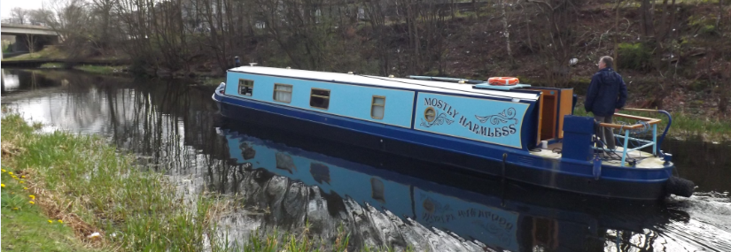

Objects float in water when their weight is balanced by the upthrust from the water. The object will sink until the weight of the water it pushes out of the way is the same as the weight of the object.
The two forces on a boat are the upthrust of the water and the weight of the boat
A boat floats because its weight is balanced by the upthrust from the water

Standing on the ground
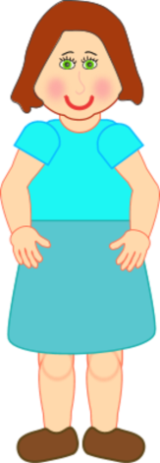
When an object rests on a surface such as the ground, its weight is balanced by the reaction force from the ground. The ground pushes up against the object. The reaction force is what you feel in your feet as you stand still. Without this balancing force you would sink into the ground.

The two forces on a book on a table are the reaction force of the table and the weight of the book

The weight of a book lying on a table is balanced by the reaction force from the table top

Unbalanced forces
When two forces acting on an object are not equal in size, we say that they are unbalanced forces.
If the forces on an object are unbalanced this is what happens:
- an object that is not moving starts to move
- an object that is moving changes speed or direction
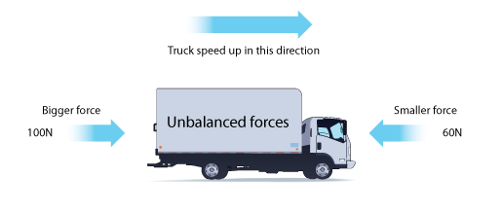
Unbalanced forces make the truck speed up.

Resultant forces
The size of the overall force acting on an object is called the resultant force. If the forces are balanced, this is zero. In the example above, the resultant force is the difference between the two forces, which is 100 - 60 = 40 N.

Extension

Balanced Forces
Two forces acting in opposite directions are said to be balanced. The effect is equivalent to no force acting on the object at all.

Newton’s First Law
“An object will remain at rest or move at a constant velocity in a straight line unless acted on by an unbalanced force”.
This means that if the forces acting on an object are balanced, then the object will remain stationary if it was already stationary. For a moving object, if the forces acting on it are balanced, then it will continue to move in a straight line at a constant velocity.
balanced forces ↔ Object at rest OR object moving at a constant velocity in a straight line
A vector is often drawn with an arrow to indicate its size and direction. The starting point of the arrow is called the “tail” and the arrow end is called the “head”.
head
tail

Resultant Forces
When several forces act on one object, they can be replaced by one force which has the same effect. This single force is called the resultant or unbalanced force.

Combining forces in a straight line
Draw a diagram of the object and mark in all the forces acting, using an arrow to represent each force. (Do not forget weight, which is often not specifically mentioned in the question).
Use arithmetic to find the resultant:
Add together forces which act in the same direction
12 N
8 N
e.g F₁ + F₂ ₌ F_{u} 12 + 8 ₌ 20 N
Subtract forces which act in the opposite direction
12 N
8 N
e.g F₁ + F₂ ₌

Collect a Question sheet and try some out.

REVIEW YOUR WORK FOR THE ASSESSMENT

