National 5 Physics

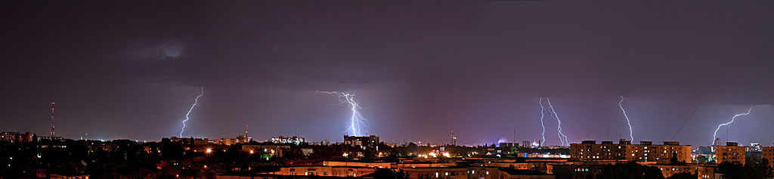
©Catlin.Fatu@English Language Wikipedia

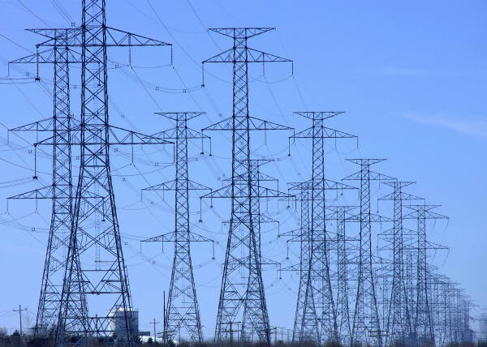
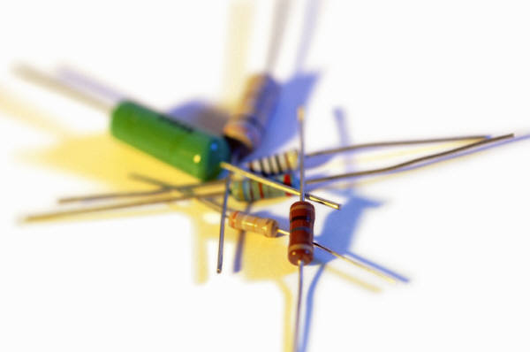
Electricity

Throughout the Course, appropriate attention should be given to units, prefixes and scientific notation.

tera | T | 10¹² | x 1,000,000,000,000
giga | G | 10⁹ | x 1,000,000,000
mega | M | 10⁶ | x 1,000,000
kilo | k | 10³ | x 1,000
centi | c | 10⁻² | /100
milli | m | 10⁻³ | /1,000
micro | µ | 10⁻⁶ | /1,000,000
nano | n | 10⁻⁹ | /1,000,000,000
pico | p | 10⁻¹² | /1,000,000,000,000

In this section the prefixes you will use most often are milli (m), micro (µ), kilo (k), and mega (M) and giga (G). It is essential that you use these correctly in calculations.

In Physics, the standard unit for time is the second (s) and therefore if time is given in milliseconds (ms) or microseconds (µs) it must be converted to seconds.

Example 1
An electronic system is now used and is able to perform the same experiment in 0.5 ms. How long is this?

0.5 ms = 0.5 milliseconds = 0.5 x 10⁻³ s = 0.5/1 000 = 0.0005 seconds.

In this unit we use the unit amperes, which is the unit of current. Often there will be currents which are measured in mA and µA.

Example 2
An ammeter reading shows that there are 54.2 µA of current in a circuit? How many amperes is this?

54.2 µA = 54.2 microamperes = 54.2 x 10⁻⁶ A = 54.2/1 000 000 = 0.0000542 amperes.

In this unit we use the unit for power – the Watt, W, this may be measured in kW and MW.

Example 3
A hairdryer is rated at 2 kW. How many W is this?

2 kW = 2 kilowatts = 2 x 10³ Hz = 2 x 1 000 = 2 000 watts.

National 5 Physics

Electricity

Contents

Charge and Current 5
Potential Difference 15
Practical Circuits 23
Ohm’s Law 42
Electrical Power 57
Tutorial Questions 64
Numerical Answers 74

Electric Charge
  - Definition of electric charge in terms of positive and negative.
  - Effect of electric field on a charge.
  - Electrical current as the electrical charge transferred per unit time.
  - Use appropriate relationship to carry out calculations involving charge, current and time.

$$Q= It$$

Charge and Current

Charge

Charge is the name we give to one of the properties of a material. Charge can either be positive or negative. Positive charge will attract negative charge and vice versa, but negative charge will repel other negative charge: the same will happen with two positive charges.

Opposite charges attract

Like charges repel

You can investigate these effects by rubbing a balloon against your jumper – it will become charged and you will be able to stick it on a wall!

The symbol we use for charge is Q and the unit of charge is the coulomb which we write as C.

Surrounding all charged particles there is an electric field. In physics, when we talk about fields, we mean a place where an object will experience a force.

We represent fields as a series of lines. This is shown below for positive and negative charges below.

The lines have arrows showing the direction that a positive charge to move in as a result of the field. In this case a positive charge would move away from the positive charge as like charges repel. In the case of the negative charge, a positive charge would be attracted, so the arrows point towards it.

The field lines are showing with arrows going away from the positive charge. | The field lines are showing with arrows going towards the negative charge.

When two particles are close together, the field lines help to explain how they interact with each other.

When a positive and negative charge are near each other, the field lines interact. This means that we can see what will happen to a positive charge if it is in the field because the arrows show us. Negative charges (such as electrons) will go the opposite way to the arrows.

Current

The electric field shows us how a charge will move, but it is useful to measure how much charge is moving. Current is a measure of the amount of movement of charge – it can be the movement of positive or negative charge but in this course we usually concentrate on the movement of electrons which have a negative charge.

Electrons have a very small negative charge

-1.6 x 10⁻¹⁹ C
this can be written as

-0.00000000000000000016 C

So to reach a charge of 1 C there has to be an incredibly large number of electrons. In fact there needs to be
6,250,000,000,000,000,000 electrons!

We define current as the rate of flow of charge and we measure it in amperes (A).
This means that current is the amount of charge which passes a point in one second, so we could write it as
$$I = \frac{Q}{t}$$
showing that the amount of charge which has passed in total, divided by the amount of time it took gives us the current.

One ampere is the same as one coulomb of charge flowing every second (in other words 6.25 x 10¹⁸ electrons every second!).
We normally state the charge equation as

$$Q = It$$

Symbol | Name | Unit | Unit Symbol
Q | Charge | coulombs | C
I | Current | amperes | A
t | Time | seconds | s

Worked examples

- A current of 2 A runs through a lamp for 3 minutes. How much charge has flowed through the lamp?

Q = ?  I = 2 A  t = 3 x 60 = 180 s | Q = It  Q = 2 x 180  Q = 360 C
- How long does it take for 50C of charge to flow through a circuit if the current is 5mA?

Q = 50 C  I = 5 mA = 5x10⁻³ A  t = ? | Q  50  t  t | = It  = 5x10⁻³ x t  = 50/5x10⁻³  = 10 000 s

Conductors and Insulators

Some materials allow electrical current to flow freely, they are called conductors. Copper is one of the most widely used conductors as it allows electrons to move very easily - it does not resist the movement of charge much.

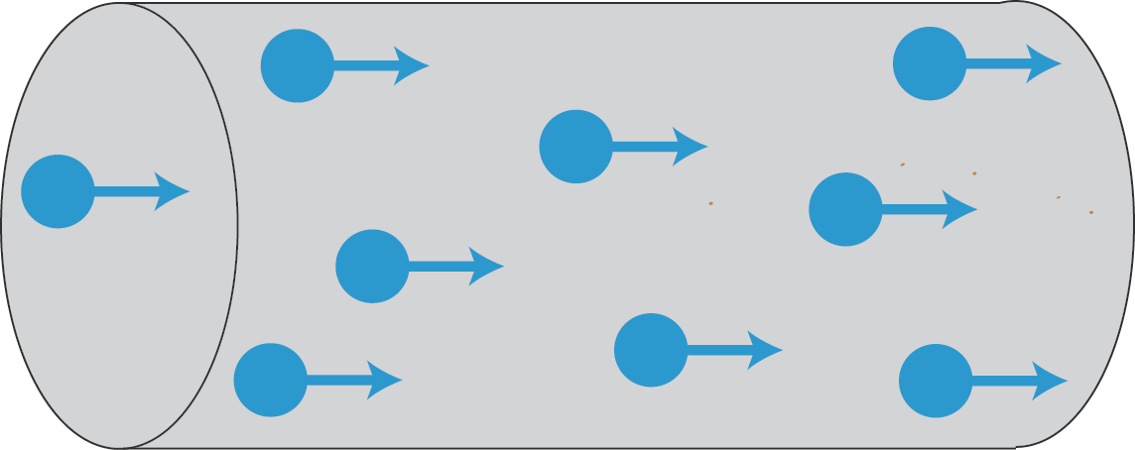

Other materials make it very difficult for charge to move: these are called insulators.
We will often find conductors and insulators working together, your headphone cable is a perfect example. Inside the insulating plastic coating are strands of copper, it is the copper which conducts the audio signal and the plastic is there to protect it, but also to stop other conductors coming into contact with it.

The following table shows some examples of each.

Ω
Conductors | Insulators
silver | plastic
copper | glass
gold | rubber
aluminium | wood
steel | air
graphite | oil

Potential Difference
  - The potential difference (voltage) of the supply is a measure of the energy given to the charge carrier in a circuit.
  - Difference between alternating and direct current.

Potential Difference

The purpose of circuits is to transform electrical potential energy into a more useful form. For current to flow in a circuit, charges in that circuit must be moving. For them to move, they need to be given energy. As current flows round a circuit, each coulomb of charge gains energy in the supply and this is transformed in the components of the circuit.

To understand the energy in a circuit we can to compare it to our everyday lives. We are familiar with the idea of gravitational potential energy. When we go upstairs we gain potential energy, and when we move to the bottom of the stairs we lose potential energy. When we are half way down the stairs, we do not have zero potential energy – we just have a smaller amount than at the top. We can state that there is a difference in our potential energy.
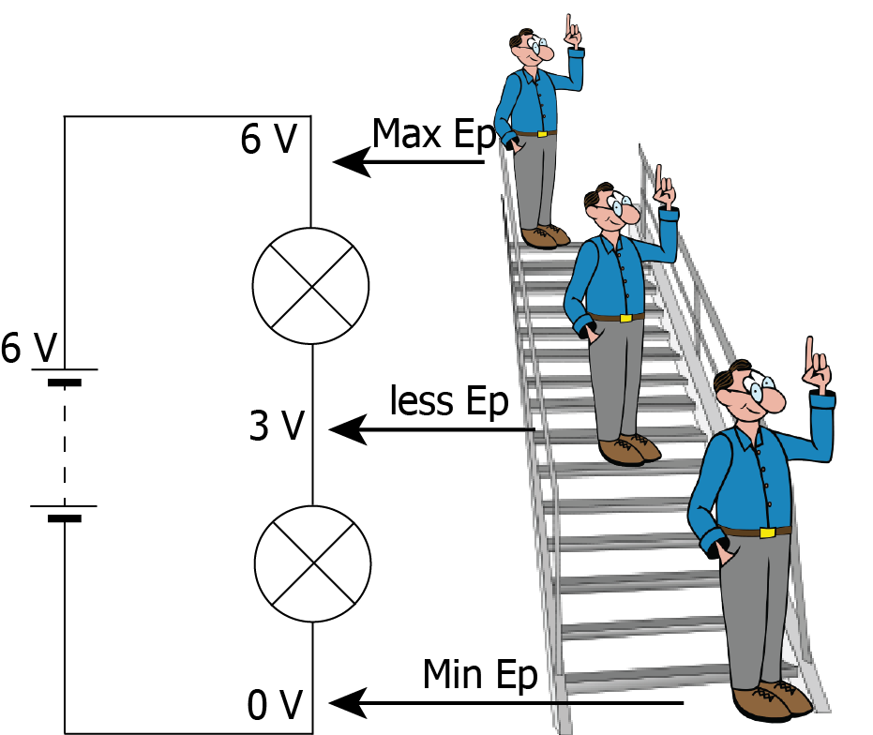

It is exactly the same in a circuit – at two different points the Electrical Potential Energy will be different. We give this difference a name – Potential Difference – and in many places you will see this being referred to as Voltage or p.d.

The Potential Difference (p.d.) in a circuit is the difference in electrical potential between two points.

The power supply of a circuit will have a potential difference. This is very important as it is a measure of the amount of energy given to a charge carrier (such as an electron) in a circuit.

Potential difference is measured in volts (V). 1 volt is equal to 1 joule for every coulomb of charge which passes. 1 V = 1 J/C. For example, a 5 V supply will supply 5 joules of energy to every coulomb which passes through.

One side of the power supply will have a larger electrical potential than the other – this will be the positive side, and the other will be the negative side.

Charge carriers will follow the rules for electric fields, for example electrons will flow from the negative terminal to the positive terminal.

AC and DC

There are two types of current in circuits - Alternating Current (AC) and Direct Current (DC).

In DC circuits, the charge carriers will only flow one direction round a circuit, in the case of electrons, this is from the negative to the positive terminal.

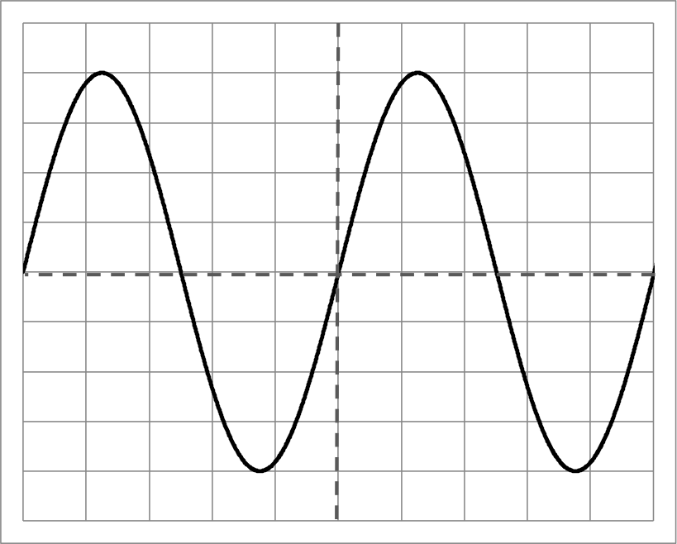
In AC circuits, the terminals constantly change (in the UK the frequency mains circuits is 50 Hz, so the current changes direction 100 times a second) between positive and negative, so the charges constantly change direction. The energy transfer in these circuits still happens because the movement of the charges changes the electric field around them.

We can investigate the waveforms of electrical signals using an oscilloscope. An oscilloscope shows time on the x-axis and amplitude of the signal on the y-axis. Each square on an oscilloscope is called a ‘division.’ There are dials on oscilloscopes which allow us to change the value of each division, both for time and for p.d. Two examples are shown below.

This is an AC trace from an oscilloscope, the x axis is time and the y axis is potential difference. The p.d. is changing between positive and negative values. If the timebase is set to 1 ms/division and the y-gain is set to 2 V/division then the peak value of this signal is 8 V and the frequency is 200 Hz.
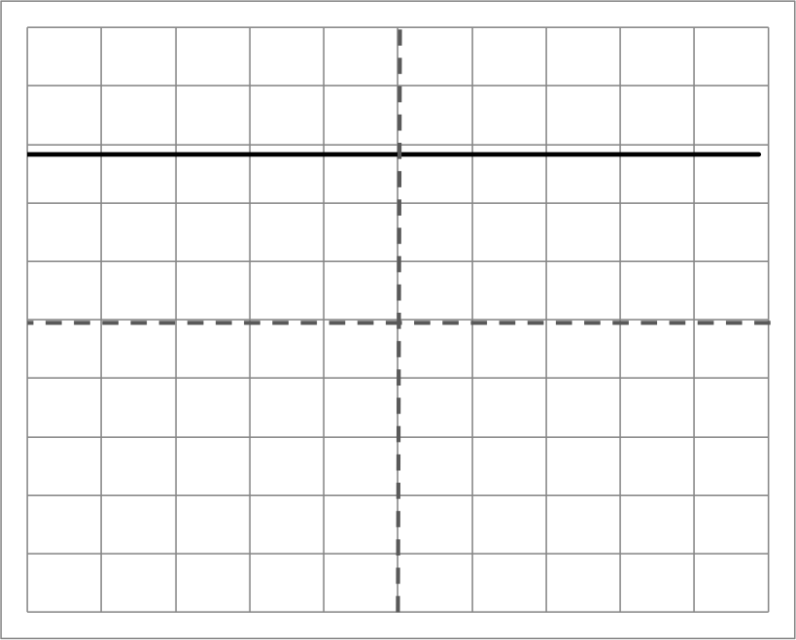
This is a DC trace from the same oscilloscope, the x axis is time and the y axis is potential difference. The p.d. is at a constant value. In this case the value is positive, but it negative DC signals are also possible. If the settings are the same as before, this signal is approximately 5.7 V.

These two traces actually deliver the same amount of energy to a circuit. This is because the peak value of the AC signal is much bigger than the average magnitude. We call the average magnitude of an AC signal the “rated value.” This is the number which will normally be stated when we are given a supply.

A 5 V DC supply and a 5 V rated AC supply will deliver the same amount of energy to a circuit.

Practical electrical and electronic circuits
  - Use of an appropriate relationship to calculate the resistance of resistors in series and in parallel circuits.
  - Measurement of current, voltage and resistance, using appropriate meters in complex circuits.
  - The function and application of standard electrical and electronic components including cell, battery, lamp, switch, resistor, variable resistor, voltmeter, ammeter, LED, motor, loudspeaker, photovoltaic cell, fuse, diode, capacitor, thermistor, LDR.
  - Current and voltage relationships in a series circuit.
  - Current and voltage relationships in a parallel circuit.

$$R_{total} = R_{1}+R_{2} +R_{3}+…$$

$$\frac{1}{R_{total}} = \frac{1}{R_{1}}+\frac{1}{R_{2}} +\frac{1}{R_{3}}+…$$

$$I_{1} = I_{2}=I_{3}=I_{4}…$$

$$V_{S} = V_{1}+V_{2}+V_{3}…$$

$$I_{P} = I_{1}+I_{2}+I_{3}…$$

$$V_{P} = V_{1}=V_{2}=V_{3}…$$

Practical Circuits

Resistance

Resistance is a measure of how much opposition there is to the current in a circuit. The more resistance there is, the harder it is for current to flow. All components in circuits, such as lamps, loudspeakers and motors have a resistance – even the connecting wires do. The energy transformation in a resistor is from electrical to heat.

The symbol for resistance is R and it is measured in ohms, there is a special symbol for ohms, Ω. For example a resistor may have a resistance of 100 Ω.

In order to draw a circuit, it is convenient to use symbols which identify different components.

The symbol for a resistor is



Normally, a resistor symbol will have a label, or a value next to it

200 Ω

In most circuits, there will be more than one component, and that means there can be more than one resistor. We need to know how these can be added up.

There are two ways components can be put together, in series (where they are put one after the other in a circuit) and in parallel (where they are placed side by side). Over the next few pages you will find out various rules associated with these circuits.

Resistors in series

R₁
R₂
R₃

The resistors here are shown in series.

If you imagine that each resistor is a tunnel and lots of people want to get from the left to the right, each tunnel is going to slow them down. In other words, the delay at each resistor will add up.

In equation form, this is

$$R_{total}= R_{1}+R_{2}+R_{3}+…$$

Symbol | Name | Unit | Unit Symbol
R_{total} | Total Resistance | ohms | Ω
R₁ | Resistance 1 | ohms | Ω
R₂ | Resistance 2 | ohms | Ω
R₃etc | Other resistors | ohms | Ω
In this equation we put … at the end as there can be any number of resistances.

Worked examples

- Calculate the resistance of the following circuit
35 Ω
22 Ω
60 Ω

R_{total}  R₁  R₂  R₃ | = ?  = 60 Ω  = 35 Ω  = 22 Ω | R_{total}  R_{total}  R_{total} | = R₁ + R₂ + R₃  = 60 + 35 + 22  = 117 Ω

- The total resistance of this circuit is 25 kΩ. Calculate the value of Resistor 2
R₂
12 kΩ
500 Ω

R_{total}  R₁  R₂  R₃ | = 25 kΩ  = 12 kΩ  = ?  = 500 Ω | R_{total}  25000  R₂  R₂  R₂ | = R₁ + R₂ + R₃  = 12000 + R₂ + 500  = 25000 – 12500  = 12500  = 12.5 kΩ

Resistors in parallel
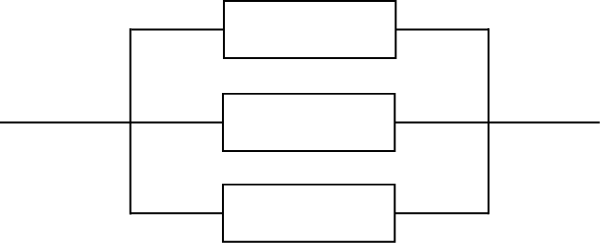
R₂
R₃
R₁

The resistors here are shown in parallel.

Again, if you imagine that each resistor is a tunnel and lots of people want to get from the left to the right, this time the tunnels allow different paths for people to get through. In other words, the individual resistors will delay people, but the overall resistance is reduced compared to only having one tunnel.

The total resistance of resistors in parallel will be smaller than any individual resistor.

In equation form, this is

$$\frac{1}{R_{total}}= \frac{1}{R_{1}}+\frac{1}{R_{2}}+\frac{1}{R_{3}}+…$$

Symbol | Name | Unit | Unit Symbol
R_{total} | Total Resistance | ohms | Ω
R₁ | Resistance 1 | ohms | Ω
R₂ | Resistance 2 | ohms | Ω
R₃etc | Other resistors | ohms | Ω
In this equation we put … at the end as there can be any number of resistances.

Worked examples

- Calculate the resistance of the circuit shown below
R_{total} = ?  R₁ = 100 Ω  R₂ = 200 Ω  R₃ = 400 Ω | 1/R_{total}  1/R_{total}  1/R_{total}  1/R_{total}  7 × R_{total}  R_{total}  R_{total} | = 1/R₁ + 1/R₂ + 1/R₃  = 1/100 + 1/200 + 1/400  = 4/400 + 2/400 + 1/400  = 7/400  = 1×400  = 400/7  = 57 Ω
100 Ω
400 Ω
200 Ω

- The total resistance of this circuit is 100Ω. Calculate the value of Resistor 1

R₁
R_{total} = 100 Ω  R₁ = ?  R₂ = 200 Ω | 1/R_{total}  1/100  1/R₁  1/R₁  1/R₁  R₁ | = 1/R₁ + 1/R₂  = 1/R₁ + 1/200  = 1/100 - 1/200  = 2/200 - 1/200  = 1/200  = 200 Ω
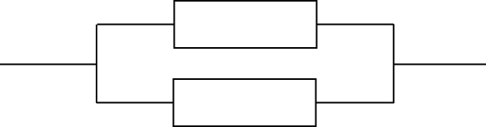
200 Ω

Measuring Current, Voltage and Resistance

Like all components, meters (which are used to measure values) have component symbols.

Component Name | Circuit Symbol | Function
Voltmeter | 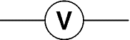 | Measures potential difference. Must be placed in parallel to measure the difference in electrical potential between two points.
Ammeter | 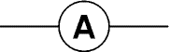 | Measures current. Must be placed in series to measure the current flowing in a circuit.
Ohmmeter | 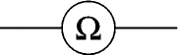 | Measures resistance. Must be placed in parallel with the component(s) which are to be measured.

They can be used in simple, or more complex circuits in order to investigate the size of any of these quantities.

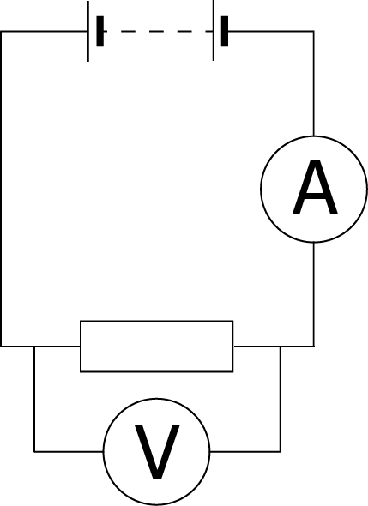 | This circuit shows a battery and a resistor. The diagram also shows how the voltmeter and ammeter must be connected.  The voltmeter must be connected in parallel because it is measuring the difference in electrical potential between two points.  The ammeter must be connected in series because it is measuring the flow of current THROUGH a component or circuit.  The two main rules are:  - To find the potential difference across a component, or components, the voltmeter must be placed in parallel with that component or those components.  - To find the current through a component or components, the ammeter must be placed in series with that component or those components.
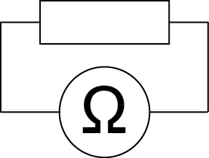 | The previous diagram does not show an ohmmeter because, in most cases, resistance should only be measured when a circuit is not ‘on’ or fully connected.  To use an ohmmeter, you would place it ‘across’ a component – in parallel, just like a voltmeter.

Components

There are lots of different components which can be used to make circuits, the ones which will often feature in National 5 Physics are shown in the table below.

Component Name | Circuit Symbol | Function
Cell | 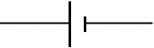 | Supplies electrical energy to a circuit, the longer line shows the positive side.
Battery | 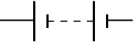 | A battery of cells means 2 or more cells.
DC Supply |  | Supplies electrical energy to a circuit in the form of a direct current.
AC Supply |  | Supplies electrical energy to a circuit in the form of an alternating current.
Lamp | 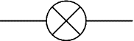 | A lamp lights when current flows through it, converting electrical energy to light energy.
Switch |  | A switch allows you to complete or break a circuit.
Resistor |  | A resistor restricts the flow of current, this may be to protect other components.
Variable Resistor | 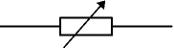 | A resistor, the resistance of which can be varied in the circuit, could be used for a dimmer switch.
LDR  (Light Dependent Resistor) | 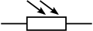 | Can be used to control a circuit. The resistance goes down as the light increases.
Thermistor | 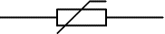 | The resistance of a thermistor will increase as the temperature increases.
Fuse |  | A fuse is a safety device – the metal core will melt when too much current is flowing in the circuit.

Voltmeter |  | Must be placed in parallel to measure the difference in electrical potential between two points.
Ammeter |  | Must be placed in series to measure the current flowing in a circuit.
Ohmmeter |  | Measures resistance. Must be placed in parallel with the component(s) which are to be measured.
Capacitor | 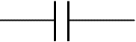 | Used to store electrical charge, can be used to create a simple timing circuit, or in the flash in a camera.
Diode | 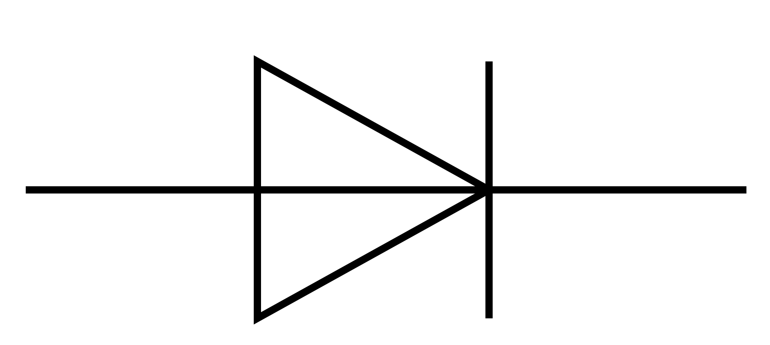 | Only allows current to flow in one direction.
Photovoltaic Cell | 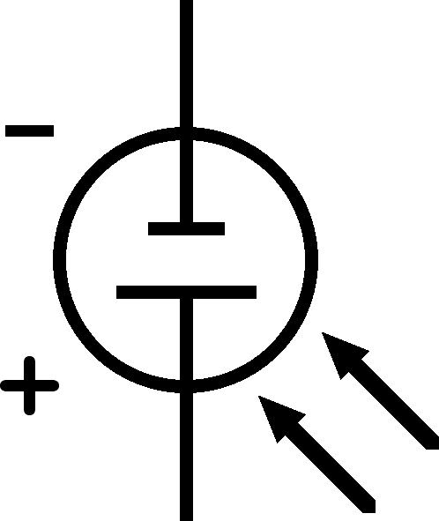 | Converts light energy to electrical energy, can be used as the power source in a circuit. More light will mean a greater p.d. across the cell.
LED  (Light  Emitting Diode) | 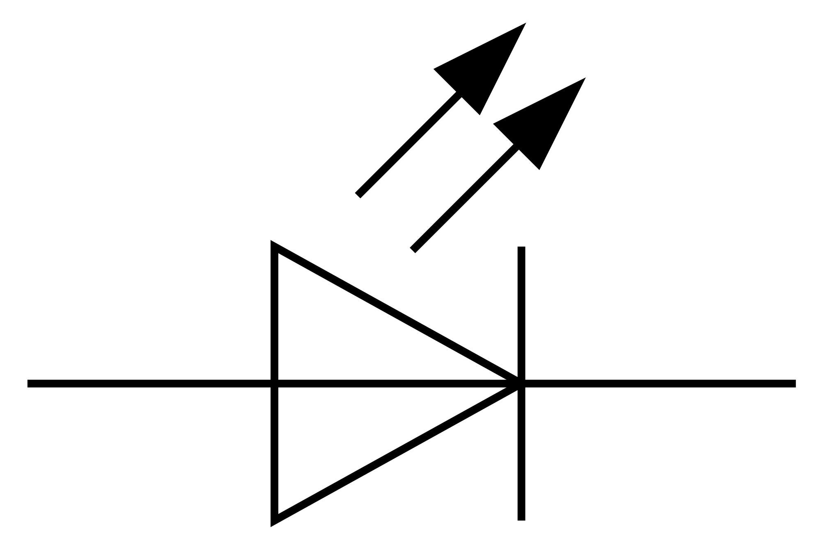 | Emits light when a current flows but only allows current to flow in one direction. Requires less energy than a lamp.
Motor | 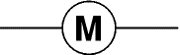 | Converts electrical energy into kinetic energy by turning.
Loudspeaker | 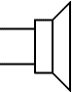 | Converts electrical energy into sound energy.

Series Circuits

A circuit is described as a series circuit if the components appear one after the other in the circuit. An example is shown below.

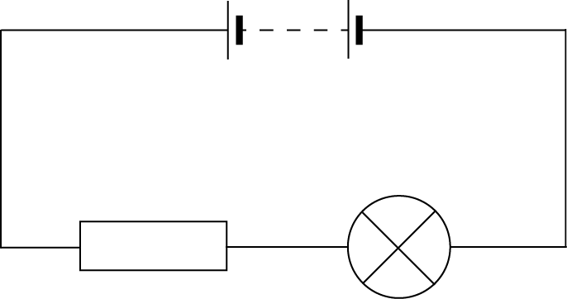

To investigate the current in the circuit, we must place multiple ammeters in the circuit.

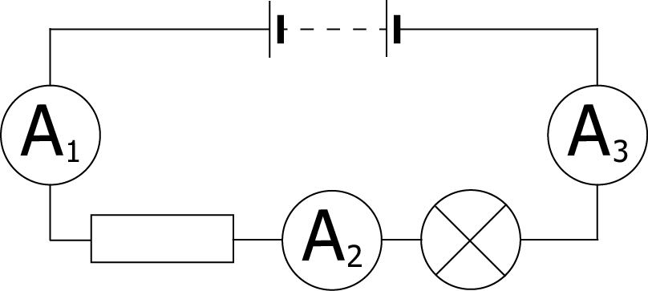

If we place an ammeter at each of these positions, we discover that the readings will be identical. In equation form, we can write this as

$$I_{1} = I_{2}=I_{3}=I_{4}…$$

The current in a series circuit is the same at all points.

We can also investigate potential difference in a series circuit.

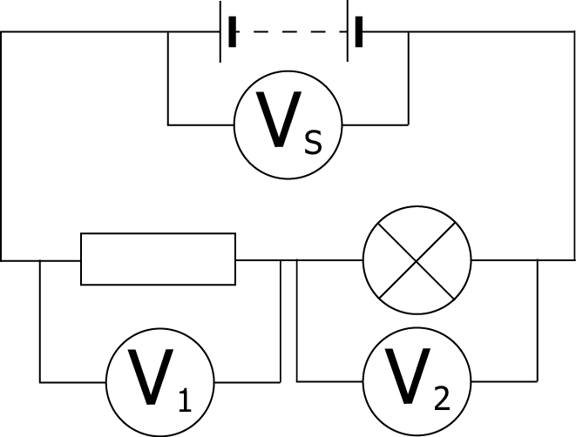

A potential difference is the difference in electrical potential between two points, so in a series circuit, the potential difference across each of the components must add up to the total potential difference across the supply.

If we call the supply p.d. V_{s} we write this as

$$V_{S} = V_{1}+V_{2}+V_{3}…$$

The p.d. across each of the components in a series circuit adds up to the supply p.d.

Parallel Circuits

A circuit is described as a parallel circuit if the components are laid out next to each other, with common connections. An example is shown below.

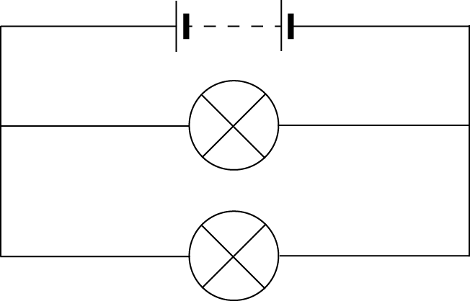

To investigate the current in the circuit, we must place multiple ammeters in the circuit.

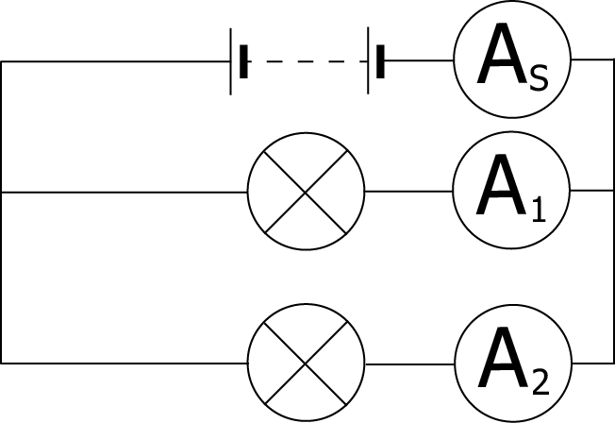

If we place an ammeter at each of these positions, we discover that the current splits between the branches, and the currents in the branches add up to the current at the supply.

In equation form, we can write this as

$$I_{S} = I_{1}+I_{2}+I_{3}…$$

The total current in a parallel circuit is equal to the sum of the currents in the branches.

We can also investigate potential difference in the parallel circuit.

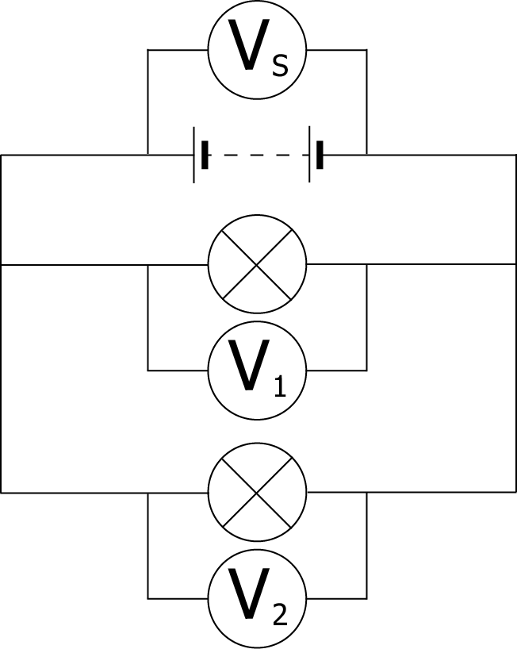

In a parallel circuit, the branches split off from the same point, so the potential at that point will be exactly the same. As a result, the potential difference across each component is the same as the supply.

We write this as

$$V_{S} = V_{1}=V_{2}=V_{3}…$$

The p.d. across each of the components in a parallel circuit is equal to the supply p.d.

Circuit Rules

Measurement | Series Circuits | Parallel Circuits
Potential Difference | $$V_{S} = V_{1}+V_{2}+V_{3}…$$ | $$V_{S} = V_{1}=V_{2}=V_{3}…$$
Current | $$I_{1} = I_{2}=I_{3}=I_{4}…$$ | $$I_{S} = I_{1}+I_{2}+I_{3}…$$
Resistance | $$R_{total}= R_{1}+R_{2}+R_{3}+…$$ | $$\frac{1}{R_{total}}= \frac{1}{R_{1}}+\frac{1}{R_{2}}+\frac{1}{R_{3}}+…$$

Ohm’s law
  - Use of a V-I graph to determine resistance.
  - Use of an appropriate relationship to calculate potential difference (voltage), current and resistance.
  - The relationship between temperature and resistance of a conductor.

$$V=IR$$

Ohm’s Law

In circuits, the components’ resistance, the current and the potential difference are all linked. To investigate this the following circuit is set up
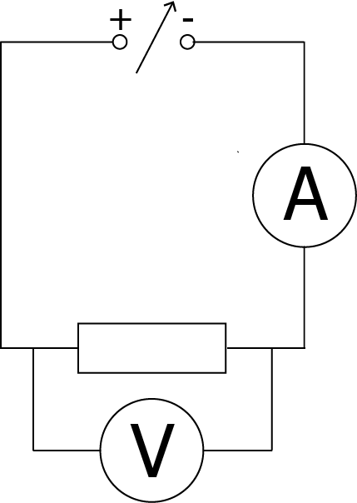
The DC power supply is varied and readings are taken as follows.

p.d./V | Ave. Current/A
0.0 | 0.00
1.0 | 0.02
2.0 | 0.04
3.0 | 0.06
4.0 | 0.08
5.0  50Ω | 0.10
6.0 | 0.12
7.0 | 0.14
8.0 | 0.16
9.0 | 0.18
10.0 | 0.20

Plotting p.d. against current for these (idealised) results gives

The gradient of the line of best fit is constant showing a the direction proportionality between V and I. The gradient of the line in the graph is 50, which matches the resistance of the resistor in the circuit. This means that V/I = R.

We can state, then, that the p.d. is equal to the current times the resistance.

$$V = IR$$

Symbol | Name | Unit | Unit Symbol
V | Potential Difference | volts | V
I | Current | amperes | A
R | Resistance | ohms | Ω

This relationship is known as Ohm’s law and can be used for circuits with many types of component.

Worked examples

- A 12 V battery supplies a motor which has a resistance of 18 Ω. What is the current in the circuit?

V  R  I | = 12 V  = 18 Ω  = ? | V =  12 =  I =  I = | IR  I × 18  12/18  0.67 A

- An LED which is in series with a 1.2 kΩ resistor must be supplied with 5 mA of current to operate. When lit, the p.d. across the LED is 0.6 V.
  - What is the potential difference across the resistor?

V  R  I | = ?  = 1.2kΩ = 1.2×10³ Ω  = 5 mA = 5×10⁻³ | V  V  V | = IR  = 1.2×10³ × 5×10⁻³  = 6 V

  - What is the minimum supply voltage required?

V_{supply}  V_{LED}  V_{resistor} | = ?  = 0.6 V  = 6 V | V_{supply} = V_{LED} + V_{resistor}  V_{supply} = 0.6 + 6  V_{supply} = 6.6 V

Resistance and Temperature

When current flows through components they often become warmer – this means that some energy is being changed from electrical energy into heat energy. While this is wanted in a toaster, it is not useful in most circuits.

In general, the resistance of a conductor will increase when it gets warmer. Resistors are considered to be ‘ohmic’ components and it is assumed that in normal conditions their resistance is constant. Lamps do not behave in this way though, as can be seen if the experiment to prove the relationship between current and voltage is repeated with a lamp instead of a resistor. As the lamp gets warmer, the resistance will increase.

LEDs and Diodes

The diode and the LED in the above list are very special. They only allow current to flow in one direction, but require a resistor in series to ensure correct operation. The resistor protects the diode ensuring that the p.d. across it, and the current through it are limited. If an LED requires 50 mA of current and 0.7 V across it we can use some of the rules from earlier in this section to calculate the size of resistor required.

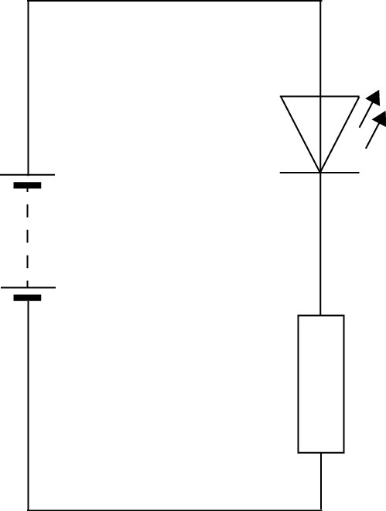
The supply. p.d. is 5 V, we know that the LED should have 0.7 V across it, so the resistor must have

5 – 0.7 V = 4.3 V

across it as it is in series. We also know that, in series circuits, the current remains the same throughout. If the LED is operating correctly, the current must be 50 mA. We can now use Ohm’s law to calculate the correct value of resistor for the circuit.
5 V

V | = 4.3 V | V | = IR
I | = 50 mA = 0.05 A | 4.3 | = 0.05 × R
R | = ? | R | = 4.3/0.05
 |  | R | = 86 Ω

An 86 Ω resistor ensures that the current through and the p.d. across the LED are correct in this circuit.

Potential Dividers

When a circuit is made in the configuration shown below, it is often called a potential divider, or a voltage divider. This is because each resistor takes a proportion of the total potential difference. How big a share of the potential difference each resistor takes depends on the size of the resistor, and the total resistance in the circuit.

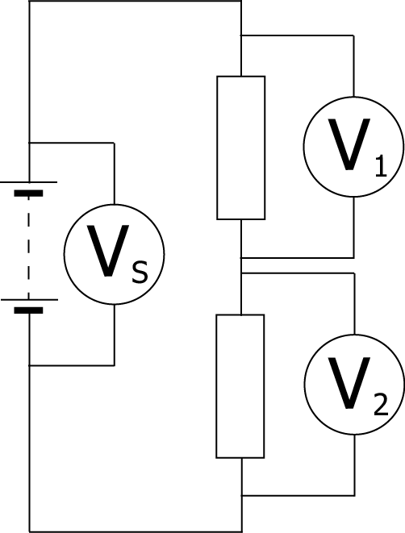
We already know that in a series circuit, like this one, the current at each point in the circuit is the same. We also know that the potential difference across each resistor depends on the resistance and the current according to ohm’s law, V = IR. Therefore, as the current through each resistor is the same;
20 V
4 Ω

the higher the resistance, the higher the potential difference across the resistor.
6 Ω

This type of circuit can be used as a controller for other devices, and as a result it can be very useful to calculate the p.d. across an individual component.

In this circuit, for example, the total resistance is 10 Ω, as there is a 6 Ω and a 4 Ω resistor in series. We can say that the 6 Ω resistor should have 6/10 of the supply p.d. In this case then, V₂ would be 12V. We can check this result using ohm’s law.

V_{s} | = IR_{T} | V₂ | = IR₂
10 | = I ×(6+4) | V₂ | = 2 × 6
I | = 20/10 | V₂ | = 12 V
I | = 2 A

It is possible to make a relationship which can be used for any potential divider. To calculate the p.d. across a component in a potential divider we multiply the supply p.d. by the fraction of the total resistance.
$$V_{1} = \frac{R_{1}}{(R_{1}+R_{2})}V_{s}$$

Symbol | Name | Unit | Unit Symbol
V₁ | Potential Difference across component 1 | volts | V
R₁ | Resistance of component 1 | ohms | Ω
R₂ | Resistance of component 2 | ohms | Ω
V_{s} | Supply Potential Difference | volts | V

This relationship can be used for any resistive components – not just resistors.

Worked Examples

- What is the p.d. across the 20 Ω resistor?

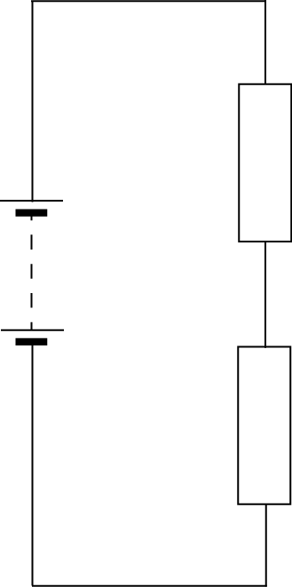  12 V  30 Ω  20 Ω | V_{s}  R₁  R₂  V₁ | = 12 V  = 20 Ω  = 30 Ω  = ? | V₁  V₁  V₁  V₁  V₁ | = R₁/(R₁ + R₂) × V_{s}  = 20/(20 + 30) × 12  = 20/50 × 12  = 0.4 × 12  = 4.8 V

- The potential difference across the variable resistor should be 6 V. The variable resistor can be any value between 1 kΩ and 10 kΩ. What should it be set to?

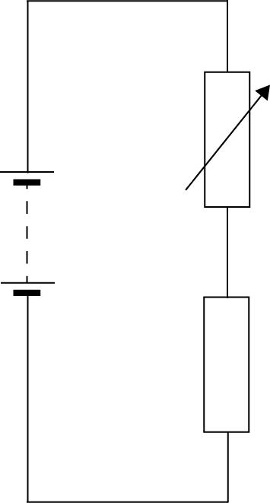  4.5 kΩ  15 V | V_{s}  R₁  R₂  V₁ | = 15 V  = 4.5 kΩ = 4500 Ω  = ?  = 6 V | V₁  6  6(R₁ + 4500)  6 R₁ + 27000  9 R₁  R₁  R₁  R₁ | = R₁/(R₁ + R₂) × V_{s}  = R₁/(R₁ + 4500) × 15  = 15 × R₁  = 15 R₁  = 27000  = 27000/9  = 3000  = 3.0 k Ω

Electrical Power
  - Use of an energy, power and time relationship.
  - Use of an appropriate relationship to determine the power, voltage, current and resistance in electrical circuits.

$$P = \frac{E}{t}$$

$$P = IV$$

$$P = I^{2}R$$

$$P = \frac{V^{2}}{R}$$

Electrical Power

When we are using electrical appliances, it is useful to have an idea of how much energy they will require. This leads to the definition of electrical power.

Power is defined as the amount of energy transformed per second, as shown in the equation below

$$P= \frac{E}{t}$$

Symbol | Name | Unit | Unit Symbol
P | Power | watts | W
E | Energy | joules | J
t | time | seconds | s

Different appliances will transform more or less electricity. Often the highest powered ones will be those which transform electrical energy into heat energy, for example a hair dryer. We often describe this as the power consumption.

Appliance | Power transformation/W
Oven | 3000
Dishwasher | 1400
Iron | 1100
Hair Dyer | 1500
Microwave | 1000
TV | 250
Stereo | 60
Filament Lamp | 100
Energy Saving Lamp | 11
Drill | 750
Fridge | 1400

Worked examples

- What is the power of a television which transforms 0.5 MJ of energy in 1 hour?

P  E  t | = ?  = 0.5 MJ  = 1 × 60 × 60 = 3600 s | P =  P =  P = | E/t  0.5×10⁶ /3600  139 W

- A 1500 W hairdryer is used for 5 minutes, how much energy is transformed?

P  t  E | = 1500W  = 5 x 60 = 300 s  = ? | P =  1500 =  E =  E =  E = | E/t  E/300  1500 × 300  450000  450 kJ

Power, Current and Potential Difference

We can also relate power to current and potential difference. Potential difference is the amount of energy supplied per coulomb of charge supplied as the charge passes the power source (remember, 1 V = 1 J/C). Current is the amount of charge per second.

If we multiply the potential difference across a circuit by the current through it we have:

volts × amperes
= joules/coulomb × coulomb/second
= joules/second

Earlier it was shown that power can be defined as the energy per unit time, so that is joules per second which means that power must also equal current multiplied by voltage.

This is written as follows
$$P= IV$$

Symbol | Name | Unit | Unit Symbol
P | Power | watts | W
I | Current | amperes | A
V | Potential difference | Volts | V

It is possible to get two further useful relationships if we combine this equation with Ohm’s law.

The first uses current and resistance:  $$V=IR$$  and  $$P =IV$$  substituting for V  $$P=I ×IR$$  simplifying this leaves  $$P=I^{2}R$$ | The second new equation we can make uses potential difference and resistance.  $$V=IR$$  which can be rearranged as  $$I =\frac{V}{R}$$  substituting this equation into  $$P =IV$$  to give  $$P= \frac{V}{R}×V$$  simplifying this leaves  $$P=\frac{V^{2}}{R}$$
$$P=I^{2}R$$ | $$P=\frac{V^{2}}{R}$$

Symbol | Name | Unit | Unit Symbol
P | Power | watts | W
I | Current | amperes | A
R | Resistance | ohms | Ω
V | Potential Difference | volts | V

Worked examples

- A vacuum cleaner is connected to the UK mains (rated at 230 V) and 8.9 A of current flows through the circuit. What power is being transformed?

P  V  I | = ?  = 230 V  = 8.9 A | P  V  V | = IV  = 230 × 8.9  = 2047 W

- The elements of a toaster have a total resistance of 15 Ω, the toaster is rated at 1650 W. What current does it draw?

P  I  R | = 1650 W  = ?  = 15 Ω | P  1650  I²  I  I | = I²R  = I² × 15  = 1650/15  = $\sqrt{\text{110}}$  = 10.5 A

- A label on a 60 W lamp states that it requires a 12 V supply to operate at full power. What is the lamp’s resistance?

P  V  R | = 60 W  = 12 V  = ? | P  60  R  R | = V²/R  = (12 × 12)/R  = 144/60  = 2.4 Ω

Tutorial Questions

Electric Charge and Current

- Explain what is meant by the term ‘electric current’.

- Write down the relationship between charge, electric current and time. Write the symbols and units used for each.

- The current in a heater is 7 A. How much charge flows through the heater in 30 seconds?

- A hair drier is switched on for 5 minutes. If the current is 3 A, how much charge flows through the hair drier?

- 2 Coulombs of charge pass through a lamp in 6 seconds. What is the current in the lamp?

- A switch is closed for 10 minutes If 3600 C of charge pass through the switch in this time, what is the current in the switch?

- A car headlamp uses a current of 2 A. How long must the lamp be switched on for 10 Coulombs to pass through it?

- If an electric current is passed through a conducting wire, what energy transformation takes place?
- Many electrical appliances in the home are designed to make use of this energy transformation. Name four of these appliances.

- One bar of an electric heater draws a current of 4 A from the mains supply.

  - How much charge flows through the bar each minute?

  - If a second bar is switched on, the charge flowing through the bar each minute increases to 440 C. Calculate the new current drawn from the mains when both bars are switched on.

- The car battery manufacturer states that a batter is rated at 40 ampèrehours. This is one way of telling the user how long the battery will be able to provide electric current to operate appliances. E.g. this could deliver 40 A for 1 hour or 8 A for 5 hours etc.

  - Calculate the total charge that this battery can deliver, in coulombs.

  - The parking lights of the car draw a current of 2 A from the battery. If these lights were left on when the car was parked, calculate the minimum time it would take for the battery to go flat. State any assumptions you make.

Potential Difference

- Define ‘potential difference’.

- In terms of energy, what is a volt?

- Explain the difference between a.c. and d.c. Your answer should state what is represented by the terms, and also include the words ‘electron’ and ‘direction’.

- Give two examples of:

  - a.c. power supplies.

  - d.c. power supplies.

- Which of these traces are a.c. and which are d.c.?
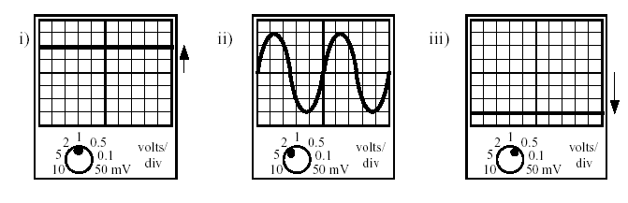
- State the maximum potential difference in the diagrams from question 5.

- For each of the following traces shown, state whether they are a.c. or d.c..
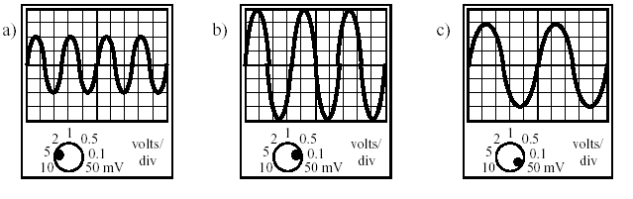
- State the maximum potential difference in the diagrams from question 7.

- Is the mains supply a.c. or d.c.?

- What is the frequency of the mains supply?

- Two identical bulbs are lit by the supplies shown below.
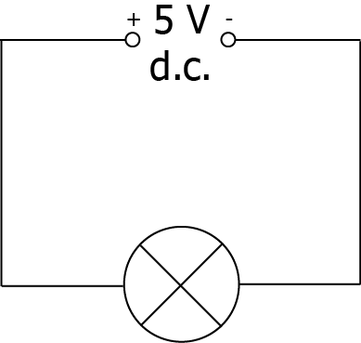 | 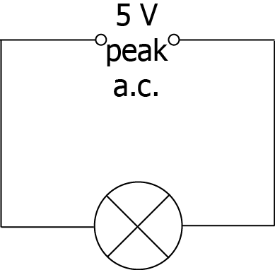

- Which bulb will be the brighter? Explain your answer.
- The d.c supply is altered so that both bulbs have the same brightness. The a.c. supply remains at the 5 V peak value. Was the d.c. supply increased or decreased?
- An a.c. supply is labelled 12 V. The peak voltage is measured using an oscilloscope.
Which of the following is likely to be the measured peak voltage:
17 V, 12 V, 8.5 V, 6 V?
Explain your answer.
- The mains supply is quoted as 230 V. If connected to the mains supply, which of the following devices would display a value of 230 V:
a. an oscilloscope
b. an a.c. voltmeter?
- Briefly explain the meaning of the term ‘effective voltage’ which is applied to an a.c. supply.

Resistance

- What is the total resistance in each of these series circuits?
a. | 300 Ω  200 Ω  50 Ω
b. | 1.5 kΩ  300 Ω | c. | 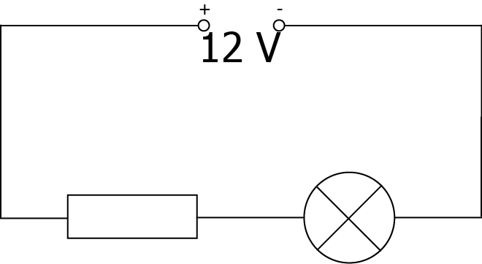  4.2 Ω  12.6 Ω

- What is the total resistance in each of these parallel circuits?
a. | 20 kΩ  14 kΩ | b. | 600 Ω  900 Ω  300 Ω
c. | 4 Ω  4 Ω

- What is the total resistance in each of these circuits?
a. | 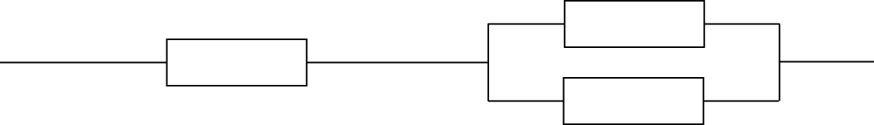  200 Ω  200 Ω  900 Ω
b. | 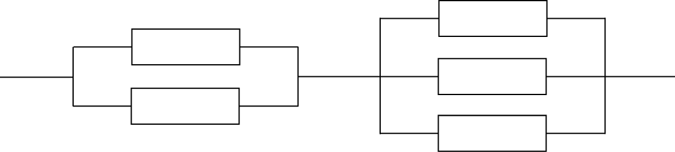  1.5 kΩ  900 Ω  1.2 kΩ  1 kΩ  500 Ω
c. | 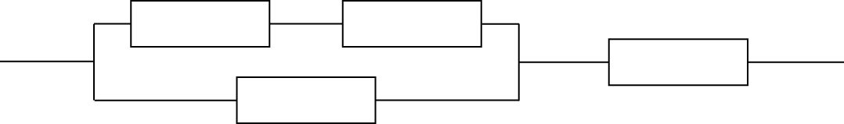  1 MΩ  750 kΩ  2 MΩ  500 kΩ

Current and p.d. In Series And Parallel Circuits

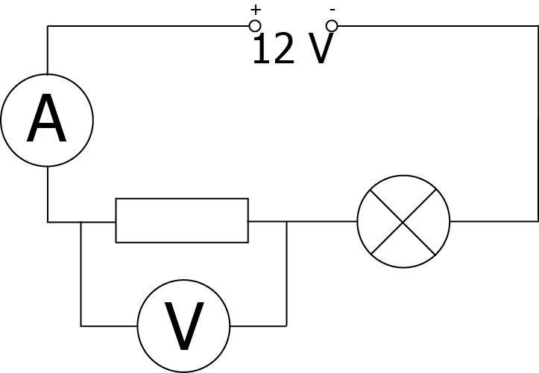
- In the circuit below the ammeter reading is 0.5 A and the voltmeter reading is 4 V.
a. State whether this is a series circuit or
a parallel circuit.
b. What is the current through the lamp?
c. What is the potential difference across
the lamp?
- Which of the following statements is/are true for
  - series circuits.
  - parallel circuits.

A There is only one pathway round the circuit.
B There is more than one pathway around the circuit.
C The potential differences around the circuit add up to the supply voltage.
D The potential difference (voltage) is the same across all components.
E The current is the same at all points in the circuit.
F The current through each component adds up to the supply current.

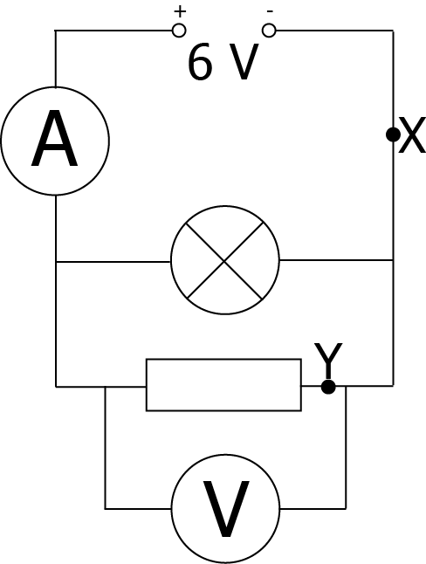
- In the circuit below the ammeter reads 0.8 A, the current through the lamp is 0.3 A and the voltmeter reads 6 V.
a. Is this a series or a parallel circuit?
b. What are the current values at X and at Y?
c. What is the potential difference across the lamp?

- Find the missing currents and voltages in the following circuits.

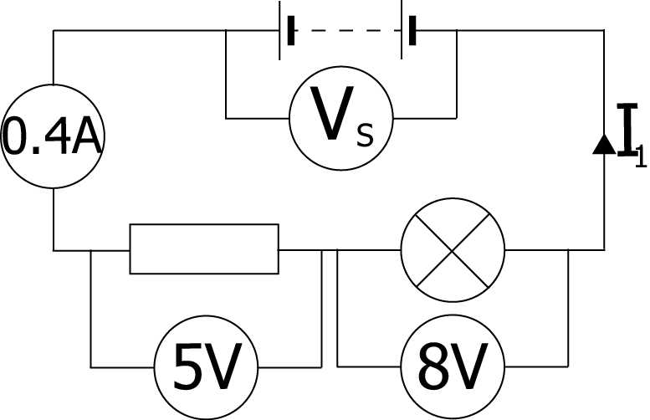 | 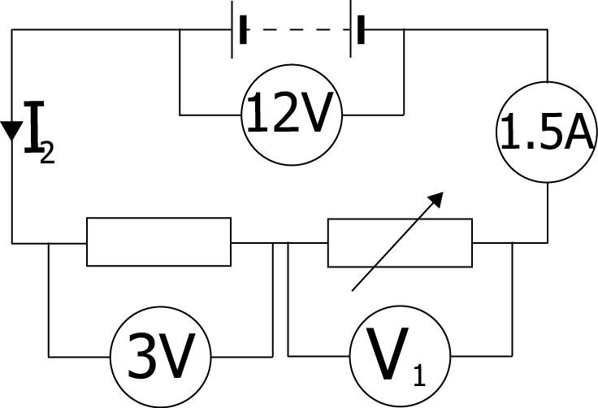
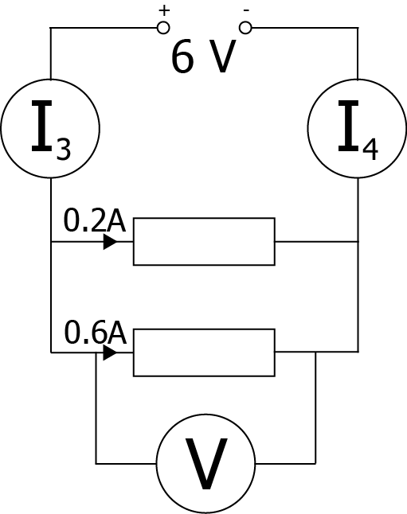 | 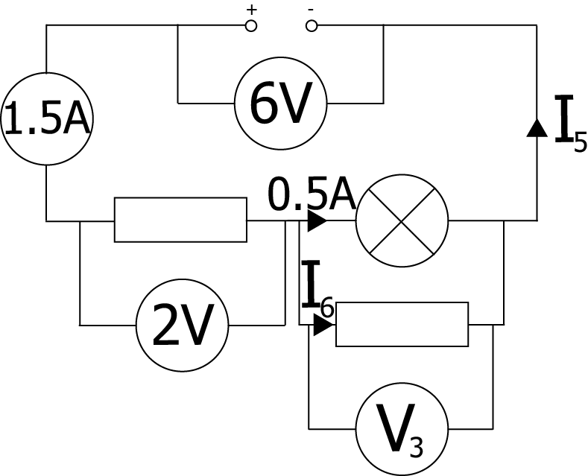

Ohm’s Law

- If V = 12 V and I = 4 A, calculate R.
- If V = 12 V and R = 4 Ω, calculate I.
- If R = 12 Ω and I = 1 A, calculate V.
- If V = 12 V and I = 2 mA, calculate R.
- If R = 4 Ω and I = 6 mA, calculate V.
- If V = 6 mV and R = 4 mΩ, calculate I.
- If R = 10 mΩ and I = 6 A, calculate V.
- If V = 50 V and I = 2 A, calculate R.
- If V = 12 mV and R = 6 m, calculate I.
- If R = 12 Ω and I = 7 mA, calculate V.
3 V
17.5 Ω
42.5 Ω

Potential Dividers

- What is the p.d. on the voltmeter in each of the following circuits?

a. | 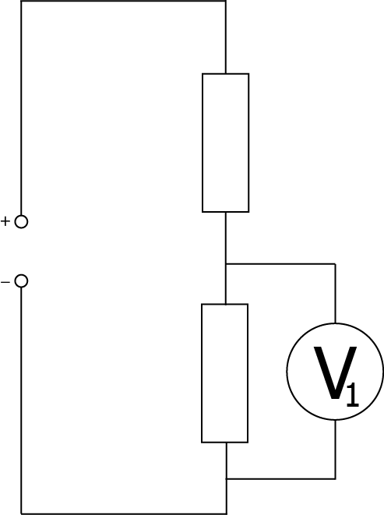  8 Ω  12 V  4 Ω | b. | 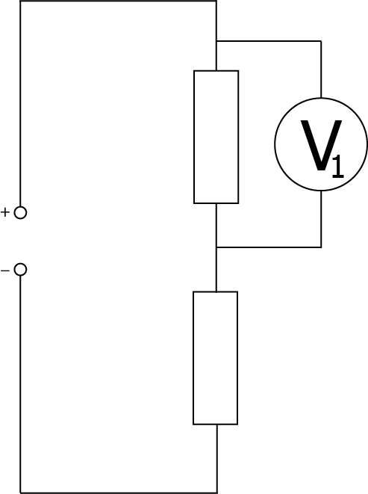  25 kΩ  100 kΩ  5 V | c.

- What is the missing resistance value in these circuits?

a. | 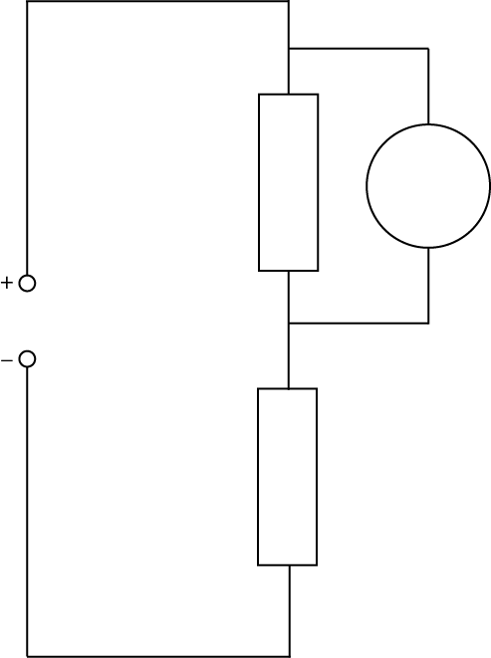  2.4 V  4.8 kΩ  12 V | b. | 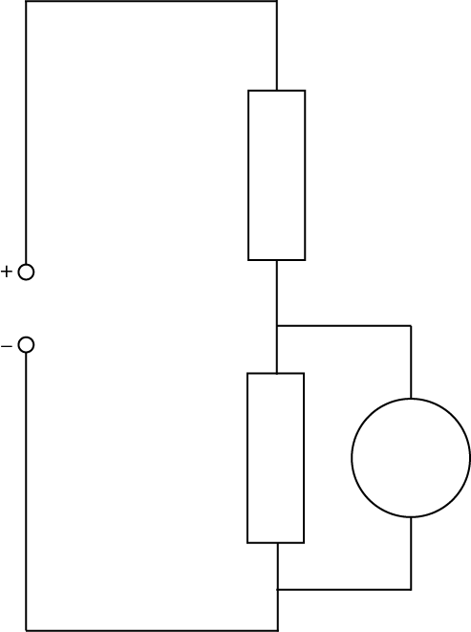  2.3 V  3 V  34 kΩ | c. | 8 Ω  5 V  6 V

- The lamp in this circuit has a resistance of 8 Ω.
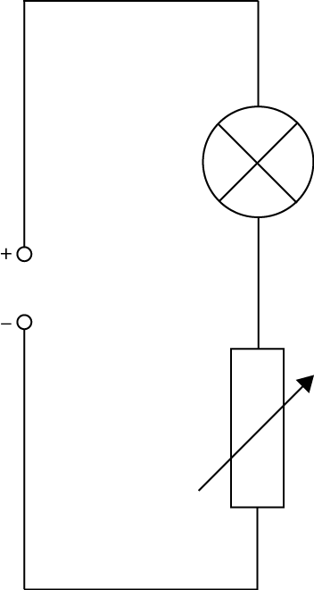  10 V  1 – 100 Ω | - What is the maximum resistance of the circuit?  - What is the minimum resistance of the circuit?  - What is the maximum current in the circuit?  - What is the maximum p.d. across the lamp?

- A student sets up the circuit shown below.
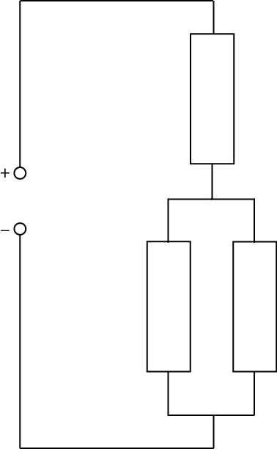  5 V  120 Ω  400 Ω  100 Ω | - Calculate the current supplied to the circuit.  - What is the potential difference across the parallel section of this circuit?  - What is the current in the 100 Ω resistor?

Power, Energy and Time

- A light bulb has a power rating of 60 W.
  - How much electrical energy is transformed by the bulb in 1 s?
  - State the energy changes involved when the lamp is switched on.
- The electric motor on a ceiling fan transforms 207 kJ of electrical energy in 30 minutes?.
  - Calculate the power rating of the motor in the fan?
  - State the energy changes involved when the ceiling fan is switched on.
- How much electrical energy is transformed by the following appliances?
  - A 400 W drill used for 45 s.
  - A 300 W food processor used for 20 s.
  - An 800 W iron used for 40 minutes.
  - A 2.4 kW kettle that takes 5 minutes to boil the water inside it.
- What is the power rating of an appliance that transforms:
  - 500 J in 5 s?
  - 1200 J in 20 s?
  - 1.8 MJ in 10 minutes?
- How long would a 2 kW electric kettle take to boil the water inside if it transforms
100 kJ of electrical energy into heat energy?

Power, Current, P.D. And Resistance

- To measure the power of a lamp a voltmeter and an ammeter are required.
  - Draw a circuit diagram to show how you would measure the power output of bulb using a voltmeter and ammeter.
  - If the meter readings in the circuit in question 1a were 6 V and 600 mA, what would be the power of the lamp?
  - How much energy would this lamp use in 1 hour?
- A colour television set is rated at 300 W.
  - Calculate the current drawn by the television when connected to the 230 V mains supply.
  - How much energy would this television use if it was left on overnight for
8 hours?
- Using the equations V = IR and P = VI, show that if a current I flows through a heating element of resistance R, the power of the heater is given by P = I²R.
- What is power rating of a 30 Ω heating element when 8 A passes through it?

- Calculate the power rating of the following devices in a car:
  - A radio of resistance 6 Ω drawing a current of 2 A.
  - The rear window heater of resistance 3 Ω drawing a current of 4 A.
- An electric fire is rated at 2 kW, 230 V.
  - What is the current in the heating element when it is switched on?
  - Calculate the resistance of the heating element.
- A 100 Ω resistor has a maximum safe power rating of 4 W. Calculate the maximum current it can safely handle.
- Calculate the resistance of a hairdryer element which has a power rating of 960 W when drawing a current of 4 A.
- By combining the equations V = IR and P = VI, show that the power can also be given by P = V² / R

- Calculate the power rating of a heater which has a resistance of 53 Ω plugged into the mains voltage of 230 V.

- A current of 6 A flows along a flex of total resistance 0.2 Ω   to an electric heater which has an element of resistance 60 Ω.
  - Calculate the heat generated each second in the flex
  - Calculate the heat generated each second in the element
  - What energy change is taking place in both the flex and the element?
  - Why does the element become hot and the wire remain cool?
  - What size of fuse, 3 A or 13 A, should be fitted to the plug connected to this heater?
  - Explain what would happen if the wrong fuse was fitted to the plug.
- The fuses used in electrical plugs in the UK come in 2 main sizes - 3 A and 13 A
  - What is the purpose if the fuse in the plug connected to an appliance?
  - What energy change does a fuse depend on to work correctly?
  - Copy and complete the table below and select which of the above fuses would be most suitable for each of the appliances.

Appliance | Power (W) | Voltage (V) | Current (A) | Most suitable fuse
Food Mixer |  | 230 | 0.3
Lamp | 100 | 230
Heater | 2.5 x 10³ | 230
Hi-fi unit |  | 230 | 1.5

Numerical Answers

Electric Charge and Current

- -
- –
- 210 C
- 900 C
- 0.3 A
- 6 A
- 5 s
- electrical -> heat
- –
- a. 240 C
- 7.3 A
- a. 144000C
b. 20 hours

Potential Difference

- –
- –
- –
- –
- i. DC
ii. AC
iii. DC
- i. 2 V
ii. 6 V
iii. -1.5 V
- a. AC
b. AC
c. AC
- a. 10 V
b. 0.4 V
c. 150 mV
- AC
- 50 Hz
- a. DC
b. Decreased
- 17 V
- B
- -

Resistance

- a. 550 Ω
b. 1.5 kΩ
c. 16.8 Ω
- a. 8.2 kΩ
b. 164 Ω
c. 2 Ω
- a. 1 kΩ
b. 716 Ω
c. 1.2 MΩ

Current and p.d. In Series And Parallel Circuits

- a. Series
b. 0.5 A
c. 8 V
- a. ACE
b. BDF
- a. Parallel
b. X = 0.8 A ,Y = 0.5 A
c. 6 V
- I₁ = 0.4 A
I₂ = 1.5 A
I₃ = 0.8 A
I₄ = 0.8 A
I₅ = 1.5 A
I₆ = 1.0 A
V_{S} = 13 V
V₁ = 9 V
V₂ = 9 V
V₃ = 4 V

Ohm’s Law

- 3 Ω
- 3 A
- 12 V
- 6 kΩ
- 24 mV
- 1.5 A
- 60 mV
- 25 Ω
- 2 A
- 84 mV

Potential Dividers

- a. 8 V
b. 1 V
c. 2.1 V
- a. 19.2 kΩ
b. 116 kΩ
c. 40 Ω
- a. 108 Ω
b. 9 Ω
c. 1.1 A
d. 8.9 V
- a. 25 mA
b. 2 V
c. 20 mA

Power, Energy and Time

- a. 60 J
b. -
- a. 115 W
b. -
- a. 18 kJ
b. 6 kJ
c. 1.92 MJ
d. 720 kJ
- a. 100 W
b. 60 W
c. 3 kW
- 50 s

Power, Current, P.D. And Resistance

- a. -
b. 3.6 W
c. 13 kJ
- a. 1.3 A
b. 8.64 MJ
- 30 Ω
- 1920 W
- a. 24 W
b. 48 W
- a. 8.7 A
b. 26.5 Ω
- 0.2 A
- 60 Ω
- –
- 998 W
- a. 7.2 J
b. 2160 J
c. -
d. -
e. 13 A
f. -
- a. -
b. -
c
Appliance | Power (W) | Voltage (V) | Current (A) | Most suitable fuse
Food Mixer | 69 | 230 | 0.3 | 3 A
Lamp | 100 | 230 | 0.4 | 3 A
Heater | 2.5 x 10³ | 230 | 10.9 | 13 A
Hi-fi unit | 345 | 230 | 1.5 | 3 A

