November 17

ELECTRICITY | Mrs J A Hargreaves
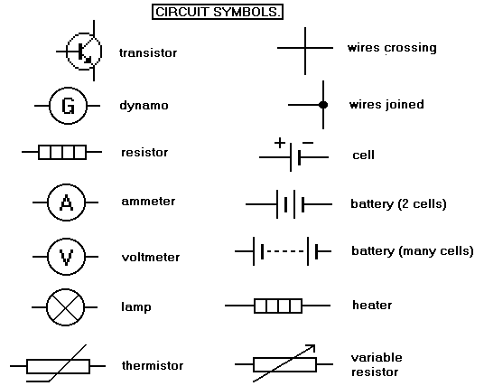
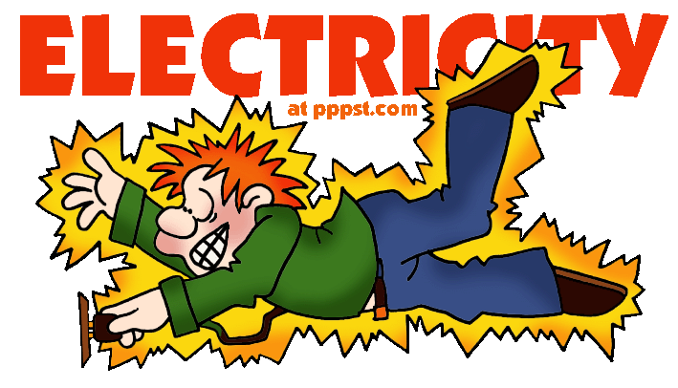
LockerbieAcademy | National 5 Electricity

Data Sheet
Contents
Symbols & Directions 4
Background Material 4
Section 9. Electrical Charge Carriers 6
Charge and Current 11
? Charge and Current Questions 12
AC/DC 15
Success Criteria 23
Section 10: Potential Difference 24
Section 12: Practical electrical and electronic circuits 29
Practical Circuits-Components 30
Ammeters and Voltmeters 35
Measuring Current, Voltage and Resistance 36
Resistance 41
Measuring Resistances in Parallel 43
Resistors in Series and Parallel – Tutorial 46
Resistance of a 12 V Lamp 47
Help Sheet: Resistance of a 12 V Lamp 47
Practical Circuits 50
Section 11: Ohm’s Law 54
Practicals: Voltage, Current and Resistance 54
? Tutorial Questions 58
Special Components 59
LED’s and Diodes 59
Capacitors 62
Transistors 63
Potential Dividers 65
Transistor Switching Circuits 72
Success Criteria 74
Section 13: Electrical Power 74
Electrical Power 74
Electrical Power 75
Power and Energy 75
Tutorial Questions 78
Power, Current and Voltage 79
P V I R Tutorial 81
The Ring Circuit 85
How the Earth wire works 88
? Revision Questions 90

National 5 Physics - ELECTRICITY

Symbols & Directions
write out a note
Stop writing out the note
Task- something to complete
Answer the questions using IESSUU in your jotter.
Quantity | Symbol | Unit | Unit Symbol
- Put anything with the above table into the middle pages of your notes jotter.
- Write formulae into your notes jotter (You should copy this automatically into your small formula jotter at home as part of your revision and review. Don’t forget to include basic units for each quantity.
- Ask your teacher if you need the equation written out in words.
- Ensure you date your work in your jotter for each lesson.
- As we complete each section you can date the section in your outcome book and assess your learning by highlighting the smiley faces!

Welcome to Unit 3 of the National 5 Physics Course. Make sure that you have completed the introduction to Maths part before starting or this next section will prove a little difficult.

Before we tackle the start of this unit it would be helpful if we know a little background. If you have completed the Dynamics Unit you will have covered this so that you can use this for revision or skip it.

Background Material

Learning intentions
0.1 | I know the units for all of the physical quantities used in this course.
0.2 | I can use the prefixes: nano (n), micro(μ), milli (m), kilo(k), Mega(M) & Giga (G)
0.3 | I can give an appropriate number of significant figures when carrying out calculations (This means that the final answer can have no more significant figures than the value with least number of significant figures used in the calculation).
0.4 | I can use scientific notation when large and small numbers are used in calculations.

0.1 Units
We will cover the units for all the physical quantities used in this course as we go along. Use the middle spread in your notes jotter to record them in table form.
Quantity | Symbol | Unit | Unit Symbol

0.2 Prefixes
Throughout the course, you need to be aware of units, prefixes and scientific notation.
Prefix | Symbol | Power | Multiplier
Tera | T | 10¹² | x 1,000,000,000,000
Giga | G | 10⁹ | x 1,000,000,000
Mega | M | 10⁶ | x 1,000,000
Kilo | k | 10³ | x 1,000
Centi | c | 10² | /100
Milli | m | 10⁻³ | /1,000
Micro | µ | 10⁻⁶ | /1,000,000
Nano | n | 10⁻⁹ | /1,000,000,000
Pico | p | 10⁻¹² | /1,000,000,000,000
In this section the prefixes you will use most often are milli (m), micro (µ), kilo (k), mega (M) and giga (G). It is essential that you use these correctly in calculations.
In Physics, the standard unit for time is the second (s) and therefore if time is given in milliseconds (ms) or microseconds (µs) it must be converted to seconds.

0.3 Significant Figures
Sometimes we do not always need to give detailed answers to problems - we just want a rough idea. When we are faced with a long number, we could round it off to the nearest thousand, or nearest million. And when we get a long decimal answer on a calculator, we could round it off to a certain number of decimal places.
Another method of giving an approximated answer is to round off using significant figures.
The word significant means: having meaning.
With the number 368249, the 3 is the most significant digit, because it tells us that the number is 3 hundred thousand and something. It follows that the 6 is the next most significant, and so on.
With the number 0.0000058763, the 5 is the most significant digit, because it tells us that the number is 5 millionths and something. The 8 is the next most significant, and so on.
Be careful however with numbers such as 30245, the 3 is the first significant figure and 0 the second, because of its value as a place holder.
We round off a number using a certain number of significant figures. The most common are 1, 2 or 3 significant figures.
Remember the rules for rounding up are the same as before:
- If the next number is 5 or more, we round up.
- If the next number is 4 or less, we do not round up.

It is vital that you tell your teacher if there is anything in this section that you do not understand. You will then be given additional resources to help you.

Section 9. Electrical Charge Carriers

Learning Intentions
- Definition of electrical current as the electric charge transferred per unit time.
- Use of an appropriate relationship to solve problems involving charge, current and time.
Q =It
- Knowledge of the difference between alternating and direct current.
- Identification of a source (as a.c. or d.c.) based on oscilloscope trace or image from data logging software.
We are going to review the definition of electric charge, investigate electrical current and the difference between alternating and direct current.

Background –The Atom
Copy and complete the guide to the Atom in your notes book.

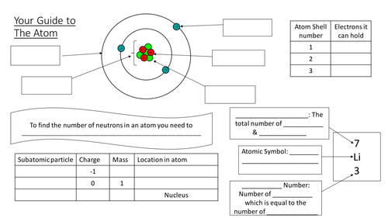

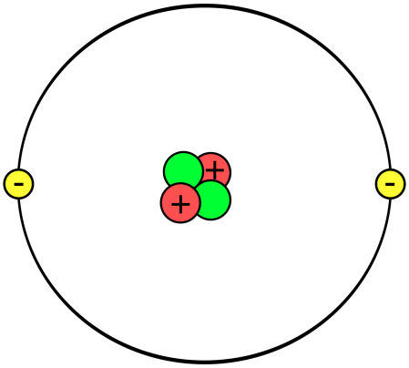
Electric charge

You may have investigated static electricity before in a number of ways.
- rubbing a balloon on your clothing and ‘sticking’ it to a wall.
- using a Van de Graaff generator.
- getting a shock getting out of a car.

It is thought that the Greeks were the first to investigate electricity. The philosopher Thales of Miletus noted around 600 BC that pieces of amber could attract light objects after being rubbed. The word electricity itself comes from ēlektron, the Greek word for amber. It is expected that as you complete this course you don’t use the word Electricity as its meaning is ambiguous, just like you shouldn’t use the term gravity on its own. Be more specific, such as electric current or electrical energy etc.

Everything you can see and touch is made from atoms. Atoms are made up of three types of particles:
Protons which have a positive charge
Neutrons which have no charge
Electrons which have a negative charge
Atoms have equal numbers of protons and electrons, which causes the atom to be neutral (no overall charge). However, charged items can still pick up small items.
A rod can be charged by rubbing. When brought close to a neutral item, this can cause the charges to be rearranged to give an imbalance on each side.

There are two types of electric charge, positive and negative.
Through experimentation it is found that like charges repel and unlike charges attract.

1.
2.
3.

+
+
+
+
-
-
-
-
+
+
+
+
-
-
-
-
+
+
+
+
-
-
-
-

The charges on the piece of paper are evenly distributed amongst the piece of paper.
When the negatively charged rod is brought near, the positive charges are attracted and the negative charges repelled.
This imbalance of charge allows the rod to pick up the piece of paper.
When a material is charged by rubbing only the electrons from the atoms are moved.

Depending on the materials used, the rod can either gain electrons and become negatively charged, or lose electrons and become positively charged.

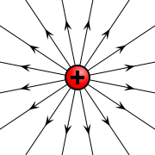
Similar to the presence of a magnetic field around a magnet, an electric field exists around electrical charge.

The field lines point in the direction that a lone positive charge would move.

Static Electricity Experiments
Investigate the interaction of charged objects, for example, metallised polystyrene spheres attracted and repelled, Van de Graaff generator discharged through a micro ammeter.

1. Stuck on You- A sticky experiment!
Materials you will need:
- A Balloon
- Strong Lungs
- A Woollen or Nylon Sweater (Jumper)

Steps:
- Blow up the balloon and tie the end so that the air does not escape.
- Take the balloon and rub it vigorously against your jumper/sweater or your head of hairs about ten times.
- Now hold the balloon against your jumper/sweater or hairs for a minute.
- Let go of the balloon. What happens? Does it stick?

When a balloon and a jumper/sweater or hairs are rubbed together; each will gain a different type of electrical charge. The balloon becomes a negative charge and the jumper/sweater or hair becomes a positive charge. Opposite charges attract each other.

2. Bending Water Experiment
Materials you will need:
- A Plastic Comb or rod
- Woollen Jumper or cloths
- Running Tap (Water)

Steps:
1. Rub the plastic comb against your jumper or comb through your hair around ten times.
2. Turn the tap on so that it has a slow, steady stream of water.
3. Place the comb close to the water (don't let the comb touch the water).

3. Resisting Balloons
Materials you will need:
• Tape
• Scissors
• Door Frame
• Two Balloons
• String/Thread
• A Woollen Sweater/Jumper

Steps:
- Cut two equal lengths of thread/string and tape them to the top of a door frame in the middle about 1 inch or 2.5 cm apart.
- Blow up the balloons and tie each end so that the air does not escape.
- Tie each of the blown up balloons to the end of each thread/string so that they are hanging at the same height and are resting next to each other.
- Rub each of the balloons with the woolly jumper/sweater to charge them (one at a time).
- What happens when you let them go? How do they react to each other?

Both of the balloons have become negatively charged once they have been rubbed with the woollen jumper/sweater and will push each other away. Items that are made up of the same material will always take on the same charge. If you have a matching charge of static electricity in like items, they will repel each other just like the same poles of magnets will repel each other.

Try to bring the two balloons together after they have been rubbed with the woollen sweater/jumper. What happens when you try to bring the balloons together?
Place your hands in between the two balloons, does something different happen?

4. Rising Tissue Paper
This is a fun experiment to watch as the tissue paper is pulled up by the charged comb/pen.
Materials you will need:
• Scissors
• Tissue Paper
• Woollen Jumper/Sweater
• A Plastic Comb/Pen

Steps:
- Cut up some small pieces of tissue paper.
- Charge up the comb/pen by rubbing it against a jumper/sweater or combing through your hair about ten times.
- Hold the comb/pen over the small pieces of tissue paper.

**Note: You must neutralize the ruler each time before you rub the ruler with a new object. You can neutralize it by rubbing on your shirt or wetting it with water.**

5. Charged or Not Charged - Balloons
Materials you will need:
- ·Tape
- ·Scissors
- ·Two Balloons
- ·String/Thread
- ·A Woollen or Nylon Sweater (Jumper)

Steps:
1. Inflate both balloons so they are the same size. Tie a knot in the neck of each balloon so that the air does not escape.
2. Tie one end of the string to one of the balloons.
3. Using tape, secure the free end of the string to the edge of a table.
4. Charge the second balloon by rubbing it with the wool scarf.
5. Hold the charged balloon near, but not touching the hanging balloon.
6. Observe the motion of the hanging balloon.

Before rubbing, like all materials, the balloons and the wool scarf have a neutral charge. This is because they each have an equal number of positively charged subatomic particles (protons) and negatively charged subatomic particles (electrons).
When you rub the balloon with the wool scarf, electrons are transferred from the wool to the rubber because of differences in the attraction of the two materials for electrons. The balloon becomes negatively charged because it gains electrons from the wool, and the wool becomes positively charged because it loses electrons.
When the negatively charged balloon is brought near the neutrally charged hanging balloon, the electrons on the surface of the hanging balloon move away because like charges repel. This leaves the surface facing the charged balloon more positive. Since opposite charges attract, the positive charge on the surface of the hanging balloon is attracted to the negative charge on the hand-held balloon. This attraction is strong enough to move the hanging balloon.

6. Charging up a Bulb
Materials you will need:
- A Dark Room
- Fluorescent Light Bulb
- A Comb/Woollen Scarf

Steps:
- Go into a dark room with the light bulb and the comb (woollen scarf).
- Run the comb through your hair around 20 times. You could rub the comb over a woollen scarf for the same effects.
- Place the comb on the metal end of the light bulb and watch as the filament in the bulb lights up.

The friction between your hair and the comb causes electrons to travel from your hair to the comb. This causes your body to become positively charged and the comb becomes negatively charged. With the comb being charged, it discharges into the light bulb causing the bulb to emit the small pulses of light.

7.Acetate and Polythene Rods
- Investigate charged polythene and acetate rods.
- Collect two polythene and two acetate rods, two watch glasses.
- Use the apparatus to investigate if the charged rods attract or repel each other.
or

Charged Rod 1 on watchglass | Charged Rod 2 brought close | effect
Make a short note to record your results, you will use this information later.

? Task & Questions

- Present the results you obtained from the experiment in a appropriate way.
- State the number of different types of charge, what is the evidence for this?
- Name the different types of charge.
- There are three different particles that make up an atom. Use an appropriate format to present information about these particles.
- Explain how a charged rod can pick up a light neutral object. Diagrams may be useful to assist you.
- You may have noticed that the hair of someone in contact with a Van de Graaf generator often sticks out on end. Using your knowledge of electrical charges, give an explanation for why this should happen.
- Using your knowledge of the structure of an atom, give a reason why electrons and not protons can be removed from a material by rubbing.

Charge and Current
One of the fundamental properties of materials is charge.
Electrostatics is the study of charges at rest. Simple electrostatics experiments that we have performed in the previous section help us to establish the following facts:
(i) There are two types of charge: positive and negative. The names have no significance other than as labels for the two types of charge.
(ii) All materials are made up of atoms that normally contain equal numbers of positively and negatively charged particles. When there is no excess charge of either type, the material is said to be uncharged, or neutral. Some types of materials can be charged, either positively or negatively, by rubbing (causing friction). Since electrons are defined as carrying negative charge, if electrons are rubbed onto a material it becomes negatively charged, while if a material loses electrons it becomes positively charged.
(iii) Electrons in a conductor are free to move and so conductors cannot be easily charged since the charge normally flows away as soon as it is placed on the conductor.
(iv) Like, or similar, charges exert forces which make them repel each other. Unlike charges exert forces which make them attract each other.

Charge
Charge is the name we give to one of the properties of a material. Charge can either be positive or negative. Positive charge will attract negative charge and vice versa, but negative charge will repel other negative charge: the same will happen with two positive charges.

Opposite charges attract
Like charges repel

The symbol we use for charge is Q and the unit of charge is the coulomb which we write as C. Electrons have a very small negative charge

-0.00000000000000000016 C
this can be written as
-1.6 x 10⁻¹⁹ C

So to reach a charge of 1 C there has to be an incredibly large number of electrons. In fact there needs to be
6,250,000,000,000,000,000 electrons!
- Surrounding all charged particles there is an electric field. In physics, when we talk about fields, we mean a place where an object will experience a force.

Current
The electric field, discussed in the next section, shows us how a charge will move, but it is useful to measure how much charge is moving. Current is a measure of the rate of movement of charge – it can be the movement of positive or negative charge but in this course we usually concentrate on the movement of electrons which have a negative charge.

This means that current is the amount of charge which passes a point in one second, so we could write it as
- Current is the rate of flow of charge and is measured in Amperes (A)
$$I = \frac{Q}{t}$$
showing that the amount of charge which has passed in total, divided by the amount of time it taken gives us the current.

One ampere is the same as one coulomb of charge flowing every second (in other words 6.25 x 10¹⁸ electrons every second!).

We normally state the charge equation as

$$Q = It$$
Where Q is the charge in Coulombs, C, I is the current in Amperes, A, t is the time in seconds, s The symbol for electrical current is I, because it was once referred to as intensite de courant or current intensity. The unit that is used to measure electrical current is the Ampere (A).
Symbol | Name | Unit | Unit Symbol
Q | Charge | coulombs | C
I | Current | amperes | A
t | Time | seconds | s

? Charge and Current Questions

Worked examples
- Calculate the charge flowing through a lamp in 3 seconds if the current in the lamp is 2 amperes?
Q=?  I= 2A  t=3s | $$Q=It \\ Q=2×3 \\ Q=6 C$$
The charge which flows through the lamp in 3 seconds is 6 coulombs.
- Fifty coulombs flow through a heater in 10 seconds. Calculate the current in the heater?
$$I=\frac{Q}{t} \\ =\frac{50}{10} \\ =5$$
Solution:
$$Q=It \\ 50=I×10 \\ 10×I=50 \\ I=\frac{50}{10} \\ I=5$$

or

The current in the heater is 5 amperes.
- A current of 2 A runs through a lamp for 3 minutes. Calculate the charge that flowed through the lamp?
Solution:
Q = ?  I = 2 A  t = 3 x 60 = 180 s | Q = It  Q = 2 x 180  Q = 360 C
- Calculate the time it takes for 50C of charge to flow through a circuit if the current is 5 mA?
Solution:
Q = 50 C  I = 5 mA = 5x10⁻³ A  t = ? | Q  50  t  t | = It  = 5x10⁻³ x t  = 50/5x10⁻³  = 10 000 s
- Calculate the charge transferred in a circuit which has a current of 0.25 A for 1 hour.
Solution:
Q = I x t  Q = 0.25 x 3,600  Q = 900 C | Current, I = 0.25 A  Charge, Q = ?  Time, t = 1 hour = 60 x 60s = 3,600 s

? Tutorial Questions

Electric Current
- Explain what is meant by the term ‘electric current’.
- Write down the relationship between charge and electric current.
- Give the names of the units used to measure the three quantities.
- Calculate the current in a circuit when a charge of 180 C is transferred in 1 minute.
- One bar of an electric heater draws a current of 4.0 A from the mains supply.
  - Calculate the charge that flows through the bar each minute?
- If a second bar is switched on, the charge flowing through the bar each minute increases to 440 C. Calculate the new current drawn from the mains when both bars are switched on.
- The manufacturer of the battery in a car states that the battery is rated at 40 ampèrehours. This is one way of telling the user how long the battery will be able to provide electric current to operate appliances. eg. this could deliver 40 A for 1 hour or 8.0 A for 5.0 hours etc.
  - Calculate the total charge that this battery can deliver, in coulombs.
  - The parking lights of the car draw a current of 2.0 A from the battery. If these lights were left on when the car was parked, calculate the minimum time it would take for the battery to go flat.
  - State any assumption you are making in your answer to part b).
- The current in a heater is 7.0 amperes. Calculate the charge flowing through the heater in 30.0 seconds?
- The total charge that flows in a circuit is 12 C. The time taken for this charge to flow is 6 s. Calculate the current in the circuit?
- A car headlamp uses a current of 2.0 A. Calculate the time the lamp will be switched on for 10.0 C to pass through it?
- A hair dryer is switched on for 5.0 minutes and the current flowing is 3.0 A. Calculate the charge that flows through the hairdryer in this time?
- Calculate the current when 4 C of charge passes a point in 0.40 s?
- Calculate charge passing through a cow if it touches an electric fence and receives a pulse of 20.0 milliamperes (mA) for 0.10 seconds? A car headlamp uses a current of 2 A. Calculate the time the lamp is switched on when 10 coulombs of charge pass through it?
- If an electric current is passed through a conducting wire, what energy transformation takes place?
- Many electrical appliances in the home are designed to make use of this energy transformation. Name four of these appliances.
- A torch lamp passes 720 C of charge in 1.0 hour. Calculate the current in the lamp?
Conductors | Insulators
silver | plastic
copper | glass
gold | rubber
aluminum | wood
steel | air
graphite | oil

Conductors and Insulators
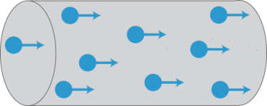
Some materials allow electrical charge to flow freely, they are called conductors. Copper is one of the most widely used conductors as it allows electrons to move very easily - it does not resist the movement of charge much.

Other materials make it very difficult for charge to move: these are called insulators.
We will often find conductors and insulators working together, your headphone cable is a perfect example. Inside the insulating plastic coating are strands of copper, it is the copper which conducts the audio signal and the plastic is there to protect it, but also to stop other conductors coming into contact with it.

? Tutorial Questions
Conductors and Insulators
            - The following set of items have to be divided into conductors and insulators.
paper clip, rubber, pencil refill ‘lead’, wooden ruler, scalpel, glass rod, tongs
- Describe a simple experiment which you could carry out to determine whether the items were conductors or insulators.
- State the group of materials that contain most conductors.
- State a material that is a conductor, but not a member of the group above.

AC/DC
There are two types of current in circuits - Alternating Current (AC) and Direct Current (DC).

? Questions
- State what the battery supplies to the electrons?
- Explain what happens when the battery is ‘flat’ – will the electrons move and create a current?
In AC circuits, the terminals constantly change (in the UK the frequency mains circuits is 50 Hz, so the current changes direction 100 times a second) between positive and negative, so the charges constantly change direction. The energy transfer in these circuits still happens because the movement of the charges changes the electric field around them.
- In DC circuits, the charge carriers will only flow one direction round a circuit, in the case of electrons, this is from the negative to the positive terminal. In A.C circuits, the charge carriers change direction as the polarity of the supply regularly changes.

Observing A.C/D.C. Traces- Practicals
Use an oscilloscope/data logging software to compare alternating and direct current sources. We can investigate the waveforms of electrical signals using an oscilloscope. An oscilloscope shows time on the x-axis and amplitude of the signal on the y-axis. Each square on an oscilloscope is called a ‘division.’ There are dials on oscilloscopes which allow us to change the value of each division, both for time and for p.d. Two examples are shown below.
This is an AC trace from an oscilloscope, the x axis is time and the y axis is potential difference. The p.d. is changing between positive and negative values. If the timebase is set to 1 ms/division and the y-gain is set to 2 V/division then the peak value of this signal is 8 V and the frequency is 200 Hz. This picture shows two complete cycles of the pattern. Each cycle has a positive half-cycle and a negative half-cycle. During the positive half-cycle the current is in one direction; during the negative half-cycle the current is reversed. | This is a DC trace from the same oscilloscope, the x axis is time and the y axis is potential difference. The p.d. is at a constant value. In this case the value is positive, but negative DC signals are also possible. If the settings are the same as before, this signal is approximately 5.7 V.

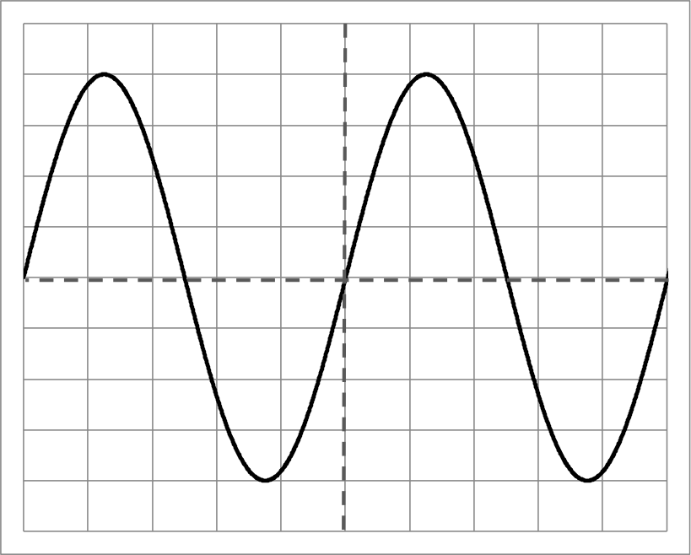
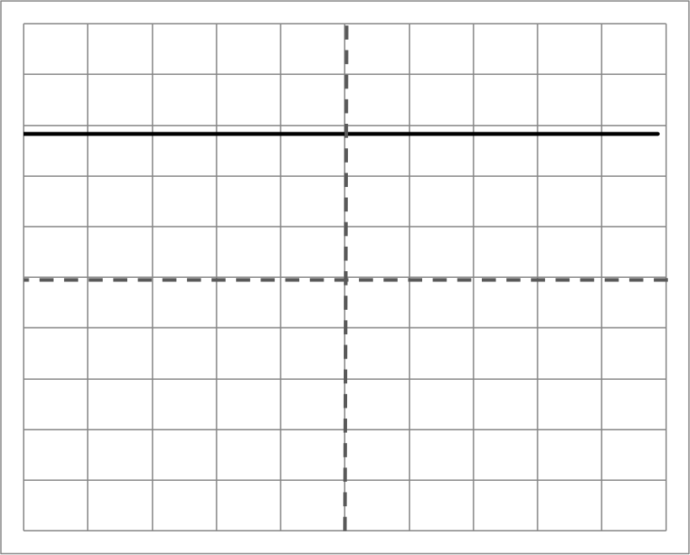
Steps
- Connect an ALBA interface to a computer and place two wires in the front 4mm slots in channel 1.
- Open the investigator programme and set the channel to -5V to +5V. Set the time to continuous and the sampling rate to 20 ms. Check the box to state that Channel 2 is “Not used”,
- Connect the two wires to a power supply set to 3.0 V and record the voltage until 5 waves are seen on the screen.
- Save the table or copy the graph and then repeat with the polarity changed across the power supply.
- Compare the two traces. Are they different?
- Replace the power supply for a cell connected to a bulb. Place the two wires connected to the ALBA and place these across the cell.
- Change the time setting to 1 s, but leave the other boxes unchanged.
- Repeat after changing the wires around across the cell, so that the polarity is reversed.
- What do you notice about the traces?
- Now repeat the original trace but plug the wires into the d.c. terminals of the supply. Repeat after reversing the polarity.

Measuring the Peak Voltage of an a.c. Supply

Read
When we connect an a.c. supply to an oscilloscope the distance the trace moves up or down the screen depends on the voltage of the supply.

Low Voltage Higher Voltage
As the trace is a curve the voltage keeps on changing. We can however measure the peak voltage. This is the maximum positive or negative voltage produced.
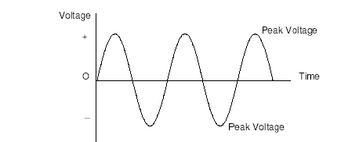
To obtain the peak voltage we first measure (in cm) how far up or down the trace moves from its centre position either to the top or bottom, or measure the distance from the top to the bottom and divide by 2. The screen of the oscilloscope has a pattern of 1 cm squares on it to help you. The peak voltage is this length multiplied by the setting on the Y-gain control.
Peak voltage = Peak deflection × Y-gain
(The Y-gain control is sometimes marked volts/cm or volts/division).
Note: The Peak voltage of an a.c. trace is always greater than the quoted voltage of the trace so that a.c. and d.c. powers can be compared directly.
The quoted value for the mains is 230V

For information only The peak voltage is 1.414 times the quoted voltage for an a.c supply. (where the quoted voltage is called the rms voltage)
$$V_{p}=V_{rms}×\sqrt{2}$$

What you need
Oscilloscope, low voltage a.c. power supply, voltmeter (20 V), connecting leads.
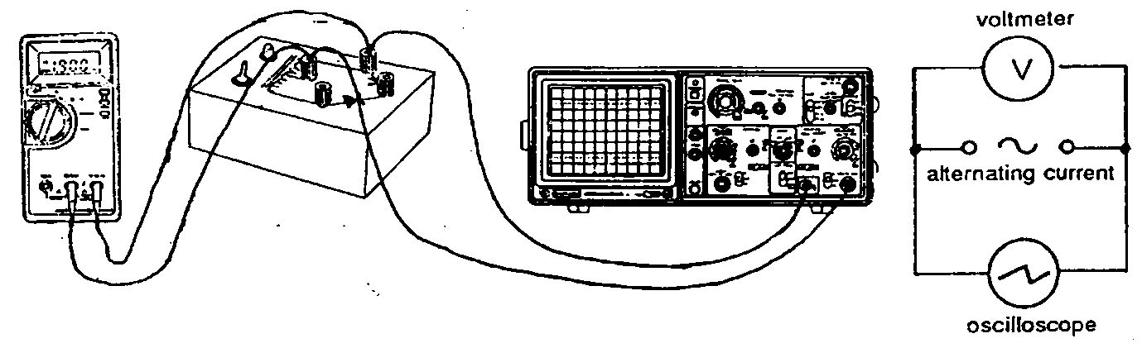

What to do
- Switch on the oscilloscope and wait for it to warm up.
- Connect a 1 V supply to the oscilloscope as shown below.
- Copy this table:
Voltage reading on meter (V)
Deflection on oscilloscope (cm)
Y-gain (V/cm)
Measured PEAK voltage (V) (calculated)

- Set the Y-gain control to give a deflection of 1 V/cm and measure the peak voltage.
- Note the reading on the voltmeter (make sure it is set to a.c. voltage).
- Replace the 1 V supply with a 2 V supply and measure the peak voltage.
- Note the reading on the voltmeter.

? Questions
- Using the voltage setting and the height of the peak, calculate the peak voltage in each case.
- Which of the following voltages is bigger?
(a) the quoted value as measured on the voltmeter
OR (b) the peak value as measured on the oscilloscope.
These two traces actually deliver the same amount of energy to a circuit. This is because the peak value of the AC signal is much bigger than the average magnitude. We call the average magnitude of an AC signal the “rated value.” This is the number which will normally be stated when we are given a supply.
A 5 V DC supply and a 5 V rated AC supply will deliver the same amount of energy to a circuit, but the peak voltage of the a.c. supply will be greater than 5.0 V.

Measuring the Frequency of the Mains Supply

What you need
Oscilloscope, low voltage a.c. power supply, signal generator, connecting leads.
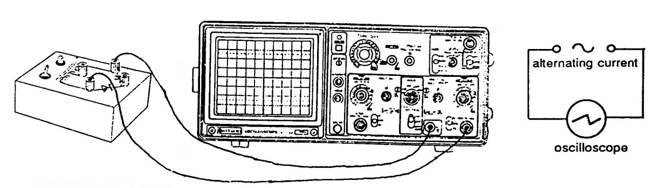

What to do
- Connect the terminals of the power supply to the oscilloscope.
- Adjust the controls of the oscilloscope until an easily recognisable pattern is obtained.
- Without adjusting the controls of the oscilloscope remove the low voltage supply and connect a signal generator to the oscilloscope.
- Vary the frequency control of the signal generator until it produces the same pattern as the one from part 2.

Questions
- What frequency is the signal generator producing when the patterns are the same?
- How must the frequencies of the two signals compare if both produce the same pattern?
- What is the frequency of the low voltage supply?
- What must be the frequency of the mains supply? (Remember that the low voltage is produced from the mains).

Extension Research:
- Discuss and research two of the uses of electrostatics, for example: laser printers, paint spraying, cling film, forensic science, removal of dust, electrostatic precipitators or electrostatic separators.
- Research the definition of current and its historical context.

The diagrams below will help you to think about what is going on when we connect an electrical circuit to a power supply. It is a “model”. We use these to help us with difficult ideas.
What happens when a battery or power supply runs out of energy?

Model | Electricity
Factory | Battery
Lorry | Electrons
Shops | Light bulbs
Road | Wires
One way street | Current goes one way
Counting cars  (in the street) | Ammeters  (go in series)
In a series circuit the counters all count the same number of lorries | In a series circuit current stays the same.
No. of boxes of mars bars=voltage | Voltage is the ENERGY per CHARGE
Weighbridge (see place at Carlisle)  PARALLEL | Voltmeter GOES IN PARALLEL
The boxes of mars bars in our series circuit adds up to what is delivered to each shop | In a series circuit the voltage across each bulb adds up to the total.
The boxes of mars bars in our series circuit adds up to what is delivered to each shop | In a series circuit the voltage across each bulb adds up to the total.
In a 2 branch town the number of mars bars each lorry delivers is the same as the total | IN a parallel circuit the voltage across each branch is the same as the supply.

A town called
CIRCUIT
BOOTHS
TESCO
ASDA

Electric Charge and Current
- The current in a heater is 7 A. Calculate the charge flowing through the heater in 30 seconds.
- A hair drier is switched on for 5 minutes. If the current is 3 A, calculate the charge which flows through the hair drier.
- 2 coulombs of charge pass through a lamp in 6 seconds. Calculate the current in the lamp.
- A switch is closed for 10 minutes If 3600 C of charge pass through the switch in this time, calculate the current in the switch.
- A car headlamp uses a current of 2 A. Calculate the time the lamp is switched on when 10 coulombs of charge pass through it.
- If an electric current is passed through a conducting wire, state the energy transformation which takes place.

- Many electrical appliances in the home are designed to make use of this energy transformation. Name four of these appliances.

a.c/d.c.
- Explain the difference between a.c. and d.c. Your answer should state what is represented by the terms, and also include the words ‘electron’ and ‘direction’.
- Give two examples of:
  - a.c. power supplies.
  - d.c. power supplies.
- State which of these traces are a.c. and which are d.c..
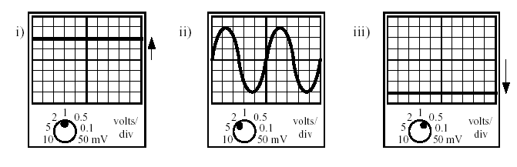
- State the maximum potential difference in the diagrams from question 5.
- For each of the following traces shown, state whether they are a.c. or d.c..
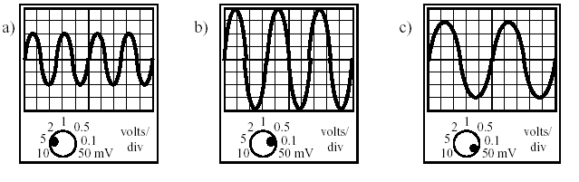
- State the maximum potential difference in the diagrams from question 7.
- Is the mains supply a.c. or d.c.?
- What is the frequency of the mains supply?
- Two identical bulbs are lit by the supplies shown below.
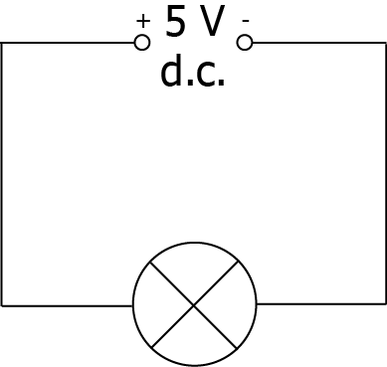 | 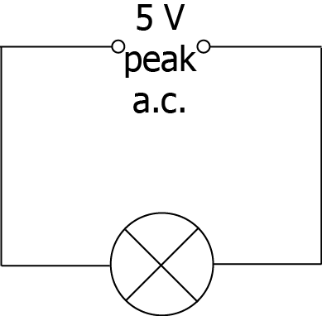
- Which bulb will be the brighter? Explain your answer.
- The d.c supply is altered so that both bulbs have the same brightness. The a.c. supply remains at the 5 V peak value. Was the d.c. supply increased or decreased?
- An a.c. supply is labelled 12 V. The peak voltage is measured using an oscilloscope. Which of the following is likely to be the measured peak voltage:
17 V, 12 V, 8.5 V, 6 V? Explain your answer.
- The mains supply is quoted as 230 V. If connected to the mains supply, which of the following devices would display a value of 230 V:
a. an oscilloscope b. an a.c. voltmeter?
- Briefly explain the meaning of the term ‘effective voltage’ which is applied to an a.c. supply.
- Look at this oscilloscope pattern:
- Is this trace representing ac or dc input?

- If the gain is set at 2 V per division, calculate the peak voltage of the trace.

- Describe what would happen to the trace on the screen if a 4 V source was used instead. Use the words frequency and amplitude in your answer.

Success Criteria
- 9.1 I can define electrical current as the electrical charge transferred per unit time.
- 9.2 I can carry out calculations using Q=It where t is measured in seconds.
- 9.3 I can explain the difference between a.c. and d.c.
- 9.4 I can compare the traces of a.c. with d.c. when viewed on an oscilloscope or data logging software.

Section 10: Potential Difference

Learning Intentions
- Knowledge that a charged particle experiences a force in an electric field.
- Knowledge of the path a charged particle follows: between two oppositely charged parallel plates; near a single point charge; between two oppositely charged points; between two like charged points.
- Knowledge that the potential difference (voltage) of the supply is a measure of the energy given to the charge carriers in a circuit.

Electric Fields
When a charge is in an electric field it will experience a force. This is similar to the way that a mass will experience a force in a gravitational field.

- Surrounding all charged particles there is an electric field. An electric field is a place where an object will experience an electrical force.
We represent fields as a series of lines. This is shown below for positive and negative charges below.
The lines have arrows showing the direction that a positive charge to move in as a result of the field. In this case a positive charge would move away from the positive charge as like charges repel. In the case of the negative charge, a positive charge would be attracted, so the arrows point towards it
Imagine a positive test charge in the field. Draw a line to show which way the test charge would move.

+
+
+
+
+
+
+
+
.  The field lines are shown  with arrows going away from the positive charge | The field lines are shown with arrows going towards the negative charge.
When two particles are close together, the field lines show how they interact with each other.
When a positive and negative charge are near each other, the field lines interact. This means that we can see what will happen to a positive charge if it is in the field because the arrows show us. Negative charges (such as electrons) will go in the opposite direction to the arrows.
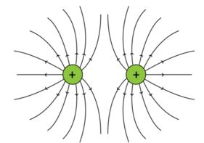
If two charges have the same charge the charges repel and you get the field shown in the diagram opposite. The field would be the same if it was two negative charges but the arrows would point in the opposite direction.

An electric field exists around any charged object. An electric field will also exist between two metal plates connected to an electrical potential. The field lines point in the direction that a positive charge would experience a force.
+
+
+
+
+
+
-
-
-
-
-
-
+
+

The strength of the field is defined as the force on each coulomb of charge:
$$E=\frac{F}{Q}$$
Where E is the electric field strength (not on this course)

Electric field strength = force in Newton on a charge of 1 Coulomb

Units of electric field strength are Newton per Coulomb, NC⁻¹

+500V
0V
+
-
F
F

A positive charge anywhere between the two plates will be attracted towards the negative plate and repelled from the positive plate. In other words a positively charged particle would move towards the negative plate. A negatively charge particle would move towards the positive plate.

Imagine that you could put a negatively charged particle (say an electron) on the negative plate. It would want to move towards the positive plate. If it was allowed to travel across the gap it would gain kinetic energy. However if it cannot move across the gap it will try to find another route to the positive plate — for instance through an electrical circuit.

If a charged object is placed in the field then the direction it moves will depend on the sign of the charge. ( +ve or –ve)

Potential difference (voltage) is a measure of the energy gained by charge moving across that potential difference.

The greater the potential difference between the plates the greater the energy gained by any charge. 
$$E_{w} = QV$$

Where E_{W} = Energy supplied to charge (J), Q = Charge (C), V= Voltage (V)

? Questions
- Calculate the work done if 15 C of charge moves between two electrodes with a p.d of 1200 V between them.
- A toy train running off a 12 V battery uses 1.5 x 10⁵ J of energy in 1 hour 30 mins. Calculate the charge transferred during this time.
- An electrical generator provides 9 x10⁷ J of energy every minute to the mains supply. It works as a voltage of 40 kV. Calculate the charged transferred in one minute.
- An electron is released from the hot cathode and accelerated by a p.d. of 5.0 kV between the cathode and anode. Calculate the work done by the field for each electron?
- When will a charged object experience a force?
- Draw a diagram to show the shape of the electric field caused by
+
- a positive point charge
-
- a negative point charge
- two positive point charges
+
+
-
-
- two negative point charges
-
+
- a positive and a negative point charge
- two parallel plates of opposite charge.
- Write a sentence to link energy gained by a charge and potential difference.

- What is meant by a potential difference of 6 volts?

Voltage and Energy
The purpose of a circuit is to transform electrical potential energy into a more useful form. To have a current, charges in that circuit must be moving. For them to move, they need to be given energy. As charge flows round a circuit, each coulomb of charge gains energy in the supply and this is transformed in the components of the circuit.
To understand the energy in a circuit we can to compare it to our everyday lives. We are familiar with the idea of gravitational potential energy. When we go upstairs we gain potential energy, and when we move to the bottom of the stairs we lose potential energy. When we are half way down the stairs, we do not have zero potential energy – we just have a smaller amount than at the top. We can state that there is a difference in our potential energy.
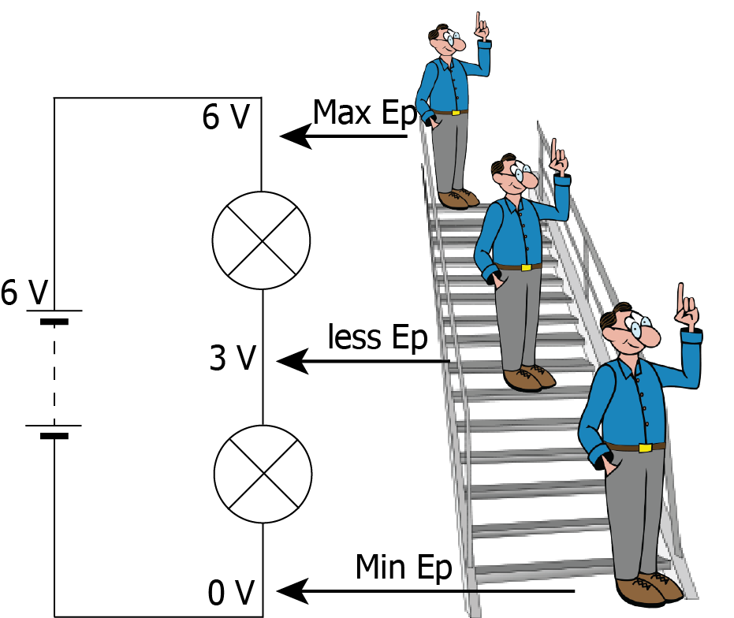
It is exactly the same in a circuit – at two different points the Electrical Potential Energy will be different. We give this difference a name – Potential Difference – and in many places you will see this being referred to as Voltage or p.d.
The Potential Difference (p.d.) in a circuit is the difference in electrical potential between two points.
The power supply of a circuit will have a potential difference. This is very important as it is a measure of the energy given to a charge carrier (such as an electron) in a circuit.
Potential difference is measured in volts (V). 1 volt is equal to 1 joule for every coulomb of charge which passes. 1 V = 1 JC⁻¹. For example, a 5 V supply will supply 5 joules of energy to every coulomb which passes through.
One side of the power supply will have a larger electrical potential than the other – this will be the positive side, and the other will be the negative side.
Charge carriers will follow the rules for electric fields, for example electrons will flow from the negative terminal to the positive terminal.
- Definition:
Potential difference is the amount of work done to move an electric charge from one point to another.
or
Voltage is the electromotive force or the electrical potential difference between two points in a circuit expressed in volts.

The Volt (reproduced here by kind permission of author Gill Arbuthnott)
This was named after Alessandro Volta It is a unit of measurement in electricity. It tells us how much energy an electric charge has. You sometimes hear people saying things like, “The number of volts running through the circuit is…”. This doesn’t actually make sense! It’s like saying, “The height running through the mountain is 1000 metres.” Heights don’t run, and neither do volts. There is no Usain Volt!

What is a volt?
So what is a volt? Imagine you are in a building with stairs and a lift. You carry a tennis ball up one floor in the lift, and let it roll back to ground level down the stairs. A battery is like the lift – it’s a way of giving energy to something. In the building this is the ball – in electrical terms it’s an electron.
The ball rolling down the stairs is losing energy. In our circuit the equivalent is the electrons losing their energy to power a bulb. The voltage is equivalent to the height you take the ball up in the lift – more height is equivalent to greater voltage. And the distance the ball goes up in the lift must be the same as the distance it comes down by the stairs.
http://www.bloomsbury.com/uk/a-beginners-guide-to-electricity-and-magnetism-9781472915740/
Voltage is a scalar quantity. The SI unit of voltage is the volt, such that
1 volt = 1 joule/coulomb.
The easiest way to understand voltage is to use a water analogy. Using a hose as an example, think of voltage as the amount of pressure forcing water through a garden hose. The higher the pressure in the pipe the more water is forced through the pipe each second. The greater the voltage, the greater the flow of electrical current (that is, the quantity of charge carriers that pass a fixed point per unit of time Q=It) through a conducting or semiconducting medium for a given resistance to the flow. Using our road model it is the number of mars bars added to each lorry passing around the circuit.
One volt will drive one coulomb (6.24 × 10¹⁸) charge carriers, electrons, through a resistance of one ohm in one second.
Voltage can be direct or alternating. A direct voltage maintains the same polarity at all times. So charges always flow in one direction. In an alternating voltage, the polarity reverses direction periodically. The number of complete cycles per second is the frequency, which is measured in hertz (one cycle per second). An example of direct voltage is the potential difference between the terminals of a cell. Alternating voltage exists between the mains positive and negative.

? Questions
- Define ‘potential difference’.
- In terms of energy, what is a volt?

Draw the electric field pattern for the following point charges and pair of charges: (a) (b) (c)

- Describe the motion of the small positive test charges in each of the following fields.
(a) (b)

(c) (d)

Success Critieria
  - 10.1 I know that a charged particle experiences a force in an electric field
  - 10.2 I can describe the effect of electric fields on a charged particle
  - 10.3 I know the path a charged particle takes between two oppositely charged parallel plate
  - 10.4 I know the path a charged particle takes near a single point charge
  - 10.5 I know the path a charged particle takes between two oppositely charged points
  - 10.6 I know the path a charged particle takes between two like charged points
  - 10.7 I can define the potential difference (voltage) of the supply as a measure of the energy given to the charge carriers in a circuit.

Section 12: Practical electrical and electronic circuits

Learning Intentions
- Measurement of current, potential difference (voltage) and resistance, using appropriate meters in simple and complex circuits.
- Knowledge of the circuit symbol, function and application of standard electrical and electronic components: cell, battery, lamp, switch, resistor, voltmeter, ammeter, LED, motor, microphone, loudspeaker, photovoltaic cell, fuse, diode, capacitor, thermistor, LDR, relay, transistor.
- For transistors, knowledge of the symbols for an npn transistor and an n-channel enhancement mode MOSFET. Explanation of their function as a switch in transistor switching circuits.
- Application of the rules for current and potential difference (voltage) in series and parallel circuits. $$I_{1} = I_{2}=I_{3}=I_{4}…$$
$$V_{S} = V_{1}+V_{2}+V_{3}…$$
$$I_{P} = I_{1}+I_{2}+I_{3}…$$
$$V_{P} = V_{1}=V_{2}=V_{3}…$$
- Knowledge of the effect on the total resistance of a circuit of adding further resistance in series or in parallel.
- Use of appropriate relationships to solve problems involving the total resistance of resistors in series and in parallel circuits, and in circuits with a combination of series and parallel resistors.
- $$R_{total} = R_{1}+R_{2} +R_{3}+…$$
$$\frac{1}{R_{total}} = \frac{1}{R_{1}}+\frac{1}{R_{2}} +\frac{1}{R_{3}}+…$$

Practical Circuits-Components
There are many different components used to make circuits, the ones which will feature in National 5 Physics are shown in the table below. You will be expected to know and draw these symbols accurately and to recognise and name them in circuit diagrams.
Component Name | Circuit Symbol | Function
Cell | 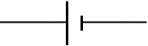 | Supplies electrical energy to a circuit, the longer line shows the positive side.
Battery | 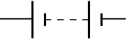 | A battery of cells means 2 or more cells.
DC Supply |  | Supplies electrical energy to a circuit in the form of a direct current.
AC Supply |  | Supplies electrical energy to a circuit in the form of an alternating current.
Lamp | 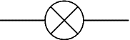 | A lamp lights when current flows through it, converting electrical energy to light energy.
Switch |  | A switch allows you to complete or break a circuit.
Resistor |  | A resistor restricts the flow of current, this may be to protect other components.
Variable Resistor | 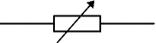 | A resistor, the resistance of which can be varied in the circuit, could be used for a dimmer switch.
LDR  (Light Dependent Resistor) | 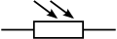 | Can be used to control a circuit. The resistance goes down as the light increases.
Thermistor | 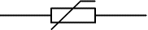 | The resistance of a thermistor will increase as the temperature increases.
Fuse |  | A fuse is a safety device – the metal core will melt when too much current is flowing in the circuit.
Voltmeter | 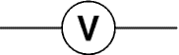 | Measures potential difference. Must be placed in parallel to measure the difference in electrical potential between two points.
Ammeter | 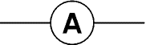 | Measures current. Must be placed in series to measure the current flowing in a circuit.
Ohmmeter | 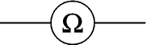 | Measures resistance. Must be placed in parallel with the component(s) which are to be measured.
Capacitor | 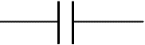 | Used to store electrical charge, can be used to create a simple timing circuit, or in the flash in a camera.
Diode | 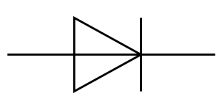 | Only allows current to flow in one direction.
Photovoltaic Cell |  | Converts light energy to electrical energy, can be used as the power source in a circuit. More light will mean a greater p.d. across the cell.
LED  (Light  Emitting Diode) | 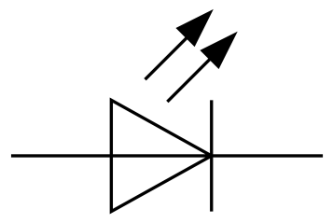 | Emits light when a current flows but only allows current to flow in one direction. Requires less energy than a lamp.
Motor | 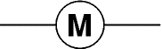 | Converts electrical energy into kinetic energy by turning.
Loudspeaker | 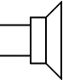 | Converts electrical energy into sound energy.
Relay | 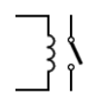 | An electronically operated switch. Used to protect operators from high currents, by using a low current supply to switch on a high current/voltage supply
Microphone |  | Converts sound energy into an electrical signal.
NPNTransistor |  | Acts as a switch when a voltage of 0.7 V is applied across the base and emitter
N-channel enhancement MOSFET |  | Acts as a switch when a voltage of approximately 2 V is applied across the gate and the source.

Additional Components and their Applications
Name of device | Input  Process  Output | Symbol | Energy change | Application
Loudspeaker | O |  | electrical→sound | In CD Player, tannoy, public address system, karaoke machine
Motor | O |  | electrical→kinetic | washing machine, car wiper motor, food processor, vacuum cleaner
Bell | O |  | electrical→sound | door bell, fire bell
Buzzer | O |  | electrical→sound | door warning
Relay | O |  | electrical→kinetic | switching on high voltage equipment e.g. control panels
Solenoid | O |  | electrical→kinetic | central locking, fire doors
LED | O |  | electrical→light | analogue- tuner indicator on radio  digital-on/off power indicators
Lamp | O |  | electrical→  heat & light | analogue-atmospheric lighting,  digital-table lamp
Microphone | I |  | sound→electrical | tannoy, public address system, karaoke machine
Thermocouple | I |  | heat→electrical | kiln thermometer
Solar Cell | I |  | light→electrical | power supply for a calculator, solar powered torch
Thermistor | I |  | heat→electrical | thermometer for an aquarium
Light Dependent Resistor | I |  | light→electrical | burglar alarms, automatic drive lights
Capacitor (& resistor) | I |  |  | time delay circuit in a pedestrian crossing patrols
Potentiometer | I |  |  | volume control in a stereo, boost control in a vacuum cleaner
Switch | I |  |  | on a table lamp
Transistor | P |  | no energy change | SWITCH  >0.7V
MOSFET | P |  | no energy change | SWITCH  2 V

LDR is short for Light Dependent Resistor- remember it as Light Drops Resistance. Some teachers use the term LURD- Light Up Resistance Down, and for a Thermistor (a temperature dependent resistor) TURD- Temperature Up Resistance Down.
The full name for the transistor used in this course is npn transistor and the full name for the MOSFET is the n-channel enhancement MOSFET.

?Questions
- Draw the circuit symbols for both transistors.
- State the full name of each of the transistors
- What is the function of a transistor?
- State the switch on voltage of each transistor, making it clear which is which.
- State two devices that can be used to convert electrical energy into sound
- State a device that can be used to monitor a baby’s temperature in an incubator.
- State the function of the following devices
  - Microphone b) relay c) lamp d) capacitor
- State the list of meters and explain what each measures.
- Make a table including the following devices and state whether they are input or output devices
lamp | diode | thermistor | LED | motor | microphone | loudspeaker | resistor
switch | fuse | capacitor | LDR | relay | transistor. | photovoltaic cell
- State the difference between a battery and a cell.

Ammeters and Voltmeters

Setting up an Ammeter and Voltmeter
Ammeters are connected in series, connect the negative side to the com and the positive side to the 10A and not the mA contact as this is likely to melt the internal fuse. Turn the dial to A d.c. setting. Voltmeters are connected in parallel, connect the negative side to the com and the positive side to the V/Ω. Turn the dial to V d.c
com
10A
V/Ω
A
com
10A
V/Ω
V

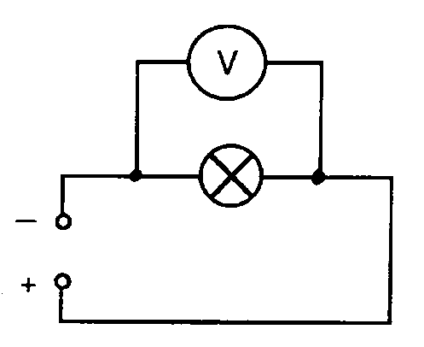
Task
Copy these circuit diagrams.
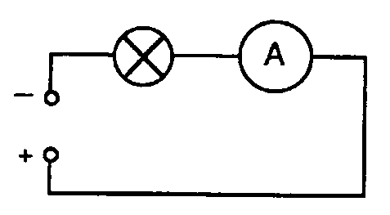
An ammeter is used in-line (in series) with the components. You need to break into the circuit to put in the ammeter.
A voltmeter is always used across (in parallel with) the component. You do not need to disturb the circuit.

- Redraw each of the following diagrams to show how to measure:
  - the voltage across component E
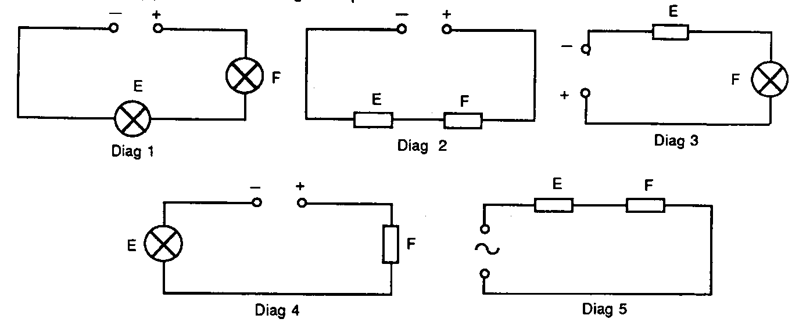
  - the current through component F.
? Question
- Which type of meter would you need in diagram 5?

Measuring Current, Voltage and Resistance
They can be used in simple, or more complex circuits in order to investigate the size of any of these quantities.
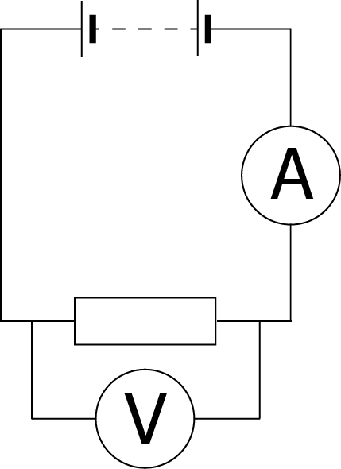  The two main rules are:  - To find the potential difference across a component, or components, the voltmeter must be placed in parallel with that component or those components.  - To find the current through a component or components, the ammeter must be placed in series with that component or those components. | This circuit shows a battery and a resistor. The diagram also shows how the voltmeter and ammeter must be connected.  The voltmeter must be connected in parallel because it is measuring the difference in electrical potential between two points.  The ammeter must be connected in series because it is measuring the flow of current THROUGH a component or circuit.
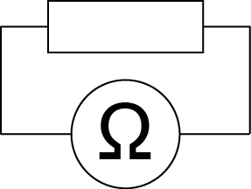 | The previous diagram does not show an ohmmeter because, in most cases, resistance should only be measured when a circuit is not ‘on’ or fully connected.  To use an ohmmeter, you would place it ‘across’ a component – in parallel, just like a voltmeter.

Series Circuits
A circuit is described as a series circuit if the components appear one after the other in the circuit. If one component breaks no charge will flow in the circuit. An example is shown below.
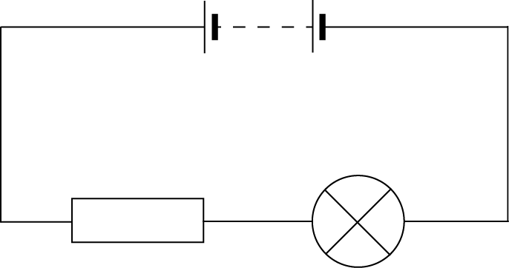
To investigate the current in the circuit, we must place multiple ammeters in the circuit.
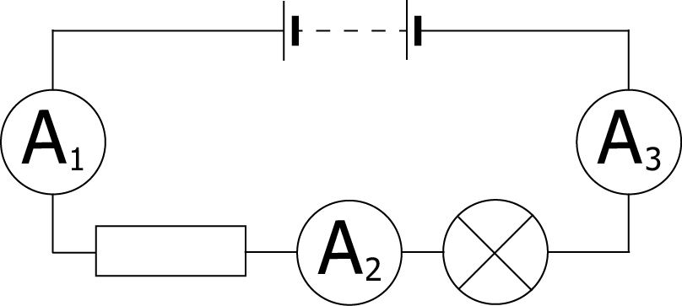
If we place an ammeter at each of these positions, we discover that the readings will be identical. In equation form, we can write this as
$$I_{1} = I_{2}=I_{3}=I_{4}…$$
The current in a series circuit is the same at all points.
We can also investigate potential difference in a series circuit.
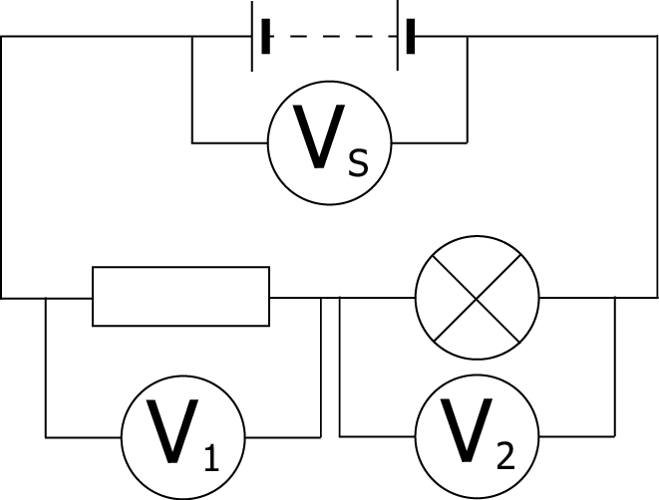
A potential difference is the difference in electrical potential between two points, so in a series circuit, the potential difference across each of the components must add up to the total potential difference across the supply.
If we call the supply p.d. V_{s} we write this as
$$V_{S} = V_{1}+V_{2}+V_{3}…$$
The p.d. across each of the components in a series circuit adds up to the supply p.d.

Parallel Circuits
A circuit is described as a parallel circuit if the components are laid out next to each other, with common connections. An example is shown below.
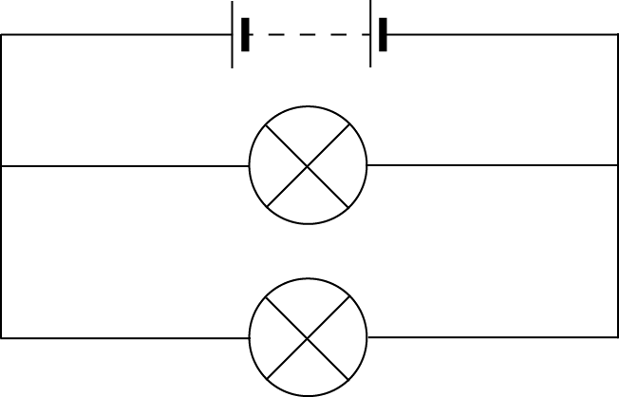
To investigate the current in the circuit, we must place multiple ammeters in the circuit.
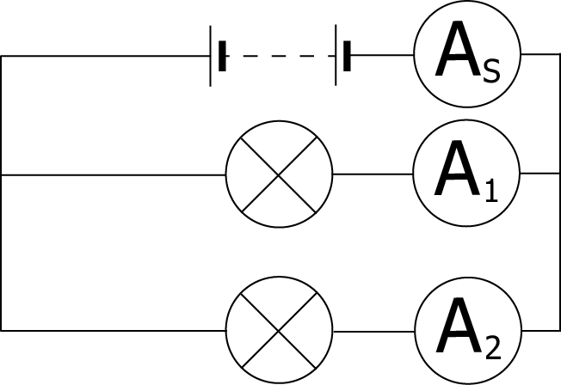
If we place an ammeter at each of these positions, we discover that the current splits between the branches, and the current in each branch adds up to the current at the supply.
In equation form, we can write this as
$$I_{S} = I_{1}+I_{2}+I_{3}…$$
The total current in a parallel circuit is equal to the sum of the currents in the branches.
We can also investigate potential difference in the parallel circuit.
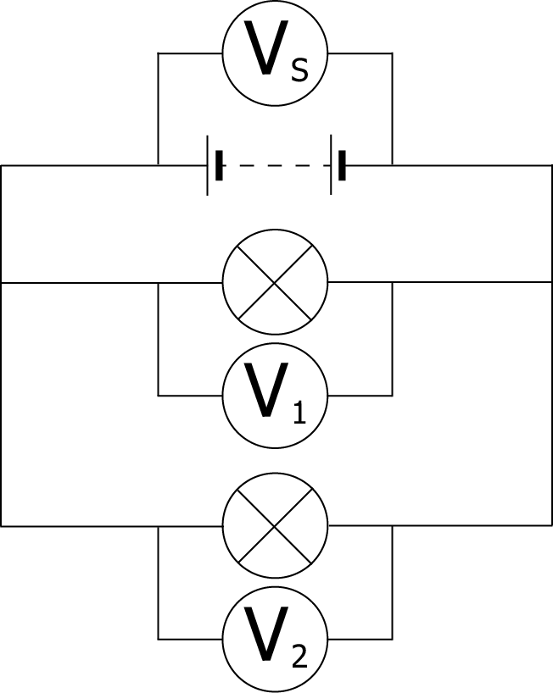
In a parallel circuit, the branches split off from the same point, so the potential at that point will be exactly the same. As a result, the potential difference across each component is the same as the supply.
We write this as
$$V_{S} = V_{1}=V_{2}=V_{3}…$$
The p.d. across each of the components in a parallel circuit is equal to the supply p.d.
If you can think of an untidy U as a V then here is a way to remember the rules for series and parallel (McNay (1999)). You really only need to remember one because you should know that I and V are opposite and series and parallel are opposite! Discuss with your teacher for clarification.
Memory Aid
IPA | I in parallel Adds
ISS | I in Series Same
USA | V in Series Adds
UPS | V in Parallel Same

? Questions on Current and p.d. in Series and Parallel Circuits
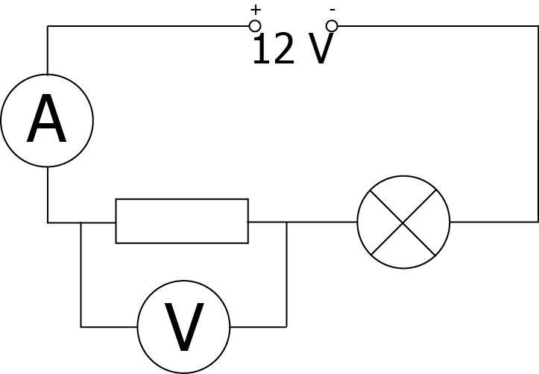
- In the circuit below the ammeter reading is 0.5 A and the voltmeter reading is 4 V.
a. State whether this is a series circuit or a parallel circuit.
b. What is the current through the lamp?
c. What is the potential difference across the lamp?
- Copy out the true statements from the list below that apply to:
  - series circuits.
  - parallel circuits.
A There is only one pathway round the circuit.
B There is more than one pathway around the circuit.
C The potential differences around the circuit add up to the supply voltage.
D The potential difference (voltage) is the same across all components.
E The current is the same at all points in the circuit.
F The current through each component adds up to the supply current.

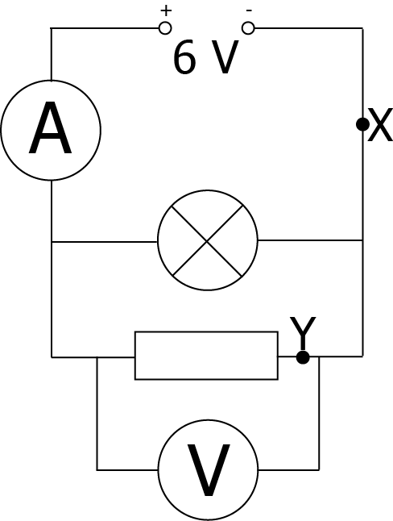
In the circuit below the ammeter reads 0.8 A, the current through the lamp is 0.3 A and the voltmeter reads 6 V.
- Is this a series or a parallel circuit?
- What are the current values at X and at Y?
- What is the potential difference across the lamp?

- Find the missing currents and voltages in the following circuits.

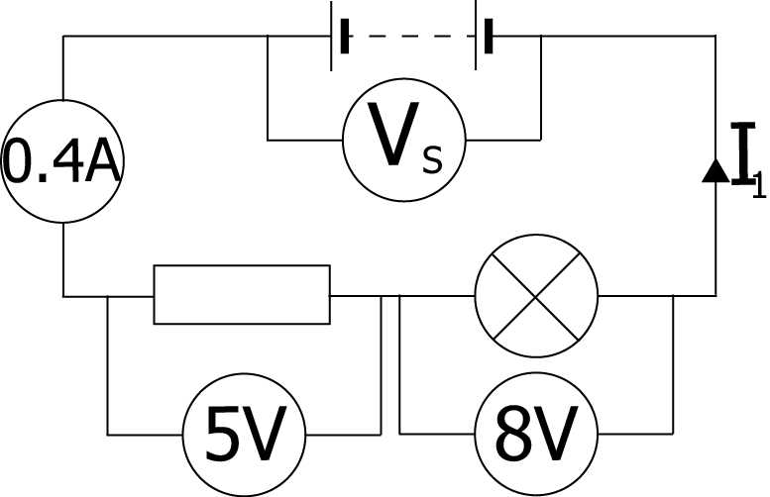 | 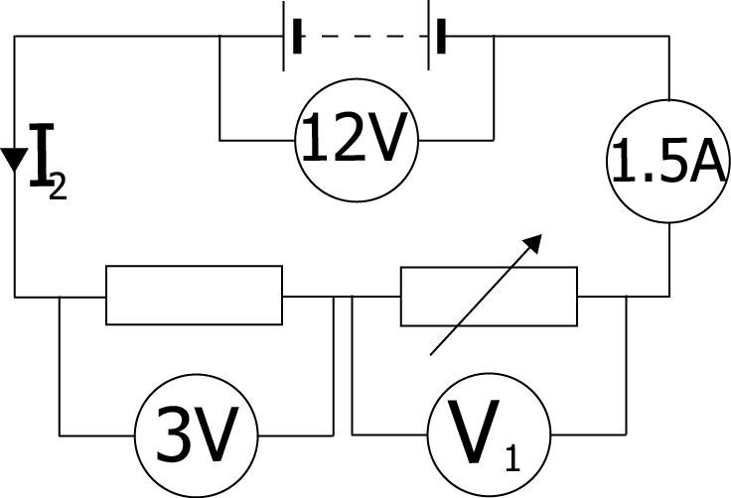
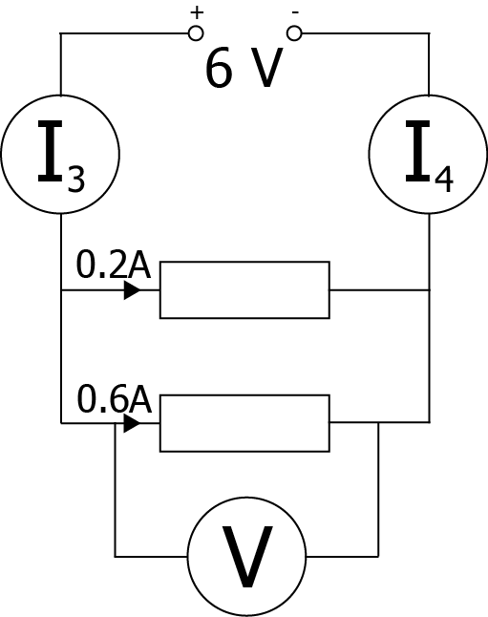 | 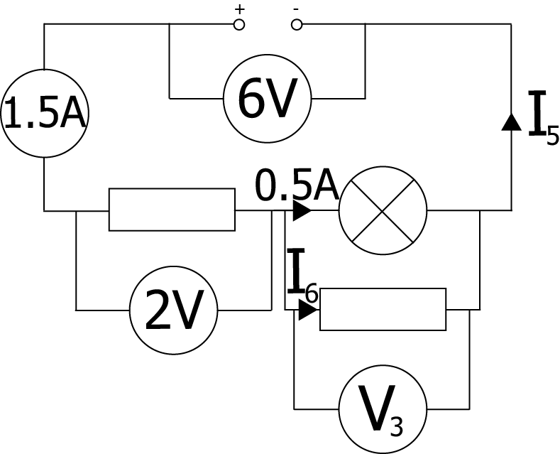
- Give one example from your home where two switches are in series to switch on an appliance.
- Why can connecting too many appliances to one socket be dangerous?

  - Draw a circuit diagram for a circuit that has three lamps in series attached to a supply,with one switch that controls all three lamps
  - If the three lamps are rated as "6 V, 0.06 A", calculate the supply voltage needed to allow them to operate properly.
  - What size of current will be drawn from the battery? Explain why it is this value.

  - Draw a circuit diagram for a circuit that has two lamps in parallel attached to a supply, with one switch that controls all three lamps.
  - If the two lamps are rated "6 V, 0.06 A", calculate the current drawn from the supply.
  - What voltage must the supply be to allow them to operate properly? Explain why it is this value

Resistance
Resistance is a measure of how much opposition there is to the current in a circuit. The more resistance there is, the harder it is for charge to flow. All components in circuits, such as lamps, loudspeakers and motors have a resistance – even the connecting wires. The energy transformation in a resistor is from electrical to heat.
Resistance is measured in OHMS (Ω)
Resistance opposes the flow of electrons or charge.

In order to draw a circuit, it is convenient to use symbols which identify different components.
The symbol for a resistor is
Normally, a resistor symbol will have a label, or a value next to it
200 Ω
In most circuits, there will be more than one component, and that means there can be more than one resistor. We need to know how these can be added up.
There are two ways components can be put together, in series (where they are put one after the other in a circuit) and in parallel (where they are placed side by side).

Changing the Current

Read
In this experiment you will find out what happens when you put components called resistors into an electric circuit. The resistance is measured in ohms (Ω). The symbol used to show a resistor in a circuit diagram is 

What you need
Resistors, low voltage d.c. power supply, lamp, connecting leads, ammeter (10 A).
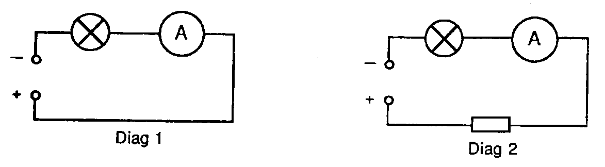

What to do
- Copy and complete this table:
Resistor | Resistance (Ω) | Current (A)
A
B
C
D

- Set the correct voltage on the power supply (12 V)
- Set up the circuit shown in diagram 1 and switch on.
- Read the current and make a note of it.
- Switch off and insert a resistor as shown in diagram 2.
- Read the current and make a note of it.
- Repeat the experiment using the other resistors and complete the table.
- Repeat this experiment but place resistors in parallel and note what happens to the current in the circuit.

Questions
- State what happens to the current when a resistor is placed in the circuit?
- State what happens to the current when the value of the resistor gets bigger?
- The value of a resistor is given as 4.2 kΩ. This means a resistance of 4200 Ω.
What do the following mean?
  - 6.8 kilohms b) 470 kilohms
- In a certain circuit the current is 4 milliamperes (4 mA). This means 4/1000 of an ampere. State which of the following could be the measured current if the resistance is increased? a) 2 mA, b) 4 mA, c) 6 mA, d) 8 mA

Resistors in series
R₁
R₂
R₃
The resistors here are shown in series.
If you imagine that each resistor is a door and lots of people want to get from the left to the right, each door is going to slow them down. In other words, the delay at each resistor will add up.
To find the total resistance in series we add up all the individual resistances$$R_{total}= R_{1}+R_{2}+R_{3}+…$$
For example what is the total of a 5Ω , 7Ω and 15Ω resistor in series?
R₁=5Ω | R_{T} =R₁+R₂+R₃
R₂ =7Ω | R_{T} =5+7+15
R₃=15Ω | R_{T}=27Ω
Symbol | Name | Unit | Unit Symbol
R_{total} | Total Resistance | Ohms | Ω
R₁ | Resistance 1 | Ohms | Ω
R₂ | Resistance 2 | Ohms | Ω
R₃etc | Other resistors | Ohms | Ω
In this equation we put … at the end as there can be any number of resistances.

Worked examples

- Calculate the resistance of the following circuit
60 Ω
35 Ω
22 Ω

R_{total}  R₁  R₂  R₃ | = ?  = 60 Ω  = 35 Ω  = 22 Ω | R_{total}  R_{total}  R_{total} | = R₁ + R₂ + R₃  = 60 + 35 + 22  = 117 Ω
- The total resistance of this circuit is 25 kΩ. Calculate the value of Resistor 2
12 kΩ
500 Ω
R₂

R_{total}  R₁  R₂  R₃ | = 25 kΩ  = 12 kΩ  = ?  = 500 Ω | R_{total}  25000  R₂  R₂  R₂ | = R₁ + R₂ + R₃  = 12000 + R₂ + 500  = 25000 – 12500  = 12500  = 12.5 kΩ

Measuring Resistances in Parallel
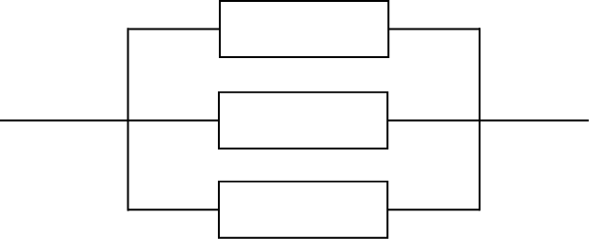
R₁
R₂
R₃
The resistors here are shown in parallel.
Again, if you imagine that each resistor is a door and lots of people want to get from a room, this time the doors allow different paths for people to get through. In other words, the individual resistors will delay people, but the overall resistance is reduced compared to only having one door.
The total resistance of resistors in parallel will be smaller than any individual resistor.

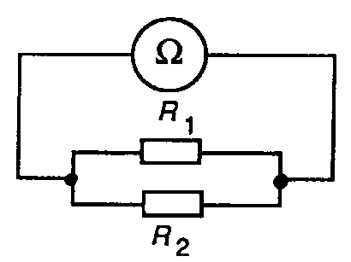
What you need
Ohmmeter, 2 resistors, connecting leads.

What to do
- Use the ohmmeter to measure the resistance of each resistor. Make a note of your results.
- Connect the two resistors in parallel as shown below and connect up the ohmmeter.
- Measure the resistance of the two resistors in parallel, R_{T}, and make a note of your result.

Questions
- Is R_{T} greater than, less than or equal to R₁?
- Is R_{T} greater than, less than or equal to R₂?
- What can you say about the resistance of resistors in parallel compared with the resistance of a single resistor?

More to do
- Find the value of 1/R₁.
- Find the value of 1/R₂.
- Find the value of 1/R₁ added to 1/R₂.
- Find the value of 1/R_{T}.
- What do you notice about the answers to the last 2 questions?
- Write down the equation which shows the relationship between R_{T}, R₁ and R₂.

Adding resistors in parallel reduces the total resistance of the circuit (It is worth noting that the total resistance will be lower than the smallest resistor, use this for estimations!)
The formula looks quite complicated and causes problems but with modern calculators it becomes an easy sum to work out.
$$\frac{1}{R_{total}}= \frac{1}{R_{1}}+\frac{1}{R_{2}}+\frac{1}{R_{3}}+…$$

For example what is the total of a 5Ω , 7Ω and 15Ω resistor in parallel?

R₁=5Ω
R₂ =7Ω
R₃=15Ω

On the calculator

How can your calculator to do this easily?

Let’s try adding a 7 ohm resistor in parallel with a 28 ohm resistor.

1 | Turn on the calculator!
2 | Make sure your calculator is in MATHS IO mode. To do this go SHIFT -> MODE->1.
 | 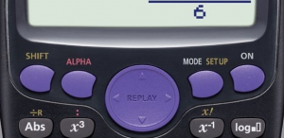
3 | Press the fraction button, two rectangles one on top of the other with a line between. (see image below)
 | 
4 | Now type in the first value which will be 1/7 (7 is the resistance but the equation tells us to find 1/Rt we need to put in the value of 1/R1)
5 | The up and down arrows allow you to move between the top and bottom parts of the fraction.
 | 
6 | Now we need to add the 1/28 to this value. Use the right arrow to make sure that you are out of the fraction.
7 | Press the + symbol.
8 | Then press the fraction button again and add in the 1/28, using the up and down arrows as before.
9 | Now when you press equals you ought to get the answer for 1/Rt, in this case 5/28.
10 | Remember this is not the answer. This is the value for 1/Rt. We need to find 1/ans to find the value Rt. Luckily we have a button for that too.
11 | Press the X-¹ button (see below)
 | 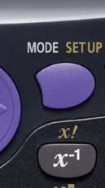
12 | When you press the equals this gives the answer 28/5. This is indeed the right answer but the SQA does not like you leaving things as a fraction. So press the S<->D button to reveal the answer 5.6 ohms
13  Adding Resistance in series, increases the overall resistance & reduces current in the circuit.  Adding resistance in parallel decreases the overall resistance & increases the current in the circuit | So adding a 7 ohm and a 28 ohm resistor in parallel gives a total resistance of 5.6 ohms

More Worked examples

- Calculate the resistance of the circuit shown below
R_{total} = ?  R₁ = 100 Ω  R₂ = 200 Ω  R₃ = 400 Ω | 1/R_{total}  1/R_{total}  1/R_{total}  1/R_{total}  R_{total}  R_{total} | = 1/R₁ + 1/R₂ + 1/R₃  = 1/100 + 1/200 + 1/400  = 4/400 + 2/400 + 1/400  = 7/400  = 400/7  = 57 Ω
100 Ω
400 Ω
200 Ω

- The total resistance of this circuit is 100Ω. Calculate the value of Resistor 1
R₁
R_{total} = 100 Ω  R₁ = ?  R₂ = 200 Ω | 1/R_{total}  1/100  1/R₁  1/R₁  1/R₁  R₁ | = 1/R₁ + 1/R₂  = 1/R₁ + 1/200  = 1/100 - 1/200  = 2/200 - 1/200  = 1/200  = 200 Ω
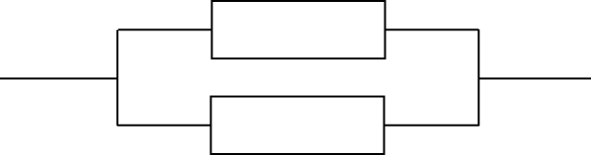
200 Ω

Resistors in Series and Parallel – Tutorial

What to do
Answer the following questions:
- A resistor of 3 Ω is in series with a resistor of 4 Ω. What is the total resistance?
- The resistance of a Christmas tree lamp is 20 Ω. What is the resistance of 24 of them in series?
- The total resistance across AB is found to be 25 Ω. What is the resistance of R₂?
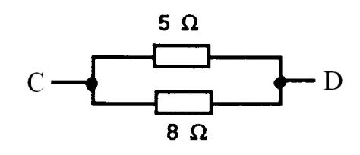
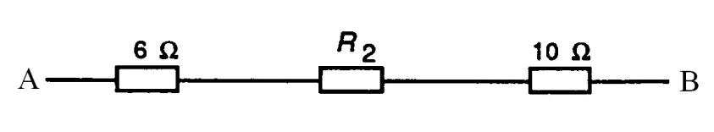
- Without using the equation, what can you say about the resistance across CD
- A lamp has a resistance of 500 Ω. What will be the resistance of:
  - Two lamps in parallel?
  - Ten lamps in parallel?

- Resistance of an electric heater = 75 Ω. Resistance of a hairdryer = 100 Ω.
  - What will be the total resistance of these appliances when connected in parallel?
  - If these appliances, in parallel, are connected up to the 240 V mains supply, what will be the total current?
- Calculate the total resistance for a 650 Ω, a 350 Ω, and a 1000 Ω resistor connected in series.
- Calculate the total resistance for ten 120 Ω resistors in series.
- A string of fifty 15 Ω Christmas tree lights are connected in series.
  - Calculate the total resistance.
  - What would be the total resistance if one of the bulbs melts?
- Calculate the total resistance for two 180 Ω resistors connected in parallel.
- A 10 Ω, 20 Ω, and 100 Ω resistors are connected in parallel. Calculate the total resistance.
- A string of fifty 15 Ω Christmas tree light are connected in parallel.
  - Calculate the total resistance. of the tree lights
  - One burns out, the rest will stay lit. Calculate the new total resistance.
- Two 33 Ω resistors are connected in parallel followed by two more 33 Ω resistors connected in parallel. What value of a single resistor would be used to replace these four resistors?
33 Ω
33 Ω
33 Ω
33 Ω

Resistance of a 12 V Lamp

What to do
You have to design and carry out an experiment to find out what happens to the resistance of a 12 V lamp when the brightness of the lamp changes.
You should use a voltmeter to measure the voltage, V, across the lamp and an ammeter to measure the current, I, through it.
The resistance can be calculated using the equation V = IR.
Discuss your plan with your teacher before starting your experiment.
DO NOT go above the maximum voltage for the lamp.

Questions
- What did you discover about the resistance of the lamp?
- Why do you think this happens?

Help Sheet: Resistance of a 12 V Lamp
This is the circuit you might use to measure the resistance of the 12 V lamp.
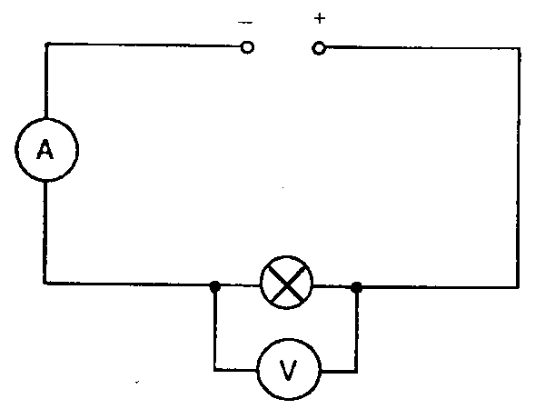
The brightness of the lamp can be changed by adjusting the supply voltage (remember not to exceed the maximum voltage of the lamp).
Measure V and I when the lamp is just lit and then take further readings of V and I as you make the lamp brighter.
Copy and complete the following table:
V (V) | I (A) | R = VI (Ω)
From the table it should be obvious what happens to the resistance of the lamp as its brightness increases.
To help you explain this you should remember that, as a lamp gets brighter, its temperature increases.

More to do
- Collect an ohmmeter.
- A thermistor is a component which can be used to measure temperature.
- Measure the resistance of a thermistor when it is cold and when it is warm.
- An LDR (light dependent resistor) can be used to measure light intensity.
- Measure the resistance of an LDR, first when it is in a dark place and then when it is in a well-lit place.
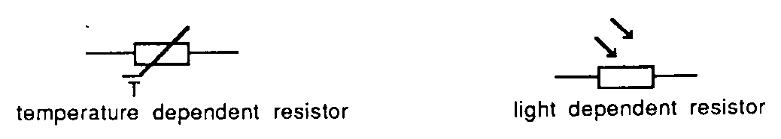

Resistance and Temperature
When charge flows through components they often become warmer – this means that some energy is being changed from electrical energy into heat energy. While this is wanted in a toaster, it is not useful in most circuits.
In general, the resistance of a conductor will increase when it gets warmer. Resistors are considered to be ‘ohmic’ components and it is assumed that in normal conditions their resistance is constant. Lamps do not behave in this way though, as can be seen if the experiment to prove the relationship between current and voltage is repeated with a lamp instead of a resistor. As the lamp gets warmer, the resistance will increase.
Increasing the temperature of a conductor increases the resistance of the conductor. Increasing the temperature does not affect the resistance of a resistor.

Variable Resistors

What you need
Low voltage d.c. power supply, variable resistors, 2 lamps, small electric motor.

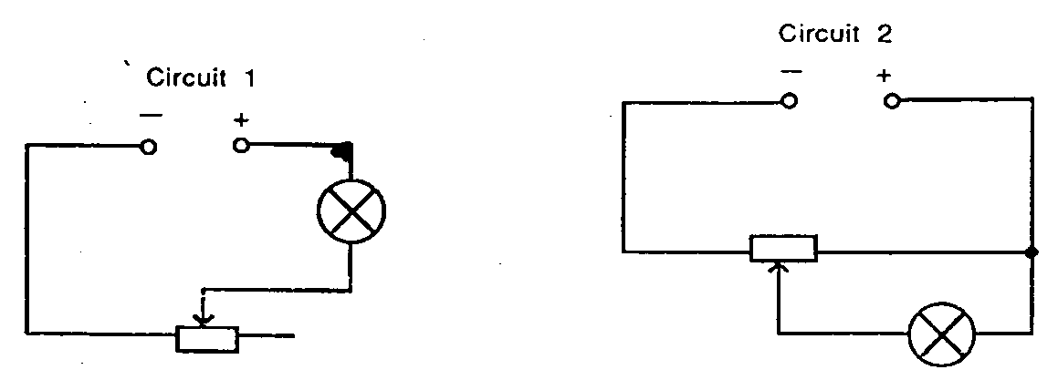

The variable resistor controls the size of the voltage that is applied across the component (lamp).
Used like this it is called a potentiometer.
The variable resistor controls the size of the current in the component (lamp).
Used like this it is called a rheostat.

What to do
- Set the power supply to the correct voltage (6 V).
- Set up circuit 1 using the middle terminal and one of the end terminals of the variable resistor.
- Switch on and adjust the brightness of the lamp using the rheostat.
- Switch off.
- Replace the lamp by a small electric motor.
- Switch on. Vary the speed of the motor using the rheostat. Switch off.
- Set up circuit 2.
- Use all three of the variable resistor terminals.
- Switch on. Adjust the potentiometer to vary the brightness of the lamp.
- Switch off.

? Questions
- Rheostats are used in Scalectrix controls. To make the motor go faster would you need to increase or decrease the resistance of the rheostat?
- Potentiometers are used in many electronic appliances to vary the voltage in the circuit. In which direction should the moving contact be moved in circuit 2 to make the lamp brighter: towards A or towards B?
- Give one use for a potentiometer.
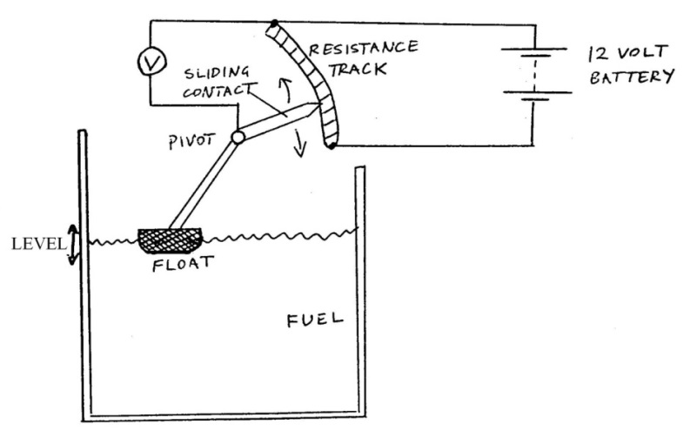
- What is the missing word below?
All types of variable resistor work by changing the resistance of the circuit. Many of them do this by varying the ___________ of the conductor used.
- The diagram below shows a fluid-level gauge for a fuel tank. Use your knowledge of variable resistors to explain how it works.

Circuit Rules
Measurement | Series Circuits | Parallel Circuits
Potential Difference | $$V_{S} = V_{1}+V_{2}+V_{3}…$$ | $$V_{S} = V_{1}=V_{2}=V_{3}…$$
Current | $$I_{1} = I_{2}=I_{3}=I_{4}…$$ | $$I_{S} = I_{1}+I_{2}+I_{3}…$$
Resistance | $$R_{total}= R_{1}+R_{2}+R_{3}+…$$ | $$\frac{1}{R_{total}}= \frac{1}{R_{1}}+\frac{1}{R_{2}}+\frac{1}{R_{3}}+…$$

Practical Circuits

What you need
Model circuits A, B, C.

What to do
Examine each of the circuits A, B, C (in any order) and investigate the operation of each circuit.

Questions
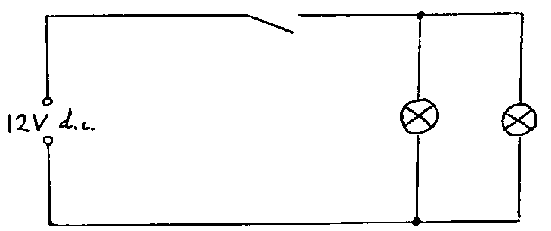
- Room lights (circuit A).
How are the lamps connected: series or parallel?

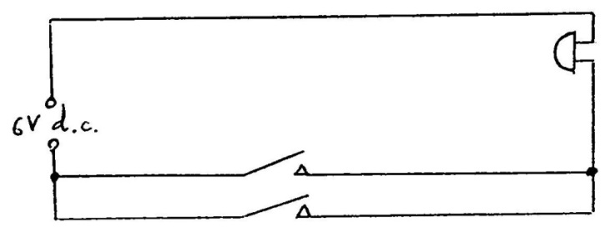
- Doorbell (circuit B).
How are the switches connected: series or parallel?

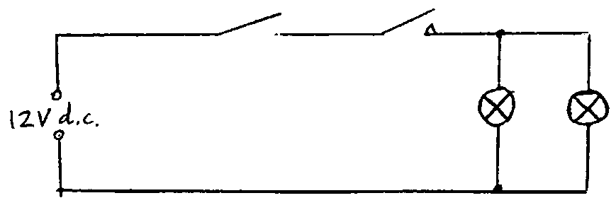
- Car stoplights (circuit C).
How are the switches connected?
How are the lamps connected?

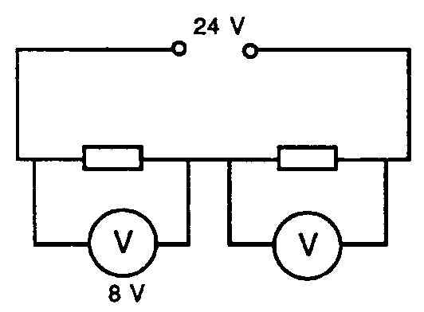
Circuits – Tutorial

What to do
Answer the following questions:
- In the circuit below the voltages are as shown.
Calculate the voltage of the supply.
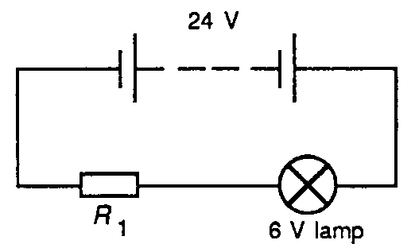

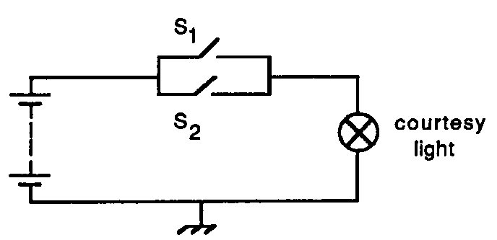
- This diagram shows a 6 V lamp working off a 24 V supply.
What must the voltage across the resistor be if the lamp is working at its correct voltage?
- The diagram shows the circuit of the courtesy light in a two-door car.
  - What happens to a switch when a door is opened?
  - Explain why the switches are in parallel rather than in series.
- This diagram is a simplified version of part of the wiring of a car.
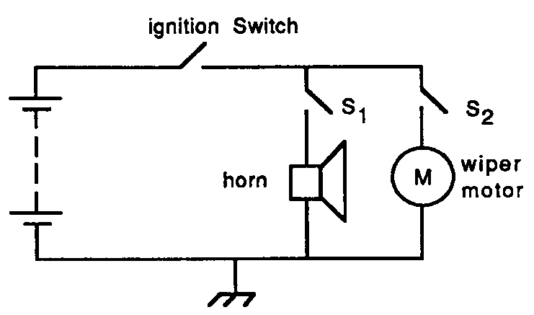
  - Which switch or switches must be closed for the wipers to come on?
  - Which switch or switches must be closed for the horn to operate?
  - When only the wipers are switched on the voltage across the wiper motor is 12 V. The horn is then switched on. What will happen to the voltage across the wiper motor?
  - Suggest what the voltage across the horn might be.
  - It takes 1 A to operate the wipers and 2 A to operate the horn. If both are switched on what current will be drawn from the battery?
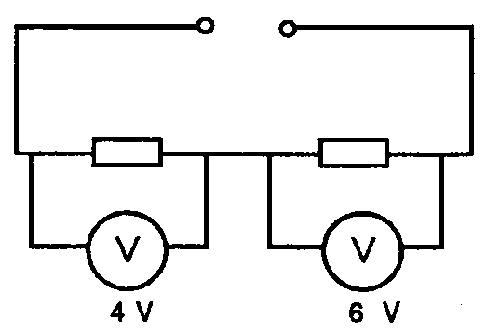
- What is the voltage across the second resistor?

More Revision Questions
- Find the total resistance of the following resistors in parallel. For each one draw the circuit and summarise the question before starting.
- 6 Ω + 4 Ω
- 12Ω + 8 Ω
- 500 Ω + 200 Ω
- 10kΩ + 100kΩ
- 5 x 15 Ω
- 25 Ω + 100 Ω + 75 Ω
- What is the total resistance in each of these series circuits?
a. | 300 Ω  200 Ω  50 Ω
b. | 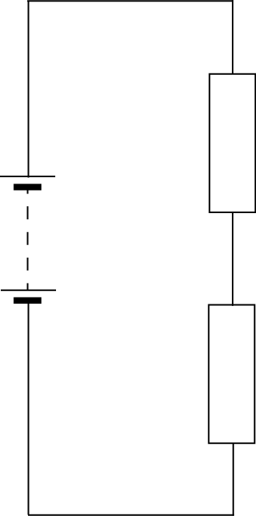  1.5 kΩ  300 Ω | c. | 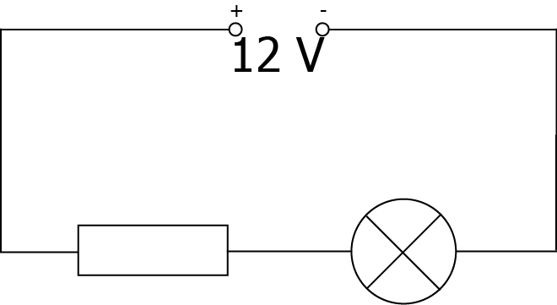  12.6 Ω  4.2 Ω
- What is the total resistance in each of these parallel circuits?
a. | 20 kΩ  14 kΩ | b. | 600 Ω  900 Ω  300 Ω
c. | 4 Ω  4 Ω
- What is the total resistance in each of these circuits?
a. | 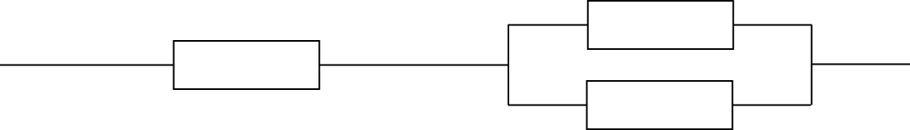  200 Ω  200 Ω  900 Ω
b. | 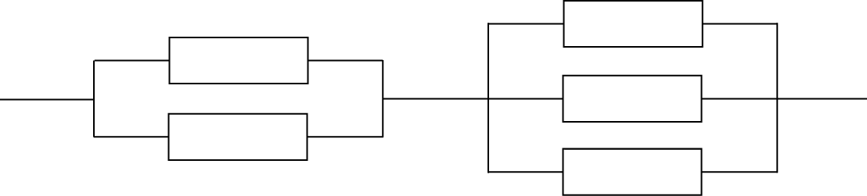  1.5 kΩ  900 Ω  1.2 kΩ  1 kΩ  500 Ω
c. | 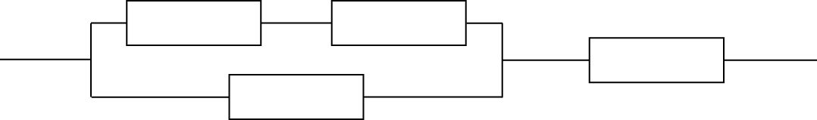  1 MΩ  750 kΩ  2 MΩ  500 kΩ
X
48 Ω
48 Ω
24 Ω
12 Ω
18 Ω
18 Ω
18 Ω
28 Ω
20 Ω
14 Ω
6 Ω
6 Ω
6 Ω
3 Ω
3 Ω
3 Ω
3 Ω
3 Ω
3 Ω
2 Ω
4 Ω
4 Ω
4 Ω
4 Ω
5 Ω
2 Ω
8 Ω
Find the total resistance of this network
Y

Success Criteria
 | 12.1 | I can make measurements of I, V and R using appropriate meters in simple and complex circuits.
 | 12.5 | I can apply the current and voltage relationships in a series circuit. I_{s}=I₁=I₂=… V_{s}=V₁+V₂=…
 | 12.6 | I can apply the current and voltage relationships in a parallel circuit. I_{s}=I₁+I₂=… V_{s}=V₁=V₂=…
 | 12.7 | I can describe and explain practical applications of series and parallel circuits.
 | 12.8 | I can use the relationship Rs=R₁+R₂+R₃ to solve problems involving total resistance of resistors in a series circuit
 | 12.9 | I can perform calculations involving current and voltage relationships in a parallel circuit.
 | 12.10 | I can make use the relationship $$\frac{1}{R_{total}} = \frac{1}{R_{1}}+\frac{1}{R_{2}} +\frac{1}{R_{3}}+…$$  to calculate the resistance of resistors in parallel circuits
 | 12.11 | I can use the appropriate relationships to calculate the resistance of resistors in with circuits with combinations of resistors in series and parallel
 | 12.12 | I know what happens in a circuit when I increase the resistance in both series and parallel circuits.

Section 11: Ohm’s Law

Learning Intentions
- Calculation of the gradient of the line of best fit on a V-I graph to determine resistance.
- Use of appropriate relationships to solve problems involving potential difference (voltage), current and resistance.
- Knowledge of the qualitative relationship between the temperature and resistance of a conductor. $$V=IR$$

- Description of an experiment to verify Ohm’s law.

Practicals: Voltage, Current and Resistance

What you need
Five resistors (A, B, C, D & E), ohmmeter, low voltage d.c. supply, ammeter (10 A), voltmeter (20 V).

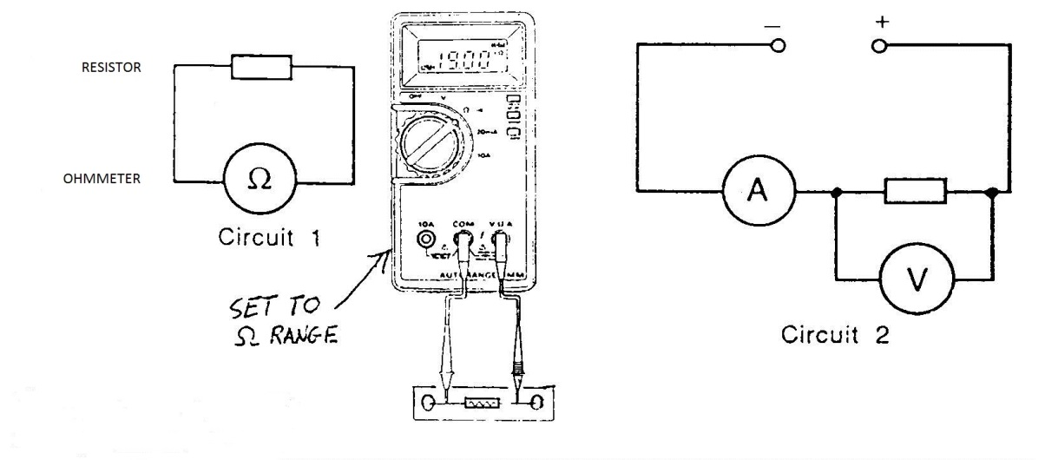
What to do
- Copy this table:
Resistor | R (Ω) | V (V) | I (A) | V/I
A
B
C
D
E

- Use circuit 1 to measure the resistances of resistors A, B, C, D and E. Enter your results in column 2.
- Now set up circuit 2 using resistor A. Set the power supply to the correct voltage (8 V).
- Switch on. Measure the voltage and the current and enter your results in columns 3 and 4.
- Repeat for each of the other resistors.
- Compare the resistance, R, with V/I

Read
It is possible to measure the resistance of a resistor by measuring the current in the resistor and the voltage across the resistor.
This relationship, R = V/I is very important and is often used in electrical work.
V (V) | I (A) | V/I (Ω)

More to do
- Select one of the resistors and change the supply voltage so that a further 5 voltages and currents can be measured.
- Copy and complete the following table:
Questions
- What do you notice about V/I for the different values of current?
- What conclusion can you make about the resistance of a resistor when the current in it changes?

Voltage Current and Resistance Experiment
- Collect 2 multimeters per group and a range of Resistors (1 x 3.3 ohm, 1 x 5.6 ohm, 1 x 15 ohm 1 x 22 ohm + one other)
- Collect 9 leads per group.
- Use an OHMETER to measure the resistance of each resistor. Record each resistance in a separate table like the one below. You will need 5 tables in total one for each resistor.
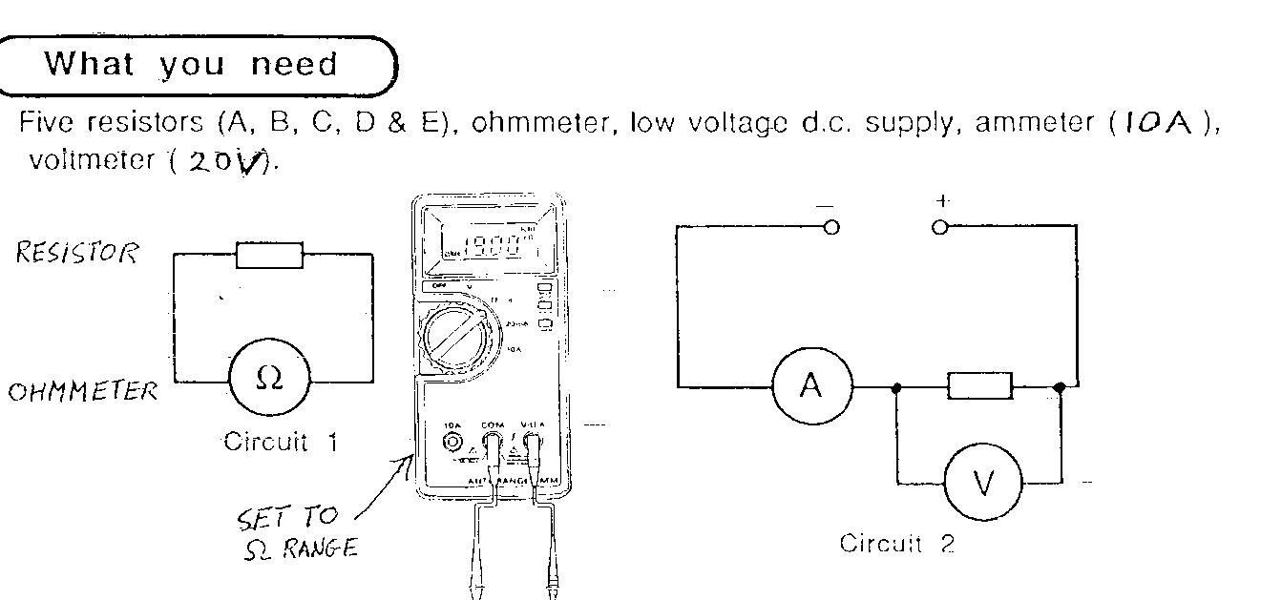

EXAMPLE ONLY USE YOUR OWN VALUES
QUOTED RESISTANCE (ohm) | 3.3 | MEASURED RESISTANCE (ohm) | 3.2
Number of Cells | Voltage (V) | Current (A) | V/I
1
2
3
4

- Collect 4 cells per group and set up one cell, an ammeter and a voltmeter across ONE of the resistors. Measure V and I for one cell and record in the table.
- Add a further cell and record V and I.
- Repeat until 4 cells used (make sure they are connected correctly).
- Repeat for all 5 resistors.
- Plot a graph of V against I for ONE resistor only.

Ohm’s Law
In circuits, the components’ resistance, the current and the potential difference are all linked. To investigate this the following circuit is set up

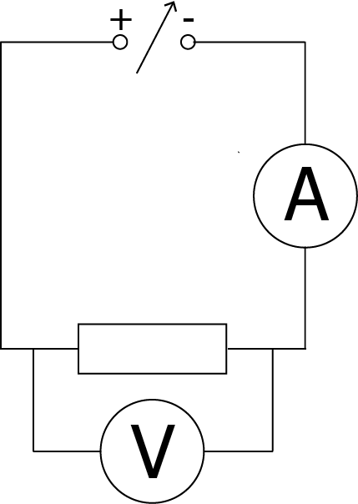
The DC power supply is varied and readings are taken as follows.
p.d./V | Ave. Current/A
0.0 | 0.00
1.0 | 0.02
2.0 | 0.04
3.0 | 0.06
4.0 | 0.08
5.0 | 0.10
6.0  50Ω | 0.12
7.0 | 0.14
8.0 | 0.16
9.0 | 0.18
10.0 | 0.20

Plotting p.d. against current for these (idealised) results gives

The gradient of the line of best fit is constant showing the direction proportionality between V and I. The gradient of the line in the graph is 50, which matches the resistance of the resistor in the circuit. This means that V/I = R.
We can state, then, that the p.d. is equal to the current times the resistance.
$$V = IR$$
Symbol | Name | Unit | Unit Symbol
V | Potential Difference | volts | V
I | Current | amperes | A
R | Resistance | ohms | Ω

This relationship is known as Ohm’s law and can be used for circuits with many types of component.

? Tutorial Questions

Ohm’s Law Tutorial
Worked example
- A 12 V battery supplies a motor which has a resistance of 18 Ω. What is the current in the circuit?
V  R  I | = 12 V  = 18 Ω  = ? | V =  12 =  I =  I = | IR  I × 18  12/18  0.67 A
- If V = 12 V and I = 4 A, calculate R.
- If V = 12 V and R = 4 Ω, calculate I.
- If R = 12 Ω and I = 1 A, calculate V.
- If V = 12 V and I = 2 mA, calculate R.
- If R = 4 Ω and I = 6 mA, calculate V.
- If V = 6 mV and R = 4 mΩ, calculate I.
- If R = 10 mΩ and I = 6 A, calculate V.
- If V = 50 V and I = 2 A, calculate R.
- If V = 12 mV and R = 6 m, calculate I.
- If R = 12 Ω and I = 7 mA, calculate V.
- An LED which is in series with a 1.2 kΩ resistor must be supplied with 5 mA of current to operate. When lit, the p.d. across the LED is 0.6 V.
  - What is the potential difference across the resistor?
V | = ?  = 1.2kΩ = 1.2×10³ Ω  = 5 mA = 5×10⁻³ | V  V  V | = IR  = 1.2×10³ × 5×10⁻³  = 6 V
  - What is the minimum supply voltage required?
V_{supply}  V_{LED}  V_{resistor} | = ?  = 0.6 V  = 6 V | V_{supply} = V_{LED} + V_{resistor}  V_{supply} = 0.6 + 6  V_{supply} = 6.6 V

Special Components

LED’s and Diodes
LED’s, like other diodes, only conduct allowing charge to flow when they are connected one way round, but LED’s emit light when they conduct. If an LED is placed in the circuit the other way round it will not light. LED’s (light emitting diodes) are made from semiconductor materials which emit light when charge flows through them. A resistor must be placed in series to limit the current to about 10 mA, or reduce the voltage across the led otherwise the led will be destroyed.
+ve
-ve
flow of electrons
The resistor protects the diode ensuring that the p.d. across it, and the current through it are limited. If an LED requires 50 mA of current and 0.7 V across it we can use some of the rules from earlier in this section to calculate the size of resistor required.
The supply. p.d. is 5 V, we know that the LED should have 0.7 V across it, so the resistor must have
$$V_{s}=V_{LED}+V_{R}$$
$V_{s}-V_{LED}=V_{R}$5 – 0.7 V = 4.3 V
across it as it is in series. We also know that, in series circuits, the current remains the same throughout. If the LED is operating correctly, the current must be 50 mA. We can now use Ohm’s law to calculate the correct value of resistor for the circuit.
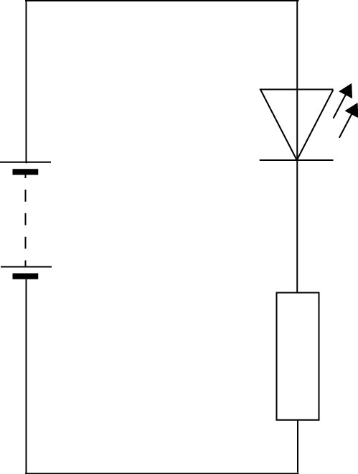
5 V
V | = 4.3 V | V | = IR
I | = 50 mA = 0.05 A | 4.3 | = 0.05 × R
R | = ? | R | = 4.3/0.05
 |  | R | = 86 Ω

An 86 Ω resistor ensures that the current through and the p.d. across the LED are correct in this circuit LED’s (light emitting diodes) are made from semiconductor materials which emit light when charge flows through them.
The voltage drop across an LED should not exceed 2 V and the maximum current should be 10 mA. If the LED is to be used on a 5 V supply the value of the series resistor, R, can be calculated.
Now find R. Remember in series, I₁ = I₂ = I₃
If I_{LED} = 10 mA then I_{R} must = 10 mA = 0.01 A
Worked example

Worked example
An LED can carry a current of 10 mA and has a voltage drop across it of 2 V
What is the size of the resistor that must be placed in series if placed in a circuit with a 12 V supply?
+
-
12 V
V_{LED}

An LED is connected to a 12 V d.c. supply. Calculate the size of the resistor needed in the circuit if the LED operates at 1·8 V, 15 mA
+
-
12 V
V_{LED}

? Questions
1 | Calculate the current in the circuit at the positions shown
(a)
V
1.6 mA
1 V
2 V
I₃
I₂
I₁
2 | Draw a diagram to show an LED connected to a 12 V d.c. supply.
3 | The table below gives information about the normal operating potential difference and the normal operating current for two light emitting diodes (LEDs).
Colour | Normal operating potential difference (V) | Normal operating current (mA)
Blue | 2.6 | 20
Orange | 2.5 | 10

a) | One of the LEDs is connected in series with a 5.0 V supply, a 120 Ω resistor and an ammeter, as shown in the circuit shown below, so that it operates normally.  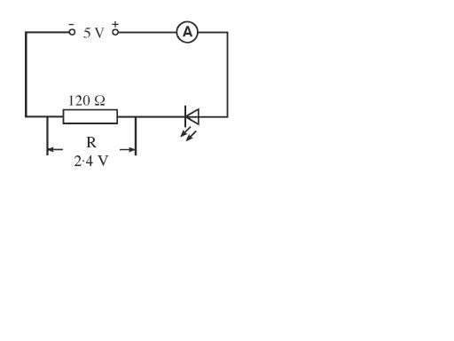
b) | Explain why the series resistor is required
c) | The potential difference across the resistor is 2.4 V. State the colour of the LED used. Explain your choice.
4 | State which of the LED’s in the circuits below would light.

Capacitors
Capacitors are devices which can store charge on its plates. As the stored charge increases, the voltage across the capacitor increases This stored charge can be used later to provide energy to the circuit.
time
Voltage
V_{s}
Capacitance, C, is measured in farads (F).
Capacitors can be used with resistors in series as timing devices.
A capacitor takes time to charge up.
The capacitor acts as a time delay input.
Capacitors and resistors, connected in series as a potential divider, can be placed with a transistor to act as a time delay switch (eg used at Pelican Crossings).
When a capacitor is being charged, the capacitor charges rapidly at first, but then charges more slowly as it becomes harder to place charges on one of the plates that make up the capacitor. Charging stops when the p.d. (voltage) across the capacitor equals the p.d. of the supply voltage.

Symbol: Use: capacitors store charge
Connect to: a resistor
Practical application: with a resistor a capacitor can be used in a time delay circuit.
The time to charge depends on the size of the capacitor and the size of the resistor in series with the capacitor. The greater the resistance the longer the charging time, the greater the value of the capacitor the longer the time it takes to charge.
When a capacitor is connected up the voltage across the capacitor increases until it reaches the value of the supply voltage (Vs)
The bigger the value of the resistance and the bigger the value of the capacitor, the longer it takes to charge to Vs
If you have time your teacher will demonstrate the charging of a capacitor using the ALBA interface.
.

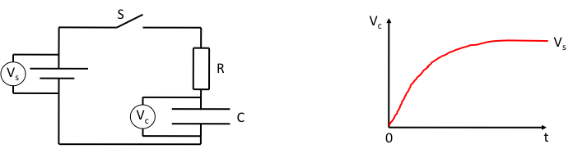

When switch S is closed, charge flows into the capacitor through the resistor R.
The voltage across the capacitor shown by the voltmeter will slowly increase.
When fully charged the voltage across the capacitor remains steady and is equal to the supply voltage.
The larger the value of R, the longer it takes to charge C.
The larger the value of C, the longer it takes to charge C.
In each case, the voltage will rise more slowly.

The product R x C is called the Time Constant of the circuit - the greater the value of RC, the greater the time taken to charge the capacitor.
By changing the value of R or C, the time taken for a voltage to build to a certain value can be altered. This type of circuit is used in timing such as: time delay circuit for pedestrian crossings, photo enlargers, and automatic doors.
By connecting one side of the capacitor directly to the other, the capacitor can be discharged quickly – this technique is often used to RESET a timing circuit.
A switch connected in parallel with the capacitor can also be used to discharge it (by closing the switch) – this is the reset switch in a timing circuit:

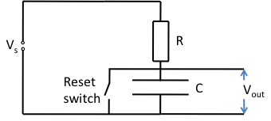

Transistors
Transistors act as a SWITCH,
A transistor can be used in a circuit as an electronic switch
The circuit symbol for an NPN transistor is shown:
b=base
c=collector
e=emitter

Transistors can be ON or OFF.
A transistor switching circuit is shown:
When a h _ _ _ voltage (___ V or more) is applied across the voltmeter, the transistor is switched ___. The transistor then switches the LED ___.
When a l _ _ voltage (less than ___ V) is applied across the voltmeter, the transistor is switched ___. The transistor then switches the LED ___.
But how do you turn on a transistor?
To turn on a transistor and make it switch you need to place a VOLTAGE ≥0.7V ACROSS THE BASE AND EMITTER
This turns on the transistor and charge flows between the emitter and collector and flows through any output device connected to it.
Another type of transistor is the n channel enhancement MOSFET. As all transistors it acts as a switch but the switch on voltage is about 2V (1.8 V)
Symbol

G
S
D
+V_{s}
0 V
V₁
G= Gate
D= Drain
S= Source

If V₁ (p.d. between gate and 0V) > 1.8 V then the MOSFET is OFF.
If V₁ < 1.8 V then the MOSFET is ON.
G
S
D
+V_{s}
0 V
V₁
When the drain is made more positive than the source and the gate has a positive voltage, electrons flow from the source to the drain

The size of the current between the source and the drain depends on the size of the voltage between the source and drain and the size of the voltage between the gate and source.

Potential Dividers
A potentiometer is a type of VARIABLE RESISTOR where the voltage is divided up!
+5V
0V
Fomula for a series circuit
R₃
R₂
R₁
V₃
V₂
V₁
V_{S}
I
In a SERIES circuit the current through each resistor is the same. To find the current use the formula:
We already know that I_{T} is the same as the current going through R₁, R₂, R₃ etc. So to find V₁, V₂, V₃, use:
As I_{T} is the same

To find the voltage across resistors you do not need to work out the current.
V₂
V₁
12 V
90 Ω
30 Ω

Either work out by ratios (quick if you can do it but costly if it goes wrong!)

EITHER:
- Summarise  V_{S} = 12 V, R₁ = 90 Ω, R₂ = 30 Ω  V₁ = ?, V₂ = ?  - Find RT  Find R_{T} = R₁ + R₂  R_{T} = 90 + 30 = 120 Ω  - Find V₁  - Find V₂  - Check  V_{s} = V₁ + V₂ = 9 + 3 = 12 V ☺  OR: | - Summarise  V_{S} = 12 V, R₁ = 90 Ω, R₂ = 30 Ω  V₁ = ?, V₂ = ?  - Find R_{T}  Find R_{T} = R₁ + R₂  R_{T} = 90 + 30 = 120 Ω  - Find I_{T}  - Find V₁  - Find V₂  - Check  V_{s} = V₁ + V₂ = 9 + 3 = 12 V ☺
OR USE

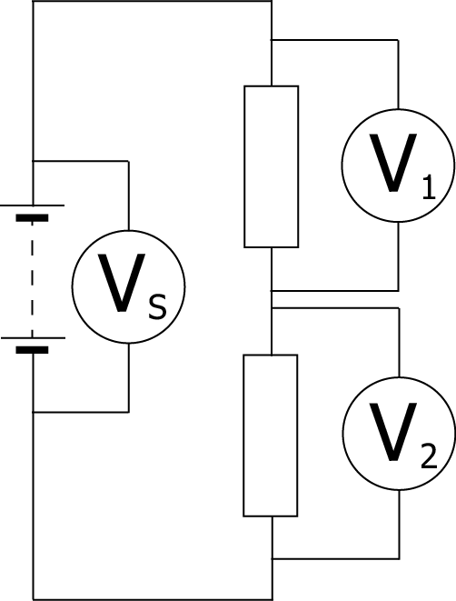
When a circuit is made in the configuration shown below, it is often called a potential divider, or a voltage divider. This is because each resistor takes a proportion of the total potential difference. How big a share of the potential difference each resistor takes depends on the size of the resistor, and the total resistance in the circuit.

We already know that in a series circuit, like this one, the current at each point in the circuit is the same. We also know that the potential difference across each resistor depends on the resistance and the current according to ohm’s law, V = IR. Therefore, as the current through each resistor is the same; the higher the resistance, the higher the potential difference across the resistor.
20 V
6 Ω
4 Ω
This type of circuit can be used as a controller for other devices, and as a result it can be very useful to calculate the p.d. across an individual component.
In this circuit, for example, the total resistance is 10 Ω, as there is a 6 Ω and a 4 Ω resistor in series. We can say that the 6 Ω resistor should have 6/10 of the supply p.d. In this case then, V₂ would be 12V. We can check this result using ohm’s law.
V_{s} | = IR_{T} | V₂ | = IR₂
10 | = I ×(6+4) | V₂ | = 2 × 6
I | = 20/10 | V₂ | = 12 V
I | = 2 A
It is possible to make a relationship which can be used for any potential divider. To calculate the p.d. across a component in a potential divider we multiply the supply p.d. by the fraction of the total resistance.
$$V_{1} = \frac{R_{1}}{(R_{1}+R_{2})}V_{s}$$

Symbol | Name | Unit | Unit Symbol
V₁ | Potential Difference across component 1 | volts | V
R₁ | Resistance of component 1 | ohms | Ω
R₂ | Resistance of component 2 | ohms | Ω
V_{s} | Supply Potential Difference | volts | V

Memory Aid for Potential Dividers
Imagine you are going on a long walk and you have to climb two mountains. Your only provisions are a tray of 10 Kendal Mint Cake bars.

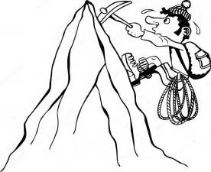
The number of bars you will consume climbing each mountain will depend on the height of each mountain compared to each other. If the mountains are equal heights you would probably consume 5 bars climbing the first mountain and 5 the second. However, if you suddenly had to climb the first mountain but a much taller second mountain, you might choose to only consume two bars for the first mountain and save eight for the second. The height of the first climb hasn’t changed but in comparison to the second hill it is now much smaller! Get it! That is like a voltage divider.
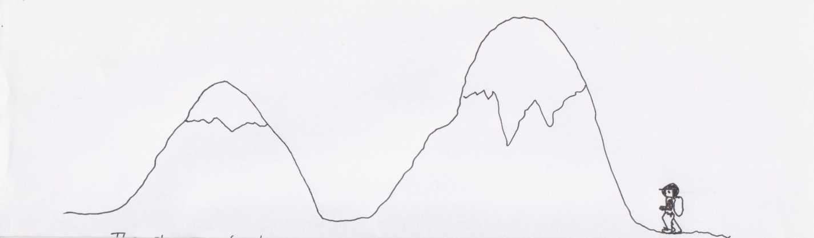

This relationship can be used for any resistive components – not just resistors.
Worked Examples
- What is the p.d. across the 20 Ω resistor?

12 V  30 Ω  20 Ω | V_{s}  R₁  R₂  V₁ | = 12 V  = 20 Ω  = 30 Ω  = ? | V₁  V₁  V₁  V₁  V₁ | = R₁/(R₁ + R₂) × V_{s}  = 20/(20 + 30) × 12  = 20/50 × 12  = 0.4 × 12  = 4.8 V

- The potential difference across the variable resistor should be 6 V. The variable resistor can be any value between 1 kΩ and 10 kΩ. What should it be set to?

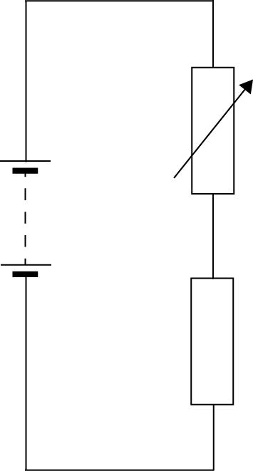  15 V  4.5 kΩ | V_{s}  R₁  R₂  V₁ | = 15 V  = 4.5 kΩ = 4500 Ω  = ?  = 6 V | V₁  6  6(R₁ + 4500)  6 R₁ + 27000  9 R₁  R₁  R₁  R₁ | = R₁/(R₁ + R₂) × V_{s}  = R₁/(R₁ + 4500) × 15  = 15 × R₁  = 15 R₁  = 27000  = 27000/9  = 3000  = 3.0 k Ω

Potential Dividers
- What is the p.d. on the voltmeter in each of the following circuits?

a. | 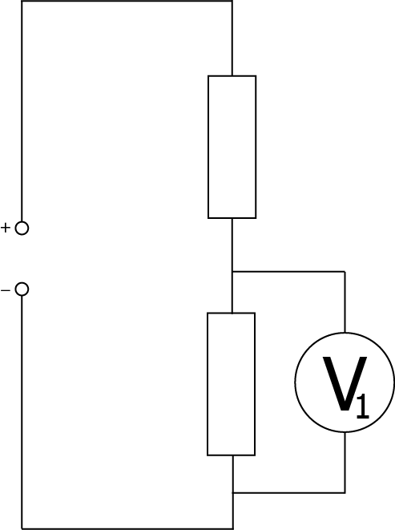  8 Ω  12 V  4 Ω | b. | 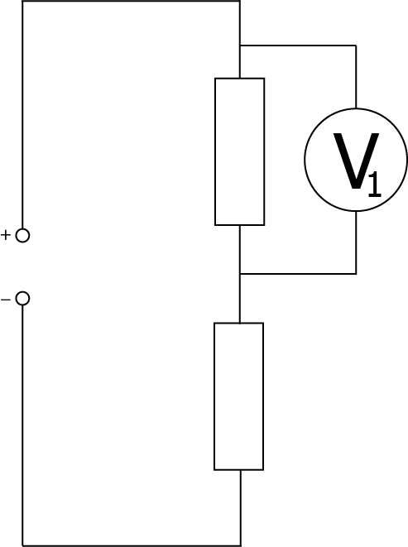  25 kΩ  100 kΩ  5 V | c.
- What is the missing resistance value in these circuits?

a.  12 V | 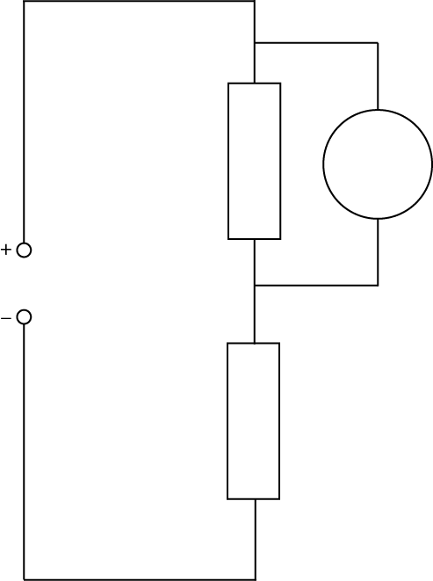  2.4 V  4.8 kΩ | b.  3 V | 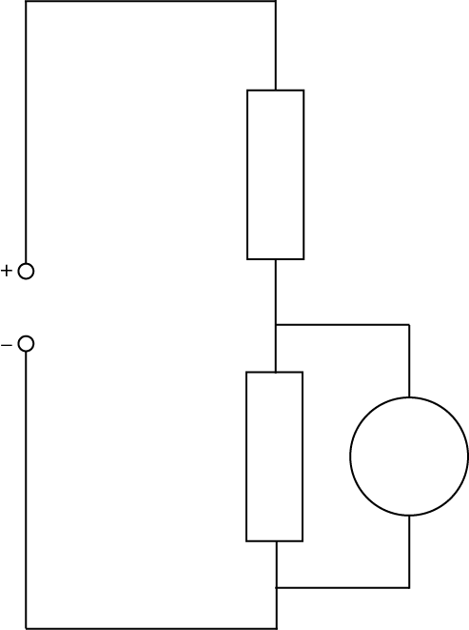  2.3 V  34 kΩ | c. | 8 Ω  5 V  6 V

- The lamp in this circuit has a resistance of 8 Ω.
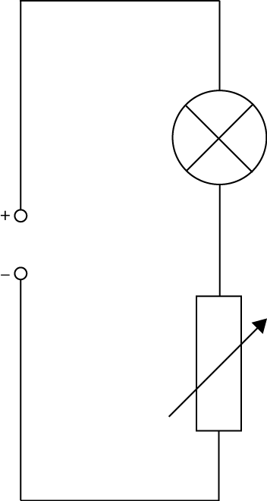  10 V  1.0 – 100 Ω | - What is the maximum resistance of the circuit?  - What is the minimum resistance of the circuit?  - What is the maximum current in the circuit?  - What is the maximum p.d. across the lamp?

- student sets up the circuit shown below.
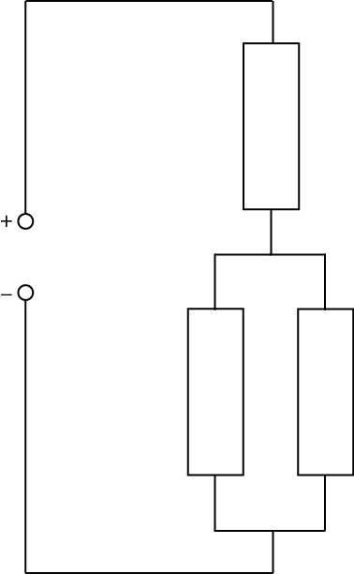  5 V  100 Ω  400 Ω  120 Ω | - Calculate the current supplied to the circuit.  - What is the potential difference across the parallel section of this circuit?  - What is the current in the 100 Ω resistor?

- FIND THE VOLTAGE DROP ACROSS BOTH RESISTORS.

12V
0 V
4.7 Ω
14.1 Ω
10 V
0 V
80 Ω
20 Ω
24 V
0 V
2 kΩ
6 kΩ
3 V
0 V
500 Ω
100 Ω
1.5 V
0 V
25 Ω
75 Ω
6 V
0 V
3 MΩ
2 MΩ
1.5 V
0 V
5 Ω
10 Ω
6 V
0 V
24 Ω
8 Ω
12 V
0 V
900 Ω
300 Ω

Transistor Switching Circuits
Voltage divider circuits can be used with transistors to switch on and off devices. They are really useful.
Ways to work out voltage divider circuits.
Follow the plan below:
- Identify the component (the input device)
- Set the conditions
- Decide what happens to the resistance
- Work out the effect of the voltage across the component
- Find the effect on V_{out}
- Find the effect on the transistor (include the magic number)
- Find the effect on the output device

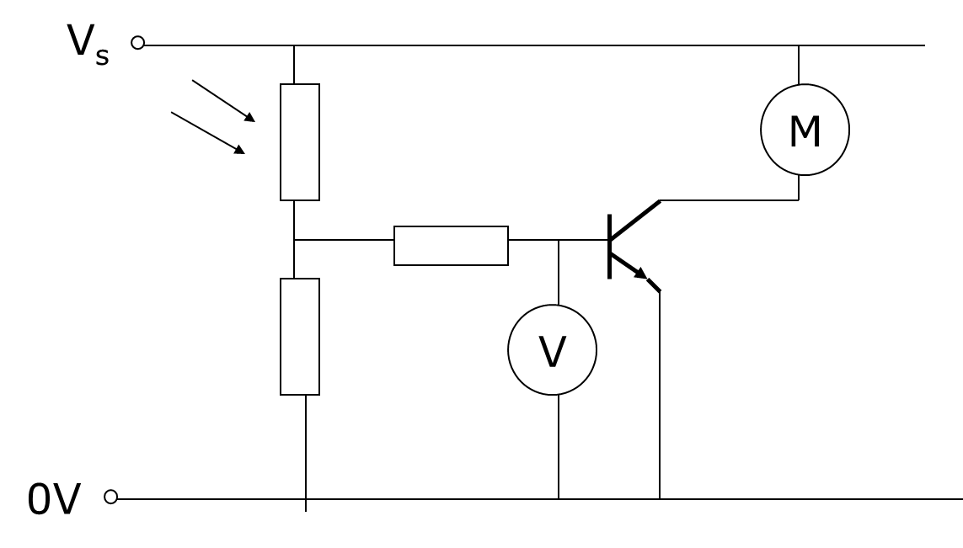
Step 1 | How this LDR circuit works
Step 2 | As light increases,
Step 3 | Resistance decreases
Step 4 | Voltage across the LDR decreases
Step 5 | As V_{LDR} decrease V_{out} increases as they are not the same
Steps  6 & 7 | As V_{out} increases the voltage will increase above 0.7 V (the magic number), the transistor will switch on. Charge will flow between the emitter and collector and the motor will be on.

- Other Transistors - N-channel enhancement MOSFETS work in a similar way but the SWITCHING VOLTAGE is 1.8V

? Question:

 | Using the template above explain how the following two transistor circuits work.
1 | 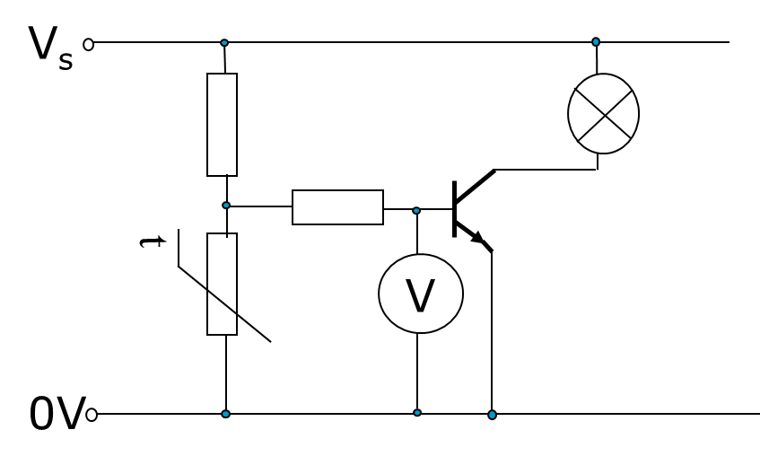
2
3
4

Success Criteria
 | 12.2 | I can describe the symbol, function and application of standard electrical and electronic components including cell, battery, lamp, switch, resistor, variable resistor, voltmeter, ammeter, LED, motor, microphone, loudspeaker, photovoltaic cell, fuse, diode, capacitor, thermistor, LDR, relay and transistor
 | 12.3 | I can draw and identify the symbols for an npn transistor, and an n-channel enhancement MOSFET
 | 12.4 | I can explain the function of the transistors above as a switch in transistor switching circuits

Section 13: Electrical Power

Learning Intentions
Definition of electrical power in terms of electrical energy and time.
Use of an appropriate relationship to solve problems involving energy, power and time.
$$P = \frac{E}{t}$$
Knowledge of the effect of potential difference (voltage) and resistance on the current in and power developed across components in a circuit.
Use of appropriate relationships to solve problems involving power, potential difference (voltage), current and resistance in electrical circuits.
$$P = IV$$
$$P = I^{2}R$$

Selection of an appropriate fuse rating given the power rating of an electrical appliance. A 3 A fuse should be selected for most appliances rated up to 720 W, a 13 A fuse for appliances rated over 720 W.
To determine the power, voltage, current and resistance in electrical circuits.
$$P = \frac{V^{2}}{R}$$

Electrical Power
When we are using electrical appliances, it is useful to have an idea of how much energy they will require. This leads to the definition of electrical power.
Power is defined as the amount of energy transformed per second, as shown in the equation below
$$P= \frac{E}{t}$$

Electrical Power
You may well have heard people talking about how much Power an electrical appliance uses.
- We can define Power as: Energy used (E) per unit time (t)
We can write this as an equation:
When we talk about electrical power we mean how much electrical energy is transferred every second. If the units of energy are measured in Joules and the time is measured in seconds, then we give the unit of Watts (W) for Power.
We can rearrange (change) the equation above to show that:
Energy used = Power x time
or
E = P x t
Worked Example:
How much electrical energy is converted into heat and light energy when a 60W bulb is turned on for 5 minutes?
E = P x t  = 60 x 300  = 18,000J or 18kJ | E = ?  P = 60W  t = 5 minutes = 5 x 60 = 300 seconds

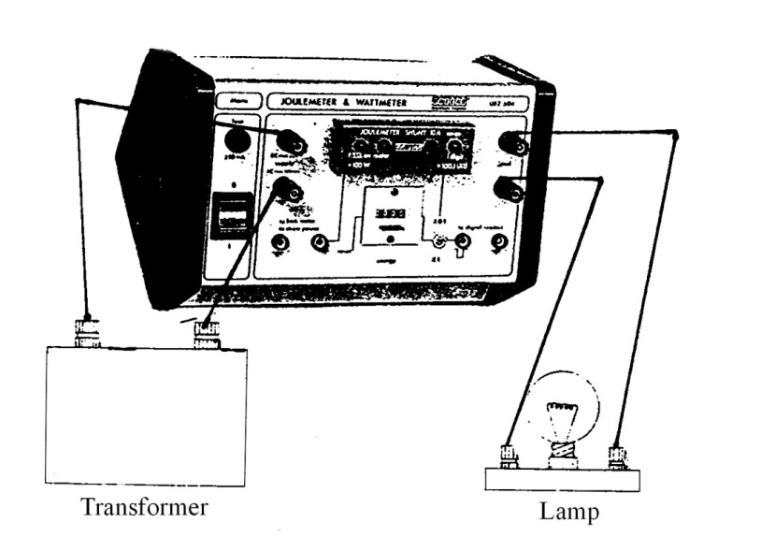
Power and Energy

What you need
a.c. power supply (12 V), car headlamp lamp, joulemeter, stopclock.

What to do
- Set up the circuit as shown.
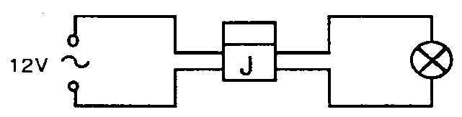

- Copy this table:

Joulemeter reading at start | J
Joulemeter reading at finish | J
Energy used in 100 seconds | J

- Note down the reading on the joulemeter.
- Switch on the circuit and start the stopclock.
- After 100 seconds (1 minute 40 seconds) switch off.
- Note down the final joulemeter reading.

Questions
- The energy (E) used by the lamp is measured in joules (J).
  - How much energy was used in 100 seconds?
  - How much energy was used in 1 second?

  - From your experimental results, how much energy was used by the lamp each second?
  - Compare the energy used each second with the power rating stamped on the lamp.
- We can link energy (E) and power (P) in a formula. The link also involves time.
Power is measured in Watts (W), named after a Scottish scientist. Use the results from your experiment to help you find the mathematical relationship between P and E.
- How much energy would be used by a household mains lamp rated at 100 W and used for 10 minutes?
- A miniature heater for making cups of tea is rated at 150 W. If it takes 45,000 J to boil the water how long would this take?
- Power and energy can be used to describe non-electrical machines. If a car produces 600,000 J of energy in 15 seconds what is its power?
- Calculate the power of a machine which uses 3000 J of energy each minute.
- Many appliances in the home are designed to change electrical energy into heat energy.
One example is a kettle. State the name of four others.
- A light bulb has a power rating of 60 W.
  - How much electrical energy is transformed by the bulb in 1 s?
  - State the energy changes involved when the lamp is switched on.
- The electric motor on a ceiling fan transforms 207 kJ of electrical energy in 30 minutes?.
  - Calculate the power rating of the motor in the fan?
  - State the energy changes involved when the ceiling fan is switched on.
- How much electrical energy is transformed by the following appliances?
  - A 400 W drill used for 45 s.
  - A 300 W food processor used for 20 s.
  - An 800 W iron used for 40 minutes.
  - A 2.4 kW kettle that takes 5 minutes to boil the water inside it.
- What is the power rating of an appliance that transforms:
  - 500 J in 5 s?
  - 1200 J in 20 s?
  - 1.8 MJ in 10 minutes?
- How long would a 2 kW electric kettle take to boil the water inside if it transforms
100 kJ of electrical energy into heat energy?

Symbol | Name | Unit | Unit Symbol
P | Power | watts | W
E | Energy | joules | J
t | time | seconds | s

Power Rating of Appliances
Different appliances will transform more or less electricity. Often the highest powered ones will be those which transform electrical energy into heat energy, for example a hair dryer. We often describe this as the power consumption.
Appliance | Power transformation/W
Oven | 3000
Dishwasher | 1400
Iron | 1100
Hair Dyer | 1500
Microwave | 1000
TV | 250
Stereo | 60
Filament Lamp | 100
Energy Saving Lamp | 11
Drill | 750
Fridge | 1400

Worked examples

- What is the power of a television which transforms 0.5 MJ of energy in 1 hour?
P  E  t | = ?  = 0.5 MJ  = 1 × 60 × 60 = 3600 s | P =  P =  P = | E/t  0.5×10⁶ /3600  139 W
- A 1500 W hairdryer is used for 5 minutes, how much energy is transformed?

P  t  E | = 1500W  = 5 x 60 = 300 s  = ? | P =  1500 =  E =  E =  E = | E/t  E/300  1500 × 300  450000  450 kJ

Tutorial Questions

POWER AND ENERGY E = Pt
- Complete the following table:
 | POWER | TIME | ENERGY
a) | 100 W | 5 s
b) |  | 750 s | 5 x 10⁴ J
c) | 25 mW |  | 5 J
d) |  | 3 ms | 7 μJ
e) | 1·2 kW | 5 min
f) | 50 W |  | 10⁶ kJ
g) |  | 0·5 h | 6·9 x 10⁵ J

- A capacitor stores 40 mJ and is discharged in 0·03 s. Calculate the power developed.
- Calculate the energy, in joules, dissipated in 1 h by a 3 kW electric fire.
- Calculate the time to completely discharge a battery which stores 2 x 10³ MJ and is used to power a 6 kW heater.
- A 20 mW LED is run from a small battery which stores 50 kJ of energy.
Calculate the time taken to convert all this energy in the LED .
- A 12 V power supply is connected to an immersion heater. If it is used for 2·5 min and provides 9 kJ of energy. Calculate the power of the immersion heater.
- Calculate the energy, in joules, used when three 100 W bulbs, an electric fire with two bars each 2 kW and a 600 W television are used for 6 h?
- In general, state the type of devices that have the highest power ratings.
- Suggest possible power ratings for the following mains appliances:
  - a colour television set
  - a light bulb
  - an electric fire
  - a kettle
  - a cooker with 4 rings, a grill and an oven
  - a hairdryer

Power, Current and Voltage

Read
Different electrical appliances have different power ratings. These ratings are given in Watts. A 100 W lamp is brighter than a 40 W lamp – it uses up more energy every second.
The power depends on the voltage across the lamp and the current through it. If there is 1 volt across the lamp and 1 ampere through it then the power will be 1 watt. Power can be calculate from the formula:
Power = Voltage x Current
$$P=VI$$
In this experiment you can use this formula to check the power rating stamped on the lamp.

What you need
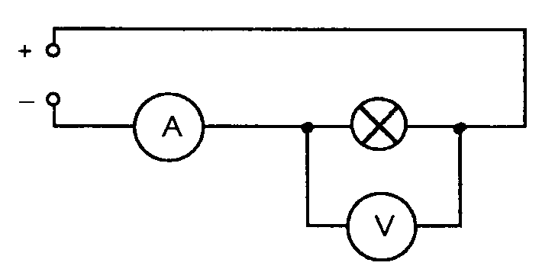
Variable low voltage d.c. power supply, ammeter (10 A), voltmeter (20 V), 3 lamps of different ratings.

What to do
Copy this table:

Lamp rating (W) | Voltage (V) | Current (A) | Current x Voltage

- Set the power supply to zero.
- Set up the circuit as shown in the diagram.
- Switch on.
- Increase the voltage until it reads the correct reading on the voltmeter (10 V).
- Note down the voltage reading and the current reading in columns 2 and 3 of the table.
- Repeat steps 2 to 6 using different lamps.
- Complete column 4 of the table.

Question
- Were the ratings stamped on the lamps correct?
- Did the lamps with higher ratings use up more energy?

P,I,V
We can also relate power to current and potential difference. Potential difference is the amount of energy supplied per coulomb of charge supplied as the charge passes the power source (remember, 1 V = 1 J/C). Current is the amount of charge per second.
If we multiply the potential difference across a circuit by the current through it we have:
volts × amperes
= joules/coulomb × coulomb/second
= joules/second
Earlier it was shown that power can be defined as the energy per unit time, so that is joules per second which means that power must also equal current multiplied by voltage.
It is possible to get two further useful relationships if we combine this equation with Ohm’s law.
The first uses current and resistance:  $$V=IR$$  and  $$P =IV$$  substituting for V  $$P=I ×IR$$  simplifying this leaves  $$P=I^{2}R$$ | The second new equation we can make uses potential difference and resistance.  $$V=IR$$  which can be rearranged as  $$I =\frac{V}{R}$$  substituting this equation into  $$P =IV$$  to give  $$P= \frac{V}{R}×V$$  simplifying this leaves  $$P=\frac{V^{2}}{R}$$
$$P=I^{2}R$$ | $$P=\frac{V^{2}}{R}$$

Symbol | Name | Unit | Unit Symbol
P | Power | watts | W
I | Current | amperes | A
R | Resistance | ohms | Ω
V | Potential Difference | volts | V

P V I R Tutorial

Worked examples

- A vacuum cleaner is connected to the UK mains (rated at 230 V) and 8.9 A of current flows through the circuit. What power is being transformed?

P  V  I | = ?  = 230 V  = 8.9 A | P  V  V | = IV  = 230 × 8.9  = 2047 W

- The elements of a toaster have a total resistance of 15 Ω, the toaster is rated at 1650 W. What current does it draw?

P  I  R | = 1650 W  = ?  = 15 Ω | P  1650  I²  I | = I²R  = I² × 15  = 1650/15  = $\sqrt{\text{110}}$  = 10.5 A

- A label on a 60 W lamp states that it requires a 12 V supply to operate at full power. What is the lamp’s resistance?

P  VR | = 60 W  = 12 V  = ? | P  60  R  R | = V²/R  = (12 × 12)/R  = 144/60  = 2.4 Ω

What to do
Use this extract from a data book on appliances to answer the questions.
Item | Current (A) | Voltage (V) | Resistance (Ω) | Power (W)
Car headlamp | 2 | 12 |  | 24
Torch bulb | 0.3 | 6
Car windscreen heater | 5 | 12
Electric heater |  | 240 |  | 960

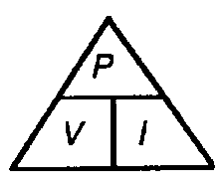
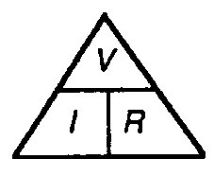
- Complete the table filling in each of the missing values. You need two formulae:
V = I x R P = V x I
- For the car headlamp you should have the following:
I = 2 A, V = 12 V, R = 6 Ω, P = 24 W
From these we can show a new formula to be true.
Making a new formula start with Ohm’s law with V as the subject:
V = IR
Write down the power equation P = VI
Substitute for V in this equation (write I x R instead of V).
Tidy up the formula:
From the data given for the car headlamp check that:
P = VI or P = I²R
- Copy the table below:
Using the table you have already filled up, fill in columns 2, 3 and 4 of this table.
Now calculate I²R for each component and put your results in column 5. How do the results in column 4 compare with those in column 5?
Component | Current (A) | Resistance (Ω) | Power (W) | I²R
Torch bulb
Windscreen heater
Electric heater

- A data book claims that a 1 kΩ resistor can safely handle a power of 0.4 W.
  - What is the maximum current it can safely handle?
  - What voltage would be across it at this time?
- An engineer is designing a new electric heater element using a new type of wire. She needs a power output from the heater of 2.4 kW when connected to a 240 V supply. What value of resistance should the wire have?
- Calculate the resistance of a hairdryer element which uses a power of 120 W and a current of 0.5 A.
- A current of 6 A flows along a flex of resistance 0.2 Ω to an electric heater which has an element of resistance 60 Ω. Calculate the heat generated each second:
  - In the flex
  - In the element.
3 V
17.5 Ω
42.5 Ω

Power, Current, p.d. and Resistance
- To measure the power of a lamp a voltmeter and an ammeter are required.
  - Draw a circuit diagram to show how you would measure the power output of bulb using a voltmeter and ammeter.
  - If the meter readings in the circuit in question 1a were 6 V and 600 mA, what would be the power of the lamp?
  - How much energy would this lamp use in 1 hour?
- A colour television set is rated at 300 W.
  - Calculate the current drawn by the television when connected to the 230 V mains supply.
  - How much energy would this television use if it was left on overnight for
8 hours?
- Using the equations V = IR and P = VI, show that if a current I flows through a heating element of resistance R, the power of the heater is given by P = I²R.
- What is power rating of a 30 Ω heating element when 8 A passes through it?

- Calculate the power rating of the following devices in a car:
  - A radio of resistance 6 Ω drawing a current of 2 A.
  - The rear window heater of resistance 3 Ω drawing a current of 4 A.
- An electric fire is rated at 2 kW, 230 V.
  - What is the current in the heating element when it is switched on?
  - Calculate the resistance of the heating element.
- A 100 Ω resistor has a maximum safe power rating of 4 W. Calculate the maximum current it can safely handle.
- Calculate the resistance of a hairdryer element which has a power rating of 960 W when drawing a current of 4 A.
- By combining the equations V = IR and P = VI, show that the power can also be given by P = V² / R

- Calculate the power rating of a heater which has a resistance of 53 Ω plugged into the mains voltage of 230 V.

- A current of 6 A flows along a flex of total resistance 0.2 Ω   to an electric heater which has an element of resistance 60 Ω.
  - Calculate the heat generated each second in the flex
  - Calculate the heat generated each second in the element
  - What energy change is taking place in both the flex and the element?
  - Why does the element become hot and the wire remain cool?
  - What size of fuse, 3 A or 13 A, should be fitted to the plug connected to this heater?
  - Explain what would happen if the wrong fuse was fitted to the plug.
- The fuses used in electrical plugs in the UK come in 2 main sizes - 3 A and 13 A
  - What is the purpose if the fuse in the plug connected to an appliance?
  - What energy change does a fuse depend on to work correctly?
  - Copy and complete the table below and select which of the above fuses would be most suitable for each of the appliances.
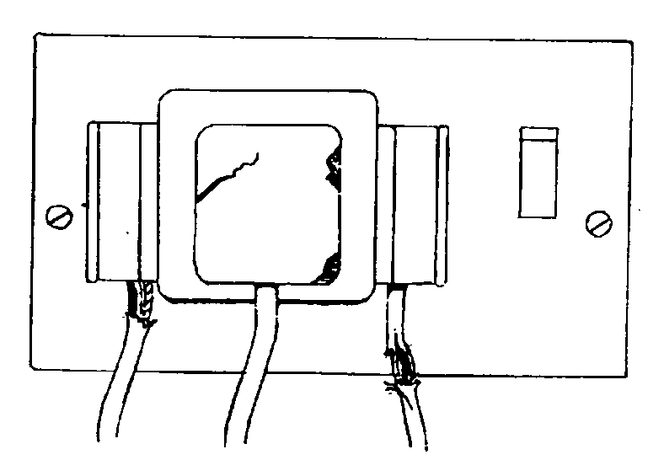
Appliance | Power (W) | Voltage (V) | Current (A) | Most suitable fuse
Food Mixer |  | 230 | 0.3
Lamp | 100 | 230
Heater | 2.5 x 10³ | 230
Hi-fi unit |  | 230 | 1.5

Additional Notes
List the faults shown in the diagram below and explain the danger involved in each.

Questions
- Why should a flex, designed for a table lamp, never be used for an electric heater?
- A 500 W appliance is connected to the mains supply by a flex. As the flex has resistance it will heat up slightly when electricity flows through it.
An information tag attached to the flex indicates that, with currents above 5 A, the flex will overheat causing the insulation to melt or burn.
Jack has purchased a 13 A fused plug and connects it to the appliance. The appliance works fine and Jack is pleased with his work.
A fault occurs inside the appliance and causes it to draw a current of 12 A from the mains.
  - What would happen to the flex?
  - What was Jack’s mistake?
- An electric hairdryer carries the warning “DO NOT USE IN THE BATHROOM”. If it is safe to use it in the bedroom, why is it dangerous to use it in the bathroom?

The Ring Circuit

What you need
Model of parallel/ring circuit, low voltage a.c. supply, ammeter (10 A), connecting leads.

What to do
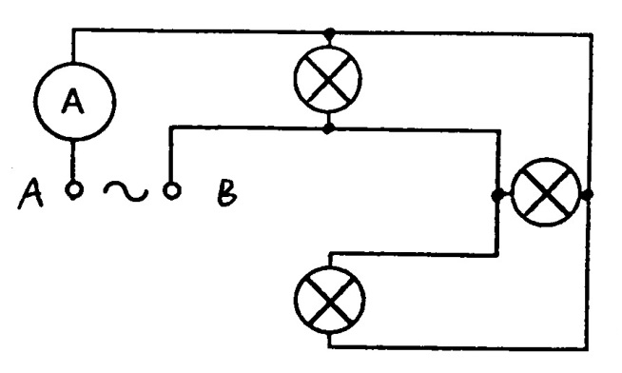
- Set the power supply to the correct voltage (12 V) and connect it to A and B on the parallel circuit.
- Note the ammeter reading
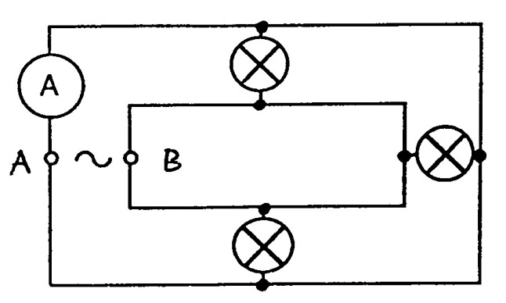
- Connect two more leads to make it a ring circuit.
- Note the ammeter reading.

Questions
- How many paths are there from the supply to the lamps using the parallel circuit?
- How many paths are there from the supply to the lamps using the ring circuit?
- Both circuits have three lamps. Why is the current less in the ring circuit?
- If the maximum total current from the supply to the sockets in a house is 30 A, what will be the maximum current in the cables:
  - If a parallel circuit is used?
  - If a ring circuit is used?

More to do
- Collect samples of 15 amp and 30 amp cable.
- Examine the cables and note the cost of each.
- What are the advantages of using a ring circuit?
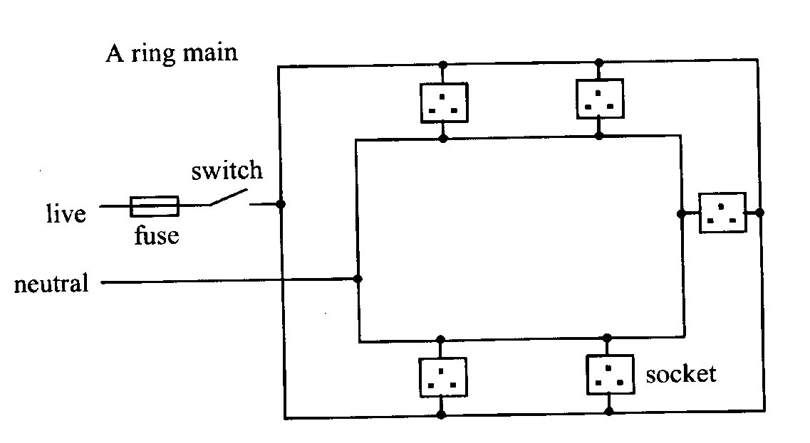

EARTHING
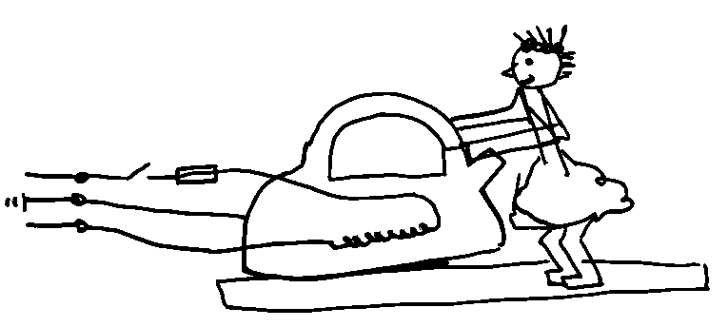
For obvious reasons it is not possible to experiment on a real life situation to find out how the Earth wire works.
We will use a model to demonstrate the importance of correctly wiring plugs.
“Polly put the kettle on…..”
Fault | What happens
Short between live and the  kettle casing | No Earth | Polly is electrocuted when she switches on the kettle  FUSE DOES NOT BLOW
Short between live and the  kettle casing | Earth | As Polly switches on a large current flows through the casing to Earth. THE FUSE BLOWS
Short between live and kettle  casing, but live and neutral  wires are reversed | No Earth | The fuse does not blow. Polly gets a very large shock, EVEN WHEN THE APPLIANCE IS SWITCHED OFF
 | Earth | This would cause a very large current which is not protected by the fuse. This could damage the supply cables. EXPENSIVE.

Fuses get hot even when working properly and so gradually deteriorate with age. Therefore, fuses can sometimes blow even when there is no fault in the appliance. So replace blown fuses once (or twice) before fault finding.

The Earth Wire
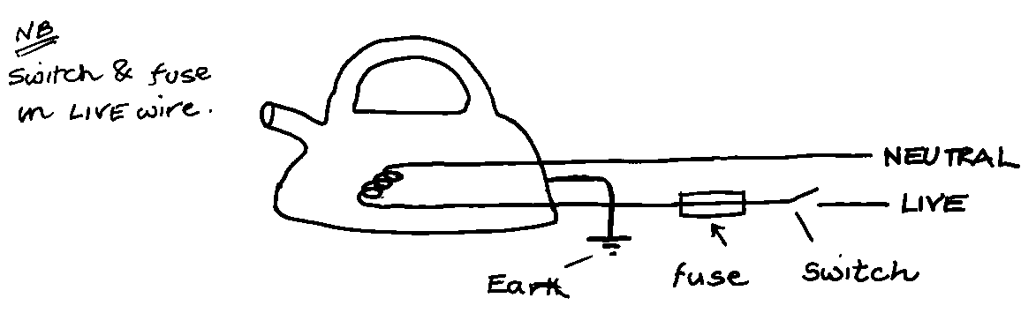
The electric current flows through the live wire, into the heating element and out through the neutral wire. The fuse and switch are placed in the live wire (see note below). The Earth wire is connected to the outside casing of the kettle. Normally, no current flows through the Earth wire, so what is it for?
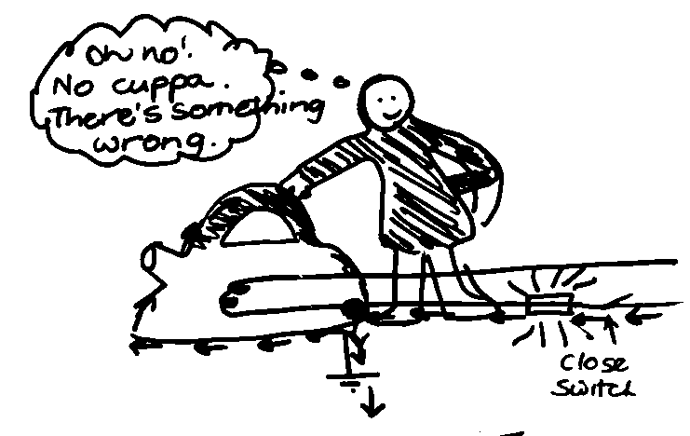
It is a safety device. If the kettle is wired correctly and a loose wire touches the casing, a large current flows along the live wire through the Earth wire. This large current causes the fuse to melt. The kettle won’t work but YOU are safe.

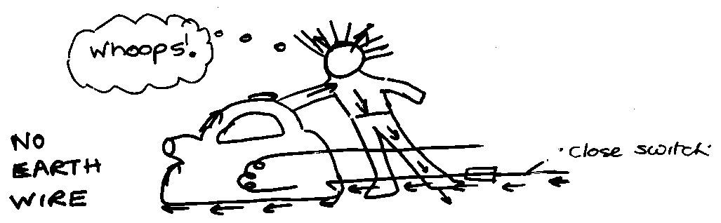

If there is a fault and a live wire touches the casing, then a person touches the casing, the electricity will go through the person and into the ground. The person could be killed.

Why did the person get an electric shock when the neutral and live wires were connected the wrong way round?

How the Earth wire works
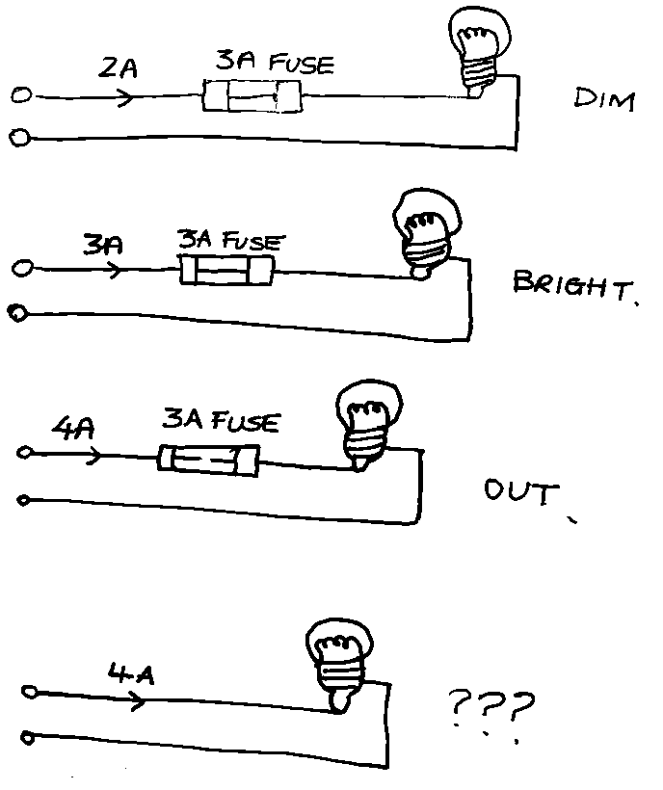
Charge flows through the live wire, through the appliance and back through the neutral wire. The Earth wire is connected to the casing of the appliance, so when the appliance is working normally no current flows through the Earth wire. If a loose live wire touches the casing the casing would be raised to a potential of 230 V, and this drives a very large current through the casing and THROUGH THE EARTH WIRE. THIS LARGE CURRENT MELTS THE FUSE AND MAKES THE APPLIANCE SAFE.
If there were no Earth wire, the metal casing would be raised to 230V if a loose live wire touched it. If you then touched the casing a large current would flow through YOU to Earth. This would be enough to kill you.
Appliances marked are double insulated and have no earth wire. They are called double insulated because they have two layers of functional insulation between any external surface and any conductor which is at a high voltage and could cause shocks.

The correct fuse
To change a fuse in a plug:
Take the plug out of the socket;
Take the top off the plug (using a screwdriver);
Lift out the fuse (carefully);
Put in a new fuse OF THE CORRECT VALUE.
There are lots of fuses that you can buy for plugs: 1A, 2A, 3A, 5A, 10A and 13A. At home the only 2 fuses that you need are 3A and 13A.

How do you choose the correct value of fuse?
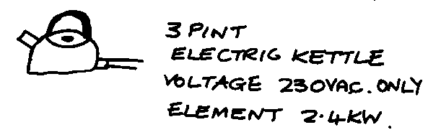
All appliances have plates showing their power rating and voltage. This information can be used to calculate the current that flows in the appliance when it is in use. You can then work out which fuse to use.

To find the current the kettle uses you do this sum:
Current (A) = Power (W)÷Voltage (V)
Current (A) = Power (W)÷230

Explain the purpose of the Earth wire
If there is a fault and the casing becomes live there is a low resistance path from the live to earth. A large current flows to earth. This causes the fuse to blow which disconnects the live wire, making the appliance safe (or isolating the appliance)

Why must switches and fuses be in the live wire?
The live wire is the dangerous wire because it is at high voltage with respect to the earth. When the fuse blows or an appliance is switched off it is important that the live wire is disconnected so the appliance is safe.

What is the purpose of the fuse?
The fuse protects the flex from overheating.

Success Criteria
 | 13.1 | I can state that electrical power is a measure of the energy transferred by an appliance every second or the energy provided by a source per second.
 | 13.2 | I can used the word dissipated as it relates to power.
 | 13.3 | I am able to use E = Pt to solve calculations relating to Power, Energy and time.
 | 13.4 | I know the effect of potential difference (voltage) and resistance on the current in  and power developed across components in a circuit.
 | 13.5 | I can use appropriate relationships to solve problems involving power, potential difference  (voltage), current and resistance in electrical circuits. $P = IV$ $P = I^{2}R P = \frac{V^{2}}{R}$
 | 13.6 | I know that I would use a 3A fuse for most appliances rated up to 720W and a 13A fuse for appliances rated over 720W.
 | 13.7 | I could select the appropriate fuse rating given the power rating of an electrical appliance

? Revision Questions

Circuits, Symbols and Meters
1 | a) | In the circuit below, name the components labelled A, B, C, D and E.
 | b) | State whether this is a series or parallel circuit.
2 |  | Look at the circuit opposite
 | a) | Write down the names of the components that are connected in series.
 | b) | Write down the names of the components that are connected in parallel
3 |  | In the circuits below, identify the meters 1, 2, 3, 4, 5 and 6.
4 | a) |  | Write down the rule for the current at all points in a series circuit.
 | b) |  | Write down the relationship between the supply voltage and the potential differences (voltages) across the individual components in a series circuit.
5 | a) |  | Write down the relationship between the supply current and the current in the branches of a parallel circuit.
 | b) |  | b) Write down the potential difference (voltage) rule for all components that are connected in parallel.
6 | a)  b)  A  B  C  D  E  F |  | Copy out the statement(s) which is/are true for series circuits.  Copy out the statement(s) which is/are true for parallel circuits.  There is only one pathway round the circuit.  There is more than one pathway around the circuit.  The potential differences around the circuit add up to the supply voltage.  The potential difference (voltage) is the same across all components.  The current is the same at all points in the circuit.  The current through each component adds up to the supply current.
7. |  |  | In the circuit below the ammeter reading is 0.5 A and the voltmeter reading is 4 V.
 | a) |  | State whether this is a series circuit or a parallel circuit.
 | b) |  | i)What is the current through the lamp?
 |  |  | - What is the potential difference across the lamp?
8 |  |  | In the circuit below the ammeter reads 0.8 A, the current through the lamp is 0.3 A and the voltmeter reads 6 V
 | a)  b) |  | Is this a series or a parallel circuit?  i) State the current values at X and at Y?  ii) State the potential difference across the lamp?
9. |  |  | Find the missing currents and voltages in the following circuits.
Electrical Resistance
10 |  |  | Rewrite the following list of potential differences (voltages) in millivolts and arrange in order of increasing value.  0.65 V, 980 mV, 0.07 V, 3.2 V, 2963 mV
11 |  |  | Rewrite the following list of currents in amperes and then arrange in order of increasing value.  5805 mA, 2 mA, 29 mA, 120 A, 8.9 A, 0.03 A
12 |  |  | In a series circuit, the ammeter reading was noted for different values of resistor in the circuit.
a) |  |  | State the electrical quantity measured by an ammeter.
b) |  |  | Copy and complete the table below, placing the ammeter readings in the correct order.  0.6 A, 2.4 mA, 1.2 A, 240 mA.
13 |  |  | The current in a lamp bulb was 2 A when connected to a 12 V battery. Calculate the resistance of the lamp bulb.
14 |  |  | When connected across a 3 V supply, the current in a resistor was 60 mA. Calculate the value of the resistor.
15 |  |  | A 220 Ω resistor is connected across a 2 V supply. Calculate the current in the resistor.
16 |  |  | A 12 V transformer is connected to a circuit of resistance 1.2 kΩ. Calculate the current in the circuit.
17 |  |  | Calculate the missing quantities in the circuits below.
18 | a)  b) |  | The diagram below shows a 6 V 60 mA lamp working off a 24 V supply.  What must be the potential difference across the resistor if the lamp is operating correctly?  Calculate the value of the resistance of resistor R.
19 |  |  | Potential difference and current were measured in both circuits below for different values of current
 | a) |  | Copy and complete both tables.
 | b) |  | What is the purpose of the variable resistor in the above circuits?
 | c) |  | What conclusion can be drawn about the resistance of the lamp bulb as the current increases?
 | d) |  | What conclusion can be drawn about the resistance of the resistor as the current increases?
 | e) |  | Explain the difference in the behaviour of the lamp bulb and the resistor as the current increases
20 |  |  | Calculate the total resistance between X and Y for the following.
21 |  |  | Calculate the total resistance between X and Y for the following circuits.
22 | a) |  | What will be the resistance of ten 20 Ω resistors when they are connected in series?
23 |  |  | What will be the resistance of ten 20 Ω resistors when they are connected in parallel?
24 |  |  | You are given the four resistors below.  1 Ω, 10 Ω, 100 Ω, 1000 Ω
 | a) |  | What is their total resistance when they are connected in series?  A less than 1 Ω  B between 1 Ω and 10 Ω  C between 10 Ω and 100 Ω  D between 100 Ω and 1000 Ω  E greater than 1000 Ω
 | b) |  | What is their total resistance when they are connected in parallel?  A less than 1 Ω  B between 1 Ω and 10 Ω  C between 10 Ω and 100 Ω  D between 100 Ω and 1000 Ω  E greater than 1000 Ω
25 |  |  | Calculate the resistance between X and Y in the following resistor networks.
Potential Divider Circuits
26 |  |  | State what is meant by a potential divider circuit.
27 |  |  | The following potential divider circuit was set up using the values shown.
 | a) |  | Calculate the current in the circuit through R1 and R2
 | b) |  | Calculate the value of the potential differences (voltages) V1 and V2, across each resistor.
 | c) |  | Use your results to show that the relationship $\frac{V_{1}}{V_{2}}=\frac{R_{1}}{R_{2}}$ is true
 | d) |  | Use your results to show that the relationship $V_{1}=\frac{R_{1}}{{R_{1}+R}_{2}} V_{s}$ is true
28 |  |  | Calculate the value of V1 in the following circuits.
29 |  |  | Calculate the value of V1 in the following circuits.
30 |  |  | A fixed 6 V d.c. power supply has to be reduced to give constant output of 1.5 V using a potential divider.  Design a potential divider circuit that will give a constant output of 1.5 V from the 6 V supply.
31 | a) |  | A 20 kΩ potentiometer AB is connected across a 6V d.c. power supply as shown below.  The sliding contact, P, can be moved to any point along the potentiometer AB.  What will be the output voltage, V1, when the sliding contact, P, is at  i) position A  ii) position B  iii) midway between A and B?
 | b) |  | What would be the output voltage, V1, if the sliding contact P was one third of the length along the potentiometer from A?
 | c) |  | What would be the resistance between points A and P if the potentiometer was adjusted to give an output voltage of 3.5V?
Power and Energy
32 | a) |  | If an electric current is passed through a conducting wire, what energy  transformation takes place?
 | b) |  | Many electrical appliances in the home are designed to make use of this energy transformation. Name four of these appliances.
33 |  |  | A light bulb has a power rating of 60 W.
 | a) |  | How much electrical energy is transformed by the bulb in 1 s?
 | b) |  | State the energy changes involved when the lamp is switched on.
34 |  |  | The electric motor on a ceiling fan uses 207 kJ of electrical energy in 30 minutes.  a) Calculate the power rating of the motor in the fan.  b) State the energy changes involved when the ceiling fan is switched on.
35 |  |  | Calculate the electrical energy used by the following appliances.  a) A 400 W drill used for 45 s  b) A 300 W food processor used for 20 s  c) An 800 W iron used for 40 minutes  d) A 2.4 kW kettle that takes 5 minutes to boil the water inside it.
36 |  |  | Calculate the power rating of an appliance which transforms -  a) 500 J in 5 s  b) 1200 J in 20 s  c) 1.8 MJ in 10 minutes?
37 |  |  | Calculate the time it would take a 2 kW electric kettle to boil the water inside if it uses 100 kJ of electrical energy?
Power, Current, Potential Difference or Voltage and Resistance
38 | a) |  | Draw a circuit diagram to show how you would measure the power output of a lamp bulb using a voltmeter and ammeter.
 | b) |  | If the meter readings were 6 V and 600 mA, what would be the power of the lamp?
 | c) |  | How much energy would this lamp use in 1 hour?
39 | a) |  | A colour television set is rated at 300 W.  Calculate the current drawn by the television when connected to the 230 V mains supply.
 | b) |  | How much energy would this television use if it was left on overnight for 8 hours?
40 | a) |  | Using the equations V = IR and P = VI, show that if a current I flows through a heating element of resistance R, the power of the heater is given by P = I²R.
 | b) |  | Calculate the power rating of a 30 Ω heating element when 8 A passes through it?
41 | a) |  | Calculate the power rating of the following devices in a car -  A radio of resistance 6 Ω drawing a current of 2 A.
 | b) |  | the rear window heater of resistance 3 Ω drawing a current of 4 A.
42 |  |  | An electric fire is rated at 2 kW, 230 V.  a) What is the current in the heating element when it is switched on?
 |  |  | b) Calculate the resistance of the heating element.
43 |  |  | A 100 Ω resistor has a maximum safe power rating of 4 W. Calculate the maximum current it can safely handle.
44 |  |  | Calculate the resistance of a hairdryer element which has a power rating of 960 W when drawing a current of 4 A.
45 |  |  | By combining the equations V = IR and P = VI, show that the power can also be given by $P = \frac{V_{2}}{R}$
46 |  |  | Calculate the power rating of a heater which has a resistance of 53 W working off the mains voltage of 230 V.
47 |  |  | The fuses used in electrical plugs in the UK come in 2 main sizes - 3 A and 13 A.
 | a) |  | What is the purpose if the fuse in the plug connected to an appliance?
 | b) |  | What energy change does a fuse depend on to work correctly?
 | c) |  | Complete the table below and select which of the above fuses would be most suitable for each of the appliances.
48 |  |  | A current of 6 A flows along a flex of total resistance 0.2 W to an electric heater which has an element of resistance 60 Ω.
 | a) |  | Calculate the heat generated each second in
i) the flex
ii) the element.
 | b) |  | i) What energy change is taking place in both the flex and the element?  ii) Why does the element become hot and the wire remain cool?
 | c) |  | i) What size of fuse, 3 A or 13 A, should be fitted to the plug connected to this heater?  ii) Explain what would happen if the wrong fuse was fitted to the plug.
A.C. or D.C.
49 |  |  | Explain the difference between a.c. and d.c. Your answer should state what is represented by the terms a.c. and d.c. and include the words ‘electron’ and ‘direction’.
50 |  |  | Give two examples each of
 | a) |  | a.c. power supplies
 | b) |  | d.c. power supplies.
51 | a) |  | For each of the following traces shown, state whether they are a.c. or d.c.
 | b) |  | Calculate  i) the applied voltage for trace i) where the Y-gain setting is set at 1 V/division
 |  |  | ii) the applied voltage for trace iii) where the Y-gain setting is set at 0.5 V/division
 |  |  | iii) the peak voltage for trace ii) where the Y-gain setting is set at 2 V/division.
52 |  |  | Calculate the peak voltages of the traces below using the Y-gain settings shown.
 | a) |  | State whether the mains supply is a.c. or d.c.
 | b) |  | What is the frequency of the mains supply?
53 |  |  | Trace a) in question 56 is produced from the mains supply. If the settings on the oscilloscope are not changed, sketch the trace that would be produced by the following a.c. supplies
 | a) |  | Peak voltage 5 V at a frequency of 25 Hz
 | b) |  | Peak voltage 20 V at a frequency of 75 Hz.
54 |  |  | Two identical bulbs are lit by the supplies shown below.
 | a) |  | Which bulb will be the brighter? Explain your answer.
 | b) |  | The d.c supply is altered so that both bulbs have the same brightness. The a.c. supply remains at the 5 V peak value. Was the d.c. supply increased or decreased?
55 |  |  | An a.c. supply is labelled 12 V. The peak voltage is measured using an oscilloscope.
 | a) |  | Which of the following is likely to be the measured peak voltage:  17 V, 12 V, 8.5 V, 6 V?
 | b) |  | Explain your answer.
56 |  |  | The mains supply is quoted as 230 V.  If connected to the mains supply, which of the following devices would display a value of 230 V:
 | a) |  | an oscilloscope.
 | b) |  | an a.c. voltmeter?
57 |  |  | Briefly explain the meaning of the term ‘effective voltage’ which is applied to an a.c. supply.
Components
58 |  |  | Draw the symbols for
 | a) |  | a relay switch
 | b) |  | a loudspeaker
 | c) |  | an LED.
59 |  |  | Why must a resistor be connected in series with a light emitting diode when using a 5 V supply?
60 |  |  | An LED and resistor are connected in series to a 5 V supply as shown. The maximum allowed current through the LED is 12 mA. The voltages are given.
 | a) |  | +5 V and 0 V are to be connected to the circuit. Which will be connected to A and B if the LED is to light?
 | b) |  | Calculate the maximum current through the resistor.
 | c) |  | What is the value of the resistor needed to protect the LED?
61 |  |  | An LED is connected as shown and the following data for the LED is shown. Calculate the least value of resistance of the resistor R, placed in series with the LED, which would allow it to work properly.
62 |  |  | Calculate the following protective resistors from the following data.  a) Vs = 6 V LED (Vmax = 1.5 V Imax = 50 mA).  b) Vs = 10 V LED (Vmax = 2.0 V Imax = 100 mA).  c) Vs = 5 V LED (Vmax = 1.5 V Imax = 50 mA).
63 | a)  b) |  | State what happens to the resistance of:  a thermistor subjected to increasing temperature  an LDR as the light intensity falling on it increases.
64 | a) |  | A thermistor is connected in series to a resistor is connected to a 5 V supply as shown. What will happen to the output voltage as the temperature of the thermistor rises?
 | b) |  | What difference would there be to the output voltage if the thermistor and the 4 kΩ resistor were interchanged?
65 |  |  | Calculate the current and voltage reading in the following circuits.
66 |  |  | An LDR is connected to a 5 kΩ resistor as shown.  The values of its resistance for particular conditions are shown below.  What will be the output voltage when the LDR is  a) in the dark b) in sunlight?
67 | a)  b) |  | An LDR of resistance 100 kΩ in darkness is placed in series with a 1 kΩ resistor. The supply voltage is 6 V d.c.  i) Draw the above circuit.  ii) Calculate the voltage across each component.  The LDR is placed in the light giving it a resistance of 4 kW.  Calculate the new voltage cross each component.
68 |  |  | The diagrams opposite show two different types of transistors.
 | a) |  | Copy and name each symbol.
 | b) |  | Label points A, B and C.
69 |  |  | A circuit which automatically switches on in light conditions is shown with one important component missing
 |  |  | a) Copy and complete the diagram, adding the missing component.
 |  |  | b) Explain how the circuit works.
70 |  |  | The circuit below shows a temperature sensing device.
 | a) |  | Calculate the voltage across the base-emitter of the transistor:
 | i) |  | in the cold when the resistance of the thermistor is 9 kΩ.
 | ii) |  | at 100 °C when its resistance is 1 kΩ.
 | b) |  | Hence explain how the circuit works.
 | c) |  | How could you alter the sensitivity of the device?
71 |  |  | Design a circuit which would allow an LED to light when it gets too dark.
72 |  |  | State the energy changes for the following input devices.  a) a microphone b) a thermocouple c) a solar cell.

