
2025
Mrs Hargreaves
2/21/2025
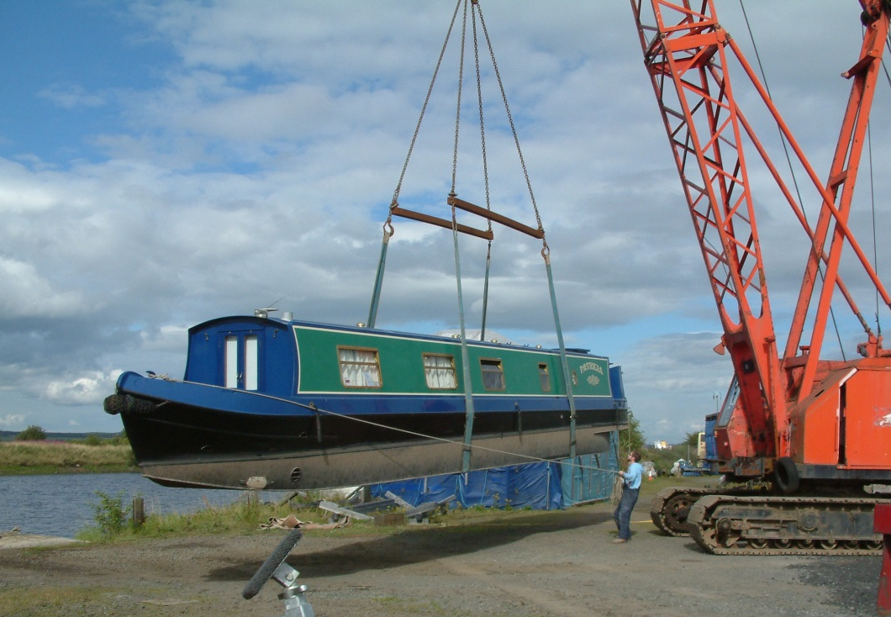
N5: Properties of Matter
Gravitational field strengths
Gravitational field strength
on the surface in N kg⁻¹
Earth | 9·8 |  |  | Specific heat capacity of materials
Jupiter | 23 |  |  | Material |  | Specific heat capacity in J kg⁻¹ ºC⁻¹
Mars | 3·7
Mercury | 3·7 |  |  | Alcohol |  | 2350
Moon | 1·6 |  |  | Aluminium |  | 902
Neptune | 11 |  |  | Copper |  | 386
Saturn | 9·0 |  |  | Glass |  | 500
Sun | 270 |  |  | Ice |  | 2100
Uranus | 8·7 |  |  | Iron |  | 480
Venus | 8·9 |  |  | Lead |  | 128
 |  |  |  | Oil |  | 2130
 |  |  |  | Sea water |  | 3900
Specific latent heat of fusion of materials |  |  |  | Water |  | 4180
Material |  | Specific latent heat  of fusion in J kg⁻¹
 |  | Specific latent heat  of fusion in J kg⁻¹ |  | Melting and boiling points of materials
Alcohol |  | 0·99 × 10⁵ |  | Material | Melting point in ºC |  | Boiling point in ºC
Aluminium |  | 3·95 × 10⁵
Carbon dioxide |  | 1·80 × 10⁵ |  | Alcohol | −98 |  | 65
Copper |  | 2·05 × 10⁵ |  | Aluminium | 660 |  | 2470
Iron |  | 2·67 × 10⁵ |  | Copper | 1077 |  | 2567
Lead |  | 0·25 × 10⁵ |  | Glycerol | 18 |  | 290
Water |  | 3·34 × 10⁵ |  | Lead | 328 |  | 1737
 |  |  |  | Iron | 1537 |  | 2737
Specific latent heat of vaporisation of materials
Material |  | Specific latent heat of vaporisation in J kg⁻¹
Alcohol |  | 11·2 × 10⁵
Carbon dioxide |  | 3·77 × 10⁵
Glycerol |  | 8·30 × 10⁵
Turpentine |  | 2·90 × 10⁵
Water |  | 22·6 × 10⁵
With thanks to Mr John Sharkey, Virtual National 5 Physics for the images on pp5,7,8,9

N5 PHYSICS DATA SHEET

Relationships Sheet
The formulae highlighted are those that are required for this unit.

Specific heat capacity Learning Intentions
- Knowledge that different materials require different quantities of heat to raise the temperature of unit mass by one degree Celsius.
- Use of an appropriate relationship to solve problems involving mass, heat energy, temperature change and specific heat capacity.
- Use of E=cmΔT
- Knowledge that the temperature of a substance is a measure of the mean kinetic energy of its particles.

HEAT
Is there a difference between HEAT and TEMPERATURE? Surely they are the same thing?
We often talk about heat and temperature as if they were the same thing – they are not! In this section we will investigate the link between the two terms.


200 ml water
100 ml water
At the start of the experiment the temperature of the water in both beakers is the same.
The bunsens are identical and the gas supply is constant so the heat that each beaker of water receives is the same.
At the end of a set time the 100 ml of water in the beaker will be hotter than the 200 ml water in the other beaker.
 | 100 ml water | 200 ml water
Start Temp (ºC) | 25 | 25
Final Temp (ºC) | 80 | 67
Increase in Temp (ºC) | 55 | 42
Conclusion
After 2 mins there was a temperature increase in each beaker. The smaller beaker had a higher increase in temp as there was less mass of water to heat.
Energy input is proportional to the rise in temperature. E_{h} α T
Temperature and Heat are related. The heat caused a change in temperature but they are NOT the same thing......

Summary
Temperature is a measure of how HOT or COLD something is; it is measured in degrees Celsius, ºC or Kelvin K. On the degrees Celsius scale water boils at 100 ºC and freezes at 0 ºC. In reality
Temperature is a measure of the mean (average) kinetic energy of the particles in the material
Heat is a name given to thermal energy. Heat is a form of energy and is measured in Joules, J.
We would define heating as transferring thermal energy from one body at a high temperature to one at a lower temperature.
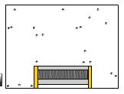
Heat is a scalar quantity.

Heating Materials
We can heat an object by using various types of heaters, for example an electrical convector heater to heat the air in a room, a kettle to heat water, a camping stove to melt snow on a mountain. What happens to the object when we heat it?
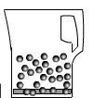
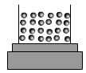
When we supply heat to the air in a room the air molecules move faster. The kinetic energy of the molecules increases.
When water is heater in a kettle the water molecules vibrate faster. When snow is heated the vibration of the molecules increases and eventually the solid turns into a liquid.

From your work in BGE you should know that there are three ways that heat can be transferred. (Remember heat travels from hot places to cold places.)
CONDUCTION
Hot particles vibrate more than cold; this vibration can be passed from one particle to another, so heat travels through the substance. Conduction occurs mainly in solids. Metals are good conductors, gases and liquids are poor conductors or insulators.

CONVECTION
When a gas or liquid is heated the particles spread out more and become less dense. This causes the hot substance to rise. As the hot substance rises it cools and falls, setting up convection currents.
RADIATION
Energy in the form of electromagnetic rays travels in all directions from a hot body; this is the only method of heat transfer through a vacuum, eg. space.
What affects the rate of heat transfer?
Heat is lost when one place is hotter than the other. The greater the temperature difference between the two surfaces the more rapid the loss in heat.
If the temperature inside and outside is the same then the objects are in equilibrium and for every joule of energy being absorbed a joule is given out.

20 °C
12 °C
10 °C
6 °C
15 °C
12 °C
18 °C
9 °C
22 °C
16 °C
15 °C
12 °C
Day 2
Day 3
Day 5
Day 6
Day 4
Day 1
Questions
- State which house cools down the fastest.
- State which house cools down the most slowly.
- Explain what happens on day 6.
If the inside of a house is cooler than the outside heat will be absorbed.

Specific Heat Capacity
So what can affect the temperature that an object gets to?
How much heat is needed to increase the temperature of an object?
This is likely to depend on:
- the temperature rise, i.e the change in temperature ΔT
- the mass of the material m
- the material of the object, e.g. copper or water.
How does the temperature rise depend on the heat supplied?
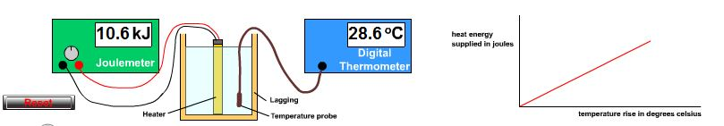

The joulemeter measures the energy supplied to the water. The temperature of the water is measured with the digital thermometer. The graph shows that the heat supplied is directly proportional to the temperature rise.
The beaker is lagged to reduce heat losses, although it is vital to have a lid on the top!
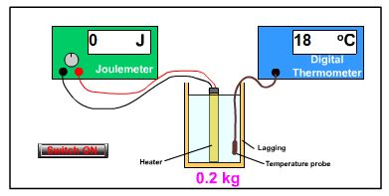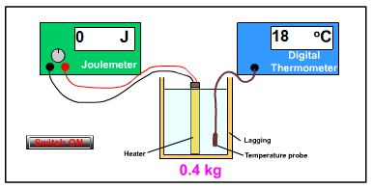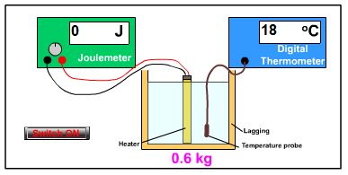
How much heat is needed to produce a 5°C increase in the temperature in different masses of water.

- If we switch on the three heaters. The temperature rises in each of the three beakers
- Note the energy required to increase the temperature by 5 °C in each of the beakers.
- Notice that a larger mass requires more heat to increase the temperature by 5°C We need double the heat energy when we double the mass to increase the temperature by the same.
We say that the Heat energy is directly proportional to the mass.
$$E_{H}∝m$$
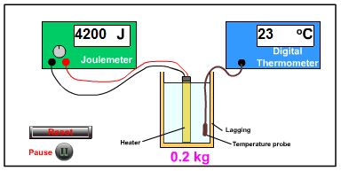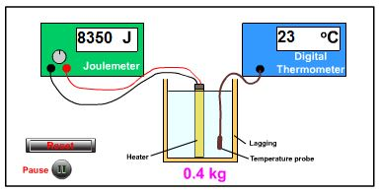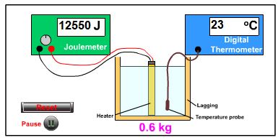

The equipment below shows how the equipment can be used to investigate how much heat energy is needed to increase the temperature of different materials. Heat is supplied to three different materials, copper aluminium and water. To make the test fair, each material is supplied with energy from a 50 W heater. Each material has a mass of 1 kg. The heaters are switched on for a set time.
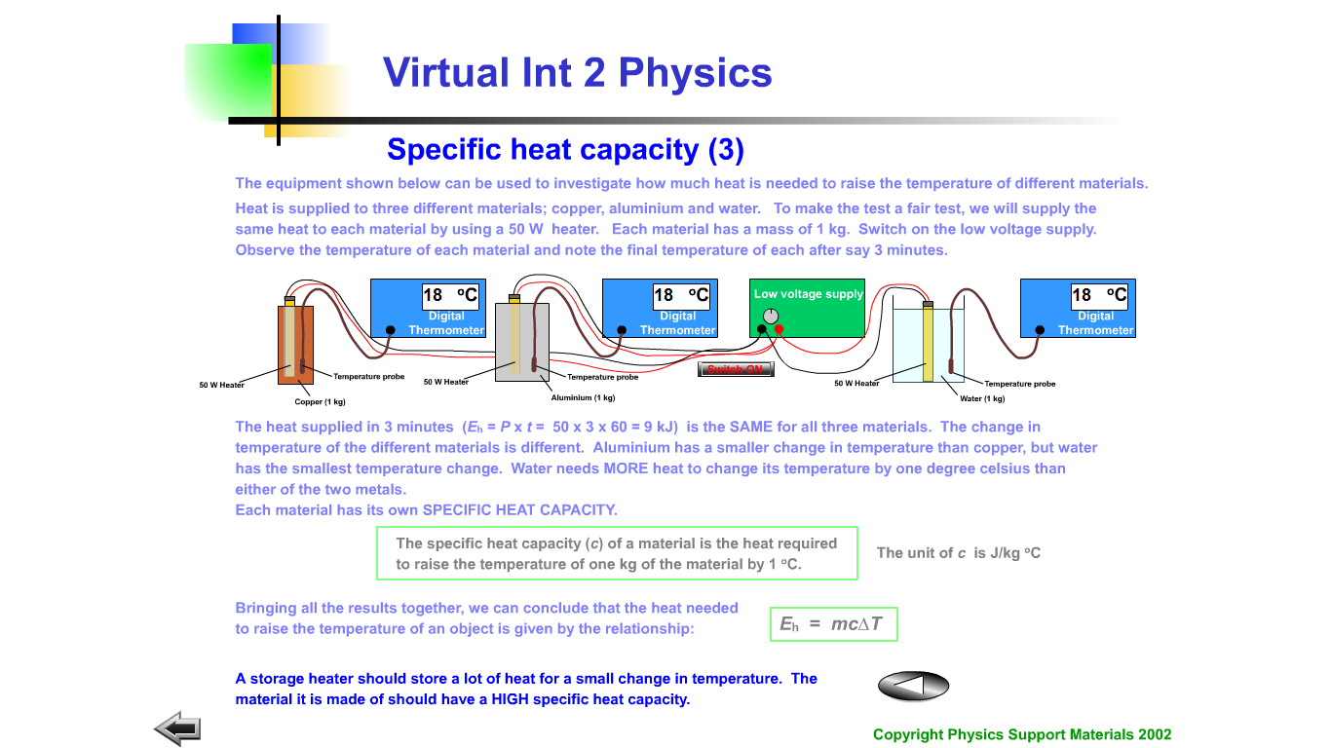
The heat supplied in three minutes is E=Pt = 50 × 3 × 60= 9 kJ is the same for all three materials. The change in temperature is different for each of the materials; Aluminium has a smaller change in temperature than copper but water has the smallest change in temperature. Water needs MORE heat to change the temperature by 1°C than either of the other two metals. Each material has its own specific heat capacity.
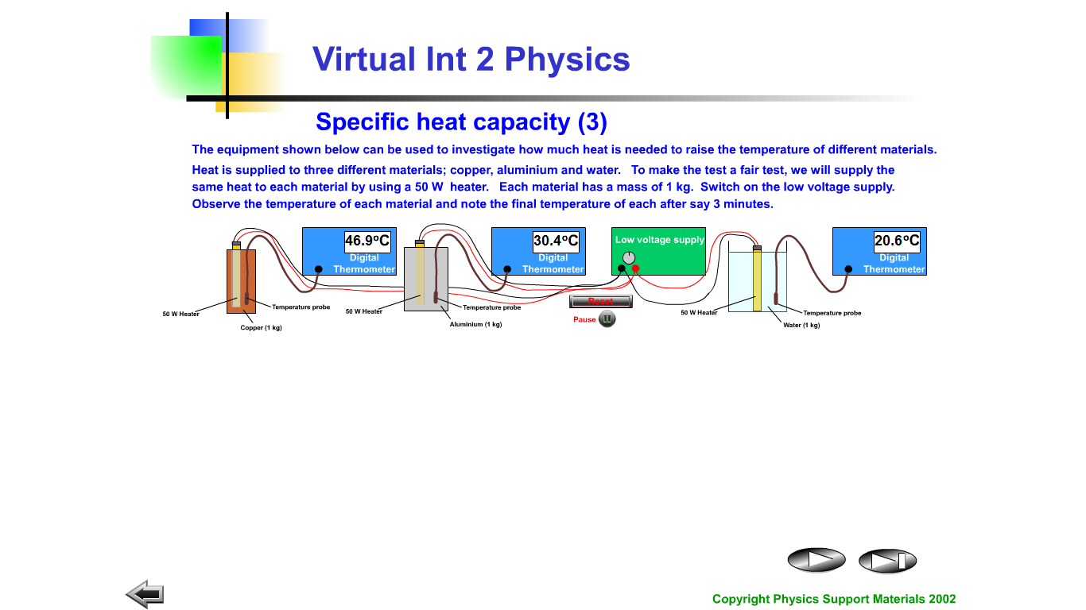
Task:
From the results in the pictures calculate the specific heat capacity for the three materials.
Title: Specific heat capacity
Aim: To measure the specific heat capacity of different metals.
Apparatus: 1 kg metal blocks, thermometer, immersion heater, power supply, stopclock.
Instructions
• Set up the apparatus as shown.
• Note the value of the power of the heater.
• Note the temperature of the metal block before heating.
• Note the temperature of the metal block after heating for 5 minutes.
• Calculate the electrical energy supplied to the heater.
• Calculate the specific heat capacity of the metal.
For different substances, it takes varying amounts of energy to raise the temperature of 1 kg by 1 oC; the amount of energy required is called the SPECIFIC HEAT CAPACITY of the substance.

From the experiments and models that we completed over the last few days we found the following:
That the greater the mass you need to heat the lower the final temperature will be for the same thermal heat supplied.
greater m requires more heat to heat
The more heat provided to a mass the greater the final temperature.
greater Eh leads to greater changes in T for same mass
The temperature rise depends on the type of material. The property, which relates to temperature, is called its specific heat capacity, c. Measured in Joules per kilogram degrees Celsius. (J kg⁻¹°C⁻¹) )
more Eh is required to increase the temperature of different materials for same mass
Specific Heat capacity is the energy required to raise the temperature of 1kg mass by 1°C
or
Specific Heat capacity is the energy given out when temperature of 1kg mass goes down by 1°C
So the heat energy supplied to a material will heat it up and increase its temperature. Heat loss, in a given time depends on the difference in temperature between the inside and outside. Remember that if the temperature outside is higher heat will pass inside.
Collecting all those results together
$$E_{H}=m×c×T$$
Where
E_{H}= heat energy
m= mass (kg)
c= specific heat capacity (Jkg^{-1 o}C⁻¹ )
ΔT is the change in temperature (sometimes you will see this as T₂-T₁ (ºC)
Beware when rearranging this equation. Many pupils write out the rearranged equation correctly but cannot properly use their calculators and this result in the wrong answer being obtained.
e.g Suppose we need to find the change in temperature of a material. The formula needs to be written as:
Do NOT enter the following in to your calculator.
ΔT=Eh÷m×c
as this will cause your answer to be too big. If you do this your calculator will divide the energy by the mass and then multiply by the whole thing by c so you are effectively doing the equation ΔT=(Eh×c)÷m
Instead do:

Tutorials: Specific Heat Capacity
Use the equation E_{h}=mc ΔT
Where m-mass, c=specific heat capacity and ΔT is the temperature change
Quick check: Knowing what you do about heat, temperature and specific heat capacity can you explain why some foods seem much warmer on the tongue than others when cooked, e.g. tomatoes in a cheese and tomato toastie?
Worked example:
When a kettle containing 2kg of water (specific heat capacity 4180J kg⁻¹°C cools from 40°C to 20 °C, calculate the heat energy given out by the water.
E_{H} = 4180 x 2 x 20  E_{H} = 167,200 or 167kJ | c = 4180 J/kg  m = 2kg  T₂ = 40  T₁ = 20  therefore = T₂ – T₁ = 20  E_{H} = ?
Questions
- 10000 J of energy raises the temperature of 1 kg of liquid by 2 °C. Calculate the energy required to raise the temperature of 4 kg of the liquid by 1 °C.
- The specific heat capacity of concrete is about 800 J kg⁻¹°C⁻¹. How much heat is stored in a storage heater containing 50 kg of concrete when it is heated through 100 °C?
- 1.344 MJ of heat energy are used to heat from 20 °C to 100 °C. Calculate the mass of water
- 9600 J of heat energy is supplied to 1 kg of methylated spirit in a polystyrene cup. Calculate the rise in temperature produced.
- When 2.0 x 10⁴ J of heat is supplied to 4 kg of paraffin at 10°C in a container the temperature increases to 14 °C.
  - Calculate the specific heat capacity of the paraffin.
  - Explain why the result in part a) is different from the theoretical value of 2200 J/kg°C.
- If a kettle containing 2 kg of water cools from 40 °C to 25 °C, calculate the heat given out by the water.
- The temperature of a 0.8 kg metal block is raised from 27 °C to 77 °C when 4200 J of energy is supplied. Find the specific heat capacity of the metal.
- The tip of the soldering iron is made of copper with a mass of 30 g. Calculate how much heat energy is required to heat up the tip of a soldering iron by 400 °C.

- The graph below represents how the temperature of a 2 kg steel block changes as heat energy is supplied. From the graph calculate the specific heat capacity of the steel.

More Practice Problems
- Calculate the energy required to heat up 1 kg of sea water by 1°C?
- A 4 kg bar of aluminium is supplied with 1800J of heat energy. What temperature increase would be measured?
- A cup of boiling water cools down from 95°C to 80°C. If the mass of water in the cup is 0.1 kg, how much heat energy is lost?
- An immersion heater is used to heat 30 kg of water at 12°C. The immersion heater supplies 8.6MJ of heat. Ignoring heat losses to the surroundings calculate the final temperature of the water.
- A 250g block of copper is allowed to cool down from 80°C to 42°C. Calculate the heat energy will it give out?
- During an experiment, a girl supplies 12,000J of energy to 0.25kg of water in a glass container.
  - Calculate the temperature increase.
  - She finds the temperature increase is less than expected. Explain why this might have happened.
  - Explain how she could reduce this heat l0oss?
- Which of the following would give out more heat energy?
A — a 2 kg block of aluminium as it cools from 5°C to 20°C
B — a 4 kg block of copper as it cools from 83°C to 40°C?
8. Fire clay blocks of specific heat capacity 800Jkg–1°C–1 are used in a night storage heater.
a) If 60kg of blocks are heated by 100°C, how much heat energy is supplied to the blocks?
b) If the heater has an output power rating of 1kW, how long will it take to heat the blocks?
c) In practice it takes longer to heat the blocks. Suggest a reason for this.
9. Oil filled radiators are a useful means of providing heating in a room. An electrical element heats up the oil inside the radiator which contains 2 kg of oil of specific heat capacity 2,500 J kg^{–1}°C^{–1}.
a) If the temperature of the oil is raised from 15 °C to 40 °C, how much heat energy is supplied to the oil?
b) The heater takes 8 minutes to heat the oil through the above temperature change. What is the output power of the heating element?
c) The element works at 230 V. What is the current in the element while it is heating the oil? Assume the heating element is 100 % efficient.
10 An electric cooker has a 500W heating element. It takes the heating element 5 minutes to raise a 1kg pan of water from 20 °C to 60°C.
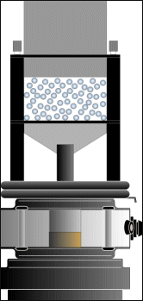
a) Determine the value this information gives for the specific heat capacity of water?
b) Why is this value lower than it should be? Temperature of a Gas

Temperature of a Gas
The particles of a gas are in constant movement. Sometimes they collide with each other and the walls of the container. This atomic model of a gas is called the Kinetic Theory.
All the particles in the gas are not travelling at the same speed. When they collide they might speed up or slow down. When the gas is heated by an outside heat source all the particles move with an increased speed. The more the particles are heated the faster the average speed of the particles.. Therefore the average kinetic energy of the particles increases. When the temperature of the gas decreases the average speed (and therefore the average kinetic energy) of the particles increases. The temperature of a gas depends on the average kinetic energy of the particles. The higher the average kinetic energy of the particles the higher the temperature of the gas.
We can represent the kinetic theory of a gas with the apparatus below. Watch the teacher demonstration of this, and create a table of model and kinetic theory equivalent.
Moving plastic balls representing molecules bombard a plastic piston and suspend a plastic piston. Increasing the frequency of the Vibration Generator increases the average kinetic energy of the molecules - this is analogous to increasing the temperature of a gas. This results in the particles pushing the piston up i.e. the volume of the gas increases with temperature.

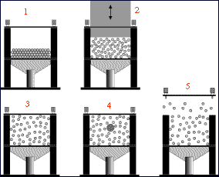
The diagrams opposite represent :
1 Solids
2 Gas under a piston
3 Gaseous state
4 Brownian motion
5 Boiling liquid

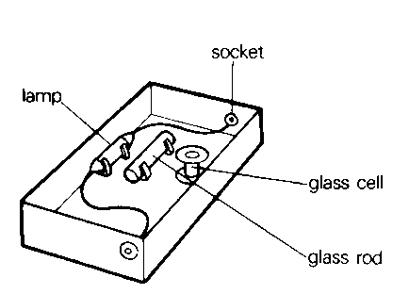
The basic assumption of the kinetic theory is that “ALL MATTER CONSISTS OF MOVING PARTICLES”.
Evidence of this was discovered by Robert Brown in 1827.
Watch the demonstration of Brownian motion.
Explanation
The first accurate explanation of this phenomenon was by Albert Einstein in 1905. According to the Kinetic Theory the air particles that are around the much larger ash particles are moving randomly and they keep colliding with each other.
Despite the much larger size of the ash molecules they are still affected by the collisions with the air particles.
The randomly occurring collisions produce unbalanced forces which cause the ash molecules to move and hence explain the random paths seen.
Pressure is caused by the gas molecules striking the container walls. The pressure on a container remains constant suggesting that there is a very large number of molecules hitting the container walls at any time, so there must be a huge number of molecules in the container.

Kelvin
In Physics we often use the Kelvin temperature scale instead of Celsius. A difference of one kelvin and one Celsius are the same however the Kelvin scale starts at a different temperature. Whilst zero on the Celsius scale is at the freezing point of water the Kelvin scale has zero at ‘absolute zero‘ — the temperature at which all particle motion stops — which is at –273°C.

The Kelvin Temperature Scale
ºC
K
100
0
-273
373
273
0
Absolute zero
to change ºC to K ADD 273.
to change K to ºC SUBTRACT 273.

Practice Problems
1. Convert the following temperatures from Celsius to kelvin:
a) 0°C b) 100° c) –273°C d) 22°C e) 500°C
2. Convert the following temperatures from kelvin to Celsius:
a) 300K b) 5000K c) 267K d) 4K e) 423K

Success Criteria Specific heat capacity
 | 14.1 | I know that the same mass of different materials require different quantities of heat energy to raise their temperature by 1 degree Celsius.
 | 14.2 | I am able to use E_{H} = c m ∆T to carry out calculations involving: mass, heat energy, temperature change and specific heat capacity.
 | 14.3 | I am able to explain that the temperature of a substance is a measure of the mean kinetic energy of its particles

learning intentions specific latent heat
- Knowledge that different materials require different quantities of heat to change the state of unit mass.
- Knowledge that the same material requires different quantities of heat to change the state of unit mass from solid to liquid (fusion) and to change the state of unit mass from liquid to gas (vaporisation).
- Use of an appropriate relationship to solve problems involving mass, heat energy and specific latent heat.
- $E_{H}= ml$ 
- Use of the principle of conservation of energy to determine heat transfer
The three states of matter that we will deal with are SOLID, LIQUID and GAS. 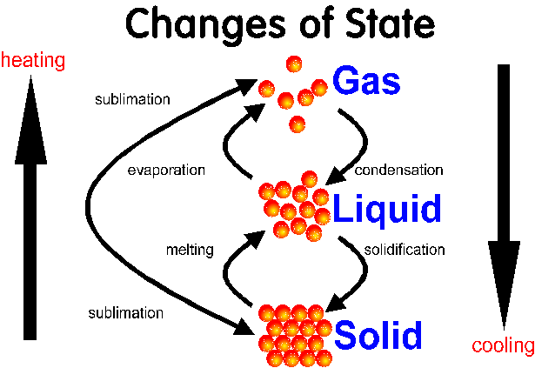
Freezing

LATENT HEAT INTRODUCTION
- To observe temperature changes in a sample of stearic acid as it cools from the liquid to the solid state
- To associate each region of the graph with the liquid, solid and the transition between them
- To associate the flat region on the graph with the change of state at the melting point temperature
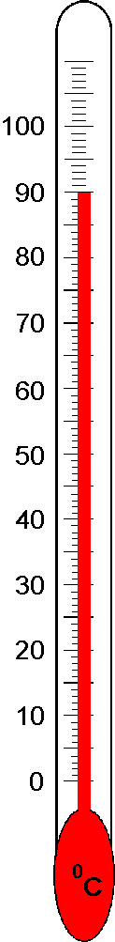
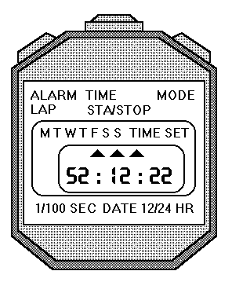
- Place temperature probes or thermometers in each of the boiling tubes.
- Set up the ALBA interface with the two temperature probes and set the temperature to be recorded every 5 s
- Collect two boiling tubes from the water bath, one containing water, and one stearic acid.
- Leave the two boiling tubes to cool, do not move the probes of thermometers during the experiment.
- Note the temperature and any change to the material in each boiling tube.
- DO NOT remove the temperature probes, but place the boiling tubes with their complete contents back in the water bath
- Compare your temperature profiles to the one given below. 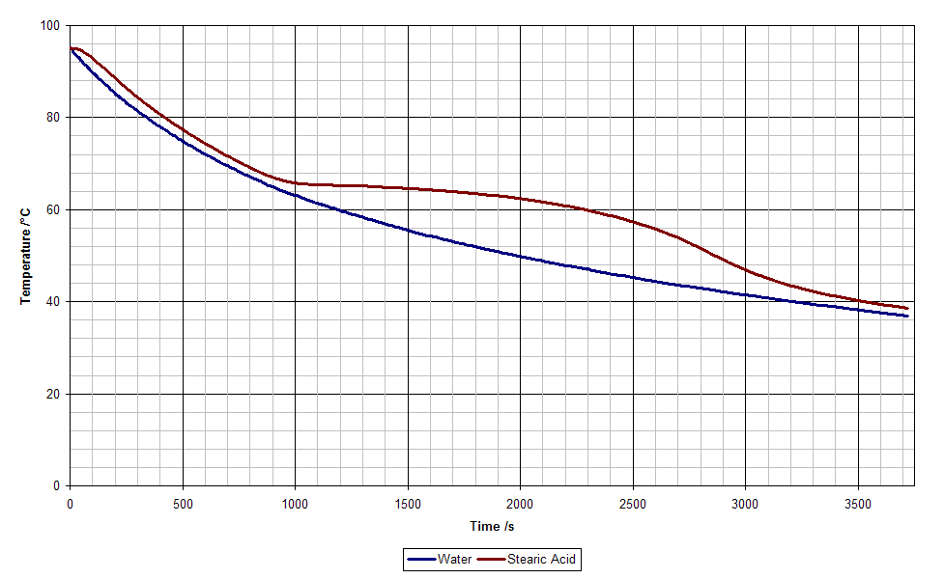

If something is hotter than its surroundings it will give out heat. Usually this results in a drop in temperature. However, the stearic acid WAS hotter than its surroundings so it must have been giving off heat but this was not causing a drop in temperature but was causing the stearic acid to change its state or solidify. This is quite hard to understand so we will look at it from a heating rather than cooling perspective.
- When we take a solid and begin to heat it we add energy to the substance. This causes an increase in the average speed and hence kinetic energy of the particles.
- At its melting point the heat energy added no longer increases the average kinetic energy of the particles but changes the bonds holding the particles together, changing the solid into a liquid.
- Energy has to be added to do this task, it comes from heating the material, but there is no increase in temperature.
- Exactly the same thing happens when the liquid reaches its boiling point.
- The energy is used to break the bonds of the liquid causing a gas to be produced.
- Again as this happens there is no change in the average kinetic energy and hence temperature of the particles.

solid
melting
Heat liquid
Heat solid
Heat gas
Boiling liquid
melting point
add energy
Temperature (°C)
Time
Boiling point
remove energy
liquid
freezing
cool liquid
cool
solid
cool gas
condensing gas

Measuring the Specific Latent Heat of Vapourisation of Water
Aim:To calculate l_{v} by experiment.
Method

- Half fill a kettle with water and place it on a triple beam balance.
- Measure the total mass of the kettle and water.
- Adjust the balance to be 500 g (0·5 kg) less than the starting mass.
- Plug the kettle into the ALBA power/energy meter and set it up to record the total energy used.
- Switch on the kettle and boil the water.
- When the water starts boiling remove the lid from the kettle (this allows the steam to escape and prevents the automatic switch-off operating). Start the ALBA recording the energy used.
- Switch off the kettle and then stop recording with ALBA once 500 g of water have been boiled off. This will be indicated by the scales becoming balanced again.
- Record the total energy used in evaporating 0.5 kg of water.
- Record the new mass and find the total mass boiled off.
- Using find .

Results
Total mass of the kettle plus water at the start of the experiment = 1543 g = 1.543 kg
Total mass of the kettle plus water at the end of the experiment = 1030 g = 1.030 kg
Total energy used = 951582 Joules
Total mass of water evaporated = 1.543 – 1.030 = 0.513 kg.
The expected value for l_{v} is 2.25 x 10⁶ J/kg.

Evaluation
Possible sources of error:
- Alba switched on at the correct time.
- Water droplets being ejected from the kettle due to the boiling action.
- Water recondensing back into the kettle (although this would raise the measured value)
- Accuracy or precision of the ALBA.

SPECIFIC LATENT HEAT
Specific latent heat is the heat energy required to change the state of one kilogram of a material without a change in temperature.
There are two types of latent heat, latent heat of fusion and latent heat of vaporisation.
SPECIFIC LATENT HEAT OF FUSION is the energy required to change one kilogram of a substance from a solid to a liquid without a change in temperature. It is measured in JOULES PER KILOGRAM (J/kg)
or
SPECIFIC LATENT HEAT OF FUSION is the energy given out when one kilogram of a substance change from a liquid to a solid without a change in temperature. It is measured in JOULES PER KILOGRAM (J/kg)
SPECIFIC LATENT HEAT OF VAPOURISATION is the energy required to change one kilogram of a substance from a liquid to a gas without a change in temperature. It is measured in JOULES PER KILOGRAM (J/kg)

or
SPECIFIC LATENT HEAT OF VAPOURISATION is the energy given out when one kilogram of a substance change from a gas to a liquid without a change in temperature. It is measured in JOULES PER KILOGRAM (J/kg)

COOL BOXES
Cool boxes are used to keep food cool for picnics.
The walls of the box are well insulated which reduces the heat transfer.
The most important part of the box is the ice pack that goes in it.
The pack is put in the freezer until the chemicals have cooled and changed into a solid.
You put the food in the bottom (why?)
The packs absorb the heat from the box and food and the chemicals in the pack change from a liquid from a solid keeping the food cool.

The FRIDGE
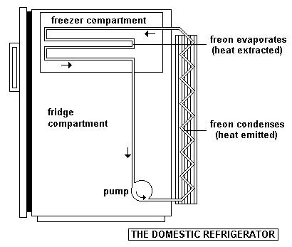
A fridge works because it changes the state of a liquid. The liquid is pumped through a narrow pipe. It expands and the heat from inside the fridge is used to change the liquid to a gas. This cools the fridge. The pump takes the vapour and compresses it (squashes it) up into thin pipes at the back. The gas changes to a liquid and gives out the heat. This is why the back of the fridge or freezer is hot.
The chemical must have
a) a high latent heat of vaporisation
b) a low boiling point.

Questions Specific Heat Capacity Questions and Specific Latent Heat
Use the following equations to help you answer the homework
Pt = mcΔT, E_{H} = mcΔT E_{H}=ml_{v} E_{h}=ml_{f}
- c = the heat energy needed to heat 1 kg of a substance by 1ºC
- l_{v} is the energy required to boil 1kg of a substance without a change in Temp.
- l_{f} is the energy required to melt 1kg of a substance without a change in Temp
(The specific heat capacity of water is 4180Jkg⁻¹°C⁻¹ and cast Iron is 380J kg⁻¹°C⁻¹. The specific latent heat of fusion of ice is 334 000 J kg⁻¹ and the specific latent heat of vaporization of water is 2 260 000 Jkg⁻¹) )
- Explain the following terms;
  - conduction, b) convection c) radiation
- A mass of 5.0 kg of ammonia at its boiling point is vaporized when 6.5 MJ of heat are supplied to it. Calculate the specific latent heat of vaporization of ammonia.
- Calculate the amount of heat which must be supplied to change a 2kg block of ice to water at 0ºC.
- Calculate the heat required to raise the temperature of 2kg of water from 0ºC to 40ºC?
- Determine the energy required to change 2 kg of ice at 0ºC to water at 40ºC?
- Calculate the energy needed to supply 1.2 kg of water from 20°C to 100°C?
- If 5000J of energy is used to heat 0.8 kg of iron,
  - Determine the temperature rise?
  - If its initial temperature is 30°C, what temperature does it reach?
- In a central heating system, steam at 100 ºC enters a radiator, and water at 100 ºC leaves the radiator. Explain whether this process can warm a room.
- Calculate the specific latent heat of naphthalene given that 2.98 ×10⁵ J of heat are given out when 2.0 kg of naphthalene at its melting point changes into a solid.
- A kettle is used to heat water from 20°C to boiling point. It has a power of 2000W and takes 120 seconds to boil.
  - Determine the energy supplied to the kettle?
  - If all of this energy is used to heat the water, how much water is in the kettle?
- Calculate the amount of heat required to change 0.50 kg of liquid ethanol to vapour at its boiling point. (specific latent heat of vaporization of ethanol is 8.5×10⁵ J kg⁻¹).
- A 2.5 kW kettle is switched on for 100s after the water has started to boil. What mass of water is boiled off in this time?
- A bullet of mass 0.20 kg travelling at 400 ms⁻¹ embeds itself in a large block of ice at 0 C. Assuming that all of the bullet’s kinetic energy is totally changed into heat, calculate the mass of the ice which will melt.
- A car of mass 1000 kg is brought to rest from a speed of 20 ms⁻¹. Assuming that all of its kinetic energy is changed into heat in the disc brakes, find the temperature rise produced if each of the four brakes has a mass of 5.0 kg
- 5 kg of a plastic is heated from 10°C to 66°C using 36000J of energy. Determine the specific heat capacity of the plastic?
- The following results were obtained from an experiment to boil 100g of water:
- mass of water m = 0.1kg
- power rating of heater P = 600W
- time taken to boil water t = 380 s
  - Determine the energy supplied by the heater.
  - Assuming the heater is 100% efficient and all of the heat was used to boil the water what is the specific latent heat of water?

Questions on Latent Heat
- Calculate the amount of heat energy required to melt 0.3 kg of ice at 0 °C.
- Calculate the specific latent heat of fusion of naphthalene given that 6 x 10⁵ J of heat are given out when 4.0 kg of naphthalene at its melting point changes to a solid.
- Calculate what mass of water can be changed to steam if 10.6 kJ of heat energy is supplied to the water at 100 °C. (Specific latent heat of vaporisation of water = 2.26 x 10⁶ J/kg)
- Ammonia is vaporised in order to freeze an ice rink.
- Find out how much heat it would take to vaporise 1 g of ammonia.
- Assuming this heat is taken from water at 0 °C, find the mass of water frozen for every gram of ammonia vaporised. (Specific latent heat of vaporisation of ammonia = 1.34 x 10⁶ J/kg (Specific latent heat of fusion of ice = 3.34 x 10⁵ J/kg).
- The graph below shows how the temperature of a 2 kg lump of solid wax varies with time when heated.
a) Explain what is happening to the wax in the regions AB, BC and CD.
b) If a 200 W heater was used to heat the wax, calculate the specific latent heat of fusion of the solid wax.

CONSERVATION OF ENERGY & HEAT TRANSFER

Principle of the Conservation of Energy
The total amount of energy remains constant during energy transfers.

Energy cannot be created or destroyed but simply transformed to one of its many forms.

Example 1
A piece of brass of mass 2 kg is dropped onto a hard surface without rebounding resulting in a temperature rise of 1 °C. Calculate the speed with which the brass hits the surface.
m = 2 kg ΔT = 1 °C c = 370 J kg⁻¹°C⁻¹ v = ?

Assuming all the kinetic energy of the brass is changed on impact to heat in the brass,
Kinetic energy lost by brass = Heat energy produced in brass
$$½ mv^{2} = c mT$$
$$½ ×2×v^{2} = 370 ×2×1$$
$$v^{2} = 740$$
$$v = 27 {ms}^{-1}$$

Example 2
Calculate the time taken for a 500 W heater to melt 2 kg of ice at 0° C
Latent heat of fusion of ice = 3.34 × 10⁵ J kg⁻¹
P = 500 W m = 2 kg l_{f} = 3.34 × 10⁵ J kg⁻¹ t = ?

Energy required to melt the ice
$$E = ml$$
$$E = 2×3∙34×{10}^{5}$$
$$E = 6∙68×{10}^{5}$$
Time taken to melt ice
$t=\frac{E}{P}$

$$t = \frac{6∙68×{10}^{5}}{500}$$

$$t = 1336 s$$

Tutorial Questions on Principle of Conservation of Energy
- If 200 g of water at 40 °C are mixed with 100 g of water at 10°C and no energy is lost, calculate the final temperature of the mixture?
- If an immersion heater heats 300 g of water for 2 minutes and the temperature rises by 30 °C, find the power rating of the heater in watts.
- A 350 W element is used to boil 300 g of water in a cup. The initial temperature of the water is 20 °C.
  - Determine the time it takes to reach a temperature of 100 °C?
  - State any assumptions made.
- Meteors are small pieces of matter made mostly of iron. Few meteors hit the surface of the Earth because of the Earth’s atmosphere. Assuming all the kinetic energy of the meteor changes to heat energy in the meteor, if a 0.001 kg meteor travelling at 30000 ms⁻¹ crashes into the Earth’s atmosphere resulting in a change in temperature of 20 000 °C, calculate the specific heat capacity of the iron.
- If a copper ball is dropped on a hard surface the ball is deformed, and we can assume all the kinetic energy is transferred to internal energy in the ball. From what height must the ball be dropped to raise its temperature by 2 °C?
- An electric shower has a 1.5 kW heating element.
  - How much heat energy can it give out in five minutes?
  - If the element is used to heat 5 kg of water for 5 minutes, what would be the rise in temperature?
- A pupil put 2·0 litres of water at 20 °C into her 1000 W kettle. She switched it on and then forgot it for 15 minutes. Unfortunately, it did not have an automatic cut-out and when she came back the kitchen was full of steam. 1·0 litre of water has a mass of 1·0 kg.
  - Determine how much energy was required to bring the water to boiling point.
  - Calculate the electrical energy that had been used altogether.
  - Determine how much water had been turned into steam.
  - Which of your answers are approximate and why?
- A heating coil carries an electrical current of 2·0 A for 100 s at a voltage of 20·0 V. If this is sufficient to boil away 20·0 g of liquid nitrogen at its boiling point, what is the specific latent heat of vaporisation of nitrogen?
- A 200 g bun is put in a 600 W microwave oven for one minute. If its temperature rises from 15 °C to 45 °C, what is the specific heat capacity of the bun?

Success Criteria for Specific Latent Heat.
 |  | 15.1 | I know that different materials require different quantities of heat to change the state of unit mass.
 |  | 15.2 | I know that the same material requires different quantities of heat to change the state of unit mass from solid to liquid (fusion) and to change the state of unit mass from liquid to gas (vaporisation)
 |  | 15.3 | I can use E_{h} =ml to solve problems involving mass, heat energy and specific latent heat.
 |  | 14.4 | I can use the principle of conservation of energy to determine heat transfer.
 | Learning Outcomes for Gas laws and the kinetic model
- Definition of pressure in terms of force and area.
- Use of an appropriate relationship to solve problems involving pressure, force and area.
- $p=\frac{F}{A}$
- Description of how the kinetic model accounts for the pressure of a gas.
- Knowledge of the relationship between Kelvin and degrees Celsius and the absolute zero of temperature.
- 0K = -273 °C  
- Explanation of the pressure–volume, pressure–temperature and volume–temperature laws qualitatively in terms of a kinetic model.
- Use of appropriate relationships to solve problems involving the volume, pressure and temperature of a fixed mass of gas.
- $p_{1}V_{1}=p_{2}V_{2}$
- $\frac{p_{1}}{T_{1}(K)}=\frac{p_{2}}{T_{2}(K)}$
- $\frac{V_{1}}{T_{1}(K)}=\frac{V_{2}}{T_{2}(K)}$
- $\frac{p_{1}V_{1}}{T_{1}(K)}=constant$
- Description of experiments to verify the pressure–volume law (Boyle’s law), the pressure–temperature law (Gay-Lussac’s law) and the volume–temperature law (Charles’ law).

PRESSURE
Get into twos and call one of you A and one B. Those who are B put you hand on the desk and person A push down with their hand.
The force (in this case weight) is spread over a large area. This isn’t too painful. Why?
A
A
B
B
Because the pressure is small.
Then swap over group A put their hand on the table and group B push down on the hand but this time leaning on a pencil! STOP!!!! Don’t really do this. It is just to give a chance to the underdogs to get their own back as always the bossy ones choose to be A!
The force in this example is the same but no sensible person would let you push down. Why?
Because the pressure is concentrated over a very small area. i.e. the pressure is large.
When an object exerts a force on another object, this force is spread across the entire surface area of contact. For example a wooden block sitting a table will exert a force on the table top due to the weight of the block. If the box is turned on its end, it will exert the same force but over a smaller surface area.
The amount of force exerted on a unit area is defined as pressure

Symbol | Name | Unit | Unit Symbol
P | Pressure | Pascal | Pa
F | Force | Newton | N
A | Area | Square Metre | m²

The unit of pressure is the Pascal. One Pascal of pressure occurs when one Newton of force acts on an area of one square metre. 1 Pa = 1 N m⁻²

When F acts at 90º to the surface i.e. NORMAL to the surface.
$$p= \frac{F}{A}$$
Additional Notes (Not likely to be required for N5)
Force, F
F cos θ
θ
If the force is applied at an angle the component of force has to be calculated

If the force is not acting along the normal, take the component along the normal before calculating pressure.

Pressure in everyday situations
An elephant has a large total foot surface area, preventing it from sinking into the Earth’s surface.
A knife has a very small surface area creating a large pressure. This allows food to be cut more easily.

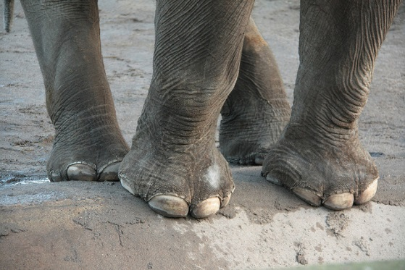
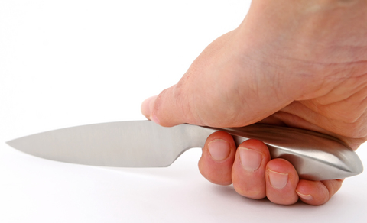


A stiletto heel has a tiny total foot surface area, so even though the weight of the wearer can be quite small they can produce huge pressure.

Pressure in not so everyday situations
“Jealous ex jailed after smashing stiletto heel into love rival’s eye
Student stabbed Christian Louboutin stiletto heel into man's eye after bust-up over crisps in Piccadilly taxi queue
Vile mum stabs woman with stiletto heel in mistaken identity attack
A TWISTED mum smashed a stiletto heel through a woman’s face in a case of mistaken identity”

Measuring Pressure probably additional notes for N5

Pressure can be measured using a BOURDON GAUGE. It works a bit like a party tooter.
Blow here (force air in) and the party tooter unravels.

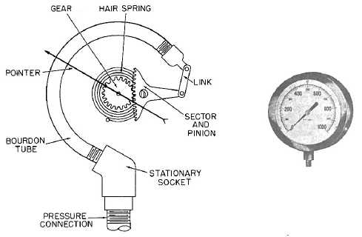
The Bourdon gauge works in a similar way. the flattened tube is made of metal with a pointer on the side. as the pressure increases the coil unravels (but only a little bit) and the pointer moves.
The Bourdon gauge does NOT read zero when left in a room. It would read ATMOSPHERIC PRESSURE (approximately 1 atmosphere = 10⁵ Pa)

Questions on Pressure Force and Area

Worked example – Pressure, force and Area
m  A  F  P | = 75 kg  = 0.5 cm² = 0.5 x 10⁻⁵ m²  = mg = 75 x 9.8 = 235 N  = ? | P  P | = 235/0.5 x 10⁻⁵  = 4.7 x 10⁷ Pa
An ice skater has a mass of 75 kg, when standing on one leg on the ice their skate has a surface area of 0.5 cm². What is the pressure exerted by the skater on the ice?

  - A cube of side 3·0 m is sitting on a bench. If the mass of the cube is 27·0 kg, calculate the pressure on the bench?
  - A man of mass 70·0 kg is standing still on both feet. The average area of each foot is 0.025 m².
        - Calculate the force the man exerts on the ground (his weight in N).
        - Calculate the pressure exerted by the man on the ground.
        - If the man now stands on only one foot, calculate the pressure this time.
  - A man of mass 60·0 kg is standing on a block of wood measuring 0·28 m × 0·08 m. Calculate the pressure on the ground.
  - A woman of mass 60·0 kg stands on one high heeled shoe. The area of sole in contact with the ground is 1·2×10^{–3} m². The area of the heel in contact with the ground is 2·5 ×10^{–5} m². Calculate the pressure on the ground.
  - Although the man in question 4 and the woman in question 5 had the same mass, they did not exert the same pressure on the ground. Explain why this is the case.
  - Explain why is it necessary to wear snow shoes to walk over soft snow?
  - Air molecules exert an average force of 6×105N on a wall. The wall measures 2 m × 3 m. What is the air pressure in the room?
  - Hydrogen molecules at low pressure exert an average force of 3×104N on one wall of a cubic container. One edge of the cube measures 2m. Calculate the pressure of the hydrogen.
  - The pressure of air at sea level is approximately 1×105Pa. Calculate the average force that air molecules exert on a wall at sea level measuring 3 m × 5 m?
  - Comment on the force exerted on an identical wall 10,000m above sea level.
  - Explain why the use of large tyres helps to prevent a tractor from sinking into soft ground.
  - A box weighs 120N and has a base area of 2m². Calculate the pressure the box exerts on the ground?
  - If atmospheric pressure is 100,000 Pa, calculate the force the air exerts on a wall of area 10 m².
  - A rectangular steel block measures 10cm x 8 cm x 6 cm and has a mass of 4kg. Calculate the greatest and the least pressure which it can exert on a surface?
  - Estimate the pressure you can exert on the floor when you are standing on one foot.

Gas laws and the kinetic model

Gas Pressure
A gas consists of very small particles, which are all very far apart and which all move randomly at high speeds. The study of gases by treating them as particles free to move in any direction is known as Kinetic Theory. These particles collide with one another and with anything else they come in contact with. Each particle exerts a tiny force on the wall of the container as it collides with it. The addition of the forces from these many collisions can become very large. The average size of this overall force divided by the area of the container gives the pressure of the gas.
Thus with particle continuously bombarding the container walls, the gas exerts a pressure on the container. On average they are 10 molecular diameters apart and move at speeds of around 500ms^{–1}

Diagram showing gas particle collisions in a container.
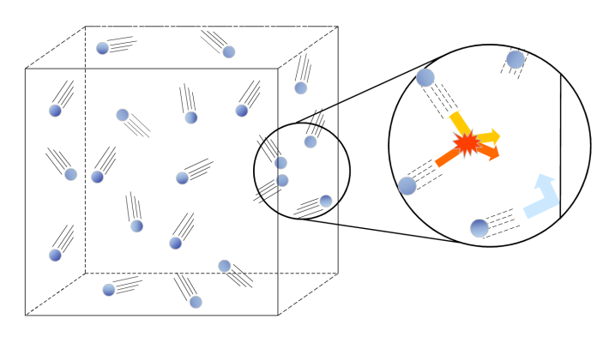
http://www.docstoc.com/docs/113002286/Kinetic-Molecular-Theory---PowerPoint

KINETIC THEORY OF GASES
This model is based on the following assumptions:
- ALL GASES ARE MADE UP OF DISTINCT PARTICLES
- THE PARTICLES COLLIDE WITH EACH OTHER AND WITH THE WALLS OF THE CONTAINER
- There are a large number of particles in a container.
- All particles are moving
- The particles move in random directions
- The particles have a range of speeds
- The hotter the temperature of the gas the higher the average speed of the particles.
- The actual volume of the particles is negligible compared with the volume of the container
- All collisions are perfectly elastic and lose no kinetic energy when they collide with the walls of the container
- Particles do not exert forces on each other except during collisions
- The time of contact spent by the particles is negligible
- The particles obey Newton’s Laws.
- The faster they move the more often and more violent the collisions with the walls, greater impulse therefore greater force.
- If the volume is less they will collide more often as there is a shorter distance between the container walls.
KINETIC THEORY
All particles are moving.
Pressure is caused when the particles collide with the container walls
The hotter the particles the higher their average speed.
The greater their average speed the more often and more violent the collisions with the walls, greater impulse therefore greater force.
If the volume is less they will collide more often as there is a shorter distance between the container walls

Temperature, energy and the kinetic model
As discussed above, the temperature of an object is a measure of the mean kinetic energy of its particles. The most common everyday temperature scale is the Celsius scale (often wrongly referred to as the centigrade scale). This scale is based on the freezing (0 ºC) and boiling point of water (100 ºC). However the SI unit of temperature is the Kelvin (K). On the Kelvin scale, water freezes at 273 K and boils at 373 K. (Note that a temperature in Kelvin is written as, say, 300 K and not 300 °K.) Like the Celsius scale, the difference between the boiling and freezing points of water is 100 units on the Kelvin scale, which means that a temperature difference of 1 K is equal to a temperature difference of 1 °C. So the size of a temperature unit is the same on both scales. The scales differ in the point at which zero is defined, 0 K is defined as the point at which the particles of a substance have no kinetic energy. 0 K is equivalent to -273 °C.
To convert between Kelvin and Celsius :-
Temperature in K = Temperature in ºC + 273
To convert between Celsius and Kelvin :-
Temperature in ºC = Temperature in K – 273

Questions on Kinetic Theory
- State two things can you say about the movement of the particles in a gas.
- How does raising the temperature of the gas affect the particles in the gas?
- What determines the “shape” of a gas?
- If a jar of gas was opened in the middle of your classroom what would the gas do and what would determine the new volume of the gas?

GAS LAW TASK:
- Use the KINETIC THEORY to explain how:
  - pressure would vary with volume;
  - volume would vary with temperature;
  - pressure would vary with temperature.
- Then design one of the experiments given above.
- For each one:
  - Draw a diagram of the apparatus.
  - Then try the experiments.
- Draw a table and graph of the results
- Record the law as a conclusion.
http://www.schoolphysics.co.uk/age16-19/Thermal%20physics/Gas%20laws/text/Gas_laws/index.html

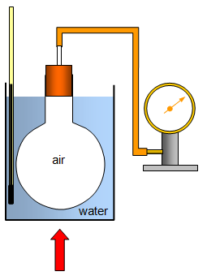
Temperature and Pressure
We will look at the relationship between the temperature and pressure of a fixed mass of gas, with the volume of the container kept constant.

According to the kinetic theory, the average speed of the gas particles increases with increasing temperature. The hotter the gas, the faster the gas particles are moving. We stated earlier that when a particle collides with a wall of a container a force is exerted. The force exerted depends in the speed of the particle, so the faster the gas particles are moving, the greater the pressure exerted by the gas on the walls of the container.
For a fixed mass of gas at fixed volume,
$$P∝ T$$
or
$$\frac{P}{T}=constant$$
Therefore
$$\frac{P_{1}}{T_{1}}= \frac{P_{2}}{T_{2}}$$

Temperature must be given in Kelvin!
TEMPERATURE – PRESSURE LAW
The pressure of a fixed mass of gas at constant volume is directly proportional to its temperature in kelvin
TEMPERATURE – PRESSURE LAW :- Kinetic Theory Summary
- If the temperature of a sealed container full of gas is increased (and the volume stays the same), the kinetic energy and hence velocity of the gas molecules increases.

- The gas molecules therefore hit the walls of the container harder and more often (with a higher frequency) - so the pressure increases.

According to the KINETIC THEORY at higher temperatures the particles have more kinetic energy and are therefore moving faster. This means the collisions are more violent and so the specks of ash are jostled around faster.
So how does this explain PRESSURE?
Pressure is caused by the gas molecules striking the container walls. The pressure on a container remains constant suggesting that there is a very large number of molecules hitting the container walls at any time, so there must be a huge number of molecules in the container.
Do our results fit in with this?
As temperature increases the kinetic energy increases so as each particle is moving faster it will collide with the container wall more frequently and with greater force. Thus the pressure increases.
What happens when pressure is zero?
Our theory would suggest that there is NO pressure on the container because no collisions occur with the walls of the container. For this to happen the particles would have no kinetic energy and therefore not be moving.
The temperature at which this occurs is ABSOLUTE ZERO (0 K, -273.15 ºC).
TASK
- Plot the raw data and notice the shape of the graph formed
- Plot the data that would allow you to show a relation
- Use the data provided to show the relationship
Temperature (ºC) | -78 | 0 | 20 | 50 | 80 | 100
Temperature (K) |  | 273 | 293 | 323 | 353 | 373
Pressure (kPa) | 67 | 93 | 100 | 110 | 120 | 127
Use this to show a relationship!

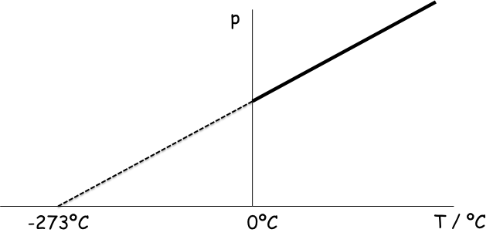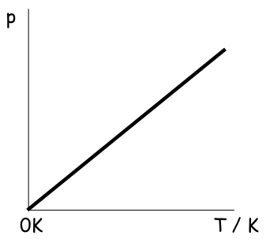

Pressure and Volume (Boyle’s Law)
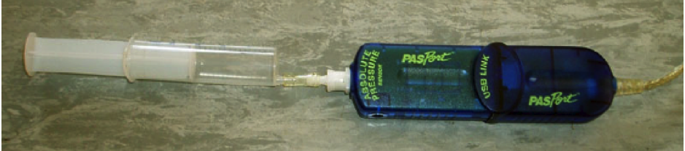
Using the apparatus below, the volume of a gas can be changed and any corresponding change in Pressure measured. The mass and temperature of the gas are fixed.

Pressure sensor connected to computer

Syringe
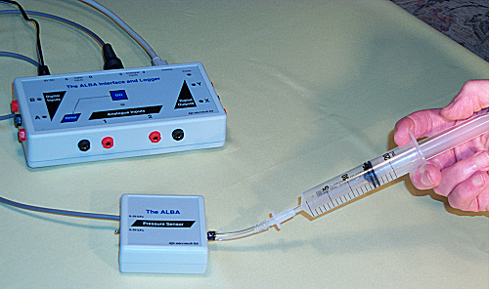
As the syringe is pushed, the volume decreases, so the pressure increases. We can explain this in terms of the kinetic model. We have seen how the pressure exerted by the gas on its container arises from the collisions of molecules with the container walls. If we have the same number of molecules in a smaller container, they will hit the walls more frequently.

An old way of carrying out the experiment.
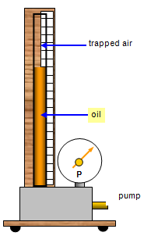
http://www.schoolphysics.co.uk/age16-19/Thermal%20physics/Gas%20laws/text/Gas_laws/index.html

TASK
- Plot the raw data and notice the shape of the graph formed
- Plot the data that would allow you to show a relation
- Use the data provided to show the relationship
Pressure (kPa) | 100 | 111 | 125 | 143 | 167 | 250
volume of air column(cm³) | 50.0 | 45.0 | 40.0 | 35.0 | 30.0 | 20.0
Use this to show a relationship!
Use this row to get values for a graph

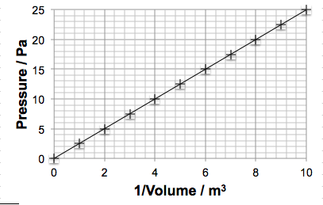
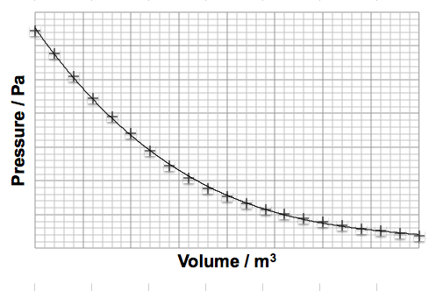
Graph of P versus 1/V
Graph of P versus V

We can state for a fixed mass of gas at constant temperature
$$P∝ \frac{1}{V}$$
or
$$PV= constant$$
so
$$P_{1}V_{1}= P_{2}V_{2}$$

Volume and Temperature (Charles’ Law)
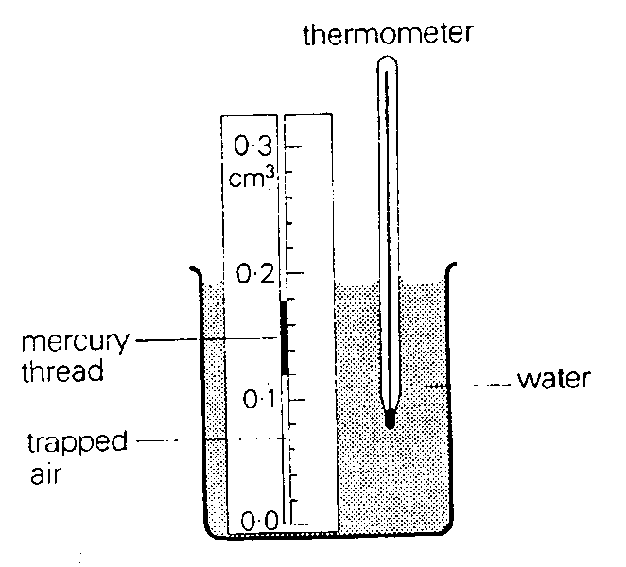
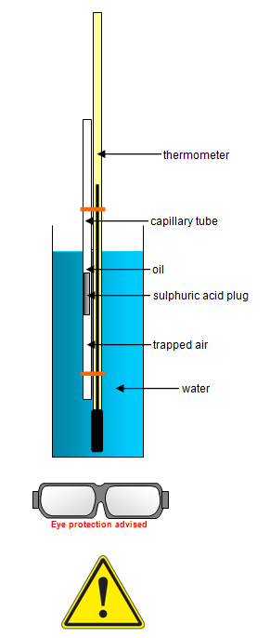

Consider a fixed mass of gas trapped in a cylinder with a frictionless piston. If the gas is heated, the average speed of the gas particles increases. This means the force exerted on the piston when gas particles collide with it increases. It also means the number of collisions per second will increase. The increased force and rate of collisions act to push out the piston, increasing the volume inside the cylinder and hence the volume of the gas.

Once the piston has been pushed out, the rate of collisions will decrease, as particles now have further to travel between collisions with the piston or the walls. Thus the pressure remains the same - the effects of greater impulse and lower rate of collision balance each other out. The overall effect is that heating a gas causes it to expand, and the relationship between volume and temperature is
$$V∝ T$$
or
$$\frac{V}{T}=constant$$
Therefore
$$\frac{V_{1}}{T_{1}}= \frac{V_{2}}{T_{2}}$$

Temperature must be given in Kelvin!
VOLUME - TEMPERATURE LAW
The volume of a fixed mass of gas at constant pressure is directly proportional to its temperature in kelvin.

VOLUME - TEMPERATURE LAW :- Kinetic Theory Summary
- If the temperature of a sealed container full of gas is increased (and the pressure stays the same), the kinetic energy and hence velocity of the gas molecules increases.

- The gas molecules therefore hit the walls of the container harder and more often (with a higher frequency) - so the walls of the container are pushed outwards (volume increases).

TASK
- Plot the raw data and notice the shape of the graph formed
- Plot the data that would allow you to show a relation
- Use the data provided to show the relationship

Temperature (ºC) | 0 | 20 | 40 | 60 | 80 | 100
Temperature (K) | 273 | 293 | 323 |  | 353 | 373
Length of air Column(cm)  Proportional to volume | 20.0 | 21.5 | 22.9 | 24.4 | 25.9 | 27.3
Use this to show a relationship!
V
V

The General Gas Equation
The gas experiment above gives three equations. These can be combined to create the general gas equation.
$$pV= constant$$ |  | $$\frac{{p_{1}V}_{1}}{T_{1}}= \frac{{p_{2}V}_{2}}{T_{2}}$$
$$\frac{V}{T}=constant$$ |  | $$\frac{{p_{1}V}_{1}}{T_{1}}= \frac{{p_{2}V}_{2}}{T_{2}}$$
$$\frac{p}{T}=constant$$ |  | $$\frac{{p_{1}V}_{1}}{T_{1}}= \frac{{p_{2}V}_{2}}{T_{2}}$$

Pressure (kPa) | 100 | 125 | 250 | 100 | 125 | 250
volume of air column(cm³) | 50.0 | 40.0 | 20.0 | 45.5 | 47.0 | 24.9
Temperature (K) | 300 | 300 | 300 | 273 | 353 | 373
Use this column to get values to put into a graph

The three gas laws, p₁V₁ = p₂V₂ for a fixed amount of gas at constant temperature, and for a fixed mass of gas at constant volume, can be combined to give a general gas law
The equation can be used to solve both types of gas behaviour problems by "cancelling out" the unwanted variable.

Remember: Temperature must always be in Kelvin.
Various pressure and volume units can be used in calculations provided they are not mixed in a single calculation – i.e. use the same units on each side of the equation!

Pressure and volume (constant temperature)
worked example: A 5.0 cm³ syringe is filled with air and the pressure of the air is found to be 1·01 x 10⁵ Pa. The syringe plunger is then pushed until there is 3·0 cm³ of air. What is the new air pressure?
V₁=5.0 cm³  p₁=1·01 x 10⁵ Pa |  | $$\frac{{{\text{P}}_{\text{1}}\text{V}}_{\text{1}}}{{\text{T}}_{\text{1}}}\text{=}$$ | $$\frac{{{\text{P}}_{\text{2}}\text{V}}_{\text{2}}}{{\text{T}}_{\text{2}}}$$
V₂=3.0 cm³ |  | $$\text{5}\text{∙}\text{0 x 1.0}\text{1}\text{ x }{\text{10}}^{\text{5}}\text{=}$$ | $$\text{3}\text{∙}\text{0 x }{\text{P}}_{\text{2}}$$
p₂=?T remains constant |  | ${\text{P}}_{\text{2}}$= | $$\frac{5∙0 ×1.01× {10}^{5}}{3∙0}$$
 |  | p₂ = | $$1∙68× {10}^{5} Pa$$

- 100 cm³ of air is contained in a syringe at atmospheric pressure (10⁵ Pa). If the volume is reduced to a) 50 cm³ or b) 20 cm³ without a change in temperature, what will be the new pressures?

- If the piston in a cylinder containing 300 cm³ of gas at a pressure of 10⁵ Pa is moved outwards so that the pressure of the gas falls to 8 × 10⁴ Pa, find the new volume of the gas.

- A weather balloon contains 80 m³ of helium at normal atmospheric pressure of 10⁵ Pa. What will be the volume of the balloon at an altitude where air pressure is 8 × 10⁴ Pa?

- The cork in a pop-gun is fired when the pressure reaches 3 atmospheres. If the plunger is 60 cm from the cork when the air in the barrel is at atmospheric pressure, how far will the plunger have to move before the cork pops out?
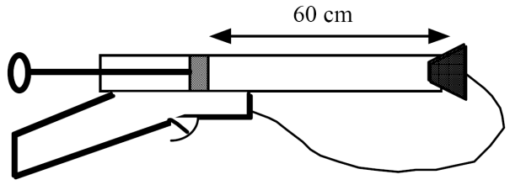
- A swimmer underwater uses a cylinder of compressed air that holds 15 litres of air at a pressure of 12000 kPa.
- Calculate the volume this air would occupy at a depth where the pressure is 200 kPa.
- If the swimmer breathes 25 litres of air each minute at this pressure, calculate how long the swimmer could remain at this depth (assume all the air from the cylinder is available).

Pressure and temperature (constant volume)
p₁= 0.8×10⁵ Pa  p₂ = ?  V₁ = V₂  T₁ = 350 K  T₂ = 535 K
  $$\frac{{{\text{p}}_{\text{1}}\text{V}}_{\text{1}}}{{\text{T}}_{\text{1}}}\text{=}$$ | $$\frac{{{\text{p}}_{\text{2}}\text{V}}_{\text{2}}}{{\text{T}}_{\text{2}}}$$
  $$\frac{{\text{0.8 x }{\text{10}}^{\text{5}}{\text{V}}_{\text{1}} }_{ }}{\text{35}\text{0}}\text{=}$$  p₂ = | $$\frac{ {\text{p}}_{\text{2}}\text{x }{\text{V}}_{\text{1}}}{\text{5}\text{2}\text{5}}$$  $$\frac{{\text{0.8 x }{\text{10}}^{\text{5}}\text{×}\text{525} }_{ }}{\text{35}\text{0}}$$
  p₂ = | $$\text{1}\text{∙}\text{2}\text{ x }{\text{10}}^{\text{5}}\text{Pa}$$
Worked example e.g. A fixed mass of gas at a constant volume has its temperature increased from 350 K to 525 K. If its original pressure is 0.8 x 10⁵ Pa, what pressure does it finally reach?

- Convert the following Celsius temperatures to Kelvin.
a) -273 °C b) -150 °C c) 10 °C d) 27 °C e) 150 °C
- Convert the following Kelvin temperatures to Celsius.
a) 10 K b) 23 K c) 100 K d) 350 K e) 373 K
- A cylinder of oxygen at 27 °C has a pressure of 3 × 10⁶ Pa. What will be the new pressure if the gas is cooled to 0 °C?
- An electric light bulb is designed so that the pressure of the inert gas inside it is 100 kPa (normal air pressure) when the temperature of the bulb is 350 °C. At what pressure must the bulb be filled if this is done at 15 °C ?
- The pressure in a car tyre is 2.5 × 10⁵ Pa at 27 °C. After a long journey the pressure has risen to 3.0 × 10⁵ Pa. Assuming the volume has not changed, what is the new temperature of the tyre?
- A compressed air tank which at room temperature of 27 °C normally contains air at 4 atmospheres, is fitted with a safety valve which operates at 10 atmospheres. During a fire the safety valve was released. Estimate the average temperature of the air in the tank when this happened.

- Describe an experiment to find the relationship between the pressure and temperature of a fixed mass of gas at constant volume. Your answer should include:
- A labelled diagram of the apparatus
- A description of how you would use the apparatus
- The measurements you would take.

- Use the following results to plot a graph of pressure against temperature in °C using axes as shown below.
Pressure (kPa) | 91 | 98 | 104 | 110 | 117
Temperature (°C) | 0 | 20 | 40 | 60 | 80

p (kPa)
-300 0 100 T (°C)

- Explain why the graph you have drawn shows that pressure does not vary directly as Celsius temperature.
- Explain how the graph can be used to show direct variation between temperature and pressure if a new temperature scale is introduced.
- Use the graph to estimate the value in °C of the zero on this new temperature scale.

- Use the particle model of a gas to explain the following:
- Why the pressure of a fixed volume of gas decreases as its temperature decreases
- Why the pressure of a gas at a fixed temperature decreases if its volume increases
- What happens to the molecules of a gas when Absolute Zero is reached?

Volume and temperature (constant pressure)
Worked example: At what temperature will a litre of trapped gas have its volume doubled if it was at-20ºC?
Using Charles’ Law we know that  $$\frac{p_{1}{\text{V}}_{\text{1}}}{{\text{T}}_{\text{1}}}\text{= }\frac{p_{2}{\text{V}}_{\text{2}}}{{\text{T}}_{\text{2}}}$$  $$\frac{\text{1}}{\text{253}}\text{= }\frac{\text{2}}{{\text{T}}_{\text{2}}}$$  T₂ = 506K | V₁ = 1 litre  V₂ = 2 litres  T₁ = -20ºC = 253K  T₂ = ?
- Describe an experiment to find the relationship between the volume and temperature of a fixed mass of gas at constant pressure. Your description should include:
- A diagram of the apparatus used
- A note of the results taken
- An appropriate method to find the relationship using the results.

- Change the following Celsius temperatures into Kelvin temperatures,
a) -273 ºC b) - 150 ºC c) 500 ºC,

- Change the following Kelvin temperatures into Celsius temperatures,
a) 0 K b) 272 K c) 500 K.
- A fixed mass of air occupies a volume of 0.2 m³ at a temperature of 0 ºC. At what temperature will its volume be 0.4 m³ if its pressure remains unchanged?

- A weather balloon contains 100 m³ of helium when atmospheric pressure is 90 kPa. If atmospheric pressure changes to 100 kPa, calculate the new volume of helium at the same temperature.
- 100 cm³ of a fixed mass of air is at a temperature of 0 °C. At what temperature will the volume be 110 cm³ if its pressure remains constant?

- Air is trapped in a glass capillary tube by a bead of mercury. The volume of air is found to be 0.10 cm³ at a temperature of 27 °C. Calculate the volume of air at a temperature of 87 °C.

- The volume of a fixed mass of gas at constant temperature is found to be 50 cm³. The pressure remains constant and the temperature doubles from 20 °C to 40 °C. Explain why the new volume of gas is not 100 cm³.

- 100cm³ of a fixed mass of air is at a temperature of 0 °C. At what temperature will the volume be 110 cm³ if its pressure remains constant?

- Air is trapped in a glass capillary tube by a bead of mercury. The volume of air is found to be 0.10cm³ at a temperature of 27 °C. Calculate the volume of air at a temperature of 87°C
- The volume of a fixed mass of gas at constant temperature is found to be 50 cm³. The pressure remains constant and the temperature doubles from 20°C to 40 °C. Explain why the new volume of gas is not 100cm³

General gas equation questions
Worked example: An air bubble at the bottom of the sea occupies a volume of 4.00 x 10⁻⁶ m³. At this depth, the pressure is 2.50 x 10⁷ Pa and the temperature is 275 K. Calculate the volume of the bubble when it has risen to a point where the pressure is 5.00 x 10⁶ Pa and the temperature is 280 K, assuming the bubble contains a fixed mass of air.
$$\frac{{{\text{P}}_{\text{1}}\text{V}}_{\text{1}}}{{\text{T}}_{\text{1}}}\text{=}$$ | $$\frac{{{\text{P}}_{\text{2}}\text{V}}_{\text{2}}}{{\text{T}}_{\text{2}}}$$
$$\frac{{\text{2.50 x }{\text{10}}^{\text{7}}\text{ x 4.00 x }{\text{10}}^{\text{-6}} }_{ }}{\text{275}}\text{=}$$ | $$\frac{\text{5.00 x }{\text{10}}^{\text{6}}\text{ x }{\text{V}}_{\text{2}}}{\text{280}}$$
0.364 = | 17857 V₂
V₂ = | 2.04 x 10⁻⁵ m³
- Given, for a fixed mass of gas, p ∝ T and p ∝ 1/V, derive the general gas equation.

- Find the unknown quantity from the readings shown below for a fixed mass of gas.

 | P₁ (Pa) | P₂ (Pa) | V₁ (cm³) | V₂ (cm³) | T₁ (°C) | T₂(°C)
_{a} | 2 x 10⁵ | 3 x 10⁵ | 50 | ? | 20 | 80
_{b} | 1 x 10⁵ | 2.5 x 10⁵ | 75 | 100 | 20 | ?
_{c} | 2 x 10⁵ | ? | 60 | 80 | 20 | 150
_{d} | 1 x 10⁵ | 2.5 x 10⁵ | 75 | 50 | ? | 40

- A sealed syringe contains 100 cm³ of air at atmospheric pressure 1×10⁵Pa and a temperature of 27°C. When the piston is depressed the volume of air is reduced to 20 cm³ and this produces a temperature rise of 4°C. Calculate the new pressure of the gas.

- Calculate the effect the following changes have on the pressure of a fixed mass of gas.
- Its temperature (in K) doubles and volume halves.
- Its temperature (in K) halves and volume halves.
- Its temperature (in K) trebles and volume quarters.

- Calculate the effect the following changes have on the volume of a fixed mass of gas.
- Its temperature (in K) doubles and pressure halves.
- Its temperature (in K) halves and pressure halves.
- Its temperature (in K) trebles and pressure quarters.

- Explain the pressure-volume, pressure-temperature and volume-temperature laws qualitatively in terms of the kinetic model.

Don’t get caught out! LEARN THESE AND SAVE YOURSELF SOME GRIEF!
What causes pressure?
- Pressure is caused by the force from the particles when they hit the walls of the container, ie F/A

(K)
A few common explanations
- For a FIXED MASS OF GAS at CONSTANT TEMPERATURE pressure is inversely proportional to the volume P₁V₁ = k
- For a FIXED MASS OF GAS at CONSTANT PRESSURE temperature (Kelvin) is proportional to the volume
V₁ / T₁(K)= k
- For a FIXED MASS OF GAS at CONSTANT VOLUME temperature (Kelvin) is proportional to the pressure P₁ / T₁(K) = k

KINETIC THEORY
- All particles are moving.
- Pressure is caused when the particles collide with the container walls
- The hotter the particles the faster they move.
- The faster they move the more often and more violent the collisions with the walls, greater impulse therefore greater force.
- If the volume is less they will collide more often as there is a shorter distance between the container walls.

GAS LAWS/ TUTORIAL 1
- A bicycle pump has a barrel filled with air at atmospheric pressure, 1 x 10⁵ Pa. As he inflates the tyre, this is compressed by the cyclist to a volume of 33.8 cm³ at a pressure of 6.5 × 10⁵ Pa. If we assume that the air in the pump keeps at a constant temperature, what is the volume of the pump before the handle is pressed down?
- A bottle containing air at atmospheric pressure and a temperature of 293 K, falls into a bonfire where its temperature rises to 879 K. What is the new pressure of the air in the bottle?
- The fuel-air mixture in a cylinder is at a pressure of 8 × 10⁵ Pa and a temperature of 293 K before the spark ignites it. What is the new pressure inside the cylinder if the burning mixture reaches a temperature of 1172 K before the piston has a chance to move?
- A girl fills a 20 ml syringe with air at 1 × 10⁵ Pa and puts her finger over the end as she presses the plunger down. What volume does she squash the air down to when she causes a pressure of 5.25 × 10⁵ Pa inside the syringe?
- (10⁵Pa). If the volume is reduced to a) 50cm³ or b) 20cm³ without a change in temperature, what will be the new pressure?\
- If the piston in a cylinder containing 300cm³ of gas at a pressure of 10⁵ Pa is moved outwards so that the pressure of the gas falls to 8·0 × 10 ⁵ Pa, find the new volume of the gas.
- A weather balloon contains 80 m³ of helium at normal atmospheric pressure of 1×10⁵ Pa. What will be the volume of the balloon at an altitude where the pressure is 8 x 10⁴ Pa
- The cork in a pop-gun is fired when the pressure reaches 3 atmospheres. If the plunger is 50cm from the cork when the air in the barrel is at atmospheric pressure, how far will the plunger have to move before the cork pops out? Diagram
- A swimmer underwater uses a cylinder of compressed air which holds 15 litres of air at a pressure of 12,000 kPa.
- Calculate the volume this air would occupy at a depth where the pressure is 200 kPa.
- If the swimmer breathes 25 litres of air each minute at this pressure, calculate how long the swimmer could remain at this depth (assume all the air from the cylinder is available)
GAS LAWS/ TUTORIAL 2

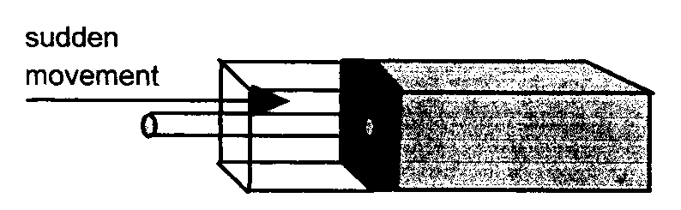
- A fixed mass of gas is enclosed in an insulated container whose volume is suddenly reduced:
Explain what happens to
  - The number of collisions per second that the molecules make with the container walls.
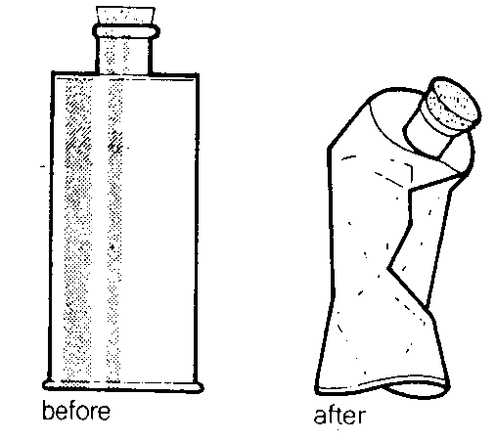
  - The average spacing between the molecules.
  - The kinetic energy of the molecules.

- When air is pumped out of a metal can it collapses as indicated in the diagram.
Explain this effect in terms of air pressure.
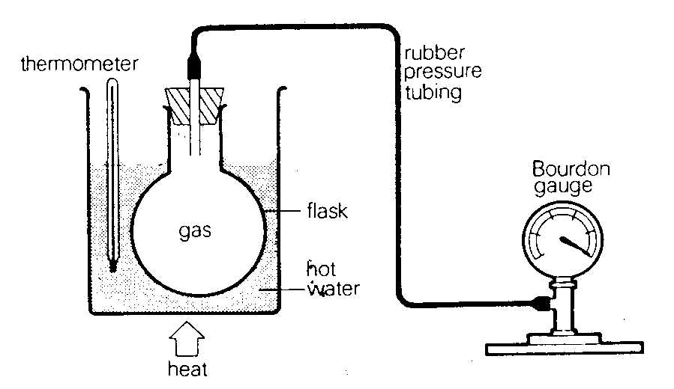
- A boy used the following apparatus to test a hypothesis that “the pressure of a gas is directly proportional to its temperature”.
He obtained the following results:
Temperature (ºC) | 0 | 20 | 40 | 60 | 80 | 100
Pressure (kN m^{–2}) | 90 | 96 | 103 | 110 | 117 | 123

  - Comment on the volume of the enclosed air during the experiment.
  - Draw a graph of the results and show how a relationship between pressure and temperature of gas may be deduced.
  - Rewrite the hypothesis in a more correct form.
  - How could the errors be reduced in this experiment?
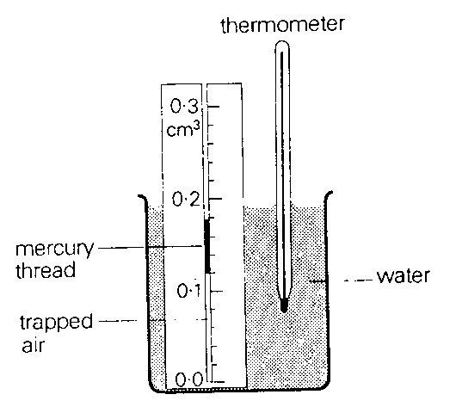
- A graduated glass tube containing air trapped below a mercury thread is immersed in a beaker of water. When the temperature of the water is 27 ºC, the volume of the air trapped is 0.12 cm³.
  - Draw a graph which shows how the volume in cm3 of this trapped air changes with temperature in Kelvin.
  - What volume does the air occupy when its temperature is 77 ºC?
  - Describe how the glass tube could be used to find the temperature in degrees Celsius of a freezing mixture of ice and salt.
  - Explain why the accuracy of this “thermometer” would be affected by changes in atmospheric pressure.
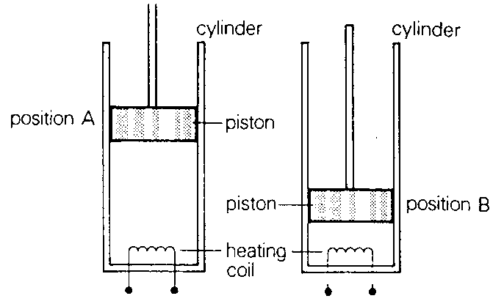
- A quantity of gas is trapped in a cylinder by a close fitting piston. The cylinder also contains a heating coil.
The piston is pushed down from position A to B and held there.
  - State what change occurs in the pressure of the trapped gas.
  - Use the particle model of the gas to explain this change.
The heating coil is switched on and the piston is held in position B.
  - State what happens to the molecules of the gas during the time the heating coil is on.
  - Use the particle model of the gas to explain this pressure change.
  - The petrol-air mixture in the cylinder of a car engine is ignited when the piston is in the position shown.
    - Explain in terms of the motion of the molecules of the gas in the cylinder why the piston moves downwards.

  - Use the kinetic theory of a gas to explain why the pressure of a fixed mass of gas increases as the temperature of the gas increases.
  - Two students wish to investigate the relationship between the pressure and temperature of a fixed mass of gas.
Describe a suitable experiment which they could carry out.
Your description should include:
    - a labelled sketch of the apparatus
    - a statement of any measurements taken
    - a clear indication of how these measurements could be used to show the relationship between pressure and temperature
    - a statement of the relationship between pressure and temperature including any conditions which apply.

- A 1 kg sample of air is contained in a gas tight cylinder as shown in the diagram below. The cylinder has a moveable piston.
The sample of air is at a temperature of 0 ºC and under a pressure of 101 kPa.
  - The density of air at 0 ºC and a pressure of 100 kPa is 1.28 kg m⁻³.
Calculate the volume of air in the cylinder.
  - The air in the cylinder is now heated to a temperature of 70 ºC. The pressure of the air is kept constant at 101 kPa.
    - Calculate the new volume of the air in the cylinder.
    - What is the density of the air in the cylinder when the temperature of the air is 70 ºC and pressure of the air is 101 kPa?
- The diagram below, taken from a physics textbook, shows the effect of increasing the force on a compression spring.
This type of spring is used in the design of a safety device for a gas cylinder.
  - The pressure of the gas in the cylinder is 5.0 x 10⁵ Pa at a temperature of 20 ºC. The area of the piston is 2.5 x 10⁻⁴ m².
    - What is the size of the force exerted by the gas on the piston?
    - Explain how the device operates, if the gas pressure in the cylinder exceeds a safety limit.
  - The safety limit is set at a pressure of 9.0 x 10⁵ Pa.
At what temperature would this limit be reached by the gas described in part (a)? Assume that any increase in volume of the gas in the cylinder can be neglected.

  - The adjuster is screwed inwards.
What would be the effect on the value of the pressure safety limit? Justify your answer.
- A pupil uses the apparatus below to investigate properties of a sample of gas.
The volume of the sample of gas can be changed by moving the piston.
The temperature of the sample of gas can be increased by using the heater.
At the start, the pressure of the gas is 400 kPa and its volume is 1000 cm³.
During the investigation, the pressure and volume of the gas change as indicated by sections AB and BC on the graph below.
During section AB, the temperature of the gas is constant at 300 K.
  - Calculate the volume of the gas when its pressure is 250 kPa during stage AB
  - State what happens to the pressure, volume and temperature of the gas over the section of the graph which starts at B and finishes at C.

  - What is the temperature of the gas, in Kelvin, corresponding to point C on the graph?

2008 Exam Paper
- A cylinder of compressed oxygen gas is in a laboratory.
  - The oxygen inside the cylinder is at a pressure of 2.82 x 10⁶ Pa and a temperature of 19.0 ºC.

    - Calculate the pressure of the oxygen inside the cylinder when its temperature is 5.0 ºC.
    - What effect, if any, does this decrease in temperature have on the density of the oxygen in the cylinder?
Justify your answer.

    - The volume of oxygen inside the cylinder is 0.030 m³.
The density of the oxygen inside the cylinder is 37.6 kg m⁻³.
Calculate the mass of oxygen in the cylinder.

    - The valve on the cylinder is opened slightly so that oxygen is gradually released.
The temperature of the oxygen inside the cylinder remains constant.
Explain, in terms of particles, why the pressure of the gas inside the cylinder decreases.

    - After a period of time, the pressure of the oxygen inside the cylinder reaches a constant value of 1.01 x 10⁵ Pa. The valve remains open.
Explain why the pressure does not decrease below this value.

2007 Exam Paper

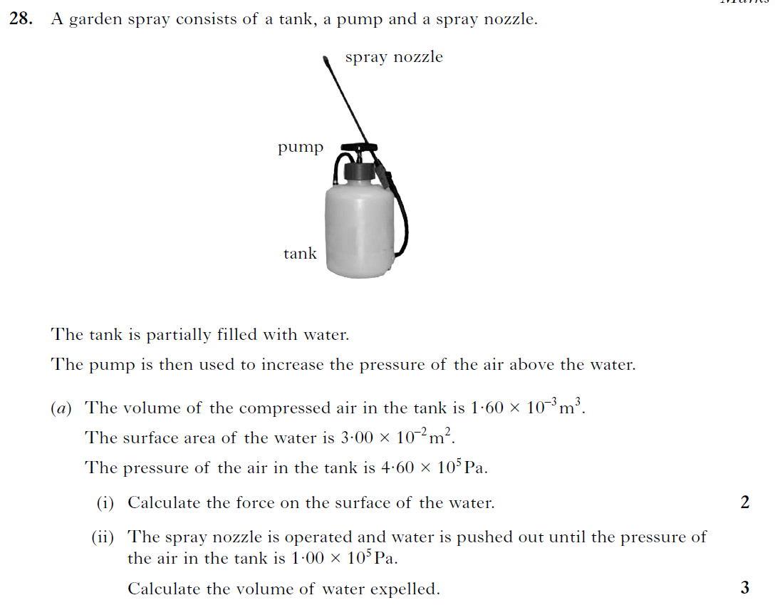

Success Criteria for Pressure and the Gas Laws
 | 16.1 | I can explain that pressure is the force per unit area exerted on a surface.
 | 16.2 | I am able to use P=F/A to calculate pressure, force and area.
 | 16.3 | I can describe the kinetic model of a gas.
 | 16.4 | I can describe the kinetic model of a gas and how this accounts for pressure.
 | 16.5 | I can convert temperatures between Kelvin and degrees Celsius and understand the term absolute zero of temperature.
 | 16.6 | I know that 0 K = -273 °C
 | 16.7 | I can explain the relationship between the volume, pressure and temperature of a fixed mass of gas using qualitative (info) in terms of kinetic theory.
 | 16.8 | I can use appropriate relationships to calculate the volume, pressure and temperature of a fixed mass of gas  $$\frac{p_{1}V_{1}}{T_{1}\left(K\right)}=\frac{p_{2}V_{2}}{T_{2}\left(K\right)}.$$  $$p_{1}V_{1}=p_{2}V_{2}$$  $$\frac{p_{1}}{T_{1}\left(K\right)}=\frac{p_{2}}{T_{2}\left(K\right)}$$  $$\frac{V_{1}}{T_{1}\left(K\right)}=\frac{V_{2}}{T_{2}\left(K\right)}$$  $$\frac{pV}{T\left(K\right)}= constant$$
 | 16.9 | I can describe an experiment to verify Boyle’s Law (pressure and volume)
 | 16.10 | I can describe an experiment to verify Gay-Lussac’s Law (pressure and temperature)
 | 16.11 | I can describe an experiment to verify Charles’ Law (volume and temperature)

