NATIONAL QUALIFICATIONS CURRICULUM SUPPORT

Physics

The Expanding Universe
and Big Bang Theory

Teacher’s Notes

Nathan Benson

[HIGHER]



The Scottish Qualifications Authority regularly reviews the arrangements for National Qualifications. Users of all NQ support materials, whether published by Learning and Teaching Scotland or others, are reminded that it is their responsibility to check that the support materials correspond to the requirements of the current arrangements.

Acknowledgement
Learning and Teaching Scotland gratefully acknowledges this contribution to the National Qualifications support programme for Physics.

The publishers gratefully acknowledge permission from the following sources to reproduce copyright material: image of Horn Antenna from http://www.alcatel-lucent.com/wps/portal/!ut/p/kcxml/04_Sj9SPykssy0xPLMnMz0vM0Y_QjzKLd4w3MXfUL8h2VAQAtvnN9Q!!?LMSG_CABINET=Bell_Labs&LMSG_CONTENT_FILE=Photos_and_Videos/Photos/Photo_Detail_000003.xml, reprinted with permission of Alcatel-Lucent USA Inc; diagram ‘Velocity–distance relation among extra-galactic nebulae’ https://www.e-education.psu.edu/astro801/book/export/html/1967, text to accompany diagram ‘Velocity–distance relation among extra-galactic nebulae’, from page 5 of Edwin Hubble, Proceedings of the National Academy of Sciences, vol 15, no 3, p. 172 http://www.pnas.org/content/15/3/168, both © Edwin Hubble, Proceedings of the National Academy of Sciences, vol. 15 no. 3, pp.168–173; image of Niels Henrik David Bohr (1885–1962) from http://photos.aip.org/exhibits/bohr.jsp © Photograph by A. B. Lagrelius and Westphal, courtesy AIP Emilio Segre Visual Archives, W. F. Meggers Gallery of Nobel Laureates; image of Albert Einstein (1879–1955) from http://photos.aip.org/exhibits/ein.jsp, image of Max Planck (1858–1947) from http://photos.aip.org/exhibits/planck.jsp, both © AIP Emilio Segre Visual Archives, W. F. Meggers Gallery of Nobel Laureates; image of Andromeda Galaxy, image of Spectrum of CMB, image of COBE dipole: speeding through the universe, all © NASA.

Every effort has been made to trace all the copyright holders but if any have been inadvertently overlooked, the publishers will be pleased to make the necessary arrangements at the first opportunity.

© Learning and Teaching Scotland 2011

This resource may be reproduced in whole or in part for educational purposes by educational establishments in Scotland provided that no profit accrues at any stage.

Contents

Introduction 4

Section 1: The expanding universe
1.1 Possible introduction to students 7
1.2 The Doppler effect and redshift of galaxies 8
1.2.1 The Doppler effect 8
1.2.2 The redshift of a galaxy 14
1.3 Hubble’s law 20
1.3.1 Measuring distance 20
1.3.2 Hubble’s law shows… 26
1.3.3 The age of the universe 28
1.4 Evidence for the expanding universe 30
1.4.1 Measurements of the velocities 30
1.4.2 The eventual fate 35
1.4.3 Dark matter 36
1.4.4 Dark energy 40

Section 2: Big Bang theory
2.1 The temperature of stellar objects 42
2.1.1 Stellar objects emit radiation 42
2.2 Evidence for the Big Bang 49
2.2.1 Hot Big Bang theory 49
2.2.2 The universe cools down as it expands 50
2.2.3 History of the discovery of CMB radiation 52
2.2.4 Other evidence for the Big Bang 54

Appendix I: Doppler and audacity 56

Appendix II: Doppler and electromagnetic radiation 60

Appendix III: Flock of birds 61

Appendix IV: Using parallax to measure distance 62

Appendix V: Planck distribution 64

Appendix VI: History of the discovery of CMB 69

Appendix VII: Summary of the different stages in the early
formation of the universe 72

Appendix VIII: The ether (re-)discovered? 73

Appendix IX: Where next for cosmology? 75

Appendix X: Timeline for milestones in cosmology 76

Glossary 77

Recommended reading 79

Bibliography 81

Websites 82

Introduction

These notes have been written primarily to support educators with the introduction of the expanding universe and the Big Bang theory topics as specified in the new Higher arrangements for physics.

To see where each section corresponds to the Arrangements document, the headings and sub-headings correspond to the Content and first sentence or introductory words of the relevant paragraph in the Notes or Contexts.

As this is an area in which many educators may not have extensive experience, they will provide a background from which to present the topics in an informed way and confident manner. Consequently, information is given beyond the bare requirements of the Arrangements document. Fuller information can be obtained from the recommended texts and bibliography.

It is especially important, with internet use being widespread, to anticipate alternative terminology and units of measurement that students may come across.

Anecdotes are included to add curiosity and intrigue. These can be used as appropriate to enrich lessons.

The very nature of this subject matter means practical work is somewhat limited, but where possible suggestions have been included for quick illustrations of principles and sometimes further investigations.

Some teaching points are included, especially in areas of possible common misconception. A few suggested cross-curricular links are also included.

Suggested reading as well as the normal bibliography is included. Although cosmology is a constantly changing subject, the Arrangements include some of the most up-to-date topics ever included in a Scottish Higher Physics course.

These notes are not prescriptive, neither do they imply that every suggested activity is undertaken or every anecdote used. Hopefully teachers will find it more of a treasure chest of ideas to delve into and take to use or modify as appropriate.
Inevitably it is also a journey through the history of science, putting a new light on Einstein and a new dimension on measurement and uncertainties.

Read on!

Section 1: The expanding universe

1.1 Possible introduction to students

A possible introduction to students for these topics could be Olbers’ paradox, ie ‘Why is the night sky dark?’

This question can be traced back to around 1576 and Thomas Digges, but it was first stated formally by the Prussian astronomer Heinrich Olbers in 1823, hence the name. (It has also been attributed to Kepler, who wrote about it in much earlier than Olbers, in 1610.)

It was commonly assumed, prior to the expansion of the universe being demonstrated by Hubble in 1929, that the universe was:

- infinite
- eternal
- static.

If this was true, no matter which direction you looked, your line of sight would eventually intersect with a star. The entire sky would be virtually as bright as the Sun!

You may think that cannot be true, since distant stars are fainter than near ones. However, surface brightness is independent of distance. This is because although the flux received decreases with the square of the distance, so does the apparent size of the star, so the flux per unit area stays the same. That means the further you look into space, a greater number of stars will appear in your line of sight, compensating for any dimming due to the inverse square law.

The paradox cannot be resolved by arguing interstellar dust blocks out the light either, as Olbers himself did, since the dust would heat up and eventually re-radiate the energy at a longer wavelength, leading to a much higher background radiation than that observed.

See Section 2.2.4 for the resolution of Olbers’ paradox.

1.2 The Doppler effect and redshift of galaxies

1.2.1 The Doppler effect

The Doppler effect is the apparent change in frequency of a wave when the source and observer are moving relative to each other. The effect is produced with all wave motions, including electromagnetic waves.

It is probably most familiar in the context of sound and in particular the apparent change in frequency of a siren as an emergency vehicle approaches then passes. Although it is potentially a good starting point, some students may confuse the change in tone of the siren itself with the effect we are trying to illustrate.

A single frequency source example is preferable. The relative speed of the source needs to be quite high compared to the speed of the waves for the effect to be noticeable. A Formula 1 racing car approaching then receding gives that characteristic eeeeee-oooooo as it approaches then passes. The effect is noticeable with any fast-moving vehicular transport, for example a train passing through a station or an aeroplane flying past at low altitude. The trick is trying to restrict examples to where the source is emitting a fairly constant frequency.

Activity: Whirling buzzer

As a demonstration experiment, get one learner to whirl a buzzer attached to a stout cord in a horizontal circle at a steady speed above their head. The rest of the class should observe at a safe distance and note what happens to the pitch of the buzzer as it is rotated.

The pitch is heard to rise and fall as the buzzer approaches and recedes.

A similar thing can be done with a plastic ‘twirling pipe’ (See Figure 1.1 and video Twirling pipe) Twirling pipes are available from B&M Stores and local toy shops for around £1-00). Make sure it is whirled at a constant speed. Different speeds can produce different harmonics, so a possible investigation and curricular link with music is possible here.

Watch the video Twirling pipe.

Figure 1.1 Twirling pipe
Commercial apparatus to consider:

- Doppler Effect Unit (a buzzer on a motor driven rotating arm) approx. £25 from Timstar (SO106208) (www.timstar.co.uk)
- Doppler Ball (a tone generator inside a plastic ball) approx. £62 from Timstar (SO76360) (www.timstar.co.uk)
- Doppler Rocket (a tone generator inside a foam body, propelled by two ropes which pass through it) approx. £56 from Pasco (WA-9826) (www.pasco.com)

Since the Doppler rocket is propelled linearly, it is perhaps particularly appropriate for Higher since it does not involve circular motion.

Activity: Whirling buzzer and computer

Carry out the Whirling buzzer activity as above, but this time use a microphone, computer and suitable software (eg Audacity) to record and analyse the signal. For full details of the procedure see Appendix I.

Investigation: Measure the highest and lowest frequencies, compare to the frequency when stationary. Use the Doppler equation to calculate the tangential speed. Measure the number of revolutions per second and hence calculate the tangential speed using distance/time. Distance will be 2πr for one revolution, ie there is no need to involve angular velocity or radians. Compare this with that measured directly.

Analogy: Sweets on a conveyor belt

Imagine a long conveyor belt running at a steady speed. An adult standing about halfway along deposits sweets onto the belt at a regular rate, say one sweet per second (frequency).

Conveyor belt
Adult
Child
Chocolate
Figure 1.2 Chocolates on conveyor belt

A child standing at the end of the conveyor belt collects the sweets in a bucket as they fall off the end. As long as they are both standing still, the child will be collecting the sweets at the same rate (frequency) as they are being deposited by the adult.

If the adult walks steadily away from the child, still depositing the sweets at the same rate, the child now receives the sweets at a lower rate (frequency). The sweets will be further spaced out on the conveyor belt (longer ‘wavelength’).

Conversely if the adult walks towards the child, the child will receive the sweets at a higher rate (frequency) and they will be spaced closer together (shorter ‘wavelength’).

Animation: Conveyor belt

Demonstrate or allow students to experiment with an animation of the above.

Explanation: Raft on river

Imagine someone lying on a raft on a very wide still river, dipping a stick into the water at a regular rate to create waves. Use simple numbers to illustrate, say twice per second (2 Hz). Assume the waves have a wavelength of 1 m.

Waves arrive at each bank at the same rate, ie with a frequency of 2 Hz. Now imagine the raft drifts slowly towards the right bank at 1 ms^{–1}. In the time between the creation of successive waves (0.5 s) the raft will have drifted 0.5 m towards the right bank and away from the left bank. The distance between these successive waves will now have increased to 1.5 m for the waves heading towards the left bank and decreased to 0.5 m for those approaching the right bank.

Animation: Raft on river

Demonstrate or allow students to experiment with an animation of the above.

Equations

A number of equations can be derived for the Doppler effect. For a moving source there is an equation for the source moving towards the observer and another for the source moving away from the observer. Similarly for a moving observer there are two equations, one for away from and one for towards the source.

Alternatively, a couple of general equations can be derived in terms of the relative velocity between the source and observer.

For this course, the only equations required are for a stationary observer with the source moving away and moving towards the observer.

Derivation: Stationary observer and source moving away

Observer
d
Source
λ_{source}
λ_{source}
Wavefront
Figure 1.3 Moving source

Wavelength of source $λ_{source}=\frac{v }{f_{source}}$ ……..[1]

When the source starts moving away, in the time between creating the first and the second wave (the period T), the source will have moved away from the observer by a distance:

$$d= v_{source}T= \frac{v_{source}}{f_{source}}$$

ie the wavelength increases by $\frac{v_{source}}{f_{source}}$

$$λ_{observed}=λ_{source}+\frac{v_{source}}{f_{source}}$$

Substituting from [1] gives:

$$λ_{observed}= \frac{v}{f_{source}}+ \frac{v_{source}}{f_{source}}$$

$λ_{observed}= \frac{\left[v + v_{source}\right]}{f_{source}}$ ……………..[2]
From $v= f_{observed}λ_{observed}$

$$λ_{observed}=\frac{v}{f_{observed}}$$
Substituting from [2],

$$\frac{v}{f_{observed}} =\frac{\left[v+v_{source}\right]}{f_{source}}$$

ie for the source moving away from the observer:

$$f_{observed}= f_{source}\left[\frac{v}{v +v_{source}}\right]$$

where v is the speed of the waves, eg the speed of sound.

Similarly, for the source moving towards the observer:

$$f_{observed}= f_{source}\left[\frac{v}{v-v_{source}}\right]$$

The first equation gives the expected reduction in frequency and the second an increase in frequency. If students are unsure whether to use the ‘+’ or ‘–’, they should be advised to check that their answer gives the expected increase or decrease. It is good practice to encourage students to check their final answers are ‘sensible’, or have increased or decreased as predicted.
We can also see from these equations that if the magnitude of v_{source} is very small compared to v there is little effect on f_{observed}. This is why for the effect to be noticeable, v_{source} should be reasonably large in comparison with the speed of the waves (v).

Anecdote: Doppler’s intention

Although the Doppler Effect is usually associated with sound, Christian Doppler (1803–53), the Austrian physicist, actually set out to explain the colour of stars (in a paper published in 1842). He assumed the natural colour of a star was white and argued approaching stars’ colour would be shifted towards blue and receding ones towards red. His principle was applied more effectively by Fizeau in 1848, who applied it to Fraunhofer lines, however it took another 20 years before this was confirmed by measurements.

Anecdote: Doppler Effect tested

In 1845 the Dutch meteorologist Christophe-Buys Ballot arranged for the Doppler Effect to be tested, using trumpeters on the open top of a railway carriage. The trumpeters played a constant note and observers noted what they heard as the carriage passed them. They confirmed that Doppler was correct.

The Doppler Effect and electromagnetic waves

The Doppler Effect also applies to electromagnetic waves, but at high speeds relativistic effects have to be taken into account. See Appendix II.

For non-relativistic speeds the equation reduces to the same as that for other types of waves.

Anecdote: Speed measurement

Police use radar speed guns, which use radio waves to measure the speed of vehicles from the Doppler Effect. Guns for measuring the speed of baseballs etc also work on this principle.

1.2.2 The redshift of a galaxy

Line spectra

Each element has its own characteristic line emission spectrum and the corresponding absorption spectrum.

These can be indicated on a diagram as a coloured strip or as an intensity versus wavelength graph.

Figure 1.4 Sodium emission spectrum

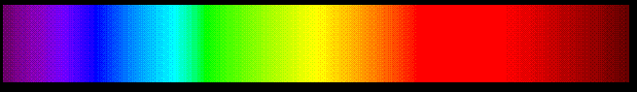

Figure 1.5 Sodium absorption spectrum

An intensity versus wavelength graph also allows spectra outwith the visible region to be represented.

These characteristic spectra allow elements in the stars and space to be identified.

Anecdote: The discovery of helium

Helium was actually discovered on the Sun through the study of solar spectra, before it was identified on Earth.

During the total solar eclipse in 1862, Pierre-Jules-Cesar Janssen (1824–1907) noted a spectral line in the solar prominences that did not match any known element.

The British astronomer Joseph Norman Lockyear (1836–1920), who also worked on solar spectra, decided that this line must represent a new element.
The new element was named ‘helium’ from the Greek word helios for ‘sun’. This was the first and only element discovered off the Earth before it was observed on our own planet.

Helium was not identified on Earth until 1895, ie 33 years later.

Redshift

Normal
Redshifted
Figure 1.6 Redshift

When studying distant celestial bodies, their spectra are found to contain the characteristic absorption lines of elements. However, sometimes the spectral lines are found to have been moved or shifted towards the red end of the spectrum because of an increase in wavelength.

This effect is called redshift and, assuming it is due to the Doppler Effect, implies these bodies are moving away from us. The amount of the shift also allows us to calculate how fast they are moving away.

1
2
3
4
4
3
2
1
Blueshifted
Redshifted
Source
Figure 1.7 Doppler Effect and redshift
Direction of movement of source
Redshift is defined as the change in wavelength divided by the original wavelength, and given the symbol z.

So, redshift $z= \frac{Δλ}{λ} = \frac{λ_{observed}- λ_{source}}{λ_{source}}$

Redshift is a dimensionless quantity since it is a ratio of two lengths.

Note: If there is a decrease in wavelength, ie the line spectrum has moved towards the blue end of the spectrum, this makes z negative, which means the body is moving towards us. This is referred to as a blueshift.

For bodies travelling at non-relativistic speeds (ie less than 10% of the speed of light) we can apply the Doppler equation for a stationery observer and a moving source. Using the Doppler equation for a source moving away from the observer and for light v = c (the speed of light), we get:

$$f_{observed}= f_{source}\left[\frac{c}{c +v_{source}}\right]$$

$\frac{f_{source}}{f_{observed}}= \left[\frac{c +v_{source}}{c}\right]$ …………. [1]

Since $c=fλ$, then $f=\frac{c}{λ}$ and so:

$\frac{f_{source}}{f_{observed}} = \frac{λ_{observed}}{λ_{source}}$ ……….. [2]

From the definition of redshift,

$$z= \frac{λ_{observed}- λ_{source}}{λ_{source}}$$

$z=\frac{ λ_{observed}}{λ_{source}}$ – 1

Substituting from [2] we get:

$z=\frac{ f_{source}}{f_{observed}}$ – 1

Substituting from [1] we get

$$z= \left[\frac{c +v_{source}}{c}\right]- 1$$

$$z= \frac{v_{source}}{c}$$

Note: This equation only applies to non-relativistic speeds, say less than 10% of the speed of light.

Radial speed

The redshift can only give us the radial speed of the object; it tells us nothing about its tangential speed. The term ‘transverse speed’ can be used in place of ‘tangential speed’. This is more descriptive and avoids possible confusion with the terms used in circular motion.

Earth
Figure 1.8 Radial speed

To find the actual velocity of an object, the radial and tangential speeds should be combined as vectors.

Bearing in mind that by definition the tangential speed is at right angles to the direction of the radial speed, all we need to know is the direction of its true space motion to allow us to find its actual velocity.

90º
90º
Radial speed
Direction of
tangential speed
Direction of
true speed
v_{R}
v_{tan}
v_{true}
Figure 1.9 Vector diagram

Note: Tangential speed and radial speed are vector quantities, since they have direction. They are sometimes called ‘speeds’ rather than ‘velocities’ since their direction is defined. This is similar to the situation with weight, ie a vector quantity whose direction is implicit in its definition.

The direction of true space motion can be found using the ‘flock of birds’ method, see Appendix III.

Anecdote

This is the apocryphal tale of an astronomer in a hurry on his way to work. He goes through a red traffic light and is stopped by traffic police. He explains the light looked green as he passed it and explains this was perhaps due to the Doppler Effect and blueshift.

The policeman listens intently, accepts his explanation but then proceeds to write a speeding ticket.

‘Why?’ enquires the astronomer. The policeman explains that for such a blueshift to occur, he must have been travelling at approximately
2 × 10⁸ kmh^{–1}!

1.3 Hubble’s Law

1.3.1 Measuring distance

Units of distance

Units of distance used in astronomy include:

- astronomical unit (AU) – 1 astronomical unit (AU) is the mean radius of the Earth’s orbit around the Sun. 1 AU is equivalent to 1.496 × 10¹¹m
- light year (ly) – 1 light-year (ly) is the distance travelled by light in one year. One light year is equivalent to 9.46 × 10¹⁵m.

The distance ladder

Measuring distance to celestial objects is done by different methods, depending on how close the objects are. It is generally more straightforward to measure distance to near objects than more distant ones. It becomes increasingly difficult to measure distances the further away objects are, often requiring a different technique. It is a multi-step process, often relying on measurements made on closer objects, hence the term ‘distance ladder’.

Distance measurement relies on the accuracy and resolution of the instruments available. Many advances in astronomy went hand-in-hand with, for example, improvements in telescope design and construction.

Radar or laser

This method is only suitable for distances up to a few AU.

By sending a pulse of radio waves (radar or laser light to an object and measuring the time it takes the pulse to reach the object and return, the distance can be calculated.

Remind students to half this total time to give the time for the pulse to travel to the object.

Using distance $d=vt$ where v is the speed of light and t is half the time for the pulse to reach the object and return, the distance to the object can be found. (Alternatively, use the full time to reach the object and return, then halve the answer for distance.)

This technique is used to obtain the distance to Venus and allows AU to be converted to metres. It has superseded more traditional observation methods.

Parallax

Activity: Parallax

Close one eye and look at a near object a few metres away. Line it up with a distant object. Without moving your head, open this eye and close the other. The objects will no longer be lined up. This effect is called parallax.

Parallax is the apparent displacement of an object when viewed from different positions.

Activity: Measuring the distance to an object using parallax

See Appendix III.

The greater the distance between the two observation positions (baseline), the greater the change in angular position of the object.

Planet
Earth
D_{Earth}
Figure 1.10 Diameter of Earth baseline
θ
θ − Parallax

When measuring the distance to planets, the diameter of the Earth can be used as this baseline.

For measuring the distance to a near star, parallax can be used by taking sightings six months apart, so the baseline is the diameter of the Earth’s orbit round the Sun.
The maximum angular displacement of the star from its mean position (when the angle between the Earth, Sun and the star is 90°) is called the annual parallax.

Star
Earth (March)
D_{Earth’s orbit}
Earth (Sep)
Sun
θ
Figure 1.11 Earth’s orbit baseline
θ − Annual parallax

Anecdote

Friedrich Bessel made the first measurement of stellar parallax in 1838 from observations taken at the observatory he established at Konigsberg. He measured the parallax for 61 Cygni to be 0.0000871°, giving the distance to it as 1 × 10¹⁴ km. This figure is now known to be 1.08 × 10¹⁴ km.

History curricular link

In 1810 Bessel was invited by Frederick William III, the Prussian king, to construct a new observatory at Konigsberg.

Germany had taken over as Europe’s foremost telescope manufacturer in the early nineteenth century, partly due to the introduction of window tax by the British Prime Minister William Pitt, which crushed the British glass industry.

Parsec

Angular measure:

1/60 of a degree is called 1 arc-minute (to distinguish it from 1 minute of time). 1/60 of 1 arc-minute is 1 arc-second (again to distinguish it from the time equivalent name).

A unit of distance which relates to parallax is the parsec (short for parallax-arc-second). 1 parsec (pc) is the distance at which a star would have a parallax of 1 arc-second. 1 parsec is equivalent to 3.09 × 10¹⁶ m or 3.26 ly.

The current limit of measuring distances with parallax is about 30 pc, beyond which the parallax becomes too small to measure.

Standard candles

Luminosity is the total power emitted by a star, rather like the rating of a lightbulb. It is found by measuring the intensity in Wm^{–2}, then multiplying by the surface area of the star.

A standard candle is an object whose absolute luminosity is assumed to be known. Apparent luminosity is assumed to decrease with distance according to the inverse square law; see the Particles and Waves unit.

The following two methods use standard candles to obtain the absolute luminosity of a body. The apparent luminosity is then measured and the inverse square law applied to find the distance.

Two main problems with this technique are:

- the assumption of known luminosity
- no account is taken of absorption of light by intervening dust.

Temperature–luminosity correlation

This technique is used for distances between 30 pc and 50 kpc.

The surface temperature of a star can be measured from the peak wavelength of its spectrum (see Section 2.1.1.1). There is a high correlation between the absolute luminosity of a star and its surface temperature. This was established from data on nearby stars, whose absolute luminosity could be measured. The correlation can be shown on a graph of absolute luminosity versus surface temperature. If the surface temperature is known, the absolute luminosity can be read from the graph.
So the technique is:

- Measure the colour spectrum of the star.
- Use the peak wavelength to calculate its surface temperature.
- Use the temperature-luminosity correlation to obtain its absolute luminosity.
- Measure its apparent luminosity.
- Use the inverse square law to calculate the distance to the star.

Period–luminosity correlation

This technique is used for distances between 1 kpc and 5 Mpc.
One class of standard candle is the Cepheid variable star. It is named after the star δ Cephei, discovered by amateur astronomer John Goodrike in 1784.

These stars have a predictable variation of luminosity with time. (See Figure 1.12) The period–luminosity relationship was discovered by Henrietta Leavitt in 1912.

luminosity/arbitrary units
Figure 1.12 Cepheid period–luminosity

The period–luminosity correlation technique is similar to the temperature–luminosity correlation except that the absolute luminosity is obtained by a different method.

- Measure the period of the star.
- Use the period–luminosity relationship to obtain its absolute luminosity.
- Measure its apparent luminosity.
- Use the inverse square law to calculate the distance to the star.

Anecdote: Distance measurement

In 1234 William Herschel (1738–1822) used his superior telescope to measure the distances to hundreds of stars.

He used the rough and ready assumption that all stars emit the same amount of light, although he knew this not to be the case. He also assumed brightness falls away with the square of the distance (inverse square law – see Particles and Waves unit).

Using Sirius, the brightest star, as a reference he defined all his stellar measurements in terms of multiples of the distance to Sirius. He named this unit of distance the ‘siriometer’.

Hubble’s early work: establishing nebulae as galaxies

Edwin Hubble (1889–1953) was born in Missouri. He obtained his first degree in mathematics and astronomy from the University of Chicago. After three years at Oxford University, obtaining a masters in law, he returned to America and spent a period teaching and served in World War I. Thereafter he returned to astronomy at Chicago, and his PhD dissertation ‘Photographic investigations of faint nebulae’ was published in 1917. In 1919 he moved to the Mount Wilson Observatory in California.

The great debate of Hubble’s time was: ‘Does the universe only consist of the Milky Way or are there separate galaxies?’

Anecdote: Out of step

Hubble was sympathetic to the view that nebulae were separate galaxies, but most of the astronomers at the Mount Wilson Observatory believed the Milky Way was the only galaxy and the nebulae were embedded within it.

He used a Cepheid variable in the Andromeda nebula (M31) in 1924 to show that it was at a much larger distance than stars in our own galaxy. He showed
the Cepheid, and so Andromeda, was 900,000 ly away, but the Milky Way is only 100,000 ly across.
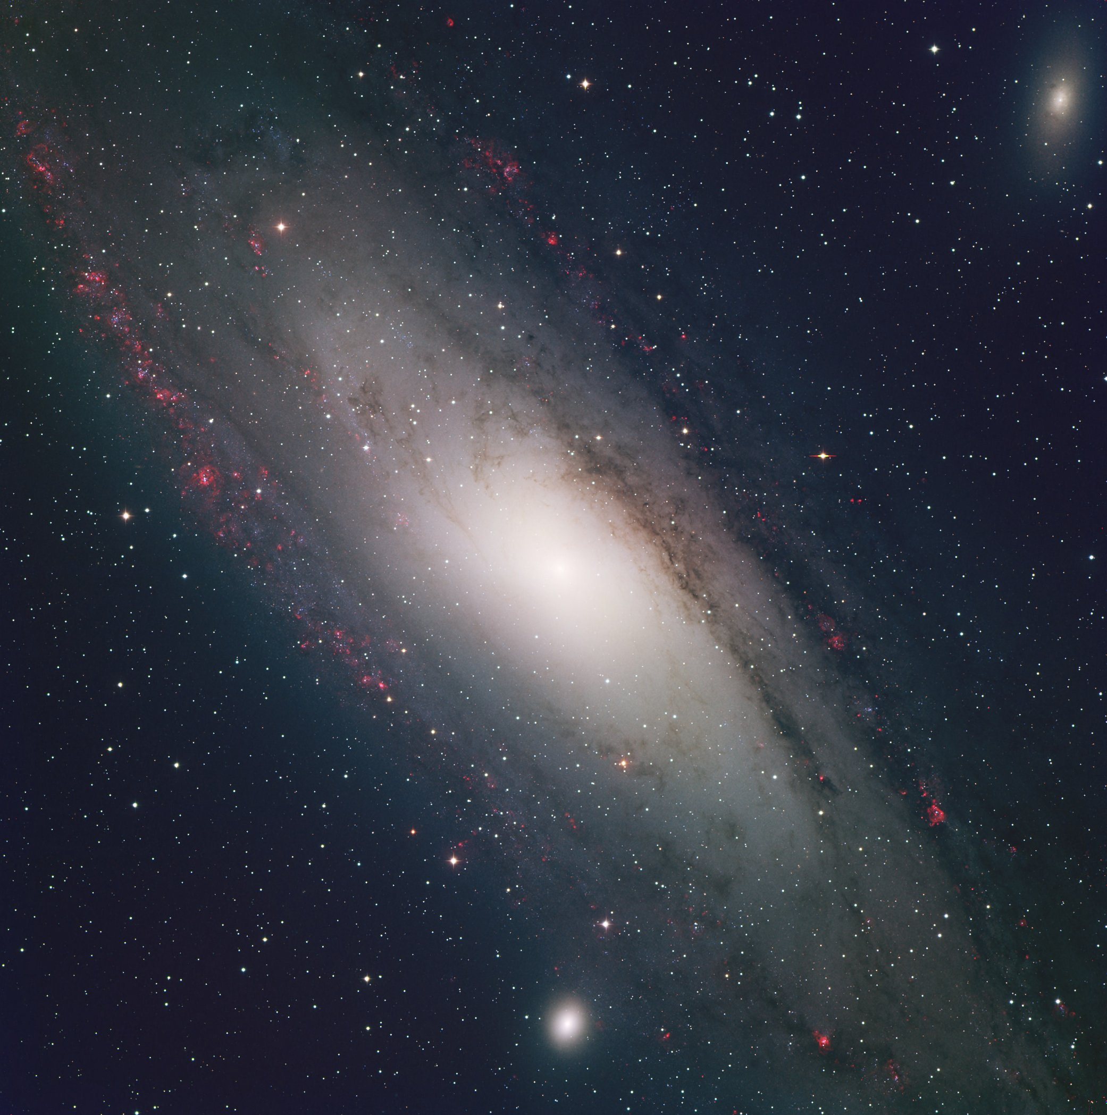
Figure 1.13 Andromeda galaxy (M31)
He called it an ‘island universe’, ie it is a galaxy rather than a gas cloud and is separate from our own Milky Way galaxy.

The Andromeda nebula is now known as the Andromeda galaxy. It is the most distant object that can be seen with the unaided eye!

Hubble’s most important discoveries, which he made at the Mount Wilson Observatory, are:

- the measurement of distances to galaxies using Cepheid variable stars
- with Milton Humason, in 1929, the redshift–distance relationship
- a morphological classification scheme for galaxies, still in use today – the tuning fork diagram.

Anecdote: Humason

Humason started his astronomical career as a mule driver, ferrying supplies up Mount Wilson to the telescope.

Anecdote and curricular link with art: Vincent van Gogh

It has been suggested van Gogh’s painting ‘Starry Night’ shows a spiral nebula that was based on Lord Rosse’s drawing of the Whirlpool nebula (M51). This was the first nebula to be seen and was observed with Rosse’s Leviathan telescope, which had an aperture of 1.8 m.

1.3.2 Hubble’s law shows…

Hubble measured the distance to galaxies and other celestial bodies, and also their recession speed, based on their redshift. He found that most galaxies are receding from us and concluded that the universe is expanding.

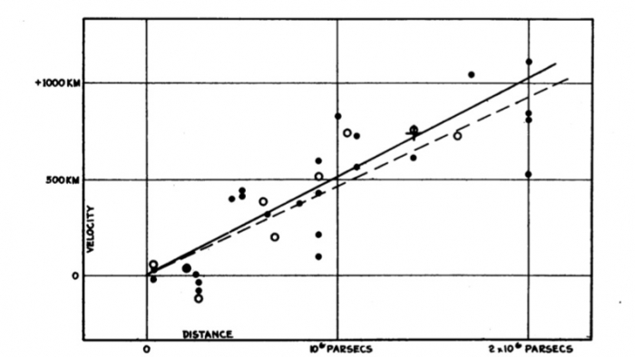

Figure 1.14 Hubble’s plot

From his results, he also concluded that more distant galaxies are receding faster than closer ones. (See Figure 1.14) In fact he found that the recession speed (v) varied directly with distance (d), ie:

v ∝ d, so v = H_{o}d

where H_{o} is the Hubble constant. The subscript ‘o’ indicates it refers to the present time, ie the current rate of expansion.

As the expansion rate of the universe has altered during certain epochs, for any time other than the present he Hubble parameter H(t) is used.

The discovery that the universe is expanding completely revolutionised twentieth century cosmology and provided the first piece of evidence for the Big Bang.

In 1952 Walter Baade found a fundamental error in the Cepheid distance scale. At the time Hubble made his measurements, it was not realised there were two types of Cepheids, with type I being about five times more luminous than type II.

Taking corrections into account, the Andromeda galaxy is believed to be 2.25 million light years away, more than double Hubble’s original estimate, and to be about 5% larger than our galaxy.
Anecdote: Blueshift

The first galaxy to have its radial velocity measured was M31. This was done in 1912 by Vesto Slipher, using a 600 mm reflecting telescope. The galaxy was found to have a negative velocity (ie blueshift) of 300 kms^{–1} (towards us). M31 is in our Local Group (the group of galaxies that includes our galaxy).

Analogy: Escalator or moving walkway

On a wide escalator, some people may ‘stand still’ and so go up at the same rate as the escalator. Others may ‘walk up’ and a small number may ‘walk down’ the rising escalator. So although the escalator steps are moving up, individual people may be moving up at the same rate, a greater rate, a slower rate or indeed coming down, ie in the opposite direction to the movement of the steps.

1.3.3 The age of the universe

From Hubble’s graph of speed versus distance, we can obtain an estimate of how long it took for a galaxy to reach its current position. Assuming they have been moving away from us at a constant speed, the time taken for a particular galaxy to reach its current position can be found by dividing the distance by the speed.

The Hubble law implies the greater the distance, the greater the speed. So a galaxy that is, say, 10 times further away than another will still have taken the same time to reach its current position, since it will have travelled at 10 times the speed of the other.
$$t= \frac{d}{v}$$

Substituting $v= H_{o}d$, we get:
$$t= \frac{1}{H_{o}}$$

Clearly the accuracy of this method depends on the accuracy of the measurement of H_{o} and whether or not the expansion rate has been constant. There has been an ongoing debate since the 1970s as to whether the value of the Hubble constant is too low or too high.

Using different sets of distance indicators, values have ranged from
55 km s^{–1} Mpc^{–1} (Allan Sandage and Gustav Tammann) to 100 km s^{–1} Mpc^{–1} (Gerard de Vancouleurs).
These values differ by almost a factor of two! Assuming a value of 50 gives the age of the universe to be about 20 billion years, whereas assuming 100 gives an age of just 10 billion years! Studies of some of the older stars in the universe give their age to be around 14–15 billion years. The universe cannot be older than its constituent parts, so 10 billion years is inconsistent with this.

Current estimates of H_{o} are converging on a value between 60 and
80 km s^{–1} Mpc^{–1}. Taking a value of 70 km s^{–1} Mpc^{–1} gives the age of the universe to be 14 billion years.

Expansion rate

It could be expected the gravitational attraction of each galaxy on every other will slow down the rate of expansion.
Distance
Time
Constant expansion rate
Decreasing expansion rate
Now
Actual age

Age if expansion rate constant
Figure 1.15 Age of the universe

If this is the case then the universe would have been expanding at a faster rate in the past.
Hence the real age of the universe may be significantly less than that predicted by assuming a constant expansion rate. (See Figure 1.15)

1.4 Evidence for the expanding universe

1.4.1 Measurements of the velocities

Hubble’s and subsequent data of velocity and distance confirm that more distant celestial objects are recessing at a greater velocity. This suggests the universe is expanding.

Systems held together by gravity, such as stars and individual galaxies, do not grow with the Hubble expansion but remain fixed in size, assuming they are not accreting or losing matter.

Activity: Expansion in one dimension

This activity requires an elastic sheet, eg Theraband (from physiotherapy suppliers, eg www.medisave.co.uk), held at each end and pulled taught.

Mark our position on the Theraband as O (observer) and the position of two galaxies, G₁ and G₂. Make G₁ say 5 cm from O and G₂ three times as far from O as G₁, ie 15 cm.

So distance G₁O = 5 cm and distance G₂O = 15 cm.

Stretch the band until distance G₁O has doubled, ie G₁O = 10 cm.
See the video One-dimensional expansion.

Measure distance G₂O, which should also have doubled, ie G₂O = 30 cm.

So, in this time galaxy G₁ has moved distance d₁ = 10 – 5 = 5 cm.

Galaxy G₂ has moved distance d₂ = 30 – 15 = 15 cm.

Galaxy G₂ has travelled three times the distance in the same time as galaxy G₁, so it has moved with three times the speed.

This is consistent with Hubble’s law: three times the distance means three times the speed.

Activity: Expansion in two dimensions – balloon

Repeat the above activity using a round balloon. Put small stickers on the balloon to represent the galaxies rather than pen marks, to emphasise that although space is expanding, the galaxies themselves are not.

Make equivalent measurements in two orthogonal directions.

Emphasise that it is the surface of the balloon we are considering, ie a two-dimensional universe.

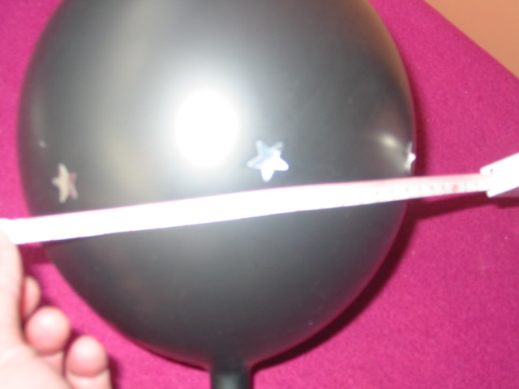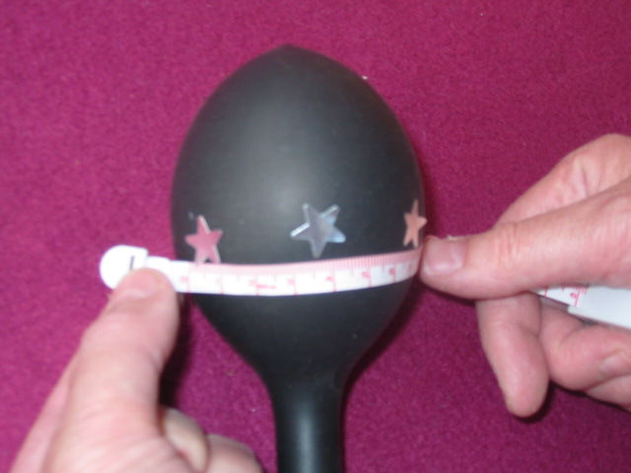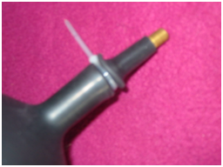
Car tyre valve
Cable tie
Balloon neck
Figure 1.16 Balloons

Tip: Use a car tyre valve and attach using a cable tie. This allows a more controlled inflation and deflation of the balloon. Giant balloons give a ‘flatter’ surface – and are much more fun as well! See www.giantballoons.co.uk.

Activity: Expansion in two dimensions – paper photocopy

Randomly mark 10 dots to represent galaxies on an A4 sheet of paper. Label each with distinguishing letters, eg A–J. Use a photocopier to increase the size to 125%.

Measure the distance between A and every other dot before and after ‘expansion’. Calculate the distance each dot moved away from A during the ‘expansion’, ie the ‘velocity’. Make up a table of distance and ‘velocity’ and make a Hubble plot of the data.

Analogy: Currant bun

Think of a currant bun before and after baking. The mix expands when baked, but the currants do not. Currants represent galaxies and the mix represents space.
Before baking
After baking
Figure 1.17 Currant bun

Space expanding

It is generally considered that a better way to think of redshift is that it is due to space itself expanding. As space expands, the waves become stretched, ie their wavelength increases.

In the time it takes light to travel from one galaxy to another, space has expanded so the distance between the galaxies and the wavelength of light have both been stretched by the same factor.

Activity: Elastic sheet or Theraband and wave

As above, but draw a wave at the ‘start’ and at the ‘finish’ on the band before stretching.

Where has the energy gone?

If space is expanding and stretches photons so they have a longer wavelength, each photon carries less energy. So,where has the energy gone?

With the Doppler Effect explanation of redshift there is no question of the photons actually increasing in wavelength; it is one of apparent wavelength (and frequency) to the observer due to the relative motion.

According to Tamara Davis (Scientific American July 2010):

- if we refer to space-time (rather than just space) and trace the trajectory of photons through it
- compare the velocities of the emitter and observer at the time the photon was emitted and observed, respectively and
- take into account general relativity (since space is relative)

then exactly the same redshift is found as when using the Doppler Effect approach. It is a matter of perspective and relative motion.
This particular conundrum only really arises when thinking of the redshift simplistically in terms of expansion of space, rather than as a Doppler shift due to relative motion.

Expansion not explosion

Although we talk about the Big Bang, it is important to emphasise that the universe, ie space, is expanding. There are a number of characteristics that indicate it is an expansion and not the result of an explosion.

Explosion |  | Expansion
Different bits fly off at different speeds |  | Expansion explains the large-scale symmetry we see in the distribution of galaxies
Fast parts overtake slow parts |  | Expanding space explains the redshifts and the Hubble law
Difficult to imagine a suitable mechanism to produce the range of velocities from 100 kms^{–1} to almost the speed of light |  | Expansion also explains redshifts and the Hubble law even if we are not at the centre of the universe
Seems likely velocity would be related to some physical property, eg if given the same energy, less massive galaxies would be moving faster |  | Balloon analogy – every galaxy moves away from every other as the space expands
If this was the case a definite correlation between mass and velocity would be expected – this is not observed |  | No galaxy is located at the centre
Hubble’s Law works well even if we only plot data for galaxies of similar mass |  | Not only are we not at the centre of the universe, it doesn’t even need to have a centre
Faster galaxies would leave slower ones behind, resulting in those near the centre (start) being more closely packed than those on the periphery (finish), like runners in a marathon, but this is not observed

How can some galaxies be blueshifted?

Although space is expanding, galaxies can be moving relative to the coordinates of space. This may be random due to the initial random motion of the material from which they were formed or a bulk motion towards an area of high density and hence strong gravity. Such deviations from the uniform Hubble expansion are called ‘peculiar velocities’.

Analogy: Ants

Imagine ants wandering randomly on a strip of elastic. As the elastic is stretched some ants could still be moving towards the observation point. See also Analogy: Escalator in Section 1.3.2.

Where in the universe was the Big Bang?

Everywhere! It’s a bit like asking ‘Where in your body were you born?’

What does the universe expand into?

The basic problem lies with the nature of spacetime. In order for the universe to expand into some larger space, that large space would need to exist in another universe. After all, what does ‘space’ even mean outside of the universe?

If you try to imagine yourself watching our universe from the outside, doesn’t that mean you are in a universe surrounding ours? The key is to think of the universe as a collection of information rather than a collection of objects. Think of it more like the flash memory in an MP3 player. When you record more tracks of music, the memory chip itself doesn’t become any larger.

Einstein’s greatest blunder

Albert Einstein, along with others (Fred Hoyle, Herman Bondi and Thomas Gold), was in favour of a static, steady-state universe. When his equations based on general relativity predicted an unstable universe, he added a factor called the cosmological constant. By carefully selecting its value he was able to ‘create’ a static universe.

Once evidence accumulated in favour of an expanding universe, in 1931 Einstein renounced his static cosmology and endorsed the Big Bang expanding model. He conceded that the addition of this cosmological constant was his ‘greatest blunder’. Without it his equations could have been used to predict the expanding universe.
Anecdote

Hubble’s original measurements implied a maximum age of the universe of just under 2 billion years. This is considerably less than the age of the Sun and the Earth and hence discredited the expanding universe model.

It was later discovered by Walter Baade (in 1952) that there was a major error in the Cepheid distance scale he had used, as mentioned earlier (see Section 1.5).

Type II Cepheids

The type of Cepheid is obtained from its spectrum: type I have a high proportion of heavy elements and show a large number of absorption lines compared to type II. Type I are also about four times more luminous than type II, with the same period.

The current uncertainty in measuring distances using Cepheids is about ±15%.

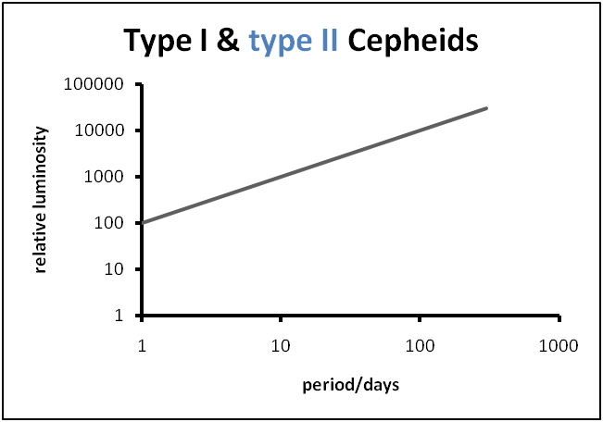

Figure 1.18 Type I and type II Cepheids

1.4.2 The eventual fate

If gravity is slowing down the rate of expansion, then it would be reasonable to conclude that the universe may eventually stop expanding and start to collapse back in on itself.

Whether or not this happens depends on the mean density (mass) of the universe.
A closed universe: if the mean density exceeds a critical value then the universe will expand to a finite size and then begin to collapse back in on itself, slowly at first, and then at an ever-increasing rate until all the galaxies collide and the universe ends in a Big Crunch.

An open universe: if the mean density is less than the critical value, gravity will slow the rate of expansion towards a steady value and the expansion will continue forever.

A flat universe: if the mean density equals the critical value, the universe will be able to expand forever with the recession velocities tending towards zero.

If it is assumed that effectively all matter in the universe is luminous, then the mean density turns out to be little more than 1% of the critical value. If that was the case the universe would certainly be ‘open’ and destined to expand forever.

1.4.3 Dark matter

Measurements of the rotational speeds of spiral galaxies leads to the conclusion that there is significant matter within them that cannot be seen. This is called dark matter. Rotational speeds of galaxies can be obtained by measuring the relative redshifts and blueshifts of galaxies that are seen edge on. (See Figure 1.19)

Effect of galaxy rotation on 21-cm hydrogen line

Wavelength
Spiral galaxy
Direction of
rotation
Bluer
Redder
Blueshifted
Redshifted

Figure 1.19 Relative redshift

Note: The 21-cm hydrogen line is used as it is in the radio wave part of the spectrum and can penetrate interstellar dust.

In the core of the galaxy, the rotational speed is found to increase in direct proportion to the distance from the rotational centre; it behaves almost like a rigid body.

Further out, where the stars are more spaced out, they would be expected to obey Newton’s laws and hence have a rotation pattern like Kepler’s third law. The rotational speed would decrease rapidly with distance from the centre.

In fact the speeds are found to become almost constant. This suggests that the orbits of more distant gas clouds and stars must encircle more and more mass. (See Figure 1.20)

Figure 1.20 Rotation curves
It is estimated that there is 10 times as much dark matter as normal matter in a typical spiral galaxy and up to 50 times as much in some galaxy clusters. Some galaxy clusters are moving too fast and the plasma is too hot to be held together by gravity due to normal matter. This used to be known as ‘missing mass’, but is now termed dark matter.

The flatness of the rotation curve of the Milky Way galaxy suggests most of the mass lies outwith the luminous area. It is estimated that this mass lies in a spherical halo, which is about 10 times the radius of the galaxy’s visible halo. (See figure 1.21)

Spiral galaxy
Dark matter

Figure 1.21 Dark matter halo

The orbital velocity law

The orbital speed (v) of a mass (m₁) circling another mass (m₂) can be found by equating the central force required to keep it in orbit to the force of gravity, using Newton’s law of gravitation.

Central force for a body m₁ moving in a circle or radius r,

$$F=\frac{{m_{1}v}^{2}}{r}$$

Newton’s gravitational force:

$$F=\frac{{Gm}_{1}m_{2}}{r^{2}}$$

Equating:

$$\frac{m_{1}v^{2}}{r}= \frac{{Gm}_{1}m_{2}}{r^{2}}$$

$$v^{2}=\frac{{Gm}_{2}}{r}$$

$$v=\sqrt{\frac{{Gm}_{2}}{r}}$$

So the orbital speed is independent of the mass of the satellite (m₁) and due entirely to the mass it is orbiting. This assumes a point mass, or mass distributed spherically symmetric within the orbiting path.

Using this relationship (the orbital velocity law) the distribution of mass in the Milky Way can be determined by applying it to the orbits of stars at different distances from the galactic centre.

1.4.4 Dark energy

In 1998 evidence from the luminosity-redshift relationship of distant type Ia supernovae convinced cosmologists that the expansion rate of the universe is increasing. (See Figure 1.22) Type Ia supernovae all have similar brightnesses, which makes them good standard candles. In the 1990s it became possible to systematically search for these distant galaxies.

Figure 1.22 Increasing expansion rate

This suggests there is something overcoming the gravitational force between the galaxies. The observational term coined for this is ‘dark energy’ and the theorists have revived Einstein’s cosmological constant, as its value allows the rate of acceleration of the expansion to be altered.

Dark energy is the name for the substance or phenomenon, but the mechanism is still not clearly understood.

Einstein

In 1917 Einstein wrote a paper called ‘Cosmological considerations of the general theory of relativity’. It gives rise to a collapsing universe (as do Newton’s equations).

One solution to create a model of an infinite, symmetric universe was to add a cosmological constant. This imbues space with a kind of anti-gravity, which is significant over cosmic distances and negligible at shorter distances.

Dark energy is the new name for Einstein’s cosmological constant.

Section 2: Big Bang theory

2.1 The temperature of stellar objects

2.1.1 Stellar objects emit radiation

From everyday experience we know that substances glow (incandesce) when heated to very high temperatures. The colour of light emitted depends on exactly how high the temperature is.

When an object is heated it does not initially glow, but radiates large amounts of energy as infrared radiation. We can feel this if we place our hand near, but not touching, a hot object.

As an object becomes hotter it starts to glow a dull red, followed by bright red, then orange, yellow and finally white (white hot). At extremely high temperatures it becomes a bright blue-white colour.

Activity: Incandescent lamp

As an introduction, use an incandescent light bulb with a clear envelope connected to a variable power supply. Slowly increase the voltage and watch the change in colour of the filament. A hotplate can be used for lower temperatures to demonstrate that infrared (heat) is given off before it incandesces, followed by shades of visible red. It won’t, however, reach white hot! The emission of the infrared can be detected by students holding their hand above the hotplate at a safe distance.

Activity: Heating a tin can lid

Heat the lid from a tin can and use an infrared thermometer to measure its temperature as it is heated to as high a temperature as the range of the thermometer allows. See the video Tin Lid

Quick check or investigation on infrared emission thermometer. Heat the lid until it glows dull red. Keep it at this temperature (colour) then take readings from different distances (Check the thermomter data sheet to ensure it is used correctly) the temperature reading should essentially be the same for the different distances

Activity: Heating glass

Heat a glass rod in a Bunsen burner until it becomes red, orange then white hot. You may need to use a glass-blowing attachment.

Alternatively (or also), show a YouTube video on making glass ornaments, eg seahorse. See, for example, http://www.youtube.com/watch?v=DRGlFrD4eEA&feature=related.

It is important to show a variety of materials going through this colour change at high temperatures.

Anecdote: Pottery

Early potters used the fact that materials glow different colours at different temperatures to determine the temperature inside their kilns.

In 1792 the famous porcelain maker Josiah Wedgewood noted that all bodies become red at the same temperature.

Potter’s guide
Colour | Temperature /°C | Temperature /K
Dark red | 550 | 823
Cherry red | 750 | 1023
Orange | 900 | 1173
Yellow | 1000 | 1273
White | 1200 | 1373

Curricular link – Art department and kiln temperatures.
Watch the video Kiln

Curricular link – Technical department, forge and heat treatment of steel.
Watch the video Furnace which shows a sheet of aluminium being heated.

Black-body

Very hot solids or liquids nearly always emit radiation with a continuous distribution of wavelengths rather than a line spectrum.

An ideal surface that absorbs all wavelengths of electromagnetic radiation is also the best emitter of electromagnetic radiation of any wavelength. Such an ideal surface is called a black-body, ie a black-body is a perfect absorber and emitter of radiation. The continuous spectrum of radiation it emits is called black-body radiation.

The graph of intensity versus wavelength has a characteristic shape, as shown in Figure 2.4. This is called a Planck distribution – see Appendix IV.

The black-body spectrum has three main features:

1. The basic shape is more or less the same (apart from a scaling factor) at all temperatures; it is like a skewed bell curve, falling off gently on the long wavelength side of the peak, and much more sharply on the shorter wavelength side.
2. As the temperature of the object is increased, the peak of the intensity spectrum shifts towards the shorter wavelengths.
3. As the temperature of the object is increased, the intensity increases for all wavelengths.

The properties of the spectrum are characterised by a single parameter, temperature, hence it is sometimes referred to as a thermal radiation spectrum.

When the temperature is raised the peak moves towards the short wavelength end, which gives the visible effect of changing from red to orange to yellow to white to blue-white, in that order.

Figure 2.1 Black-body radiation
Wien displacement law

The peak wavelength varies inversely with the kelvin temperature. The experimental value of the constant of proportionality is 2.90 × 10^{–3} m K.

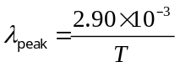

Animation: Black-body radiation

Demonstrate or allow students to use an animation that allows the temperature to be altered and show the resulting effect on the Planck distribution and shows/indicates the visible colour that would be seen.

Points to watch or emphasise

If the x-axis is for frequency rather than wavelength, the shape becomes the mirror image of that obtained with wavelength as the abscissa.

To allow a wider range of spectra to be shown on one graph, some texts use log–log scales. This alters the shape of the graphs. Students shouldn’t meet this at Higher.

The y-axis (ordinate) can have various values or labelling. Generally it is ‘intensity at that particular wavelength’ (monochromatic specific intensity). This is sometimes written as I(λ). More formally it is the average energy per unit area between λ and (λ + Δλ).The units are therefore Wm^{–3} rather than Wm^{–2} and hence it is sometimes referred to as ‘energy density’.

Often it is simply labelled ‘intensity’ (‘for that wavelength’ being implied), ‘relative intensity’, ‘energy per unit volume’ or ‘relative flux’. The units may sometimes be given as ‘arbitrary’, for simplicity.

Commercial apparatus to consider

Pasco (www.pasco.com) sell a blackbody radiation experiment kit (EX-9920) which allows qualitative intensity-wavelength blackbody curves to be produced. However it is very expensive, costing currently £1750 and also requires the ScienceWorkshop 750 Interface. A PASPORT version is also available (EX-9971).

Schools or colleges that already have an interface and some of the other equipment included in the kit (eg an optics bench) will only need to purchase the additional pieces of apparatus.

Anecdote: Quantum theory

Black-body radiation is one of the three critical experiments that produced results that could not be explained by classical physics and consequently led to the formulation of quantum theory.

The other experiments, namely the photoelectric effect and line spectra, are covered in the Particles and Waves unit.

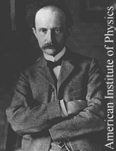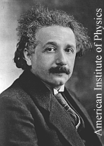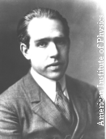
Max Planck Albert Einstein Niels Bohr

Figure 2.2 Founders of old quantum theory

The key players in putting forward solutions were Max Planck (1858–1947), Albert Einstein (1879–1955) and Niels Bohr (1885–1962). Their combined work culminated in the Bohr model of the atom in 1913, which is now known as ‘old quantum theory’.

Stars

Stars behave rather like a black-body, but with additional emission and absorption spectra.

This allows the temperature of stars to be measured by measuring the peak wavelength in their spectrum.

Black-body curves for the temperatures of some typical stars are shown in Figures 2.6 to 2.8.

Figure 2.3 3000 K (Barnard’s Star)

relative Intensity

Figure 2.4 6000 K (the Sun)

Figure 2.5 9500K (Sirius)

2.2 Evidence for the Big Bang

2.2.1 Hot Big Bang theory

From the expanding universe idea, if we consider running time backwards we come to the conclusion that the universe began from a single point called the initial singularity.

Anecdote: The term ‘Big Bang’

The term ‘Big Bang’ was initially coined by Fred Hoyle as a term of derision of the expanding universe theory. He was a proponent of a static universe that invoked the continual creation of matter to avoid the existence of a ‘big bang’.

He used the phrase ‘Big Bang theory’ during a broadcast on the BBC radio station The Third Programme, broadcast on 28 March 1949. Previously it was referred to as the ‘dynamic evolving model’.

What happened before the Big Bang?

This question makes no logical sense since both space and time were created at the Big Bang. (It’s the equivalent of asking ‘What is north of the North Pole?’ The question doesn’t have an answer.)

Hot Big Bang cosmology

The phrase ‘Big Bang cosmology’ or ‘hot Big Bang cosmology’ is generally used to relate to the aftermath of the supposed Big Bang itself.

George Gamow (1904–68) played a key role in the early development of the hot Big Bang theory. Gamow realised that in the hot early stages of the expansion after the Big Bang, light atomic nuclei such as hydrogen and helium could be formed. This was an alternative to the creation of helium by fusion in stars. His ideas were first published in 1946. They were then developed quantitatively with his PhD student Ralph Alpher and published in 1948.

Although calculations on the origin of the light elements (nucleosynthesis) have become increasingly sophisticated over the years, the basic ideas remain intact.

Anecdote

Gamow insisted that his friend Hans Bethe, the nuclear scientist’s name was added to the list of authors although he did not actually contribute to the work. This was so the author list became a pun on the first three letters of the Greek alphabet – alpha, beta and gamma (Alpher, Bethe and Gamow), which he thought apt for a paper on the beginnings of the universe.

2.2.2 The universe cools down as it expands

Cosmic microwave background (CMB) radiation is predicted by the hot Big Bang theory.

During the very early stages of the universe, say when it was one millionth its present size, the temperature would have been around 3,000,000 K. If an electron became bound with a nucleus, high energy radiation would immediately strip it off. The universe was in a plasma state.

The universe expanded and cooled due to the redshifting effect. As space expanded, the wavelength of photons became longer, so each photon had less energy.

Where has the energy gone?

As we have already seen (Section 1.4.1), according to Tamara Davis (Scientific American July 2010) the apparent drop in energy of individual photons is just a matter of perspective and relative motion.

However, when considering the universe as a whole, there is a fundamental limitation, since we cannot assign a value to something called the ‘energy of the universe’. It is a well-known problem with general relativity that we cannot unambiguously define gravitational energy that applies to the universe as a whole. So we cannot apply the principle of conservation of energy to the expanding universe as a whole. The total energy of the universe is neither conserved nor lost, it is just indefinable!

Radiation was less able to disrupt the formation of atoms until, at around 3000 K, atoms were first able to form – mostly hydrogen and helium. (3000 K is about half the surface temperature of the Sun.) Photons were now too weak to interact with atoms so they were free to propagate uninterrupted through the universe.

Around this time two processes were taking place:

- recombination – electrons combining with nuclei to form atoms
- decoupling – photons were able to propagate freely.

The process described above explains why CMB has a black-body (thermal) spectrum. This is characteristic of situations where there are frequent interactions to establish a thermal equilibrium. In the hot Big Bang model the photons were in a strongly interacting equilibrium state in the early universe, when they were much hotter. This makes the black-body (thermal) property of the CMB clinching evidence for the hot Big Bang and against the steady-state model.

Redshifting of light preserves the black-body spectrum while reducing the corresponding temperature. The kelvin temperature of the universe is inversely proportional to its size. The long wavelength of CMB makes it difficult to measure.

CMB is very close to isotropy, ie almost identical from every direction. Isotropic CMB corresponds to a temperature of radiation from an object at 2.725 K.

The peak intensity of CMB occurs at around 3 × 10¹¹ Hz and so is in the microwave region. Although CMB is very low in intensity, the universe is filled with it, so the total energy added up makes it the dominant radiation.

2.2.3 History of the discovery of CMB radiation

The story briefly is:

- CMB was ‘discovered’ even before its existence had been predicted.
- It was discovered by accident.
- Theorists predicted its existence – not realising it had already been detected.
- There are many more twists to the tale. Read the full story in Appendix V.

CMB – characteristics and detection

So the basic observation is this: microwaves are picked up by a receiver pointed at the sky in any direction, even when the receiver is just pointing toward ‘empty’ space.

The radiation is remarkably isotropic (the same in every direction). It’s as if the radiation is all coming from the same source, except that the source is in every direction. This is a puzzling and important clue to the nature of the source.

Because of its universal nature, this ‘glow from everywhere’ is called the cosmic microwave background.

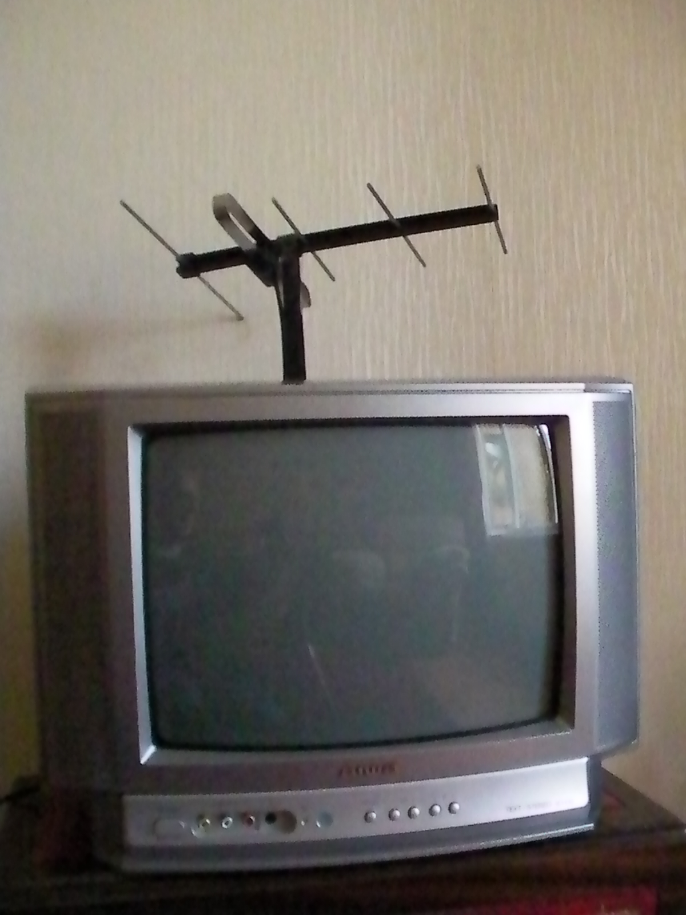
Activity: Detector
Figure 2.6 CMB detector

You can use a television receiver (Figure 2.6) to detect cosmic microwaves. Just select or tune the television to a frequency where there is no broadcasting station. This could be demonstrated with some impact and effectiveness to students by concealing the TV and leading in with a big build up that you managed to obtain the loan of a CMB detector – then reveal the TV and conduct the demonstration.

The screen will be covered by a fuzzy ‘snow’. Some of this ‘snow’ on the screen will be CMB!

COBE satellite

The Cosmic Background Explorer (COBE) satellite was launched by NASA in 1989. It carried the Far-Infrared Absolute Spectrometer (FIRAS) experiment.

More detailed observations of the CMB reveal further clues to its nature.
For example, the radiation covers a range of frequencies with different intensities. By measuring the intensity of the radiation at various frequencies, a graph of intensity versus frequency can be produced.

Figure 2.10 shows the spectrum of the CMB obtained by the COBE satellite in 1989. Remember that a black-body glows with a precise spectrum that is mathematically determined by its temperature. This cosmic radiation is a nearly perfect black-body spectrum.

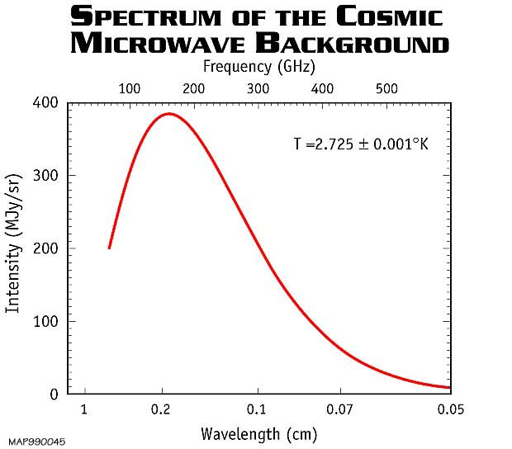

Figure 2.7 Spectrum of CMB

The spectrum indicates that the temperature of the universe is just a little above absolute zero, 2.725 ± 0.005 K, which is very close to that predicted by Alpher and Herman.

It is a more perfect black-body spectrum than any other known source. This provides absolutely incontrovertible evidence that the CMB was a black-body curve.

Anecdote: Photon density

The determination of the temperature of the universe has allowed the number density of CMB radiation photons to be calculated.
We can expect to find an average of 400 CMB photons per cm³ of space – an overwhelming number of photons, which totally dwarfs the number of photons produced by starlight or any other celestial process.

Thus CMB is the dominant source of radiation in the universe.

Proof of the Big Bang

The existence of black-body (thermal) radiation, at a temperature of about 3000 K, filling the universe at the time of recombination, is consistent with a universe which has expanded and cooled from a much hotter and denser original state at much earlier times – as the Big Bang theory predicts.

2.2.4 Other evidence for the Big Bang

The most abundant elements in the universe are hydrogen (70–75%) and helium (25–30%).

Known as the ‘helium problem’, the abundance of helium in the universe cannot be explained by it being synthesised inside stars. Most of it remains locked up in their cores. However, it can be accounted for by being formed during the dense phase of the early universe, ie shortly after the Big Bang.

Anecdote: Fred Hoyle

Fred Hoyle, an opponent of the Big Bang model, eventually showed that heavier elements were formed inside stars, undermining one of the main arguments against the Big Bang model.

Olbers’ paradox

One solution to the paradox comes from considering the finite time light takes to reach us.

Consider a galaxy very distant from our own. We only become aware of its existence when light from it reaches us. So if the universe is not infinitely old, galaxies must exist that are so distant that their light has not reached us yet.

If the universe is not infinitely old, that implies that it was created some time in the past, which is consistent with the Big Bang theory.

Olbers’ own explanation – that invisible interstellar dust absorbed the light – would make the intensity of starlight decrease exponentially with distance.

It can be shown that the amount of dust needed to do this would be so great as to block out the Sun! Also the radiation would heat up the dust so much that it would start to glow, becoming visible in the infrared region.

Expansion or age?

The order of magnitude of intergalactic light intensity can be estimated from the average rate of energy production within galaxies and their average age.

Using various models of the universe, estimates have been made of the ratio of intergalactic light intensity with and without expansion. The different models give a consensus that this ratio is approximately 0.5, ie the intensity in an expanding universe with equivalent properties to a static one is merely reduced by half.

Since the order of magnitude of the intensity is determined by the ﬁnite age of the galaxies, and only modiﬁed by a number of order unity by the expansion of the universe, then clearly the finite age is the more important.

So the main reason why the night sky is dark is due to the finite age of the galaxies, not the expansion of the universe. This is consistent with the hot Big Bang model, but not with a steady-state universe.

Bang?

The Big Bang was not like a conventional explosion in which matter is thrown apart from a single point into a pre-existing empty space.

Most cosmologists think space, time and matter originated at the Big Bang and before that there was no space, time or matter in the sense we think of them today.

Rather than thinking of galaxies as flying away from each other through space, it is much better to think of them as being essentially at rest in an expanding space.

Appendix I: Doppler and Audacity

This information is courtesy of SSERC (www.sserc.org.uk).

Connect a microphone to your computer.

Start Audacity.

Switch on the Doppler ball, place it a few centimetres from the microphone and click to start recording.

If the amplitude of the trace is too large or small, adjust it using the microphone slider (circled in red below).

If you are still getting only a very small amplitude, you may have to use your computer’s more advanced volume controls. These vary from computer to computer but often look something like the ones below.

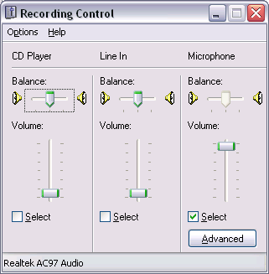
Try going to Start, then Control Panel. Look for Sounds and Audio Devices. If only a simple volume control is shown, look for a button marked Advanced. Try Options or Properties if the recording controls are not shown.

All being well, you should record something like the trace shown below. Don’t worry if the amplitude isn’t as big as the one shown.

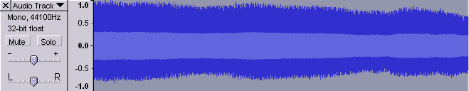
To delete a recording, click the cross as shown:
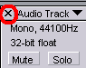

It is possible to calculate the frequency manually by zooming in on a selected part of the trace and finding the time for, say, 10 waves.
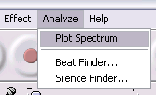
Another way is to select all or part of the trace by dragging over it and going to Analyze and Plot Spectrum.
Something similar to the following should appear:

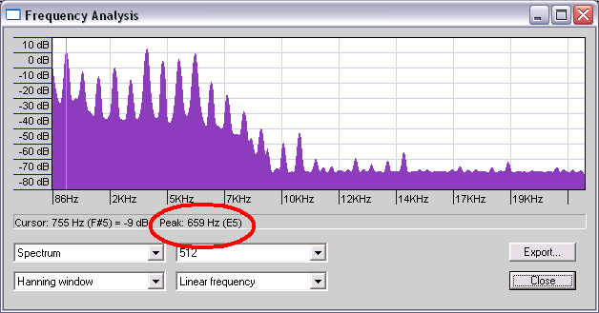
Move the cursor to the first peak. It does not need to be exactly on the peak, just close to it, for the software to display the relevant frequency. This is ringed in red above.

Now swing the Doppler ball like a pendulum, with the microphone positioned as near as possible to the lowest point of the swing. Alternatively, swing the ball in a circle with the microphone placed as near to the circumference of the circle as possible. Either way, you should record something like this:

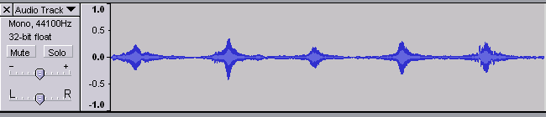
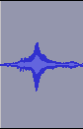
Select one of the bits – like the one shown on the right – by dragging over it. This section represents the sound getting louder as the Doppler ball approaches the microphone and quieter as it moves away.


Now click the zoom button to make the trace look like this:

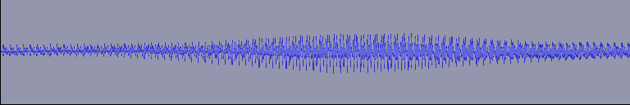

We will now use the Frequency Analysis tool to investigate the frequencies as the ball moves towards and away from the microphone.

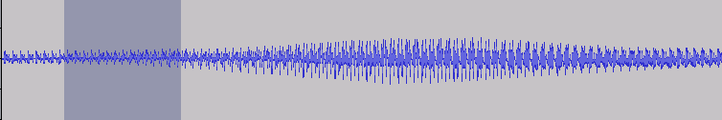

Select an area just before the peak, as shown above. Analyse the frequency as before. This frequency should be higher than the frequency of the stationary ball. If no frequency graph appears, see the tips below.

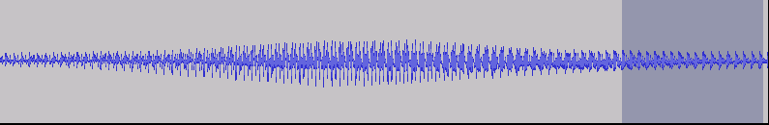
Now select and analyse a region after the peak, when the ball is moving away from the microphone. Here the frequency should be smaller.

The formula for the Doppler effect is:

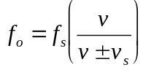

where:
f_{o} is the observed frequency.

- v is the speed of sound
- v_{s} is the speed of the sound source
- f_{s} is the frequency of sound emitted by the Doppler ball.

Using, say, 340 ms^{–1} for the speed of sound, work out the speed of the source as it approaches the microphone. Is the value realistic? Can you verify it by measuring the speed by some other method?

Tips

- Carry out the experiment in as large a space as possible. If there are strong echoes, the lowered frequency can beat with the higher frequency, giving results that are hard to analyse.
- Don’t analyse the frequency too close to the peak, as this will be the point where it changes from low to high.
- Choose a reasonably symmetrical region to analyse. Avoid areas where there are spikes or ripples on the trace. All sorts of interference – the string twanging and so forth – can mess up the recorded sound.

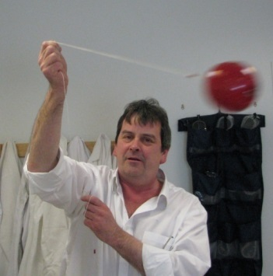

Appendix II: Doppler and electromagnetic radiation

For electromagnetic radiation there is no fixed medium to provide a frame of reference and relativity has to be taken into account.

For the source and observer moving apart the equation for observed frequency is:*

$$f_{observed} = f_{source}{\left\{\frac{1- v/c}{1+ v/c}\right\}}^{1/2}$$

The exact relationship between redshift and velocity derived from the special theory of relativity is given by:

$$z = {\left\{\frac{1+ v/c}{1- v/c}\right\}}^{1/2}- 1$$

Even this relationship ignores the expansion of the universe as the light propagates through it. This relationship is really the combined effect of the standard Doppler equation and a time dilation factor.

For a nice explanation, see: http://mb-soft.com/public/reltvty1.html.

*If v²/c² is small compared to 1 (but not zero) then the equation for observed frequency simplifies to the equation for other waves, ie

$$f_{observed}= f_{source}\left[\frac{v}{v +v_{source}}\right]$$

Appendix III: Flock of birds

now
2 min ago
4 min ago
Convergent point
Figure AIII.1 Flock of birds

A flock of birds flying towards us exhibits a perspective effect whereby the flock appears to be diverging from a point in the distance.

This effect can be used with star clusters, where the individual stars have almost the same radial speeds and proper motions of more or less the same magnitude. This confirms they are all part of the same cluster.

However, the directions of the proper motions are all slightly different. The true direction of motion of the cluster is found by determining the average convergent point for these proper motions.

Appendix IV: Using parallax to measure distance

Choose a target about 1 metre away and a very distant object.

Close your right eye and using your left eye position yourself so the target and distant object are in line.

Without moving, open your right eye and close your left one.

Measure the angle between the line of sight of the distant object and the line of sight of the target (θ) using a hand-bearing compass. (available from yacht chandlers eg. www.force4.co.uk approx £35) See Figure 2 and Figure 1. (Alternatively use a protractor held horizontally at eye level.)

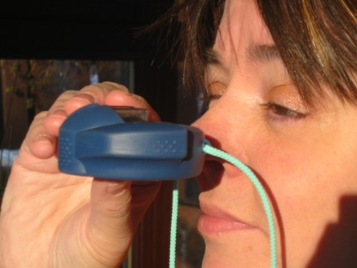

Figure AIV.1 Hand-bearing compass Figure AIV.2 Using a hand-bearing compass

Ask someone to measure the distance between the centres of your eyes (d) and also the distance to the target.

Calculate the distance to the target using x = d/tan θ.

Compare with the measured distance.

Left eye
Right eye
target
To distant
object
θ
θ
d
x
Figure AIV.3 Using parallax to measure distance

Spectrometer

The parallax method can also be performed using the telescope on a spectrometer.

Position an object as close to the telescope as possible, but far enough away that it can still be focused on.

Line it up with a distant object. Note the reading on the scale.

Physically move the spectrometer, say 30 cm to one side, and repeat.

Calculate the distance to the target as above, where d is now the distance between the two positions of the spectrometer telescope.

This method allows more accurate measurement of the parallax and also allows the baseline to be chosen or varied, which you can’t do with the separation of your eyes!

The effect of the size of the baseline on parallax could be investigated.

Appendix V: Planck distribution

The Planck radiation law

$$I\left(λ\right)= \frac{2πhc^{2}}{λ^{5}\left(e^{hc/λkT}- 1\right)}$$
where:

- h is Planck’s constant
- c is the speed of light
- k is Boltzmann’s constant
- T is temperature in kelvin
- λ is wavelength
- I(λ) is monochromatic specific intensity.

The average power per unit surface area between λ and (λ + dλ) is I(λ)dλ.

The Wein displacement law is embodied in this. If the derivative is taken and set to zero, to givethe value of λ at which I(λ) is a maximum. we obtain

max = 2.90x10-3T

ie Wein’s displacement Law.

Temperature and wavelength

This information is courtesy of SSERC www.sserc.org.uk).

Hot objects emit a range of wavelengths of electromagnetic radiation. Wein’s distribution law states that the wavelength distribution of heat energy has the same shape for any temperature, except that the peak wavelength varies inversely with temperature.

The peak wavelength is the wavelength at which the greatest amount of radiation is emitted.

Figure AV.1 shows that the distribution curve for a heat source at a temperature of 3500 K has the same shape as the one for a source at 5500 K, but the peak of the hotter source is around 530 nm (visible light) while the colder one peaks at about 830 nm (infrared light).

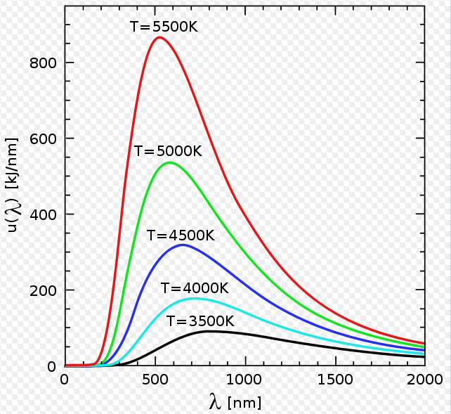

Figure AV.1 Intensity distribution for radiation from a black-body

Activity

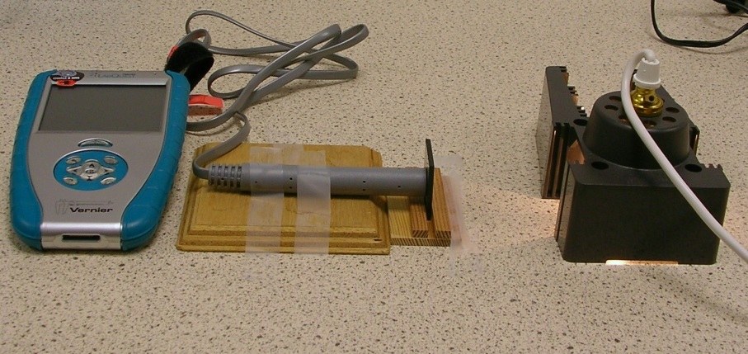
A filament lamp, such as the one found in many school ray boxes, is obviously designed to give out visible light. In fact, much of its radiation is emitted in the infrared, as the filament temperature is around 3500 K.

Find the percentage of the radiation from a filament lamp that is emitted in the infrared band.
Figure AV.2 Possible set up of apparatus

What would you expect to happen to this percentage at lower filament temperatures?

Figure AV.2 shows a possible set up. A variable power supply (not shown) is connected to a ray box. A light sensor, connected to a datalogger or meter, measures the visible and infrared radiation from the lamp. A filter that passes only infrared can be placed in front of the sensor.
Further study

Wein’s displacement law refers to a particular type of object called a black-body radiator.

Wein’s law can be expressed mathematically as:

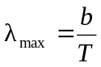

where b is a constant equal to 2.9 × 10^{–3} m K.

Temperature and wavelength – technical guide

This information is courtesy of SSERC www.sserc.org.uk).

Students are asked to examine the effect that changing the temperature of a lamp filament has on the percentage of infrared in the radiation emitted by the lamp.

They are not expected to give numerical values of temperature. The instructions remind them that the filament temperature increases as the current in it increases. (It is possible to estimate the temperature of the filament using an empirical formula that is a function of filament resistance.)

The results may be counter-intuitive to some students. Infrared radiation is ‘heat radiation’ they are told, so they may reason that hotter objects give out proportionally more infrared radiation. The bulb obviously gives out more visible and infrared light as the voltage is increased. This can be seen and felt. What cannot be determined without carrying out the above activity is the change in proportion of each type.

We measured light levels with sensors from DJB, Pasco and Vernier. The infrared filter (which blocks visible light) came from www.mutr.co.uk.

Our method was as follows:

- Place the sensor facing the lamp. Turn the supply voltage to 12 V.
- Check the reading on the meter or logger to ensure that it is not saturated. If it is, move the sensor and lamp further apart. Note that some sensors have ×1, ×10 and ×100 range switches.
- Note the reading.
- Repeat with the infrared filter in place.
- Repeat for different voltages.
- Express the amount of infrared as a percentage of the total radiation output for each voltage.

Uncertainties and general discussion

The detector may show a reading when the bulb is off, even if the experiment is carried out in darkness. Thus a ‘background value’ may have to be subtracted from all readings. This background value is not necessarily the same when the infrared filter is in place.

At low voltages, when the filament is relatively cold, the reading from the detector is small. If the sensor has a sensitivity control, this can be used to increase the reading. If not, the sensor and lamp can be moved closer together. The students may correctly remark that this is not a fair comparison. They should be asked to explain why, and could be invited to check whether, for a particular voltage, the percentage of IR changed with distance.

When taking readings, we initially used the digit display on the logger but this tended to fluctuate. We therefore logged for around 30 seconds and used the software’s statistical analysis function to find the mean. This software also gave the maximum and minimum readings and the standard deviation. These could be used, along with the number of readings, to estimate the uncertainty. For example:

uncertainty = (maximum – minimum)/number of readings
or
uncertainty = 2 × (standard deviation/√(number of readings))

The second method assumes a normal distribution of readings around the mean, in which case there is a 95% probability that the actual value lies within the range mean ± uncertainty.

We carried out this investigation using a 24 W ray box lamp, starting at 4 V and increasing to 12 V in steps of 1 V. There was a clear decrease in the percentage of infrared detected as the filament became hotter.

Context

This experiment is designed to reinforce understanding of Wein’s law. It is assumed that students have at some point in a physics course produced a spectrum from a white light source and have determined that there is some radiation detected beyond red. They may have used a black bulb thermometer, electronic sensor or an adapted webcam for this. The activity should show that the amount of infrared radiation detected decreases as a percentage of the total radiation detected when the source gets hotter. In truth, we can only really say that this is true with respect to the amount of radiation detected by our sensor. It is unlikely that these sensors can detect the full range of infrared, particularly the longer wavelengths.

Appendix VI: History of the discovery of CMB

Introduction

The discovery of CMB is one of the most significant of recent times. It provides the single biggest piece of evidence about the beginnings of our universe, and was essentially accidental.

It has been described as ‘one of the greatest discoveries in 500 years of modern astronomy’.

Pre Big Bang model

Prior to the proposal of the hot Big Bang model, CMB had already been ‘discovered’ by Andre McKellar in 1941. He was observing transitions between rotational energy levels in interstellar molecules (cyanogen) and observed that the absorption was consistent with the gas being bathed in radiation at a temperature of around 2.3 K.

Theoretical prediction

The first theoretical prediction was made by George Gamow’s colleagues, Ralph Alpher and Robert Herman, in 1948. Following on from earlier work with Gamow on nucleosynthesis, they predicted there would be radiation left over from the Big Bang. It would be thermal (black-body) radiation at a temperature of around 5 K (ie microwave radiation). They did not realise it might be detectable, never mind that it already been detected seven years earlier!

Observers

Over the following decades several other observers, using radio telescopes, noted the presence of thermal background radiation at around 3 K, without making a connection with cosmology.

Theorists

In the mid-1960s, theorists again came to realise that CMB was expected and it would be key evidence in support of the hot Big Bang.
Two main groups, working entirely independently, were involved:

- a Soviet (Moscow) research group led by Yakov Zel’dovich
- an American (Princeton, New Jersey) group led by Robert Dicke.

The theory predicted the signal should be in the form of microwaves.

Meanwhile…

Arno Penzias and Robert Wilson at Bell Labs in Holmdel, New Jersey, were testing a radio horn antenna (See Figure AVI.2) for an early satellite communication system (Telstar). They were working only 30 miles away from Princeton, yet the Princeton group were unaware of this. Bizarrely the Soviet group were aware.

Missed opportunity

Even more bizarrely the Soviet group misinterpreted a technical paper by EA Ohm on the problem of excess noise. Ohm referred to ‘sky’ temperature, meaning the contribution from the Earth’s atmosphere. The Soviet group assumed this included contributions from both atmospheric and any possible isotropic background radiation. Since the ‘sky’ temperature closely matched that calculated for the atmosphere alone, they concluded any isotropic background radiation must be less than 1 K. Zel’dovich then used this to negate the hot Big Bang theory.

In fact there was a measured excess of 3.3 K in Ohm’s 1961 work, even when atmospheric emission, etc had been taken into account.

And another thing

Dicke proposed his group build a radiometer capable of detecting the predicted background radiation, forgetting he had actually designed one back in 1946.

In fact, the detector on the Holmdel antenna was exactly his design!

Pigeon droppings etc

Dicke and his team were struggling to eliminate a quiet radio hiss from the antenna. The noise remained, no matter what part of the sky they pointed the antenna towards. That meant one of two things: either the antenna was faulty or its source was somehow everywhere at once.
Figure AVI.1 A pigeon

They initially worked on the basis of the antenna being faulty. They even tried removing the large quantities of pigeon droppings that had been deposited on the receiver by the family of pigeons living there. It didn’t help because there was nothing wrong with the antenna. It turned out that they couldn’t get rid of the radio noise and they couldn’t find a unique source for it because it floods the entire universe.

Get together

Eventually Penzias and Wilson learned of the Princeton group’s plan to detect CMB. When they got together with the Princeton group, it was rapidly concluded that the Holmdel telescope was most likely detecting CMB at a temperature of approximately 3.5 K. This annoying ‘hiss’ was eventually shown to be the first observed point on the graph of the CMB radiation spectrum. Penzias and Wilson’s data point was actually CMB radiation’s intensity at a wavelength of 7.35 cm.

Work was swiftly begun to measure the background’s intensity at other wavelengths. More and more data points were added to the curve and a black-body (thermal) curve gradually began to take shape.

Publication

To avoid possible conflict, Penzias, Wilson and the Princeton group agreed to publish their papers simultaneously. The Princeton group’s letter appeared in the Astrophysical Journal in 1965, adjacent to the letter from Penzias and Wilson.

In the first letter, the Princeton group outlined the importance of cosmic background radiation as substantiation of the Big Bang theory. In the second letter, Penzias and Wilson noted the existence of the residual background noise attributing a possible explanation to that given by the Princeton group in their companion letter.

Penzias and Wilson were awarded the Nobel Prize for Physics in 1978 for their joint discovery.

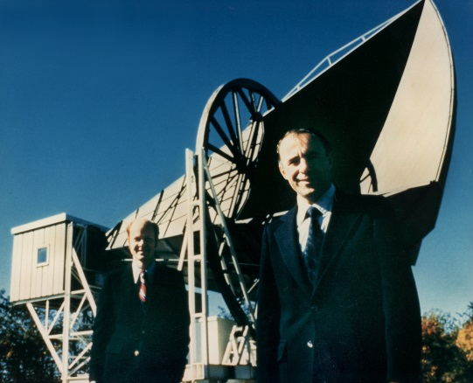
Figure AVI.2 Penzias and Wilson

Appendix VII: Summary of the different stages in the early formation of the universe

Up to 10^{–10} s after the Big Bang – temperature greater than 10¹⁵ K

Unknown due to lack of knowledge of the laws of physics at these very high temperatures.

From 10^{–10} s to 10^{–4} s (0.1 ms) after the Big Bang – temperature between 10¹⁵ K and 10¹² K

A dense ‘sea’ of quarks, electrons, neutrinos and photons. Radiation too energetic to allow formation of protons or neutrons.

From 0.1 ms to 1.0 s – temperature between 10¹² K and 10¹⁰ K

Quarks have condensed into protons and neutrons. Radiation too energetic to allow formation of nuclei.

From 1.0 s to 30,000 years – temperature between 10¹⁰ K and 10,000 K

Protons and neutrons have joined to form atomic nuclei. Universe still radiation dominated.

From 30,000 years and 300,000 years – temperature between 10,000 K and 3000 K

Universe is now matter dominated rather than radiation dominated. Otherwise as above.

After 300,000 year to present – temperature between 3000 K and 3 K

Atoms now formed by electrons attaching themselves to nuclei. Photons no longer energetic enough to knock electrons out of atoms (decoupling).

Photons now cooling to form what we see as microwave background radiation.

Appendix VIII: The ether (re-)discovered?

Temperature variations in the CMB

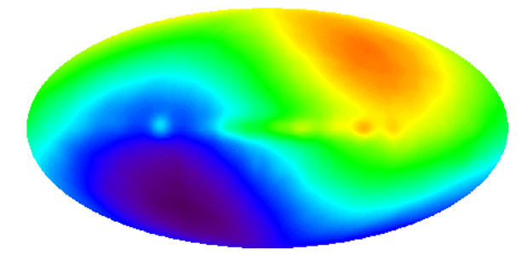
Figure AVIII.1 COBE dipole: speeding through the universe
(Scale adjusted to show differences of a few mK)

CMB
Earth
Redshifted
Blueshifted

Figure AVIII.2 Moving through the CMB

The microwave radiation is very slightly hotter (blueshifted) in one direction of the sky and slightly cooler (redshifted) in the opposite direction (180° away in the sky). Remember that hotter corresponds to a larger peak frequency (ie blueshifted) and cooler to a smaller peak frequency (ie redshifted).

At 90º and 270º there is no shift. This is due to the earth’s motion through the CMB.

So not only can we detect the temperature of the universe, we can also measure our motion relative to this background glow. (Is the idea of the ether back?)

When the effect of the Earth’s motion is subtracted from the CMB temperature measurements, the uniformity of the temperature in all directions becomes even more remarkable.

Once we take into account the Earth’s motion, we could increase the sensitivity to notice variations smaller than 0.0001 K and still the COBE diagram (Figure AVIII.1) would be a featureless grey with no variations in shading.

Appendix IX: Where next for cosmology?

What is dark matter?

Why do protons and neutrons only make up 4% of the total density?

Dark energy – really just a name for something we don’t understand at all.

Neutrino telescopes – Scientific American, May 2010 reports on this next generation of telescopes, likening it to the advances in optical telescopes a century ago. The same article has an inset on dark matter. It suggests that as yet unobserved sterile neutrinos may make up dark matter. The idea that dark matter was due to neutrinos fell out of favour as they were too light.

See also http://icecube.wisc.edu/ on the Icecube neutrino telescope being constructed at the South Pole, due for completion in 2011.

A new standard has been set in astronomy as the Pan-STARRS sky survey telescope begins scanning the skies nightly with the world's largest digital camera.

See press release from the University of Edinburgh, June 2010, at:
http://www.ph.ed.ac.uk/news/photographing-universe-17-06-10

and associated information on the Web:

http://pan-starrs.ifa.hawaii.edu/public/.

http://www.roe.ac.uk/~jap/PS/

http://www.roe.ac.uk/roe/support/pr/pressreleases/100617-panstarrs/index.html

Appendix X: Timeline for milestones in cosmology

Date/era | Milestone
1917 | Slipher’s measurements indicate the universe is expanding.
1924 | Hubble measures distances to nebulae, proving them to be extra-galactic, ie separate and distinct galaxies from our own.
1929 | Hubble and Humason measure the expansion rate of the universe.
1933 | Zwicky proposes the existence of dark matter.
1950s | Big Bang versus steady-state debate.
1965 | Penzias and Wilson discover CMB radiation.
1970s | Dark matter becomes ‘mainstream’.
1980s | Cold dark matter developed.
1992 | Cosmic Background Explorer satellite experiment discovers anisotropies.
1998 | Dark energy becomes a standard part of cosmological models.
2000 | Boomerang CMB experiment supports a flat universe.

Glossary

Accretion | Accumulation of matter at a particular location under the action of gravity.
Comoving | An object receding with the general flow (Hubble expansion) of the universe.
Cepheid variable | A class of star that increases and decreases brightness in a predictable periodic manner.
Cosmological principle | The universe looks basically the same wherever you are and in whatever direction you look. Isotropic and homogeneous.
Decoupling | The process when photons cease to interact with matter.
Flux | The amount of electromagnetic radiation received per unit time from a source.
Galaxy | A large aggregation of stars, star clusters, gas and dust clouds.
Homogeneous | The same no matter where you view it from.
Isotropic | The same no matter where you are.
Local Group | The group of galaxies that includes our galaxy, the Milky Way. It comprises more than 30 galaxies, including the Andromeda galaxy (M31).
Luminosity | The total amount of energy emitted per unit time.
Luminous | Emitting energy in the electromagnetic spectrum.
Nebula/nebulae | Cloud(s) of interstellar gas and dust.
Nucleosynthesis | Big Bang or cosmic nucleosynthesis is the process by which atomic nuclei first formed in the universe.
Parsec | Unit of distance at which an object would have an annual parallax of one arc-second – 1/3600 of a degree – equal to 3.26 ly.
Peculiar velocities | Deviations from the uniform Hubble expansion.

Proper motion | The angular change in position of a star due to its motion across the line of sight relative to the Solar System.
Radial speed/velocity | Speed or velocity along our line of sight from Earth.
Recombination | Free electrons combining with nuclei to form atoms.
Standard candle | A star or luminous object whose luminosity is assumed to be known.
Supernova | A star that experiences a cataclysmic explosion, suddenly increasing its luminosity. Type II supernovae have prominent hydrogen lines in their spectrum, whereas type I do not.
Surface brightness | The flux received per unit area from an extended source.
Tangential speed/velocity | Speed or velocity perpendicular to the line of sight of an object. Sometimes called transverse speed/velocity, which avoids confusion with circular motion.
Transverse speed/velocity | Speed or velocity perpendicular to the line of sight of an object. Sometimes called tangential speed/velocity.

Recommended reading

Nicolson I, Unfolding Our Universe

This book is highly recommended for this course because of its depth of treatment, layout etc. The only downside is that it is perhaps a little dated (1999). However, that doesn’t prevent the vast majority of the relevant topics being covered. It has a couple of very useful introductory chapters:

- Chapter 1: Overview of the universe
- Chapter 2: Observing the universe (which covers a lot of the relevant basic physics).

Good, clear colour diagrams throughout the book explain the concepts well to a ‘physics’ audience. Inset boxes give additional information, often including equations and calculations. Good glossary included.

Liddle A, Loveday J, The Oxford Companion to Cosmology

This book is highly recommended for your bookshelf or desk to provide an authoritative reference for those unexpected questions. It also has a good extensive overview ‘The hot big bang cosmology’ at the beginning. The rest of the book is set out like a dictionary/mini-encyclopaedia.

Duncan T, Tyler C, Your Cosmic Context

An excellent book aimed at a single-term undergraduate course on cosmology. The explanations are very clear and taken step by step. The diagrams and illustrations are clear, original and helpful. Many useful analogies are used throughout. It also has crosswords as part of the review at the end of each section.

Bennett J, Donahue M, Schneider N, Voit M, The Cosmic Perspective Fundamentals

This is basically an adapted version of The Cosmic Perspective. It has been abridged and modified to take into account active learning and acknowledges the use of new technology. Each chapter has a summary of key concepts and a
multiple choice quick quiz. There are a number of insets on common misconceptions.

Bennett J, Donahue M, Schneider N, Voit M, The Cosmic Perspective

An introduction to astronomy for non-science undergraduates. Very clear and useful summaries at the end of each chapter.

Singh S, Big Bang

This is a popular science book that also traces the historical development of ideas in cosmology. It is very readable and has useful ‘hand written’ summaries at the end of each section.

Bibliography

Bennett J, Donahue M, Schneider N, Voit M, The Cosmic Perspective Fundamentals, Addison-Wesley 2010, ISBN 0-321-56704-8.

Bennett J, Donahue M, Schneider N, Voit M, The Cosmic Perspective, 3rd edition, Addison-Wesley 2004, ISBN 0-8053-8762-5.

Clark S, Towards the Edge of the Universe, 2nd edition, Praxis 1999, ISBN 1-85233-098-8.

Duncan T, Tyler C, Your Cosmic Context, Addison Wesley 2009, ISBN 978-0-13-240010-7.

Hodgkinson K, Surveying the Universe, Open University Press 1982, ISBN 0335-16115-4.

Liddle A, An Introduction to Modern Cosmology, Wiley 2003, ISBN 0470-84835-9.

Liddle A, Loveday J, The Oxford Companion to Cosmology, Oxford University Press 2008, ISBN 978-0-19-956084-4.

Nicolson I, Unfolding Our Universe, Cambridge University Press 1999, ISBN 0-521-59270-4.

Overduin JN, Wesson PS, Dark Sky, Dark Matter, Institute of Physics 2003, ISBN 0-7503-0684-X.

Partridge RB, 3K: The Cosmic Microwave Background Radiation, Cambridge University Press 1995, ISBN 0-521-35808-6.

Roos M, Introduction to Cosmology, Wiley 2003, ISBN 0-470-84909-6.

Singh S, Big Bang, Harper Collins 2004, ISBN 0-00-715251-5.

Websites

NASA’s data centre for CMB research: http://lambda.gsfc.nasa.gov/.

NASA’s resources (good background notes) on the Wilkinson Microwave Anisotropy Probe (WMAP), including a pdf downloadable version:
http://wmap.gsfc.nasa.gov/universe/.

National Park Service: Astronomy and Astrophysics – Horn Antenna:
http://www.nps.gov/history/history/online_books/butowsky5/astro4k.htm.

