`
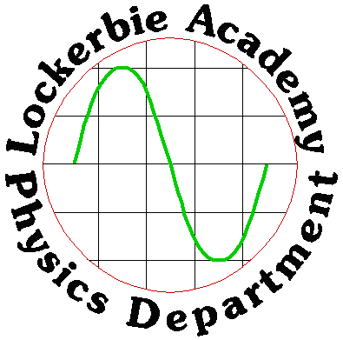
J A Hargreaves
Lockerbie Academy
August 2019

J A Hargreaves
Lockerbie Academy
August 2015
2019

Higher

OUR DYNAMIC UNIVERSE part 2



CONTENT

Summary
Contents
CONTENT 2
Summary 2
CHAPTER 5: GRAVITATION 5
Summary of content equations of motion 5
Astronomical Data 5
Gravitational Field Strength on other planets 6
Projectiles 6
Projectiles fired Vertically 6
Projectiles fired horizontally 7
Projectiles at an angle 8
Task: Launch Velocity 10
Notes on Projectile Motion 10
Projectiles: Worked Examples 12
Orbits and Newton’s Thought Experiment 17
Gravity and Mass 19
Newton’s Universal Law of Gravitation 20
Gravitational Fields 22
Equations of Motion / Tutorial 1 24
Gravity and Mass/ Tutorial 2 26
Gravitation exam questions 26
Answers: Equations of Motion 28
Answers: Gravitation Answers 29
CHAPTER 6: SPECIAL RELATIVITY 30
Summary of content 30
Special Relativity 30
Notation 32
Frames of Reference 33
Postulates of Special Relativity 35
The Principles of Relativity 37
Time Dilation 38
Another thought experiment 39
Time Dilation and the Lorenz Transformation 41
Time Dilation Formula and the Lorentz Transformation 45
Answering Lorenz Factor Questions 46
Why we do not notice relativistic time differences in everyday life? 47
Another example and some effects 50
Length contraction 50
Length paradox 51
How do you measure a fish? 51
Ladder paradox - solution 52
The Michelson-Morley Experiment 53
Communicating Scientific Results 55
Objective 55
Learning outcome 55
Learning activity 55
Special Relativity / Tutorial 1 57
Time dilation / Tutorial 2 59
Length Dilation / Tutorial 3 60
Relativity Miscellaneous/ Tutorial 4 61
EXAM QUESTIONS / Special Relativity 63
Tutorial Answers 64
Special relativity 64
Time dilation 64
Length dilation 64
Relativity Miscellaneous 65
Chapter 7: THE EXPANDING UNIVERSE 66
Summary of Content 66
The Doppler effect and redshift of galaxies 67
Analogy: Sweets on a conveyor belt 69
Equations 69
Deriving the Doppler Equations 69
Method 1 70
Method 2 71
Method 3 72
Big Bang Theory 76
Line spectra 76
Redshift, z 77
Blueshift. 80
Anecdote 80
Hubble’s Law 81
Units of Hubble’s constant H₀: 83
Evidence for the Expanding Universe 83
The Expanding Universe 84
Why such a shock? 84
Einstein's Greatest Blunder 85
The Cosmological Constant 85
Dark Energy vs. Dark Matter 85
More on Dark Matter 86
What do we observe? 87
The Big Bang Theory 88
What was the evidence - 88
Determining the Temperature of Distance Stars & Galaxies. 88
Bang? 89
Evidence for the Big Bang Theory 90
Redshift (see previous notes) / Evidence from the Expanding Universe 90
Cosmic microwave background (CMB) radiation 90
Black Body Radiation 91
The Helium Problem 91
Olbers’ paradox 93
A summary of some of the evidence of the Big Bang and its interpretation 94
Further Questions on the Universe 94
Where in the universe was the Big Bang? 94
What does the universe expand into? 94
Definitions for the Expanding Universe: 95
Expansion not explosion 96
Tutorials 97
The Expanding Universe/ Tutorial 1 97
Hubbles Law / Tutorial 2 100
Big Bang Theory/ Tutorial 3 102
The Expanding Universe/ Exam Questions 103
The Expanding Universe TUTORIAL ANSWERS 103

CHAPTER 5: GRAVITATION

Summary of content equations of motion

5. |  | Gravitation
 | eq | $d=\overline{v}t, s=\overline{vt} ; s=\frac{1}{2}\left(u+v\right)t;$ $F=\frac{G{m_{1}m}_{2}}{r^{2}}$
 |  | I can use the equation $F=\frac{G{m_{1}m}_{2}}{r^{2}}$
 |  | I can give a description of an experiment to measure the acceleration of a falling object.
 |  | I know that the horizontal motion and the vertical motion of a projectile are independent of each other.
 |  | I know that satellites are in free fall around a planet/star.
 |  | I can resolve the initial velocity of a projectile into horizontal and vertical components and their use in calculations.
 |  | I can use resolution of vectors, vector addition, and appropriate relationships to solve problems involving projectiles.
 |  | I can use Newton’s Law of Universal Gravitation to solve problems involving force, masses and their separation.

Astronomical Data
This data is required to answer the tutorial questions.
Mass of Earth | M_{E} | 6·0 × 10²⁴ kg
Radius of Earth | R_{E} | 6·4 × 10⁶ m
Mass of Moon | M_{M} | 7·3 × 10⁶ kg
Radius of Moon | R_{M} | 1·7 × 10⁶ m
Mean radius of Moon orbit |  | 3·84 × 10⁸ m
Mass of Jupiter | M_{J} | 1·0 × 10²⁷ kg
Radius of Jupiter | R_{J} | 7·15 × 10⁷ m
Mean radius of Jupiter orbit |  | 7·8 × 10¹¹ m
Universal constant of gravitation | G | 6·67 × 10⁻¹¹ m³ kg⁻¹ s⁻²

Gravitational Field Strength on other planets
Solar System object | g (Nkg⁻¹)
Mercury | 3.7
Venus | 8.8
Earth | 9.8
(Moon) | 1.6
Mars | 3.8
Jupiter | 26.4
Saturn | 11.5
Uranus | 11.7
Neptune | 11.8

Projectiles
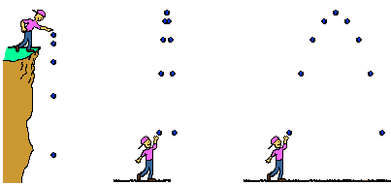
Generally projectiles have both horizontal and vertical components of motion. As there is only a single force, the force of gravity, acting in a single direction, only one of the components is being acted upon by the force. The two components are not undergoing the same kind of motion and must be treated separately.
This force creates an acceleration equal to “g” in the vertical direction, which on Earth has a value of 9.8ms⁻²

Projectiles fired Vertically
To summarise, for a vertical projectile on Earth:
Direction of motion | Forces | Velocity | Acceleration
Horizontal | Air resistance negligible so no forces in the horizontal direction. | Constant  (in this case 0 ms^{–1}) | None
Vertical | Air resistance negligible so only force of gravity acting in the vertical direction. | Changing with time | Constant or uniform acceleration of  – 9.8 m s⁻²

Projectiles fired horizontally
The second projectile situation to consider is the horizontal projectile.
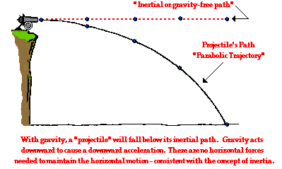
In projectile motion we ignore air resistance, or any force other than the force of gravity, in our calculations, but you could be asked the effect of air resistance in a supplementary question.
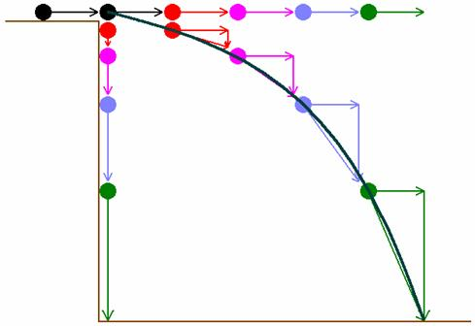
Analysis of this projectile shows the two different components of motion.
Horizontally: there are no forces acting on the cannonball and therefore the horizontal velocity is constant.
Vertically: The force due to gravity is constant in the vertical plane and so the projectile undergoes constant vertical acceleration.
The combination of these two motions causes the curved path of a projectile.
Example: The cannonball is projected horizontally from the cliff with a velocity of 100 ms⁻¹. The cliff is 20 m high.
Determine: (a) the vertical speed of the cannonball, just before it hits the water;
(b) if the cannonball will hit a ship that is 200 m from the base of the cliff.
Solution:
Horizontal | Vertical
s = ? | s = 20 m
v= 100 m s⁻¹ | u = 0
t = ? | v= ?
 | a = 9·8 m s⁻²
 | t= ?
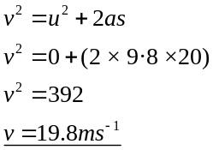 (b) 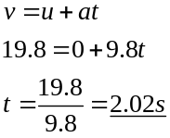 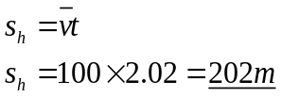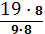
The cannonball will hit the ship.

To summarise, for a horizontal projectile on Earth:
Direction of motion | Forces | Velocity | Acceleration
Horizontal | Air resistance negligible so no forces in the horizontal direction. | Constant  v | Zero
Vertical | Air resistance negligible so only force of gravity acting in the vertical direction. | Changing with time | Constant or uniform acceleration of  -9.8 m s^{–2}

Projectiles at an angle
u
Path of a mass in a uniform gravitational field
Over short distances, g can be thought of as uniform.
If a rugby ball is kicked horizontally with initial horizontal velocity, u, it will move in a parabolic trajectory to the ground.
Horizontal velocity remains constant but the ball accelerates downwards
The third and final projectile situation to consider is the projectile at an angle to the horizontal. Projectiles at an angle require us to use our knowledge of splitting vectors into their horizontal and vertical components.
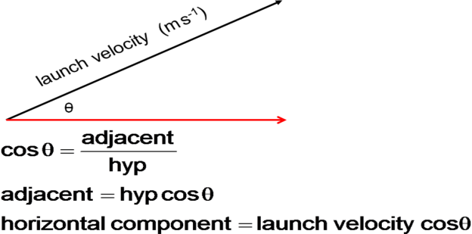
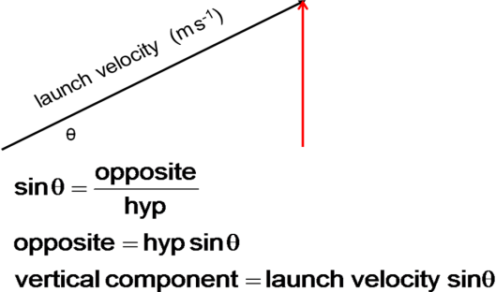
Rec(launch velocity, angle)

The distance travelled horizontally (the range) is determined by the cosine component of the launch velocity. The time of flight is determined by the sine component of the launch velocity, providing the angle to the horizontal is given.

To summarise, for a projectile fired on Earth at an angle to the horizontal:
Direction of motion | Forces | Velocity | Acceleration
Horizontal | Air resistance negligible so no forces in the horizontal direction | Constant  v cos θ | Zero
Vertical | Air resistance negligible so only force of gravity acting in the vertical direction. | Changing with time.  Initially  v sin θ | Constant or uniform acceleration of  -9.8 m s^{–2}
range
trajectory
50 ms⁻¹
v_{h}
v_{v}
60º

The velocity at an angle must be split into its vertical and horizontal components before calculating any solution to projectile motion as only the vertical component is acting upon by the force of gravity.
$$v_{h}=v\cos{θ}$$
$$v_{v}=v\sin{θ}$$

For projectiles fired at an angle above a flat horizontal surface with no air resistance:
1. The path of the projectile is symmetrical, about the highest point. This means that:
initial vertical velocity = − final vertical velocity
u_{v} = − v_{v}
2. The time of flight = 2 × the time to highest point (if s_{v} = 0 m)
3. The vertical velocity at the highest point is zero.
4. The overall velocity at the highest point is equal to v_{h}, the horizontal velocity.

To summarise, for any projectile on Earth:

Direction of motion | Forces | Velocity | Acceleration
Horizontal | Air resistance negligible so no forces in the horizontal | Constant  v cos θ | Zero
Vertical | Air resistance negligible so only force of gravity acting in the vertical | Changing with time  Initially  v sin θ | Constant or uniform acceleration of  –9.8 m s^{–2}

Task: Launch Velocity
Determine experimentally and/or theoretically the angle, which gives the greatest range for a fixed, launch velocity.

Notes on Projectile Motion
- Assume air resistance is negligible.
Horizontal velocity ms⁻¹
Time (s)
0
- Objects travel sideways as well as falling.
- The motion is symmetrical about the highest point.
- The flight of a projectile is parabolic.
- When dealing with projectiles you must deal with the two motions separately.
- HORIZONTALLY, ignoring air resistance, the projectile moves with constant velocity.
- VERTICALLY the motion is affected by a constant acceleration of 9.8ms⁻² downwards on Earth, the acceleration due to gravity.
Vertical velocity ms⁻¹
Time (s)
The gradient of this graph equals the acceleration due to gravity. For problems on Earth this gradient
= - 9.8ms⁻²
0
- If we take air resistance into account then the speed tends to decrease in the horizontal direction, however this makes the calculations too difficult so for the higher course you must assume that you’re your calculations are occurring in a vacuum!
- When fired upward the object will decelerate at 9.8ms⁻², reach a maximum height where its vertical velocity is zero. It will then accelerate downwards at 9.8ms⁻².
- The forces on an object will be the same if an object accelerates downwards as they are if the object decelerates upwards!
- Don’t forget that even when the vertical velocity of the object is zero there is still a force on the object and it is still accelerating downwards at 9.8ms⁻².
- The velocity of the object changes during the flight.
- Remember that velocity is a vector quantity. We must split the resultant velocity (the velocity that the object is travelling in) into its components, in this case horizontal and vertical. We do this by taking components which has been dealt with elsewhere. Notice there is only one gradient because there is only one acceleration, but this causes a deceleration in objects moving upwards, away from the Earth and it causes an acceleration in objects moving downwards, towards the centre of the Earth.
- We then do not use the resultant again unless we are asked for the resultant at any further point.
- The horizontal and vertical motions are independent of each other and the only link between the two motions is the TIME!
sometimes the graph can be shown with a positive gradient
Vertical velocity ms⁻¹
Time (s)
0
- At any point during the flight the horizontal and vertical components are added together to give the resultant velocity of the object.
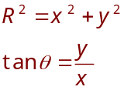
θ
Vertical component
Horizontal component
Resultant
velocity


When working out the projectile problems follow the method below.
- Draw out a quick sketch of the problem.
- Find the horizontal and vertical components of the initial velocity. 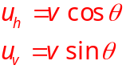
Horizontal motion | Vertical motion
s_{H} | s_{v}
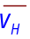(usually v cos θ) | u_{v} (usually v sin θ)
t | v_{v}
 | a = 9.8ms⁻² ↓
 | t
TIME IS THE COMMON FACTOR
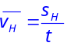 | 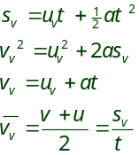
- Draw up a table with the following information and fill in as much as you can.
YOU MUST REMEMBER THAT DIRECTION IS IMPORTANT. You indicate direction by positive and negative signs.
You can work by convention i.e. axes, or take each question individually and decide which way you will take as positive. Show this in your summing up of the question. If an object is thrown upwards then u and a must have opposite signs.
+
+
-
-
0
+
negative
positive
- Usually in questions they will ask you to find either the horizontal or vertical quantities but this will involve you working out something that is missing from the horizontal quantities. e.g. Find the horizontal range but you will only be given enough information to find the time from the vertical component. This time will then need to be substituted into the equation for horizontal components.
- An important thing to remember is that at the top of the throw the vertical velocity will be zero. This can be equal to v for that part of the journey and u for the next part of the journey.This will occur half way through the journey if the journey is symmetrical (i.e. it lands at the same height that it was thrown.) These questions are becoming less common as they were considered too easy!
- Other hints to remember, if the journey is symmetrical then the resultant velocity on landing is the same but in the opposite direction. i.e if an object is projected with an initial velocity of 7⋅5 ms⁻¹ at an angle of 60° to the horizontal, then it will land at a velocity of -7⋅5 ms⁻¹ at an angle of 60° to the horizontal.
- You can always break journey’s into bits if they are too difficult to complete in one go, eg find the time it takes to go to the top of the throw and then find the time it takes to come back down.
- The vertical displacement for a symmetrical journey is 0 m.
- 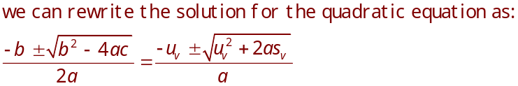Remember you can use the version of the quadratic with it already set up for the equation (s=ut+ ½ at²) if you feel confident and can remember it (it will not be on the relationship sheet).

See the next page on the theory behind this and choose which ever equation suits. Both have things that can catch you out.

- If you find yourself with a difficult quadratic to solve then you can use two equations instead, ie usually v²=u²+2as and then v=u+at.
- You don’t get extra marks for being smart it is being correct that is important and carrying out a method that works!
- Remember that an object that is thrown with only a horizontal initial speed only will land at the same time as an object dropped with zero initial vertical velocity.
- For all our problems we ignore air resistance. Air resistance and wind would affect the journey but it is too hard to work out. You could be asked what effect this would have on the journey.
- Sometimes you could be caught out with trying to square root a negative number. You can always try changing the sign convention and then seeing if that works out better. Remember that the square root of a number has two values, positive and negative. You can’t ever end up with a negative time and expect the right answer!
- If an object hits the ground its velocity on hitting is not zero!

Use of a quadratic when finding time with the equation of motion
$s=ut+\frac{1}{2}at^{2}$ (equation 1)
This can be rewritten as
$0=\frac{1}{2}at^{2}+ut-s$ (equation 1b)
The roots (solution) of a quadratic equation
$$ax^{2}+bx+c=0$$
are given by:
$x=\frac{-b±\sqrt{b^{2}-4ac}}{2a}$ (equation 2)
Quadratic Equation | Equation of motion
x | t
b | u_{v}
c | -s_{v}
a | $\frac{a}{2}$ where a= acceleration
Substituting equation 1b into equation 2 gives:
$t=\frac{-u±\sqrt{u^{2}-\frac{4a}{2}-s_{v}}}{\frac{2a}{2}}$ (equation 3)
This can be reduced to:
$t=\frac{-u±\sqrt{u^{2}+2as_{v}}}{a}$ (equation 4)
So either learn this particular equation (4) for use with equation 1 (but you must always check your directions for each quantity)
Or remember when you substitute equation 1 into equation 2
that a in equation 2 is $\frac{acceleration}{2}$.
There is also only one solution to equation 4 as time cannot be negative.

Projectiles: Worked Examples
            - Show that the horizontal velocity of the can is 0.6 m s⁻¹ immediately after being struck by the toy arrow.
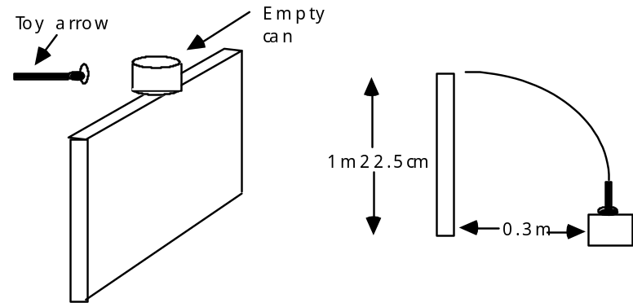
First, consider the vertical velocity in order to find the time.
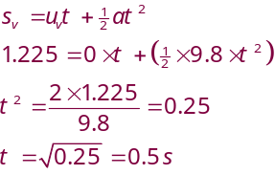
Horizontally:
$$s_{h}=u_{h}t$$
$$0∙3=u_{h} × 0∙5,$$
$$u_{h}=0∙6 {ms}^{-1}$$
            - Determine the time taken for a stone to reach the ground from the top of a 100m high building if,
- it is thrown vertically downwards at 5 ms⁻¹.
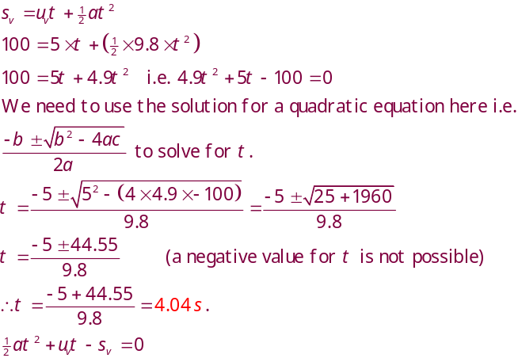As u and a are both down, down can be taken as positive or u,v,a and s will need to be written as negaive
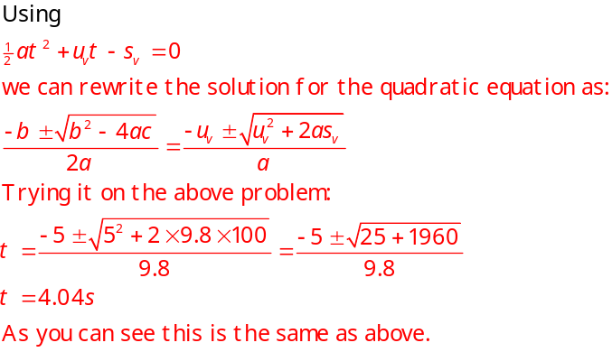

    - If this last method is too difficult then try breaking it up into smaller chunks!
If you can’t do quadratics we need to use one of the other formulae.
v²= u² + 2as doesn’t contain time so that isn’t the equation that we finally need but if we use v = u + at we have 2 unknowns. We don’t know either v or t so we have to work it out. So first find the final velocity on landing.
s = 100m | $$v^{2}=u^{2}+2as$$
u = 5ms⁻¹ downwards | $$v^{2}=5^{2}+2×9.8×100$$
v = ? | $$v^{2}=25+1960$$
a = 9.8ms⁻² downwards | $$v=\sqrt{1985}=44.55 ms^{-1}$$
t = ?
Now put the new velocity into the other equation | 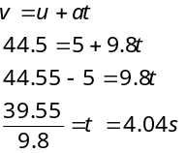

- if it is thrown upwards at an angle of 39.3° to the horizontal at 7.9 ms⁻¹?

(b) Although the stone has both a horizontal and vertical component, we only need to consider the VERTICAL one.
39.3º
7.9 ms⁻¹
The vertical component of the motion, v_{v} is given by:
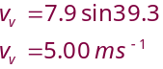
[Rec(7.9,39.3)]
Find how long it takes to reach the ground?
s=100m (downwards)
u =5ms⁻¹(upwards)
v=
a=9.8ms⁻²(downwards)
t=

Find how long it takes for it to reach the top of the flight.  s = ?  u = 5 m s⁻¹ upwards  v = 0 m s⁻¹  a = 9.8 m s⁻² downwards |  | 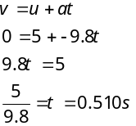
  t =
You now need to know what height this is above the 100m building.
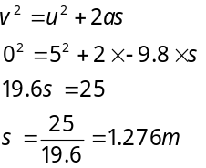
So now you need to know the time it takes for the object to fall 1.276 + 100 m to the ground. remember that for this part of the journey the initial starting velocity of the object is zero, as it has reached the highest point. | 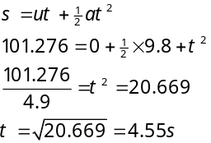
so total time = 4.55 + 0.51= 5.06 s
3. A projectile is fired across level ground taking 6 s to travel from A to B. The highest point reached is C. Air resistance is negligible.
C
A
B
Velocity - time graphs for the flight are shown below
3
-30
0
6
v_{H}
/ m s⁻¹
t / s
40
0
3
6
v_{v} / m s⁻¹
t / s
30
- Describe the horizontal and vertical motions of the projectile.
- Use a vector diagram to find the speed and angle at which the projectile was fired from point A.
- Find the speed at position C. Explain why this is the smallest speed of the projectile.
- Calculate the height above the ground of point C.
- Find the range AB.
Answer
- The horizontal motion is a constant speed ( 40 m s⁻¹). The vertical motion is a constant acceleration ( 9.8 m s⁻²).
 | 30 m s⁻¹  40 m s⁻¹  v  θ | [Pol(40,30)]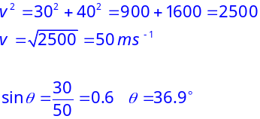
 | The speed at C is 40 m s⁻¹ (the vertical speed is zero).
 | Consider the vertical motion of the projectile:  s = ?  v = 0 m s⁻¹  u = 30 m s⁻¹  a = -9.8 m s⁻²  t = 3 s |  | 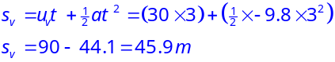
 | Consider the horizontal motion of the projectile: |  | 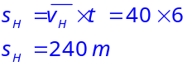
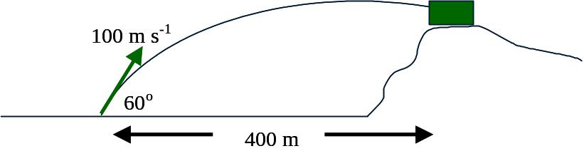
4. A missile is launched at 60º to the ground and strikes a target on a hill as shown below.
(a) If the initial speed of the missile was 100 ms⁻¹ find:
(i) the time taken to reach the target
(ii) the height of the target above the launcher.

- Consider the horizontal motion of the projectile:
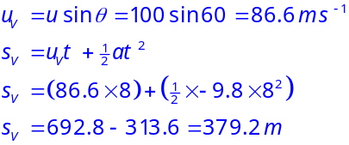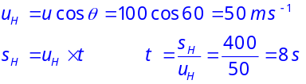
          - Consider the vertical motion of the projectile:

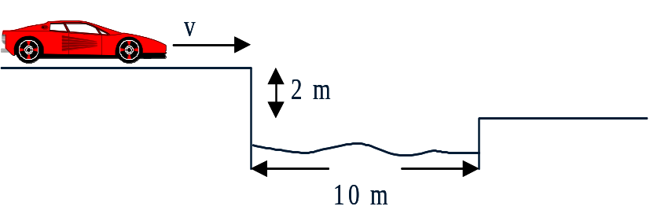
5. A stunt driver hopes to jump across a canal of width 10 m. The drop to the other side is 2 m as shown.
(a) Calculate the horizontal speed required to make it to the other side.
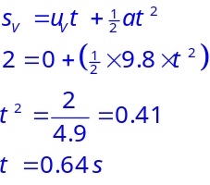(b) State any assumptions you have made.
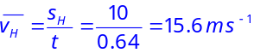(a)

        - The calculations do not take into account the length of the car. In practice, the front of the car will accelerate downwards before the back.

Orbits and Newton’s Thought Experiment
Newton died in 1727, 230 years before the launch of Sputnik 1, the first man-made object to orbit Earth, in 1957. However, like all good Physicists, he did have a great imagination and conducted thought experiments.
Newton considered the example of the cannon firing horizontally off a cliff. He knew that, as the Earth is approximately a sphere, the ground curves away from the projectile as it falls.
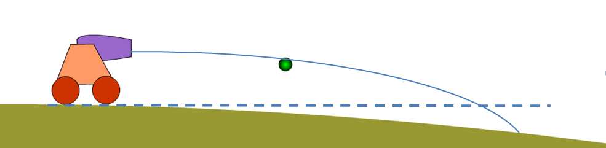
If we give the projectile a greater horizontal velocity, it will travel a greater distance before reaching the ground.
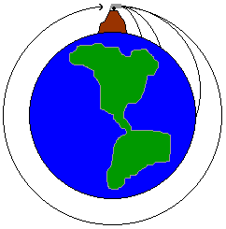
If that ground is also curving down and away from the projectile, the projectile would take even longer to land. (see the diagram, note the additional distance that the cannonball would travel due to the curvature of the Earth).
Newton theorized that there must be a horizontal launch velocity for a projectile which results in it following a course parallel to the curved surface of the Earth; causing it to go into orbit. Above this horizontal velocity the object would never return to Earth without an external force and would leave the Earth’s *****, and is dependent on the planet’s gravitational field.
To put a satellite into geostationary orbit the satellite would be travelling at approximately 3 kms⁻¹, if a rocket was launched vertically from Earth with a velocity of roughly 11 kms⁻¹ it could escape the Earth’s gravitational field.
As of 2019 a total of 8 378 objects have been launched into space. Currently, 4 994 are still in orbit – although 7 of them are in orbit around celestial bodies other than the Earth; meaning there are 4 987 satellites whizzing around above our heads every single day.. Radar is used to track more than 13,000 items that are larger than ten centimetres. This celestial clutter includes everything from the international space station (ISS) and the Hubble Space Telescope to defunct satellites, rocket stages, or nuts and bolts left behind by astronauts. And there are millions of smaller, harder-to-track objects such as flecks of paint and bits of plastic.

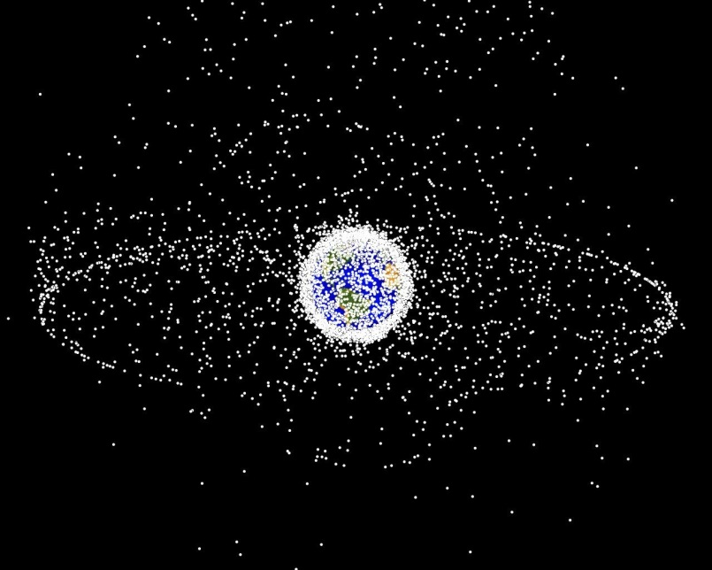
Note the geostationary and polar orbits that are rather busy and full!
Satellites in Low Earth Orbit (LEO), including the ISS, have a period of approximately 90 minutes, with the period depending on height above the Earth’s surface.
Many communication satellites, for telecommunications and television, are in geostationary orbit. This orbit is at a greater radius, with a period of 24 hours and an altitude of almost 36,000 km. This allows the satellites to stay above the same point on the Earth’s equator at all times and provide consistent communication across the globe.
Though high orbits have revolutionized global communications, they are prone to early failure of electronic components as they are not protected by the Earth’s magnetic field and are exposed to very high levels of solar radiation and charge build-up. Satellites huge energies to achieve the required altitudes and powerful amplifiers to ensure successful transmission of data back to Earth.
To avoid these orbits many organisations choose to use a ‘constellation’ of satellites in LEO (low Earth orbit), placed between the atmosphere and the inner Van Allen Belt. These have their own issues, as gases from the upper atmosphere cause drag which can degrade the orbit.

Gravity and Mass
If there is one thing that causes confusion in physics then it is the distinction between mass and weight.
In Physics we must be very careful about our use of terms.
Do NOT use the term GRAVITY when you mean the “force of gravity”. Try to think of gravity as a phenomenon rather than a force. If you wish to talk about the force of gravity on an object then you should use the term weight of the object or the force of gravity.
Mass is a measure of how much matter an object contains. This will only change if matter is added to or taken from the object.

The force of gravity is caused by mass, any object that has mass creates its own gravitational field. The magnitude of the field depends on the mass of the object and the distance from that mass. This field then exerts a force on any mass within it. You will have done an experiment to measure the Earth’s gravitational field using a set of masses and a Newton balance. If you measured the acceleration due to gravity earlier in the unit, then you have effectively measured the gravitational field strength since the magnitude of these two quantities is the same.
I’m attracted
to you
The force of gravity permeates the entire universe; scientists believe that stars were formed by the gravitational attraction between hydrogen molecules in space. As mass accumulated the gravitational attraction on the gases increased so that the forces at the centre of the mass were big enough to cause the hydrogen molecules to fuse together. This process is nuclear fusion and generates the sun’s energy. The energy radiating outwards from the centre of the sun counteracts the gravitational force trying to compress the sun inwards.
In time the hydrogen will be depleted, the reaction will stop and the sun will collapse under its own force of gravity, but this shouldn’t worry you unless you expect to live for approximately four billion years.
gravitational pull
core reaction push
It is believed that our solar system formed from the debris generated from the formation of the sun. This debris joined together to form planets, due to the gravitational attraction between the particles.

Newton’s Universal Law of Gravitation
Newton formulated the laws of gravity, inventing calculus along the way to help him get his laws in a simple form. Remember, Newton didn’t invent gravity; he produced the calculations that explained his observations.

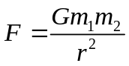His Law of Gravitation states that the gravitational attraction between two objects is directly proportional to the mass of each object and is inversely proportional to the square of their distance apart. Newton produced what is known as the Universal Law of Gravitation.

Where G is the universal constant of gravitation and has the value 6.67 x 10⁻¹¹ m³kg⁻¹s⁻² or Nm²kg⁻²
Gravitational force is always attractive, unlike electrostatic or magnetic forces.
Example: Consider a folder, of mass 0.3 kg and a pen, of mass 0.05 kg, sitting on a desk, 0.25 m apart. Calculate the magnitude of the gravitational force between the two masses.
Assume they can be approximated to point objects, where all their mass is concentrated in one place.
0.3 kg
0.05 kg
0.25 m
Solution:

m₁ = 0.3 kg  m₂ = 0.05 kg  r = 0.25 m  G = 6.67 x 10⁻¹¹m³ kg⁻¹ s⁻²  F = ? | 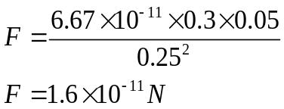
We do not notice the gravitational force between everyday objects because it is so small, in fact it is the weakest of the four fundamental forces of our universe. This is just as well, or you would have to fight against the force of gravity every time you walk past a large building! The force of gravity only becomes really apparent when very large masses are involved, e.g. planetary masses.
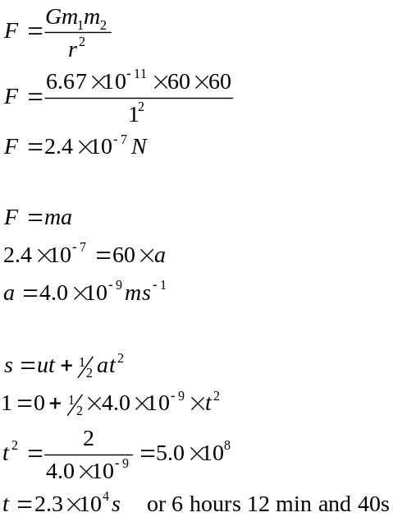For example the force of attraction between two pupils of average mass [60kg] sitting 1 metre apart is 2.4 x 10⁻⁷N. If there were no resistive forces and one pupil were able to move under the influence of this force towards the other, it would take 22 360s to cover the 1m distance.
1m
When this is applied to gas molecules or dust particles then the aggregation of larger and larger masses becomes easier to understand.
ms⁻²

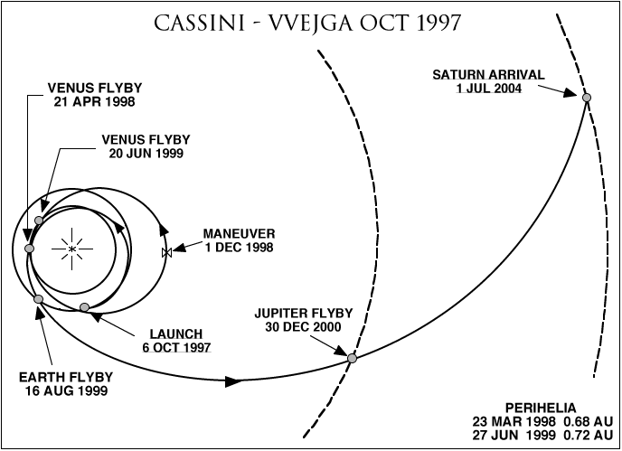
Another application of the gravitational force is the use made of the ‘slingshot effect’ by space agencies to get some ‘free’ energy to accelerate their spacecraft. Simply put they send the craft close to a planet, where it accelerates in the gravitational field of the planet. Here’s the clever part, if the trajectory is correct the craft then speeds past the planet with the increased speed. Don’t get it right and you still get a spectacular crash into the planet, which could be fun but a bit on the expensive side!

Gravitational Fields
A gravitational field is the region around a mass where another mass experiences a force. The strength or intensity of the gravitational field, g, is defined as the force acting per unit mass placed at a point in the field.
If a mass, m, experiences a gravitational force, F, then gravitational field strength, $g=\frac{F}{m}$ with units of N kg⁻¹ (m s⁻²):
$$g=\frac{F}{m}=\frac{W}{m}$$

Where g= gravitational field strength in Nkg⁻¹ Gravitational field strength is the force on a 1kg mass placed in the field.
F or W is the weight in Newtons, m = mass being attracted in kilograms

We can visualise the direction of a field by drawing field lines. For an isolated point mass the lines are always directed towards the mass, the field lines are radial.
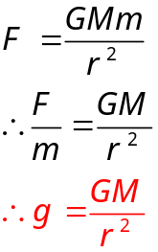For a radial field:

As you get further away from the mass the strength of the field gets weaker. You can see from the diagram that the closer the field lines the stronger the field.. These field lines do not really exist (look out of the window!) but they do show a concept that is real. (This is also similar to magnetic field lines when you draw the direction that a compass will point around a magnet)
outside planet g ∝ 1/r²
(GM constant)
g
r
planet’s surface
0

The gravitational field strength is the force of attraction between 1 kg of mass and the Earth. Remember the law of gravitation is a force of attraction between two masses, this means the 1 kg mass is attracting the Earth towards it, as well as the other way round.
Example 1: Show, using the universal law of gravitation, that the gravitational field strength on Earth is 9·8 N kg⁻¹.
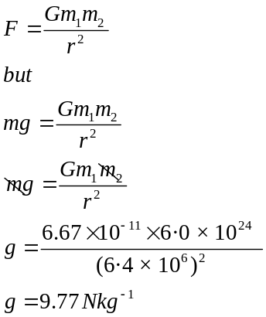

Example 2:
(a) Calculate the gravitational field strength on the surface of the Moon.
(b) Calculate the gravitational force between the Moon and the Earth.
(a) | 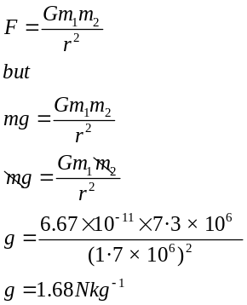 | (b) | 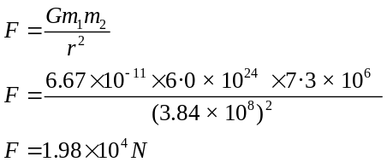

Equations of Motion / Tutorial 1

  - A child's ball rolls down a pavement and passes a mark at 1.5 ms⁻¹. If its velocity is 6.6 ms⁻¹ three seconds later, calculate its acceleration.
  - The same ball rolls round a corner at 7·0 ms-1 onto a new slope which gives it an acceleration of 2·0 ms⁻² calculate the time it take for its velocity to rise to 10 ms⁻¹.

- A water chute has a constant slope which gives the sliders an acceleration of 4·0 ms⁻². If a girl jumps on the chute at a velocity of 3·0 ms⁻¹, calculate the distance she slides in 5·0 s.

- An air-gun pellet has an initial velocity of zero and a muzzle velocity of 225 ms⁻¹. If the barrel of the rifle is 0.5 m long, calculate the pellet's acceleration.

- A football player catches up on a ball rolling at 3·0 ms⁻¹ and kicks it ahead along the same line with an acceleration of 200 ms⁻² while his foot is in contact with it. If his boot moves with the ball over a distance of 13.75 cm, determine the speed the ball moves after the kick.

- A ball is thrown upwards out of a window at 15·0 ms⁻¹ and strikes the ground with a velocity of 30·0 ms⁻¹. Determine the height of the window.

- A balloon is released with an initial upwards velocity of 1·0 ms⁻¹ and accelerates at 2·0 ms⁻² for the first 12·0 s of its climb.
        - Calculate its average velocity during these 12·0 s.
        - Determine its displacement during this time.

- A golf ball is driven from a tee and reaches a velocity of 50·0 ms⁻¹ in a time of 3·0 ms.
  - Calculate the ball's acceleration.
  - Calculate the distance travelled by the ball during the first 3·0 s after it is struck assuming there is no air resistance during its flight.

- A stone is thrown horizontally off a cliff and lands 2·0 s later 45·0 m out from the spot vertically below the thrower.
  - Calculate the height of the cliff.
  - Determine the stone's initial velocity.

- A meteroid strikes the Moon's surface and the impact ejects a 5·0 kg rock with a velocity of 200·0 ms⁻¹ at 60o to the horizontal. If the rock lands 21.6 km away, determine the gravitational acceleration at the Moon's surface.

- A person holds a golf ball at arm’s length so that the ball is 2·0 m above the ground. Calculate the time it takes the ball to reach the ground if he drops it.

- A mountain biker comes down a hill and then shoots horizontally off a riverbank at 5.50 ms⁻¹. The far bank is 1.50 m vertically below his starting height and 3·0 m away horizontally:

State if he makes it across. You must justify your answer with calculations.

- An angler is standing on a bridge reeling in a hooked fish, which is rising vertically at 1.50 ms⁻¹ when it manages to wriggle off. If the fish hits the water 1.20 s later, calculate the height of the fish above the surface when it escaped.

- A trolley is fitted with a mechanism which fires a ball bearing vertically upwards 5·0 s after the trolley is released. The trolley itself is fitted with a propeller that accelerates it along a horizontal track:
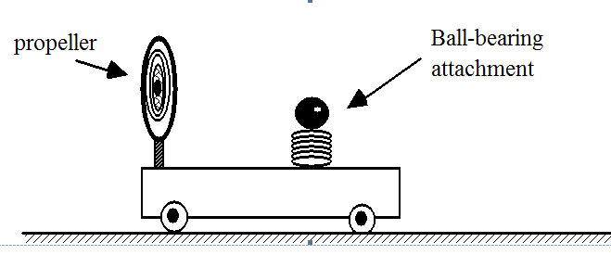
        - If the ball-bearing is released when the vehicle reaches a velocity of 2.50 ms⁻¹, calculate how far the trolley has moved along the track to this point.
        - If the ball-bearing starts with a vertical velocity of 4.80 ms⁻¹, calculate the maximum height it reaches.
        - Calculate the distance the ball-bearing lands from the trolley, assuming that the trolley travels with the same acceleration.

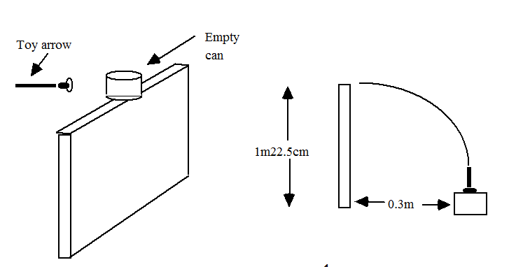 | Show that the horizontal velocity of the can is 0.60 ms⁻¹ immediately after being struck by the toy arrow.

- A train moving at 40·0 kmh⁻¹ has an acceleration of 1.50 ms⁻².
  - Calculate the speed of the train after 6·0 s?
  - Calculate the speed of the train after it has travelled 100·0 m.

- A lucky 20p is dropped down a wishing well 80·0 m deep. Calculate the time it takes to reach the bottom. (Ignore any effects of air resistance on the coin.)

- Calculate the time it takes for a stone to reach the ground from the top of a 100·0 m high building if,
  - it is thrown vertically downwards at 5·0 ms⁻¹.
  - it is thrown vertically upwards at 5·0 ms⁻¹.

Gravity and Mass/ Tutorial 2
In the following questions, when required, use the following data:
Gravitational constant = 6·67 × 10⁻¹¹ N m² kg⁻²
- State the inverse square law of gravitation.
- Show that the force of attraction between two large ships, each of mass 5·00 × 10⁷ kg and separated by a distance of 20 m, is 417 N.
- Calculate the gravitational force between two cars parked 0·50 m apart. The mass of each car is 1000 kg.
- In a hydrogen atom an electron orbits a proton in a circle with a radius of 5·30 × 10⁻¹¹ m. The mass of an electron is 9·11 × 10⁻³¹ kg and the mass of a proton is 1·67 × 10⁻²⁷ kg. Calculate the gravitational force of attraction between the proton and the electron in a hydrogen atom.
- The distance between the Earth and the Sun is 1·50 × 10¹¹ m. The mass of the Earth is 5·98 × 10²⁴ kg and the mass of the Sun is 1·99 × 10³⁰ kg. Calculate the gravitational force between the Earth and the Sun.
- Two protons exert a gravitational force of 1·16 × 10⁻³⁵ N on each other.
The mass of a proton is 1·67 × 10⁻²⁷ kg. Calculate the distance separating the protons.

Gravitation exam questions
For past paper questions please refer to the LA Homework Booklet, available at https://www.mrsphysics.co.uk/higher/category/homework/
1. A ball is rolled up a slope so that it is travelling at 14 m s⁻¹ as it leaves the end of the slope.
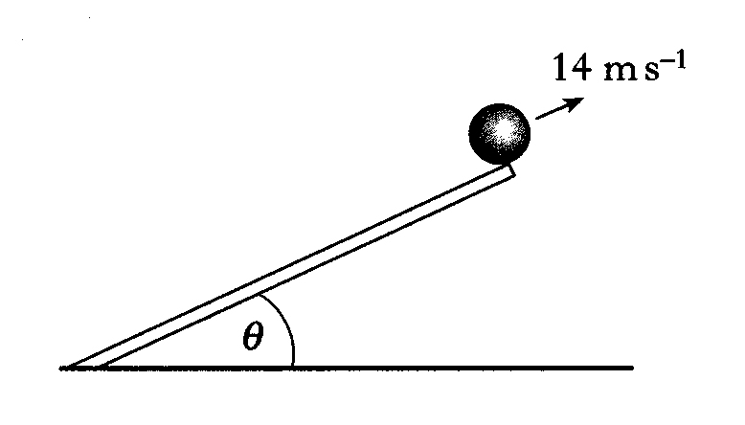
(a) The slope is set so that the angle to the horizontal,θis 30°.
Calculate the vertical component of the velocity of the ball as it leaves the slope.
(b) The slope is now tilted so that the angle to the horizontal, θ, is increased. The ball is rolled so that it still leaves the end of the slope at 14 m s⁻¹. Describe and explain what happens to the maximum height reached by the ball.
2. An archer fires an arrow at a target which is 30 m away.
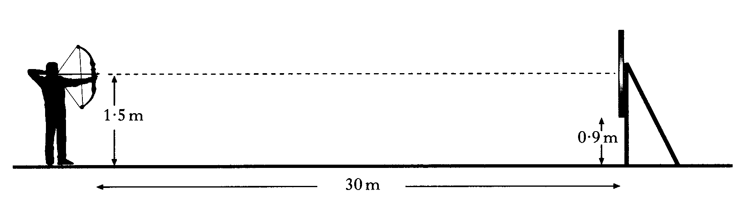
The arrow is fired horizontally from a height of 1·5 m and leaves the bow with a velocity of 100 m s⁻¹.
The bottom of the target is 0·90 m above the ground.
Show by calculation that the arrow hits the target.
3. The fairway on a golf course is in two horizontal parts separated by a steep bank as shown below.
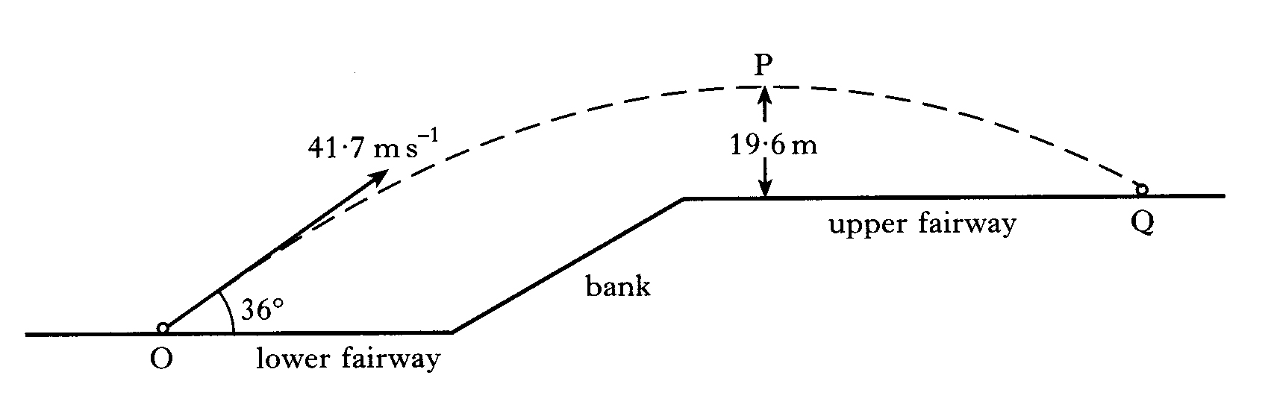
A golf ball at point O is given an initial velocity of 41·7 m s⁻¹ at 36° to the horizontal.
The ball reaches a maximum vertical height at point P above the upper fairway. Point P is 19·6 m above the upper fairway as shown. The ball hits the ground at point Q.
The effect of air resistance on the ball may be neglected.
(a) Calculate:
(i) the horizontal component of the initial velocity of the ball;
(ii) the vertical component of the initial velocity of the ball.
(b) Show that the time taken for the ball to travel from point O to point Q is 4·5 s.
(c) Calculate the horizontal distance travelled by the ball.

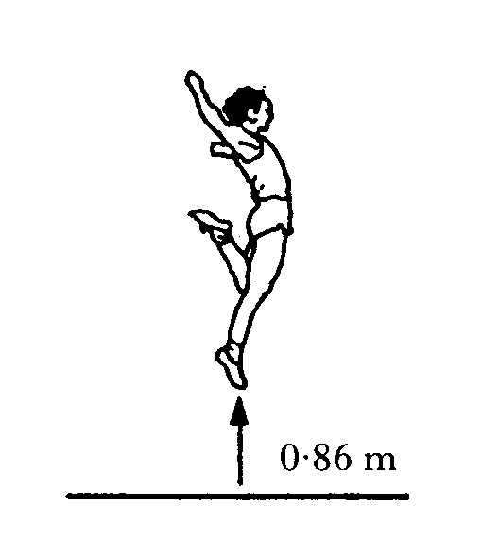
4. (a) A long jumper devises a method for estimating the horizontal component of his velocity during a jump.
His method involves first finding out how high he can jump vertically.
He finds that the maximum height he can jump is 0·86 m.
          - Show that his initial vertical velocity is 4·1 m s⁻¹.

(ii) He now assumes that when he is long jumping, the initial vertical component of his velocity at take-off is 4·1 m s⁻¹.
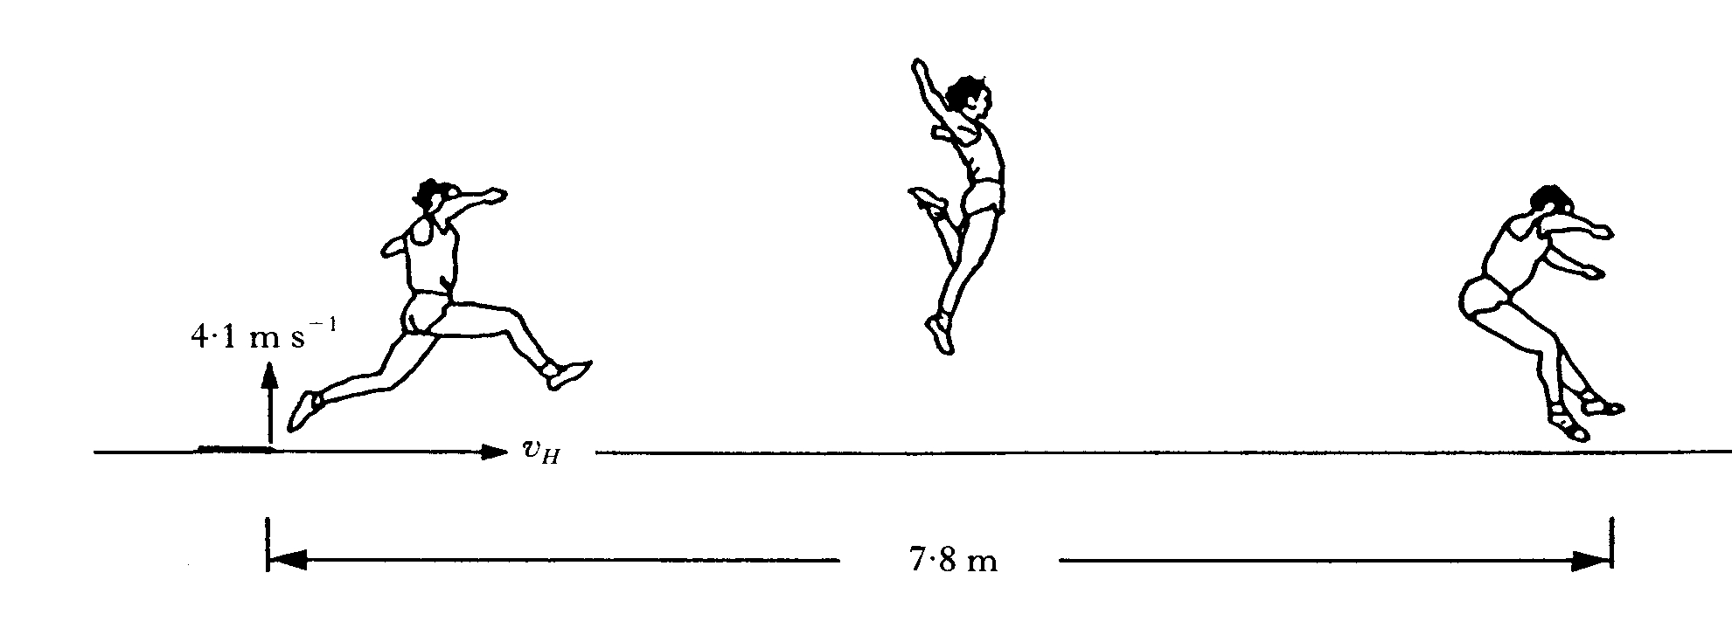
The length of his long jump is 7·8 m.
Calculate the value that he should obtain for the horizontal component of his velocity, v_{H}.
  - His coach tells him that, during his 7·8 m jump, his maximum height above the ground was less than 0·86 m. Ignoring air resistance, state whether his actual horizontal component of velocity was greater or less than the value calculated in part (a) (ii). You must justify your answer.

Answers: Equations of Motion

Tutorial 1 Answers
1 a) | 1.7 ms⁻² |  | 7 a) | 20 000 ms⁻² (16,667) |  | 12 | 5.3 m
b) | 1.5 s |  | b) | 150 m |  | 13 a | 1.25 ms^{–1}
2. | 65 m |  | 8.a) | 20 m |  | b) | 1.2 m
3. | 50625 ms⁻² |  | b) | 22.5 ms⁻¹ |  | c) | 2.5 m
4. | 8 ms⁻¹ |  | 9 a) | 216 s |  |  | 0.24 m
5. | 34 m |  | b) | 1.6 ms⁻² |  | 14. | 0.6 ms⁻¹
6.a) | 13 ms⁻¹ |  | 10. | 0.64 s |  | 15. | 20.1 ms^{–1} (74 kmh^{–1} )
b) | 156 m |  | 11. | 0.54 s to cross the river, but 0.55s to drop ∴ he makes it. |  | 16. | 4 s
 |  |  |  | 0.54 s to cross the river, but 0.55s to drop ∴ he makes it. |  | 17. a) | 4 s
 |  |  |  |  |  | b) | 5 s

Answers: Gravitation Answers

Tutorial 2 Answers

Gravity and mass
1. F = 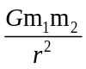
3. 2·67 × 10⁻⁴ N
4. 3·61 × 10⁻⁴⁷ N
5. 3·53 × 10²² N
6. 4·00 × 10⁻¹⁵ m

CHAPTER 6: SPECIAL RELATIVITY

These notes are produced with material from EducationScotland, Dick Orr, and Arfur Dogfrey and lots of reading from other sources. Note most books transcribe the terms t and t’ which appears to give a different equation. It is the same equation but the terms are reversed. Always use the formula given in the SQA Relationships sheet.
Guides to Special Relativity:
https://www.dummies.com/education/science/physics/einsteins-special-relativity/
http://physicsforidiots.com/physics/relativity/
https://www.youtube.com/watch?v=ttZCKAMpcAo
https://www.pdfdrive.com/relativity-a-very-short-introduction-emilkirkegaarddk-e7286899.html

Summary of content

6 |  | Special relativity
 | eq | 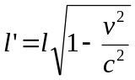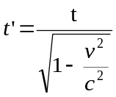
 |  | I know that the speed of light in a vacuum is the same for all observers.
 |  | I know that measurements of space, time and distance for a moving observer are changed relative to those for a stationary observer, giving rise to time dilation and length contraction.
 |  | I can use appropriate relationships to solve problems involving time dilation, length contraction and speed.

Special Relativity
Before we start this part of the course, please accept that the Newtonian Mechanics you have been taught so far is true – up to a point.
Useful Definitions and ideas
inertial reference frames | Simply two objects that are moving at constant speed relative to one another.
absolute reference frame | A unique, universal frame of reference from which everything could be defined or measured against. Einstein’s theories prove no such reference frame exists.
the ether (aether) | Early theories suggested that electromagnetic waves (light) required a medium: (a space-filling substance or field) to travel through. This ether was believed to be an absolute reference frame. Modern theories have no requirement for this idea, and the Michelson–Morley experiment performed in 1887 provided no evidence for such a field.
Time dilation | A difference in a time interval as measured by a stationary observer and a moving observer.
Length contraction | A difference in a length along the moving axis as measured by a stationary observer and a moving observer.
https://bambinidisatana.com/wp-content/uploads/2013/10/Galileo-Galilei-z3.jpg?6746a2    Galilean Invariance  Galileo was one of the first scientists to consider the idea of relativity.  He stated that the laws of Physics should be the same in all inertial frames of reference.  He first described this principle in 1632 using the example of a ship, travelling at constant velocity, without rocking, on a smooth sea; any observer doing experiments below the deck would not be able to tell whether the ship was moving or stationary.  In other words, the laws of Physics are the same whether moving at constant speed or at rest. |  |  | http://www.biografiasyvidas.com/biografia/n/fotos/newton.jpg  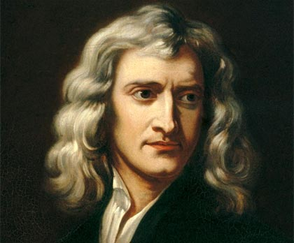  Newtonian Relativity  Newton followed this up by expanding on Galileo’s ideas.  He introduced the idea of absolute or universal space time.  He believed that it was the same time at all points in the universe as it was on Earth, not an unreasonable assumption.  According to Newton, absolute time exists independently of any perceiver and progresses at a consistent pace throughout the universe. Absolute space, in its own nature, without regard to anything external, remains always similar and immovable.
Many people know that Einstein was renowned for his theories on Relativity but for some people that is far as their knowledge goes.
Einstein wrote two papers on relativity. His theory on Special Relativity was published in 1905 in a paper titled, "On the Electrodynamics of Moving Bodies" by Albert Einstein. Special Relativity deals with the concepts of space and time as viewed by observers moving relative to one another with uniform velocities. It is called “Special” as it deals with only one situation and that is one where objects are not accelerating, so are continuing at constant velocity. In 1916 Einstein published another paper, on General Relativity. The Theory of General Relativity is the one which redefined the laws of gravity. The Theory of General Relativity also says that large objects cause outer space to bend in the same way a marble laid onto a large thin sheet of rubber would cause the rubber to bend. The larger the object, the further space bends. Just like a bowling ball would make the rubber sheet bend much more than the marble would.
If you want more information refer to the other material in the Our Dynamic Universe Folder. Don’t give up too early, try to get to grips with one of the major works of the twentieth century. However, do be aware that the literature is not consistent on the choice of definition of terms so that you can find various forms of the equations (I know I found them) use intuition as your best form of defence!

Notation
t time interval measured in the same frame of reference as the event (e.g. the pulse of light, throwing up a ball, running a race)
t’ time interval measured in a frame of reference moving relative to the one containing the event(e.g. on a train)
l length measured in the same frame of reference as the object (e.g. rod)
l’ length measured in a frame of reference moving relative to the one containing the object (e.g. rod)
v relative velocity of the two frames of reference
(Note: Recall that no one frame of reference is any more ‘stationary’ or ‘moving’ than any other. There is no ‘absolute rest’.)
It is Einstein’s theory of Special Relativity that we need to introduce in this course.
SQA CfE Higher Physics    SPECIAL RELATIVITY  Uniform Motion Only | SQA CfE Advanced Higher Physics  GENERAL RELATIVITY  Any motion –e.g. accelerate,curve etc
Before we can go deeply into the idea of Special Relativity we must introduce the concept of Frames of Reference
.

Frames of Reference



How we see things in the world is determined by our position or viewing point. We call this our frame of reference. Relativity is all about observing events and measuring physical quantities, such as distance and time, from different reference frames. Frames of reference refer to any laboratory, vehicle, platform, spaceship, planet etc. and often have a relative velocity to another ‘frame of reference’. When the movement is in a straight line with a constant velocity we call these inertial frames of reference.
If you ask most people to explain what the term "motion" means, they will probably say something about movement, transport, travel, and other similar words that convey the idea of movement from one point to another. However, most people would omit to mention that all motion is relative. That is, motion can only be judged by comparing the position of the moving object with some other reference point or object.
In the language of physics, the reference against which the motion of an object is measured is called a "frame of reference". Thus, in the figure above, for example, the road is a frame of reference against which the motion of the car can be measured. Alternatively, the house could be a frame of reference against which the motion of the car is measured.
Thus;.
1. Car moves relative to the road
2. Person in car moves relative to the car
3. Car moves relative to the house
4. Person in the house moves relative to the house
An inertial frame of reference is one in which Newton's first law of motion holds, i.e you are travelling at constant velocity or are at rest.
Example. Imagine sitting in your stationary car on a flat road, with the gears in neutral. The car remains stationary, as there are no unbalanced forces acting on the car. Now put the car in gear and floor the accelerator. Forces from the engine act on the car and it picks up speed. Now if you were holding a cup of coffee at this point you are likely to spill this down your top. You will experience Newton’s Laws of Motion.
Remember this as a memory aid. If you’d spill your coffee you are not in an inertial reference frame. As the car continues to pick up speed, wind resistance increases on the car, and eventually the car will reach its maximum speed. At this point, the force from the engine is exactly balanced by the frictional and wind resistance forces, and hence the net force on the car is zero. The speed remains constant, at terminal velocity, in accordance with Newton's first law.
In this example, the road (or surface of the earth), against which the motion of the car is measured, is an inertial frame of reference. Frames of reference need not be stationary. It can be shown that if a stationary frame of reference is inertial, then it is also inertial if it moves at constant speed. Thus, in the figure above, the car is an inertial frame of reference whether it is stationary or moving relative to the road.
Here is another example, you probably feel that you are currently stationary, but remember that the Earth rotates on its axis once a day so at the equator a person would be moving at 1670 kmh⁻¹. The Earth is also moving with respect to the Sun, orbiting the Sun once a year requires the Earth to be moving at approximately 100 000 kmh⁻¹, with respect to the Sun. We are in the outer spiral of the Milky Way galaxy, so from an inertial reference frame in another galaxy we would observe someone on the Earth as travelling 800 000 kmh^{-1.} Which speed is correct? They are all correct- it depends on your frame of reference
However, any accelerating frame of reference is not inertial. Thus, the car in the figure above, if it is accelerating, is not an inertial frame of reference. Remember that if you spill your coffee you are not in an inertial frame of reference.
Note that without a frame of reference, it would not be possible to judge the state of motion of an object moving at constant speed. Newton believed that there was one overall, preferred, reference frame, called the "absolute" frame of reference, but Einstein disagreed.
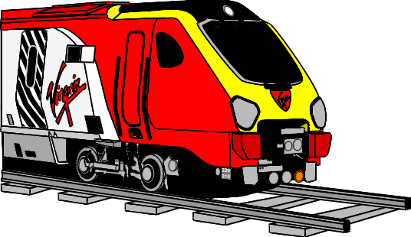
Einstein asserted that there is no "preferred" inertial frame of reference against which motion should be measured. In other words, all inertial frames of reference are equivalent. It does not matter which inertial frame of reference is used to judge the motion of an object, in our example either the road or the house are acceptable frames of reference against which to judge the motion of the car.
Here is another example of the same event seen by three different observers, each in their own frame of reference:
Event 1: You are reading your Kindle on the train. The train is travelling at 60 mph.
Observer | Location | Observation
1 | Passenger sitting next to you | You are stationary
2 | Person standing on the platform | You are travelling towards them at 60 mph
3 | Passenger on train travelling at 60 mph in opposite direction | You are travelling towards them at 120 mph.
This example works well as it only involves objects travelling at relatively low speeds. The comparison between reference frames does not work in the same way, however, if objects are moving close to the speed of light.
Event 2: You are reading your Kindle on an interstellar train. The train is travelling at 2 × 10⁸ m s⁻¹.
Observer | Location | Observation
1 | Passenger sitting next to you | You are stationary
2 | Person standing on the platform | You are travelling towards them at 2 × 10⁸ m s⁻¹
3 | Passenger on train travelling  at 2 × 10⁸ m s⁻¹ in opposite direction | You are travelling towards them at 4 × 10⁸ m s⁻¹
The observation made by observer three is impossible as an object cannot travel faster than the speed of light from any reference frame and it would certainly be impossible to watch something travel faster than light.

Postulates of Special Relativity
Einstein took this one stage further, and came up with his first postulate of special relativity, which generalises our discussion to ALL of the laws of physics:
Postulate 1:
All the laws of physics are the same in all inertial frames of reference.
We can give a simple example of this principle in action. Consider a person standing at the road side and a person sitting in a car moving at constant speed. This postulate states that both people must observe the same laws of physics for all phenomena. If the car is accelerating, then it does not constitute an inertial frame of reference, and the person on the ground and in the car need not observe the same laws of physics.
The second postulate is, in a sense, a corollary (consequence) of the first postulate:
Postulate 2:
The speed of light (in a vacuum) is the same in all inertial frames of reference.
This postulate leads to a surprising difficulty when we consider what we expect to happen in everyday life. Suppose we are driving along at 50 mph, approaching a stationary person on the pavement. At the instant we pass the person, he throws a ball at 50 mph, relative to him and in the direction we and the car are travelling. In the frame of reference of the car, therefore, the ball is stationary.
The second postulate says that light does not behave in this way. Suppose that, instead of throwing a ball, the person on the pavement switches on a torch. The second postulate says that both we and him have to measure the same speed of light from the torch - no matter how fast we are travelling in the car.
Our consideration of throwing the ball suggests that if the speed of light is c, and our speed is v then the person on the pavement sees light travelling at speed c, but we should see it travelling at speed c - v. The second postulate says that this is not the case. The second postulate says that we see the light travelling at speed c.
Light beam
A
v
B
The figure (left) illustrates this, but in the conventional notation used to represent frames of reference, in the context of relativity. In this example, frame A is the pavement, and frame B is the car.
Person in frame A fires a light beam (e.g. switching on a torch) at the instant that frame B passes by. The second postulate implies that BOTH observers would measure the same speed for the light beam!
Einstein showed:
1. everyone sees the same speed for light (given the symbol c)
2. what happens when you try to go faster than c.
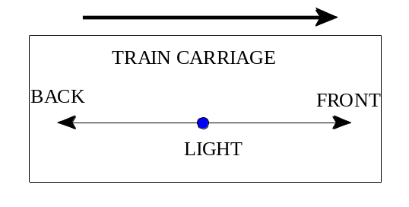
To understand this, our concepts of time, length, and mass must be changed. Consider two observers viewing the same event. One observer is stationary and one moving. If c is the same for both observers then they must experience different distances and times. Two events can be simultaneous in one frame of reference but when viewed from another frame of reference the events are not simultaneous. This is called the Relativity of Simultaneity.
Imagine a train travelling with both its front and back doors open. A light is uncovered from under a dark casing, causing a beam of light to be emitted. The beam is emitted from the centre of a train carriage. A person on the train would see the beam of light arrive at the end walls of the train at the same time. But a person viewing the same event on the railway banking would see the beam of light exit from the back door before the front door because the train is moving forward.
Newton | Einstein
d and t constant | c constant
c relative | d and t relative
These ideas seem very contrary to classical Newtonian Mechanics which you have dealt with so far.
Newtonian Mechanics states that:
1. the time interval between events is independent of the observer.
2. the space interval is independent of the observer.

The Principles of Relativity
To summarise
Special relativity (which applies to observers/reference frames in relative motion with constant velocity) has two postulates:
1. The laws of physics are the same for all observers in all parts of the universe. All the laws of physics are the same in all inertial frames of reference.
2. Light always travels at the same speed in a vacuum, 3.0 × 10⁸ m s^{–1} (299,792,458 m s^{–1} to be more precise). (Light does slow down inside transparent material such as glass.)
This means that no matter how fast you go, you can never catch up with a beam of light, since it always travels at 3·0 × 10⁸ m s^{–1}relative to you.
The best known experimental evidence that started the proof for the Theory of special relativity is the Michelson-Morley interferometer experiment. It actually failed to show the expected results, despite many people repeating the experiment. (see later).
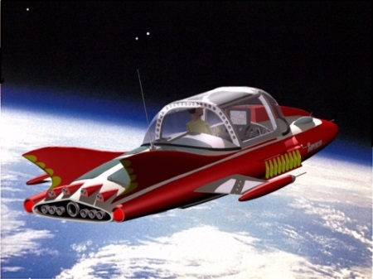
Example: A “space car” is travelling through space at 90% of the speed of light (2.7 x 10⁸ m s⁻¹) with its headlights on. The occupants of the car will see the beams of the headlights travel away from them at 3 × 10⁸ m s⁻¹, so “common sense” or Newtonian Mechanics would say that the light from the headlights is travelling at 5.7 x 10⁸ m s ⁻¹. But it is not, it is travelling at 3 x 10⁸ m s⁻¹.
An observer on Earth will also observe light from the headlamps travel at 3 × 10⁸ m s⁻¹.The speed of light, c, is constant in and between all reference frames and for all observers.
These principles have strange consequences for the measurement of distance and time between reference frames.

Time Dilation
Time dilation is the increase in an observed time interval for an object moving relative to an observer, compared to that measured when they are in the stationary frame of reference.
A very simple thought experiment shows that one consequence of the speed of light being the same for all observers is that time experienced by all observers is not necessarily the same. There is no universal clock that we can all refer to – we can simply make measurements of time as we experience it.
Imagine you are on a spaceship travelling at constant speed (v) relative to a colleague on a space station. You are investigating a timing device based on the fact that the speed of light is constant. You fire a beam of light at a sensor and time how long it takes to arrive. From your point of view the light has less distance (l) to travel than from the point of view of your colleague on the space station (d). If you both observe the speed of light as the same then you cannot agree on when it arrives, i.e. both of you experience time in a different way.
Time is different for observers in different reference frames because the path they observe for a moving object is different.
light source
sensor
l
Your point of view, where the source and sensor are moving along together
Your stationary colleague’s point of view, where the sensor moves after the light is fired
light source
sensor
d
movement of spaceship
v


Example 1: How distance can be different for different observers
h
Event: Inside a moving train carriage, a tennis ball is thrown straight up and
caught in the same hand.
Observer 1: In Observer 1’s reference frame they are stationary and the ball has gone straight up and down.
Observer 1 sees the ball travel a total distance of 2h.
The ball is travelling at a speed s.
The period of time for the ball to return to the observers hand is:
$t=\frac{2h}{v_{1}}$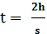
Observer 2, standing on the platform watches the train go past at a speed, v₂, and sees the passenger throw the ball. However, to them, the passenger is also travelling horizontally, at speed v. This means that, to Observer 2, the tennis ball has travelled a horizontal distance, as well as a vertical one.
Observer 2 sees the ball travel a total distance of 2d.
The period of time for the ball to return to the observers hand is:$t^{'}=\frac{2d}{v_{1}}$
For observer 2, the ball has travelled a greater distance, in the same time.
Example 2: How time can be different for different observers
Event: Observer 1 is in a spaceship travelling to the left at speed s. Inside the spaceship cabin, a pulsed laser beam is pointed vertically up at the ceiling and is reflected back down. The laser emits another pulse when the reflected pulse is detected by a photodiode.
Reference frame 1: Inside the cabin, the beam goes straight up, reflects off the ceiling and travels straight down.
Period of pulse: 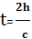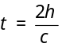
h

Reference frame 2: Observer 2 on another, stationary ship.

d
d
v

Period of pulse: 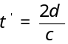
The time for the experiment as observed by observer 2 (reference frame 2), t', is greater than the time, t, observed by observer 1 when moving with the photodiode. Neither observer would be aware of any difference until they met up and compared data.
For observer 2, the light has taken a greater time as the light has travelled a greater distance.

LET’s Do THE MATHS!

Consider a person on a platform who shines a laser pulse upwards, reflecting the light off a mirror. The time interval for the pulse to travel up and down is t (no superscript). For travellers on board the train moving along the x-axis at high speed v,, the light travels as shown in diagram A.
1 Diagram A
v
d
d
Travellers in this different frame of reference observe the ‘event’ (eg out of the window of the train), which takes place in the platform frame of reference and measure a time t’.
platform
mirror
h
Person in same frame as ‘event’ measures a time t.

Total distance travelled by pulse 2h = ct.
h
v
2: Diagram B
The time taken for the light to travel up and back, as measured by travellers in this frame, is t’ (t dash or t priime).
In the time t’ that it takes for the light to travel up and back down the train in this frame, the train has travelled a distance d.
Both observers measure the same speed for the speed of light.
Train frame of reference
Platform frame of reference
2 h = c t
d = v t’
Total distance travelled by pulse= ct’
Horizontal distance travelled by train = vt’
A right- angled triangle can be formed where the vertical side is the height, h, of the pulse (½ ct), the horizontal side is half of the distance, d, gone by the train ( ½ vt’) and the hypotenuse is half the distance gone by the pulse as seen by the travellers on the train ( ½ct’). | ½ ct  ½ c t’  ½ v t’
Applying Pythagoras to the triangle gives:
( ½ ct’ )² = ( ½ ct)² + ( ½ vt’)²
(ct’ )² = (ct)² + (vt’)²
(c² – v²) t’ ² = c² t²
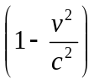 t’ ² = t²
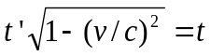 (1)
(2)
Where
t time interval measured in the same frame of reference as the event (e.g. the pulse of light, throwing up a ball, running a race).
t’ time interval measured in a frame of reference moving relative to the one containing the event(e.g. on a train).
v relative velocity of the two frames of reference.

What assumptions have we made?
(i) The two frames are moving relative to each other along the x-axis, i.e. the train passes the platform. There is no bending or circular motion involved.
(ii) We require two travellers on the train since the start and finish places are separate. This is fine since two clocks can be synchronised in the same frame of reference.

Additional Notes
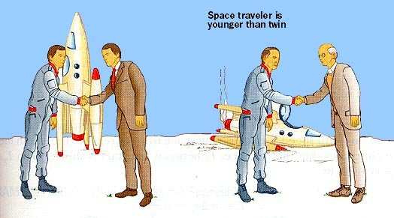
One famous situation leading from this theory is the thought experiment regarding the twin paradox. (which is not currently possible):
At the age of 25 you leave your twin behind on Earth to go on a space mission. You are in a spaceship travelling at 90% of the speed of light (this is why it is a thought experiment) and you go on a journey for 20 years as you measure it. When you get back you will find that 46 years have elapsed on Earth. Your clock will have run slower than those on Earth, but both your clock and the one on Earth are correct. You are 45, but your twin is 71, not just in terms of what the clock says but biologically as well. This is “real” time to both of you (even though it seems different).
You can read about this paradox in more detail by asking your Physics teacher for the additional note or reading it for yourself from Russell Stannard’s excellent book “Relativity- a very short introduction” Oxford. (2008) ISBN 978–0–19–923622–0
At velocities which we are more familiar with, a retired airline pilot who may have spent 35,000 hours travelling at, say, 180 m s⁻¹ whilst in the air will be 23 μs younger than if they had stayed on the ground. Scott Kelly, a twin, who used to be 6 minutes younger than his older twin is now 6 minutes and 5 milliseconds younger, due to his 520 days on the ISS orbiting at 28,160 kmh⁻¹ (17,500 mph). Even your calculators are unable to show this and you’d need to prove it using something like Microsoft Excel.

Time Dilation Formula and the Lorentz Transformation
The formula linking these can be shown to be:
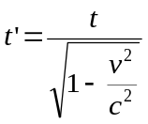
Note this is often written as:
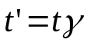
where γ is known as the Lorentz Factor. It is often used in the study of special relativity and is given by:
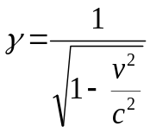
Example:
A rocket is travelling at a constant 2.7 × 10⁸ m s^{–1} compared to an observer on Earth. The pilot measures the journey as taking 240 minutes. (Note this is an impossible scenario with current technology)
How long did the journey take when measured from Earth?
Solution: | Note as time dilation is about relative times etc there is no requirement to change the units of time to seconds. Whatever unit you use will be the same unit for your unknown time.
 | t = 240 minutes  v = 2.7 × 10⁸ m s^{–1}  c = 3 × 10⁸ m s^{–1}  t' = ? | 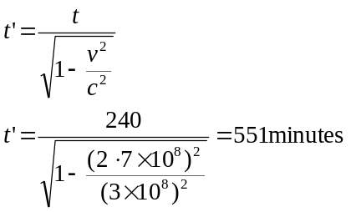
An observer on Earth would measure the journey as taking 551 minutes, i.e. 551 minutes would have passed from their point of reference.

Answering Lorenz Factor Questions
- Make sure you know what the terms mean.
t time interval measured in the same frame of reference as the event (e.g. the pulse of light, throwing up a ball, running a race). Referred to in books as “proper time”
t’ time interval measured in a frame of reference moving relative to the one containing the event (e.g. on a train)
l length measured in the same frame of reference as the object (e.g. rod) Referred to in books as “proper length”
l’ length measured in a frame of reference moving relative to the one containing the object (e.g. rod).
v relative velocity of the two frames of reference.
(Note: Recall that no one frame of reference is any more ‘stationary’ or ‘moving’ than any other. There is no ‘absolute rest’.
- Think through the question and try to decide what you would expect to happen.
- Remember that 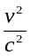 is the same as 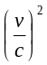
- Note that the question can give the value of v in terms as a portion of c. e.g. the speed in the above example could have been given as 90% c or 0.9 times c or 9/10 of the speed of light. So using the question previously given we would calculate it as shown.
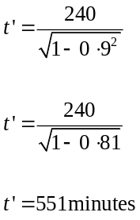

- You might find it easier to square both sides which would give you the following equation 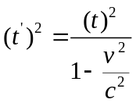
- The ratio of t to t’ can be given and again this would be calculated in the following way
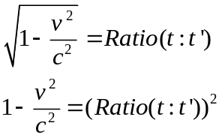
- The ratio of t’ to t can be given and again this would be calculated in the following way
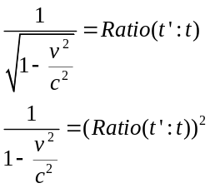
- Don’t separate v² from c² until after you have dealt with the 1.
- Remember that it is 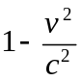 so if 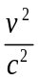is taken to the other side it becomes +.
- must give a value less than 1.
- It is not necessary to put times into seconds, whatever the given units of time your calculated time quantity will have the same units as the equation works out ratios.
- As we will see later the length transformation equation looks similar but is written in terms of t’=tγ compared with the time transformation written as l’=l/γ
- Some people recommend working out the 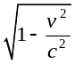 bit first and then using t’=tγ or l’=l/γ, but remember that

Relativistic time differences in everyday life?
A graph of the Lorentz factor versus speed (measured as a multiple of the speed of light) is shown below.
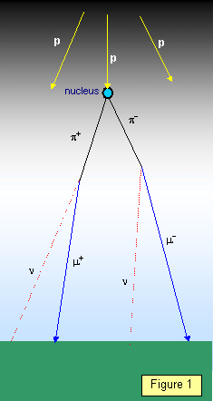
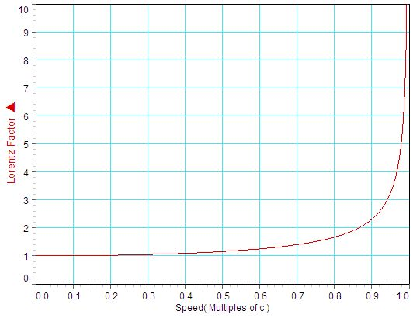
We can see that for small speeds (i.e. less than 0.1 times the speed of light) the Lorentz factor is approximately 1 and relativistic effects are negligibly small. Even 0.1 times the speed of light is 30,000,000 m s^{–1} or 108,000,000 km h^{–1} or about 67,500,000 mph – a tremendously fast speed compared to everyday life.
However, the speed of satellites is fast enough that even these small changes will add up over time and seriously affect the synchronisation of global positioning systems (GPS) and television satellites with users on the Earth. They have to be specially programmed to allow for the effects of special relativity (and also general relativity, which is not covered here). Very precise measurements of these small changes in time have been performed on fast-flying aircraft and agree with predicted results within experimental error.
Further evidence in support of special relativity comes from the field of particle physics and the detection of particles called muons at the surface of the Earth. Muons are created in the upper atmosphere by cosmic rays (high-energy protons from space).
The half-life of a muon is 2.2 µs and so moving at 0.994 c they would only expect to travel about 660 m before half of them decayed. Muons formed at, say 12000 m would take 40 µs or about 20 half-lives to reach the ground. This would mean that only 1/2²⁰ of the original number would be detected. The fact that the proportion reaching the ground is much higher than this means that the muons are existing for longer.
At 0.994c the formula for time dilation gives the half-life for the muons to be 20 µs. This means that at 0.994c the proportion reaching the ground should be 0.25, indicating the number of muons per second detected at the ground is much greater than expected. This is because the ‘muon clock’ runs slowly compared to the observer on Earth and the muon reaches the ground.
http://www.scivee.tv/node/2415
Example: Using the figures above, show, by calculation, why time dilation is necessary to explain the observation of muons at the surface of the Earth.
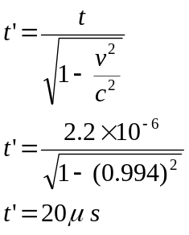Solution:
t = 2.2 µs = 2.2 × 10⁻⁶ s
v = 0.994 × 3.00 × 10⁸ = 2.982 × 10⁸ m s⁻¹
d = ?

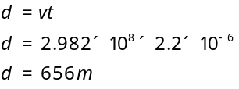
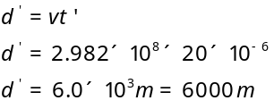
In the reference frame of an observer on Earth the half-life of the muon is recorded as 20 µs during which it travels 6000 m. From this perspective, a period of only two half-lives is needed for the muons to reach the earth from 12000 m altitude.
It is useful to mention the significance of the term 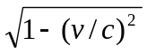.
(The reciprocal is known as the gamma factor, or Lorenz Transformation.)
This term occurs in relativity equations and its size determines when relativity effects will be observed. At everyday speeds it is almost unity (one).
You should be able to interpret the final equation, stating what each of the symbols represent, and what the equation means in terms of the time interval for each observer.
Note: In our thought experiment above with the pulse emitted on the platform the laser pulse starts and finishes at the same place on the platform. Thus equation (1) is used to calculate the time interval t’ registered in a frame of reference, e.g. the train, for an event which takes place in a different frame of reference from the ‘event’.
For example if v = 0.4c then (v/c)² = 0.16 and = 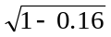 = 0.917.
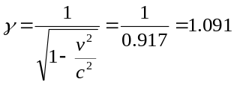
Let us use this value of v = 0.4c in our thought experiment with a laser pulse time of 8.0 ns.
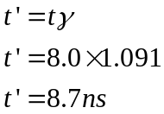
Thus, if t = 8.0 ns, we can calculate t’, giving t’ = 8.7 ns. A longer time interval is ‘measured’ by travellers on the train. This effect, known as time dilation (dilation = expanding), is a direct result of the postulate that the speed of light is measured to be the same by all observers.
Time dilation leads to observers being unable to agree about simultaneous events. Two events may appear to be simultaneous to one observer, but may not be simultaneous for others.

Another example and some effects
Consider a space ship passing Earth at a velocity of 0.5c. It emits a pulse (or on Earth we observe ‘ticks’ of their clock) of duration ΔT = 2.0 ns. We on Earth can ‘measure’ the duration t’ we observe. Note that we are not in the same frame of reference as the ‘event’ so our time interval is t’ not t. The duration of the event, in the frame of the event on the space ship, is t.
Using equation
$t^{'}=\frac{t}{\sqrt{1-\left(\frac{v^{2}}{c^{2}}\right)}}$

gives us an observed time interval of t × 1 /0.87 = 2.3 ns.
We consider their clock is running slow, time is passing more quickly for us so they could end up ‘younger’! Although time dilation can give rise to interesting discussions on time travel (into the future), the explanation of the twin paradox requires more consideration since any acceleration may involve general relativity. and returning from a long fast space trip would require a ‘change’ frames of reference, and hence a knowledge that the observer is moving.
When is almost unity no effect is noticeable. It is useful to calculate this term (or the reciprocal) for various speeds, for example:
- a supersonic plane 422 m s^{–1} (900 mph);
- × 10⁸ m s^{–1};
- 0.3 × 10⁸ m s^{–1} (10%c);
- 1.0 × 10⁸ m s^{–1};
- 2.0 × 10⁸ m s^{–1},
- 2.8 × 10⁸ m s^{–1}
- and 99% c.
If you do these calculations you will clearly see that effects in everyday life are not noticeable. We need v > 10%c for any noticeable effects.

Special Relativity / Tutorial 1
1. A river flows at a constant speed of 05 ms⁻¹ south. A canoeist is able to row at a constant speed of 15 ms⁻¹.
(a) Determine the velocity of the canoeist relative to the river bank when the canoeist is paddling north.
(b) Determine the velocity of the canoeist relative to the river bank when the canoeist is paddling south.
2. In an airport, passengers use a moving walkway. The moving walkway is travelling at a constant speed of 08 ms⁻¹ and is travelling east.
For the following people, determine the velocity of the person relative to the ground:
(a) a woman standing at rest on the walkway;
(b) a man, on the walkway, walking at 20 ms⁻¹ in the same direction as the walkway is moving;
(c) a boy on the walkway, running west at 30 ms⁻¹ .
3. The steps of an escalator move upwards at a steady speed of 10 ms⁻¹ relative to the stationary side of the escalator.
(a) A man walks up the steps of the escalator at 20 ms⁻¹. Determine the speed of the man relative to the side of the escalator.
(b) A boy runs down the steps of the escalator at 30 m s⁻¹. Determine the speed of the boy relative to the side of the escalator.
4. Copy and complete filling in the missing letters below:
In _A_ Theory of Special Relativity the laws of physics are the _B_for all observers, at rest or moving at constant velocity with respect to each other ie _C_ acceleration.
An observer, at rest or moving at constant _D_ has their own frame of reference.
In all frames of reference the _E_, c, remains the same regardless of whether the source or observer is in motion.
Einstein’s principles that the laws of physics and the speed of light are the same for all observers leads to the conclusion that moving clocks run _F_(time dilation) and moving objects are _G_ (length contraction).
Match each letter with the correct word from the list below:
acceleration different Einstein’s fast lengthened Newton’s
same shortened slow speed of light velocity zero
5. An observer at rest on the Earth sees an aeroplane fly overhead at a constant speed of 2000 kmh⁻¹. At what speed, in kmh⁻¹, does the pilot of the aeroplane see the Earth moving?
6. A scientist is in a windowless lift. Can the scientist determine whether the lift is moving with a:
(a) uniform velocity
(b) uniform acceleration?
7. Spaceship A is moving at a speed of 24 × 10⁸ ms⁻¹. It sends out a light beam in the forwards direction. Meanwhile another spaceship B moves towards spaceship A at 24 × 10⁸ ms⁻¹. At what speed does spaceship B see the light beam from spaceship A pass?
8. A spacecraft is travelling at a constant speed of 75 × 10⁷ ms⁻¹. It emits a pulse of light when it is 30 × 10¹⁰ m from the Earth as measured by an observer on the Earth.
Calculate the time taken for the pulse of light to reach the Earth according to a clock on the Earth when the spacecraft is moving:
(a) away from the Earth , (b) towards the Earth.
9. A spaceship is travelling away from the Earth at a constant speed of 15 × 10⁸ ms⁻¹. A light pulse is emitted by a lamp on the Earth and travels towards the spaceship. Find the speed of the light pulse according to an observer on:
(a) the Earth , (b) the spaceship.
10. Convert the following fraction of the speed of light into a value in ms⁻¹ :
(a) 01 c , (b) 05 c, (c) 06 c, (d) 08 c
11. Convert the following speeds into a fraction of the speed of light:
(a) 30 × 10⁸ m s⁻¹ , (b) 20 × 10 ⁸ m s⁻¹ , (c) 15 × 10 ⁸ m s⁻¹ , (d) 10 × 10 ⁸ m s⁻¹

Time dilation / Tutorial 2
            - Write down the relationship involving the proper time t and dilated time t’ between two events which are observed in two different frames of reference moving at a speed, v, relative to one another (where the proper time is the time measured by an observer at rest with respect to the two events and the dilated time is the time measured by another observer moving at a speed, v, relative to the two events).

2. In the table shown, use the relativity equation for time dilation to calculate the value of each missing quantity (a) to (f) for an object moving at a constant speed relative to the Earth.
Dilated time | Proper time | Speed of object / m s⁻¹
(a) | 20 h | 1·00 × 10⁸
(b) | 10 year | 2·25 × 10⁸
1400 s | (c) | 2·00 × 10⁸
1.40 × 10⁻⁴s | (d) | 1·00 × 10⁸
84 s | 60 s | (e)
21 minutes | 20 minutes | (f)

3. Two observers P, on Earth, and Q, in a rocket, synchronise their watches at 11.00 am just as observer Q passes the Earth at a speed of 2 × 10⁸ ms ⁻¹.
(a) At 11.15 a.m. according to observer P’s watch, observer P looks at Q’s watch through a telescope. Calculate the time, to the nearest minute, that observer P sees on Q’s watch.
(b) At 11.15 a.m. according to observer Q’s watch, observer Q looks at P’s watch through a telescope. Calculate the time, to the nearest minute, that observer Q sees on P’s watch.
4. The lifetime of a star is 10 billion years as measured by an observer at rest with respect to the star. The star is moving away from the Earth at a speed of 081 c.
Calculate the lifetime of the star according to an observer on the Earth.
5. A spacecraft moving with a constant speed of 075 c passes the Earth. An astronaut on the spacecraft measures the time taken for Usain Bolt to run a 100 m world record. The astronaut measures this time to be 1448 s. Calculate Usain Bolt’s winning time as measured on the Earth. (When and where on Earth was the spacecraft viewing?)
6. A scientist in the laboratory measures the time taken for a nuclear reaction to occur in an atom. When the atom is travelling at 80 × 10⁷ ms−1 the reaction takes 40 × 10⁻⁴ s.
Calculate the time for the reaction to occur when the atom is at rest.
7. The light beam from a lighthouse sweeps its beam of light around in a circle once every 10 s. To an astronaut on a spacecraft moving towards the Earth, the beam of light completes one complete circle every 14 s. Calculate the speed of the spacecraft relative to the Earth.
8. A rocket passes two beacons that are at rest relative to the Earth. An astronaut in the rocket measures the time taken for the rocket to travel from the first beacon to the second beacon to be 100 s. An observer on Earth measures the time taken for the rocket to travel from the first beacon to the second beacon to be 400 s. Calculate the speed of the rocket relative to the Earth.
9. A spacecraft travels to a distant planet at a constant speed relative to the Earth. A clock on the spacecraft records a time of 1 year for the journey while an observer on Earth measures a time of 2 years for the journey. Calculate the speed, in ms⁻¹, of the spacecraft relative to the Earth.

Length contraction
https://www.youtube.com/watch?v=FPzGAksFCbs
Length contraction is the shortening of the measured length of an object moving relative to the observer’s frame.
Another implication of Einstein’s Special theory of Relativity is the shortening of length when an object is moving. Consider the muons discussed above. Their large speed means they experience a longer half-life due to time dilation. An equivalent way of thinking about this is that the muons experience the height of the atmosphere as smaller (or contracted) by the same proportion as the time has increased (or dilated). A similar formula for time dilation can be derived. Note that the contraction only takes place in the direction that the object is travelling:
where  l proper length or rest length refers to the length of an object in the object's rest frame.so it is the.length measured in the same frame of reference as the object  l’ length measured in a frame of reference moving relative to the one containing the object. | 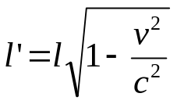

Thought Experiment 2
v
1
2
The observer on board the carriage and to them the carriage appears stationary relative to them. | The carriage is moving to the right with a velocity v.
For the observer on the train the ball goes from one end of the train to the other and back | To the observer on the platform the ball travels to the end of the carriage, but it has moved forwards, so the total distance travelled is less.
Length contraction is only observed when objects travel at a speed close to the speed of light and in a direction parallel to the direction in which the observed body is travelling.
l = length measured on the platform by the observer
l’ = length measured on the train by the observer
v = speed the object is moving at (ms⁻¹)
c = speed of light (ms⁻¹)

How do you measure a fish?
Suppose an oceanographer wished to measure the length of a fish that swims by his metre stick. He would note, where the head was and at the same moment he would notice where the tail was. The fish would then be said to be the same length as the distance between the two marks on the metre stick. If the oceanographer were to notice where the head was, wait a moment and then look where the tail was the fact that the fish was moving through the water would give a shorter measurement. Let's see that in pictures:
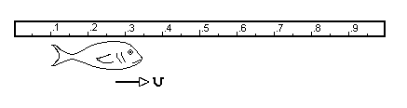
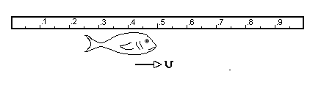
Picture 1:Look at both ends simultaneously:
head point: 0.35 metres
tail point: 0.1 metres
Length = 0.35 metres - 0.1 metres
=0.25 metres
Now, the "wrong" way
Picutre 2: Look at the head first:
head point: 0.35 metres.
(wait a moment)
Picture 3: Now look at the tail:
tail point: 0.25 metres.
length = 0.35 metres - 0.25 metres = 0.1 metres.
For two objects to be the same length their endpoints must coincide SIMULTANEOUSLY. The measuring process for a moving object includes the concept of simultaneity. But, as we will see events deemed simultaneous in one inertial frame are not always simultaneous in another inertial frame. Thus the length of an object will be different when measured in different inertial frames. Since all these inertial frames are equally valid (postulate 1) each of their measurements are as correct as any other's.
For more details on Length Contraction read the additional notes in Special Relativity Paradoxes.

Length Dilation / Tutorial 3
1. Write down the relationship involving the proper length l and contracted length l’ of a moving object observed in two different frames of reference moving at a speed, v, relative to one another (where the proper length is the length measured by an observer at rest with respect to the object and the contracted length is the length measured by another observer moving at a speed, v, relative to the object).
2. In the table shown, use the relativity equation for length contraction to calculate the value of each missing quantity (a) to (f) for an object moving at a constant speed relative to the Earth.
Contracted length | Proper length | Speed of object / m s⁻¹
(a) | 5·00 m | 1·00 × 10⁸
(b) | 15.0 m | 2·00 × 10⁸
0·15 km | (c) | 2·25 × 10⁸
150 mm | (d) | 1·04 × 10⁸
30 m | 35 m | (e)
10 m | 11 m | (f)
3. A rocket has a length of 20 m when at rest on the Earth. An observer, at rest on the Earth, watches the rocket as it passes at a constant speed of 18 × 10⁸ ms⁻¹. Calculate the length of the rocket as measured by the observer.
4. A pi meson is moving at 090 c relative to a magnet. The magnet has a length of 200 m when at rest to the Earth. Calculate the length of the magnet in the reference frame of the pi meson.
5. In the year 2050 a spacecraft flies over a base station on the Earth. The spacecraft has a speed of 08 c. The length of the moving spacecraft is measured as 160 m by a person on the Earth. The spacecraft later lands and the same person measures the length of the now stationary spacecraft.
Calculate the length of the stationary spacecraft.
6. A rocket is travelling at 050 c relative to a space station.
Astronauts on the rocket measure the length of the space station to be 080 km.
Calculate the length of the space station according to a technician on the space station.
7. A metre stick has a length of 100 m when at rest on the Earth. When in motion relative to an observer on the Earth the same metre stick has a length of 050 m. Calculate the speed, in ms⁻¹, of the metre stick.
8. A spaceship has a length of 220 m when measured at rest on the Earth. The spaceship moves away from the Earth at a constant speed and an observer, on the Earth, now measures its length to be 150 m.
Calculate the speed of the spaceship in ms⁻¹.
9. The length of a rocket is measured when at rest and also when moving at a constant speed by an observer at rest relative to the rocket. The observed length is 990 % of its length when at rest. Calculate the speed of the rocket.

The Michelson-Morley Experiment
The prevalent belief in the nineteenth century was that light is a wave, carried by a subtle medium, the aether, which is at rest in the universe. The sun is at rest, in the centre of the universe, and the earth moves through the aether and around the sun at about 30 kms⁻¹.

The Michelson-Morley (M&M) experiment was designed to verify this belief. If light is sent back and forth on earth, in the direction of the earth's movement, then the round trip should take longer than it would if there were no aether. It should also take a little longer, but not as much as in the parallel direction, for light moving back and forth in the direction perpendicular to the earth's movement. The M&M experiment used two identical rods perpendicular to each other along which the light moved back and forth.

A Boat Race: A Model for the Michelson Morely Experiment
This can be modelled by thinking about two boats travelling the same distance but one crossing a river (the ether) and one going parallel to the ether (the river)
Here the river represents the ether, and the boats represent the two beams of light going off perpendicular to each other. Boat Y has to move against the river tide on the way out, but is assisted by the tide on the return part of the journey. Boat X will always arrive first.

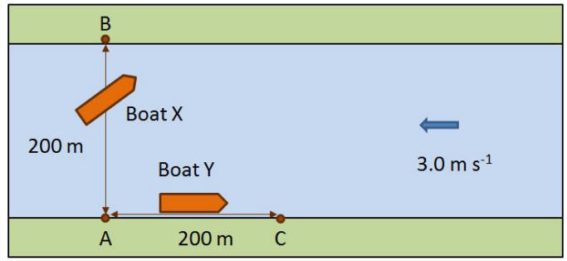
Both boats, X and Y have a speed of 5 ms⁻¹. Boat X has to cross the river from A to B and back to A, while Boat Y has to travel from A to C and back again.
Questions
(a) Calculate the velocity of X relative to the river bed (Use a vector diagram).
(b) Calculate the time for X to travel from A to B to A.
(c) Calculate the velocity of Y relative to the river bed going from A to C and the time.
(d) Calculate the velocity of the boat Y going from C to A and its time.
(e) State which boat wins and by what time interval.
Answers
(a) Velocity is 4 m s⁻¹ (since it’s a 3, 4, 5 triangle).
5ms⁻¹ Boat X
Engine
4ms⁻¹ Boat X resultant across the river
3ms⁻¹ river
(b) What is the time for X to travel from A to B to A?
$$time =\frac{distance}{speed} = \frac{400}{4} = 100 s$$
(c) What is the velocity of Y relative to the river bed going from A to C and the time?
5ms⁻¹ Boat Y
Engine
2ms⁻¹ Boat Y resultant up the river
3ms⁻¹ river
$$by vector addition Velocity = 5- 3 = 2 {m s}^{-1}$$
$$time =\frac{distance}{speed} = \frac{200}{2} = 100 s$$
(d) What is the velocity of the boat Y going from C to A and its time?
5ms⁻¹ Boat Y Engine
8ms⁻¹ Boat Y resultant down river
3ms⁻¹ river
$$by vector addition Velocity = 5+ 3 = 8 {m s}^{-1}$$

$$time =\frac{distance}{speed} = \frac{200}{8} = 25 s$$
  - Which boat wins and by how much? Boat X wins by 25 s

To see how this fits with the Michelson Morely Experiment check out the link below.
https://tinyurl.com/MichelsonMorely

Back to the michelson morely experiment

The apparatus consists of a light source, a beam splitter (a half-silvered glass plate) and two mirrors, M₁ and M₂, each of which is equidistant from the beam splitter. The beam splitter is at 45º to the incident beam and the return beams pass to the detector, a telescope.
light source
mirror
M₁
mirror, M₂
beam splitter
L
L
detector

Sometimes one light beam may be travelling in the same direction as the aether and the other beam at right angles to the aether. They will have slightly different speeds. The detector should show interference between the two beams travelling perpendicular to each other. The aim was to measure the speed of the Earth relative to the aether.
No discernible interference fringes were found, despite repeating the experiment at different times in the Earth’s orbit and with different orientation. The world's physicists used these results to add on a few qualities to the ether. They assumed that the movement through the ether "compressed" the apparatus in the direction of the motion so that the "no movement" reading always resulted. On the prevailing theory and experimental accuracy, the small destructive interference should have been observed.
This experiment, first performed in 1881, repeated in 1887, and often thereafter, could find no indication of a difference. But the belief could not be shaken, and Hendrik Lorentz, in 1895 and again in 1904, thought the explanation could possibly be that the rod placed in the direction of the earth's movement might contract due to the earth's movement, just enough to make the round trip time equal to the case when there is no movement. The equation he developed is known as the Lorentz transformation (LT).
This null result had great importance since it could not be explained.
It was against this background of theories that were fundamentally untestable that Einstein and others stated that any experimental science such as physics must have its fundamental entities defined in terms of some experiment. To avoid this was to invent ghosts. This is the basis of Operational Definition. An operational definition is simply a way of defining a physical quantity or quality in terms of an operation performed. Instead of saying length is "the amount of distance between two points" a modern physicist would give a procedure (an operation) for measuring the distance between two points. ("lay metre sticks end to end and count how many" or "send a light signal from point A to point B and reflect it back to A again; then multiply the elapsed time for the signal by ½ c.") The result of such a measurement would be the definition of the length. Physics is a way of predicting and explaining observations encountered under certain circumstances. All Physics should be based on observation and experiment. Any concept that could not, in principle, be connected with experiment was declared to be not physics but metaphysics.
http://www.youtube.com/watch?v=AKhvqO5UBsA
http://www.youtube.com/watch?v=SUf8zA-LwUk&feature=related
To summarise
1. Defining t, t’, l and l’ as shown below, equations for time dilation and length contraction can be derived. The equations (1) and (2) are provided on the SQA data sheet.
t and l time interval (‘event’) or length of object under discussion in a frame of reference.
t’ and l’ time interval or length of object ‘measured’ by travellers in a different frame of reference.
v relative velocity of the two frames of reference.
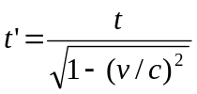 (1)
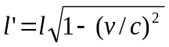 (2)
2. No object can travel faster than the speed of light.
3. Relativistic effects are negligible when relative velocity is less than10% of the speed of light.
4. Experimental verification is provided by observing the life time of fast-moving muons.
5. There is not a separate conservation of mass, but a combined conservation of mass and energy. A greater energy than expected is required to increase the speed of an object as its speed approaches the speed of light.
http://www.scivee.tv/node/2415 http://hyperphysics.phy-astr.gsu.edu

Relativity Miscellaneous/ Tutorial 4
1. Two points A and B are separated by 240 m as measured by metre sticks at rest on the Earth. A rocket passes along the line connecting A and B at a constant speed. The time taken for the rocket to travel from A to B, as measured by an observer on the Earth, is 100 × 10⁻⁶s.
(a) Show that the speed of the rocket relative to the Earth is 240 × 10⁸ ms⁻¹.
(b) Calculate the time taken, as measured by a clock in the rocket, for the rocket to travel from A to B.
(c) What is the distance between points A and B as measured by metre sticks carried by an observer travelling in the rocket?
2. A spacecraft is travelling at a constant speed of 095 c. The spacecraft travels at this speed for 1 year, as measured by a clock on the Earth.
(a) Calculate the time elapsed, in years, as measured by a clock in the spacecraft.
(b) Show that the distance travelled by the spacecraft as measured by an observer on the spacecraft is 28 × 10¹⁵m.
(c) Calculate the distance, in m, the spacecraft will have travelled as measured by an observer on the Earth.
3. A pi meson has a mean lifetime of 26 × 10⁻⁸ s when at rest. A pi meson moves with a speed of 099 c towards the surface of the Earth.
(a) Calculate the mean lifetime of this pi meson as measured by an observer on the Earth.
(b) Calculate the mean distance travelled by the pi meson as measured by the observer on the Earth.
4. A spacecraft moving at 24 × 10⁸ m s ⁻¹ passes the Earth. An astronaut on the spacecraft finds that it takes 50 × 10⁻⁷ s for the spacecraft to pass a small marker which is at rest on the Earth.
(a) Calculate the length, in m, of the spacecraft as measured by the astronaut.
(b) Calculate the length of the spacecraft as measured by an observer at rest on the Earth.

5. A neon sign flashes with a frequency of 02 Hz.
(a) Calculate the time between flashes.
(b) An astronaut on a spacecraft passes the Earth at a speed of 084 c and sees the neon light flashing. Calculate the time between flashes as observed by the astronaut on the spacecraft.
6. When at rest, a subatomic particle has a lifetime of 015 ns. When in motion relative to the Earth the particle’s lifetime is measured by an observer on the Earth as 025 ns. Calculate the speed of the particle.
7. A meson is 100 km above the Earth’s surface and is moving towards the Earth at a speed of 0999 c.
(a) Calculate the distance, according to the meson, travelled before it strikes the Earth.
(b) Calculate the time taken, according to the meson, for it to travel to the surface of the Earth.
8. The star Alpha Centauri is 42 light years away from the Earth. A spacecraft is sent from the Earth to Alpha Centauri. The distance travelled, as measured by the spacecraft, is 36 light years.
(a) Calculate the speed of the spacecraft relative to the Earth.
(b) Calculate the time taken, in seconds, for the spacecraft to reach Alpha Centauri as measured by an observer on the Earth.
(c) Calculate the time taken, in seconds, for the spacecraft to reach Alpha Centauri as measured by a clock on the spacecraft.
9. Muons, when at rest, have a mean lifetime of 260 × 10⁻⁸ s. Muons are produced 10 km above the Earth. They move with a speed of 0995 c towards the surface of the Earth.
(a) Calculate the mean lifetime of the moving muons as measured by an observer on the Earth.
(b) Calculate the mean distance travelled by the muons as measured by an observer on the Earth.
(c) Calculate the mean distance travelled by the muons as measured by the muons.

EXAM QUESTIONS / Special Relativity
    - OCR 10 JAN 494 4
A beam of charged particles is accelerated in particle accelerators to a speed of 20 × 10⁸ m s⁻¹.
(a) The particles are unstable and decay with a half-life of 82 × 10⁻⁷ s when at rest.
Calculate the half-life of the particles in the beam as observed by a stationary observer.
- Calculate the mean distance travelled by a particle in the beam before it decays as observed by a stationary observer.

            - SQA 2018 Q7
A spacecraft is travelling at a speed of 0·200c relative to the Earth.The spacecraft emits a signal for 20·0 seconds as measured in the frame of reference of the spacecraft.
An observer on Earth measures the duration of the signal as
A. 19·2 s
B. 19·6 s
C. 20·0 s
D. 20·4 s
E. 20·8 s

            - SQA 2015 Q7
A spacecraft is travelling at a constant speed of 0∙60c relative to the Moon. An observer on the Moon measures the length of the moving spacecraft to be 190 m. The length of the spacecraft as measured by an astronaut on the spacecraft is
A. 120 m
B. 152 m
C. 238 m
D. 297 m
E. 300 m.

            - SQA 2017 Q4
A spacecraft is travelling at a constant speed of 2·75 ⋅ 108 m s⁻¹ relative to a planet.
A technician on the spacecraft measures the length of the spacecraft as 125 m.
An observer on the planet measures the length of the spacecraft as
A. 36 m
B. 50 m
C. 124 m
D. 314 m
E. 433 m.

            - SQA RH 2013 Q5
The length of a spaceship at rest is L. This spaceship passes a planet at a speed of 0·95c. Which row in the table gives the measured lengths of the spaceship according to an observer on the spaceship and an observer on the planet?

 | Length measured by observer on spaceship | Length measured by observer on planet
A | L | L
B | L | less thanL
C | less than L | L
D | Less than L | Less than L
E | Greater than L | Less than L

            - SQA 2016 Q4
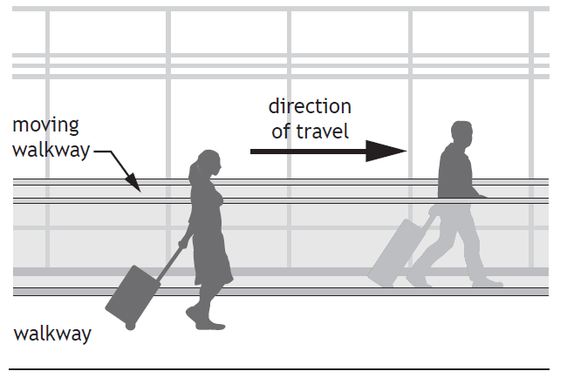
Two physics students are in an airport building on their way to visit CERN.
(a) The first student steps onto a moving walkway, which is travelling at 0·83 m s⁻¹ relative to the building. This student walks along the walkway at a speed of 1·20 m s⁻¹ relative to the walkway.
The second student walks alongside the walkway at a speed of 1·80 m s⁻¹ relative to the building
Determine the speed of the first student relative to the second student.
(b) On the plane, the students discuss the possibility of travelling at relativistic speeds.
(i) The students consider the plane travelling at 0·8c relative to a stationary observer. The plane emits a beam of light towards the observer. State the speed of the emitted light as measured by the observer. Justify your answer.
(ii) According to the manufacturer, the length of the plane is 71 m.
Calculate the length of the plane travelling at 0·8 c as measured by the stationary observer.
(iii) One of the students states that the clocks on board the plane will run slower when the plane is travelling at relativistic speeds.Explain whether or not this statement is correct.
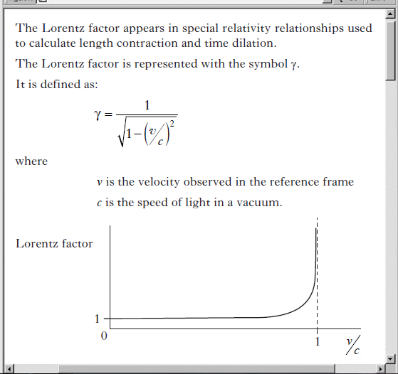
            - SQA RH 2013 Q24
A page from a website on special relativity is shown.

        - Explain what is meant by the term length contraction.
        - Calculate the Lorentz factor when the ratio $v/c$ = 0.80.
        - Length contraction calculations use the relationship
where the symbols have their usual meanings.
State this relationship in terms of l', l and γ.
        - Explain, in terms of the Lorentz factor, why an observer can ignore relativistic effects for an object which is moving with a velocity much less than c.

Tutorial Answers
Special relativity | Time dilation |  |  | Length dilation
1. (a) 1·0 ms ⁻¹north  (b) 2·0 ms ⁻¹ south  2. (a) 0·8 ms ⁻¹east  (b) 2·8 ms ⁻¹east  (c) 2·2 ms ⁻¹ west  3. (a) 3·0 ms⁻¹  (b) 2·0 ms ⁻¹  4. A = Einstein’s; B = same; C = zero; D = velocity; E = speed of light; F = slow; G = shortened  5. 2000 kmh ⁻¹  6. (a) No  (b) Yes  7. 3 × 10⁸ ms ⁻¹  8. (a) 100 s  (b) 100 s  9. (a) 3 × 10⁸ ms ⁻¹  (b) 3 × 10 ⁸ ms ⁻¹  10. (a) 0·3 × 10⁸ ms⁻¹  (b) 1·5 × 10 ⁸ ms ⁻¹  (c) 1·8 × 10 ⁸ m s ⁻¹  (d) 2·4 × 10 ⁸ m s ⁻¹  11. (a) c  (b) 0·67 c  (c) 0·5 c  (d) 0·33 c | 1. Teacher Check  2. (a) 21·2 h  (b) 15·1 year  (c) 1043 s  (d) 1·32 × 10⁻⁴ s  (e) 2·10 × 10 ⁸ m s⁻¹  (f) 9·15 × 10 ⁷m s ⁻¹  3. (a) 11.20 am  (b) 11.20 am  4. 17·1 billion years  5. 9·58 s Berlin World Record 2009  6. 3·9 × 10 ⁻⁴ s  7. 2·1 × 10 ⁸ m s ⁻¹ or 0·70 c  8. 2·90 ×10 ⁸ m s ⁻¹ or 0·97 c  9. 2·60 × 10 ⁸ m s ⁻¹ |  |  | 1. Teacher Check  2. (a) 4·71 m  (b) 11·2 m  (c) 0·227 km  (d) 160 mm  (e) 1·55 × 10 ⁸ m s ⁻¹  (f) 1·25 × 10 ⁸ m s ⁻¹  3. 16 m  4. 0·872 m  5. 267 m  6. 0·92 km  7. 2·60 × 10 ⁸ m s ⁻¹  8. 2·19 × 10 ⁸ m s ⁻¹  9. 4·23 × 10 ⁷ m s ⁻¹ or 0.14 c

Relativity Miscellaneous
1. (a) Teacher Check  (b) 1·67 × 10 ⁻⁶ s  (c) 144 m  2. (a) 0·31 of a year  (b) Teacher Check  (c) 8·97 × 10 ¹⁵ m  3. (a) 1·84 × 10 ⁻⁷ s  (b) 54·6 m or 54·7 m  4. (a) 120 m  (b) 72 m  5. (a) 5 s |  |  | (b) 9·22 s  6. 0·8 c  7. (a) 447 m  (b) 1·49 × 10 ⁻⁶ s  8. (a) 0·52 c  (b) 2·55 × 10 ⁸ s  (c) 2·18 × 10 ⁸ s  9. (a) 2·60 × 10 ⁻⁷ s  (b) 77·6 m  (c) 7·75 m or 7·76 m

Answers Exam Questions
OCR 10 JAN 494 4
$$t^{'}=\frac{8∙2×{10}^{-7}}{\sqrt{1-\left(\frac{{2∙0×{10}^{8}}^{2}}{{3∙0×{10}^{8}}^{2}}\right)}}$$
$$t=1.1×{10}^{-6} s$$
$$t=1.1 μs$$
b)
$$d=vt$$
$$d=2∙0×{10}^{8}×1.1×{10}^{-6}=220m$$
- SQA 2018 Q7 D
- SQA 2015 Q7 C
- SQA 2017 Q4 B
- SQA RH 2013 Q5 E

- SQA 2016 Q4
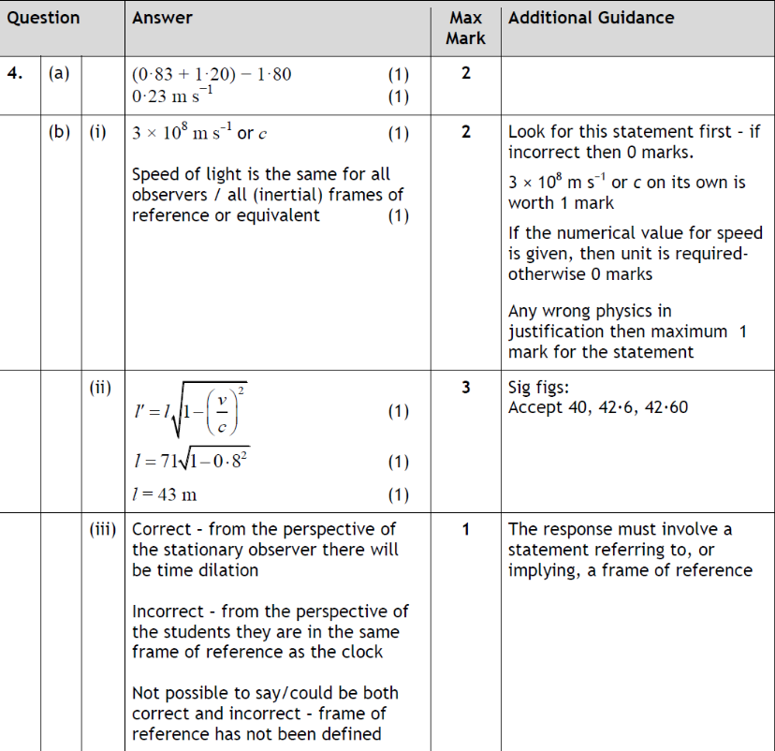
- SQA RH 2013 Q24
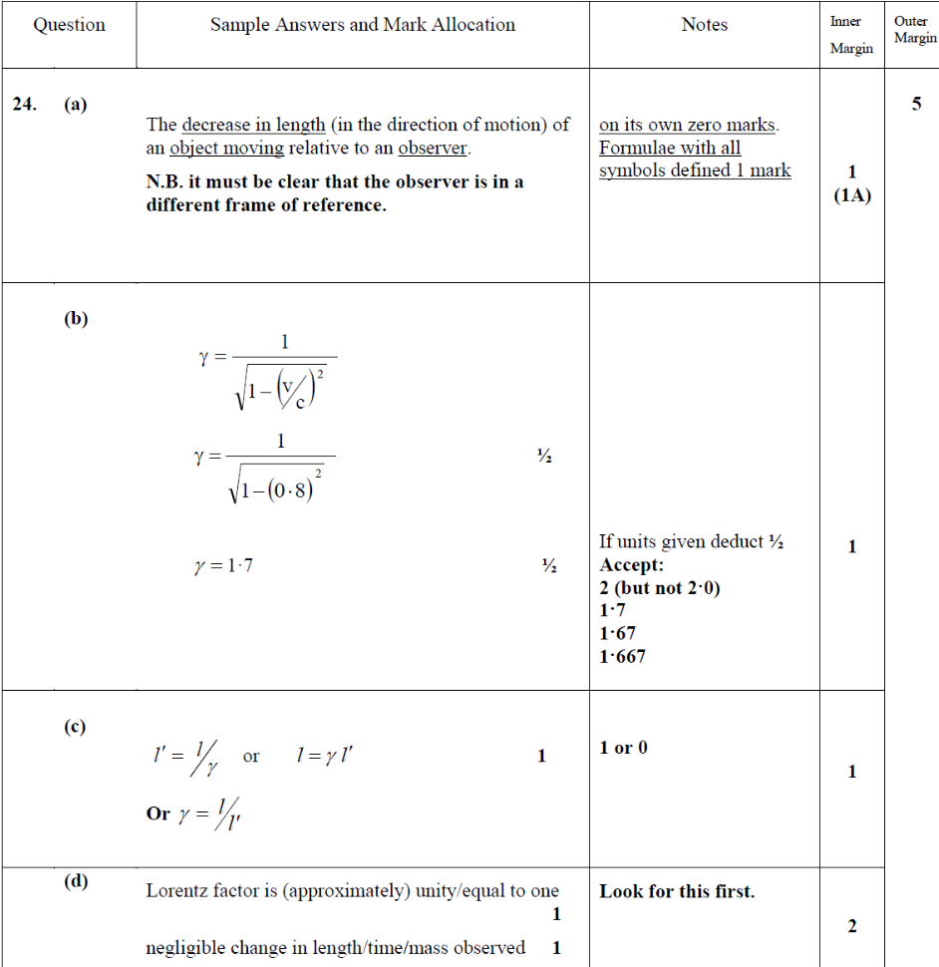

Chapter 7: THE EXPANDING UNIVERSE

Summary of Content

8. |  | The expanding Universe
 | eq | 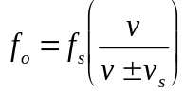 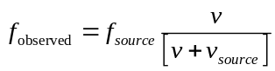 $v = H_{o}d$ 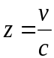  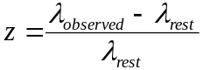
 | - b | I know that the Doppler effect causes shifts in wavelengths of sound and light.
 |  | I can use appropriate relationship to solve problems involving the observed frequency, source frequency, source speed and wave speed.
 |  | I know that the light from objects moving away from us is shifted to longer wavelengths (redshift).
 |  | I know that the redshift of a galaxy is the change in wavelength divided by the emitted wavelength. For slowly moving galaxies, redshift is the ratio of the recessional velocity of the galaxy to the velocity of light..
 |  | I can use appropriate relationships to solve problems involving redshift, observed wavelength, emitted wavelength, and recessional velocity
 |  | I can use appropriate relationship to solve problems involving the Hubble constant, the recessional velocity of a galaxy and its distance from us.
 |  | I know that Hubble’s law allows us to estimate the age of the Universe.
 |  | I know that measurements of the velocities of galaxies and their distance from us lead to the theory of the expanding Universe.
 |  | I know that the mass of a galaxy can be estimated by the orbital speed of stars within it.
 |  | I know that evidence supporting the existence of dark matter comes from estimations of the mass of galaxies.
 |  | I know that evidence supporting the existence of dark energy comes from the accelerating rate of expansion of the Universe.
 |  | I know that the temperature of stellar objects is related to the distribution of emitted radiation over a wide range of wavelengths.
 |  | I know that the peak wavelength of this distribution is shorter for hotter objects than for cooler objects.
 |  | I know that hotter objects emit more radiation per unit surface area per unit time than cooler objects.
 |  | I know of evidence supporting the big bang theory and subsequent expansion of the Universe: cosmic microwave background radiation, the abundance of the elements hydrogen and helium, the darkness of the sky (Olbers’ paradox) and the large number of galaxies showing redshift rather than blueshift.

The Doppler effect

Definition:
The Doppler Effect is the apparent change in frequency of a wave when the source and observer are moving relative to each other.
The Doppler Effect is produced with all wave motions, including electromagnetic waves.
The Doppler Effect is applied in many different disciplines:
- Police radar guns use the Doppler Effect to measure the speed of motorists. Police speed guns send out an electromagnetic wave (radar) and measure the Doppler shift of the reflected wave to measure the speed of an approaching car.
- An echocardiogram uses the Doppler Effect to measure the velocity of blood flow and cardiac tissue and is one of the most widely used diagnostic tests in cardiology. For example it is used to measure the speed of blood flow in veins to check for deep vein thrombosis [DVT].
In this course we will concentrate on a wave source moving at constant speed relative to a stationary observer.
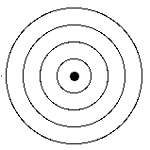
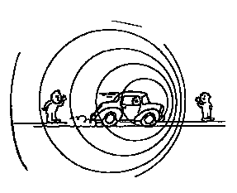
You have already experienced the Doppler Effect many times. You may have noticed a change in pitch as a car comes first towards you then passes and goes away from you. The most noticeable is when a police car, ambulance or fire engine passes you. You hear the pitch of their siren increase as it moves towards you and then decrease as it moves away. Another memorable example is the sound of a very fast moving vehicle, such as a motorbike passing you (or passing a microphone on the television), the sound of the engine rises in frequency as it approaches and falls in frequency as it moves away.
When the source moves towards you, more waves reach you per second and the frequency heard is increased. If the source moves away from you, fewer waves reach you each second and the frequency heard decreases.
Why do we hear a change of frequency?
A stationary sound source produces sound waves at a constant frequency f, and the wavefronts propagate symmetrically out from the source at a constant speed, which is the speed of sound in the medium. The distance between wave-fronts is the wavelength. All observers will hear the same frequency, which will be equal to the actual frequency of the source:
f_{source} = f_{0bserved}
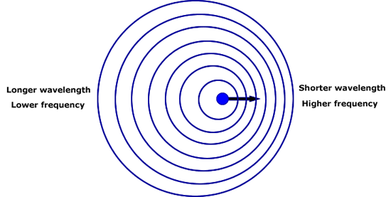
where f_{source} is the frequency produced by the source and f_{observed} is the observed frequency.
The sound source now moves to the right with a speed v_{s}. The wavefronts are produced with the same frequency as before. Therefore the period of each wave is the same as before. However, in the time taken for the production of each new wave the source has moved some distance to the right. This means that the wavefronts on the left arrive further apart and the wavefronts on the right arrive closer together. This leads to the spreading out and bunching up of waves you can see above and hence the change in frequency. 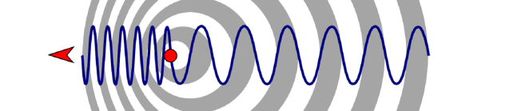
https://www.youtube.com/watch?v=h4OnBYrbCjY

Analogy: Sweets on a conveyor belt
Imagine a long conveyor belt running at a steady speed. An adult standing about halfway along deposits sweets onto the belt at a regular rate, say one sweet per second (frequency).
Conveyor belt
Adult
Child
Chocolate
Chocolates on conveyor belt

A child standing at the end of the conveyor belt collects the sweets in a bucket as they fall off the end. As long as they are both standing still, the child will be collecting the sweets at the same rate (frequency) as they are being deposited by the adult.
If the adult walks steadily away from the child, still depositing the sweets at the same rate, the child now receives the sweets at a lower rate (frequency). The sweets will be further spaced out on the conveyor belt (longer ‘wavelength’).
Conversely if the adult walks towards the child, the child will receive the sweets at a higher rate (frequency) and they will be spaced closer together (shorter ‘wavelength’).

Equations
There are equations that we can use to calculate the apparent change in frequency and we can derive these equations for the Doppler effect. For a moving source there is an equation for the source moving towards the observer and another for the source moving away from the observer.
Similarly for a moving observer there are two equations, one for moving away from and one for moving towards the source, but these last two are not covered in this course.
For this course, the only equations required are for a stationary observer with the source moving away and moving towards the observer.

Deriving the Doppler Equation
Derivation: Stationary observer and source moving away
Beware in these derivations the frequency of the source is the actual frequency generated by the object producing the sound waves. The speed of sound would have a value of 340 ms⁻¹. The sound is generated from a moving object which is moving with speed v_{source} The speed of the source is the speed at which the vehicle is moving, not the speed of the sound. This generates an observed frequency and wavelength in a stationary observer. Other derivations use different symbols, you must define your terms.
These are the symbols that the SQA use to define the terms. Most other books use the same symbols but use them to represent different terms so the equation can look different.
speed of sound = v speed of source = v_{s}
frequency source = f_{s} observed frequency = f_{o}

We can consider how this effect occurs. A source produces a sound of frequency f_{s}.
The frequency of the source will remain constant, it is the observed frequency that changes.
Movement towards observer: The waves will 'bunch up'

v metres
Stationary: in 1 second there will be f_{s} waves produced. The sound will travel a distance of v metres in 1 second. This means there are f_{s} waves in a distance of v metres.
Moving at speed v_{s}: In the same way as above, in 1 second f_{s} waves will cover a distance of (v - v_{s}) metres.
As 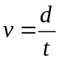 then numerically in one second the value of v is equal to the value of d
(v-v_{s}) metres
v_{s} ms⁻¹

The observed wavelength of the waves will be
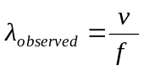
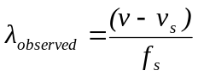
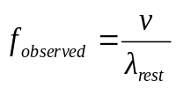
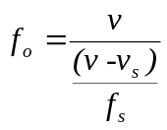
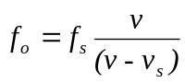
This gives an observed frequency that is higher/greater than that of the source.
If the source is moving away from the observer then the frequency observed will be lower/smaller than that of the source.
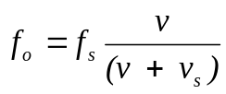

Remember the correct formula from ADD when the object moves AWAY
and TAKE AWAY (subtract) when the object comes TOWARDS

Frequency increases as they come towards you and frequency decreases as they move away.
We can also see from these equations that if the magnitude of v_{source} is very small compared to v there is little effect on f_{observed}. This is why for the effect to be noticeable, v_{source} should be reasonably large in comparison with the speed of the waves (v).

Providing objects emitting or reflecting light are travelling at speeds less than 10%c then we can use this Doppler equation to find out fast objects are moving.
For a stationary observer with a light source moving towards them, the relationship between the original frequency, f_{s}, of the source and the observed frequency is:
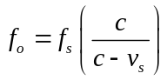
For a stationary observer with a light source moving away from them, the relationship between the original frequency, f_{s}, of the source and the observed frequency is:
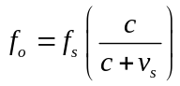
This second scenario is exactly what is observed when we look at the light from distant stars, galaxies and supernovae. These relationships also allow us to calculate the speed at which an exoplanet is orbiting its parent star, or the velocity of stars orbiting a galactic core, which has lead us to theorise the existence of dark matter.
http://www.youtube.com/watch?v=Y5KaeCZ_AaY

Tutorials

The Doppler Effect/ Tutorial 1

In the following questions, when required, use the approximation for
speed of sound in air = 340 m s^{−1.}
1. In the following sentences the words represented by the letters A, B, C and D are missing:
A moving source emits a sound with frequency f_{s}. When the source is moving towards a stationary observer, the observer hears a A frequency f_{o}. When the source is moving away from a stationary observer, the observer hears a _B_ frequency f_{o} . This is known as the _C_ _D_.
Match each letter with the correct word from the list below:
Doppler effect higher louder
lower quieter softer
2. Write down the expression for the observed frequency f_{o}, detected when a source of sound waves in air of frequency f_{s} moves:
(a) towards a stationary observer at a constant speed, v_{s}
(b) away from a stationary observer at a constant speed, v_{s} .
3. In the table shown, calculate the value of each missing quantity (a) to (f), for a source of sound moving in air relative to a stationary observer.
Frequency heard by stationary observer / Hz | Frequency of source / Hz | Speed of source moving towards observer / ms⁻¹ | Speed of source moving away from observer / ms ⁻¹
(a) | 400 | 10 | –
(b) | 400 | – | 10
850 | (c) | 20 | –
1020 | (d) | – | 5
2125 | 2000 | (e) | –
170 | 200 | – | (f)
4. A girl tries out an experiment to illustrate the Doppler effect by spinning a battery-operated siren around her head. The siren emits sound waves with a frequency of 1200 Hz.
Describe what would be heard by a stationary observer standing a few metres away.
5. A police car emits sound waves with a frequency of 1000 Hz from its siren. The car is travelling at 20 ms⁻¹ .
(a) Calculate the frequency heard by a stationary observer as the police car moves towards her.
(b) Calculate the frequency heard by the same observer as the police car moves away from her.
6. A student is standing on a station platform. A train approaching the station sounds its horn as it passes through the station. The train is travelling at a speed of 25 ms⁻¹ . The horn has a frequency of 200 Hz.
(a) Calculate the frequency heard as the train is approaching the student.
(b) Calculate the frequency heard as the train is moving away from the student.
7. A man standing at the side of the road hears the horn of an approaching car. He hears a frequency of 470 Hz. The horn on the car has a frequency of 450 Hz.
Calculate the speed of the car.
8. A source of sound emits waves of frequency 500 Hz. This is detected as 540 Hz by a stationary observer as the source of sound approaches.
Calculate the frequency of the sound detected as the source moves away from the stationary observer.
9. A whistle of frequency 540 vibrations per second rotates in a circle of radius 0·75 m with a speed of 10 ms⁻¹ .
Calculate the lowest and highest frequency heard by a listener some distance away at rest with respect to the centre of the circle.
10. A woman is standing at the side of a road. A lorry, moving at 20 ms⁻¹, sounds its horn as it is passing her. The lorry is moving at 20 ms⁻¹ and the horn has a frequency of 300 Hz.
(a) Calculate the wavelength heard by the woman when the lorry is approaching her.
(b) Calculate the wavelength heard by the woman when the lorry is moving away from her.
11. A siren emitting a sound of frequency 1000 vibrations per second moves away from you towards the base of a vertical cliff at a speed of 10 m s ⁻¹ .
(a) Calculate the frequency of the sound you hear coming directly from the siren.
(b) Calculate the frequency of the sound you hear reflected from the cliff.
12. A sound source moves away from a stationary listener. The listener hears a frequency that is 10% lower than the source frequency. Calculate the speed of the source.
13. A bat flies towards a tree at a speed of 3·60 m s ⁻¹ while emitting sound of frequency 350 kHz. A moth is resting on the tree directly in front of the bat.
(a) Calculate the frequency of sound heard by the bat.
(b) The bat decreases its speed towards the tree. Does the frequency of sound heard by the moth increase, decrease or stays the same? Justify your answer.
(c) The bat now flies directly away from the tree with a speed of 4·50 m s ⁻¹ while emitting the same frequency of sound. Calculate the new frequency of sound heard by the moth.
14. The siren on a police car has a frequency of 1500 Hz. The police car is moving at a constant speed of 54 km h⁻¹ .
(a) Show that the police car is moving at 15 m s⁻¹.
(b) Calculate the frequency heard when the car is moving towards a stationary observer.
(c) Calculate the frequency heard when the car is moving away from a stationary observer.
15. A source of sound emits a signal at 600 Hz. This is observed as 640 Hz by a stationary observer as the source approaches. Calculate the speed of the moving source.
16. A battery-operated siren emits a constant note of 2200 Hz. It is rotated in a circle of radius 0·8 m at 3·0 revolutions per second. A stationary observer, standing some distance away, listens to the note made by the siren.
(a) Show that the siren has a constant speed of 15·1 m s⁻¹.
(b) Calculate the minimum frequency heard by the observer.
(c) Calculate the maximum frequency heard by the observer.
17. You are standing at the side of the road. An ambulance approaches you with its siren on. As the ambulance approaches, you hear a frequency of 460 Hz and as the ambulance moves away from you, a frequency of 410 Hz. The nearest hospital is 3 km from where you are standing. Estimate the time for the ambulance to reach the hospital. Assume that the ambulance maintains a constant speed during its journey to the hospital.
18. On the planet Lots, a poobah moves towards a stationary glonk at 10 m s ⁻¹. The poobah emits sound waves of frequency 1100 Hz. The stationary glonk hears a frequency of 1200 Hz. Calculate the speed of sound on the planet Lots.

exam Questions
SQA AH 2005
A train emits a sound of frequency 800 Hz as it passes through a station. The sound is heard by a person on the station platform as shown.

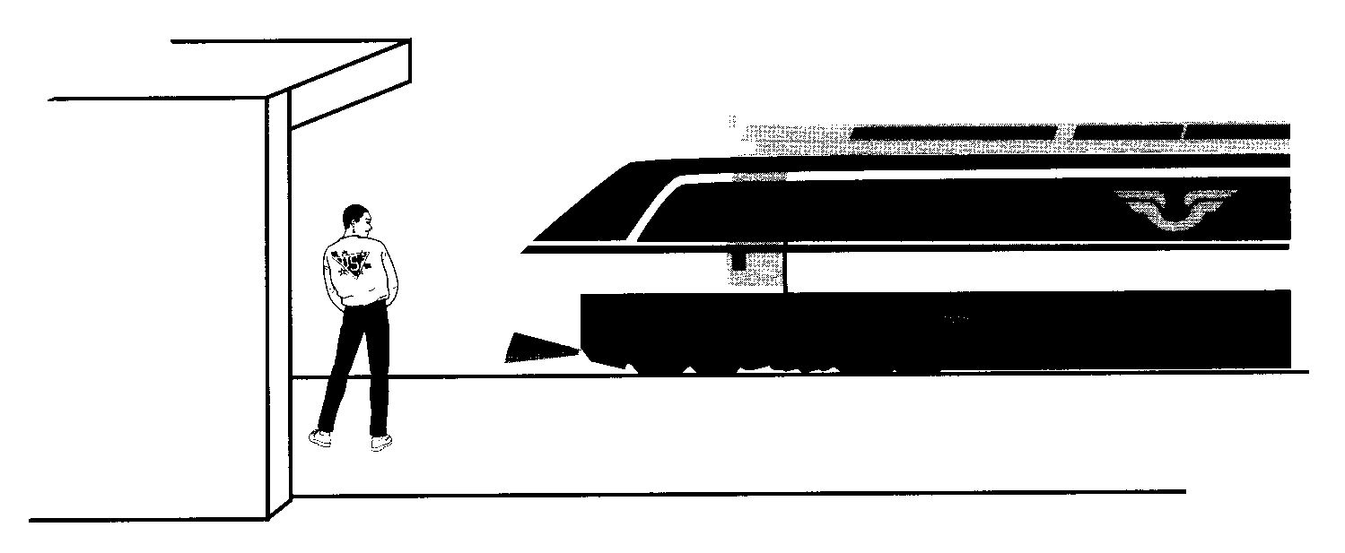

(a) Describe how the frequency of the sound, heard by the person, changes as the train passes through the station. 1

(b) Explain, in terms of wavefronts, why this frequency change occurs. You may wish to include a diagram as part of your answer.
(c) At one instant the person hears a sound of frequency 760 Hz. Calculate the speed of the train relative to the person on the platform at this time.

SQA AH 2002
(c ) (i) A car horn produces a note of frequency 200 Hz. The horn is sounded as the car is moving at 30 m s–1 away from a stationary observer. Calculate the frequency heard by the observer.
          - An observer on Earth notes that the frequency of light from a distant galaxy is Doppler shifted towards the red end of the spectrum. Describe how the galaxy is moving relative to the Earth. You must justify your answer.

It would be a good idea to write the following perfect answer in your notes
SQA AH 2005 Answer
This is the marking scheme from the AH paper from which the above question was adapted
(b)(ii) The waves (wavefronts) are closer together as they approach the person and then they are further apart after they pass the person
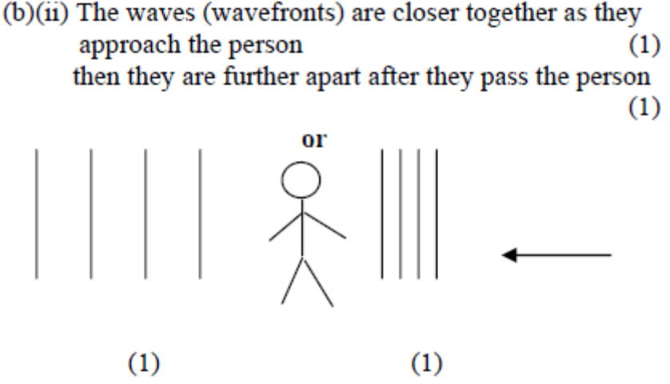
(b)(iii)
$$f=f_{s}\left(\frac{v}{v+v_{s}}\right)$$
$$760=800\left(\frac{340}{340+v_{s}}\right)$$
$$\frac{760}{800}=\left(\frac{340}{340+v_{s}}\right)$$
$$\frac{800}{760}=\left(\frac{340+v_{s}}{340}\right)$$
$$\frac{800}{760}×340=340+v_{s}$$
$$\left(\frac{800}{760}×340\right)-340=v_{s}=18{ms}^{-1}$$
If - used then 0 marks
If ± used then no mark for the formula unless the + is used in the next line

SQA AH 2002
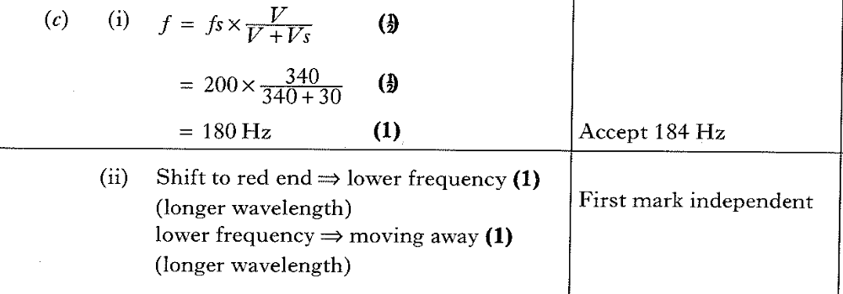

Recessional Velocity

https://www.youtube.com/watch?v=h4OnBYrbCjY
https://www.youtube.com/watch?v=LIvVzJ6KZpk
2005
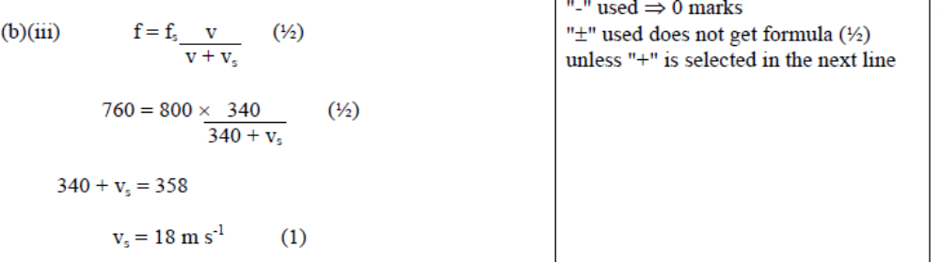
2002

Big Bang Theory

Line spectra
All atoms give off electromagnetic radiation when heated, although sometimes this is not in the visible part of the spectrum. Each element has its own distinctive line spectrum. A prism is an example of a device that can be used to split this light to form a spectrum. Spectroscopy is the name given to the experimental technique of spectroscopic methods; but also refers to the measurement of radiation intensity as a function of wavelength. Spectral measurement devices are referred to as spectrometers, spectrophotometers, spectrographs or spectral analyzers.
Some examples of what line spectra look like are shown below:
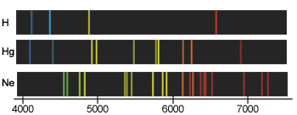
Scientists have used line spectra to discover new elements. In fact, the discovery of some elements, such as rubidium and caesium, was not possible until the development of spectroscopy. The element helium was discovered by studying line spectra emitted by the Sun.
Each element has its own characteristic line emission spectrum and the corresponding absorption spectrum.
These can be indicated on a diagram as a coloured strip or as intensity versus wavelength graph.
eg
Sodium emission spectrum

Sodium absorption spectrum


Redshift, z
Redshift is an example of the Doppler Effect. It is the term given to the change in frequency of the light emitted by stars, as observed from Earth, due to the stars moving away from us.
Redshift has always been present in the light reaching us from stars and galaxies but it was first noticed by astronomer Edwin Hubble, in the 1920’s, when he observed that the light from distant galaxies was shifted to the red end of the spectrum.
The light emitted by a star is made up of the line spectra emitted by the different elements present in that star. Each of these line spectra is an identifying signature for an element and these spectra are constant throughout the universe. You will learn a lot more about spectra in the Particles and Waves unit of this course.
Sometimes the spectral lines are found to have been moved or shifted towards the red end of the spectrum because of an increase in wavelength. This effect is called redshift and, assuming it is due to the Doppler Effect, implies these bodies are moving away from us. The amount of the shift also allows us to calculate how fast they are moving away.
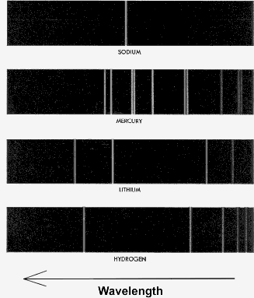
An intensity versus wavelength graph also allows
Normal
Redshifted
Redshift

spectra outwith the visible region to be represented. These characteristic spectra allow elements in the stars and space to be identified.
Since these line spectra are so recognisable, we can compare the spectra produced by these elements, on Earth, with the spectra emitted by a distant star or galaxy.
1
2
3
4
4
3
2
1
Blueshifted
Redshifted
Source
Doppler Effect and redshift
Direction of movement of source

Redshift, z, of a galaxy is defined as the change in wavelength divided by the original wavelength, and given the symbol z.
So, redshift $z= \frac{Δλ}{λ} = \frac{λ_{observed}- λ_{source}}{λ_{source}}$
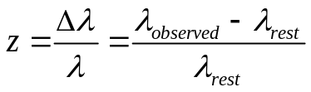Where z = redshift, λ_{obs} = observed wavelength
λ_{rest} = wavelength of the source
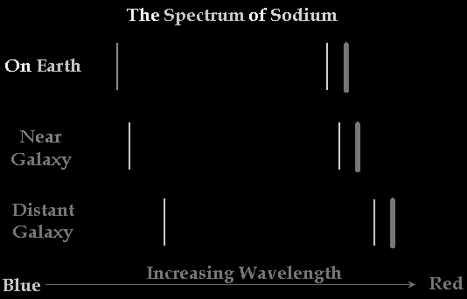
Note: Redshift is a dimensionless quantity since it is a ratio of two lengths.
Redshift of galaxies, travelling at non-relativistic speeds, can also be shown to be the ratio of the velocity of the galaxy to the velocity of light:
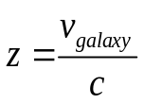
The redshift of a galaxy
http://www.youtube.com/watch?v=LIvVzJ6KZpk this even has a canal!
The Doppler Effect also applies to electromagnetic waves, but at high speeds relativistic effects have to be taken into account.
For bodies travelling at non-relativistic speeds (ie less than 10% of the speed of light) we can apply the Doppler equation for a stationary observer and a moving source. Using the Doppler equation for a source moving away from the observer and substituting c (the speed of light) for v , we get:
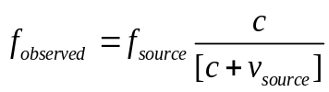
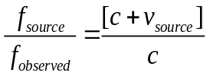…………. [1]
Additionally 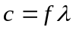$c=fλ$, then $f=\frac{c}{λ}$:
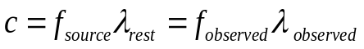
$\frac{f_{source}}{f_{observed}} = \frac{λ_{observed}}{λ_{source}}$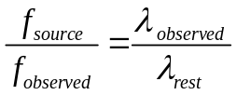 ……….. [2]
From the definition of redshift,
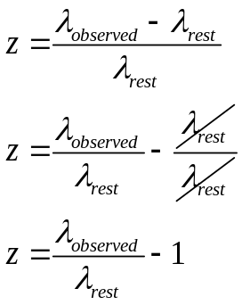
Substituting from [2] we get:
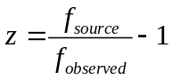
(But from the Doppler Equation) Substituting from [1] we get
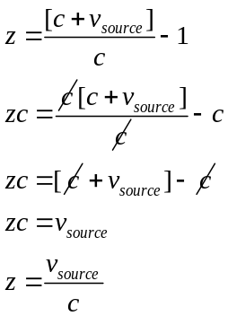
Note: This equation only applies to non-relativistic speeds, say less than 10% of the speed of light.
As an aside, which is not required for this current Higher Course: For electromagnetic radiation there is no fixed medium to provide a frame of reference and relativity has to be taken into account? For the source and observer moving rapidly apart when relativistic speeds are required the equation for observed frequency is:
$$f_{observed} = f_{source}{\left\{\frac{1- v/c}{1+ v/c}\right\}}^{1/2}$$
The exact relationship between redshift and velocity derived from the special theory of relativity is given by:
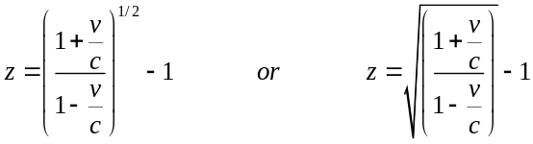
Even this relationship ignores the expansion of the universe as the light propagates through it. This relationship is really the combined effect of the standard Doppler equation and a time dilation factor.
For a nice explanation, see: http://mb-soft.com/public/reltvty1.html.
Note: Radial speed
The redshift can only give us the radial speed of the object; it tells us nothing about its tangential speed

Blueshift.
Note: If there is a decrease in wavelength, ie the line spectrum has moved towards the blue end of the spectrum, this makes z negative, which means the body is moving towards us. This is referred to as a blueshift.
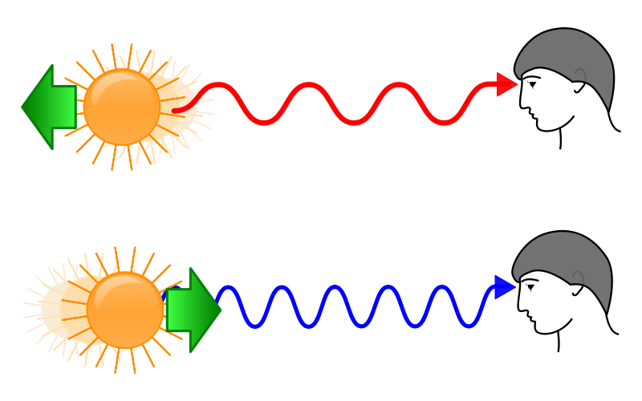
See electronic version, it works so much better in colour!

Anecdote
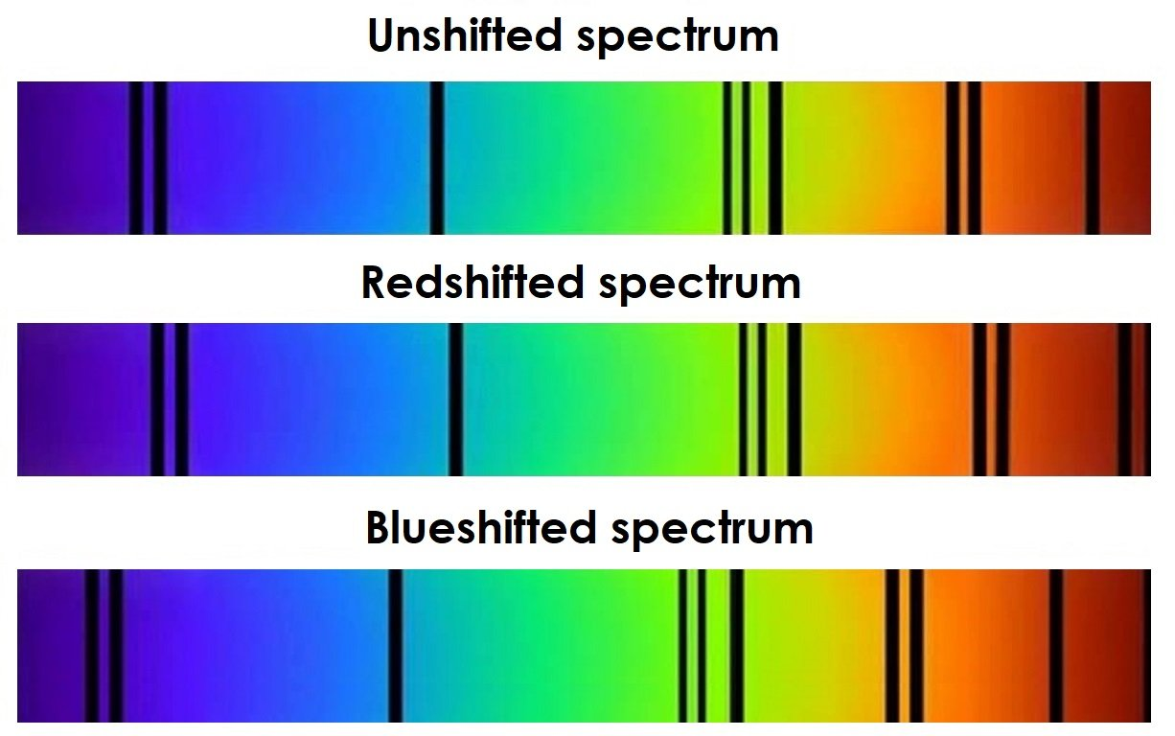

This is the apocryphal tale of an astronomer in a hurry on his way to work. He goes through a red traffic light and is stopped by traffic police. He explains the light looked green as he passed it and explains this was perhaps due to the Doppler Effect and blueshift.
The policeman listens intently, accepts his explanation but then proceeds to write a speeding ticket.
‘Why?’ enquires the astronomer. The policeman explains that for such a blueshift to occur, he must have been travelling at approximately 2 × 10⁸ kmh^{–1} !

Hubble’s Law
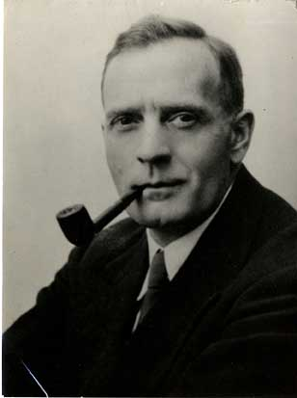
The astronomer Edwin Hubble noticed in the 1920’s that the light from some distant galaxies was shifted towards the red end of the spectrum.
Hubble examined the spectral lines from various elements and found that each galaxy was shifted towards the red by a specific amount. This shift was due to the galaxy moving away from the Earth at speed, causing the Doppler Effect to be observed. The bigger the magnitude of the shift the faster the galaxy was moving.
spectrum of element on Earth
spectrum of element from galaxy

Red
Blue
shift

Over the course of the few years Hubble examined the red shift of galaxies at varying distances from the Earth. He found that the further away a galaxy was the faster it was travelling. The relationship between distance and speed of galaxy is known as Hubble’s Law.
The graph below shows the data collected by Hubble. It shows the relationship between the velocity of a galaxy, as it recedes (moves away) from us, and its distance, known as Hubble’s Law.
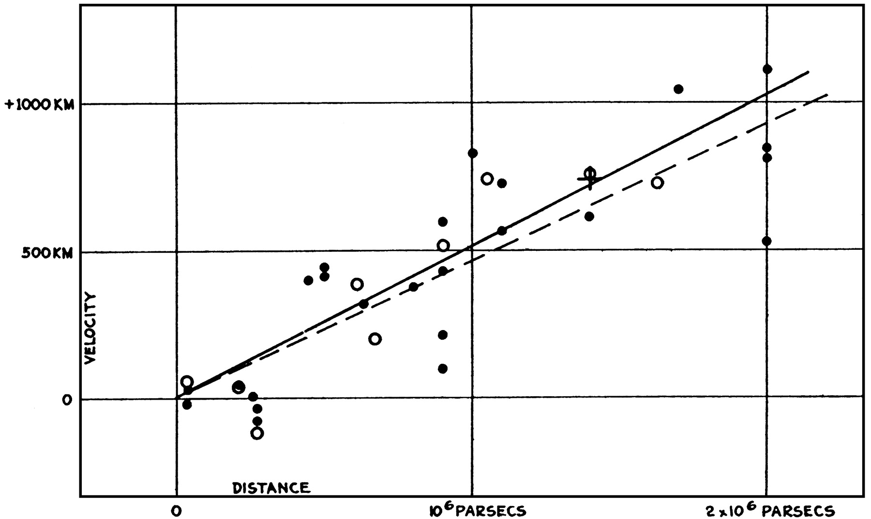
x axis is the distance: d / Mpc (Mpc =megaparsec)
y axis is the recession velocity: v / km s⁻¹
Information from the graph above
The graph shows velocity against distance among extra-galactic nebulae. Radial velocities, corrected for solar motion (but labelled in the wrong units), are plotted against estimated distances. The black discs and full line represent the solution for solar motion by using the nebulae individually; the circles and broken line represent the solution combining the nebulae into groups; the cross represents the mean velocity corresponding to the mean distance of 22 nebulae whose distances could not be estimated individually. [Reproduced with permission from Hubble, E. P. (1929) Proc. Natl. Acad. Sci. USA 15, 168–173. (Copyright 1929, The Huntington Library, Art Collections and Botanical Gardens).]
From his results, he concluded that more distant galaxies are receding faster than closer ones. In fact he found that the recession speed (v) varied directly with distance (d), ie:
v ∝ d, so v = H_{o}d
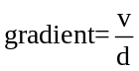
MENTION RECESSIONAL VELOCITY
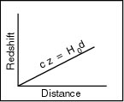
This gradient is known as Hubble’s constant, H₀: 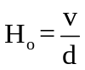 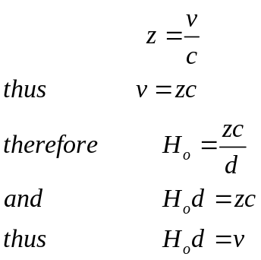
Where H₀ = the Hubble constant
c = speed of light
d = distance to galaxy
$$v = H_{0}d$$

Units of Hubble’s constant H₀:
The value of the Hubble constant is not known exactly, as the exact gradient of the line of best fit is subject to much debate. However, as more accurate measurements are made, especially for the distances to observable galaxies, the range of possible values has reduced. It is currently thought to lie between 50 – 80 kms⁻¹ Mpc⁻¹, with the most recent data putting it at 70.4 ± 1.4 kms⁻¹ Mpc⁻¹. The units for the Hubble constant are always in units of time.
1 Mpc = 3·2 x 10⁶ light years = 3·1 x 10²²m
For this course the Hubble Constant is given as
Hubble’s Constant Ho | 2·3 x 10⁻¹⁸ s⁻¹

Evidence for the Expanding Universe
From Hubble’s graph of speed versus distance, we can obtain an estimate of how long it took for a galaxy to reach its current position. Assuming they have been moving away from us at a constant speed, the time taken for a particular galaxy to reach its current position can be found by dividing the distance by the speed.
Galaxies are moving away from the Earth and each other in all directions, which suggests that the universe is expanding. This means that in the past the galaxies were closer to each other than they are today. By working back in time it is possible to calculate a time where all the galaxies were in fact at the same point in space. This allows the age of the universe to be calculated. Currently NASA have a value of 13.7 billion years as the age of the universe from this method.
Example:
v = speed of galaxy receding from us
d = distance of galaxy from us
H₀ = Hubble’s constant
t = time taken for galaxy to reach that distance, i.e. the age of the universe
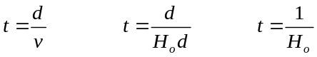
If we take the inverse of the Hubble constant we should be able to predict the age of the Universe i.e.
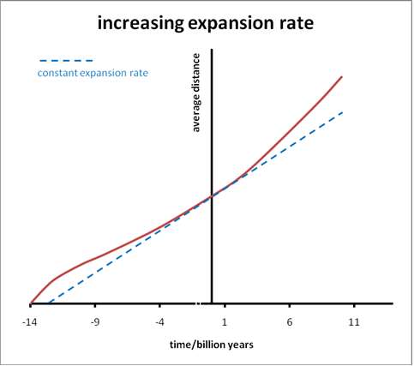
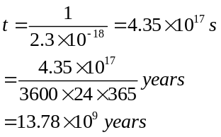
Since Hubble’s time, there have been other major breakthroughs in astronomy. All of these support the findings of Hubble, and allow the age of the universe to be calculated even more accurately. Such a discovery is Cosmic Microwave Background (CMB). Observations of the CMB also support the theory that the universe is expanding out from a single point, as Hubble postulated.

We have also discovered, however, that not only is the universe expanding but it is expanding at an increasing rate, i.e. the acceleration is increasing. This was the conclusion of astronomers in 1998 when observing distant supernovae. Their discovery was a great shock to the scientific community and was awarded the Nobel Prize in Physics in 2011.

The Expanding Universe

Why such a shock?
The force of gravity acts between all matter in the universe. Matter clumps together due to gravity, such as the contraction of hydrogen gas to create new stars, the grouping of stars to create galaxies and the grouping of galaxies to create local groups and superclusters. The Hubble telescope has been able to give us a glimpse of the universe on an even larger scale and images of many of the observable galactic clusters show them gravitating towards each other to form unimaginably large structures, known as filaments.
The force of gravity should be an unbalanced force acting to slow the expansion down. A universe like this, which eventually collapses back in on itself is known as a closed universe. The force of gravity, determined by the mass of the universe, eventually overcomes any expansion and all matter accelerates back towards a central point. The alternative scenario is an open universe where the universe continues to expand. Which of these two scenarios is more likely is purely down to the total mass of the universe.
Hubble’s Law and subsequent observations, shows that the rate of expansion of the universe is increasing. This suggests that there is a force acting against the force of gravity, pushing matter apart. This force is causing a significant acceleration and so it is much greater in magnitude than the force of gravity. As yet, astronomers and cosmologists have not been able to determine a source of energy capable of producing this force. For lack of a better term it is, for now, simply referred to as dark energy.
Try this experiment
http://www.schoolsobservatory.org.uk/astro/cosmos/uniball
Summary
1. Closed universe: the universe will slow its expansion and eventually begin to contract.
2. Open universe: the universe will continue to expand forever.

Einstein's Greatest Blunder
http://www.jb.man.ac.uk/~jpl/cosmo/blunder.html

The Cosmological Constant
Much later, when I was discussing cosmological problems with Einstein, he remarked that the introduction of the cosmological term was the biggest blunder of his life.
-- George Gamow, My World Line, 1970
Einstein's remark has become part of the folklore of physics, but was he right? He certainly had cause to feel rueful about the cosmological constant; he had introduced it into his general theory of relativity in 1917, as a last resort, to force the equations to yield a static universe. Even at the time, he apologized for doing so, because it spoiled the elegant simplicity of the field equations that he had struggled so hard to find. Of course the universe is not static, just as his original equations were trying to tell him; his blindness lost him the chance to make one of the great predictions in physics. Even worse, a little more analysis would have shown that his static universe was not stable, and would have started to expand or contract if its perfect equilibrium was disturbed in any way.
A universe which does not collapse in due to gravity but continues to expand indefinitely is called an open universe. This type of universe would undergo an end known as ‘heat death’. This refers to the fact that, eventually, all energy becomes heat energy and as time goes on all matter would be so far apart that the heat energy of the universe would be spread too far apart to allow any further production of stars and galaxies.
As the magnitude of the force of gravity in the universe is dependent on the mass within that universe, it is mass which determines whether a universe is open or closed and therefore the eventual fate of that universe:
if a universe has enough mass then the force of gravity will be greater than that produced by dark energy; expansion will decrease and the universe will be closed.
If a universe does not have enough mass then the force produced by dark energy will be greater than gravity; expansion will continue indefinitely and the universe will be open.

Dark Energy vs. Dark Matter
Our universe may contain 100 billion galaxies, each with billions of stars, great clouds of gas and dust, planets and moons. The stars produce an abundance of energy, from radio waves to X-rays, which streak across the universe at the speed of light.
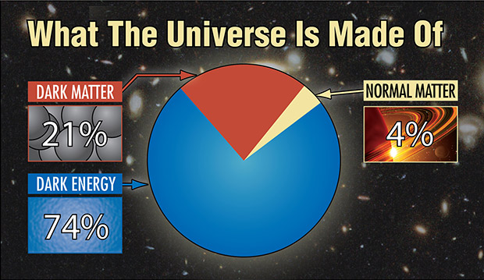
Yet everything that we can see only accounts for only about 4% of the total mass and energy in the universe.

About one-quarter of the universe consists of dark matter, which releases no detectable energy, but which exerts a gravitational pull on all the visible matter in the universe. What dark matter consists of is uncertain at present, though it is believed not to be the type of matter with which we are familiar – electrons, neutrons, and protons.
While dark energy repels, dark matter attracts. And dark matter’s influence shows up even in individual galaxies, while dark energy acts only on the scale of the entire universe
Are dark matter and dark energy related? No one knows. The leading theory says that dark matter consists of a type of subatomic particle that has not yet been detected, although upcoming experiments with the world’s most powerful particle accelerator may reveal its presence. Dark energy may have its own particle, although there is little evidence of one.
Instead, dark matter and dark energy appear to be competing forces in our universe. The only things they seem to have in common is that both were forged in the Big Bang, and both remain mysterious.
Because of the names, it’s easy to confuse dark matter and dark energy. And while they may be related, their effects are quite different. In brief, dark matter attracts, dark energy repels. While dark matter pulls matter inward, dark energy pushes it outward. Also, while dark energy shows itself only on the largest cosmic scale, dark matter exerts its influence on individual galaxies as well as the universe at large.

More on Dark Matter
Observations of the Doppler Effect being evident in light observed from space has led to the development of another, equally perplexing theory; dark matter. This one comes from observing the light from individual stars within galaxies.
We know that galaxies rotate about their cores as the light observed on one side of a galaxy will be blue shifted, indicating that the source of that light is moving towards us, in comparison to the other side which will be redshifted, by the same amount.
Measuring the amount which the light is shifted by allows us to calculate the exact rotational velocity of that galaxy and thus the velocity of the stars within it.
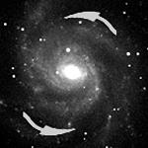
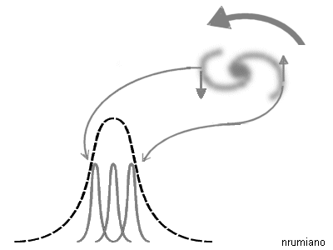
Blueshifted as the light source comes towards us.
Redshifted as the light source travels away from us.
wavelength

From the section on gravitation you know that orbits are a careful balance between the gravitational field strength, created by a mass, and the velocity of a projectile.
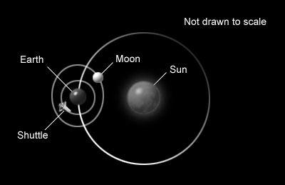
M
v
m
r

If you give an object a great enough velocity it can escape the gravitational field it is in and escape from the orbit. An example of the same kind of action, occurring on Earth, is being on a roundabout in a park.

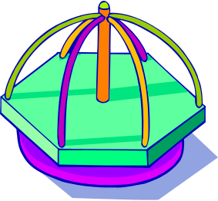
When on a roundabout you must hold on to stay on. If you did not provide this force your body would continue in a straight line and you would come of at a tangent to the circle. In the case of a roundabout, the force causing you to go in a circle is a force of friction. As the roundabout spins faster, so do you and you must provide a larger and larger force, by holding on more tightly? If you cannot provide a force big enough you will come off.

http://www.youtube.com/watch?v=m0bSJkrDYH8 (idiots! NEVER TRY THIS IT HAS LED TO SERIOUS INJURY!)
It is exactly the same with an orbit in space. Only here, the force causing the object to continue in a circle is gravity. As the magnitude of this force is determined by the mass of the planet, star, or galaxy, it is fixed and cannot increase. If the object travels too fast, the force of gravity will not be able to keep it on a circular path and it will escape its orbit and travel off in a straight line.
If we know:
- the mass of the orbiting object, m
- the velocity of the orbiting object, v
- the radius of its orbit, r
Then we can calculate the mass of the central body, M, using the Universal Law of Gravitation.
Stars on the on the outer arms of the galaxy should travel slower than those towards the galactic core as they are 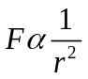further from the central mass and therefore experience a smaller gravitational force

We can directly observe the distribution of matter, and therefore mass, within a galaxy from its brightness. Matter in a galaxy is either producing light,(stars), or reflecting it, (nebulae and dust).

What do we observe?
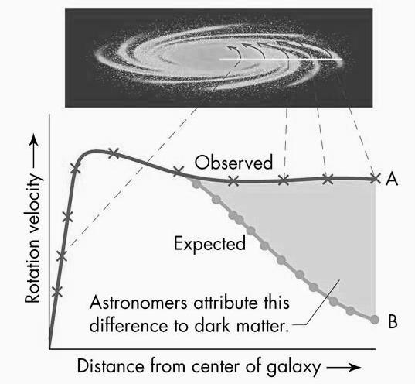
The stars are travelling too fast.
As you can see from the graph above, the velocity of stars does not drop off as expected, at greater orbital radii. At these high velocities the observed mass of the galaxy should not be enough to hold on to many of its stars and we should see them fly off into intergalactic space.
The only logical conclusion that astronomers have to explain this consistent observation is that there must be a significant amount of mass that we cannot see. Hence the name: dark matter.

The Big Bang Theory
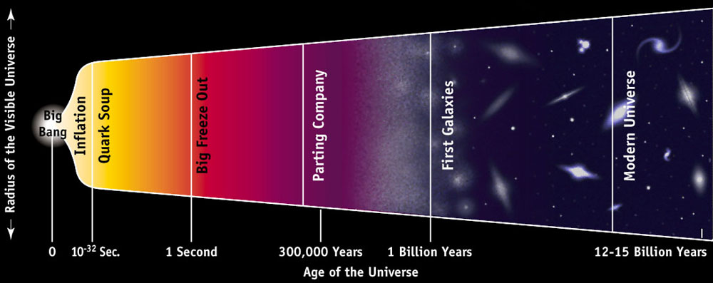
http://archive.ncsa.illinois.edu/Cyberia/Cosmos/Images/CosmicTimeline_gr.jpg
http://www.schoolsobservatory.org.uk/astro/cosmos/bb_history
Scientists have gathered a lot of evidence and information about the universe. They have used their observations to develop a theory called the Big Bang. The theory states that originally all the matter in the universe was concentrated into a single incredibly tiny point, called a singularity. This began to enlarge rapidly in a hot explosion, and it is still expanding today. This explosion is called the Big Bang, and happened about 13.7 billion years ago (that's 13,700,000,000 years using the scientific definition of 1 billion = 1,000 million).
The universe started with a sudden appearance of energy which consequently became matter and is now everything around us. There were two theories regarding the universe
The Steady State Universe: where the universe had always been and would always continue to be in existence.
The Created Universe: where at some time in the past the universe was created.
Ironically the term ‘Big Bang’ was coined by Fred Hoyle a British astronomer who was the leading supporter of the Steady State theory and who was vehemently opposed to the, currently named, Big Bang theory. He used the phrase ‘Big Bang theory’ during a broadcast on the BBC radio station The Third Programme, broadcast on 28 March 1949.

What was the evidence -
that finally swung the balance towards the Big Bang theory?

Determining the Temperature of Distance Stars & Galaxies.
From everyday experience we know that substances glow (incandesce) when heated to very high temperatures. The colour of light emitted depends on exactly how high the temperature is.
When an object is heated it does not initially glow, but radiates large amounts of energy as infrared radiation. We can feel this if we place our hand near, but not touching, a hot object.
As an object becomes hotter it starts to glow a dull red, followed by bright red, then orange, yellow and finally white (white hot). At extremely high temperatures it becomes a bright blue-white colour.
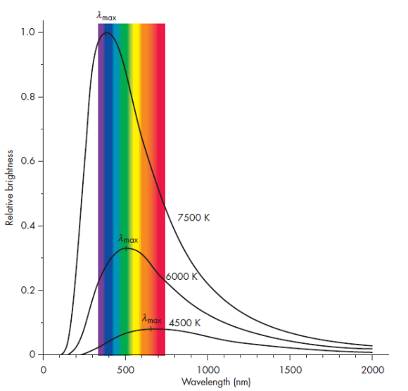
We first need to consider how it is possible to determine the temperature of distant stars and galaxies. You will have seen what happens to a piece of iron as it is heated, as it gets hotter its colour changes from dull red to bright red to orange then yellow.
Figure 3 Courtesy of John D Fix Astronomy Journey to the Cosmic Frontier 5th Ed.
The observant amongst you may realize that these are the first colours in the visible spectrum. The temperature of an object determines the frequency of light it emits. This idea has been with us for a long time; Jožef Stefan proposed in 1879 that the power irradiated from an object was proportional to its temperature in Kelvin to the fourth power.
P = σT⁴
Where σ is Stefan’s (also referred to as the Stefan- Boltzmann) constant and
σ = 5.67 x 10⁻⁸ Wm⁻²K⁻⁴.
What this means is that by examining the spectrum of a distant star, its temperature can effectively be determined.

A "black-body" is an ideal object whose temperature is the same at every point and constant in time. It is useful for study because such an object produces a spectrum which is dependent only on the temperature. The spectrum of black-body radiation is continuous from zero energy at zero wavelength, rising to a maximum at some wavelength determined by Wien's law (AH Physics), and then falling off to zero at infinite wavelength. The hotter the black body, the more energy is produced at EVERY wavelength. Black-bodies are useful models because many stars radiate approximately as black-body.
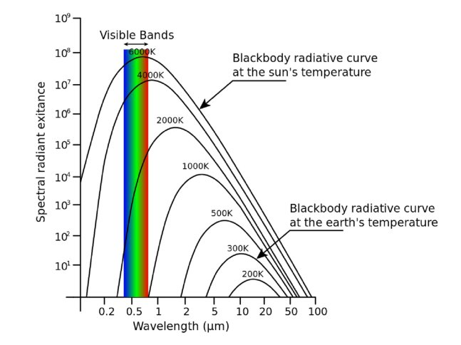
The black-body spectrum has three main features:
1. The basic shape is more or less the same (apart from a scaling factor) at all temperatures; it is like a skewed bell curve, falling off gently on the long wavelength side of the peak, and much more sharply on the shorter wavelength side.
2. As the temperature of the object is increased, the peak of the intensity spectrum shifts towards the shorter wavelengths.
3. As the temperature of the object is increased, the intensity increases for all wavelengths.
The properties of the spectrum are characterised by a single parameter, temperature, hence it is sometimes referred to as a thermal radiation spectrum.
When the temperature is raised the peak moves towards the short wavelength end (blue), which gives the visible effect of changing from red to orange to yellow to white to blue-white, in that order.

Bang?
The Big Bang was not like a conventional explosion in which matter is thrown apart from a single point into a pre-existing empty space.
Most cosmologists think space, time and matter originated at the Big Bang and before that there was no space, time or matter in the sense we think of them today.
Rather than thinking of galaxies as flying away from each other through space, it is much better to think of them as being essentially at rest in an expanding space.

Evidence for the Big Bang Theory

Redshift (see previous notes) / Evidence from the Expanding Universe
From the expanding universe idea we can extrapolate our figures back (we consider running time backwards) and come to the conclusion that all matter in the Universe was all collected at a single point called the initial singularity.

Cosmic microwave background (CMB) radiation
CMB is predicted by the hot Big Bang theory.
During the very early stages of the universe, say when it was one millionth its present size, the temperature would have been around 3,000,000 K. If an electron became bound with a nucleus, high energy radiation would immediately strip it off. The universe was in a plasma state.
The universe expanded and cooled due to the redshifting effect. As space expanded, the wavelength of photons became longer, so each photon had less energy.
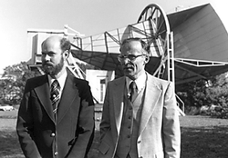
Gamow, Alpher and Herman, three physicists, had produced a paper in 1948 that if the Big Bang had actually taken place then there would be a residual background EM radiation, in the microwave region, in every direction in the sky representing a temperature of around 2.7K.
This value for the wavelength of the light and it’s consequent equivalent temperature was arrived at by considering how the light produced at the Big Bang would have changed as the universe expanded.
The discovery of this background radiation was another example of scientists finding something they weren’t looking for.

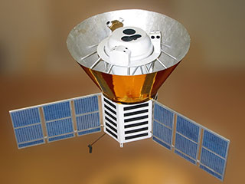
Arnold Penzias and Robert Wilson were working for Bell Labs in the USA. They were working with a special radio telescope [shown in the picture above] experimenting with satellite communication.
They were getting a residual signal that seemed to come from outside the galaxy. At first they though it was actually due to pigeon droppings from the pigeons that roosted in the horn. Finally they realised that they had found the echo of the Big Bang.
As one of their colleagues commented,
"Thus, they looked for dung but found gold, which is just opposite of the experience of most of us."
He may not have actually said the word dung but I’m not going to write in the actual word as I find it too rude!
In 1989 a satellite was launched to study the background radiation, it was called the Cosmic Background Explorer [COBE].
In 1992 it was announced that COBE had managed to measure fluctuations in the background radiation. This was further evidence to support the Big Bang theory.
An image of the fluctuations is shown below.
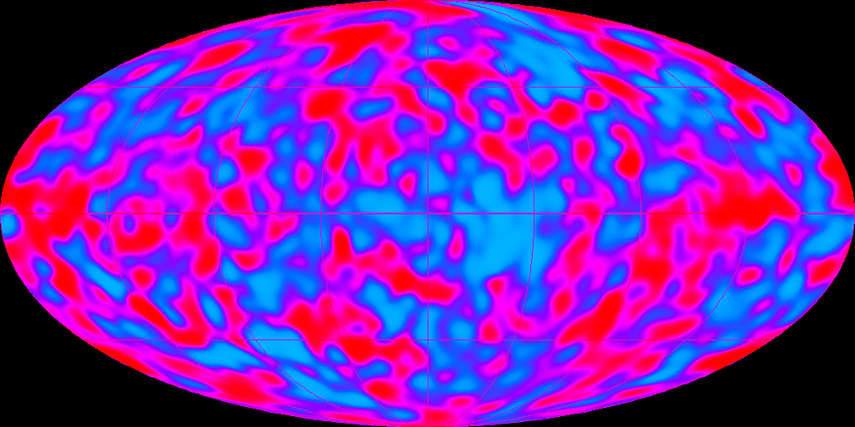

Black Body Radiation
Stars are black bodies in that they absorb all the radiation. The existence of black-body (thermal) radiation, at a temperature of about 3000 K, filling the universe at the time of recombination (when electrons combined with nuclei to form atoms), is consistent with a universe which has expanded and cooled from a much hotter and denser original state at much earlier times – as the Big Bang theory predicts.

The Helium Problem
Other evidence to support the Big Bang theory includes the relative abundances of hydrogen and helium in the universe. Scientists predicted that there should be a significantly greater proportion of hydrogen in the universe. The next most abundant should be helium. The most abundant elements in the universe are hydrogen (70–75%) and helium (25–30%). However, the abundance of helium in the universe cannot be explained by the formation inside stars as most of it remains locked up in their cores. However, it can be accounted for by being formed during the dense phase of the early universe, ie shortly after the Big Bang.
The elements present in the universe can be determined by spectroscopy, which you will study later in Particles and Waves.
The ability to determine the elements in space brought an updated version of an old song

Twinkle, twinkle little star,
I don’t wonder what you are;
For by spectroscopic ken,
I know that you are hydrogen;
Twinkle, twinkle little star,
I don’t wonder what you are.

The latest proportions are given in the table shown. These observations conform to the predicted proportions.

Element | relative abundance
Hydrogen | 10 000
Helium | 1 000
Oxygen | 6
Carbon | 1
All others | 1

Olbers’ paradox

Why is the night sky dark?
This question can be traced back to around 1576 and Thomas Digges, but it was first stated formally by the Prussian astronomer Heinrich Olbers in 1823, hence the name. It was commonly assumed, prior to the expansion of the universe being demonstrated by Hubble in 1929 that the universe was:
1. infinite
2. eternal
3. static.
If this was true, no matter which direction you looked, your line of sight would eventually intersect with a star. The entire sky would be virtually as bright as the Sun!
You may think that cannot be true, since distant stars are fainter than near ones. However, surface brightness is independent of distance. This is because although the flux received decreases with the square of the distance, so does the apparent size of the star, so the flux per unit area stays the same. That means the further you look into space, a greater number of stars will appear in your line of sight, compensating for any dimming due to the inverse square law.
Olbers’ own explanation – that invisible interstellar dust absorbed the light – would make the intensity of starlight decrease exponentially with distance.
It can be shown that the amount of dust needed to do this would be so great as to block out the Sun! Also the radiation would heat up the dust so much that it would start to glow, becoming visible in the infrared region.
One solution to the paradox comes from considering the finite time light takes to reach us. Consider a galaxy very distant from our own. We only become aware of its existence when light from it reaches us. So if the universe is not infinitely old, galaxies must exist that are so distant that their light has not reached us yet. If the universe is not infinitely old, that implies that it was created some time in the past, which is consistent with the Big Bang theory.
Another is the explanation for Olber’s paradox was in answer to the question, “why is the sky dark at night?”
This is not as obvious as you first might imagine.
Tam says:
The sun has set at night


What about all the stars? They’re suns as well

Wullie replies:

The Big Bang theory gives a finite age to the universe, and only stars within the observable universe can be seen. This means that only stars within the distance of 15,000 light years will be observed. Not all stars will be within that range and so the dark sky can be explained. So the main reason why the night sky is dark is due to the finite age of the galaxies, not the expansion of the universe. This is consistent with the hot Big Bang model, but not with a steady-state universe.

A summary of some of the evidence of the Big Bang and its interpretation
Evidence | Interpretation
The light from other galaxies is red-shifted. | The other galaxies are moving away from us.
The further away the galaxy, the more its light is red-shifted. | The most likely explanation is that the whole universe is expanding. This supports the theory that the start of the universe could have been from a single explosion.
Cosmic Microwave Background | The relatively uniform background radiation is the remains of energy created just after the Big Bang.

Further Questions on the Universe

Where in the universe was the Big Bang?
Everywhere! It’s a bit like asking ‘Where in your body were you born?’

What does the universe expand into?
The basic problem lies with the nature of spacetime. In order for the universe to expand into some larger space, that large space would need to exist in another universe. After all, what does ‘space’ even mean outside of the universe?
If you try to imagine yourself watching our universe from the outside, doesn’t that mean you are in a universe surrounding ours? The key is to think of the universe as a collection of information rather than a collection of objects. Think of it more like the flash memory in an MP3 player. When you record more tracks of music, the memory chip itself doesn’t become any larger.
For more information read the document
The Expanding Universe and Big Bang Theory Teacher’s Notes by Nathan Benson
ExpandingUniverseBigBangTheoryTeachersNote_tcm4=649504(1).doc

Definitions for the Expanding Universe:
Black Body Radiation
A "black-body" is an ideal object whose temperature is the same at every point and constant in time. It is useful for study because such an object produces a spectrum which is dependent only on the temperature. The spectrum of black-body radiation is continuous from zero energy at zero wavelength, rising to a maximum at some wavelength determined by Wien's law, and then falling off to zero at infinite wavelength. The hotter the black body, the more energy is produced at EVERY wavelength. Black-bodies are useful models because many stars radiate approximately as black-body.
Heliocentric Universe
A model of the universe that puts the sun at its center.
Hubble Expansion
Used to describe the expansion of the universe based on the redshifted light of distant galaxies. The relationship between recession velocity and distance is described by Hubble's Law, where [recessional velocity of an object]=[Hubble constant]*[distance of object from Earth]
Infinite
When we talk about the universe being infinite in relation to steady state theory, we can talk about several things. First, steady state theory predicts the universe to be infinitely big, without limits. Secondly, steady state theory says the universe is infinitely old, as old as time itself.
Isotropic
An isotropic universe has no preferred direction. It acts the same in every direction. For example, the redshift of distant galaxy clusters looks the same from our location as it does from another distant cluster in the universe.
Not Expanding
A universe that is not expanding is what we call static. According to steady state theory, the universe just is. It cannot be expanding because steady state theorists think this is the way the universe has always looked. A universe that is expanding would have looked very different at a time billions of years ago.
Primordial Soup
The name for the time in the evolution of the universe where the universe was to hot to form ordinary matter. The universe was opaque and glowed due to photons that were being continuously scattered by electrons.
Redshift
When a radiating object moves away from us, we observe a redshift in its light, or the light waves it emits are getting longer (shifting to the red part of the spectrum).
Steady State Theory
Theory of the creation of the universe that says the universe has been and always will be like it is today. It assumes that the universe is uniform, infinite, and not expanding.
For more about steady state theory go to: http://cfpa.berkeley.edu/Education/IUP/Big_Bang_Primer.html.

Uniform
When we talk about a homogeneous universe, we are making the assumption that the universe is uniform, or has the same makeup throughout. So, we figure that the matter density of our local region, or lets say the amount of galaxies, stars, gas and dust per a certain volume is pretty much the same anywhere in the universe.
Visible Spectrum
This is the part of the Electromagnetic Spectrum that contains the light we can see. The colors in the visible Spectrum from longest wavelength to shortest are: red, orange, yellow, green, blue, and violet.
A closed universe: if the mean density exceeds a critical value then the universe will expand to a finite size and then begin to collapse back in on itself, slowly at first, and then at an ever-increasing rate until all the galaxies collide and the universe ends in a Big Crunch.
An open universe: if the mean density is less than the critical value, gravity will slow the rate of expansion towards a steady value and the expansion will continue forever. If it is assumed that effectively all matter in the universe is luminous, then the mean density turns out to be little more than 1% of the critical value. If that was the case the universe would certainly be ‘open’ and destined to expand forever.
A flat universe: if the mean density equals the critical value, the universe will be able to expand forever with the recession velocities tending towards zero.
Space expanding
It is generally considered that a better way to think of redshift is that it is due to space itself expanding. As space expands, the waves become stretched, ie their wavelength increases.
In the time it takes light to travel from one galaxy to another, space has expanded so the distance between the galaxies and the wavelength of light have both been stretched by the same factor.

Expansion not explosion
Although we talk about the Big Bang, it is important to emphasise that the universe, ie space, is expanding. There are a number of characteristics that indicate it is an expansion and not the result of an explosion.

Explosion |  | Expansion
Different bits fly off at different speeds |  | Expansion explains the large-scale symmetry we see in the distribution of galaxies
Fast parts overtake slow parts |  | Expanding space explains the redshifts and the Hubble law
Difficult to imagine a suitable mechanism to produce the range of velocities from 100 kms^{–1} to almost the speed of light |  | Expansion also explains redshifts and the Hubble law even if we are not at the centre of the universe
Seems likely velocity would be related to some physical property, eg if given the same energy, less massive galaxies would be moving faster |  | Balloon analogy – every galaxy moves away from every other as the space expands
If this was the case a definite correlation between mass and velocity would be expected – this is not observed |  | No galaxy is located at the centre
Hubble’s Law works well even if we only plot data for galaxies of similar mass |  | Not only are we not at the centre of the universe, it doesn’t even need to have a centre
Faster galaxies would leave slower ones behind, resulting in those near the centre (start) being more closely packed than those on the periphery (finish), like runners in a marathon, but this is not observed

Tutorials
19. Copy and complete the following paragraph in your notes replacing the letters with the correct word from the word list:
A hydrogen source gives out a number of emission lines. λ for one of these lines is measured. When the light source is at rest, the value of this wavelength is λ_{rest}. When the same emission line is observed in light coming from a distant star the value of the wavelength is λ_{observed}.
When a star is moving away from the Earth λ_{observed} is _A_ than λ_{rest} . This is known as the _B_ shift.
When the distant star is moving towards the Earth λ_{observed} is __C__ than λ_{rest} . This is known as the __D__ shift.
Measurements on many stars indicate that most stars are moving _E__ from the Earth.
Match each letter with the correct word from the list below:
away blue longer
red shorter towards.

20. In the table shown, calculate the value of each missing quantity.

Fractional change in wavelength, z | Wavelength of light on Earth λ_{rest}/ nm | Wavelength of light observed from star, λ _{observed} / nm
(a) | 365 | 402
(b) | 434 | 456
8·00 × 10⁻² | 486 | (c)
4·00 × 10⁻² | 656 | (d)
5·00 × 10⁻² | (e) | 456
1·00 × 10⁻¹ | (f) | 402

Hubbles Law / Tutorial 2
In the following questions, when required, use the approximation for H_{o} = 2·4 × 10⁻¹⁸ s ⁻¹

1. Convert the following distances in light years into distances in metres.
(a) 1 light year
(b) 50 light years
(c) 100, 000 light years
(d) 16, 000, 000, 000 light years
2. Convert the following distances in metres into distances in light years.
(a) Earth to our Sun = 1·44 × 10¹¹m.
(b) Earth to next nearest star Alpha Centauri = 3.97 × 10 ¹⁶ m.
(c) Earth to a galaxy in the constellation of Virgo = 4·91 × 10²³ m.
3. In the table shown, calculate the value of each missing quantity.

Speed of galaxy relative to Earth / m s⁻¹ | Approximate distance from Earth to galaxy / m | Fractional change in wavelength, z
(a) | 7.10 × 10²² | (b)
(c) | 1.89 × 10²⁴ | (d)
1·70 × 10⁶ | (e) | (f)
2·21 × 10⁶ | (g) | (h)
4. Light from a distant galaxy is found to contain the spectral lines of hydrogen. The light causing one of these lines has a measured wavelength of 466 nm. When the same line is observed from a hydrogen source on Earth it has a wavelength of 434 nm.
(a) Calculate the Doppler shift, z, for this galaxy.
(b) Calculate the speed at which the galaxy is moving relative to the Earth.
(c) In which direction, towards or away from the Earth, is the galaxy moving?

5. Light of wavelength 505 nm forms a line in the spectrum of an element on Earth. The same spectrum from light from a galaxy in Ursa Major shows this line shifted to correspond to light of wavelength 530 nm.
(a) Calculate the speed that the galaxy is moving relative to the Earth.
(b) Calculate the approximate distance, in metres, the galaxy is from the Earth.
6. A galaxy is moving away from the Earth at a speed of 0·074 c.
(a) Convert 0·074 c into a speed in ms⁻¹.
(b) Calculate the approximate distance, in metres, of the galaxy from the Earth.
7. A distant star is travelling directly away from the Earth at a speed of 2·4 × 10⁷ ms⁻¹ .
(a) Calculate the value of z for this star.
(b) A hydrogen line in the spectrum of light from this star is measured to be 443 nm. Calculate the wavelength of this line when it observed from a hydrogen source on the Earth.
8. A line in the spectrum from a hydrogen atom has a wavelength of 489 nm on the Earth. The same line is observed in the spectrum of a distant star but with a longer wavelength of 538 nm.
(a) Calculate the speed, in m s⁻¹, at which the star is moving away from the Earth.
(b) Calculate the approximate distance, in metres and in light years, of the star from the Earth.
9. The galaxy Corona Borealis is approximately 1 000 million light years away from the Earth. Calculate the speed at which Corona Borealis is moving away from the Earth.
10. A galaxy is moving away from the Earth at 3·0 × 10⁷ ms⁻¹. The frequency of an emission line coming from the galaxy is measured. The light forming the same emission line, from a source on Earth, is observed to have a frequency of 5·00 × 10¹⁴ Hz.
(a) Show that λ for the light of the emission line from the source on the Earth is 6·00 × 10⁻⁷m.
(b) Calculate the frequency of the light forming the emission line coming from the galaxy.
11. A distant quasar is moving away from the Earth. Hydrogen lines are observed coming from this quasar. One of these lines is measured to be 20 nm longer than the same line, of wavelength 486 nm from a source on Earth.
(a) Calculate the speed at which the quasar is moving away from the Earth.
(b) Calculate the approximate distance, in millions of light years, that the quasar is from the Earth.
12. A hydrogen source, when viewed on the Earth, emits a red emission line of wavelength 656 nm. Observations, for the same line in the spectrum of light from a distant star, give a wavelength of 660 nm. Calculate the speed of the star relative to the Earth.
13. Due to the rotation of the Sun, light waves received from opposite ends of a diameter on the Sun show equal but opposite Doppler shifts. The relative speed of rotation of a point on the end of a diameter of the Sun relative to the Earth is 2 kms⁻¹. Calculate the wavelength shift for a hydrogen line of wavelength 486·1 nm on the Earth.

Big Bang Theory/ Tutorial 3
1. The graphs below are obtained by measuring the energy emitted at different wavelengths from an object at different temperatures.
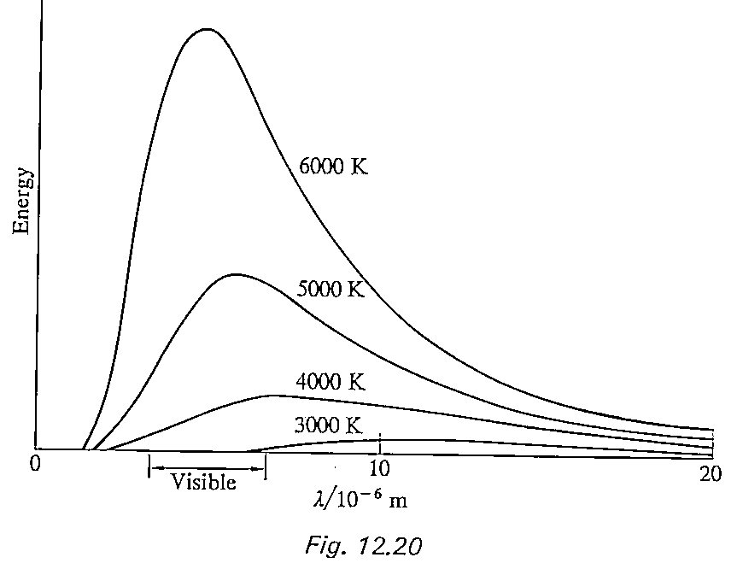
P
Q

(a) Which part of the x-axis, P or Q, corresponds to ultraviolet radiation?
(b) What do the graphs show happens to the amount of energy emitted at a certain wavelength as the temperature of the object increases?
(c) What do the graphs show happens to the total energy radiated by the object as its temperature increases?
(d) Each graph shows that there is a wavelength λ_{max} at which the maximum amount of energy is emitted.
(i) Explain why the value of λ_{max} decreases as the temperature of the object increases.
The table shows the values of λ_{max} at different temperatures of the object.

Temperature /K | λ_{max} / m
6000 | 4·8 × 10⁻⁷
5000 | 5·8 × 10⁻⁷
4000 | 7 3 × 10⁻⁷
3000 | 9·7 × 10⁻⁷
(ii) Use this data to determine the relationship between temperature T and λ_{max}.
(e) Use your answer to (d) (ii) to calculate:
(i) the temperature of the star Sirius where λ_{max} is 2·7 × 10⁻⁷ m
(ii) the value of λ_{max} for the star Alpha Crucis which has a temperature of 23,000 K
(iii) the temperature of the present universe when λ_{max} for the cosmic microwave radiation is measured as 1·1 × 10⁻³ m.
(iv) the approximate wavelength and type of the radiation emitted by your skin, assumed to be at a temperature of 33º C.

The Expanding Universe/ Exam Questions
Exam questions are found in the L.A. Homework Booklet.

The Expanding Universe TUTORIAL ANSWERS

1. A = higher; B= lower; C = Doppler; D = effect
2. (a) and (b) Teacher Check
3. (a) 412 Hz
(b) 389 Hz
(c) 800 Hz
(d) 1035 Hz
(e) 20 m s ⁻¹
(f) 60 m s ⁻¹
4. Teacher Check
5. (a) 1063 Hz
(b) 944 Hz
6. (a) 216 Hz
(b) 186 Hz
7. 14·5 m s ⁻¹
8. 466 Hz
9. 556 Hz, 525 Hz
10. (a) 1·07 m
(b) 1·2 m
11. (a) 971 Hz
(b) 1030 Hz
12. 37·8 m s ⁻¹
13. (a) 354 kHz
(b) Decrease – denominator is larger
(c) 345 kHz
14. (a) Teacher Check
(b) 1569 Hz
(c) 1437 Hz
15. 21·3 m s ⁻¹
16. (a) Teacher Check
(b) 2106 Hz
(c) 2302 Hz
17. 154 s
18. 120 m s ⁻¹
19. A = longer; B = red; C = shorter; D = blue; E = away
20. (a) 1·01 × 10⁻¹
(b) 5·07 × 10 ⁻²
(c) 525 nm
(d) 682 nm
(e) 434 nm
(f) 365 nm

Hubbles Law

1. (a) 9·46 × 10¹⁵m
(b) 4·73 × 10 ¹⁷m
(c) 9·46 × 10 ²⁰m
(d) 1·51 × 10 ²⁶ m
2. (a) 1·52 × 10⁻⁵light years
(b) 4·2 light years
(c) 5·19 × 10⁷ light years
3.
v / m s⁻¹ | d / m | z
1·70 × 10⁵ | 7·10 × 10²² | 5·67 × 10⁻⁴
4·54 × 10⁶ | 1·89 × 10²⁴ | 1·51 × 10⁻²
1·70 × 10⁶ | 7·08 × 10²³ | 5·667 × 10⁻²
2·21 × 10⁶ | 9·21 × 10²³ | 7·37 × 10⁻³

4. (a) 7·37 × 10⁻²
(b) 2·21 × 10⁷ ms
(c) Away
5. (a) 1·49 × 10⁷ ms⁻¹
(b) 6·21 × 10 ²⁴ m
6. (a) 2·22 × 10⁷ ms⁻¹
(b) 9·25 × 10 ²⁴ m
7. (a) 8 × 10⁻²
(b) 410 nm
8. (a) 3·0 × 10⁷ ms⁻¹
(b) 1·25 × 10 ²⁵ m, 1·32 × 10⁹ light years
9. 2·27 × 10⁷ ms ⁻¹
10. (a) Teacher Check
(b) 4·55 × 10¹⁴ Hz
11. (a) 1·23 × 10⁷ ms ⁻¹
(b) 542 million light years
12. 1·83 × 10⁶ ms ⁻¹
13. 3·24 × 10⁻¹² m

The Big Bang Theory
1. (a) P
(b) Energy emitted increases
(c) Increases
(d) (ii) T λ_{max} = 2·9 × 10⁻³m K
(e) (i) T =11, 000 K
(ii) λ_{max} = 1·3 × 10⁻⁷m
(iii) T = 2·6 K
(iv) λ = 9·5 × 10⁻⁶ m, infrared

