

2025
J. A. Hargreaves
Lockerbie Academy
August 2018


Higher
Electricity Part 2

CONTENT

Content
CONTENT 2
Content 2
CHAPTER 5: CAPACITORS 5
Summary of content 5
Background to Capacitors 5
What is a capacitor? 5
Modelling Capacitance 6
So how do Capacitors work? 7
Capacitor circuit symbol 7
Charging a Capacitor 9
Charging and Discharging 10
PRESCRIBED PRACTICAL 11
Aim 11
Risk Assessment 12
Results 12
Homework 12
Determining the capacitance of a capacitor. 13
iNSTRUCTIONS 13
Gradient of a QV graph 13
Charging a capacitor on a d.c. supply. 13
Discharging a capacitor. 13
Factors affecting the rate of charge and discharge 13
Energy stored in a Capacitor 13
Capacitors and a.c. 13
Charging on a.c. 14
Resistance and Frequency 16
Part 1 Resistance and Frequency 16
Worked example 17
Blocking and Smoothing 19
Blocking 19
Smoothing 19
Tutorials Capacitors 20
Tutorial 1: Capacitance 27
Tutorial 2: Capacitance 27
Tutorial 3: Capacitance 27
Tutorial 4: Capacitance 28
Tutorial 5: Exam Questions 30
Tutorial Answers Capacitance 34
CHAPTER 6: SEMICONDUCTORS AND P-N JUNCTIONS 38
Summary of Content 38
Electrical properties of materials 39
Structure of the atom 40
Photoelectric Effect 41
Conduction and Valence Bands 42
Band theory of solids 43
How do Energy bands Arise? 43
Band theory of conduction 44
Band Theory Summarised 45
The Fermi Level 46
Semiconductors 46
Intrinsic Semiconductor 47
N-Type Semiconductor 47
P-Type Semiconductor 47
Notes on doping 48
Valence Electrons 49
P-N Junctions 49
Unbiased p-n junction 50
The Diode 50
Forward and Reverse Bias 50
Biasing the diode 50
Reverse biased diode 50
Forward biased diode 51
LEDs 52
Practical 2 Photodiode 54
Aim 54
Practical 3 Forward and reverse-biased 55
Apparatus 55
Photodiodes 55
Solar Cells 55
Tutorial 1: Semiconductors 56
Tutorial 2: Photodiodes 59
Tutorial Solutions 60
Tutorial Exam Questions 60
Open-ended Questions 66
Additional Notes 67
Forward and Reverse Biasing 68
Biasing the diode 68
The forward-based diode 68
The reverse-biased diode 69
Voltage and Current graphs for junction diodes 70
Breakdown Voltage 70
Uses of Junction Diodes 71
Applications 72
Half wave rectification. 72
Full wave rectification. 72
Smoothing 73
Glossary for Semiconductor Revision 74
What charge carriers actually move across the p-n junction? 79
Tutorial Solutions- 80
Tutorial 1:Semiconductors 80
Exam Questions 80

Thanks to Dr Chris Hooley of St. Andrew’s University for his notes from the Webinar and to Paul Looyen from High School Physics Explained. I have drawn on their excellent information to provide the notes in Chapter 6.

CHAPTER 5: CAPACITORS

Summary of content

Capacitors
 | eq | $C=\frac{Q}{V} Q=It$  $$E=\frac{1}{2}QV=\frac{1}{2}CV^{2}=\frac{1}{2}\frac{ Q^{2}}{C}$$
 | a) | I know that a capacitor of 1 farad will store 1 coulomb of charge when the potential difference across it is 1 volt.
 | b) | I can use the equation C=Q/V to solve problems involving capacitance, charge and potential difference.
 | c) | I can use the equation Q = It to determine the charge stored on a capacitor for a constant charging current.
 | d) | I know the total energy stored in a charged capacitor is equal to the area under a charge-potential difference graph.
 | e) | I can use $E=\frac{1}{2}QV=\frac{1}{2}CV^{2}=\frac{1}{2}\frac{Q^{2}}{C}$ to solve problems involving energy, charge, capacitance, and potential difference.
 | f) | I know the variation of current with time for both charging and discharging cycles of a capacitor in an RC circuit (charging and discharging curves).
 | g) | I know the variation of potential difference with time for both charging and discharging cycles of a capacitor in an RC circuit (charging and discharging curves).
 | h) | I know the effect of resistance and capacitance on charging and discharging curves in an RC circuit.
 | i) | I can describe experiments to investigate the variation of current in a capacitor and voltage across a capacitor with time, for the charging and discharging of capacitors

Background to Capacitors

What is a capacitor?
Capacitance is the ability (or capacity) to store charge. A capacitor is a useful device which stores charge, and hence energy. Capacitors are very important components in electrical devices; they have numerous uses and so obviously lots of potential for exam questions; many of which are quite tricky, so it is important you have an understanding of how they work.
A simple capacitor consists of two parallel metal conducting plates separated by an electrical insulator such as air.

Modelling Capacitance
This information on capacitors can help your understanding
https://www.youtube.com/watch?v=58PzPrjGsG8 Resistors and Capacitors American resistor sign, so don’t use that!
https://www.youtube.com/watch?v=X4EUwTwZ110

- Capacitors are analogous with a beaker:
- The size of beaker corresponds to the maximum capacitance.
- Volume of liquid in the beaker corresponds to the charge on the capacitor.
- Show and describe
metal plate
insulator
another metal plate in front of this to compete a “sandwich”
Most capacitors can be connected either way around, but ELECTROLYTIC capacitors must be connected correctly according to the + and – labels or they will be destroyed.
If the rated p.d. across a capacitor is exceeded it will break down (puncturing the insulation).
- As an aside:
Capacitors in parallel:
Capacitors in series:
4) Factors affecting capacitance:
- area of plates;
- distance between plates;
- material between plates.
So No. 4 could potentially be an assignment topic.

So how do Capacitors work?
Capacitors store electric charge. Once charged, as in the circuit below - the capacitor will retain the charge. This charge will remain stored on the capacitor (actually, it will slowly leak away, ionising the air) and can be used to power a circuit for a very short time. They are often used in a delay circuit. Some capacitors are polarity sensitive – i.e. they won't work properly if you insert them into the circuit the wrong way round.
Note that these little dudes can explode if you put too much current through or voltage across them. They can be destroyed if you connect it the wrong way round (although that only applies to the electrolytic capacitor).
No one bothered to explain to me when I was at school how a capacitor worked. It is easy to confuse them with work done moving a charge between two parallel plates. This is not the same, with a capacitor charge is not moved from one plate to the other plate.
-
-
-
-
-
-
+
+
+
+
+
+
Electrons are transferred from the cell to this plate
Electrons are repelled from this plate by the electrons on the other plate.
The first thing to realise is that the electrons do not pass between the capacitor plates. Electrons travel to one of the capacitor plates; because the plates are in such close proximity the electrons on that plate repel electrons from the other plate which pass around the circuit. The first electron is very easy to add to the plate and the capacitor offers no resistance. As the charge builds up on one plate it becomes more difficult to add charge and so the reactance (resistance) of the capacitor increases. Eventually the voltage on the capacitor equals the supply voltage. There is then no potential difference between the plates and the source so no more charge can be added. As the reactance of the capacitor increases, the current in the circuit decreases. In this circuit we have also placed a resistor as this is used to control the maximum current passing through the capacitor circuit. Too much current can destroy a capacitor.
Charging the capacitor requires a potential difference to be placed across it. Work is done transferring charge (Q) onto the plates. The rate at which the charge is transferred is controlled by the capacity of the capacitor and the value of the resistor.

Capacitor circuit symbol
Capacitance is measured in Farads.
$$\text{Capacitance =}\frac{\text{Charge}}{\text{potential difference}}$$
Units of capacitance are therefore C V⁻¹ or Farads (F)
1 Farad = 1 coulomb per volt.
A capacitor of 10 pF can store 10 pC of charge at a voltage of 1 Volt.
N.B. 1 Farad is a very large unit. Capacitance would normally be expressed as μF or mF.
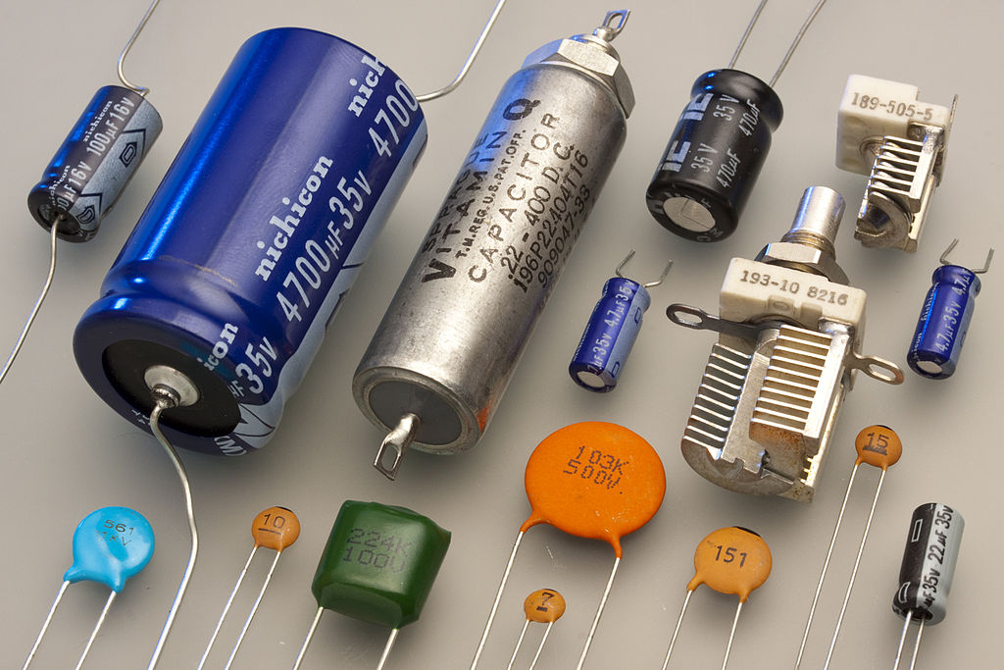
By Eric Schrader from San Francisco, CA, United States - 12739s, CC BY-SA 2.0, https://commons.wikimedia.org/w/index.php?curid=37625896

Charging a Capacitor
When working out calculations on charging a capacitor it is really important that you remember the material on this page. It will remind you of what you know and can work out. In the D.C circuit below:
constants
V_{S}
R_{R}
I
V_{C}
R_{R} = The resistance of the resistor remains constant throughout the charging process.
 | I = | 0 A |  | R_{c}= | 0 Ω
 | V_{c} = | 0 V |  | V_{R}= | 0 V |  | Q_{c}= |  | 0 C
When the switch is open and the capacitor holds no charge:

The instant the switch is closed
 |  |  |  | R_{c}= | 0 Ω
 | V_{c} = | 0 V |  | V_{R}= | V_{s} |  | Q_{c}= |  | 0 C

thereafter
I decreases as charge builds up on the capacitor
V_{c} increases
Q_{c} increases
V_{R} decreases
one plate of the capacitor becomes positively charged
one plate of the capacitor becomes negatively charged
When the capacitor is fully charged
V_{c} = V_{s}
V_{R} = 0 V
I = 0 A
To find V_{R} use the current given for that time multiplied by R_{R.}.
To find V_{C} subtract the value of V_{R} from V_{S}.
V_{C} = V_{S} - V_{R} .

Charging and Discharging
During the charging process the voltage across the capacitor gradually increases until it reaches a maximum which is equal to the supply voltage Vs. The rate of change of voltage across the capacitor is greatest at the beginning. V_{s} remains constant (ignoring lost volts so there would be a difficult question!) therefore as V_{c} increases, V_{R} must decrease.
The total of these two voltages (V_{c} and V_{R}) must remain equal to the supply voltage so if you know the supply voltage at any time and one of the voltages V_{c} or V_{R} then the other can be found.
If we charge the capacitor by closing the switch at time A then arrange the circuit so that at point B the capacitor is DISCHARGED through the same resistor we would observe the following voltage graph. (Set this up and see it in action).
Below are the graphs of voltage across the capacitor, Vc and voltage across the resistor, V_{R} against time and the I against time for the charging phase. The discharging phase would give a reflection of the current graph about the x-axis

PRESCRIBED PRACTICAL
You can work in groups of up to 3 people, everyone must be actively involved or you can fail this assessment. You must complete one of the two experiments and know how to complete the other. By the end of this lesson (2 periods) I need:

Aim
- To investigate the variation of current in a capacitor during the charging and discharging of a capacitor.
- To investigate the variation of voltage across a capacitor during the charging and discharging of a capacitor.
1: Diagram 1 | 2: Diagram 2
This electric circuit can be used to investigate the discharging of a capacitor. (The resistor is present to set the maximum current which can flow) Once the capacitor is fully charged, no current is flowing. The capacitor will discharge and the current will start to flow immediately when the switched is moved to the right. Electrons will flow from the bottom capacitor plate, through the resistor and ammeter to the top capacitor plate, until the potential difference across the plates is zero, when no more electrons will flow. The current will be zero. | This electric circuit can be used to investigate the charging of a capacitor. (The resistor is present to set the value of the maximum current which can flow). Current starts to flow immediately when the switch is closed. In the circuit, the capacitor and resistor are connected in series. This means that, at any time:  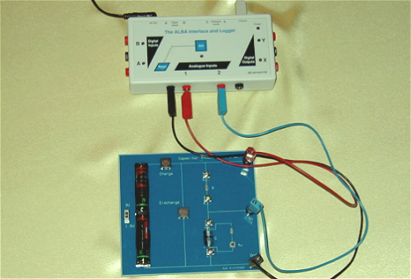  $V_{c}+V_{R}=V_{s}$

Risk Assessment
I want you to think about
- Hazards
  - What are your hazards?
  - What could go wrong and how?
- Risk
  - How likely is it that each thing goes wrong?
  - How serious would it be if the above did go wrong (these two are called the risk)
- Control Measures
  - How can you reduce the risk (seriousness and likelihood) of something going wrong?

Results
Remember it is best if you can plot your results and graph them as you go along and then you can tell if you have got a dodgy point.
- This can be done through ALBA and it will automatically plot your points
- How many repeats?
- How many different points?
- How close should they be? Evenly spaced or more at a certain point?
- What do you need to measure?
- What are the best measuring instruments?

Homework
Hand in from everyone an individual piece
- An excel table and graph of your results!
- Results and Conclusion
- Evaluation, did you plan well enough or launch in and make mistakes (hint don’t!)
References: For more info go into Assignment and look at the Intro to Risk Assessment, Look in your notes on how to do the practical
!SLLIKS LACITCARP RUOY GNIVORPMI ERA UOY EPOH I !KCUL DOOG

Determining the capacitance of a capacitor.
mA
V
constant current supply
+
-
C
R
0:00:00

iNSTRUCTIONS
- Discharge C.
- Connect up the ALBA circuit. Start clock and take regular values of V and I at set time intervals.
- Find the charge that has accumulated on the capacitor at each time interval according to Q = I x t. NB This assumes that your circuit has a constant current supply. If I is not constant you will need to use a coulombmeter to measure charge.
- Plot a graph of Q against V. Since the gradient of the graph will be the capacitance

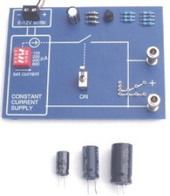
This is the ALBA constant current supply board. You can set the constant current using the slide switches on the red mounts

From the fact that $C=Q/V$ 1 Farad must equal 1 Coulomb per volt.
From the graph you can see that Q and V are (directly) proportional and the capacitor has a capacitance of 3.1 mF

Gradient of a QV graph
Using your knowledge work out what the area under this graph would represent. We will come back to it later.
V
Q
0

From the formula you can tell that the gradient of a Q-V graph for a capacitor gives the magnitude of the capacitance.
Beware though, if Q is in mC then you must account for this in the value of the capacitance, ie your capacitance will be in mF.

Charging a capacitor on a d.c. supply.
0
0

As the switch is closed the current in a capacitor circuit starts at a maximum and then decreases rapidly to zero. The voltage across the capacitor increases from zero until it reaches a maximum Vs.

Discharging a capacitor.
As the capacitor discharges the voltage across the capacitor decreases from a maximum of Vs until it reaches zero the current in a circuit starts at a maximum and then decreases rapidly to zero, usually in the opposite direction to the charging current. In the discharge phase, both current and voltage fall to zero.
0
0

Factors affecting the rate of charge and discharge
The time taken for a capacitor to charge is controlled by the resistance of the resistor R (because it controls the size of the current, i.e. the charge flow rate) and the capacitance of the capacitor (since a larger capacitor will take longer to fill and empty). As an analogy, consider charging a capacitor as being like filling a jug with water. The size of the jug is like the capacitance and the resistor is like the tap you use to control the rate of flow, or the pipes through which the water flows.
The values of R and C can be multiplied together to form what is known as the time constant. Can you prove that R × C has units of time, seconds? The time taken for the capacitor to charge or discharge is related to the time constant.
Large capacitance and large resistance both increase the charge or discharge time.
The I/t graphs for capacitors of different value during charging are shown below:
current
0
time
large capacitor
small capacitor
current
0
time
small resistor
large resistor

The effect of capacitance on charging The effect of resistance on charging current current
Note that since the area under the I/t graph is equal to charge, for a given capacitor the area under the graphs must be equal.
The area under the current-time graph (= I x t) is the total charge, Q, stored on the capacitor. The area under the graph in the charging phase must be equal to the area under the graph in the discharging phase (assuming the capacitor is COMPLETELY discharged)  In the examples below the areas are obviously the same since the capacitor is charged and discharged through the same resistor. | Current /A  3  time /s
However, if the capacitor is discharged through a smaller value resistor it will discharge more quickly and have a larger initial current. BUT THE AREA UNDER THE DISCHARGE CURVE WILL BE EXACTLY THE SAME AS BEFORE. When discharging a capacitor, if the load resistor is halved in value then the initial current will be doubled and therefore the time for discharging must be halved, as the total charge is the same.
If values can be put on the graph then make sure you do put them on!

Energy stored in a Capacitor
When a charge is moved between 2 charged, parallel plates, work is done. If we move a charge from one plate to the other against the uniform field then work done is given by:
$work done. E = QV$
When a capacitor is being charged, work is done moving charges against opposing forces. Electrons are pushed onto the already negative plate, which repels them. They are also removed from the positive plate which tends to attract them.
The voltage across the capacitor is, however, constantly changing so:
E ≠ QV
We average the voltage over the charging period so that
i.e. Energy stored is the area under a V-Q graph for a capacitor.
In summary, using and Q = CV,
V
Q
0

Capacitors and a.c.
As the current and voltage are changing on A.C. there is no fixed resistance for the capacitor. The resistance offered to the ac currents by capacitors is called reactance and it is usually given the symbol X.

Charging on a.c.
With A.C. a capacitor will begin to charge up, then charge starts flowing in the opposite direction. The capacitor therefore discharges and then begins to charge up again.
Hopefully you can imagine that the storage of charge will be greatly affected by how regularly this change of direction occurs, i.e. the frequency of the supply.

Low frequency a.c.
When the frequency of the supply is low the capacitor can fully charge (voltage is high across the capacitor and the current zero) before the current flows in the opposite direction, (see the diagram below).

High frequency a.c.
The capacitor does not get time to fully charge up or discharge before the current direction is changed.
This shows us that capacitors block D.C. but allow A.C. through.
Resistance (properly called reactance when used with capacitors) of a capacitor can be found out in the usual way.
With a LOW FREQUENCY supply the average VOLTAGE is LARGE and the average CURRENT is SMALL.
∴ Reactance is large.
With a HIGH FREQUENCY supply the average VOLTAGE is SMALL and the average CURRENT is LARGE.
∴ Reactance is small.
We tend therefore to say that capacitors allow current to flow in an a.c. circuit but not in a d.c. circuit.

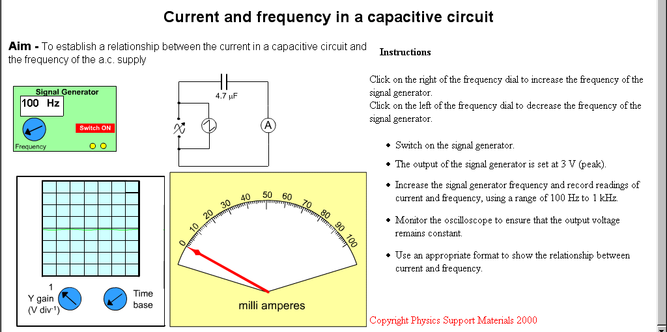
Resistance and Frequency

Part 1 Resistance and Frequency
Set up the above circuit and use it to see how the voltages across and the current in R change as you vary the frequency of the supply.
A
Signal Generator
V
R
Examine your results to see if there is any connection between an increase in frequency and the resisting effect of R.
Write up your experiment briefly.

Part 2 Resistance and frequency with an oscilloscope
Replace the voltmeter with an oscilloscope and explain how to measure the frequency.
Write up this experiment INCLUDING ALL YOUR WORKING.
This can therefore be a method of determining whether a component is a capacitor or a resistor. NB.THE RESISTANCE OF A RESISTOR IS UNAFFECTED BY FREQUENCY.

It is clear from the graph that the greater the capacitor the greater the current for a given frequency of current in the circuit.

Worked example
The switch in the following circuit is closed at time t = 0. The capacitor is uncharged.
1 MΩ
V_{S} = 10 V
2 μF
(a) Immediately after closing the switch determine the:
(i) charge on C;
(ii) p.d. across C;
(iii) p.d. across R;
(iv) current through R.
(b) When the capacitor is fully charged determine the:
(i) p.d. across the capacitor;
(ii) charge stored.

Solution
(a) (i) The initial charge on the capacitor is zero.
(ii) The initial p.d. across the capacitor is zero since there is no charge.
(iii) The p.d. across the resistor is 10 V
(V_{R} = V_{S} – V_{C} = 10 – 0 = 10 V)
(iv) 1 × 10^{–5} A
(b) (i) The final p.d. across the capacitor equals the supply voltage, 10 V.
(ii) Q = VC = 2 × 10^{–6} × 10 = 2 × 10^{–5} C

Blocking and Smoothing
Read up on BLOCKING and SMOOTHING from the class text books as examples of uses of reactance of a capacitor.
The change in reactance of a capacitor with frequency can be exploited as follows.

Blocking
An electrical signal consists of a steady d.c. voltage with an a.c. voltage superimposed on it.
If this signal is now fed into the following circuit:
then the d.c. component of the signal is removed (or blocked)

Smoothing
A capacitor can also be used in to smooth an a.c. voltage as follows.
A normal a.c. signal is fed into the following circuit.
In the absence of the capacitor the four diodes would rectify this signal thus:
But with the capacitor present this signal is smoothed by the repeated charging and discharging of the capacitor. This output is known as the ripple voltage.

Tutorials Capacitors
1. A 50 µF capacitor is charged until the p.d. across it is 100 V.
(a) Calculate the charge on the capacitor when the p.d. across it is 100 V.
(b) (i) The capacitor is now ‘fully’ discharged in a time of 4·0 milliseconds.
Calculate the average current during this time.
(ii) Explain why is this average current?
2. A capacitor stores a charge of 3·0 × 10^{–4} C when the p.d. across its terminals
is 600 V.
Calculate the capacitance of the capacitor?
3. A 30 µF capacitor stores a charge of 12 × 10^{–4} C.
(a) Calculate the p.d. across its terminals.
(b) The tolerance of the capacitor is ± 0·5 µF. Express this uncertainty as a percentage.
4. A 15 µF capacitor is charged using a 1·5 V cell.
Calculate the charge stored on the capacitor when it is fully charged.
5. (a) A capacitor stores a charge of 1·2 × 10^{–5} C when there is a p.d. of 12 V across it. Calculate the capacitance of the capacitor.
(b) A 0·10 µF capacitor is connected to an 8·0 V d.c. supply. Calculate the charge stored on the capacitor when it is fully charged.
6. A circuit is set up as shown.
The capacitor is initially uncharged. The switch is now closed.
The capacitor is charged with a constant charging current of
2·0 × 10^{–5} A for 30 s.
At the end of this time the p.d. across the capacitor is 12 V.
(a) Explain what has to be done to the value of the variable resistor in order to keep the current constant for 20 s.
(b) Calculate the capacitance of the capacitor.
7. A 100 µF capacitor is charged using a 20 V supply.
(a) Determine the charge stored on the capacitor when it is fully charged.
(b) Calculate the energy is stored in the capacitor when it is fully charged.
8. A 30 µF capacitor stores 6·0 × 10^{–3} C of charge. How much energy is stored in the capacitor?
9. The circuit below is used to investigate the charging of a capacitor.
The battery has negligible internal resistance.
The capacitor is initially uncharged. The switch is now closed.
(a) Describe what happens to the reading on the ammeter from the instant the switch is closed.
(b) Explain how you know when the capacitor is fully charged.
(c) State a suitable range for the ammeter.
(d) The 10 k Ω resistor is now replaced by a larger resistor and the investigation repeated.
State the maximum voltage across the capacitor now.
10. In the circuit below the neon lamp flashes at regular intervals.
The neon lamp requires a potential difference of 100 V across it before it conducts and flashes. It continues to glow until the potential difference across it drops to 80 V. While lit, its resistance is very small compared with the resistance of R.
(a) Explain why the neon bulb flashes.
(b) Suggest two methods of decreasing the flash rate.
11. In the circuit below the capacitor C is initially uncharged.
9 V
C
A
V
S
+
–
Switch S is now closed. By carefully adjusting the variable resistor R a constant charging current of 1·0 mA is maintained.
The reading on the voltmeter is recorded every 10 seconds. The results are shown in the table below.
Time /s | 0 | 10 | 20 | 30 | 40
V /V | 0 | 1·9 | 4·0 | 6·2 | 8·1
(a) Plot a graph of the charge on the capacitor against the p.d. across the capacitor.
(b) Use the graph to calculate the capacitance of the capacitor.
12. The circuit below is used to charge and discharge a capacitor.
100 V
V_{R}

V_{C}

1
2
A
B
The battery has negligible internal resistance.
The capacitor is initially uncharged.
V_{R} is the p.d. across the resistor and V_{C} is the p.d. across the capacitor.
(a) What is the position of the switch:
(i) to charge the capacitor
(ii) to discharge the capacitor?
(b) Sketch graphs of V_{R} against time for the capacitor charging and discharging. Show numerical values for the maximum and minimum values of V_{R}.
(c) Sketch graphs of V_{C} against time for the capacitor charging and discharging. Show numerical values for the maximum and minimum values of V_{C}.
(d) (i) When the capacitor is charging what is the direction of the electrons between points A and B in the wire?
(ii) When the capacitor is discharging what is the direction of the electrons between points A and B in the wire?
(e) The capacitor has a capacitance of 4·0 µF. The resistor has resistance of 2·5 MΩ.
Calculate:
(i) the maximum value of the charging current
(ii) the charge stored by the capacitor when the capacitor is fully charged.

13. A capacitor is connected in a circuit as shown.
3 V
+
–
3 MΩ
3 μF
S

The power supply has negligible internal resistance. The capacitor is initially uncharged.
V_{R} is the p.d. across the resistor and V_{C} is the p.d. across the capacitor.
The switch S is now closed.
(a) Sketch graphs of:
(i) V_{C} against time during charging. Show numerical values for the maximum and minimum values of V_{C}.
(ii) V_{R} against time during charging. Show numerical values for the maximum and minimum values of V_{R}.
- (i) What is the p.d. across the capacitor when it is fully charged?
(ii) Calculate the charge stored by the capacitor when it is fully charged.
- Calculate the maximum energy stored by the capacitor.

14. A capacitor is connected in a circuit as shown.

12 V
+
–
6 kΩ
20 μF
S

The power supply has negligible internal resistance.
The capacitor is initially uncharged. The switch S is now closed.
(a) Calculate the value of the initial current in the circuit.
(b) At a certain instant in time during charging the p.d. across the capacitor is 3 V. Calculate the current in the resistor at this time.
15. The circuit shown is used to charge a capacitor.
12 V
+
–
5 kΩ
10 μF
S
The power supply has negligible internal resistance. The capacitor is initially uncharged. The switch S is now closed. At a certain instant in time the charge on the capacitor is 20 µC.
Calculate the current in the circuit at this time.
16. The circuit shown is used to investigate the charge and discharge of a capacitor.
12 V
V_{R}

V_{C}
2
1
1 kΩ
10 mF
A

The switch is in position 1 and the capacitor is uncharged.
The switch is now moved to position 2 and the capacitor charges.

The graphs show how V_{C}, the p.d. across the capacitor, V_{R}, the p.d. across the resistor, and I, the current in the circuit, vary with time.

(a) The experiment is repeated with the resistance changed to 2 kΩ.
Sketch the graphs above and on each graph sketch the new lines which show how V_{C}, V_{R} and I vary with time.
(b) The experiment is repeated with the resistance again at 1 kΩ but the capacitor replaced with one of capacitance 20 mF. Sketch the original graphs again and on each graph sketch the new lines which show how V_{C}, V_{R} and I vary with time.
(c) (i) What does the area under the current against time graph represent?
(ii) Compare the areas under the current versus time graphs in the original graphs and in your answers to (a) and (b). Give reasons for any differences in these areas.
(d) At any instant in time during the charging what should be the value
of (V_{C} + V_{R})?
(e) The original values of resistance and capacitance are now used again and the capacitor fully charged. The switch is now moved to position 1 and the capacitor discharges.
Sketch graphs of V_{C}, V_{R} and I from the instant the switch is moved until the capacitor is fully discharged.
17. A student uses the circuit shown to investigate the charging of a capacitor.
12 V
+
–
1 kΩ
10 µF
S
The capacitor is initially uncharged.
The student makes the following statements:
(a) When switch S is closed the initial current in the circuit does not depend on the internal resistance of the power supply.
(b) When the capacitor has been fully charged the p.d. across the capacitor does not depend on the internal resistance of the power supply.
Use your knowledge of capacitors to comment on the truth or otherwise of these two statements.

Tutorial 1: Capacitance
1. Calculate the capacitance of a capacitor storing 0.005C when the p.d. between its plates is 50V.
2. A capacitor has a p.d. of 20V between its plates. If its capacitance is 25µF, determine the charge on it.
3. Calculate the p.d. across a 50µF capacitor storing 2.5mC.

Tutorial 2: Capacitance
1. Calculate the work done in charging up a 30µF capacitor which stores 0.001C at 20V.
2. Calculate the capacitance of a capacitor storing 0.016J at a p.d. of 40V.
3. Calculate the charge on a 30µF capacitor storing 1.35J.
4. Calculate the p.d. across a 10µF capacitor if 0.0125J is required to charge it.

Tutorial 3: Capacitance
1. Determine the reactance of a capacitor when the p.d. across it is 20V and the current in the circuit 5mA.
2.
Determine the reactance of the capacitor.
3. A 2000Ω resistor is connected in series with a capacitor whose reactance measures 1500Ω. If the a.c. supply is quoted as 14V, what is the peak voltage across the capacitor?

Tutorial 4: Capacitance
1.
Explain how you show that the component in the box is a resistor.
2. A 24V a.c. power supply sends a 100Hz current through a 480Ω resistor:-
Calculate the current when the frequency is doubled to 200Hz.
3.
The 2µF capacitor holds 20mC of charge. Determine the initial current when S is closed.
4. If the switch S is moved to A and held for a time, then moved quickly to B, Sketch the graphs of current against time and p.d. against time for the resistor R while the switch is held at B?

5.
Explain how the brightness of each lamp changes when the supply voltage is increased to 25V?
6. In the diagram below, the bulbs are identical and the three capacitors have the values shown. Explain how the lamps compare in brightness?
7.
8. Calculate the p.d. of the supply at the instant C is storing 1.125x10-4J in the circuit shown here:-

Tutorial 5: Exam Questions
2000 Q24.
- In an experiment to measure the capacitance of a capacitor a student sets up the following circuit:
C
Coulombmeter
Y
X
V
V_{S}
C
When the switch is in position X the capacitor charges up to the supply voltage,V_{S}. When the switch is in position Y the coulombmeter indicates the charge stored by the capacitor.
The student records the following measurements and uncertainties.
Reading on voltmeter = (2·56 ± 0.01) V
Reading on coulombmeter = (32 ± 1) μC
Calculate the value of the capacitance and the percentage uncertainty in this value. You must give your answer in the form value ± percentage uncertainty.
  - The student designs the circuit shown below to switch off a lamp after a certain time.
The 12·0 V battery has negligible internal resistance.
The relay contacts are normally open. When there is a current in the relay coil the contacts close and complete the lamp circuit. Switch S is initially closed and the lamp is on.
V
+
-
12 V
S
relay
2200 μF
3·3 kΩ
    - What is the maximum energy stored in the capacitor?
      - Switch S is now opened. Explain why the lamp stays lit for a few seconds.
      - The 2200 μF capacitor is replaced with a 1000 μF capacitor. Describe and explain the effect of this change on the operation of the circuit.
2001 Q25
- a) The following diagram shows a circuit that is used to investigate the charging of a capacitor.
6·0 V
470 μF
1·5 kΩ
V
A
S
The capacitor is initially uncharged. It has a capacitance of 470 μF and the resistor has a resistance of 1.5 kΩ. The battery has an EMF of 6 V and negligible internal resistance.
    - Switch S is now closed. Calculate the initial current in the circuit.
    - Calculate the energy stored in the capacitor when it is fully charged.
    - State a change that could be made to this circuit to ensure that the same capacitor stores more energy.
  - A capacitor is used to provide the energy for an electronic flash in a camera.
When the flash is fired, 6·35 x 10⁻³ J of the stored energy is emitted as light.
The mean value of the frequency of photons of light from the flash is 5·80 x 10¹⁴ Hz. Calculate the number of photons emitted in each flash of light.
2002 Q25

The circuit below is used to investigate the charging of a 2000 μF capacitor. The d.c. supply has negligible internal resistance.
R
S
V
A
2000 μF
+
-
The graphs below show how the potential difference, V_{R} across the resistor and the current, I, in the circuit vary with time from the instant switch S is closed.

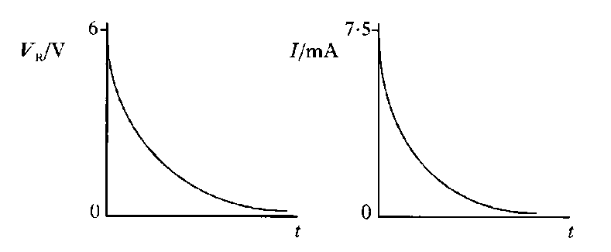
a)i) Determine the potential difference across the capacitor when it is fully charged.
ii) Calculate the energy stored in the capacitor when it is fully charged.
iii) Calculate the resistance of R in the circuit above.
- The circuit below is used to investigate the charging and discharging of a capacitor.
R
S
V
A
C
+
-
power supply
The graph below shows how the power supply voltage varies with time after switch S is closed.
The capacitor is initially uncharged.
The capacitor charges fully in 0·3 s and discharges fully in 0·3 s.
Sketch a graph of the reading on the voltmeter for the first 2·5 s after switch S is closed.
The axes on your graph must have the same numerical values as those in the above graph 2
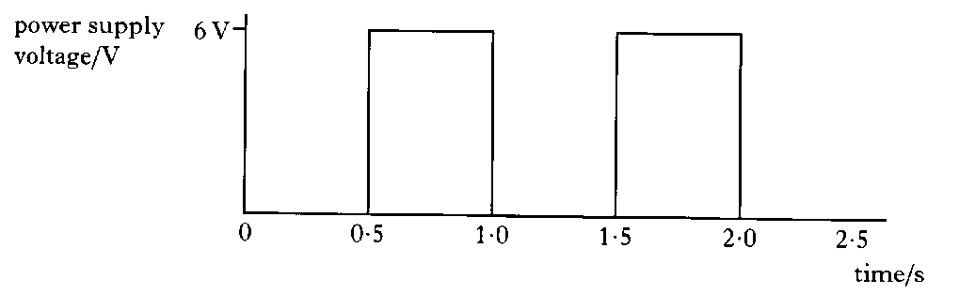
- A technician carries out an experiment to measure the capacitance of a capacitor C.
The capacitor, initially uncharged, is charged up to 2 V using the circuit below.
The charging current is kept constant at 0·20 mA during the charging process by adjusting the resistance of R. The capacitor is fully charged in 10 seconds.
  - Explain whether the resistance of R is increased or decreased during the charging period. 1
  - What is the charge supplied to the capacitor?
  - Calculate the capacitance of the capacitor. 2
  - The capacitor is then used in a circuit where it is connected across a 10 V supply. Calculate:
    - the charge stored on the capacitor
    - the energy stored on the capacitor. (9)

- An audio engineer obtains the results shown on the graph below. The graph shows how the current in a circuit containing an 8 μF capacitor varies with frequency. The output of the electrical supply is 2 V r.m.s.
  - Describe an experiment to obtain such a graph. Your answer should include the following:
    - a circuit diagram of the apparatus required
    - a statement of the variables measured and controlled
    - a description of how the measurements were taken
    - conclusions which can be drawn from the graph.

  - An engineer has two loudspeakers, LS1 and LS2, to connect to an audio amplifier. One of the speakers is designed so that it is able to produce low frequency sounds. The engineer connects the loudspeakers to the amplifier using the circuit shown.
Which of the loudspeakers, LS1 or LS2, is intended to emit low frequency sounds. You must explain your answer. (7)

Tutorial Answers Capacitance
Capacitors
1. (a) 5·0 × 10^{–3} C | 9. (b) Reading on ammeter is 0 A
(b) (i) 1·25 A | (c) 0 to 2 mA (max. current 1·2 mA)
 | (d) 12 V
2. 0·5 F
 | 11. (b) 4·9 mF
3 (a) 40 V
(b) 1·7% | 12. (e) (i) 40 A
 | (ii) 4·0 × 10² C
4. 2·25 × 10^{–5} C
 | 13. (b) (i) 3 V
5. (a) 1·0 F | (ii) 9 C
(b) 0·8 C | (c) 1·35 × 10^{–5} J
6. (b) 50 F | 14. (a) 2 mA
 | (b) 1·5 mA
7. (a) 2·0 × 10^{–3} C
(b) 0·020 J | 15. 2 mA
8. 0·60 J

Tutorial 1
1. The capacitance is 1x10-4F (100µF)
2. The capacitor is storing 0.0005C
3. The p.d. across the capacitor is 50V

Tutorial 2
1. The work done during charging is 0.01J
2. The capacitance is 2x10-5F (20µF)
3. The stored charge is 0.009C
The p.d. across the capacitor is 50V

Tutorial 3
1. The reactance of the capacitor is 4000Ω
2. Since the resistance of the whole circuit is 2500Ω, the reactance of the capacitor must be 1000Ω
3. The peak voltage must = 8V

Tutorial 4
1. Note the voltage and current at some frequency. Use them to calculate the resistance of the component. Repeat the measurements for different supply frequencies. If the resistance remains constant, then the component is a resistor.
2. Since the resistance is independent of the frequency, the current remains at 0.005A when the frequency doubles to 200Hz.
3. The initial current is 1A
4.
5. Each is 2.5 times brighter since neither the resistance nor the capacitive reactance depend on the supply voltage.
6. The bulbs increase in brightness from (1) to(3) since the capacitive reactance becomes less with increasing capacitance.
7. Bulb (1) remains at constant brightness while bulb (2) increases in brightness as the capacitive reactance decreases with the increase in supply frequency.
8. The supply voltage is 8V.

Tutorial Answers: Exam soutions
2000
24.a. To calculate the capacitance uses the mean values of charge and voltage.
C = Q/V
C = (32/2.56)μF
C=12.5μF
The percentage error in capacitance value can be taken to be equal to that of largest individual percentage error.
% error in voltage = (0.01/2.56)x100 = 0.39%
% error in charge = (1/32)x100= 3.125%
C=12.5μF+-3 %
OR 3.125% of 12.5μF = 0.39μF => C = (12.5±0.4)μF
NB. Only quote the error to the same number of decimal places as the capacitance value.
b.i.The maximum energy is stored in the capacitor when the voltage across the capacitor is equal to the supply voltage.
V_{c}= 12V
C = 2200x10⁻⁶
E = ?
E = 1/2(QV_{c})
Q = CV_{c}
=>E = 1/2(CV_{c}²)
E = 0.5(2200x10⁻⁶x12²)
E = 0.1584J E=0.16 J
b.ii.(A) When the switch is opened the capacitor discharges through the resistor and relay coil. The discharge current magnetises the coil closing the switch in the lamp circuit, causing the lamp to light. As the discharge current gradually falls the coil loses its magnetism and the switch in the lamp circuit opens. When this happens the lamp goes off.
(B) Increasing the value of the capacitor increases the discharge time. The energy stored in the capacitor is also greater. This means that the lamp will stay lit for longer.
2001
25.a.i. The initial charging current(I_{max}) occurs when all of the supply voltage(V_{supply}) is across the 1.5kΩ resistor(R).
I_{max} = V_{supply}/R
I_{max} = 6/1500
I_{max} = 4x10⁻³A
a.ii. When fully charged the voltage across the supply voltage is equal to the voltage across the capacitor.
V_{supply} = V_{c} = 6V
E_{capacitor} = QV_{c}/2
Q = CV_{c}
=>E_{capacitor} = CV_{c}²/2
E_{capacitor} = 470x10⁻⁶x6²/2
E_{capacitor} = 8.46x10⁻³J
a.iii. Increasing the supply voltage would increase the energy storing capacity of the capacitor. This is because the final voltage, across the fully charged capacitor, would be higher.
25.b. E_{total} = 6.35x10⁻³J
f_{photon} = 5.80x10¹⁴Hz
h = 6.63x10⁻³⁴Js
E_{photon} = ?
E_{photon} = hf_{photon}
E_{photon} = 6.63x10⁻³⁴ x 5.80x10¹⁴
E_{photon} = 3.84x10⁻¹⁹J
E_{total} = NE_{photon}
N = E_{total}/E_{photon}
N = 6.35x10⁻³/3.84x10⁻¹⁹
N = 1.65x10¹⁶
2002
25.a.i. Initially all the supply voltage is across the resistor.
V_{R} = V_{supply} = 6V
When the capacitor is fully charged: V_{supply} = V_{capacitor}
V_{capacitor} = 6V
a.ii. E = CV²/2
E = (2000x10⁻⁶x6²)/2
E = 0.072/2
E = 0.036J
a.iii. I_{max} = V_{supply}/R
R = V_{supply}/I_{max}
R = 6/7.5x10⁻³
R = 800Ω
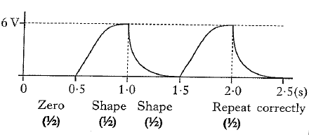
b)

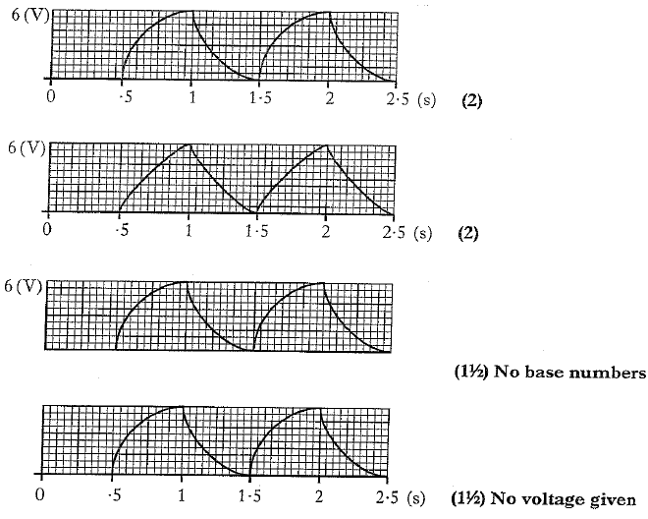

CHAPTER 6: SEMICONDUCTORS AND P-N JUNCTIONS

Summary of Content

Semiconductors and p-n junctions
 | a) | I know and can explain the terms conduction band and valence band.
 | b) | I know that solids can be categorised into conductors, semiconductors or insulators by their band structure and their ability to conduct electricity. Every solid has its own characteristic energy band structure. For a solid to be conductive, both free electrons and accessible empty states must be available.
 | c) | I can explain qualitatively the electrical properties of conductors, insulators and semiconductors using the electron population of the conduction and valence bands and the energy difference between the conduction and valence bands. (Reference to Fermi levels is not required.)
 | d) | I know that the electrons in atoms are contained in energy levels. When the atoms come together to form solids, the electrons then become contained in energy bands separated by gaps.
 | e) | I know that for metals we have the situation where one or more bands are partially filled.
 | f) | I know that some metals have free electrons and partially filled valence bands, therefore they are highly conductive.
 | g) | I know that some metals have overlapping valence and conduction bands. Each band is partially filled and therefore they are conductive.
 | h) | I know that in an insulator, the highest occupied band (called the valence band) is full. The first unfilled band above the valence band is the conduction band. For an insulator, the gap between the valence band and the conduction band is large and at room temperature there is not enough energy available to move electrons from the valence band into the conduction band where they would be able to contribute to conduction. There is no electrical conduction in an insulator.
 | i) | I know that in a semiconductor, the gap between the valence band and conduction band is smaller and at room temperature there is sufficient energy available to move some electrons from the valence band into the conduction band allowing some conduction to take place. An increase in temperature increases the conductivity of a semiconductor.
 | j) | I know that, during manufacture, semiconductors may be doped with specific impurities to increase their conductivity, resulting in two types of semiconductor: p-type and n-type.
 | k) | I know that, when a semiconductor contains the two types of doping (p-type and n- type) in adjacent layers, a p-n junction is formed. There is an electric field in the p-n junction. The electrical properties of this p-n junction are used in a number of devices.
 | l) | I know and can explain the terms forward bias and reverse bias. Forward bias reduces the electric field; reverse bias increases the electric field in the p-n junction.
 | m) | I know that LEDs are forward biased p-n junction diodes that emit photons. The forward bias potential difference across the junction causes electrons to move from the conduction band of the n-type semiconductor towards the conduction band of the p- type semiconductor. Photons are emitted when electrons ‘fall’ from the conduction band into the valence band either side of the junction
 | n) | I know that solar cells are p-n junctions designed so that a potential difference is produced when photons are absorbed. (This is known as the photovoltaic effect.) The absorption of photons provides energy to ‘raise’ electrons from the valence band of the semiconductor to the conduction band. The p-n junction causes the electrons in the conduction band to move towards the n-type semiconductor and a potential difference is produced across the solar cell.

Electrical properties of materials
Solids can be divided into three broad categories according to the availability of conduction electrons in their structures. They are conductors, insulators and semiconductors. Really a semiconductor is a special form of insulator.
A conductor is a material for which an applied voltage causes a current to flow. The current is proportional to the voltage (Ohm’s law).
An insulator is a material for which an applied voltage causes very little current. The current remains very small until the voltage becomes very large.
A semiconductor is really just an insulator, but where the voltage necessary to drive a current is smaller than usual.
Solid classification | Definition | Example |  |  | R (Ω)
Conductors | both free electrons and accessible empty states must be available. |  | Silver  copper  Aluminium | 0.016 Ω  0.017 Ω  0.028 Ω
Insulators | For an insulator, the gap between the valence band and the conduction band is large and at room temperature there is not enough energy available to move electrons from the valence band into the conduction band where they would be able to contribute to conduction. There is no electrical conduction in an insulator.. |  | wood  rubber  plastic | 1×10¹⁸ Ω
Semi-conductors | These materials have resistances that lie between good conductors and good insulators. They are crystalline materials that are insulators when pure, but will conduct when an impurity is added and/or in response to light, heat, voltage, etc. |  | Silicon  Germanium | 6 × 10⁷  2.3 × 10¹¹

(Resistances are given for 1 m lengths and 0.1 mm² cross sectional area)
Rather than use the resistance as an indicator of a conductor or insulator it is better define them by the effect of temperature on the resistance of the material.
Insulator
Resistance
Temperature
Conductor
Resistance
Temperature
In insulators and SEMICONDUCTORS an increase in temperature results in a decrease in the resistance.
In CONDUCTORS an increase in temperature, leads to an increase in the resistance.

Structure of the atom
Diagrams not drawn to scale.  Sodium (Na) is our example. | By now you ought to know that one model of the atom suggests a nucleus containing protons and neutrons with electrons in orbits around the nucleus in discrete shells.  The diagram shows a model of the electron arrangement in a sodium atom. We know that each neutral sodium atom contains 11 protons in the nucleus and 11 electrons arranged in the shells.
In the nucleus (not shown) are 11 protons and 12 or so neutrons, with electrons held in shells, or levels around the nucleus. 2 electrons are found in the lowest energy level, 8 in the next and only one in the last shell. Each element has its own individual number of electrons arranged in specific energy levels.
Electrons can move up and down energy levels but they cannot exist in the regions between these energy levels, called the energy gap.
↔ ↔ ↔ } forbidden zone- areas unavailable to electrons

In solids the energy levels of the many atoms in close proximity combine by a bit of quantum physics to produce energy bands. The valence band is the outermost (highest band) filled with electrons (“filled” means all states are occupied)
The conduction band is higher than the valence band and is empty or partly filled.
The forbidden gap is the energy difference between the valence and conduction bands and is equal to the width of the forbidden band.

Photoelectric Effect
If you have covered the Photoelectric Effect in the Particles and Waves Section this will be revision. If you have yet to cover this then you might want to take some time out to cover it in more detail than is covered here.
We can observe that shining e-m radiation on a metal can result in electrons being ejected from the surface. Classical Physics would suggest that any e-m radiation could cause this effect providing enough radiation is incident on the surface, i.e. low energy e-m radiation would just need a higher intensity or a longer time to create the same effect as high energy e-m radiation; this does not happen. We observe that only e-m radiations above certain fixed frequencies for each metal can cause this photoemission. (where f₀ is the THRESHOLD FREQUENCY)
incident
light
ejected
electron
If f < f₀ no electron emission
If f = f₀ then the photon is just able to release an electron from its surface without it having any E_{K}
If f > f₀ electrons are freed and excess energy is given to the freed electron as E_{K}.
As well as showing the particle nature of light this demonstrates the valence model of the atom where electrons are limited to certain energy levels in an atom and cannot be found outside these energy shells.

Conduction and Valence Bands
https://www.youtube.com/watch?v=zdmEaXnB-5Q
Now this is the way High School Physics Explained explains energy bands but it is over- simplified linking shells with energy bands but it might help you get the beginning of an idea. The bands actually only arise through quantum physics as the atoms come together to form solids, the electrons then come together to form energy bands.
Valence Band- outermost fully filled energy shell containing electrons  conduction band- | The outer electron is loosely held and contributes to the conductivity of sodium.  The lower two shells are full (a maximum of two and eight in each shell respectively).  The valence shell is the outer most highest energy shell filled with electrons  The next shell to the valence shell (empty or partially filled) is the conduction shell and has a higher energy. As there are electrons already in this energy shell then no energy is required to excite electrons to this level.
The single electron in the outer shell is in the conduction shell.
Because this electron is in the outer shell and not tightly held then it is free to move under a p.d. therefore this shell is also known as the conduction shell.

 | In a Chlorine (Cl) atom there are two electrons in the lowest shell, eight in the next and seven in the outer shell. As there are 7 electrons they are tightly held in the valence shell, the outer shell containing electrons. As the electrons are tightly held they don’t have enough energy to become conductive and are not able to move up to the next shell (the conduction shell).
This requires too much energy to overcome the energy gap. The difference in energy between the valence and conduction band is the forbidden gap.

Band theory of solids
The information given above is rather too simplified and that is why it has been referred to as valence shells and conduction shells. In reality when atoms come together to form solids, the electrons then come together to form energy bands: discrete energies only occur in the case of free atoms

How do Energy bands Arise?
This is outside the Higher course, but sometimes knowing a little bit more about a subject can help fill in the missing gaps and make understanding easier. Remember that at this level we are mostly dealing with models, a way of explaining what we observe. We can explain how energy bands arise by a thought experiment. Where do the real energy bands come from? The real reason lies in quantum mechanics and quantum tunnelling (we’ll save that for AH but we can show in a cartoon model). Electrons in atoms are contained in energy levels. When the atoms come together to form solids, a model of the atom suggests the electrons then become contained in energy bands separated by gaps.
Imagine building the crystal by bringing the constituent atoms together one by one.
A single atom has a discrete set of allowed energy levels.
As the second atom is brought up, the electron can quantum tunnel from one atom to the other and back again, thus creating new orbits, one with a little higher energy than the original one and one a little lower energy. When the crystal is eventually produced these energy levels have become so close that they have become an energy band. Notice that the forbidden zone between each energy level and energy band remains, despite the increasing number of energy levels.
Increasing energy
Building a crystal one atom at a time
electron
Now back to the course!

Band theory of conduction
In a large collection of atoms, e.g. a metal wire or a semiconductor crystal, the energy levels become reorganised into two bands.
- the valence band is the lower energy levels of electrons
- the conduction band is the higher energy levels of electrons
- As the energy levels increase the energy gap between the levels reduces.
- Electrons can’t exist in the energy 'gap' between bands.
Conduction is a movement of electrons in a solid. For conduction to occur there must be:
- electrons free to move in the conduction band
- spaces in energy bands for electrons to move into
Conductors
- In metals one or more bands are partially filled.
- Some metals have free electrons and partially filled valence bands, therefore they are highly conductive.
- Some metals have overlapping valence and conduction bands. Each band is partially filled and therefore they are conductive.
- In a conductor there are no band gaps between the valence and conduction bands. In some metals the conduction and valence bands partially overlap. This means that electrons can move freely between the valence band and the conduction band.
- The conduction band is only partially filled. This means there are spaces for electrons to move into. When electrons for the valence band move into the conduction band they are free to move. This allows conduction.
valence  band  conduction  band  semiconductor  valence  band  conduction  band  insulator  band gap  valence  band  conduction  band  conductor | In a conductor, e.g metals, the bands overlap and the conduction band contains electrons free to move. These electrons can move to produce the current when an e.m.f. is applied to the solid.  In an insulator, the highest occupied band (called the valence band) is full. The first unfilled band above the valence band is the conduction band. There is a large energy gap between the bands [band gap]. It is so large that electrons almost never cross the gap and the solid never conducts, and at room temperature there is not enough energy available to move electrons from the valence band into the conduction band where they would be able to contribute to conduction. There is no electrical conduction in an insulator.  If we supply enough energy the solid will conduct but often the large amount of energy ends up destroying the solid.  Semiconductors are like insulators in that the valence band is full. However the gap between the two bands is small and at room temperature some electrons have enough energy to jump the gap and move from the valence to the conduction band. An increase in temperature increases the conductivity of a semiconductor.

Band Theory Summarised

The Fermi Level
(Going deeper Fermi level is not required for this course)
If an atom is cooled to absolute zero temperature (0 K) the thermal energy available to its electrons is zero. If all its electrons were removed and replaced one by one, each electron would occupy the lowest available energy level at the time. Since electrons cannot occupy the same level, the electrons would fill up the atom from the bottom up. The Fermi Level is the name given to the highest occupied energy level of the electron in the valence band. This would be occupied by the last electron to be replaced.
No overlap
Electron
energy
Fermi level
Insulator
Band gap
Semiconductor
Conductor
Valence
band
Valence
band
Valence
band
Conduction
band
Conduction
band
Conduction
band
Bands
overlap
In a conductor, there is no energy gap between the top Fermi level of the valence band and the lowest energy level of the conduction band. At normal room temperature, there is some thermal energy available to the electrons. Effectively this means that the valence band and the conduction bands overlap. In contrast, for a semi-conductor there is a small energy band gap, and for an insulator there is a large energy band gap.
NB The FERMI LEVEL cannot be in an energy gap, it is shown here as this would be the average energy of the Fermi level.

Semiconductors
They behave like insulators when pure but will conduct on the addition of an impurity and / or in response to a stimulus such as light, heat or a voltage.An example is silicon. In a semiconductor the gap between the valence band and the conduction band is smaller, and at room temperature there is sufficient energy available to move some electrons from the valence band into the conduction band, allowing some conduction to take place. An increase in temperature increases the conductivity of a semiconductor as more electrons have enough energy to make the jump to the conduction band. This is the basis of a thermistor where an increase in temperature produces a lower resistance

Intrinsic Semiconductor
Elements that are used as semiconductors, such as silicon and germanium, have four outer shell electrons. This means that they can form four bonds with other identical atoms.
In a crystal of pure silicon each silicon atom is surrounded by four other silicon atoms. In this state the silicon will not conduct unless they are given thermal energy or a potential difference.
This silicon or germanium crystal is called an intrinsic semiconductor, also called an undoped semiconductor, and a pure semiconductor which can conduct a small amount of current. The number of charge carriers is therefore determined by the properties of the material itself instead of the amount of impurities.

N-Type Semiconductor
A semiconductor can be made more conducting by increasing the temperature because it has a very small energy gap.
There is, however, a more efficient way. If, when we grow the silicon, we include a few atoms of a different type, they can donate their electrons to the conduction band. This process is called doping, and the extra atoms are called donors. An example of a donor atom is phosphorus.
Atoms in a grid of silicon covalently bonded to four other atoms with 8 electrons in their outer shell.
If an impurity element with five outer shell electrons, such as arsenic, is added to silicon in small quantities, (approximately one impurity atom to every one million silicon atoms), the impurity atoms will fit into the crystal structure. The additional outer shell electron will not be bonded into the valence band of the crystal. This doping affects the electrons' ability to move between energy bands. More electrons are available in the conduction band.
NB The overall charge on a n-type semiconductor is zero as every electron in a shell is balanced by a proton in the nucleus. The n-type refers to the negative charge of the extra electron.

P-Type Semiconductor
We can dope the semiconductor with atoms which remove electrons from the bands. Such atoms are called acceptors.
If an impurity element with three outer shell electrons, such as Indium, is added to silicon in similar small quantities, the impurity atoms will fit into the crystal structure but there will be one electron missing. This doping allows more spaces for electrons above the valence band. This increases the conductivity of the material.

Notes on doping
- The two types of doping are called n-type (‘n’ for ‘negative’) and p-type (‘p’ for ‘positive’) respectively.
- The doping material cannot simply be added to the semiconductor crystal. It has to be grown into the lattice when the crystal is grown so that it becomes part of the atomic lattice.
- The quantity of impurity is extremely small; it may be as low as one atom in a million. If it were too large it would disturb the regular crystal lattice.
- Although p-type and n-type semiconductors have different charge carriers, they are still both overall neutral (as any electron in its shell is ‘equalized’ by a proton in the nucleus).
- In terms of band structure we can represent the electrons as dots in the conduction band, and holes as circles in the valence band. The majority of charge carriers are electrons in n-type and holes in p-type, respectively.
However, there will always be small numbers of the other type of charge carrier, known as minority charge carriers, due to thermal ionisation.
Band diagram for an  n-doped semiconductor | Band diagram for a  p-doped semiconductor
conduction band
valence band

Dopants donate electrons → more free electrons in crystal → more occupied states → Fermi level goes up, into conduction band | Dopants absorb electrons → fewer free electrons in crystal → more empty states → Fermi level goes down, into valence band

Valence Electrons
The electrons in the outermost shell of an atom are called valence electrons; they determine the nature of the chemical reactions of the atom and greatly influence the electrical nature of solid matter.
Si
Si
Si
Si
Si
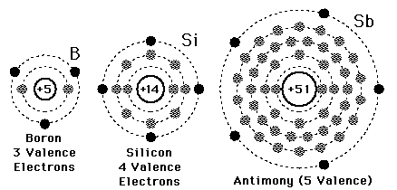

Silicon (germanium) and its lattice
Solid state electronics arises from the unique properties of silicon and germanium; both these materials have a valency of four, that is they have four outer electrons (electrons in their outer shell) available for bonding. In a pure crystal, each atom is bonded covalently to another four atoms; all of its outer electrons are bonded and therefore there are few free electrons available to conduct. This makes the resistance very large. Such pure crystals are known as intrinsic semiconductors.
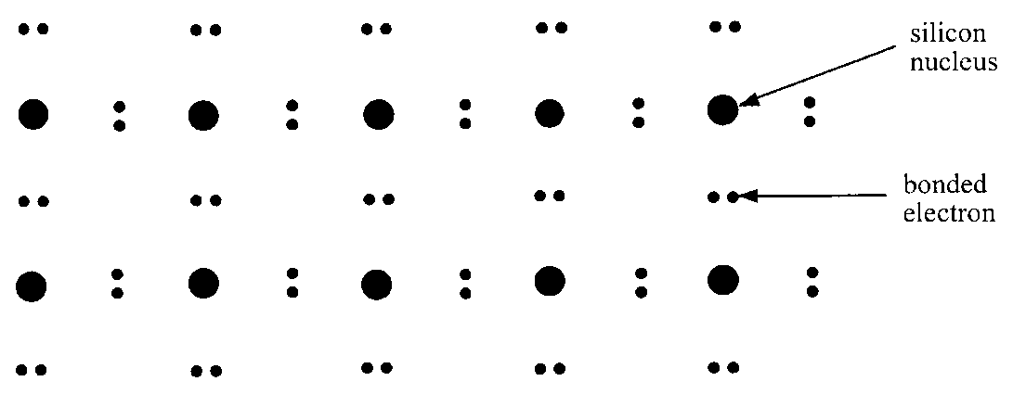
The few electrons that are available come from imperfections in the crystal lattice and thermal ionisation due to heating. A higher temperature will result in more free electrons, increasing the conductivity and decreasing the resistance, as in a thermistor.

P-N Junctions
n-type
p-type

A p-n junction diode is formed by doping one half of the semiconductor crystal with p-type impurity and the other half with n-type impurity while the crystal is being formed.
When an electron in the conduction band of the n-type material falls into the space in the valence band of the p-type, energy is released due to the change in energy level.
A diode will only allow current to flow in one direction.

Unbiased p-n junction
Unbiased conditions mean that there is no external energy source (no voltage) In an unbiased diode an electric field is set up across the depletion layer between the n-type and the p-type material. This is caused by the imbalance in free electrons due to the doping.

The Diode
Now let’s think about including the p-n junction as a component in an electrical circuit.
For simple components like an incandescent light bulb or a switch, which way round we connect them doesn’t matter.
But for the p-n junction, we shall see that the sign of the applied voltage has an important effect on the results. This is called the diode effect.
The two possibilities are called forward bias and reverse bias.

Forward and Reverse Bias

Biasing the diode
When we apply an external voltage we say that the diode is biased. There are two possibilities: forward and reverse bias.
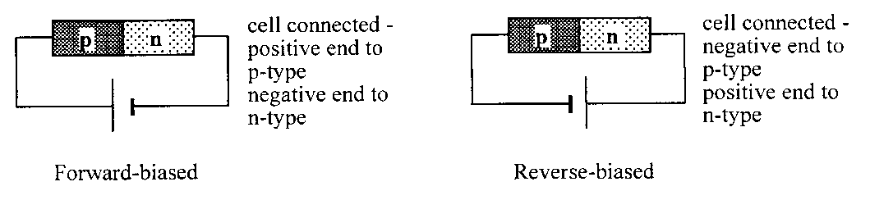

Reverse biased diode
In reverse bias the diode is connected with the p-type connected to the negative supply terminal and the n-type connected to the positive. The electric field across the depletion layer increases. This acts as a barrier that stops electron flow.
The valence band energy level in the p-type material is raised above the free electrons of the conduction band of the n-type. This is due to the combination of doping and electric field across the junction.
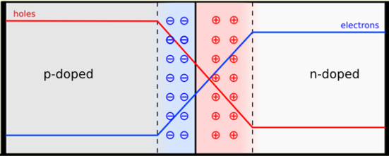
emf pushes holes this way
emf pushes electrons this way
no current
force on holes from bigger depletion layer
force on electrons from bigger depletion layer

Forward biased diode
In forward bias the diode is connected with the p-type connected to the positive supply terminal and the n-type connected to the negative terminal. The electric field across the depletion layer is reduced. This no longer acts as a barrier and electrons are able to flow.
The free electrons of the conduction band of the n-type are now just above the spaces in the valence band of the p-type. This is due to the doping and electric field across the junction.
Diodes can also be made so that the junction will absorb photons of light.

spaces pushed this way
electrons pushed this way
electrical current

- The electromotive force from the cell pushes both electrons and spaces towards the junction.
- Here they annihilate, making room for more electrons and spaces to enter the sample at the ends.
- This process continues indefinitely, and results in a constant current in the device.
- Forward bias → conduction!

LEDs
clear plastic case
with convex lens to focus light
junction near the surface
connections
+ve
-ve
flow of electrons

Depending on the impurity and semiconductor used, the difference in energy level between conduction and valence bands can be large enough to emit the energy as a photon of light. This is what happens in a light emitting diode, or LED.
p
n
0·7 V
A
B
Worked example
(a) Explain how a semiconductor is ‘doped’ to form a p-type semiconductor and how this doping affects the electrical properties of the semiconducting material.
(b) A potential difference of 0.7 V is maintained across the ends of a p–n diode as shown in the diagram:
- In what direction do the majority of the charge carriers in the p-type material flow?
- The recombination of charge carriers in the junction region can be represented by a transition between two energy levels separated by 2·78 × 10^{–19} J. What is the wavelength of the radiation emitted from the junction region?
(a) The semiconducting material has added to it very small quantities of an element; this has fewer outer electrons. When a material is doped in this way there exists in its atomic arrangement places where electrons should be, but are not. These places are called positive holes, hence p-type semiconductor. The existence of these positive holes gives rise to conduction through the migration of electrons into holes. Thus the resistance of the semiconductor is reduced.
(b) (i) A to B
(ii) E = hf
2·78 × 10^{–19} = 6·63 × 10^{–34} × f
f = = 4·19 × 10¹⁴ Hz
λ = = 7·16 × 10^{–7} m (716 nm)
Practical 1: Finding the Switch on Voltage for A diode

Aim
Measurement of the variation of current with applied p.d. for a forward and reverse-biased p-n junction.

Apparatus
1.5 V cell, p-n junction diode, potentiometer, milliammeter, voltmeter.
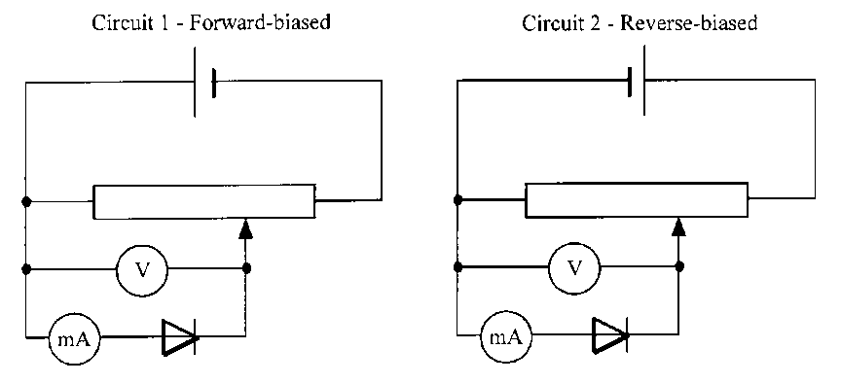

Instructions
- Set up circuit 1, the forward-biased diode.
- The diode is connected in the circuit so that the current through it can be measured as the p.d. across it is increased.
- For a range of values of potential difference across the diode, measure the corresponding value of current through it.
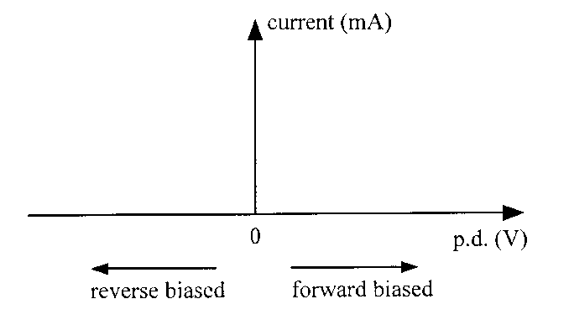
- Reverse the 1.5 V cell so that the diode is reverse-biased. Again increase the p.d. across the diode and note the current through it.
- Graph your results with current on the y axis and p.d. across the diode on the x axis. Reverse bias p.d. can be represented by negative values on the y axis.

Practical 2 Photodiode

Aim
To measure the frequency of an a.c. supply using a photodiode in photovoltaic mode.

Apparatus
12 V a.c. power supply, 12 V lamp, photodiode, oscilloscope.
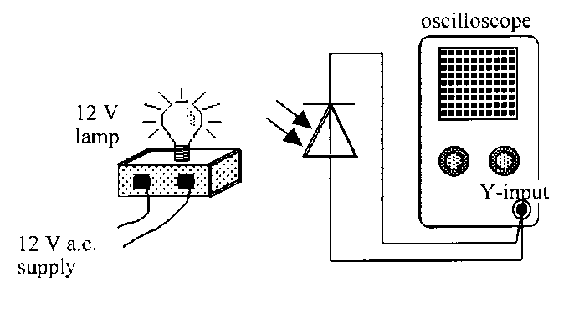

Instructions
- Set up the circuit above, preferably with the room darkened.
- Adjust the oscilloscope to obtain a clear trace.
- Calculate the frequency of the wave trace produced.
- Write a conclusion based on the results of the experiment.

Practical 3 Forward and reverse-biased

Apparatus
1.5 V cell, photodiode, potentiometer, milliammeter, voltmeter, 12 V lamp and power supply.
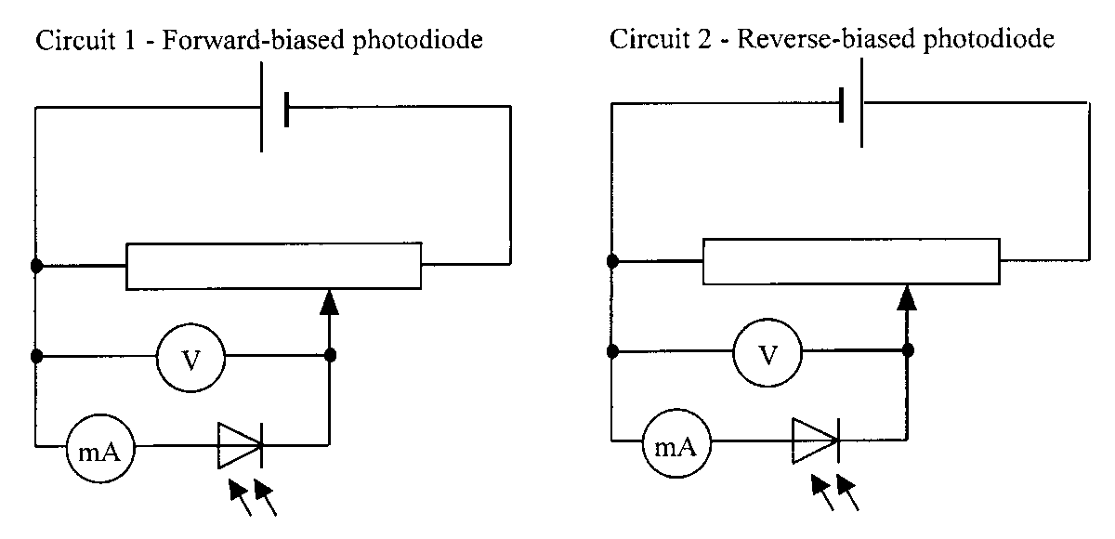

Instructions
- Set up Circuit 1, the forward-biased photodiode.
- In a darkened room, position the 12 V lamp to give a constant fixed level of illumination of the diode.
- Using the potentiometer, adjust the value of the potential difference across the photodiode.
- For a range of values of potential difference across the photodiode, measure the corresponding value of current through it.
- Repeat for the reverse-biased photodiode in Circuit 2.
- Use an appropriate format to show the relationship between current and applied p.d. for both circuits.

Photodiodes
Photodiodes can be used in two modes:
- Photovoltaic – no biasing
- Photoconductive- reversed biased.

Solar Cells
Diodes can also be made so that the junction will absorb photons of light.
A photon of light will cause an electron from the valence band of the p-type to be promoted to the n-type conduction band in the junction. This allows the diode to generate an EMF. This is what happens in a photodiode or photovoltaic cell.
Many photodiodes connected together form a solar cell.
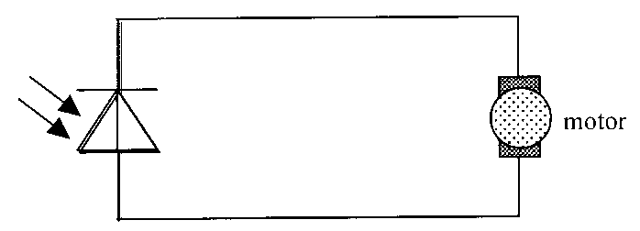
It is interesting to note that there is no bias applied to a solar cell and the photodiode therefore acts like an LED in reverse.
Photodiodes working in the photovoltaic mode are:
• usually referred to as photocells
• form the basis of the solar cells used to supply electrical power in satellites and calculators.
• limited to very low power applications (as listed above)
• A photodiode in this mode acts like an LED in reverse.

Tutorial 1: Semiconductors
1. In the following descriptions of energy levels in metals, insulators and semiconductors some words and phrases have been replaced by the letters A to N.
In a metal the ____A____ band is completely filled and the ____B____ band is partially filled. The electrons in the ____C____ band are free to move under the action of ____D____ so the metal has a ____E____ conductivity.
In an insulator there are no free electrons in the ____F____ band. The energy gap between the two bands is large and there is not enough energy at room temperature to move electrons from the ____G____ band into the ____H____ band.
Insulators have a very ____I____ conductivity.
In a pure semiconductor the energy gap between the valence and conduction bands is ____J____ than in a metal. At room temperature there is enough energy to move some electrons from the ____K____ band into the ____L____ band. As the temperature is increased the number of electrons in the conduction band ____M____ so the conductivity of the semiconductor ____N____.
From the table below choose the correct words or phrases to replace the letters.

Letter | List of replacement word or phrase
A, B, C, F, G, H, K, L | conduction, valence
D | an electric field, a magnetic field
E, I | low, high
J | bigger, smaller
M, N | decreases, increases

2. The conductivity of a semiconductor material can be increased by ‘doping’.
(a) Explain what is meant by the ‘conductivity’ of a material.
(b) Explain, giving an example, what is meant by ‘doping’ a semiconductor.
(c) Why does ‘doping’ decrease the resistance of a semiconductor material?

3. (a) A sample of pure germanium (four electrons in the outer shell) is doped with phosphorus (five electrons in the outer shell). What kind of semiconductor is formed?
(b) Why does a sample of n-type semiconductor still have a neutral overall charge?

4. Describe the movement of the majority charge carriers when a current flows in:
- an n-type semiconductor material
- a p-type semiconductor material.

5. A p-n junction diode is connected across a d.c. supply as shown. 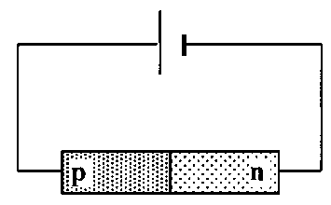
- Is the diode connected in forward or reverse bias mode?
- Describe the movement of the majority charge carriers across the p-n junction.
- What kind of charge is the only one that actually moves across the junction?
6. When positive and negative charge carriers recombine at the junction of ordinary diodes and LEDs, quanta of radiation are emitted from the junction.
- Does the junction have to be forward biased or reverse biased for radiation to be emitted?
- What form does this emitted energy take when emitted by:
- an LED
- an ordinary junction diode?

7. A particular LED is measured as having a recombination energy of 3·12 × 10^{–19} J.
(a) Calculate the wavelength of the light emitted by the LED.
(b) What colour of light is emitted by the LED?
(c) What factor about the construction of the LED determines the colour of the emitted light?

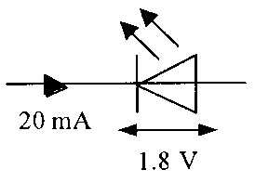
8. (a) State two advantages of an LED over an ordinary filament lamp.
(b) An LED is rated as follows:
operating p.d. 1·8 V, forward current 20 mA
The LED is to be operated from a 6 V d.c. power supply.
- Draw a diagram of the circuit, including a protective resistor, which allows the LED to operate at its rated voltage.
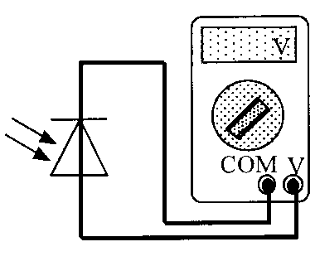
- Calculate the resistance of the protective resistor that allows the LED to operate at its rated voltage.

9. The diagram shows a photodiode connected to a voltmeter.
- In which mode is the photodiode operating?
- Light is now incident on the photodiode.
(i) Explain how an e.m.f. is created across the photodiode.
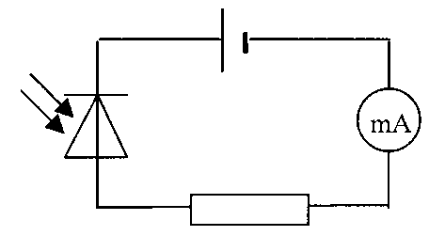
(ii) The irradiance of the light incident on the photodiode is now increased. Explain why this increases the e.m.f. of the photodiode.

10. A photodiode is connected in reverse bias in a series circuit as shown.
(a) In which mode is the photodiode is operating?
(b) Why is the photodiode connected in reverse bias?
(c) What is the current in the circuit when the photodiode is in darkness? Explain your answer.
(d) The irradiance of the light on the photodiode is now increased.
(i) What is the effect on the current in the circuit?
(ii) What happens to the effective ‘resistance’ of the photodiode? Explain why this happens.

Tutorial 2: Photodiodes

If the ammeter shown here has its ampere scale replaced to allow us to read the light intensity directly from it, is the zero of this light intensity at the left or right of the dial?
- The basic components necessary for sending a signal that tells when a rotating mechanism has reached a certain position are shown below.
Explain the functions of the L.E.D. and the L.D.R.
- A school power supply pack contains a step-down transformer which can give a variety of output voltages, and a full-wave rectifying bridge of junction diodes.
Which is their correct order in the power pack, and why?
  - Mains input, transformer, rectifier, output
  - Mains input, rectifier, transformer, output.

Tutorial Solutions
Electrons at work
1. A = valence; B = conduction; C = conduction; D = an electric field; E = high; F = conduction; G = valence; H = conduction; I = low; J = smaller; K = valence; L = conduction; M = increases; N = increases.
7. (a) 638 nm
(b) Red
8. (b) (ii) 210 Ω

Tutorial Exam Questions
Revised Higher Physics 2013

        - Use band theory to explain how electrical conduction takes place in a pure semiconductor such as silicon. Your explanation should include the terms: electrons, valence band and conduction band.

most/majority of electrons in valence band or “fewer electrons in conduction band”
band gap is small electrons are excited to conduction band charge can flow when electrons are in conduction band

        - A light emitting diode (LED) is a p-n junction which emits light. The table gives the colour of some LEDs and the voltage across the junction required to switch on the LED.
Colour of LED | Switch on Voltage /V
Green | 2.0
Red | 1.4
Yellow | 1.7
Using this data, suggest a possible value for the switch on voltage of an LED that emits blue light.
(c ) The remote control for a television contains an LED.
The graph shows the range of wavelengths emitted by the LED and the relative light output. Calculate the maximum energy of a photon emitted from this LED.

(b)value greater than 2·1V but less than 2·8V (inclusive)
must have unit , must be a value, not a range.

Higher Physics 2012
        - An n-type semiconductor is formed by adding impurity atoms to a sample of pure semiconductor material. State the effect that the addition of the impurity atoms has on the resistance of the material.

Decreases

        - A p-n junction is used as a photodiode as shown.
(i) In which mode is the photodiode operating?
(ii) The irradiance of the light on the junction of the photodiode is now increased.
Explain what happens to the current in the circuit
Answer
          - Photoconductive mode
- Current increases | (½) |  | 2
more photons of light arrive at the |  | Any wrong physics in the explanation
junction | (½) |  | max (½) (for 'current increases')
more free charge carriers produced |  | (½)
per second (could be linked to |  | (½)
either photons or charge carriers)

1. An LED consists of a p-n junction as shown.
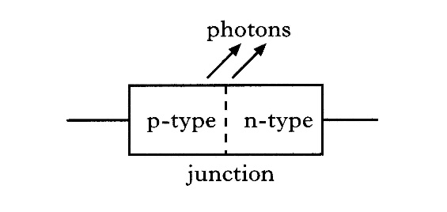
(a) Copy the diagram and add a battery so that the p-n junction is
forward-biased. 1
(b) Using the terms electrons, holes and photons, explain how light is produced at the p-n junction of the LED. 1
(c) The LED emits photons, of energy 3·68 × 10⁻¹⁹ J.
(i) Calculate the wavelength of a photon of light from this LED. 2
(ii) Calculate the minimum potential difference across the p-n junction when it emits photons. 2
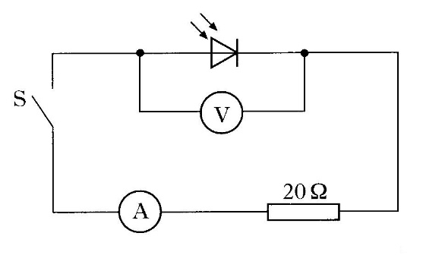
(6)
2. A photodiode is connected in a circuit as shown below.
Switch S is open.
Light is shone on to the photodiode.
A reading is obtained on the voltmeter.
(a) (i) State the mode in which the photodiode is operating. 1
(ii) Describe the effect of light on the material of which the photodiode is made. 1
(iii) The irradiance of the light on the photodiode is increased.
What happens to the reading on the voltmeter? 1

(b) Light of a constant irradiance is shone on the photodiode in the circuit shown above.
The following measurements are obtained with switch S open and then with switch S closed.
 | S open | S closed
reading on voltmeter/V | 0·508 | 0·040
reading on ammeter/mA | 0·00 | 2·00
(i) What is the value of the e.m.f. produced by the photodiode for this light irradiance? 1
(ii) Calculate the internal resistance of the photodiode for this light irradiance. 2
(c) In the circuit above, the 20  resistor is now replaced with a 10  resistor.
The irradiance of the light is unchanged.

The following measurements are obtained.
 | S open | S closed
reading on voltmeter/V | 0·508 | 0·021
Explain why the reading on the voltmeter, when S is closed, is smaller than the corresponding reading in part (b). 2
(8)
3. A circuit is set up as shown below. The amplitude of the output voltage of the d.c. supply is kept constant.
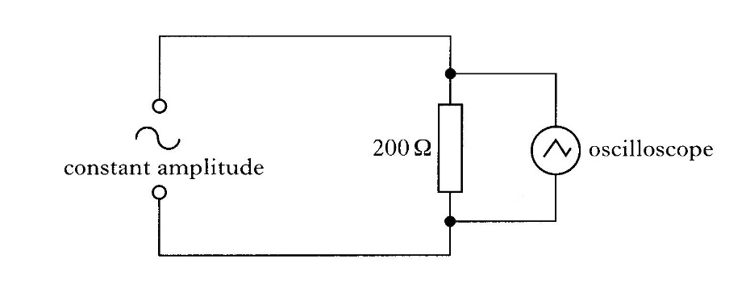
The settings of the controls on the oscilloscope are as follows:
y-gain setting = 5V/division
time-base setting = 2·5 ms/division
The following trace is displayed on the oscilloscope screen.
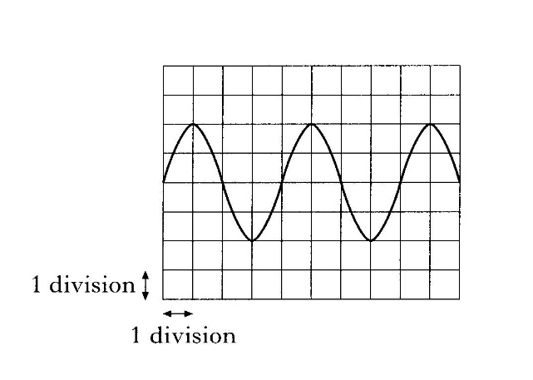
(a) (i) Calculate the frequency of the output from the a.c. supply. 2
(ii) Calculate the r.m.s. current in the 200 Ω resistor. 3
(b) A diode is now connected in the circuit as shown below.
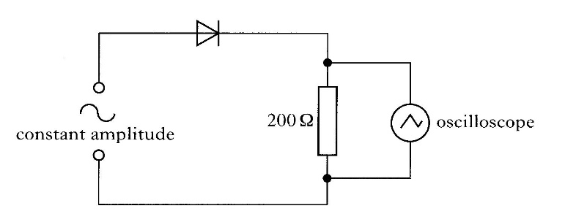
The setting on the controls of the oscilloscope remains unchanged.
Connecting the diode to the circuit causes changes to the original trace displayed on the oscilloscope screen. The new trace is shown below.
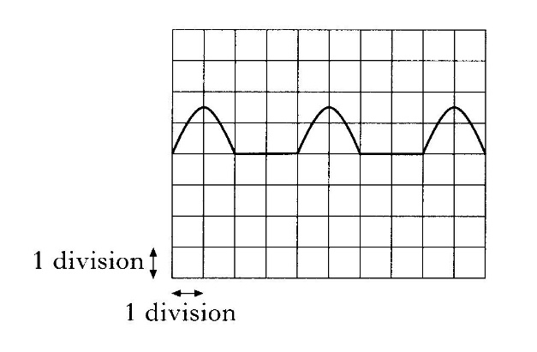
Describe and explain the changes to the original trace. 2
(7)
4. The diagram shows a photodiode connected to a voltmeter. A lamp is used to shine light onto the photodiode.
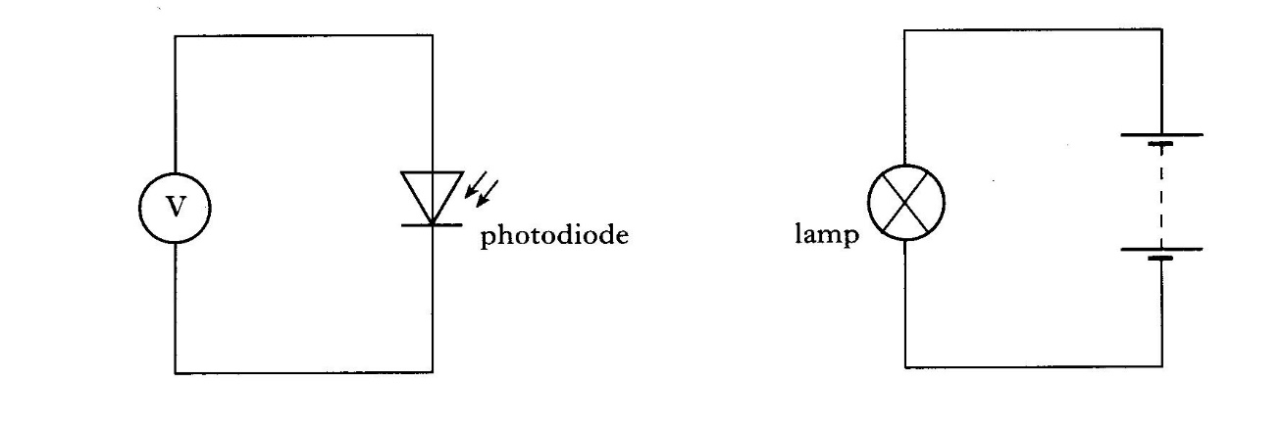
The reading on the voltmeter is 0·5 V.
The lamp is now moved closer to the photodiode.
Using the terms photons, electrons and holes, explain why the voltmeter reading changes. 2
(2)
5. (a) The diagram below represents the p-n junction of a light emitting diode (LED).
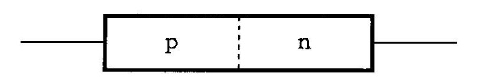
(i) Draw a diagram showing the above p-n junction connected to a battery so that the junction is forward biased. 1
(ii) When the junction is forwarded biased, there is a current in the diode. Describe the movement of charge carriers which produces this current. 2
(iii) Describe how the charge carriers in the light emitting diode enable light to be produced. 2
(b) The following graph shows the variation of current with voltage for a diode when it is forward biased.
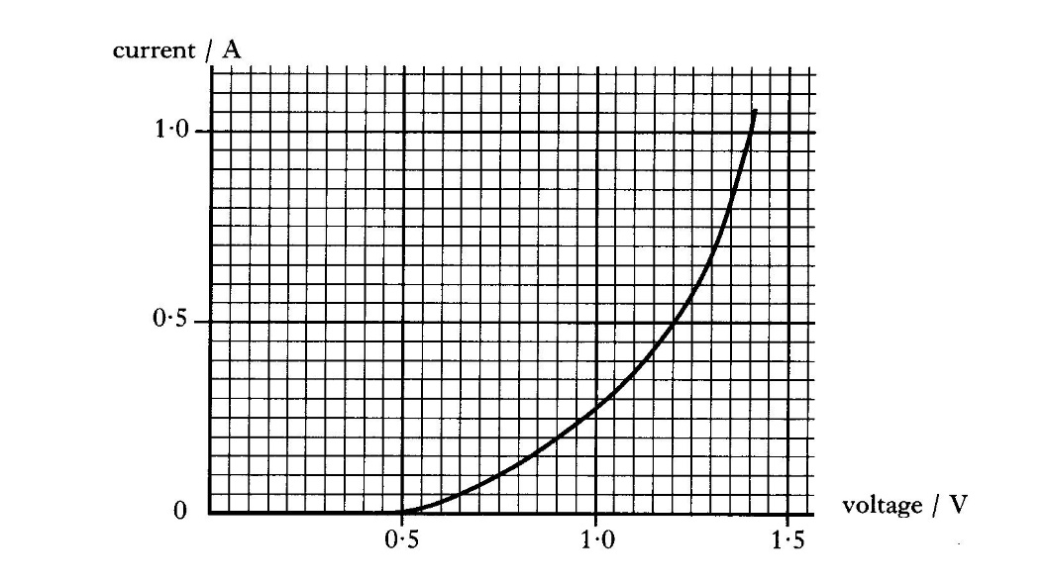
(i) What is the minimum voltage required for the diode to conduct. 1
(ii) What happens to the resistance of the diode as the voltage is increased above this minimum value?
Use information from the graph to justify your answer. 2
6. The circuit below shows a photodiode connected in series with a resistor and an ammeter. The power supply has an output voltage 5 V and negligible internal resistance.
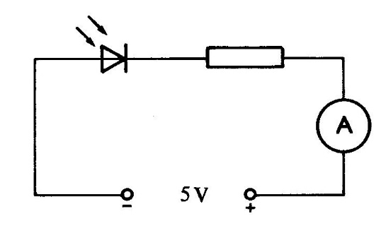
In a darkened room, there is no current in the circuit.
When light strikes the photodiode, there is a current in the circuit.
(a) Describe the effect of light on the material of which the photodiode is made. 1
(b) In which mode is the photodiode operating? 1
(c) When the photodiode is placed 1·0 m from a small lamp, the current in the circuit is 3·0 A.
Calculate the current in the circuit when the photodiode is placed 0·75 m from the same lamp. 3
(5)
7. The power for a space probe is produced by an array of photodiodes. Each photodiode in the array acts as a photovoltaic cell. Under certain conditions the power output of the array is 150 W at 34 V.
(a) Calculate the current produced by the array.
(b) Explain how a photovoltaic cell can produce a small voltage.
(c) What happens to the irradiance of the solar radiation falling on the array if the probe moves to a position twice as far from the Sun? Justify your answer.

Uncertainties in Electricity
1. Measurements of the p.d. across a resistor and the current in the resistor give the following results.
p.d. = (30·00 ± 0·03) V
current = (2·00 ± 0·01) A
Use these results to calculate the resistance of the resistor and express your answer in the form
resistance ± uncertainty 3

Open-ended Questions
1. A battery is charged using a 12 V d.c. supply as shown in Diagram I.
5 Ω
12 V

++
-+
5 Ω
12 V
MP3
player

Diagram I Diagram II
When charged it is connected to an MP3 player, as shown in Diagram II.
A teacher states that ‘The energy used to charge the electrical battery is always greater than the energy that can be taken from it.’
Use your knowledge of physics to comment on this statement.
You may use calculations to aid your comment.

Additional Notes
When p-type and n-type material are joined, a layer is formed at the junction. The electrical properties of this layer are used in a number of devices.
n-type
p-type

The different types of semiconductor have to be grown together so that one half is p-type and the other half is n-type, the product is called a p–n junction and it functions as a diode.
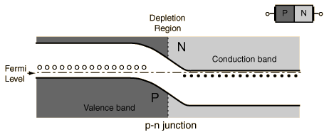
Representation of a p-n junction at equilibrium
When an electron meets a hole, they recombine, i.e. the electrons ‘fill in’ the holes, creating a charge imbalance: excess negative charge in the p-type region and excess positive in the n-type. This creates a slope in the conduction level which acts as a potential barrier (V_{i} ≈ 0.7 V for silicon) since it would require work of eV_{i} to be done in order to get electrons to move against the barrier (e is the electron charge).
An excess of n-type electrons diffuse across the junction to fill holes on p-type side which becomes negatively charged while n side becomes positively charged. Any free electrons in junction drift back towards the n-type material, resulting in the holes drifting back to the p-type.
The build-up of charge on either side of the junction causes any free electrons/holes in the junction to drift back across the junction. Once this drift balances the diffusion in the opposite direction, equilibrium is reached and the Fermi level (where you are likely to find electrons) is flat across the junction.
When no external voltage is applied to a p–n junction we refer to it as unbiased.

Forward and Reverse Biasing

Biasing the diode
When we apply an external voltage we say that the diode is biased. There are two possibilities: forward and reverse bias.

The forward-based diode
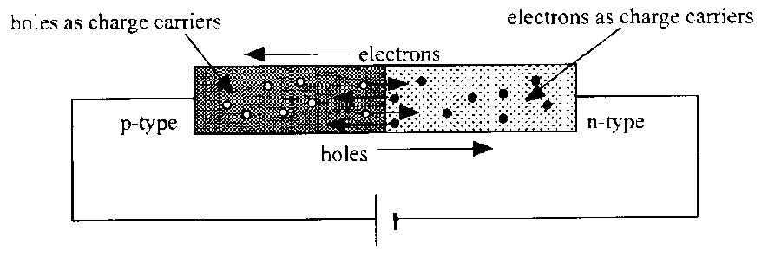
FORWARD BIASING CURRENT
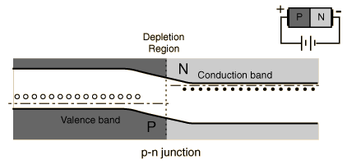
When the p-side is attached to the positive side of a battery (V_{a} = applied voltage) then the electrons at that side have less potential energy than under no bias. This lowers the Fermi level and the conduction bands on the p-side from where they were originally. We say it is forward biased.

Acknowledgement: Hyperphysics
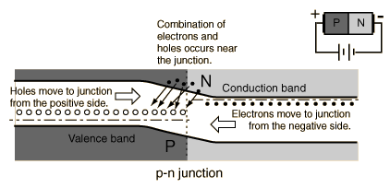
As the applied voltage (V_{a}) approaches the built in voltage (V_{i}), more electrons will have sufficient energy to flow up the now smaller barrier and an appreciable current will be detected. Once the applied voltage reaches the in-built voltage there is no potential barrier and the p–n junction presents almost no resistance, like a conductor. The holes are similarly able to flow in the opposite direction across the junction towards the negative side of the power supply.

The reverse-biased diode
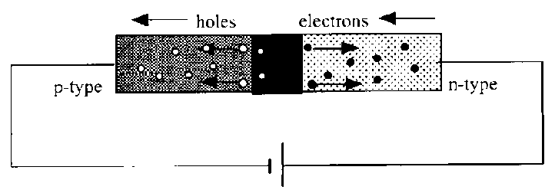
REVERSE BIASING NO CURRENT
The applied voltage can either act against or with the in-built potential barrier. When the p-side is attached to the negative side of a power supply (V_{a}, the applied voltage is now negative) then the electrons at that side have more potential energy than previously. This has the effect of raising the bands on the p-side from where they were originally. We say it is reverse biased.
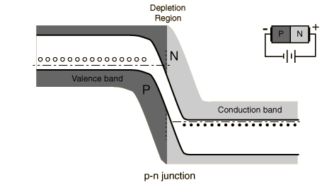
Almost no conduction can take place since the battery is trying to make electrons flow ‘up the slope’ of the difference in the conduction bands. The holes face a similar problem in flowing in the opposite direction. The tiny current that does flow is termed reverse leakage current and comes from the few electrons which have enough energy from thermal ionisation to make it up the barrier.

Voltage and Current graphs for junction diodes
I–V characteristics
A graph of the variation of current with pd across a p–n junction is shown below:
In reality the graph is slightly different!
V
I
Forward bias
Reverse bias
0

Breakdown Voltage
The breakdown voltage of an insulator is the minimum voltage that causes a portion of an insulator to become electrically conductive.
The breakdown voltage of a diode is the minimum reverse voltage to make the diode conduct in reverse. Some devices (such as TRIACs) also have a forward breakdown voltage.
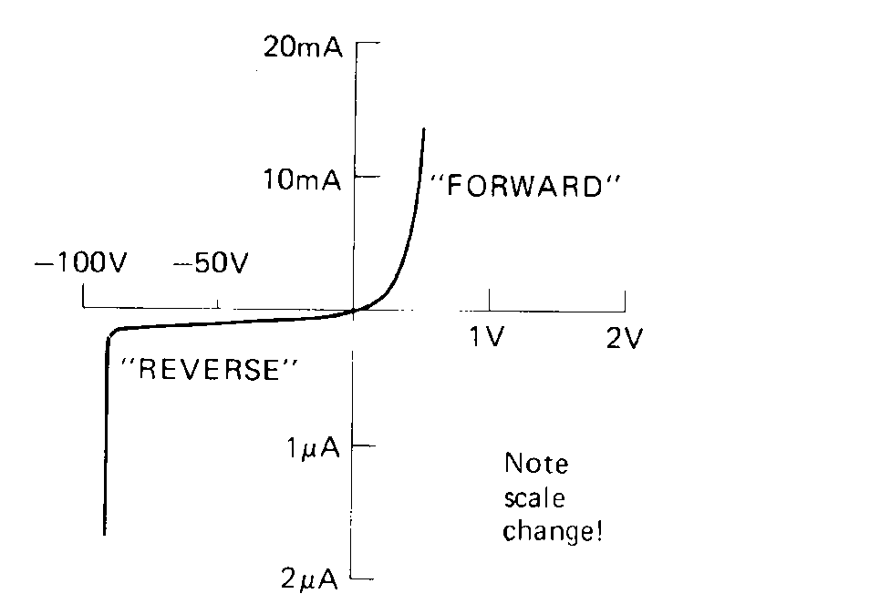
The rapid change in current at about –90V is the reverse breakdown voltage . This large current usually destroys the diode
(Note the different scale on each side of the x-axis)

Uses of Junction Diodes
+ -
Valuable
Component

diode

A diode can be placed as a safety device in a circuit to protect the circuit or a valuable component against incorrect polarity. Usually when the batteries are inserted correctly the diode is in reverse bias and there is no conduction through it. The valuable component works as it is designed. If the power supply is connected with the wrong polarity this could potentially destroy the component, however, the diode is now in forward bias and provides a route for the current. Charge flows through the diode in preference to the valuable component, which is not working, but is not damaged.
Valuable
Component

Diode
FORWARD BIAS
- +

Valuable
Component

Diode
REVERSE BIAS
+ -

Applications
c.r.o. screen

Half wave rectification.

Adding a single diode in a circuit is a very basic way of providing a d.c. from a.c., but for half the cycle there is zero voltage and current in the circuit. Many circuits would not work with this design, and a more appropriate circuit is required.

Full wave rectification.
This is a better way of getting d.c. from a.c. and is known as a BRIDGE RECTIFIER.
c.r.o. screen

LOAD
You might need to view these diagrams in colour to distinguish the difference! Can you spot all the differences?
c.r.o. screen

LOAD
+
-
c.r.o. screen
LOAD
+
-

Smoothing
As previously mentioned in the capacitance section adding a capacitor to the bridge rectifier circuit smooths the voltage across the component and results in a more consistent voltage or ripple voltage.

Glossary for Semiconductor Revision
https://quizlet.com/90855867/122-conductors-semiconductors-and-insulators-flash-cards/

Conductors
Conductivity is the ability of materials to conduct charge carriers (electrons or positive holes) (all metals, semi metals like carbon-graphite, antimony and arsenic)

Insulators
Materials that have very few charge carriers (free electrons or positive holes). (plastic, glass and wood)

Semiconductors
These materials lie between the extremes of good conductors and good insulators. They are crystalline materials that are insulators when pure but will conduct when an impurity is added and/or in response to light, heat, voltage, etc (silicon (Si), germanium (Ge), gallium arsenide (GaAs)

Band structure
Electrons in an isolated atom occupy discrete energy levels. When atoms are close to each other these electrons can use the energy levels of their neighbours. When the atoms are all regularly arranged in a crystal lattice of a solid, the energy levels become grouped together in a band. This is a continuous range of allowed energies rather than a single level. There will also be groups of energies that are not allowed, what is known as a band gap. Similar to the energy levels of an individual atom, the electrons will fill the lower bands first. The fermi level gives a rough idea of which levels electrons will generally fill up to, but there will always be some electrons with individual energies above this

In a conductor:
the highest occupied band, known as the conduction band, is not completely full. This allows the electrons to move in and out from neighbouring atoms and therefore conduct easily

In an insulator:
the highest occupied band is full. This is called the valnce band, by analogy with the valence electrons of an individual atom. The first unfilled band above the valence band above the valence band is the conduction band. For an insulator the gap between the valence and conduction bands is large and at room temperature there is not enough energy available to move electrons from the valence band into the conduction band, where they would be able to contribute to conduction. Normally, there is almost no electrical conduction in an insulator. If the applied voltage is high enough (beyond the breakdown voltage) sufficient electrons can be lifted to the conduction band to allow current to flow. Often this flow of current causes permanent damage. Within a gas this voltage is often referred to as the striking voltage, particularly within the context of a fluorescent lamp since this is the voltage at which the gas will start to conduct and the lamp will light.

In a semiconductor:
the gap between the valence band and the conduction band is smaller, and at room temperature there is sufficient energy available to move some electrons from the valence band into the conduction band, allowing some conduction to take place. An increase in temperature increases the conductivity of the semiconductor as more electrons have enough energy to make the jump to the conduction band. This is the basis of an NTC thermistor. NTC stands for "negative temperature coefficient" (increased temperature means reduced resistance). This makes current increase so conductivity increases.

Optical properties of materials
Electron bands also control the optical properties of materials. They explain why a hot solid can emit a continuous spectrum rather than a discrete spectrum as emitted by a hot gas. In the solid the atoms are close enough together to form continuous bands. The exact energies available in these bands also control at which frequencies a material will absorb or transmit and therefore what colour will appear

Bonding in semiconductors
The most commonly used semiconductors are silicon and germanium. Both these materials have a valency of 4 (they have 4 outer electrons available for bonding. In a pure crystal, each atom is bonded covalently to another 4 atoms: all of its outer electrons are bonded and therefore there are few free electrons available to conduct. This makes resistance very large. Such pure crystals are known as intrinsic semiconductors. The few electrons that are available come from imperfections in the crystal lattice and thermal ionisation due to heating. A higher temperature will thus result in more free electrons, increasing the conductivity and decreasing the resistance, as in a thermistor

Doping
Semiconductor's electrical properties are dramatically changed by the addition of very small amounts of impurities. Once doped the semiconductors are known as extrinsic semiconductors.
OR
Doping a semiconductor involves growing impurities such as boron or arsenic into an
intrinsic semiconductor such as silicon

An intrinsic semiconductor is
an undoped semiconductor

Fermi level
Energy of latest occupied level in which the states below this energy are completely occupied and above it are completely unoccupied

N-type semiconductors
If an impurity such as arsenic with 5 outer electrons is present in the crystal lattice then 4 of its electrons will be used in bonding with the silicon. The 5th will be free to move about and conduct. Since the ability of the crystal to conduct is increased, the resistance of the semiconductor is therefore reduced. Because of the extra electrons present, the Fermi level is closer to the conduction band than in an intrinsic semiconductor. This type of conductor is called n - type, since most conduction is by the movement of free electrons (-ve)

P-type semiconductors
The semiconductor may also be doped with an element like Indium, which has 3 outer electrons. This produces a hole in the crystal lattice, where an electron is "missing". Because of this lack of electrons, the Fermi level is closer to the valence band than in an intrinsic semiconductor. An electron from the next atom can move into the hole created, as described previously. Conduction can thus take place by the movement of positive holes. Most conduction takes place by the movement of positively charged holes

Notes on doping
The doping material cannot be added to the semiconductor crystal. It has to be grown into the lattice when the crystal is grown so that it becomes part of the atomic lattice.
The quantity of the impurity is extremely small (could be 1 atom in 1 million). If it were too large it would disturb the regular crystal lattice.
Overall charge on semiconductors are still neutral
In n - type and p - type there will always be small numbers of the other type of charge carrier, known as minority charge carriers, due to thermal ionisation.

p-n junctions
When a semiconductor is grown so that 1 half is p-type and 1 half is n-type, the product is called a p-n junction and it functions as a diode. A diode is a discrete component that allows current to flow in one direction only.

At temperatures other than absolute Zero kelvin, the electrons in the n-type and the holes in the p-type material will constantly
diffuse(particles will spread from high concentration regions to low concentration regions). Those near the junction will be able to diffuse across it.

Reverse-biased
Cell connected negative end to p-type and positive end to n-type

Forward-biased
Cell connected positive end to p-type and negative end to n-type.

Reverse biased - charge carriers
When the p-side is attached to the negative side of a battery then the electrons at that side have more potential energy than previously. This has the effect of raising the bands on the p-side from where they were originally. We say it is reverse-biased. Almost no conduction can take place since the battery is trying to make electrons flow "up the slope" of the difference in conduction bands. The holes face a similar problem in flowing in the opposite direction. The tiny current that does flow is termed reverse leakage current and comes from the few electrons which have enough energy from the thermal ionisation to make it up the barrier.

Forward biased - charge carriers
When the p-side is attached to the positive side of the battery then the electrons at that side have less potential energy than under no bias. This has the effect of lowering the bands on the p-side from where they were originally. We say it is forward biased. As the applied voltage approaches the switching voltage, more electrons will have sufficient energy to flow up the now smaller barrier and an appreciable current will be detected. Once the applied voltage reaches the set voltage there is no potential barrier and the p-n junction has almost no resistance, like a conductor.

In the junction region of a forward-biased LED
electrons move from the conduction band to the valence band to emit photons.

The colour of light emitted from an LED depends on
On the elements and relative quantities of the three constituent materials. The higher the recombination energy the higher the frequency of light.

The LED does not work in reverse bias since the charge carriers
do not/can not travel across the junction towards each other so cannot recombine

Photodiode
A p-n junction in a transparent coating will react to light in what is called the photovoltaic effect. Each individual photon that is incident on the junction has its energy absorbed, assuming the energy is larger than the band gap. In the p-type material this will create excess electrons in the conduction band and in the n-type material it will create excess holes in the valence band. Some of these charge carriers will then diffuse to the junction and be swept across the built-in electric field of the junction. The light has supplied energy to the circuit, enabling current to flow (it is the emf in the circuit). More intense light (more photons) will lead to more electron-hole pairs being produced and therefore a higher current. Current is proportional to light intensity.
OR
The incoming light provides energy for an electron within the valence band of the p-type to be removed from a positive hole and moved up to the conduction band in the n-type material. As this electron is moved up into the conduction band it has an increase in energy. Since EMF is the energy per coulomb of charge an EMF is generated.

Photovoltaic mode
The p-n junction can supply power to a load (motor). Many photo-diodes connected together form a solar cell. This is described as photovoltaic mode.There is no bias applied to a solar cell and it acts like an LED in reverse. The increased movement of charge across a p-n junction can reduce resistance of component containing the junction .

Photoconductive mode
When connected to a power supply a photodiode will act as a LDR. This is described as photoconductive mode. The LDR is connected in reverse bias, which leads to a large depletion region. When light hits the junction, electrons and holes are split apart. This leads to free charge carriers in the depletion region. The free charge carriers reduce overall resistance of the diode, allowing current to flow. Conductivity of diode is being changed.

Addition of impurity atoms to a pure semiconductor(doping) decreases its
Resistance

Applications of p-n junctions
Photovoltaic cell /LED /Photoconductive mode(LDR)

What is photovoltaic effect?
A process in which a photovoltaic cell converts photons of light into electricity.

How light is produced at the p-n junction of an LED
When the diode is forward biased the free electrons in the conduction band of the n-type material are given energy by the supply to overcome the energy barrier generated by the depletion layer at the junction. Once these electrons overcome the energy barrier they drop down from the conduction band to the valence band of the p-type material and combine with a positive hole in the valence band of the p-type material. As the electron drops between the bands it loses energy and emits this as light.

Use band theory to explain how electrical conduction takes place in a pure semiconductor such as silicon.
Your explanation should include the terms: electrons, valence band and conduction band.
most/majority of electrons in valence band (½) or "fewer electrons in conduction band" (½)
band gap is small electrons are excited to conduction band (½)
charge can flow when electrons are in conduction band (½)

What charge carriers actually move across the p-n junction?
Electrons

Tutorial Solutions-

Tutorial 1:Semiconductors
1. A = valence; B = conduction; C = conduction; D = an electric field; E = high; F = conduction; G = valence; H = conduction; I = low; J = smaller; K = valence; L = conduction; M = increases; N = increases.
7. (a) 638 nm
(b) Red
8. (b) (ii) 210 Ω

Exam Questions
NB What is acceptable to the SQA in this section has changed in 2019. Beware of looking at answers prior to this date as answers that were acceptable may no longer receive credit and marks.
1. (a)
(b) Electrons and holes (re)combine (½) (at junction) energy released as photons (½) OR photons given out OR light photons combine/join together/falls into hole
(c) (i) E = hf 3·68 x 10⁻¹⁹ = 6·63 x 10⁻³⁴ f f = 5·55 x 10¹⁴ (Hz)
v = fλ (½) for both E and v equations
3 x 10⁸ = 5·55 x 10¹⁴ λ
λ = 5·40 x 10⁻⁷ m
(ii) E = QV 3·68 x 10⁻¹⁹ = 1·6 x 10⁻¹⁹ V V = 2·3 V
2. (a) (i) Photovoltaic mode
(ii) The light causes electron-hole pairs (to be created) in the junction (or intrinsic layer)
(iii) It will increase
(b) (i) emf =0.508 V
(ii) r = (E – V)/I = (0.58 – 0.040)/2.00 x 10 ⁻³ =234 Ω
OR R_{T} = 0.508/2.00 x 10⁻³ = 254 Ω r = 254 – 20 = 234 Ω
OR correct use of V₁/V₂ = R₁/R₂
(c) With 10 Ω resistor in circuit there is more current (drawn from photodiode). Pd across internal resistance increases OR lost volts increases.
3. (a) (i) f = 1/t = 1/0.01 = 100 Hz
(ii) V_{rms} = V_{peak}/√2 = 10/√2 = 7.1 V
I_{rms} = V_{rms}/R = 7.1/200 = 0.036 A
(b) Half cycle missing as diodes only conduct in one direction.
V_{peak} across resistor less since p.d. developed across diode.
4.
- The lamp produces photons of light that have an energy that can be calculated using the equation E=hf.
- Some of this energy is absorbed by the semiconductor material of the photodiode.
- The absorbed energy creates electron hole pairs in the photodiode that increases the conductivity of the photodiode.
- There is a reduction in the potential barrier at the pn junction and therefore a reduction in the voltmeter reading.
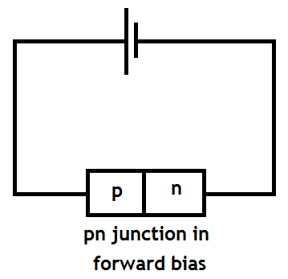
5. (a) (i)

- When forward biased the majority charge carriers in the n-type material, electrons, flow to the p-type material. This movement of electrons also makes it appear that holes in the p-type material move towards the n-type material.
(iii) When conduction band electrons in the n-type material pass into the p-type material they fall into lower energy holes and emit energy as a visible photon, if the energy loss is equal to the energy of a visible photon.
(b) (i) Conduction starts when the applied voltage is 0.5V.
(ii) The resistance of the diode decreases as the applied voltage increases. This can be justified by using ohms law to calculate the resistance at different applied voltages.
R1 = V1/I1 = 1.0/0.275 = 3.6Ω
R2 = V2/I2 = 1.2/0.5 = 2.4Ω
6. (a) Light incident on the pn-junction photodiode will increase the number of electron hole pairs and consequently increase the conductivity of the diode.
(b)The diode is operating in photoconductive mode.
(c) I₁d₁² = I₂d₂² I₂ = I₁d₁²/d₂² = 3.0x1²/0.75² = 5.33mA
7. (a) P = VI so I = P/V =150/34 = 4.1 A
(b) The light causes electron-hole pairs (to be created) in the junction (or intrinsic layer). Electrons can move through the semiconducting to fill the holes thus creating a potential difference.
(c) I₁d₁² = I₂d₂² so doubling the distance reduces the irradiance by a factor of 4
Uncertainties in Electricity
1. Uncertainty in p.d. = (0.03/30.00) x 100% = 0.1%
Uncertainty in current = (0.01/2.00) x 100% = 0.5%
Greatest % uncertainty is 0.5%
R = V/I = 30/2 = 15 Ω ± 0.5%
0.5% of 15 = 0.075 Ω
So R = (15.00 ± 0.08) Ω


YOU MADE IT TO THE END OF THE COURSE
WELL DONE!
NOW YOU’VE JUST TO LEARN IT ALL!
T’was nice knowing you- ALL THE BEST
KEEP IN TOUCH
Mrs H


