

Name

Class Teacher

Advanced Higher Physics

Electromagnetism

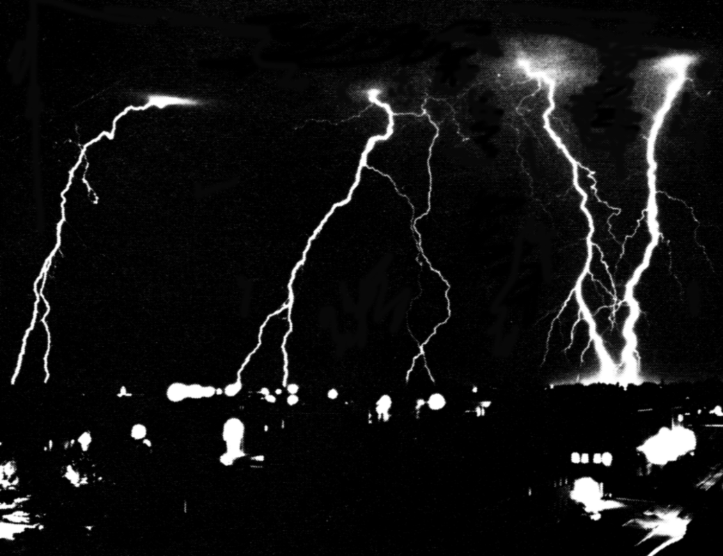

Summary Notes

ELECTRIC FIELDS

Forces between Electric Charges Coulomb's Law (1785)
Forces between electric charges have been observed since earliest times. Thales of Miletus, a Greek living in around 600 B.C., observed that when a piece of amber was rubbed, the amber attracted bits of straw.
However it was not until 2500 years later that the forces between charged particles were actually measured by Coulomb using a torsion balance method. The details of Coulomb's experiment are interesting but his method is difficult to reproduce in a teaching laboratory.

Coulomb's Inverse Square Law
Coulomb's experiment gives the following mathematical results:
F α $\frac{1}{r2}$and F α (Q1 Q2)
Thus F = k

Value of k
When other equations are developed from Coulomb's Law, it is found that the product 4πk frequently occurs. Thus, to avoid having to write the factor 4π in these derived equations, it is convenient to define a new constant εo, called the permittivity of free space and is equal to 8.85 x 10⁻¹² F m⁻¹, such that:
εo = $\frac{1}{4pk}$or k = $\frac{1}{4peo}$where ε is the Greek letter 'epsilon'
k is approximately 9.0 x 109 N m2 C-2

Equation for Coulomb's inverse square law
$\boxed{F = \frac{1}{4peo} \frac{Q1Q2}{r2}}$when Q₁ and Q₂ are separated by air

Notes:
• Force is a vector quantity. If more than two charges are present, the force on any given charge is the vector sum of all the forces acting on that charge.
• Coulomb's law has a similar form as the gravitational force, FG =.

Example
Three identical charges A, B and C are fixed at the positions shown in the right angled triangle below.

Each charge is +8 nC (i.e. +8.0 x 10-9 C) in magnitude.
(a) Calculate the forces exerted on charge A by charges B and C.
(b) Calculate the resultant force on charge A. (This means magnitude and direction)

Solution
(a) FBA = $\frac{1}{4peo} \frac{QBQA}{r2}$= 9 x 109 x = 1.6 x 10-6 N
Direction is along BA, or repulsion.
FCA = $\frac{1}{4peo} \frac{QCQA}{r2}$= 9 x 109 x = 0.90 x 10-6 N
Direction is along CA, or repulsion
Resultant = $\sqrt{FBA2 + FCA2}$ = 1.8 x 10-6 N
tan θ = $\frac{0.9 x 10-4}{1.6 x 10-4}$= 0.563 thus θ = 29°
Resultant force on charge A = 1.8 x 10-6 N at an angle of 29° as shown above.

The table below contains some atomic data for answering the questions in Tutorial 1.

Particle | Symbol | Charge/C | Mass/kg |  | Typical  diameter of  atoms/m | Typical  diameter of  nuclei/m
proton | p | +e  1.60 x 10-19 | 1.673 x 10-27 |  | 1 x 10-10 | 1 x 10-15
neutron | n | 0 | 1.675 x 10-27 |  | to | to
electron | e- | -e  -1.60 x 10-19 | 9.11 x 10-31 |  | 3 x 10-10 | 7 x 10-15
For very small distances, for example between nucleons, there is a strong attractive nuclear force. At distances above 1 x 10-15 m the electrostatic force comes into play. This is the force which basically binds atoms together. At very large distances the gravitational force is dominant.

The Electric Field
The idea of a field is a useful way to visualise how charges affect one another.
We say that a charge sets up a field around itself such that it will influence other charges in that field.

Charge Qt placed at point P in the field, set up by charge Q, will experience a force F due to the field at P. A charged object cannot experience its own electric field.

Definition of an electric field
An electric field is said to be present at a point if a force, of electrical origin, is exerted on a charge placed at that point.

In the following work on electric fields there are two problems:
• calculating the fields set up by certain charge distributions
• calculating the force experienced by a charge when placed in a known field.

Electric Field Strength
The electric field strength E at any point is the force on unit positive charge placed at that point.
If a charge Qt, placed at point P in the electric field, experiences a force F then:

E = | unit of E: N C⁻¹

• The direction of E is conventionally taken as the direction in which a positive test charge would move in the field. Thus for a positive charge, the direction of the field is away from the charge.
• The charge Qt must be small enough not to alter E.
• The unit N C-1 is equivalent to the unit V m-1, see later.
This is similar to the gravitational field around mass m: g = $\frac{F}{m}$unit of g: N kg-1.

Electric Field Lines
An electric field line is a convenient concept developed by Michael Faraday to help the visualisation of an electric field.

• The tangent to a field line at a point gives the direction of the field at that point.
• Field lines are continuous; they begin on positive charges and end on negative charges. They cannot cross.
• If lines are close the electric field strength is strong, if the lines are far apart the field is weak. If lines are parallel and equally spaced the field is said to be uniform.
• Field lines cut equipotential surfaces at right angles, see later.

Examples of electric field patterns
An isolated positive charge An isolated negative charge
+
−

These patterns are called radial fields. The lines are like the radii of a circle.

Two equal but opposite charges  +  +  +  +  −  −  −  −  +  − | Charged parallel plates  The field lines are parallel and equally spaced between the plates.  This is called a uniform field.

Equation for Electric Field Strength
Consider placing test charge Qt at a point distance r from a fixed point charge Q in a vacuum.
The force between the two charges is given by: F = $\frac{1}{4peo}$$\frac{QQt}{r2}$
But electric field strength, E is defined as $\frac{Force}{Charge}$ thus E = giving:
E =

• This equation gives the magnitude of the electric field strength around an isolated point charge; its direction is radial. The electric field strength reduces quickly as the distance r increases because E α $\frac{1}{r2}$
• Electric field strength is a vector quantity. When more than one charge is present, the electric field strength must be calculated for each charge and the vector sum then determined.

Example: The Electric Dipole
A pair of charges +4.0 x 10-9 C and -4.0 x 10-9 C separated by 2.0 x 10-14 m make up an electric dipole. Calculate the electric field strength at a point P, a distance of 5.0 x 10-14 m from the dipole along the axis shown.

Solution
In magnitude: E1 = E2 = $\frac{1}{4peo}$. $\frac{Q}{r2}$= $\frac{1}{4peo}$. = 1.38 x 1028 N C-1
Horizontally: E1 sin θ + E2 sin θ = 0 since E1 and E2 are in opposite directions.
Vertically: EP = 2 E1 cosθ = 2 x 1.38 x 1028 x= 5.4 x 1027
Thus EP = 5.4 x 1027 N C-1

The direction of EP is given in the sketch above.

A knowledge of electric dipoles is important when trying to understand the behaviour of dielectric materials which are used in the construction of capacitors.
An analysis of the water molecule also shows that there is a resultant electric field associated with the oxygen atom and two hydrogen atoms - water is called a polar molecule.

Potential Difference and Electric Field Strength for a uniform field
For a uniform field the electric field strength is the same at all points.
_
+
The potential difference between two points is the work done in moving one coulomb of charge from one point to the other against the electric field, i.e. from the lower plate to the upper plate.
The minimum force needed to move Q coulombs from the lower plate to the upper plate is QE.

Thus work = force x distance = QE x d. but work = QV by definition
thus QV = QE x d
$\boxed{V = E d}$ for a uniform field.
An alternative equation for electric field strength is E =with a unit of V m-1,
showing that the unit N C-1 is equivalent to the unit V m-1 as mentioned above.

Conducting Shapes in Electric Fields

As shown in the Faraday's Ice-Pail Experiment any charge given to a conductor always resides on the outer surface of the conductor. A direct consequence of this fact is that the electric field inside a conductor must be zero, that is Einside = 0.

Reasoning
The field must be zero inside the conductor because if it were non-zero any charges placed inside would accelerate in the field and move until balance was reached again. This would only be achieved when no net force acted on any of the charges, which in turn means that the field must be zero. This is also why any excess charge must reside entirely on the outside of the conductor with no net charge on the inside. Also, the field outside the conductor must start perpendicular to the surface. If it did not there would be a component of the field along the surface causing charges to move until balance was reached.
If an uncharged conductor is placed in an electric field, charges are induced as shown below so that the internal field is once again zero. Notice that the external field is modified by the induced charges on the surface of the conductor and that the overall charge on the conductor is still zero.
You can now see why the leaf deflection of a charged gold leaf electroscope can go down if an uncharged metal object is brought close - the field set up by the charge on the electroscope causes equal and opposite charges to be induced on the object.

Electrostatic shielding
If the conductor is hollow then the outer surface acts as a "screen" against any external electric field. This principle is used in co-axial cables (shown below).
The 'live' lead carrying the signal is shielded from external electric fields, i.e. interference, by the screen lead which is at zero volts.

Electrostatic Potential

To help understand this concept consider the sketch below.
To move Qt from a to b requires work from an external agent, e.g. the moving belt of a Van de Graaff machine. This work supplied increases the electrostatic potential energy of the system. This increase of energy depends on the size of the charge Q and on the positions a and b in the field.

Definition of electrostatic potential
Let an external agent do work W to bring a positive test charge Qt from infinity to a point in an electric field.

The electrostatic potential, V, is defined to be the work done by external forces in bringing unit positive charge from infinity to that point.

Thus V = $\frac{W}{Qt}$ unit of V: J C-1
$\boxed{W = QtV}$

A potential exists at a point a distance r from a point charge; but for the system to have energy, a charge must reside at the point. Thus one isolated charge has no electrostatic potential energy.

Electrostatic Potential due to a Point Charge

To find the electrostatic potential at a point P a distance r from the charge Q we need to consider the work done to bring a small test charge Qt from infinity to that point.

+Q_{t}
Q
P
r
vacuum
+
Q_{t} brought from infinity
to point P

The force acting against the charge Q_{t} increases as it comes closer to Q. Calculus is used to derive the following expression for the electrostatic potential V at a distance r due to a point charge Q.
$\boxed{V = \frac{1}{4peo} \frac{Q}{r}}$ Thus V α $\frac{1}{r}$

Notice that the expression for electrostatic potential has a very similar form to that for gravitational potential: V = - G .

• Electrostatic potential is a scalar quantity. If a number of charges lie close to one another the potential at a given point is the scalar sum of all the potentials at that point. This is unlike the situation with electric field strength. Negative charges have a negative potential.
• In places where E = 0, V must be a constant at these points. We will see this later when we consider the field and potential around charged spheres.

Electrostatic Potential Energy

Electrostatic potential at P is given by
+
P
r

V =

If a charge Q_{t} is placed at P
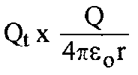
electrostatic potential energy of charge Q_{t} =

electrostatic potential energy of charge Q_{t} =
A positively charged particle, if free to move in an electric field, will accelerate in the direction of the field. This means that the charge is moving from a position of high electrostatic potential energy to a position of lower electrostatic potential energy, losing electrostatic potential energy as it gains kinetic energy.

The Electronvolt

This is an important unit of energy in high energy particle physics.

The electronvolt is the energy acquired when one electron accelerates through a potential difference of 1 V. This energy, QV, is changed from electrical to kinetic energy.
1 electronvolt = 1.6 x 10-19 C x 1 V giving 1 eV = 1.6 x 10-19 J.
Often the unit MeV is used; 1 MeV = 1.6 x 10-13 J.

Equipotentials

This idea of potential gives us another way of describing fields.
The first approach was to get values of E, work out the force F on a charge and draw field lines. A second approach is to get values of V, work out the electrostatic potential at a point and draw equipotential lines or surfaces.

Equipotential surfaces are surfaces on which the potential is the same at all points; that is no work is done when moving a test charge between two points on the surface. This being the case, equipotential surfaces and field lines are at right angles.

The sketches below show the equipotential surfaces (solid lines) and field lines (broken) for different charge distributions. These diagrams show 2-dimensional pictures of the field. The field is of course 3-dimensional.

(a) an isolated charge (b) two unlike charges
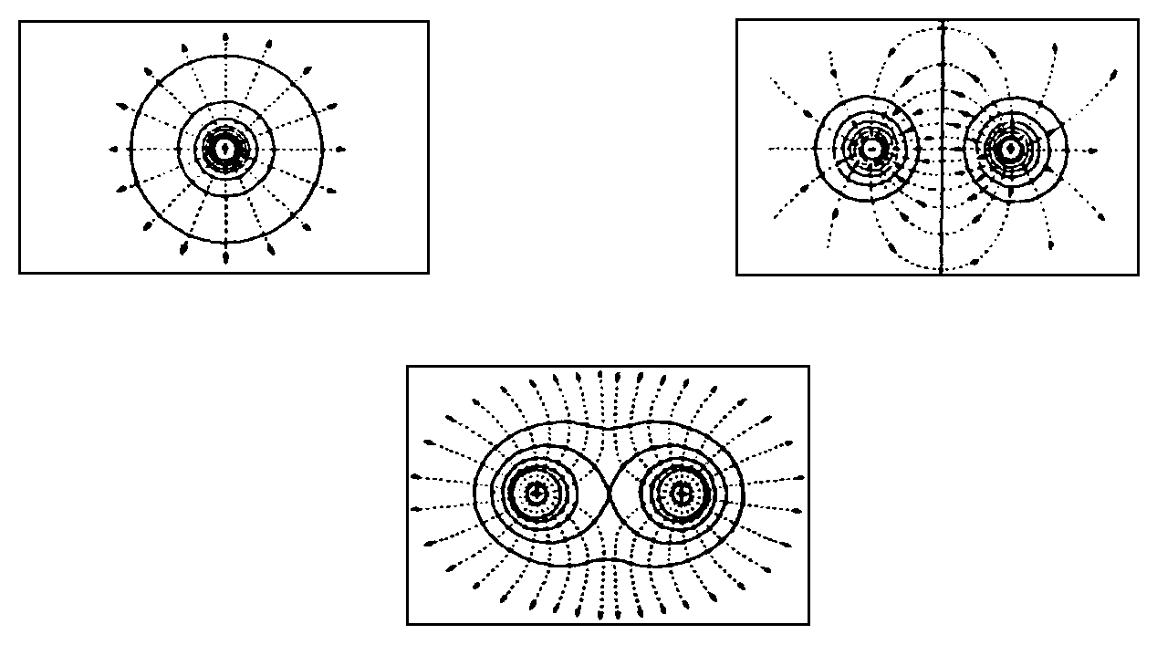

(c) two like charges

Charged Spheres
For a hollow or solid sphere any excess charge will be found on its outer surface.
The graphs show the variation of both electric field strength and electrostatic potential with distance for a sphere carrying an excess of positive charge.

The main points to remember are:
• the electric field is zero inside the sphere
• outside the sphere the electric field varies as the inverse square of distance from sphere; E α $\frac{1}{r2}$
• the potential has a constant (non-zero) value inside the sphere
• Outside the sphere the potential varies as the inverse of the distance from the sphere; V α $\frac{1}{r}$.

Graphs of Electric Field and Electrostatic Potential

If a sphere, of radius a, carries a charge of Q coulombs the following conditions apply:
Eoutside = $\frac{Q}{4peor2}$where r > a; E_{surface} = $\frac{Q}{4peoa2}$; and Einside = 0
Voutside = $\frac{1}{4peo} \frac{Q}{r}$ where r > a. Vsurface = Vinside = $\frac{1}{4peo} \frac{Q}{a}$.

Applications of Electrostatic Effects
There are a number of devices which use electrostatic effects, for example, copying machines, laser printers, electrostatic air cleaners, lightning conductors and electrostatic generators.

Movement of Charged Particles in Uniform Electric Fields

Charge moving perpendicular to the plates
The particle, mass m and charge Q, shown in the sketch opposite will experience an acceleration upwards due to an unbalanced electrostatic force.
Here the weight is negligible compared to the electrostatic force. The particle is initially at rest.
a = (acceleration uniform because E uniform)
E is only uniform if length l >> separation d.

Ek acquired by the particle in moving distance d = Work done by the electric force
change in Ek = F x displacement
mv2 - 0 = F x d where F = EQ
giving the speed at the top plate, v = notice that Ed also = V
Alternatively the equation for a charged particle moving through voltage V is $\frac{1}{2}$mv2 = QV and v =

Charge moving parallel to plates
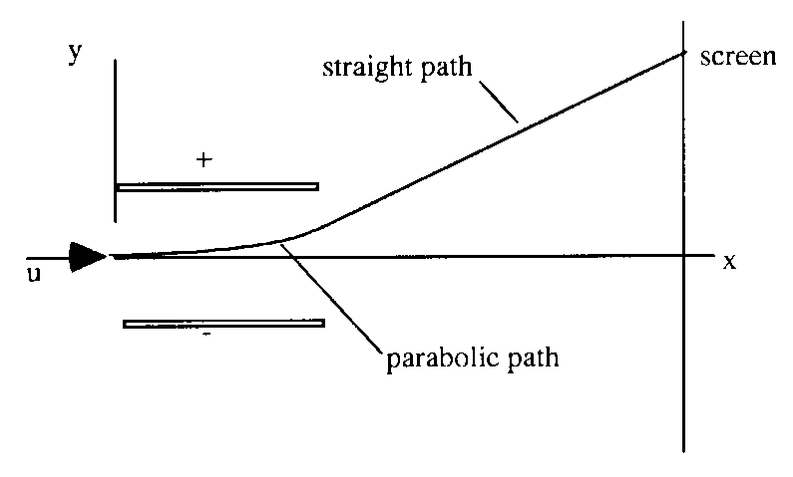 | Consider an electron, with initial speed u, entering a uniform electric field mid-way between the plates:  using s = ut + $\frac{1}{2}$at2  horizontally: x = ut  (no force in x direction)  vertically: y = $\frac{1}{2}$at2  (uy = 0 in y direction)  eliminating t: y = $\frac{1}{2}$a $\frac{x2}{u2}$  Now, a = $\frac{F}{m}$= $\frac{QE}{m}$= $\frac{eE}{m}$  Thus y = [$\frac{eE}{2mu2}$] . x2
Now since e, E, m and u are all constants we can say: y = (constant) . x2
This is the equation of a parabola. Thus the path of an electron passing between the parallel plates is a parabola, while the electron is within the plates. After it leaves the region of the plates the path of the electron will be a straight line.
(Note: there is no need to remember this formula. You can work out solutions to problems from the basic equations. This type of problem is similar to projectile problems).

Applications of electrostatic deflections, in addition to those mentioned previously:
• deflection experiments to measure charge to mass ratio for the electron; $\frac{e}{m}$
• the cathode ray oscilloscope.

Example - The Ink-Jet Deflection
The figure below shows the deflecting plates of an ink-jet printer. (Assume the ink drop to be very small such that gravitational forces may be neglected).
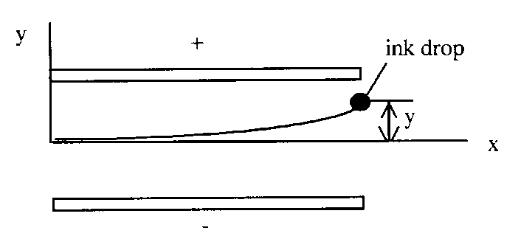
An ink drop of mass 1.3 x 10-10 kg, carrying a charge of 1.5 x 10-13 C enters the deflecting plate system with a speed u = 18 m s-1. The length of the plates is 1.6 x 10-2 m and the electric field between the plates is 1.4 x 106 N C-1.
Calculate the vertical deflection, y, of the drop at the far edge of the plates.

Solution
a = = = 1615 m s⁻²
t = = = 8.9 x 10⁻⁴ s
y = $\frac{1}{2}$at2 = $\frac{1}{2}$x 1615 x (8.9 x 10⁻⁴)²
y = 6.4 x 10⁻⁴ m
y = 6.4 mm

This method can be used for the deflection of an electron beam in a cathode ray tube.

Relativistic Electrons
You may have noted from Tutorial 3 that the velocity of an electron which accelerates through a potential difference of 1 x 106 V works out to be 6.0 x 108 m s-1. This is twice the speed of light! The equation used sets no limits on the speed of a charged particle - this is called a classical equation. The correct equation requires us to take Special Relativity effects into account.
The equation E = mc2 applies equally well to stationary and moving particles.
Consider a particle, charge Q, accelerated through a potential difference V.
It is given an amount of kinetic energy QV in addition to its rest mass energy (moc2), so that its new total energy (E) is moc2 + QV.

General relativistic equation
The general equation for the motion of a charged particle is given below.
mc² = m_{o}c² + QV where m =
If we take the voltage quoted above, 1 x 106 V, and use the relativistic equation we find that the speed of the electron works out to be 2.82 x 108 m s-1 or v = 0.94c. You can check this for yourself.

Relativistic effects must be considered when the velocity of a charged particle is more than 10% of the velocity of light.

Head-On Collision of Charged Particle with a Nucleus

In the situation where a particle with speed v and positive charge q has a path which would cause a head-on collision with a nucleus of charge Q, the particle may be brought to rest before it actually strikes the nucleus.
If we consider the energy changes involved we can estimate the distance of closest approach of the charged particle.
At closest approach change in Ek of particle = change in Ep of particle.

Position |  | Kinetic energy | Electrostatic potential energy
infinity | v  far from nucleus  + | mv2 | 0
closest approach |  | 0 | $\frac{qQ}{4peo}$$\frac{1}{r}$

Change in Ek =mv2 - 0 =mv2
Change in electrostatic Ep = $\frac{qQ}{4peo}$$\frac{1}{r}$ - 0 = $\frac{qQ}{4peo}$$\frac{1}{r}$
Change in Ek = change in electrostatic Ep
mv2 = $\frac{qQ}{4peo}$$\frac{1}{r}$
and rearranging r = $\frac{2qQ}{4peomv2}$

Example
Fast moving protons strike a glass screen with a speed of 2.0 x 106 m s-1. Glass is largely composed of silicon which has an atomic number of 14.
Calculate the closest distance of approach that a proton could make in a head-on collision with a silicon nucleus.

Solution
Using $\frac{1}{2}$mv2 = $\frac{qQ}{4peo}$. $\frac{1}{r}$ which gives r = $\frac{2qQ}{4peomv2}$and $\frac{1}{4peo}$= 9.0 x 109
here q = 1.6 x 10-19 C and Q = 14 x 1.6 x 10-19 C (i.e. equivalent of 14 protons)

r = 9.0 x 109 x $\frac{2 x 1.6 x 10-19 x 14 x 1.6 x 10-19}{1.67 x 10-27 x (2.0 x 106)2}$
r = 9.7 x 10-13 m.

Millikan's Oil-Drop Experiment (1910 - 1913)

If possible, view a simulation of this experiment before reading this note.

The charge on the electron was measured by Millikan in an ingenious experiment. The method involved accurate measurements on charged oil drops moving between two parallel metal plates, see below.

Tiny oil drops are charged as they leave the atomiser.

The drops quickly reach a steady speed and an accurate measurement of this speed allows a value for the radius of the drop to be calculated. From this radius the volume is found, and using the density of the oil, the mass of the drop is discovered. The drop can be kept in view by switching on and off the voltage between the plates. For the polarity shown above, negatively charged oil drops, can be held within the plates.

The second part of each individual experiment involved finding the p.d. needed to 'balance' the oil drop (gravitational force equal and opposite to the electric force).
Therefore mg = QE and E = $\frac{V}{d}$ giving $\boxed{Q = \frac{mgd}{V}}$

Analysis of results
Millikan and his assistants experimented on thousands of oil drops and when all these results were plotted it was obvious that all the charges were multiples of a basic charge. This was assumed to be the charge on the electron. Single electron charges were rarely observed and the charge was deduced from the gaps between 'clusters' of results where Q = ne (n = ±1, ±2, ±3 etc.)

Conclusions
• Any charge must be a multiple of the electronic charge, 1.6 x 10-19 C. Thus we say that charge is 'quantised', that is it comes in quanta or lumps all the same size.
• It is not possible to have a charge of, say, 2.4 x 10-19 C because this would involve a fraction of the basic charge.

ELECTROMAGNETISM

Introduction
Modern electromagnetism as we know it started in 1819 with the discovery by the Danish scientist Hans Oersted that a current-carrying wire can deflect a compass needle. Twelve years afterwards, Michael Faraday and Joseph Henry discovered (independently) that a momentary e.m.f. existed across a circuit when the current in a nearby circuit was changed. Also it was discovered that moving a magnet towards or away from a coil produced an e.m.f. across the ends of the coil. Thus the work of Oersted showed that magnetic effects could be produced by moving electric charges and the work of Faraday and Henry showed that an e.m.f. could be produced by moving magnets.

All magnetic phenomena arise from forces between electric charges in motion. Since electrons are in motion around atomic nuclei, we can expect individual atoms of all the elements to exhibit magnetic effects and in fact this is the case. In some metals like iron, nickel, cobalt and some rare earths these small contributions from atoms can be made to 'line up' and produce a detectable magnetic property. This property is known as ferromagnestism.

The Magnetic Field
As you have seen from gravitational and electrostatics work, the concept of a field is introduced to deal with 'action-at-a-distance' forces.

Permanent Magnets
It is important to revise the field patterns around some of the combinations of bar magnet. (You can confirm these patterns using magnets and iron filings to show up the field lines).
N
S
N
S
N
S

isolated bar magnet opposite poles adjacent
N
S
S
N

like poles adjacent

To establish which end of a bar magnet is the north (N) pole, float the magnet on cork or polystyrene in a bowl of water and the end which points geographically north is the 'magnetic north'. Similarly a compass needle, which points correctly towards geographic north, will point towards the magnetic south pole of a bar magnet. Thus a compass needle will show the direction of the magnetic field at a point which is defined to be from magnetic north to south.

Electromagnets
A magnetic field exists around a moving charge in addition to its electric field.
A charged particle moving across a magnetic field will experience a force.

Magnetic field patterns

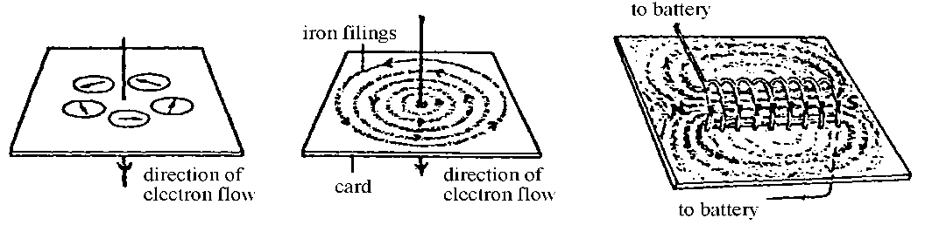  A straight wire  Before the current is switched on the compass needles will point north. | A coil (solenoid)  Notice the almost uniform field inside the coil.

Left hand grip rule
The direction of the magnetic field, (the magnetic induction, see below) around a wire is given by the left hand grip rule as shown below.
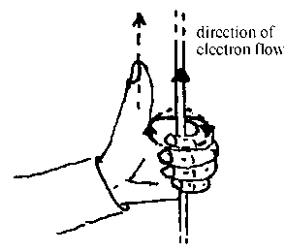  Sketch | Direction (Left Hand Grip Rule)
 | Grasp the current carrying wire in your left hand with your extended left thumb pointing in the direction of the electron flow in the wire. Your fingers now naturally curl round in the direction of the field lines.

Magnetic Induction
The strength of a magnetic field at a point is called the magnetic induction and is denoted by the letter B. The direction of B at any point is the direction of the magnetic field at that point.

Definition of the Tesla, the unit of magnetic induction
One tesla (T) is the magnetic induction of a magnetic field in which a conductor of length one metre, carrying a current of one ampere perpendicular to the field is acted on by force of one newton.

The magnitude of the force on a current carrying conductor in a magnetic field
The force on a current carrying conductor depends on the magnitude of the current, the magnetic induction and the length of wire inside the magnetic field. It also depends on the orientation of the wire to the lines of magnetic field.
F = IlBsinθ | where θ is the angle between the wire and the direction of the magnetic field
The force is maximum when the current is perpendicular to the magnetic induction.

The direction of the force on a current carrying conductor in a magnetic field
The direction of the force is perpendicular to the plane containing the wire and the magnetic induction. When θ is 90º the force is perpendicular to both the current and the magnetic induction.

Right hand rule: using the right hand hold the thumb and first two fingers at right angles to each other. Point the first finger in the direction of the field, the second finger in the direction of the electron flow, then the thumb gives the direction of the thrust, or force.
Note: the direction of the force will reverse if the current is reversed.

Example
A wire, which is carrying a current of 6.0 A, has 0.50 m of its length placed in a magnetic field of magnetic induction 0.20 T. Calculate the size of the force on the wire if it is placed:

(a) at right angles to the direction of the field,
(b) at 45° to the to the direction of the field and,
(c) along the direction of the field (i.e. lying parallel to the field lines).

Solution

(a) F = IlBsinθ = IlBsin90°
F = 6.0 x 0.50 x 0.20 x 1
F = 0.60 N
(b) F = IlBsinθ = IlBsin45°
F = 6.0 x 0.5 x 0.20 x 0.707
F = 0.42 N
(c) if θ = 0° sinθ = 0 F = 0 N

Magnetic induction at a distance from a long current carrying wire
The magnetic induction around an "infinitely" long current carrying conductor placed in air can be investigated using a Hall Probe*(see footnote). It is found that the magnetic induction B varies as I, the current in the wire, and inversely as r, the distance from the wire.
$\boxed{B = \frac{moI}{2pr}}$where μo is the permeability of free space.
μo serves a purpose in magnetism very similar to that played by εo in electrostatics. The definition of the ampere fixes the value of μo exactly.

*Footnote. A Hall Probe is a device based around a thin slice of n or p-type semiconducting material. When the semiconducting material is placed in a magnetic field, the charge carriers (electrons and holes) experience opposite forces which cause them to separate and collect on opposite faces of the slice. This sets up a potential difference - the Hall Voltage. This Hall Voltage is proportional to the magnetic induction producing the effect.
Force per unit length between two parallel wires

Two adjacent current carrying wires will influence one another due to their magnetic fields.

For wires separated by distance r , the magnetic induction at wire 2 due to the current in wire 1 is: B1 = $\frac{moI1}{2pr}$
Thus wire 2, carrying current I2 will experience a force:
F1→2 = I2 l B1 along length l

Substitute for B1 in the above equation:
F1→2 = I2 l $\frac{moI1}{2pr}$
= $\frac{moI1I2}{2pr}$
is known as the force per unit length.

Direction of force between two current carrying wires
Wires carrying current in the same direction will attract.
Wires carrying currents in opposite directions will repel.
This effect can be shown by passing fairly large direct currents through two strips of aluminium foil separated by a few millimetres. The strips of foil show the attraction and repulsion more easily if suspended vertically. A car battery could be used as a supply.

Definition of the Ampere
A current of one ampere is defined as the constant current which, if in two straight parallel conductors of infinite length placed one metre apart in a vacuum, will produce a force between the conductors of 2 x 10-7 newtons per metre.
To confirm this definition apply = $\frac{moI1I2}{2pr}$to this situation.

Thus I1 and I2 both equal 1 A, r is 1 m and μo = 4π x 10-7 N A-2.
= $\frac{4p x 10-7 x 1 x 1}{2p x 1}$= 2 x 10-7 N m-1.
Equally, applying this definition fixes the value of μo = 4π x 10-7 N A-2.
We will see later that the usual unit for μo is H m⁻¹ which is equivalent to N A-2.

Comparing Gravitational, Electrostatic and Magnetic Fields

Experimental results and equations | Field concept
(a) Two masses exert a force on each other.  m₁  m₂  r  F  F  m₁  m₂  Force, F = | Either mass is the source of a gravitational field and the other mass experiences a force due to that field.  At any point, the gravitational field strength g (N kg-1) is the force acting on a one kg mass placed at that point.
(b) Two stationary electric charges exert a force on each other.  + Q₁  + Q₂  + Q₂  + Q₁  r  F  Force, F = | Either charge is the source of an electrostatic field and the other charge experiences a force due to that field.  At any point, the electric field strength E  (N C⁻¹) is the force acting on +1 C of charge placed at that point.
(c) Two parallel current-carrying wires exert a force on each other.  F  F  r  I₁  I₂  I₁  B  I₂ experiences the magnetic induction B of I₁  Force for one metre of wire, F is given by F =  The force between such wires is due to the movement of charge carriers, the current. | Either current-carrying wire is the source of a magnetic field and the other current-carrying wire experiences a force due to that field.  At any point, the magnetic induction B is given by B = $\frac{moI}{2pr}$.

Motion in a magnetic field

Magnetic Force on Moving Charges
As mentioned previously, the force on a wire is due to the effect that the magnetic field has on the individual charge carriers in the wire. We will now consider magnetic forces on charges which are free to move through regions of space where magnetic fields exist.

Consider a charge q moving with a constant speed v perpendicular to a magnetic field of magnetic induction B.
B
charge q moving with velocity v

We know that F = IlBsinθ.
Consider the charge q moving through a distance l. (The italic l is used to avoid confusion with the number one.)
Then time taken t = and current I == giving l I = qv.
Substituting into F = IlBsinθ, with sinθ = 1 since θ = 90º, gives:

F = qvB

The direction of the force is given by the same right hand rule mentioned for the force on a current carrying conductor. You should be able to state the direction of the force for both positive and negative charges.

Note: If the charge q is not moving perpendicular to the field then the component of the velocity v perpendicular to the field must be used in the above equation.

Motion of Charged Particles in a Magnetic Field
The direction of the force on a charged particle in a magnetic field is perpendicular to the plane containing the velocity v and magnetic induction B. The magnitude of the force will vary if the angle between the velocity vector and B changes. The examples below illustrate some of the possible paths of a charged particle in a magnetic field.

Charge moving parallel or antiparallel to the magnetic field
The angle θ between the velocity vector and the magnetic field direction is zero hence the force
F = 0. The path is a straight line.
v
B

v

The direction of the charged particle is not altered.

Charge moving perpendicular to the magnetic field
If the direction of v is perpendicular to B, then θ = 90° and sin θ = 1.
F = qvB
The direction of the force F is perpendicular to the plane containing v and B.
A particle travelling at constant speed under the action of a force at right angles to its path will move in a circle. This central force is studied in the Mechanics unit.

The sketch below shows this situation. (Remember an X indicates that the direction of the field is 'going away' from you 'into the paper'.)
+q
v
r
F
X

X
X
X
X
X
X
X
X
X
X
X
X
X
X
X
X
X
X
X

The charged particle will move in a circle, of radius r. The magnetic force supplies the central acceleration, and maintains the circular motion.
Thus: qvB = $\frac{mv2}{r}$ giving the radius
The frequency of the rotation can be determined using angular velocity ω = $\frac{v}{r}$and ω = 2πf and substituting in the above equation, giving f = .

Charge moving at an angle to the magnetic field
If the velocity vector v makes an angle θ with B, the particle moves in a helix (spiral), the axis of which is parallel to B.

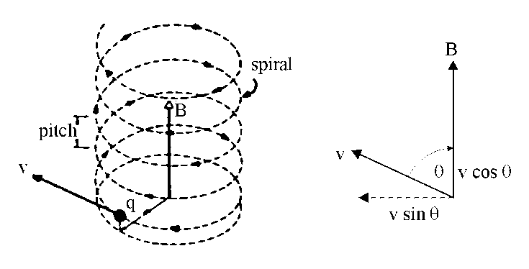
The spiral is obtained from the sum of two motions:

a uniform circular motion, with a constant speed v sin θ in a plane perpendicular to the direction of B.
a uniform speed of magnitude v cos θ along the direction of B

The frequency of the rotation is f = giving the period T = , the time between similar points. The pitch p of the helix, shown on the sketch, is the distance between two points after one period and is given by p = v cos θ T .
Notes
• The orbit frequency does not depend on the speed v or radius r. It is dependent on the charge to mass ratio ( $\frac{q}{m}$) and the magnetic induction B.
• Positive charges will orbit in the opposite sense to negative charges, force F reversed.
• Particles, having the same charge but different masses, e.g. electrons and protons, entering the magnetic field along the same line will have different radii of orbit.
• The kinetic energy of the particle in orbit is a constant because its orbital speed is constant. The magnetic force does no work on the charges.

Deflections of charged particles in a bubble chamber
The diagram below is a sketch of a photograph taken in a bubble chamber in which there is a strong magnetic field. The detecting medium is liquid hydrogen. The ionisation associated with fast moving charged particles leaves a track of hydrogen gas (bubbles). The magnetic field is perpendicular to the container. This allows positive and negative particles to separate and be measured more easily.
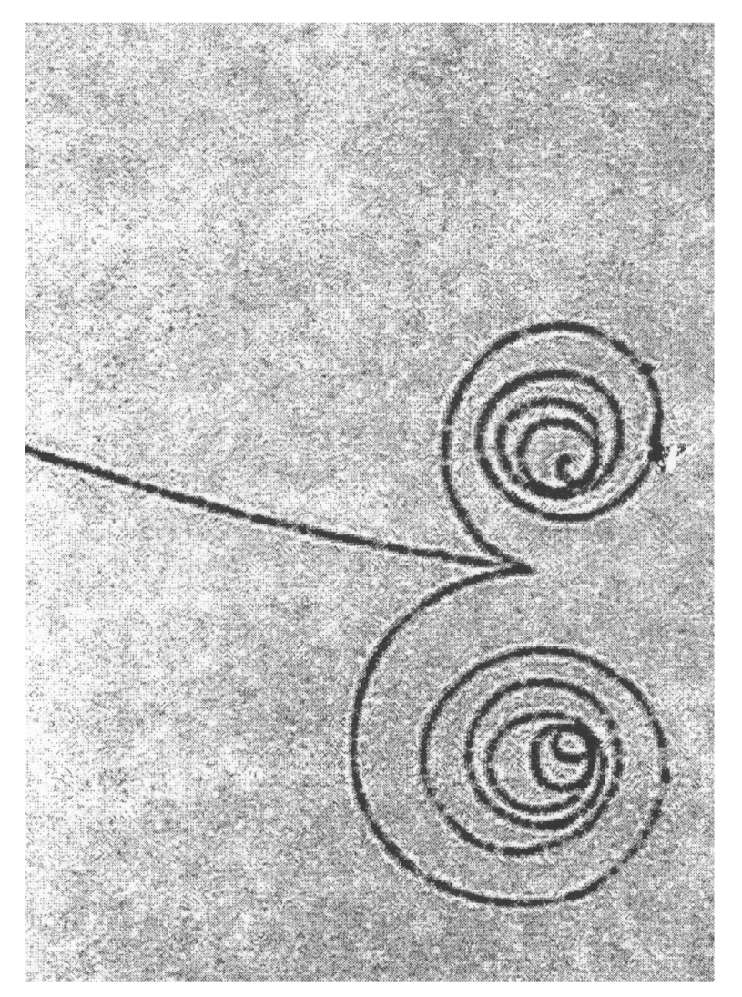
The tracks of two particles in a bubble chamber, one electron and one positron are created by an incoming gamma ray photon, γ.

Notice the nature and directions of the deflections.

As the particles lose energy their speed decreases and the radius decreases.

Note: Problems involving calculations on the motion of charged particles in magnetic fields will involve non-relativistic velocities only. Although in many practical applications electrons do travel at high velocities, these situations will not be assessed.

Applications of Electromagnetism
When electric and magnetic fields are combined in certain ways many useful devices and measurements can be devised.

The Cyclotron
This device accelerates charged particles such as protons and deuterons. Scientists have discovered a great deal about the structure of matter by examining high energy collisions of such charged particles with atomic nuclei.
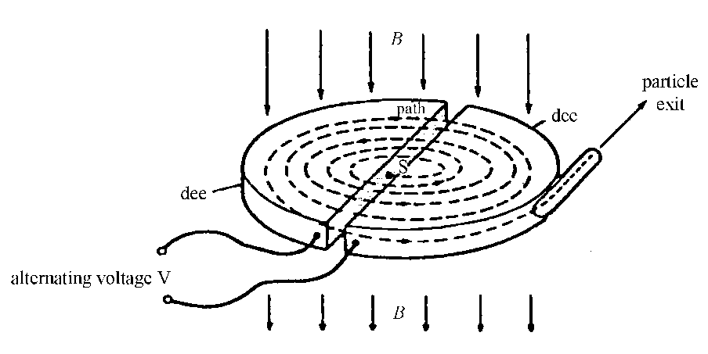 | The cyclotron comprises two semi-circular d-shaped structures ('dees').  There is a gap between the dees across which there is an alternating voltage.  Towards the outer rim there is an exit hole through which the particle can escape; radius = R. From this point the particle is directed towards the target.
Charged particles are generated at the source S and allowed to enter the cyclotron.
Every time an ion crosses the gap between the dees it gains energy, qV, due to the alternating voltage. For this to happen in step, the frequency of the a.c. must be the same as the cyclotron frequency, f.
f = $\frac{qB}{2pm}$ and r = $\frac{mv}{qB}$
Thus, radius increases as velocity increases. At R, velocity will be a maximum.
vmax = $\frac{qBR}{m}$ and Ek on exit = $\frac{1}{2}$mv2 = $\frac{q2B2R2}{2m}$

The Velocity Selector and Mass Spectrometer
Charged particles can be admitted to a region of space where electric and magnetic fields are 'crossed', i.e. mutually perpendicular. Particles can only exit via a small slit as shown below.
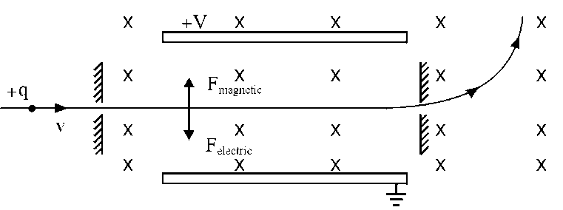 | Magnetic field is uniform and is directed 'into the paper'.  Electric field, E = $\frac{V}{d}$  Electric deflecting force, Fe = qE  Beyond the exit slit, the particles only experience a magnetic field.
Magnetic force, Fm = qvB and its direction is as shown.
If particle is undeflected; Fm = Fe (in magnitude) thus qvB = qE and v = .
Hence only charges with this specific velocity will be selected. Note that this expression is independent of q and m. Thus this device will select all charged particles which have this velocity.

In the mass spectrometer ions are selected which have the same speed. After leaving the velocity selector they are deflected by the magnetic field and will move in a circle of radius, as shown previously. The ions tend to have lost one electron so have the same charge. Since their speed is the same the radius of a particular ion will depend on its mass. Thus the ions can be identified by their deflection.

JJ Thomson's Experiment to Measure the Charge to Mass Ratio for Electrons
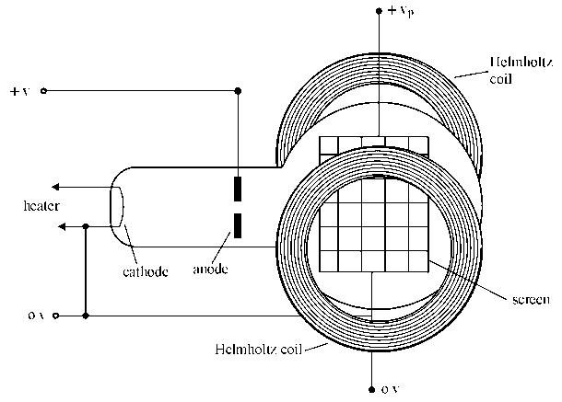
This method uses the crossed electric and magnetic fields mentioned above.
plates of length L  electrons enter at velocity v  deflection y  apparatus | magnetic field only
The electric field E is applied by the p.d. V_{p} across the plates. The separation of the plates is d and their length is L. The current in the Helmholtz coils is slowly increased until the opposite magnetic deflection cancels out the electric deflection and the electron beam appears undeflected. This value of current I is noted.
Using the magnetic field only, the deflection y of the beam is noted.

For the undeflected beam: Fmag = Felec thus qvB = qE
giving v = $\frac{E}{B}$ ----------- (1)
For the magnetic field only, the central force is provided by the magnetic field
evB = where r is the radius of curvature
giving $\frac{e}{m}$= ------------ (2)
Eliminate v between equations (1) and (2).
$\frac{e}{m}$= = using E =

The plate separation d and V_{p} are easily measured, r is determined from the deflection y using r = (L²+y²)/2y. B is found using the current I and the Helmholtz coil relation, (B = $\frac{8moNI}{\sqrt{125} r}$where N is the number of turns and r the radius of the coils).

Capacitors

Capacitors in d.c. circuits

Charging

Consider the following circuit:

When the switch is closed the current flowing in the circuit and the voltage across the capacitor behave as shown in the graphs below.

Discharging
Consider the circuit opposite in which
the capacitor is fully charged:

If the cell is shorted out of the circuit
the capacitor will discharge.

While the capacitor is discharging, the current in the circuit and the voltage across the capacitor behave as shown in the graphs below:

Although the current/time graph has the same shape as that during charging, the currents in each case are flowing in opposite directions. The discharging current decreases because the pd across the plates decreases as charge leaves them.

A capacitor stores charge, but unlike a cell it has no capability to supply more energy. When it discharges, the energy stored will be used in the circuit, e.g. in the above circuit it would be dissipated as heat in the resistor.

Factors affecting the rate of charge and discharge

The time taken for a capacitor to charge is controlled by the resistance of the resistor R (because it controls the size of the current, i.e. the charge flow rate) and the capacitance of the capacitor (since a larger capacitor will take longer to fill and empty). As an analogy, consider charging a capacitor as being like filling a jug with water. The size of the jug is like the capacitance and the resistor is like the tap you use to control the rate of flow.

The values of R and C can be multiplied together to form what is known as the time constant. Can you prove that R × C has units of time, seconds? The time taken for the capacitor to charge or discharge is related to the time constant.

Large capacitance and large resistance both increase the charge or discharge time.

The I/t graphs for capacitors of different value during charging are shown below:
current
0
time
small resistor
large resistor
current
0
time
large capacitor
small capacitor

The effect of capacitance on charging current The effect of resistance on charging current

Note that since the area under the I/t graph is equal to charge, for a given capacitor the area under the graphs must be equal.

Time constant

The time it takes a capacitor to discharge through a resistor depends on capacitance C of the capacitor and the resistance R of the resistor.

When a capacitor C is charged to a p.d. V₀ it stores a charge Q₀ since Q₀ = CV₀. When the capacitor is discharged through resistor R the current I = V/R where V is the p.d. across C.

The current at time t during the discharge is also given by I = −dQ/dt. The negative sign indicates that Q decreases with time.

Since I = V/R

$-\frac{dQ}{dt}= \frac{Q}{CR}$

$\int_{Q0}^{Q}{\frac{dQ}{Q}}= -\frac{1}{CR}\int_{0}^{t}{dt}$

${\left[lnQ\right]}_{Q0}^{Q}= -\frac{1}{CR}{\left[t\right]}_{0}^{t}$

$ln\frac{Q}{Q_{0}}=-\frac{t}{CR}$

$Q=Q_{0}e^{-t/CR}$

Hence charge Q decreases exponentially with time t. Since the p.d. V across C is directly proportional to Q it follows that $V=V_{0}e^{-t/CR}$.

In addition, since the current I in the circuit is directly proportional to V, then $I=I_{0}e^{-t/CR}$ where I₀ is the initial current value and I₀ = V₀/R.

From $Q=Q_{0}e^{-t/CR}$, Q decreases from Q₀ to half its value Q₀/2 in a time t₁ given by
$e^{-t/CR}= \frac{1}{2}=2^{-1}$
$t_{1}=CR ln2$

Similarly Q decreases from Q₀/2 to Q₀/4 in time t₁. Thus the time for a charge to decrease from any value to half of that value is always the same.

The time constant T of the discharge circuit is defined as CR seconds, where C is the capacitance in farads and R is the resistance in ohms.

Hence if t = T = CR then
$Q=Q_{0}e^{-1}=\frac{1}{e}Q_{0}$
current
0
time
Q₀

0.37Q₀
t₁
Therefore the time constant can be defined as the time for the charge to decay to 1/e times its initial value. Since e = 2.72. 1/e = 0.37. If the time constant is high, then the charge will decay slowly, if the time constant is small, then the charge will decay rapidly.

An uncharged capacitor C is charged through a resistor R by a battery of e.m.f. E and negligible internal resistance. Initially the capacitor has no charge and hence no p.d. across it. Therefore the initial current I₀ = E/R. If I is the current flowing after time t and the p.d. across the capacitor is V_{C} then

$I=\frac{E-V_{C}}{R}$

But I = dQ/dt and V_{C} = Q/C so

$\frac{dQ}{dt}=\frac{E-Q/C}{R}$

$CR\frac{dQ}{dt}=CE-Q=Q_{0}-Q$

where Q₀ = CE = the final charge on C when no current flows.

Integrating

$\frac{1}{CR}\int_{0}^{t}{dt}=\int_{0}^{Q}{\frac{dQ}{Q_{0}-Q}}$

$\frac{t}{CR}=-\left(ln\left[Q_{0}-Q\right]-lnQ_{0}\right)$

$\frac{t}{CR}=-ln\left(\frac{Q_{0}-Q}{Q_{0}}\right)$

$e^{-t/{CR}}=\frac{Q_{0}-Q}{Q_{0}}$

$Q=Q_{0}\left(1-e^{{-t}/{CR}}\right)$

Where the time constant CR is large then it takes a long time for the capacitor to reach its final charge, that is the capacitor charges slowly. If the time constant is small the capacitor charges quickly. The p.d. across the capacitor V_{C} shows the same variation as Q since V_{C} ∝ Q.

current
0
time
Q₀

0.63Q₀
t₁

Capacitors in a.c. circuits

Consider the following circuit:

The signal generator is set to a low frequency and the potential difference across the resistor to a known voltage. The current in the circuit is then measured using the ammeter.

The frequency of the signal generator is altered but the potential difference kept constant and the current measured.

0

The current in the resistive remains constant with frequency with I = V/R. Resistors are unaffected by the frequency of the supply and behave in the same way in both d.c. and a.c. circuits.

The resistor is replaced with a capacitor and the experiment repeated.

0

The current in the circuit increases in direct proportion to the frequency.
The opposition to current in a capacitive circuit is the capacitive reactance, X_{C}.

Current in a capacitive circuit is determined by I = V/X_{C} and therefore X_{C} = V/I. X_{C} is measured in ohms, the same as resistance, but it is not appropriate to refer to the opposition to current in a capacitive circuit as a resistance.

I ∝ f and X_{C} ∝ 1/I therefore X_{C} ∝ 1/f.

X_{C} = 1 / 2πfC

Inductors

Electromagnetic Induction
Our present day large scale production and distribution of electrical energy would not be economically feasible if the only source of electricity we had came from chemical sources such as dry cells. The development of electrical engineering began with the work of Faraday and Henry. Electromagnetic induction involves the transformation of mechanical energy into electrical energy.

A Simple Experiment on Electromagnetic Induction
Apparatus: coil, magnet, centre-zero meter
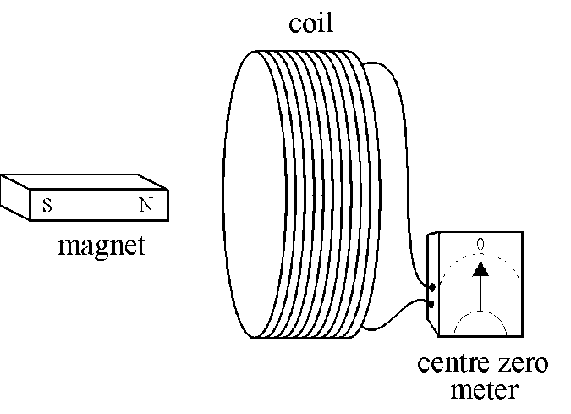 | Observations  When the magnet is moving into coil - meter needle moves to the right (say). We say a current has been induced.  When the magnet is moving out of the coil - induced current is in the opposite direction (left).  Magnet stationary, either inside or outside the coil - no induced current.  When the magnet is reversed, i.e. the south pole is nearest the coil, - induced current reversed.  Moving the magnet faster makes the induced current bigger.
Note: Moving the coil instead of the magnet produces the same effect. It is the relative movement which is important.

The induced currents that are observed are said to be produced by an induced electromotive force, e.m.f. This electrical energy must come from somewhere. The work done by the person pushing the magnet at the coil is the source of the energy. In fact the induced current sets up a magnetic field in the coil which opposes the movement of the magnet.

Summary
The size of the induced e.m.f. depends on:
- the relative speed of movement of the magnet and coil
- the strength of the magnet
- the number of turns on the coil.

Growth and Decay of Current in an Inductive Circuit.

R  S₂  S₁  _  +  L  A  The circuit symbol is  V_{s} | An inductor is a coil of wire wound on a soft iron core.  An inductor is denoted by the letter L.  An inductor has inductance, see later.

Growth of current  time  large inductance  small inductance  current  V_{s}  R | Switch S₂ is left open.  When switch S₁ is closed the ammeter reading rises slowly to a final value, showing that the current takes time to reach its maximum steady value. With no current there is no magnetic field through the coil. When S₁ is closed the magnetic field through the coil will increase and an e.m.f. will be generated to prevent this increase. The graph opposite shows how the circuit current varies with time for inductors of large and small inductance.
Decay of current  V_{s}  R  large inductance  small inductance  time  current | After the current has reached its steady value S₂ is closed, and then S₁ is opened. The ammeter reading falls slowly to zero. The current does not decay immediately because there is an e.m.f. generated which tries to maintain the current, that is the induced current opposes the change. The graph opposite shows how the circuit current varies with time for inductors of large and small inductance.

Notes
- For both the growth and decay, the induced e.m.f. opposes the change in current.
- For the growth of current, the current tries to increase but the induced e.m.f. acts to prevent the increase. It takes time for the current to reach its maximum value. Notice that the induced e.m.f. acts in the opposite direction to the circuit current.
- For the decay of current the induced e.m.f acts in the same direction as the current in the circuit. Now the induced e.m.f. is trying to prevent the decrease in the current.

Experiment to show build up current in an inductive circuit
R  S  _  +  B₂  L  B₁ | The switch is closed and the variable resistor adjusted until the lamps B₁ and B₂ have the same brightness.  The supply is switched off.  The supply is switched on again and the brightness of the lamps observed.

Lamp B₂ lights up immediately. There is a time lag before lamp B₁ reaches its maximum brightness. An e.m.f. is induced in the coil because the current in the coil is changing. This induced e.m.f. opposes the change in current, and it is called a back e.m.f. It acts against the increase in current, hence the time lag.
The experiment is repeated with an inductor of more turns. Lamp B₁ takes longer to light fully. If the core is removed from the inductor, lamp B₁ will light more quickly.

Induced e.m.f. when the current in a circuit is switched off
When the current in a circuit, containing an inductor, is switched off the magnetic field through the inductor will fall very rapidly to zero. There will be a large change in the magnetic field leading to a large induced e.m.f. For example a car ignition coil produces a high e.m.f. for a short time when the circuit is broken.

Lighting a neon lamp
The 1.5 V supply in the circuit below is insufficient to light the neon lamp. A neon lamp needs about 80 V across it before it will light.

1.5 V | The switch is closed and the current builds up to its maximum value. When the switch is opened, the current rapidly falls to zero. The magnetic field through the inductor collapses (changes) to zero producing a very large induced e.m.f. for a short time. The lamp will flash.

Self inductance
A current in a coil sets up a magnetic field through and round the coil. When the current in the coil changes the magnetic field changes. A changing magnetic field induces an e.m.f across the coil. This is called a self induced e.m.f. because the coil is inducing an e.m.f. in itself due to its own changing current.

The coil, or inductor as it is called, is said to have the property of inductance, L.
The inductance of an inductor depends on its design. Inductance is a property of the device itself, like resistance of a resistor or capacitance of a capacitor. An inductor will tend to have a large inductance if it has many turns of wire, a large area and is wound on an iron core.

Circuit symbols for an inductor
An inductor is a coil of wire which may be wound on a magnetic core, e.g. soft iron, or it may be air cored.

Inductor with a core | Inductor without a core

Conservation of Energy and Direction of Induced e.m.f.
In terms of energy the direction of the induced e.m.f. must oppose the change in current. If it acted in the same direction as the increasing current we would be able to produce more current for no energy! This would violate the conservation of energy.

The source has to do work to drive the current through the coil. It is this work done which appears as energy in the magnetic field of the coil and can be obtained when the magnetic field collapses, e.g. the large e.m.f. generated for a short time across the neon lamp.

Lenz's Law.
Lenz’s laws summarises this. The induced e.m.f. always acts in such a direction as to oppose the change which produced it. Anything which causes the magnetic field in a coil to change will be opposed.

An inductor is sometimes called a ‘choke’ because of its opposing effects.

However it must be remembered that when the current decreases the effect of an inductor is to try and maintain the current. Now the induced e.m.f. acts in the same direction as the current.

Magnetic flux - an aside to clarify terminology
Magnetic flux may be thought of as the number of lines of magnetic field which pass through a coil.
Large magnetic flux,
many lines through the coil
Small magnetic flux, only a few lines through the coil

Faradays laws refer to the magnetic flux φ rather than the magnetic induction B. His two laws are given below.
1. When the magnetic flux through a circuit is changing an e.m.f. is induced.
2. The magnitude of the induced e.m.f. is proportional to the rate of change of the magnetic flux.

Magnitude of the induced e.m.f.
The self-induced e.m.f. E in a coil when the current I changes is given by
E = -L | where L is the inductance of the coil.
The negative sign indicates that the direction of the e.m.f. is opposite to the change in current.

The inductance of an inductor can be determined experimentally by measuring the e.m.f. and rate of change of current, .

Definition of Inductance
The inductance L of an inductor is one henry (H) when an e.m.f. of one volt is induced across the ends of the inductor when the current in the inductor changes at a rate of one ampere per second.

A comment on units
The unit for permeability μ_{o} was stated to be N A⁻² with a usual unit of H m⁻¹. From the above formula, in terms of units, we can see that the e.m.f (joules per coulomb)
J C⁻¹ = H A s⁻¹ which is N m (A s)⁻¹ = H A s⁻¹
giving N m A⁻¹ s⁻¹ = H A s⁻¹ and N A⁻² = H m⁻¹ (the s⁻¹ cancels)

Energy stored by an Inductor
In situations where the current in an inductor is suddenly switched off large e.m.f.s are produced and can cause sparks. At the moment of switch off the change in current is very large. The inductor tries to maintain the current as the magnetic field collapses and the energy stored by the magnetic field is given up. A magnetic field can be a source of energy. To set up the magnetic field work must have been done.

Equation for the energy stored in an inductor
For an inductor with a current I the energy stored is given by the equation below:

Energy = L I²

where L is the inductance of the inductor and I the steady current.

Example
An inductor is connected to a 6.0 V direct supply which has a negligible internal resistance. The inductor has a resistance of 0.8 Ω. When the circuit is switched on it is observed that the current increases gradually. The rate of growth of the current is 200 A s-1 when the current in the circuit is 4.0 A.
L
resistance of inductor 0.8 Ω
_
+
6 V

(a) Calculate the induced e.m.f. across the coil when the current is 4.0 A.
(b) Hence calculate the inductance of the coil.
(c) Calculate the energy stored in the inductor when the current is 4.0 A.
(d) (i) When is the energy stored by the inductor a maximum?
(ii) What value does the current have at this time?

Solution
(a) Potential difference across the resistive element of the circuit V = I R
= 4 x 0.8 = 3.2 V
Thus p.d. across the inductor = 6.0 - 3.2 = 2.8 V
(b) Using E = - L $\frac{dI}{dt}$gives L = $\frac{2.8}{200}$= 0.014 H = 14 mH
(c) Using E = $\frac{1}{2}$L I2 = 0.5 x 0.014 x 4 x 4 = 0.11 J
(d) (i) The energy will be a maximum when the current reaches a steady value.
(ii) Imax = = $\frac{6.0}{0.8}$= 7.5 A

Inductors in a.c. circuits
In an a.c. circuit the current is continually changing. This means that the magnetic field through the inductor is continually changing. Hence an e.m.f. is continually induced in the coil.

Consider the applied alternating voltage at the point in the cycle when the voltage is zero. As the current tries to increase the induced e.m.f. will oppose this increase. Later in the cycle as the voltage decreases the current will try to fall but the induced e.m.f. will oppose the fall. The induced e.m.f. produced by the inductor will continually oppose the current.

If the frequency of the applied voltage is increased then the rate of change of current increases. The magnitude of the induced e.m.f. will also increase. Hence there should be a greater opposition to the current at a higher frequency.

Frequency response of inductor
∼  A | An inductor is connected in series with an alternating supply of variable frequency and constant amplitude.  Readings of current and frequency are taken.

As the frequency is increased the current is observed to decrease. The opposition to the current is greater at the higher frequencies. Graphs of current against frequency and current against 1/frequency are shown below.
current
1/frequency
0
0
current
frequency

Note: these graphs show the inductive effects only. Considering the construction of an inductor, it is likely that the inductor has some resistance. A 2400 turns coil has a resistance of about 80 Ω. The opposition to the current at ‘zero’ frequency will be the resistance of the inductor. In practice if readings were taken at low frequencies, the current measured would be a mixture of the inductive and resistive effects.

An inductor can be used to block a.c. signals while transmitting d.c. signals, because the inductor produces large induced e.m.f.s at high frequencies.
For a capacitor in an a.c. circuit the current increases when the frequency increases. The inductor has the opposite effect to a capacitor.

Reactance
The reactance of a capacitor or an inductor is its opposition to alternating current.
The resistance of a resistor is given by R = .
The reactance of an inductor or capacitor is given by X = (X_{L} or X_{C} respectively).

The opposition of a capacitor, the capacitive reactance, decreases as the frequency increases. At high frequencies there is a greater transfer of charge per second on and off the capacitor plates. For an inductor, the inductive reactance increases with frequency. At higher frequencies there is a larger induced e.m.f. opposing the current.

Current in an inductive circuit is determined by I = V/X_{L} and therefore X_{L} = V/I. X_{L} is measured in ohms, the same as resistance, but it is not appropriate to refer to the opposition to current in a capacitive circuit as a resistance.

I ∝ 1/f and X_{L} ∝ 1/I therefore X_{L} ∝ f.

X_{L} = 2πfC

In inductive and capacitive circuits reactances and resistance cannot be added arithmetically. There are phase differences between inductive and capacitive reactances and resistances and therefore vector addition must be used. The total impedance Z, measured in ohms, in an a.c. circuit is given by:

$Z= \sqrt{{\left(X_{L}-X_{C}\right)}^{2}+R^{2}}$

Uses of inductors and capacitors in a.c. circuits

The circuit below shows a capacitor and inductor in series with an alternating supply.

∼
L
C
V_{L}
V_{C}

At low frequencies the opposition to the current by the inductor is low, so the p.d across L will be low. At low frequencies the opposition to the current by the capacitor is high so the p.d. across C will be high. At low frequencies X_{L}<X_{C}.

At high frequencies, the reverse is the case. The p.d. across the inductor V_{L} will be the higher than the p.d. across the capacitor. At high frequencies X_{L}>X_{C}.

This circuit could be used to filter high and low frequency signals.

Cross-over Networks in Loudspeakers
C₁
LS₁
LS₂
L
C₂
Capacitor C₁ allows high frequency signals to pass to loudspeaker LS₁.

High frequency signals can also pass more easily through capacitor C₂ than loudspeaker LS₂.

Low frequency signals are ‘blocked’ by C₁ and C₂ but pass easily through inductor L to loudspeaker LS₂.

Capacitors in Radio Circuits

L
C₁
C₂
aerial
diode (decoder)
to amplifier

Capacitor C₁ is a variable capacitor, which when used in conjunction with inductor L, allows the radio to be tuned to one particular radio frequency. Capacitor C₂ allows the high frequency radio carrier signal to flow to earth but ‘blocks’ the low frequency audio signal which must then pass on to the amplifier and loudspeaker of the radio.

Amplifier Bias Network
+V_{s}
V_{in}
0 V
V_{out}
When an a.c. signal is to be amplified by a simple transistor amplifier the a.c. signal should be input to the transistor via a capacitor.

The capacitor will allow the a.c. signal to pass but ‘block’ any unwanted d.c. signal.

The transformer

The principle of operation of the transformer can be given in terms of induced e.m.f.

S
a.c.
ammeter
primary coil
secondary coil
a.c. supply
soft iron core
S
centre zero meter
primary coil
secondary coil
d.c. supply
soft iron core

When S is closed, the meter needle ‘kicks’ momentarily then returns to zero. When the current is steady the meter reads zero. When S is opened, the meter needle kicks briefly in the opposite direction and returns to zero.  A changing magnetic field is produced in the coil when the current changes. This changing magnetic field will produce an induced e.m.f. during this short time. However when the current is steady, there is no changing field hence no induced e.m.f. | With an a.c. supply the current is continually changing. This sets up a continually changing magnetic field in the soft iron core. Hence an induced e.m.f. is produced in the secondary coil.  From the conservation of energy the direction of the induced e.m.f. will oppose the change which sets it up. Hence the direction of a current in the secondary, at any time, will always be in the opposite direction to the current in the primary.

We can now understand why a transformer only operates with an alternating supply.
The transformer is an example of mutual inductance.
The unification of electricity and magnetism

In the 1860s James Clerk Maxwell unified electricity and magnetism using four equations. One of the outcomes of these equations was the prediction of electromagnetic waves.

Electromagnetic waves have both electric and magnetic field components which oscillate in phase, perpendicular to each other and to the direction of energy propagation.

The diagram below shows a 3-dimensional picture of such a wave.
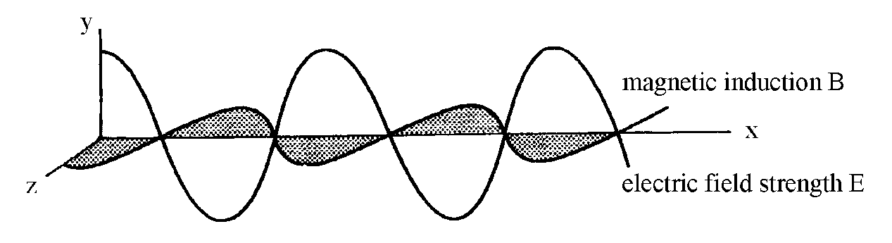

The above diagram shows the variation of the electric field strength, E, in the x-y plane and the variation of the magnetic induction, B, in the x-z plane.

Maxwell’s equations result in the relationship between the speed of light and the permittivity and permeability of free space.

$c=\frac{1}{\sqrt{μ_{0}ϵ_{0}}}$

This means that all electromagnetic waves, regardless of frequency or wavelength, travel at a constant speed in a vacuum.

$c=\frac{1}{\sqrt{4π×{10}^{-7}×8·85×{10}^{-12}}}$

c = 3·00 × 10⁸ m s⁻¹

