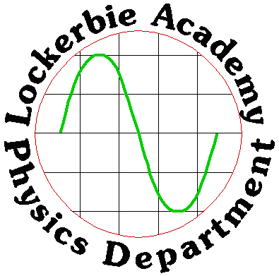
2019
J. A. Hargreaves
Lockerbie Academy
February 2019

PARTICLES AND WAVES Part 2

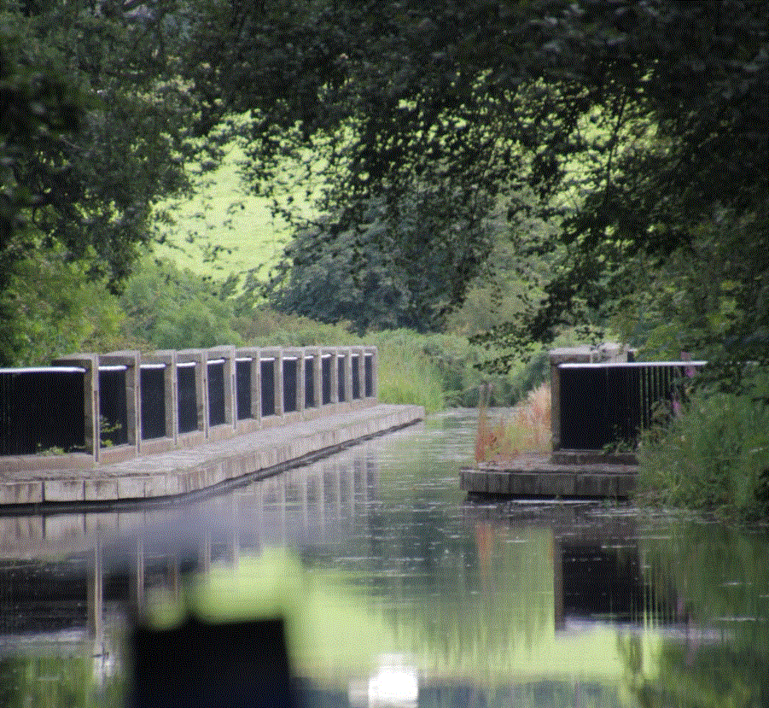

CONTENT

Table of Contents
CONTENT 2
Table of Contents 2
CHAPTER 5: WAVE PARTICLE DUALITY 5
Summary of Content 5
Wave particle duality 5
Photoelectric Effect 6
Observations for this experiment 9
Applications of the Photoelectric effect 14
Photomultipliers 14
Photomultiplier operation 15
Practical 1 The photoelectric effect (demo) 15
Practical 2: Photodiode – photovoltaic mode 15
Tutorial 1 Photoelectric Effect 16
Tutorial 2: Wave-particle duality 16
Exam Questions 19
Exam Answers 21
Tutorial 1 Answers 22
Tutorial 2 Answers 22
CHAPTER 6: INTERFERENCE AND DIFFRACTION 24
Summary of Content 24
Superposition of Waves 24
Interference Patterns 24
Interference and Path Difference 29
Practical 1- Hearing Interference Patterns 31
Interference of Light 32
Young’s double slit experiment 32
Practical 2- Laser interference pattern 34
Practical 3 –Finding the wavelength of light 35
Practical 4- Wavelengths of coloured light 35
Another method for measuring λ- Diffraction 36
Gratings 36
Splitting White Light 37
Differences between a Grating and a Prism 39
Thin film interference: an example of interference 39
Tutorial 1- Path Difference 40
Tutorial 2- Gratings 40
Tutorial 3 –Interference 40
Tutorial 4 (SCET) 41
Exam Questions 44
Tutorial answers: 47
Tutorial 1 47
Tutorial 2 47
Tutorial 3 48
Tutorial 4: (SCET) Waves 48
Exam paper answers 49
CHAPTER 7: REFRACTION OF LIGHT 52
Summary of Content 52
Refraction of Light 52
Snell’s Law: 53
Practical 1: Proving Snell’s Law 53
Finding the Relationship for Refractive Index 53
Refractive Index and Waves- proof (for interest) 54
Another way to prove this 56
Refractive index and frequency of light 56
Refractive index and relationship with v, λ and f 57
Critical angle and total internal reflection 57
Fibre-optic Uses 59
Medical Industry 60
Other Uses 60
Examples 61
Refraction Equation Summary 61
Critical angle equations 61
Optical Instruments 62
Tutorial 1: Refraction 63
Tutorial 2 Refraction with Angles 63
Tutorial 3 Critical Angle 63
Tutorial 4 Refraction- mixed problems 64
Tutorials (SCET) Refraction of light 65
Exam Questions 67
Tutorial Answers: 70
CHAPTER 8: INVERSE SQUARE LAW 74
Summary of Content 74
Irradiance 74
Proving the inverse square law, 76
The Principles of a Method for showing 76
Light Irradiance 77
Practical 1- Inverse Square Law 77
Practical 2- Inverse square again 77
Variation of light irradiance with distance from a point source of light 77
Practical 3- LASER Beam diameter & Distance 78
Tutorial 1 Irradiance 78
Tutorial 2 79
Exam Questions 81
Tutorial Answers 83
Irradiance and inverse square law 83
Exam Papers 83
CHAPTER 9 SPECTRA 85
Summary of Content 85
The Atom 85
Quantum Mechanics 86
Energy Levels of the Hydrogen Atom 86
Energy Levels of the Hydrogen Atom 86
Ionisation 87
Methods of Excitation 87
Line Emission Spectra 87
The Continuous Spectrum 89
Emission and Absorption Spectra 89
Absorption 91
Absorption Lines in Sunlight 92
Fraunhofer lines 93
Summary 95
Blackbody Radiation 95
LASER 96
Medical Uses of Lasers 97
Welding and Cutting 97
Laser Printers 97
Lasers in Communication 97
Compact Disc Audio 98
Barcode Scanners 98
Surveying and Ranging 98
Atoms as Clocks 98
Practical 1: emission spectra 99
Tutorial 1: Photoelectric Effect 100
Tutorial 1: Lasers 100
Tutorial 3: Line and continuous spectra 101
Exam Questions 103
Tutorial Answers: 106
Photoelectric Effect 106
Lasers 106
Line and continuous spectra 107
Exam Question Answers 108

CHAPTER 5: WAVE PARTICLE DUALITY

Summary of Content

No | CONTENT
Wave Particle Duality
 | $E=hf$ $E=\frac{hc}{λ}$ $E_{k}=hf-hf_{0} E_{k}=\frac{1}{2}mv^{2} and v=fλ$
 | I know that the photoelectric effect is evidence for the particle model of light.
 | I know that photons of sufficient energy can eject electrons from the surface of materials (photoemission).
 | I can use $E=hf$ and $E=\frac{hc}{λ}$ to solve problems involving the frequency and energy of a photon.
 | I know that the threshold frequency, f₀ is the minimum frequency of a photon required for photoemission.
 | I know that the work function, W or hf₀ of a material is the minimum energy of a photon required to cause photoemission.
 | I can use $E_{k}=hf-hf_{0}$ $E_{k}=\frac{1}{2}mv^{2} and v=fλ$ to solve problems involving the mass, maximum kinetic energy and speed of photoelectrons, the threshold frequency of the material, and the frequency and wavelength of the photons.
The GREAT DEBATE!
This is mind blowing stuff!

Wave particle duality

WAVES | PARTICLES
DIFFRACTION | LINE SPECTRA
REFRACTION | BAND SPECTRA
REFLECTION | MATHEMATICS
INTERFERENCE | REFLECTION
POLARIZATION | REFRACTION
 | PHOTOELECTRIC EFFECT

http://en.wikipedia.org/wiki/wave%e2%80%93particle_duality#brief_history_of_wave_and_particle_viewpoints
One of the greatest and most interesting debates in Physics has been the nature of light. From ancient Greek times people have argued over whether light was made up of particles or if it was a wave. Although the debate has raged for centuries it was possibly at its fiercest at the turn of the twentieth century when many eminent Scientists of the era were on one or other side. The resulting studies produced many Nobel Prize winners and indeed, it was Einstein’s experiments in 1905 on the photoelectric effect that led to him being awarded the Nobel Prize for Physics in 1922.

The result of the debate was the dawning of a new branch of physics, namely Quantum Mechanics

At the macroscopic (large) scale we are used to two broad types of phenomena: waves and particles. Briefly, particles are small pieces of matter, restricted to a local area, which transport both mass and energy as they move, whilst a wave can be described as a disturbance that travels through a medium from one location to another location and carries energy but no mass. Physical objects that can be touched like a cricket ball display particle-like phenomena while, for example, ripples on a lake are waves. (Note that there is no net transport of water in a wave, therefore no net transport of mass).

In Quantum Mechanics this distinction between particles and waves is blurred. Things which we would normally think of as particles (e.g. electrons) can behave like waves in certain situations, while things which we would normally think of as waves (e.g. electromagnetic radiation: light) can behave like particles. Electrons can create wave-like diffraction patterns after passing through narrow slits, just like water waves do as they pass through the entrance to a harbour. Equally, the photoelectric effect (i.e. the absorption of light by electrons in solids) can only be explained if the light is particle in nature (leading to the concept of photons).

It is this photoelectric effect that we are dealing with here.

Photoelectric Effect

Under certain situations an electrically charged object can be made to discharge by shining electromagnetic radiation on it. This can be best demonstrated by charging a device on which the charge stored can be measured, either a digital coulombmeter or by a gold leaf electroscope (g.l.e). As charge is added to a g.l.e. the thin piece of gold leaf rises up at an angle from the vertical rod to which it is attached.
gold leaf
metal plate
gold leaf
metal plate
0.01

digital coulombmeter gold leaf electroscope
Example | Metal | Charge on metal | e-m radiation | Result
A | Copper | + | white light | No change
B | Copper | + | UV | No change
C | Copper | - | white light | No change
D | Copper | - | UV | No change
E | Zinc | + | white light | No change
F | Zinc | + | UV | No change
G | Zinc | - | white light | No change
H | Zinc | - | UV | Metal discharges

In most circumstances nothing happens when the electromagnetic radiation strikes the charged metal, for example in situations A to G below. However, in a few cases, such as H below, a negatively charged metal can be made to discharge by certain high frequencies of electromagnetic radiation.

A further example is given below
gold leaf
metal plate
UV
-
-
-
-
-
-
-
-
-
-
-
-
glass
UV
+
+
+
+
+
+
+
+
+
+
+
+
The U.V. makes the leaf fall on a g.l.e.
UV
-
-
-
-
-
-
-
-
-
-
-
-

Zinc plate
The freed electrons are drawn back by the +ve charge. The leaf stays up.
Glass absorbs U.V. therefore no electrons are emitted. The leaf stays up.

Evidence | Conclusion
UV discharges the zinc plate of an electroscope which is negatively charged. | Discharge is the result of ejecting electrons and not a result of ionising the air.
Visible radiation, however bright, doesn’t produce the same effect. | It is NOT simply a case of the energy supplied but whether each “bundle” has radiation of the appropriate frequency.

Visible light on zinc does not cause this phenomenon even if the intensity (and hence energy) is high. This cannot be explained by thinking of the light as a continuous wave: if we give a wave enough energy, (i.e. a greater amplitude), the wave ought to have enough energy to cause electrons to be ejected from the atom. But, the light is behaving as if it were arriving in discrete packets of energy the value of which depends on the wavelength or frequency of the light. Einstein called these packets of energy photons.

The experimental evidence shows that photoelectrons are emitted from a metal surface when the metal surface is exposed to electromagnetic radiation of high enough frequency. In case F any photoelectrons which are emitted from the zinc surface are immediately attracted back to the zinc metal because of the attracting positive charge on the electroscope. The electroscope does not therefore discharge.
It is important to realise that if the frequency of the incident radiation is not high enough then no matter how great the irradiance of the radiation no photoelectrons are emitted. This critical or threshold frequency, f_{o}, is different for each metal. For copper the value of f_{o} is even greater than that of the ultraviolet part of the spectrum so no photoelectrons are emitted for ultraviolet radiation. Some metals, such as selenium and cadmium, exhibit the photoelectric effect in the visible light region of the spectrum.

Complete the Virtual Higher task on this and also check it out with the equipment in the lab. Also check https://phet.colorado.edu/en/simulation/photoelectric
(A copy of which is in the Particles and Waves section of the website)
Definition The PHOTOELECTRIC effect is the production of a free electron (or photoelectron) from the surface of a metal, when electromagnetic radiation of sufficiently high frequency is incident on it.it.

Another Practical to Demonstrate the Photoelectric Effect
- Light falls on the emitter.
d.c. supply
To microammeter
emitter
collector
vacuum
LIGHT
- Emitter emits electrons. If the collector is positive with respect to the emitter then all the electrons are collected. If the collector is negative with respect to the emitter, the collector will tend to repel the electrons and only those with a large initial E_{K} will reach the collector.
- If the voltage becomes progressively more negative then the signal on the oscilloscope. will decrease as fewer electrons reach the collector.
- Eventually a p.d. is found beyond which no electrons reach the collector. Since there is a definite stopping potential there must also be a maximum E_{K}.

Wave theory would not predict a maximum E_{k}.
p.d. between emitter & collector
current
-V₀
high intensity
low intensity

Observations for this experiment
0
- Photoelectric current is proportional to the intensity of the radiation.
- Increasing intensity leads to an increase in the current because the number of photons per second and hence number of electrons increases.
- Stopping potential, V₀, is independent of the intensity of the radiation; therefore the energy of the electrons is independent of intensity.
So: E_{W} = qV
collector
emitter
p.d. = V
q
If stopping p.d. = V₀ then work done = qV₀
The E_{W} on the electron = E_{K} lost by the electron.
E_{K} (max) = qV₀. (Dependent on the frequency of the e-m radiation).

In a metal the electrons are loosely held, therefore it takes less energy to remove an electron.

The minimum energy required to remove one electron from the surface is called the WORK FUNCTION (hf₀). It is characteristic of the metal. Work function can also be written as W.

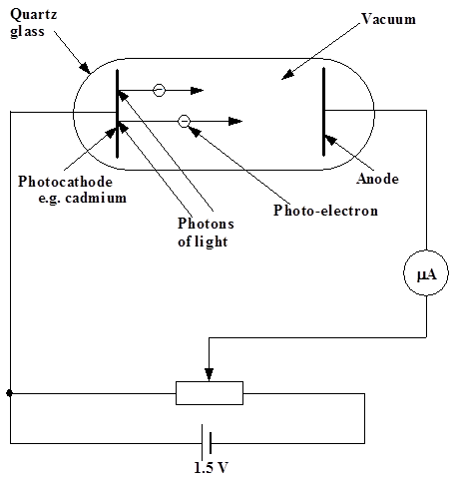
One reason why different metals have different values of f_{o} is that different energy is required to bring an electron to the metal surface due to the distinctive arrangements of atoms in different metals. Some metals will hold on to their electrons a little stronger than others. The name given to the small amount of energy required to bring an electron to the surface of a metal and free it from that metal is the work function. If measured in joules the value of this work function is very small, in the order of 10⁻¹⁹ or 10⁻²⁰ J. This is comparable with the energy a single electron gains when it passes through a single 1·5 V cell.
If a photon of incident radiation carries more energy than the work function value then the electron not only is freed at the surface but has “spare” kinetic energy and it can “go places”. An experiment can be carried out to demonstrate and quantify the photoelectric effect.
Notice that the supply is opposing the electron flow.
I/μA
f/Hz
0
f_{o}

Initially with the supply p.d. set at 0 V, light of various frequencies is allowed to fall on the photocathode. In each case a small current is observed on the microammeter. The value of this current can be altered by altering the irradiance of the light as this will alter the number of photons falling on the cathode and thus the number of photoelectrons emitted from the cathode. In fact the photocurrent is directly proportional to the irradiance of the incident light - evidence that irradiance is related to the number of photons arriving on the surface.
current
irradiance
0
If, when blue light only is used the p.d. of the supply is slowly turned up in such a direction to oppose the electron flow, there comes a point when the p.d. is just sufficient to stop all the photoelectrons from reaching the anode. This is called the stopping potential for the blue light. The photoelectrons are just not reaching the anode as they have not sufficient kinetic energy to cross the gap to the anode against the electric field. In fact their kinetic energy has all been turned to potential energy and they have come to rest.

If the blue light is now replaced with violet light, and no other alterations are made, a current suddenly appears on the microammeter. This means that some electrons are now managing to get across from the cathode to the anode. Hence they must have started out their journey with more kinetic energy than those produced by blue light. This means that photons of violet light must be carrying more energy with them than the photons of blue light. No matter how “strong” the blue light source is or how “weak” the violet light source the photons of violet light always “win”.

If several experiments are done with photocells with different metal cathodes and in each case a range of different frequencies of light are used, graphs of maximum energy of photoelectrons against frequency of light can be plotted, as follows:

All metals are found to give straight line graphs which do not pass through the origin. However the gradient of each line is the same. This gradient is Planck’s constant h.
The value of Planck’s constant is 6·63 × 10⁻³⁴ J s. The work function of the metal is the intercept on the energy axis.
From the straight line graph it can be seen that:
y = mx + c
E_{k} = mf + c
E_{k} = hf – W
Hence:
hf = W +E_{k} or hf = hf_{o} +E_{k}
Energy of absorbed photon = work function + kinetic energy of emitted electron

work function
Kinetic Energy of emitted electron
Energy of absorbed photon

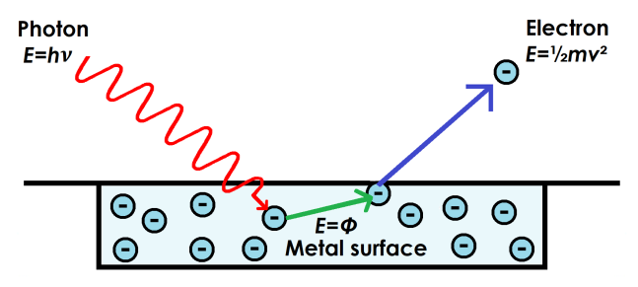
Image Credit: Helen Klus, http://www.thestargarden.co.uk/Quantum-mechanics.html. Licensed under an Attribution-NonCommercial-ShareAlike 4.0 International (CC BY-NC-SA 4.0) license, https://creativecommons.org/licenses/by-nc-sa/4.0/

We can calculate the energy of a typical visible light photon as follows:

The range of wavelengths in the visible spectrum is approximately 400 nm to 700 nm. Therefore an average wavelength from the visible spectrum is 550 nm.

- Calculate the frequency of this wavelength. (speed of light = 3·00 × 10⁸ m s⁻¹ )
$$v=fλ$$
$$3∙0 ×{10}^{8}=f×550×{10}^{-9}$$
$$f=5∙5×{10}^{14}Hz$$
Using E = hf , calculate the energy of the photon. Each photon still has a frequency and wavelength associated with it and the energy contained in each photon is given by:

$$E = hf$$
$$E=6∙63×{10}^{-34}×5∙5×{10}^{14}$$
$$E=3∙6×{10}^{-19}J$$
where h is the Planck constant, h = 6.63 × 10^{–34} Js Note the units are Joules second
Note: You do not need to know the value of this constant, it will be provided for you on the data sheet.

The energy supplied by light or other electromagnetic radiation takes the form of photons of energy, hf. When a photon goes into the metal it is wholly absorbed by a single electron.
If hf < W no electron emission

If hf = W=hf₀ then the photon is just able to release an electron from its surface without it having any E_{K} (f₀ or THRESHOLD FREQUENCY). (hf = W = hf₀)

If hf > W then excess energy is given to the freed electron as E_{K}.

hf = W + E_{K}

where hf = energy of incoming radiation measured in Joules
W = work function (energy required to remove one electron) measured in Joules

Work function. Energy required to free the electron. (Joules)
Energy of photon coming in. (Joules)
Anything left over becomes E_{K}. (Joules)

The two energies relate to the energy of the photons producing the effect because when a photon is absorbed its energy ejects electrons with a certain amount of E_{K}.

OR:
Energy of incident photon | = | Work function |  | + | Extra kinetic energy
E | = | W | + | E_{K}
E | = | hf₀ | + | E_{K}
E | = | hf₀ | +
E | = | W | +
hf | = | W | + | E_{K}
hf | = | hf₀ | + | E_{K}
hf | = | hf₀ | +
hf | = | W | +
hf | = | W | + | stopping energy
E | = | W | + | qV₀
hf | = | W | + | qV₀
hf | = | hf₀ | + | qV₀
 | = | hf₀ | + | qV₀
 | = | hf₀ | +

Applications of the Photoelectric effect

Photomultipliers
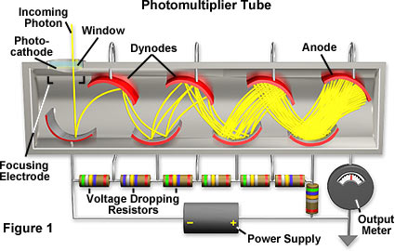
Photomultipliers (sometimes called photon multipliers) are vacuum tubes, where light absorbed on a photocathode generates free electrons, which are subsequently accelerated with a high voltage (at least hundreds of volts), generate secondary electrons on other electrodes, and finally a useable photocurrent. Due to this avalanche process, the photocurrent can be orders of magnitude higher than from, e.g., a photodiode. Therefore, photomultipliers can be used for, e.g., single photon counting. Photomultiplier tubes can be highly sensitive detectors.
http://hamamatsu.magnet.fsu.edu/articles 1

Photomultiplier operation
Photons enter the photomultiplier tube and strike the photocathode. When this occurs, electrons are produced as a result of the photoelectric effect.
Once the electrons have been generated they are directed towards an area of the photomultiplier called the electron multiplier. As the name suggests, this area serves to increase or multiply the number of electrons by a process known as secondary emission.

Practical 1 The photoelectric effect (demo)
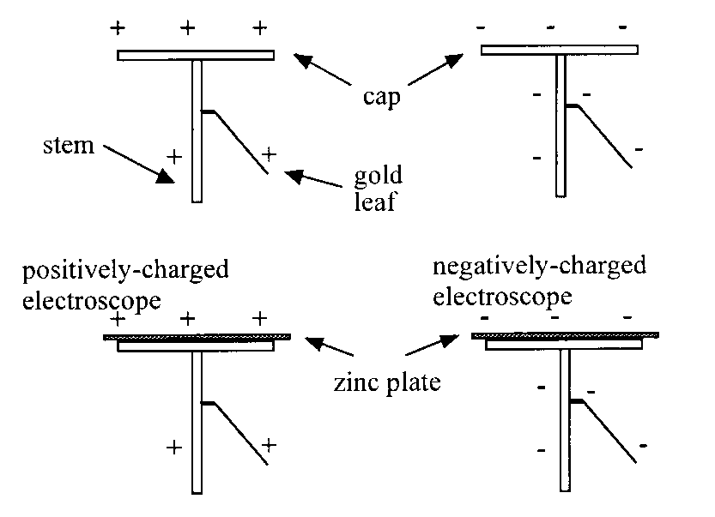
Aim: To compare the effect of white light and U.V. radiation on charged electroscopes.

Apparatus: 12 V lamp and power supply, U.V. lamp and power supply, 2 gold-leaf electroscopes, zinc plate, polythene and acetate rods.

Instructions
- Copy the table of results.
- The electroscopes are charged using the polythene and acetate rods.
- White light is shone in turn on each of the charged electroscopes.
- Ultra violet light is shone in turn on each of the charged electroscopes.
- Write a conclusion based on the results of the experiment.

Surface | White light |  | Ultraviolet light
Surface | +ve | -ve | +ve | -ve
Cap of electroscope
Zinc plate

Practical 2: Photodiode – photovoltaic mode
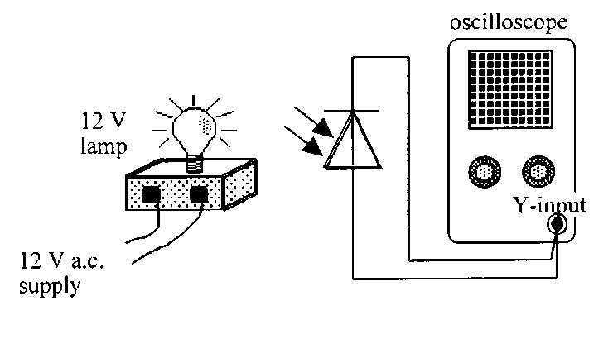
Aim: To measure the frequency of an a.c. supply using a photodiode in photovoltaic mode.

Apparatus: 12 V a.c. power supply, 12 V lamp, photodiode, oscilloscope.

Instructions
- Set up the circuit above, preferably with the room darkened.
- Adjust the oscilloscope to obtain a clear trace.
- Calculate the frequency of the wave trace produced.
- Write a conclusion based on the results of the experiment.

Tutorial 1 Photoelectric Effect

- What is the energy of a photon from a beam of light with a frequency of 700THz?
- What frequency of light has photons with an individual energy of 3⋅0×10⁻¹⁹ Joules?
- A light beam consists of red and green light whose photons carry energies of either 2.97 × 10⁻¹⁹ J, or 3.43 ×10⁻¹⁹ J. Which photon is associated with which colour?
- If the work function of a metal is 5⋅0×10⁻¹⁹ joules, what is its threshold frequency?

  - What is the maximum possible kinetic energy of a photo-electron ejected by light of frequency 10¹⁵ Hz?
  - If the ejected electron in (a) above (charge 1⋅6 ×10⁻¹⁹ C), moves against a p.d. of half a volt, how much kinetic energy is it left with?
- What effect does it have on the appearance of a spectrum if one particular energy level change is more likely than any of the others so that it occurs more frequently?
- What do the symbols stand for in each of the following equations?

Tutorial 2: Wave-particle duality
1. A ‘long wave’ radio station broadcasts on a frequency of 252 kHz.
(a) Calculate the period of these waves.
(b) What is the wavelength of these waves?

2. Green light has wavelength 546 nm.
(a) Express this wavelength in metres (using scientific notation).
(b) Calculate:
(i) the frequency of these light waves
(ii) the period of these light waves.

3. Ultraviolet radiation has a frequency 2·0 × 10¹⁵ Hz.
(a) Calculate the wavelength of this radiation.
(b) Calculate the period of this radiation.

- Blue light has a frequency of 6·50 × 10¹⁴ Hz. Calculate the energy of one photon of this radiation.

- Red light has a wavelength of 6·44 × 10⁻⁷ m. Calculate the energy of one photon of this light.

- A photon of radiation has an energy of 3·90 × 10⁻¹⁹ J. Calculate the wavelength of this radiation in nm.

7. In an investigation into the photoelectric effect a clean zinc plate is attached to a coulombmeter, as shown.
nC
-
3
5
ultraviolet lamp
zinc plate
coulombmeter
The threshold frequency of radiation for zinc is 6·50 × 10¹⁴ Hz.
The zinc plate is initially negatively charged.
A lamp is used to shine ultraviolet radiation of frequency 6·7 × 10¹⁴ Hz onto the zinc plate.
(a) Describe and explain what happens to the reading on the coulombmeter.
The zinc plate is again negatively charged.
(b) Describe and explain the effect each of the following changes has on the reading on the coulombmeter:
(i) moving the ultraviolet lamp further away from the zinc plate
(ii) using a source of red light instead of the UV lamp.
The zinc plate is now positively charged. The UV lamp is again used to irradiate the zinc plate.
(c) Describe and explain the effect this has on the positive reading on the coulombmeter.

8. In a study of photoelectric currents, the graph shown was obtained.
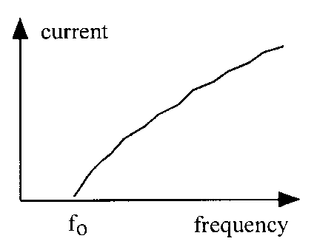
0
(a) What name is given to the frequency f_{o}?
(b) Explain why no current is detected when the frequency of the incident radiation is less than f_{o}.

9 For a certain metal, the energy required to eject an electron from the atom is 3·30 × 10⁻¹⁹ J.
(a) Calculate the minimum frequency of radiation required to emit a photoelectron from the metal.
(b) Explain whether or not photoemission would take place using radiation of:
(i) frequency 4⋅0 × 10¹⁴ Hz
(ii) wavelength 5⋅0 × 10⁻⁷ m.

10. The minimum energy required to remove an electron from zinc is 6·10 × 10⁻¹⁹ J.
(a) What is the name is given to this minimum energy?
(b) Calculate the value of f_{o} for zinc.
(c) Photons with a frequency of 1·2 × 10¹⁵ Hz strike a zinc plate, causing an electron to be ejected from the surface of the zinc.
Calculate the amount of energy the electron has after it is released from the zinc.
(d) What kind of energy does the electron have after it is released?

11. Radiation of frequency 5·0 × 10¹⁴ Hz can eject electrons from a metal surface.
(a) Calculate the energy of each photon of this radiation.
(b) Photoelectrons are ejected from the metal surface with a kinetic energy of 7·0 × 10⁻²⁰ J. Calculate the work function of this metal.

12. An argon laser is used in medicine to remove fatty deposits in arteries by passing the laser light along a length of optical fibre. The energy of this light is used to heat up a tiny metal probe to a sufficiently high temperature to vaporise the fatty deposit.
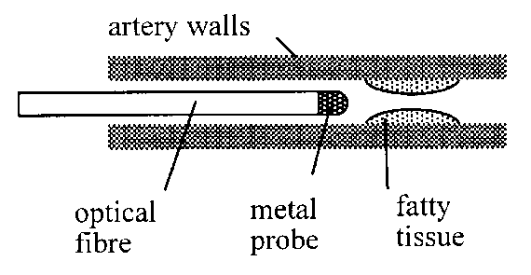
The laser has a power of 8·0 W. It emits radiation with a wavelength of 490 nm.
(a) How much energy is delivered from the laser in 5 s?
(b) Calculate the number of photons of this radiation required to provide the 5 s pulse of energy from the 8·0 W laser.

13. The apparatus shown is used to investigate photoelectric emission from a metal plate when electromagnetic radiation is shone on the plate.
The irradiance and frequency of the incident radiation can be varied as required.
A
metal plate
vacuum
glass tube
incident light
(a) Explain what is meant by ‘photoelectric emission’ from a metal.
(b) What is the name given to the minimum frequency of the radiation that produces a current in the circuit?
(c) A particular source of radiation produces a current in the circuit. Explain why the current in the circuit increases as the irradiance of the incident radiation increases.

14. State whether each of the following statements is true or false.
(a) Photoelectric emission from a metal occurs only when the frequency of the incident radiation is greater than the threshold frequency for the metal.
(b) The threshold frequency depends on the metal from which photoemission takes place.
(c) When the frequency of the incident radiation is greater than the threshold frequency for a metal, increasing the irradiance of the radiation will cause photoemission from the metal to increase.
(d) When the frequency of the incident radiation is greater than the threshold frequency for a metal, increasing the irradiance of the radiation will increase the maximum energy of the electrons emitted from the metal.
(e) When the frequency of the incident radiation is greater than the threshold frequency for a metal, increasing the irradiance of the incident radiation will increase the photoelectric current from the metal.

Exam Questions

SQA 2011
29. A metal plate emits electrons when certain wavelengths of electromagnetic radiation are incident on it.

The work function of the metal is 2·24 × 10^{–19} J.

        - Electrons are released when electromagnetic radiation of wavelength 525 nm is incident on the surface of the metal plate.
          - Show that the energy of each photon of the incident radiation is 3·79 × 10^{–19} J.
          - Calculate the maximum kinetic energy of an electron released from the surface of the metal plate.

        - The frequency of the incident radiation is now varied through a range of values. The maximum kinetic energy of electrons leaving the metal plate is determined for each frequency. A graph of this maximum kinetic energy against frequency is shown.
(i) Explain why the kinetic energy of the electrons is zero below the frequency fo.
(ii) Calculate the value of the frequency fo.

SQA 2018 Q7

7. A student uses a gold-leaf electroscope to investigate the photoelectric effect. A deflection of the gold leaf on the electroscope shows that the metal plate is charged.
The student charges the metal plate on the electroscope and the gold leaf is deflected.

- Ultraviolet light is shone onto the negatively charged metal plate. The gold-leaf electroscope does not discharge. This indicates that photoelectrons are not ejected from the surface of the metal. Suggest one reason why photoelectrons are not ejected from the surface of the metal.

- The student adjusts the experiment so that the gold-leaf electroscope now discharges when ultraviolet light is shone onto the plate.

The work function for the metal plate is 6∙94 ⋅ 10⁻¹⁹ J.
- State what is meant by a work function of 6∙94 ⋅ 10⁻¹⁹ J.
- The irradiance of the ultraviolet light on the metal plate is reduced by increasing the distance between the gold-leaf electroscope and the ultraviolet light source. State what effect, if any, this has on the maximum kinetic energy of the photoelectrons ejected from the surface of the metal. Justify your answer.
- The graph shows how the kinetic energy of the photoelectrons ejected from the metal plate varies as the frequency of the incident radiation increases.
The threshold frequency for the metal plate is 1∙05 ⋅ 10¹⁵ Hz.

The metal plate is now replaced with a different metal plate made of aluminium.
The aluminium has a threshold frequency of 0∙99 ⋅ 10¹⁵ Hz.
Copy the graph and add a line to the graph to show how the kinetic energy of the photoelectrons ejected from the aluminium plate varies as the frequency of the incident radiation increases.

(d) Explain why the photoelectric effect provides evidence for the particle nature of light.

SQA Higher 2014
30. The following apparatus is set up in a physics laboratory to investigate the photoelectric effect.
The work function of sodium is 3∙78 × 10⁻¹⁹ J.
Light of frequency 6∙74 × 10¹⁴ Hz is incident on the sodium plate and photoelectrons are emitted.
(a)
(i) Calculate the maximum kinetic energy of a photoelectron just as it is emitted from the sodium plate.
(ii) Calculate the maximum velocity of a photoelectron just as it is emitted from the sodium plate.
(b) The irradiance of this incident light is now decreased. Explain how this affects the maximum velocity of a photoelectron just as it is emitted from the sodium plate.

Exam Answers

(b) (i) Photons with frequency below fo “do not have enough energy to release electrons OR Photons with frequency below fo have energy smaller than work function “because fo is threshold frequency” – No Must be an answer in terms of photon energy
SQA 2014
$$E= hf- hf$$
$$E=\left(6.63×{10}^{-34} × 6.74 × {10}^{ 14}\right)-3.78 ×{10}^{-19}$$
Ek− =6·89 × 10⁻²⁰J

Accept 6·9 × 10⁻²⁰, 6·886 × 10⁻²⁰, 6·8862 × 10⁻²⁰

$$Ek = ½ mv^{2}$$
$$6·89 × {10}^{-20}=\frac{1}{2}×9.11×{10}^{-31}×v^{2}$$
v = 3·89 × 10⁵ m s⁻¹

(b) The maximum velocity remains the same (1) one photon releases one electron (½) each photon has same energy as before (½) Do not accept a statement such as ‘changing the irradiance has no effect on the rate of emission of photoelectrons’. The candidate must explain why this is true in order to gain the second two (½) marks

SQA Higher Paper 2018
- Frequency of UV/photons/light is not high enough. OR Frequency of UV/photons/light is less than threshold frequency. OR Energy of photons (of UV light) is not high enough. OR Energy of photons (of UV light) is less than work function. OR May not be a ‘clean plate’.

          - 6·94 × 10⁻¹⁹ joules of energy is the minimum energy required for (photo) electrons to be emitted/ejected/photoemission (of electrons).
          - No change (to the kinetic energy). (1) As the irradiance does not affect the energy of the photons/ E = hf is unchanged.

- Lower starting frequency. (1) Same gradient.
- Each photon contains a fixed/discrete amount of energy. OR Each photon removes one electron.

Tutorial 1 Answers  Photoelectric Effect  - 4.64×10⁻¹⁹ joules.  - 452 THz  - Red 2.97 ×10⁻¹⁹ J  - 754THz  - 6.63x10⁻¹⁹J b)  - .  - E, energy (J); h, Planck’s constant (J s); f, frequency (Hz)  - h, Planck’s constant (J s); f, frequency (Hz); hf₀, work function (J); E_{K}, kinetic energy (J).  - h, Planck’s constant (J s); f, frequency (Hz); W_{1/2}, energy levels (J). | Tutorial 2 Answers  Wave particle duality  1. (a) 3·97 × 10⁻⁶ s  (b) 1·19 × 10³ m  2. (a) 5·46 × 10⁻⁷ m  (b) (i) 5·49 × 10¹⁴ Hz  (ii) 1·82 × 10⁻¹⁵ s  3. (a) 1·5 × 10⁻⁷ m  (b) 5·0 × 10⁻¹⁶ s  4. 4·31 × 10⁻¹⁹ J  5. 3·09 × 10⁻¹⁹ J  6 510 nm  7. (a) reading on the coulombmeter gradually reduces to zero as electrons are emitted from the surface of the zinc.  (b) (i) the reading would decrease the rate of reduction as fewer photons will hit the metal surface.  (ii) the reading would remain at 35nC as red light will not cause photoemission as the f < f_{o}  8 Threshold frequency  (b) the f < f_{o} so electrons are not released from the surface of the metal .  9. (a) 4·98 × 10¹⁴ Hz  (b) i would not occur  …………….ii would occur  10. (a) work function  (b) 9.20 × 10¹⁴ Hz  (c) (i) 1.86 × 10⁻¹⁹ J  (d)¶ E_{k}  11. (a) 3·3 × 10⁻¹⁹ J  (b) 2·6 × 10⁻¹⁹ J  12. (a) 40 J  (b) 9·9 × 10¹⁹
13 (b) threshold frequency
(c ) once photoemission occurs as I is increased each additional photon in the incident beam can cause one electron to be emitted I=Nhf
14 True statements
a, b, c,
 | d will lead to more electrons but each will have the same energy. To increase the energy photons of a higher frequency must be incident on the metal.

CHAPTER 6: INTERFERENCE AND DIFFRACTION

Summary of Content

No | CONTENT
Interference
$path difference=mλ or \left(m+\frac{1}{2}\right)λ$ where m =0,1,2.
$d sinθ=mλ$
 | I know that interference is evidence for the wave model of light.
 | I know that coherent waves have a constant phase relationship.
 | I can describe of the conditions for constructive and destructive interference in terms of the phase difference between two waves.
 | I know that maxima are produced when the path difference between waves is a whole number of wavelengths
 | I know that minima are produced when the path difference between waves is an odd number of half-wavelengths respectively.
I can use $path difference=mλ or \left(m+\frac{1}{2}\right)λ$ where m =0,1,2...
to solve problems involving the path difference between waves, wavelength and order number.
 | I can use $d sinθ=mλ$ to solve problems involving grating spacing, wavelength, order number and angle to the maximum.

For interference of electrons visit
https://phet.colorado.edu/en/simulation/legacy/wave-interference

For holography & interferometers
http://hyperphysics.phy-astr.gsu.edu/hbase/hframe.html
http://hyperphysics.phy-astr.gsu.edu/hbase/phyopt/michel.html

Superposition of Waves
Coherent Sources
Two sources that are oscillating with a constant phase relationship are said to be coherent. This means the two sources also have the same frequency. Interesting interference effects can be observed when waves with a similar amplitude and come from coherent sources meet.

Interference Patterns

(INTERFERENCE IS THE TEST FOR A WAVE)
When waves from 2 coherent sources superpose a pattern, called an INTERFERENCE PATTERN is formed.

The pattern consists of regions where there are large waves constructive interference and between these regions where there are no waves destructive interference

=

constructive interference
(IN PHASE)

=

destructive interference
(OUT OF PHASE)

Constructive interference | Destructive interference
Two sets of waves meet in phase.  Two crests meet or two troughs meet to produce a larger crest or trough. | Two sets of waves meet completely out of phase, i.e. 180° out of phase.  A crest meets a trough and combine to cancel each other out and produce no wave at that point.
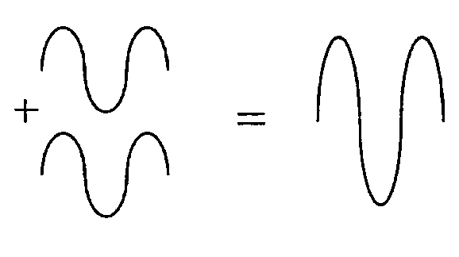 | If the waves are not of equal amplitude, then complete cancelling does not occur.
 | 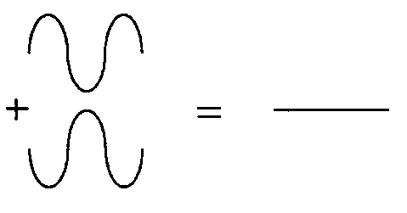

You will not be expected to know anything other than CONSTRUCTION or total DESTRUCTION.

Interference can be demonstrated by allowing waves from one source to diffract through two narrow slits in a barrier. This can be done with water waves in a ripple tank, microwaves and light. If the gap (aperture) is smaller than one wavelength then the waves that have diffracted around the barrier are semi-circular. These two coherent waves can interfere to produce an interference pattern.

S₁
S₂
    - Sources S₁ and S₂ in phase and 5 cm apart, wavelength 1 cm.

S₁
S₂
    - Sources S₁ and S₂ in phase and 5 cm apart, wavelength 2 cm.

( C) Sources S1 and S2 in phase and 3 cm apart, wavelength 1 cm.
S₁
S₂

(a) Decreasing the separation of the sources S₁ and S₂ increases the spaces between the lines of interference.
(b) Increasing the wavelength (i.e. decreasing the frequency) of the waves increases the spaces between the lines of interference.
(c) Observing the interference pattern at an increased distance from the sources increases the spaces between the lines of interference.

P
S₁
S₂
path difference
= slit
S₁ = source 1
S₂ = source 2
P = point

The path difference is calculated by
the distance S₂P - the distance S₁P
Path difference = S₂P - S₁P

The wave from S₂ is traveling further to reach P. The extra distance S₂ wave has to travel is called the path difference and is shown in the diagram

IN PHASE

OUT OF PHASE

If the waves leave S1 and S2 at the same time and in phase, how they arrive at P will depend on the number of waves that fit into the path difference. If a whole number of waves fit this path difference then the waves arrive in phase and constructive interference occurs. If a half number of waves fit in then the waves at P arrive out of phase, and destructive interference occurs

If S₂P - S₁P = whole number of wavelengths then:

constructive

maxima

in phase

or length 2 – length 1 = whole number of wavelengths

Path difference = mλ (where m = whole no. or integer) (m = 0,1,2,3, etc)

If S₂P - S₁P = half number of wavelengths then:

destructive

minima

out of phase

or length 2 – length 1 = (a whole number + ½ ) of wavelengths

Path difference = (m + ½) λ (where m = whole no. or integer), (m = 0,1,2,3,etc)

Also remember that it is (m + ½) λ (ie 0.5λ, 1.5λ, 2.5λ, 55.5λ) 
(ie ½λ, 1½λ, 2½λ, 55½ λ)
it is NOT (m)+ ½ λ (ie 0.5λ, 1.0λ, 1.5λ, etc) 

N.B. In older Higher books and past papers m will be labelled as n. It changed in CfE Higher to m to be consistent with AH and to distinguish it from n, refractive index.

Interference and Path Difference
Two sources S₁ and S₂ in phase and 3 cm apart, wavelength 1 cm.- example (C)
P₀ is a point on the centre line of the interference pattern.
P₀ is the same distance from S₁ as it is from S₂.
The path difference between S₁P₀ and S₂P₀ = 0
Waves arrive at P₀ in phase and therefore constructive interference occurs.
S₁
S₂
P₀

S₁
S₂
P₀
P₁

P₁ is a point on the first line of constructive interference out from the centre line of the interference pattern.
P₁ is one wavelength further from S₂ than it is from S₁.
The path difference between S₁P₁ and S₂P₁ = 1 × λ

Waves arrive at P₁ in phase and therefore constructive interference occurs.
S₁
S₂
P₀
P₁
P₂

P₂ is a point on the second line of constructive interference out from the centre line of the interference pattern.
P₂ is one wavelength further from S₂ than it is from S₁.
The path difference between S₁P₂ and S₂P₂ = 2 × λ
Waves arrive at P₂ in phase and therefore constructive interference occurs.

Constructive interference occurs when:
path difference = mλ where m is an integer
P₀
P₁
P₂
P_{0.5}
P_{1.5}
S₁
S₂

Destructive interference occurs when:
path difference = ( m + ½ )λ where m is an integer

Example 1: A student sets up two loudspeakers a distance of 1·0 m apart in a large room. The loudspeakers are connected in parallel to the same signal generator so that they vibrate at the same frequency and in phase (coherent).
B
A

signal generator

The student walks from A and B in front of the loudspeakers and hears a series of loud and quiet sounds.
(a) Explain why the student hears the series of loud and quiet sounds.
(b) The signal generator is set at a frequency of 500 Hz. The speed of sound in the room is 340 m s⁻¹. Calculate the wavelength of the sound waves from the loudspeakers.
(c) The student stands at a point 4·76 m from loudspeaker and 5·78 m from the other loudspeaker. State the loudness of the sound heard by the student at that point. Justify your answer.
(d) Explain why it is better to conduct this experiment in a large room rather than a small room.

Solution:
(a) The student hears a series of loud and quiet sounds due to interference of the two sets of sound waves from the loudspeakers. When the two waves are in phase there is constructive interference and a loud sound. When the two waves are exactly out of phase there is destructive interference and a quiet sound.

(b) v = fλ
340 = 500 × λ
λ = 0·68 m

(c) Path difference = 5·78 – 4·76 = 1·02 m
Number of wavelengths = 1·02/0·68 = 1·5λ
A path difference of 1·5 λ means the waves are exactly out of phase.
The student hears a quiet sound (unlikely to hear nothing due to reflections off the wall and both ears are unlikely to be in a position of destructive interference)

(d) In a small room, sound waves will reflect off the walls and therefore other sound waves will also interfere with the waves coming directly from the loudspeakers.

Example
If distances AC and BC are 51 cm and 63 cm respectively, and point C is the third order maximum, determine the wavelength of the source.

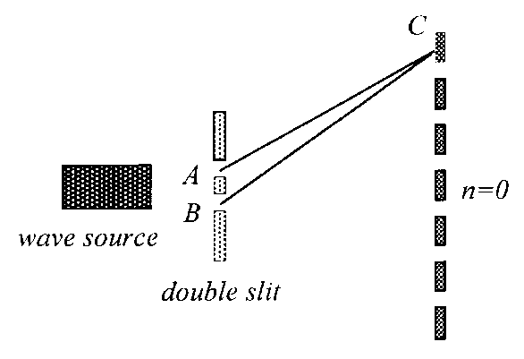
Path difference BC – AC = 63-51 cm
m
Path difference BC – AC = 12 cm.
For third order maximum, path difference = 3λ.
3λ = 12 cm, so 1λ = 4 cm.

If the above source was replaced by another with wavelength 8 cm, what effect would be produced at point C?
Path difference BC – AC = 12 cm, as before.
If λ = 8 cm: Therefore the path difference = or 1λ.
Point C would be the second minimum above the central bright band (or the ‘first order minimum’). The pattern is now more spaced out.

Practical 1- Hearing Interference Patterns

- Switch on the white board and set a note playing of 440 Hz.
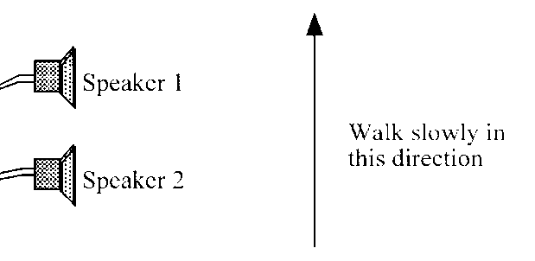
- Walk across the room from one side to the other. Note the places of increased intensity and decreased intensity.
- Place one coloured post-it notes for places of high sound levels and a different colour for low sound levels.
- Does everyone agree on the position? Discuss your findings.
- Repeat the process with the board playing a different note. Are the post-it notes in the same place? Can you determine the wavelength and frequency of the note by the positions of the post-it notes? Assume the speed of sound in air is 340 ms⁻¹.

Interference of Light

The problems with showing interference of light are:
s₁
s₂
Monochromatic light source
single slit
double slit
- very small wavelength
- producing a coherent light source (light is emitted in bursts)

To overcome this we can use one light source and two slits close together – YOUNG’S SLIT EXPERIMENT
To do this experiment you need:
- two slits very close together
- a monochromatic light source
- a big distance between the slits and the screen
- a tape measure and “rule”

You need to measure:
- d – distance between the slits
- D – distance from slits to screen
- x – distance between centre and first order maxima
or
  - d
  - θ - between slits and 1st order maxima (hard to do in practice)
Passing light from the lamp through the single slit ensures the light passing through the double slit is coherent. An interference pattern is observed on the screen.

Young’s double slit experiment

http://www.walter-fendt.de/ph14e/doubleslit.htm
http://vsg.quasihome.com/interfer.htm
This would prove light is a wave.
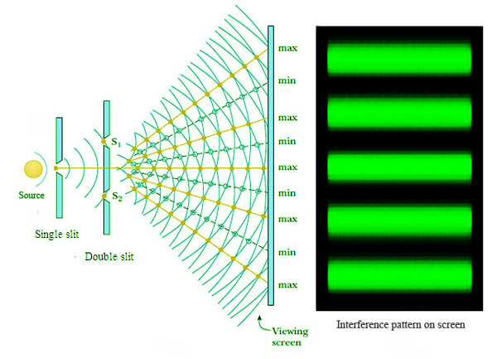
Passing waves through the single narrow slit produces semicircular waves.

Passing through the double slit produces two sets of COHERENT semicircular waves which will produce an interference pattern.

We have already seen that for constructive interference the difference between the length travelled between the waves (the path difference) is equal to a whole number of wavelengths.
ie. path difference = mλ.
So: S₂P – S₁P = mλ OR
or

FORMULAE FOR THIS SECTION
m = number of maxima (m = 0,1,2 etc.)  λ = wavelength  d = distance between slits  NB.questions often give number of slits per mm! $\frac{1}{no. of lines per metre}=d$ | D = distance from source to screen  x = distance from centre to measured point  θ = angle from centre to measured point.
CONSTRUCTION
CONSTRUCTION
DESTRUCTION

First order minima

- path difference = 1λ m = 1
Zero order minima

- path difference = 0 m = 0
Zero order minima

- path difference = 1λ m = 1
First order minima

DESTRUCTION

CONSTRUCTION

O central
(zero order)
maximum
P first
order
maximum
Δx
D
θ
S₁
S₂
θ
λ
d

The path difference between S₁P and S₂P is one wavelength.
As the wavelength of light λ, is very small the slits separation d must be very small and much smaller than the slits to screen distance D. Angle θ between the central axis and the direction to the first order maximum is therefore very small. For small angles sinθ is approximately equal to tanθ, and the angle θ itself if measured in radians.
Hence from the two similar triangles:
$$θ=\sin{θ}=\frac{λ}{d} \text{ and θ = tan θ =}\frac{Δx}{D}$$
Therefore: $\frac{λ}{d}=\frac{Δx}{D}$
Resulting in the expression for the fringe spacing:
$$∆x=\frac{λD}{d}$$
To produce a widely spaced fringe pattern:
(a) Very closely separated slits should be used since Δx ∝ 1/d.
(b) A long wavelength light should be used, i.e. red, since Δx ∝ λ.
(Wavelength of red light is approximately 7·0 × 10⁻⁷ m, green light approximately 5·5 × 10⁻⁷ m and blue light approximately 4·5 x 10⁻⁷ m.)
(c) A large slit to screen distance should be used since Δx ∝ D.
If you do not know whether you are in an area of construction or destruction use:

Practical 2- Laser interference pattern

This is an exercise in observation where you set up the laser to give an interference pattern using a double slit.
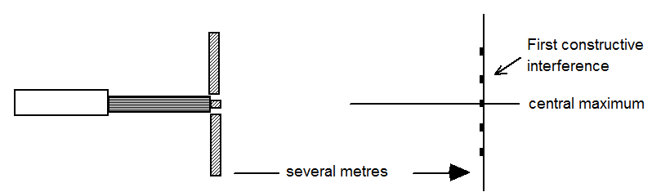
- Change the position of the laser by putting it closer or further from the slits to see how the interference pattern alters.
- Replace the double slit with a tapered slit. Observe the effect on the pattern spacing as the slit separation is altered by jacking up the laser.

Practical 3 –Finding the wavelength of light

Use the laser, a double slit and a screen to calculate the wavelength of the laser light. Find sin θ from measurements of x and D as shown below.

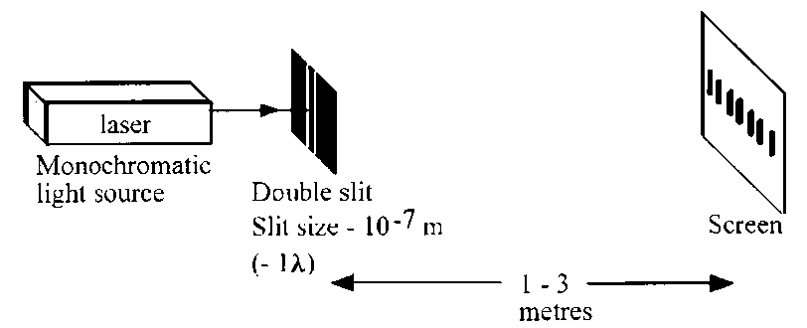
Part A: Interference of laser light (demonstration)
Apparatus
Laser, double slit, metre stick, screen.

Instructions
- Observe the pattern on the screen.
- Describe the pattern produced on the screen, noting any change in intensity across the pattern.
- Write a conclusion based on the results of the experiment.

Part B: Measurement of wavelength (demonstration)
Apparatus
Laser, grating, metre stick, screen.

Instructions
- Replace the double slit shown in the above diagram with the grating.
- Observe the pattern on the screen.
- Measure the distance across a number of spots (d).
- Measure the grating to screen distance D.
- Calculate the wavelength of the laser light.
- Consider the uncertainties in each measurement.

Practical 4- Wavelengths of coloured light

Use a spectrometer with difference coloured LEDs as a light source to find the average wavelengths of red, green and blue lights. Do not look directly into the spectrometer as the monochromatic light could damage your eyesight.

Another method for measuring λ- Diffraction

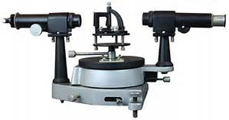
Light source
grating
spectrometer
The whole apparatus acts as one unit. The spectrometer is attached to the round disc with angles marked on them. The spectrometer is moved round by a thumb screw until light is viewed.
What you need to measure:
d – line spacings of the grating;
θ - angle to the maxima;
m – number of order maxima.

Gratings
d
λ
θ₁
A double slit gives a very dim interference pattern since very little light can pass through the two narrow slits. Using more slits allows more light through to produce brighter and sharper fringes.
As in Young’s Double Slit Experiment the first order bright fringe is obtained when the path difference between adjacent slits is one wavelength λ.
Therefore$: sinθ_{1}=\frac{λ}{d}$
$$λ=d sinθ_{1}$$

d
2λ
θ₂

The second order bright fringe is obtained when the path difference between adjacent slits is two wavelengths 2λ.
Therefore: $sinθ_{2}=\frac{2λ}{d}$
$$2λ=d sin θ_{2}$$

laser
grating
screen
22°
3rd order
maximum
3rd order
maximum

The general formula for the m^{th} order spectrum is:
$$mλ=d\sin{θ_{m}}$$
where m is an integer.

Example: Monochromatic light from a laser is directed through a grating and on to a screen as shown. The grating has 100 lines per millimetre.
Calculate the wavelength of the laser light.
Solution:
m = 3
θ = $\frac{22}{2}$ = 11° n =100 lines per millimetre = 100 000 lines per metre,
$$d=\frac{1}{100 000}=1∙00 × {10}^{-5} m$$

$$mλ = d sin θ$$
$$3 × λ = 1·00 × {10}^{-5} × sin 11°$$
$$λ = \frac{1·00 × {10}^{-5} × sin 11°}{3 }=6·36 × {10}^{-7} m$$
λ = 6·36 × 10⁻⁷ m

Splitting White Light
When white light is passed through a prism the different wavelengths refract by different angles. With a prism RED refracts least, BLUE refracts most.
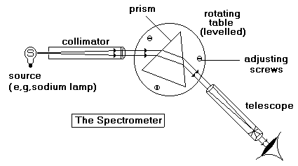
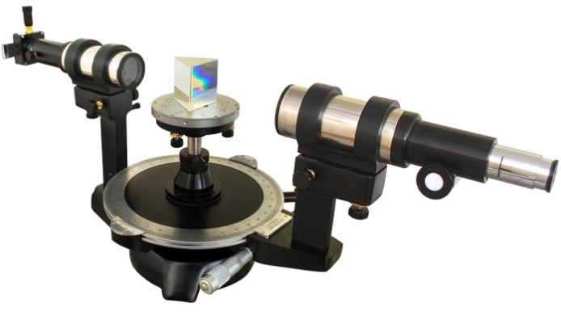

RED ≈ 690 nm
GREEN ≈ 540 nm
BLUE ≈ 440 nm

This is different to what we would observe if we put red and blue light through a diffraction grating.

Imagine we have two monochromatic sources, one red and the other giving blue light.
Using the red source arrangement gives us the following arrangement.
FIRST RED MAX
CENTRAL RED MAX
θ_{R}
Replacing the red with the blue gives:

FIRST BLUE MAX
CENTRAL BLUE MAX
θ_{B}

θR is different toθB since red and blue lights have different frequencies. So if we shine both sources simultaneously:
FIRST RED MAX
CENTRAL MAX FOR RED AND BLUE
FIRST BLUE MAX

When white light passes through a grating a series of visible spectra are observed either side of a central white maximum.

At the central maximum all wavelengths of light are in phase so all wavelengths interfere constructively. All colours mix to produce white light.
white light
grating
white
red

violet
violet

red
first
order
spectrum
first
order
spectrum
screen

If we use white light through a grating we get the following pattern:
blue/indigo/violet
blue/indigo/violet
red
red
orange
green
yellow
orange
yellow
green
white

Differences between a Grating and a Prism

It is important that you are aware of the differences between passing light through a prism and a grating, the first is an example of the effects of refraction the latter is due to diffraction.

PRISM | GRATING
Refraction angle of red least. | Diffraction angle of red greatest
Only one spectrum | More than one spectrum but some overlapping so that spectra may not be pure
Continuous
Compact | More spread out

Uses of Diffraction and Interference
http://hyperphysics.phy-astr.gsu.edu/hbase/optmod/holog.html

Thin film interference: an example of interference

Interference patterns can be observed whenever waves from two or more coherent sources come together. In Young's experiment the waves came from two separate sources but in thin film interference, the waves come from one source. One wavefront is split into two parts which are recombined after traversing different paths. Examples of thin film interference occur in oil slicks, soap bubbles and the thin layer of air trapped between two glass slabs. Here thin film means a layer of transparent material no thicker than several wavelengths of light.
Rays which have travelled different optical paths
Rays from one point on the source

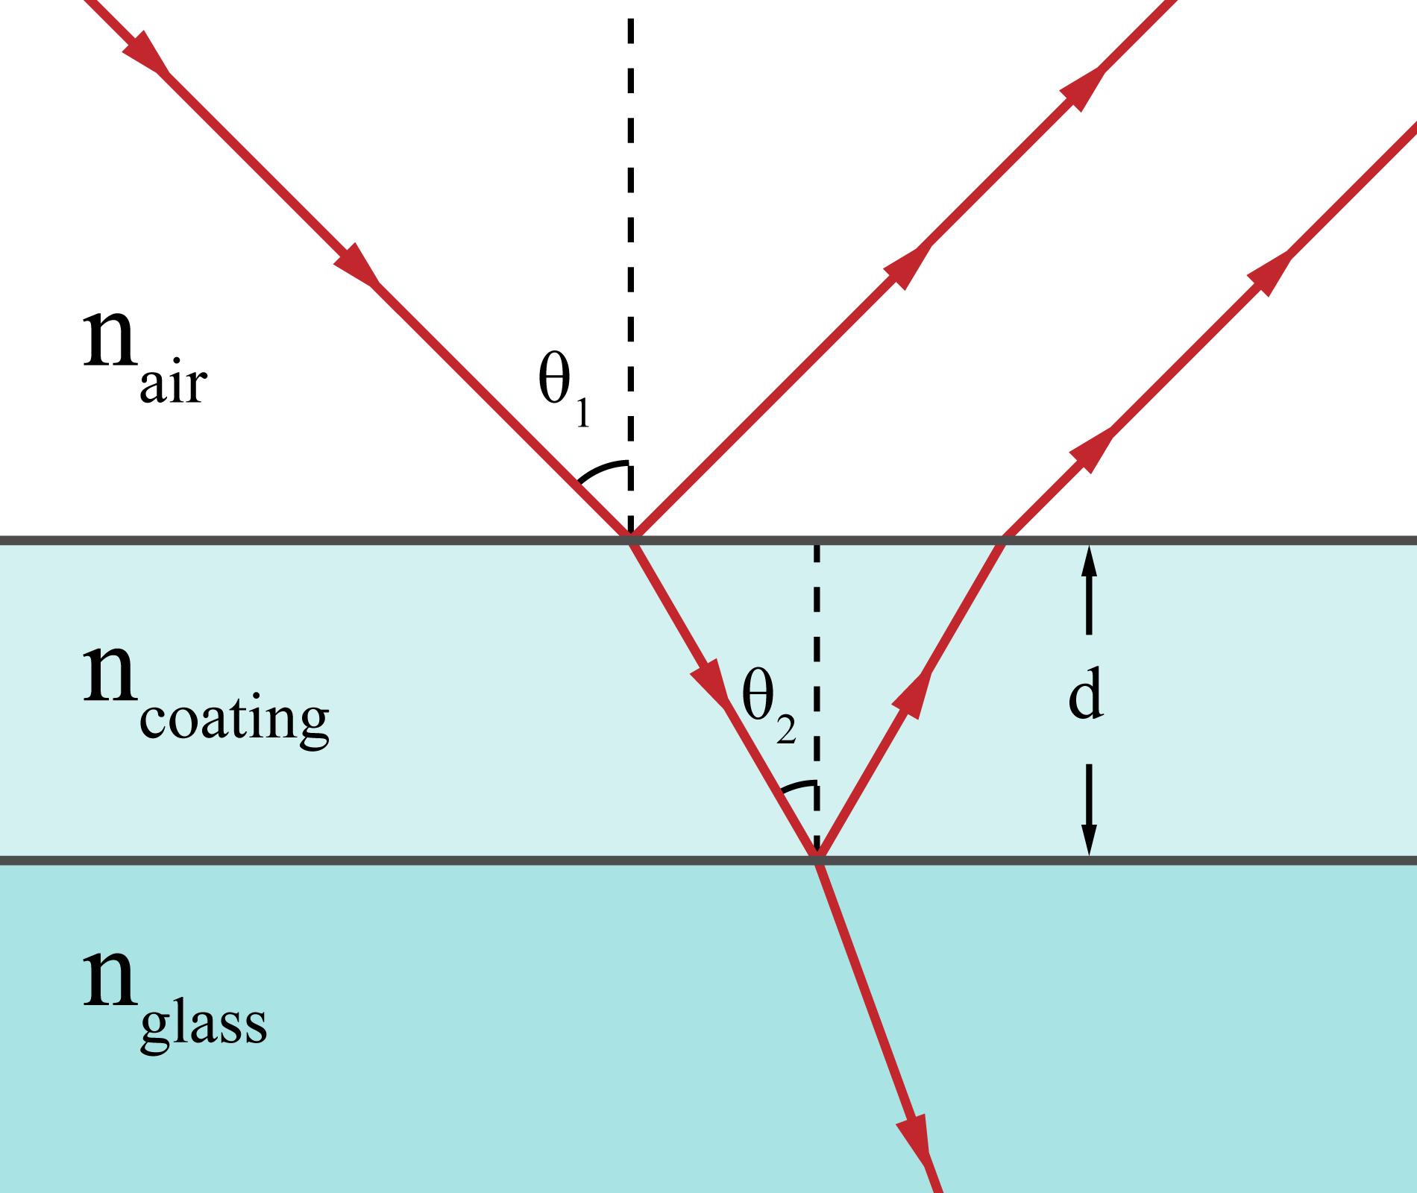
When light strikes one boundary of the film, some of it will be reflected and some will be transmitted through the film to the second boundary where another partial reflection will occurs. This process, partial reflection back and forth within the film and partial transmission, continues until the reflected portion of the light gets too weak to be noticed. The interference effects come about when parts of the light which have travelled through different optical paths come together again. Usually that will happen when the light enters the eye. Thus for example, light reflected back from the top surface of the film can interfere with light which has been reflected once from the bottom surface and is refracted at the top surface. The interference effect for monochromatic light, light or dark or somewhere in between, is determined by the amplitudes of the interfering waves and their phase difference.

Tutorial 1- Path Difference

- A harbour has two openings in its walls and a boat is moored 200m from one and 240m from the other. If the average wavelength is 1.6m, determine if the boat at a position of constructive or destructive interference.
- Two synchronized sets of drips fall from an overhead gutter into a puddle. The centres of the two sets of waves are 10cm apart and a spent match which is 40cm from one centre and 43cm from the other does not bob up and down at all. Calculate the largest possible wavelength for the waves in the puddle.
- A stereo system is putting out a single note of wavelength 16cm and a microphone is placed in a position of destructive interference between its speakers. If the microphone is exactly 208cm from one speaker, what is its distance from the other speaker if the full stretch of its supply cable does not allow it to be further than 186cm?

Tutorial 2- Gratings

1. A grating with 200 lines per millimetre engraved on it gives an interference pattern where the second order maximum occurs at an angle of 11.5o to the zero order maximum. Calculate the wavelength of the light used.
2. A grating with a line spacing of 8x10⁻⁶m is illuminated with light of wavelength 600nm. Calculate the angle where the first order maximum is found.
3. A maximum is found at an angle of 29.2°when light of wavelength 650nm is shone on a diffraction grating with a line spacing of 4x10⁻⁶m: State which order maximum has been found.

Tutorial 3 –Interference

1. A flat piece of wood is dropped onto the surface of a pond in order to send out a set of waves. If the wood is released from a greater height, state which of the following increases, you must justify your answer.
(a) Frequency, (b) Period, (c) Amplitude, (d) Speed, (e) Wavelength.

2. In each of the following examples, state whether the waves arriving at P are in or out of phase.
3.
If S1P = 60cm and the wavelength in use is 1.2cm, calculate the length of S2P.
4. When a wire ring with a soap film across it is held horizontally in red light, we see that it has even bands of red and black across it as shown:
5. A line spectrum is formed using a diffraction grating with 100 lines per millimetre. On examination, it is suspected that one of the fuzzier lines might be two lines very close together. Explain what change we can make that might resolve the problem.

6. Determine at what angles you find the red, green and blue lines of a spectrum using gratings with (a) 80 lines per mm, and (b) 300 lines per mm.

Tutorial 4 (SCET)

- In an experiment to measure the period of a simple pendulum, the time for 20 complete swings was found to be 40 s.
  - Explain why were 20 swings timed.
  - Calculate the period of this pendulum.
  - Calculate the frequency of this pendulum.
  - A pupil counted 100 heartbeats during 60 swings of this pendulum. Calculate the period of his pulse.

- The ‘mains’ frequency is 50 Hz. Calculate the time taken for one wave to be produced.

- A ‘long wave’ radio station broadcasts on a frequency of 252 kHz.
- Calculate the period of these waves.
- Calculate the wavelength of these waves.

- A green light has wavelength 546 nm.
- Express this wavelength in micrometres (μm).
- Express this wavelength in metres (using scientific notation).
- Calculate the frequency and period of these light waves.

- Explain how it is possible for interference to occur in the following situations:
  - a single loudspeaker emitting sound in a room with no other objects in the room
  - radio reception in a car when passing large buildings.
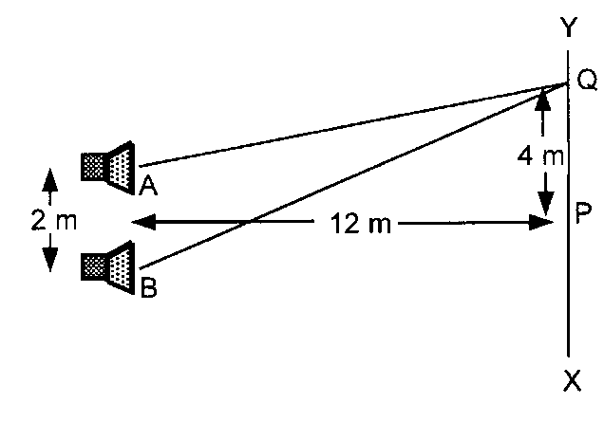
- In an experiment on sound interference, two sources A and B are placed 2 m apart. As a girl walks from X to Y she hears a point of maximum loudness at point P and the next at point Q. Using information from the diagram below:
  - find distances AQ and BQ
  - calculate the wavelength of the sound
  - calculate the frequency of the sound (speed of sound = 330 ms⁻¹).

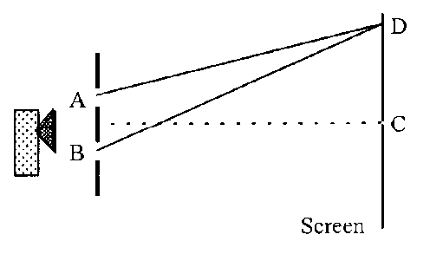
- In the microwave experiment shown below, C is the zero order maximum and D is the first order maximum. AD = 52 cm and BD = 55 cm
  - State the path difference at point D?
  - Calculate the wavelength of the microwaves.
  - Calculate the path difference to the second order maximum.
  - Determine the path difference to the minimum next to C.
  - Calculate the path difference to the second order minimum.
  - Calculate the path difference at point C.

- In a microwave interference experiment, H is the first order minimum that is there is one other minimum between H and G. Measurement of distances EH and FH gives: EH = 42.1 cm and FH = 46.6 cm.
Calculate the wavelength and frequency of the microwaves used.
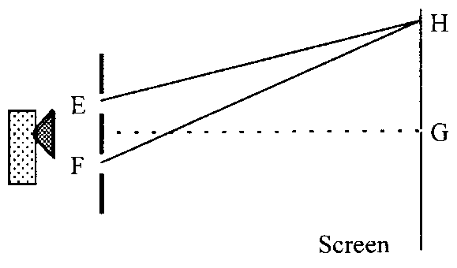

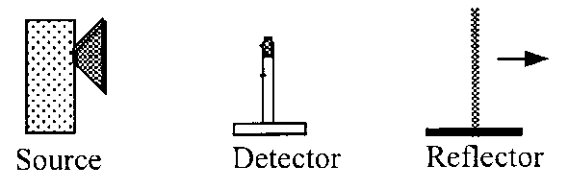
- In a microwave experiment the waves reflected from a metal plate interfere with the incident waves on the detector. As the reflector is moved away from the detector, a series of maxima and minima are found.
A maximum is found when the reflector is at a distance of 25 cm from the detector and a further 8 maxima are found as the reflector is moved to a distance of
37.8 cm from the detector.
  - Determine the average distance between maxima.
  - Calculate the wavelength of the microwaves.
  - Calculate the frequency of the microwaves.

- In a microwave interference experiment, P is the first order minimum away from the centre. The measured distances and their uncertainties are:
S₁P = 42.1 ± 0.5 cm S₂P = 46.6 ± 0.5 cm
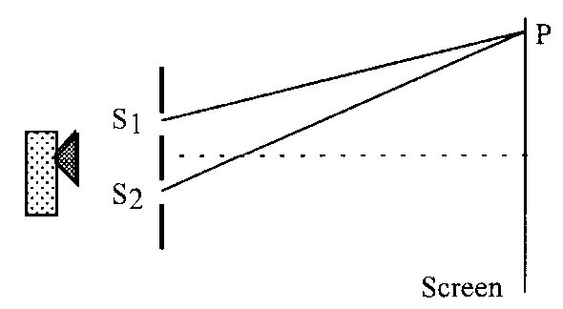
Calculate the wavelength of the microwaves and the uncertainty in this value of wavelength.

- A grating with 600 lines per mm is used with a monochromatic source and gives the first order maximum at an angle of 20.5°.
  - Calculate the wavelength of the source.
  - Determine the angle to the first order maximum if a grating of 1200 lines per mm was used.

- Light of wavelength 600 nm is passed through a grating with 400000 lines per metre. Calculate the angle between the zero and first order maxima.

- Light of wavelength 6.50 × 10⁻⁷ m is passed through a grating and the angle between the zero and third order maxima is 31.5°. Calculate the slit spacing of the grating.
- Light of wavelength 500 nm is used with a grating of 500 lines/mm. Calculate the angle between the first and second order maxima.

- White light, with a range of wavelengths from 440 nm to 730 nm is passed through a grating with 500 lines/mm.
  - Describe what would be seen.
  - Explain the pattern produced.
  - Calculate the angle between the extremes of the first order maximum, i.e. the angle between violet and red.
  - A green filter is placed in front of a white light source and the filtered light is passed through a grating with 300 lines/mm. A pattern of bright and dark bands is produced on a screen. State the colour of the bright bands of light.
  - Explain whether the spacing of the bright bands would increase or decrease when the following changes were made:
    - using a blue filter instead of a green filter
    - using a grating with 600 lines/mm
    - using a brighter lamp
    - bringing the screen closer to the grating.

- Spectra can be produced from white light by two methods as shown below.
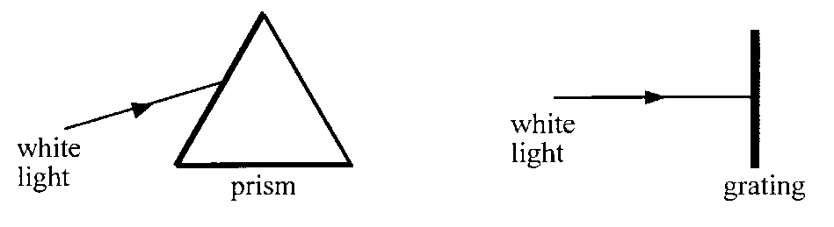
  - Copy and complete the above diagrams to show the spectra produced.
  - List the differences between the two spectra produced.

Exam Questions

SQA 2007 Q16

      - A beam of white light is passed through two optical components P and Q. Component P
produces a number of spectra and component Q produces a spectrum as shown.

Which row in the table identifies the optical components and the colour of light seen at position X and position Y?

 | Optical Component P | Colour seen at X | Optical Component Q | Colour seen at Y
A | grating | Red | Triangular Prism | Red
B | Grating | Red | Triangular Prism | Violet
C | grating | Violet | Triangular Prism | Red
D | Triangular Prism | Red | Grating | Violet
E | Triangular Prism | Violet | grating | Red

SQA H 2010 27
      - A student is carrying out an experiment to investigate the interference of sound waves. She sets up the following apparatus.

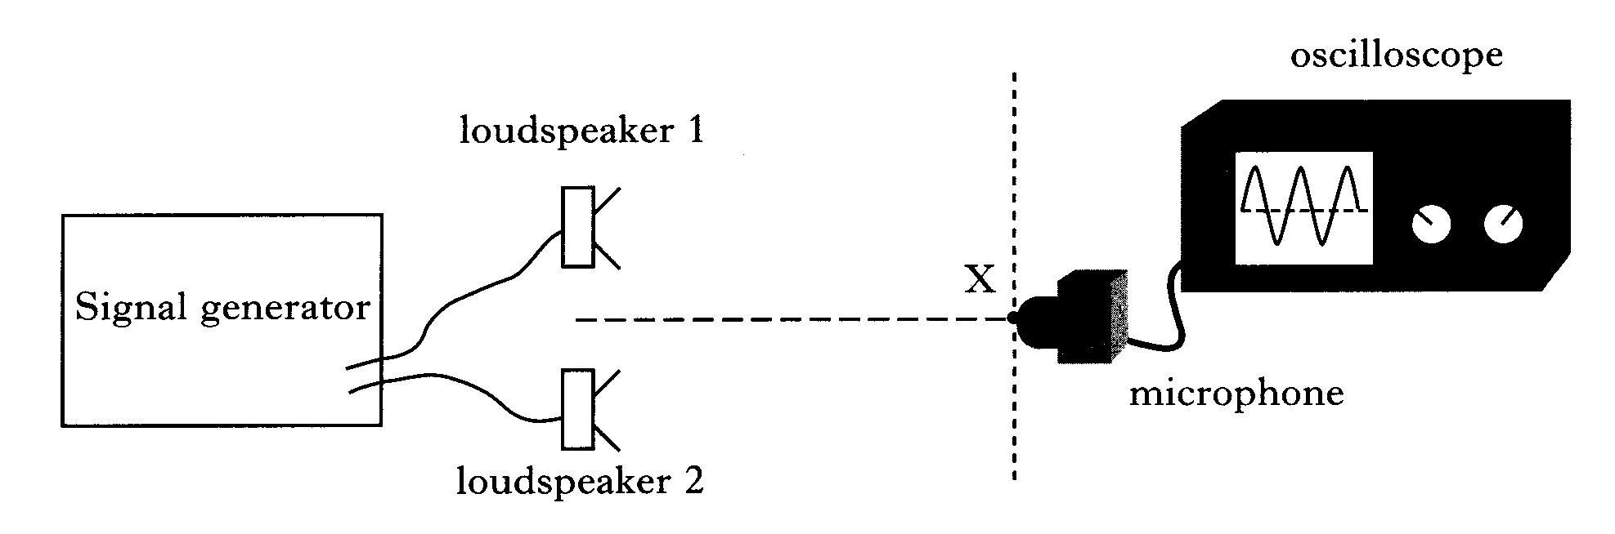

The microphone is initially placed at point X which is the same distance from each loudspeaker. A maximum is detected at X.

(a) The microphone is now moved to the first minimum Y as shown.

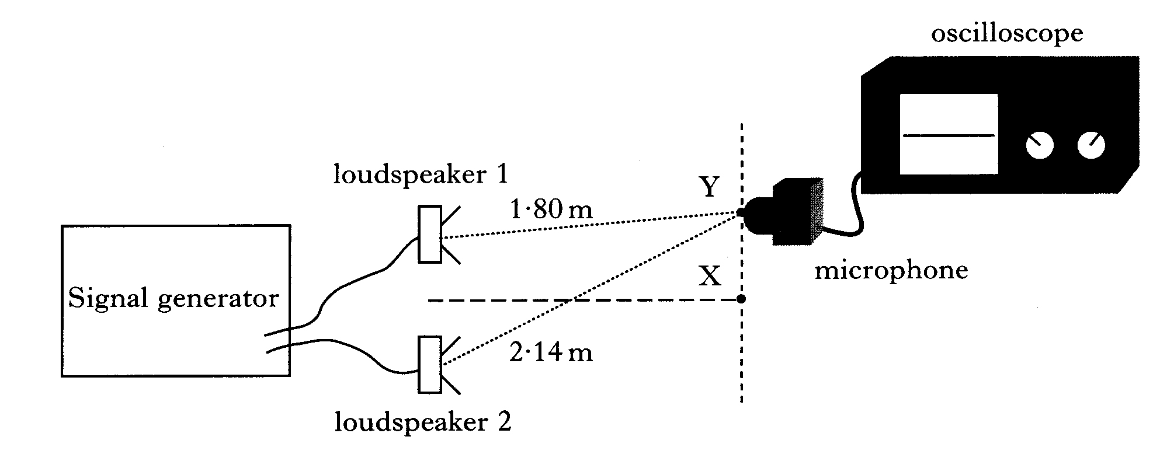

Calculate the wavelength of the sound waves.

(b) Loudspeaker 1 is now disconnected.

What happens to the amplitude of the sound detected by the microphone at Y?

Explain your answer.

SQA H 97 Paper II 8

2. Two identical loudspeakers X and Y are set up in a room which has been designed to eliminate the reflection of sound. The loudspeakers are connected to the same signal generator as shown.
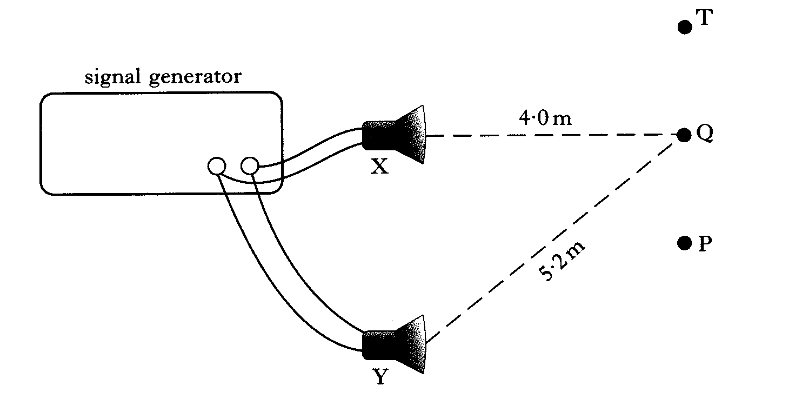
(a) (i) When a sound level meter is moved from P to T, maxima and minima of sound intensity are detected.

Explain, in terms of waves, why the maxima and minima are produced.

(ii) The sound level meter detects a maximum at P.

As the sound level meter is moved from P, it detects a minimum then a maximum then another minimum when it reaches Q.

Calculate the wavelength of the sound used.

(b) The sound level meter is now fixed at Q.

The frequency of the output from the signal generator is increased steadily from 200 Hz to 1000 Hz.

(i) What happens to the wavelength of the sound as the frequency of the output is increased?

(ii) Explain why the sound level meter detects a series of maxima and minima as the frequency of the output is increased.

SQA 2007 Q28

An experiment to determine the wavelength of light from a laser is shown.
A second order maximum is observed at point B.
(a) Explain in terms of waves how a maximum is formed.
(b) Distance AB is measured six times.
The results are shown.
1.11m | 1.08m | 1.10m | 1.13m | 1.11m | 1.07m
(i) Calculate:
(A) the mean value for distance AB;
(B) the approximate random uncertainty in this value.
(ii) Distance BC is measured as (270 ± 10) mm.
Show whether AB or BC has the larger percentage uncertainty.
(iii) The spacing between the lines on the grating is 4.00 × 10⁻⁶m.
Calculate the wavelength of the light from the laser.
Express your answer in the form
wavelength ± absolute uncertainty

Tutorial answers:

Tutorial 1
1. There is constructive interference at the boat's mooring position.
2. Maximum wavelength is 6 cm.
3. The second speaker is 184 cm from the microphone.

Tutorial 2
1. The wavelength of this light is 498.4 nm
2. The first order maximum is at an angle of 4.3°.
3. We are looking at the third order maximum

Tutorial 3
1. Dropping the wood from a greater height gives the waves more energy therefore their amplitude is increased.
2. (a) The two sets are exactly out of phase at P.
(b) Both sets are in phase at P.
3. S₂P= 55.2 cm
4. The interference pattern is caused by light reflecting off the rear surface of the film interfering with the light reflecting off the top surface. The even spacing of the light and dark bands shows that the film is of uniform thickness.
5. Replace the grating with one containing more lines per millimetre.
6. Assuming you know the average wavelength of the colours are red 740nm, green 530nm, blue 450nm then,
m=1  Red θ = 3.4°  Green θ = 2.43°  Blue θ = 2.06° | m=2  Red θ = 12.83°  Green θ = 9.15°  Blue θ = 7.77°

Other answers are found in the P&W answer book, with fully worked answers.

Tutorial 4: (SCET) Waves

- a) reduces uncertainty and increases reliability and validity.
b) 2s c) 0.5 Hz d) 1.2 s.
- 0.02 s.
- a) 3.97 × 10⁻⁶ s b) 1190 m.
- a) 0.546 μm b) 5.46 × 10⁻⁷ m c) 5.49 × 10¹⁴ Hz, 1.82 × 10⁻¹⁵ s.
- a) AQ = 12.37 m, BQ = 13.00 m b) 0.63 m c) 524 Hz.
- a) 3 cm b) 3 cm c) 6 cm d) 1.5 cm e) 7.5 cm f) zero.
- 3cm, 1.0 × 10¹⁰ Hz.
- a) 1.6 cm b) 3.2 cm c) 9.38 × 10⁹ Hz.
- 3.0 ± 0.04 cm.
- a) 5.84 × 10⁻⁷ m b) 44.5°.
- 13.9°.
- 3.73 × 10⁻⁶ m.
- 15.5°.
- a) A repeating continuous spectrum (from violet to red) would be produced either side of the centre line of the diffraction grating. The light at the centre line would be white.
b) For a given value of m, the value of dsinθ is smaller for smaller wavelengths, therefore q is also smaller for smaller wavelengths. As wavelength increases so does the angle for the nth order constructive interference points
c) 8.7°.
16. a) The bright bands are green.
b) i) Blue light has a shorter wavelength than green, therefore nl is smaller and hence θ is smaller. Therefore the bands will be closer together.
ii) Halving d will require sinθ to double for the same value of m λ. Therefore θ will be larger and the bands will be further apart.
iii) A brighter lamp will have no effect on the spacing since the wavelength is not affected.
iv) θ will remain the same so the bands will move closer together.

Exam paper answers

SQA 2007 Q16 Answer C

SQA H 2010 27

SQA H 97 Paper II 8
8.a.i. A maxima occurs when two waves interfere constructively. This happens
when waves are in phase.

A minima occurs when two waves interfere destructively. This happens when
the two waves are 180º out of phase.

a.ii.
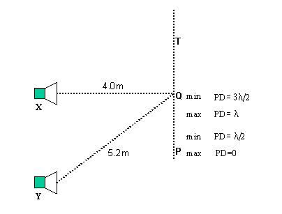
The minima is produced when the path difference YQ-XQ is equal to 3/2λ.

YQ-XQ = (5.2-4.0)m = 1.2m
YQ-XQ = 3/2λ
λ=(2x1.2)/3
λ = 0.8m

b.i. The speed of sound is constant in air, therefore increasing the frequency will decrease the wavelength. If the frequency is increased by a factor of 5 the wavelength will decrease by a factor of 5.

Wavelength at 1000Hz = 1.2/5 = 0.24m

b.ii. If the path difference is fixed at 1.2m this will represent a whole number of wavelengths for certain frequencies and produce maxima, however, for other frequencies this will represent a whole number of half wavelengths and produce minima. For this reason a series of maxima and minima are produced.

SQA 2007 Q28

CHAPTER 7: REFRACTION OF LIGHT

Summary of Content

No | CONTENT
Refraction
 | $n=\frac{\sin{θ_{1}}}{\sin{θ_{2}}}=\frac{λ_{1}}{λ_{2}}=\frac{v_{1}}{v_{2}}$ and $v=fλ$ and
 | I can define absolute refractive index of a medium as the ratio of the speed of light in a vacuum to the speed of light in the medium.
 | I can use $n=\frac{\sin{θ_{1}}}{\sin{θ_{2}}}$ to solve problems involving absolute refractive index, the angle of incidence and the angle of refraction.
 | I can describe an experiment to determine the refractive index of a medium.
 | I can use $\frac{\sin{θ_{1}}}{\sin{θ_{2}}}=\frac{λ_{1}}{λ_{2}}=\frac{v_{1}}{v_{2}}$ and $v=fλ$ to solve problems involving the angles of incidence and refraction, the wavelength of light in each medium, the speed of light in each medium, and the frequency, including situations where light is travelling from a more dense to a less dense medium.
 | I know that the refractive index of a medium increases as the frequency of incident radiation increases.
 | I can define critical angle as the angle of incidence which produces an angle of refraction of 90°.
 | I know that total internal reflection occurs when the angle of incidence is greater than the critical angle.
 | I can use to solve problems involving critical angle and absolute refractive index.

Refraction of Light

Light, and other forms of electromagnetic radiation, do not require a medium through which to travel and so travel at its greatest speed in a vacuum. Light also travels at almost this speed in gases such as air. The speed of any electromagnetic radiation in space or a vacuum is 3·00 × 10⁸ m s⁻¹.

Refraction is the property of light which occurs when it passes from one medium to another. Light travels in a straight line in one medium. Whenever light passes from a vacuum to any other medium its speed and wavelength decreases. Unless the light is travelling perpendicular to the boundary between the media this change in speed results in a change in direction. It is the change in the speed of the light that causes refraction. The greater the change in speed, the greater the amount of refraction.

Media such as glass, perspex, water and diamond are optically more dense than a vacuum. Air is only marginally more dense than a vacuum when considering its optical properties.
The refractive index of a material (or medium) is a measure of how much the material slows down light passing through that material. It therefore also gives a measure of how much the direction of the light changes as it passes from one material to another.

The absolute refractive index of a material, n, is the refractive index of that material compared to the refractive index of a vacuum. The absolute refractive index of a vacuum (and therefore also air) is 1·0.
medium 1
medium 2
θ₁
θ₂
normal

Snell’s Law:
$$n_{1} sin {}_{1} = n_{2} sin {}_{2}$$
where medium 1 is a vacuum or air, and therefore n₁ = 1·0, this simplifies to:
$$\sin{{}_{1}}= { n}_{2}\sin{{}_{2}} or n_{2} =\frac{sinθ_{1}}{sinθ_{2}}$$
Where n₂, is the refractive index for that material.

Practical 1: Proving Snell’s Law

Finding the Relationship for Refractive Index
θ_{g}
θ_{a}
glass
air

- On plain paper draw round a Perspex block with a PENCIL.
- Copy the table as shown below
- Draw a normal to the block using a protractor and shine a ray of light into the block.
- Measure the angle of incidence and the angle of refraction. NB. all angles are measured from the normal. Why do you think it is best to draw lines either side of the normal?
- Repeat for other angles.
- Find the angle at which total internal reflection occurs.

θ₁  Angle of incidence (º) | θ₂  Angle of refraction (º) | sin θ₁ | sin θ₂

By varying the angle θ_{a}, a relationship between θ_{a} and θ_{g} can be found.
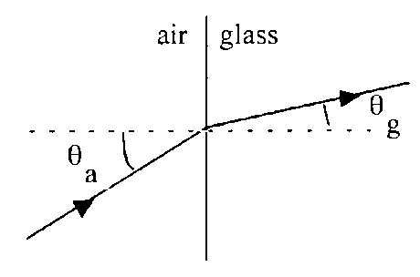
Experiment shows that is constant.
This constant is called the refractive index n of the medium.
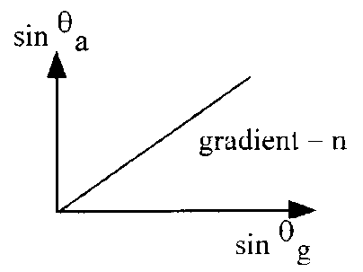
The values given in data books are called absolute refractive indices. These are the ratios of the sine of the angle in a vacuum, not air, to the sine of the angle in the medium. However, for most practical purposes we can use air.
θ_{a} = angle in air measured relative to normal
θ_{m} = angle in medium measured relative to normal.

The refractive index measures the effect a medium has on light. The greater the refractive index, the greater the change in speed and direction.
The refractive index of a medium is the same whether light moves from air into the medium or vice versa.

The absolute refractive index is always a value greater than (or equal to) 1.

Refractive Index and Waves- proof (for interest)

When light waves pass from one medium to another the frequency of the waves does not change. The number of wavelengths leaving one medium per second must equal the number of waves entering the other medium per second. The wave is continuous and energy must be conserved.

Since v = fλ, v is directly proportional to λ Therefore if the waves pass into an optically more dense medium the speed of the waves must decrease and therefore the wavelength of the waves must also decrease as the frequency remains constant.

Consider the wavefronts of a parallel sided beam of light entering an optically more dense medium, i.e. one with a higher refractive index, as shown:
medium 1
medium 2
λ₂
θ₂
θ₂
θ₁
θ₁
θ₁
θ₂
B
C
A
D
λ₁
v₁
v₂
The relative refractive index is the ratio of the speed of light in the two media:
The distance the light travels in the time of one period, T, in medium 1 is BC.

Hence:
Likewise, the distance the light travels in one period, T, in medium 2 is AD. Hence:
Therefore:

But from the triangle ABC:
and from the triangle ABD:

Therefore:

In summary, the refractive index of medium 2 relative to medium 1 can be determined from:
- the ratio of the speeds in the two media
- the ratio of the wavelengths in the two media
- the ratio of the sines of the angles in the two media.

$$n=\frac{v_{1}}{v_{2}}=\frac{λ_{1}}{λ_{2}}=\frac{sin{ θ}_{1}}{sin{ θ}_{2}}$$

As the refractive index of a medium is only a ratio it does not have a unit. The absolute refractive index of all media is greater than 1·00 as light slows down in all media compared with a vacuum.

Waves refract when they enter materials of different density. The speed alters as does the wavelength but frequency remains constant.

(Water waves refract when they go from deep to shallow water and vice versa).

Another way to prove this
$$v=fλ$$
Rearrange to make f the subject
$$f=\frac{v}{λ}$$
When waves refract, f remains constant, v and λ change.
$$∴\frac{v_{1}}{λ_{1}} = f_{1} \frac{v_{2}}{λ_{2}} = f_{2}$$

as f is constant f₁ = f₂
$$∴\frac{v_{1}}{λ_{1}} = \frac{v_{2}}{λ_{2}}$$

When material 1 is a vacuum (or air!) then: the ratio of v₁:v₂ and λ₁:λ₂ is called the REFRACTIVE INDEX (symbol, n).
n is dependent on the material (and also the wavelength)

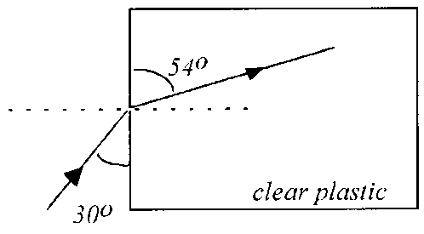
Example
Using information from the diagram, find the refractive index of the clear plastic.
All angles must be measured from the normal.

Refractive index and frequency of light
The refractive index of a medium depends upon the frequency of the incident light. The fact that there is a change of index of refraction with wavelength gives rise to chromatic dispersion, where light is split into different wavelengths. This arises when white light passes into a prism. Blue light travels more slowly in the material than red light giving rise to a spectrum when the light emerges from the prism. This happens because each frequency is refracted by a different amount. (we refer to frequency rather than wavelength as wavelength alters with the material, whereas frequency remains constant).

Since violet is refracted more than red (i.e. it has changed speed and direction by a greater amount), it follows that the refractive index for violet light must be greater than the refractive index for red light.

RED light has a wavelength ≈ 690nm
GREEN light has a wavelength ≈ 540nm
BLUE light has a wavelength ≈ 440nm

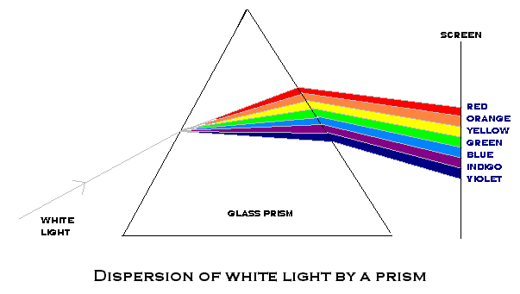
From this information find the frequency of each colour of light.

From the equation

Speed = frequency × wavelength

3×10⁸ = frequency × wavelength

RED light | BLUE light | GREEN light
Frequency=v/λ | Frequency=v/λ | Frequency=v/λ
Frequency=3×10⁸/700×10⁻⁹ | Frequency=3×10⁸/400×10⁻⁹ | Frequency=3×10⁸/540×10⁻⁹
f = 4.3×10¹⁴Hz | f = 7.5×10¹⁴Hz | f = 5.5×10¹⁴Hz

Refractive index and relationship with v, λ and f

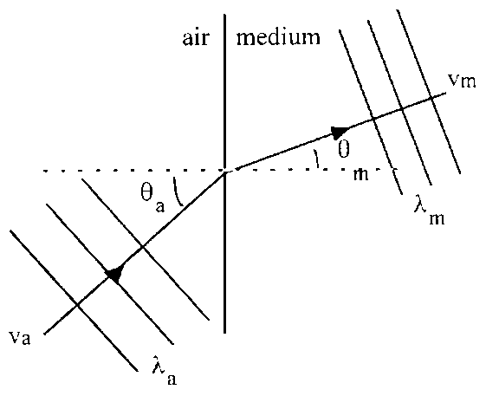
In general, from medium 1 to medium 2:
or

Example
Calculate the speed of light in glass of refractive index 1.50.

Critical angle and total internal reflection

When light travels from a medium of high refractive index to one of lower refractive index (e.g. glass into air), its direction changes away from the normal. If the angle within the medium θ_{m} is increased, a point is reached where the angle in θ_{a} becomes 90°. The angle in the medium which causes this is called the critical angle, θ_{c}.
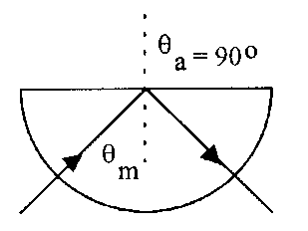
θ_{c}
θ_{a}
glass
air

For angles of incidence less than the critical angle some reflection and some refraction occur. The energy of the light is split along two paths.
θ_{c}
glass
air
total internal
reflection
For angles of incidence greater than the critical angle only reflection occurs, i.e. total internal reflection, and all of the energy of the light is reflected inside the material.

If the angle in the medium is greater than the critical angle, then no light is refracted and Total Internal Reflection takes place within the medium.
At the critical angle, θ_{m} = θ_{c} and θ_{a} = 90°

Total internal reflection allows light signals to be sent large distances through optical fibres. Very pure, high quality glass absorbs very little of the energy of the light making fibre optic transmission very efficient. Total internal reflection is more likely to take place in a material with a small critical angle; therefore, it is desirable to use a medium of high refractive index when designing optical fibres.
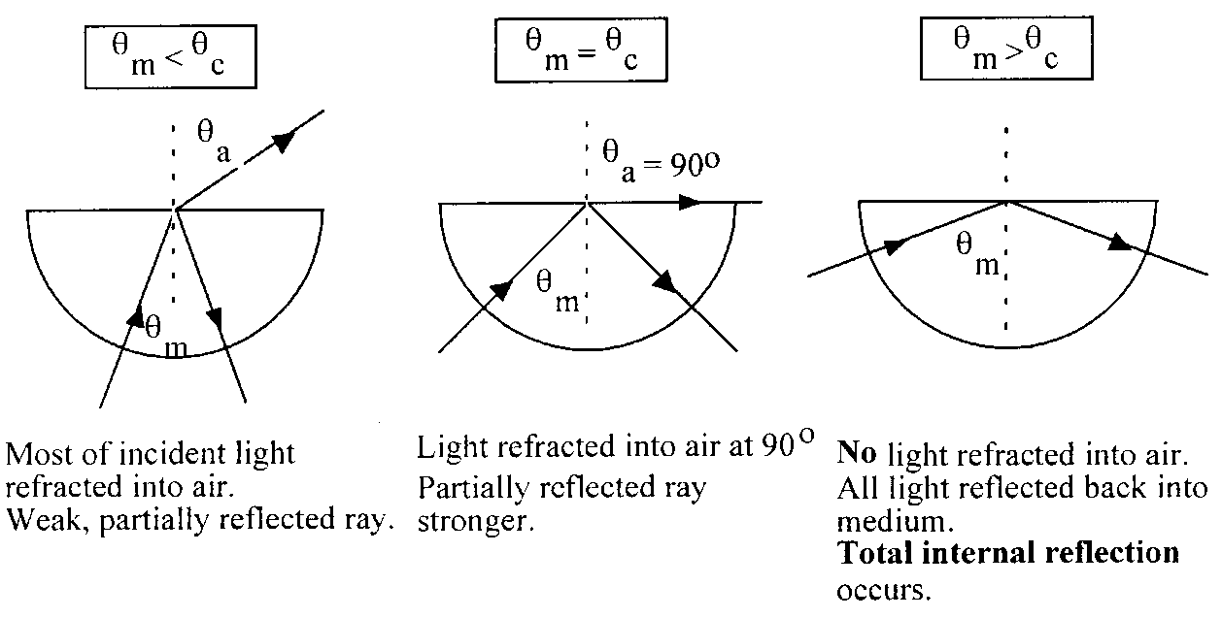

Fibre-optic Uses

An optical fibre is a thin glass fibre down which light can travel by total internal reflection. The rays of light always strike the internal surface of the glass at an angle greater than the critical angle; so that all the light, and hence energy remains in the fibre.

A commercial optical fibre has a fibre core of high refractive index surrounded by a thin, outer cladding of glass with lower refractive index than the core. This ensures that total internal reflection takes place.
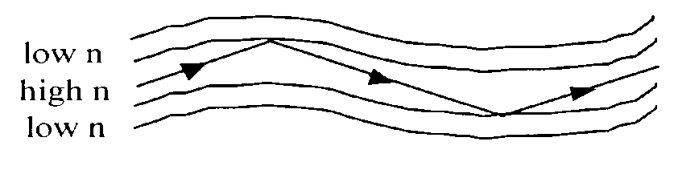
Until the optical fibre network was developed, telephone calls were mainly sent as electrical signals along copper wire cables. As demand for the systems to carry more telephone calls increased, simple copper wires did not have the capacity, known as bandwidth, to carry the amount of information required.
Systems using coaxial cables like TV aerial leads were used but as the need for more bandwidth grew, these systems became more and more expensive especially over long distances when more signal repeators were needed: i.e. the signal needs to be provided with more energy due to signal losses. As demand increases and higher frequency signals are carried, eventually the electronic circuits just cannot cope with the increased load.

Optical fibres allow for huge capacity in communication. A single fibre can carry the conversations of every man, woman and child on the face of this planet, at the same time, twice over. The latest generations of optical transmission systems are beginning to use a significant part of this huge capacity, to satisfy the rapidly growing demand for data communications and the internet.

The main advantages of using optical fibres in the communications industry are:
- A much greater amount of information can be carried on an optical fibre compared to a copper cable.
- In all cables some of the energy is lost as the signal goes along the cable. The signal then needs to be boosted using regenerators. For copper cable systems these are required every 2 to 3 km but with optical fibre systems they are only needed every 50 km.
- Unlike copper cables, optical fibres do not experience any electrical interference. Neither will they cause sparks so they can be used in explosive environments such as oil refineries or gas pumping stations.
- For equal capacity, optical fibres are cheaper and thinner than copper cables which make them easier to install and maintain.

Optical fibre submarine links are in use all around the world. Because of the low loss and high bandwidth of optical fibre systems they are ideal for submarine systems where you want to minimise the amount of complex electronics in regenerators sitting on the sea bed. In fact, the link from the UK to the English Channel Islands is achieved directly without any submerged regenerators.

Medical Industry

Optical fibres have paved the way for a whole new field of surgery, called laparoscopic surgery (or more commonly, keyhole surgery), which is usually used for operations in the stomach area such as appendectomies. Keyhole surgery usually makes use of two or three bundles of optical fibres. A "bundle" can contain thousands of individual fibres. The surgeon makes a number of small incisions in the target area and the area can then be filled with air to provide more room.

One bundle of optical fibres can be used to illuminate the chosen area, and another bundle can be used to bring information back to the surgeon. Moreover, this can be coupled with laser surgery, by using an optical fibre to carry the laser beam to the relevant spot, which would then be able to be used to cut the tissue or affect it in some other way.

Other Uses
- Optical fibres can be used for the purposes of lighting up buildings.
- Another important application of optical fibres is in sensors.
  - If a fibre is stretched or squeezed, heated or cooled or subjected to some other change of environment, there is usually a small but measurable change in light transmission. Hence, a rather cheap sensor can be made which can be put in a tank of acid, or near an explosion or in a mine and connected back, perhaps through kilometres of fibre, to a central point where the effects can be measured.
  - An advantage of fibre-optic sensors is that it is possible to measure the data at different points along the fibre and to know to what points the different measurements relate. These are the so-called distributed sensors.
- Fibre optics are also used to carry high power laser beams from fixed installations within factories to the point of use of the laser light for welding, cutting or drilling. The fibre provides a flexible and safe means of distributing high power laser radiation around a factory so that robots or machine tools can be provided with laser machining capability.
- Optical fibres can also be used as simple light guides. Cars are being developed where optical fibres are taking the light from a single high intensity lamp under its bonnet to a series of mini-headlamps on the front.
- A research group at the Clarendon Laboratory, Oxford, is designing a laser installation at the William Hershel Telescope on La Palma to help astronomers make an 'artificial' star in the layer of atomic sodium which exists at a height of 100km above the Earth's surface. The Earth's atmosphere is a big problem for astronomers. It is a gas that is constantly moving which makes the light traveling through it from distant stars flicker. If astronomers could use a reference 'star' whose brightness they knew, then they could allow for this twinkling. The telescope will look at how the atmosphere is affecting the artificial star second by second and adjust the telescope's mirror to compensate. This should allow astronomers to capture pictures of astronomical objects of a quality previously only obtainable from the Hubble Space Telescope. The optical fibre in this case is used to pipe the laser power needed to create the artificial star from the lasers to the telescope itself.
- As light is not affected noticeably by electromagnetic fields. It also does not interfere with other instruments that do use electricity. For this reason, fibre-optics are also becoming very important for short-range communication and information transfer in applications like aircraft.

Examples
- Calculate the critical angle for water of refractive index = 1.33.
- A ray of light strikes the inside of a glass block as shown. Will the ray emerge from the glass?
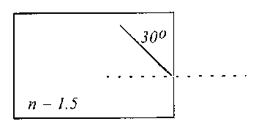
The angle inside the glass is 60°, which is greater than 41.8°.
Hence total internal reflection occurs.

Refraction Equation Summary

$$v=fλ$$

For most of this topic v in air = 300 000 000 ms⁻¹

Critical angle equations
Example: A narrow ray of white light is shone through a glass prism as shown.
The ray disperses into the visible spectrum. The glass has a refractive index of 1·47 for red light and 1·51 for violet light.
θ_{d}
50·0°
red
violet
(a) Calculate the angle of dispersion θ_{d} in the glass.
(b) Calculate speed of the red light in the glass prism.

Solution:
(a) Red:  $$n_{g}= \frac{\sin{θ_{a}}}{\sin{θ_{m}}}$$  $$1.47= \frac{\sin{50∙0}}{\sin{θ_{r}}}$$  $$\sin{θ_{r}}= \frac{\sin{50∙0}}{1.47}$$  θ_{R} = 31·4°  θ_{d} = 31·4° − 30·5° = 0·9°  (b)  $$n=\frac{v_{1}}{v_{2}}$$  $$1.47=\frac{3·00× {10}^{8}}{v_{1}}$$  $$v_{1}=\frac{3·00× {10}^{8}}{1.47}$$  v₁ = 2·04 × 10⁸ m s⁻¹ | Violet  $$n_{g}= \frac{\sin{θ_{a}}}{\sin{θ_{m}}}$$  $$1.51= \frac{\sin{50∙0}}{\sin{θ_{v}}}$$  $$\sin{θ_{r}}= \frac{\sin{50∙0}}{1.51}$$  θ_{V} = 30·5°

Optical Instruments
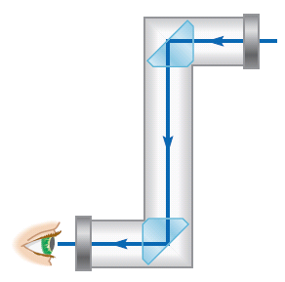
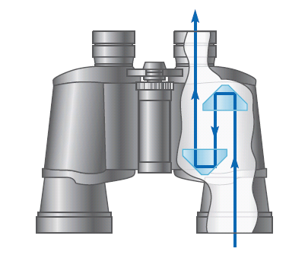
Optical instruments such as periscopes (seen on the left), binoculars (right),single-lens reflex (SLR) cameras, and telescopes often use prisms to redirect a beam of light by reflection. In a periscope two prisms, each reflecting light through a 90° angle, displace the beam so that it emerges at the eye.

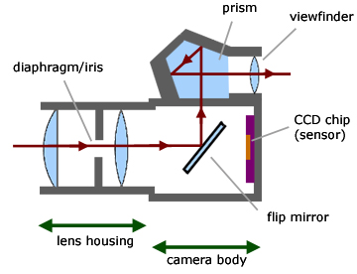
In an SLR camera, one of the prisms is replaced by a movable mirror. When the mirror is in place, the light through the camera lens is diverted up to the viewfinder, so you can see exactly what will appear on the picture. Depressing the shutter moves the mirror out of the way so the light falls onto the film or sensor instead. In binoculars and telescopes, erecting prisms are often used to turn an upside-down image right-side-up.

An advantage of using prisms instead of mirrors in these applications is that 100% of the light is reflected. A typical mirror reflects only about 90%.

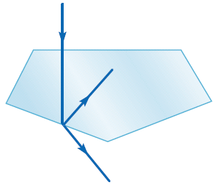
1 poorly cut diamond
The brilliant sparkle of a diamond is due to total internal reflection. The cuts are made so that most of the light incident on the front faces is totally reflected several times inside the diamond and then re-emerges toward the viewer.
2 well cut diamond

A poorly cut diamond allows too much light to emerge from one of the back faces where it has hit and an angle less than the critical angle so the ray is mostly transmitted out the back of the diamond away from the viewer.

Tutorial 1: Refraction
1. Light travelling at 3⋅0 x108 m s⁻¹ strikes the surface of a glass block at 50o to the normal. If its velocity inside the block is 2⋅0 x108 m s⁻¹, at what angle to the normal is it travelling there?
2. Light of wavelength 500 nm and velocity 3⋅0 x 108 m s⁻¹ is incident on the end of a fibre optic cable inside which its velocity is 1⋅9 x 108 m s⁻¹. What is the wavelength of this light inside the cable?
3. As light crosses a boundary between two media, its wavelength changes from 600 nm to 450 nm. If the angle between the light and the normal is 30o inside the second medium, what is its angle of incidence on it?

Tutorial 2 Refraction with Angles
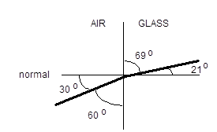
1. What is the refractive index of the glass in this diagram?
or Q1
2. A perspex block of refractive index 1⋅2 has light striking it at 40o to the normal. What is the angle between the light and the normal inside the block?
3. A fish sees a fly a few centimetres above the level water surface of a tank.
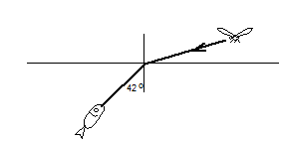
If the refractive index of the water is 1⋅29, at what angle is the light from the fly actually striking the water?
DISCUSSION OPPORTUNITY: Looking at this situation from the fish's point of view, what is wrong with making a grab for this fly directly at where it appears to be?

Tutorial 3 Critical Angle
1. What is the critical angle of a glass whose refractive index is 1.4?
2. What is the refractive index of a plastic material whose critical angle is 41.81o?
3. If the refractive index of a precious stone is 1.9 and that of a dense glass is 1.7, which has the smaller critical angle?

Tutorial 4 Refraction- mixed problems
1. What is the refractive index of the substance shown in this diagram?
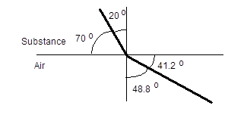
2.
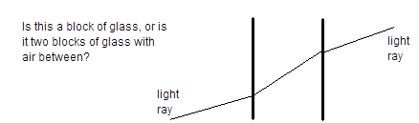
3. Green light of wavelength 535 nm travelling down a glass vacuum tube is incident at 80o with one wall. If its angle of refraction inside the glass is 44.7o,
(a) At what speed is it moving through the glass?
(b) What is its wavelength in the glass?
4. We can obtain plastic sheet that appears transparent but which becomes bright round its edges if we shine a light on it. Explain how this happens.
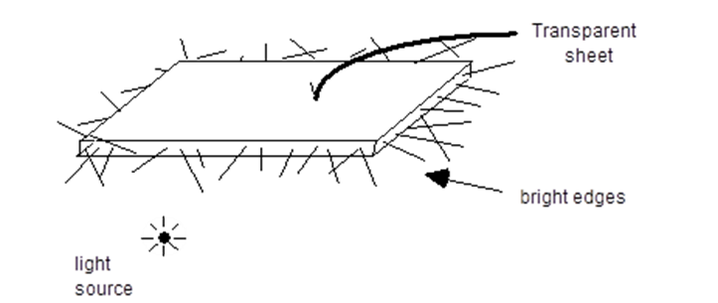
- This is a cross-section of an optical fibre:-
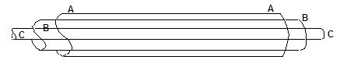
The materials used are:-
POLY METHYL METHACRYLATE of refractive index 1.59
POLYTHENE which is opaque
FLUORINATED POLYMER of refractive index 1.35
What letter is used for each of these materials in the diagram above?
6. (a) What is the critical angle for a transparent plastic with a refractive index of 1.59?
(b) A similar plastic has a critical angle of 48o. Does is have a higher or lower refractive index?

Tutorials (SCET) Refraction of light
- Calculate the refractive index n of each of the materials below:
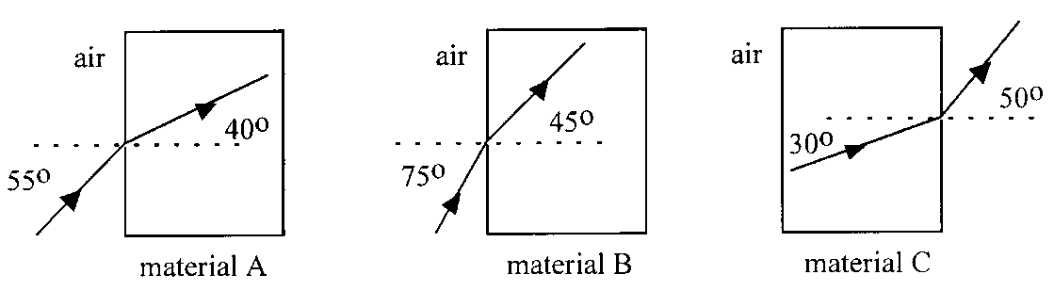
- Calculate the missing angle in each of the following diagrams:
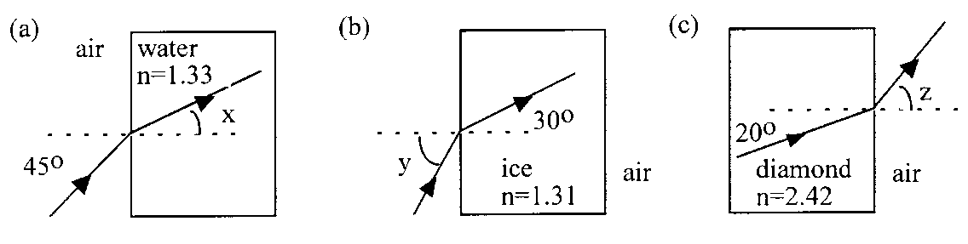
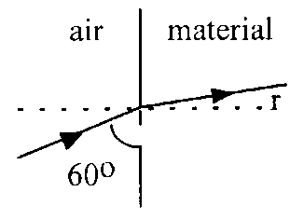
- The refractive index of the material shown in the diagram below is 1.35.
- Calculate the angle r.
- Find the velocity of the light in the material.
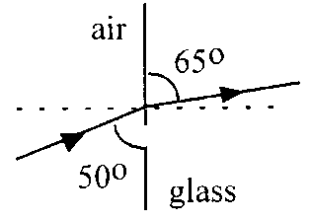
- A ray of light of wavelength 6.00 × 10⁻⁷ m passes from air to glass as shown below.
- Calculate the refractive index of the glass.
- Calculate the speed of light in the glass.
- Calculate the wavelength of the light in the glass.
- Calculate the frequency of the light in air.
- State the frequency of the light in the glass.

- A ray of light of wavelength 500 nm passes from air into perspex of refractive index 1.50 as shown.
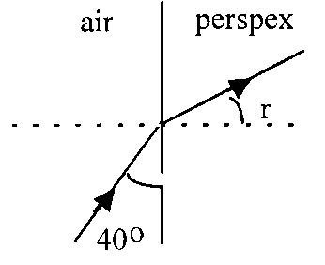
- Calculate the angle r.
- Calculate the speed of light in the perspex.
- Calculate the wavelength of light in perspex.

- The refractive index for red light in crown glass is 1.513 and for violet light it is 1.532.
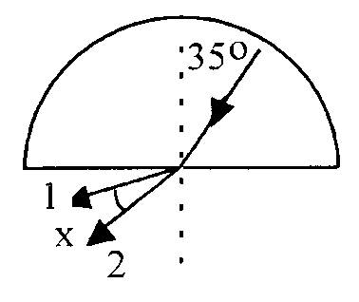
Using this information, explain why white light can produce a spectrum when passed through crown glass.
- A ray of white light passes through a semi-circular block of crown glass as shown and produces a spectrum.
- Which exit ray is red and which ray is violet?
- Calculate the refracted angle in air for each of the exit rays.
- Find angle x, the angle between the red and violet rays.
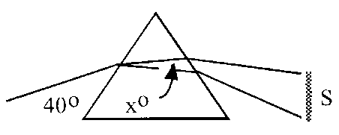
- A ray of white light is dispersed by a prism producing a spectrum, S.
The angle x° between red light and blue light is found to be 0.7°. If the refractive index for red light is 1.51, calculate the refractive index for blue light.
- Calculate the critical angle for each material using the refractive index given in the table below.
Material | n
Glass | 1.54
Ice | 1.31
Perspex | 1.50
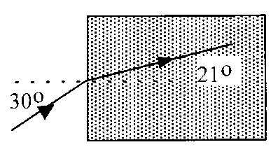
- A beam of infrared radiation is refracted by a type of glass as shown.
- Calculate the refractive index of the glass for infrared.
- Calculate the critical angle of the glass for infrared.
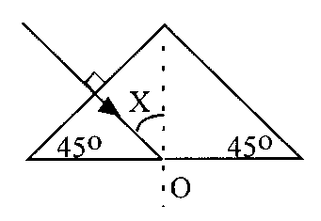
- A ray of light enters a glass prism of absolute refractive index 1.52, as shown:
- Why does the ray not bend on entering the glass prism?
- What is the value of angle X?
- Why does the ray undergo total internal reflection at O?
- Redraw the complete diagram showing the angles at O with their values.
- Explain what would happen if the experiment was repeated with a prism of material with refractive index of 1.30.
- The absolute refractive indices of water and diamond are 1.33 and 2.42 respectively.
- Calculate the critical angles for light travelling from each substance to air.
- Comment on the effect of the small critical angle of diamond on the beauty of a well cut stone.

Exam Questions

- In the arrangements of apparatus shown below, a ray of light is incident on a number of transparent perspex blocks. The refractive index of the perspex is 1.5.
Which arrangement can be used to demonstrate total internal reflection in perspex, without any further adjustment of the apparatus?
 | A ray of white light enters a triangular glass prism and splits into a spectrum of colours. Only the directions of the red and blue light inside the prism are shown in the diagram below.
glass
air
30·0°
50·0°
40·0°
white light
red
blue
N
 | Figure 28A
- (i) | (i) | Show that the refractive index of the glass for blue light is 1·53.
 | (ii) | State whether the refractive index of the glass for red light is less than, equal to, or greater than 1·53. Justify your answer.
(b) |  | The blue light continues through the prism to the boundary between the glass and air as shown below.
Figure 28B |  | 44·0°  blue light
 |  | Copy the diagram above and draw in the path taken by the ray of blue light immediately after reaching the boundary between the glass and air. Show any calculations made and include all relevant angles in your diagram.

SQA 2007 Q29.
- A ray of red light is incident on a semi-circular block of glass at the midpoint of XY as shown.
The refractive index of the block is 1.50 for this red light.
        - Calculate angle shown on the diagram.

        - The

        - wavelength of the red light in the glass is 420 nm.
Calculate the wavelength of the light in air.

(c) The ray of red light is replaced by a ray of blue light incident at the same angle. The blue light enters the block at the same point.
Explain why the path taken by the blue light in the block is different to that taken by the red light.

SQA 2000 Q27
- A student is investigating the effect that a semicircular glass block has on a ray of a monochromatic light.
She observes that at point X the incident ray splits into two ways.
T – a transmitted ray
R- a reflected ray.
The student uses a light meter to measure the irradiance of ray R as angle θ is changed.
        - State what is meant by irradiance.
        - Explain why, as angle θ is changed, it is important to keep the light meter at a constant distance from point X for each measurement of the irradiance
        - The following graph is obtained from the student’s results
          - State the value of the critical angle in the glass for this light.
          - Calculate the refractive index of the glass for this light
          - As the angle θ is increased, state what happens to the intensity of ray T.

Tutorial Answers:

Tutorial 1
1. It travels at 30.7o to the normal inside the glass block.
2. The wavelength inside the cable is 317nm
3. The angle of incidence is 41.8o

Tutorial 2
1. The refractive index of the glass is 1.4
2. The angle of refraction is 32.4o
3. The light from the fly makes an angle of incidence of approximately 60o with the water surface.

Tutorial 3
1. The critical angle is 45.6o.
2. The refractive index is 1.5
3. The lower the refractive index, the larger the angle before total internal reflection occurs. This explains why precious stones, which have high refractive indices, are so sparkly. They reflect more light internally.

Tutorial 4
1. Refractive index 2.2
2.
The right hand side ray is further from the normal than the ray on the left. Thus the left hand side of this boundary has a greater refractive index than the right and so the gap is air.
3.
(a) speed in glass = 2.14×10⁸ ms⁻¹
(b) Using the wavelength version of the above equation gives the wavelength in glass as 382nm

4. The plastic causes a large fraction of the light to be reflected internally so that it emerges from the edges:-
5. A ----- Polythene
B ----- Fluorinated polymer
C ----- Polymethylmethacrylate
The outer coating is protection against mechanical hazards like scrapes and scratches.
The central core is highly transparent and carries the signal while the B layer is a cladding of lower refractive index than the core so that total internal reflection occurs at the boundary.
6. (a) The critical angle is 38.9o.
- Using the same equation as above gives the refractive index of the second type of plastic as 1.35, which is lower than the first.

Tutorials (SCET) Refraction of Light

- nA = 1.27, nB = 1.37, nC = 1.53.
- a) 32.1° b) 40.9° c) 55.9°.
- a) 21.7° b) 2.22 × 10⁸ ms⁻¹.
- a) 1.52 b) 1.97 × 10⁸ ms⁻¹ c) 3.95 × 10⁻⁷ m d), e) 5.00 × 10¹⁴ Hz.
- 30.7° b) 2.00 × 10⁸ ms⁻¹ c) 333 nm.
- c) Red = 60.2°, Violet = 61.5° d) 1.3°.
- 1.54.
- Glass 40.5°, Ice 49.8°, Perspex 41.8°.
- a) 1.40 b) 45.6°.
- b) 45°.
- a) Water 48.8°, Diamond 24.4°.

Exam Paper Answers

Question |  | Marking Instructions | Notes | Marks
29 | (a) | n = sinθ_{a}/sinθ_{g} (½)  n = sin50/sin30 (½)  n = 1·53 |  | 1 | 6
 | (b) | less than 1·53 (1)  red is refracted less (1) |  | 2
 | (c) | n = 1/sinθ_{c}  1·53 = 1/sinθ_{c} (½)  θ_{c} = 41° (½)  or  n = sinθ_{a}/sinθ_{g}  1·53 = sinθ_{a}/sin44 (½)  sinθ_{a} = 1·06 (½)  total internal reflection occurs (1)  44·0°  blue light  N  44·0°  diagram with reflected ray and angle shown (1) |  | 3

SQA 2000 Q27
5.
              - The irradiance of radiation is equal to the incident power per unit area.
I = P/A
              - By keeping the light meter a constant distance from X you are justified in stating that any change in the recorded irradiance is a result of changing θ. If the distance was altered a change in intensity could be the result of a diverging beam.

                - The critical angle is found by noting the incident angle at which the reflected intensity reaches a maximum. θ = 42º
                - n_{glass} = 1/sinθ_{critical}
n_{glass} = 1/sin42º
n_{glass} = 1.49

iii .The intensity of ray T will decrease as angle θ is increased upto 42º.At angles equal to and above 42º the intensity of ray T will fall to zero, as the incident ray will be totally internally reflected.

CHAPTER 8: INVERSE SQUARE LAW

Summary of Content

No | CONTENT
Inverse square law
 | $I=\frac{P}{A}$ $I_{1}d_{1}^{2}=I_{2}d_{2}^{2}$
 | I know that irradiance is the power per unit area incident on a surface.
 | I can use the equation $I=\frac{P}{A}$ to solve problems involving irradiance, the power of radiation incident on a surface and the area of the surface.
 | I know that irradiance is inversely proportional to the square of the distance from a point source.
 | I can describe an experiment to verify the inverse square law for a point source of light
 | I can use and $I_{1}d_{1}^{2}=I_{2}d_{2}^{2}$ to solve problems involving irradiance and distance from a point source of light.

Irradiance

Irradiance, I at a surface on which radiation is incident is the power per unit area.
Irradiance, I is measured in watts per square metre.
The equation for irradiance comes from the equation, $I=\frac{E}{At}$
Reducing to:
Irradiance, I is inversely proportional to the square of the distance, d, from a point source.

Imagine a balloon with a light bulb shining inside (for these models we will ignore the Health and Safety problems with such an experiment). If the source is radiating 100W, then 100W of light is landing on the inside of the balloon skin. This is true, regardless of the size of the balloon skin. As the balloon is blown up the amount of light (irradiance) landing on each part of the balloon skin reduces.
Suppose we arranged for the balloon to have radii of 1m, 2m, 3m etc. one after the other, then I for each surface (assuming the balloon was spherical) would be

Therefore:
$$I∝\frac{1}{r^{2}}$$
Which gives the equation:
$$I_{1}r_{1}^{2}= I_{1}r_{1}^{2}$$
These results would give the following:  Irradiance  Radius  Irradiance  1/Radius²  Irradiance  1/Radius | This graph confirms that as r increases, I decreases.  A simple inverse proportion does not fit the graph, as the figures do not yield a straight line plot.  This graph is a straight line through the origin indicating irradiance is inversely proportional to the square of the distance from the source. Therefore:  $$I∝\frac{1}{r^{2}}$$
Which gives the equation:
$$I_{1}r_{1}^{2}= I_{1}r_{1}^{2}$$
0r

For all of these cases below as d increases by a factor of 2 the quantity decreases by a factor of 4

Where I = irradiance, A= activity and H= equivalent dose

Proving the inverse square law,
The Principles of a Method for showing
NB This experiment must be carried out in a darkened room WHY!?
NB Point source needed.
When light shines on the photovoltaic cell, the cell produces an emf (this comes later!). The emf is proportional to the irradiance landing on it. Therefore we take readings from the voltmeter and metre stick at various distances then plot a graph and check against what we expect for the inverse square law
Irradiance
1/Radius²
Irradiance
Radius
metre stick

low resistance voltmeter
selenium photovoltaic cell
I (units) | 15 | 48 | 116 | 249 | 442 | 761
d(cm) | 114 | 64 | 41 | 28 | 21 | 16
The voltmeter reading is proportional to irradiance so it is plotted on the y-axis. This is an example of the inverse square law.
A graph of Voltage or irradiance against 1/r² should give a straight line graph through the origin.
Quantities that obey the inverse square law are
e.g.
- light irradiance
- gravitational fields (and other fields)
- radioactivity

Light Irradiance
Irradiance is the product of the number of photons per second per square metre and the energy carried by each photon.
I=NE
I=Nhf
I=Nhf

irradiance = No. of photons Energy per photon (J)
(Wm⁻²) per second per
square metre (s⁻¹m⁻²)

Practical 1- Inverse Square Law

Set up the apparatus shown below and use it to show that the intensity of the light from the lamp varies with the inverse square of the distance from it.
LDR
Distance scale
Light Absorbing Paint
Light source
inside the tube
Light-tight tube

Practical 2- Inverse square again

Variation of light irradiance with distance from a point source of light
Apparatus
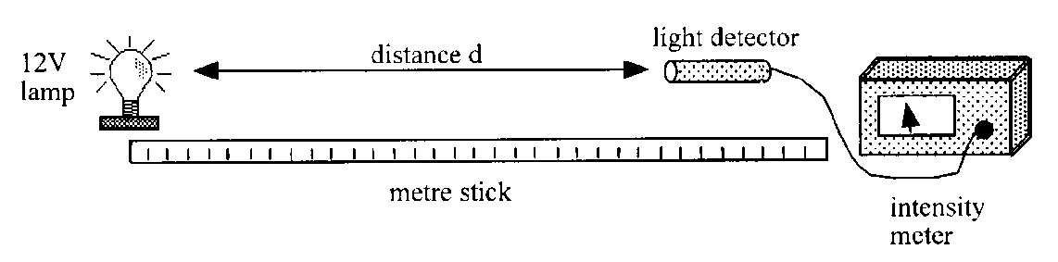
12 V power supply, 12 V lamp, light detector and meter, metre stick.

Instructions
- Darken the room. Place the light detector a distance from the lamp.
- Measure the distance from the light detector to the lamp and the irradiance of the light at this distance.
- Repeat these measurements for different distances between detector and lamp.
- Plot a graph of light irradiance against distance from the lamp.
- Consider this graph and your readings and use an appropriate format to find the relationship between the light irradiance and distance from the lamp.

Practical 3- LASER Beam diameter & Distance
Calculate the intensity of the laser beam at various distances from the source by measuring its beam diameter and using the information given about its power supply.
N.B. Remember to wear suitable laser goggles while conducting the practical work and use matte surfaces like plain paper to 'capture' the beam's cross-section.

Aim: Measurement of the beam diameter at various distances from a laser.
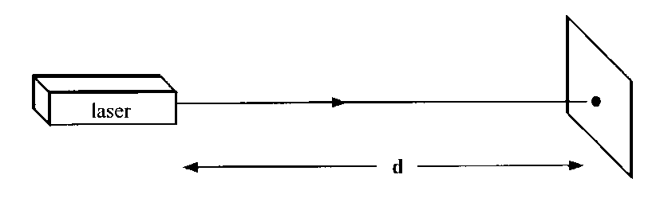
Apparatus: Laser, measuring tape or metre stick, white screen.

Instructions
- Set up the laser so that the beam shines on the white screen.
DO NOT look directly into the laser beam and avoid specular reflections.
- Over a range of distances d, measure the diameter of the laser beam (‘spot’).
- Record the measurements of distance and beam diameter.
- Calculate the irradiance of the laser beam at each distance.
Power of laser = 0.1 mW).
- Write a conclusion based on the results of the experiment.

Tutorial 1 Irradiance
- A satellite is orbiting the Earth where the irradiance of the Sun’s radiation is
1.4 kW m⁻². Calculate the power received by the satellite’s solar panels if they have an area of 15 m².
- A pupil measures the light irradiance of a 100 W light bulb as 0·2 W m⁻² at a distance of 2 m. Calculate the irradiance that would be measured at a distance of:
  - 1 m from the light bulb
  - 4 m from the light bulb.
- In an experiment on light irradiance, the following results were obtained:
Distance from point source d (m) | 1.0 | 1.4 | 2.2 | 2.8 | 3.0
Measured irradiance I (W m⁻²) | 85 | 43 | 17.6 | 10.8 | 9.4
a Sketch the apparatus that could be used to obtain these results.
b. Use an appropriate format to show the relationship between the irradiance I and the distance d.
c. Calculate the irradiance at a distance of 5 m from the source.
d. At what distance would the irradiance of the light be 150 W m⁻²?
- At a certain point on the Earth’s surface, the Sun’s radiation has an irradiance of 200 W m ⁻ ².
  - What area of solar cells would be required to produce a power output of 1 MW?
  - If the cells were only 15% efficient, what additional area of solar cells would be required?
- In an experiment to measure the irradiance of a light source, the power of the source is measured as 150 ± 1 W and the area of the surface as 1.8 ± 0.1 m².
Calculate the irradiance and the uncertainty in the irradiance. Express your answer in the form: value ± uncertainty.
- Which of the following graphs is correct for the intensity of light landing on a tapestry which is placed at varying distances from a single light bulb?
- An experiment is set up in a darkened laboratory with a small lamp L₁ with a power P. The irradiance at a distance of 0·50 m from the lamp is 12 W m⁻². The experiment is repeated with a different small lamp L₂ that emits a power of 0·5 P.

Calculate the irradiance at a distance of 0·25 m from this lamp.

Tutorial 2

- The power of light hitting a 10 cm² area is measured to be 100 mW. Calculate the irradiance of light hitting the area.

- The irradiance of light hitting a solar panel measuring 2 m x 5 m is found, on average, to be 80 W m⁻² over a one hour period. Calculate the energy received by the panel during that period.

- A 2.0 m² solar panel receives 300 kJ over a 20 minute period. Calculate the average irradiance of the sunlight during this time.

- A 500 W spotlight produces a circle of light of diameter 4 m on a theatre stage. Assuming no energy losses, calculate the irradiance of the light at the stage.

- A laser light produces a spot of light of irradiance 125 W m⁻². If the spot has diameter of 1 mm and assuming no energy losses, calculate the power output of the laser.

- The irradiance of a point source of light is measured to be 32 W m⁻² at a distance of 2 m, calculate the irradiance at 8 m.

- The irradiance of a point source of light is measured to be 2.5 W m⁻² at a distance of 12 m, calculate the irradiance at 3 m.

- The irradiance of a point source of light is measured to be 2 W m⁻² by an observer at a distance of 140 cm. Another observer measures it to be 3 W m⁻². Calculate the distance of the second observer from the source.

- The power of a point source of light is measured to be 2 W spread over an area 0.1 m⁻² at a distance of 5 m. Calculate the irradiance of the light at 2 m.

- The irradiance of a laser beam is measured as 140 W m⁻² at a distance of 50 cm, calculate the irradiance at 2 m.

Exam Questions

- Which of the following sets of readings satisfies the relationship between the distance from a point source of light and the intensity of illumination at that distance?

 | Distance / m | Intensity / W m⁻²
A | 2 | 20
 | 8 | 5

 | Distance / m | Intensity / W m⁻²
B | 4 | 20
 | 2 | 10

 | Distance / m | Intensity / W m⁻²
C | 4 | 20
 | 2 | 5

 | Distance / m | Intensity / W m⁻²
D | 2 | 20
 | 4 | 5

 | Distance / m | Intensity / W m⁻²
E | 2 | 20
 | 8 | 10

- The diagram shows a light sensor connected to a voltmeter.
A small lamp is placed in front of the sensor.

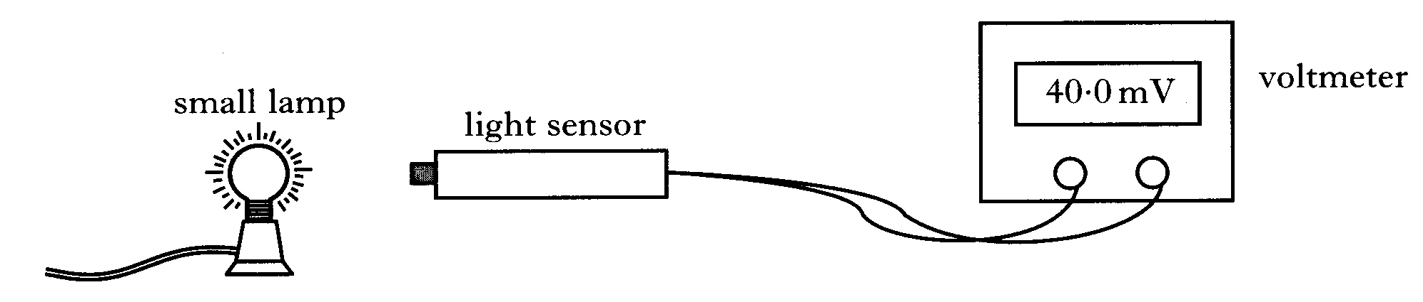

The reading on the voltmeter is 20 mV for each 1·0 mW of power incident on the sensor.

(a) The reading on the voltmeter is 40 mV.
The area of the light sensor is 8·0 × 10⁻⁵ m².
Calculate the irradiance of light on the sensor.

(b) The small lamp is replaced by a different source of light.
Using this new source, a student investigates how irradiance varies with distance.
The results are shown.

Distance/m | 0·5 | 0·7 | 0·9
Irradiance/W m² | 1·1 | 0·8 | 0·6

Can this new source be considered to be a point source of light?
Use all the data to justify your answer.

- A student carries out an experiment to investigate how irradiance on a surface varies with distance from a small lamp.
Irradiance is measured with a light meter.
The distance between the small lamp and the light meter is measured with a metre stick.
The apparatus is set up as shown in a darkened laboratory.

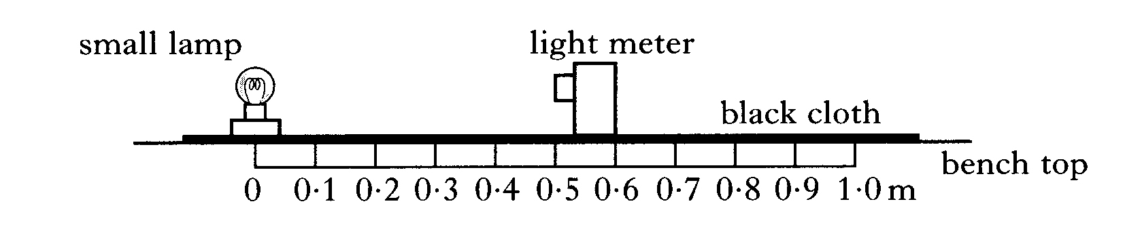
The following results are obtained.

Distance from source/m | 0·20 | 0·30 | 0·40 | 0·50
Irradiance/units | 675 | 302 | 170 | 108

(a) What is meant by the term irradiance?

(b) Use all the data to find the relationship between irradiance I and the distance d from the source.

(c) What is the purpose of the black cloth on top of the bench.

(d) The small lamp is replaced by a laser. Light from the laser is shone on the light meter.
A reading is taken from the light meter when the distance between it and the laser is 0·50 m.
The distance is now increased to 1·00 m.
State how the new reading on the light meter compared with the one taken at 0·50 m. Justify your answer.

- Robert sets up an experiment in a darkened laboratory with a small light bulb, B₁ which emits light at a power P.
The light intensity 50 cm from his bulb is 12 W m⁻².
Alison repeats Robert’s experiment with a different small bulb, B₂, which emits power 0.5P.
What is the intensity 25 cm from her bulb?
  - 1.5 W m^{–2}
  - 3.0 W m^{–2}
  - 6.0 W m^{–2}
  - 12.0 W m^{–2}
  - 24.0 W m⁻²

Tutorial Answers

Irradiance and inverse square law
1. 21 kW
2. (a) 0·8 W m ⁻²
(b) 0·05 W m⁻²
3. (c) 3·4 W m ⁻²
(d) 0·75 m
4. (a) 5000 m²
(b) 28333 m²
5. 24 W m ⁻²

Exam Papers
            - Answer D, as you double the distance the irradiance 1/4’s

            - The reading on the voltmeter is 20 mV for each 1·0 mW of power incident on the sensor.

(a) The reading on the voltmeter is 40 mV. = 2 x 1·0 mW = 2·0 mW
$$I=\frac{P}{A}$$
$$I=\frac{2.0× {10}^{-3}}{8.0× {10}^{-3}} = 0.25 Wm^{-2}$$

(b) The results are shown.

Distance/m | 0.5 | 0.7 | 0.9
Irradiance/W m² | 1.1 | 0.8 | 0.6
d² /m² | 0.25 | 0.49 | 0.81
Id² | 0.275 | 0.392 | 0.486

You must use ALL the data and show that Id² ≠k This shows that the new source is not a point source

            - The following results are obtained.

(a) What is meant by the term irradiance?
I=P/A = Power per unit area.
(b) Use all the data to find the relationship between irradiance I and the distance d from the source.
Distance from source/m | 0.2 | 0.3 | 0.4 | 0.5
Irradiance/units | 675 | 302 | 170 | 108
d² /m² | 0.04 | 0.09 | 0.16 | 0.25
Id² | 27 | 27.18 | 27.2 | 27

You could also plot a graph of I against1/d² and show it is a straight line through the origin, but I wouldn’t recommend that is lots of calculations followed by a graph.!
(c) To prevent reflections from the lamp causing uncertainties in the results.
(d) State how the new reading on the light meter compared with the one taken at 0·50 m. Justify your answer. The laser does not act as a point source so when you double the distance from the source you will not quarter the irradiance therefore the reading would be slightly lower than that taken at 0.5 m but will more than a quarter of the reading from 0.5 m

- E: 24.0 W m⁻²
There are various ways of doing this. You can work out the constant of proportionality using $I_{1}d_{1}^{2}=k$ halve the constant and then put it back in to the equation for $I_{2}d_{2}^{2}=k$



CHAPTER 9 SPECTRA

Summary of Content

No | CONTENT
Spectra
 | $E_{2}-E_{1}=hf$ and
 | I have knowledge of the Bohr model of the atom.
 | I can explain the Bohr model of the atom using the terms ground state, energy levels, ionisation and zero potential energy.
 | I know the mechanism of production of line emission spectra, continuous emission spectra and absorption spectra in terms of electron energy level transitions.
 | I can use $E_{2}-E_{1}=hf$ and to solve problems involving energy levels and the frequency of the radiation emitted/absorbed.
 | I know that the absorption lines (Fraunhofer lines) in the spectrum of sunlight provide evidence for the composition of the Sun’s outer atmosphere.

The Atom

Nucleus = protons and neutrons. Massive. Positive charge.
Electrons = electrons, negative, distinct energy levels.

In AN ATOM the number of protons equals the number of electrons

Electrons stay in their orbits as they are bound by the positive nucleus, (although this is just a model to fit the findings. In reality current thinking is that electrons are somewhere in a probability cloud.)

Energy must be added to remove an electron from the atom.

We say that zero potential energy is taken as being when the electron is outside the “field” of the atom. Therefore, electrons in the atom have negative energy because they are bound.

Ionisation level is the level at which an electron is free from the atom.

Zero potential energy is defined as equal to that of the ionisation level, implying that other energy levels have negative values.

The lowest energy level is the ground state.

Quantum Mechanics
The energy in the bound electrons is QUANTISED, or comes in specific quantities (QUANTA). This means that the electrons of an atom can have certain quantities of energy and no other.
Electrons are confined to energy levels.
-1.4
-0.8
-2.4
-1.5
-5.4
-3.4
-21.8
-13.6
BOUND ELECTRONS
FREE
ELECTRONS
Energy
x 10⁻¹⁹ J
eV
0
0
∞
n=4
n=3
n=2
n=1
n=5
n=6
-0.9
-0.5
-0.6
-0.4

Energy Levels of the Hydrogen Atom
EXCITED ELECTRONS
Energy is required to excite an electron or free an electron. A photon is emitted when an electron moves to a lower energy level and its frequency depends on the difference in energy levels.

Energy Levels of the Hydrogen Atom

eV = electron volt = energy needed to raise the potential of 1 electron by 1 V.

W₂, or E₂ = high energy level
W₁ or E₁ = low energy level
h = Planck’s constant (6.63 x 10⁻³⁴ J s)
f = frequency of electromagnetic radiation
NB. can also be known as .
Alternatively:
c = speed of electromagnetic radiation (= 3 x 10⁸ m s⁻¹)
λ= wavelength of electromagnetic radiation.
NB. RANDOM

Ionisation

When an electron is completely removed from an atom the atom becomes ionised.

The ionisation energy, E_{I}, is the energy required to remove an electron from an atom in its ground state to a free state in which it has no E_{K} i.e. its total energy is zero.

Excitation energy is the energy required to promote an electron from one energy level to a higher energy state.

Methods of Excitation

- Collisions with free electrons. An incident electron can either give up ALL, PART or NONE of its energy. The receiving electron can only accept specific amounts of energy if it is being excited. If it is being ionised then any amount above the E_{I} can be absorbed, the excess appearing as kinetic energy of the freed electron.

- Absorption of photons. Photons are either totally absorbed or not absorbed at all. They cannot give up only part of their energy. If the photon energy is less than E_{I} they can only be absorbed if their energy equals an excitation energy. If the photon energy is greater than E_{I} then the excess energy can be used as kinetic energy for the freed electron.

Line Emission Spectra

A line spectrum is emitted by excited atoms in a low pressure gas. Each element emits its own unique line spectrum that can be used to identify that element. The spectrum of helium was first observed in light from the sun (Greek - helios), and only then was helium searched for and identified on Earth.

A line emission spectrum can be observed using either a spectroscope or a spectrometer using a grating or prism.
vapour lamp
spectroscope

vapour lamp
collimator
grating
telescope

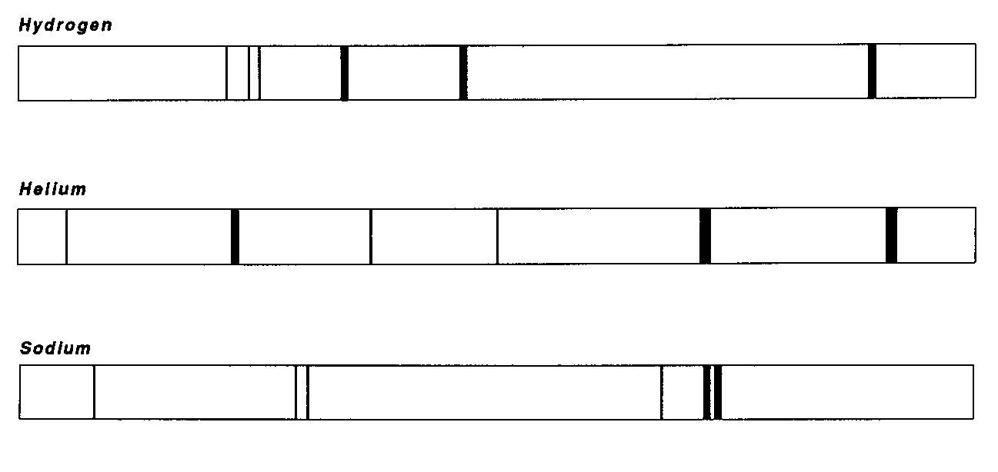
As with the photoelectric effect, line emission spectra cannot be explained by the wave theory of light. In 1913, Neils Bohr, a Danish physicist, first explained the production of line emission spectra. This explanation depends on the behaviour of both the electrons in atoms and of light to be quantised.

The electrons in a free atom are restricted to particular radii of orbits. A free atom does not experience forces due to other surrounding atoms. Each orbit has a discrete energy associated with it and as a result they are often referred to as energy levels.

Bohr model of the atom Energy level diagram

permissible electron orbits
nucleus
ground state

The Continuous Spectrum
A continuous visible spectrum consists of all wavelengths of light from violet (~400 nm) to red (~700 nm). Such spectra are emitted by glowing solids (a tungsten filament in a lamp), glowing liquids or gases under high pressure (stars). In these materials the electrons are not free. The electrons are shared between atoms resulting in a large number of possible energy levels and transitions.

Emission and Absorption Spectra
n=4
n=3
n=2
n=1
n=5
n=6
When an electron jumps up an energy level it takes in energy.

When an electron jumps down one or more energy levels energy is given out.

The energy is given out in the form of photons of energy. Each jump would be a certain quantity of energy. The more energy available from a jump, the higher the frequency of the radiation, according to E=hf. Some of these photons have a frequency in the visible band. We detect these with a spectroscope as a line (look at the back of a

Higher Core Physics book).
The colour indicates the energy of the jump.
Higher energy
Lower energy

This pattern, called an emission spectrum is different for each atom.
Notice this section was covered in the work on Hubble’s Law in Our Dynamic Universe.
When an electron is at the ground state it has its lowest energy. When an electron gains energy it moves to a higher energy level. If an electron gains sufficient energy it can escape from the atom completely - the ionisation level.

The brightness indicates how common the jump is (i.e. more electrons are doing it).

By convention, the electron is said to have zero energy when it has escaped the atom. Therefore the energy levels in the atom have negative energy levels. The ground state is the level with the most negative energy. When an electron moves to a higher energy level it gains energy and moves to a less negative energy level.

The electrons move between the energy levels by absorbing or emitting a photon of electromagnetic radiation with just the correct energy to match the gap between energy levels. As a result only a few frequencies of light are emitted as there are a limited number of possible energy jumps or transitions.
The lines on an emission spectrum are made by electrons making the transition from high energy levels (excited states) to lower energy levels (less excited states).
excited state
electron
photon

When the electron drops the energy is released in the form of a photon where its energy and frequency are related by:

E = hf

W₃
W₂

W₁
increasing energy

W₀
ground state
long wavelength
medium wavelength
short wavelength

- The photons emitted may not all be in the visible wavelength.
- The larger the number of excited electrons that make a particular transition, the more photons are emitted and the brighter the line in the spectrum.

Absorption
An electron may also make a transition from a lower energy level to a higher energy level. The electron must gain energy corresponding to the energy level gap. It can do this by absorbing a photon of exactly the correct frequency.
excited state
electron
photon

When you shine e-m radiation onto a material it absorbs the relevant wavelength (or frequency) to allow the electrons to jump between levels. You will “see” the spectra with the relevant wavelength (or frequency) removed, leaving black lines.

The black lines are in the same place as the coloured lines of the emission spectrum. This is because the same energy is needed to jump up as is given out when jumping back down.
When white light is passed through a colour filter, a dye in solution or a glowing vapour, the frequencies of light corresponding to the energy level gaps are absorbed. This gives dark absorption lines across the otherwise continuous spectrum.

white light source
glowing vapour
spectrometer

The fact that the frequencies of light that are absorbed by the glowing vapour match exactly those emitted can be demonstrated by the fact that a sodium vapour casts a shadow when illuminated with sodium light.

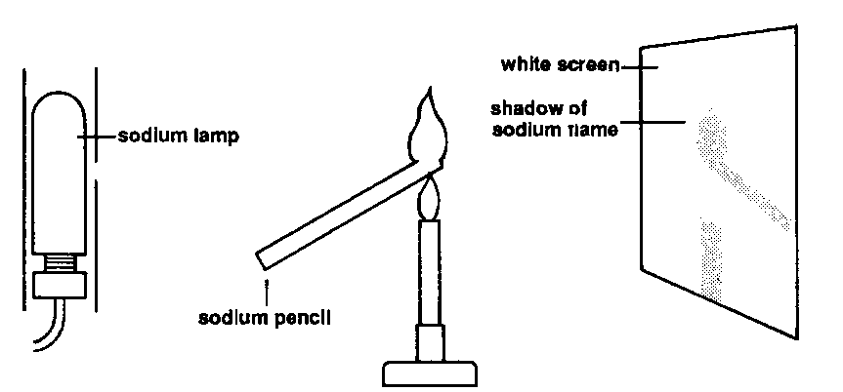

Absorption Lines in Sunlight

The white light produced in the centre of the Sun passes through the relatively cooler gases in the outer layer of the Sun’s atmosphere. After passing through these layers, certain frequencies of light are missing. This gives dark lines (Fraunhofer lines) that correspond to the frequencies that have been absorbed.

The lines correspond to the bright emission lines in the spectra of certain gases. This allows the elements that make up the Sun to be identified.

Example: The diagram below shows two energy transitions within an atom.
−3·6 × 10⁻¹⁹ J
−7·3 × 10⁻¹⁹ J
−11·5 × 10⁻¹⁹ J
A
B

- Determine the energy of the photons emitted during transitions A
and B.
- Calculate the frequency of the emission line produced by transition A.
- Determine the wavelength of the remaining spectral line due to transitions between these energy levels.

Solution:
(a) A:
ΔE = (−11·5 × 10⁻¹⁹) – (−3·6 × 10⁻¹⁹)
ΔE = −7·9 × 10⁻¹⁹ J
energy of photon A = 7·9 × 10⁻¹⁹ J

B:
ΔE = (−11·5 × 10⁻¹⁹) – (−7·3 × 10⁻¹⁹)
ΔE = −4·2 × 10⁻¹⁹ J
energy of photon B = 4·2 × 10⁻¹⁹ J

(b) E = hf
7·9 × 10⁻¹⁹ = 6·63 × 10⁻³⁴ × f
7·9 × 10⁻¹⁹
6·63 × 10⁻³⁴
f =

f = 1·2 × 10¹⁵ Hz

(c) ΔE = (−7·3 × 10⁻¹⁹) – (−3·6 × 10⁻¹⁹)
ΔE = −3·7 × 10⁻¹⁹ J

E = hf
3·7 × 10⁻¹⁹ = 6·63 × 10⁻³⁴ × f
3·7 × 10⁻¹⁹
6·63 × 10⁻³⁴
f =

f = 1·09 × 10¹⁵ Hz

v = fλ
3·00 × 10⁸ = 1·09 × 10¹⁵ × λ
λ = 2·75 × 10⁻⁷ m

Fraunhofer lines

The German physicist Joseph von Fraunhofer (1787–1826) invented a device called a spectroscope which contained a diffraction grating. When he used this device to analyse the light coming from the Sun he discovered dark lines on a continuous spectrum. These are called Fraunhofer lines.
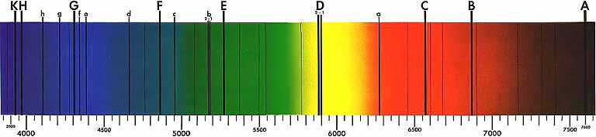
nl:Gebruiker:MaureenV [Public domain], via Wikimedia Commons

We now know that these dark lines are absorption lines. But how are they produced, and what do they show us?
The Sun and other stars produce all wavelengths of light. As this light passes through the cooler outer atmosphere, gas atoms absorb certain wavelengths of the light, producing a line absorption spectrum which we see from Earth.
Scientists in the 19th century were able to compare these dark lines with the line emission spectra of the known elements and identify what elements were in the cooler atmosphere.
Fraunhofer lines can be seen when sunlight is passed through a prism to separate it into the colours of the rainbow. They occur because cooler gas, which is higher in the Sun's atmosphere, absorbs some colours of the light emitted by hotter gas lower in the Sun's atmosphere. Fraunhofer counted 574 dark lines were segments of colours missing from the complete spectrum, which we now call Fraunhofer lines. Today, using much more sophisticated techniques, astronomers have discovered tens of thousands of Fraunhofer lines. Why doesn't the Sun emit these missing colours? Or, if the Sun does emit these colours, what happens to the light before it reaches Earth? The answer lies at the surface of the Sun.

When we look at a picture of the Sun, the surface that we see is called the photosphere. The photosphere is a region, several hundred kilometres thick, in which the Sun changes from opaque to transparent. It is not actually the outermost surface: the Sun extends for thousands of kilometres beyond the photosphere, but it is not usually visible from Earth. The photosphere is interesting because within this thin layer of the Sun (thin compared to the whole Sun, of course) sunlight is created, and some of the colours are lost almost immediately. The lower region of the photosphere has a temperature of about about 5,500º C and glows white-hot. Any object that glows due to a high temperature gives off a complete spectrum, that is, it has all the colours of the rainbow. As this light proceeds upwards in the Sun into a higher region of the photosphere, the temperature drops several thousand degrees. Although most of the light passes right through, some of the light is absorbed by the cooler gas. Only certain colours are removed because the chemical elements in the photosphere can only absorb certain wavelengths of light, and different wavelengths correspond to different colours. For example, sodium absorbs some yellow light at a wavelength of about 5.89x10⁻⁷ m. These absorbed colours cause the Fraunhofer lines. By measuring precisely the wavelengths of the missing colours, that is, the Fraunhofer lines, and how much light is actually absorbed, astronomers have learned much about the temperature inside the Sun and its chemical composition.

We can also learn about other stars in the sky by looking at the absorption lines in their spectra. By studying the similarities and differences that they have with the Fraunhofer lines, we can learn a lot about the similarities and differences that other stars have with our Sun.

Read more: Fraunhofer Lines - Sun, Colors, Light, and Photosphere - JRank Articles http://science.jrank.org/pages/2851/Fraunhofer-Lines.html#ixzz5eJ5K9Qfj

Summary
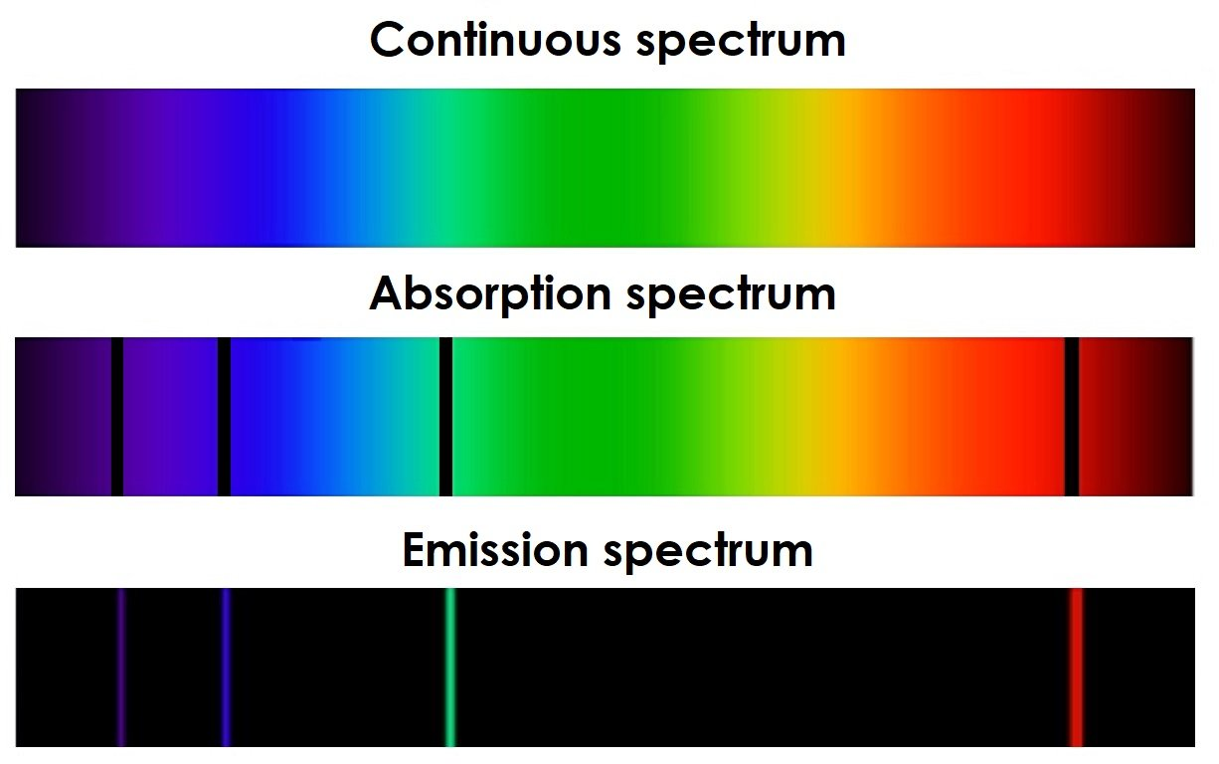
http://www.thestargarden.co.uk/Spectral-lines.html
Image Credit: Magnus Manske/Jhausauer.

Modified by Helen Klus, http://www.thestargarden.co.uk/Spectral-lines.html, original image by Magnus Manske/Jhausauer
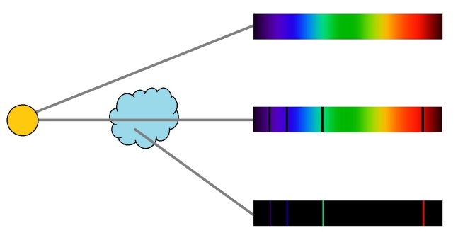

Blackbody Radiation

The term ‘blackbody’ is used to describe a hypothetical object that emits a continuous spectrum, with no absorption or emission lines. A blackbody absorbs all of the light that hits its surface. This means that it doesn’t reflect light and it doesn’t let light pass through it.

When a blackbody is cold it’s completely black, and as it heats up it remains in thermal equilibrium, emitting light at all wavelengths. There’s no such thing as a perfect blackbody, but there are lots of objects that are close, including the filaments of light bulbs, the hob of electric ovens, larva, metals like iron, and stars.
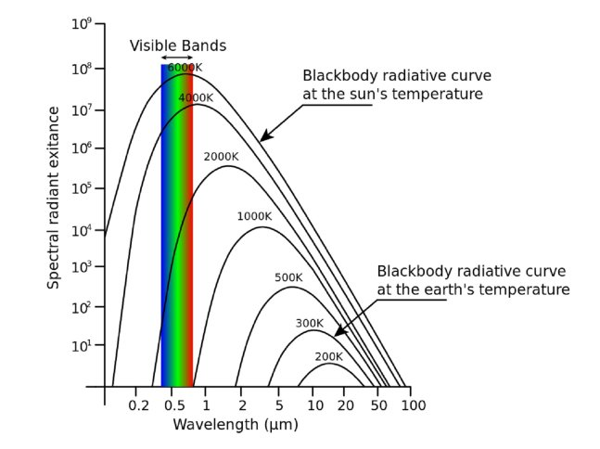
Modified by Helen Klus, http://www.thestargarden.co.uk/Spectral-lines.html, original image by Ant Beck/Jhausauerl, https://commons.wikimedia.org/wiki/File:Blackbody_emission.svg. Licensed under an Attribution 4.0 International (CC BY 4.0) license, https://creativecommons.org/licenses/by/4.0/deed.en.]

The relationship between a star’s energy and temperature was not known until 1879, when Austrian physicist Josef Stefan showed that the total energy emitted by a blackbody is proportional to its temperature to the power of four. Blackbodies, like stars, produce a continuous spectrum, absorption lines are caused by hot gases that absorb some of this light, and emission lines are caused by hot gases emitting light.

LASER

http://hyperphysics.phy-astr.gsu.edu/hbase/hframe.html
For more information on LASERS check out HYPERPHYSICS particularly good for information on this section.

LASER stands for:
LIGHT AMPLIFICATION BY THE STIMULATED EMISSION OF RADIATION

The light from a typical laser emerges in an extremely thin beam with very little divergence. Another way of saying this is that the beam is highly "collimated".
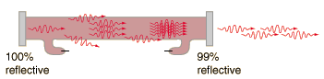
The highly collimated nature of the laser beam contributes both to its danger and to its usefulness. You should never look directly into a laser beam, because the beams can focus to a tiny dot on the retina of your eye, causing damage to the retina. On the other hand, this contributes to the both the medical applications and the industrial applications of the laser.

Medical Uses of Lasers
The narrow beam of a laser can be further focused to a tiny dot of extremely which would concentrate the energy is a tiny space. A focused laser can act as an extremely sharp scalpel for delicate surgery, cauterizing as it cuts. This makes it useful as a cutting and cauterizing instrument (“cauterizing” is the practice of using a hot instrument to seal blood vessels and stop bleeding). Lasers are used for sealing blood vessels that might be leaking into the eye, this is a common complaint and consequence of diabetes. Higher power lasers are used after cataract surgery. lasers are also use in laser eye surgery to correct long and short sight.
https://www.youtube.com/watch?v=f-YkzgfgN2k
http://www.youtube.com/watch?v=O4kDC4sZ5Jg

Lasers have been used to make incisions half a micron wide, compared to about 80 microns for the diameter of a human hair.

Welding and Cutting
The highly collimated beam of a laser can be further focused to a microscopic dot of extremely high energy density for welding and cutting.
The car industry makes extensive use of carbon dioxide lasers with powers up to several kilowatts for computer controlled welding on auto assembly lines.

CO₂ lasers are used to weld handles made of stainless steel to copper cooking pots. This is usually very difficult because of the great difference in thermal conductivities between stainless steel and copper, it is done so quickly by the laser that the thermal conductivities are irrelevant.

Laser Printers
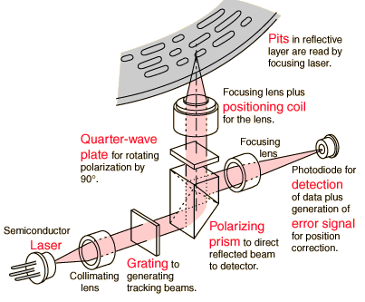
The laser printer has in a few years become the main method of printing in offices. The laser is focused and scanned across a photoactive selenium coated drum where it produces a charge pattern which mirrors the material to be printed. This drum then holds the particles of the toner to transfer to paper which is rolled over the drum in the presence of heat. The typical laser for this application is a laser at 760 nm wavelength, just into the infrared.

Lasers in Communication
Fibre optic cables are a major mode of communication. This is because lots of high quality signals can be sent with little loss of signal along the fibre. The light signals can be modulated with the information to be sent by either light emitting diodes or lasers.

Compact Disc Audio
CDs and DVDs use lasers to “read” the pits in the disc and convert the binary pattern to an analogue signal via the circuitry.

http://hyperphysics.phy-astr.gsu.edu/hbase/audio/cdplay3.html#c1

Barcode Scanners
Modern supermarkets identify products by their universal barcodes. Typically helium-neon lasers are to scan barcodes, although semiconductors can be used. The laser beam reflects off a rotating mirror and scans the code, sending a beam to a light detector and then to a computer which has the product information stored.

Surveying and Ranging
A fast laser pulse is sent to a corner reflector at the point to be measured and the time of reflection is measured to get the distance.
Some such surveying is long distance! The Apollo 11 and Apollo 14 astronauts put corner reflectors on the surface of the Moon for determination of the Earth-Moon distance. A powerful laser pulse from an Observatory in USA had spread to about a 3 km radius by the time it got to the Moon, but the reflection was strong enough to be detected. We now know the range from the Moon to Texas within about 15 cm, a nine significant digit measurement.
Telephone fibre drivers may be solid state lasers the size of a grain of sand and consume a power of only half a milliwatt. Yet they can sent 50 million pulses per second into an attached telephone fibre and encode over 600 simultaneous telephone conversations (Ohanian). The mechanism that gives us laser light is slightly different to that of ordinary light where excited electrons change to a lower energy level, spontaneously producing incoherent light.

DANGERS OF LASERS
- The beam does not spread out according to the inverse square law.
- Monochromatic therefore all the light is focussed at the same place in the eye, which can cause burning of the retina.
- the light is coherent therefore the irradiance is proportional to the amplitude squared, (I∝A²)
So don’t shine a bright LED or LASER into the air, it could have devastating effects on pilots.

Atoms as Clocks
www.npl.co.uk

Have a quick read only!
http://www.npl.co.uk/educate-explore/factsheets/atomic-timekeeping/
For thousands of years the Earth's rotation was our most stable timekeeper. However, the quartz and atomic clocks invented during the 1930s and 1950s are even better timekeepers, and show that the Earth does not rotate steadily but wobbles. Since 1967 the definition of the second has been related to the movement of electrons in a caesium atom:
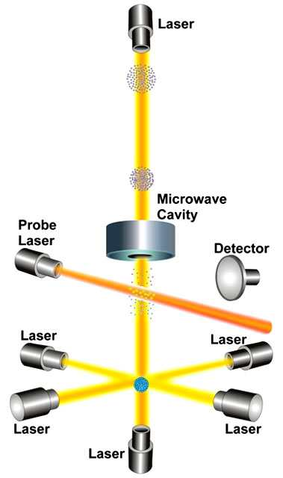
The second is the duration of 9 192 631 770 periods of the radiation corresponding to the transition between the two levels of the ground state of the caesium-133 atom.
Every atom is composed of a nucleus, which contains the atom’s protons and neutrons (collectively known as nucleons). Orbiting that nucleus are the atom’s electrons, which occupy different orbits, or energy levels.
By absorbing or releasing exactly the right amount of energy, the electrons can ‘jump’ from one energy level to another. This is called a transition. The electrons absorb energy to move to a higher energy level (away from the nucleus), and release energy to move down an energy level (towards the nucleus).
The energy released or absorbed in these transitions takes the form of electromagnetic radiation (e.g. visible light or microwaves). The same amount of energy is released every time the same transition occurs, no matter where or how many times it is measured.
As with all waves, the radiation has a certain frequency (i.e., it completes a certain number of full waves in a second) and this frequency can be measured. This means that a clock can be based on the wave frequency of an electron’s transition energy in an atom, in a similar way to a clock based on the swinging of a pendulum.

Practical 1: emission spectra
Aim:
To compare the emission spectra from various light sources.
Apparatus:
12 V lamp and power supply, Na or Hg discharge lamp and power supply, fluorescent lamp in lab, hand-held spectroscope. 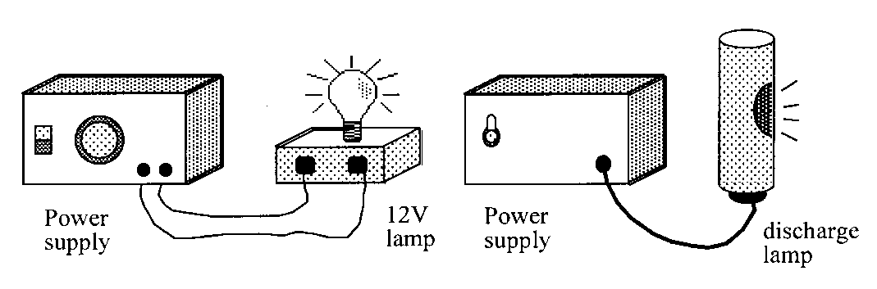
Instructions
- Use the spectroscope (or a grating) to examine the spectra emitted by each of the following light sources:
white light from the 12 V filament lamp
white light from one of the fluorescent lights in the laboratory
daylight from outside.
DO NOT look directly at the light emitted from a sodium (Na) or mercury (Hg) discharge lamp.
- Sketch each of the spectra observed above, noting whether it is a continuous spectrum or a line spectrum. (Diagrams or photographs of spectra may be available).
- Write a conclusion based on the results of the experiment.

Tutorial 1: Photoelectric Effect

- What is the energy of a photon from a beam of light with a frequency of 700THz?
- What frequency of light has photons with an individual energy of 3x10-19 joules?
- A light beam consists of red and green light whose photons carry energies of either 2.97 x 10-19 J, or 3.43 x 10-19J. Which photon is associated with which colour?
- If the work function of a metal is 5x10-19 joules, what is its threshold frequency?

  - What is the maximum possible kinetic energy of a photo-electron ejected by light of frequency 1015Hz?
  - If the ejected electron in (a) above (charge 1.6x10-19C), moves against a p.d. of half a volt, how much kinetic energy is it left with?
- What effect does it have on the appearance of a spectrum if one particular energy level change is more likely than any of the others so that it occurs more frequently?
- What do the symbols stand for in each of the following equations?
A white light is shone through the gas and its spectrum analysed on the far side. Describe what you expect it looks like.

Tutorial 1: Lasers
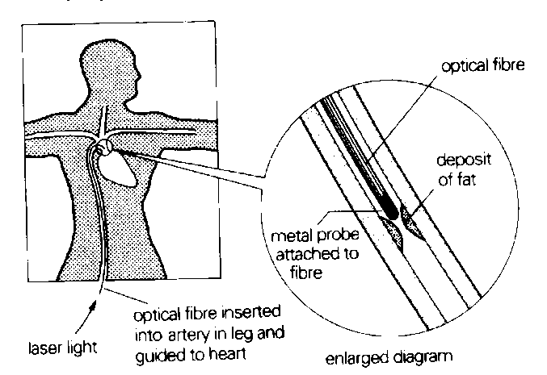
- Explain why a school laser with a beam diameter of 2mm and a power output of 0.1 mW can cause damage if shone directly into an eye.
- Describe how stimulated emission takes place in a laser.
- Explain why one of the mirrors at the ends of a laser cavity is half-mirrored.
- The diagram below shows a technique for removing a deposit of fat blocking an artery leading to the heart.
Laser light is transmitted along an optical fibre inserted into the artery as shown.
The energy of this light heats up a tiny metal probe to a temperature sufficiently high to vapourise the fatty deposit.
The light from the 8 W argon laser used is of 490 nm wavelength.

  - If the metal probe has a mass of 2·5 x 10⁻⁴ kg and specific heat capacity of 441 J kg⁻¹ K⁻¹, calculate the time required to supply a pulse of energy necessary to raise its temperature from body temperature of 37ºC up to 400ºC.
  - Calculate how many photons are required to provide this pulse of energy from the laser.

Tutorial 3: Line and continuous spectra

1. When the light emitted by a particular material is observed through a spectroscope, it appears as four distinct lines.
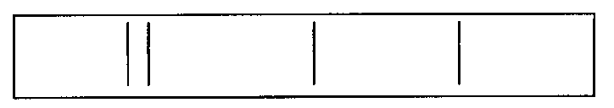
(a) What name is given to this kind of emission spectrum?
(b) Explain why a series of specific, coloured lines is observed.
(c) The red line in the spectrum coincides with a wavelength of 680 nm.
Calculate the energy of the photons of light that produced this line.
(d) The spectroscope is now used to examine the light emitted from a torch bulb (filament lamp). What difference is observed in the spectrum when compared with the one in the diagram?

2. The diagram shows some of the energy levels for two atoms X and Y.

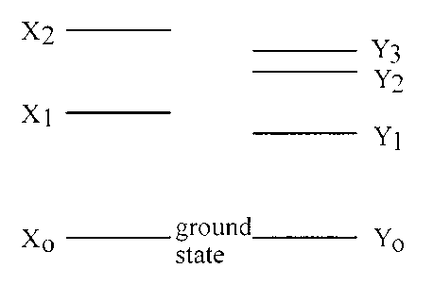

(a) (i) How many downward transitions are possible between these energy levels of each atom?
(ii) How many lines could appear in the emission spectrum of each element as a result of these energy levels?
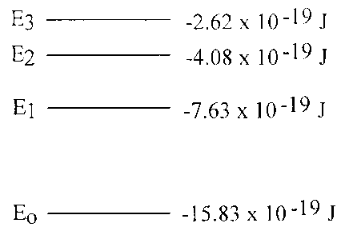
(iii) Copy the diagram of the energy levels for each atom and show the possible transitions.

(b) Which transition in each of these diagrams gives rise to the emitted radiation of:
(i) lowest frequency;
(ii) shortest wavelength?

3. The diagram shows some of the electron energy levels of a particular element.

(a) How many lines could appear in the emission spectrum of this element as a result of these levels?
(b) Calculate the frequencies of the photons arising from:
(i) the largest energy transition
(ii) the smallest energy transition.
(iii) Show whether any of the emission lines in the spectrum correspond to frequencies within the visible spectrum.
          - Explain which transition would produce the photons most likely to cause photoemission in a metal.

4. The diagram shows some of the electron energy levels in a hydrogen atom.
W₀
W₁
W₂
W₃
–21·76 × 10^{–19} J
–5·424 × 10^{–19} J
–2·416 × 10^{–19} J
–1·360 × 10^{–19} J

(a) How many emission lines are possible from electron transitions between these energy levels?
(b) Which of the following radiations could be absorbed by the electrons in a hydrogen atom?
(i) frequency 2·92 × 10¹⁵ Hz
(ii) frequency 1·57 × 10¹⁵ Hz
(iii) wavelength 4·89 × 10⁻⁷ m.

5. Explain why the absorption spectrum of an atom has dark lines corresponding to frequencies present in the emission spectrum of the atom.

6. (a) Explain the presence of the Fraunhofer lines, the dark lines that appear in the spectrum of sunlight.

(b) Explain how are Fraunhofer lines used to determine the gases that are present in the solar atmosphere.

7. The light from a star can be analysed to show the presence of different elements in the star. Explain how the positions of the spectral lines for the elements be used to determine the speed of the star.

Exam Questions

- SQA 1994 PII Q10
  - A sodium vapour lamp emits bright yellow light when electrons make transitions from one energy level to another within the sodium atoms.
    - State whether electrons are moving to a higher or lower energy level when the light is emitted.
    - Using the information provided in the data sheet, calculate the energy difference between these two electron energy levels in the sodium atom

  - A Bunsen flame containing vaporised sodium is placed between a sodium vapour lamp and a screen as shown.
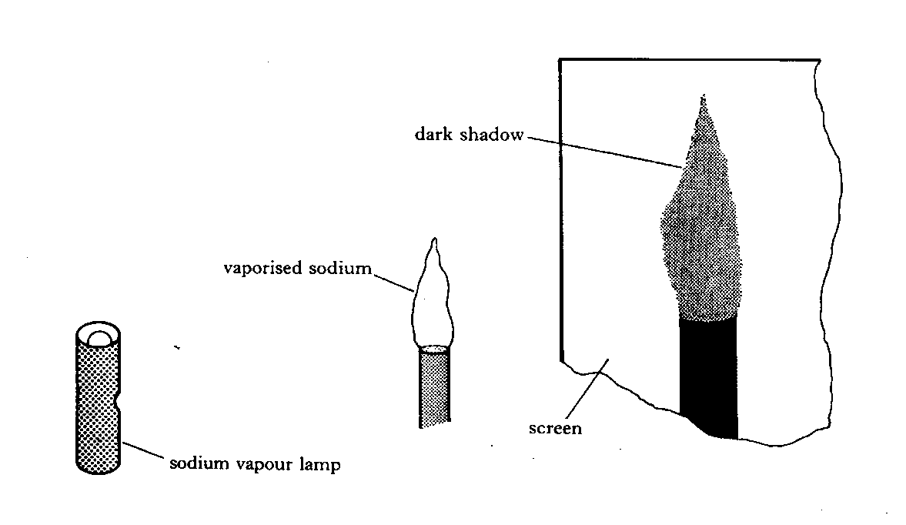
    - Explain why a dark shadow of the flame is seen on the screen.
    - The sodium vapour lamp is replaced with a cadmium vapour lamp.
Explain why there is now no dark shadow of the flame on the screen.

  - The work function of sodium metal is 2.9 × 10 ⁻¹⁹ J.
Light of wavelength 5.4 ×10 ⁻⁷ m strikes the surface of this metal. What is the kinetic energy of the electrons emitted from the surface?

- (from 2000 Higher Physics, Q28).
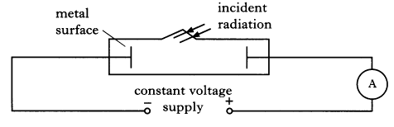
  - The apparatus shown below is used to investigate photoelectric emission from a metal surface when electromagnetic radiation is shone on the surface.
The intensity and frequency of the incident radiation can be varied as required.
    - Explain what is meant by photoelectric emission from a metal.
    - What is the name given to the minimum frequency of the radiation that produces a current in the circuit?
    - A particular source of radiation produces a current in the circuit.
Explain why the current in the circuit increases as the intensity of the incident radiation increases.

  - A semiconductor chip is used to store information. The information can only be erased by exposing the chip to ultraviolet radiation for a period of time.
The following data is provided.
Frequency of ultraviolet radiation used = 9·0 x 10¹⁴ Hz
Minimum intensity of ultraviolet radiation
required at the chip = 25 W m⁻²
Area of the chip exposed to radiation = 1·8 x 10⁻⁹ m²
Time taken to erase the information = 15 minutes
Energy of radiation needed to erase the information = 40·5 μJ

    - Calculate the energy of a photon of the ultraviolet radiation used.
    - Calculate the number of photons of the ultraviolet radiation required to erase the information.
    - Sunlight of intensity 25 W m⁻², at the chip, can also be used to erase the information.
State whether the time taken to erase the information is greater than, equal to or less than 15 minutes.
You must justify your answer.
- (From 2001 Higher Paper, Q.28)
  - In a laser, the light is produced by stimulated emission of radiation.
Explain the term “stimulated emission” by making reference to the energy levels in atoms.
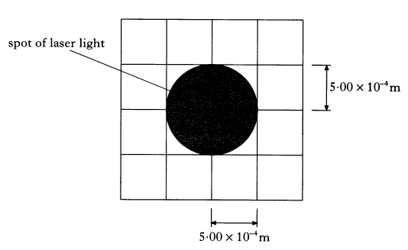
  - A laser beam is shone on to a screen which is marked with a grid.
The beam produces a uniformly lit spot of radius 5·00 x 10⁻⁴ m as shown.
    - The intensity of the spot of light on the screen is 1020 W m⁻².
Calculate the power of the laser beam.
    - The distance between the screen and the laser is now doubled.
State how the radius of the spot now compares with the one shown in the diagram. You must justify your answer.
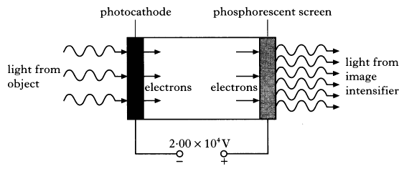
- (From 2002 Higher Paper, Q.28)
An image intensifier is used to improve night vision. It does this by amplifying the light from an object.
Light incident on a photocathode causes the emission of photoelectrons. These electrons are accelerated by an electric field and strike a phosphorescent screen causing it to emit light. This emitted light is of a greater intensity than the light that was incident on the photocathode.
The voltage between the photocathode and the phosphorescent screen is 2·00 x 10⁴ V.
The minimum frequency of the incident light that allows photoemission to take place is 3·33 x 10¹⁴ Hz.
  - What name is given to the minimum frequency of the light required for photoemission to take place?

    - Show that the work function of the photocathode material is 2·21 x 10⁻¹⁹ J.
    - Light of frequency 5·66 x 10¹⁴Hz is incident on the photocathode. Calculate the maximum kinetic energy of an electron emitted from the photocathode.
    - Calculate the kinetic energy gained by an electron as it is accelerated from the photocathode to the phosphorescent screen.

Tutorial Answers:

Photoelectric Effect
- The photon has an energy of 4.64x10-19 joules.
- The light's frequency is 452 THz
- The red light has a lower frequency than the green and so its individual photons carry less energy.
- The threshold frequency is 754THz

  - The energy of a photon from light of frequency 10¹⁵ Hz is given by:
The greatest available kinetic energy occurs when the work function of the surface is zero. In this situation, the maximum kinetic energy equals the energy of the incoming photon, 6.63x10-19J
  - The energy change involved when a charge moves through a p.d. is given by
- It will be brighter than the other spectra.

  - E, energy (J); h, Planck’s constant (J s); f, frequency (Hz)
  - h, Planck’s constant (J s); f, frequency (Hz); hf₀, work function (J); E_{K}, kinetic energy (J).
  - h, Planck’s constant (J s); f, frequency (Hz); W_{1/2}, energy levels (J).
- A continuous spectrum would be seen apart from 10 dark lines, one particularly prominent, this corresponds to the transition W₂ to W₃.

Lasers
- Laser light is coherent and does not obey the inverse square law. If the light is coherent all the peaks of the waves are in phase, so more capable of damage. By not obeying the inverse square law, the eye focuses the beam to a spot of very small area on the retina and this makes the intensity there high enough to damage the rods and cones.
- A photon of exactly the right energy, equal to the energy difference between two energy levels, stimulates the emission of another photon. The emitted photon will have the same frequency as the stimulating photon. It will also be in phase with the stimulating photon, and in exactly the same direction. No longer on the course
- It allows a small proportion of the light to escape, thus forming the laser beam.

  - $E=mcT E=2.5× {10}^{4} × 441 × \left(400-37\right)=40J$

Line and continuous spectra
1. (a) emission spectrum,
(b) these lines correspond to the frequencies of the photons that as the electrons in the specific atom move down from various energy levels to different lower energy levels Each line corresponds to a specific jump between energy levels which produces a single wavelength of radiation.
. (c) 2·93 × 10⁻¹⁹ J
(d) A continuous spectrum would be observed
2. (a) (i) X 3; Y 6
(ii) X 3; Y 6
(iii) X₂-X₁, X₁-X₀, X₂-X₀ / Y₃-Y_{2,,} Y₂-Y₁, Y₁-Y₀, Y₂-Y_{0 ,} Y₃-Y₁ , Y₃-Y₀
(b) (i) X₂ to X₁: Y₃ to Y₂
(ii) X₂ to X_{o}; Y₃ to Y_{o}
3. (a) 6 lines
(b) (i) 2·0 × 10¹⁵ Hz
(ii) 2·2 × 10¹⁴ Hz
4. (a) 4 lines
5. It is the same frequencies of photon absorbed causing an electron to move up an energy level, as the photon emitted when the electron drops to a lower energy level. Because the energy transitions responsible for producing the emission spectrum are identical to those which absorb radiation, thus leading to dark lines in the absorption spectrum.
6 a) The Sun and other stars produce all wavelengths of light. As this light passes through the cooler outer atmosphere, gas atoms absorb certain wavelengths of the light, producing a line absorption spectrum which we see from Earth. These are caused by the absorption spectra of the various elements found in the outer layers of the sun.
  - Each element has its own individual set of Frauhofer lines. By comparing these with that of known elements gases present in the solar atmosphere can be determined.
  - Comparing the Frauhofer lines from the gases on Earth to those from the sky will show that the lines are shifted. The greater the shifting of the lines the faster the stars are moving (see the Expanding Universe)

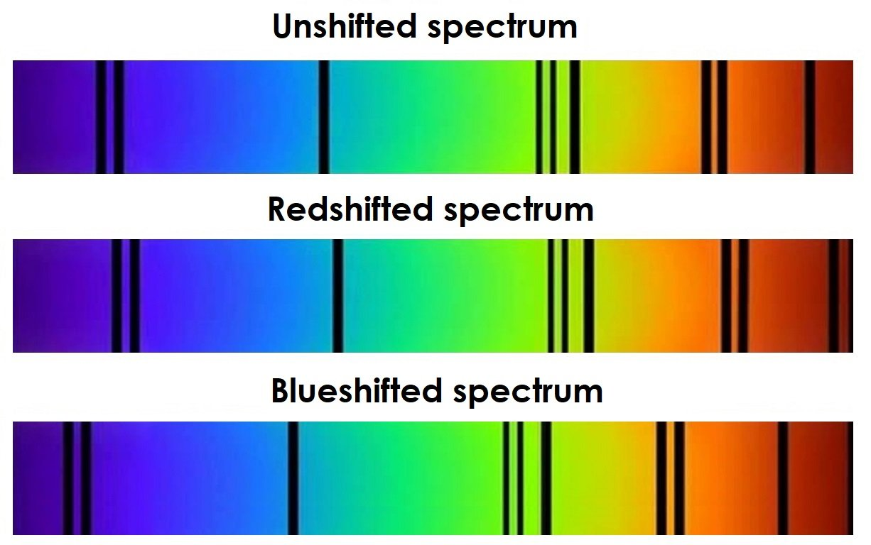
Cool Cosmos Courtesy NASA/JPL-Caltech. Cool Cosmos Image Use Policy.

Exam Question Answers

            - 1994 Higher Physics Paper II Q 10
10.a.i. Electrons are moving from a high to low energy level within the atom. A photon of light is emitted when this happens.
a.ii. λ_{sodium yellow} = 589nm
E_{photon} = hf
E_{photon} = hc/λ
E_{photon} = 6.63x10⁻³⁴x3x10⁸/589x10⁻⁹
E_{photon} = 3.38x10⁻¹⁹J

The photon energy and the energy difference are equal.
E_{difference} = 3.38x10⁻¹⁹J

b.i. Photons emitted from the sodium lamp and passing through the flame containing vaporised sodium will be absorbed by sodium electrons. This means that sodium light passing through the flame will be reduced in intensity and produce a dark shadow behind the flame.

b.ii. There is no energy gap in cadmium with the same energy as a photon emitted from the sodium lamp. Therefore, no absorption will take place and there will be no shadow region.

            - from SQA 2000 Higher Physics, Q28.

28.a.i. Photoelectric emission is the term used to describe the process by which
an electron bound in an atom can absorb enough energy from a single photon
to escape, or be emitted, from the atom.

a.ii. Threshold frequency

a.iii. As the intensity of the radiation is increased there are more incident photons on the metal. Consequently, more electrons can absorb energy from the incident radiation. This will result in more emitted electrons which is consistent with the increased current.

b.i. E_{photon} = hf
E_{photon} = 6.63x10⁻³⁴x9.0x10¹⁴
E_{photon} = 5.967x10⁻¹⁹J

b.ii. E_{total} = NE_{photon}
N = E_{total}/E_{photon}
N = 40.5x10⁻⁶/5.967x10⁻¹⁹
N = 6.79x10¹³

OR (If you like doing things the hard way.)

I = P/A
I = (E_{total}/t)/A
I = (NE_{photon}/t)/A
=>N = AIt/E_{photon}
=>N = (1.8x10⁻⁹x25x15x60)/ 5.967x10⁻¹⁹
=>N = 4.05x10⁻⁵/5.967x10⁻¹⁹
=>N = 6.79x10¹³

b.iii.The time taken for sunlight to erase the chip will be greater. This is because only a proportion of the 25W/m² from sunlight is ultraviolet and it would therefore take longer for the semiconductor to absorb the required number of photons.

- (From 2001 Higher Paper, Q.28)
28.a.
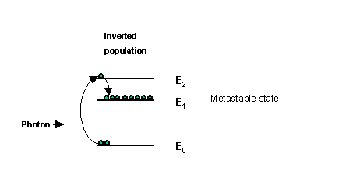
A high voltage or other energy source can be used to pump electrons up into higher energy states. For example, an electron can be pumped up to energy level (E₂) and then fall into the metastable state E₁, creating what is called an inverted population. A passing photon, having an energy equal to the energy gap E₁ to E₀ can encourage/stimulate an electron to drop from energy state E₁ to E₀ with the production of a photon in phase, with the same frequency and travelling parallel to the stimulating photon. Thereafter, photons produced by stimulated emission can cause further stimulated emission. This is the basis for stimulated emission and amplification.

b.i. P = IA

I = 1020 Wm⁻²

A = πr²
A = πx(5.00x10⁻⁴)²
A = 7.85x10⁻⁷m⁻²

P = 1020x7.854x10⁻⁷
P = 8.01x10⁻⁴W

b.ii. The laser beam is non divergent. It does not spread out. This means the radius of the spot is a constant.

From 2002 Higher Paper, Q.28

28.a. Threshold frequency.

28.b.i. f₀ = 3.33x10¹⁴Hz
work function(W) = hf₀
W = 6.63x10⁻³⁴x3.33x10¹⁴
W = 2.21x10⁻¹⁹J

b.ii. E_{photon} = hf
E_{photon} = 6.63x10⁻³⁴x 5.66x10¹⁴
E_{photon} = 3.75x10⁻¹⁹J

E_{k}(electron) = E_{photon} - W
E_{k}(electron) = 3.75x10⁻¹⁹ - 2.21x10⁻¹⁹
E_{k}(electron) = 1.54x10⁻¹⁹J

b.iii. E_{k}(gain) = qΔV
q = e = 1.6x10⁻¹⁹C
ΔV = 2.00x10⁴V

E_{k}(gain) = 1.6x10⁻¹⁹ x 2.00x10⁴
E_{k}(gain) = 3.2x10⁻¹⁵J

The End of Particles & Waves, now just revise for your test!

