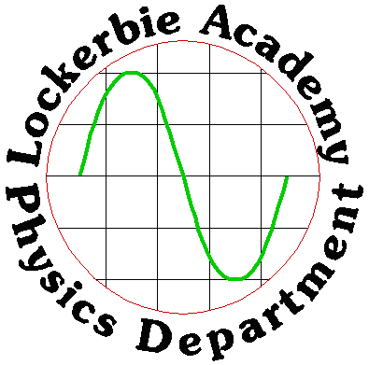
2018
Horn & Hargreaves
Lockerbie Academy
3/1/2018
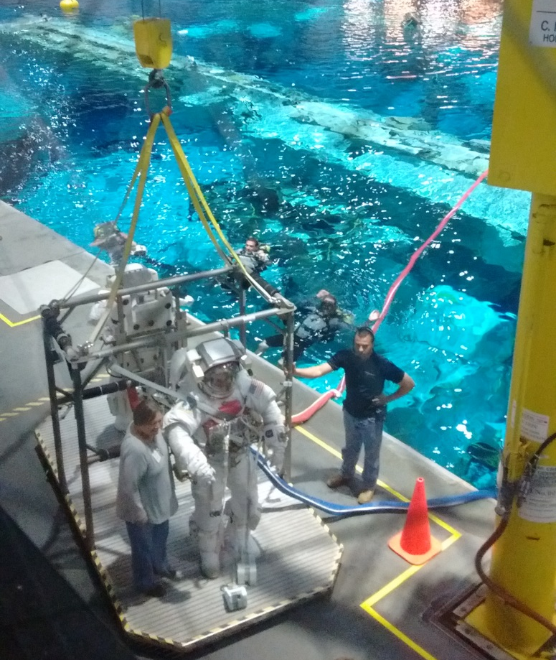
-the final frontier
N5: SPACE

Data Sheet

Relationships Sheet
The formulae highlighted are those that are required for this unit.

SPACE GENERAL KNOWLEDGE QUIZ
- In terms of space what makes one day?
- In terms of space what is a year?
- Why do we have leap years?
- How long does it take for the moon to go round the Earth?
- What causes a solar eclipse?
- What do the following terms refer:
    - Sum total of everything
    - Dominant member of the solar system
    - Large body orbiting a sun
    - A natural satellite of a planet
    - Basic building block of the Universe
    - Planets orbiting one or more suns
- How far is the moon from the Earth if it take light 1.2 seconds to get here? (Use v=d/t)
- How far is the Sun from the Earth if it takes light 8 minutes to get here? (Use v=d/t)
- How far is one light year (ly)?
- How far is the Alpha Centuri from the Earth if it take light 4.3 years to get here? (Use v=d/t) or any previous calculation.
- Rank these in order of size with the smallest first
SUN, GALAXY, STAR, MOON, SOLAR SYSTEM, PLANET, UNIVERSE
- Which lens in a telescope produces the image?
- Which lens in a telescope magnifies the image?
- List the colours of the visible spectrum with the lowest frequency first.
- List the members of the electromagnetic spectrum in order of increasing frequency
- Name the device for splitting up white light into different colours.

Space exploration Learning Intentions
  - Basic awareness of our current understanding of the Universe.
  - Use of the following terms correctly and in context: planet, dwarf planet, moon, Sun, asteroid, solar system, star, exoplanet, galaxy, universe.
  - Awareness of the benefits of satellites: GPS, weather forecasting, communications, scientific discovery and space exploration (for example Hubble telescope, ISS).
  - Knowledge that geostationary satellites have a period of 24 hours and orbit at an altitude of 36 000 km.
  - Knowledge that the period of a satellite in a high altitude orbit is greater than the period of a satellite in a lower altitude orbit.
  - Awareness of the challenges of space travel:
  - travelling large distances with the possible solution of attaining high velocity by using ion drive (producing a small unbalanced force over an extended period of time)
  - travelling large distances using a ‘catapult’ from a fast moving asteroid, moon or planet
  - manoeuvring a spacecraft in a zero friction environment, possibly to dock with the ISS
  - maintaining sufficient energy to operate life support systems in a spacecraft, with the possible solution of using solar cells with area that varies with distance from the Sun
  - Awareness of the risks associated with manned space exploration:
- fuel load on take-off
- potential exposure to radiation
- pressure differential
- re-entry through an atmosphere
  - Knowledge of Newton’s second and third laws and their application to space travel, rocket launch and landing.
  - Use of an appropriate relationship to solve problems involving weight, mass and gravitational field strength, in different locations in the Universe. W = mg

7.1 Understanding the Universe
Our current understanding of the origin of the Universe is based on the Big Bang theory. The theory proposes the Universe came into existence when a singularity rapidly expanded from an extremely hot dense state to what exists today.
According to current estimates, the Universe is approximately 13·8 billion (13·8 × 10⁹) years old and consists of approximately 100 billion galaxies, each containing approximately 100 – 1000 million stars! That’s a big place and our minds aren’t built to comprehend this.
Before the Universe began, the entire Universe was contained in a singularity. The Big Bang singularity was a point of zero volume, but very high mass, which makes the density infinite. This singularity contained all of the matter and energy in the Universe. At the singularity, all the laws of physics broke down: then it exploded. Time, space and all of the matter and energy we know today began with the Big Bang. In a fraction of a second, the Universe grew this singularity to bigger than a galaxy. And it kept on growing at a fantastic rate. It is still unclear why this happened or what a singularity actually is, but we do know that the Universe is still expanding at an increasing rate.
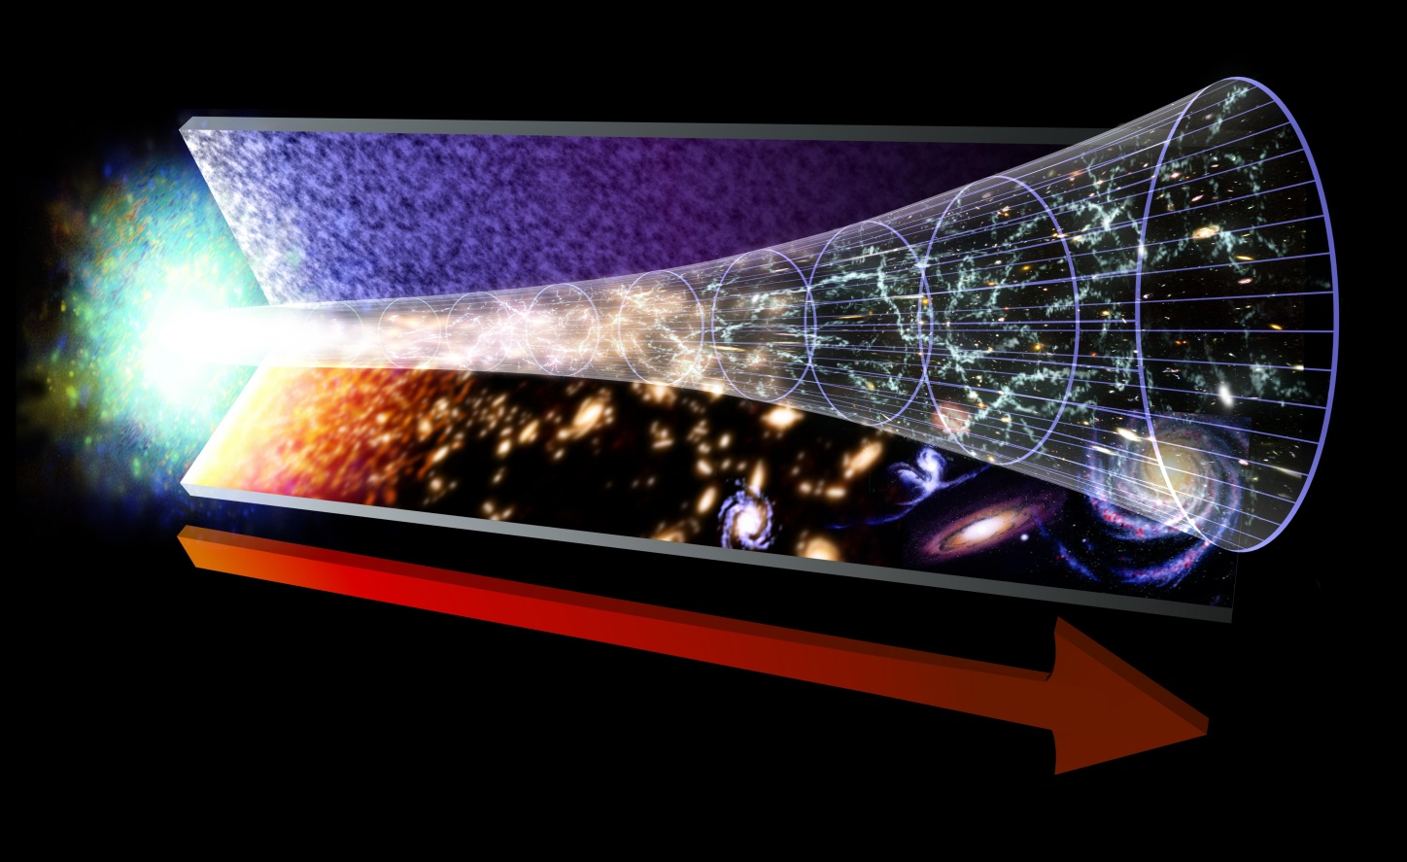
As the Universe expanded and cooled, energy changed into particles of matter and antimatter. These two opposite types of particles largely destroyed each other. But some matter survived. More stable particles called protons and neutrons started to form when the Universe was just one second old.
Over the next three minutes, the temperature dropped below 1 billion degrees Celsius. It was now cool enough for the protons and neutrons to come together, forming hydrogen and helium nuclei.
After 300 000 years, the Universe had cooled to about 3 000 degrees Celsius. Atomic nuclei could finally capture electrons to form atoms. The Universe filled with clouds of hydrogen and helium gas.
Our understanding of the immediate and distant universe comes mainly from two activities, space exploration and looking up.
https://www.esa.int/esaKIDSen/SEMSZ5WJD1E_OurUniverse_0.html
http://www.hawking.org.uk/the-beginning-of-time.html

Surprisingly, despite our huge knowledge of the Universe that has been developed over the life of humans we can only account for about 5 % of the expected mass.

What are dark matter and dark energy?
The majority of the Universe is made up of dark matter and dark energy,
•Dark matter – Scientists aren't exactly sure what dark matter is, but believe it exists due to results from experiments. Dark matter gets its name because it cannot be seen with any type of instrument we currently have. Around 27% of the Universe is made up of dark matter. Dark matter attracts matter.
•Dark energy - Dark energy is something that scientists believe fills all space. It turns out that "empty space" is more than just nothing, it is really dark energy. The theory of dark energy helps scientists to explain why the Universe is expanding. Around 68% of the Universe is dark energy. Dark energy repels matter.

evidence for the big bang

Big Bang Theory - Evidence for the Theory
- Galaxies appear to be moving away from us. The greater the galaxy’s distance the greater their speed . This observation supports the expansion of the Universe and suggests that the Universe was once compacted.
- “Doppler red-shift” The light from galaxies appears to be more red than it should be, and the decreased frequency of the light tells us that the galaxies are moving away from us.
- If the Universe was initially very, very hot as the Big Bang suggests, we should be able to find some remnant of this heat. In 1965 this background heat, now termed Cosmic Microwave Background radiation (CMB) which spreads through the observable universe was discovered .
- The abundance of the "light elements" Hydrogen and Helium found in the observable universe are thought to support the Big Bang theory of origins.

A summary of some of the evidence of the Big Bang and its interpretation
Evidence | Interpretation
The light from other galaxies is red-shifted. | The other galaxies are moving away from us.
The further away the galaxy, the more its light is red-shifted. | The most likely explanation is that the whole universe is expanding. This supports the theory that the start of the Universe could have been from a single expansion.
Cosmic Microwave Background Radiation | The relatively uniform background radiation is the remains of energy created just after the Big Bang.
Task
Answer the following questions in full sentences in your jotter
- State the current estimate of the age of the Universe and estimate the number of galaxies it contains.
- We now have evidence to support the Big Bang Theory.
  - State two pieces of evidence that scientists have provided that support the Big Bang Theory.
  - Provide a description of how each piece of evidence supports ideas in the Big Bang Theory.
- Is the Universe expanding, contracting or static?
- Explain how the Universe could expand at such a rate at the Big Bang, when nothing can go faster than the speed of light.
- Draw a table with headings dark matter and dark energy. Try to add as many facts or theories into the table under these two headings.

7.2 Space Terms
Below is a list of space definitions. Most are simplified for National 5, but still good enough for you to be able to answer all the questions.
Term | Definition
Universe | The Universe consists of the sum total of everything, including many galaxies separated by empty space.
galaxy | A galaxy is a large cluster of stars (eg the Milky Way).
star | A star is a large ball of matter that is undergoing nuclear fusion and emitting light and other forms of electromagnetic radiation. The sun is a star.
sun | A solar system consists of one or more central stars orbited by planets.
planet | A planet is a large ball of matter that orbits a star (e.g. Earth or Jupiter). Planets do not emit light themselves.
exoplanet | An exoplanet is a planet existing around another star, outside of our solar system
dwarf planet | A dwarf planet is an object that orbits a star but is not large enough or roughly spherical enough to be classed as a small planet.
moon | A moon is a natural satellite of a planet. A moon is a lump of matter that orbits a planet e.g Deimos and Phoebus orbit Mars, so are moons of Mars
asteroid | An asteroid is an orbiting object which is even smaller than a dwarf planet.

 | Distance from Sun (km)
Mercury | 57,910,000
Venus | 108,200,000
Earth | 149,600,000
Mars | 227,900,000
Asteroid Belt | 329,100,000-478,700,000
Jupiter | 778,500,000
Saturn | 1,429,000,000
Uranus | 2,877,000,000
Neptune | 4,498,000,000
Our Solar System is called the Milky Way and the planets of the solar system arranged in order of distance from the sun are : Mercury, Venus, Earth, Mars, Jupiter, Saturn, Uranus and Neptune.
The distance from the Earth to the Moon (the closest object to us in space) is 384,000,000m. From the Earth to the Sun is 149,597,871,000m. The distances of the major features of the Solar System from the Sun are given in the table:

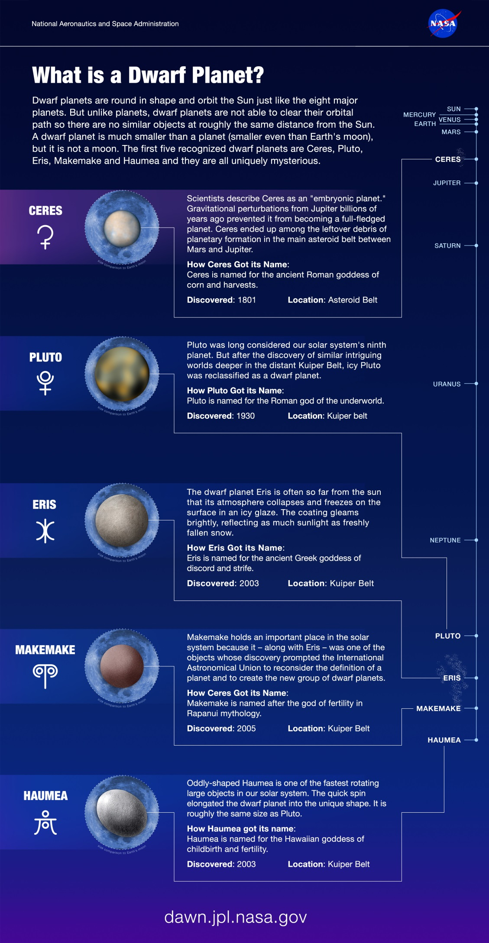
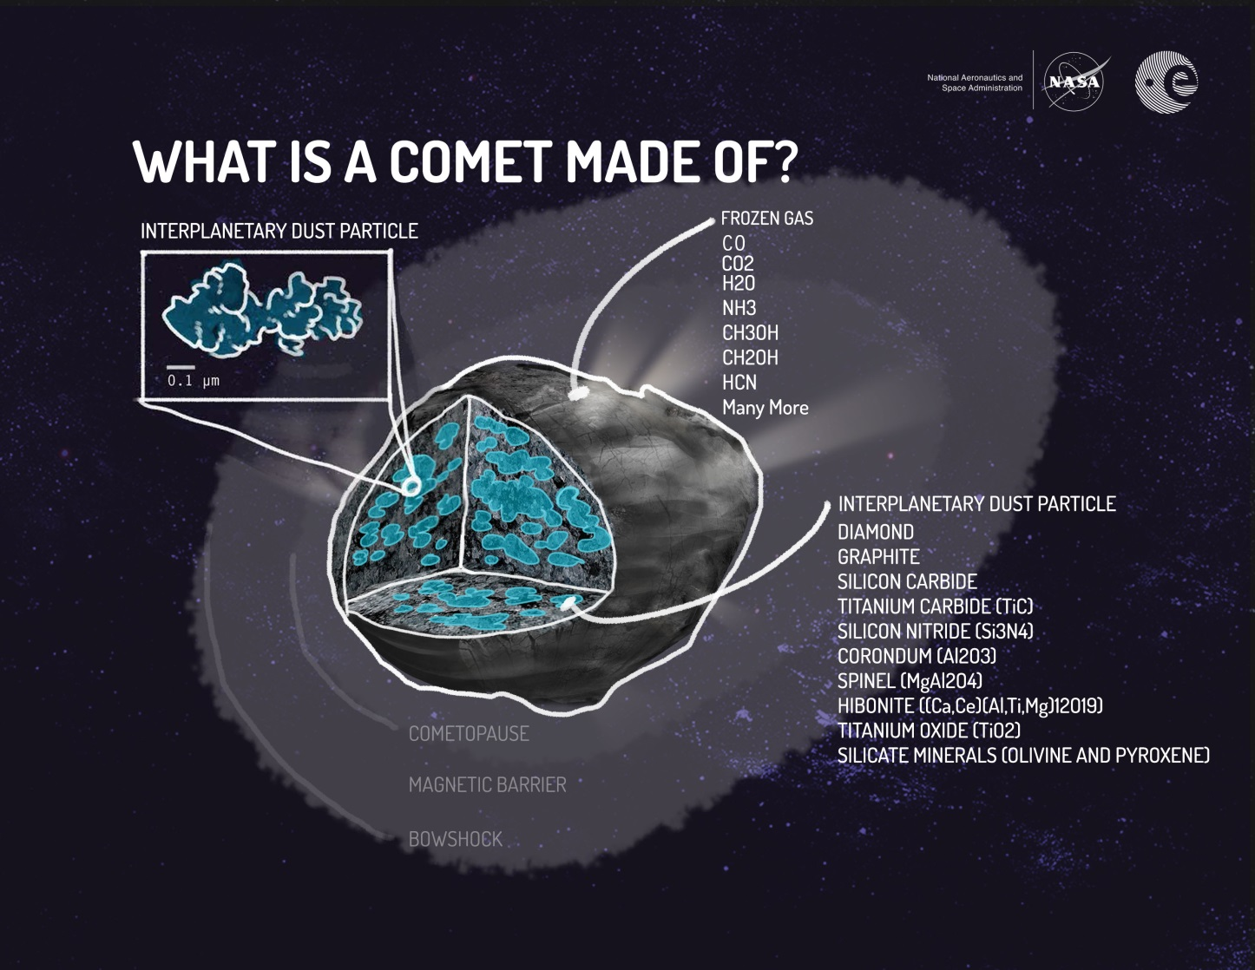
0-A the distances are not to scale
https://www.nationalgeographic.com/science/space/our-solar-system/ Scale models of the Solar System have been produced to give an idea of how vast the distances are. A virtual scale model of the Universe can be found here, one where the Moon is only 1 pixel in size.
http://joshworth.com/dev/pixelspace/pixelspace_solarsystem.html

Exoplanets
Exoplanets are planets that orbit a star that is not the Sun. Over the last 20 years there have been thousands of exoplanets found throughout the galaxy. Much focus on exoplanets has been towards looking for planets that could support life as we know it.
Life on Earth has several major requirements:
- oxygen to allow respiration
- water
- food
- energy from the sun

For life to exist it really only needs two things: a stable and moderate range of temperatures that will allow biological reactions to take place and a source of energy. On the surface of the Earth, we use the Sun as our energy store.
Around each star there is a narrow range of distances where a planet can orbit and liquid water will exist on its surface. Too close to the star and the high temperature will cause the water to boil into steam. Whilst too far away and the temperature will be so low that any water will freeze. We call this the 'habitable zone' (sometimes called 'the Goldilocks zone') because it is the area around a star that is not too hot and not too cold to sustain the conditions required for life to exist. Liquid water is vital for life to exist on a planet.
However, the habitable zone alone is not enough to say that the exoplanet could support Earth-like life. To sustain life on its surface a planet must have an atmosphere. The atmosphere on Mars is very thin because Mars is too small to have a magnetic field. A planet's magnetic field protects its atmosphere from being stripped away by the constant bombardment of cosmic particles from the star.
Life on Earth is carbon-based. This is because carbon can be made into large structures to form the basis for all life on Earth. Nitrogen in the air is a fundamental part of our DNA and amino acids. Oxygen allows for respiration. Hydrogen and oxygen also form water, which is the foundation of life on Earth.
The conditions most likely to support life on exoplanets are:
- a planet inside the habitable zone of a star
- a rocky planet that is large enough to sustain its own magnetic field.
- a planet with an atmosphere that contains some or all of the following: carbon, oxygen, nitrogen and hydrogen.
However, all of these simply describe Earth. It could be possible for life elsewhere in the Universe to be as versatile as life on Earth. Planets that we consider uninhabitable could harbour very different forms of life.

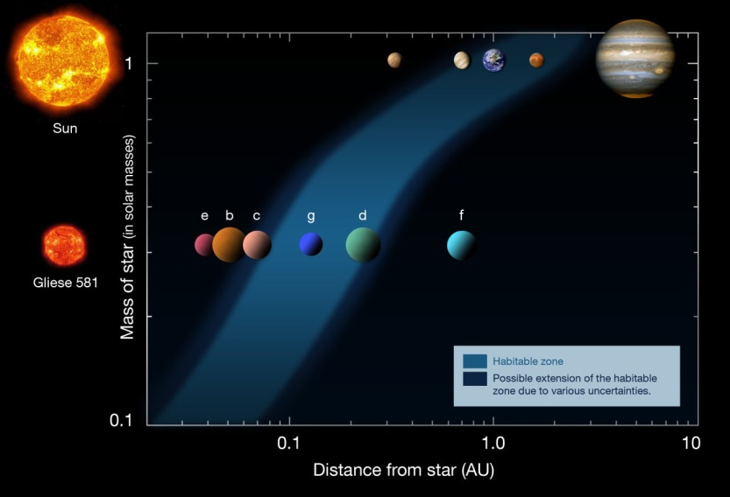

Task
- Make up flash/cue cards of the definitions and learn these over the next week.
Answer the following questions in your jotter.
- Name the planets in our solar system in order of distance from the sun.
- List the order of the planets in our solar system in order of size.
- Explain the following in astronomical terms
  - a day and
  - year
- Which planet in our solar system has the
  - longest days
  - longest years
  - days longer than years.
- Name the first exoplanet discovered and when it was discovered.
- Find the number of Exoplanets that have been discovered to date.
- Explain the term habitable zone.
- State the requirements for planets to sustain Earth-like life.
- Name the dwarf planets in our solar system.

Space Exploration & Understanding of the Universe
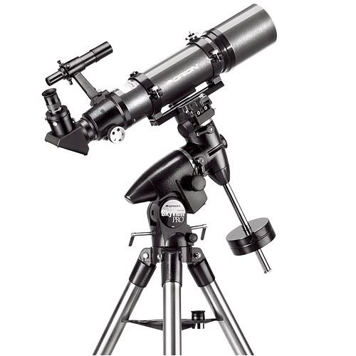
Our understanding of the Universe is widely based on observations made using telescopes.

Telescopes
Telescopes are devices used to observe the Universe. There are many different types and some are even sited in space.
Optical telescopes observe visible light from space. Small ones allow amateurs to view the night sky relatively cheaply but there are very large optical telescopes sited around the world for professional astronomers to use.
Optical telescopes on the ground have some disadvantages:
- They can only be used at night.
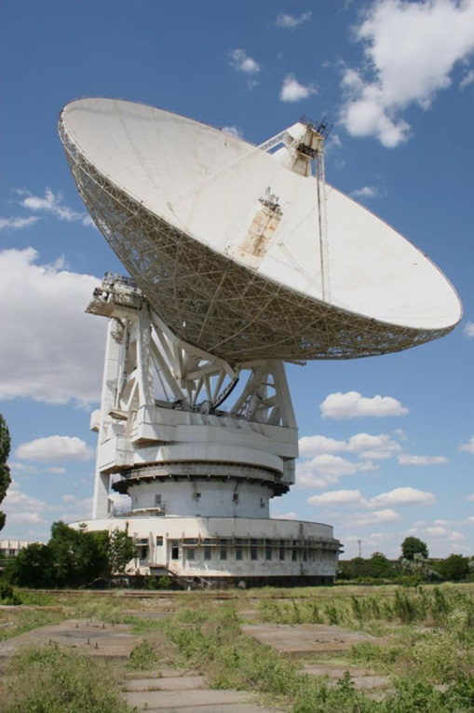
- They cannot be used if the weather is poor or cloudy.
Radio telescopes detect radio waves coming from space. Although they are usually very large and expensive, these telescopes have an advantage over optical telescopes. They can be used in bad weather because the radio waves are not blocked by clouds as they pass through the atmosphere. Radio telescopes can be used in daytime as well as at night.
X-ray telescopes need to be at high altitude, flown in balloons or carried in satellites above the Earth's atmosphere because X-rays are partly blocked by the Earth's atmosphere. Objects in the Universe emit other electromagnetic radiation such as infrared, X-rays and gamma rays. These are all blocked by the Earth's atmosphere, but can be detected by telescopes placed in orbit round the Earth.
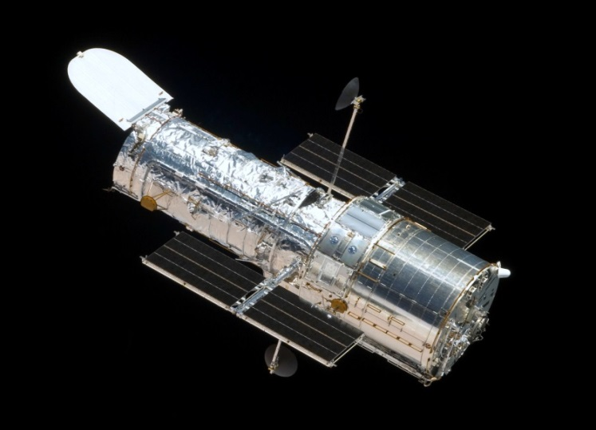
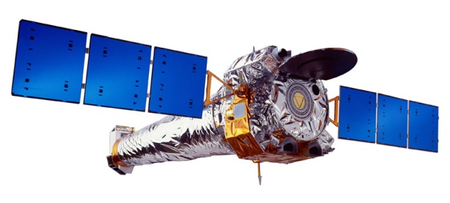
0-B Hubble space telescope

0-C X-ray telescope

Telescopes in space can observe the whole sky and they can operate both night and day. However, they are difficult and expensive to launch and maintain. The most famous telescope in space is the Hubble Telescope.
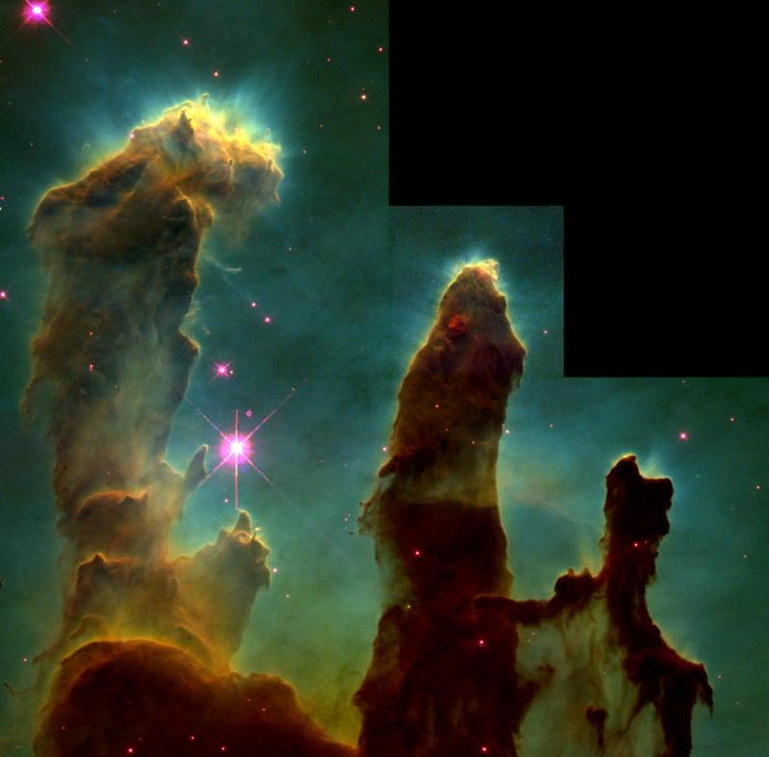
Credits: NASA/ESA/STScI/Arizona State University)
One of Hubble’s most iconic images is of this portion of the Eagle Nebula (M16). Dubbed the “Pillars of Creation,” it shows three huge columns of cold gas illuminated by light from a cluster of young stars with strong stellar winds located out of view above. Embedded in the tips of the finger-like protrusions at the top of the columns are dense, gaseous globules within which stars are being born. The largest of the three columns is approximately four light-years tall.

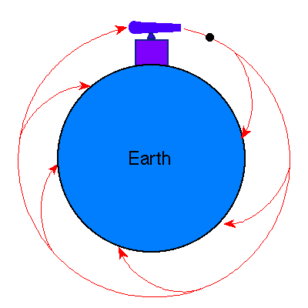
7.3 Satellites

Newton’s thought experiment
In this experiment Newton pictures a cannon on top of a very high mountain. If there were no forces of gravity or air resistance, the cannonball would follow a straight line away from Earth, in the direction that it was fired. If a gravitational force acts on the cannonball, it will follow a different path depending on its initial velocity. If the speed is low, it will simply fall back on Earth, if it’s initial horizontal speed is increased then the cannonball goes much further before it reaches the ground. If the horizontal speed is very high then the curvature of the Earth means the cannonball travels further around the Earth before it lands.
https://en.wikipedia.org/wiki/Newton%27s_cannonball
Newton’s Thought Experiment allowed us to understand satellite orbits.
If a projectile is launched with sufficient horizontal velocity, it will travel so far that the curvature of the Earth must be taken into account.
Now imagine a projectile launched with such a great horizontal velocity that it never reaches the ground! It will continue to circle the Earth until its horizontal velocity decreases- it becomes a satellite.
The satellite orbits around the Earth because it is in constant free-fall due to the Earth’s gravitational pull.

Functions of Satellites
A satellite is any object that is in orbit around a planet. There are two types of satellite: natural and artificial. For example, our Moon is a natural satellite, but a communication satellite for relaying signals around the world or a weather satellite are examples of artificial satellites.

Natural Satellites
Natural satellites of any planet are called moons. We have one natural satellite called “The Moon”, although it is also referred to as Lunar.
Other planets can have any number of moons. Venus has none, Mars has two and Jupiter has the most in our Solar System with 63 confirmed moons.

Artificial Satellites
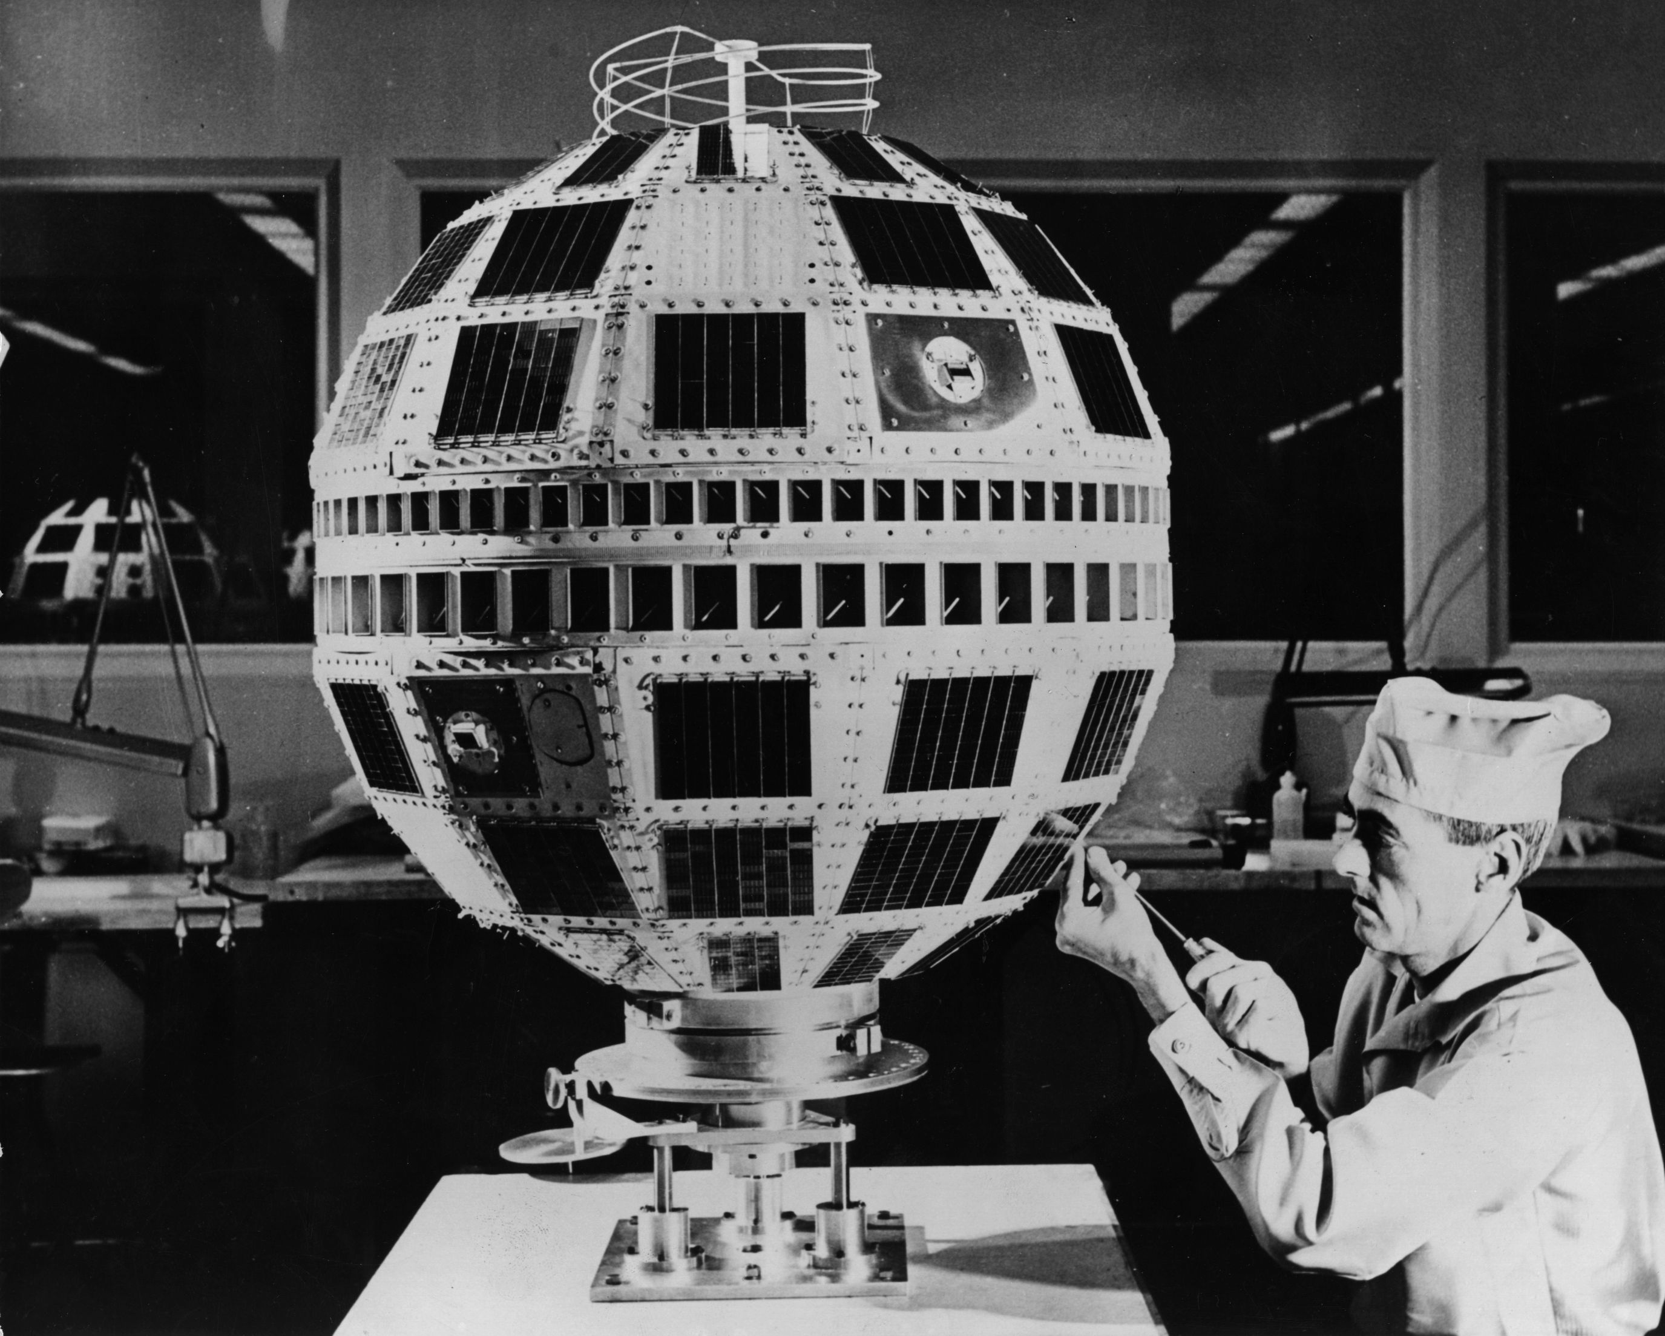
Artificial satellites orbit the Earth. They are unmanned and do not leave the orbit of the Earth. The first satellite launched into space was Sputnik in 1957. Sputnik was only a tiny metal ball that transmitted a signal for about three weeks. It wasn't until 1962 that the first orbiting satellite provided long-term service to the Earth. That satellite was named Telstar (right).
https://www.wired.com/images_blogs/underwire/2012/04/telstar_1.jpg
Artificial satellites today have many different purposes and orbits, and the number and their complexity has continued to increase. Today there are thousands of man-made objects orbiting the Earth. If you go outside on a very clear night, there is a good chance you will see a bright light speed across the sky. These fast moving objects are often satellites that are reflecting the light from the Sun.
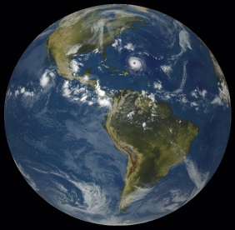
7.4 Geostationary Orbit
36,000 km
Geostationary Orbit
NATIONAL OCEANIC AND ATMOSPHERIC ADMINISTRATION
U.S. DEPARTMENT OF COMMERCE
One of the most common types of satellite is one that travels around the Earth in 24 hours, the same time the Earth takes to rotates on its axis. This means that the satellite appears to “hover” above the same point on the Earth’s surface. A receiver can be pointed at this satellite, allowing for a link for information.

Geostationary satellites take 24 hours to orbit the earth and orbit at an altitude of 36 000 km above the equator on the Earth’s surface.
Geostationary satellites have a period of 24 hours

These satellites are known as “geostationary” and have to be placed at a height of 36,000 km and and positioned above the equator of the Earth.
With three geostationary satellites placed in orbit around the equator worldwide communication is possible. Each satellite communicates with ground stations on different continents.

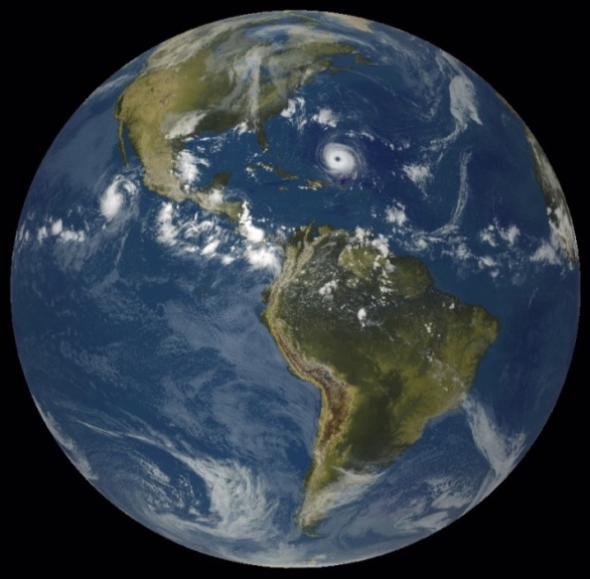
Polar Orbit
Polar Orbit
715 km
Polar satellites orbit above the Earth at about 715 kilometers (445 miles). Polar satellites monitor strong storms that move across the poles (regions of the Earth that Geostationary satellites cannot view).

7.5 Orbital Period & Height
The time a satellite takes to orbit a planet is called its period, T. If the satellite is at a high altitude above a planet's surface, it will take a greater time to orbit the Earth – it will have a long period. However if the satellite is closer to the planet's surface, i.e. it moves in a lower orbit, then it will take less time to orbit – it will have a smaller period.
Object | Distance from Earth (Mm) | Period (days)
International Space Station | 0.24 | 0.0625
X | 1 | 0.07
Geostationary satellite | 36 | 1
The Moon | 384.4 | 27.5
Y | 200 | 10.8
TASK
- Plot a graph of the distance from the Earth’s surface against period of the objects given in the table.
- State a conclusion you can draw from these results.
- From your graph estimate the orbital period of a satellite 300,000 km (300 Mm) above the Earth’s surface.

Distance=speed x time and Satellite Communication
A satellite will have several receiving and several transmitting curved reflectors. Signals are not “bounced” off satellites. They are taken in (received), amplified and then retransmitted on a different frequency to avoid interference with the incoming signal.
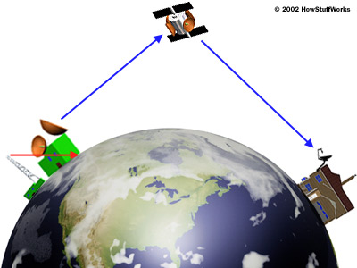
However, as all the signals are electromagnetic radiation, they all travel at the speed of light. This means that the signal is not instantaneously transmitted from A to B and there is a slight delay due to the long distances the signals travel.
A
B

Parabolic Reflectors
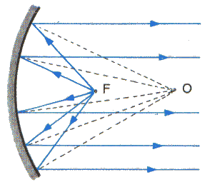
Satellite dishes are designed to receive signals. The curved reflectors have a special parabolic shape that makes any waves that strike it reflect to the same point. This point is called the focus and it will be the place where the signal will be the strongest. The larger the dish the more signal it can collect.

Transmitters
In a transmitter the transmitting device is placed at the focus of the parabolic reflector. The waves are emitted from the transmitter and are reflected off the curved reflector.
The special shape means that the reflected waves emerge in a parallel beam. This makes it very good for sending the waves in a particular direction.
Outgoing waves are transmitted as a parallel beam.
This is what happens in searchlights, torches and in microwave transmitters sending messages up to satellites.

Receivers
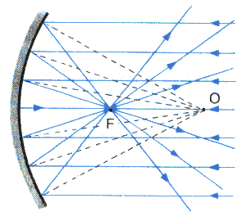
In a receiver the receiving device, such as an aerial, is placed at the focus of the parabolic reflector. The waves that strike the curved reflected are all reflected to the focus.
This makes the signal at the focus much stronger. The curved “dish” can gather more energy from the wave and focus it onto the receiver.
Incoming waves are reflected to the focus.
Curved reflectors are used in satellite receivers, radio telescopes, solar cookers and in many other applications.

Example
A signal station directly under a geostationary satellite orbiting at 36,000km “pings” a signal up to the satellite and receives a response signal. How long does it take for the signal to return?
solution:
As the signal travels to the satellite and back again, the total distance is twice the distance to the satellite.
$d=2×\left(36000×{10}^{3}\right)$ (as the signal is making a round trip) $=7·2×{10}^{7}$m
$v=c=3×{10}^{8}$ ms⁻¹
$t= \frac{d}{v}=\frac{7∙2×{10}^{7}}{3×{10}^{8}}=0.24$s

7.3 Applications of Satellites
Satellites can have different functions.

Weather Forecasting
Over 200 weather satellites carry equipment that allow real time detection of visible, infrared and microwave radiation. Weather satellites are either “geostationary” or “polar orbiting”. The geostationary satellites are used to photograph cloud cover, these images are then animated and used in weather forecasts on TV. The Earth turns underneath the polar orbiting satellites allowing full global data collection. Often these satellites are “sun-synchronous”, allowing data measurements to be recorded twice a day at the same point on the Earth’s surface at the same time each day.
Three polar-orbiting satellites working together can observe the entire planet every six hours. This allows a closer look at the Earth, producing images and measurements with a high resolution. These satellites are however always on the move and therefore do not allow continuous observation of a particular geographical area. Temperature, wind speed and direction, chemical content of the atmosphere, water vapour, cloud cover, precipitation, storms, and tropical cyclones can all be observed.

Environmental Monitoring
Satellites are ideal for observing human impact on the Earth and its environment, as they are capable of revealing and monitoring remote environments, hidden features, and even events that the human eye cannot detect. They provide reliable data 24 hours a day, seven days a week. Satellites can also monitor how winds disperse smoke from wildfires or ash from volcanic eruptions. Information on land surface temperature, winds, vegetation cover, bodies of water, human settlements, soil moisture, depth and extent of snow and ice can all be recorded.
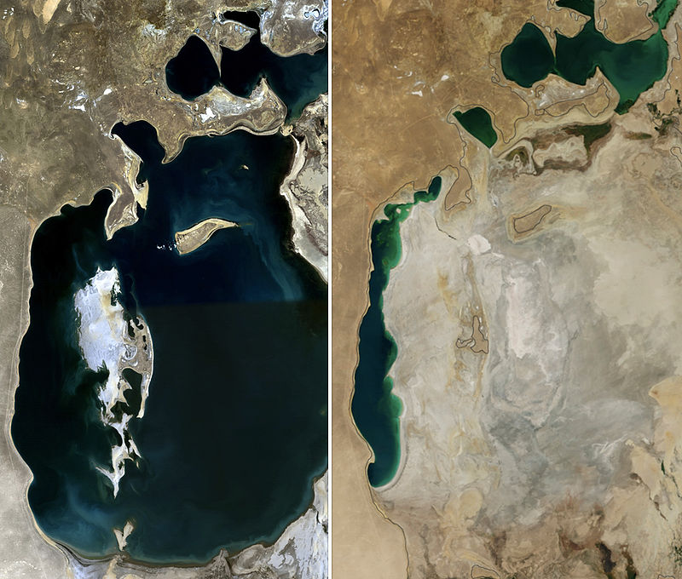
By NASA. Collage by Producercunningham. - 1989: aral sea 1989 250mFile:Aralsea tmo 2014231 lrg.jpg, Public Domain,
A comparison of the Aral Sea in 1989 (left) and 2014 (right).
Two pictures taken of the Aral Sea, one in 1989 and one taken in 2014. It is clear that in those three decades the Aral Sea has been drained and has become a desert. It was once the fourth largest lake in the world by area.
https://commons.wikimedia.org/w/index.php?curid=35813435

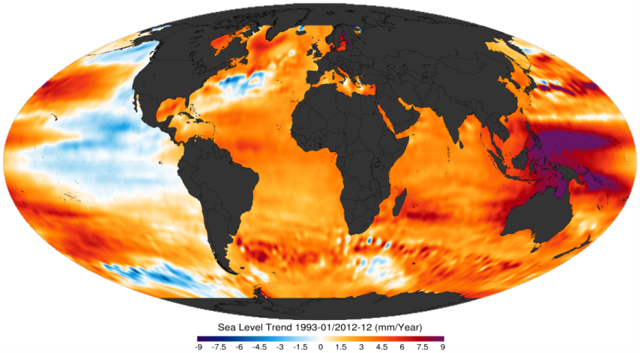
Details of the Ocean
Sea surface temperature, sea level height, ocean currents, and ocean winds are all monitored. It is also possible to monitor accidents, such as large oil spills, and periodic changes in the sea that affect global weather patterns, such as El Niño in the Pacific Ocean.

Climate Monitoring
Satellites are ideal for monitoring climate change because they can monitor the concentration of greenhouse gases in the atmosphere, such as aerosols, water vapour, carbon monoxide (CO), carbon-dioxide (CO₂) and methane.

Satellite Imaging/Sensing
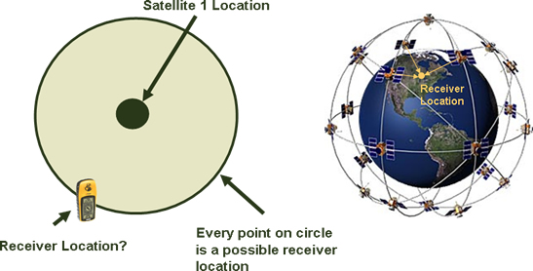
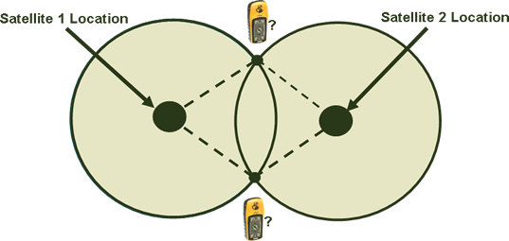
Satellites have been used to obtain detailed imagery of military sites and nuclear facilities across the world. Coastal management, ground quality, irrigation, and many more applications can be found here http://www.satimagingcorp.com/services.html.

7.4 GPS
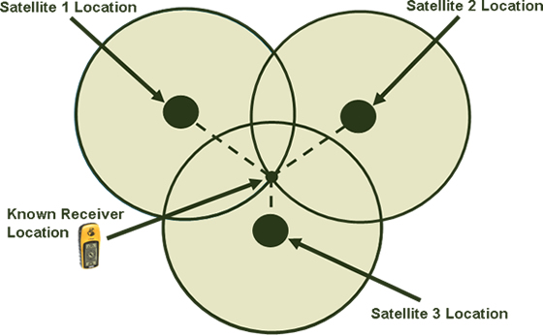
The GPS system uses 24 geostationary satellites transmitting microwaves to allow accurate determination of the position of an object. This includes a time stamp signal so by comparing multiple distance measurements, an object’s velocity can be calculated. This allows your smartphone to give you directions using Google Maps. A GPS receiver finds its position by measuring the distance between itself and three or more GPS satellites (called trilateration). A microwave signal is sent out from one satellite to the GPS receiver, the receiver measures how long it took for the signal to reach it. The signal travels at a known speed, the receiver then uses the length of travel time for the signal to calculate a circular range of possible locations.
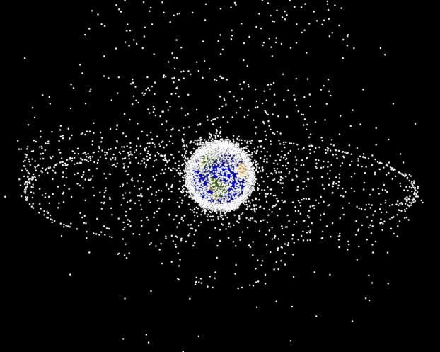
Using the signal from a second satellite, possible locations of the receiver on the ground are narrowed to the two points where the circles intersect as shown.
When a third satellite locates the receiver, an approximate location can be determined. Most GPS receivers give a location to within 100 metres using three satellites, but additional satellites will increase this accuracy. If four or more satellites are in range, the receiver can determine the user's position and elevation.

Impact of Space Exploration
With the vast amount of obsolete satellites and debris left over from manned space missions, the space around Earth is getting extremely cluttered with space junk. The diagram shows computer simulation of monitored space debris orbiting the Earth.
This debris can pose a risk to current satellites and manned space missions and some debris can fall to Earth and cause damage on the ground.
In 2009, a defunct Russian defence satellite collided with a commercial phone satellite and both were destroyed. This has led to interest in ways to collect space debris to prevent further collisions.
Many aspects of our day-to-day life is dependent upon satellites:
- Global Positioning Systems (GPS) allow us to use a phone or other device, such as a sat nav, to determine our location to within a few metres.
- Television networks rely heavily on satellites to transfer signals from one area to another eg live reporting from major events.
- Our weather forecasts are based upon data taken from satellite systems which have monitored the area around where we live. We can receive very up-to-date images of clouds and such which are then shown on our forecasts.
- Satellites with various detectors and telescopes can observe distant objects and allow us to analyse them in order to increase our knowledge of the Universe in which we live. The Hubble space telescope has increased our knowledge of space a great amount.

Getting in to space
http://www.bbc.co.uk/bitesize/standard/physics/space_physics/space_travel/revision/1/
How does a rocket get into space? Rockets use Newton’s third law of motion which states
“For every action there is an equal but opposite reaction”
or
“If ‘A’ exerts a force on ‘B’, then ‘B’ exerts and equal but opposite force on ‘A’”

Newton’s Third Law
Newton noticed that forces occur in pairs. He called one force the action and the other the reaction. These two forces are always equal in size, but opposite in direction. They do not both act on the same object. Newton’s Third Law can be stated as:
If an object A exerts a force (the action) on object B, then object B will exert an equal, but opposite force (the reaction) on object A.

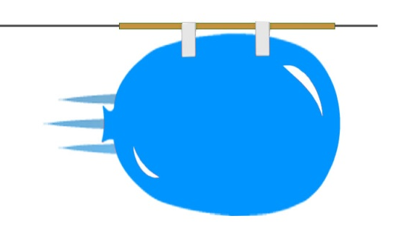
Task
- Tie a string between two clamp stands on opposite sides of the classroom.
- Carefully sellotape a straw to a partially inflated balloon and attach it to the string.
- Let the balloon go and use a stopwatch to measure the time taken for the balloon to travel across the classroom.
Why does the balloon move along the string? The air in the balloon is forced out of the open hole by the balloon. The air applies a force, equal but opposite on the balloon pushing this forwards. This is Newton’s third law in action and is called a Newton Pair.
This is the same as a real rocket sitting on the launch pad and ready to go to space.

In summary
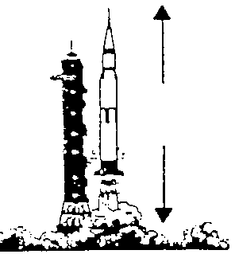
A rocket is pushed forward because the "propellant" is pushed back.
Both these forces are equal in size but opposite in direction
Object A is the rocket. Object B is the exhaust gases from the fuel. When the rocket takes off, the rocket exerts a force downwards on the exhaust gases. The exhaust gases exerts a force on the rocket that is equal in size and opposite in direction.

7.6 Challenges of Space Travel

Lift Off
You’ve probably heard it said that what goes up must come down! This is due to the force of gravity pulling things towards the centre of the Earth. We now know that things that go up don’t have to come back down.
If you launch something with enough speed then it is still pulled towards the Earth but the thrust produced by the rockets overcomes the weight and the air resistance or frictional forces. Rockets take off by burning fuel. This fuel burns slowly and generates lots and lots of heat. When the rocket fuel burns, it also produces gas. The build-up of this gas escapes the rocket with a lot of force and provides enough thrust for the rocket to blast off. To maintain enough thrust to overcome the Earth's gravitational pull, the rocket must carry lots of fuel in many tanks. As the rocket takes off the mass of the rocket decreases as the fuel is used up.
When a tank of fuel is used up, the fuel tank is released from the rocket, which makes the rocket much lighter This makes the weight of the rocket much less and as unbalanced Force=mass x acceleration as the mass decreases the acceleration increases for constant thrust.
Frictional forces increase with speed but the higher up the Earth’s atmosphere you are, the thinner the air is and the frictional forces decrease until at the edge of the atmosphere the frictional forces on the outside of the rocket at zero.
Finally the value of g, the gravitational field strength reduces with height, although only by a small value. The value of the gravitational field strength at the height of the ISS is approximately 8.5 Nkg⁻¹So what sort of materials can provide a force great enough to lift a rocket of mass nearly 3×10⁶ kg?
The Saturn V rockets which took men to the moon had a mass of 2·95 ×10⁶ kg and had on board 777000 litres of kerosene and 1·2×10⁶ litres of liquid Oxygen. Each litre of fuel could produce about 32 MJ of heat energy.
So when an astronaut or cosmonaut is on the Launchpad, they are sitting on top of a very large rocket, a potential fatal bomb, if things went wrong where nothing an astronaut could prevent fatality. Getting in to space is a risky business!

In Summary
ON THE LAUNCH PAD | AT TAKE OFF | AS THE ROCKETS ACCELERATES | IN SPACE
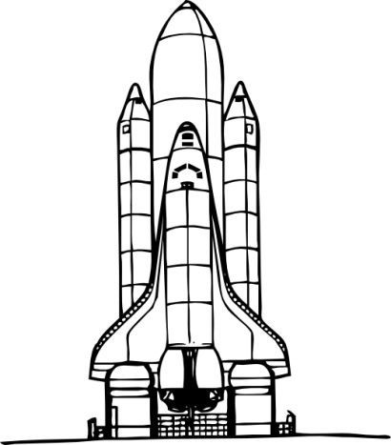 | T  W | 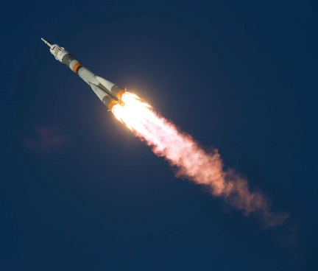 | 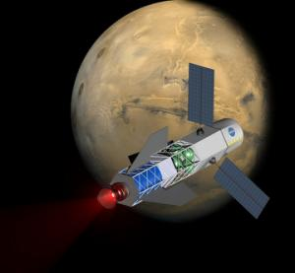
W=R  On the launch pad the Weight of the rocket is equal to the reaction force from the ground. The rocket is stationary. | T>>W  The weight of the rocket acts downwards, but the thrust of the rocket is much greater creating an unbalanced upwards force resulting in an acceleration  F_{un}= F_{thruest} – W  F_{un}=ma | F_{un} = ma  If m deceases a increases for the same thrust.  F_{un} = Thrust-(Weight+ frictional forces)  as mass decreases weight decreases giving a greater unbalanced force. | A rocket does not need to keep its engines going during interplanetary flight as there is no friction to slow it down. Newton’s First Law of Motion applies, which states  An object will remain at rest or move at constant speed in a straight line unless acted upon by an unbalanced force.
Newton’s Third Law, for every action there is an equal but opposite reaction | Newton’s Third Law  A rocket is pushed forward because the "propellant" is pushed back. | Newton’s Second Law  F_{un} = ma | Newton’s First Law to manoeuvre in space the rockets are briefly switched on and then the rocket thrusters are set in the opposite direction to slow the rocket down

once in Space
A rocket does not need to keep its engines going during interplanetary flight as there is no friction to slow it down. Newton’s First Law of Motion applies, which states
An object will remain at rest or move at constant speed in a straight line unless acted upon by an unbalanced force.
With smaller gravitational field strength and no air friction objects move in a different way in space. When a thruster is fired the ship will accelerate forward (say). When the thruster stops firing it will continue to move at a constant speed. In order to stop the vehicle we would have to fire a thruster in the opposite direction.
We cannot brake or turn a wheel.
All change in movement has to be caused by applying a force in a certain direction.
Whilst in orbit the spacecraft is also in freefall. ie it is falling to Earth but the curvature of the Earth means that it never lands. In reality frictional forces are usually at work on the spacecraft in lower space orbit and the spacecraft have to occasionally adjust their orbit to prevent them from returning to Earth.

Getting into deep space.
To obtain such high accelerations and speeds rockets require a large mass of fuel on board and this is not practical for long distance missions, which would require such large mass on fuel on take off that the thrust required to overcome the weight would be too great. An alternative method of rocket propulsion is required for long distance missions.
Two solutions are currently available
- ion drive propulsion and
- gravity assist.

Ion Drive Propulsion.
Ion propulsion is one of the latest advances in spaceflight propulsion. Rather than ejecting a relatively large amount of mass over a short period of time to create thrust, an ion propulsion engine ejects individual atoms at velocities 5-30 times higher than traditional engines, over a much longer period of time (days, weeks, or longer). This type of thrust eventually will propel the spacecraft to much larger velocities than that obtained by traditional engines. Ion propulsion is currently one of the best answers to long distance missions, and, ironically, is also very well suited for small attitude adjustment thrusting, because of the extremely low impulse of the thrust.
A project to compares a mission to Saturn using traditional propulsion with an identical mission using ion propulsion determined that for this mission, ion propulsion used 98% less fuel than conventional propulsion, but took nearly 50% longer.

How does the ion drive work?
Ion thrusters are another example of Newton’s Third Law in action.
Ions must be created before they can be expelled. To do this, a plasma (typically xenon, because it is relatively stable and is over 4 times heavier than air) is bombarded with electrons emitted from a cathode. When an electron strikes a xenon atom, it knocks away one of the atom’s electrons, resulting in a positively charged xenon ion. An electric field is created in the rear of the xenon chamber using a pair of positively and negatively charged metal grids. The xenon atom accelerates through this electric field, and is ejected from the spacecraft- imparting an equal and opposite force to the spacecraft as it leaves. To prevent the ion from being attracted back to the spacecraft (and therefore negating any thrust it provided) a stream of electrons is directed into the exhaust to neutralize the ions The energy to power the electron gun can either come from solar panels, or from a radioisotope thermoelectric generator
State-of-the-art ion thrusters can deliver a grand total of 0.5 newtons of thrust (equivalent to the force of a few coins pushing down on your hand), while chemical thrusters (which power just about every spacecraft ever launched) on a satellite or probe deliver thousands of newtons. The reason ion thrusters will be used for more future missions is they have a fuel efficiency that’s 10 to 12 times greater than chemical thrusters. Obviously, for long trips through space, fuel efficiency is very important.

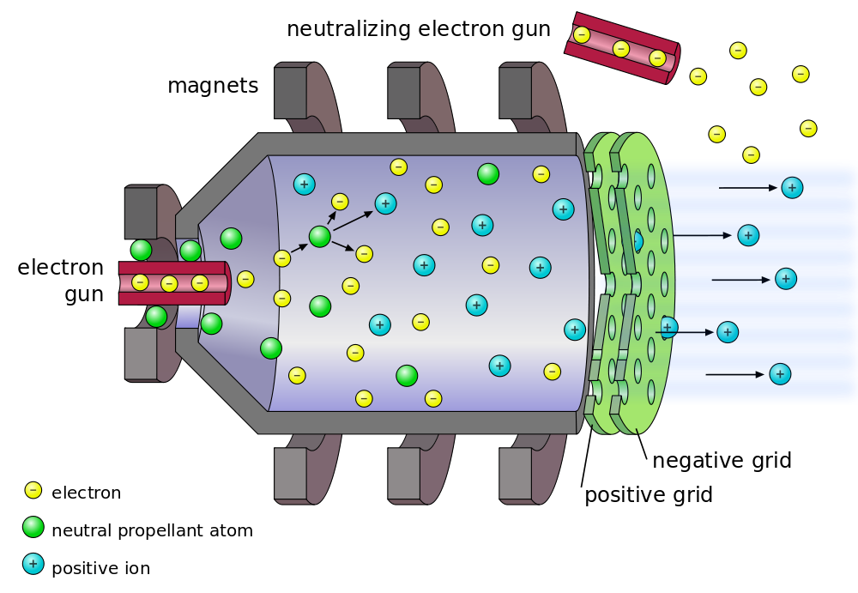

Gravity Assist
Gravity assist is another method that has been used in missions to get spacecraft into deep space. Gravity assist uses a planet’s gravitational field to provide additional speed and usually a change of direction of the spacecraft; allowing travel to be accomplished with much less fuel (and hence with a much smaller, cheaper rocket) than would otherwise be required. Lifting extra fuel into orbit, just so it can be used later, is exponentially expensive. Furthermore, the extra speed gained by gravity assists dramatically reduces the duration of a mission to the outer planets. So how does gravity assist work?
http://bit.ly/2DByTTT
The spacecraft’s velocity increases during the “slingshot”, During the approach, as the spacecraft falls into the gravitational field of the planet, it gains kinetic energy and speed and loses gravitational potential energy, trading one for the other. After the approach it climbs back out and loses whatever kinetic energy it gained during the approach, ending up with the same final speed it started with. The direction of the spacecraft changes during the encounter, however, so typically it leaves the planet heading in a different direction. The closer the spacecraft gets to the planet, the greater the deflection. The maximum deflection is 180 degrees, sending the spacecraft back where it came from; this occurs if the spacecraft gets extremely close to the planet.
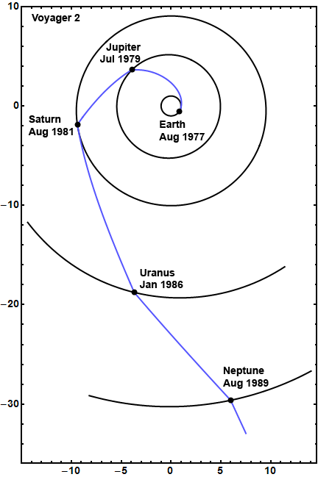
Velocity is a vector, which means direction is important, and as the direction of the spacecraft has changed the spacecraft must have accelerated. There is a transfer of momentum and kinetic energy from the planet to the spacecraft. The planet slows down very slightly in its orbit, and the spacecraft speeds up. Newton's third law states, "To every action there is an equal and opposite reaction," and that's true in this case. Because the planet is so much more massive than the spacecraft, we are unable to measure the effect, but to the spacecraft it's a big deal. For example, we can calculate that during the Voyager encounters with Jupiter in 1979, Jupiter slowed down by roughly 10⁻²⁴ kilometres per second -- a change much too small to measure. But each Voyager gained about 10 kms⁻¹, a pretty big number and enough to put them on a fast path to Saturn (and in the case of Voyager 2, to Uranus and Neptune as well) and eventual escape from the solar system.

Further Task
Research and find further technologies that have been developed to assist with space exploration and their everyday uses.

Space Walks

The first person to go on a spacewalk was Alexei Leonov. He was from Russia. The first spacewalk was on March 18, 1965. It was 10 minutes long.

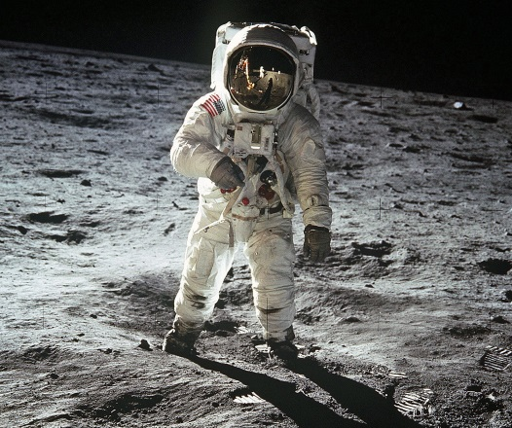
The first American to go on a spacewalk was Ed White. His spacewalk was on June 3, 1965, during the Gemini 4 mission. White's spacewalk lasted 23 minutes.
Extravehicular activity (EVA) is any activity done by an astronaut or cosmonaut outside a spacecraft beyond the Earth's appreciable atmosphere. The term most commonly applies to a spacewalk made outside a craft orbiting Earth (such as the International Space Station), but also has applied to lunar surface exploration (commonly known as moonwalks) performed by six pairs of American astronauts in the Apollo program from 1969 to 1972.
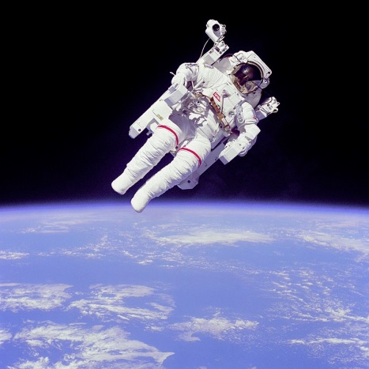
EVAs may be either tethered (the astronaut is connected to the spacecraft; oxygen and electrical power can be supplied through an umbilical cable; no propulsion is needed to return to the spacecraft), or untethered. Untethered spacewalks were only performed on three missions in 1984 using the Manned Manoeuvring Unit (MMU), and on a flight test in 1994 of the Simplified Aid For EVA Rescue (SAFER), a safety device worn on tethered U.S. EVAs.
The EVA’s are extremely dangerous and the astronauts train for these for many hours. They spend approximately 7 hours in the pool (neutral buoyancy lab) for every hour of space walk they do. They also use virtual reality to train for their walks
The obvious risks are the difference in pressure and air outside. Their spacesuits must be pressurised and able to cope with the enormous pressure difference between the inside of the spacesuit and the outside environment. If the pressure suit were to leak it wouldn’t be long before the astronaut died.
Another problem with the harshness of space is the difference in temperature. In the sun the temperature can reach 149°C but in the shade it can be as low as -184°C . That is a huge temperature difference and the astronauts try to manoeuvre to get at a comfortable temperature. The white space suits and the internal cooling system maintain a tolerable body temperature.
One unusual risk from a spacewalk occurred when an astronaut nearly drowned after his pressurized helmet began to fill with water, covering his eyes, ears and nose, while he was carrying out a spacewalk at the International Space Station in July.2014. Blinded by the water, Italian Luca Parmitano relied on his memory to get him back to the airlock cabin and had to be pulled back inside the space station by his fellow astronauts. As Parmitano was in freefall the water didn’t flow to the bottom of the helmet but clung to his face.
An astronaut getting hit by space debris would be a great risk to the astronaut. First, the spacesuit would be punctured and would rapidly lose pressure. If it was a very small puncture, there would be time to get to the airlock and inside the spacecraft before the oxygen runs out. But for a large puncture, the suit would lose pressure quickly and there may not be sufficient time to get to the airlock and it is likely that the astronaut would die.
Second, space debris typically moves faster than a bullet shot from a gun, relative to the speed of the spacecraft. It would not only puncture the spacesuit but it would seriously injure the astronaut. With the astronaut injured this way, there would be severe blood loss and there would likely not be enough time to re-enter, perform a rescue after the spacecraft has landed, and get the stricken astronaut to a hospital. Currently neither the Russian Space Agency or NASA have had to deal with this, but with the growing amount of orbiting space debris and as astronauts continue to work outside their spacecraft in their spacesuits, the chances of an accident of this nature occurring will become increasingly significant.
As the atmosphere is either minimal or non-existent in space the astronauts and cosmonauts are exposed to far more cosmic radiation that us on the Earth. If solar flares are forecast the astronauts can be confined to parts of the ISS which are more protected areas, such as the US built Destiny laboratory, or the Russian built service module Zvezda. The ISS crew did receive a Solar weather warning several times and were advised to enter the protected areas but they were in all instances well within the safety margins.
Cosmic rays are super-charged subatomic particles coming mainly from outside our solar system. Sources include exploding stars, and black holes. Unlike solar protons, which are relatively easy to stop with materials such as aluminium or plastic, cosmic rays cannot be completely stopped by any known shielding technology.
Even inside their ships, astronauts are exposed to a slow drizzle of cosmic rays coming right through the hull. The particles penetrate flesh, damaging tissue at the microscopic level. One possible side-effect is broken DNA, which can, over the course of time, cause cancer, cataracts and other illnesses.
On top of advance warnings due to observations of the Sun's activity by several satellites, and also ground based observations, ISS is still well within the Earth's magnetic field, which helps reduce the effects of prolonged exposure to Cosmic radiation. Solar storms can however cause other problems, such as burning sensitive electronic equipment with highly charged EM pulse, so the ISS would try and limit possible damage by other means too, and if deemed necessary, rotate photovoltaic arrays (solar panels wings) perpendicular to the impending Solar flare, rotate the whole station, or any other risk management procedure
A document produced by NASA has a list of possible health risks associated with Space travel. The chapters are listed below
- Risk of Inability to Adequately Treat an Ill or Injured Crew Member.
- Risk of Inadequate Nutrition
- Risk of Inadequate Food System.
- Risk of Behavioural and Psychiatric Conditions.
- Risk of Radiation Carcinogenesis from Space Radiation
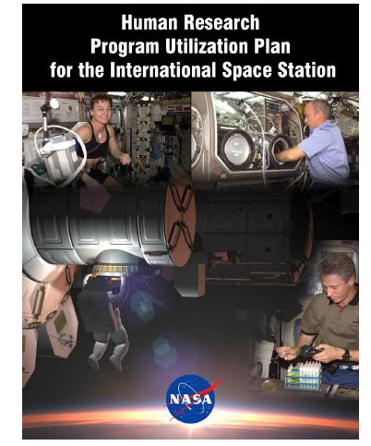
- Risk of Compromised EVA Performance and Crew Health Due to Inadequate EVA Suit Systems.
- Risk of Accelerated Osteoporosis
- Risk of Orthostatic Intolerance During Re-exposure to Gravity.
- Risk of Impaired Performance Due to Reduced Muscle Mass, Strength and Endurance.
- Risk of Reduced Physical Performance Capabilities Due to Reduced Aerobic Capacity
- Risk of Therapeutic Failure Due to Ineffectiveness of Medication
- Risk of Performance Errors Due to Poor Team Cohesion, Performance, & Psychosocial Adaptation; Inadequate Selection/Team Composition & Training.
- Risk of Cardiac Rhythm Problems10 Risk of Intervertebral Disc Damage.
- Risk of Crew Adverse Health Event Due to Altered Immune Response
- Risk of Impaired Ability to Maintain Control of Vehicles and Other Complex Systems
- Risk of Performance Errors Due to Sleep Loss, Circadian Desynchronization, Fatigue, and Work Overload
- Risk of Operational Impact of Prolonged Daily Required Exercise.
- Risk of Unnecessary Operational Limitations due to Inaccurate Assessment of Cardiovascular Performance
- Risk of Bone Fracture
- Risk of Renal Stone Formation.
- Risk of Urinary Tract Dysfunction.
- Risk of Impaired Vision Due to Refractive Visual Changes During Long Duration Space Flight
- Risk of Adverse Health Effects Due to Exposure to Hypoxic Environments
- Risk of Adverse Health Effects Due to Prolonged Exposure to Elevated Carbon Dioxide Levels

Re-Entry into Atmosphere
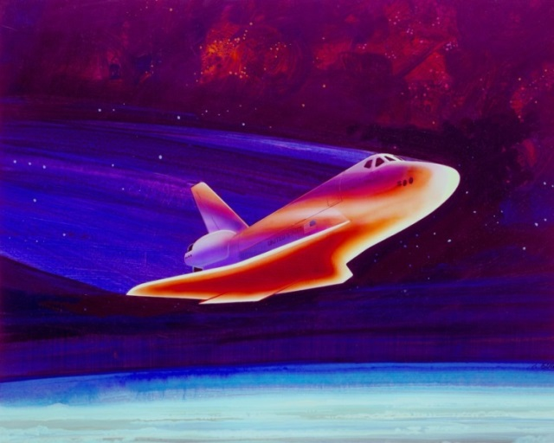
Another dangerous time during the whole risky spaceflight is re-entry, when work is done by friction with the air converting the huge speeds and kinetic energy into heat energy on the outside of the spacecraft and the air around it.
- When a spacecraft re-enters the Earth’s atmosphere, it is travelling at a velocity of around 17 500 mph, or 8 kms⁻¹.
- The force of air resistance from the Earth’s atmosphere is huge at these velocities.
- The temperature of the air around the space shuttle and other spacecraft is so great it produces electrically charged plasma.
- Air resistance does work on the spacecraft which changes the kinetic energy to heat (E_{k}→E_{h}).
- The heat absorbed can cause a temperature increase of around 1300 °C on the space shuttle black tiles.
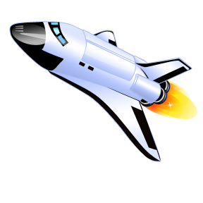
Heat Shield Design
Case Study – the Shuttle
The Shuttle was the first (and only) reusable spacecraft. The first Shuttle mission was launched in 1981 and the final mission was in July 2011.
The part of the Shuttle that returns to Earth is called the Orbiter and its shape resembles an aircraft.
(For more information, see http://www.nasa.gov/mission_pages/shuttle/main/index.html).
- The Shuttle Orbiter is made from aluminium alloy covered in special tiles to protect it from the intense heat generated during re-entry.
- The Shuttle needs around 34 000 thermal protection tiles (all of different shapes and sizes).
- The tiles are made of a material called silica, which has a high specific heat capacity and a high melting point (c=1040 Jkg⁻¹° C⁻¹, melting point = 1610 ° C).
- The tiles are painted black so that heat is lost to the surroundings. The air around the shuttle heats up. The temperature increase of the shuttle is therefore not as great.
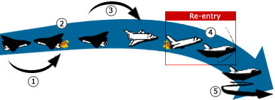
http://ffden-2.phys.uaf.edu
Example
A heat shield on a spacecraft has a mass of 50 kg.
The spacecraft is travelling at 1000 ms⁻¹. On re-entry into the Earth’s atmosphere, the velocity of the spacecraft is reduced to 200 ms⁻¹.
- Calculate the change in kinetic energy of the heat shield.
- Calculate the change in temperature of the heat shield. (Assume all of the kinetic energy is changed to heat in the heat shield material).
Specific heat capacity of heat shield material = 1040 Jkg⁻¹°C⁻¹
Solution
(a)
m = 50 kg $Change in Ek = initial Ek – final Ek$
u = 1000 m/s $= (½mu^{2}) – (½mv^{2})$
v = 200 m/s $= (½×50×{1000}^{2}) – (½×50×{200}^{2})$
$= 2.5×{10}^{7} – 1.0×{10}^{6}$
$= 2.4×{10}^{7} J$
(b)
ΔE_{h} = ΔE_{k} = 2.4x10⁷J $E_{H} = cm ΔT$
c = 1040 J/kg°C $2.4×{10}^{7} = 1040×50× ΔT$
m = 50 kg $∆T=\frac{2.4×{10}^{7}}{1040×50}$
ΔT = = 460 °C

In Summary

- The space shuttle arrives at the edge of our atmosphere
Ek is big
Ek is small
- The shuttle has a very high kinetic energy (E_{K} is high)
- So E_{K} must be lost as the shuttle passes through the atmosphere.
- As the space shuttle is travelling at very high speeds the frictional forces on the shuttle are massive as it moves through the atmosphere.
- E_{W} – work is done against FRICTION as the shuttle passes through the atmosphere.
- The work done causes the shuttle to heat up
- The heat energy produced is given by the equation E_{H} = m x c x ΔT
- E_{W} – work is done against FRICTION as the shuttle passes through the atmosphere. E_{W} = F x d
- Size of friction, F = ma
- Where a = deceleration of the shuttle and should be zero
FRICTION
Friction decreases
as speed decreases
Friction
opposes
motion
- Finally the shuttle stops, (E_{K} is now zero)
- $E_{k} lost is ½mv^{2}$
- $E_{k}= ½mv^{2}$at the outside of the atmosphere
- $E_{k} lost is ½mv^{2}=E_{w} = Fd= E_{H} gained= mcΔT$

TASK
the following questions on Re-entry in your jotter
- In low orbit a space shuttle with a mass of 75 000 kg and a payload of 25000 kg travels at a speed of 8 kms⁻¹ On the ground the space shuttle has the same mass but it is stationary. It takes 53 mins and 20 seconds to come to rest after the re-entry engines are fired.
  - Calculate
    - the average acceleration
    - the total distance travelled
    - What was the shuttle’s Ek in orbit?
  - The shuttle is slowed down by frictional forces of the air.
    - Determine the size of these forces.
    - Calculate the work done by this force.
    - Explain why the air friction affect the shuttle so much.

7.13 Mass & Weight
Mass is a measure of the amount of matter (stuff) in an object. It is measured in kilograms (kg)
Mass (g) | Predicted weight (N) | Weight (N)
100 |  | 1
200 |  | 2
300 |  | 3
400 |  | 4
500 |  | 5
600 |  | 6
700 |  | 7
800 |  | 8
900 |  | 9
1000 (1kg) |  | 10

Task

What is the link between Mass and Weight
Weight is a force and it is the pull of gravity acting on an object. It is measured in Newtons.
Experiment
- Collect a 20N spring balance and a set of 100 g masses.
- Predict the weight (force of gravity) on 100 g.
- Record this in the table.
- Test your answer and record the measured weight.
- Repeat for other masses until you can discover a relationship.
- Replace the 20 N spring balance with a 50 N spring balance and place 5 kg on the end.
- Record carefully the value of the weight.

Conclusion
From our experiment we have found out that the Earth pulls every 1kg with a force of ?N

Formula : Weight =mass × ??
This value of ?? Newtons per kilogram is called the GRAVITATIONAL FIELD STRENGTH, g
Weight =mass × gravitational field strength
W = m × g
Object | Mass (kg) | Weight (N)
A bag of sugar | 1 | 10
A bag of tatties | 5
A loaf of bread | 0.5
An apple |  | 1
A small car |  | 8000
A small pupil |  | 450
ME
Bag of crisps | 23g

Change 23g into kg =23 x 1/1000 = 0.023kg
Inertia is the tendency of an object to remain in a state of rest or uniform speed unless acted upon by an unbalanced force. That is, it is the resistance of an object to motion. Measurement of inertia is a way of measuring mass.
“g” is the gravitational field strength. It is measured in NEWTONS PER KILOGRAM. It is the WEIGHT PER UNIT MASS (force of gravity on every kilogram)

My Weight on other planets

Task
- Calculate your own weight on each of the planets.
  - Find out the distance of each of the planets from the Sun.
ii) Present the above information on ‘g’ on a drawing of the Solar System.

Planet | g (N/kg) | m (kg) | W (N) =m x g
Mercury | 3.7
Venus | 8.8
Earth | 10.0
(Moon) | 1.6
Mars | 3.8
Jupiter | 26.4
Saturn | 11.5
Uranus | 11.7
Neptune | 11.8
Pluto | 4.2

Forces and the Newton Balance
Aim: To use the newton balance to pull and lift various known masses.
Apparatus: Newton balance
Selection of masses of known size
Instructions for experiment 1
• Use the newton balance as in Diagram 1 to pull each mass across the top of your desk.
• Compare the force required to
a) start the mass moving
b) keep the mass moving slowly at a steady speed
c) keep the mass moving quickly at a steady speed.
Explain how the newton balance is used to measure force.
Instructions for experiment 2
• Use the newton balance as in Diagram 2 to lift each mass.
• Compare the force required to
a) support the mass so that it is not moving
b) move the mass upwards at a steady speed
Planet | g (N/kg)
Mercury | 3.7
Venus | 8.8
Earth | 10
Mars | 3.8
Jupiter | 26.4
Saturn | 11.5
Uranus | 11.7
Neptune | 11.8
Pluto | 4.2
c) move the mass downwards at a steady speed.
Record your results in a table, recording the mass in kilograms (kg).
Extend your table, calculate the ratio of weight to mass; ie.
State the name given to this ratio.

Gravity, mass and weight
The data table on the right may be required for questions.
Assume the questions refer to the Earth unless otherwise stated
1. What is the weight of a 10 kg bag of potatoes?
2. What is the weight of a 250 g bag of sweets?
3. What is the mass of a 450 N girl?
4. What is the weight of a 10,000 kg spacecraft on
a) Earth b) Mars c) Venus?
5. What would a 60 kg man weigh on Jupiter?
6. Which planet’s gravity is closest to our own?
7. An astronaut who weighs 700 N on Earth goes to a planet where he weighs 266 N.
Calculate his mass and state which planet he was on.
8. What would an astronaut weigh on Earth, if his weight on Venus was 528 N?

Gravitational Field Strength with Height
The value of g changes with the distance from a planet. On Earth the radius of the Earth is approximately 6400 km or 4000 miles. So on average the value of g on the surface of the Earth is just under 9.8 N/kg. However, you can see from the graph that the value of g takes a very long distance to reduce.
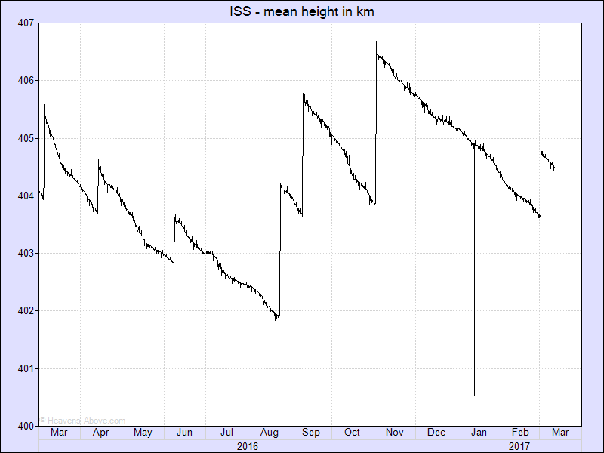
This plot shows the orbital height of the ISS over the last year. Clearly visible are the re-boosts which suddenly increase the height, and the gradual decay in between. The height is averaged over one orbit, and the gradual decrease is caused by atmospheric drag. As can be seen from the plot, the rate of descent is not constant and this variation is caused by changes in the density of the tenuous outer atmosphere due mainly to solar activity. http://heavens-above.com/IssHeight.aspx
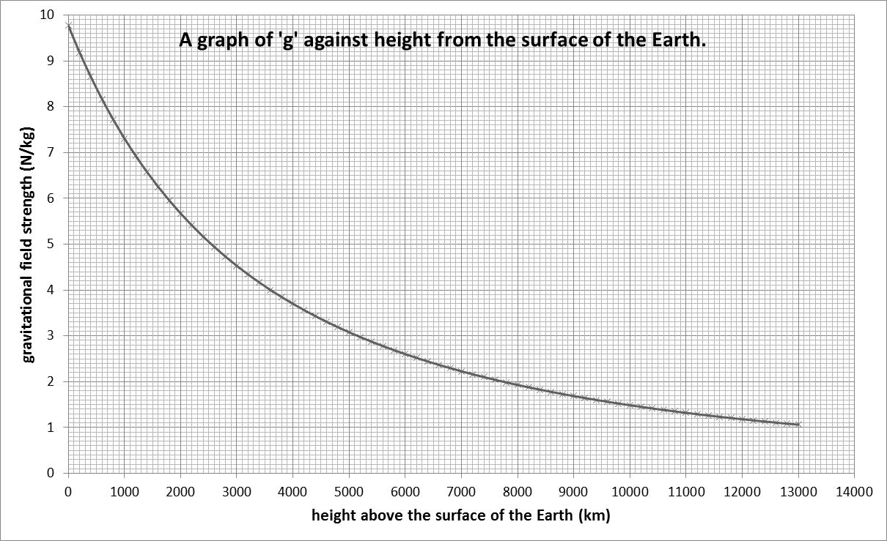
Plot your own graph of g aginst height using the data in the table below.
Height in km | gravitational field stegnth (N/kg)
0 | 9.8
200 | 9.2
400 | 8.7
600 | 8.2
800 | 7.7
1000 | 7.3
2000 | 5.7
2600 | 4.9
2800 | 4.7
3000 | 4.5
3800 | 3.8
4000 | 3.7
4800 | 3.2
5000 | 3.1
6000 | 2.6
7000 | 2.2
8000 | 1.9
9000 | 1.7
10000 | 1.5
11000 | 1.3
12000 | 1.2
13000 | 1.1

- Choose your birthday or a significant day and find the approximate height of the ISS on this day. Record the day and the height.
- Using the information in the graph of g against height, find the value of the gravitational field strength on the ISS when it is at your chosen height.
- What would be the calculated value of your weight on the ISS?
- Why would you be described as “weightless”
Test your current ideas about weightlessness:
Astronauts on the orbiting space station are weightless because...
A. There is no gravity in space and they do not weigh anything.
B. Space is a vacuum and there is no gravity in a vacuum.
C. Space is a vacuum and there is no air resistance in a vacuum.
D. The astronauts are far from Earth's surface at a location where gravitation has a minimal effect.
http://www.physicsclassroom.com/class/circles/Lesson-4/Weightlessness-in-Orbit
Find the answer at the website above, I think some of you might be surprised by the answer.

Weightlessness
The answer to the multiple choice question above was that none of the answers were correct, I promise the SQA won’t write a question like that!
When we say “weightless” what we generally mean is “in freefall”.
According to the formula:
W= mg | Where W = weight  m = mass  g = gravitational field strength
To be weightless you must travel to a region where there is no gravitational field. Even in space, where spacecraft travel, ‘g’ has a value greater than zero. An example of what actually happens is when a car goes over a bump in the road too fast and takes off. Both the car and the occupants fall back to the road at the same rate and so the occupants momentarily feel ‘weightless’ because they are not being supported by anything. Being in contact with the ground makes us aware of our weight. In a spacecraft the spacecraft and the occupants are falling to Earth at the same rate so they feel weightless even though there is gravitational force acting on them. The astronauts are actually in freefall.
Weightlessness is simply a sensation experienced by you when there are no external objects touching and exerting a push or pull upon you. Weightless sensations exist when all contact forces are removed. These sensations are common when you are momentarily in a state of free fall. When in free fall, the only force acting upon your body is the force of gravity - a non-contact force. Since the force of gravity cannot be felt without any other opposing forces, you would have no sensation of it. You would feel weightless when in a state of free fall.
http://www.physicsclassroom.com/class/circles/Lesson-4/Weightlessness-in-Orbit

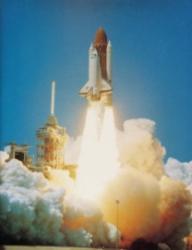
task
Answer the following questions
            - A space shuttle is about to be launched from the surface of the Earth. It has a mass of 7.9 x 10⁴ kg.
- What is the weight of the space shuttle at launch?
- Describe and explain what happens to the weight of the space shuttle as it gets further away from the surface of the Earth.
            - A space rocket has a mass of 9.0 x 10⁴ kg. What engine thrust is required to make the rocket accelerate at 25 ms⁻² at take off?
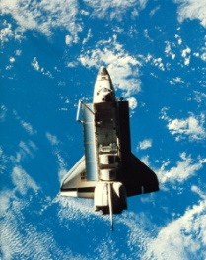
            - A spacecraft of mass 9000 kg is to re-enter Earth’s atmosphere. Just before re-entry it has a speed of 7500 ms⁻¹. At a point during re-entry, the speed of the spacecraft drops to 700 ms⁻¹. What is the heat energy gained by the spacecraft up to this point in re-entry?
            - A pupil in a physics class makes the following statement:
“The material used to protect space shuttles during re-entry needs to have a low specific heat capacity”
Do you agree or disagree with this statement? Give a reason for your opinion.
            - A 50 kg piece of space junk orbits the Earth with a speed of 1200 ms⁻¹. It re-enters the Earth’s atmosphere and its speed drops to 400 ms⁻¹. The specific heat capacity of the piece of space junk is 850 Jkg⁻¹ °C⁻¹. What is the temperature change of the space junk during re-entry?
            - A NASA scientist has to choose a suitable material to construct heat tiles on the outside of a space shuttle. The possible materials are shown.
Material | Density (g/cm³) | Specific Heat Capacity (J/kg °C) | Melting Point (°C)
Aluminium | 2.700 | 897 | 660
Copper | 8.960 | 385 | 1085
Iron | 7.874 | 450 | 1538
Silica | 2.448 | 703 | 1725
Titanium | 4.506 | 523 | 1668
Which material is best suited to protect a space shuttle during re-entry to the Earth’s atmosphere? Give reasons for your answer.
            - Voyager 2 is a spacecraft that was launched on August 20th 1977. It took many photographs of Jupiter, Saturn, Uranus and Neptune in the 1980s and is still in contact with the Earth despite now being over 1.50 x 10¹³ metres away. Why is it useful to have explored these planets using spacecraft, such as Voyager 2, and telescopes?
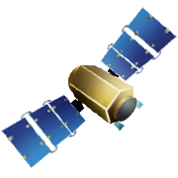
            - Satellites which orbit the Earth are of great use to society. Give some examples of everyday use of satellites.
            - The Hubble Space Telescope orbits the Earth and is used to look at far away stars and galaxies. Why does the Hubble Space Telescope get clearer images of space than telescopes on the surface of the Earth?

              - What part of the electromagnetic spectrum is used to communicate with satellites?
              - What speed does this radiation travel at?
            - At what height must a satellite be placed to ensure geostationary orbit?
            - State the position on the Earth’s surface above which all geostationary satellites orbit.
            - Why can some electromagnetic frequencies not be used when sending a signal from Earth to an orbiting satellite?
            - Copy and complete the paragraph for your notes.
Geostationary satellites orbit above the ______________. Geostationary satellites always remain at the _____________ point above the earth’s surface. Geostationary satellites orbit ___________ every 24 hours. Other satellites complete several ________________ every 24 hours. Other satellites operate at a ______________ height than Geostationary satellites.

            - . Copy and complete the table by filling in the gaps choosing from the following:
390km 28 days 20 000km 1000km
380 000km 90 minutes 12 hours 100 minutes

Type of Satellite | Approximate Height above the earth (km) | Time taken for 1 orbit | Notes
International Space Station |  |  | Zero gravity Lab
Polar Orbit |  |  | Monitoring Land use, Weather
GPS Fleet |  |  | Navigation aid
Geostationary | 36 000 | 24 hours | Worldwide communication Broadcasting TV
The Moon |  |  | Gives us the Earths tides.
- State the conclusion regarding the height of a satellite and the period of orbit.
- An aerial cannot pick up strong enough signals from a satellite. In order to bring radio signals to a focus a _________________ reflector must be used.
- In short; what do parabolic mirrors do to electromagnetic radiation coming from far away?
- By adding an appropriate shaped mirror complete the following diagram to show how signals are brought into focus.

- Parabolic mirrors are used in torches and headlamps draw a diagram to show how they help to form a beam of light that can be directed.
- Radio telescopes use large parabolic reflectors, what are they used for?
- High frequency radio signals are sent from the USA to Britain. The signals are received by a ground station in Cornwall.
(a) Describe what happens to the signal after it leaves the American ground station.
(b) Weather forecasters on television show us detailed pictures of rain clouds over Britain. Explain how this kind of information is gathered?
24. An army unit on military exercise at the Earth's equator have positioned a satellite dish as shown.
During their stay they find there is no need to change the position of the dish, which is pointing vertically upward. Communications are good and are never interrupted.

  - Why is there no need to continually alter the position of the satellite dish?
  - What name is given to the type of satellite being used?
  - What is the purpose of the curved reflector behind the aerial?
- Why can radio waves not be used to carry television signals from America to Britain using land based transmitters and receivers?
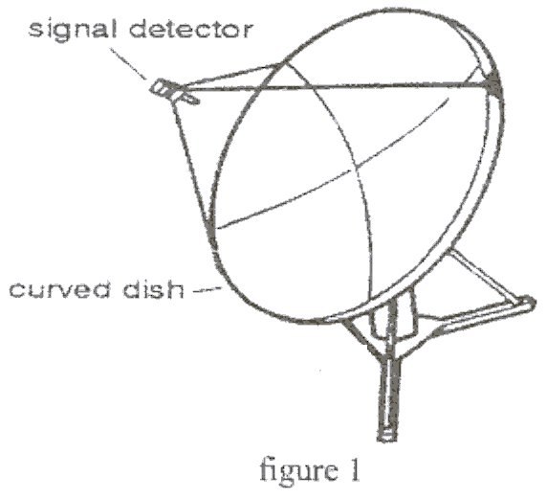
- A Satellite is used to relay the signal from America to Britain. The distance between the satellite and America is 55 000km which is the same as the distance between Britain and the satellite. Calculate the time taken for the signal to be sent from America to Britain.
- Mrs Brown looked out of her window and saw a satellite-receiving dish being installed on her neighbour's wall.
The installation engineers take great care to point the receiver towards a geostationary satellite.
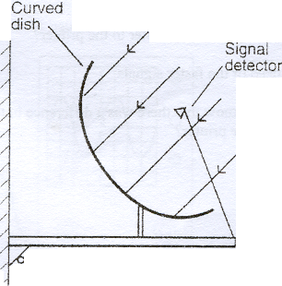
a) What is a satellite?
Wall
b) Explain what is meant by geostationary.
c) Figure 2 shows signals from the satellite coming towards the curved dish on the wall. Copy and complete figure 2 to show what happens to the signals after they hit the curved dish.
figure 2
d) How do the signals get from the receiving dish to the T.V. in the house?
e) It is recommended that people living northern Scotland should use a 85-centimetre diameter dish, while those living in south-east England only need a 55-centimetre diameter dish.
(i) State one advantage of having an 85 centimetre dish rather than a 55 centimetre dish.
(ii) What does this suggest about the satellite signals received in northern Scotland.

Tutorial Problems on Space Exploration and Specific Heat
- What is a satellite?
- What is a geostationary orbit?
- Explain the difference between an natural satellite and an artificial satellite.
- What is a Galaxy?
- What is a Star?
- A large telescope array uses many curved reflecting dishes to receive signals from space.
- What parts of the em spectrum are detected using large telescope arrays?
- Show by means of a diagram how the em rays are received.
- Explain, using a diagram how a curved reflector is used to transmit satellite TV images from a geostationary satellite to Britain.
- How can a curved reflector be used to create a “solar cooker”?
- There have been many technological advances due to space exploration, including infrared ear thermometers, scratch resistant lenses, high performance solar cells, freeze drying, robotic surgery etc. Pick any two technologies and research why they were developed for space and explain how they are benefiting the human race.
- A satellite orbiting the Earth transmits radio signals to a receiver. The signals take a time of 150 ms to reach the receiver. What is the distance between the satellite and the receiver?
- Explain what causes items of “space junk” to burn up on entry into the Earth’s atmosphere.
- Copy and complete the following sentence by selecting the correct words.
Compared to infrared radiation, X-rays have a longer/shorter wavelength which means they have a higher/lower frequency.

Tutorial Problems for Space Exploration and Energy
- A multistage rocket jettisons its third stage fuel tank when it is empty. The fuel tank is made of aluminium and has a mass of 4 000 kg. (specific heat capacity of aluminium is 900 J/kgºC)
  - Calculate the kinetic energy lost by the fuel tank as it slows down from 5 000 ms⁻¹ to 1 000 ms⁻¹ during its journey through the atmosphere.
  - How much heat energy is produced?
  - Calculate the rise in temperature of the fuel tank.
- The space shuttle Columbia re-entered the Earth’s atmosphere at a speed of 8000 ms⁻¹ and was slowed down by friction to a speed 200 ms⁻¹. The shuttle has a mass of 2 x10⁶ kg.
  - How much kinetic energy did the shuttle lose?
  - How much heat energy was produced during this process?
- A space shuttle of mass 2 x 10⁶ kg was travelling with a speed of 9 000 ms⁻¹ as it entered the Earth’s atmosphere. The speed of the shuttle dropped to 100 ms⁻¹ at touch down, at which point the brakes were applied, bringing the shuttle to rest.0
  - Explain why the speed of the shuttle decreased from 9 000 ms⁻¹ to 100 ms⁻¹ before the brakes were applied.
  - How much kinetic energy did the shuttle lose before the brakes were applied?
  - How much heat energy was created as the shuttle speed dropped from 9000 ms⁻¹ to 100 ms⁻¹?
  - The shuttle was covered with special heat-resistant tiles. Why was this necessary?
  - The specific heat capacity of the heat-resistant material used in the tiles is 35 700 J/kg⁰C. The temperature of the tiles should increase by no more than 1300 ⁰C during re-entry.
    - What mass of tiles would be required to absorb all of the heat energy produced?
    - Explain why in practice the mass of the tiles was less than calculated in part (e).
    - How much work was done by the brakes to bring the shuttle to rest?
- The nose section of the shuttle is covered with 250 kg of heat resistant tiles which experience a rise in temperature of 1400 ºC during the shuttle’s journey back through the Earth’s atmosphere. The shuttle is slowed from 10 000 ms⁻¹ to 100 ms⁻¹ during this part of the journey .
v = 10 000 m/s
shuttle enters Earth’s
atmosphere
v = 100 m/s

    - How much kinetic energy does the nose of the shuttle lose?
    - How much heat energy is produced at the nose during re-entry?
    - Calculate the specific heat capacity of the material used to make the nose tiles.

Space Exploration

Success Criteria
 | 7.1 | I have a basic understanding of the Universe https://map.gsfc.nasa.gov/universe/uni_life.html
 | 7.2 | I can use the following terms correctly and in context: planet, dwarf planet, moon, Sun, asteroid, solar system, star, exoplanet, galaxy, universe.
 | 7.3 | I am aware of the benefits of satellites: for example for GPS, weather forecasting, communications, scientific discovery and space exploration (for example Hubble telescope, ISS).
 | 7.4 | I know that geostationary satellites have a period of 24 hours and orbit at an altitude of 36 000 km above the equator on the Earth’s surface.
 | 7.5 | I know that the period of a satellite in a high altitude orbit is greater than the period of a satellite in a lower altitude orbit.
 | 7.6 | I am aware of the challenges of space travel.
 | 7.7 | I am aware of potential space travel across large distances by the possible solution of attaining high velocity by using ion drive (producing a small unbalanced force over an extended period of time)
 | 7.8 | I have a basic awareness that travelling large distances through space using a ‘catapult’ from a fast moving asteroid, moon or planet might be possible.
 | 7.9 | I have a basic awareness of how astronauts manoeuvre a spacecraft in a zero friction environment, possibly to dock with the ISS
 | 7.10 | I have a basic awareness of maintaining sufficient energy to operate life support systems in a spacecraft, with the possible solution of using solar cells with area that varies with distance from the Sun
 | 7.11 | I can describe the risks associated with manned space exploration such as fuel load on take-off, potential exposure to radiation, pressure differential and re-entry through an atmosphere.
 | 7.12 | I have knowledge of Newton’s second and third laws and their application to space travel, rocket launch and landing.
 | 7.13 | I can use W=mg to solve problems involving weight, mass and gravitational field strength, in different locations in the universe.

Learning intention Cosmology
- Use of the term ‘light year’ and conversion between light years and metres.
- Basic description of the ‘Big Bang’ theory of the origin of the universe.
- Knowledge of the approximate estimated age of the universe.
- Awareness of the use of the whole electromagnetic spectrum in obtaining information about astronomical objects.
- Identification of continuous and line spectra.
- Use of spectral data for known elements, to identify the elements present in stars.

8.1 light years
The Universe is massive, so big it is pretty much impossible to really imagine how big it is! It is estimated that the Universe is at least 9.2 x 1026 metres wide. This number is too large to really comprehend, indeed all distances in the Universe are huge. The Earth is approximately 150 million kilometres away from the Sun and approximately 39.9 x 10¹² km away from Proxima Centauri (the nearest star to our Solar system). These numbers are just too big so astronomers use a longer standard unit of distance – The Light Year.
Light does not travel at an infinite speed. It takes time to travel. It is so fast that we do not usually notice, although out in space the distances involved are so big that light takes a reasonable amount of time to reach us.
Light from our Sun takes approximately eight minutes to reach us.
Given that it takes 8 minutes for light to get from the sun, how far is it away is it from the Earth?
8×60 = number of seconds in minutes
480s =
Each second light travels 3×10⁸m
v× t = d
3×10⁸ × 480 = d
d = 1.44×10¹¹m

Astronomical data from observations of galaxies in space involve extremely large distances. The light year is a unit of distance used in astronomy, and it is defined as the distance that light travels in one year.
How far does light travel in one year?
1 year = 365days
365days = 8760 hours
8760×60×60 = 31536000s in one year
Light travels 300 million metres in one second. (speed of light in a vacuum is 3.0 ×10⁸ ms⁻¹). In one year it will cover a distance of 9.46×10¹⁵ metres.
After the Sun, the nearest star to us is Proxima Centauri which is 4.2 light years from Earth. One light year (distance) can be calculated as follows:
distance = speed × time
distance = 3.0 ×10⁸ × (seconds in one year)
distance =3.0 ×10⁸ × (60 × 60 ×24 ×365)
distance = 9.46×10¹⁵ m
$So 4.2 light years = 9.46×{10}^{15}×4.2=4×{10}^{16}$m
Source | Time taken for light  to reach us | Distance (m) | Working
Moon | 1.2 s | 3.6 ×10⁸ | 1.2 ×3×10⁸
Sun | 8 min | 1.44 × 10¹¹ | 480 × 3 ×10⁸
Next nearest Star | 4.3 y | 4.07 ×10¹⁶ | 4.3 × 9.46 ×10¹⁵
Other side of galaxy | 100 000 y | 9.46 ×10²⁰ | 100 000 × 9.46 ×10¹⁵
Andromeda galaxy | 2 200 000 y | 2.08 ×10²² | 2 200 000× 9.46 ×10¹⁵

NB When we look at the sky we are looking into the past e.g. our nearest star. If we looking at our nearest star we are seeing what happened 4.3 years ago.
REMEMBER LIGHT YEAR IS A DISTANCE
1 LIGHT YEAR IS 9·46 × 10¹⁵ m

Origin of the Known Universe
Our current understanding of the origin of the Universe is based on the Big Bang model. The model proposes that approximately 13.8 billion years ago, the Universe came into existence as a singularity and rapidly expanded from an extremely hot dense state to what exists today. It is still unclear why this happened or what a singularity actually is, but we do know that the Universe is still expanding at an increasing rate

Evidence for the Big Bang Model
If the start of the Universe was so hot, where has all that energy gone? The Big Bang theory predicts that as the Universe expanded, it cooled. Cosmic Microwave Background Radiation has been detected in space as evidence of this cooling. The average temperature of the Universe is currently around 2.7K or -270.5 ºC.
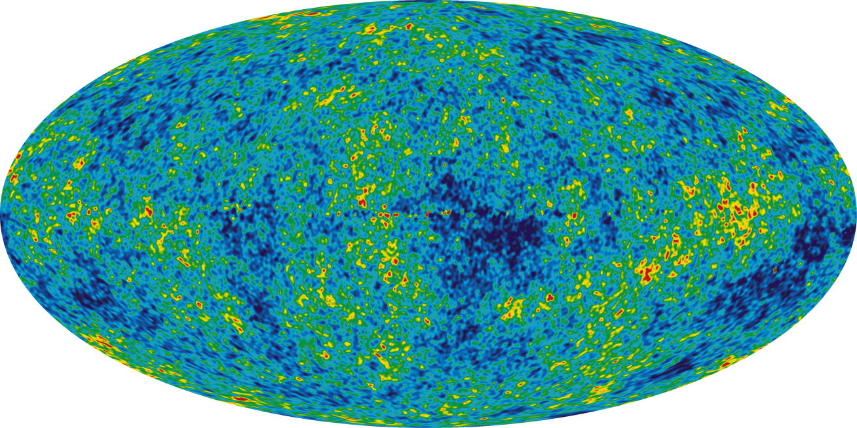
Cosmic Microwave Background Radiation, gathered from 9 years of WMAP data
Observations of distant stars, show what is called a red shift in their colour spectrum. This red shift in galaxies is evidence the galaxies are moving away from us, indicating that they are moving further away from a single point when the Big Bang occurred. This is further covered in Higher.

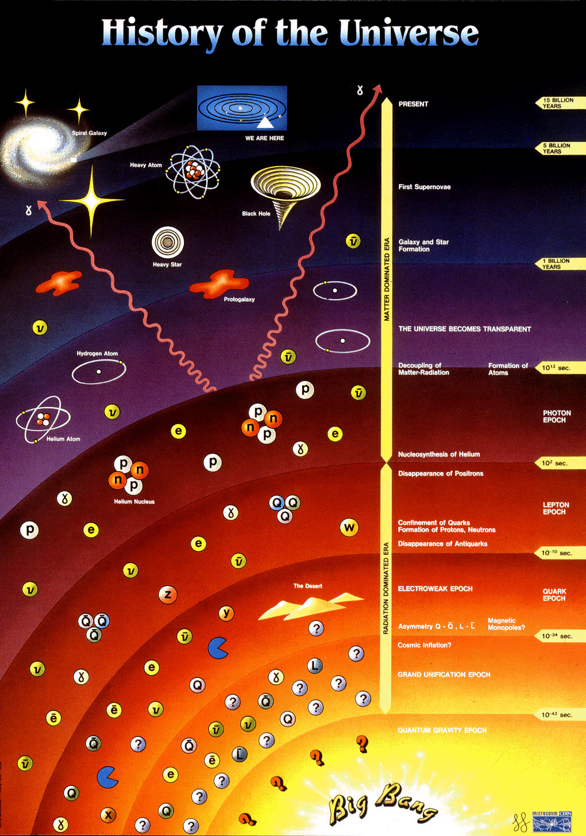
http://eliotche.com/wp-content/uploads/2009/09/history-of-the-universe.gif

Electromagnetic Spectrum & Cosmology
The electromagnetic spectrum consists of a group of radiations that all travel at the speed of light, 3x10⁸ms⁻¹. In the middle of the EM spectrum is the visible spectrum consisting of a range of different colours of light:
- Red
- Orange
- Yellow
- Green
- Blue
- Indigo
- Violet
There are many other parts of the EM spectrum we cannot see. The diagram below illustrates those parts.
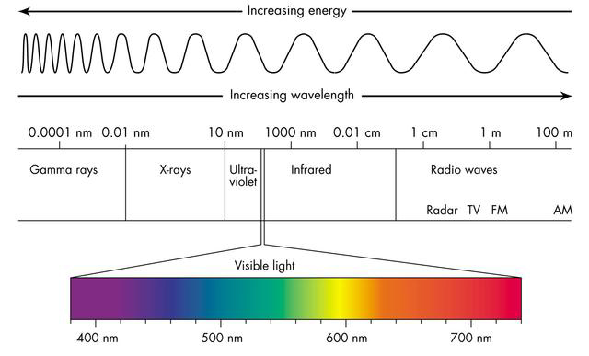
The electromagnetic spectrum
The electromagnetic spectrum ranges from long wavelength, low frequency waves (like radio waves which can be used for communication) to short wavelength, high frequency waves (like gamma rays which can be used for medical treatment). In the electromagnetic spectrum, waves with higher frequency have greater energy than lower frequency waves.
Because electromagnetic waves can travel through a vacuum and can carry information, they can be used to determine facts about deep space. Some telescopes detect radio waves instead of visible light and infrared imaging was used to gain the image of the CMB Radiation.
Range of EM spectrum | Information gained
Gamma rays & x rays | Extremely high energy particles, cosmic explosions, high speed collisions can be detected. Material moving at extremely high speeds emit these rays. Some emanate from supernovae remnants.
Ultra-violet | Very young massive stars, some very old stars, bright nebulae, white dwarfs stars, active galaxies and quasars shine brightly in the ultraviolet region.
Visible | Chemical composition of the stars, particles at the outer edges of nebula
Infra Red | Infrared observations are used to peer into star-forming regions and into the central areas of our galaxy. Cool stars and cold interstellar cloud are detected.
Radio Waves | The study of the radio universe brought us the first detection of the radiation left over from the Big Bang. Radio waves also bring us information about supernovae, quasars, pulsars, regions of gas between the stars, and interstellar molecules.

Spectra
White light is made up of a range of colours. These colours can be separated by splitting white light with a glass prism to obtain a spectrum. Each colour of light is refracted by different amounts, depending on its frequency - higher frequency colours are refracted more than lower frequency colours. Violet is refracted most, red light least.
A spectroscope uses a prism to display the colours which make up a source of light. This continuous spectrum is what would be seen from a source of white light.
Continuous Spectrum of White Light
Every element in the periodic table produces a unique line spectrum when heated, consisting of specific colours at specific wavelengths seen as thin bands.
Hydrogen Spectra
Helium Spectra
Sodium Spectra

Using Spectra
By analysing the line spectrum (or combination of line spectra) from sources of light, e.g. a star, it is possible to determine the chemical elements that make it up. Alternatively, line spectra can drawn as a negative white rectangle with black bands.
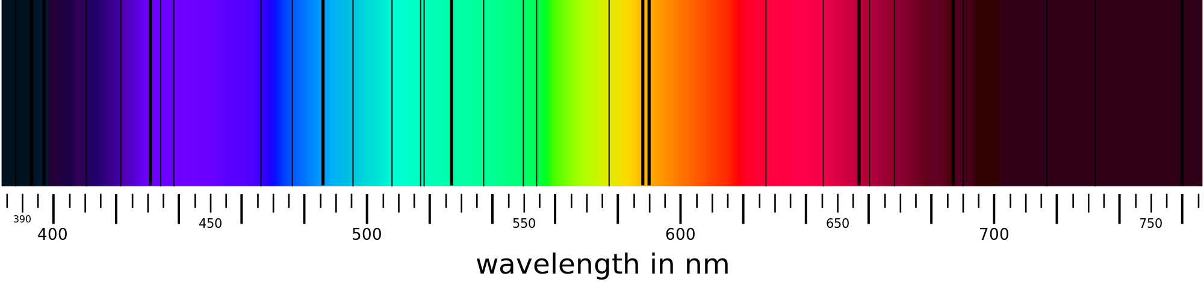
Line spectra from our Sun

Continuous and Line Spectra
Astronomers can find out information about stars from the light the star emits using an instrument called a spectroscope.
The spectroscope splits up the light to produce a spectrum.
There are two types of spectra:
- Continuous – produced by light from solids, liquids and gases at high pressure and at high temperature. Each colour in the spectrum has a different frequency and wavelength
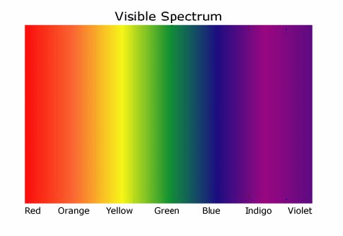
- Line – produced by hot gases at low pressure and gases which have an electric current passed through them. Each line in the spectrum corresponds to a particular frequency and wavelength.
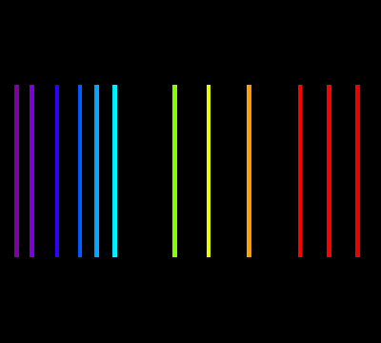
Line spectra are extremely useful for astronomers because every chemical element has its own unique spectrum (like D.N.A or fingerprints). This allows astronomers to identify elements present in distant stars.





You may find this easier to understand after looking at the example below.
H
He
N
O
C

tutorial
- Why is the underside of the space shuttle fitted with special heatproof tiles?
  - What is the purpose of the curved reflector?
  - Copy this diagram and complete it to show how the curved reflector in a transmitter helps produce a parallel beam of microwaves:

- The period of a geostationary satellite is 24 hours.
  - Explain what a geostationary satellite is.
  - In satellite communication, what is meant by the word period?
- How is a satellite’s period affected by its height above the Earth?
- Match the following term with a description. Write them together in your jotter. You don’t have to write the extra clue in brackets. e.g. The Universe is all of physical reality.
Term | Description
This is a natural satellite of a planet.
(Mars has two but Mercury and Venus have none).
 | A round body which orbits the Sun and has “cleared the neighbourhood” about its orbit. (There are 8 of these).
 | (Otherwise known as planetary systems). The set of all bound objects orbiting a star or star system.
 | The most massive object in a solar system. (It produces vast amounts of energy by nuclear fusion at some time in its life).
The Universe | ALL of physical reality.  (Nothing physical is outside this; no empty space, nothing).
 | A planet outside our solar system
A huge collection of stars.
(It has a supermassive black hole at its centre).
- Copy and complete the following table: (3)
Source | Time taken for light to reach us on Earth
Sun
Next nearest star
Farthest point in known universe

- What is the definition of a light year?
- A geostationary satellite orbits at 36,000 km above the Earth’s surface. Calculate the minimum time it would take to transmit at signal to it from the surface and to relay the signal to another point on the Earth’s surface.
- Give 2 uses of satellites and for each one indicate how they have affected our world.

Newton’s Laws of Motion ‒ Balanced and unbalanced forces
- Sir Isaac Newton’s First Law of Motion states:
“An object at rest will remain at rest unless acted on by an unbalanced force. An object in motion continues in motion with the same speed and in the same direction unless acted upon by an unbalanced force.”
(a) Explain how this law applies to a Rocket on the launch pad.
(b) Explain how this law applies to a snooker ball after it has been hit by a snooker cue.
- A force is applied to a rocket. State three ways in which the rocket may be affected.
- Sir Isaac Newton’s Second Law of Motion states:
“The acceleration of an object is dependent upon two variables – the net force acting upon the object and the mass of the object. The acceleration of an object depends directly upon the net force and inversely upon the mass of the object. The relationship between an object's mass m, its acceleration a, and the applied force F is:
F = m × a.
(a) Explain how this law predicts the acceleration of a rocket as the rocket fuel is used up.
(b) Explain how this law predicts the acceleration of a rocket when the engine provides a small force and a large force.
- Calculate the missing values in the table below.
Force | Mass | Acceleration
(a) | 10 kg | 2 m s–2
(b) | 0·5 kg | 200 m s–2
50 N | 5 kg | (c)
10 N | 1 kg | (d)
20 N | (e) | 4 m s–2
30 N | (f) | 0·6 m s–2
Work Done, Force and Distance
1. Give an equation which links work done, unbalanced force and distance
2. Calculate the missing values in the table below.
Work Done | Force | Distance
(a) | 10 N | 0·5 m
(b) | 100 N | 20 m
200 J | 5 N | (c)
10 J | 20 N | (d)
20 J | (e) | 2 m
2 kN | (f) | 20 m

Weight and Gravity
1. Three pupils are discussing their Physics lesson that day.
Pupil A says “Weight is measured in kilograms and is the downwards pull on a body due to gravity.”
Pupil B says “Weight is measured in newtons and is the downwards pull on a body due to gravity.”
Pupil C says “Mass is measured in kilograms and is the downwards pull on a body due to gravity.”

State which pupil made the correct statement and explain what mistakes the others made
- State the value of gravitational field strength on Earth?
- State an equation that can be used to convert the mass of a body into its weight.
- Complete the table below to convert between mass and weight for an object on Earth.
Mass | Weight
1 kg | (a)
0·5 kg | (b)
4 kg | (c)
(d) | 9·8 N
(e) | 49 N
(f) | 30 N
- A pupil says that her weight is 50 kg.
(a) What is wrong with her statement?
(b) Calculate the value of her weight on Earth.
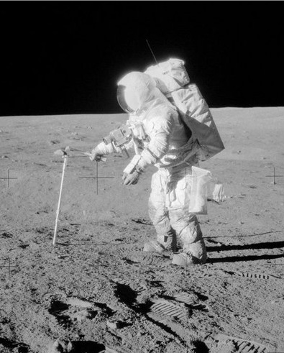
6. An astronaut has a hammer with a mass of 0·8 kg on the Moon
(a) Calculate the hammer’s weight on Earth where the value of g is 9·8 N kg–1.
(b) Calculate the hammer’s weight on the Moon where the value of g is 1·6 N kg–1.
7. A satellite orbits the earth at a height of 2000 kilometres where the value of gravitational field strength is 5·7 Nkg-1. Calculate the weight of the satellite if it has a mass of 900 kilograms.

8. The diagram opposite represents the gravitational field strength around the earth. The closer the field lines are together, the stronger the gravitational field.
(a) What happens to the strength of the gravitational field acting on a body as it moves away from the earth?
(b) An asteroid with a mass of 2·5 kg is moving towards the Earth. What will be its weight when the gravitational field from the Earth is 4·5 N kg–1?
9. (a) The Apollo Moon missions travelled from the Earth to the Moon. Describe what happened to the gravitational field strengths from the Earth and the Moon as the Apollo spaceship made that journey.
(b) A pupil says that at some point between the Earth and the Moon the gravitational fields will cancel each other out. Comment on this statement.

Extension questions
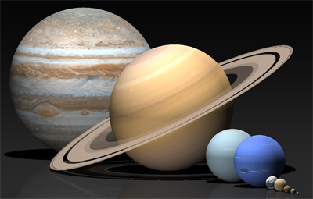
- The table below shows the gravitational field strength on a number of planets in our solar system. Use these values to answer the questions which follow.

Planet | Gravitational field strength (N kg–1)
Mercury | 3·7
Venus | 8·9
Earth | 9·8
Mars | 3·7
Jupiter | 26
Saturn | 11·2
Uranus | 9·0
Neptune | 11·3
(a) A vehicle exploring Mars has a mass of 174 kg. Calculate its weight on the Martian surface.
(b) What would be the weight of:
(i) a 60 kg person on Earth;
(ii) a 60 kg person on Jupiter?
(c) An object has a weight of 63 N on the surface of Uranus. Calculate its mass.
(d) Calculate the weight of a 5 kg object on the surface of Neptune.

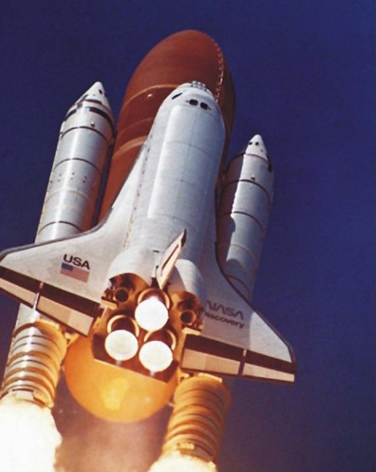
Newton’s Laws and Space Flight
- When the space shuttle took off it piggy backed on a large fuel tank. This supplied fuel for the three rocket motors. The shuttle also used two solid fuel rockets to boost its acceleration.
Information is given below about the rockets and the shuttle.
Thrust from each engine = 1800 kN
Thrust from each solid fuel booster rocket = 12 000 kN
Mass of fuel tank at lift off = 750 000 kg
Mass of solid booster rockets at lift off = 600 000 kg
Mass of shuttle at lift off = 110 000 kg
(a) Calculate the total mass of the shuttle at lift off including the two solid fuel booster rockets and the fuel tank.
(b) (i) Calculate the total thrust provided by the solid fuel booster rockets and the three main engines.
(ii) Calculate the weight of the shuttle at lift off.
(iii) Calculate the unbalanced force acting on the shuttle at lift off and hence its initial acceleration.
(c) The solid fuel booster rockets and large fuel tank are jettisoned when their fuel is used up. Explain why this is done.
(d) (i) Name two forces which act against the motion of the shuttle when it initially lifts off.
(ii) Explain why these two forces decrease as the shuttle gains altitude.
(iii) What effect has the decrease of these forces have on the acceleration of the shuttle?
- Sir Isaac Newton’s Third Law of Motion states:
“For every action force there is an equal and opposite reaction force.”
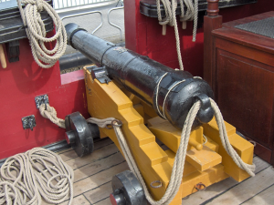
(a) When a cannon ball is fired from a cannon like the one opposite, the cannon moves backwards. Explain why this happens.
photo by Georges Jansoone
(b) If you blow up a balloon and release it, it will demonstrate Newton’s 3rd law. Explain how it does this.
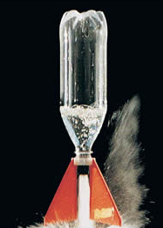
- A rocket can be made using a ‘Rokit’ kit and an empty plastic bottle. The bottle is half filled with water and then air pumped in through a tube connected to the bottom of the rocket. When the pressure inside is great enough the tube is forced out from the base of the rocket and the water ejected. Explain why the rocket is propelled upwards when this happens.

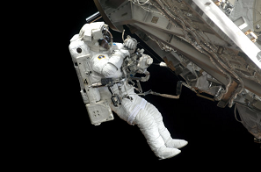
- (i) An astronaut is making a space walk outside a spaceship. He pushes against the side of the spaceship. Which of the following will happen?
- The astronaut moves backwards.
- The spaceship moves backwards.
- Both the astronaut and spaceship move backwards.
          - Give reasons for your answer.
Free Fall and Terminal Velocity
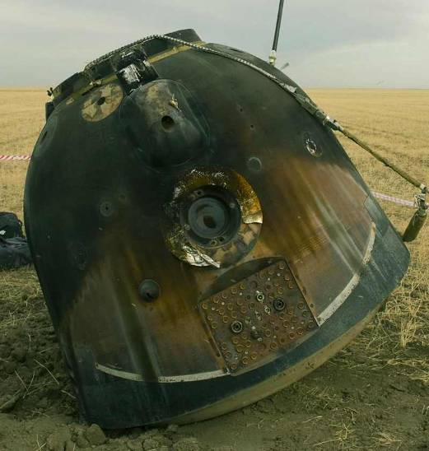
15. The picture opposite shows a Russian Soyuz space capsule after it has returned to Earth.
(a) The capsule’s outer shell is badly scorched. Explain why this happens.
(b) The capsule has a very high terminal velocity on entry to the Earth’s atmosphere. Explain what is meant by ‘terminal velocity’.
(c) How is the terminal velocity reduced to a value where the capsule can safely land on solid ground?
Extension Questions
- An RAF free-fall parachute display team control their rate of descent by altering their body position. In this way they can join up together as part of a display
The speed-time graph for a skydiver is shown below from the time he jumps out of the plane until he links up with other skydivers after 12 s.
0 1 2 3 4 5 6 7 8 9 10 11 12
time in s
80
60
40
20
100
speed in m s-1
X
90
70
50
30
10

(a) Calculate the acceleration of the skydiver between 0 s and 5 s.
(b) Calculate the height the skydiver fell during the first 12 s after jumping out of the plane.
(c) At point X the skydiver stretches out his arms and legs. Explain the effect this has on his motion.
(d) The skydiver has a mass of 65 kg. The diagram below shows the forces acting on him as he falls.
skydiver’s weight = 637 N
force of air resistance = 137 N

Calculate the acceleration of the skydiver.
Satellite motion
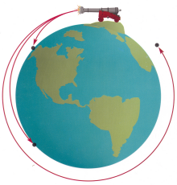
- Newton’s ‘thought experiment’ considers a cannonball fired from the top of a very high mountain.
Copyright 1995, Mosby-Year Book, Inc, Astronomy:Journey to the Cosmic Frontier
A
B
C

(a) What name is given to the motion of the cannonball as shown in A?
(b) The cannonball is fired with a higher horizontal speed.
(i) What change has the higher horizontal speed have on the vertical motion of the cannonball?
(ii) How does the curve of the Earth affect the time the cannonball is in the air?
(c) The horizontal speed of the cannonball is increased further still as shown in C.
(i) What name is given to this motion?
(ii) Explain why the cannonball now has this motion.
- A satellite is in orbit around the Earth.
(a) The satellite orbits the Earth once every 24 hours. What name is given to the time for one complete orbit?
(b) What will happen to the time for one complete orbit of the satellite if:
(i) the height of the orbit is increased;
(ii) the height of the orbit is decreased?
(c) (i) What name is given to a satellite which always remains above the same point on the Earth’s surface?
(ii) State one use for a satellite of this type.

Space exploration
- The Mars Rover was sent to Mars to explore its surface.
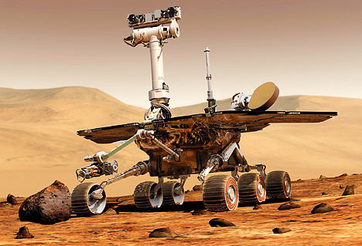

(a) Why was the Mars Rover sent on its mission?
(b) Describe any of the discoveries made by the Mars Rover which could only have been made by sending a vehicle to Mars.
(c) What is the next stage in the exploration of Mars?

- 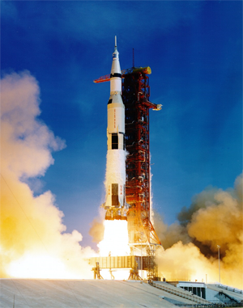Read the passage which follows and then answer the questions on the risks and benefits of space exploration.
For thousands of years, men and women have studied the stars and looked at what we call ‘space’. Only recently, in the last 60 years, have we had the means to actually go into space, send probes to distant planets and use ever more powerful telescopes. The exploration of space has brought great benefit along with costs and risks.

Benefits
Communication – modern communication uses satellites. Would you be without your mobile phone or Sky television?
Satellite navigation – this is not only used in cars but a whole range of industries including shipping, mining and aviation. The oil industry uses it to accurately position drilling rigs.
Jobs – there are thousands of people employed directly by the space industry but there are probably millions who are employed in spin off technology such as satellite communication including mobile phones and television.
Spin off technologies – Many applications that are developed for the space industry have been adopted widely and are now part of everyday life such as bar codes, miniaturised electronics, scratch resistant glasses, industrial materials, cordless power tools, water purification systems – even non-stick coatings for frying pans!
Mapping – satellites are able to accurately map the surface of the earth which aids important industries such as mining and can improve land use.
Weather monitoring –predicting weather patterns and anticipating dangerous hurricanes and tropical storms is now made more accurate and easier through using satellite imaging.
Satisfying our curiosity – finding out more about the Universe and our place in it has become possible through the advances in space exploration. In the past 50 years we have sent men to the Moon and probes to distant planets.

Risks and Costs
Pollution of space with debris from satellites and spacecraft. There is a risk that some debris may fall to Earth and reach the Earth’s surface. The risk of being hit is infinitely small though
Danger to life – several astronauts have lost their lives in both the Apollo Moon missions and shuttle missions.
Cost – the budget for space exploration is high. Could that money be better spent elsewhere?
20. Answer these questions on the passage above.
(a) How long ago did space exploration begin?
(b) How are modern communication systems dependent on space?
(c) Are more people employed in the space industry directly or in jobs which depend upon space ‘spin-offs’?
(d) How do modern maps of the earth depend upon the exploration of space?
(e) The furthest man has travelled so far into space is to the Moon.
(i) Find out some facts about the Apollo 11 mission⎯the first mission to the Moon.
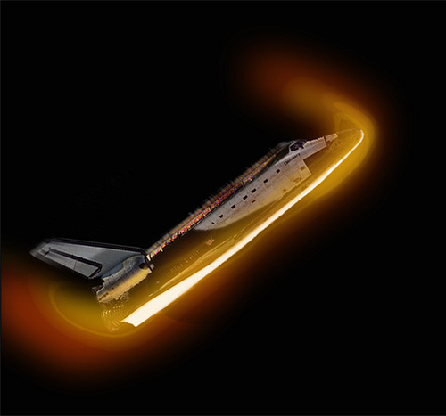
(ii) It is hoped to send a manned mission to the planet Mars. Investigate some of the difficulties of such a mission.

Re-entry and Heat
21. When the shuttle enters the atmosphere it does so at an angle. This helps to slow it down but generates a lot of heat.
(a) Why is so much heat generated when the shuttle enters the Earth’s atmosphere?
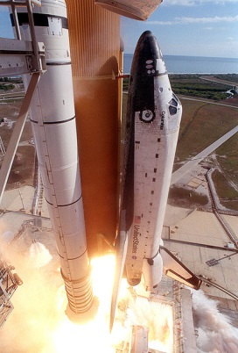
(b) How is the shuttle protected from the intense heat?
22. The space shuttle Columbia was destroyed when it broke up re-entering the Earth’s atmosphere on the return from its mission. A piece of foam is believed to have hit the tiles on the edge of one of the shuttle’s wings. Explain why this may have led to the disaster.
23. State a formula linking heat energy, latent heat and mass.
24. (a) What name is given to the latent heat when a solid turns into a liquid or vice versa?
(b) What name is given to the latent heat when a liquid turns into a gas or vice versa?
25. Calculate the missing values in the table below.
Heat Energy | Mass | Latent Heat
(a) | 2 kg | 11·2 × 105 J kg-1
(b) | 0·5 kg | 3·34 × 105 J kg-1
36 000 J | 0·01 | (c)
3·0 × 107 J | 30 kg | (d)
3·6 × 106 J | (e) | 1·8 × 105 J kg-1
113 000 J | (f) | 22·6 × 105 J kg-1
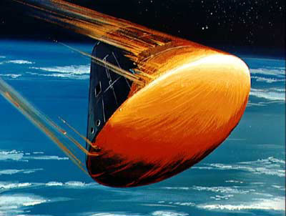
- The Apollo missions to the Moon during the 1970s required the astronauts to return to earth in a capsule like the one shown opposite. The heat shield points towards the Earth and heats up to very high temperatures where it undergoes a process called ablation (the heat shield melts and erodes away).
(a) What is required to change the state of an object from solid to liquid?
(b) Why does the capsule heat up so much during re-entry?
(c) Explain how the capsule is prevented from being destroyed during re-entry.
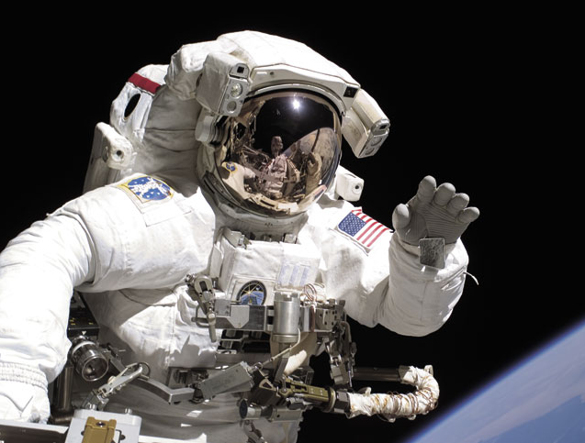
- When an astronaut is walking on the Moon or in space, he or she has to wear a special protective suit. Explain why this is necessary.
Extension Questions
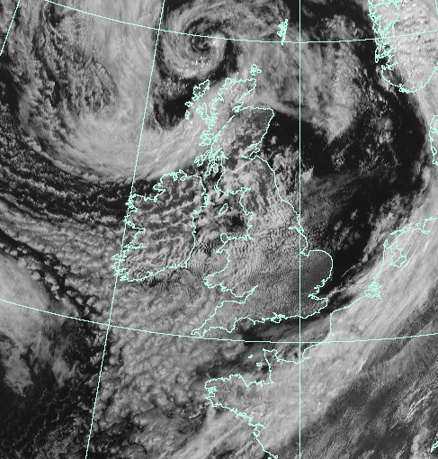
- Weather satellites are in orbit around the Earth. Pictures of the weather systems around the globe can be sent back to allow more accurate weather predictions to be made.
(a) Explain what is meant by the weather satellite being in orbit around the Earth.
(b) A satellite transmits an image of the same part of the Earth all the time. State whether this is a geostationary or orbiting satellite.
(c) A satellite is relocated to a higher orbit. How does this affect:
(i) The pull of gravity on the satellite?
(ii) The time for the satellite to make one orbit of the Earth?
- Read the passage which follows and then answer the questions on the dangers of outer space.
Outer space is a very unpleasant place to be. It is hard to get up there in the first place but once you are there, you have to be protected from all the dangers that are surround you. This is largely accomplished through wearing a specially designed space suit.
What would happen if you left a spacecraft and forgot to put your spacesuit on?
Space is a vacuum so there is no oxygen there. As a result you would lose consciousness very quickly. Worse will happen however, due to this lack of an atmosphere. As there is no air pressure acting on your body, dissolved gases in your body would come out of solution and your body fluids would start to boil. (fluids boil at lower temperatures at lower pressure). The boiling process also removes energy from the body which cools down very rapidly indeed.
Tissues in your body and critical organs such as the heart will swell up and expand due to the boiling fluids. Death would be very quick but agonisingly painful.
There would be extremes of temperature. Parts of your body in direct sunlight would experience very high temperatures whilst those in the shade would be extremely cold.
Your body would be bombarded by radiation and charged particles from the Sun. The Earth’s atmosphere filters most of the harmful radiation out before it reaches the Earth’s surface but there would be no protection in space.
If all of the above have not already killed you, there is a strong risk that you would be hit by tiny particles of dust or rock that are moving at very high speeds. You might even be hit by debris or ‘space junk’ from the many satellites and spacecraft that have been abandoned in space.
(a) Why would the fluids in your body ‘boil’ in outer space?
(b) (i) Calculate the kinetic energy of a speeding bullet which has a mass of 0·004 kg (4 g) travels at 600 m s-1.
(ii) Calculate the kinetic energy of a tiny particle space debris which has a mass of 1 × 10-5 kg (0·01 g) and is travelling at 10 × 103 m s-1. (10 km per s)
(iii) Explain why being hit by the space debris is more dangerous than being hit by the bullet.
(c) Spacesuits have circulating water to keep the body temperature constant. Why is this required.

Cosmology

The Universe
- Astronomers us the term a ‘light year’. Explain what is meant by the term a ‘light year’.
- Light travels at 3 × 108 m s–1. Calculate the distance that light will travel in one year.
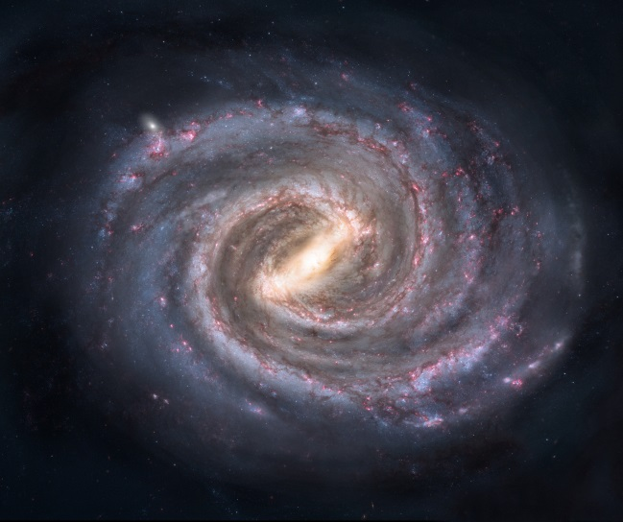
- Calculate the distance the Sun is from the Earth if it takes light 8·5 minutes to travel to the Earth.
The Milky Way
you are here
- The nearest star to our solar system is Alpha Centauri. Calculate how many light years away it is if it is 4 × 1016 m away.
- Our solar system lies within the galaxy called the Milky Way. The distance from Earth to the centre of the Milky Way is 2·84 × 1020 m. How many light years is Earth from the centre of our galaxy?
- Copy the following terms down then match them against their correct definitions.
Term | Definition
(a) Solar system - | a body revolving around a planet.
(b) Moon - | a body revolving around a star.
(c) Planet - | the star at the centre of our solar system.
(d) Sun - | a grouping of solar systems.
(e) Galaxy - | a ball of burning gas at the centre of a solar system.
(f) Universe - | a star and its associated planets.
(g) Star - | all the matter that we know of.
- The most popular theory about the origins of the Universe is the ‘Big Bang Theory’.
Describe what is meant by the Big Bang Theory and what evidence there is for it.

Telescopes and waves
- The electromagnetic spectrum is made up of a number of different types of wave. Match each of the waves below with the appropriate type of detector.
Wave | Detector
(a) Visible light - | Geiger counter, photographic film.
(b) X-rays - | aerial and radio receiver.
(c) Radio - | aerial and microwave receiver.
(d) Television - | photographic film.
(e) Gamma radiation - | IR camera or film.
(f) Infrared - | fluorescent material.
(g) Ultraviolet - | the eye or photographic film.
(h) Microwaves - | aerial and television receiver
- (a) The electromagnetic spectrum is shown below. Copy and complete the diagram to show the missing waves at A, B, C and D.
A
B
C
visible light
ultraviolet radiation
D
gamma radiation
TV
waves

(b) What is the speed of travel of waves from the electromagnetic spectrum when in a vacuum?
(c) (i) Which of the waves has the longest wavelength?
(ii) Which of the waves has the highest frequency?
39. (a) The illustration opposite shows a special type of telescope. Which part of the electromagnetic spectrum is it designed to detect?
(b) The telescope is designed to detect very weak signals. Describe one way in which its design helps to accomplish this.
(c) The Hubble telescope is in orbit around the Earth. Why does this allow it to obtain much better images than telescopes situated on the Earth’s surface?
40. (a) A diagram of a basic refracting telescope is shown below.
A
B
C

Match the letters, A, B and C, with the following labels:
eyepiece lens objective lens light-tight tube
(b) The diameter of the objective lens of the telescope is made larger. What effect has this on the image seen by the observer?
41. A ray of white light is directed into a glass prism as shown below.
white light
raybox
prism

(a) Describe what happens to the white light as it passes through the prism.
(b) (i) State the component colours of white light.
(ii) Which colour in the visible spectrum has the highest frequency?
(c) The light from a star can be analysed by astronomers by splitting it into its component wavelengths. A line spectrum is produced like the one shown below.

(i) State the difference between a line spectrum and a continuous spectrum.
(ii) What information can astronomers obtain about a star from the line spectrum?
42. The light from a distant star is analysed to produce the graph shown below.
intensity of visible light present in starlight
wavelength of light in m x 10–9
400 500 600 700

(a) What colour of visible light has a wavelength of:
(i) 400 x 10–9 m;
(ii) 700 x 10–9 m?
b) What information can be obtained about a star from the graph above?

EXTENSION QUESTIONS
43. A probe is sent to analyse the atmosphere surrounding a Moon orbiting Saturn. The line spectrum produced is shown below.

spectral lines from moons atmosphere

Use the spectral lines from the elements shown below to identify which are present in the atmosphere sampled.
helium
hydrogen
mercury
nitrogen

44. Read the passage below on a journey through space then answer the questions which follow.
The fastest speed that anything can travel, is at 3 × 108 m s–1. With our current technology, the fastest spaceships only travel at 11 000 m s–1. The Apollo Moon missions took about 3 days to travel from the Earth to the Moon as they only travelled at their maximum speed for a short time. Whilst light will take eight and a half minutes to reach the Earth from the Sun, a spaceship travelling from the Earth to the Sun would have to travel a distance of 1·5 × 1011 m which would take much, much longer. Not only would the journey take a long time, the spaceship would be exposed to many dangers. The level of ionising radiation would be very high, there would be a risk of being struck by tiny meteorites and there would be extremes of temperature—minus 180 °C in the shade and 115 °C in sunlight—and that is just near the Earth!
The Earth is part of our solar system which orbits the star in the middle—the Sun. The Sun is just one of many stars which are found in the galaxy of which we are part. The galaxy is called the Milky Way and contains 100 000 million other stars. The Milky Way consists of a spiral of stars and is about 1 × 1021 m wide.
The Milky Way is not the only galaxy there is. It is estimated there are hundreds of billions of galaxies. That means there are vast number of stars, some of which will have orbiting planets and some of these may also contain life. The Universe itself is probably about 93 billion light years but that’s only for what we can observe. Scientists have been able to calculate that the Universe is about 13 billion years old and it is constantly expanding. No one knows what lies beyond the edge of the Universe.
(a) What travels at a speed of 3 × 108 m s–1?
(b) If an Apollo space ship could travel at its maximum speed all the time, calculate how long it would take to reach the moon if it was 363 000 000 m away.
(c) Calculate the time it would take a spaceship travelling at 11 000 m s–1 to travel from the Earth to the Sun.
(d) What dangers would a spaceship be exposed to as it left the Earth?
(e) In which Galaxy is the Earth found?
(f) (i) What is meant by the term ‘a light year’?
(ii) How wide is the Milky Way?
(iii) Calculate the number of light years it would take light to travel from one side of the Milky Way to the other.
  - How wide is the observable universe?

Tutorial Problems on Cosmology
- What is a light year?
- How many metres are in a light year?
- Light from the Sun takes 8 minutes to reach earth.
    - How many years is eight minutes?
    - How far away is the sun (in metres)?
- The star “Sirius” is 8.146 x 10¹⁶ m from Earth. How far is this in light years?
- The dwarf planet Pluto is approximately 5.9 x 10¹² m away from Earth, how many light years is this?
- The nearest Galaxy to Earth is approximately 2.2 x 10⁶ light years away form Earth, how far is this in metres?
- To the nearest billion years, how old is the Universe?
- State what is meant by the term solar system.
- What is a planet?
- What is a galaxy?
- Radio waves emitted by galaxies are detected and used to provide images of the galaxies.
    - How does the wavelength of the radio waves compare with the wavelength of light?
    - Why are different kinds of telescope used to detect signals form space?
- Read the following:-
“Halley’s Comet is famous because it is visible to the naked eye, orbiting from beyond the planet Neptune and returning to the solar system on average once every 76 years.
Halley’s Comet last visited the inner solar system in 1986. It will return again in 2061.
Comets are made of ice mixed with frozen methane; substances very similar to those found on a moon called Miranda.
Comets can only survive very far away from the Sun. Most comets reside in the Oort Cloud which contains many billions of comets. The Oort Cloud reaches a quarter of the distance from the Sun to the next nearest star called Proxima Centauri.
The Oort Cloud is easily affected by the gravitational pull of the Milky Way galaxy which causes comets to move into new orbits that carry them closer to the Sun.”

Use information given in the passage to answer the following questions.
    - State the name of one object that orbits a planet.
    - State the name of one object that generates light.
    - State the name of the object furthest away from the Earth.
    - State the name of one object that orbits the Sun.

EXAM QUESTIONS
Int2 2015 Q16
- the diagram shows two rays of light incident on a curved reflector. the focal point, F, of the reflector is shown.
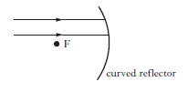

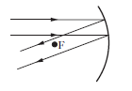
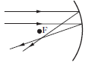
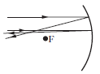
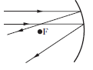
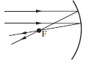
- Which of the following diagrams shows the paths of the rays of light after reflection?

Int2 2006 Q3
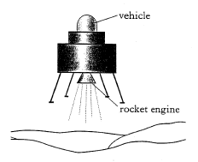
- A space vehicle of mass 20kg is falling vertically towards a planet. The gravitational field strength at this point is 3.5N/kg. The vehicle fires a rocket engine which applies a steady upward force of 660N to the vehicle. Initially, the vehicle will
- Move towards the surface, accelerating
- Move towards the surface at a steady speed
- Move towards the surface, decelerating
- Move away from the surface, accelerating
- Move away from the surface at steady speed.
Int2 2012 Q21
- A spacecraft returns to earth and passes through the atmosphere. the spacecraft has a heat shield of mass 931kg. during the journey through the Earth’s atmosphere the heat shield absorbs 1.25x10⁹ J of energy and its temperature rises by 1300°C. Using this information and the data sheet, identify the material from which the heat shield is made.
You must include a calculation as part of your answer.
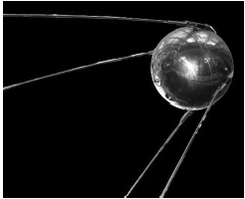
- Sputnik 1, the first man-made satellite was launched in 1957. it orbited the Earth at a speed of 8300ms⁻¹ and had a mass of 84kg.

- (i) Sputnik 1 orbited Earth in 100 minutes. Calculate the distance travelled in this time.
(ii) Although Sputnik 1 travelled at a constant speed in a circular orbit, it accelerated continuously.
Explain this statement.
- Sputnik 1 transmitted radio signals a distance of 800km to the surface of the earth.
Calculate the time taken for the signals to reach the Earth’s surface.
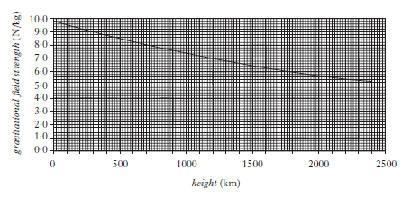
- The graph shows how the gravitational field strength varies with height above the surface of the Earth.

- Define the term gravitational field strength.
- What is the value of the gravitational field strength at a height of 800km?
- Calculate the weight of Sputnik 1 at this height.
int2 2011 Q22
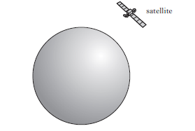
- a satellite moves in a circular orbit around a planet. the satellite travels at a constant speed whilst accelerating.

- (i) Define the term acceleration.
(ii) Explain how the satellite can be accelerating when it is travelling at a constant speed.
- At one particular point in its orbit the satellite fires two rockets. the forces exerted on the satellite by these rockets are shown on the diagram.
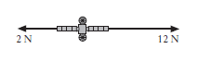

The satellite has a mass of 50kg. Calculate the resultant acceleration due to these forces.
int2 2010 Q23
- On the planet Mercury the surface temperature at night is -173°C. The surface temperature during the day is 307°C. A rock lying on the surface of the planet has a mass of 60kg.
- The rock absorbs 2.59 x10⁷ J of heat energy from the Sun during the day. Calculate the specific heat capacity of the rock.
- Heat is released at a steady rate of 1440 J/s at night.
Calculate the time taken for the rock to release 2.59 x10⁷ J of heat.
- Energy from these rocks could be used to heat a base on the surface of mercury. How many 60kg rocks would be needed to supply a 288kW heating system?
- using information from the data sheet, would it be easier, the same or more difficult to lift rocks on Mercruy compared to Earth? You must explain your answer.
Int2 2010 Q28
- A satellite sends microwaves to a ground station on Earth.

- The microwaves have a wavelength of 60mm.
- Calculate the frequency of th waves.
- Determine the period of the waves.
- The satellite sends radio waves along with the microwaves to the ground station. Will the radio waves be received by the ground station before, after or at the same time as the microwaves?
Explain you answer.
- When the microwaves reach the ground station they are received by a curved reflector. Explain why a curved reflector is used. Your answer may include a diagram.
Int2 2004 Q28
- Radio waves are transmitted between New York and Edinburgh.
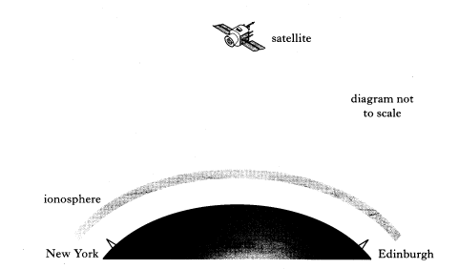
The ionosphere is a layer of charged particles above the Earth.
Radio waves with frequencies below 40 MHz are reflected by the ionosphere.
Radio waves with frequencies above 40 MHz pass through the ionosphere.
- What is transferred by a radio wave?
- An aerial in New York transmits and receives signals of the following frequencies.
300 kHz 3MHz 30MHz 300MHz
State which of these frequencies could be used for communication with Edinburgh by satellite. You must give a reason for your answer.
- a satellite is 36 000 km from both transmitting and receiving stations in New York and Edinburgh. Calculate the minimum time for a signal to pass from New York to Edinburgh using the satellite.
Int2 2003 Q22
- A spacecraft travels through space between planet X and planet Y. Information on these planets is shown in the table below.
 | Planet X | Planet Y
Gravitational field strength on surface | 8.4 N/kg | 13 N/kg
Surface temperature | 17.0⁰C | 9.0⁰C
Atmosphere | No | Yes
Period of rotation | 48 hours | 17 hours

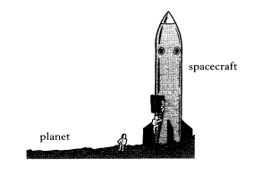
The spacecraft has a total mass of 2.5x10⁶ kg.
The spacecraft engines produce a total force of 3.8 x10⁷ N.

- The spacecraft is initially on planet X.
- Calculate the weight o the spacecraft when it is on the surface of planet X.
- Sketch a diagram showing forces acting on the spacecraft just as it lifts off from planet X. You must name these forces and show their directions.
- Calculate the accelerating of the spacecraft as it lifts off from planet X.
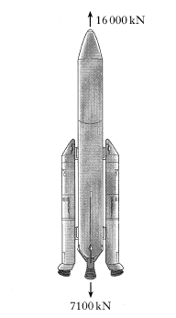
- On another occasion, the spacecraft lifts off from planet Y. the mass and engine force of the spacecraft are the same as before. Is the acceleration as it lifts off from planet Y less than, more than or equal to the acceleration as it lifts off from planet X?
You must give a reason for your answer using information contained in the table.
- A spacecraft consisting of a rocket and a lunar probe is launched from the Earth to the Moon.
- At lift-off from the Earth, the spacecraft has a weight of 7100 kN. The thrust from the engines is 16 000 kN.
- (i) Calculate the unbalances force acting on the spacecraft.
- Calculate the mass of the spacecraft.
- Calculate the initial acceleration of the spacecraft.

EXAM QUESTIONS
SG Credit
13 (a) | The navigation satellite shown in figure 1 moves in a circular orbit above the Earth’s atmosphere
Explain why:
- the satellite does not move in a straight line into space;
- the satellite does not fall straight down to Earth
 | Many satellites do not have circular orbits but travel as shown in figure 2.
The Earth’s atmosphere gradually becomes thinner until at a height of 1000 km above the surface there is almost no air.
Study the information given in the table below.
Satellite | Minimum height above Earth (km) | Maximum height above Earth (km) | Life-time in orbit
“Spy” | 120 | 450 | 2 weeks
Sputnik 1 | 225 | 945 | 3 months
Explorer 1 | 360 | 2550 | 12 years
Navigation | 1110 | 110 | 1000 years

 | Explain why the “spy” satellite has such a short life-time in orbit while the navigation satellite is expected to remain in orbit much longer.
(c ) | A satellite of mass 80 kg orbits the Earth at a speed of 4000 ms-1. The satellite is constructed mainly from a metal alloy of specific heat capacity 320 Jkg⁻¹°C⁻¹
 | - Calculate the kinetic energy of the satellite when in orbit.
 | - Calculate the change in temperature of the satellite which might be expected if all its kinetic energy is rapidly converted to heat energy as the satellite comes back to Earth
 | - Suggest why in practice the change in temperature you have calculated in part (ii) will not be obtained

SG Credit 1993
1 | Short wave television signals can travel only in a straight line from the transmitting aerial to the receiver. The diagram below shows a transmitter in New York and a receiver in London
(a) | Explain why UHF (ultra-high frequency) television signals cannot be sent directly from New York to London.
(b) | Describe how UHF television signals are sent from New York to London
(c) | What is the wavelength of a UHF television signal which is transmitted at a frequency of 625 MHz?

SG Credit 1993
14 (a) |  | The graph below shows the value of the gravitation field strength at various heights above the Earth’s surface.
 |  | An astronaut of mass 80 kg orbits in a capsule at a height of 3 000 km.
 |  | - What is the gravitational field strength at this height?
 |  | - Calculate the astronaut’s weight at this height.
 |  | - What is the mass of the astronaut when he returns to Earth?
(b) |  | The sketch graph below shows how the speed of the space capsule changes with time during part of its journey back to Earth
 |  | - How far did the capsule travel in the 100 m shown?
 |  | - Calculate the deceleration of the capsule before it reaches a constant speed.
(c ) |  | During re-entry the astronaut sits in the capsule as shown below.
 |  | Sitting in this position, the astronaut feels as if he is being pushed against the back of his seat during re-entry. Using Newton’s Laws, explain why he experiences this feeling
(d) |  | During re-entry some of the heat shield on the capsule melts. Explain why this helps to keep the capsule cool.
 | SG Credit 1994
 | Q11 (a) |  | A space shuttle of mass 2·1×10⁶ kg lifts off from Earth. At lift-off, the force on the shuttle due to air resistance is zero.
 |  |  | - Calculate the weight of the shuttle at lift-off.
 |  |  | - Copy the diagram, label the forces acting on the shuttle at lift-off and show their direction.
 | (b ) |  | - Explain why the speed of a spacecraft, travelling in outer space, is constant although the engines are switched off.
 |  |  | - A space shuttle is used to launch a satellite. The period of the orbit is 12 hours. State what would happen to the height of the orbit to make it geostationary.
 | ( c) |  | The satellite has solar panels, as shown below, which use solar power to produce electricity.
 |  |  | The solar power received on each square metre of panel is 1.5 kW. The total area of the panels is 12 m² and their efficiency is 10%. Calculate the electrical power of the panels
 | (c ) |  | During re-entry to the Earth’s atmosphere the temperature of the heat shield of the of the shuttle rises by 1300 °C. The heat shield has a mass of 3500 kg and gains 4·7 × 10⁹J.  - Calculate the specific heat capacity of the heat shield
 |  |  | - Using the Data Sheet, identify the material from which the shield is made.

1994 SG Credit
11 (a) | The Hubble telescope was put in orbit around the Earth in 1990.
 | - The telescope uses a curved mirror to collect light rays from a star as shown below.
 | Copy and complete the diagram to show what happens to the rays of light as they reach the mirror.
12 (b) | - The telescope has detectors for various radiations. Name a possible detector for ultraviolet radiation
 | - The spectral lines of radiation from a distant star are shown in figure 1. Figure 2 shows the spectral lines from a number of elements
Q14 | 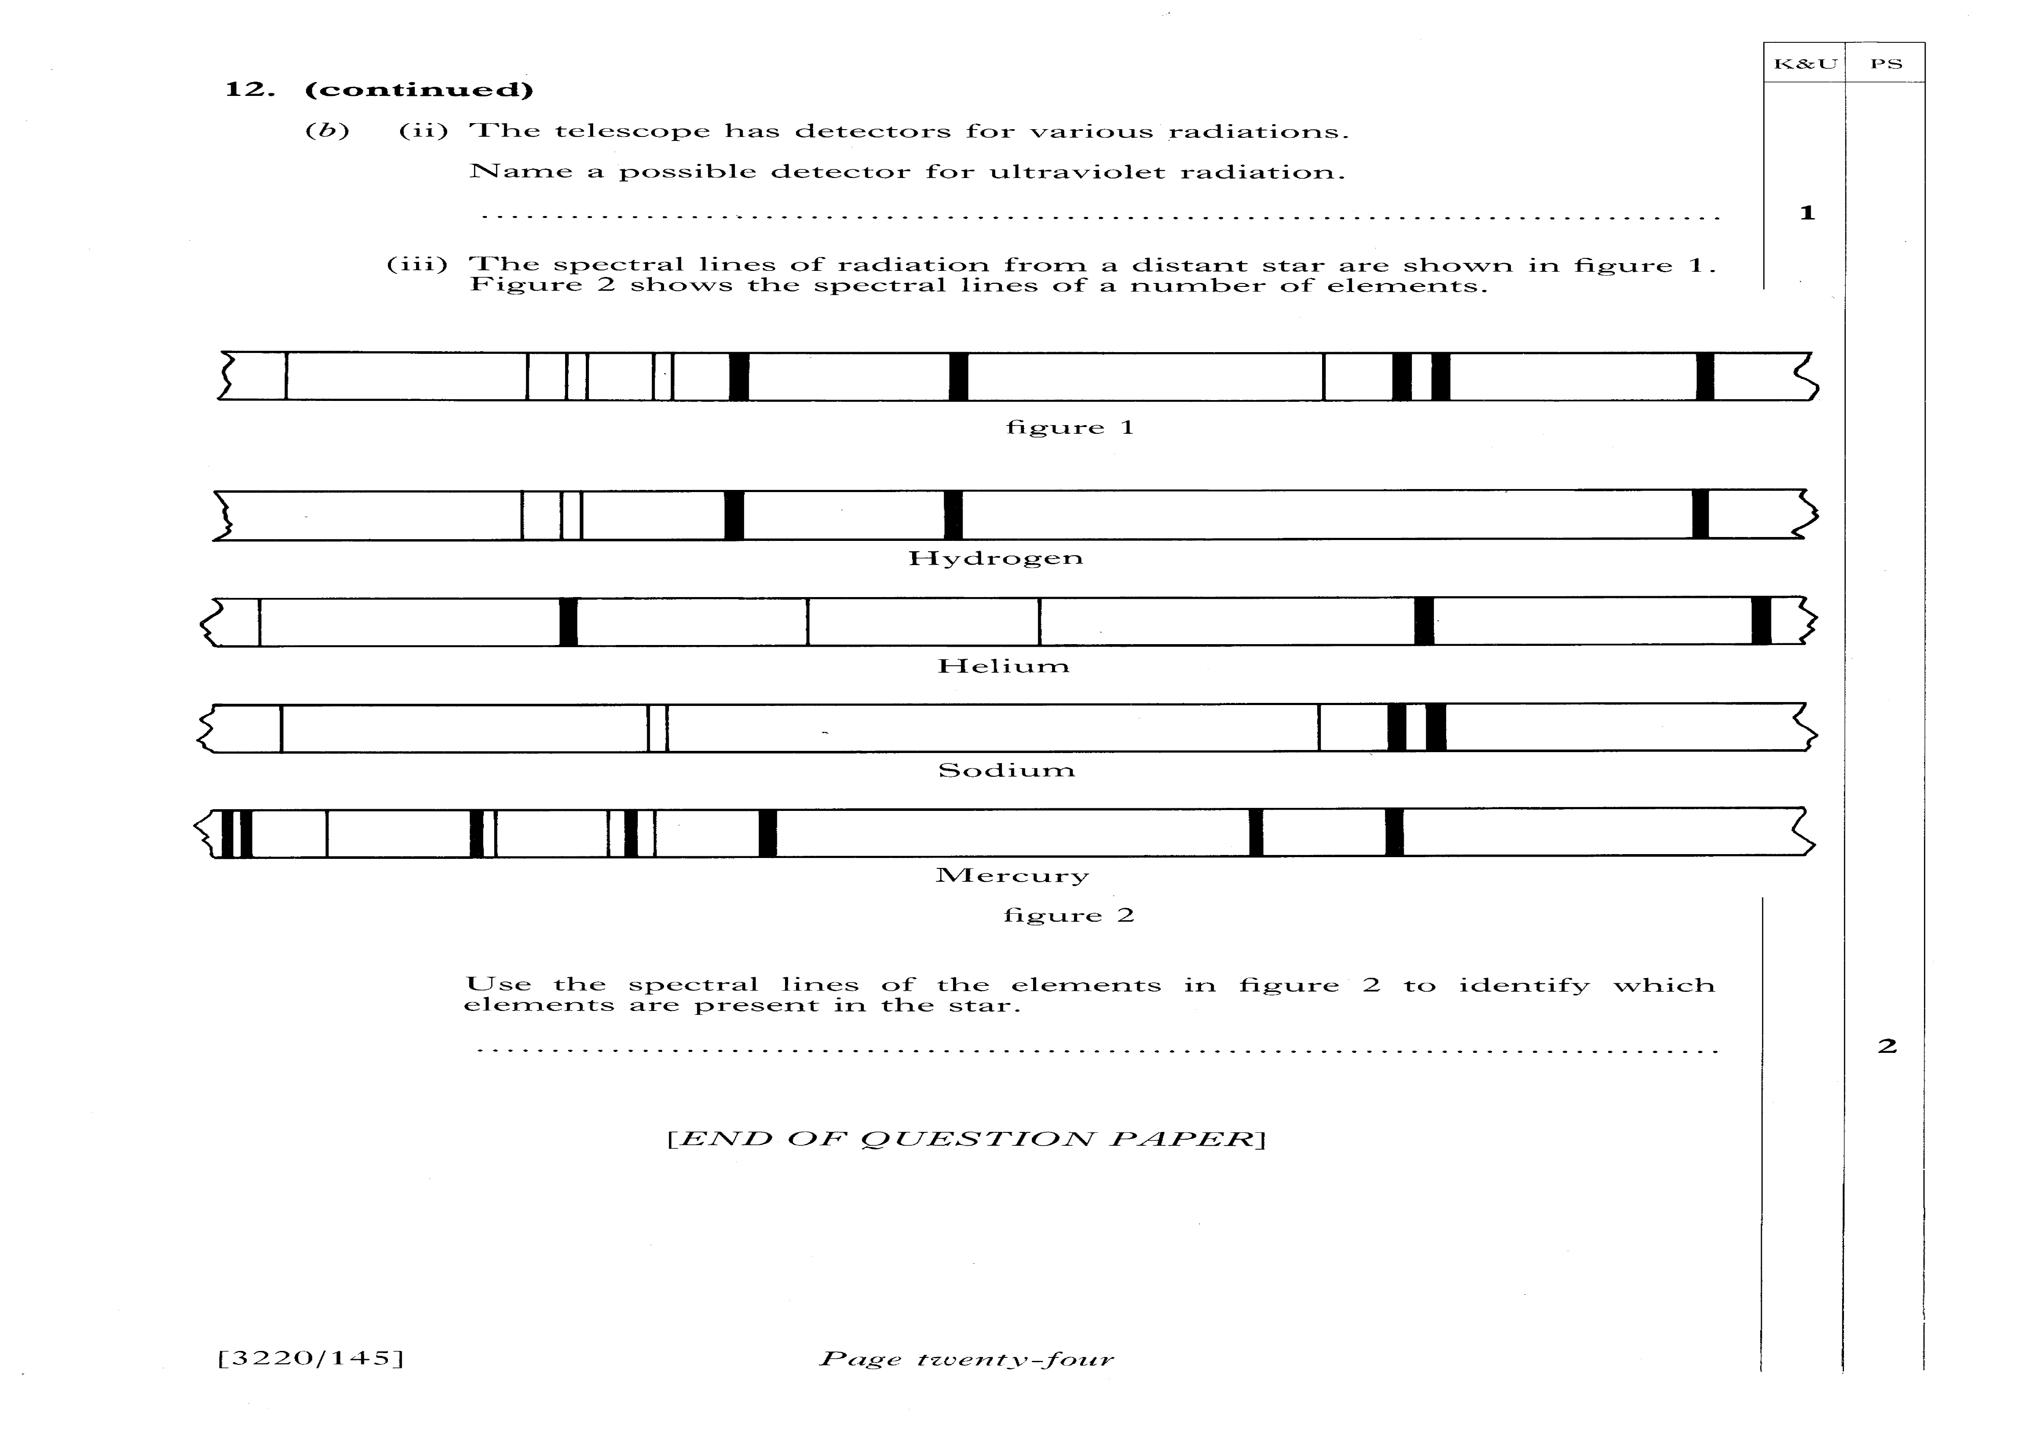
 | Use the spectral lines of the elements in figure 2 to identify which elements are present in the star.
SG Credit 1995
13 (a) | A telescope may be used to look at distant objects such as stars. A simple refracting telescope is shown below.
 | - A pupil replaces the objective lens in the telescope by one of the identical focal length but having a smaller diameter as shown below
 | Explain the effect this has on the image of the object seen through the telescope
SG Credit 1995
13 (a) |  | The radiation emitted by a star forms part of the electromagnetic spectrum. Part of the electromagnetic spectrum is show below. Two radiations P and Q have not been named
- Name each of the radiations P and Q
Radiation P: ______________________________
Radiation Q: _______________________________
(II) |  | One type of radiation in the electromagnetic spectrum has a wavelength of 300 m. Using information from the data sheet and the electromagnetic spectrum above, determine the name of this radiation. You must show clearly the calculation you used to arrive at your conclusion

Other exam questions to try
1997 SG Credit Q15 and 16 | Intermediate 2 2015 Q16
1998 SG Credit Q14, 15 | Intermediate 2 2014 Q23c
1999 SG Credit Q12 | Intermediate 2 2012 Q21
2000 SG Credit Q1, 12 | Intermediate 2 2011 Q2
2001 SG Credit Q13 | Intermediate 2 2010 Q23, 28
2002 SG Credit Q2, 13 | Intermediate 2 2009 Q15
2004 SG Credit Q13, 14, 15 | Intermediate 2 2006 Q3,17
2005 SG Credit Q15 | Intermediate 2 2004 Q28

Success Criteria

Cosmology
 | 8.1 | I can correctly use the term light year
 | 8.2 | I can convert between light years and metres
 | 8.3 | I can give a basic description of the Big Bang theory of the origin of the Universe.
 | 8.4 | I know that the estimated age of the Universe is approximately 14 billion years or 13.8 billion years old.
 | 8.5 | I can describe how different parts of the electromagnetic spectrum are used to obtain information about astronomical objects.
 | 8.6 | I can identify continuous and line spectra.
 | 8.7 | I can use spectral data for known elements, to identify the elements present in stars.

Glossary of Terms
Term | Definition
acceleration | The rate of change of velocity, measured in metres per second squared. Acceleration = change in velocity/time taken
average speed | Average speed = distance ÷ time over a known distance and time. For example, the average speed of the bus between Edinburgh and Glasgow was 9·0 m s⁻¹.
balanced force | When the total force in opposite directions are equal in magnitude. For example, with a thrust of 15 N and a frictional force of 15 N, the body experiences balanced forces.
bearing | A direction given where due North is 000 and through a circle clockwise. Eg: Due East is 090, due South is 180 and due West is 270.
constant speed | When the speed of body does not change. eg The car was travelling at a constant speed of 30 m s-1.
curvature | The slight bending of horizon due to the roundness of the Earth, more noticeable at higher altitudes, e.g. the curvature of the Earth can be seen from the International Space Station
deceleration | Slowing down or negative acceleration, e.g. the car slowed down with a deceleration of 2 m s-1
direction | Information to give the direction of travel or the direction of a force
displacement | Quantity describing the distance from the start of the journey to the end in a straight line with a described direction, eg the hiker ended up at the hostel 50km due north of his original position.
distance | Numerical description of how far apart two things are. For example, the distance from Edinburgh to Glasgow is approximately 50 miles.
element | A substance made of one type of atom only
energy | The capacity of a system to do work. For example, electrical work. Measured in Joules (J). Eg: A signal with 0.002 J of electrical energy was received at the aerial.
final speed | The speed of a body after accelerating, e.g. after an acceleration for 5 seconds, the car's final speed was 20 ms-1
force | A push or a pull. The unit of force is the newton (N)
freefall | Falling freely in space/air, not attached to anything; e.g. the skydiver was in freefall after leaving the plane.
frequency | The number of waves produced each second. The unit of frequency is hertz, (Hz)
galaxy | A cluster of billions of stars held together by gravity
geostationary | A satellite, orbiting a planet, at the same rate as the planet. A geostationary satellite orbiting Earth has a period of 24 hours
gravitational field strength | Force per unit mass. Measured in newtons per kg
horizontal | Parallel to the ground
infrared | Radiation which transfers heat energy. Part of the electromagnetic spectrum with a longer wavelength than light waves but a shorter wavelength than radio waves.
initial speed | The speed of a body before accelerating, e.g. the car has an initial speed of 5ms⁻¹
instantaneous speed | The speed at a particular point in time, e.g. the speed of the car at the corner was 5ms-1
International Space Station | Collection of modules constructed by several countries that currently orbits above the Earth at altitudes of 330km to 430km. A permanent space station. E.g. The ISS orbits the Earth 15 times a day
kilometre (km) | 1000m. A large unit for distance.
light year | The distance travelled by light in one year - a very large distance, usually used to describe distances between stars. A light year is 9·46 × 10¹⁵ m
magnetic field | Area of influence around and planets and stars that attract and affect the motion of other planets and stars. Also found around ferrous (iron) containing materials.
mass | The amount of matter an object contains. Mass is measured in kilograms (kg).
microwaves | Electromagnetic radiation with a frequency between that of visible light and radio waves.
newton | Unit of force named after British scientist Isaac Newton (1642-1727), e.g. the frictional force on the boat is 20,000N.
optical telescope | A device used to see distant objects more clearly. An optical telescope receives and refracts visible light using an arrangement of lenses.
projectile | An object travelling through space unaided by an engine, e.g. the cannon shot a projectile over the horizon
radio waves | Low frequency electromagnetic radiation used to transmit information such as television and radio programmes.
radio-telescope | A telescope that detects the Radio wave part of the EM spectrum. Often used to detect signals from other star systems and space.
rest | A stationary object which has a speed of zero, e.g. the bus started from rest before it reached a speed of 8ms-1
satellite | Body that orbits a planet. For example, the Moon is a natural satellite of the Earth but communication satellites are artificial satellites of the Earth.
scalar | A quantity that requires only a size, for example, distance travelled is 20m.
scale diagram | A diagram drawn where each length represents a exact magnitude in direct proportion. Eg: a scale of 1:10 in a diagram means that 1cm will represent a force of 10N.
speed | The distance travelled in a fixed time period, usually 1 second. The unit of speed is metres per second
star | A large mass at the centre of a solar system (if there are other bodies present) that produces heat and light, eg the star at the centre of our solar system is called the Sun.
stationary | Not moving.
temperature | How warm or cold something is
thrust | A force used to move a body forwards or up, e.g. the rocket had a thrust of 10,000N.
time | Term that describes the order and duration of events. For example, the Physics lesson was 50 minutes long.
universe | All the energy and matter that exists.
vacuum | A volume that contains no matter.
vector | A vector describes a movement from one point to another. A vector quantity has magnitude (size) and direction.
velocity | The speed of an object in a particular direction. The unit of velocity is metres per second
vertical | At right angles (perpendicular) to the ground or the horizontal axis)
visible | You can see this part of the spectrum.
wavelength | The length of a single wave, measured from one wave crest to the next.

Useful Revision Links
http://mrsphysics.co.uk/n5/ Mrs Physics
http://www.bbc.co.uk/education/topics/zv8k7ty BBC Bitesized National 5 Physics Dynamics & Space Topic -

