Dynamics Topic
1. | speed in  m s⁻¹ | The graph below represents the motion of a cyclist travelling between two sets of traffic lights.
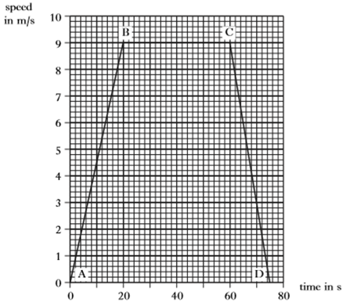
10
9
8
7
6
5
4
3
2
1
0
0
20
40
60
80
time in s

 | (a) | Describe the motion of the cyclist  (i) between B and C  (ii) between C and D. | 1  1
 | (b) | Calculate the acceleration between A and B. | 3
 | (c) | Calculate the distance between the two sets of traffic lights. | 3
 | (d) | Later in the journey the cyclist free-wheels down a hill at constant speed.  Explain this motion in terms of the forces acting on the cyclist. | 2

Electricity, Dynamics and Space Topics
2. |  | A lightning conductor is fitted to a tall building.
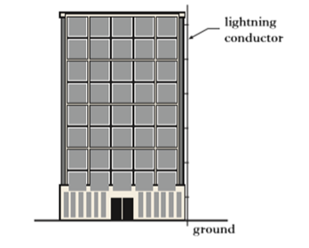
ground
lightning conductor

The specification for the lightning conductor is:
length 50·0 m
resistance per metre 0·080 Ω
mass 100 kg
specific heat capacity 385 J kg^{-1 o}C⁻¹
 |  | During a thunderstorm, a total charge of 300 C flows through the lightning conductor to the ground in 0·120 s.
 | (a) | Calculate the current in the lightning conductor during this time. | 3
 | (b) | Show that the power in the lightning conductor is 25 MW. | 3
 | (c) | (i) Calculate the maximum temperature rise that could be produced in the lightning conductor by this flow of charge. | 4
 |  | (ii) State one assumption that you have made in your calculation for (c) (i). | 1

3. |  | A student is given a piece of resistance wire 200 mm long and is asked to find its resistance.  Part of the circuit the student builds is shown below.  Electricity Topic
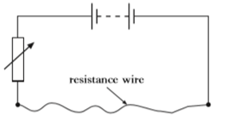
resistance wire
 |  | The student is also provided with a voltmeter and an ammeter.
 | (a) | Redraw the diagram to show how the student should connect the meters to measure the resistance of the wire. | 2
 | (b) | The student now uses measurements from the experiment to draw the following graph.
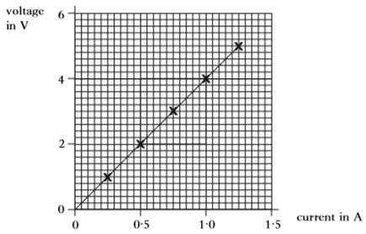
1·5
1·0
0·5
6
4
2
0
0
current in A
voltage in V
 |  | (i) Describe how the student uses the circuit to obtain the measurements for the graph. | 1
 |  | (ii) Calculate the resistance of one metre of the wire. | 4
 |  | Two resistance wires are then connected as shown below.
 |  | 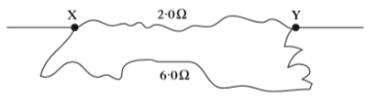
 | (c) | Calculate the total resistance between points X and Y. | 3
Radiation Topic
4. |  | Some smoke alarms use a radioactive source which emits alpha particles.  The detector operates because of ionisation caused by the alpha particles in the space between the alpha source and the sensor.  If smoke or dust enter the space, the alarm operates.
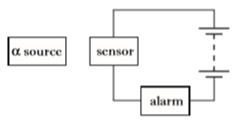
alpha
source
sensor
alarm

 | (a) | (i) Describe what is meant by an alpha particle. | 1
 |  | (ii) State what it meant by the term ionisation. | 1
 |  | (iii) Explain why an alpha source should be used rather than beta or gamma. | 2
 |  | The smoke alarm manufacturer has to choose from three alpha emitting sources. The half-life of each source is shown in the table below.
Source | Half-life
A | 4 hours
B | 4 weeks
C | 400 years

 | (b) | State which source the manufacturer should choose.  You must explain your answer. | 2

Electricity Topic
5. |  | One design of smoke detector has an LED which lights to show that the battery is in good condition.  A 9·0 V battery is used in the LED circuit shown below.  One component is missing, between A and B.
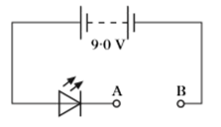
B
A
9·0 V
 |  | In normal operation, the LED carries a current of 20 mA and the voltage across it is 1·9 V.
 | (a) | State the name of the component that should be connected between A and B to protect the LED. | 1
 | (b) | Calculate the resistance which this component should have so that the LED operates normally. | 4
 | (c) | Calculate the power of the LED when operating normally. | 3

Waves Topic
6. |  | Typical wavelengths of light of different colours in air are given in the table below.
Colour | Wavelength in air in m
red | 6·5 x 10⁻⁷
green | 5·2 x 10⁻⁷
blue | 4·0 x 10⁻⁷

 | (a) | State the speed of light in the air. | 1
 | (b) | The frequency of a certain colour of light is 4·6 x 10¹⁴ Hz.  State the colour of this light.  You must justify your answer by calculation. | 2
7. |  | A ray of red light is incident on a glass block as shown below.
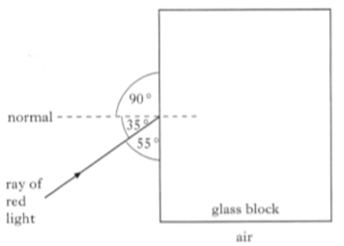
air

glass block
ray
of
red
light
normal
55 ⁰
35 ⁰
90 ⁰
 | (a) | (i) State the angle of incidence value in the diagram above. | 1
 |  | (ii) Copy the diagram and complete it to show the path of the ray inside the glass block. | 1
 | (b) | The frequency of the red light in the glass block is 4·4 x 10¹⁴ Hz. Calculate the wavelength of the red light inside the glass block. | 3

Dynamics Topic
8. |  | A flag is raised at the opening of an athletics competition. The mass of the flag is 0·5 kg and it is raised at a constant speed through a height of 6m.
 | (a) | Calculate the gravitational potential energy gained by the flag. | 3
 | (b) | A constant force of 7 N is applied to raise the flag.  Calculate the work done raising the flag. | 3
 | (c) | Explain why there is a difference between the answers to parts (a) and (b). | 2
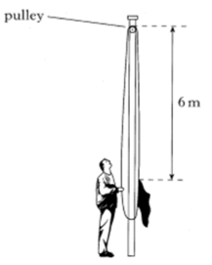
6 m
pulley

Dynamics Topic
9. |  | A rowing team is taking part in a race on calm water.
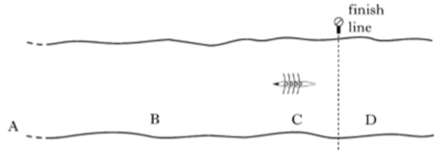
A
B
C
D
finish line
 |  | The following graph shows how it is predicted that the speed of the boat will vary with time during the stages A, B, C and D of the race.
 | speed in m s⁻¹ | 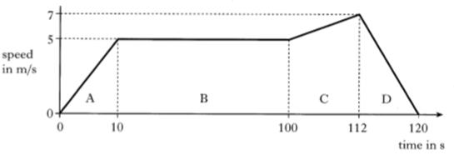  120  112  100  10  7  5  0  C  B  A  D  time in s
 |  | The prediction assumes that the frictional force on the team's boat remains constant at 800 N during the race.
 | (a) | (i) State the size of the forward force applied by the oars during stage B. | 1
 |  | (ii) Calculate the acceleration of the boat during stage C. | 3
 |  | (iii) The total mass of the boat and its crew is 400 kg.  Calculate the size of the forward force applied by the oars during stage C. | 4
 |  | (iv) The boat crosses the finishing line after 112 seconds.  Calculate the distance the boat travels from the instant it crosses the line until it come to rest. | 3
 | (b) | The frictional force acting on the boat during stage D actually becomes smaller as the speed decreases.  Describe and explain the effect of this smaller frictional force on the time taken for the boat to come to rest. | 2

Space and Dynamics Topics
10. |  | Some bottles of water are placed in a compartment of a refrigerator.  The refrigerator reduces the temperature of the water from 22·0 ºC to  10·0 ºC.  The total mass of water in the bottles is 2·40 kg.
 |  | 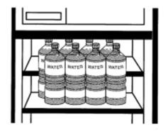
 | (a) | The specific heat capacity of the water is 4200 J kg⁻¹ ºC⁻¹.  Show that the heat energy lost by the water is 121 kJ, correct to 3 significant figures. | 2
 | (b) | The refrigeration system removes heat energy from the compartment at a rate of 100 J s⁻¹.
 |  | (i) Assuming that heat is removed from the water at this rate, calculate how long it will take to lower the water temperature from 22·0 ºC to 10·0 ºC. | 3
 |  | (ii) Explain why the actual time take to lower the temperature of the water will be longer than the value calculated in  part (b) (i). | 2

Electricity Topic
11. |  | A hotel owner decided to install three lamps on the drive between the hotel and the street.  lamps
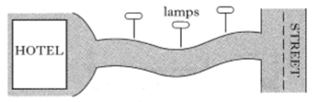
Street
Hotel
 |  | The circuit diagram below shows how the lamps are connected to the mains supply.
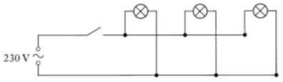
230 V
 |  | Each lamp has a rating of 230 V, 200 W.
 | (a) | Explain why the lamps must be connected in parallel rather than series. | 1
 | (b) | Calculate the resistance of each lamp. | 3
 | (c) | Calculate the current draw from the supply when all three lamps are operating. | 4
 | (d) | The lamps are connected to the circuit shown below so that they come on automatically when it gets dark.  relay
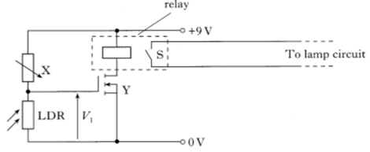
V₁
LDR
X
Y
S
To lamp circuit
0 V
+9 V
 |  | (i) Identify components labelled X and Y. | 2
 |  | (ii) Component Y switchs on when the voltage V₁ reaches  2·0 V.  Switch S is closed when there is a current in the relay.  Explain how this circuit will switch the lamps on when it becomes dark. | 3

12. |  | A strain gauge is an electrical device that is attached to an object.  The strain gauge detects a change in the shape of the object.  In the following diagrams, the strain gauge is shown attached to a piece of flexible metal.  strain gauge
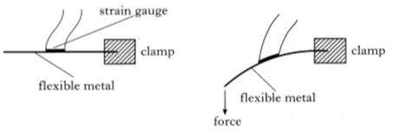
force
flexible metal
clamp
flexible metal
clamp
When a force is applied to the end of the piece of metal, it bends.
When the metal is bent, the strain gauge also bends and its resistance changes.
The strain gauge is connected in series with a resistor, R, and a 9 V supply as shown in the circuit diagram below.
9 V
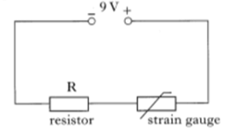
resistor
strain gauge
 | (a) | A student is asked to find the resistance of the strain gauge using a voltmeter and an ammeter.  Redraw the diagram to show how the student should connect the meters to measure the resistance of the strain gauge. | 2
 | (b) | The student obtains the following results.
 | Voltmeter reading (V) | Ammeter reading (mA)
No force applied | 7·20 | 60·0
Force applied | 7·23 | 59·0

 |  | Does the resistance of the strain gauge increase or decrease when the force is applied to the piece of metal? You must justify your answer. | 2
 | (c) | Calculate the resistance of the resistor R. | 4
Electricity Topic
Radiation Topic
13. |  | In a nuclear reactor uranium nuclei are bombarded by neutrons. This can cause a nuclear reaction, resulting in smaller nuclei and additional neutrons being produced as shown below. Energy is also released.  Uranium nucleus  smaller nuclei
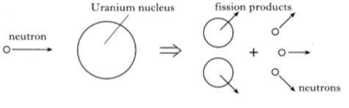
neutron
neutrons

 | (a) | State the name of this type of nuclear reaction. | 1
 | (b) | Explain how the additional neutrons can cause a chain reaction. | 1
 | (c) | A graph of activity against time for a sample of some of the radioactive waste produced is shown below.
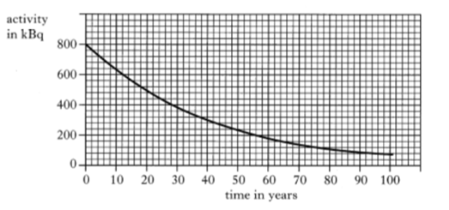
100
90
80
70
60
50
40
30
20
10
0
0
200
400
600
800
activity
in kBq
time in years
 |  | (i) From the graph, determine the half life of the radioactive waste. | 1
 |  | (ii) A scientist states that the sample will be safe only when the activity falls to 100 kBq. Determine how long this will take to happen. | 2
 |  | (iii) State a suitable method of storing the sample during the time it takes for the activity to fall to a safe level. | 1

Dynamics Topic
14. |  | An observation wheel rotates slowly and raises passengers to a height where they can see across a large city. The passengers are carried in capsules.  Q
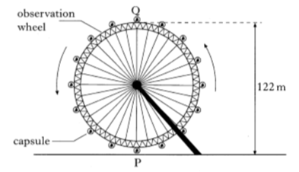
122 m
P
observation
wheel
capsule
 | (a) | Each capsule is raised through a height of 122 m as it moves from P to Q.  Each capsule with passengers has a total mass of 2750 kg.  Calculate the gravitational potential energy gained by a capsule with passengers. | 3
 | (b) | The wheel is rotated by a driving force of 200 kN.  circumference of wheel = 383 m
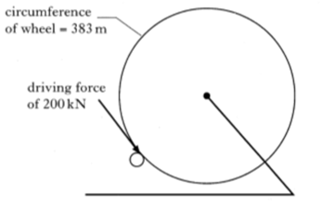
driving force of 200 kN
 |  | (i) For one revolution, the driving force is applied through the circumference of the wheel, a distance of 383 m.  Calculate the work done by the driving force for two revolutions. | 4
 |  | (ii) The observation wheel rotates twice every 30 minutes.  Calculate the power delivered to the wheel. | 3

Dynamics Topic
15. |  | A tractor and a loaded trailer have a total mass of 9500 kg.
 |  | 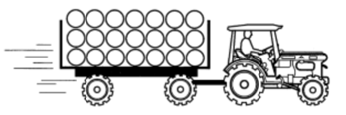
 | (a) | The tractor applies a forward force of 15 250 N. At the instant the tractor and trailer move off the total frictional force is 1000 N.  Calculate the initial acceleration of the tractor and trailer. | 4
 | (b) | The following graph shows how the speed of the tractor and trailer varies with time.
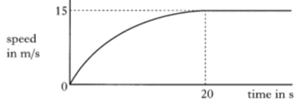
0
20
15
time in s
speed in
m s⁻¹
 |  | The tractor continues to apply a forward force of 15 250 N.  State the size of the frictional force after 20 s. | 1
 | (c) | On a second journey the trailer is loaded in a different way. The total mass of the tractor and trailer is again 9500 kg.
 |  | 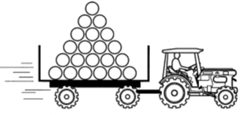
 |  | The tractor again applies a forward force of 15 250 N. The maximum speed on this journey is 12 m s⁻¹.  Explain, in terms of forces, why the maximum speed on this journey is less than the maximum speed in part (b). | 2

Electricity Topic
16. |  | A cooker hood contains two 40 W lamps and an extractor fan.
 |  | 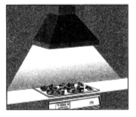
 |  | A circuit diagram for the cooker hood is shown below.
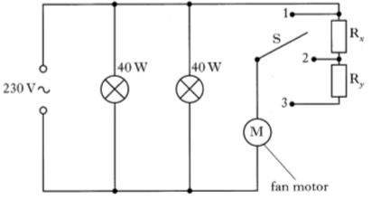
S
1
2
3
fan motor
40 W
40 W
230 V
R_{b}
R_{a}
 | (a) | Calculate the current drawn by on lamp. | 3
 | (b) | Calculate the resistance of one lamp. | 3
 | (c) | The speed of the fan motor is varied by moving the switch S to position 1, 2 or 3.  State the position of S for maximum speed of the extractor fan motor.  You must explain your reason for selecting this position. | 2
 | (d) | When S is in position 2 the voltage across the motor is 180 V and the current through the motor is 0·25 A.  Calculate the resistance of R_{a}. | 4

17. |  | The following table contains information about two radioactive sources used in medicine.
Radioactive Source | Activity (MBq) | Half-life (days)
R | 1600 | 8
S | 80 | 74

 | (a) | Calculate the number of decays of source R in 30 s. | 3
 | (b) | The radioactive sources can be disposed of after their activity has fallen below 40 MBq.  Determine which source, R or S, will be the first to reach an activity of 40 MBq. | 4
 | (c) | State two safety precautions which should be taken when handling radioactive sources. | 4
18. |  | A student reads the following article about nuclear power.  "In a nuclear reactor, uranium nuclei in fuel rods are bombarded with neutrons. A uranium nucleus may absorb a neutron and then break up into two smaller nuclei releasing further neutrons and energy."  smaller nucleus
 | neutron | 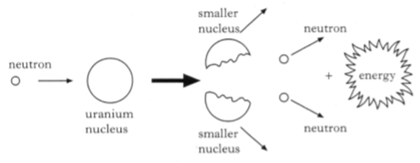  energy  neutron  neutron  smaller nucleus  uranium nucleus
 | (a) | (i) A nucleus contains 2 types of particle. Name the particles. | 2
 |  | (ii) State the type of nuclear reaction shown in the diagram. | 1
 |  | (iii) Explain why the fuel rods that are removed from the reactor are a safety hazard. | 1
 | (b) | In a nuclear reactor 166 MJ of energy is transferred to 2000 kg of coolant. All of this energy is absrbed by the coolant which has a specific heat capacity of 830 J kg⁻¹ ºC⁻¹.  Assuming the coolant does not change state, calculate the rise in temperature of the coolant. | 3
Radiation and Space Topics
Dynamics Topic
19. |  | A theme park has a water splash ride. A carriage loaded with passengers is raised through a height of 30 m to the top of the ride. The combined mass of the carriage and the passengers is 1400 kg.
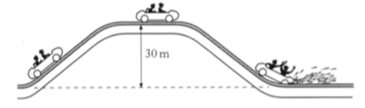
30 m
 | (a) | Calculate the gain in gravitational potential energy of the carriage and passengers when it is taken to the top of the ride. | 3
 | (b) | The carriage and passengers stop briefly before being released at the top of the ride. A speed-time graph of the motion of the carriage from the top of the ride is shown below.
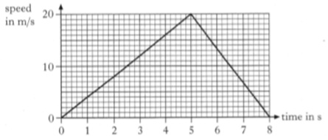
8
7
6
5
4
3
2
1
0
20
10
0
time in s
speed in
m s⁻¹
 |  | (i) Calculate the acceleration of the carriage from the top of the ride to the point where it reaches the water. | 3
 |  | (ii) Calculate the distance travelled by the carriage from the top of the ride to the point where it comes to rest. | 3
 |  | (iii) A test run is carried out without any water in the ride. The carriage travels a longer distance before it comes to rest. Explain why this happens. | 2

Dynamics Topic
20. |  | A spacecraft travels through space between planet X and planet Y. Information on these planets is shown in the table below.
 | planet X | planet Y
Gravitational field strength on surface | 8·4 N kg⁻¹ | 13 N kg⁻¹
Surface temperature | 17·0 ºC | 9·0 ºC
Atmosphere | No | Yes
Period of rotation | 48 hours | 17 hours

The spacecraft has a total mass of 2·5 x 10⁶ kg.
The spacecraft engines produce a total force of 3·8 x 10⁷ N.
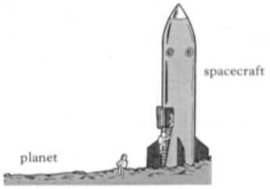
planet
spacecraft
 | (a) | The spacecraft is initially on planet X.
 |  | (i) Calculate the weight of the spacecraft when it is on the surface of planet X. | 3
 |  | (ii) Sketch a diagram showing the forces acting on the spacecraft just as it lifts off from planet X.  You must name these forces and show their direction. | 2
 |  | (iii) Calculate the acceleration of the spacecraft as it lifts off from planet X. | 4
 | (b) | On another occasion, the spacecraft lifts off from planet Y. The mass and engine force of the spacecraft are the same as before.  Is the acceleration as it lifts off from planet Y less than, more than or equal to the acceleration as it lifts off from planet X? Explain your answer. | 2
21. |  | An LED is connected in the circuit shown.
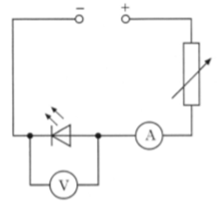
A
V
 |  | The variable resistor is adjusted and voltmeter and ammeter reading are taken. The following graph is obtained from the experimental results.
 | Current in mA | 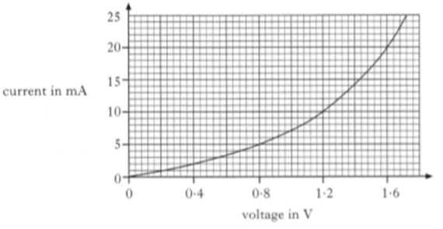  1·6  1·2  0·8  0·4  10  5  25  20  15  0  Voltage in V  0
 | (a) | Using information from the graph, determine how the resistance of the LED changes as the voltage across it is increased.  You must justify your answer by calculation. | 2
 | (b) | The LED is now connected into a series circuit with a resistor R as shown.
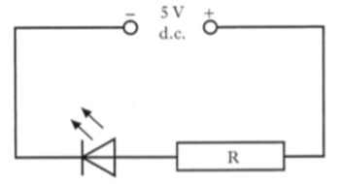
Electricity Topic
5 V
d.c.
R
 |  | (i) The current in the LED is 20 mA. Using the graph, state the voltage across the LED. | 1
 |  | (ii) Calculate the resistance of resistor R. | 4
Space, Dynamics and Electricity Topics
22. | (a) | A heater is used to melt ice on the rear window of a car.
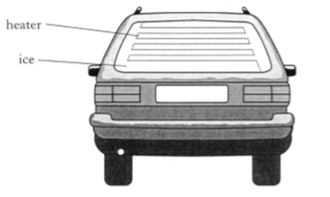
ice
heater
 |  | (i) Calculate the heat energy required to melt 0·05 kg of ice. | 3
 |  | (ii) The heater takes 5 minutes to melt 0·05 kg of ice. Assuming all the energy is used to melt the ice, calculate the output power of the heater. | 3
 | (b) | The car has a warning light which comes on when the outside temperature falls below 3 ºC. The circuit for the warning light is shown.
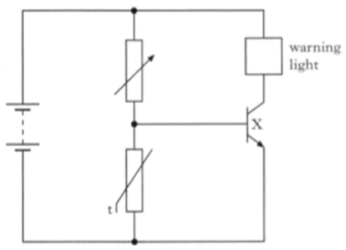
t
X

warning light
 |  | (i) Name component X . | 1
 |  | (ii) State what happens to the resistance of the thermistor as the temperature decreases. | 1
 |  | (iii) Explain how the circuit operates so that the warning light comes on when the temperature falls below 3 ºC. | 2

Electricity and Waves Topics
23. |  | A satellite orbiting the Earth has large panels as shown.
 | panels | 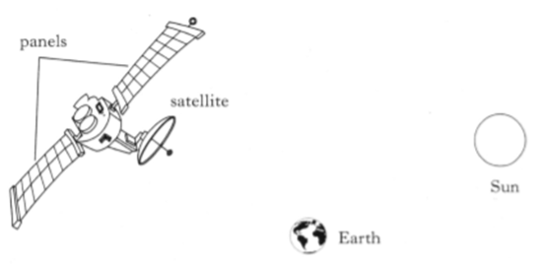  Sun  Earth  satellite
 |  | The panels absorb light energy from the Sun and change it to electrical energy.
 | (a) | (i) Name a device which can change light energy to electrical energy. | 1
 |  | (ii) The panels produce a current of 4·5 A for 5 minutes.  Calculate the charge moved in this time. | 3
 | (b) | Not all light is visible. The retina in the human eye can only detect wavelengths of light between 400-700 nm.
 |  | (i) State the type of electromagnetic radiation which could have a wavelength of 390 nm. | 1
 |  | (ii) State one use of the type of radiation you gave as an answer to (b) (i). | 1

Radiation Topic
24. |  | Companies delivering radioactive sources have to follow strict safety rules. One rule is that sources must be labelled. The following information is displayed on the label of a radioactive source.
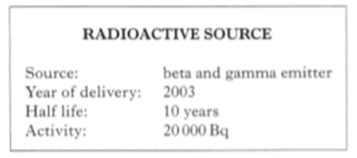
Source: beta and gamma emitter
Year of delivery: 2005
Half-life: 10 years
Activity: 20 000 Bq
RADIOACTIVE SOURCE
 | (a) | (i) State what is meant by the term activity. | 1
 |  | (ii) Determine the activity of the source in the year 2045. | 2
 | (b) | After delivery, the source is placed in a thick walled aluminium storage box.  State which type of radiation, if either, could penetrate the storage box.  You must explain your answer. | 2
 | (c) | A technician handling an alpha-emitting source estimates that his hand receives an absorbed dose of 5 x 10⁻⁵ Gy. The mass of the technician's hand is 500 g. | 3
 |  | (i) Calculate the total energy absorbed by the technician's hand. | 3
 |  | (ii) Calculate the equivalent dose received by his hand. | 3

Dynamics Topic
25. |  | The driver of a train travelling at 45 m s⁻¹ sees a sign indicating that there is a speed limit of 10 m s⁻¹ on a bridge on the track ahead. At this point the distance from the train to the bridge is 500 m.
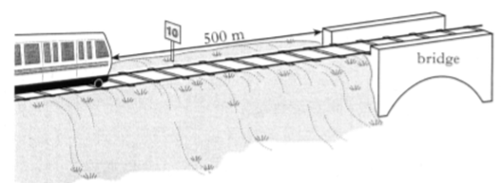
500 m
bridge
The speed-time graph of the train’s motion, from the moment the driver sees the sign, is shown below.
50
 | speed in  m s⁻¹ | 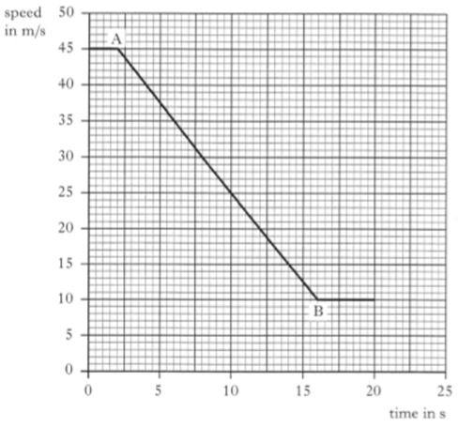  45  40  35  30  25  20  15  10  5  25  20  15  10  5  0  0  time in s
 | (a) | State the time at which the driver starts to apply the brakes.  Explain your answer. | 2
 | (b) | Calculate the acceleration of the train between A and B. | 3
 | (c) | State whether or not the train is travelling at 10 m s⁻¹ when it reaches the bridge.  You must justify your answer by calculation. | 2
Space and Electricity Topics
26. |  | A heater immersed in 0·40 kg of a liquid is switched on for 4 minutes. The temperature of the liquid rises by 5 ºC in this time. The specific heat capacity of the liquid is 2400 J kg⁻¹ ºC⁻¹.
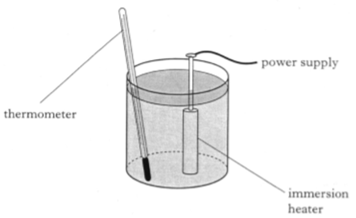
lead to power supply
thermometer
immersion heater
 | (a) | State the energy transformation that takes place in the heater. | 1
 | (b) | Calculate the heat energy gained by the liquid. | 3
 | (c) | Calculate the power rating of the heater. | 3
 | (d) | State one assumption that you have made for your answer to (c). | 1

27. |  | A car has a system that switches on the windscreen wipers when rain is detected on the windscreen.
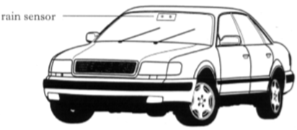
rain sensor
 | (a) | The rain sensor contains an LED which emits a beam of infrared radiation inside the car. In dry conditions this beam travels through the glass and is picked up by a detector.
 |  | (i) Draw the symbol for an LED. | 1
 |  | (ii) The LED circuit is shown below.
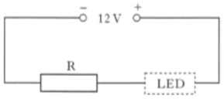
12 V
LED

R

 |  | The voltage across the LED is 1·8 V and the current in the LED is 100 mA.  Calculate the resistance of R. | 4
 | (b) | When rain falls on the windscreen the detector picks up less infrared radiation and the windscreen wipers are switched on.  A student builds a model of the system. The model uses an LDR to represent the infrared detector and visible light to represent infrared radiation. The circuit is shown below.
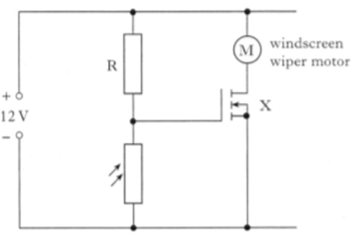
Electricity Topic
M
12 V

R
X
windscreen wiper motor
 |  | (i) Name component X. | 1
 |  | (ii) Describe how this electronic system operates when less light falls on the LDR. | 3
Electricity Topic
28. |  | A paint stripper contains a heater and a motor which drives a fan.
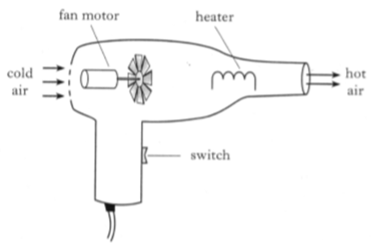
fan motor
cold
air
heater
hot
air
switch
The heater and the motor both operate at mains voltage, 230 V.
Information about the heater and motor is shown in the table below.
 | Heater | Motor
Symbol |  |   M
Operating Voltage | 230 V | 230 V
Power | 1425 W | 575 W

 | (a) | Calculate the resistance of the motor. | 3
 | (b) | Draw the circuit diagram for the paint stripper. | 2
 | (c) | The heater burns out. State the effect this will have on the speed of the fan motor.  You must explain your answer. | 2

Radiation Topic
29. |  | In a reactor of a nuclear power station a uranium nucleus is bombarded by a slow neutron as shown below.
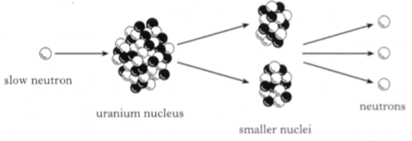
smaller nuclei
neutrons
uranium nucleus
slow neutron
 | (a) | State the name of this type of nuclear reaction. | 1
 | (b) | In this reaction neutrons are released.  Explain why these neutrons are important to the operation of the reactor. | 1
 | (c) | A worker in the power station is exposed to the following absorbed doses over a time of 500 hours.  2·0 mGy of slow neutrons  5·0 mGy of fast neutrons  (i) Calculate the equivalent dose the worker receives from this radiation. | 4
 |  | (ii) Calculate the equivalent dose rate. | 3

Radiation Topic
30. |  | A roller mill produces thin sheets of aluminium foil. The thickness of the foil is checked using a source of beta radiation, a Geiger-Muller tube and a counter as shown below.
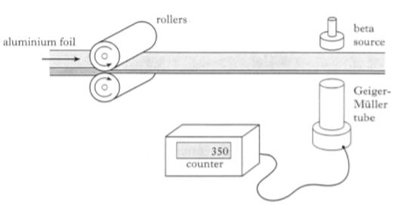
Geiger-
Muller
tube
beta source
counter
rollers
aluminium foil
 | (a) | State what happens to the count rate when the thickness of the foil increases. | 1
 | (b) | Explain why an alpha source would not be suitable for this system. | 1
 | (c) | Radioactive sources give off radiations that cause ionisation.
 |  | (i) State what is meant by the term ionisation. | 1
 |  | (ii) Give two precautions that should be taken when handling radioactive sources. | 2

Dynamics Topic
31. |  | A sky-diver of mass 90 kg drops from a stationary balloon. The speed-time graph shows how the vertical speed of the sky-diver varies until shes reaches the ground. She falls 3000 m before opening her parachute.
 | vertical  speed  in m s⁻¹ | 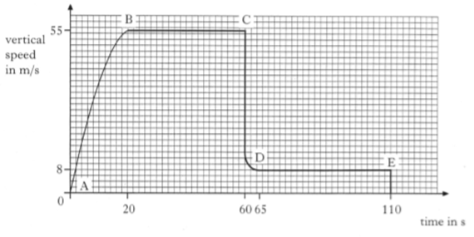  65  64  110  20  0  0  8  55  time in s
 | (a) | At what point does the sky-diver:
 |  | (i) open her parachute;  (ii) reach the ground? | 1  1
 | (b) | Sketch a diagram showing the forces acting on the sky-diver between B and C.  You must name these forces and show their directions. | 2
 | (c) | Calculate the frictional forces acting on the sky-diver between B and C. | 4

Electricity Topic
32. | (a) | A student connects two resistors in series with a power supply set at  20 V.
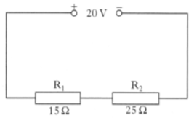
15 Ω
25 Ω
R₂
R₁
20 V
 |  | (i) Calculate the current in the circuit. | 4
 |  | (ii) Calculate the potential difference across resistor R₁. | 3
 |  | (iii) Redraw the above circuit diagram showing meters correctly connected to measure the quantities in (i) and (ii) above. | 2
 | (b) | R₁ is now replaced by a 4 V lamp and the supply voltage is reduced to 12 V.  The lamp is operating at its stated voltage.
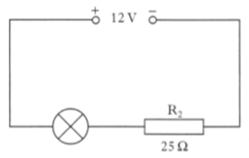
R₂
25 Ω
12 V
 |  | Calculate the rate at which electrical energy is converted to heat energy in resistor R₂. | 4

33. |  | The sun is 1·5 x 10¹¹ m from the Earth. The sun emits all radiations in the electromagnetic spectrum. All these radiations travel through space at 3 x 10⁸ m s⁻¹.  Waves Topic  Sun
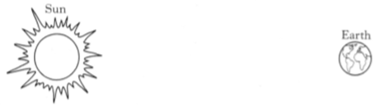
Earth
 | (a) | State what all waves transfer. | 1
 | (b) | Calculate the time taken for sunlight to reach Earth. | 3
 | (c) | The diagram below shows the electromagnetic spectrum in order of increasing frequency. One part has been missed out.
  Radio & TV | ? | Infrared | Visible Light | Ultraviolet | X-Rays | Gamma Rays
 |  | (i) State the name of the missing radiation. | 1
 |  | (ii) State the name of an ionising radiation from the spectrum. | 1
 |  | (iii) State what is meant by the term ionisation. | 1
34. |  | An osprey sees a fish in a loch.  The diagram shows the path of a light ray from the fish to the osprey.
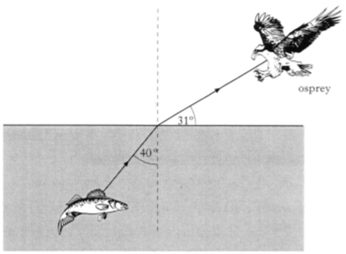
31º
40º
osprey
 | (a) | State the size of the angle of incidence. | 1
 | (b) | State the size of the angle of refraction. | 1
Radiation Topic
35. |  | A diagram of the core of a gas cooled nuclear reactor is shown below.  control rods
 | Uranium-235 fuel rods | 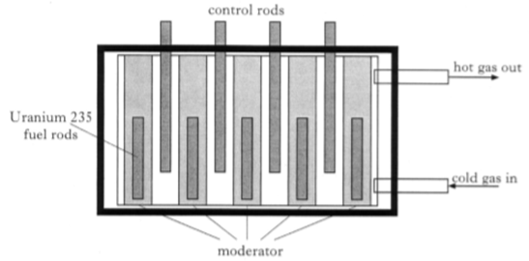  hot gas out  cold gas in  moderator
 | (a) | One of the waste products produced in the nuclear reactor is the chemical element caesium.
 |  | The caesium in the waste products removed from the reactor has an activity of 16 x 10¹² Bq.
 |  | Caesium has a half-life of 30 years.
 |  | (i) State what is meant by the activity of a radioactive source. | 1
 |  | (ii) State what is meant by a half-life of 30 years. | 1
 |  | (iii) Determine the activity of the caesium 150 years after its removal from the reactor. | 2
 | (b) | A worker at the nuclear power station has a mass of 90 kg and receives a dose equivalent of 276 µSv from slow neutrons.
 |  | Calculate how much energy the worker absorbed from the slow neutrons. | 4

Dynamics and Waves Topics
36. |  | A fully laden oil tanker of mass 7·5 x 10⁸ kg leaves a loading terminal.  Its engine and propellers produce a forward force of 6·0 x 10⁶ N. A tugboat pushes against one side of the tanker as shown. The tug applies a pushing force of 8·0 x 10⁶ N.
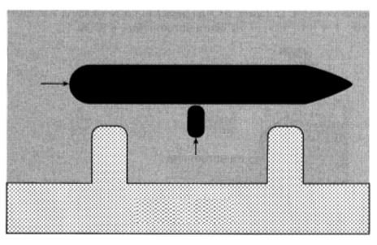
tanker
tugboat
loading terminal
8·0 x 10⁶ N
6·0 x 10⁶ N
 | (a) | By scale diagram or otherwise, determine the magnitude of the resultant of these two forces. | 2
 | (b) | Calculate the initial acceleration of the tanker. | 3
 | (c) | Out in the open sea, the side of the tanker is struck by a wave once every 16 s. The speed of the waves is 12·5 m s⁻¹.
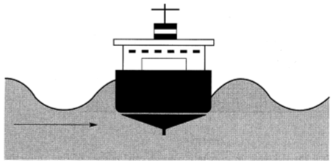
12·5 m s⁻¹
 |  | For these waves, calculate:
 |  | (i) the frequency; | 3
 |  | (ii) the wavelength. | 3
Space Topic
37. |  | A blacksmith cools a hot iron horse-shoe of mass 0·75 kg by dropping it into water. The mass of the water is 15 kg and its initial temperature is 17 ºC. Heat energy from the iron warms the water until both iron and water are at 23 ºC.
 |  | 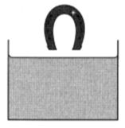
 | (a) | Calculate the heat energy absorbed by the water. | 3
 | (b) | Calculate the initial temperature of the horse-shoe. | 4
 | (c) | State one assumption that you have made for the calculation in part (b). | 1
 | (d) | If the blacksmith had replaced the water with the same mass of oil and put the horse-shoe in would the temperature rise of the liquid have been more, less or the same.  You must explain your answer. | 2

Radiation Topic
38. |  | The table shows properties of some isotopes of the element iodine.
Isotope | Radiation emitted | Half-life
Iodine-127 | none | -
Iodine-128 | beta | 25 minutes
Iodine-129 | beta | 16 million years
Iondine-131 | beta | 8·1 days
Iodine-135 | beta | 6·7 hours

 | (a) | State what is meant by the term half-life. | 1
 | (b) | The activity of a sample of iodine-131 is 56·0 MBq.  Determine how long it will take for its activity to reach 1·75 MBq. | 2
 | (c) | A patient suffers from cancer of the thyroid gland. This cancer is treated with an injection of a radioactive iodine isotope, which becomes concentrated in the thyroid gland. The thyroid receives a large dose of radiation for several hours, but surrounding tissues receive much less. Next day, when the activity of the isotope has decreased to a safe level, the patient can return home.  State which of the above isotopes would be the most suitable to treat the patient.  Explain your answer. | 2

Dynamics Topic
39. |  | A climber of mass 60 kg is attached by a rope to point A on a rock face. She climbs up to point B in 20 seconds. Point B is 3·2 m vertically above point A.
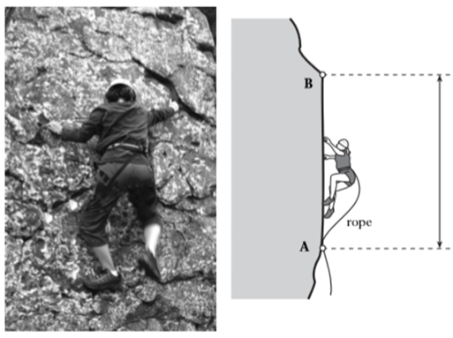
rope
3·2 m
 | (a) | (i) Calculate the average speed of the climber between A and B. | 3
 |  | (ii) Calculate the weight of the climber. | 3
 |  | (iii) Calculate her gain in gravitational potential energy between A and B. | 3
 | (b) | She then loses her footing and free falls from point B. After passing point A she is held safely by the rope.
 |  | (i) Calculate her speed as she passes point A. | 3
 |  | (ii) Explain why her actual speed when passing point A would be less than the speed calculated in (b) (i). | 1

Dynamics Topic
40. |  | A cyclist rides along a road.
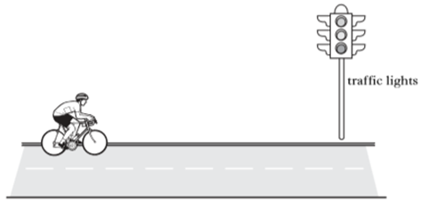
traffic lights
 | (a) | Describe a method by which the average speed of the cyclist could be measured.  Your description must include the following  - Measurements made  - Equipment used  - Any necessary calculations. | 3
 | (b) | The cyclist approaches traffic lights at a constant speed of 8 m s⁻¹. He sees the traffic lights turn red and 3 s later he applies the brakes. He comes to rest in a further 2·5 s.
 |  | (i) Calculate the acceleration of the cyclist whilst braking. | 3
 |  | (ii) Sketch a speed-time graph showing the motion of the cyclist from the moment the lights turn red until he stops at the traffic lights.  Numerical values must be included. | 2
 |  | (iii) Calculate the total distance the cyclist travels from the moment the lights turn red until he stops at the traffic lights. | 3

Space and Electricity Topics
41. |  | A steam wallpaper stripper is used on the walls of a room.  Water is heated until it boils and produces steam. The plate is held against the wall and steam is released from the plate.
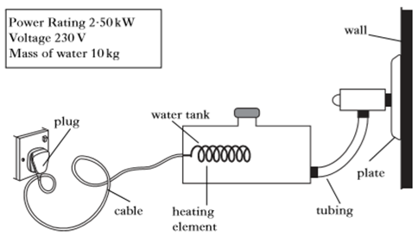
water tank
heating
Power Rating: 2·50 kW
Voltage: 230 V
Mass of water: 10 kg
plug
cable
tubing
plate
wall
The tank is filled with water. The water has an initial temperature of
20 ºC.
 | (a) | (i) Calculate the energy required to bring the water to its boiling point. | 3
 |  | (ii) Calculate the time taken for this to happen. | 3
 |  | (iii) The actual time taken for this to happen was found to be longer than that calculated in (a) (ii). Explain why. | 1
 | (b) | Calculate the current required by the wallpaper stripper. | 3
 | (c) | State a component which should be used to break the circuit if the current becomes too large. | 1
 | (d) | After using the wallpaper stripper for some time, 1·2 kg of water is converted into steam when it is at its boiling point.  Calculate the energy required to do this. | 3

Waves and Electricity Topics
42. |  | A group of students visit a Laser Game Centre. The laser gun emits both a visible beam and an IR beam. Each target jacket contains three IR sensors.
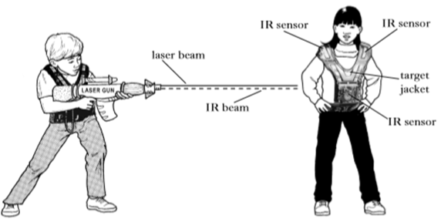
laser gun
target
jacket
IR sensor
IR sensor
IR sensor
IR beam
laser beam
 | (a) | (i) State what the term IR stands for. | 1
 |  | (ii) State which of the two beams arrives at the target first.  You must explain your answer. | 2
 | (b) | The laser gun operates from a 7·2 V rechargeable battery. The battery is charged from the mains and takes two hours to fully recharge. A current of 3 A is used in the charging circuit.  Calculate how much charge the battery stores when fully charged. | 3
 | (c) | When the IR beam hits a sensor on the target jacket, the following circuit is completed and the LED lights. The LED has an operating voltage of 2 V and an operating current of 15 mA. The circuit has an 8 V supply.
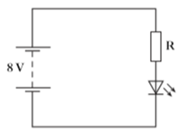
8 V
R
 |  | Calculate the resistance value of resistor R. | 4

Waves Topic
43. | (a) | Two types of waveform are shown.
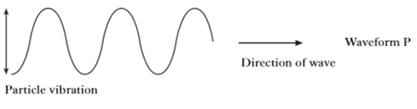
Waveform P
Direction of wave
Particle vibration
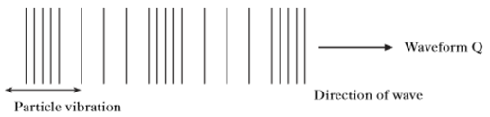
Direction of wave
Waveform Q
Particle vibration
 |  | (i) State which waveform represents a longitudinal wave. | 1
 |  | (ii) State which waveform represents a sound wave. | 1
 | (b) | A signal generator is connected to a loudspeaker which produces a sound wave of frequency 2 kHz.
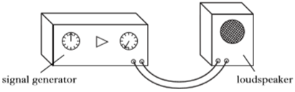
loudspeaker
signal generator
 |  | (i) Calculate the wavelength of the sound wave in air. | 3
 |  | (ii) The loudspeaker is placed a distance of 10·2 m from a wall.  Calculate the time taken for the sound to return to the loudspeaker. | 4
 | (c) | The loudspeaker is now placed in a tank of carbon dioxide gas. The frequency of the sound remains at 2 kHz.  State whether the wavelength of the sound increases, decreases or remains the same.  You must justify your answer. | 2

Radiation Topic
44. |  | A football player injures his leg while playing in a match.
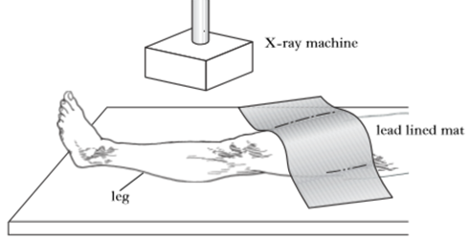
lead lined mat
X-ray machine
leg
 |  | In hospital the player has three X-rays, each producing an absorbed dose of 50 µGy.
 | (a) | The mass of the player’s leg is 6 kg.  Calculate the energy absorbed by the leg from the three X-rays. | 4
 | (b) | Explain why the rest of the player’s leg is covered with a lead lined mat. | 1
 | (c) | Apart from the absorbed dose, state one other factor that contributes to biological harm. | 1

Radiation and Electricity Topics
45. |  | A simplified diagram of a smoke detector is shown. Radiation from the source causes ionisation of the air molecules between the plates. This produces a small current in a circuit. When smoke particles pass between the plates, the current decreases and a buzzer sounds.
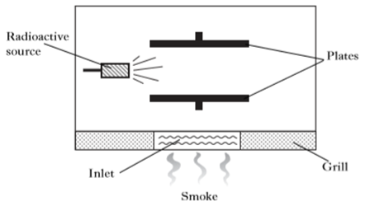
plates
grill
smoke
inlet
radioactive source
 | (a) | (i) State what is meant by the term ionisation. | 1
 |  | (ii) Explain whether the source should be an alpha, beta or gamma emitter. | 2
 | (b) | A manufacturer is choosing a new source for its smoke detectors.
Source | Half-life (years) | Range (metres)
W | 1 | 0·05
X | 10 | 2·0
Y | 100 | 0·05
Z | 1000 | 2·0

 |  | From the above information, select the most suitable source to use.  Explain your answer. | 2
 | (c) | The smoke detector circuit contains a 9 V battery. When there is no smoke present the operating current in the circuit is 30 mA.
 |  | (i) Calculate the resistance of the circuit. | 3
 |  | (ii) State the energy change which takes place in the buzzer. | 1

Radiation Topic
46. |  | An experiment is carried out in a laboratory to determine the half-life of a radioactive source. A Geiger-Muller tube and counter are used to measure the background radiation over a period of 10 seconds. This is repeated several times and an average value of 4 counts in 10 seconds is recorded.  The apparatus shown is used to measure the count rate over a period of time. The readings are corrected to exclude background radiation.
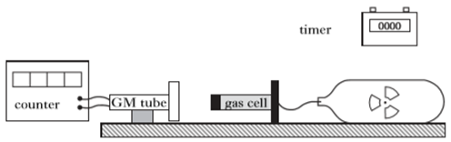
gas cell
counter
timer
GM tube
Time (minutes) | Corrected count rate
0  2  4  6  8  10  12 | 168  120  84  60  42  30  21

 | (a) | Name two factors that affect the background count rate. | 2
 | (b) | Calculate the activity of the background radiation. | 3
 | (c) | Determine the half-life of the radioactive source. | 2
Dynamics Topic
47. |  | A fairground ride uses a giant catapult to launch people upwards using elastic cords.
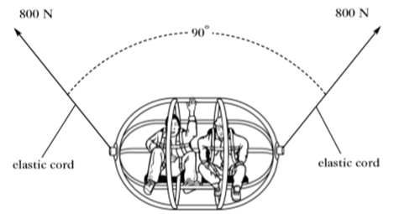
90º
elastic cord
elastic cord
800 N
800 N
 | (a) | Each cord applies a force of 800 N and the cords are at 90º as shown. Using a scale diagram, or otherwise, find the magnitude of the resultant of these two forces. | 2
 | (b) | The cage is now pulled further down before release. The cords provide an overall upward force of 2700 N. The cage and its occupants have a total mass of 180 kg.
 |  | (i) Calculate the weight of the cage and occupants. | 3
 |  | (ii) Calculate the acceleration of the cage and occupants when released. | 4

Dynamics and Space Topics
48. |  | One type of exercise machine is shown below.
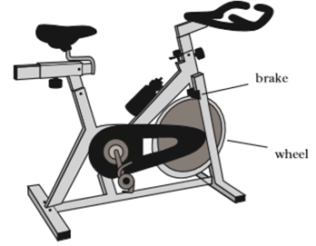
wheel
brake
 | (a) | A person using this machine pedals against friction forces applied to the wheel by the brake.
 |  | A friction force of 300 N is applied at the edge of the wheel, which has a circumference of 1·5 m.
 |  | (i) Calculate the work done by friction in one turn of the wheel. | 3
 |  | (ii) The person turns the wheel 500 times in 5 minutes. Calculate the average power produced. | 4
 | (b) | The wheel is a solid aluminium disc of mass 12·0 kg.
 |  | (i) All the work done by friction is converted to heat in the disc.  Calculate the temperature rise of the disc after 500 turns. | 3
 |  | (ii) Explain why the actual temperature rise of the disc is less than calculated in (b) (i). | 1

Dynamics Topic
49. |  | An early method of crash testing involved a car rolling down a slope and colliding with a wall.  In one test, a car of mass 750 kg starts at the top of a 7·2 m high slope.
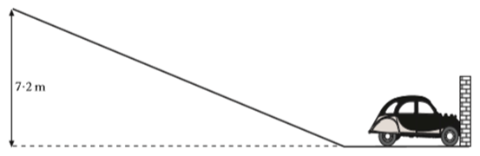
7·2 m
 | (a) | Calculate the gravitational potential energy of the car at the top of the slope. | 3
 | (b) | (i) State the value of the kinetic energy of the car at the bottom of the slope, assuming no energy losses. | 1
 |  | (ii) Calculate the speed of the car at the bottom of the slope, before hitting the wall. | 3

Electricity Topic
50. |  | Some resistors are labelled with a power rating as well as their resistance value. This is the maximum power at which they can operate without overheating.
 |  | 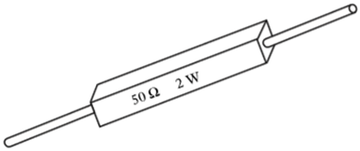
 | (a) | A resistor is labelled 50 Ω, 2 W.  Calculate the maximum operating current for this resistor. | 3
 | (b) | Two resistors, each rated at 2 W, are connected in parallel to a 9 V d.c. supply.  They have resistances of 60 Ω and 30 Ω
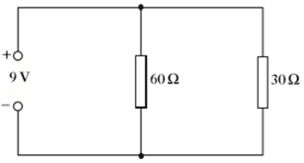
30 Ω
60 Ω
9 V
 |  | (i) Calculate the total resistance of the circuit. | 3
 |  | (ii) Calculate the power produced in each resistor. | 4
 |  | (iii) State which, if any, of the resistors will overheat. | 1
 | (c) | The 9 V d.c. supply is replaced by a 9 V a.c. supply.  Explain whether this would have any effect on your answers to part  (b) (ii). | 2

Radiation Topic
51. |  | When welders join thick steel plates it is important that the joint is completely filled with metal. This ensures there are no air pockets in the metal weld, as this would weaken the joint.  One method of checking for air pockets is to use a radioactive source on one side of the joint. A detector, placed as shown, measures the count rate on the other side.
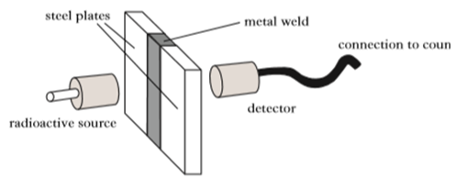
radioactive source
detector
connection to counter
metal weld
steel plates
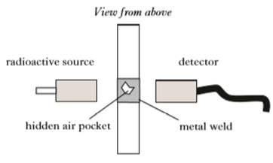
View from above
metal weld
detector
radioactive source
hidden air pocket
 | (a) | The radioactive source and detector are moved along the weld.  State and explain how the count rate would change when the detector moves over an air pocket. | 2
 | (b) | State which type of nuclear radiation alpha, beta or gamma must be used. Explain your answer. | 2
 | (c) | X-rays are sometimes used to detect air pockets.  State how the wavelength of X-rays compares to gamma rays. | 1

Radiation Topic
52. |  | Gold-198 is a radioactive source that is used to trace factory waste which may cause river pollution.  A small quantity of the radioactive gold is added into the waste as it enters the river. Scanning the river using radiation detectors allows scientists to trace where the waste has travelled.  Gold-198 has a half-life of 2·7 days.
 | (a) | State what is meant by a half-life of 2·7 days. | 1
 | (b) | A sample of Gold-198 has an activity of 64 kBq when first obtained by scientists.  Determine the activity of the sample after 13·5 days. | 2
 | (c) | State two precautions taken by the scientists to reduce the equivalent dose they receive while using radioactive sources. | 2
 | (d) | A scientist receives an absorbed dose of 10 mGy of alpha radiation.
 |  | (i) Calculate the equivalent dose received. | 3
 |  | (ii) The risk of biological harm from radiation exposure depends on the absorbed dose and the type of radiation. State two other factors which could affect biological harm. | 2

Dynamics and Electricity Topics
53. |  | A ski lift with a gondola of mass 2000 kg travels to a height of 540 m from the base station to a station at the top of the mountain.
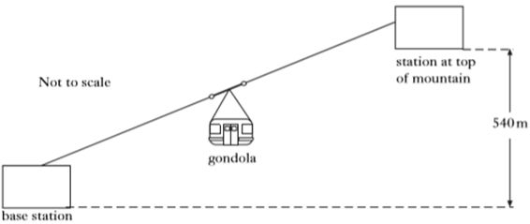
540 m
station at top of mountain
gondola
base station
Not to scale
 | (a) | Calculate the gain in gravitational potential energy of the gondola. | 3
 | (b) | During the journey, the kinetic energy of the gondola is 64 000 J.  Calculate the speed of the gondola. | 3
 | (c) | The ski lift requires a motor which operates at 380 V to take the gondola up the mountain. The maximum power produced is 45·6 kW.
 |  | (i) Calculate the maximum current in the motor. | 3
 |  | (ii) Calculate the electrical energy used by the motor when it has been operating at its maximum power for a total time of 1 hour. | 3

Dynamics Topic
54. |  | A child sledges down a hill.
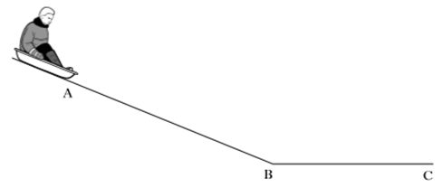
A
B
C
 |  | The sledge and child are released from rest at point A. They reach a speed of 3 ms⁻¹ at point B.
 | (a) | The sledge and child take 5 s to reach point B.  Calculate the acceleration. | 3
 | (b) | The sledge and child have a combined mass of 40 kg.  Calculate the unbalanced force acting on them. | 3
 | (c) | After the sledge and child pass point B, they slow down, coming to a halt at point C.  Explain this motion in terms of forces. | 2

Space and Dynamics Topics
55. |  | A fridge/freezer has water and ice dispensers as shown.
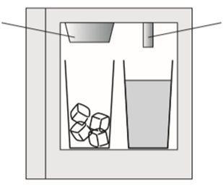
water dispenser
ice dispenser
 | (a) | Water of mass 0·1 kg flows into the freezer at 15 ºC and is cooled to  0 ºC.  Calculate the energy removed when the water cools. | 3
 | (b) | Calculate how much energy is released when 0·1 kg of water at 0 ºC changes to 0·1 kg of ice at 0 ºC. | 3
 | (c) | The fridge/freezer system removes heat energy at a rate of 125 W.
 |  | (i) Calculate the minimum time taken to produce 0·1 kg of ice from 0·1 kg of water at 15 ºC. | 4
 |  | (ii) Explain why the actual time taken to make the ice will be longer than the value calculated in question (b) (i). | 1

56. |  | A student sets up the following circuit to investigate the resistance of resistor R.
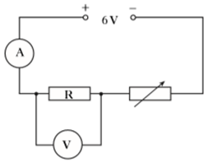
R
6 V
V
A
The variable resistor is adjusted and the voltmeter and ammeter readings are noted. The following graph is obtained from the experimental results.
Electricity Topic
 | Current (A) | 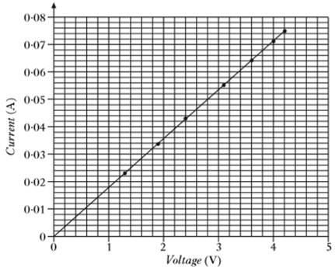  0·08  0·07  0·06  0·05  0·04  0·03  0·02  0·01  0  5  4  3  2  1  0  Voltage  (V)
 | (a) | (i) Calculate the value of the resistor R when the reading on the voltmeter is 4·2 V. | 3
 |  | (ii) Using information from the graph, state whether the resistance of the resistor R increases, stays the same or decreases as the voltage increases.  Justify your answer. | 2
 | (b) | If the current was to get too large then a fuse could be used to break the circuit. Draw the symbol for a fuse. | 1
Waves and Electricity Topics
57. |  | Parking sensors are fitted to the rear bumper of some cars. A buzzer emits audible beeps, which become more frequent as the car moves closer to an object.
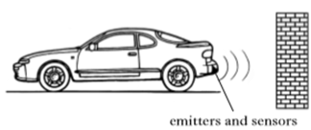
emitters and sensors

 |  | Ultrasonic pulses are emitted from the rear of the car. Objects behind the car reflect the pulses, which are detected by sensors. Ultrasonic pulses travel at the speed of sound.
 | (a) | The time between these pulses being sent and received is 2 x 10⁻³ s.  Calculate the distance between the object and the rear of the car. | 4
 | (b) | At a certain distance, the buzzer beeps every 0·125 s.  Calculate the frequency of the beeps. | 3
 | (c) | The sensor operates at a voltage of 12 V and has a current range of  20-200 mA.  Calculate the maximum power rating of the sensor. | 3
 | (d) | An LED system can be added so that it flashes at the same frequency as the beeps from the buzzer. The LED circuit is shown below.
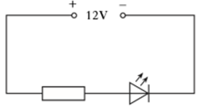
12 V

 |  | (i) A resistor is connected in series with the LED.  State the purpose of the resistor. | 1
 |  | (ii) When lit, the LED has a voltage of 3·5 V across it and a current of 200 mA.  Calculate the resistance value of the resistor. | 4

Dynamics Topic
58. |  | A balloon of mass 400 kg rises vertically from the ground.
 |  | 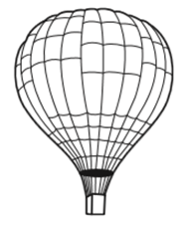
 |  | The graph shows how the vertical speed of the balloon changes during the first 100 s of its upward flight.
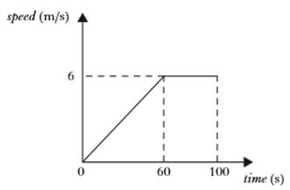
speed (ms⁻¹)
6
0
60
100
time (s)

 | (a) | Calculate the acceleration of the balloon during the first 60 s. | 3
 | (b) | Calculate the distance travelled by the balloon in 100 s. | 3
 | (c) | Calculate the average speed of the balloon during the first 100 s. | 3
 | (d) | Calculate the weight of the balloon. | 3
 | (e) | Calculate the total upward force acting on the balloon during the first  60 s of its flight. | 4

Space and Dynamics Topics
59. |  | On the planet Mercury the surface temperature at night is -173 ºC. The surface temperature during the day is 307 ºC. A rock lying on the surface of the planet has a mass of 60 kg.
 |  | 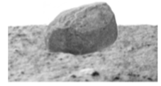
 | (a) | The rock absorbs 2·59 x 10⁷ J of heat energy from the Sun during the day.  Calculate the specific heat capacity of the rock. | 3
 | (b) | Heat is released at a steady rate of 1440 Js⁻¹ at night.  Calculate the time taken for the rock to release 2·59 x 10⁷ J of heat. | 3
 | (c) | Energy from these rocks could be used to heat a base on the surface of Mercury.  Determine how many 60 kg rocks would be needed to supply a 288 kW heating system. | 1
 | (d) | Would it be easier, the same or more difficult to lift rocks on Mercury compared to Earth?  You must explain your answer. | 2

Electricity and Waves Topics
60. |  | A student sets up the following circuit.  6 V
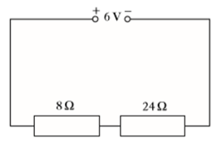
24 Ω
8 Ω
 | (a) | Calculate the current in the 8 Ω resistor. | 4
 | (b) | Calculate the voltage across the 8 Ω resistor. | 3
 | (c) | The 24 Ω resistor is replaced by one of greater resistance. How will this affect the voltage across the 8 Ω resistor?  Explain your answer. | 2
61. |  | A satellite sends microwaves to a ground station on Earth.
 |  | 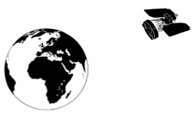
 | (a) | The microwaves have a wavelength of 60 mm.
 |  | (i) Calculate the frequency of the waves. | 3
 |  | (ii) Calculate the period of the waves. | 3
 | (b) | The satellite sends radio waves along with the microwaves to the ground station. Will the radio waves be received by the ground station before, after or at the same time as the microwaves?  Explain your answer. | 2

Waves and Electricity Topics
62. |  | At the kick-off in a football match, during the World Cup Finals, the referee blows her whistle. The whistle produces sound waves.
 | Referee | 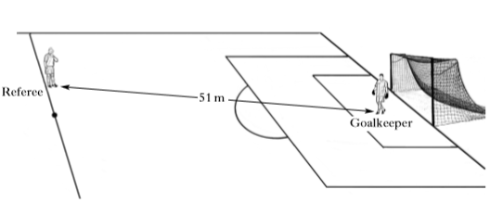  Goalkeeper  51 m
 | (a) | Using information from the diagram and the data sheet, calculate the time taken for the sound waves to reach the goalkeeper. | 3
 | (b) | (i) State whether sound waves are longitudinal or transverse. | 1
 |  | (ii) Describe the difference between transverse and longitudinal waves. | 1
 |  | (iii) State what is transferred by all waves. | 1
 | (c) | (i) Floodlights in the stadium are switched on. Each lamp has a power rating of 2·40 kW. The operating voltage is 315 V.  Calculate the resistance of a lamp. | 3
 |  | (ii) The floodlights consist of 20 lamps connected in parallel.  State two reasons why the lamps are connected in parallel. | 2

Radiation Topic
63. |  | In 1908 Ernest Rutherford conducted a number of experiments involving alpha particles.
 |  | 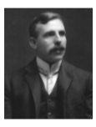
 | (a) | Describe what is meant by the term an alpha particle. | 1
 | (b) | Alpha particles produce a greater ionisation density than beta particles or gamma rays.  State what is meant by the term ionisation. | 1
 | (c) | A radioactive source emits alpha particles and has a half-life of 2·5 hours. The source has an initial activity of 4·8 kBq.  Determine the time taken for its activity to decrease to 300 Bq. | 2
 | (d) | Calculate the number of decays in the sample in two minutes, when the activity of the source is 1·2 kBq. | 3
 | (e) | Some sources emit alpha particles and are stored in lead cases despite the fact that alpha particles cannot penetrate paper. Suggest a possible reason for storing these sources using this method. | 1

Space Topic
64. |  | A cricketer strikes a ball. The ball leaves the bat horizontally at 20 m s⁻¹. It hits the ground at a distance of 11 m from the point where it was struck.
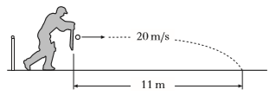
11 m
20 m s⁻¹
 |  | Assume air resistance is negligible.
 | (a) | Calculate the time of flight of the ball. | 3
 | (b) | Calculate the vertical speed of the ball as it reaches the ground. | 3
 | (c) | Sketch a graph of vertical speed against time for the ball. Numerical values are required on both axes. | 2
 | (d) | From your graph, calculate the vertical distance travelled by the ball during its flight. | 3

Dynamics, Space and Waves Topics
65. | Not to scale | A satellite moves in a circular orbit around a planet. The satellite is lined with solar cells so that it can be powered by a nearby star. The star is 7.8 x 10⁷ km away from the satellite.  star
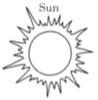
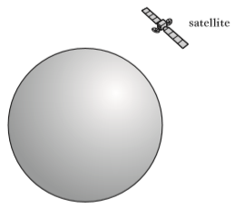
satellite
planet
 | (a) | Explain, in terms of projectile motion, why the satellite stays in orbit around the planet. | 2
 | (b) | State the energy change for a solar cell. | 1
 | (c) | Calculate the time it takes for light from the nearby star to reach the satellite. | 3
 | (d) | At one particular point in its orbit the satellite fires two rockets. The forces exerted on the satellite by these rockets are shown on the diagram below.
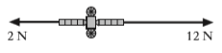
12 N
2 N
 |  | The satellite has a mass of 500 kg.  Calculate the resultant acceleration due to these forces. | 4

Dynamics and Radiation Topics
66. |  | An aircraft is flying horizontally at a constant speed.
 |  | 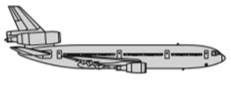
 | (a) | The aircraft and passengers have a total mass of 50 000 kg. Calculate the total weight. | 3
 | (b) | State the magnitude of the upward force acting on the aircraft. | 1
 | (c) | During the flight, the aircraft’s engines produce a force of 4·4 x 10⁴ N due North. The aircraft encounters a crosswind, blowing from west to east, which exerts a force of 3·2 x 10⁴ N.
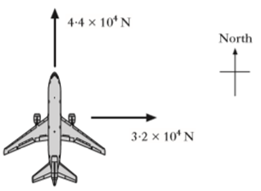
3·2 x 10⁴ N
4·4 x 10⁴ N
North
 |  | By scale drawing or otherwise, determine the resultant force on the aircraft. | 4
 | (d) | During a particular flight, a pilot received an absorbed dose of 15 µGy from gamma rays.  Calculate the equivalent dose received due to this type of radiation. | 3
 | (e) | Gamma radiation is an example of radiation which causes ionisation.  State what is meant by the term ionisation. | 1

Space and Dynamics Topics
67. |  | An experiment was carried out to determine the specific heat capacity of water. The energy supplied to the water was measured by a joulemeter.
 | thermometer | 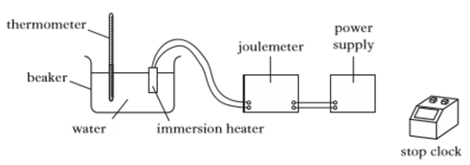  stop clock  power supply  joulemeter  immersion heater  water  beaker
The following data was recorded.
Initial temperature of the water = 21 ºC.
Final temperature of the water = 33 ºC.
Initial reading on the joulemeter = 12 kJ.
Final reading on the joulemeter = 120 kJ.
Mass of water = 2·0 kg.
Time = 5 minutes.
 | (a) | (i) Determine the change in temperature of the water. | 1
 |  | (ii) Determine the energy supplied by the immersion heater. | 1
 |  | (iii) Calculate the value for the specific heat capacity of water obtained from this experiment. | 3
 | (b) | (i) The accepted value for the specific heat capacity of water is quoted in the table in the Data Sheet.  Explain why there is a difference between the accepted value and the value obtained in the experiment. | 2
 |  | (ii) Identify a factor that could improve the experiment to reduce this difference. | 1
 | (c) | Calculate the power rating of the immersion heater. | 3

Electricity Topic
68. |  | Light emitting diodes (LEDs) are often used as on/off indicators on televisions and computers.  An LED is connected in a circuit with a resistor R.
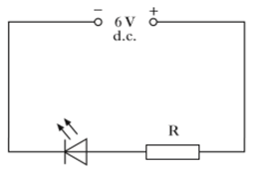
6 V
d.c.
R
 | (a) | State the purpose of the resistor R. | 1
 | (b) | The LED is rated at 2 V, 100 mA. Calculate the resistance of resistor R. | 4
 | (c) | Calculate the power developed by resistor R when the LED is working normally. | 3
 | (d) | State what is meant by the term power. | 1
 | (e) | State two factors which could prevent the LED from working in this circuit. | 2

Electricity and Waves Topics
69. |  | A solar cell is tested for use in a buggy.
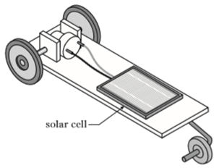
solar cell
 |  | The solar cell produces a voltage of 0·5 V and a current of 0·4 mA.
 | (a) | (i) Calculate the power produced by the solar cell. | 3
 |  | (ii) The buggy requires 0·8 x 10⁻² W to operate.  Determine the number of solar cells required to supply this power. | 1
 | (b) | State the energy change in a solar cell. | 1
 | (c) | The solar cell is illuminated by light of frequency 6·7 x 10¹⁴ Hz.  Calculate the wavelength of this light. | 3

Waves and Electricity Topics
70. |  | The Sun produces electromagnetic radiation. The electromagnetic spectrum is shown below in order of increasing wavelength. Two radiations P and Q have been left out.
 | Gamma rays | 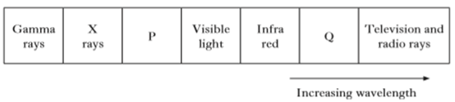  TV and radio rays  Increasing wavelength  Q  Infra-  red  Visible  light  P  X  rays
 | (a) | (i) Identify radiations P and Q. | 2
 |  | (ii) The planet Neptune is 4·5 x 10⁹ km from the Sun.  Calculate the time taken for radio waves from the Sun to reach Neptune. | 3
 |  | (iii) State what happens to the frequency of electromagnetic radiation as the wavelength increases. | 1
 | (b) | The Sun produces a solar wind consisting of charged particles. In one particular part of the solar wind, a charge of 360 C passes a point in space in one minute.  Calculate the current at this point in space. | 3

71. |  | It is possible to determine the age of a prehistoric wooden boat by measuring the activity of radioactive carbon-14.
 |  | 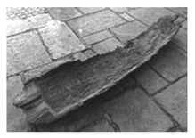
 |  | The activity of the piece of wood shown in the image above is measured to be 300 µBq.
 | (a) | Calculate the number of carbon-14 atoms that decay in one day. | 3
 | (b) | When the boat was carved, the activity of the piece of wood shown in the image was 2400 µBq due to carbon-14 atoms. The half-life of carbon-14 is 5700 years.  Determine the number of years that have passed since the piece of wood was first carved. | 2
 | (c) | Carbon-14 emits beta particles.  Describe what is meant by a beta particle. | 1
 | (d) | State which type of radiation is the most ionising. | 1
 | (e) | (i) A student sets up and experiment as shown below.
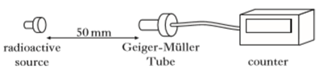
Geiger-Müller
Tube
50 mm
radioactive source
counter
 |  | The student places a 3 mm sheet of aluminium between the radioactive source and the Geiger-Müller Tube. The count rate is observed to decrease and the student concludes that the radioactive material is emitting beta radiation.  Suggest one reason why her conclusion may be incorrect. | 1
 |  | (ii) State two saftey precautions that the student should follow when handling radioactive source. | 2
Radiation Topic
Dynamics Topic
72. |  | A car of mass 700 kg travels along a motorway at a constant speed. The driver sees a traffic hold-up ahead and performs an emergency stop. A graph of the car’s motion is shown, from the moment the driver sees the hold-up.
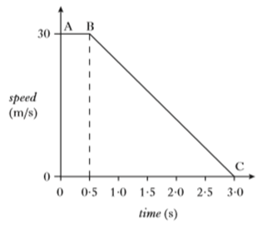
3·0
2·5
2·0
1·5
1·0
0·5
0
0
speed (m s⁻¹)
30
B
A
C
time (s)
 | (a) | Describe and explain, in terms of forces, the motion of the car between A and B. | 2
 | (b) | Calculate the kinetic energy of the car at B. | 3
 | (c) | Calculate the magnitude of the unbalanced force required to bring the car to rest between B and C. | 4

Dynamics and Space Topics
73. |  | A student reproduces Galilleo’s famous experiment by dropping a solid copper ball of mass 0·50 kg from a balcony on the Leaning Tower of Pisa.
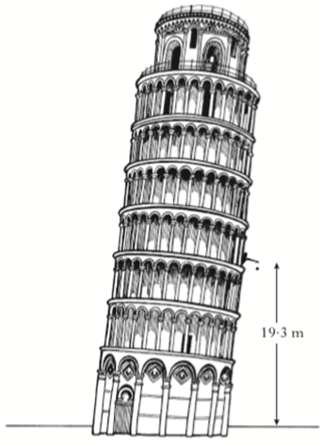
19·3 m
 | (a) | (i) The ball is released from a height of 19·3 m.  Calculate the gravitational potential energy lost by the ball. | 3
 |  | (ii) Assuming that all of this gravitational potential energy is converted into heat energy in the ball, calculate the increase in the temperature of the ball just as it reaches the ground. | 3
 |  | (iii) Is the actual temperature change of the ball greater than, the same as or less than the value calculated in part (a)(ii)?  You must explain your answer. | 2
 | (b) | The ball has moulded into its shape by melting 0·50 kg of copper at its melting point.  Calculate the amount of heat energy required for this. | 3

Radiation Topic
74. |  | A technician checks the count rate of a radioactive source. A graph of count rate against time for the source is shown. The count rate has been corrected for background radiation.
 | count rate (counts per minute) | 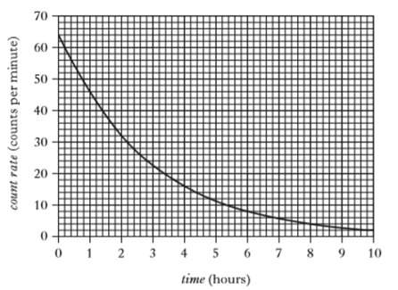  70  60  50  40  30  20  10  10  9  8  7  6  5  4  3  2  1  0  0  time (hours)
 | (a) | Use the graph to determine the half-life of the source. | 1
 | (b) | Determine the time it takes for the count rate to decreases to 1 count per minute. | 2
 | (c) | State two factors which can affect the background radiation level. | 2
 | (d) | The source emits gamma rays.  State what is meant by a gamma ray. | 1
 | (e) | State two safety precautions the technician would need to take when handling or storing the radioactive sources. | 2

Radiation Topic
75. |  | An ageing nuclear power station is being dismantled.
 |  | 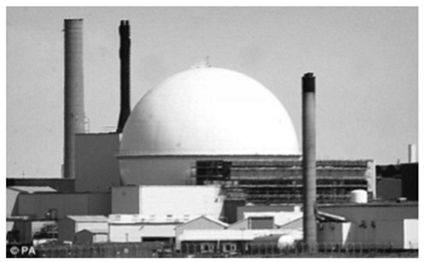
 | (a) | During the dismantling process a worker comes into contact with an object that emits 24 000 alpha particles in five minutes. The worker's hand has a mass of 0·50 kg and absorbs 6·0 μJ of energy.
 |  | Calculate:  (i) the absorbed dose received by the worker's hand; | 3
 |  | (ii) the equivalent dose received by the worker's hand; | 3
 |  | (iii) the activity of the object. | 3
 | (b) | Inside the power station, a nuclear reactor has a containment vessel around it which acts like a shield.
 |  | (i) State the purpose of the containment vessel. | 1
 |  | (ii) State a suitable material that the containment vessel should be constructed out of.  Explain your answer. | 2
 | (c) | In a nuclear power station's reactor, uranium nuclei are bombarded with neutrons, causing the uranium nuclei to split into smaller nuclei and also causing energy to be released.  State the name of this type of nuclear reaction. | 1

Space Topic
76. |  | In a TV game show contestants are challenged to run off a horizontal platform and land in a rubber ring floating in a swimming pool.  The platform is 2·8 m above the water surface.
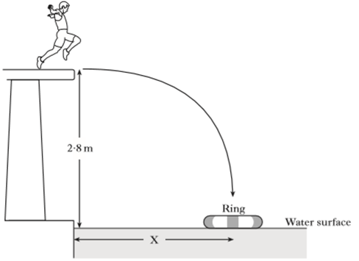
ring
water surface
poolside
X
2·8 m
 | (a) | A contestant has a mass of 60 kg.  He runs off the platform with a horizontal velocity of 2 m s⁻¹. He takes 0·75 s to reach the water surface in the centre of the ring.
 |  | (i) Calculate the horizontal distance X from the poolside to the centre of the ring. | 3
 |  | (ii) Calculate the vertical velocity of the contestant as he reaches the water surface. | 3
 | (b) | Another contestant has a mass of 80 kg.  Will she need to run faster, slower or at the same horizontal speed as the first contestant to land in the ring?  You must justify your answer. | 2

Electricity, Space and Waves Topics
77. |  | The rating plate on a microwave oven shows the following data.
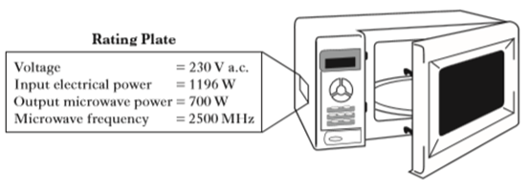
Voltage = 230 V a.c.
Input electrical power = 1196 W
Output microwave power = 700 W
Microwave frequency = 2500 MHz
Rating plate
 | (a) | State what is meant by the term voltage. | 1
 | (b) | (i) Calculate the input current. | 3
 |  | (ii) The microwaves is used to heat a cup of milk for 1 minute 30 seconds.  Calculate how much electrical charge passes into the microwave in this time. | 3
 |  | (iii) The milk of mass 0·25 kg absorbs 48 kJ of energy during the heating process. The specific heat capacity of milk is 3900 J kg⁻¹ ºC⁻¹.  Calculate the temperature rise in the milk. | 3
 | (c) | Calculate the wavelength of the microwaves. | 3

Electricity Topic
78. |  | An overhead projector contains a lamp and a motor that operates a cooling fan.  A technician has a choice of two lamps to fit in the projector.
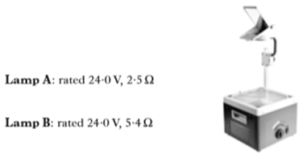
Lamp B: rated 24·0 V, 5·4 Ω
Lamp A: rated 24·0 V, 2·5 Ω
 | (a) | State which lamp gives a brighter light when operating at the correct voltage.  Explain your answer. | 2
 | (b) | Calculate the power developed by lamp A when it is operating normally. | 3
 | (c) | The overhead projector plug contains a fuse.  (i) Draw the circuit symbol for a fuse. | 1
 |  | (ii) State the purpose of the fuse. | 1
 | (d) | The technician builds a test circuit containing a resistor and a motor, as shown in Circuit 1.
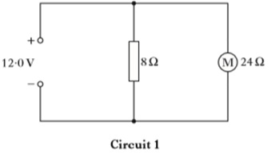
24 Ω
8 Ω
M
Circuit B
12·0 V
 |  | (i) State the voltage across the motor. | 1
 |  | (ii) Calculate the combined resistance of the resistor and the motor. | 3
78. | (e) | The resistor and the motor are now connected in series, as shown in Circuit 2.
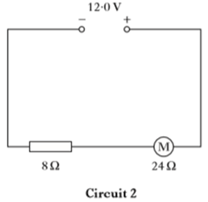
M
12·0 V
8 Ω
24 Ω
Circuit 2
 |  | State how this affects the speed of the motor compared to Circuit 1.  Explain your answer. | 2

Dynamics Topic
79. |  | In a rowing event a boat moves off in a straight line.
 |  | 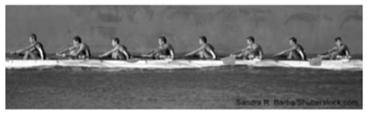
 |  | A graph for the boat's motion is shown.
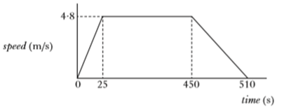
0
25
450
510
4·8
speed (m s⁻¹)
time (s)
 | (a) | (i) Calculate the acceleration of the boat during the first 25 s. | 3
 |  | (ii) Describe the motion of the boat between 25s and 450s. | 1
 |  | (iii) Draw a diagram showing the horizontal forces acting on the boat between 25 s and 450 s.  You must name these forces and show their direction. | 2
 | (b) | The boat comes to rest after 510 s.
 |  | From the speed-time graph above calculate:  (i) the total distance travelled by the boat; | 3
 |  | (ii) the average speed of the boat. | 3

Dynamics Topic
80. |  | An arrow is fired at a target.
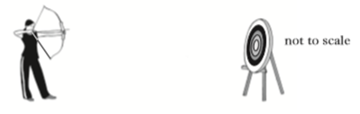
not to scale
 |  | The average forward force on the arrow is 500 N. The average frictional force acting on the arrow is 15 N. The arrow has a mass of 0·20 kg.
 | (a) | Calculate the average acceleration of the arrow when fired. | 4
 | (b) | The arrow hits the target and accelerates at -3600 ms⁻² before coming to rest in 12 x 10⁻³ s.  (i) State why the acceleration is a negative value. | 1
 |  | (ii) Calculate the initial velocity of the arrow just before it hits the target. | 3
 | (c) | A second arrow of mass 0·10 kg is now fired at the target with the same average forward force and the same average frictional force.  Is the time taken for the second arrow to reach the target more than, less than or the same as the time taken for the first arrow to reach the target?  You must justify your answer. | 2

Electricity and Waves Topics
81. |  | The circuit shown is used to investigate the relationship between voltage and current for a filament lamp.  6·0 V
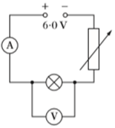
A
V
 | (a) | State the energy transformation in the filament lamp. | 1
 | (b) | The variable resistor is altered and reading of current and voltage are taken. These values are plotted on the graph shown.  6·0
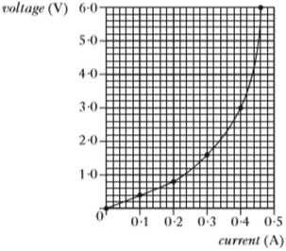
1·0
Current (A)
5·0
4·0
3·0
2·0
0·5
0·4
0·3
0·2
0·1
0
0
Voltage (V)
 |  | (i) Calculate the resistance of the filament lamp when the current is 0·4 A. | 3
 |  | (ii) What happens to the resistance of the filament lamp as the voltage across it increases?  You must justify your answer. | 2
 | (c) | In many modern electronic systems LEDs are used instead of filament lamps.
 |  | (i) Using a 6·0 V supply, a 2·0 V LED and one other suitable component, draw a circuit that would let the LED light. | 2
 |  | (ii) A red LED emits light of wavelength 6·0 x 10⁻⁷ m.  Calculate the frequency of this light. | 3
Radiation Topic
82. |  | An airport worker passes suitcases through an X-ray machine.
 |  | 
 | (a) | The worker has a mass of 80 kg and on a particular day absorbs 7·2 mJ of energy from the X-ray machine in a time of 4 hours.
 |  | (i) Calculate the absorbed dose received by the worker. | 3
 |  | (ii) The radiation weighting factor for X-ray radiation is 1.  Calculate the equivalent dose received by the worker. | 3
 |  | (iii) Calculate the equivalent dose rate. | 3
 | (b) | X-rays can cause ionisation.  State what is meant by the term ionisation. | 1

Properties of Matter Topic
83. |  | Air is trapped in a syringe. The syringe of trapped air is set up with other apparatus as shown.  tablet display
 | water | 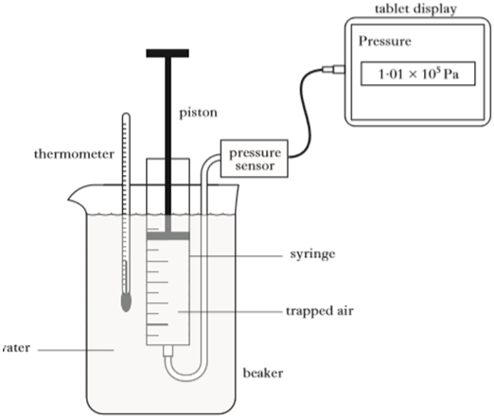  1·01 x 10⁵ Pa  Pressure  thermometer  piston  pressure  sensor  syringe  trapped air  beaker
 | (a) | The trapped air is at a temperature of 20 ºC, a pressure of 1·01 x 10⁵ Pa and its volume is 5·00 x 10⁻⁴ m³.  The piston on the syringe is now pushed in until the volume of the trapped air is reduced to 1·25 x 10⁻⁴ m³.  The temperature of the trapped air remains constant.  (i) Calculate the pressure of the trapped air when its volume is 1·25 x 10⁻⁴ m³. | 3
 |  | (ii) Use the kinetic model to explain what happens to the pressure of the trapped air as its volume is decreased. | 3
 | (b) | The temperature of the trapped air is now increased to 40 ºC.  The volume is kept constant at 1·25 x 10⁻⁴ m³.  Calculate the new pressure of the gas after this increase in temperature. | 3

Properties of Matter Topic
84. |  | A student invesitgates the relationship between the pressure and the temperature of a fixed mass of gas using the apparatus shown.  pressure sensor
 | temperature sensor  oil  beaker | 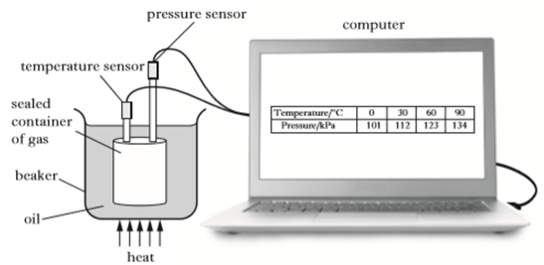  sealed container of gas  heat  computer
A sealed container of gas is submerged in a beaker of oil.
The volume of the container remains constant during the experiment.
The oil is heated slowly and readings of the temperature and pressure of the gas are recorded. The results are shown in the table.
Temperature (ºC) | 0 | 30 | 60 | 90
Pressure (kPa) | 101 | 112 | 123 | 134

 |  | [Question continues on the next page]

84. |  | The student uses these results to produce the following graph.
 | Pressure in kPa | 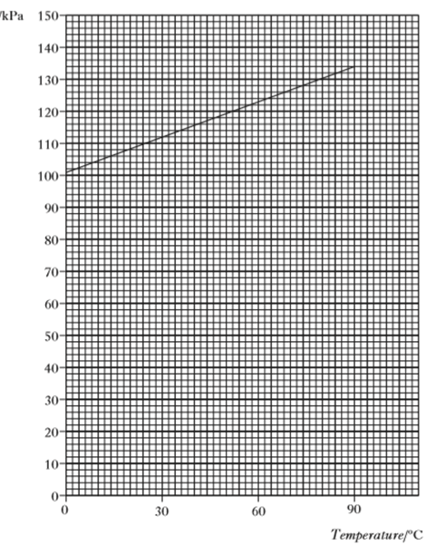  Temperature in ºC  10  20  30  40  50  60  70  80  90  100  110  120  130  140  150  90  60  30  0  0
 | (a) | The student comes to the conclusion that the pressure is not directly proportional to the temperature of the gas in degrees celsius.  Explain, with reference to the graph, why the student is correct. | 2
 | (b) | The temperature of the gas is increased to 170 ºC.  Calculate the pressure of the gas at this temperature. | 3
 | (c) | The gas is now allowed to cool.  Use the kinetic model to explain what happens to the pressure of the gas as its temperatures decreases. | 3

Properties of Matter and Dynamics Topics
85. |  | The cylinder of a bicycle pump has a length of 360 mm as shown in the diagram.  The outlet of the pump is sealed.  The piston is pushed inwards until it is 160 mm from the outlet.  final position of piston
 | sealed  outlet | 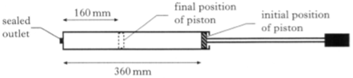  initial position of piston  360 mm  160 mm
 | (a) | The initial pressure of the air in the pump is 1·0 x 10⁵ Pa.  (i) Assuming that the temperature of the air trapped in the cylinder remains constant, calculate the final pressure of the trapped air. | 3
 |  | (ii) State one other assumption you have made for this calculation. | 1
 |  | (iii) Use the kinetic model to explain what happens to the pressure of the trapped air as its volume decreases. | 3
 | (b) | The piston is let go of, causing it to accelerate away from the outlet.  Explain, in terms of forces, why the piston accelerates away. | 1

Properties of Matter Topic
86. |  | A technician designs the apparatus shown in the diagram to investigate the relationship between the temperature and pressure of a fixed mass of nitrogen gas. The volume of the gas remains constant.  pressure gauge
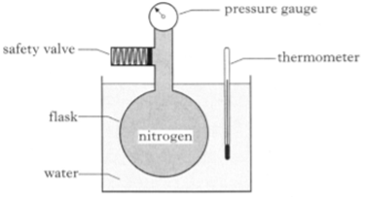
safety valve
water
flask
thermometer
nitrogen
 | (a) | The pressure of the nitrogen is 109 kPa when its temperature is 15 ºC.  The temperature of the nitrogen rises to 45 ºC.  Calculate the new pressure of the nitrogen in the flask. | 3
 | (b) | Use the kinetic model to explain what happens to the pressure of the nitrogen as its temperature is increased. | 3
 | (c) | The technician has fitted a safety valve to the apparatus.  A diagram of the valve is shown below.
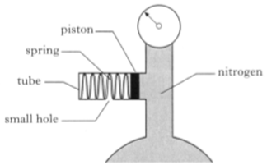
nitrogen
small hole
tube
spring
piston
 |  | The piston of cross-sectional area 4·0 x 10⁻⁶ m² is attached to the spring. The piston is free to move along the tube.
 |  | The following graph shows how the length of the spring varies with the force exerted by the nitrogen on the piston.
 |  | [Question continues on the next page]

86.  force exerted by the nitrogen on the piston (N) |  | 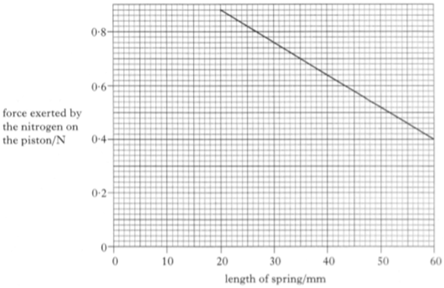  length of spring (mm)  0·8  0·6  0·4  0·2  0  0  10  20  30  40  50  60
 |  | (i) Calculate the force exerted by the nitrogen on the piston when the reading on the pressure gauge is 1·75 x 10⁵ Pa. | 3
 |  | (ii) State the length of the spring in the safety valve when the pressure of the nitrogen is 1·75 x 10⁵ Pa. | 1
 | (d) | The technician decides to redesign the apparatus so that the bulb of the thermometer is placed inside the flask.  Give one reason why this improves the design of the apparatus. | 1

Properties of Matter and Electricity Topics
87. |  | A technician designs the following apparatus to investigate the pressure of a gas at different temperatures.
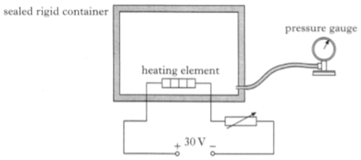
sealed rigid container
30 V
heating element
pressure gauge
 |  | The heating element is used to raise the temperature of the gas.
 | (a) | Initially the gas is at a pressure of 1·56 x 10⁵ Pa and a temperature of 27 ºC. The temperature of the gas is then raised by 50 ºC.  Calculate the new pressure of the gas in the container. | 4
 | (b) | At a particular point in the investigation the voltage across the variable resistor is 10 V and the current passing through it is 2A.  Calculate the power of the heater at this point in the investigation. | 4
 | (c) | The heating element is switched off by turning off the power supply.  The gas inside the container begins to cool down in temperature.  Use the kinetic model to explain what happens to the pressure of the gas as its temperature decreases. | 3

Properties of Matter Topic
88. |  | The apparatus used to investigate the relationship between volume and temperature of a fixed mass of air is shown.
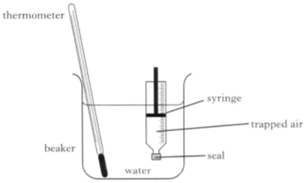
beaker
trapped air
syringe
water
seal
thermometer
The volume of the trapped air is read from the scale on the syringe.
The temperature of the trapped air is altered by heating the water in the beaker. It is assumed that the temperature of the air in the syringe is the same as that of the surrounding water. The pressure of the trapped air is constant during the investigation.
 | (a) | Readings of volume and temperature for the trapped air are shown.
Temperature (ºC) | 25 | 50 | 75 | 100
Volume (ml) | 20·6 | 22·6 | 24·0 | 25·4

 |  | (i) Using all the data, establish the relationship between temperature and volume for the trapped air. | 3
 |  | (ii) Calculate the volume of the trapped air when its temperature is 65 ºC. | 3
 | (b) | Use the kinetic model of gases to explain the change in volume as the temperature increases in this investigation. | 3

Properties of Matter and Electricity Topics
89. |  | A refrigerated cool box is being prepared to carry medical supplies in a hot country.  The internal dimensions of the box are 0·30 m x 0·20 m x 0·50 m.  release valve
 | Not to scale | 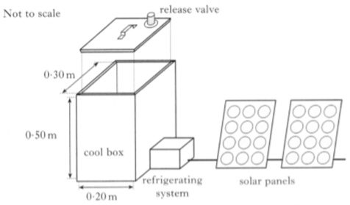  lid  0·20 m  0·50 m  0·30 m  cool box  refrigerating system  solar panels
 | (a) | The lid is placed on the cool box with the release valve closed. An airtight seal is formed. When the lid is closed the air inside the cool box is at a temperature of 33 ºC and a pressure of 1·01 x 10⁵ Pa.  The refrigerating system then reduces the temperature of the air inside the cool box until it reaches its working tempertature.  At this temperature the air inside is at a pressure of 9·05 x 10⁴ Pa.
 |  | (i) Calculate the temperature of the air inside the cool box when it is at its working temperature. | 3
 |  | (ii) Using the kinetic model, explain what happens to the air pressure inside the cool box when the temperature decreases. | 3
 | (b) | Atmospheric pressure (outside of the cool box) is 1·01 x 10⁵ Pa.  Show that the magnitude of the force on the lid due to the difference in air pressure between the inside and outside of the cool box is now  630 N. | 3
 | (c) | The refrigerating system requires an average current of 0·80 A at 12 V.  Each solar panel has a power output of 3·4 W at 12 V.  Calculate the minimum number of solar panels needed to operate the refrigerating system. | 4
Properties of Matter Topic
90. |  | A student is training to become a diver.
 |  | The student carries out an experiment to investigate the relationship between the pressure and volume of a fixed mass of gas using the apparatus shown.
 | piston | 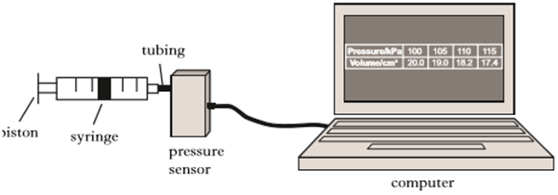  pressure sensor  computer  tubing  syringe
The pressure of the gas is recorded using a pressure sensor connected to a computer. The volume of the gas is also recorded. The student pushes the piston to alter the volume and a series of readings is taken. The temperature of the gas is constant during the experiment.
The results are shown.
Pressure (kPa) | 100 | 105 | 110 | 115
Volume (cm³) | 20·0 | 19·0 | 18·2 | 17·4

 | (a) | Using all the data, establish the relationship between the pressure and volume of the gas. | 3
 | (b) | Use the kinetic model to explain the change in pressure as the volume of the gas decreases. | 3

Properties of Matter Topic
91. |  | A student carries out an experiment to investigate the relationship between the pressure and temperature of a fixed mass of gas. The apparatus used is shown.  pressure sensor
 | stopper  temperature sensor  water bath  fixed mass of gas | 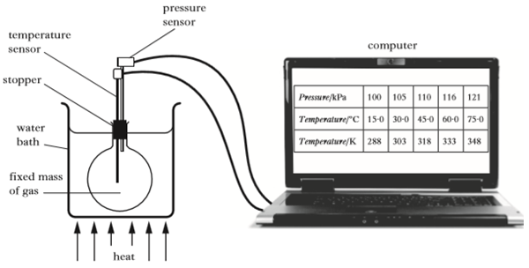  computer  heat
The pressure and temperature of the gas are recorded using sensors connected to a computer. The gas is heated slowly in the water bath and a series of readings is taken.
The volume of the gas remains constant during the experiment.
The results are shown.
Pressure (kPa) | 100 | 105 | 110 | 116 | 121
Temperature (ºC) | 15·0 | 30·0 | 45·0 | 60·0 | 75·0
Temperature (K) | 288 | 303 | 318 | 333 | 348

 | (a) | Using all the relevant data, establish the relationship between the pressure and the temperature of the gas. | 3
 | (b) | Use the kinetic model to explain the change in pressure as the temperature of the gas increases. | 3
 | (c) | Explain why the level of water in the water bath should be above the bottom of the stopper. | 1

Open-Ended
92. |  | A girl holds a tennis ball and a heavier cricket ball in her hands. She holds each one at the same height over the edge of a pier. She states that the cricket ball will hit the water below first and with a greater velocity than the tennis ball. She then releases the balls.  Using your knowledge of Physics, comment on the above situation and the girl’s statement. | 3
93. |  | A fisherman and his daughter bob up and down in their boat on a clear, moon-lit night. Light from distant stars shines off the surrounding sea. “Look, a shooting star!” calls out the daughter as a flash of light tears across the sky before disappearing into nothingness.  Using your knowledge of Physics, comment on the fisherman and his daughter’s experience. | 3
94. |  | An astronomer and a particle physicist are out for lunch. The astronomer says to the particle physicist, “You know, there isn’t much difference between how a solar system works and how particles in an atom work.”  Using your knowledge of Physics, comment on the astronomer’s statement. | 3
95. |  | A train is travelling along a track at 80 mph. A sudden call comes through to the driver warning her that the track ahead is blocked by a land-slide. The driver emergency stops and comes to rest some time later.  Using your knowledge of Physics, comment on the train’s emergency stop. | 3
96. |  | A ship is sinking far out at sea in the middle of the night. The captain has three choices to send out a distress sign. He can sound his fog-horn, shoot a flare high into the sky or send out a radio signal.  Using your knowledge of Physics, comment on the suitability of the distress signs available. | 3
97. |  | Some teachers sign up to do a charity sky-dive. As a homework task, pupils are asked to write a report on the Physics involved from the moment the teachers leave the plane to the moment they land.  Using your knowledge of Physics, comment on what pupils could include in their reports. | 3
98. |  | A nuclear power station goes into meltdown and a huge explosion releases tons of radioactive waste into the atmosphere. A team of experts are sent in to limit the harm caused.  Using your knowledge of Physics, comment on the above situation. | 3
99. |  | 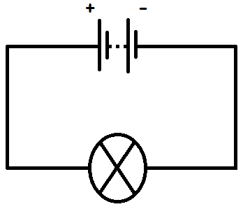  A pupil sets up the above circuit. She aims to come up with ways of making the bulb more or less powerful.  Using your knowledge of Physics, explain how the pupil could accomplish her aim. | 3
100 |  | A student at school inflates a balloon with helium gas. The temperature of the gas in the school is 20 ºC. The student then ties the balloon up outside.  When he goes back to check on it a few hours later the balloon has shrunk in volume.  Using your knowledge of Physics, comment on the above situation. | 3

