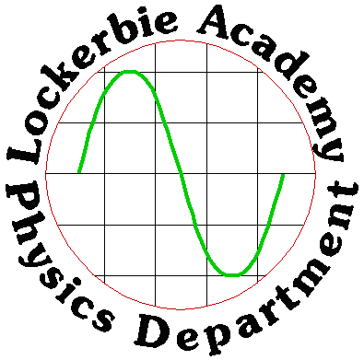
2018
Miss Horn
Lockerbie Academy
2/14/2018

N5: RADIATION NOTES

N5 Physics Data Sheet

Acknowledgements
With thanks to John Sharkey of Flashlearning for images from the Virtual Physics ranges.
Thanks also to George Watson’s College for their notes.
Thanks to student Adam Pritchard for his sources of background radiation pie chart.
Relationships sheet
The formulae highlighted are those required for this unit

Structure of the Atom and Ionising Radiation

Learning Intentions
- Knowledge of the nature of alpha, beta and gamma radiation,
- The relative effect of their ionisation, and their relative penetration.

The Atom
Before we can understand ionising radiation, which originates from the nucleus of atoms we must have an idea of the structure of the atom.
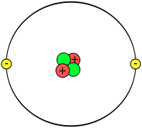
electron
proton
neutron
nucleus

- The neutrons and the protons are in the centre or nucleus of the atom.
- The electrons are moving around the nucleus.
- A proton has a positive charge. (p)
- An electron has a negative charge.(e)
- A neutron is uncharged.(n)
Normally the atom has no overall charge. It is said to be neutral because the number of protons in the nucleus is equal to the number of electrons in the orbits.

Task
Answer the following questions in your jotter
- Draw a labelled diagram of the atom, (make sure your atom is neutral) and clearly labelling the following parts
nucleus, proton, neutron, electron, positive charge,
negative charge, neutral charge,
- Copy and complete the paragraphs below filling in the missing words. This will form a summary of the structure of the atom.
___________ make up all materials. There are ______ parts to atoms. They are called ___________ , ____________, and _____________ . The ____________ are positively charged. The _________ are negatively charged and the __________ have no charge. The centre of the atom is called the ____________ . This contains the _____________ and _____________ . The ___________ move round the centre of the atom. Atoms usually have _________ charge and are called ____________ because the number of _______________ in the nucleus is equal to the number of electrons in the orbits.

Nuclear Radiation
Everything in nature prefers to be in a stable state of minimum energy. The unstable nuclei are unstable because they have too much energy. They get rid of this energy by emitting some form of radiation (either particles or electromagnetic waves). This radiation is nuclear radiation because it comes from the nucleus of an atom. These atoms are said to be radioactive
Nuclear radiation can come from natural sources such as cosmic rays and naturally occurring radioactive materials such as uranium. It can also come from artificial sources such as man-made radioisotopes such as plutonium.
Nuclear radiation can be used in medicine to sterilise instruments by killing germs and bacteria. It can also be used to kill the cells which make up a cancerous tumour. Nuclear radiation can also be used to examine the body through using radioactive materials in something called a tracer. This is a substance that is injected into the body and detected to analyse its progress through the body.
There are some atoms which have unstable nuclei. (Nuclei is the plural of nucleus)

Types of Radiation
We will look at three different types of nuclear radiation: alpha, α, beta β and gamma δ

Alpha Particles
An alpha particle consists of two protons and two neutrons. They have the same structure as a helium nucleus, so we can write it down as ${}_{2}^{4}{He}$
The top number 4 is the total number of protons and neutrons (or nucleons- things in the nucleus) and the bottom number is the number of protons. If we take the bottom number from the top number it will give us the number of neutrons.

Beta Particles
A beta particle is an electron which comes from the nucleus. But there aren’t any electrons in the nucleus so where do these come from? A neutron changes into a proton and an electron
$${}_{0}^{1}n→{}_{1}^{1}p+{}_{-1}^{0}e$$
Neutron → proton + electron

Gamma Radiation
Gamma rays are not particles but high energy electromagnetic radiation. Gamma rays carry excess energy from the nucleus. There is no change in the atomsic structure before and after the emission of gamma rays unlike the other two particles where new atoms are formed.

IONISATION
There are some atoms which have unstable nuclei which throw out particles to make the nucleus more stable in the materials through which they pass. These atoms are called radioactive. The particles thrown out cause ionisation and are called ionising radiations.
There are three types of ionising radiation: Alpha beta and gamma. Energy may be absorbed from alpha, beta or gamma by the material. When an alpha particle collides with an atom an electron can be “knocked off”. The alpha particle transfers energy to the electron and the alpha particle slows down.
A cloud chamber can be used to investigate the ionisation density. This is the ionisation produced for each mm along the path.
http://www.furryelephant.com/player.php?subject=physics&jumpTo=re/11Ms3

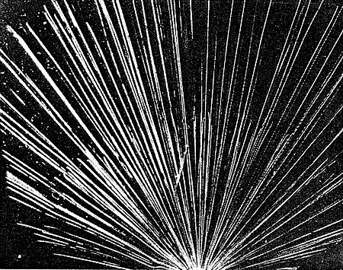
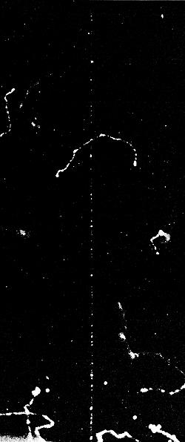
Alpha particle tracks showing their short range Note that there are two lots of alpha particles, one with a shorter range than the other.

Beta particle tracks
One fast particle crosses the tracks of several slow ones.
Alpha particles produce short thick tracks in a cloud chamber as they attract electrons from the air molecules. Beta particles are much smaller and are less likely to be deflected. The lines produced by beta in a cloud chamber are more scattered. Gamma rays have no mass and there is little interaction with the air and produce no trace in a cloud chamber.
The process by which nuclear radiation damages cells is known as ionization. This is where electrons are stripped from their atoms. Alpha radiation is far more ionising than beta or gamma radiation, we say alpha particles produce greater ionisation density than beta particles or gamma radiation.
Ionisation is the gaining or losing of electrons from atoms.

Absorption of Ionising Radiation

Teacher Demonstration: Absorption of Radiation
Aim: To determine the absorption ability of alpha, beta and gamma radiations
Apparatus: Geiger Muller Tube, alpha, beta and gamma sources, counter or ratemeter, paper, thick and thin aluminium sheet, thin and thick lead sheets/
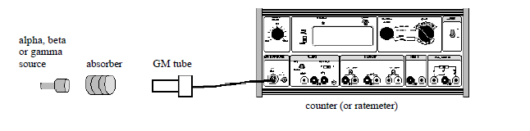

Instructions
Copy the table
Absorber/  Source | No absorber | Paper | Thin  Al | Thick Al | Thin Pb | Thick Pb
Alpha source
Beta Source
Gamma Source

- Watch the demonstration and complete the table
- Record your conclusions from the results
Alpha, beta and gamma require different materials to absorb them.
Alpha particles are absorbed by a thin sheet of paper. Beta particles are absorbed by a few mm of aluminium and gamma rays required several cm of lead or several metres of concrete to absorb most of them.
Alpha particles transfer energy to the air by causing ionisation during collisions. The range of alpha particles in air is a few cm. The range of beta particles in air is a few metres. Gamma rays are only very slightly absorbed by air.



Summary

type of radiation | symbols |  | nature | absorbed by
alpha | α | $${}_{2}^{4}{He}$$ | two protons and two neutrons (helium nucleus) | sheet of paper, few cm of air
beta | β | $${}_{-1}^{0}e$$ | fast-moving electron | few cm of aluminium
gamma | γ |  | electromagnetic wave | most few m of lead

TASK
Answer the following questions in your jotter

Ionising radiations
- Using a diagram, describe the simple model of an atom.

- Copy and complete the table, showing the structure of the atom.
Name | Charge | Inside or outside nucleus
neutron
 |  | outside
 | positive

- Copy and complete the following table, showing the properties of the nuclear radiations.
Radiation type | Range (give an approximate distance) | Stopped by | Ionisation level (high/med/low)
alpha |  | air
beta |  |  | medium
gamma | infinite

- When radiation passes through a material it can ionise the atoms of that material. Explain what is meant by the ionisation of atoms.

- Explain the term ionisation.
- In an experiment, radiation from a sample of radium is passed through an electric field. It is split into three different components (as shown in the diagram below).

(a) Name the radiations labelled (i), (ii) and (iii).
(b) Which radiation is deflected most by the electrostatic field?
(c) What is the function of the lead shield?
(d) Why is the experiment carried out in an evacuated chamber?
(e) What is the purpose of the photographic film?

- The brain can suffer from cancer called glioblastoma. This form of cancer is treated by injecting the patient with boron-10 and then irradiating the patient with neutrons. This produces two particles lithium and an alpha particle.
(a) Explain how the alpha particle could help with the glioblastoma.
(b) Why could this process be dangerous for healthy tissue?

- Two radioactive sources are fired at different absorbing materials as shown below. Name the types of radiation X & Y.
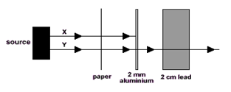
- The table below represents data obtained from an absorption experiment using three separate radioactive sources (background count = 20 counts per minute).
 | Count Rate (counts per minute)
Absorber | Source A | Source B | Source C
air | 3125 | 900 | 420
paper | 3130 | 880 | 38
1 mm aluminium | 3000 | 380 | 20
10 mm lead | 1900 | 20 | 21

(a) What effect did paper have on each of the three sources?
(b) Use the data in the table to try to identify the type of radiation from each source.

Success Criteria
20.1 | I understand the nature of alpha, beta and gamma radiation: including the relative effect of ionization, their relative penetration.
20.2 | I can explain the term ‘ionisation’ as the gaining or losing of electrons from (neutral) atoms
20.3 | I can state that alpha is the most ionising nuclear radiation, and gamma the least ionising.
20.4 | I can state that alpha can travel a few cm in air and is stopped by a sheet of paper, beta can travel a few metres in air and can be stopped by a few mm of aluminium and gamma radiation can travel through air and most is stopped by several cm of lead or a few metres of concrete.

Activity

Learning Intentions
- Use of an appropriate relationship to solve problems involving activity, number of nuclear disintegrations and time.
The activity or a radioactive source is the number of nuclei decays every second.

It is calculated by $A =\frac{N}{t}$
where
A is the activity in becquerels (Bq)
N is the number of nuclei that decay
and t is the time in seconds (s)
A source has an activity of 1 Bq if one of its atoms disintegrates each second

In real life, the becquerel is a very small unit. Radioactive sources in medicine have activities measured in kilobecquerels (kBq) or megabecquerels (MBq)

TASK
Answer the following questions
- Copy and complete this table.

 | Activity / Bq | Number of Decays | Time / s
(a) |  | 720 | 60
(b) |  | 4500 | 180
(c ) | 1000 |  | 100
(d) | 12 500 |  | 500
(e) | 40 000 | 3.0 x 10⁷
(f) | 2.5 x 10⁶ | 5.0 x 10⁸

- Explain the term ‘activity’ of a source?
- Explain the term ‘radioactive decay’?
- Calculate the activity of a source that has 210 decays in a minute?
- A source has an activity of 2.0 kBq. Determine the number of counts will be recorded from the source by a Geiger-Muller tube (and counter) in 30 seconds?
- Determine the time it take a source with an activity of 1.8 MBq to have 8.1 x 10⁸ radioactive decays.
- 3x10⁸ disintegrations are recorded in a 5 minute interval, calculate the activity of the sample involved?
- A school source has an activity of 4x10⁴Bq, determine the number of decays in one hour?
- Calculate the time it take a counter to clock up one million disintegrations from a source whose activity is 5x10⁷Bq?
- Determine the time it take 7.56x10¹¹ nuclei to decay if their average activity is 1.2x10¹⁰Bq ?
- In a laboratory, the background activity is measured as 1.5 Bq. A Geiger- Muller tube is used to measure the activity of a source in the laboratory. In three minutes, 1440 counts are recorded. What is the activity of the source?

Success Criteria
20.5 | I can state that Activity is the number of nuclear disintegrations per second.
20.6 | I can state that the activity of a source is measured in becquerels.
20.7 | I can use A=N/t to solve problems involving activity, number of nuclear disintegrations and time

Background radiation

Learning Outcomes
- Knowledge of background radiation sources
Background radiation is all around us. Some of it comes from natural sources and some comes from artificial sources. Humans have always been exposed to a continual ‘background’ of radiation. Background radiation can be divided into two groups, according to the source, naturally occurring radiation and artificial or manmade sources.

Natural sources
Natural sources of background radiation include:
- Cosmic rays - radiation that reaches the Earth from space
- Rocks and soil - some rocks are radioactive and give off radioactive radon gas, granite is known to be more radioactive than other rocks
Living things - plants absorb radioactive materials from the soil and these pass up the food chain.
For most people, natural sources contribute the most to their background radiation dose. Absorbed dose is measured in Sieverts and we will discuss this later.
The average annual background radiation in the UK is 2·2 mSv

Cosmic rays are high energy particles from outer space and our own sun. Primary cosmic rays (mostly protons) lose energy, by collisions in the atmosphere, and produce secondary cosmic rays, of γ-rays, electrons and neutrons that may reach the Earth’s surface. Cosmic rays are more intense at high altitudes.
The degree of protection offered by the atmosphere can be seen from the following measurements:
- Add 0.001mSv for every 30m above sea level
- People in Denver “Mile High City” receive approximately 0.9mSvy⁻¹ in cosmic radiation.
- A single transatlantic flight gives 0.5mSv
- People in the Granite city receives about 5 times the average Equivalent dose
Rocks and soil contain traces of radioactive materials, mainly uranium-238, thorium-232 and their daughter products radium, and potassium-40. Granite is more radioactive than brick or sandstone. Areas where there are large amounts of granite have higher background rates, e.g. Aberdeen and Dartmoor.

Artificial sources
There is little we can do about natural background radiation. After all, we cannot stop eating, drinking or breathing to avoid it; but human activity has added to background radiation by creating and using artificial sources of radiation. These include radioactive waste from nuclear power stations, radioactive fallout from nuclear weapons testing and medical x-rays.

Detecting radiation

Geigr - Muller tube.
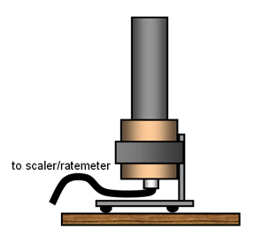
We can detect radioactivity with a Geiger - Muller tube.
0-Ahttps://tap.iop.org/atoms/radioactivity/509/page_47071.html
Inside the tube there is a gas. When radioactivity enters the tube through a thin window, made of mica, in the front or through its walls, atoms in the gas are ionised. The electrons knocked out of the atom form an electric current- This produces a reading on a meter. This shows us that radioactivity is present. Geiger Muller tubes can detect alpha, beta and gamma radiation.
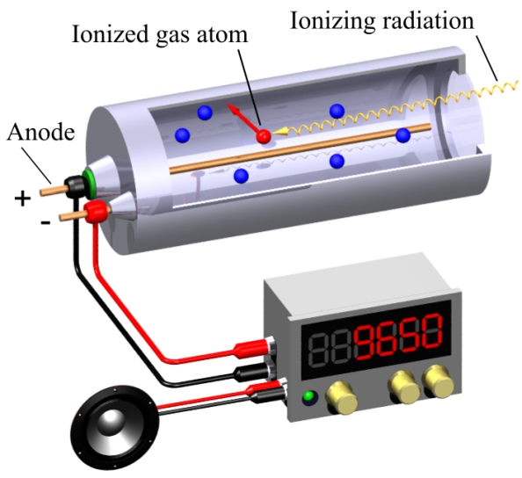
0-BBy Svjo-2 - Own work, CC BY-SA 3.0, https://commons.wikimedia.org/w/index.php?curid=39176160

Film Badges
People who work with radioactivity often wear a badge containing photographic film - a film badge. When they finish work, they hand in their film badge. The photographic film inside is developed. Film badges can detect beta, gamma and X-ray radiation. We can tell how much radioactivity they have received at work by observing how fogged the film is.
Film badges have generally been overtaken by electronic ratemeters.
A film badge can also show that radioactivity is present. When radioactivity hits photographic film, it affects the atoms on the film surface. When the film is developed, it looks foggy.
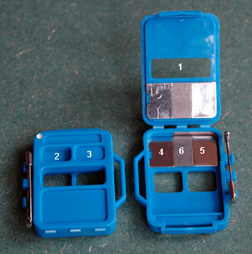
The badge has six filters:
- An open window which allows all incident radiation that can penetrate the film wrapping to interact with the film.
- A thin plastic film which attenuates beta radiation but passes all other radiations
- A thick plastic filter which passes all but the lowest energy photon radiation and absorbs all but the highest beta radiation.
- A dural filter which progressively absorbs photon radiation at energies below 65keV as well as beta radiation.
- A tin/lead filter of a thickness which allows an energy independent dose response of the film over the photon energy range 75keV to 2Mev.
- A cadmium lead filter where the capture of neutrons by cadmium produces gamma rays which blacken the film thus enabling assessment of exposure to neutrons.

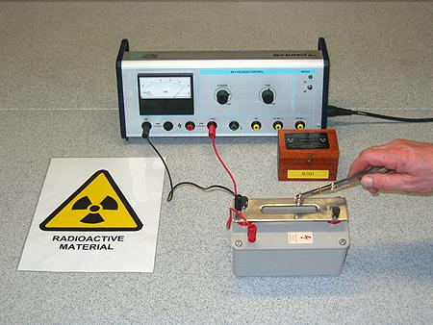

Spark Counters
A spark counter is a highly visible (and audible) way of showing and counting ionisation of the air caused by alpha radiation.
A spark counter is similar to a Geiger Muller tube. It consists of thin wire with fine gauze suspended above, with a few kilovolts between the wire and gauze. Alpha particles ionise the air between them and cause a spark. Only alpha is detected as beta and gamma do not ionise strongly enough.

Scintillation counters
Scintillation counters rely on the fluorescent natures of some substances. When they are hit by radiation, they absorb the energy and emit it as light. These flashes (known as scintillations) are counted by a light detector and electronic counter.
Alpha is detected by zinc sulphide, beta by anthracene and gamma detected by sodium iodide.

Measuring background radiation
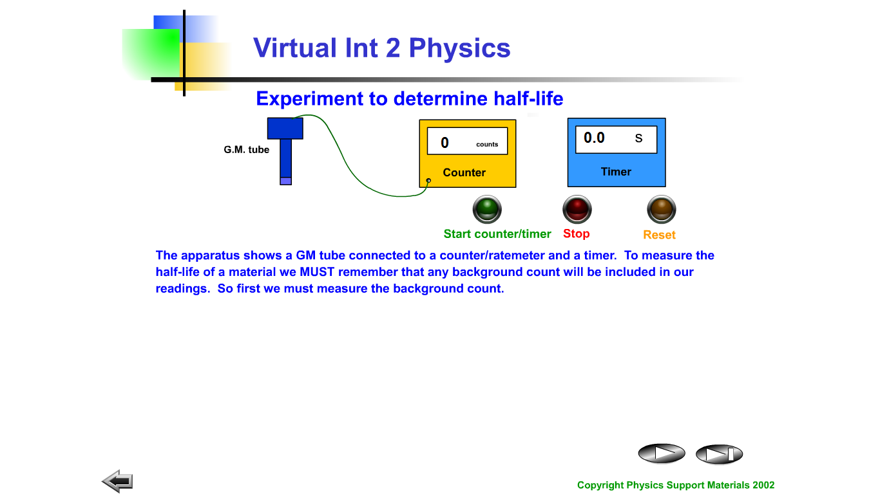
- Set up the apparatus as shown above.
- Connect the Geiger Müller tube to a counter or ratemeter and take a count for at least a minute.
- Record this value in your jotter.
- Repeat or complete one count for a longer period of time.

Task
Answer the following questions in your jotter.
- List 4 causes of background radiation.
- Name the source of most of our background radiation.
- Name the type of detector that relies on a colour change.
- Name the type of detector normally used in schools for demonstrations.
- Explain how a Geiger Müller tube and counter work.
- Name the type of detector which can only detect alpha radiation.
- Explain why film badges cannot be used to detect alpha radiation.
- Describe an experiment to find the activity of a radioactive source using the following equipment: Stopwatch, Geiger-Müller Tube, Counter.
- In a laboratory, the background activity is measured as 1.5 Bq. A Geiger-Müller tube is used to measure the activity of a source in the laboratory. in three minutes, 1440 counts are recorded. What is the activity of the source?

Success Criteria
20.8 | I can identify background sources of radiation, e.g. cosmic radiation from space, radioactivity from rocks (e.g. granite) and soil of the earth, radiation from buildings e.g radon, radiation from the human body etc artificial sources, such as medical, fallout from weapons tests or power stations and radioactive waste.

Dose

Learning Intentions
- Use of appropriate relationships to solve problems involving absorbed dose, equivalent dose, energy, mass and radiation weighting factor.
- Comparison of equivalent dose due to a variety of natural and artificial sources. Awareness of equivalent dose rate and exposure safety limits for the public and for workers in radiation industries in terms of annual effective equivalent dose.
- Use of an appropriate relationship to solve problems involving equivalent dose rate, equivalent dose and time.

ABSORBED DOSE
Ionising radiation carries energy. This energy can be absorbed by tissue and possibly cause damage to the tissue. The more energy is absorbed the more damage could occur. The amount of energy received by a substance per unit mass is known as the absorbed dose.
The ABSORBED DOSE, D, is the ENERGY ABSORBED PER KILOGRAM. It is measured in GRAYS, Gy.

where D is the absorbed dose in grays (Gy) 1 Gy = 1 J kg⁻¹
E is the energy in joules (J)
and m is the mass of the absorbing tissue in kilograms (kg)

Equivalent Dose
Absorbed dose does not tell the whole story of how a person would be affected by nuclear radiation. The problem with using absorbed dose is that it gives no indication of the type of radiation and the damage it causes.
So a Radiation Weighting Factor, w_{R}, is introduced to take account of the biological harm. The Radiation Weighting Factor, w_{R}, is given in published tables.
This gives us a new term called equivalent dose. The equivalent dose allows us to take the type of radiation into account. It is calculated by using the equation.
equivalent dose = absorbed dose x radiation weighting factor
Equivalent dose is measured in Sieverts (Sv).
$$H=D x w_{R}$$
where H is the equivalent dose in sieverts (Sv)
D is the absorbed dose in grays (Gy)
and w_{R} is the radiation weighting factor
The equivalent dose takes account of the different susceptibilities to harm of the tissue being irradiated and is used to indicate the risk to health from ionising radiation.
The risk of biological harm from an exposure to radiation depends on:
- the absorbed dose
- the kind of radiation e.g α, β, δ
- the body organs or tissue exposed.
Equivalent dose (H) is a measure of the radiation dose to tissue where an attempt has been made to allow for the different relative biological effects of different types of ionising radiation
.

Here are examples of Radiation Weighting Factor for types of radiation. You are not expected to know these values but you are expected to be able to use them
Type of radiation | Radiation Weighting Factor
X-rays | 1
γ rays | 1
β-particles (E<30KeV) | 1.7
β-particles (E>30KeV) | 1
α particles | 20
heavy nuclei | up to 20
protons | 10
slow neutrons | 2.3
fast neutrons (1Mev) | 10
really fast neutrons (10Mev) | 6.5

Alpha radiation has a radiation weighting factor of 20, whereas beta and gamma radiation both have a radiation weighting factor of 1.

ABSORBED DOSE RATE
Absorbed dose rate is the dose absorbed in unit time and indicates the amount of radioactive dose received by a person within a certain period of time. The shorter the time the radiation is received by the tissue the more dangerous this is likely to be.
Absorbed dose rate is given by the formula

(the dot indicates a rate) (pronounced D-dot). is the rate at which the energy is absorbed. It is measured in Grays per minute, Grays per hour etc.

EQUIVALENT DOSE RATE
Again, the Equivalent dose value gives no indication of the time the radiation is absorbed for. So a new quantity is produced. Equivalent dose rate is the equivalent dose absorbed in unit time and indicates the amount of radioactive dose received by a person within a certain period of time.

( the dot indicates rate)( pronounced H-dot)
Another way of calculating the equivalent dose rate is
$$\dot{H}=\dot{D}× w_{R}$$
Usual Equivalent dose rates are in mSvy⁻¹ or μSvy⁻¹
The average person in the UK receives a background equivalent dose of 2·2 mSv per year.

Safety with radiation
There are several safety precautions that must be taken when handling radioactive substances.
- Always handle radioactive substances with forceps. Do not use bare hands.
- Never point radioactive substances at anyone.
- Never bring radioactive substances close to your face, particularly your eyes.
- Wash hands thoroughly after using radioactive substances especially after using open sources or radioactive rock samples.
- Unauthorised people must not be allowed to handle radioactive substances. In particular, in the United Kingdom, no one under 16 years of age may handle radioactive substances.
In addition there are several safety precautions relating to the storage and monitoring of radioactive substances.
- Always store radioactive substances in suitable lead-lined containers.
- As soon as source has been used, return it to its safe storage container,to avoid unnecessary contamination.
- Keep a record of the use of all radioactive sources.
The equivalent dose received by people can be reduced by three methods:
- shielding;
- limiting the time of exposure;
- increasing the distance from the source.
If there is a question on the exam about reducing your dose, only give one example from each group.

Annual effective dose equivalent limits
For the public, exposure should not exceed 5 mSv in any year and should not exceed 1 mSv per year on a long term basis.
Radiation workers are permitted higher doses, because:
• they are unlikely to be either old and infirm or young and vulnerable
• they will be subject to regular medical examination
• they will have their exposure monitored.
- Average annual background radiation in UK: 2·2 mSv.
- Annual effective dose limit for member of the public: 1 mSv.
- Annual effective dose limit for radiation worker: 20 mSv.

Currently the limits are 20mSvy⁻¹ (as from 2000) but many industries try to keep their workers bleow this, for example Chapelcross limits its workers to ½ the permitted equivalent dose, i.e 10mSvy⁻¹ full body dose.

LIMITING EXPOSURE
The 2 main precautions that you can take
- Get as far from the source as possible (as radiation obeys the inverse square law)
- Get a dense material between the source and the spectators.

Task
Answer the following questions. NB the ones marked * are particularly tough!

Absorbed dose questions
- A patient’s thyroid gland is to receive an absorbed does of 500 Gy from a source so that the gland absorbs 15 J of energy. From this information calculate the mass of the thyroid gland.

- The radiology department in a hospital uses radioactive iodine to examine the functioning of the thyroid gland in a patient. The thyroid gland of the patient receives an absorbed dose of 750 μGy of radiation from the radioactive iodine. Calculate the total energy absorbed if the gland has a mass of 0.04 kg.
- What is the equivalent dose absorbed by a person exposed to 5.0 mGy of radiation with a radiation weighting factor of 6?
- Visitors to a nuclear reprocessing plant are informed that they have absorbed an equivalent dose of 2.0 µSv from a measured absorbed dose of 2 µGy. What is the radiation weighting factor of the radiation they were exposed to?
- What absorbed dose of radiation with a radiation weighting factor of 20 leads to an equivalent dose of 4.0 µSv?

Dosimetry
- What do we mean by the activity of radioactive material?
- What does the risk of biological harm from radiation depend on?
- A worker spends some time in an area where she is exposed to the following radiations:
- thermal neutrons = 8 mGy Radiation weighting factor = 3
- fast neutrons = 40 μGy Radiation weighting factor = 10
(a) Calculate the dose equivalent for each type of neutron.
(b) Determine the total dose equivalent for the exposure.
- What does the radiation weighting factor for each radiation indicate?
- In the course of his work an industrial worker receives a dose equivalent of 200 µSv. Determine the absorbed dose if he is exposed to alpha particles, with a radiation weighting factor of 20.
- An unknown radioactive material has an absorbed dose of 500 µGy and gives a dose equivalent of 1 mSv. Calculate the radiation weighting factor of the material.
- A patient receives a chest X-ray with a dose equivalent of 2.0 mSv. If the radiation weighting factor of the X-ray is 1, calculate the absorbed dose received by the patient.
- A lady has a dental X-ray which produces an absorbed dose of 0.3 mGy. Calculate the dose equivalent of this X-ray.
- A nuclear worker is exposed to a radioactive material producing an absorbed dose of 10 mGy. She finds that the material emits particles with a radiation weighting factor of 3.Calculate the dose equivalent for this exposure.
- A physics teacher uses a gamma source in an experimental demonstration on absorption. The teacher receives an equivalent dose of 0.5 mSv. Calculate her absorbed dose if the radiation weighting factor for gamma radiation is 1.
- (a) Alpha particles produce a dose equivalent of 50 mSv from an absorbed dose of 2.5 mGy. Calculate the radiation weighting factor of the alpha particles.
(b) Explain why exposure to alpha radiation increase the risk of cancer more than X-rays or gamma rays?
- 1The unit for absorbed dose is the gray, Gy. Explain this term and give another unit for absorbed dose.

Extension tutorial;
- Why is swallowing an alpha particle source more dangerous than a gamma ray source since alpha particles are less penetrating than gamma?
- If 3x10⁸ disintegrations are recorded in a 5 minute interval, what is the activity of the sample involved?
- If a school source has an activity of 4x10⁴Bq, how many disintegrations take place in one hour?
- How long does it take a counter to clock up one million disintegrations from a source whose activity is 5x10⁷Bq?
- How long does it take 7.56x10¹¹ atoms to disintegrate if their average activity is 1.2x10¹⁰Bq ?
- What is the equivalent dose absorbed by a person exposed to 5mGy of radiation with a radiation weighting factor of 6?
- Visitors to a nuclear reprocessing plant are informed that they have absorbed an equivalent dose of 2µSv from a measured absorbed dose of 2µGy. What is the radiation weighting factor of the radiation they were exposed to?
- What absorbed dose of radiation with a radiation weighting factor of 20 leads to a equivalent dose of 4µSv?
- * A manned satellite's dose detector goes from 20µGyh-1 to 100µGyh-1 for a 3 hour period during a one day mission.
  - What is the equivalent dose for the astronauts for the 24 hour period?
  - What is the average equivalent dose rate during the mission?

- For an absorbed dose of 50 mGy, calculate the equivalent dose for the following radiations:
  - X-rays
  - protons
  - slow neutrons.

- A worker receives the following absorbed doses:
- γ–radiation 150 μGy
- Thermal neutrons 240 μGy
- Fast neutrons 90 μGy.

  - What is the equivalent dose for each radiation?
  - Find the total equivalent dose.
  - * If the doses were received in 6 hours, calculate the equivalent dose rate in μSv h⁻¹.

- It is found that a radiation worker has received an equivalent dose of 500 μSv in the course of a 25-hour working week. Calculate the equivalent dose rate in μSv h⁻¹.

- The cosmic ray detector on board an aircraft indicates an equivalent dose rate of 15 μSv h⁻¹.
  - Calculate the equivalent dose to those on board during a 4-hour flight.
  - *How many such flights would a crew member have to make in a year to receive the maximum permissible equivalent dose of 5 mSv in a year?

- State three sources of background radiation.

- Give the annual effective equivalent dose limits for:
  - the general public
  - radiation workers.

- A sample of tissue has a mass of 25g, how much energy is absorbed from fast moving neutrons with an absorbed dose rate of 400μGyh⁻¹?

Absorbed Dose
- What is the meaning of the term ‘absorbed dose’?
- Copy and complete this table.

 | Absorbed Dose / Gy | Energy/ J | Mass / kg
(a) | 6 x106 |  | 0.5
(b) | 3.5 x10-5 |  | 0.25
(c ) |  | 8.8 x10-5 | 0.05
(d) |  | 6.5 x10-5 | 0.26
(e) | 1.1 x10-5 | 3.3 x10-6
(f) | 1.2 x10-5 | 1.8 x10-6

- What is the absorbed dose of a 400 g hand that absorbs 7 μJ of alpha particles?
- What is the mass of skin exposed to radiation with 4.2 μJ of energy if the absorbed dose is 10 μGy?
- A tumour of mass 150 g is exposed to gamma rays. The absorbed dose from this exposure is 5.1 x 10-5 μGy. What is the energy of the gamma rays absorbed by the tumour?

Equivalent Dose
- What is the meaning of the term ‘equivalent dose’?
- Copy and complete this table.
 | Equivalent Dose/Sv | Absorbed Dose/Gy | Radiation Weighting Factor
(a) |  | 4.2 x 10⁻⁶ | 1
(b) |  | 1.7 x 10⁻⁵ | 3
(c ) | 6.8 x 10⁻⁵ |  | 10
(d) | 3.5 x 10⁻⁵ |  | 20
(e)
(f) | 1.1 x 10⁻⁵ | 1.1 x 10⁻⁴
 | 4.5 x 10⁻⁵ | 1.5 x 10⁻⁵

- Determine the equivalent dose of a patient’s tissue, if it is exposed to 1.5 μGy of slow neutrons?
- Determine the absorbed dose of a patient’s foot, if it’s equivalent dose is 0.4 mSv of gamma rays?
- A piece of skin is exposed to 15 μGy of a radiation. The equivalent dose of the skin is 0.3 mSv.
  - Calculate the weighting factor of the radiation?
  - State the kind of radiation has the skin likely been exposed to?
- A piece of tissue has a mass of 100 g and is exposed to 10 μJ of fast neutrons.
  - Calculate the absorbed dose of the tissue?
  - Calculate the equivalent dose of the tissue?
- As a part of his job, an airport security guard has to expose his hand to X-rays. (w_{R} = 1) as he removes blockages from a baggage scanner. On average, each time he does this, the absorbed dose of his hand is 0.03 μGy. Calculate the equivalent dose of his hand each time he removes a blockage.
- The safety rules in the airport state that the maximum equivalent dose for his hand in one hour is 0.6 μSv. How many times can the airport security guard safely put his hand in the scanner in an hour?

- The average annual equivalent dose of the most common sources of background radiation in the UK are shown.
Background Source | Equivalent Dose/mSv
Radon Gas(from rocks) | 1.25
Buildings | 0.35
Medical | 0.35
Food& Drink | 0.30
Cosmic Rays | 0.25
Nuclear Power | 0.2

- Construct a bar graph or pie chart to show this information. Make sure that it is clear which sources are man-made and which are naturally occurring.

- Radioactive substances have many uses in society, such as in medicine.
However, there are also some disadvantages of using radioactivity, such as the altering and killing of living cells. List some risks and benefits of using radioactivity in society.

Success Criteria

20.9 | Knowledge of the dangers of ionising radiation to living cells and of the need to measure exposure to radiation
20.10 | I can use appropriate relationships to solve problems involving absorbed dose and equivalent dose energy, mass and radiation weighting factor. (H = DW_{R}, D = E / m).
20.11 | I can state that the unit for absorbed dose is the gray (Gy), the unit for equivalent dose is the sievert (Sv) and the radiation weighting factor has no unit
20.12 | I can use (H dot) =H/t to solve problems involving equivalent dose and time to calculate an equivalent dose rate.
20.13 | I can state the units of H dot are Sieverts per year, Sieverts per day, Sieverts per hour etc.
20.14 | I can compare equivalent dose due to a variety of natural and artificial sources.
20.15 | I know that the average annual background radiation in the UK is 2.2 mSv
20.16 | I know that the average annual effective dose limit for a member of the public in the UK is 1 mSv (ie 1 mSv/y)
20.17 | I know that the average annual effective dose limit for radiation workers is 20 mSv (ie 20 mSv/y)
20.18 | I can give some applications of nuclear radiation: for example electricity generation, cancer treatment and other industrial and medical uses.

Half life

Learning Intentions
- Use of graphical or numerical data to determine the half-life of a radioactive material.
The activity of a source decreases over time. Whilst the decay of an individual atom is completely random and unpredictable, the time taken for half the atoms in a large sample of a particular material to decay can be predicted as it will always be the same time. This is known as the half-life.
Half life: the time taken for half of the radioactive atoms to decay or half life is the time for the activity to decrease by half

Finding the half-life of a radioactive source
To measure the half-life of a radioactive source, the level of the background radiation is first measured. Then the count rate with the radioactive source present is measured over a suitable period of time using a suitable detector such as a Geiger-Muller tube connected to a scaler. A graph of the count rate (with the source present), corrected for background radiation, is plotted.

Apparatus:
Geiger-Muller tube,, Scaler counter or ratemeter , Source (eg.sealed protactinium-234 radioactive source and drip tray).

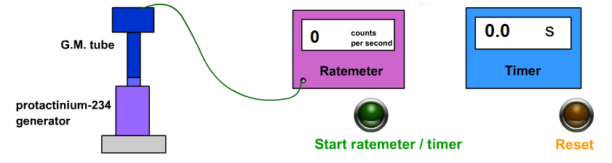

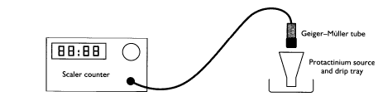

IInstructions:
- Use the Geiger-Muller tube and scaler counter to measure the background count rate.
- Record this value.
- Set up the apparatus shown in the diagram.
- Measure and record values of count rate and time interval for a suitable time period.
- Correct all your measurements for background by taking the background count off all other measured count rates.
- Plot a graph of corrected count rate or against time.
- Find the half-life from the graph

Different materials have different half- lives; a few are given in the table.

Atom | Half Life | Atom | Half Life
hydrogen-7 | 1 x 10⁻²² s | californium-254 | 60.5 days
carbon-15 | 2.5 s | plutonium-238 | 87.7 years
nobelium-259 | 58 minutes | uranium-238 | 4.5 billion years

This can be represented on a graph of activity against time as shown. The half life is the time taken for the activity of a sample to drop by half. From the graph it can be seen that the time taken to drop from 200 Bq to 100 Bq is the same amount of time taken to drop from 100 Bq to 50Bq

Time (s) | 0 | 60 | 120 | 180 | 240 | 300 | 360
Corrected count rate (counts/s) | 70 | 50 | 35 | 25 | 20 | 15 | 10

From the best-fit line on the graph the time taken to fall from
§▪ 70 counts/s to 35 counts/s = 125 s
§▪ 35 counts/s to 17.5 counts/s = 125 s
Average half-life of caesium-140 = 125 s.
TASK
If possible collect your own data from the website below
http://www.mediamatters.co.uk/physics.htm

- Using the data in the table find the corrected count in counts per minute.
- Plot a graph of the corrected count against time
- Use the graph to find the half life of Indium-116

Results from half-life experiment of Indium -116
Background count |  | 31 cpm
Time (O’Clock) | Time from start(mins) | Count rate(cpm)
09:00 | 0 | 675
09:15 | 15 | 570
09:30 | 30 | 452
09:45 | 45 | 375
10:00 | 60 | 328
10:15 | 75 | 275
10:30 | 90 | 219
10:45 | 105 | 181
11:00 | 120 | 164
11:15 | 135 | 149
11:30 | 150 | 126
11:45 | 165 | 106
12:00 | 180 | 90

Results from the Half-life of Protactinium
Using the data in the table fond the half-life from a graph
Background Count 0.5 counts per second
Time (s) | Count rate(cps) |  | Time (s) | Count rate(cps)
0 | 80.3 |  | 160 | 17.6
10 | 73.9 |  | 170 | 16.0
20 | 67.3 |  | 180 | 14.9
30 | 60.5 |  | 190 | 13.4
40 | 55.2 |  | 200 | 12.3
50 | 49.6 |  | 210 | 11.2
60 | 45.7 |  | 220 | 10.2
70 | 41.5 |  | 230 | 9.2
80 | 37.4 |  | 240 | 8.4
90 | 34.1 |  | 250 | 7.5
100 | 31.3 |  | 260 | 6.9
110 | 28.5 |  | 270 | 6.4
120 | 25.9 |  | 280 | 5.7
130 | 23.9 |  | 290 | 5.3
140 | 21.7 |  | 300 | 4.7
150 | 19.4

Half-life can be likened to sharing a cake with friends. Your friends arrive one by one, and as each new person arrives, you offer them half the cake you have left. The first friend to arrive gets significantly more cake than the 7th friend! (as shown in the pie chart)

Half Life is the time it takes for the activity of the substance to decrease by half. (it is measured in units of time, e.g seconds, minutes, days, years, millions of years!)
No. of half lives | fraction | Power of 2!
0 | 1/1
1 | ½
2 | ¼
3
4
5
6
n

After 17 half lives you would have 1/2¹⁷ of the material left
You’d have 1/131072 th of the original material left!

Formula for finding the half life
Radioactive decay involves a change from a high energy state to a lower energy state for the individual atoms involved. As a result of decay then there are fewer high energy, radioactive atoms. This means the overall activity will decrease over time as fewer candidate atoms are available to decay.
Radioactive decay is a random process. This means that for a radioactive source, it is not possible to predict when an atom will decay. Each atom has an equal probability to be the next atom to decay. In any radioactive source, the activity decreases with time because the number of unstable atoms gradually decreases leaving fewer atoms to decay.

The half-life of a radioactive source is the time for the activity to fall to half its
original value. Half-life is measured in units of time. This may be seconds, minutes, days or years.
Using a graph of activity versus time, it is possible to calculate the half-life of a radioactive source.
The count rate drops from 80 to 40 in two days. In the next two days, it drops from
40 to 20 - it halves. In the two days after that, it drops from 20 to 10 - it halves again - and so on. So the half life, t_{1/2} = 2 days t½ should be the same value no matter which starting activity is selected.

Corrected count rate
When making accurate measurements of the decay of a radioactive source you must always use the corrected count rate. This is the count rate that is due to the source alone and not including any background radiation.
From the diagram it can be seen that incorrectly using the total count curve gives
an erroneously large value for t1/2 corrected count = total count – average
background count

e.g.1 A source has an original activity of 1000 Bq. What is the half life if the activity is 15.6 Bq after one day?
1000 → 500 → 250 → 125 → 62.5→ 31.25→ 15.6 Bq
1 2 3 4 5 6
(What to do is - Keep halving the Activity until you reach the value that you want. COUNT THE ARROWS, not the NUMBERS. The number of arrows tells you the number of half lives)
1000 500 250 125 62.5 31.25 15.6 Bq

1 2 3 4 5 6

e.g A Geiger Muller tube and rate meter were used to measure the half-life of Caesium-140. The activity of the source was noted every 60 seconds. The results are shown in the table. By plotting a suitable graph, determine the half-life of Caesium-140.
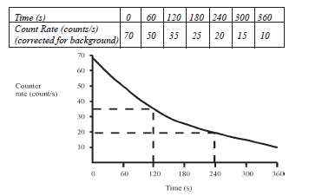
from the graph: time taken to fall from 70 cps to 35 c: 120s
from 35 cps to 17.5 cps: 120s

Task
Answer the following questions in your jotter
- The activity of a source drops from 1000 kBq to 125 kBq in 9 days. Calculate the half-life of the source.

- The activity of a source drops from 4800 kBq to 150 kBq in 10 days. Calculate the half-life of the source.

- The activity of a source drops from 720 MBq to 45 MBq in 20 years. Calculate the half-life of the source.

- The activity of a source drops from 4096 kBq to 1 kBq in 2 days. Calculate the half-life of the source.

- A source has an activity of 1800 kBq after being stored for 72 s. If the half-life is 24 s, what was its initial activity?

- A source has an activity of 40 kBq after being stored for 10 years. If the half-life is 2 years, what was its initial activity?

- A source has an activity of 30 kBq after being stored for 2 days. If the half-life is 8 h, what was its initial activity?

- If the background count is 28 counts per minute and the count with a source drops from 932 to 141 counts per minute in 24 h, what is the half life of the source?

- If the background count rate is 24 counts per minute and the count rate with a source present drops from 4120 to 25 counts per minute in 2 days, what is the half-life of the source?

- A source has an activity of 800 kBq after being stored for 4 days. If the half-life is 1 day, what was its initial activity?

- A source has an activity of 1800 kBq after being stored for 72 s. If the half-life is 24 s, what was its initial activity?

- A source has an activity of 40 MBq and a half-life of 15 s. How long will it take for its activity to drop to 625 kBq?

- A source has an activity of 25 MBq and a half-life of 8 days. Approximately how long will it take for its activity to drop to below 1MBq?

HINTS for Answering these questions
For Questions 1-4 (to find t ½ when Ao and A known)
Step
1. Summarise
2. Starting with the original activity, A₀ keep halving until you reach the final activity, A
3. COUNT THE ARROWS. This is the NUMBER of half-lives.
4. Use the formula
t½= time ÷ No. of t ½
5. Don’t forget to write out the time.
For Questions 5-7 (to find the final activity when t and t ½ are known)
Step
1. Summarise
2. Use the formula to find the number of half-lives (this will be the number of arrows)
No. of t ½ = time÷ t½
3. Starting with the original activity keep halving until you reach the final activity
COUNT THE ARROWS. This is the NUMBER of half-lives.
4. Don’t forget to write out the units for final activity.
For Questions 7-9 (to find Ao when A, t ½ and time are known)
Step
1. Summarise
2. Use the formula to find the number of half-lives (this will be the number of arrows)
No. of t½ = time÷ t½
- DOUBLE the final activity for the number of t ½ eg If you have 4 half -lives double the final activity 4 times. NB DO NOT MULTIPLY BY 4
- The alternative is to MULTIPLY the final activity by 2^{n} (2 to the power n where n is the number of half lives)
- The number at the end of the arrows is your original activity, don’t forget to add the units.
For Questions
Step
- Summarise
- Starting with the original activity keep halving until you reach the final activity
- Count the Arrows
- Use the formula
time = t½ × No. of t ½
ADVANCED, INTELLECTUAL METHOD. Not for the faint hearted or those who can’t get every calculation correct!

YOU ARE NOT EXPECTED TO BE ABLE TO USE THE LOG STUFF BUT SOME OF YOU MIGHT.
(If you want you could do it a swotty way, you don’t particularly have to be able to understand what you are doing but you do need to be able to put the numbers correctly into your calculator

or
= 6
6 t_{1/2} = 24 hrs
1 t_{1/2} = 24 = 4 hrs
6
e.g.2 What fraction of a 1000 Bq source will be left after 6 half-lives.?

(What to do is - Keep halving the fraction until you have completed the right number of arrows, in this case 6. The fraction remaining is your answer or remember that fraction remaining after so many half-lives is 1/2^{n})

or fraction remaining =
e.g.3 What is the number of half-lives if 1/64 of the original activity is left?
(What to do is - Keep doubling the fraction until you have got back to 1. The number of arrows tells you the number of half-lives.)

Or again if you want a challenge you can use the formula given. You do not need to understand it but you might want to use it. If you do want to use this method you must be able to remember it in an exam.
or

Task
Answer the following questions in your jotter.

Half-life and safety
- Explain what is meant by ‘half-life’.
- The following data was obtained from an experiment to determine the half-life of radioactive source:
Time (minutes) | 0 | 20 | 40 | 60 | 80
Count rate (number of counts per minute) | 100 | 60 | 45 | 30 | 20

  - Describe how you could carry out this experiment.
  - Determine the half-life of the radioactive source.
- A radioactive material has a half-life of 5 days. If the original activity is 120 Bq, what will be the activity after 20 days?
- If a radioactive material has a half-life of 600 years, how long will it take for the activity to fall to 10 Bq if the original activity was 80 Bq?
- A radioactive substance has a half-life of 4 hours. What fraction of the original activity is left after one day?
- The activity of a source starts at 100 MBq. After 20 days it has fallen to 6.25 MBq. Calculate the half-life of the source.
- What is the half-life of a radioactive source if the activity falls from 4000 kBq to 125 kBq in 40 days?
- The half-life of Cobalt-60 is 5 years. If the source, 25 years ago, had an activity of 500kBq, what would be the activity now?
- What are the main sources of background radiation.
Time (minutes) | 0 | 5 | 10 | 15 | 20
Count rate (cpm) | 1660 | 1100 | 750 | 510 | 350
- The table of results below show how the count rate for a radioactive source varies with time. The background count was 60 counts per minute.

- Plot a graph of corrected count against time.
- Determine the half-life of the source.

- Describe the safety procedures when handling radioactive materials.
- How can the dose equivalent be reduced for a radioactive source?
- Write a note on the storage of radioactive material including warning signs and where they should be displayed.

Success Criteria
20.19 | I can define half-life as the Time for activity to decrease by half or time taken for half of the radioactive atoms to decay
20.20 | I can use graphical and numerical data to determine the half-life
20.21 | I can describe an experiment to determine the half-life of a radioactive material.

Fission and Fusion

Learning Intentions
- Qualitative description of fission and fusion, with emphasis on the importance of these processes in the generation of energy.
Nuclear radiation can be used to generate energy. There are two ways in which nuclear radiation can be used to generate energy.
Nuclear fission is the process in which one nucleus splits into more than one nuclei, leading to formation of other elements and the release of energy in the process. There are two types of nuclear fission: spontaneous and stimulated fission. Some heavy nuclei are not stable so they will undergo spontaneous fission and give lighter nuclei. Sometimes fission is stimulated by collisions with other particles. For example, the fission of uranium 235 in nuclear reactors is started by the collisions with neutrons. If a neutron is fired into the nucleus of a uranium 235 atom, the atom will split into two new nuclei emitting further neutrons and releasing energy in the form of heat (i.e. the kinetic energy of the emitted nuclei).
This splitting of the atom is known as STIMULATED NUCLEAR FISSION. The new nuclei are known as fission fragments. The emitted neutrons hit other atoms causing them to split. If this process keeps going, a CHAIN REACTION results giving out huge amounts of energy in a way which is difficult to control.

Fission
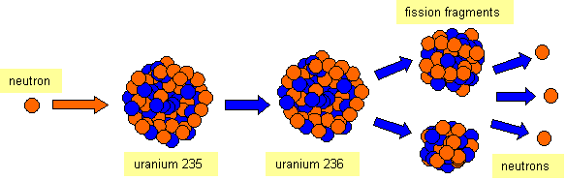
If a neutron is fired at a uranium 235 nucleus, it becomes unstable and separates into two smaller nuclei and releases some more neutrons. The mass of these nuclei and neutrons is slightly less than the mass of the original nucleus and neutron. Using the equation E= mc²we can calculate the energy released in each fission reaction. If the neutrons that are released are captured by other uranium 235 nuclei, the process can be repeated. This is known as a chain reaction.
In nuclear power stations, the energy released is used to heat water to produce steam to turn a turbine. This drives a generator which produces electricity.

Fusion
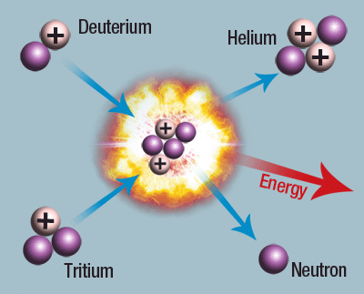
Fusion is a process where two smaller nuclei are combined to create a larger nucleus. Again, the total mass of the products of this reaction is less than the total mass before the reaction, allowing us to calculate the energy released by using the equation E = mc². It is thought that fusion would allow us to generate far more energy than fission at much lower risk, however we are currently unable to do this economically. Fusion is the process in which stars convert fuel to light and heat.
Note: It is important that you do not misspell fusion or fission!

Nuclear Power Stations
A nuclear power station is similar to a coal or oil fired power station, but the fuel used to produce the heat is uranium or plutonium.
The particles (or atoms) of the uranium or plutonium are spilt into smaller particles in a nuclear reactor. This is called FISSION.
When the atoms split a large amount of heat is produced, which turns water into steam. In turn the steam is used to spin a turbine, which turns a generator to produce electricity.
Using nuclear radiation to produce electricity reduces the amount of carbon dioxide released into the atmosphere. Carbon dioxide is a greenhouse gas which helps contribute to global warming. However, nuclear reactors produce radioactive waste which needs to be stored for thousands of years before it is safe.
Nuclear power stations produce radioactive waste materials, some of which have half-lives of hundreds of years. The difficulties in storing this are controversial and the decisions made will affect generations to come. Some scientists believe the containers will keep the radioactive material safe for a long time, other scientists are worried that the containers will not remain intact for such a long time.
Although nuclear power stations can produce large amounts of electricity, with no further use of fossil fuels there are other dangers involved.

Advantages of Using Nuclear Power to Produce Electricity
  - Fossil fuels are running out, so nuclear power provides a convenient way of producing electricity.
  - A nuclear power station needs very little fuel compared with a coal or oil-fired power station. A tonne of uranium gives as much energy as 25000 tonnes of coal.
  - Unlike fossil fuels, nuclear fuel does not release large quantities of greenhouse gases or sulphur dioxide (a cause of acid rain) into the atmosphere.
  - A country may not want to be reliant on imports of fossil fuels. If a country has no fossil fuels of its own it might use nuclear power for security reasons.
Physics through application

Disadvantages of Using Nuclear Power to Produce Electricity
  - A serious accident in a nuclear power station is a major disaster. British nuclear reactors cannot blow up like a nuclear bomb but even a conventional explosion can possibly release tonnes of radioactive materials into the atmosphere. (The Chernobyl disaster was an example of a serious accident.)

  - Nuclear power stations produce radioactive waste, some of which is very difficult to deal with. Nobody wants radioactive waste stored near them.

  - After a few decades nuclear power stations themselves will have to be decommissioned.

Nuclear reactors
A nuclear reactor replaces the boiler in a fossil-fuelled power station. The five main parts of a reactor are shown here.
- Fuel: Uranium metal was first used as fuel but today uranium dioxide is more common. The dioxide powder is compressed to form solid pellets which are loaded into narrow tubes about 3.7 m long. These are called pins and are mounted side by side into cylinders to form the fuel rods for the reactor.

- Moderator: The moderator slows the neutrons.
Slow moving neutrons are more likely than fast neutrons to cause fission and keep the reactor going. As the fission process produces fast-moving neutrons they have to be slowed, down. This is done by a material known as a moderator. The most common moderators used are carbon (graphite) or water.

- Control rods: These absorb neutrons.
To run the reactor safely we need to control the flow of neutrons. The control rods are made of a material, such as cadmium, which absorbs neutrons. By pushing the rods into the reactor neutrons are absorbed and the reaction slows down; by pulling the rods out the reaction speeds up.
In a nuclear reactor, the chain reaction is controlled by control rods and the moderator. Fission reactions take place only if the neutrons are travelling slow enough to be ‘captured’ by the atom. Collisions with the moderator will slow down the fast neutrons and allow more fission to take place. Control rods absorb neutrons. This will allow the reactor to produce energy at a steady rate. In a controlled chain reaction, on average only one neutron from each fission will strike another nucleus and cause further stimulated fission to occur. In an uncontrolled chain reaction all the neutrons from each fission strike other nuclei producing a large surge of energy. This occurs in atomic bombs.

- Coolant: The heat produced by the fission reactions is removed by pumping a coolant such as gas or water past the hot fuel elements. The heated fluid is then piped from the core to a heat exchanger where it heats water to produce steam. The coolant then returns to the core of the reactor to be reheated. Nuclear reactors usually take their names from the kind of coolant they use: for example Advanced Gas-cooled Reactor (AGR) or Pressurised Water Reactor (PWR).

- Containment Vessel: A very thick shield of steel and concrete is required to prevent any escape of neutrons or radioactive fragments.

Task
Answer the following questions in your jotter

Nuclear reactors
- Explain what is meant by fission?
- a. What is a chain reaction?
- Explain how a chain reaction works in a nuclear reactor and a nuclear bomb.
- In a nuclear reactor what is the purpose of the following:
  - the concrete shield surrounding the reactor
  - the carbon dioxide pumped through the reactor
  - the graphite moderator?
- How is the temperature of a nuclear reactor controlled?
- Write down some advantages and disadvantages of using nuclear fuel to generate electricity.
- Why does radioactive waste worry many people
- Describe the problems with the storage and disposal of radioactive waste.

Success Criteria
20.22 | I can provide a qualitative (info) description of fission chain reactions and their role in the generation of energy.
20.23 | I can provide a qualitative description of fusion, plasma containment, and their role in the generation of energy.

Additional Reading

Nuclear Fusion
Where nuclear fission is the splitting of large, heavy nuclei into smaller, lighter fragments nuclear fusion is the process in which the nuclei of light elements combine, or fuse together, to give heavier nuclei.
An example of a fusion reaction is that of two deuterium nuclei fusing together to give a helium nucleus. Deuterium is an isotope of hydrogen (${}_{1}^{2}{H }$). The reaction is as follows:
$${}_{1}^{2}{H }+ {}_{1}^{2}{H }→ {}_{2}^{4}{He}+ energy$$
Fusion reactions are accompanied by a much greater mass to energy conversion than in fission reactions. Nuclear fusion is difficult to achieve, as it requires extremely high temperatures. This is because the small nuclei are positively charged and therefore repel each other. The high temperature means that they have enough kinetic energy to overcome their electrostatic repulsion.
Nuclear fusion occurs naturally in stars where the gravitational attraction of the large mass making up the star gives rise to such high temperature and pressure that the fusion process becomes possible. So the energy we receive from the sun is from nuclear fusion.

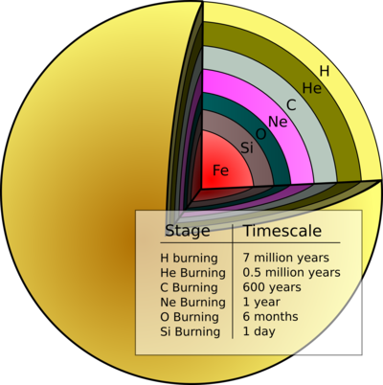
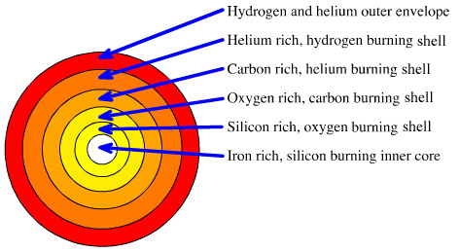
Our nearest star, the Sun, is made up mainly of mostly hydrogen and helium. Within the sun the temperature is millions of degrees Celsius, there is the constant fusion of small nuclei into larger nuclei.

The fusion process in stars is the method by which all of the elements in the Universe were formed from the original simple particles present after the Big Bang. This is known as nucleosynthesis (the creation of new heavier nuclei from lighter ones) and continues over the star’s life cycle producing heavier and heavier elements.

A limit is reached when Iron (26 protons) is produced, as the energy required to fuse elements heavier than Iron is greater than that available from the fusion reaction.

Man-made Nuclear Fusion
On Earth, attempts have been made to create nuclear fusion reactors for use in electrical power generation but the technology to achieve the extremely high temperatures and pressures is very expensive and difficult to create.
Compared to nuclear fission, nuclear fusion reactors:
  - Release even more energy per kg of fuel
  - Make less radioactive emissions as many of the products are stable (e.g. ${}_{2}^{4}{He}$)
  - Use ‘cleaner’ fuel: isotopes of hydrogen, which can be made from water and lithium

Magnetic containment: the TOKAMAK
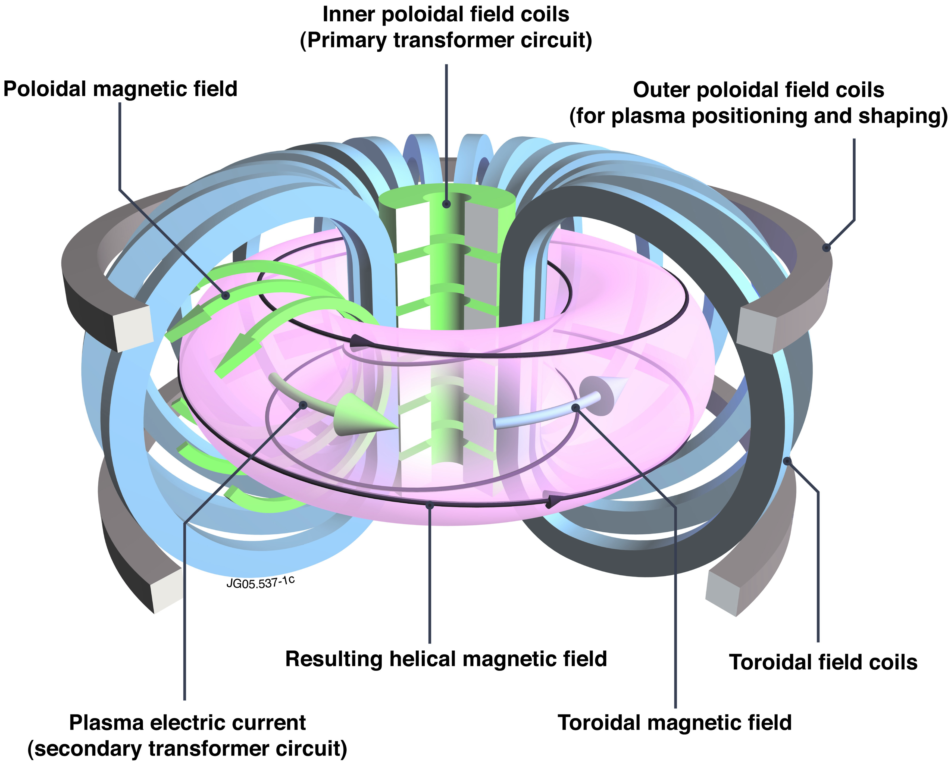
ITER (International Thermonuclear Experimental Reactor) is a joint international research and development project that aims to demonstrate the scientific and technical feasibility of fusion power. ITER is being constructed in Europe, at Cadarache in the South of France.
ITER will use the reaction between two hydrogen (H) isotopes: deuterium (D, ${}_{1}^{2}{H }$) and tritium (T, ${}_{1}^{3}{H }$ ). The D-T fusion reaction produces the highest energy gain at the 'lowest' temperatures. It requires nonetheless temperatures of 150,000,000° C to take place – ten times higher than the H-H reaction occurring at the Sun's core. At these extreme temperatures, electrons are separated from nuclei and a gas becomes a plasma - a hot, electrically charged gas. In a star as in a fusion device, plasmas provide the environment in which light elements can fuse and yield energy. In ITER, the fusion reaction will be achieved in a TOKAMAK device that uses magnetic fields to contain the charged particles of the plasma in a doughnut shaped ring inside a vacuum chamber.
The fusion between deuterium and tritium (D-T) will produce one helium nuclei, one neutron, and energy.
$${}_{1}^{2}{H }+ {}_{1}^{3}{H }→ {}_{2}^{4}{He}+ {}_{0}^{1}{n }+energy$$

The helium nucleus is electrically charged and so will remain confined within the plasma by magnetic fields of the TOKAMAK. Around 80% of the energy liberated by the fusion is carried as kinetic energy of the neutron. As this is electrically neutral its travel is unaffected by magnetic fields and so these neutrons will be absorbed by the surrounding walls of the TOKAMAK, transferring their energy to the walls as heat.

Inertial Confinement Fusion:
Researchers in the US are trialling a different system called Inertial Confinement Fusion (ICF) which uses small pellets of hydrogen fuel in lithium cases. Intensely powerful LASERs are focused on the pellets, starting a fusion reaction. These are in effect tiny nuclear fusion bombs. A continuous series of pellets would be detonated, with the heat produced being used to produce electricity.

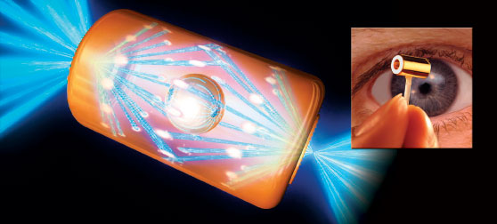
The reactor chamber in ICF is called a hohlraum – a hollow area or cavity – which contains the tiny, 2mm diameter fuel pellets. Once illuminated by the proposed 192 laser beams concentrated onto the target fuel pellet is compressed and heated to ignition temperature within 20 billionths of a second.

Just a little thing to finish on……

It's a Dead Duck!
A man brought a very limp duck into a veterinary surgery. As he lay her pet on the table, the vet pulled out her stethoscope and listened to the bird's chest.
After a moment or two, the vet shook her head sadly and said, "I'm so sorry, Cuddles has passed away."
The distressed owner wailed, "Are you sure?"
“Yes, I am sure. The duck is dead," she replied.
"How can you be so sure," he protested. "I mean, you haven't done any testing on him or anything. He might just be in a coma or something."
The vet rolled her eyes, turned around and left the room, and returned a few moments later with a black Labrador Retriever. As the duck's owner looked on in amazement, the dog stood on its hind legs, put its front paws on the examination table and sniffed the duck from top to bottom. The dog then looked at the vet with sad eyes and shook its head.
The vet patted the dog and took it out, and returned a few moments later with a beautiful cat. The cat jumped up on the table and also sniffed delicately at the bird. The cat sat back on its haunches, shook its head, meowed softly and strolled out of the room.
The vet looked at the man and said, "I'm sorry, but as I said, this is most definitely, 100% certifiably, a dead duck."
Then the vet turned to his computer terminal, hit a few keys and produced a bill which she handed to the man.
The duck's owner, still in shock, took the bill.
"£75.00!" he cried, "£75.00 just to tell me my duck is dead?!!"
The vet shrugged. "I'm sorry. If you'd taken my word for it, the bill would have been £20, but with the Lab Report and the Cat Scan ..."

