The Twin Paradox

( Read it for yourself from Russell Stannard’s excellent book “Relativity- a very short introduction” Oxford. (2008) ISBN 978–0–19–923622–0)

Additional note on Special Relativity

Imagine an astronaut in a high-speed spacecraft and a mission controller on the ground. They both have identical clocks. The astronaut is to carry out a simple experiment. On the floor of the craft she is to fix a lamp which emits a pulse of light. The pulse travels directly upwards at right angles to the direction of motion of the craft (see Figure 1). There the pulse strikes a bullseye target fixed to the ceiling. Let us say that the height of the craft is 4 metres. With the light travelling at speed, c she finds that the time taken for this trip, t, as measured on her clock, is given by t= 4/c. (From t=d/v)
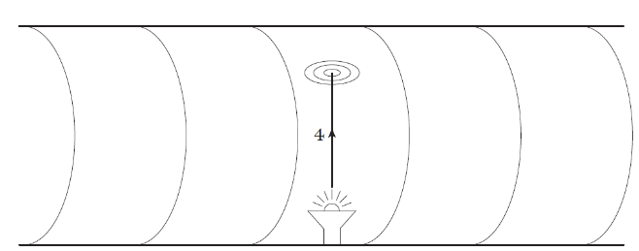
Figure 1
Now let’s see what this looks like from the perspective of the mission controller. As the craft passes him overhead, he too observes the trip performed by the light pulse from the source to the target.
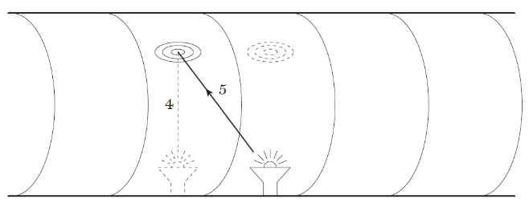
Figure 2
According to his perspective, during the time taken for the pulse to arrive at the target, the target will have moved forward from where it was when the pulse was emitted. For him, The astronaut arranges for a pulse of light to be directed towards a target such that the light travels at right angles to the direction of motion of the spacecraft According to the mission controller on earth, as the spacecraft passes overhead, the target moves forward in the time it takes for the light pulse to perform its journey. The pulse, therefore, has to traverse a diagonal path the path is not vertical; it slopes (see Figure 2). The length of this sloping path will clearly be longer than it was from the astronaut’s point of view. Let us say that the craft moves forward 3 metres in the time that it takes for the light pulse to travel from the source to the target. Using Pythagoras’ theorem, where 3² + 4² = 5², we see that the distance travelled by the pulse to get to the target is, according to the controller, 5 metres.
So what does he find for the time taken for the pulse to perform the trip? Clearly it is the distance travelled, 5 metres, divided by the speed at which he sees the light travelling. This we have established is c (the same as it was for the astronaut). Thus, for the controller, the time taken, t, registered on his clock, is given by t = 5/c.
But this is not the time the astronaut found. She measured the time to be t= 4/c. So, they disagree as to how long it took the pulse to perform the trip. According to the controller, the reading on the astronaut’s clock is too low; her clock is going slower than his. And it is not just the clock. Everything going on in the spacecraft is slowed down in the same ratio. If this were not so, the astronaut would be able to note that her clock was going slow (compared, say, to her heart beat rate, or the time taken to boil a kettle, etc.). And that in turn would allow her to deduce that she was moving – her speed somehow affecting the mechanism of the clock. But that is not allowed by the principle of relativity. All uniform motion is relative. Life for the astronaut must proceed in exactly the same way as it does for the mission controller. Thus we conclude that everything happening in the spacecraft – the clock, the workings of the electronics, the astronaut’s ageing processes, her thinking processes – all are slowed down in the same ratio. When she observes her slow clock with her slow brain, nothing will seem amiss. Indeed, as far as she is concerned, everything inside the craft keeps in step and appears normal. It is only according to the controller that everything in the craft is slowed down. This is time dilation. The astronaut has her time; the controller has his. They are not the same. In that example we took a specific case, one in which the astronaut and spacecraft travel 3 metres in the time it takes light to travel the 5 metres from the source to the target. In other words, the craft is travelling at a speed of 3/5c, i.e. 0.67c. And for that particular speed we found that the astronaut’s time was slowed down by a factor 4/5, i.e. 0.8. It is easy enough to obtain a formula for any chosen speed, v..We apply Pythagoras’ theorem to triangle ABC. The distances are as shown in Figure 4. Thus:
AC² = AB² + BC²  AB² = AC² − BC²  c²t² = (c² − v²)t’ ² (1)  t² = (1 − v²/c²)t’ ²  t = t’ ∨ (1 − v²/c²) | ct  c t’  v t’  A  B  C
From this formula we see that if v is small compared to c, the expression under the square root sign approximates to one, and t≈ t. Yet no matter how small v becomes, the dilation effect is still there. This means that, strictly speaking, whenever we undertake a journey – say, a bus trip – on alighting we ought to re-adjust our watch to get it back into synchronization with all the stationary clocks and watches. The reason we do not is that the effect is so small. For instance, someone opting to drive express trains all their working life will get out of step with those following sedentary jobs by no more than about one-millionth of a second by the time they retire, hardly worth bothering about. At the other extreme, we see from the formula that, as v approaches c, the expression under the square root sign approaches zero, and tends to zero. In other words, time for the astronaut would effectively come to a standstill. This implies that if astronauts were capable of flying very close to the speed of light, they would hardly age at all and would, in effect, live for ever. The downside, of course, is that their brains would have almost come to a standstill, which in turn means they would be unaware of having discovered the secret of eternal youth.
So much for the theory! But is it true in practice? Emphatically, yes. In 1977, for instance, an experiment was carried out at the CERN laboratory in Geneva on subatomic particles called muons. These tiny particles are unstable, and after an average time of 2.2 × 10⁻⁶ seconds (i.e. 2.2 millionths of a second) they break up into smaller particles. They were made to travel repeatedly around a circular trajectory of about 14 metres diameter, at a speed of v = 0.9994c. The average lifetime of these moving muons was measured to be 29.3 times longer than that of stationary muons – exactly the result expected from the formula we have derived, to an experimental accuracy of 1 part in 2000. In a separate experiment carried out in 1971, the formula was checked out at aircraft speeds using identical atomic clocks, one carried in an aircraft, and the other on the ground. Again, good agreement with theory was found. These and innumerable other experiments all confirm the correctness of the time dilation formula.
http://alternativephysics.org/book/TimeDilationExperiments.htm
At first one might think that if her time is going slow, then when she observes what is happening on the ground, she will perceive time down there to be going fast. But wait. That cannot be right. If it were, then we would immediately be able to conclude who was actually moving and who was stationary. We would have established that the astronaut was the moving observer because her time was affected by the motion whereas the controller’s wasn’t. But that violates the principle of relativity i.e. that for inertial frames, all motion is relative. Thus, the principle leads us to the, admittedly somewhat uncomfortable, conclusion that if the controller concludes that the astronaut’s clock is going slower than his, then she will conclude that his clock is going slower than hers. But how, you might ask, is that possible? How can we have two clocks, both of which are lagging behind the other?!
To address this problem we must first recognize that in the set-up we have described we are not comparing clocks directly side-by-side. Though the astronaut and controller might indeed have synchronized their two clocks as they were momentarily alongside each other at the start of the space trip, they cannot do the same for the subsequent reading; the spacecraft and its clock have flown off into the distance. The controller can only find out how the astronaut’s clock is doing by waiting for some kind of signal (perhaps a light signal) to be emitted by her clock and received by himself. He then has to allow for the fact that it has taken time for that signal to travel from the craft’s new location to himself at mission control. By adding that transmission time to the reading of the clock when it emitted the signal, he can then calculate what the time is on the other clock now, and compare it with the reading on his own. It is only then that he concludes that the astronaut’s clock is running slow. But note this is the result of a calculation, not a direct visual comparison. And the same will be true for the astronaut. She arrives at her conclusion that it is the controller’s clock that is running slow only on the basis of a calculation using a signal emitted by his clock .Which doubtless still leaves a nagging question in your mind, namely ‘But whose clock is really going slow?’ With the set-up we have described, that is a meaningless question. It has no answer.
As far as the mission controller is concerned, it is true that the astronaut’s clock is the one going slow; as far as the astronaut is concerned, it is true that it is the mission controller’s clock that is going slow. And we have to leave it at that.
Not that people have left it at that. Enter the famous twin paradox. This proposal recognizes that the seemingly contradictory conclusions arise because the times are being calculated. But what if the calculations could be replaced by direct side-by-side comparisons of the two clocks – at the end of the journey as well as at the beginning? That way there would be no ambiguity. What this would require is that the spacecraft, having travelled to, say, a distant planet, turns round and comes back home so that the two clocks can be compared directly. In the original formulation of the paradox it was envisaged that there were twins, one who underwent this return journey and the other who didn’t. On the traveller’s return one can’t have both twins younger than each other, so which one really has now aged more than the other, or are they still both the same age?
The experimental answer is provided by the experiment we mentioned earlier involving the muons travelling repeatedly round the circular path. These muons are playing the part of the astronaut. They start out from a particular point in the laboratory, perform a circuit, and return to the starting point. And it is these travelling muons that age less than an equivalent bunch of muons that remain at a single location in the laboratory. So this demonstrated that it is the astronaut’s clock which will be lagging behind the mission controller’s when they are directly compared for the second time.
So does this mean that we have violated the principle of relativity and revealed which observer is really moving, and consequently which clock is really slowed down by that motion? No. And the reason for that is that the principle applies only to inertial observers. The astronaut was in an inertial frame of reference while cruising at steady speed to the distant planet, and again on the return journey while cruising at steady speed. But – and it is a big ‘but’ – in order to reverse the direction of the spacecraft at the turn-round point, the rockets had to be fired, loose objects lying on a table would have rolled off, the astronaut would be pressed into the seat, and so on. In other words, for the duration of the firing of the rockets, the craft was no longer an inertial reference frame; Newton’s law of inertia did not apply. Only one observer remained in an inertial frame the whole time and that was the mission controller. Only the mission controller is justified in applying the time dilation formula throughout. So, if he concludes that the astronaut’s clock runs slow, then that will be what one finds when the clocks are directly compared. Because of that period of acceleration undergone by the astronaut, the symmetry between the two observers is broken – and the paradox resolved. At least it is partially resolved. The astronaut knows that she has violated the condition of remaining in an inertial frame throughout, and so has to accept that she cannot automatically and blindly use the time dilation formula (in the way that the mission controller is justified in doing). But it still leaves her with a puzzle. During the steady cruise out, she is able, from her calculations, to conclude that the controller’s clock was going slower than her own. During the steady cruise home, she can conclude that the controller’s clock will be losing even more time compared to her own (the time dilation effect not being dependent on the direction of motion – only on the moving clock’s speed relative to the observer). That being so, how on earth (literally) did the mission controller’s clock get ahead of her own? What was responsible for that? Is there any way the astronaut could calculate in advance that the controller’s clock would be ahead of hers by the end of the return journey? The answer is yes; there is. But we shall have to reserve the complete resolution of the twin paradox for later – when we have had a chance to see what effect acceleration has on time.

