
N5 Physics

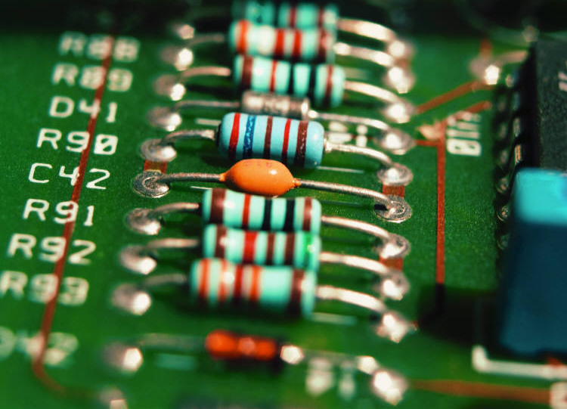
Electricity

Name _______Class__

At National 5 level, by the end of this section you should be able to:

- Define electrical current as the electric charge transferred per unit time.
- State that current is measured in Amperes (A)
- State that charge is measured in Coulombs (C)
- Use the relationship $Q=It$ to solve problems involving charge, current and time.
- State that direct current flows in one direction at one value.
- State that alternating current changes direction and changes value.
- Identify a source as direct current (d.c.) or alternating current(a.c.) based on an oscilloscope trace or an image from data logging software.
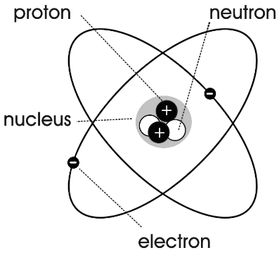
Electrons - negatively charged
Protons – positively charged.
Neutrons – neutral (no charge)

Atoms are electrically neutral because the number of protons is equal to the number of electrons in the atom.

Electrical Current.
Only electrons are free to move. Electric current is the rate of flow of electrons (charge carriers) so I =$\frac{Q}{t}$

Q = It Q = charge (Coulombs – C)
I = Current (Amperes- A)
t = time (seconds – s)

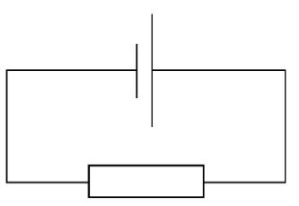
Current flows round a circuit from negative to positive because this is the direction an electron would move in.

Conductors | Insulators
Metals  Carbon - graphite | Plastic  Glass  Wood  Air

Example 2
If a current of 2A flows for 30 s, what is the charge?

Q = It = 2 x 30 = 60C

Example 3
A battery stores 360C of charge. When connected in a circuit it delivers a current of 15mA. How long will the battery be able to keep the circuit running?
Q = It => t = Q/I = 360/15 x 10⁻³ = 24000s
Example 1
12 Coulombs pass through a lamp in 6 seconds. What is the current flowing through the lamp?
Q = It => I = Q/t = 12/6 = 2A

Example 4
The batteries in a child’s toy car take 10 hours to fully recharge using a charging current of 3.2A
Calculate how much charge is transferred to the batteries in this time.
Q = It = 3.2 x 10 x 60 x 60 = 115200C

SQA 2013 SG Credit Q4c

Example 5
The charge passing a point in a conductor when a current of 4mA flows for 1000s is
A 0.25C
B 0.4C
C 4C
D 250C
E 4000C SQA 2005 Int2 Q9

Electricity question booklet P2 Q 1 - 13
Leckie + Leckie P34 Ex 1.2.1 Q 1-3
P39 Ex 1.3.1 Q 1-5

DC = direct current.
Current flows in one direction and has a single value.
From a battery .

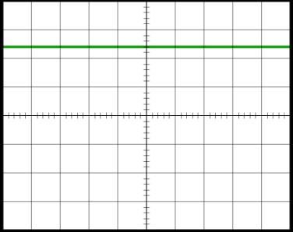

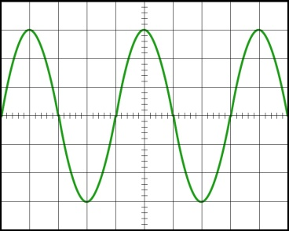
AC = Alternating current.
Current changes direction and has a changing value.
From the mains.

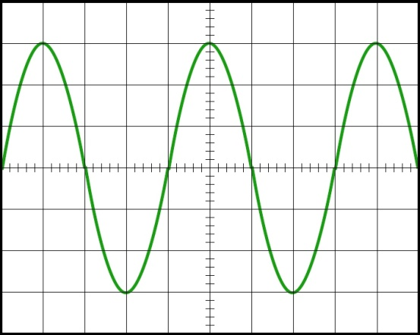
The voltage measured when the wave is a maximum on an oscilloscope is the peak voltage.
The voltage measured using a voltmeter is less than this.

Mains electricity is 230V a.c. at 50Hz.
The peak voltage is higher than this (around 325V).

Example 6
The voltage of the mains supply in the UK is 230V a.c.
Which row in the table shows the peak voltage and frequency of the mains supply in the UK?
 | Peak voltage (V) | Frequency (Hz)
A | 175 | 50
B | 175 | 60
C | 230 | 50
D | 325 | 50
E | 325 | 60
SQA 2010 Int 2 Q10

Example 7
A student makes the following statements about electrical supplies.
- The frequency of the mains supply is 50Hz
- The quoted value of an alternating voltage is less than its peak value.
- A d.c. supply and an a.c. supply of the same quoted value will supply the same power to a given resistor.
Which of the following statements is/are correct?
A I only
B II only
C III only
D I and II only
E I, II and III
SQA 2011 Int 2 Q 8

Example 8
A technician measures the voltage across a component in a circuit using first a digital voltmeter and then an oscilloscope.
Figure 1 shows a digital voltmeter connected to the component and figure 2 shows an oscilloscope connected to the same component.
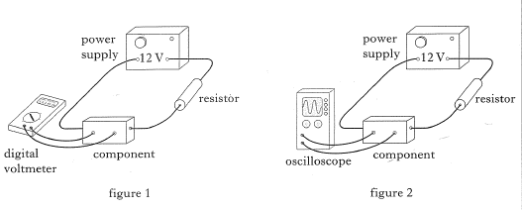
- State whether the voltage across the component is direct or alternating.

alternating
- The graph below shows how the voltage across the component varies with time.
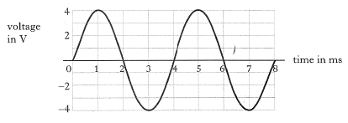
What is the peak voltage across the component?

4V

- How does the peak voltage compare with the voltage reading which would be shown on the digital voltmeter?
The peak voltage is higher than the reading on the digital voltmeter

SQA SG Credit 1997 Q4

Electricity question booklet P4 Q 1 - 10
Leckie & Leckie P42 Ex 1.3.2 Q 1-3
Example 9
A stage technician monitors the output voltage from a loudspeaker.
The oscilloscope trace and gain setting are shown.
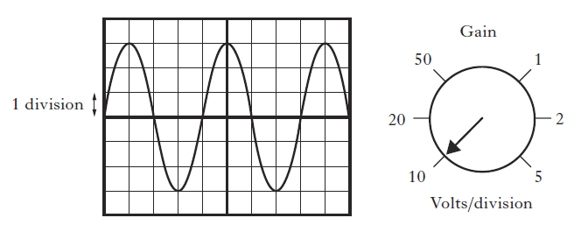
Calculate the peak value of the output voltage.
Wave is 3 squares high
Each square is worth 10V
3 x 10 = 30V

At National 5 level, by the end of this section you should be able to:

- State that a charged particle experiences a force in an electric field.
- Describe (by drawing a diagram or other method) the path a charged particle follows
  - Between two oppositely charged parallel plates
  - Near a single point charge
  - Between two oppositely charged points
  - Between two like charged points.
- State that the potential difference (voltage) of the supply is a measure of the energy given to the charge carriers in a circuit.
When drawing an electric field the arrows show how a positively charged particle would move if you put it at that point.
-
+
+

Positive point charge negative point charge
Arrows always point AWAY from positive and TOWARDS negative
+

-

Two unlike charges
-
-
+
+
+
+

Two positive charges Two negative charges

The field lines also show how strong the electric field is – the closer together the stronger the field,
A charged particle experiences a force in an electric field. The stronger the field, the greater the force.

-

Two parallel plates Plate and point charge

A special situation exists when the electric field is created by two parallel plates. This creates what is called a uniform field because the electric field between the plates has the same value
When drawing a uniform field you should
- Use a ruler
- Space the lines EVENLY
- Add the arrows pointing in the correct direction.
Voltage
Example 10
The voltage of an electrical supply is a measure of the
A resistance of the circuit
B speed of the charges in the circuit
C energy given to the charges in the circuit
D power developed in the circuit
E current in the circuit
SQA 2007 Int 2 Q7
Voltage is a measure of the energy given to each electron (charge carrier) in a circuit.
Measured in Volts (V).

Electricity question booklet P6 Q 1 - 4

At National 5 level, by the end of this section you should be able to:
  - Measuring Electricity
- State that an ammeter is used to measure current in a circuit.
- State that an ammeter is connected in series when measuring current.
- Use an ammeter to measure current in simple and complex circuits.
- State that a voltmeter is used to measure voltage in a circuit.
- State that a voltmeter is connected in parallel when measuring voltage.
- Use a voltmeter to measure voltage in simple and complex circuits.
- State that an ohmmeter is used to measure resistance.
- Measure resistance in simple and complex circuits
  - Circuit components
- Recognise the circuit symbol and describe the function and application of the following standard electrical and electronic components

  - Cell
  - Battery
  - Lamp
  - Switch
  - Resistor
  - Variable resistor
  - Voltmeter
  - Ammeter
  - Light emitting diode (LED)
  - Motor
  - Microphone
  - Loudspeaker
  - Photovoltaic cell
  - Fuse
  - Diode
  - Capacitor
  - Thermistor
  - Light dependent resistor (LDR)
  - Relay
  - Npn Transistor
  - N-channel enhancement mode MOSFET

- Explain the function of transistors (both npn and MOSFET) as a switch in transistor switching circuits.
  - Circuit rules
- Apply the rules for current and potential difference (voltage) in series circuits
  - I_{s} = I₁ = I₂ = …
  - V_{s} = V₁ + V₂ + …
- Apply the rules for current and potential difference (voltage) in parallel circuits
  - I_{p} = I₁ + I₂ + …
  - V_{p} = V₁ = V₂ = …

Circuit symbols are used because they are quicker to draw and are easy to recognize.
You need to be able to
- Name the component represented by the symbol
- Draw the symbol for certain components
- Put together symbols to represent a circuit in a circuit diagram.
Wires | Wire |  | Wires  joining
Wires |  |  | Wires crossing
Measurement | Voltmeter | 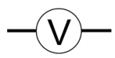 | Ammeter | 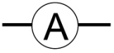
Measurement | Ohmmeter | Ω | Oscilloscope
Energy supplies | Cell |  | Battery | 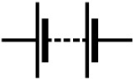
Energy supplies | DC power supply | 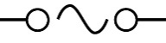  + - | AC power supply | 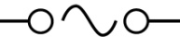
Energy supplies | Photovoltaic cell | 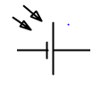
Resistors | Resistor | 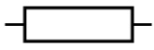 | Variable resistor | 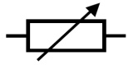
Resistors | LDR | 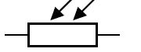 | Thermistor | 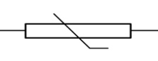

components | Lamp (bulb) | 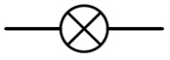 | Switch | 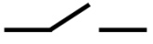
components | Fuse | 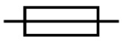 | Capacitor | 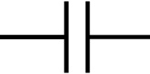
 |  |  |  | 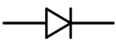
Semiconductor devices | Diode |  | LED
Semiconductor devices | Npn transistor | 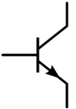 | MOSFET | 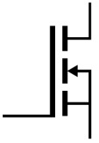

Input device | Microphone | 
Output device | Loudspeaker
Output device | Motor | M

Example 11
Four circuit symbols W,X,Y,Z are shown.
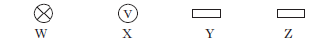
Which row in the table identifies the components represented by these symbols?

 | W | X | Y | Z
A | battery | ammeter | resistor | variable resistor
B | battery | ammeter | fuse | resistor
C | lamp | ammeter | variable resistor | resistor
D | lamp | voltmeter | resistor | fuse
E | lamp | voltmeter | variable resistor | fuse

SQA 2014 Int 2 Q8

Example 12
Which of the following is the circuit symbol for an NPN transistor?
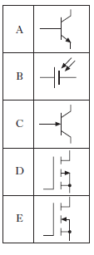
SQA 2011 Int 2 Q10

Nat Physics booklet
P17 Ex 2.8 Q 1 - 2

Current is measured using an ammeter.
The ammeter is connected in SERIES.
Break the circuit where you want to measure the current. Join in the ammeter.
This will need one extra wire.
Start off with the highest current reading, then work down.
If the meter gives a negative reading the wires need to be swopped round.

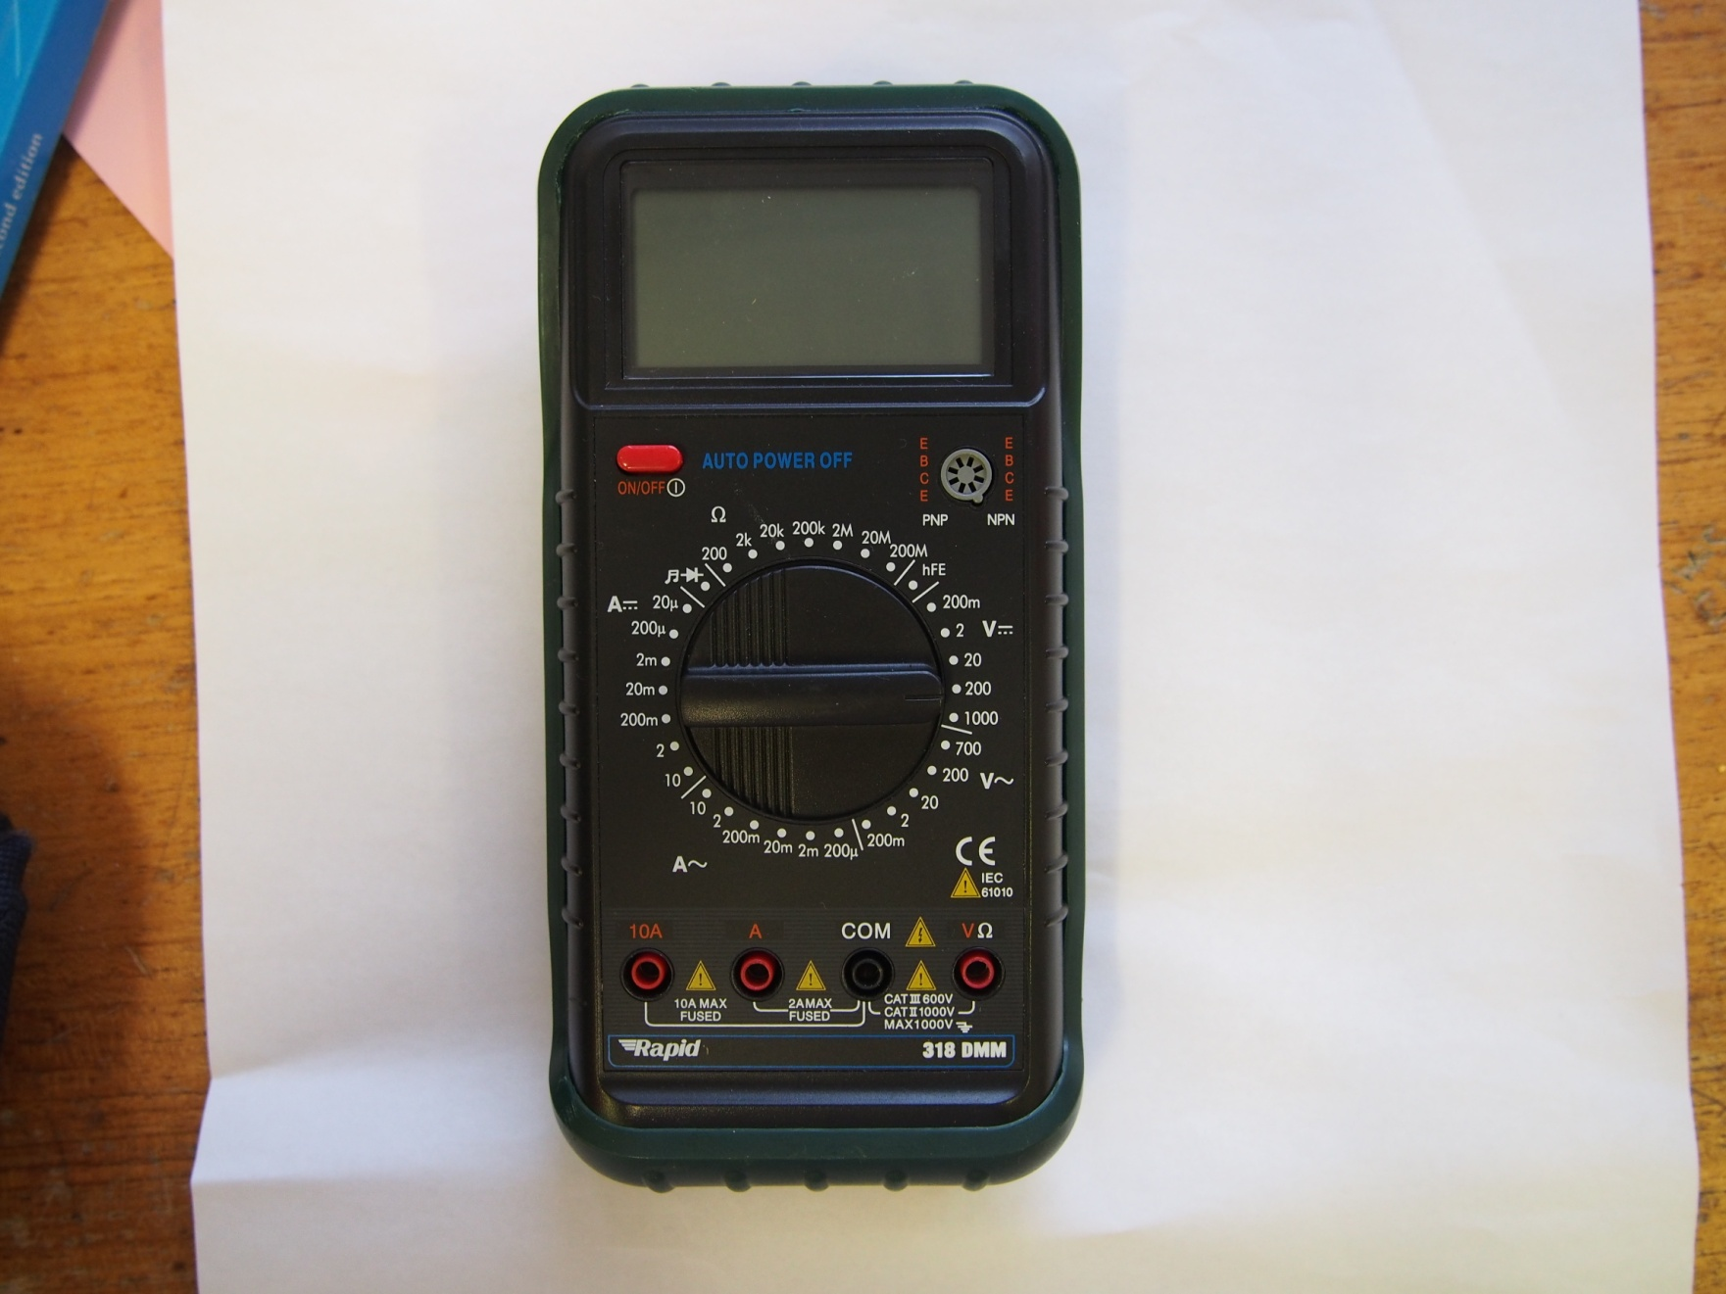

Current ACCurrent AC
Current (DCCurrent DC

CURRENT
1. Turn the dial so that it points towards ac current or dc current as appropriate.
2. Use COM and A or COM and 10A

Voltage is measured using a voltmeter.
The voltmeter is connected in parallel.
Connect the voltmeter on either side of the component you wish to measure the voltage across.
Start off with the highest voltage reading, then work down.
If the meter gives a negative reading the wire need to be swopped round.

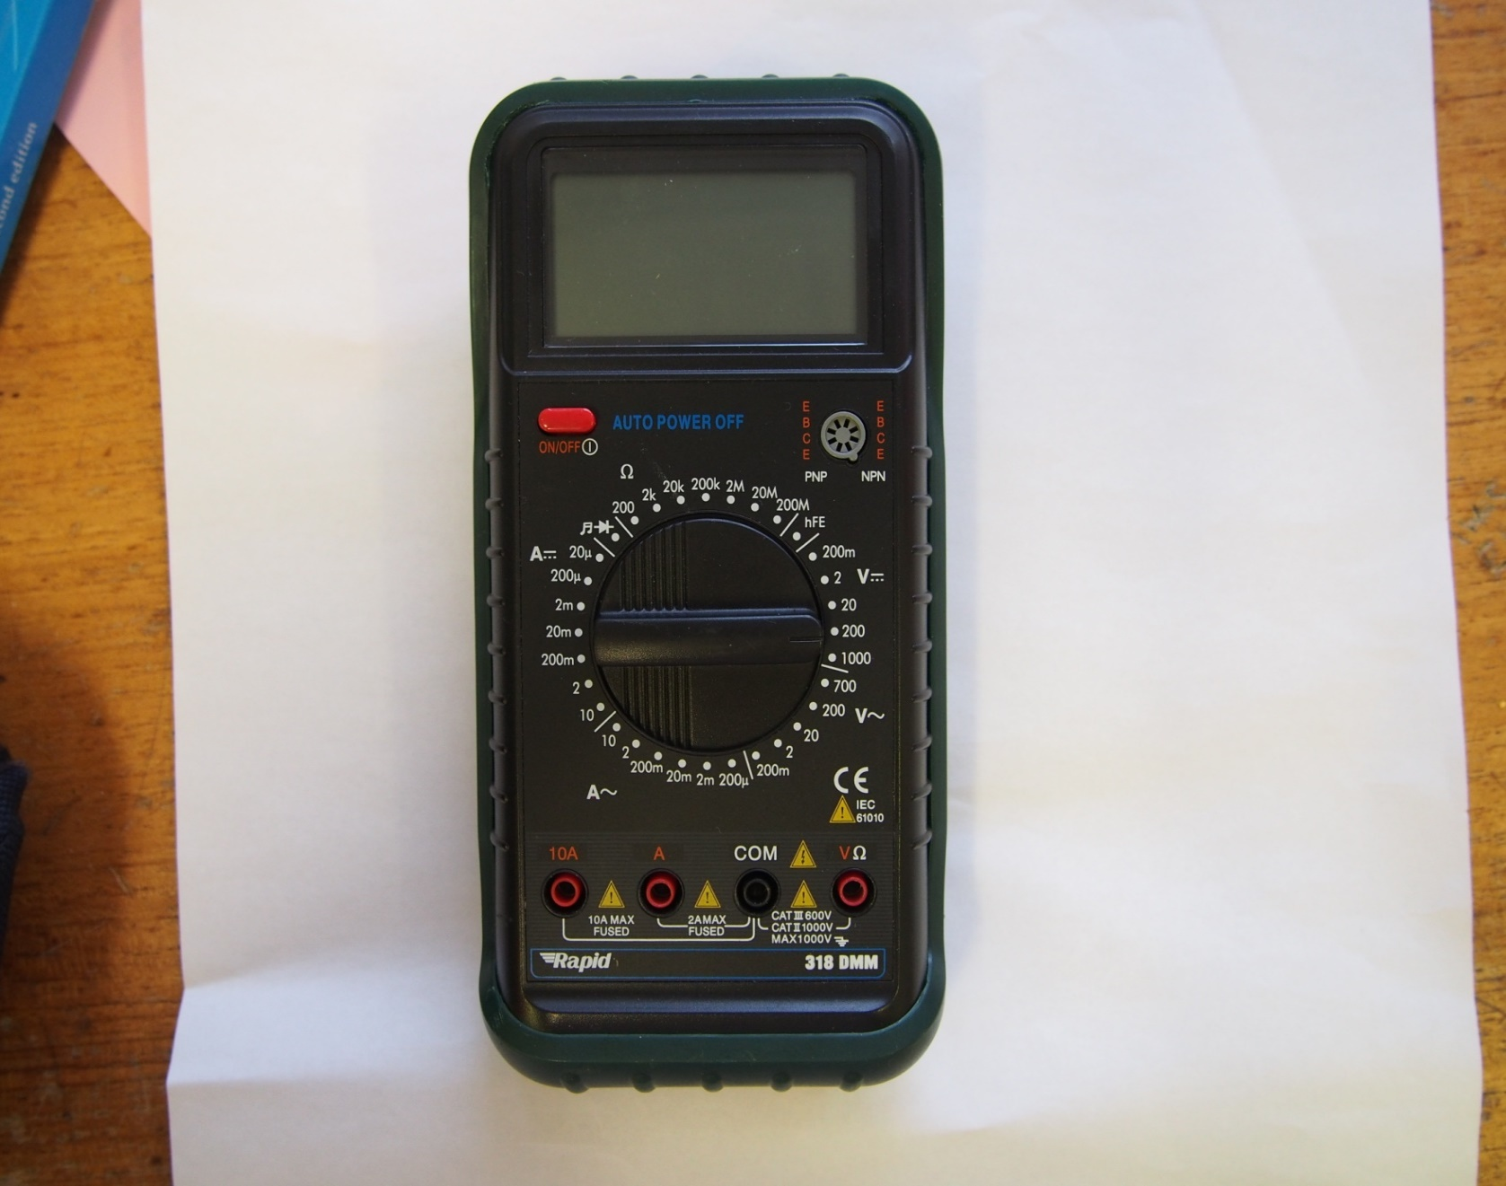
VOLTAGE
1. Turn the dial so that it points towards ac voltage or dc voltage as appropriate.
2. Use COM and VΩ

Voltage DC DCVotage DC
Voltage AC
10A A COM VΩ 10A A COM
Resistance is measured using an ohmmeter.
The ohmmeter is connected in parallel.
Connect the ohmmeter on either side of the component you wish to measure the resistance of.
Note – the component should not have current flowing through it at this time. If it does you may get an inaccurate reading.
The unit for resistance is the ohm – symbol Ω.
Resistance (Ω)
10A A COM VΩ
RESISTANCE
1. Turn the dial so that it points towards resistance.
2. Use COM and VΩ

Example 14
A student sets up an experiment to investigate the current in and the voltage across two different resistors.
The student uses a battery, an ammeter, a voltmeter and some wires to obtain measurements for each resistor.
Complete the diagram below, by inserting a resistor, to show how the measurements could be obtained.
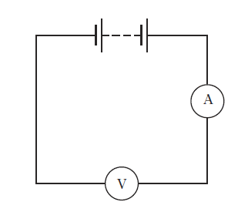
SQA 2011 SG General 8a
Example 13
A student has designed a simple electric cart. The cart uses 2 large 12V rechargeable batteries to drive an electric motor. The circuit diagram for the cart is shown.
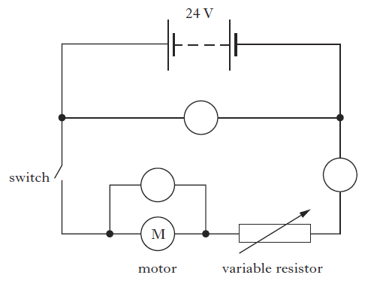
The circuit contains two voltmeters and an ammeter.
Complete the diagram by labelling the meters.
SQA 2013 SG Credit Q4a
Example 15
Redraw the circuit shown below using the correct circuit symbols for each component. Your circuit should include an ammeter which measures the current in the circuit and a voltmeter which measures the potential difference across the lamp.
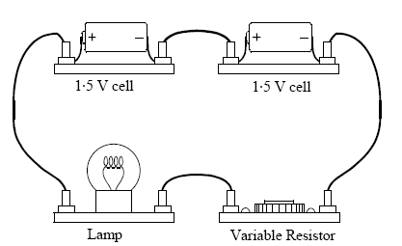

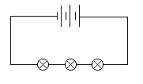
The simplest type of circuit is a series circuit.
In a series circuit there is only ONE path for the electricity to flow around.

The energy in the circuit comes from the cells. They supply the voltage for the circuit.
The energy is carried round the circuit by the electrons as the current flows round the circuit.
As each electron flows through each bulb it gives up some of the energy carried. This energy is converted into light (and heat).
The wires use up a very tiny amount of energy – this is usually ignored.
We need to be able to measure these changes so we can calculate what is
If the circuit is broken – the bulbs go out.
- there is no path for the energy to flow.
If more cells are added – the bulbs get brighter.
- the total energy in the circuit has gone up.
If more bulbs are added – the bulbs get dimmer.
- the energy available is being shared among more components.

happening in the circuit

V_{s}
B₁ B₂ B₃
V₁ V₂ V₃
I₁
I₂

The current in a series circuit is the same at all points.
I₁ = I₂
The supply voltage is equal to the sum of the voltage drops.
V_{S} = V₁ + V₂ + V₃
R₂ = 12 – 5 = 7V
Current is same at all points so
Current at B = Current at A = 2A

The cell supplies 12V and the current is 2A at point A.
The voltage across R₁ is 8V.
What is the current at B and the voltage across R₂?
Example 16
R₁
R₂
A
B
5V
12V
Example 17
A series circuit has a supply voltage of 24V. There are 4 identical lamps in the circuit. What is the voltage across each lamp?
Each lamp will have the same voltage across it, so 24/4 = 6V

Leckie + Leckie P 196
Ex 1.4.1 Q 1 - 3
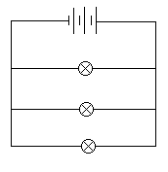
In a parallel circuit there is more than one path for the electricity to flow around.

The energy in the circuit comes from the cells. They supply the voltage for the circuit.
The energy is carried round the circuit by the electrons as the current flows round the circuit.

As each electron flows from the cells it reaches a junction. Some electrons flow through the first loop – as these electrons pass through the bulb they give up all the energy carried.
The rest of the electrons travel through the wire until the reach the next junction. Some electrons flow through the second loop and the rest flow through the third loop. Again as each electron passes through the bulb in its loop it gives up all the energy carried.
This energy is converted into light (and heat).

The wires use up a very tiny amount of energy – this is usually ignored.
If the circuit is broken at the cells - all the bulbs go out.
If a bulb is disconnected - the other bulbs stay on.
If more cells are added – the bulbs get brighter.
If more bulbs are added – the bulbs stay the same brightness as one another.

Is
Is
I₁
I₂
I₃
B₁
B₂
B₃
V₁
V₂
V₃
V_{s}
The current from the supply is equal to the sum of the current in all the branches.
I_{s} = I₁ + I₂ + I₃
The voltage across each component in parallel with the supply is the same.
V_{s} = V₁ = V₂ = V₃
Example 18
V_{s}
I₄
I₁
I₃
I₄
R₁
R₂₂
R₁ and R₂ are identical. If the voltage across R₁ is 10V and the current through R₂ is 0.4A, what are the values for I_{1,} I₂ and I₄ and what is the voltage across the supply and R₂?
I₂ =I₃ so I₂ = 0.4A. I₁= I₄ = I₂ ₊ I₃ = 0.4 + 0.4 = 0.8A
V_{s} = V₁ = V₂ = 10V

Example 19
A circuit is set up as shown.
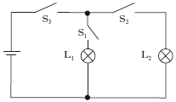
Which switch or switches must be closed to light lamp L₁ only.
- S₁ only
- S₂ only
- S₁ and S₂ only
- S₁ and S₃ only
- S₂ and S₃ only.
SQA 2008 Int 2 Q 10

Example 20
A circuit is set up as shown.
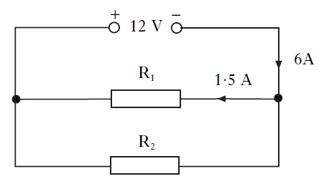
The current from the supply is 6A.
The current in resistor R₁ is 1.5A
Which row in the table shows the potential difference across resistor R₂ and the current in resistor R₂?

 | Potential difference across R₂ (V) | Current in R₂ (A)
A | 12 | 1.5
B | 6 | 1.5
C | 12 | 4.5
D | 6 | 4.5
E | 12 | 7.5
SQA 2013 Int2 Q10

Example 22
A circuit is set up as shown
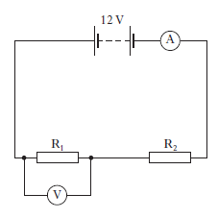
The reading on the ammeter is 3.0A. The reading on the voltmeter is 4.0V.
Which row in the table shows the current in resistor R₂ and the voltage across resistor R₂?
 | Current in resistor R₂ (A) | Voltage across resistor R₂ (V)
A | 1.5 | 8.0
B | 3.0 | 4.0
C | 3.0 | 8.0
D | 1.5 | 12.0
E | 6.0 | 4.0

Example 21
A student makes the following statements about electrical circuits.
- The sum of the potential differences across components connected in series is equal to the supply voltage.
- The sum of the currents in parallel branches is equal to the current drawn from the supply
- The potential difference across components connected in parallel is the same for each component.
Which of the statements is/are true?
A I only
B III only
C I and II only
D II and III only
E I, II and III
SQA 2010 Int 2 Q7

Electricity question booklet P7 Q 1 - 6
Leckie + Leckie P 68 Ex 1.4.3 Q 1 - 3
At National 5 level, by the end of this section you should be able to:
- Describe an experiment to verify Ohm’s Law.
- State that the unit of resistance is the ohm (Ω)
- Draw a graph of V against I
- Use the gradient of the line of best fit on a V-I graph to determine resistance.
- Use of an appropriate relationship to solve problems involving potential difference (voltage), current and resistance.
  - V = IR
  - $V_{2}= \left(\frac{R_{2}}{R_{1}+R_{2}}\right)V_{s}$
  - $\frac{V_{1}}{V_{2}}=\frac{R_{1}}{R_{2}}$
- State the qualitative relationship between the temperature and resistance of a conductor.

Resistance is the opposition to current flow.
Resistance is measured in ohms (Ω).
All conductors show some resistance to current flow – factors which affect the resistance of a conductor are
- Material – copper has a lower resistance than brass
- Length – the longer the wire the greater the resistance.
- Thickness – thin wires have greater resistance than thick wires
- Temperature – heating a wire decreases the resistance.

In a circuit we use components called resistors.
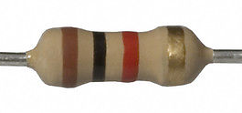
These take up less room than a long piece of wire and can be manufactured to have a particular resistance.
An ohmmeter can be used to measure the value of a resistor – but only if there is no current flowing in the resistor.

If the resistor is part of a circuit, then the resistance can be calculated if the current through the resistor and voltage across the resistor are measured.
V
A

The current through and voltage across a fixed value resistor are measured when the value of the supply voltage is altered.
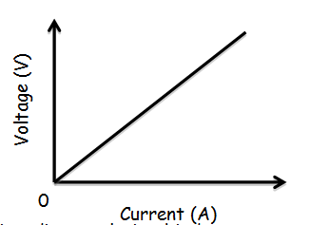

A graph of current against voltage is plotted.

The graph produced shows that there is a direct relationship between current and voltage. This is the resistance. We can write this as an equation.
$R= \frac{V}{I}$ $Resistance= \frac{Voltage}{Current}$
This is Ohm’s law, more often written as V = IR.
The gradient of the graph is the resistance of the resistor.

To improve the results from this experiment the results are repeated and are taken over a range of readings.
Example 1
Which circuit is used to find the resistance of resistor R₂?
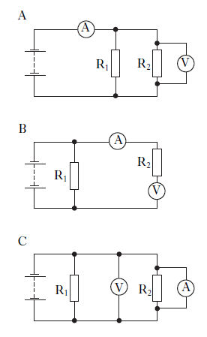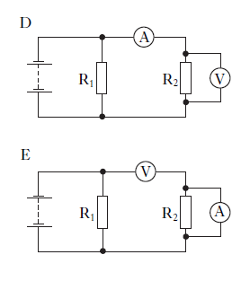
SQA Int2 2007 Q8

SQA Int2 2011 Q6
Example 2
Which graph shows how the potential difference V across a resistor varies with the current A in the resistor?
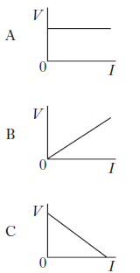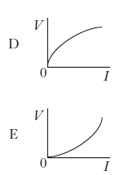

Example 3
Two groups of pupils are investigating the electrical properties of a lamp.
- Group 1 is given the following equipment:
Ammeter; voltmeter; 12V d.c. supply, lamp, connecting leads.
Complete the circuit diagram to show how this equipment is used to measure the current through, and the voltage across, the lamp.

- Group 2 uses the same lamp and is only given the following equipment:
Lamp; ohmmeter; connecting leads
What property of the lamp is measured by the ohmmeter?

$V=IR$
V = voltage – volts (V)
I = current – amperes (A)
R = resistance – ohms (Ω)

Example 5
A 12V car battery supplies current for the starter motor in a car. The current is 2A – what is the resistance of the wire?

$R= \frac{V}{I}= \frac{12}{2}= 6Ω$
Example 4
A torch bulb has a resistance of 25 Ω. When it is operating at the correct voltage the current through it is 0.024 A.
What is the voltage?
V = IR = 25 x 0.24 = 6V

Example 7
A 4kΩ resistor has a current of 2.5 mA flowing through it. What is the voltage across the resistor?
V = IR = 4 x 10³ x 2.5 x 10⁻³
= 10V

Example 6
A light bulb is designed to work at 230V, The resistance of the bulb is 200Ω. What is the current?
$I= \frac{V}{R}= \frac{230}{200}= 1.15A$

Example 8
A student has four resistors labelled A, B, C and D. The student sets up circuit 1 to identify the value of each resistor.
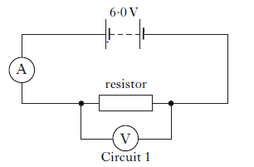
Each resistor is placed in the circuit in turn and the following results are obtained.
Resistor | Voltage across resistor (V) | Current (A)
A | 6.0 | 0.017
B | 6.0 | 0.027
C | 6.0 | 0.050
D | 6.0 | 0.033
- (i) Show, by calculation, which of the resistors has a value of 120Ω.

SQA SG Credit 2008 Q4 a,b

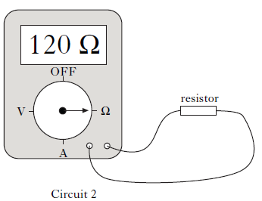
(ii) The student then sets up circuit 2 to measure the resistance of each resistor. State one advantage of using circuit 2 to measure the resistance compared to using circuit 1.

Leckie and Leckie P188, Ex 3.11.1 Ohm’s Law Q 1 - 5
National 5 Electricity questions P9 Q1 - 14

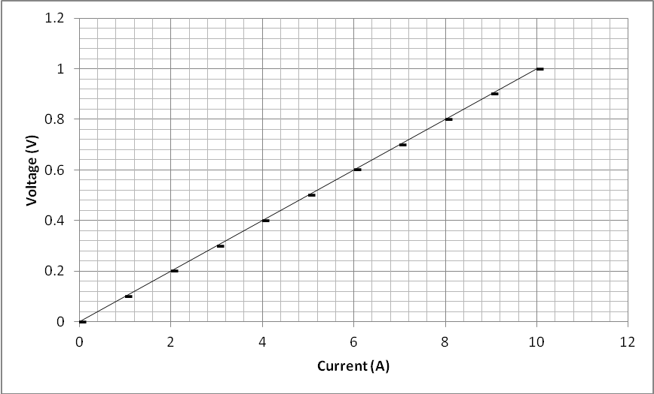
The values for voltage and current can be plotted on a graph like the one above. Resistance can be calculated in two ways
- Choose a point from the graph and use the values for V and I to calculate R
- Use the gradient of the graph to calculate R.

Method 2
Gradient = y₂ – y₁
x₂- x₁
= 0.6 – 0.2
6 – 2
= 0.4 = 0.1 Ω
4
Method 1
V = 0.6V
I = 6A

R = V/I = 0.6/6 = 0.1 Ω

Example 9
A student sets up the following circuit to investigate the resistance of resistor R.
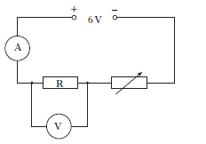
The variable resistor is adjusted and the voltmeter and ammeter readings are noted. The following graph is obtained from the experimental results.
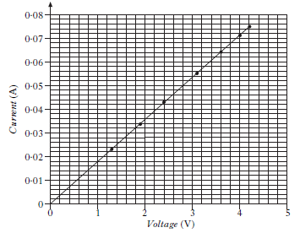
- Calculate the value of the resistor R when the reading on the voltmeter is 4.2V.

- Using information from the graph, state whether the resistance of the resistor R, increases, stays the same or decreases as the voltage increases.
Justify your answer.

SQA Int2 2009 Q25a

Example 10
The graph shows the relationship between the voltage across a resistor and the current in the resistor.
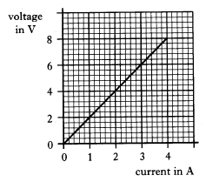
The resistance of the resistor is
- 0.5Ω
- 2Ω
- 4Ω
- 12Ω
- 32Ω
SQA Int 2 2004 Q13

Leckie and Leckie P188, Ex 3.11.1 Ohm’s Law Q6

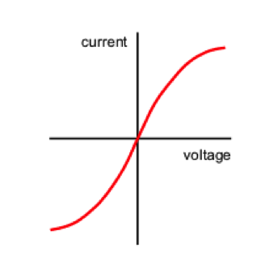
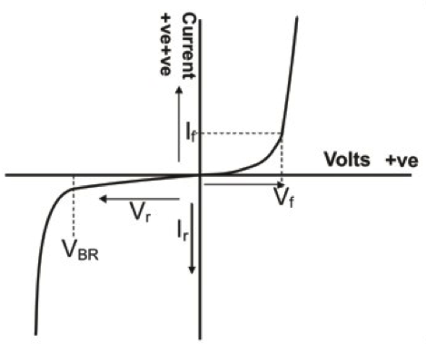
A non-ohmic material is one which does not obey Ohm’s Law.

If you plot a graph of current against voltage it will not give a straight line. The devices below are examples of non-ohmic components.

A filament lamp (bulb) is a non-ohmic device. When the bulb is switched on current flows through the wire. The wire has resistance and heats up. When it is glowing white-hot it emits both light and heat.As the temperature increases the resistance also increases.
The graph for the
current and voltage
in a filament lamp
looks like this.
Different lamps will
have different curves.
Other non-ohmic devices include
light emitting diodes, thermistors
and light dependent resistors.
The graph shows the change in
resistance for a light emitting
diode.
Example 11
Which graph shows how the resistance of most thermistors varies with temperature?
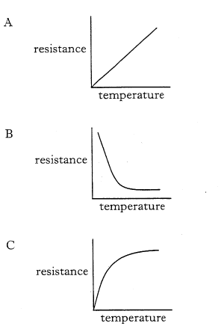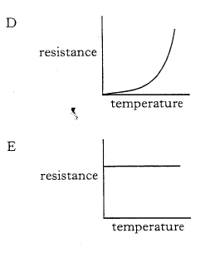

SQA Int2 2005 Q13

Resistance in circuits

- State that adding further resistance in series increases the total resistance.
- State that adding further resistance in parallel decreases the total resistance.
- Use an appropriate relationship to solve problems involving the total resistance of resistors in series circuits.
R_{t} = R₁ + R₂ +…
- Use an appropriate relationship to solve problems involving the total resistance of resistors in parallel circuits.
$$\frac{1}{R_{T}}= \frac{1}{R_{1}}+ \frac{1}{R_{2}}+…$$
- Use appropriate relationships to solve problems with a combination of series and parallel resistors.

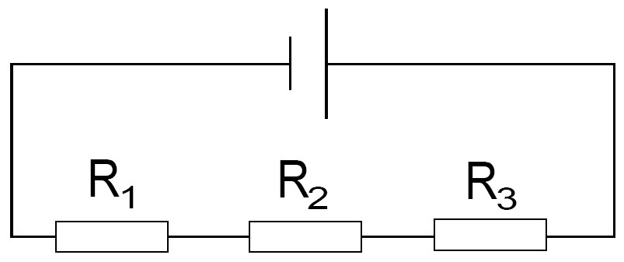

If resistors are joined in series with one another the total resistance increases.

The total resistance can be calculated using
R_{T} = R₁ + R₂ + R₃
The total resistance is always greater than the largest resistance.

Example 12
A circuit contains two resistors connected in series. The resistors are 15Ω and 27Ω respectively. What is the total resistance of the circuit?
R_{T} = R₁ + R₂ = 15 + 27 = 90Ω

Example 13
A circuit contains three resistors connected in series. The resistors are 10Ω, 30Ω and 50Ω respectively. What is the total resistance of the circuit?
R_{T} = R₁ + R₂ + R₃ = 10 + 30 + 50 = 90Ω

Example 14
A circuit is set up with three identical lamps connected as shown in the circuit below. Each lamp has a resistance of 25Ω.
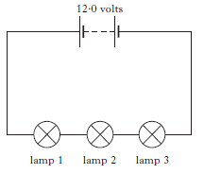
Calculate the total resistance in the circuit.
R_{T} = R₁ + R₂ + R₃ = 25 + 25 +25 = 75Ω

SQA SG 2010 Gen Q8 adapted

Example 15
A circuit is set up as shown
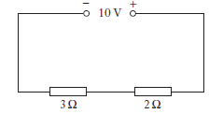
The potential difference across the 2Ω resistor is
- 4V
- 5V
- 6V
- 10V
- 20V
SQA Int2 2011 Q7
Leckie and Leckie P198, Ex 3.12.2 Total resistance in a series circuit
National 5 Electricity questions P11 Q1 - 3

A

If resistors are joined in parallel with one another the total resistance decreases. The total is always less than the smallest resistor being added

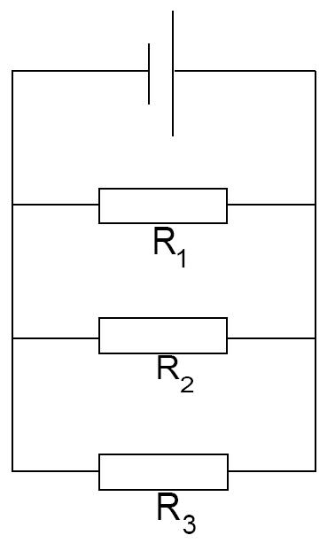
The total resistance can be calculated
using
$$\frac{1}{R_{t}}\text{ = }\frac{1}{R_{1}}+\frac{1}{R_{2}}+\frac{1}{R_{3}}$$
To calculate total resistance in parallel either
- Use fractions
OR
- Use x⁻¹ button on the calculator

- Using Fractions
If R₁ = 6Ω, R₂ = 12 Ω and R₃ = 24 Ω.
$\frac{1}{R_{t}}\text{ = }\frac{1}{R_{1}}+\frac{1}{R_{2}}+\frac{1}{R_{3}}$
- $\frac{1}{R_{t}}\text{ = }\frac{1}{6}+\frac{1}{12}+\frac{1}{24}$ Find the lowest common denominator
- $\frac{1}{R_{t}}\text{= }\frac{4}{24}+\frac{2}{24}+\frac{1}{24}= \frac{7}{24}$ Remember that this is $\frac{1}{R_{t}}$
- R_{t} = $\frac{24}{7}$ = 3.4 Ω

x⁻¹
x⁻¹

2. Using the x⁻¹ button on the calculator.
Remember that you should write down the calculation as you go along.
$\frac{1}{R_{t}}\text{ = }\frac{1}{R_{1}}+\frac{1}{R_{2}}+\frac{1}{R_{3}}$
- $\frac{1}{R_{t}}\text{ = }\frac{1}{6}+\frac{1}{12}+\frac{1}{24}$ Key 6 + 12 + 24 = 7/24
Remember that this is $\frac{1}{R_{t}}$
Enter = This gives the answer.



x⁻¹
x⁻¹

x⁻¹

Three resistors are connected in parallel. Their resistances are 4Ω, 6Ω and 12Ω. What is the total resistance? 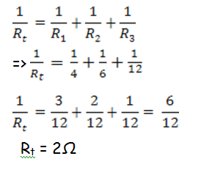

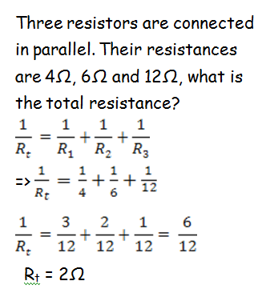

Example 16
A circuit has two resistors connected in parallel. The resistors are both 20Ω. What is the total resistance?
$\frac{1}{R_{t}}\text{ = }\frac{1}{R_{1}}+\frac{1}{R_{2}}$= $\frac{1}{20}+\frac{1}{20}$=$\frac{2}{20}$ R_{t} = 10Ω

Example 17
How could you use only 20Ω resistors to make 5Ω?
Connect four 20 Ω resistors in parallel with one another.

Example 18
A 25Ω resistor is connected in parallel with a 15Ω and a 30Ω resistor.
What is the total resistance?
$$\frac{1}{R_{t}}\text{ = }\frac{1}{R_{1}}+\frac{1}{R_{2}}+\frac{1}{R_{3}} => \frac{1}{R_{t}}\text{ = }\frac{1}{25}+\frac{1}{15}+\frac{1}{30}$$
1/R_{t} = 0.14 => R_{t} = 7.1Ω

Example 19
A student sets up a circuit using a 12V supply and two lamps which each have a resistance of 4Ω. The resistance of the variable resistor is set to 6Ω.
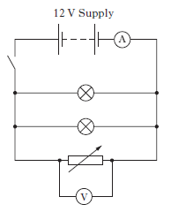
- Calculate the total resistance of this circuit
$$\frac{1}{R_{t}}\text{ = }\frac{1}{R_{1}}+\frac{1}{R_{2}}+\frac{1}{R_{3}} => \frac{1}{R_{t}}\text{ = }\frac{1}{4}+\frac{1}{4}+\frac{1}{6}$$
$$\text{ = }\frac{3}{12}+\frac{3}{12}+\frac{2}{12}= \frac{8}{12}$$
R_{t} = $\frac{12}{8}$ = 1.5 Ω

- The variable resistor is now removed from the circuit.
- What happens to the reading on the ammeter?

It decreases
(B) Justify your answer.
The total resistance in the circuit has increased so the total current in the circuit decreases.
SQA SG Credit 2012 Q3b

Example 20
An electric fire uses the circuit shown below.
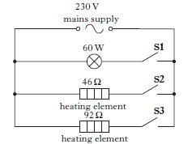
The person using the fire opens switch S1 and closes switches S2 and S3.
Calculate the combined resistance of both heating elements.
$$\frac{1}{R_{t}}\text{ = }\frac{1}{R_{1}}+\frac{1}{R_{2}} => \frac{1}{R_{t}}\text{ = }\frac{1}{46}+\frac{1}{92}$$
$$\text{ = }\frac{2}{92}+\frac{1}{92}= \frac{3}{92}$$
R_{t} = $\frac{92}{3}$ = 30.7 Ω

SQA SG Credit 2011 Q3b(i)
Leckie and Leckie P209, Ex 3.12.4 Total resistance in a parallel circuit
National 5 Electricity questions P12 Q1 - 5

$$\frac{1}{R_{t}}\text{ = }\frac{1}{R_{1}}+\frac{1}{R_{2}} => \frac{1}{R_{t}}\text{ = }\frac{1}{20}+\frac{1}{20}=\frac{2}{20}$$
R_{t} = $\frac{20}{2}$ = 10 Ω

Example 21
Storage heaters contain heating elements which are used to heat up bricks.
Circuit 1 shows heating elements connected in series and circuit 2 shows heating elements in parallel.
Find the resistance of
- Circuit 1
- Circuit 2.
R_{T} = R₁ + R₂ + R₃ = 4 + 4 + 4 = 12Ω

Resistors are designed in a range of particular values. This means that sometimes engineers need to use a mixture of resistors in both series and parallel to obtain a particular value.

You can solve problems for these circuits using the rules you have already learned for resistors in series and resistors in parallel.
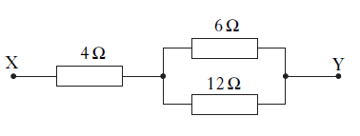
20Ω

20Ω

30Ω
- Work out the resistance of the two resistors in parallel.

- $\frac{1}{R_{t}}\text{ = }\frac{1}{R_{1}}+\frac{1}{R_{2}} => \frac{1}{R_{t}}\text{ = }\frac{1}{20}+\frac{1}{20}= \frac{2}{20}$

$R_{t}= \frac{20}{2}= 10Ω$

- If you replaced the parallel resistors with a single resistor your circuit would look like this.
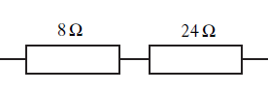
10Ω

30Ω

Y
X

- Work out the total resistance.
R_{t} = R₁ + R₂
= 30 + 10 = 40Ω

This shows that the total resistance between X and Y is 40Ω.

Example 22
Part of a circuit is shown below
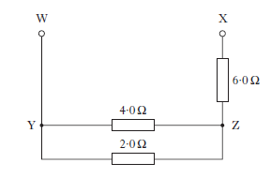
- Calculate the total resistance between points Y and Z.

- Calculate the total resistance between points W and X.

R_{T} = R₁ + R₂ = 1.33 + 6 = 7.3Ω
- Calculate the voltage across the 2.0 Ω resistor when the current in the 4.0 Ω resistor is 0.10A.

SQA Int2 2011 Q25 a, b

Example 23
Three resistors are connected as shown.
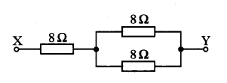
The total resistance between X and Y is
- 4Ω
- 8Ω
- 12Ω
- 16Ω
- 24Ω
SQA Int2 2010 Q8

C

C
Example 25
The resistance of combinations of resistors on a circuit board, shown below, is being measured with an ohmmeter.
- What resistance will be measured between points A and B?
- What resistance will be measured between points B and C?
R_{T} = R₁ + R₂ = 47 + 22 = 69Ω (b) 15 ohms
Int 2 Homework package
Example 24
Three resistors are connected as shown.
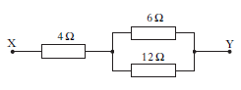
The total resistance between X and Y is
- 2Ω
- 4Ω
- 8Ω
- 13Ω
- 22Ω
SQA Int2 2010 Q8

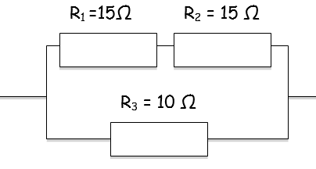
y
X

- Find the resistance of the two resistors in series first.
- R_{t} = R₁ + R₂
= 30 + 10 = 40Ω
- If you replaced the series resistors with a single resistor your circuit would look like this.
30Ω
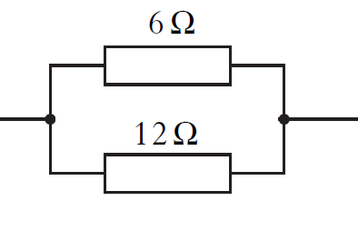
10Ω
- Work out the total resistance
$$\frac{1}{R_{t}}\text{ = }\frac{1}{R_{1}}+\frac{1}{R_{2}} => \frac{1}{R_{t}}\text{ = }\frac{1}{30}+\frac{1}{10}$$
$$= \frac{1}{30}+\frac{3}{30}= \frac{4}{30}$$

$R_{t}= \frac{30}{4}= 7.5Ω$

This shows that the total resistance between X and Y is 7.5Ω.

Example 26
A student is given a task to combine two resistors from a pack containing one each of 33Ω, 56Ω, 82Ω, 150Ω, 270Ω, 390Ω.
Show by calculation which two resistors should be used to give:
- The largest combined resistance;
- The smallest combined resistance.

- 270 + 390 = 660 ohms

- 33 and 56 in parallel

SQA Int 2 2009 Q25 b

Example 27
Using only 25Ω resistors, draw a combination of resistors which has a total resistance of 17.5Ω

Two 25 ohm resistors in parallel = 12.5 ohms
Five 25 ohm resistors in parallel = 5 ohms
Put the two sets of resistors in series with one another..

Leckie and Leckie P212, Ex 3.12.5 Resistance in series and parallel circuits
National 5 Electricity questions P14 Q1 – 5, P16 Q1-20

The current in the circuit can be calculated using Ohm’s Law.
I = V = V_{S}
R R₁+R₂
To calculate the voltage across each resistor use Ohm’s Law again.
V₁ = I R₁ = V_{S} R₁ V₂ = I R₂ = V_{S} R₂
R₁+R₂ R₁+R₂

Voltage divider circuits are often drawn like this.

The calculations are exactly the same as above.

If you prefer the circuit to look like the first one turn the page on its side.
R₁
R₂
V_{OUT}
V_{S}
0V

Example 28
The supply voltage is 6V.
R₁ is 2.5kΩ and R₂ is 500Ω.
Calculate the output voltage

The supply voltage is 12V.
R₁ is 6kΩ and R₂ is 18kΩ.
Calculate the voltage across R₁
Example 29

Example 30
R₁ is 500Ω and R₂ is 5.5kΩ.
The voltage across R₁ is 1V.
Calculate the voltage across R_{2,} then find the supply voltage.

Leckie and Leckie P216, Ex 3.12.6 The potential divider
National 5 Electricity questions P21 Q1 - 12

The voltage divider containing a thermistor can be used to provide the input of a circuit which responds to changes in temperature (like a thermostat).
- As the temperature increases
- The resistance of the thermistor decreases
- The voltage across the thermistor decreases
- The voltage across the variable resistor increases
- V out increases

- If the temperature decreases the output voltage decreases

- As the temperature increases
- The resistance of the thermistor decreases
- The voltage across the thermistor decreases
- V out decreases

- If the temperature decreases the output voltage increases

Useful Mnemonics
LDR = Light Decreases Resistance OR LURD – Light up resistance down

LDR = Light Decreases Resistance OR LURD – Light up resistance down

A thermistor is a temperature dependent resistor. When the temperature increases the resistance of the thermistor falls. This is a non-ohmic device. Values for the resistance at certain temperatures are often given in a graph or a table.

- As the light level increases
- The resistance of the LDR decreases
- The voltage across the LDR decreases
- V out decreases

- If the light level decreases the output voltage increases

Useful Mnemonic
TURD – temperature up resistance down.

TURD – temperature up resistance down.

A light dependent resistor changes its resistance depending upon the light level – when the light level goes up the resistance goes down. This is also a non-ohmic device. Again values for resistance at certain light levels are commonly given in a table or on a graph.

The voltage divider containing a thermistor can be used to provide the input of a circuit which responds to changes in temperature (like a thermostat).
V_{out}
V_{s}
0V
- As the light level increases
- The resistance of the LDR decreases
- The voltage across the LDR decreases
- The voltage across the variable resistor increases
- V out increases

- If the light level decreases the output voltage decreases

Example 31
A light dependent resistor (LDR) is used as the sensor in a soap dispenser.
A student investigates the properties of the LDR by connecting it into the circuit shown below
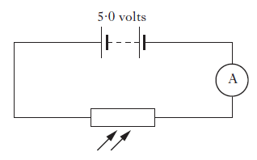
When the LDR is uncovered the reading on the ammeter is 0.002A.
- Calculate the resistance of the LDR.
- State what happens to the resistance of the LDR when it is covered.

Example 32
A circuit is set up as shown
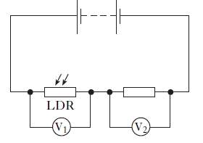
The initial reading on both voltmeters V₁ and V₂ is 2.5V.
The light shining on the LDR is made brighter.
Which row in the table shows possible new readings on voltmeters V₁ and V₂?
 | Reading on V₁ (V) | Reading on V₂ (V)
A | 2.0 | 3.0
B | 2.5 | 2.0
C | 2.5 | 2.5
D | 2.5 | 3.0
E | 3.0 | 2.0
SQA Int 2 2007 Q14

Example 33
A bank has an alarm system which can be triggered by the cashiers who work behind the counter. The alarm can be triggered when a cahsier removes an imitation £20 note from a cash drawer.
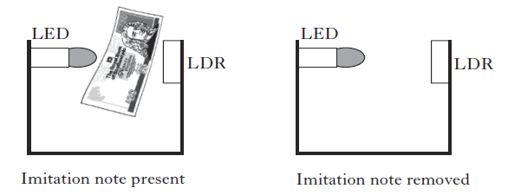
The table shows the resistance of the LDE in different light conditions.
Imitation £20 note | Resistance (kΩ)
Present | 24
removed | 2
Part of the cash drawer circuit is shown below.
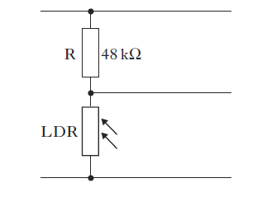
When the imitation £20 note is removed from the drawer, the voltage across the LDR is 0.36V.
Calculate the voltage across R.

A diode conducts electricity in one direction only. A light emitting diode (LED) is a diode which gives out light. It uses a much smaller current than a filament lamp. LED’s are used as power indicators.

In a circuit which has a dc power supply the circuit will not conduct if the diode is the wrong way around.

Changing a.c. to d.c.
In a circuit which has an a.c. power supply the circuit will conduct on one half cycle only.
If a capacitor is added to the circuit it can make the output smoother by storing charge between each half cycle.
There are other circuits, using diodes, which can improve the quality of the d.c. output even more

If a capacitor is added to the circuit it can make the output smoother by storing charge between each half cycle.
There are other circuits, using diodes, which can improve the quality of the d.c. output even more.

The LED in this circuit has a particular operating voltage (V_{LED}) and current (I_{max}). If either the voltage or current are exceeded it is likely to stop working. To protect the LED from too much current through it or too much voltage across it a resistor is added in series.
The size of series resistor necessary to protect the LED can be calculated in two steps.
2. Calculate the size of the resistor using Ohm’s Law
$$R= \frac{V_{r}}{I_{max}}$$

Example 34
A circuit is set up with a 9V battery connected to a resistor in series with a light emitting diode.
The operating conditions for the LED are 1.5V and 7.5 mA.
What value of series resistor is needed?
- V_{R} = V_{S} - V_{LED}
= 9 – 1.5 = 7.5V
- R = V_{R} = 7.5
I_{max} 7.5 x 10⁻³
= 1000Ω
Example 35
A student makes a circuit which contains a 6V battery, LED and resistor. The voltage across the LED must not exceed 1.6V and the current must not exceed 8mA. What size of series resistor is needed?
- V_{R} = V_{S} - V_{LED}
= 6 – 1.4 = 4.6V
- R = V_{R} = 4.6
I_{max} 8 x 10⁻³
= 575Ω

Example 36
A student sets up the circuits shown. In which circuit will both LEDs be lit?
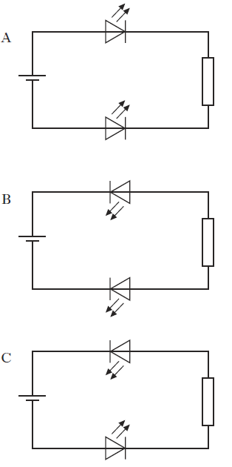
SQA Int2 2012 Q11

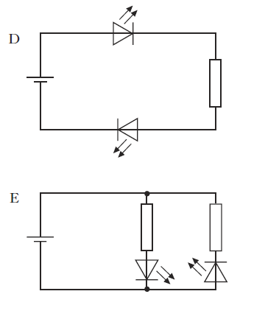

Example 37
Light emitting diodes (LEDs) are often used as on/off indicators on televisions and computers.
An LED is connected in a circuit with a resistor R.
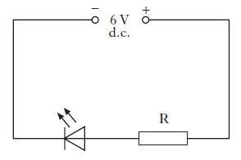
The LED is rated at 2V, 100mA. Calculate the resistance of resistor R.
SQA Int2 2011 Q27

Leckie and Leckie P220, Ex 3.12.7
Bulb vs. LED
National 5 Electricity questions P23 Q1 - 5

Example 38
The rear light of a car is made up of a row of 10 identical red LED’s. Each LED requires 2V and 20 mA to operate correctly.
- The circuit for this is shown.
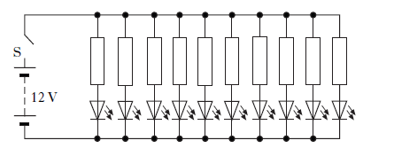
- Why does each LED need a resistor in series?
- The voltage of the car battery is 12V.
Calculate the value of each resistor.
- Calculate the total current, in amperes, from the battery when the rear light is operating correctly.

A transistor is an electronic switch.
You need to recognize two types of transistor.

emitter
collector
base

drain
gate
source

This is an npn-bipolar transistor.
This transistor switches ON when the This is an n-channel enhancement metal voltage at the base (between base oxide semiconductor field effect
and emitter) is 0.7V or more transistor – MOSFET.
This transistor switches ON when the voltage at the gate (between gate and source) is 2V or more.
Transistors can be used to provide the link between an input circuit and an output circuit.

The input part of the circuit could be a voltage divider circuit with a thermistor or a light dependent resistor.
The transistor will switch depending on the voltage from the input section.
The output part of the circuit could be a resistor in series with a light emitting diode. Other possible output devices are a relay operating a second circuit which contains a motor.
When the circuit is broken down into the individual sections it is easy to work out how it operates.

The circuit breaks into three bits.
A – the voltage divider
B – the transistor switch
C – LED output

When the light level falls, the resistance of the LDR increases, so the voltage across the LDR increases. When this reaches 0.7V or above the transistor switches on, so the bulb switches on.
A
B

C

A
B
C
The circuit breaks into three bits.
A – the voltage divider
B – the MOSFET transistor switch
C – output (bulb)
When the temperature rises, the resistance of the thermistor falls, so the voltage across the thermistor decreases. The voltage across the variable resistor rises. When this reaches 2V or above the MOSFET switches on, so the bulb switches on.

Example 39
A student observes that the brighter the light shining on a set of solar cells the higher the voltage output. She constructs a circuit to show how solar cells could operate the motor-driven sun shade above a shop window.
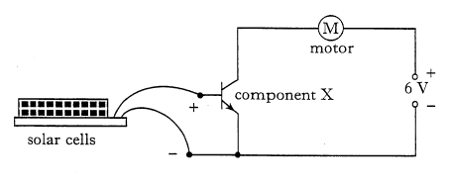
- Name component X
- Explain how this circuit operates the motor of the sun shade when the sunlight has become sufficiently bright.

SQA Int2 2006 Q27d

Example 40
An electronic circuit, used to give a warning, is shown below.
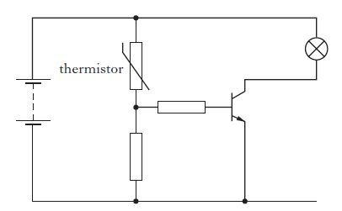
- What causes the resistance of a thermistor to change?

- State the function of the transistor in this circuit

- Explain how this circuit operates.

- Suggest where this circuit could be used to give a warning.

SQA SG Gen 2012 Q 13 Adapted

SQA SG Gen 2012 Q 13 Adapte
SQA SG Gen 2012 Q 13 Adapted

Example 41
The circuit shown switches a warning lamp on or off depending on the temperature.
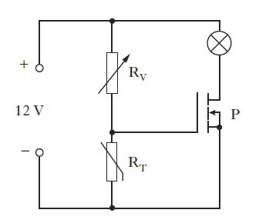
- Name component P
- As the temperature increases the resistance of thermistor R_{T} decreases. What happens to the voltage across R_{T} as the temperature increases?
- When the voltage applied to component P is equal to or greater than 2.4V, component P switches on and the warning lamp lights.
R_{V} is adjusted until its resistance is 5600 Ω and the warning lamp now lights.
At this point calculate:
- The voltage across R_{V}
- The resistance of R_{T}
- The temperature of R_{T} now decreases.
Will the lamp stay on or go off?
You must explain your answer.

SQA Int2 2012 Q25

Leckie and Leckie P227, Ex 3.12.8 Transistor control circuits
National 5 Electricity questions P25 Q1 - 6

Example 42
A photographic darkroom has a buzzer that sounds when the light level in the room is too high. The circuit diagram for the buzzer system is shown below.
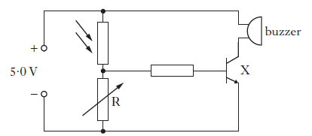
- (i) Name component X

(ii) What is the purpose of component X in the circuit?

- The darkroom door is opened and the light level increases.
Explain how the circuit operates to sound the buzzer.

- The table shows how the resistance of the LDR varies with light level.
Light level (units) | LDR resistance (Ω)
20 | 4500
50 | 3500
80 | 2500
The variable resistor has a resistance of 570Ω.
The light level increases to 80 units.
Calculate the current in the LDR.

SQA Int2 2013 Q28
At National 5 level, by the end of this section you should be able to:
- Define electrical power in terms of electrical energy and time.
- State that the unit of electrical power is the Watt (W).
- Use an appropriate relationship to solve problems involving energy, power and time.
$$P= \frac{E}{t}$$
- State the effect of potential difference (voltage) and resistance on the current in and power developed across components in a circuit.
- Use appropriate relationships to solve problems involving power, potential difference (voltage) current and resistance in electrical circuits.
P = IV
P = I²R
$$P= \frac{V^{2}}{R}$$
- Select an appropriate fuse rating given the power rating of an electrical appliance.
  - State that a 3A fuse should be selected for most appliances rated up to 720W.
  - State that a 13A fuse should be selected for appliances rated over 720W.

Power is the energy transferred per second.

$Power=\frac{Energy}{Time}$ $P= \frac{E}{t}$
P = Power – Watts (W)
E = Energy – Joules (J)
t = time – seconds (s)

Example 45
A scientific research station near the South Pole uses a vertical axis windmill to generate electrical power.
During a 24 hour period the average power output of the wind-powered generator is 25kW.
Calculate the electrical energy generated during this time.

SQA SG Gen 2011 Q17a
Leckie and Leckie P234, Ex 3.13.1 How much power?
National 5 Electricity questions P29 Q1 - 16

Example 44
What is the power rating of a low energy light bulb which uses 1,296,000 J when left on continuously for a whole day?

P = E/t = 1296000/ (24 x 60 x 60)

= 15 W
Example 43
A hairdryer operating at medium heat has a power rating of 480W. How much energy is used if it takes 5 minutes to dry Mrs Hunter’s hair?

E = Pt = 480 x (5 x 60)
= 144,000J

The power used by a device can be calculated from the voltage and current.
P = IV P = power -Watts (W)
I = current – Amperes (A)
V = voltage – Volts (V)

Ohm’s law states that V= IR or that I = V/R

Substituting for V Substituting for I
P = IV P = IV
P = IR x I P = V x V/R
P = I²R P = V²/R

Devices which produce heat use a lot of energy – this includes toasters, hair dryers, hair straighteners, fan heaters etc.

Light bulbs have been changing from filament light bulbs to energy efficient light bulbs. Filament light bulbs had typical ratings of 60W or 100W and produced both light and heat.

Energy efficient light bulbs are either fluorescent light bulbs or LED light bulbs. They produce an equivalent amount of light but very little heat. This means that you can use an 11W bulb in place of a 60W bulb.

Example 47
What is the power rating of a bulb which operates at 12V and
3A?

P = IV = 3 x 12 = 36W
Example 46
A kettle is rated at 2kW.
What is the current when the supply voltage is 230V?

I = P/V = 2000/230
= 8.7A
Example 48
A sensor operates at a voltage of 12V and has a current range of 20 -200mA. Calculate the maximum power rating of the sensor.

SQA Int2 2009 Q28c

Example 49
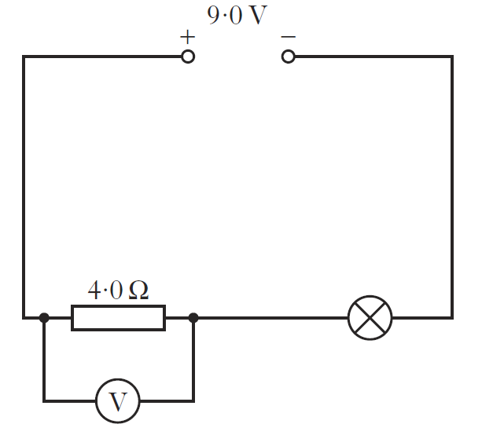

- 3.0 W
- 4.5 W
- 6.0 W
- 9.0 W
- 13.5 W
A circuit is set up as shown.
The current in the lamp is 1.5A. The reading on the voltmeter is 6.0V
The power developed in the lamp is

National 5 Electricity questions P31 Q1 - 15

Example 51
The resistance of a wire is 6Ω. The current in the wire is 2A.
The power developed in the wire is
- 3W
- 12 W
- 18 W
- 24 W
- 72 W
SQA Int2 2010 Q9
Example 50
The power rating of a heater is 2.5kW. What is the current if the resistance is 100Ω?

P = I²R => 2500 = I²100
- I² = 25
- I = 5A

Example 52
A power company installs transmission lines to take electricity to a remote community.
The current in the transmission lines is 200mA.
The transmission lines have a total resistance of 20Ω.
Calculate the total power loss in these transmission lines.

SQA SG Credit 2011 Q11 c

Example 53
A circuit is set up as shown.
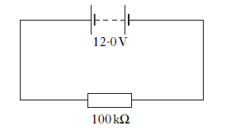
The power supplied to the resistor is
- 1.20 x 10⁻⁴ W
- 1.44 x 10⁻³ W
- 1.44 W
- 694 W
- 1.20 x 10⁶ W

Example 55
A loudspeaker in a bank alarm has a resistance of 48Ω and a power of 3.0W. Calculate the voltage across the loudspeaker when it sounds

SQA SG Credit 2012 Q7.
Example 54
Calculate the resistance of a device which has a power rating of 550W when the operating voltage is 10V.

P = V²/R => 550 = 10x10
R
=> R = 100 /550 = 0.18Ω

National 5 Electricity questions P34 Q1 - 15

Example 56
A resistor is labelled “10 Ω ±10%, 3W”
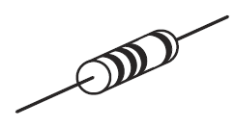
This means that the resistance value could actually be between 9Ω and 11Ω.
- A student decides to check the value of the resistance.
Draw a circuit diagram, including a 6V battery, a voltmeter and anammeter, for a circuit that could be used to determine the resistance.

- Readings from the circuit give the voltage agross the resistor as 5.7 V and the current in the resistor as 0.60A
Use these values to calculate the resistance.

Example 56 (continued)
- During the experiment, the resistor becomes very hot and gives off smoke. Explain why this happens.
You must include a calculation as part of your answer

- The student states that two of these resistors would not have overheated if they were connected together in parallel with the battery.
Is the student correct?
Explain your answer.

SQA Int2 2012 Q24

Leckie and Leckie P236, Ex 3.13.2 Power, current and voltage
National 5 Electricity questions P36 Q1 - 16

A fuse is a safety device.
The wire inside the case melts if the current gets too high, breaking the circuit.
Common values – 3A fuse for low power devices (under 700W) and 13A fuse for higher power devices (over 700W).

NOTE – fuses melt do not use ‘blow’ in your description.
Example 57
The rating plate on a microwave oven shows the following data.
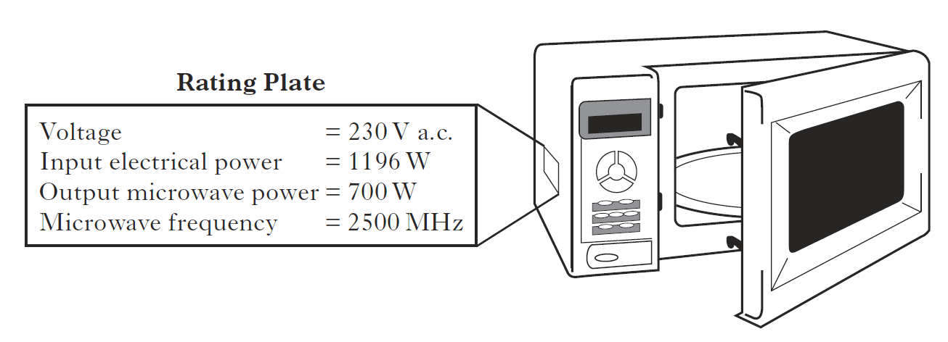
- State what is meant by the term voltage
- Calculate the input current
- What size of fuse is required – 3A or 13A? You must justify your answer.

SQA Int2 2013 Q25

