
N5 Physics

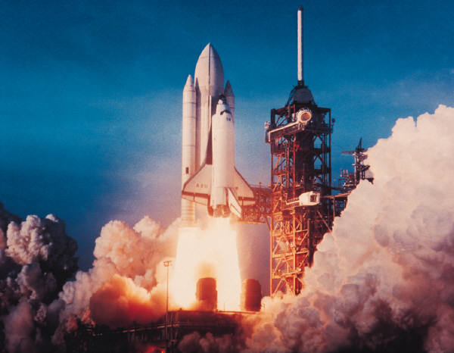

Space

Name ______________Class__
At N5 level, at the end of this unit you should be able to
- Use the following terms correctly and in context
  - Planet
  - Dwarf planet
  - Moon
  - Sun
  - Asteroid
  - Solar system
  - Star
  - Exoplanet
  - Galaxy
  - Universe

- Give a basic description of our current understanding of the universe.
- State that artificial satellites have a number of uses can be used to benefit society
  - Global positioning satellites (GPS)
  - Weather forecasting
  - Communications
  - Space discovery and space exploration e.g. Hubble telescope and International space station (ISS)

- State that geostationary satellites appear to stay in the same position relative to earth
  - State that geostationary satellites have a period of 24 hours
  - State that geostationary satellites orbit at an altitude of 36,000km

- State that the period of a satellite in a high altitude orbit is greater than the period of a satellite in a lower altitude orbit

- Describe some of the challenges of space travel
  - Travelling long distances with the possible solution of attaining high velocity by using an ion drive. (producing a small unbalanced force over an extended period of time)
  - Travelling long distance using a ‘catapult’ from a fast moving asteroid, moon or planet
  - Manoeuvring a spacecraft in a zero friction environment, possibly to dock with the ISS
  - Maintaining sufficient energy to operate life support systems in a spacecraft, with the possible solution of using solar cells with area that varies with distance from the sun.

- Describe some of the risks associated with space travel
  - Fuel load on take-off
  - Potential exposure to radiation
  - Pressure differential
  - Re-entry through atmosphere.

- State Newton’s second and third laws

- Apply Newton’s second and third laws to space travel, rocket launch and landing

- Use an approximate relationship to solve problems involving weight, mass and gravitational field strength, in different locations in the universe
$$W=mg$$
A planet orbits a star. It does not emit light.
In order from the sun the planets in our solar system are:
- Mercury, Venus, Earth, Mars, Jupiter, Saturn, Uranus, Neptune.

A dwarf planet
- Pluto is a dwarf planet – there are others in our solar system
- A dwarf planet orbits a star, but is not large enough or roughly spherical enough to be classified as a small planet

A moon orbits a planet.
- Earth has one moon. Mercury and Venus do not have moons, the other planets have many moons.

A star is a ball of hot matter which gives out light and other forms of electromagnetic radiation. It does not burn – nuclear fusion reactions are taking place.
- The sun is our nearest star.

Asteroids are lumps of rock orbiting a star which are smaller than dwarf planets.
- Most asteroids in our solar system are found in a narrow belt between Mars and Jupiter.

A solar system is the planets, moons and asteroids which orbit a star.
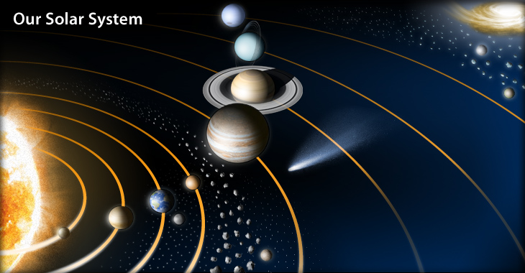

An exoplanet is a planet which orbits a star which is not our Sun.
The basic needs for human life are
- Oxygen
- Water
- Food
- Shelter
- Warmth
If humans are going to live somewhere other than Earth all these needs must be met.

A galaxy is an enormous group of stars, some of which may have planets orbiting them.
- We are part of the Milky Way galaxy. It contains approximately 100,000 million stars.

The universe is everything that exists – many galaxies separated by empty space.

Understanding of the Universe
Our understanding of the universe is
- It started with ‘the big bang’ – a rapid expansion from a point which was infinitely dense.
- As it expanded the universe began to cool down, energy changed into particles of matter. Particles combined to form atoms.
- It is still expanding
- It is approximately 13.8 billion years old.
- u + at = 0 + (3 x 9.8) = 29.4ms⁻¹

- draw a graph and use distance = area under graph
Or/
Average speed = (29.4+ 0) /2 = 14.7 ms⁻¹
Distance = average speed x time = 14.7 x 3 = 44.1 ms⁻¹

Any projectile follows a curved path.

If you fire a projectile with greater velocity it will travel further.

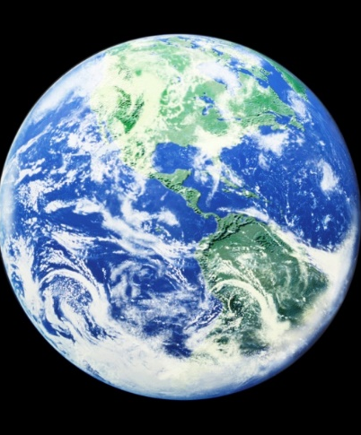
Newton’s Thought Experiment
Newton thought that if it were possible to fire an object from a very large cannon with enough velocity it would fall towards Earth at the same rate as the Earth falls away.
The object will orbit Earth.
This is how satellites work.

A satellite is an object which orbits a planet.
The Moon is a natural satellite.

The period of a satellite is the time it takes to make one complete orbit.
The higher the satellite orbit the longer it takes for one complete orbit.

A satellite which appears to stay in the same place, relative to Earth, is called a geostationary satellite.
The period of geostationary satellite is 24 hours.

Example 4
The ISS orbits at a height of approximately 360km above the Earth. Explain why they ISS stays in orbit around the Earth.

SQA SG Credit 2013 Q13

Example 5
Images from outer space can be obtained using space telescopes.
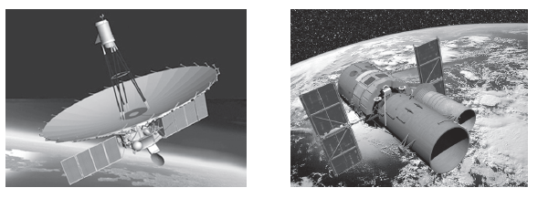
Radioastron Hubble
Two space telescopes which orbit the Earth are the Hubble space telescope and the Radioastron space telescope.
The Hubble space telescope completes one orbit of the Earth in 97 minutes.
The Radioastron space telescopes completes one orbit of the Earth in 9.5 days.
How does the orbital height of the Hubble space telescope compare with the orbital height of the Radioastron space telescope?

SQA SG Credit 2013 Q14

Artificial satellites have a number of uses can be used to benefit society
- Global positioning satellites (GPS)
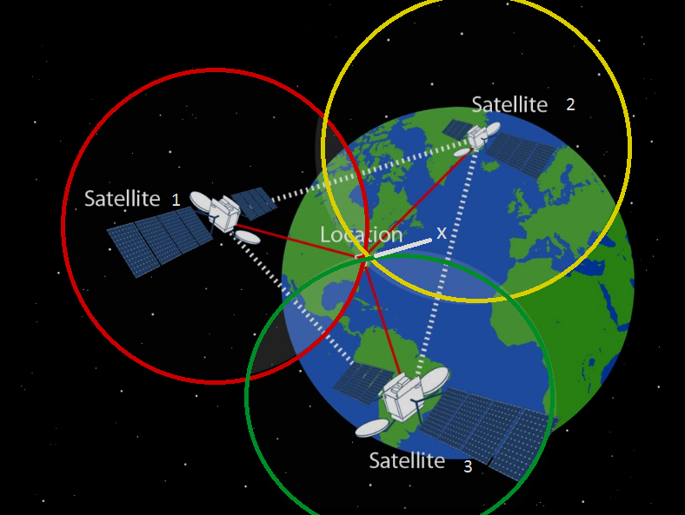
https://thesciencegeek01.files.wordpress.com/2017/01/gps-distance1.png
The signal from three or more satellites is used to find your location accurately. This is useful when navigating your way around somewhere you are not familiar with (sat-nav in a car) or when trying to find a ship in trouble at sea.
- Weather forecasting
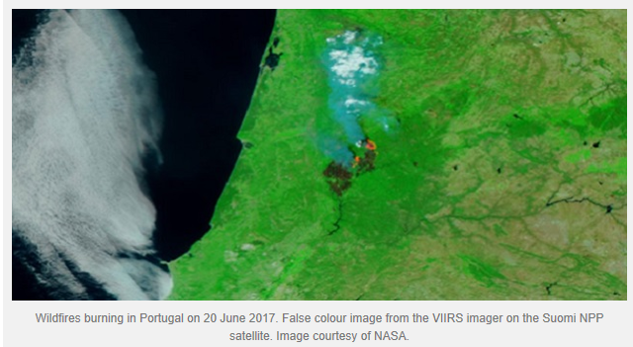
https://blog.metoffice.gov.uk/2017/11/20/new-eye-in-the-sky-to-help-uk-weather-forecasts/
Satellites can help predict the weather, providing warnings of extreme conditions. They can also be used to track forest fires and monitor areas where the conditions make it likely that forest fires could break out.
This could save lives.
- Communications

Satellites are used to send radio and television signals around the world. This allows people to keep in touch with what is happening in real time.

- Space discovery and space exploration e.g. Hubble telescope and International Space Station (ISS)
The International Space Station (ISS) allows experiments to be carried out in space and provides the opportunity to find out more about the effects of micro-gravity on the human body.

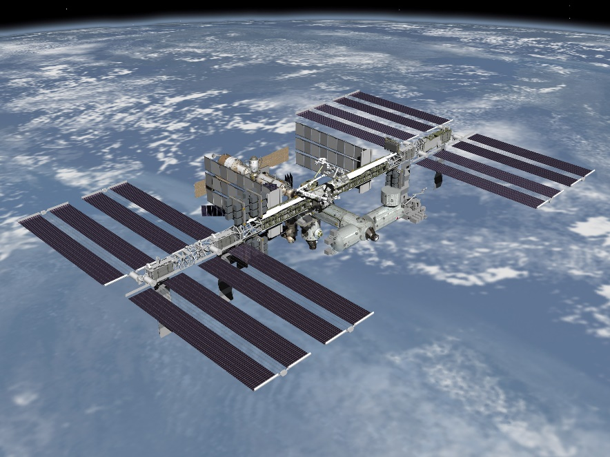
http://www.exeterobservatory.com/wp-content/uploads/2013/04/ISS.jpg
The Hubble space telescope takes pictures of planets, stars and galaxies from outside the Earth’s atmosphere.
This allows it to take clearer pictures.
The images contribute to our understanding of space.
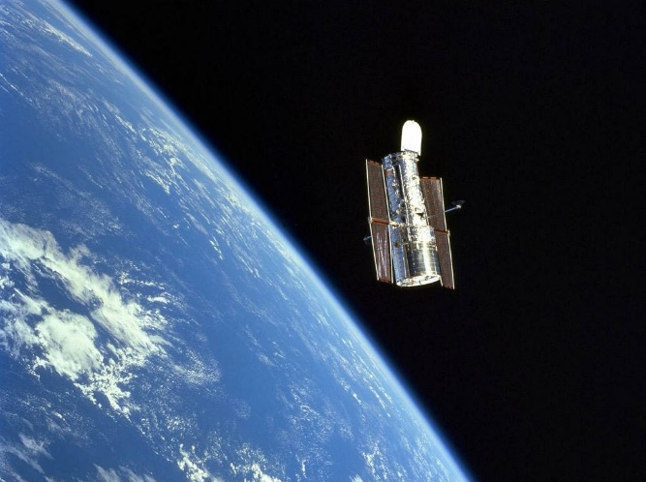 http://3.bp.blogspot.com/_OmNlK5Pg_OA/TFF5CTGWvaI/AAAAAAAAAGg/8WEkMqz9h5w/s1600/hubble-space-telescope.jpg
Travelling long distances with the possible solution of attaining high velocity by using an ion drive. (producing a small unbalanced force over an extended period of time)
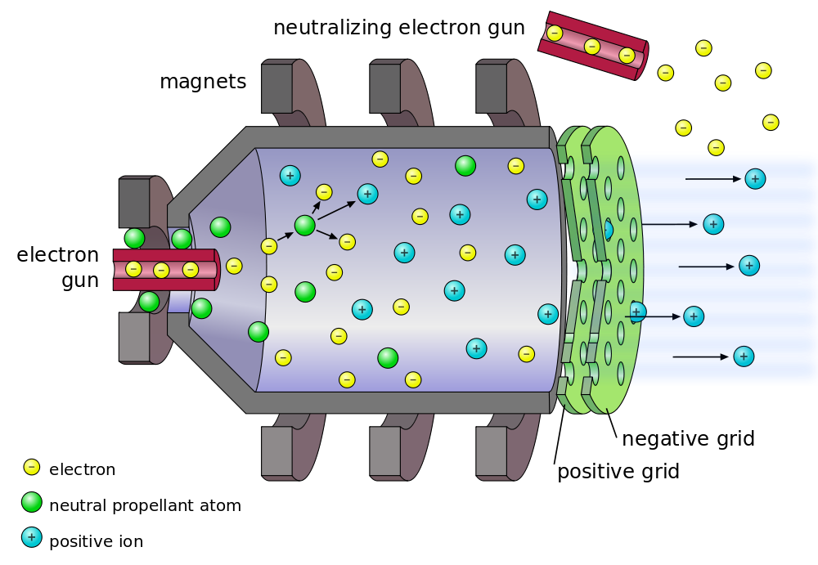
https://www.extremetech.com/extreme/144296-nasas-next-ion-drive-breaks-world-record-will-eventually-power-interplanetary-missions
An ion drive produces a very small amount of thrust – around 0.5N, but are much more fuel efficient than chemical thrusters. They can’t be used on Earth because there would be too much friction, but can work in space because it is very close to a vacuum.

Travelling long distance using a ‘catapult’ from a fast moving asteroid, moon or planet
Planet

By planning the correct approach to a planet or other large object a space probe can experience a change in direction and an increase in velocity.
This is useful because it means less fuel is needed to propel the spacecraft.

Manoeuvring a spacecraft in a zero friction environment, possibly to dock with the ISS
It is difficult to get two objects in space to dock since both are moving and there is no option to brake like a car since there is no friction.
The two objects need to be placed in similar orbits to match their speed so that they do not collide and cause damage.
An object which is going to dock with the International Space Station (ISS) approaches at a rate of 0.05 ms⁻¹ and needs to be accurate to with 0.05m.

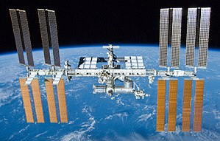
Maintaining sufficient energy to operate life support systems in a spacecraft, with the possible solution of using solar cells with area that varies with distance from the sun.

The basic needs for human life are
- Oxygen
- Water
- Food
- Shelter
- Warmth.
By NASA/Crew of STS-132 - http://spaceflight.nasa.gov/gallery/images/shuttle/sts-132/hires/s132e012208.jpg(http://spaceflight.nasa.gov/gallery/images/shuttle/sts-132/html/s132e012208.html), Public Domain, https://commons.wikimedia.org/w/index.php?curid=10561008

Any spacecraft carrying astronauts must be able to provide all these things, which means that it must also need energy. Some energy can be provided from fuel – but that needs to be supplied to the spacecraft, either at lift off or during it’s time in space.
The easiest way to supply energy to a spacecraft is to convert light energy from the sun (or nearest star) into electrical energy using solar cells.
The ISS has large solar cells to help power its life support systems.
The further away a spacecraft is from the sun the less energy it will receive from the sun. To provide the same amount of energy it would either need larger solar cells or have stored energy from the time when it was nearer to the sun.

Fuel load on take-off
When a spacecraft takes off it has a huge amount of fuel. This means that it is very heavy – if the load is too great it will not be able to take off.
There is also a risk that the fuel may explode rather than burning in a controlled manner.
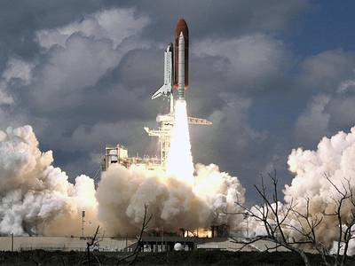
https://www.nasa.gov/centers/armstrong/multimedia/imagegallery/Shuttle/index.html
Potential exposure to radiation
Location | Average dose (mSv)
Earth | 2.4
Nuclear power station | 20
Level above which cancer is more likely | 100
International space station | 200
Interplanetary space | 600

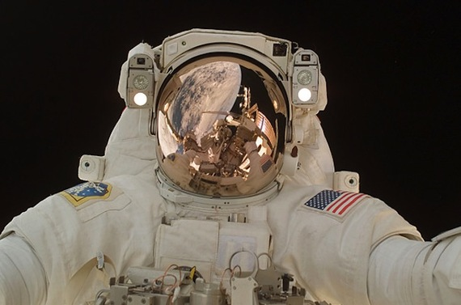
If you are on Earth the atmosphere and the Earth’s magnetic field help shield you from radiation – out in space you do not have this protection.
Space helmets have a thin layer of gold inside the visor to protect the astronauts from radiation.
Exposure to high levels of cosmic radiation can cause cataracts to form in astronaut’s eyes earlier than would be expected.
http://topnews.ae/images/Astronaut-Flooded-Helmet-nasa.jpg

Pressure differential
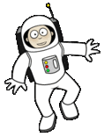
There are so few particles per cubic metre in space it is very close to being a vacuum. This means there is a big difference between the pressure inside and outside a space suit.
This Photo by Unknown Author is licensed under CC BY-SA
Space suits must be pressurised to cope with this pressure differential. If the suit was punctured (for example with a piece of space junk) the astronaut would die quickly.

Re-entry through atmosphere.

Returning to Earth is dangerous because the spacecraft has to re-enter the atmosphere. Friction between the spacecraft and the air particles causes the spacecraft to heat up – the space shuttle would be travelling at approximately 28,000 km h⁻¹ (17,000 mph) and would heat to around 1650 ⁰C.

The angle of re-entry needs to be just right – too steep and it heats up too much, too shallow and the spacecraft will bounce off the atmosphere like a stone across the surface of water.

The contents of the spacecraft are protected by using insulating materials which have been specially created to withstand the high temperatures experienced such as ceramic tiles, reinforced carbon-carbon and Nomex (a flame resistant polymer related to nylon)

The equations for specific heat capacity and latent heat could be used to calculate the rise in temperature of the materials used to insulate the spacecraft.

Example
In the future it is hoped that humans will be able to travel to Mars. One challenge of space travel to Mars is maintaining sufficient energy to operate life support systems.
- Suggest one solution to this challenge.

- State another challenge of space travel to Mars

Newton’s first law
An object at rest will remain at rest, an object moving with constant speed in a straight line will continue to do so – unless acted on by an external force.

Newton’s second law
An unbalanced force causes acceleration.
F = ma

Newton’s third law
For every reaction there is an equal and opposite reaction.

F_{un} = Engine Force – [Weight + Frictional forces]

As long as F_{un} > zero the rocket will take off and accelerate.
Use F = ma to calculate the acceleration.

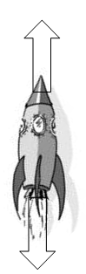
Example 1
After lift off a spacecraft of mass 6000kg applies its thruster rockets with a combined thrust of 480,000N. What is the acceleration of the rocket?

W = mg = 6000 x 9.8 = 58,800N

Unbalanced force = 480,000 – 58,800 = 421,200N

F = ma => a = 421,200/6000 = 70.2 ms⁻²

Newton’s third law – rocket launch
A high speed stream of hot gases, produced by burning fuel, is pushed backwards – with a large force.
A force of the same size pushes the rocket forwards.

ACTION = Rocket pushes hot gases backwards
REACTION = Hot gases push the rocket forwards

Example 2
The first manned space flights took place 50 years ago. Spacecraft were launched into space using powerful rockets.
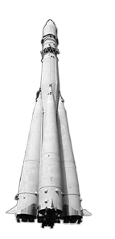
- The operation of a rocket engine can be explained using Newton’s Third Law of Motion.
  - State Newton’s Third Law of Motion

  - Explain, in terms of Newton’s Third Law, how the rocket engines propel the rocket upwards

- At lift-off, one rocket has a total mass of 2.05 x 10⁶ kg. The resultant force acting upwards on the rocket is 8.2 x 10⁶N.
Calculate the acceleration of the rocket at lift-off.

SQA SG Credit 2011 Q 15

As the rocket rises the acceleration increases because
- Mass decreases as fuel is used up
- Weight decreases as gravitational field strength decreases (with height)
- Frictional forces decrease since ‘air is thinner’

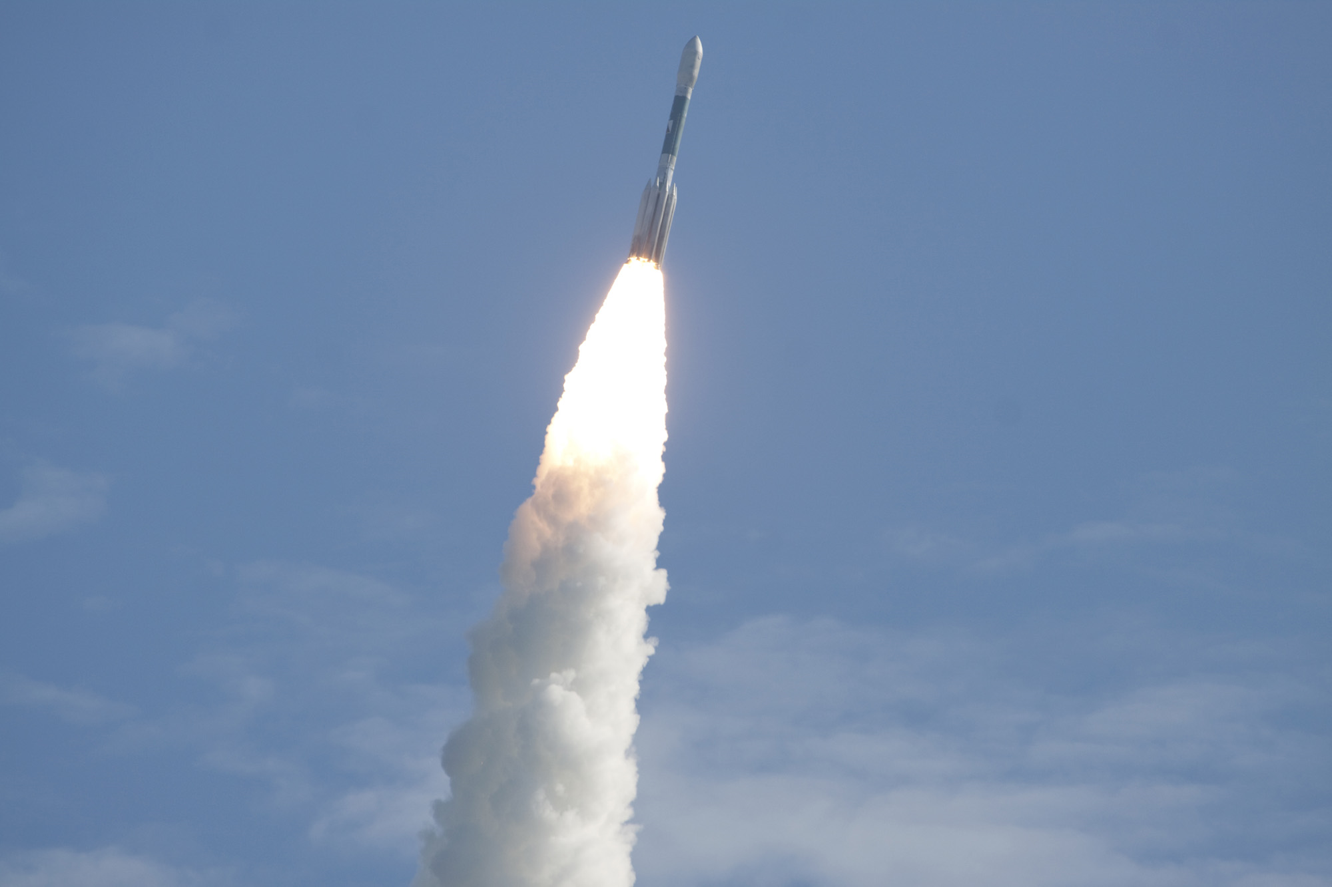
http://www.space.com/images/i/000/012/034/original/
nasa-grail-delta-2-rocket-launch-ascent.jpg?1315673629


While the rocket is in space there is negligible gravity acting on it.
Newton’s laws help explain how the rocket moves in space.
Travelling at constant speed – all thrusters are switched off OR both forward and backward thrusters are on, applying the same force. In both situations the forces are balanced. (Newton’s First Law)
Accelerating – forward thrusters on. There is an unbalanced force in the forwards direction. (Newton’s Second Law)
Decelerating - backwards thrusters on. There is an unbalanced force in the backwards direction. (Newton’s Second Law)

When the thrusters are on the propel the gases out (action) which applies a force to the rocket in the opposite direction (reaction). (Newton’s Third Law)
A rocket returning to Earth has two problems
- Re- entry to Earth’s atmosphere
- Landing safely.

Re-entry to Earth’s atmosphere
A spacecraft returning to the Earth’s atmosphere must approach at the correct angle.
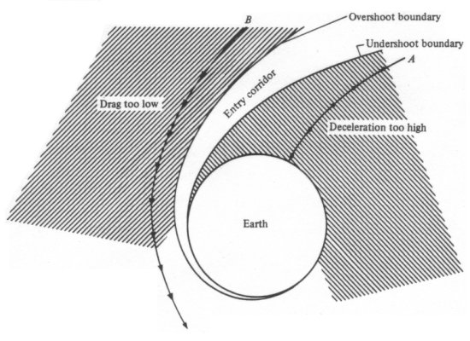
If the angle is too steep the deceleration will be too high, and the spacecraft will burn up.
If the angle is too shallow the rocket may overshoot, skipping off the atmosphere.
Even when the angle is correct there is a lot of friction between the spacecraft and the atmosphere which will cause heating. Any astronauts must be protected by insulating materials.
The heat gained by these materials can be calculated using the equations for specific heat capacity from the ‘Properties of Matter’ unit.

Landing
When landing a parachute opens, the force due to air resistance (drag) drastically increases and causes an unbalanced force acting backwards against motion. This will result in the rocket decelerating and eventually coming to a safe stop.
Weight is a downwards force due to gravity.
W = mg W = weight (N)
m = mass (kg)
g = acceleration due to gravity (ms⁻²) or gravitational field strength (Nkg⁻¹)

The mass of an object depends on the amount of matter it contains. If the object changes location the mass remains constant.
The weight of an object depends on the gravitational pull, g, on the object. If you change location e.g. moving from the equator to the North pole, the gravitational pull is different, so the weight would be different.
The data sheet in your exam paper gives the gravitational field strength for the moon and other planets.
Example
During a visit to a science centre a student learns more about gravitational field strength.
The science centre has a set of specially designed scales. The weight of the student on different planets in the solar system can be found by using these scales. The student stands on each of these scales in turn. The weight on each of the scales is shown.
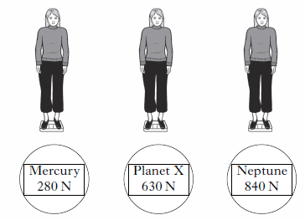
The student has a mass of 70kg. Calculate the gravitational field strength on planet X and identify it.

Example 12
Find the weight and mass of a 75kg spaceman on
- Moon
- Mars

- Mass = 75kg W= mg = 75 x 1.6 = 120N
- Mass = 75kg W = mg = 75 x 4 = 300N

Example 6
The International Space Station (ISS) orbits the Earth at a height of 400km.
- The graph shows how the gravitational field strength varies with height above the surface of the Earth.
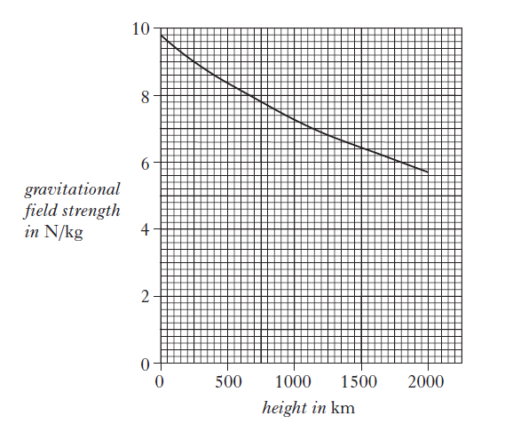
    - State what is meant by gravitational field strength

    - What is the value of gravitational field strength at the orbital height of the ISS?
Example
A group of students are watching a video clip of astronauts on board the International Space Station (ISS) as it orbits the Earth.
One student states ‘I would love to be weightless and float like the astronauts do on the ISS.’
Using your knowledge of physics, comment on the statement made by the student.

SQA N5 2018 Q5
Example 6 (continued)
- An astronaut of mass 75kg is on board the ISS.
    - Calculate the weight of the astronaut inside the ISS

    - State the mass of the astronaut on the surface of the Earth.

SQA SG Credit 2012 Q15
Cosmology
At N5 level, at the end of this unit you should be able to
- State that the term ‘light year’ is a measurement of distance
- Convert between light years and metres
- Provide a basic description of the ‘Big Bang’ theory of the universe
- State the approximate estimated age of the universe
- Describe the use of the whole electromagnetic spectrum in obtaining information about astronomical objects
- Identify line spectra and continuous spectra from a diagram
- State that spectral data for known elements can be used to identify the elements present in stars.

A light year is a measure of distance.
One light year is the distance light travels in a year.
Light (in a vacuum) travels at a speed of 3 x 10⁸ ms⁻¹ (300,000,000 ms⁻¹).

How far is one light year?
d = vt
= 3 x 10⁸ x 365 x 24 x 60 x 60
= 9,460,800,000,000,000 m
= 9.46 x 10¹⁵m

Distances in Space
Source of light | Time for light to reach us | Calculation | Distance (m)
Moon | 1.2s | 3 x 10⁸ x 1.2 | 3.6 x 10⁸
Sun | 8 minutes | 3 x 10⁸ x (8 x 60) | 1.44 x 10¹¹
Proxima Centuri (next nearest star) | 4.3 years | 9.46 x 10¹⁵ x 4.3 | 4.07 x 10¹⁶
Other side of our galaxy | 100,000 years | 9.46 x 10¹⁵ x 100,000 | 9.46 x 10²⁰
Andromeda galaxy | 2,200,000 years | 9.46 x 10¹⁵ x 2,200,000 | 2.08 x 10²²

Space question booklet P16 Q 1- 10, P17 Q 1-8
Leckie and Leckie P157 Ex 2.8.1 Q 1 - 7

Example 7
The table below gives information about planets that orbit the Sun.
Planet | Distance from the Sun (Gm) | Period  (days) | Mass  (Earth masses)
Earth | 150 | 365 | 1
Jupiter | 780 |  | 318
Mars | 228 | 687 | 0.11
Mercury | 58 | 88 | 0.06
Saturn | 1430 | 10760 | 95
Venus | 110 | 225 | 0.82

- Give an approximate value, in days, for the period of Jupiter

- Calculate the time taken for the Sun to reach Saturn.

SQA SG Credit 2010 Q 15

Big Bang Theory

Cosmologists estimate the age of the universe to be around 14 billion years, since the “Big Bang”.
Scientists observing light from stars realised that the stars were moving away from us. If stars are moving away now, going backwards they must have started from a single point. That single point contained all the energy that is in the universe.
The Big Bang theory is the best explanation we have based on scientific evidence

All parts of the electromagnetic spectrum can be used in astronomy.
Starting with the lowest frequency, the components of the spectrum are:
Radio, Microwaves, Infrared, ROYGBIV, Ultraviolet, X-Rays, Gamma.
- As the frequency increases, the energy of the radiation also increases.
Range of EM spectrum | Information gained
Gamma rays and X-rays | Extremely high energy particles, cosmic explosions and high energy collisions can be detected.  Some come from supernovae remnants
Ultraviolet | Many types of star emit radiation in the ultraviolet region - very young massive stars, some very old stars, bright nebulae, white dwarfs, active galaxies and quasars
Visible | The chemical composition of stars can be identified using visible light
Infra red and microwaves | Infra-red observations give information about what is happening in star forming regions and into the central areas of our galaxy.
Radio waves | Radio waves gave the first signals detected of the radiation left over from the Big Bang.
Example 8
Yellow light is part of the visible spectrum. The wavelength of yellow light is 5.9 x 10⁻⁷m.
The visible spectrum also contains red, blue and green light.
Use the information above to complete the following table.
Colour | Wavelength (m)
 | 7 x 10⁻⁷
Yellow
 | 5.5 x 10⁻⁷
 | 4.5 x 10⁻⁷
SQA SG Credit 2010 Q14

Optical Telescopes
Optical telescopes use visible light to study objects in space. They can only be used at night if the sky is clear (no clouds or bad weather).
Large telescopes are normally sited away from sources of light and high up on mountains so that the faint light from stars has to pass through less atmosphere. The larger the diameter of the telescope the more light it gathers.

Radio Telescopes
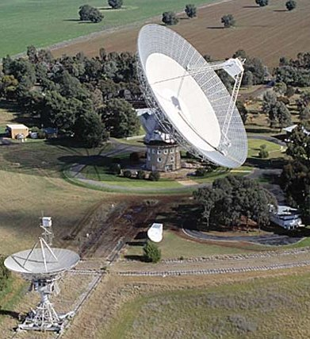
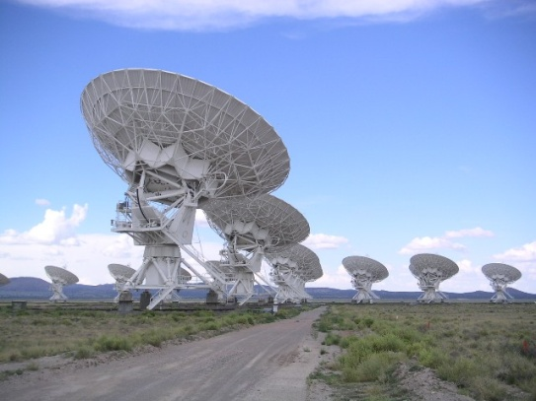
Radio telescopes tune into radio waves from space. Radio signals are not blocked by clouds so they can be used during the day as well as at night time and are not affected by bad weather.
Signals detected are turned into images using a
computer.

Very Large Array, New Mexico, USA

To produce a sharper, more detailed image a
number of smaller telescopes can be joined
together to make a ‘Very Large Array’ (VLA).

Parkes Observatory, NSW, Australia

Radio astronomy has led to the discovery of
new types of star such as Quasars in the 1950’s
and Pulsars in 1967.

Space telescopes
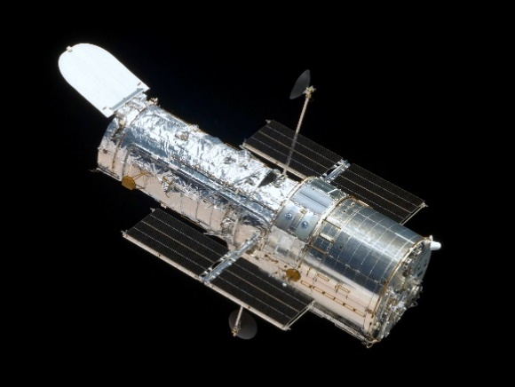
Infra-red, X-rays and gamma rays are all blocked by the Earth’s atmosphere. Telescopes in orbit round the Earth are used to pick up these frequencies of radation to help us gain a better understanding of the universe.
The Hubble Space Telescope is an example of a space telescope. http://www.sun.org/uploads/images/Hubble_Space_Telescope.jpeg
Example 9
All stars emit electromagnetic radiation. The diagram below shows the electromagnetic spectrum in order of increasing wavelength. The names of three of the radiations are missing.
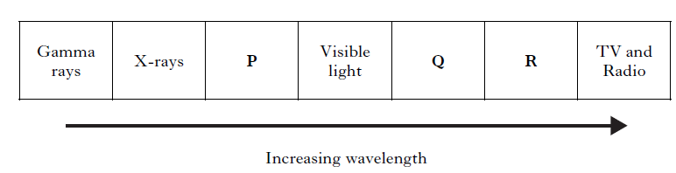
- (i) Name radiation:

P………………………………………………………………

Q………………………………………………………………

R………………………………………………………………
(ii) Which radiation in the electromagnetic spectrum has the lowest frequency?

SQA SG Credit 2011 Q14
The visible spectrum observed in a rainbow is an example of a continuous spectrum.


A line spectrum looks like a continuous spectrum with bits missing.

When the light given out by a hot gas is viewed through a spectroscope you see a line spectrum. Each element has its own unique line spectrum which can be used to identify it.
If the light from a star is analysed it is possible to identify the elements which make up that star. It can also be used to work out how fast the star is moving and whether the star is moving towards or away from you.
Example 10
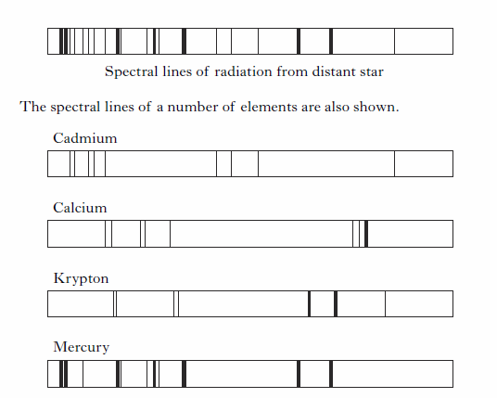
Some spectral lines of radiation from a distant star are shown below.

Use the spectral lines of the elements shown to identify which of these elements are present in the distant star.

