
Physics

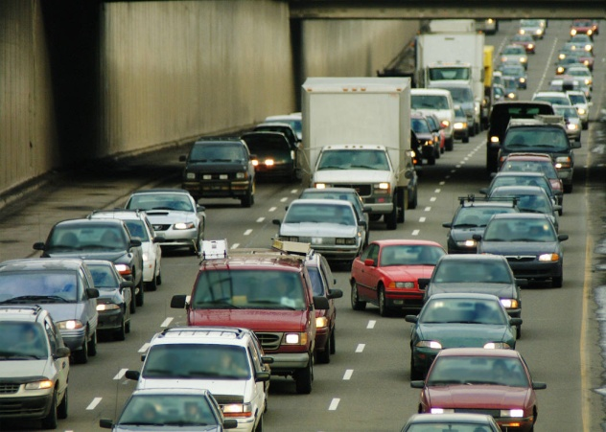

Dynamics

Name______________ Class__

At National 5 level, by the end of this section you should be able to:
- Define vector quantities as those having both magnitude and direction.
- Define scalar quantities as those having magnitude only.
- Identify the following quantities as vector quantities
  - Force,
  - Velocity
  - Displacement
  - Acceleration
- Identify the following quantities as scalar quantities
  - Speed
  - Distance
  - Mass
  - Time
  - Energy
- Calculate the resultant of two vectors in one dimension
- Calculate the resultant of two vectors at right angles.
- Determine displacement and/or distance using a scale diagram or by calculation
- Determine velocity and/or speed using a scale diagram or calculation.
- Use appropriate relationships to solve problems including velocity, speed, displacement, distance and time
$s=vt$
$s=\overline{vt}$
$d=\overline{vt}$
- Describe experiments to measure average and instantaneous speed.

Definition
A vector quantity has magnitude and direction
e.g. velocity
A scalar quantity has magnitude only.
e.g. speed

Scalar | Vector
Speed | Velocity
Distance | Displacement
Time | Force
Energy | Acceleration
Mass

Example 1
Which of the following is a vector quantity?
- Distance
- Energy
- Speed
- Time
- Velocity
SQA Int2 2008 Q1

Example 2
Which of the following contains one vector and two scalar quantities?
- force, time and acceleration
- power, force and velocity
- acceleration, velocity and force
- mass, distance and speed
- acceleration, time and speed.
SQA H 2012 Q1

Direction can be given in two ways – using a compass to give headings or using three figure bearings.
N (000)
SE (135)
NW (315)
W (270)
SW (225)
NE (045)
E (090)
S (180)
If you use a compass heading it is important to remember that each heading has a precise value, so you can’t guess.


Example 3
The coastguards receive a Mayday call from a vessel which describes its position as being 15km on a bearing of 230º from Lerwick. The Hrossey is 2km South of Lerwick. Should she head towards the vessel in distress? If not, why not?

No. The vessel in distress is on the other side of the Mainland. The Hrossey would need to go round Sumburgh Head first – a very long journey. Better to send the Coastguard helicopter and possibly the Aith lifeboat!

Distance just tells you how far away you are from a certain point.

If a pupil arranges to meet someone at a supermarket 600m away from the school at lunchtime they could be anywhere in the circle.

Displacement tells you how far away you are in a certain direction.
If the pupil includes the information that they are 600m South of the school, it narrows things down
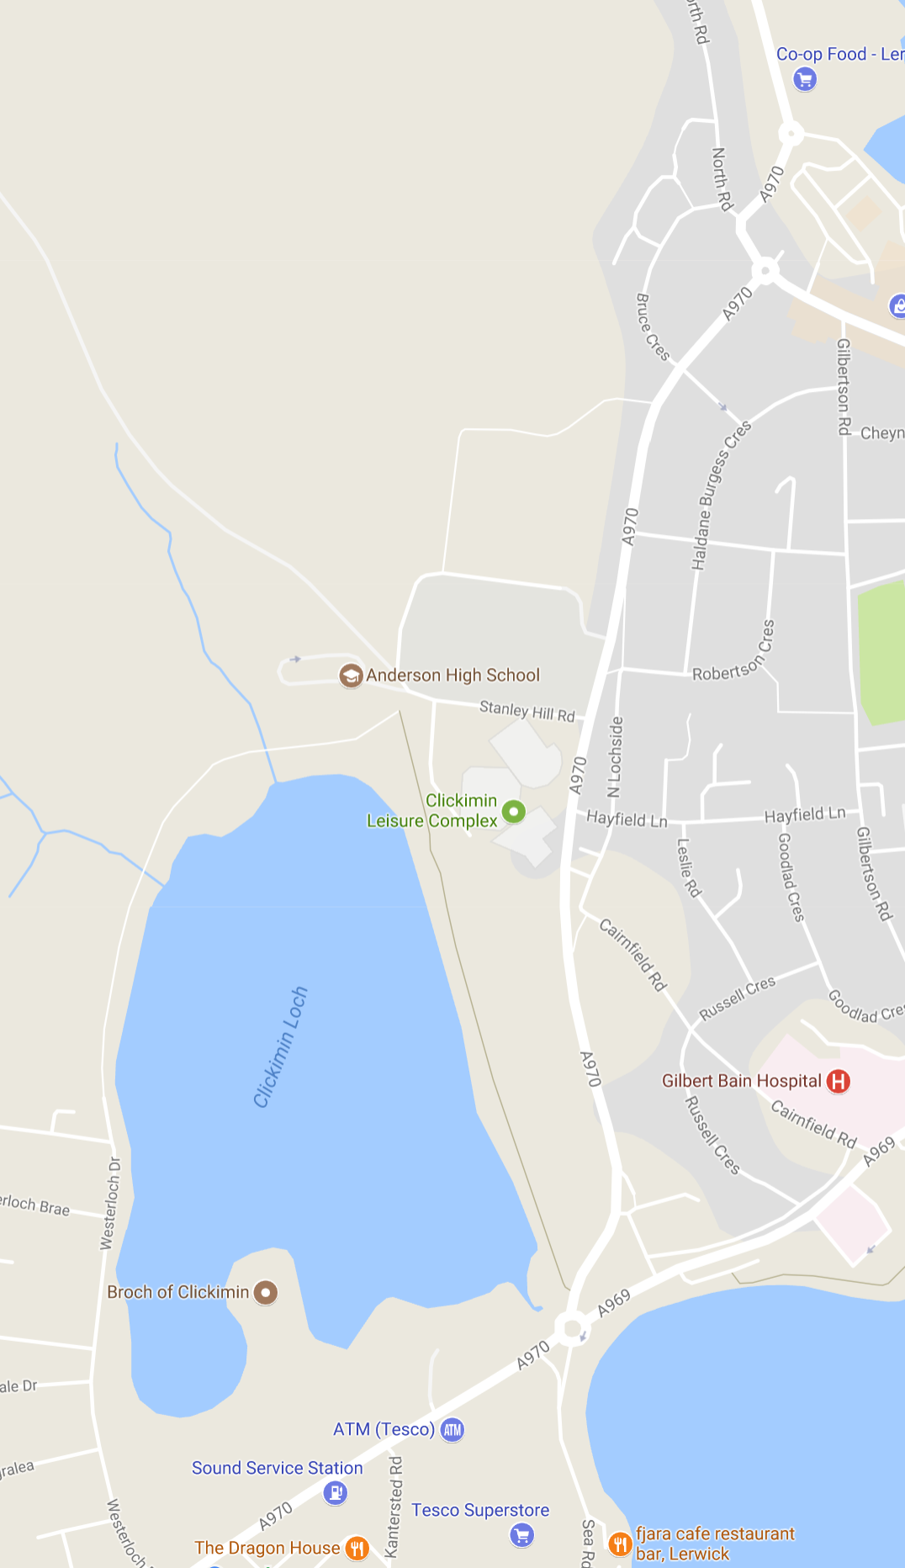

Distance is a scalar quantity because it only has magnitude. (size)
Displacement is a vector quantity because it has magnitude and direction.
Example 4

Which row shows the total distance travelled and the size of the displacement of the aircraft?

 | Total distance travelled (m) | Size of displacement  (m)
A | 400 | 800
B | 450 | 200
C | 450 | 400
D | 800 | 400
E | 800 | 800

SQA Int2 2012 Q1
At an airport an aircraft moves from the terminal building to the end of the runway.
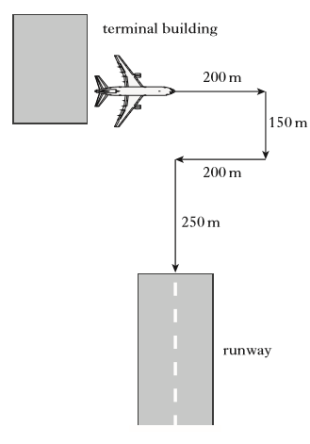

Example 5
A student follows the route shown in the diagram and arrives back at the starting point.
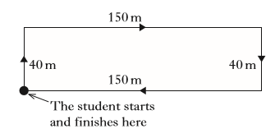
Which row in the table shows the total distance walked and the magnitude of the final displacement?
 | Total distance (m) | Final displacement (m)
A | 0 | 80
B | 0 | 380
C | 190 | 0
D | 380 | 0
E | 380 | 380

velocity = displacement
time

Velocity is a vector quantity e.g. 5ms⁻¹ North or 15ms⁻¹ on a heading 045⁰.
speed = distance
time

Speed is a scalar quantity e.g. 5ms⁻¹

Example 6
A car travels 10m due S, stops at traffic lights then carries on for another 10m. This takes 5s.
What is the velocity?

velocity = displacement
time
= 20/5
= 4 ms⁻¹ due South.

What is the speed of the car?
Example 7
A car travels 8m E along a road, then has to reverse 3m to let the ambulance past. This takes 10s.
What is the velocity?

velocity = displacement
time
= 5/10
= 0.5 ms⁻¹ due East.

What is the speed of the car?

Example 8
A cyclist completes a 400m circuit of a track in a velodrome in 50s. What is their velocity? (Think very carefully!!)

velocity = displacement = 0 = 0 ms⁻¹
time 50

If two vectors act in the same direction you add them together, if they act in opposite directions you subtract one from the other.

The shortest distance from start to finish is called the resultant.
Example 9
Using the squared paper below work out the resultant vector for the following examples.
- A dog walks 5m E followed by 3m E. What is its displacement?
- A cat walks 5m E followed by 2m W. What is its displacement.
- A car travels 6m N followed by 6m S. What is its displacement?

Vectors in two dimensions will always be at right angles to one another.

The vectors must always be drawn ‘head-to-tail’.

The resultant vector is the shortest distance from start to finish and is marked with a double arrow. This can be worked out by drawing a scale diagram or by carrying out a calculation.

Example 10
- A person walks 4m East followed by 3m South. What is their displacement from their starting point?
- A person walks 12m East, followed by 5m North. What is their displacement from the starting point?

Using calculation
First sketch out a diagram of the vectors include the magnitude and direction of each vector. Remember the vectors must be head-to-tail.
The resultant vector should be marked with a double arrow.

Use Pythagoras theorem to work out the magnitude of the resultant.

$$a^{2}= b^{2}+c^{2}$$

Use trigonometry to work out the size of the angle.

$sine= \frac{opposite}{hypotenuse}$ $cosine= \frac{adjacent}{hypotenuse}$ $tangent= \frac{opposite}{adjacent}$

a - hypotenuse
b - opposite
θ
c - adjacent

Example 11
A car travels 400m S, then 400m W. This takes 20s.
Calculate a. the average speed for this journey
b. the average velocity for this journey.

Example 12
A student walks from X to Y and then from Y to Z.
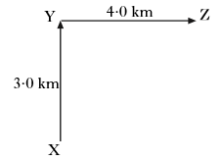

 | Average speed | Average velocity
A | 2.5 km/h | 2.5 km/h at 053
B | 2.5 km/h at 053 | 2.5 km/h
C | 3.5 km/h | 2.5 km/h at 053
D | 3.5 km/h at 053 | 3.5 km/h
E | 3.5 km/h | 3.5 km/h at 053
SQA Int 2 2008 Q2

The complete walk takes 2 hours.
Which row in the table shows the average speed and the average velocity for the complete walk?

Example 13
The diagram below shows the resultant of two vectors.
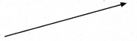
Which of the diagrams below shows the vectors which could produce the above resultant?
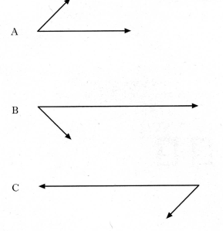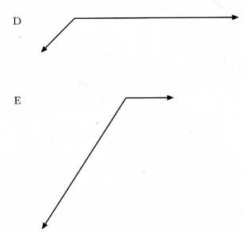
SQA H 2001 Q2

Example 14
During a flight an aircraft is travelling with a velocity of 120 ms⁻¹ due south and then encounters a crosswind of 30 ms⁻¹ due west.

By scale diagram, or otherwise, determine the resultant velocity of the aircraft.
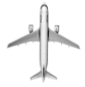

SQA N5 Specimen paper adapted

Average speed is the total distance divided by the total time
v = speed (metres per second – ms⁻¹)
$speed= \frac{distance}{time}$ $v= \frac{d}{t}$ d = distance (metres – m)
t = time (seconds – s)

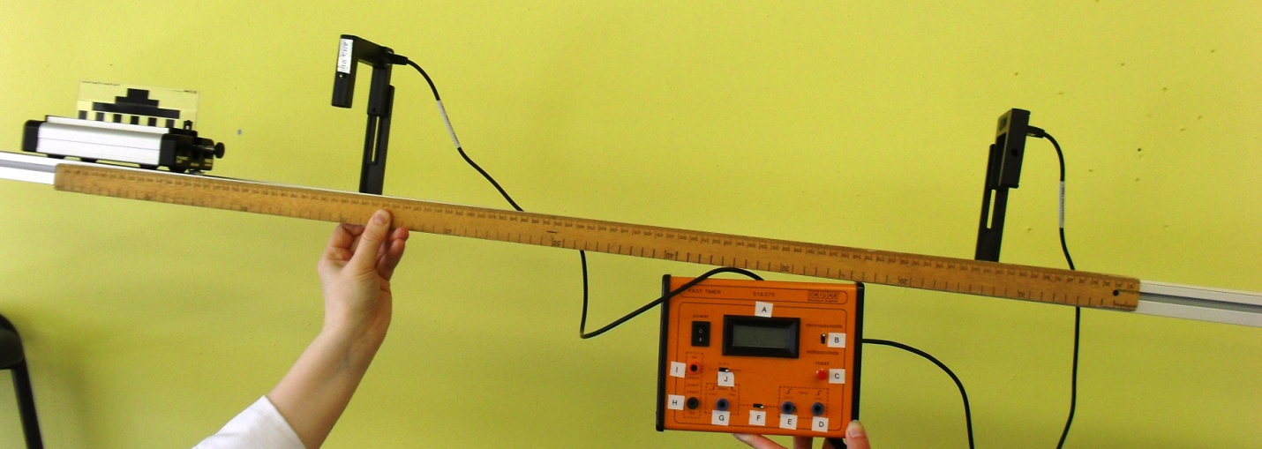
Average Speed using Light Gates

Label light gates, trolley, mask, ruler/metre stick, timer and ramp

Timer starts when the mask on the trolley cuts the first light gate and stops when it cuts the second light gate.
Measure the distance between the light gates using the metre stick.

Speed of trolley = distance between light gates
Time on timer

Could be used to measure the speed of a car passing between lamp-posts or past a fence.

Remember to stress that light gates on their own are no use – they need to be connected to a timer.

Instantaneous speed is the speed calculated using a short distance or short time interval.

Instantaneous Speed using Light Gate

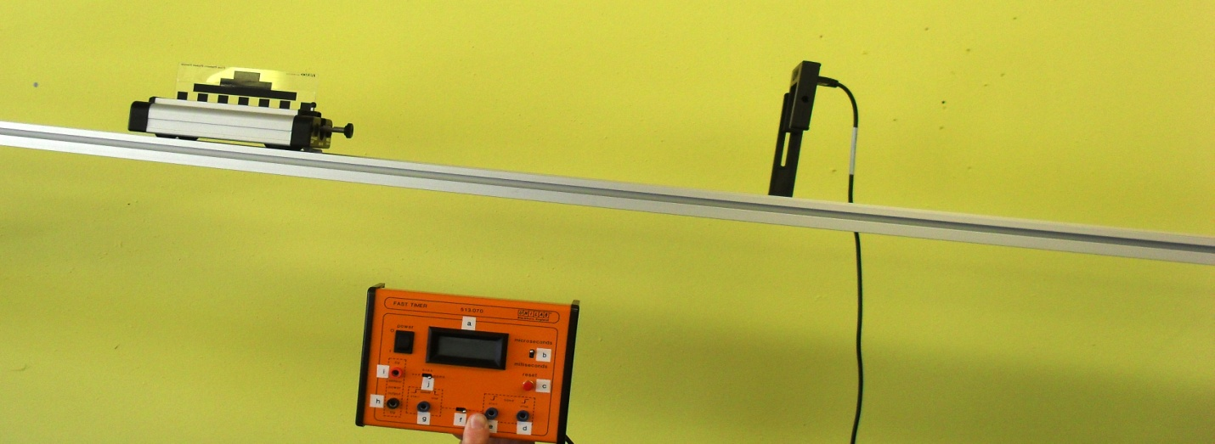

Label light gate, timer, trolley, mask, runway, ramp – diagram should also have a ruler in it.

The trolley runs down the slope. When the mask passes through the light gate the timer records the time the light beam is interrupted for.

The length of the mask is measured using a ruler.

Instantaneous speed = length of mask
Time on timer

Example 15
Cameras placed at 5km intervals along a stretch of road are used to record the average speed of a car.
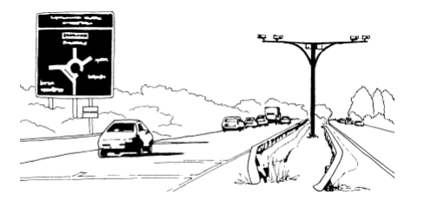
The car is travelling on a road which has a speed limit of 100 kmh⁻¹. The car travels a distance of 5km in 2.5 minutes.
- Does the average speed of the car stay within the speed limit?
You must justify your answer with a calculation.

- At one point in the journey, the car speedometer records 90km h⁻¹. Explain why the average speed for the entire journey is not always the same as the speed recorded on the car speedometer.

SQA SG Credit 2007 Q10

SQA N5 Specimen paper adapted
At National 5 level, by the end of this section you should be able to:
- Draw or sketch velocity-time or speed-time graphs from data
- Describe the motion of an object from information in a velocity-time graph
- Determine displacement from a velocity-time graph.
Speed time graphs can help describe the motion of an object.
time
speed
0
0
time
speed
time
speed
0

Time is always shown on the x-axis, speed on the y-axis.

Distance travelled is equal to the area under a speed time graph.
Example 16
Athletes in a race are recorded by a TV camera which runs on rails beside the track.
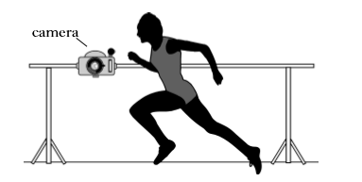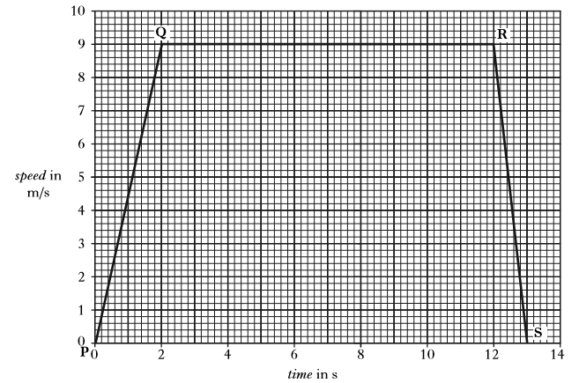
The graph shows how the speed of the camera varies during the race.
How far does the camera travel in the 13s?

SQA SG Int2 2007 Q10

SQA N5 Specimen paper adapted

A velocity-time graph looks very similar to a speed-time graph, but the direction is important because velocity is a vector quantity.

0
ms⁻¹
Decreasing velocity.
This would be like a ball being thrown into the air.
The ball leaves my hand at A.
At B the ball has reached its highest point.
At C the ball has dropped down again – note the velocity is increasing but the direction has changed.
v
A
B
C

t (s)

Increasing velocity.
This would be like a ball being dropped onto the floor.
The ball leaves my hand at 0.
At A the ball has reached the floor.
Between A and B the ball squashes and unsquashes.
At B the ball starts to travel upwards again, slowing down as it travels.
This is an ideal version (no energy losses)

ms⁻¹
v
A
B
C
t (s)
0
0
t s

Increasing velocity.
This would be like a ball being dropped onto the floor.
The ball leaves my hand at 0.
At A the ball has reached the floor.
Between A and B the ball squashes and unsquashes.
At B the ball starts to travel upwards again, slowing down as it travels.
This is an ideal version.

Example 17

The following velocity-time graph describes the motion of a ball, dropped from rest and bouncing several times.
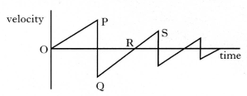
Which of the following statements is/are true?
- The ball hits the ground at P
- The ball is moving upwards between Q and R
- The ball is moving upwards between R and S
- I only
- II only
- III only
- I and II only
- I and III only
SQA H 2000 Q3

Displacement = Area under a velocity-time graph
(in the same way that Distance = Area under a speed-time graph)

Example 18

Example 19

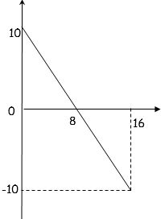
v (ms⁻¹)
t (s)

At National 5 level, by the end of this section you should be able to:

- Define acceleration in terms of initial velocity, final velocity and time
- Use an appropriate relationship to solve problems involving acceleration, initial velocity (or speed), final velocity (or speed) and time.
$$a= \frac{v-u}{t}$$
- Determine acceleration from a velocity-time graph.
a = gradient of the line on a v-t graph
- Describe an experiment to measure acceleration.

$$acceleration = \frac{change in velocity}{time}$$
a = acceleration (metres per second squared – ms⁻²)
v = final velocity (metres per second ms⁻¹)
u = initial velocity (metres per second ms⁻¹)
t = time (seconds – s)
$$a= \frac{v-u}{t}$$

An acceleration of 4 ms⁻² means that the velocity of the object increases by
4 ms⁻¹ each second.

Acceleration is a vector quantity so direction is important.

Measuring Acceleration
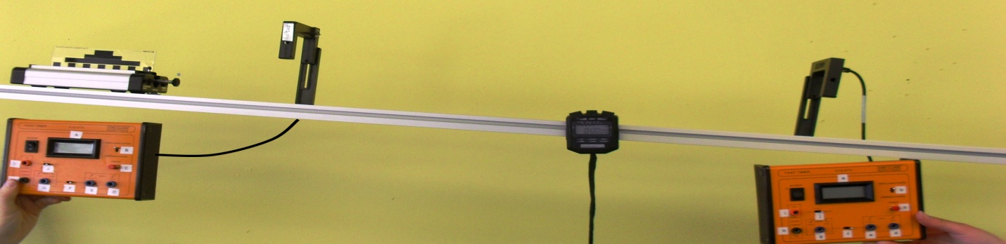

Label – runway, trolley, mask, light gate 1+ timer, light gate 2 + timer, stopwatch

The trolley runs down the slope. When the mask cuts the first light gate the time is recorded on the timer.
We can calculate the initial speed (u) using
$$speed=\frac{length of mask}{time on timer}$$
The final speed (v)is calculated in the same way using the second light gate.
The time between light gates (t) is recorded on the stopwatch.

These values can be used to calculate acceleration using a = v –u
t
This experiment could be improved by using an electronic timer to record the time between the gates.

Example 23
A car travelling at 5 ms⁻¹ accelerates at 3 ms⁻² for 4s. What is its final speed?

a = v-u ⇒ 3 = v – 5
t 4

⇒ 3x 4 = v – 5
⇒ v = 12 + 5 = 17 ms⁻¹

Example 22
A trolley starts at rest and speeds up at 4 ms⁻² for 6 seconds.
Calculate the final speed.

a = v-u ⇒ 4 = v – 0 ⇒ v = 4 x 6
t 6

= 24 ms⁻¹

Example 21
An object travelling at 80 ms⁻¹ suddenly comes to a stop in 2 seconds Calculate the acceleration.

a = v-u = 0 – 80 = -80 = -40 ms⁻² t 2 2

Example 20
A car accelerates from 20 ms⁻¹ to 80 ms⁻¹ in 12 seconds. Calculate the acceleration.

a = v-u = 80 – 20 = 60 =5 ms⁻²
t 12 12

Acceleration can be calculated from a velocity time graph, by selecting values for u, v and t from the graph.
The acceleration could also be found from the gradient of the velocity-time graph
Example 24
A graph showing how the speed of the ball changes while in contact with the racquet during a serve at a tennis match is shown.
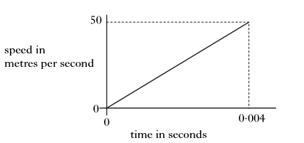
Calculate the acceleration of the ball during the serve.

SQA SG Gen 2007 Q14b

v

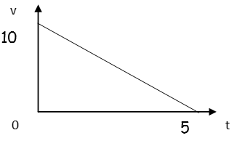
If an object slows down its acceleration will be negative.
This is sometimes referred to as deceleration.

$$a= \frac{v-u}{t}=\frac{0-10}{5}= -2ms^{-2}$$

Example 25
The driver of a train travelling at 45 ms⁻¹ sees a sign indicating that there is a speed limit of 10 ms⁻¹ on a bridge on the track ahead. At this point the distance from the train to the bridge is 500m.
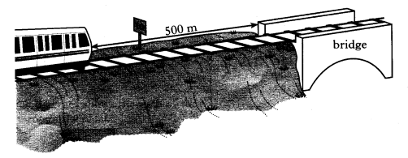
The speed-time graph of the trains motion, from the moment the driver sees the sign, is shown below.
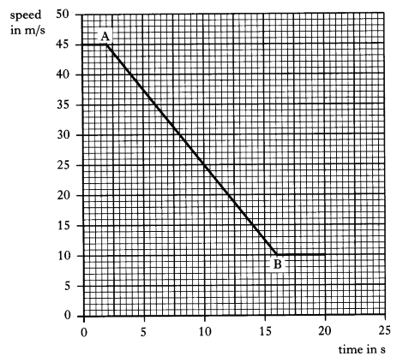
- (i) State the time at which the driver starts to apply the brakes.
(ii) Explain your answer.
- Calculate the acceleration of the train between A and B.

SQA Int2 2004 Q22

At National 5 level, by the end of this section you should be able to:

- Apply Newton’s laws and balanced forces to explain constant velocity (or speed)
- Describe the effect of friction on an object moving at constant velocity (or speed)
- Apply Newton’s laws and unbalanced forces to explain and/or determine acceleration for situations where more than one force is acting.
- Use an appropriate relationship to solve problems involving unbalanced force, mass and acceleration for situations where one or more forces are acting in one dimension or at right angles.
$F=ma$
- Use of an appropriate relationship to solve problems involving weight, mass and gravitational field strength.
$w=mg$
- Explanation of motion resulting from a ‘reaction’ force in terms of Newton’s third law.
- Explanation of free-fall and terminal velocity in terms of Newton’s laws.
An object at rest will remain at rest or will remain at constant speed in a straight line unless acted on by an unbalanced force.

Balanced Forces
Equal forces in opposite directions
In both cases the trolley will not move.

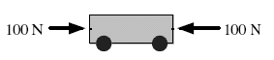
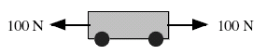

Balanced Forces on the Move
50N
50N
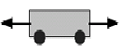

Trolley will move with constant speed in a straight line (this is the same as constant velocity).
Example 26
A block is pulled across a horizontal surface as shown.
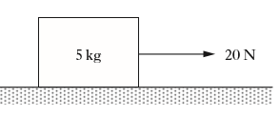
The mass of the block is 5kg.
The block is travelling at a constant speed.
The force of friction acting on the block is
- 0N
- 4N
- 15N
- 20N
- 25N
SQA Int2 2013 Q4

Friction is a force which opposes motion

The effects of friction can be reduced by streamlining, by lubrication or by making surfaces smoother.
Example 27
The diagram shows some of the forces acting on a cyclist during a race.
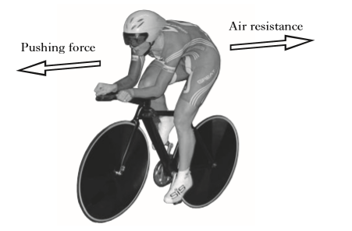
- Suggest one way in which the cyclist reduces air resistance

- Suggest one place where the cyclist requires friction.

SQA SG Credit Q10?

F = ma F = force (N)
a = acceleration (ms⁻²)
m = mass (kg)

If an unbalanced force is applied to a mass it will accelerate.

Example 29
Calculate the acceleration caused by a force of 300N acting on a 25kg mass.

F = ma ⇒ 300 = 2.5 a
⇒ a = 300/2.5 = 12 ms⁻²

AHS notes

Example 28
Calculate the unbalanced force needed
to accelerate a bike of mass 60kg at a rate of 4 ms⁻².

F = ma = 4 x 60 = 240N

AHS notes

Example 31
A boy pushes his sister downhill on her sledge with a force of 150N. The combined mass of the girl and sledge is 40kg. What is her acceleration?

F = ma ⇒ 150 = a x 40
⇒ m = 150/40 = 3.75 ms⁻²

AHS notes

Example 30
An object accelerates at 15 ms⁻² when a force of 900N is applied. What was its mass?

F = ma ⇒ 900 = m x 15
⇒ m = 900/15 = 600kg

AHS notes

Example 32
A plane of mass 750kg is at rest on a runway. The engine applies a force of 4.50 kN.
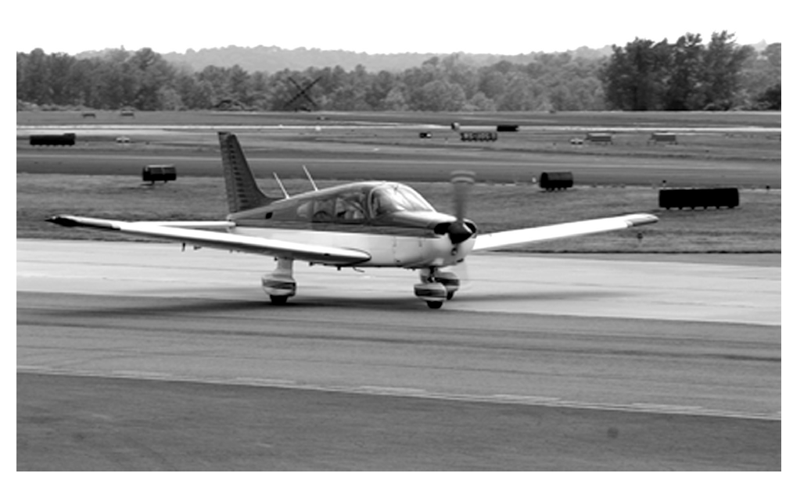
- Calculate the magnitude of the acceleration of the plane assuming there are no other forces acting on the plane at this point.
- The required speed for take-off is 54 ms⁻¹.
Calculate the time it takes to reach this speed assuming the acceleration is constant.
- In practice the acceleration is not constant. Give a reason for this.

Example 33
The diagram shows the horizontal forces acting on a box.
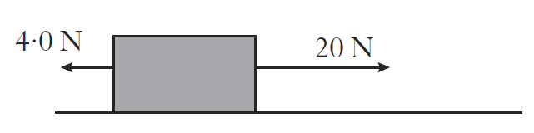
The box accelerates at 1.6 ms⁻².
Calculate the mass of the box.

SQA Int2 2012 Q4 adapted

Example 34
Two forces act on an object O in the
directions shown.
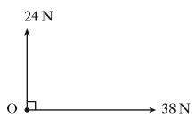
SQA Int 2
The size of the resultant force is
- 14N
- 24N
- 38N
- 45N
- 62N

Example 35
Four tugs apply forces to an oil-rig in the directions shown.
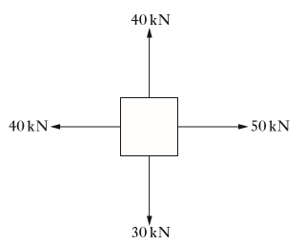
Which of the following could represent the direction of the resultant force?
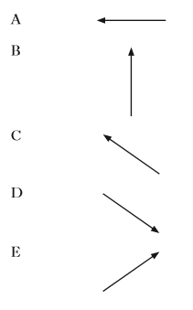


Gravity is a force of attraction that exists between objects because of their masses.

We are aware of gravity on Earth because it has a very large mass compared to a person.

Gravititational Field Strength (g)
Gravitational Field Strength = force per unit mass
Force of gravity = pull of Earth on an object = gravitational force on an object

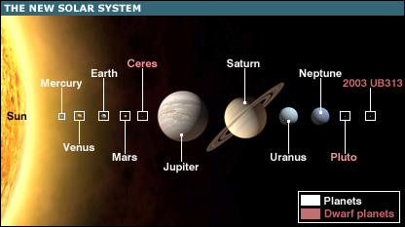

Different planets have different gravitational field strengths because they have different masses.

The gravitational field strength on different planets is listed in the data sheet.
Weight is a downwards force due to gravity.
W = mg W = weight (N)
m = mass (kg)
g = acceleration due to gravity (ms⁻²) or gravitational field strength (Nkg⁻¹)

Example 36
What is the weight of a person with a mass of 65kg (on Earth)

W = mg = 65 x 9.8 = 637N

Example 37
What is the mass of an object which has a weight of 7200N on Earth.

W = mg ⇒ 7200 = 9.8m ⇒ m = 735kg

Your weight can change depending upon where you are – even on Earth. If you go in a lift your weight will alter as the lift accelerates.

The mass of an object stays the same – regardless of where you are.

If you go to a different planet you have a different weight because the weight of an object depends on the acceleration due to gravity.

Planet/Moon | ‘g’ (Nkg⁻¹)
Mercury | 4
Venus | 9
Earth | 9.8
Mars | 4
Jupiter | 25
Saturn | 10
Uranus | 10
Neptune | 12
Moon | 1.6
Example 38
Find the weight and mass of a 75kg spaceman on
- Moon
- Mars

- Mass = 75kg W= mg = 75 x 1.6 = 120N
- Mass = 75kg W = mg = 75 x 4 = 300N

Example 12
Find the weight and mass of a 75kg spaceman on
- Moon
- Mars

- Mass = 75kg W= mg = 75 x 1.6 = 120N
- Mass = 75kg W = mg = 75 x 4 = 300N

Example 39
A robot has a weight of 900N on Earth
The gravitational field strength on Mars is 4 N kg⁻¹.
Which row in the table shows the mass and weight of the robot on Mars?

 | Mass (kg) | Weight (N)
A | 90 | 360
B | 90 | 225
C | 900 | 3600
D | 9000 | 360
E | 9000 | 360
SQA Int2 2014 Q3

Example 40
A space probe has a mass of 60kg. The weight of the space probe at the surface of a planet in our solar system is 720N.
The planet is
- Venus
- Mars
- Jupiter
- Saturn
- Neptune
SQA Int2 2013 Q3

Example 41
Near the Earth’s surface, a mass of 6kg is falling with constant velocity.
The air resistance and the unbalanced force acting on the mass are:
(Take g as 10N kg⁻¹)
 | Air resistance | Unbalanced force
A | 60 N upwards | 0 N
B | 10 N upwards | 10 N downwards
C | 10 N downwards | 70 N downwards
D | 10 N upwards | 0 N
E | 60 N upwards | 60 N downwards

For every action force there is an equal and opposite reaction force.

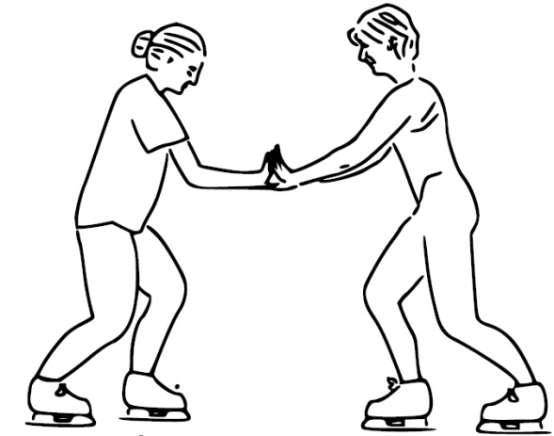


Skater A pushes on Skater B
Skater B pushes back on Skater A
Lift force pushes up on the air.
The air pushes down on the balloon.

Swimmer pushes back on the water.
The water pushes forward on the swimmer

The walker pushes backwards on the ground.
The ground pushes the walkers foot forwards

Example 43
An aircraft engine exerts a force on the air.
Which of the following completes the ‘Newton pair’ of forces.

- The force of the air on the aircraft engine
- The force of friction between the aircraft engine and the air
- The force of friction between the aircraft and the aircraft engine
- The force of the Earth on the aircraft engine
- The force of the aircraft engine on the Earth.

SQA Int 2 2007 Q5
Example 42
A person sits on a chair which rests on the Earth. The person exerts a downward force on the chair.
Which of the following is the reaction to this force?


Weight is a force which pulls us down towards the ground – we are aware of our weight because of the ground pushing back on our feet.
If the ground falls away from you at the same rate as you fall towards the ground you experience weightlessness.
If you are a long way away from a planet the gravitational force of the planet would be so small that you feel weightless.
In the Space Station astronauts are weightless because they fall at the same rate as the Space Station falls round Earth.
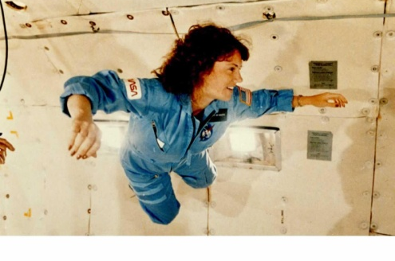
Example 44
On Earth an astronaut has a weight of 550N. What is her weight in the Space Station?

0N

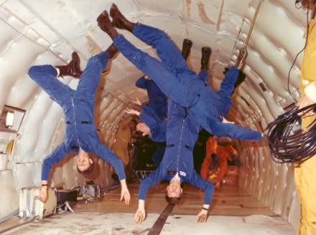
Example 45
On Earth an astronaut has a weight of 550N. What is her mass in the Space Station?

W = mg => m = 550/10 = 56.1kg

Example 46
An astronaut on board the ISS takes part in a video link-up with a group of students. The students see the astronaut floating.
- Explain why the astronaut appears to float
- The astronaut then pushes against a wall and moves off. Explain in terms of Newton’s Third Law why the astronaut moves.

SQA SG Credit 2013 Q13

When a parachutist (or other object) falls they accelerate because gravity pulls them downwards.
As they get faster the air resistance increases until the forces are balanced.

When the forces are balanced they travel at constant speed. This is called their terminal velocity.

Air resistance

Weight

Air resistance

When a parachute is opened there is a greater air resistance, so the person slows down.

Eventually the force acting on the person are balanced.

When the two forces are balanced they again travel at constant speed. This is their new terminal velocity.

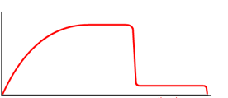

Velocity (ms⁻¹)

Time (s)
0
0
At National 5 level, by the end of this section you should be able to:

- Give examples of energy conservation, energy conversion and energy transfer.
- Use an appropriate relationship to solve problems involving work done, unbalanced force and distance/displacement.
$$E_{w}=Fd or W=Fd$$
- Define gravitational potential energy
- Use of an appropriate relationship to solve problems involving gravitational potential energy, mass, gravitational field strength and height.
$$E_{p}=mgh$$
- Define kinetic energy.
- Use an appropriate relationship to solve problems involving kinetic energy, mass and speed.
$$E_{k}= \frac{1}{2}mv^{2}$$
- Use appropriate relationships to solve problems involving conservation of energy.
$$E_{w}=Fd or W=Fd$$
$$E_{p}=mgh$$
$$E_{k}= \frac{1}{2}mv^{2}$$

When you exert a force on an object for a certain distance you use energy.
This is called ‘Work Done’.
E_{w} = Fd W = Work done (Joules – J)
F = Force (N)
d = distance (m)

Example 48
A battery powered model car has a motor which exerts a force of 1.5N over a distance of 25m.
How much work does the motor do?

E_{w} = Fd = 1.5x 25 = 37.5J

AHS notes

Example 47
A cyclist exerts a force of 200N when riding a bike a distance of 60m.
How much work has she done?

E_{w} = Fd = 200 x 60 = 12,000J

AHS notes

Example 50
How far can a football team tow a truck using a force of 1500N if their available energy is 22,500J ?

E_{w} = Fd ⇒22,500 = 1500 x d
⇒ d = 15m

AHS notes

Example 49
A winch uses 750J of energy pulling a car 6m out of a ditch. What force is exerted on the car?

E_{w} = Fd ⇒750 = F x 6 ⇒ F = 125N

AHS notes

mass m kg
To lift the box we need to do work against gravity.

Work done = Fd
= mgh

We describe this as the box gaining potential energy.
E_{p} = mgh E_{p} = potential energy (J)
m = mass (kg)
g = gravitational field strength (Nkg⁻¹)
h = height (m)
A child of weight 250N slides from the top to the bottom.
The change in gravitational potential energy of the child is
- 50J
- 500J
- 1250J
- 5000J
- 12500J
SQA Int2 2014 Q5

Example 53
A diagram of a slide is shown.
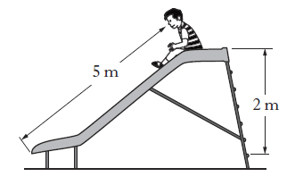
Example 52
It takes 145J to lift a suitcase onto the luggage rack on a train. The rack is 2m above the ground. What was the mass of the suitcase?
E_{p} = mgh => m = E_{p} /gh
- m = 145/ (9.8 x 2)
- m = 7.4kg
Example 51
A crane lifts a container of mass 1000kg from the dock onto the deck of the ship, 15m above. How much potential energy does the container gain?
E_{p} = mgh
= 1000 x 9.8 x 15
=147000J

A moving object is described as having kinetic energy.
E_{k} = Kinetic Energy (J)
E_{k} = ½ mv²
m = mass (kg)
v = velocity (ms⁻¹)
Example 55
A car of mass 40kg uses 500J of energy to move. What speed does it move at?
E_{k} = ½ mv²
500 = 0.5 x 40 x v²
500/20 = v²
V²= 25
V = 5ms⁻¹

Example 54
A car of mass 900kg travels at a speed of 12ms⁻¹. How much kinetic energy does it have?
E_{k} = ½ mv²
= 0.5 x 900 x 12²
= 64800J
Example 56
An object travelling at 60ms⁻¹ has an energy of 45,000J. What is the mass of the object?
E_{k} = ½ mv²
45000 = 0.5 x m x 60²
M = 45000/(0.5 x 60 x 60)
M = 25kg

Energy cannot be created nor destroyed.

Energy can change from one type to another. A light bulb converts electrical energy into light and heat energy.

When energy is converted from one type to another the total energy before the conversion is equal to the total energy after the conversion.

Sometimes energy is converted to a type which you can’t use. When a car moves some of the kinetic energy is converted to heat because of friction. This isn’t useful energy and may be described as energy ‘lost’.

When energy is converted it is usual to assume that all the energy is converted and none is ‘lost’.
We can use the idea of conservation of energy to allow us to predict what happens in certain situations.
The pendulum swings between A and C, passing through point B. At points A and C it has potential energy. At point B it has kinetic energy.
Using conservation of energy we can predict that all the potential energy at A is converted to kinetic energy B.
E_{p} = mgh E_{k} = ½ mv²
m gh = ½ mv²
mgh = ½ mv²
$v= \sqrt{2g}h$
This equation allows us to calculate the velocity of the pendulum at B

Pendulum
B
C
A

c
c

c

Conservation of energy is used in many different situations..

Example 57
In a garage, a mechanic lifts an engine from a car using a pulley system.
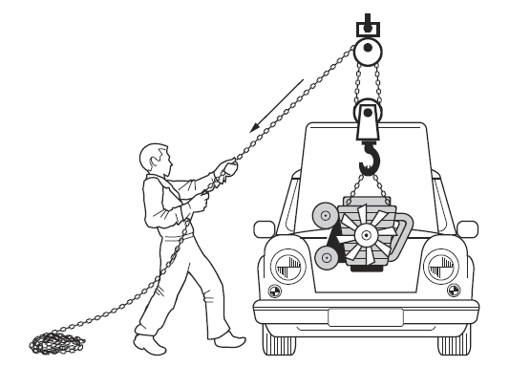
- The mechanic pulls 4.5m of chain with a constant force of 250N.
Calculate the work done by the mechanic
- The engine has a mass of 144 kg and is raised 0.75m.
Calculate the gravitational potential energy gained by the engine.
- Why is there a difference between the two readings?

SQA Int2 2013 Q24 (adapted)

Example 58
A car of mass 700kg travels along a motorway at constant speed. The driver sees a traffic hold-up ahead and performs an emergency stop. A graph of the car’s motion is shown, from the moment the driver sees the hold-up.
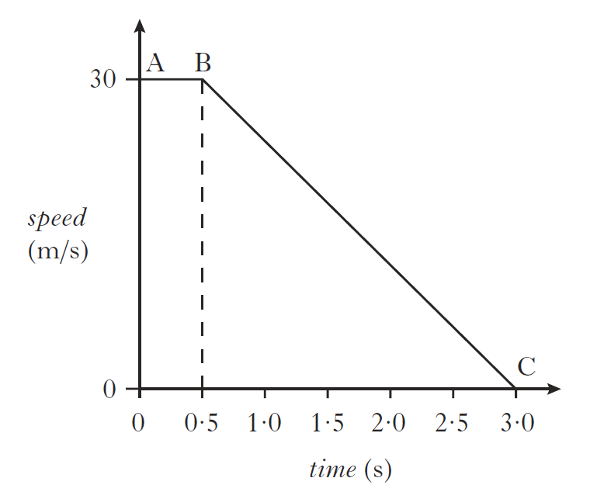
- Describe and explain the motion of the car between A and B.
- Calculate the kinetic energy of the car at A.
- State the work done in bringing the car to a halt between B and C.
- Show by calculation that the magnitude of the unbalanced force required to bring the car to a halt between B and C is 8400N.

SQA Int2 2012 Q22

Example 59
A child of mass 42kg is playing on a water slide at a water park.
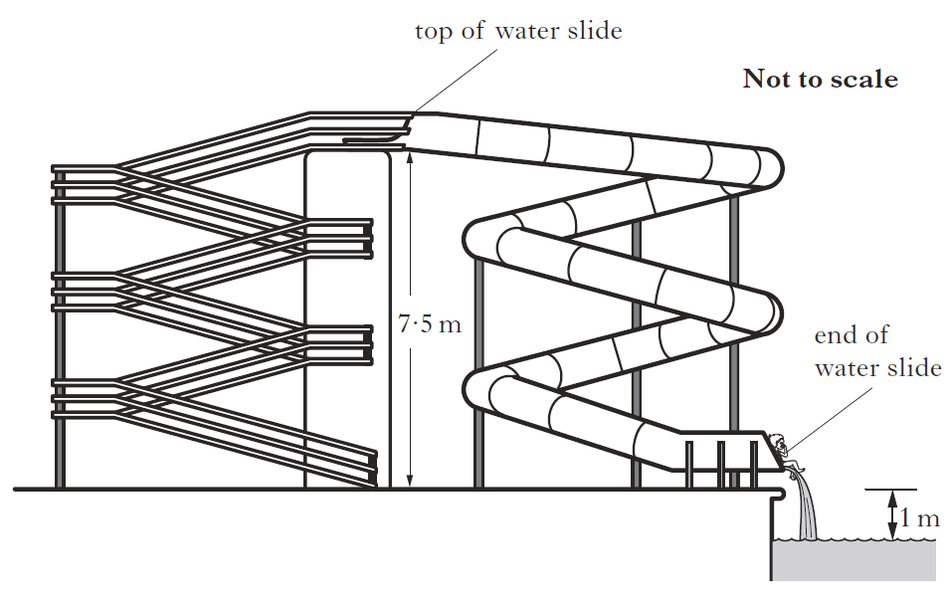
- The child climbs 7.5m to the top of the slide.
Calculate the gain in potential energy of the child.
- When sliding down, an average frictional force of 15N acts on the child. This causes 1050J of heat energy to be produced.
Calculate the length of the slide.
- Calculate the speed of the child at the end of the slide.

SQA SG Credit 2013 Q10
At National 5 level, by the end of this section you should be able to:
- Explain projectile motion in terms of constant vertical acceleration and constant horizontal velocity.
- Use appropriate relationships to solve problems involving projectile motion from a horizontal launch, including the use of motion graphs.
- State that horizontal range = area under v_{h}-t graphs
- State that vertical height = area under v_{v}-t graphs
- State that constant horizontal velocity can be calculated from
$$v_{h}=\frac{s}{t}$$
- State that constant vertical acceleration can be calculated from
$$v_{v}= u_{v}+at$$
- Explain satellite orbits in terms of projectile motion, horizontal velocity and weight.

If you push a ball off the edge of a table the ball follows a curved path. (called a parabola)
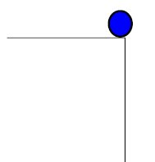
At any moment we could think of the balls movement in terms of how fast it travels horizontally and how fast it travels vertically.

There are no unbalanced forces in the horizontal direction, so the horizontal velocity is constant
0
t
V_{v}
0
t
V_{h}

In the vertical direction the force due to gravity acts on the object, causing it to accelerate when moving downwards and decelerate when moving upwards.
To calculate the vertical velocity we can use the equation

v = u + at Where u = initial velocity (ms⁻¹)
v = final velocity (ms⁻¹)
a = acceleration (ms⁻²)
t = time (s)

Example 60
A helicopter flying at 40ms⁻¹ releases an aid package. It takes 3s to hit the ground.
Calculate:
- The horizontal speed when the package hits the ground
- The horizontal distance travelled
- The initial vertical speed
- The final vertical speed when it hits the ground.
- The height of the helicopter when it released the package.

40ms⁻¹

- Horizontal velocity = 40ms⁻¹
- d = vt = 40 x 3 = 120m
- 0ms⁻¹
- v= u + at = 0 + (3 x 9.8) = 29.4ms⁻¹
- Either draw a graph and use distance = area under graph
Or/
Average speed = (29.4+ 0) /2 = 14.7 ms⁻¹
Distance = average speed x time = 14.7 x 3 = 44.1 ms⁻¹

Example 61
Two identical balls X and Y are projected horizontally from the edge of a cliff. The path taken by each ball is shown.
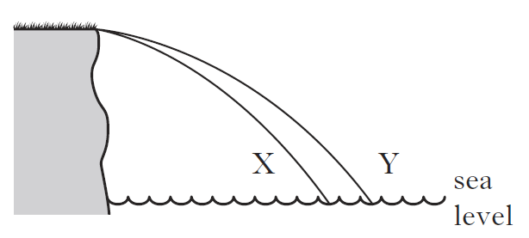
A student makes the following statements about the motion of the two balls.
They take the same time to reach sea level.
- They have the same vertical acceleration.
- They have the same horizontal velocity.

Which of these statements is/are correct? SQA Int2 2012 Q5 adapted

Example 62
In a TV game show contestants are challenged to run off a horizontal platform and land in a rubber ring floating in a swimming pool.
The platform is 2.8m above the water surface.
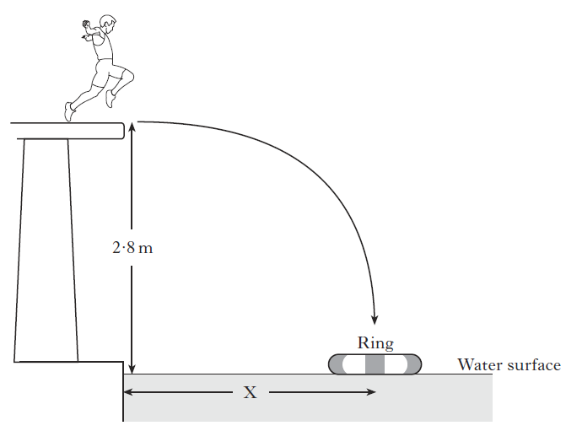
- A contestant has a mass of 60kg
He runs off the platform with a horizontal velocity of 2 ms⁻¹. He takes 0.75s to reach the water surface in the centre of the ring.
  - Calculate the horizontal distance X from the poolside to the centre of the ring.
  - Calculate the vertical velocity of the contestant as he reaches the water surface.
- Another contestant has a mass of 80 kg.
Will she need to run faster, slower or at the same horizontal speed as the first contestant to land in the ring?
You must explain your answer.

SQA Int2 2013 Q23

