
N5 Physics

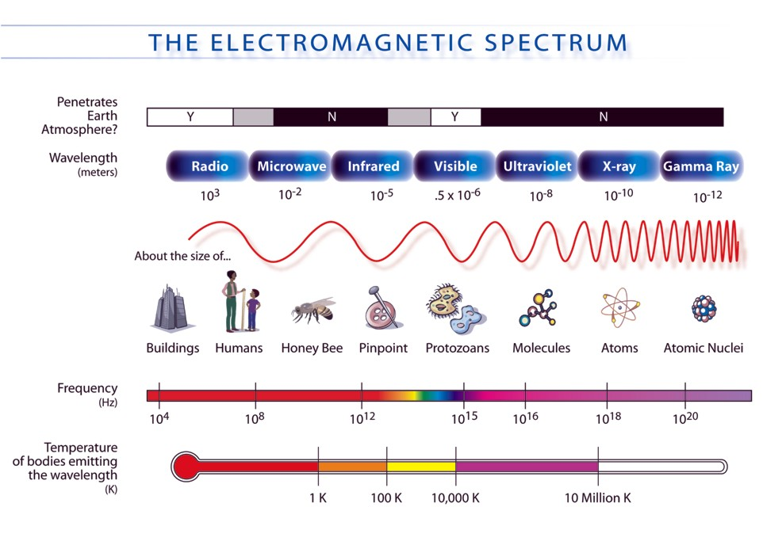
Waves Notes
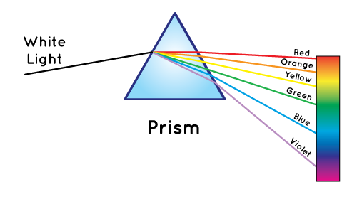
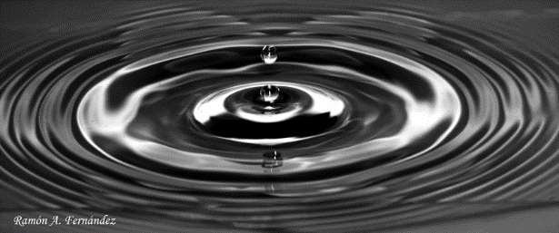

Name ____________ Class ____

At National 5 level you should be able to:
- State that waves transfer energy.
- Define transverse waves as waves where the particles move at right angles to the direction of energy travel.
- State that water waves and electromagnetic radiation are examples of transverse waves.
- Define longitudinal waves as waves where the particles move parallel to the direction of energy travel.
- State that sound is an example of a longitudinal wave.
- Define frequency as the number of waves per second.
- Define the period of a wave as the time taken for a complete wave to pass a point.
- Define the wavelength of a wave as the distance between a point on a wave and the same point on the following wave.
- Identify the amplitude of a wave on a diagram.
- Use appropriate relationships to solve problems involving wave speed, frequency, period, wavelength, distance, number of waves and time.
$v= \frac{d}{t}$
$$f= \frac{N}{t}$$
$$v=fλ$$
$$T=\frac{1}{f}$$
- State that diffraction occurs when waves pass through a gap or around an object.
- State that waves which have a long wavelength diffract more than waves which have a shorter wavelength.
- Draw diagrams which show diffraction when waves
  - Pass through a gap.
  - Pass around an object.

Waves and Energy
All waves transfer energy – this includes water waves, sound waves and all the different parts of the electromagnetic spectrum (radio and tv waves, microwaves, infra red, visible light, ultraviolet, x-rays and gamma radiation)

Types of wave

There are two types of wave – transverse and longitudinal waves.

Transverse waves
Particle movement
Direction of energy travel

The particles move at right angles to the direction of energy travel.
Water and all the waves on the electromagnetic spectrum are transverse waves.

Longitudinal Wave

Particle movement
Direction of energy travel

The particles move parallel to the direction of energy travel
Sound waves are longitudinal waves.
Example 1
A student makes the following statements about transverse waves.

I Transverse waves transfer energy
II The particles in a transverse wave oscillate parallel to the direction of the wave movement
III Light is an example of a transverse wave

Which of these statements is/are correct?

A. I only
B. III only
C. I and II only
D. I and III only
E. I, II and III.

Example 2
Which of the following waves is a longitudinal wave?

A. Microwaves
B. Radio waves
C. Sound waves
D. Light waves
E. Water waves

Waves question book P4 Q 1- 4
Leckie and Leckie P288, Ex 5.17.1 Waves and energy
Example 3
When a sound wave travels through air the particles of air

A. move continuously away from the source
B. move continuously towards the source
C. vibrate at random
D. vibrate at 90° to the wave direction
E. vibrate along the wave direction.

Wave Terms
wavelength
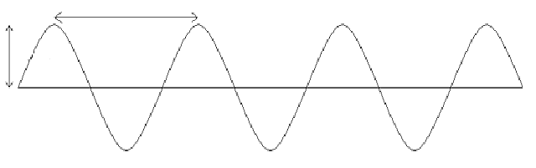
amplitude

Wavelength
Symbol – λ unit – Metre (m)
This is the distance from one point on a wave to the corresponding point on the next wave.

Amplitude
unit – metre (m)
The height of a wave from the middle to the top (or middle to the bottom). The greater the amplitude the more energy a wave has.

Frequency
Symbol – f unit – Hertz (Hz)
The number of waves per second.

Period
Symbol – T unit – Second (s)
The time taken for one complete wave to pass a point.

Wave speed
Symbol – v unit – Metres per second (ms⁻¹)
Distance travelled by wave in one second.

Example 4
The energy of a wave depends on its

A. period
B. wavelength
C. amplitude
D. colour
E. speed

Example 5
Which of the following describes the period of a water wave?

A. The distance between the crest of a wave and the crest on the next wave.
B. The number of waves passing any point in one second
C. The distance travelled by a crest in one second
D. The time taken for one complete wave to pass any point
E. The height of a wave from the middle of a wave to the crest of a wave.

Waves question book P5 Q1 – 10
Leckie and Leckie P291, Ex 5.17.2 Wavelength and amplitude
Example 6
The following diagram gives information about a wave.
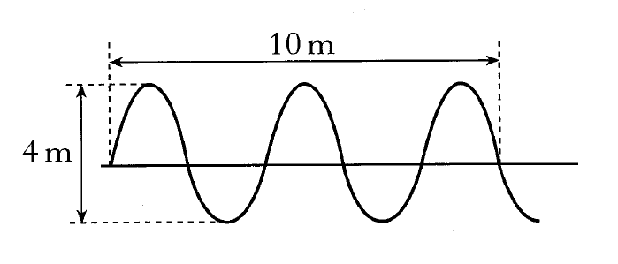
Which row shows the wavelength and amplitude of the wave?

 | Wavelength (m) | Amplitude (m)
A | 2 | 2
B | 4 | 2
C | 5 | 2
D | 2 | 4
E | 4 | 4

Example 10
Radio One broadcasts on a frequency of 97 MHz.
What does this mean?

Example 9
In a water tank, 20 waves pass a point in 4 seconds. What is the frequency of the waves?

Example 8
An observer watches a wave which has a frequency of 3.5 Hz for 20 seconds. How many waves does she count?

Example 7
Find the frequency of a wave where 15 waves pass a point in 5 seconds.

Where f = frequency (Hertz, Hz)
f = N N = number of waves (no unit)
t t = time (seconds, s)

Example 11
The frequency of a wave generator in a swimming pool is 0.67 Hz. What is the time between each wave?

T = 1 Where f = frequency (Hertz, Hz)
f T = period of wave (seconds, s)

Example 12
The period of a wave is 0.015 s. What is the frequency of this wave?

Waves question book P8 Q 1- 12
Leckie and Leckie P293, Ex 5.17.3 Period and frequency

Example 14
A light wave has a frequency of
4.9 x 10¹⁴ Hz.
The period of the wave is

A. 2.0 x 10⁻¹⁵ s
B. 6.1 x 10⁻⁷ s
C. 0.15 s
D. 1.6 x 10⁶ s
E. 4.9 x 10¹⁴ s

Example 13
60 waves pass a point in an hour.
What is the period of each wave?

Example 15
Find the speed of a wave with frequency 30Hz and wavelength 25cm

v= fλ where v = speed of wave (metres per second, ms⁻¹)
f = frequency (Hertz, Hz)
λ = wavelength (metres, m)

Example 16
A sound wave (v = 340 ms⁻¹) has a frequency of 60Hz. What is its wavelength?

Example 18
What is the wavelength of SIBC? (96.2MHz)

Example 17
What is the frequency of a wave with speed 1500 ms⁻¹and wavelength 20km ?

Example 19
A water wave is shown below.
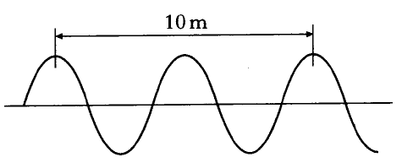
The speed of the wave is 2.0 ms⁻¹.
The frequency of the wave is
A. 0.2 Hz
B. 0.4 Hz
C. 2.5 Hz
D. 10 Hz
E. 20 Hz.

Example 20
In a water tank, 10 waves pass a point in 2 seconds. The speed of the waves is 0.4 ms⁻¹. The wavelength of the waves is
A. 0.005 m
B. 0.02 m
C. 0.04 m
D. 0.08 m
E. 2 m

Example 21
A beam of light has a wavelength of 4.80 x 10⁻⁷ m in air. The frequency of this light is
A. 1.60 x 10⁻¹⁵ Hz
B. 2.40 x 10⁻¹⁵Hz
C. 7.08 x 10⁸ Hz
D. 4.17 x 10¹⁴ Hz
E. 6.25 x 10¹⁴ Hz.

Example 22
A boy and girl are watching the movement of water next to a pier. The pier has a gauge which measures the depth of the water as shown in the diagram.
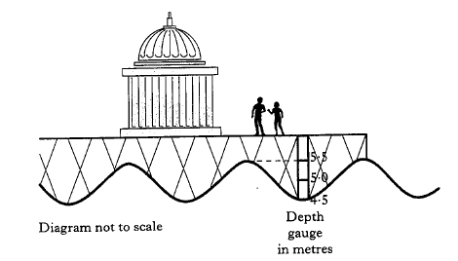
The boy notes that the crest of a wave takes 2.5 seconds to travel a distance of 30 metres along the side of the pier and so the wavespeed is 12 ms⁻¹.
The girl notes hat 24 waves crests pass her every minute.
(a) Show that the frequency of the waves is 0.4 Hz.

(b) Calculate the wavelength of the waves.

(c) The boy and girl note that when a trough passes the gauge, the water sssssdepth is recorded at 4.5 metres. When a crest passes the gauge, it is sssssrecorded at 5.5 metres.
sssssCalculate the amplitude of the waves.
Waves question book P 10 Q 1 - 18
Leckie and Leckie P299, Ex 5.17.5 Speed, frequency and wavelength

Example 23
What is the speed of a sound wave that travels 6800m in 60 seconds?

Where v = speed (metres per second, ms⁻¹)
$v= \frac{d}{t}$ d = distance (metres, m)
t = time (seconds, s)

Example 24
How long does it take a water wave to travel 15m at 0.5 ms⁻¹?

Example 25
The sound of a horn is heard 1190m away, 3.5 seconds after it is sounded. What is the speed of the horn sound in air?

Example 26
A boat sounds a foghorn and hears the echo 4seconds later. How far is it from the cliff?

Waves question book P13 Q 1 - 10
Leckie and Leckie P296, Ex 5.17.4 Speed of a wave
Example 27
Bottlenose dolphins produce sounds in the frequency range 200 Hz – 150 kHz.
Echolocation is the location of objects by using reflected sound. Bottlenose dolphins use ultrasounds for echolocation.
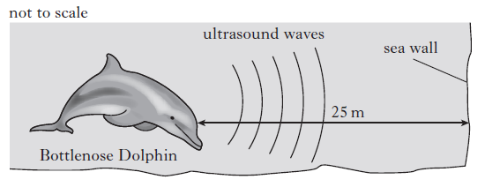
The speed of sound in water is 1500 ms⁻¹.
When the dolphin is 25m from the sea wall, it emits a pulse of ultrasound.
Calculate the time taken for this pulse to return to the dolphin

Example 28
Some people who are visually impaired make clicking sounds with their mouths to help them move safely around their environment. Use your knowledge of physics to explain how this works.

Example 29
In the aircraft industry non-destructive metal testing is used to look for flaws in aluminium propellers.
Ultrasound pulses are sent from a transmitter into the propeller being tested. If there are no flaws in the propeller the ultrasound will be reflected from the back edge of the propeller as shown at position A. The reflected signal is detected by a receiver. If a flaw is present inside the propeller a reflection from the flaw will take place inside the propeller as shown at position B.
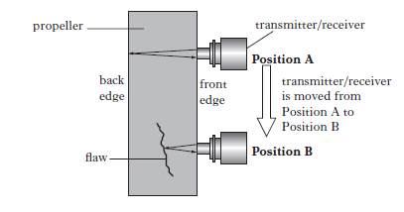
The graph shows the time taken between transmitting and receiving the pulses at positions A and B.
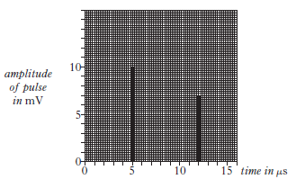
- State the time between transmitting and receiving the pulse at position B.

Example 29 (continued)

- The speed of the sound waves in the aluminium propeller is 5200 ms⁻¹. Calculate the distance of the flaw from the front edge of the propeller.

c) The frequency of the ultrasound pulses is 15 MHz.
Calculate the wavelength of the ultrasound pulses in the propeller.

Diffraction occurs when waves pass through a gap or around an object.

Long wavelengths diffract more than short wavelengths.

When drawing diagrams

- Use a ruler for straight lines

- Keep the distance between waves the same



If the gap is less than a wavelength circular wavefronts are produced.
If the gap is greater than a wavelength then only the ends of the waves show diffraction.
Example 30
Water waves are produced in two identical ripple tanks. The waves reach a barrier and are diffracted.

Which pair of ripple tanks shows correct diffraction?
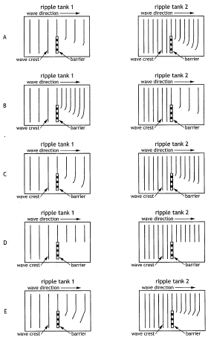

Leckie and Leckie P302, Ex 5.17.6 Diffraction
At National 5 level you should be able to:
- State that the bands in the electromagnetic spectrum are
  - Radio and TV
  - Microwaves
  - Infra red
  - Visible light (red, orange, yellow, green, blue, indigo, violet)
  - Ultraviolet
  - X-rays
  - Gamma radiation
- List the different bands of the electromagnetic spectrum in order of in order of frequency (or wavelength)
- State typical sources for each band in the electromagnetic spectrum
- State a detector for each band in the electromagnetic spectrum
- Describe applications for each band of the electromagnetic spectrum.
- State that all radiations in the electromagnetic spectrum are transverse waves.
- State that all radiations in the electromagnetic spectrum travel at the speed of light.

(NASA diagram)

All parts of the electromagnetic spectrum travel at the speed of light.

The speed of light in a vacuum is 300,000,000 metres per second.
This can also be written as 3 x 10⁸ ms^{-1.}

The equations $v=fλ$ and $v= \frac{d}{t}$ can be used to calculate information about waves.

Gamma radiation has the highest frequency and shortest wavelength.
High frequency waves have high energy, so gamma radiation has the highest energy of all the bands in the electromagnetic spectrum.

Example 31
Which of the following electromagnetic waves has a higher frequency than infrared and a lower frequency than ultraviolet?

A. Gamma rays
B. Radio
C. Visible light
D. X-rays
E. Microwaves

Example 32
Which of the following list the electromagnetic waves in order of increasing wavelength?

A. Microwaves, infrared, ultraviolet, gamma rays
B. Radio, microwaves, visible light, x-rays
C. Visible light, microwaves, x-rays, gamma rays
D. X-rays, infrared, visible light, ultraviolet
E. Gamma rays, ultraviolet, infrared, radio

Example 33
A student writes the following statements about electromagnetic waves.

I Electromagnetic waves all travel at the same speed in air
II Electromagnetic waves all have the same wavelength
III Electromagnetic waves all transfer energy

Which of these statements is/are correct?

A. I only
B. II only
C. I and II only
D. I and III only
E. I, II and III

Typical Sources
Electrical aerial/ radio transmitter connected to an electronic circuit.
Also produced by stars, sparks and lightning – which is why you hear interference on a radio during a thunderstorm.

Detector
Aerial

Application
Telecommunications
Broadcasting radio and tv programmes
Radio signals used for communication

Example 34
Drivers in two cars, A and B, are listening to the performance on the radio.
The performance is being broadcast on two different wavebands, from the same transmitter.

The radio in car A is tuned to an AM signal of frequency 1152 kHz.
The radio in car B is tuned to an FM signal of frequency 102.5 MHz.

Both cars drive into a valley surrounded by hills.
The radio in car B loses the signal from the broadcast.
Explain why this signal is lost.

Example 35
Brian says ‘Microwaves are just little waves – they are the same as every other wave, just smaller’. Anna disagrees with him. How can she explain what is right and wrong about what he says?

Application
Communications, satellites, phone signals, heating water and food, radar for navigation in ships and aircraft, speed cameras.
Detector
Aerial
Typical Sources
Electronic circuit in devices such as radars or microwaves.
Stars
Application
Remote controls for TV etc.
Detector in security lighting
Thermograms in medicine – detect inflammation.
Physiotherapists use infra-red lamps to help muscles heal.
Infra-red heaters are used in large spaces such as games halls.
Emergency services use infra-red to find people who are lost e.g. at sea.
Security markings on banknotes.
Checking for areas of heat loss in buildings/circuits.
Detector
Electronic detectors (phototransistor), heat sensitive paper, black-bulb thermometer.
Typical Sources
Objects which are warm – people, lamps, flames
Sun
Electronic devices e.g. remote control for TV

Example 36
A toy helicopter is operated using an infrared signal from a remote control. The helicopter has a receiver that can detect infrared radiation.
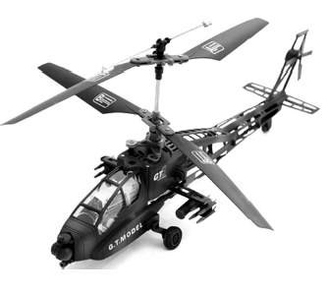

State a suitable detector of infrared for this situation.

Example 37
Visible light travels at 2 x 10⁸ ms⁻¹ through glass.
How long would it take for a signal to travel 500 km?

Application
Seeing, photography, communications – optical fibres, laser surgery,
CD/DVD players
Detector
Eye, photographic film, electronic components such as a light dependant resistor (LDR).
Typical Sources
Electronic devices e.g. LEDs
Objects which glow
Stars

Example 38
How can UV be used to identify fake banknotes?

Application
Sun-tan lamp – can also be used to treat skin conditions.
Helps body produce Vitamin D
Killing bacteria in water treatment plants and hand dryers
Used as a tracer in biological experiments
Used to set fillings at the dentist.
Used to mark valuables and to identify bank notes.
Detector
Objects which fluoresce (glow) when uv shines on them.
Photographic film.
Typical Sources
Sun
Gas discharge lamps
Application
Medical imaging – to detect broken bones or abnormalities in the body. Sometimes the use of contrast material is needed to show a clear image e.g. of the stomach and intestines.
Radiotherapy – use of x-rays to treat tumours.
Scanning luggage at airports to detect hidden objects.
Scanning welds in pipes to detect defects in quality (where the pipe may break)
Used in astronomy.
Detector
Photographic film
Typical Sources
Very fast electrons hitting a metal target
Cosmic sources

Example 39
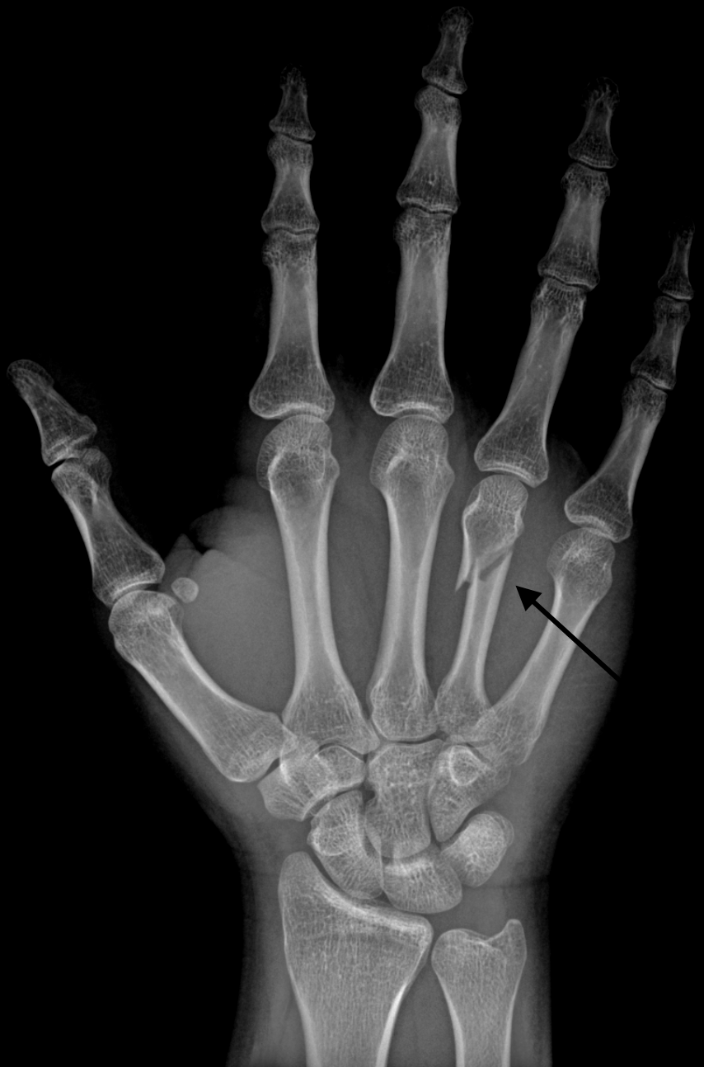

X-rays are used in medical imaging to detect broken bones.

How do X-rays allow the detection of broken bones?

Typical Sources
Radioactive nuclei decaying

Detector
Photographic film
Geiger Muller Tube (GM tube)

Application
Medical tracers – can be injected into the blood stream to give an image of parts of the body such as kidneys.
Killing cancerous cells.
Sterilisation of medical equipment.

Example 40
Gamma radiation has the shortest wavelength and highest frequency of all the waves on the electromagnetic spectrum. It also has the highest energy.
Name a use of gamma radiation.

Example 41
On one of the missions to the Moon, astronauts took a large mirror which they set up and left behind on the surface. Scientists on Earth determined the distance between the Earth and the Moon by reflecting laser light from the mirror.

(a) Using a powerful laser and a clock, scientists on Earth measured the exact time for the laser light to travel to the Moon and back. The reading on the clock was 2.56 s.

[Speed of light in air or vacuum = 3 x 10⁸ ms⁻¹]
Calculate the distance from the Earth to the Moon.

(b) While setting up the mirror on the Moon, the astronauts were in radio communication with Earth.
(i) How did the time taken for the radio waves to travel to the Moon compare with the time taken for the laser light to travel to the Moon?

(ii) Name a detector for radio waves.

(iii) Name a source of radio waves.

(c) Visible light from the laser is one part of the electromagnetic spectrum.
The diagram below shows the electromagnetic spectrum but two parts, P and Q are missing.
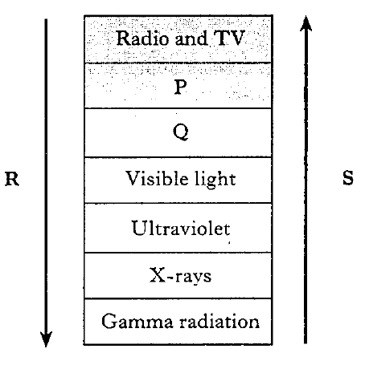
(i) Name radiation P and radiation Q.

Radiation P ……………………………………………………………….

Radiation Q ……………………………………………………………….

(ii) Which of the arrows, R or S, shows the direction of increasing wavelength of the electromagnetic radiation in the spectrum?

Example 42
Satellites transmit and receive microwaves. Microwaves are part of the electromagnetic spectrum.

The satellite transmits microwaves on the following three frequencies.
1.0 x 10¹⁰ Hz
9.0 x 10⁹ Hz
8.0 x 10⁹ Hz
(a) Calculate the wavelength of the microwaves with the longest wavelength.

(b) Name a detector of microwaves.

Waves question book P 18 Q 1- 15, P 20 Q 1 – 15.
Leckie and Leckie P308, Ex 5.18.1 The electromagnetic spectrum
At National 5 level you should be able to:
- State that refraction occurs when waves pass from one medium to another (such as air to glass or vice versa)
- Describe refraction in terms of change of wave speed, change in wavelength and change of direction (where the angle of incidence is greater than 0°), for waves passing into both a more dense and a less dense medium.
- Identify the normal, angle of incidence and angle of refraction in ray diagrams showing refraction.

When light passes from one medium to another its speed and wavelength changes. The direction of the ray may also change.

Examples of light passing from one medium to another would be light passing through glass or plastic, looking at the bottom of the swimming pool or into a gemstone. Light is also refracted when it passes through warm air causing ‘heat haze’ and mirages.

Light entering a block at right angles to the surface will pass straight through. The speed of light is slower in more dense materials. The wavelength of light is shorter in more dense materials.

If light meets the surface of another material at an angle, it appears to ‘bend’. The light slows down, the wavelength decreases and changes direction when it enters a more dense material at an angle.

$$∠r$$
$$∠i$$

The normal is a reference line, drawn at right angles to the surface where the incident ray touches it.
All angles are measured between the ray and the normal.

$∠i$ = angle of incidence
$∠r$ = angle of refraction

Semicircular Block

$$∠i$$

$$∠r$$

When light enters a semicircular block on the curved side it travels along the normal.

The light is refracted when it leaves the block as long as the angle of incidence is below a certain value for that material.

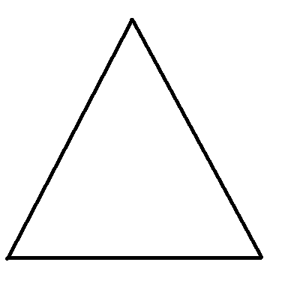Triangular Prism

Light passing through a prism will change direction as it enters and as it leaves the block due to refraction

If it is white light, the light leaving the block will split up into the visible spectrum. Sunlight passing through raindrops does this – creating a rainbow.

Example 43
A ray of light changes direction as it travels from air to water. This effect is called
A. diffraction
B. diffusion
C. incidence
D. refraction
E. reflection.

Example 44
What is the name of the glass shape used to split white light into different colours?

A. Concave lens
B. Convex lens
C. Prism
D. Rectangular block
E. Semi-circular block.

Example 45
A student writes four statements for a ray of light travelling from air to glass.

I. The direction of light always changes.
II. The direction of light sometimes changes.
III. The speed of light increases.
IV. The wavelength of light decreases.

Which of these statements is/are correct?

A. I only
B. II only
C. I and III only
D. II and IV only
E. II, III and IV

Example 46
A ray of light passes through a glass block as shown.
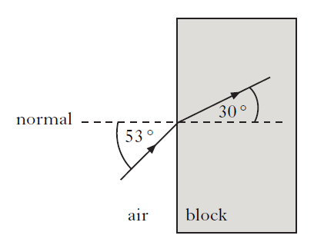
Which line correctly shows the angle of incidence in the glass and the corresponding angle of refraction?

 | Angle of incidence | Angle of refraction
A | 37 | 60
B | 53 | 60
C | 30 | 53
D | 37 | 30
E | 53 | 30

Waves question book P25 Q 1 - 6
Leckie and Leckie P316, Ex 5.19.1 Refraction

