DYNAMICS

Quantities for the Dynamics Unit
For this unit copy and complete the table.
Quantity | Symbol | Unit | Unit Symbol | Scalar / Vector
Time
Speed
Velocity
Acceleration
Distance
Displacement
Force
Weight
Friction
Gravitational Field Strength
Energy
Work
Heat Energy
Gravitational Potential Energy
Kinetic Energy
Height
Initial velocity
Final velocity
Average velocity
Mass

The DYNAMICS unit in numbers
Quantity | Value
State the number seconds in a minute.
State the number of seconds in an hour.
State the gravitational field strength on the surface of Earth.
State the number of metres in a kilometre.
State the number metres in a mile?
If 70 mph is equivalent to 31.29 ms⁻¹ and 30 mph is equivalent to 13.41 ms⁻¹, what is the conversion factor to convert mph into ms⁻¹?

No. | CONTENT
Vectors and scalars
1.1 | I can define scalar quantities and vector quantities.
1.1.1 | Define the term scalar quantity.
1.1.2 | Define the term vector quantity.
1.1.3 | Describe the difference between vector quantities and scalar quantities.
1.2 | I can identify vector and scalar quantities such as: force, speed, velocity, distance, displacement, acceleration, mass, time and energy.
1.2.1 | Copy and complete the following table placing the quantities in the correct part of the table. force, speed, velocity, distance, displacement, acceleration, mass, time and energy.
  Scalar | Vector
1.3 | I can calculate the resultant of two vector quantities in one dimension or at right angles.
1.3.1 | Define the term “resultant” in terms of two vector quantities.
1.3.2 | Explain how to calculate the resultant and direction of a pair of vectors at right angles.
1.3.3 | Determine the resultant of the following vectors  (b)  (c)
1.3.4 | (d)  (b)  (c)  Find the resultant of each of the pairs of vectors, remember to quote the direction.
1.4 | I can determine displacement and/or distance using scale diagram or calculation.
1.4.1 | Explain the term distance.
1.4.2 | Explain the term displacement.
1.4.3 | 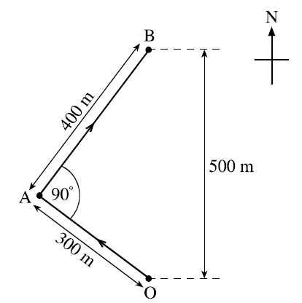  The diagram shows the course taken by a boat during a race.  The boat starts the race at O and sails to a marker buoy at A. The boat then turns through 90° and sails to a marker buoy at B.  (i) Calculate the total distance travelled by the boat in going from O to B.  (ii) On reaching the marker buoy at B, determine the displacement of the boat from O.
1.4.4 | An orienteer starts at A, runs to B, then C and finishes at D.  - Calculate the total distance travelled by the orienteer.  - State the final displacement of the orienteer from point A.
1.5 | I can determine velocity and/or speed using scale diagram or calculation.
1.5.1 | Define the terms  - distance b) displacement
1.5.2 | Define the terms  - Speed b) Velocity
1.5.3 | State the difference between speed and velocity.
1.5.4 | A cyclist travels 500 m in a straight line and then turns directly around and travels 300 m back.  - State the magnitude of the displacement of the cyclist from the start.  - If the cyclists takes 4 minutes and twenty seconds to travel the complete distance, calculate the magnitude of the cyclist’s  - speed and  - velocity.
1.5.5 | A sculler is rowing his boat at 3 ms⁻¹ through the water straight across a river which is flowing at 1 ms⁻¹.  - Draw a vector diagram of these two motions.  - Calculate the boat’s velocity relative to the bank.
1.5.6 | On an orienteering course, a girl runs due north from point A to point B, a distance of 3 km. She then heads in an easterly direction for 4 km to point C.  - Calculate the distance the girl ran from A to C.  - Calculate the girl’s displacement from point A when she reaches C.
1.5.7 | The distance between the wickets on a cricket pitch is 20.12 m. On one pitch, the wicket has a north-south orientation. A batsman scores three runs off one ball.  - Calculate the distance he ran.  - Calculate his final displacement if the wicket at which he batted is at the south end.  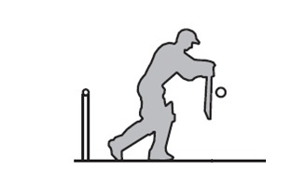
1.5.8 | Jen jogs around the centre circle of a football pitch.  - Calculate the distance she travelled.  - State her displacement from the start.  Chris walks one and a half times around the circle in the same time  - Calculate the distance Chris travelled.  - State Chris’ displacement from the start.  circumference  = 25 m
1.6 | I can perform calculations/ solve problems involving the relationship between speed, distance and time. (d = vt, and $d=\overline{v}t$)
1.6.1 | A car travels 100 miles in 2½hours. Calculate its speed in mph?
1.6.2 | A train travels 120 km in 45 minutes.  (i) Calculate the speed of the train in kmh⁻¹?  (ii) Calculate the speed of the train in ms⁻¹?
1.6.3 | A jet plane travels at an average speed of 300 ms⁻¹.  (i) Calculate the distance the plane travels in an hour.  (ii) Determine the time it would take to travel 500km from Edinburgh to London.
1.6.4 | A runner completes a 200 m race in 25 s. Calculate the runner’s average speed.
1.6.5 | An athlete takes 4 minutes 20 s to complete a 1500 m race. Calculate the average speed of the athlete in ms⁻¹.
1.6.6 | Bloodhound SSC is due to travel at 500 mph (approximately 230 ms⁻¹).  At this speed, calculate the distance Bloodhound could travels in 25 s.
1.6.7 | A girl can walk at an average speed of 2 ms⁻¹. Calculate the distance she walks in 20 minutes.
1.6.8 | Calculate the time it takes a cyclist to travel 40 km at an average speed of 5 ms⁻¹.
1.6.9 | Calculate the time (to the nearest minute) the Glasgow to London shuttle will take if it flies at an average speed of 220 ms⁻¹ for the 750 km flight.
1.6.10 | Calculate the time to the nearest minute, a car will take to travel 50 km if its average speed is 20 ms⁻¹?
1.7 | I can perform calculations/ solve problems involving the relationship between velocity, displacement and time ( $s=\overline{v}t$) in one dimension
1.7.1 | A person walks 25 metres west along a street before turning back and walking  15 metres east. The journey takes 50 seconds. Calculate the:  a) total distance travelled by the person  b) displacement of the person  c) average speed of the person  d) average velocity of the person.
1.7.2 | An Olympic runner runs one complete lap around an athletics track in a race.  The total length of the track is 400 metres and it takes 45 seconds for the runner to complete the race. Calculate the:  a) displacement of the runner at the end of the race  b) average speed of the runner during the race  c) average velocity of the runner during the race.
1.7.3 | A car drives 15 kilometres East for 12 minutes then changes direction and drives  18 kilometres West for 18 minutes.  a) Calculate the total distance travelled by the car.  b) Calculate the displacement of the car from the start of the journey.  c) Calculate the average velocity of the car, in metres per second.
1.7.4 | On a journey, a lorry is driven 120 kilometres west, 20 kilometres north then 30  Kilometres east. This journey takes 2 hours to complete.  a) Calculate the average displacement of the lorry, in km.  b) Calculate the average velocity of the lorry, in km/h.
1.8 | I can determine average and instantaneous speed.
1.8.1 | Explain the term average speed.
1.8.2 | Explain the term instantaneous speed.
1.8.3 | 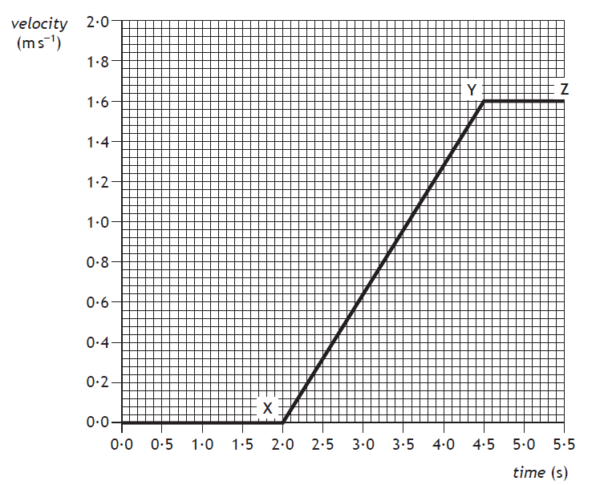  State the instantaneous speed of the vehicle at
   | 0.5 s |  | 3.0 s |  | 4.0 s
1.8.4 | A runner takes 35 seconds to run round 250 metres of a track, calculate her average speed.
1.8.5 | Calculate the average speed of a motor boat which takes 350 seconds to cover a 10 000 m course
1.8.6 | Calculate the distance a car travels in 300 seconds when it is travelling at a top speed of 30 ms⁻¹.
1.8.7 | Calculate the time it takes to walk to school if you walk at an average speed of 3 ms⁻¹ and you live 900 metres away?
1.8.8 | A train travels at 35 ms⁻¹ and takes 15 seconds to pass through a tunnel. Calculate the length of the tunnel.
1.8.9
  Calculate the average speed of Sammy Snail who slithers 0⋅005 m in 4.0 s.
1.8.10 | How long does the TGV take to travel 60 km given that it goes at an average speed of 30 ms⁻¹.
1.8.11 | A school bus takes 20 minutes to travel 15 km. Calculate it’s average speed in ms⁻¹
1.8.12 | A bird maintains an average speed of 11⋅2 ms⁻¹ for 5 minutes. Calculate the distance it travels.
1.8.13 | Calculate the time taken for a roller blader to travel 2 km if her average speed is 7 ms⁻¹
1.8.14 | A runner decides to analyze her track performance in order to improve her overall running time during the 400 m event. She sets up light gates at six points round the track so that she can work out her instantaneous speed at each point.  As the runner cuts the beam of light from the light gate the timer operates.  $$instantaneous speed= \frac{width of runner}{time to pass the point}$$  The results she recorded are shown below.  Use the results to calculate her instantaneous speed at each position and hence determine the point is she running:  (a) fastest (b) slowest.
  Position | width of runner (m) | time (s) | instantaneous speed (m/s)
  A | 0·2 | 0·025
  B | 0·2 | 0·026
  C | 0·2 | 0·030
  D | 0·2 | 0·029
  E | 0·2 | 0·025
  F | 0·2 | 0·024
1.8.15 | Civil engineers need to know the speed of a train as it enters a tunnel which they are planning to build. They set up their equipment to measure the length of a section of the train and time how long that section takes to pass the planned point of entry to the tunnel.  The length of train is 23.0 m and the time to pass the point of entry is recorded as 1·23 s. Calculate the instantaneous speed of the train.
1.8.16 | A coin is dropped from a height so that it passes through a light gate connected to a computer. The coin has a width of 0·02 m and it takes 0·005 seconds to pass through the light gate. Calculate the coin’s instantaneous speed.
1.8.17 | Two insulated wires are laid across the road 1.00 metres apart to test the instantaneous speed of cars as they travel between the wires. A Mondeo of wheelbase length 2.85 m takes 0.06 s to pass between the two wires. Calculate the instantaneous speed of the car.
1.9 | I can describe experiments to measure average and instantaneous speed.
1.9.1 | Describe how you can measure the average speed of a runner. Include a list of the apparatus you would use, the measurements you would take, how you would carry these out, and the calculation needed to obtain a final value for the speed. You may use a diagram to help you.
1.9.2 | (a) List various methods for measuring the instantaneous speed.  (b) State of these methods is most accurate, you must justify your answer.
1.9.3 | An arrow of length 0·8 m is shot from a bow.  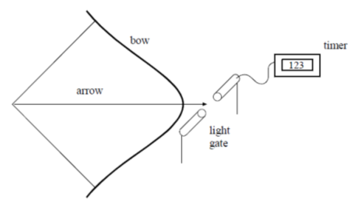  A student designs an experiment to measure the instantaneous speed of the arrow, as it leaves the bow. The student places a light gate connected to a timer, as shown below.  The student states that the speed of the arrow can be found from  $$speed of the arrow= \frac{length of arrown}{time on timer}$$  (i) Explain why the method used by the student does not give the correct value for the speed of the arrow as it leaves the bow.  (ii) Suggest how the experiment could be modified to enable the speed of the arrow as it leaves the bow to be found.
1.9.4 | 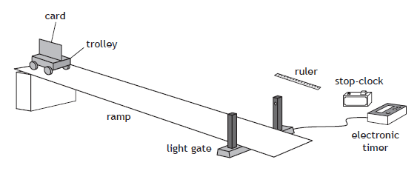  Copy and complete the diagram and state how the following can be determined:  - the instantaneous speed of the trolley at the bottom of the slope.  - the average speed of the trolley down the ramp  - the acceleration of the trolley as it rolls down the ramp.
1.9.5 | 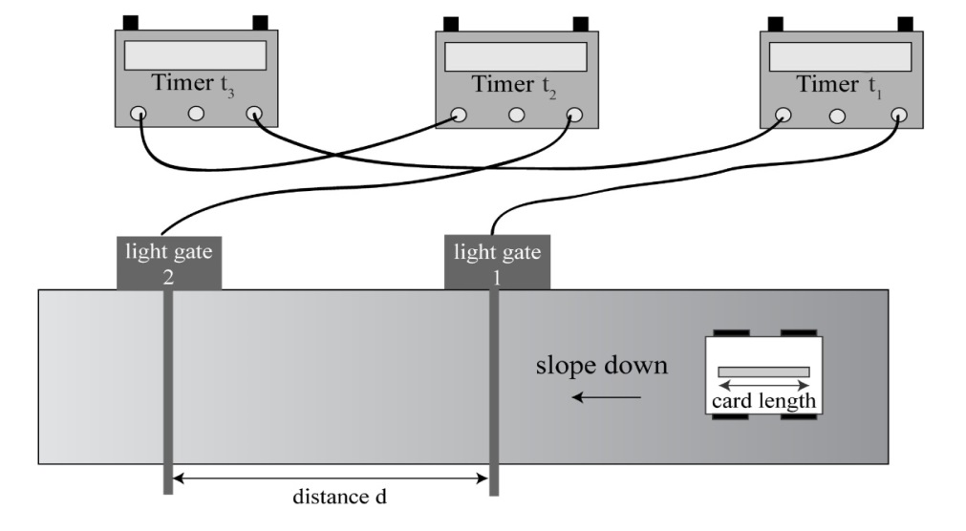  t₃  t₂  t₁  From the diagram above, state what measurements are required to find:  - the average speed of the vehicle as it passes down the slope?  - the instantaneous speed at the bottom of the slope?  State what pieces of equipment give the measurements to find:  - the average speed of the vehicle as it passes down the slope?  - the instantaneous speed at the bottom of the slope?  - What additional equipment is required to complete these measurements?
Velocity- time graphs
2.1 | I can draw velocity–time graphs for objects from recorded or experimental data.
2.1.1 | - On graph paper, draw a velocity-time graph of the race car’s journey.  - Using the graph, describe the motion of the race car over the 80 seconds.  - Using the graph you have drawn, calculate  - The acceleration between 10 and 40 s.  - The total distance travelled by the race car.  - The average speed during the 80 seconds.
  Time (s) | 0 | 10 | 20 | 30 | 40 | 50 | 60 | 70 | 80
  Speed (m/s) | 5 | 5 | 20 | 35 | 50 | 50 | 50 | 25 | 0
2.1.2 | Draw a labelled speed-time graph showing an object  (a) accelerating at 2 ms⁻²,  (b) travelling at a steady velocity of 6 ms⁻¹,  (c) accelerating at -5ms⁻².
2.1.4 | During a test run, a car starts from rest on a straight, flat track. For the first 2 s it has a constant acceleration. It then maintains a constant velocity for a further 3 s. Sketch a velocity–time graph to show how the velocity of the car varies during the test run. Numerical values are only required on the time axis.
2.2 | I can interpret velocity–time graphs to describe the motion of an object.
2.2.1 | Fully describe the motion of the vehicles.  Time (s)  Velocity (ms⁻¹)  Time (s)  Velocity /ms⁻¹  (b)  Velocity /ms¹  Time (s)  (c)  (a)  velocity / ms⁻¹  Time (s)  T  (d)
2.2.2 | - Describe the motion of the car during the 35 seconds  - Calculate the acceleration between 0 and 10 seconds  - Calculate the acceleration between 30 and 35 seconds  - Calculate the final displacement of the car from the starting position  - Calculate the average velocity during the 35 seconds.
2.1.3 | The velocity-time graph shown below describes the motion of a ball which has been thrown straight up into the air then allowed to fall to the ground.  From the graph below  - Determine the time the ball reaches its maximum height.  - Calculate the maximum height that the ball reaches.  - Calculate the height from maximum to the ground.  - Use your answers to ii. and iii. to calculate the height above the ground that the ball was thrown from.
2.2.4 | (i) For each of the graphs shown below, find  (a) the instantaneous speed at 10s  (b) the distance travelled over the 20 second period  (c) the average speed over the 20 second journey.  (NB time axis scale has each major unit = 5s, velocity axis major unit is 2 ms⁻¹)  (ii) Compare the average speed with the instantaneous speed at ten seconds and comment on the difference (if any).  (iii) In what situation will the instantaneous speed always be the same as the average speed?
2.2.5 | A car travels along a motorway.  A graph of the car’s motion is shown.  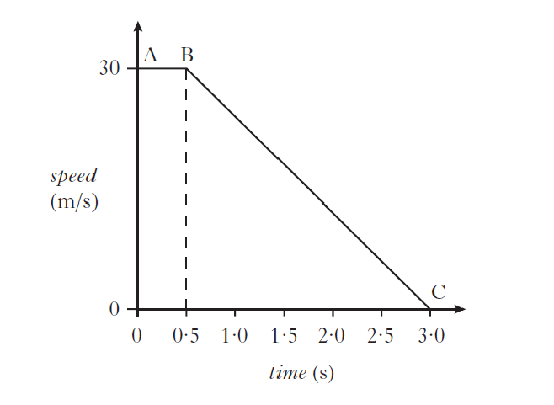  Describe the motion of the car:  (a) Between A and B  (a) Between B and C.
2.2.6 | 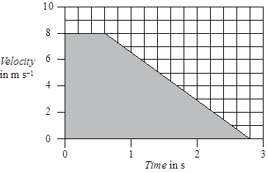  - State what quantity is found by calculating the area under the velocity time graph  - Determine the area under this graph.
2.2.7 | The graph below shows how the speed of a skier varies with time during the first 10 seconds of a downhill run.  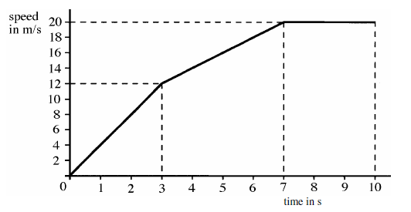  (a) Calculate the acceleration of the skier during the first 3 seconds of the run. 2  (b) Suggest a possible reason for the change in the skier’s acceleration after the first 3 seconds.  (c) Describe the motion of the skier between 7 seconds and 10 seconds.  (d) Show that the average speed of the skier during the first 7 seconds of the run is  11·7 ms⁻¹.
2.3 | I can find displacement from a velocity–time graph.
2.3.1 | State how you calculate the displacement from a velocity-time graph.
2.3.2 | Calculate the distance the train travels in the 150 seconds shown in the graph above.
2.3.3 | Use the velocity time graphs below to calculate the displacement travelled during each journey.  time in s  25  5  20  0  20  time in s  14  10  32  0  30  time in s  30  12  0  5  v/ ms⁻¹  2  5  0  time in s  30  12  0  v / ms⁻¹  t/s  10  18  50  0  v / ms⁻¹  v/ ms⁻¹  v/ ms⁻¹  v/ ms⁻¹
Acceleration
3.1 | I can define acceleration as the final velocity subtract the initial velocity divided by the time for the change
3.1.1 | State the meaning of the term “acceleration”.
3.1.2 | Explain what is meant by a uniform acceleration of 1.4 ms⁻²
3.2 | I can use the relationship involving acceleration, change in speed and time  (a = ∆v/t).
3.2.1 | A Jaguar can reach 27 ms⁻¹ from rest in 9.0 s, calculate its acceleration.
3.2.2 | The space shuttle reached 1000 ms⁻¹, 45 s after launch, calculate its acceleration.
3.2.3 | Starting from rest, a flea accelerates to 1·2 ms⁻¹ in a time of 0·001 s. Calculate the acceleration of the flea.
3.2.4 | A car reaches a velocity of 30 ms⁻¹ from a velocity of 18 ms⁻¹ in 6 s. Calculate its acceleration.
3.2.5 | A train moving at 10 ms⁻¹ increases its speed to 45 ms⁻¹ in 10 s. Calculate its acceleration.
3.2.6 | A bullet travelling at 240 ms⁻¹ hits a wall and stops in 0.2 s. Calculate its acceleration.
3.2.7 | A car travelling at 20 ms⁻¹ brakes and slows to a halt in 8 s. Calculate its acceleration.
3.3 | I can use appropriate relationships to solve problems involving acceleration, initial velocity (or speed) final velocity (or speed) and time of change.
3.3.1 | State the formula linking velocity and acceleration. Explain what each letter stands for and the units of each.
3.3.2 | A girl is riding a bicycle. She starts at rest, and accelerates to 20 ms⁻¹ in 8.0 seconds, calculate her acceleration.
3.3.3 | A car increases its velocity from 30 ms⁻¹ to 80 ms⁻¹ in 20 seconds. Calculate its acceleration.
3.3.4 | When you drop a stone, it accelerates downwards at 9.8 ms⁻².  If the stone is initially at rest, calculate its speed after falling for 1.5 seconds.
3.3.5 | A racing car can accelerate at 7 ms⁻², calculate the time taken to increase its velocity from 20 ms⁻¹ to 60 ms⁻¹.
3.3.6 | A rocket in orbit accelerates at 12 ms⁻² for 15 seconds. If its final velocity is 300 ms ⁻¹, calculate its initial velocity.
3.3.7 | On approaching the speed limit signs, a car slows from 30 m/s to 12 m/s in 5 s. Calculate its acceleration.
3.3.8 | A bowling ball is accelerated from rest at 3 ms⁻² for 1.2 s, calculate the final speed it will reach.
3.3.9 | Calculate the time it takes a car to increase its speed from 8 ms⁻¹ to 20 ms⁻¹ if it accelerates at 3 ms⁻².
3.3.10 | A cyclist can accelerate at 0.5 ms⁻² when cycling at 4 ms⁻¹. Calculate the time taken to reach 5.5 ms⁻¹.
3.3.11 | The maximum deceleration a car’s brakes can safely produce is 8 ms⁻², this is an acceleration of -8 ms⁻² Calculate the minimum stopping time if the driver applies the brakes when travelling at 60 mph (27 ms⁻¹).
3.3.12 | A car is stationary at a traffic light. When the light turns green the car accelerates, and reaches a speed of 30mph twenty seconds later.  (i) State the car’s initial velocity.  (ii) Calculate the car’s acceleration in miles per hour per second.
3.4 | I can find the acceleration as the gradient of a velocity–time graph.
3.4.1 | Use the velocity time graphs below to calculate the displacement travelled during each journey.  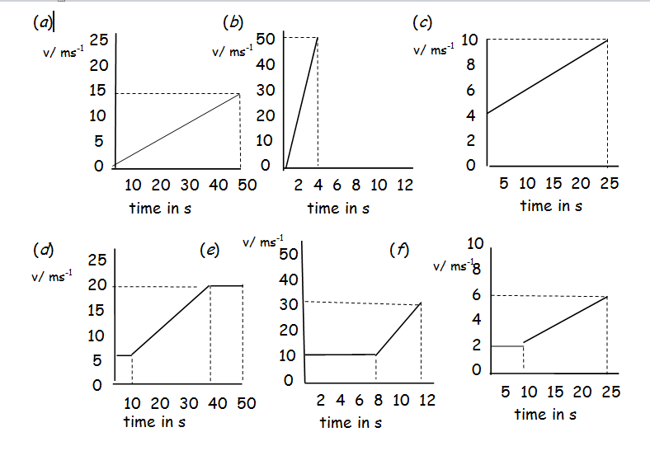
3.4.2 | This speed-time graph shows the changes in the speed of a train. Describe as fully as possible how the train is moving.  Using the graph above, calculate the acceleration of the train between  (a) 0 and 30 seconds, (b) 30 and 60 seconds, (c) 120 and 150 seconds.
3.4.3 | - Calculate the acceleration of the vehicle between X and Y.  - State the acceleration of the vehicle between Y and Z
3.4.4 | The speed-time graph below shows how the speed of the train changes from the instant its brakes are applied until it stops.  speed  in  m/s  20  0  0  100  time in s  Calculate the average acceleration of the train as it slows down.
3.4.5 | 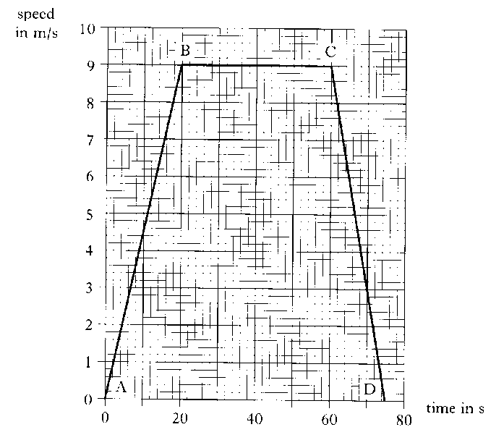  Exam Question  The graph below represents the motion of a cyclist travelling between two sets of traffic lights.  (a) Describe the motion of the cyclist  - between B and C  - between C and D.  - Calculate the acceleration between A and B.
3.4.6 | The graph shows how the speed of a car changes during a journey.  - Complete the following table  - Calculate the acceleration during the first 4 seconds.  The car travelled a total distance of 132 metres. Calculate the average speed of the journey.
  time in s | 0 | 2 | 4 | 6 | 8 | 10 | 12 | 14 | 16
  speed in ms⁻¹
3.5 | I can describe an experiment to measure acceleration
3.5.1 | Describe an experiment using two light gates to measure the acceleration of a vehicle as it rolls down a slope. Draw a diagram of the set-up, note what measurements you would need to make and how the acceleration will be calculated.
3.5.2 | Describe an experiment using one light gate to measure the acceleration of a vehicle as it rolls down a slope. Draw a diagram of the set-up, note what measurements you would need to make and how the acceleration will be calculated.
3.5.3 | The apparatus shown in the Figure above is used to find the acceleration of a vehicle moving along a linear air track.  State two ways of modifying the experiment to produce an acceleration which is double the acceleration.
Newton’s Laws
4.1 | I can give applications and use Newton’s laws and balanced forces to explain constant velocity (or speed), making reference to frictional forces of this.
4.1.1 | (a) State the meaning of the term force.  (b) State the effects a force have on an object.
4.1.2 | Describe how you can measure a force.
4.1.3 | (a) State what is meant by the term friction.  (b) State the effect of friction on movement?
4.1.4 | List ways of reducing the force of friction between two surfaces.
4.1.5 | State ways you increase the force of friction between objects.
4.1.6 | Explain some of the ways friction is used in motor racing. Include at least two examples of where friction is increased, and one where it is decreased.
4.1.7 | Explain, in terms of friction how basic brakes work.
4.1.8 | (a) If you increase the unbalanced force acting on an object while its mass remains constant, what happens to its acceleration?  (b) If you increase the mass of an object, while keeping the unbalanced force the same, what happens to its acceleration?
4.1.9 | State Newton’s First Law of Motion.
4.1.10 | State Newton’s Second Law of Motion.
4.1.11 | Use Newton's first law to explain why a passenger in a train appears to be pushed backwards when the train suddenly starts, and why they appear to be pushed forwards when the train brakes.
4.1.12 | A boy of mass 45 kg pulls a sledge of mass 15 kg up a slope at a constant velocity of 0·5 ms⁻¹. Are the forces acting on the sledge balanced or unbalanced? Explain your answer.
4.1.13 | A motor is used to apply a force of 120 N to a box of mass 30 kg.  The box moves at a constant speed across a horizontal surface.  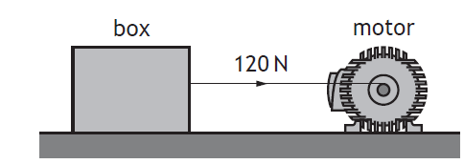  State what you can tell about the forces on this box.  State any other forces acting on the block.
4.1.14 | A weightlifter applies an upwards force of 1176 N to a barbell to hold it in a stationary position as shown.  Describe how the upward force exerted by the weightlifter on the barbell compares to the weight of the barbell
4.1.15 | Exam Question  A rowing team is taking part in a race on calm water.  A  B  C  D  finish line  The following graph shows how it is predicted that the speed of the boat will vary with time during the stages A, B, C and D of the race.  Time/ s  Speed/ ms⁻¹  15  168  150  180  5  7  0  0  A  B  C  D  The prediction assumes that the frictional force on the team’s boat remains constant at 800 N during the race.  (a)  (i) State the size of the forward force applied by the oars during stage B  (ii) Calculate the acceleration of the boat during stage C  (iii) The total mass of the boat and its crew is 500 kg.  calculate the size of the forward force applied by the oars during stage C  (iv) The boat crosses the line after 168 seconds.  Calculate the distance the boat travels from the instant it crosses the line until it comes to rest.  (b)  The frictional force acting on the boat during stage D becomes smaller as the speed decreases.  (i) State the effect of this smaller frictional force on the time taken for the boat to come to rest.  (ii) Sketch a graph of speed against time for stage D, assuming that the frictional force becomes smaller as the speed decreases.
4.1.16 | Exam Question  An air descender is a machine that controls the rate at which a climber drops from a platform at the top of a climbing wall.  A climber, attached to the air descender by a rope, steps off the platform and drops towards the ground and lands safely.  During part of the drop the forces on the climber are balanced. Copy the diagram below show all the forces acting vertically on the climber during this part of the drop.
4.2 | I can give applications of Newton’s laws and balanced forces to explain and or determine acceleration for situations where more than one force is acting, (F=ma)
4.2.1 | Explain the term balanced forces.
4.2.2 | Describe what happens to the speed of an object when there is  (a) no force acting on it,  (b) balanced forces acting on it.
4.2.3 | A passenger in a lift has a mass of 50 kg. As the lift starts its journey, it applies an upwards force of 600 N to the passenger.  (i) State the force of gravity on the passenger.  (ii) Draw a diagram showing the forces acting on the passenger as the lift starts to move.  (iii) State the unbalanced force on the passenger.  (iv) Calculate the acceleration of the passenger.  (v) State the direction of the acceleration
4.2.4 | A boat has a mass of 700 kg, and can accelerate at 3.0 ms⁻². If the engines produce a force of 7000 N, what is the size of  (i) the unbalanced force on the boat, and  (ii) the drag force of the water on the boat?
4.2.5 | (a) State the purpose of a seatbelt?  (b) Explain in terms of forces how a seatbelt fulfils this purpose.
4.2.6 | The unbalanced force acting on an 800 kg car is 1900 N. Calculate its acceleration.
4.2.7 | Calculate the unbalanced force needed to accelerate a 6000 kg lorry at 1.2 ms⁻².
4.2.8 | The unbalanced force on an object is 49 N, and it accelerates at 9.8 ms⁻², calculate the mass of the object.
4.2.9 | Exam Question  The length of runway required for aircraft to lift off the ground into the air is known as the ground roll.  The ground roll of an aircraft varies for each take-off.  Use your knowledge of physics to comment on why the ground roll of an aircraft varies for each take-off.
4.3 | I can use F=ma to solve problems involving unbalanced force, mass and acceleration for situations where more than one force is acting, in one dimension or at right angles.
4.3.1 | A rocket has a total mass of 500 kg and produces a thrust of 10 000 N.  - Calculate the initial acceleration of the rocket.  - State what happens to the mass of the rocket as it burns its fuel.  - If the thrust remains constant, state what happens to the acceleration of the rocket as the fuel is burnt.
4.3.2 | A space vehicle of mass 300.0 kg lifts off from the surface of Mars. At the instant of lift-off the acceleration of the vehicle is 6.0 ms⁻² vertically upwards.  (i) Calculate the unbalanced force acting on the space vehicle at lift-off from Mars.  (ii) Show that the force produced by the engine at lift-off is 3000 N. You must show clearly your working.
4.3.3 | At the corner of a field two fencing wires meet at right angles. Both wires are joined to a fence post.  The wires exert forces of 50 N and 120 N on the fence post as shown.  (i) Find by scale diagram or otherwise the magnitude of the resultant force exerted on the fence post by the wires and its direction with reference to the 50 N force.  (ii) At the corner of fields the fence posts usually have a support wire fitted as shown. The end of the support wire is pegged into the ground.  Referring to the forces acting on the fence post explain why the support wire is fitted.
4.3.4 | Exam Question  A ship of mass 5·0 × 10⁶ kg leaves a port. Its engine produces a forward force of 8·0 × 10³ N. A tugboat pushes against one side of the ship as shown. The tugboat applies a pushing force of 6·0 × 10³ N.  (a) (i) By scale drawing, or otherwise, determine the size of the resultant force acting on the ship.  (ii) Determine the direction of the resultant force relative to the 8·0 × 10³ N force.  (iii) Calculate the size of the acceleration of the ship. (iii) Calculate the size of the acceleration of the ship.
4.3.5 | Exam Question  A weightlifter applies an upwards force of 1176 N to a barbell to hold it in a stationary position as shown.  (a) Describe how the upward force exerted by the weightlifter on the barbell compares to the weight of the barbell. (see 4.1.14)  (b) Calculate the mass of the barbell.  (c) The weightlifter increases the upward force on the barbell to 1344 N in order to lift the barbell above their head.  Calculate the initial acceleration of the barbell.
4.3.6 | A passenger aircraft is flying horizontally.  At one point during the flight the aircraft engines produce an unbalanced force of 184 kN due south (180).  At this point the aircraft also experiences a crosswind. The force of the crosswind on the aircraft is 138 kN due east (090).  (i) By scale diagram, or otherwise, determine:  (A) the magnitude of the resultant force acting on the aircraft;  (B) the direction of the resultant force acting on the aircraft.  (ii) The mass of the aircraft is  6·8 × 10⁴ kg. Calculate the magnitude of the acceleration of the aircraft at this point.
4.4 | I can use W=mg to solve problems involving weight mass and gravitational field strength, including on different planets (where g is given on page 2 of section1 of the exam and in your compendium)
4.4.1 | Explain the difference between mass and weight.
4.4.2 | State the meaning of the phrase 'Gravitational Field Strength'.
4.4.3 | Mars, Jupiter and Earth  On which of the above planets would a 1.0 kg mass dropped near the surface of the planet have the greatest acceleration? Explain your answer.
4.4.4 | Calculate the weight of a person on Earth with a mass of 65.0 kg.
4.4.5 | Calculate the mass of an object which has a weight of 7200 N on Earth.
4.4.6 | 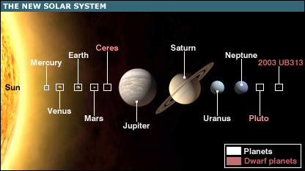  State where in the solar system would your mass be greatest.  State where in the solar system would your weight be greatest.
4.4.7 | On 12th November 2014, on a mission known as Rosetta, the European Space Agency successfully landed a probe on the surface of a comet.  The main structure of the Rosetta spacecraft consists of an orbiter, a lander and propellant.  Calculate the total weight of the spacecraft on Earth.
4.4.8 | SQA N5 2014  A helicopter is used to take tourists on sightseeing flights.  Information about the helicopter is shown in the table.  - The pilot and passengers are weighed before they board the helicopter. Explain the reason for this.  - Six passengers and the pilot with a combined weight of 6125 N board the helicopter. Determine the minimum upward force required by the helicopter at take-off.
  weight of empty helicopter | 13 500 N
  maximum take-off weight | 24 000 N
  cruising speed | 67 m s⁻¹
  maximum speed | 80 m s⁻¹
  maximum range | 610 km
4.5 | I can use Newton’s 3rd law and its application to explain motion resulting from a ‘reaction’ force.
4.5.1 | State Newton’s Third Law of Motion.
4.5.2 | In terms of Newton's third law, what is the 'equal and opposite force' in each of these situations:-  (i) A ship’s propeller pushes on the water,  (ii) A rocket pushes on the exhaust gases,  (iii) The earth's gravitational pull on the moon,  (iv) The Earth’s gravitational pull on an aeroplane.
4.5.3 | Draw the following diagrams and in each case mark and state the reaction force.  Skateboarder pushes wall to the left (action force)  Swimmer pushes water to right (action force)  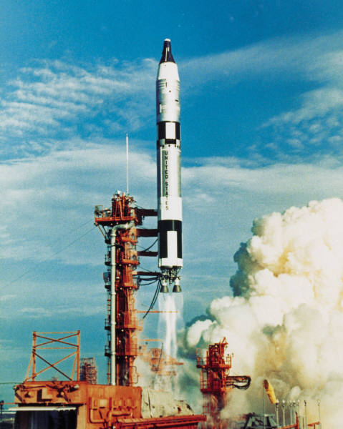  Cannon fires cannonball to the right (action force)  Rocket forces fuel downwards (action force)
4.5.4 | A person sits on a chair which rests on the Earth. The person exerts a downward force on the chair.  State the reaction force.
4.6 | I can use Newton’s laws to explain free-fall and terminal velocity.
4.6.1 | State the meaning of the term free-fall.
4.6.2 | State the meaning of the term terminal velocity.
4.6.3 | - State what happens to an object as it is dropped from a height above the Earth’s surface.  - State the cause of this.
4.6.4 | State the effects of an unbalanced (resultant) force on an object
4.6.5 | A car is travelling at a constant speed along a flat level road.  - State what you can say about the forces on the car.  - An unbalanced force is added to the car, state what happens to the motion of the car.
4.6.6 | A hot air balloon is falling at constant velocity to the ground.  - Draw a free body diagram and label the forces on the balloon.  - State what you can say about the forces on the balloon.  - A balloonist throws a sandbag over the side of the balloon basket, state what happens to the forces on the balloon  - Describe the motion of the balloon when the sandbag is thrown overboard.
4.6.7  A | This question related to question 4.1.16.  From the graph  - State during which times the forces on the climber are balanced.  - Explain your answer to part (i)
4.6.7  B | - Copy the diagram of the climber and label the forces on the climber
4.6.8 | Explain why a ship floats.
4.6.9 | D  V/m s⁻¹  C  B  A  E  t /s  F  The diagram above shows the velocity time graph for a parachutist during her fall from when she exits the plane to when she lands.  - Describe the motion of the parachutist at each point  - State at which points she has reached terminal velocity.  - Explain in terms of forces and Newton’s Laws of motion why the parachutist reaches terminal velocity.  - Explain how can there be two points where she reaches terminal velocity when the weight of the parachutist hasn’t changed.  - Explain which of Newton’s Laws of Motion explains the different parts of the graph.
4.6.10 | Copy and complete using the correct ending….  A spacecraft completes the last stage of its journey back to Earth by parachute, falling with constant speed into the sea.  The spacecraft falls with constant speed because  …the gravitational field strength of the Earth is constant near the Earth’s surface  …it has come from space where the gravitational field strength is almost zero  …the air resistance is greater than the weight of the spacecraft  …the weight of the spacecraft is greater than the air resistance  …the air resistance is equal to the weight of the spacecraft.
4.6.11 | Explain the results of these experiments:  (a) When released from the same height on Earth, a hammer will hit the ground before a feather.  (b) When released from the same height on the moon, a hammer and feather will hit the ground at the same time.
4.6.12 | The diagram shows the vertical motion of a skydiver as he returns from a parachute jump  0  v / m/s  t / s  15  53  30  45  60  A  B  C  D  6  - State the two vertical forces acting on the sky diver during the jump.  - State the value of the terminal velocity of the sky diver during the jump  - Explain, in terms of vertical forces, the motion of the sky diver at each of the points indicated on the graph.
Energy
5.1 |  | I can state the Law of Conservation of Energy.
5.1.1 |  | State the Law of Conservation of Energy.
5.2 |  | I can identify and explain energy conversions and transfer.
5.2.1 |  | Describe the energy conversions when a pendulum swings back and forth.
5.2.2 |  | Describe the energy conversions and transfers as a parachutist falls to Earth, from the time they jump from the plane to them safely landing on the ground
5.2.3 |  | Describe the energy transfers and conversions when a light bulb is connected to a cell and the switch closed.
5.2.4 |  | When an object is dropped from a height of 4.0 m it is found that not all its gravitational potential energy is transferred into kinetic energy. Explain this observation.
5.2.5 |  | Explain why all the electrical energy from a kettle element does not go in to heating the water in the kettle.
5.2.6 |  | State the energy transfer as four women row in an Olympic boat race.
5.3 |  | I can apply the principle of ‘conservation of energy’ to examples where energy is transferred between stores.
5.3.1 |  | In terms of energy, state what happens when a vehicle  (a) accelerates,  (b) moves at constant speed,  (c) brakes,  (d) goes up a slope,  (e) goes down a slope
5.3.2 |  | 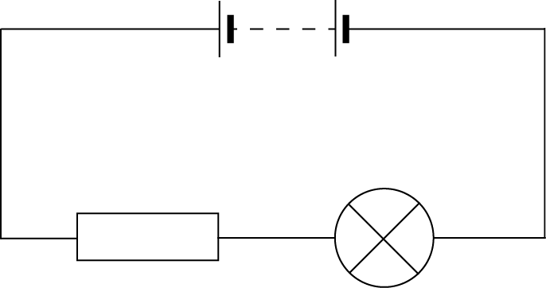  State the energy transfers in the circuit below
5.3.3 |  | An early method of crash testing involved a car rolling down a slope and colliding with a wall.  - State the energy changes as the car moves down the slope and collitdes with the wall.  - State why the mass of the car is not required for the calculation.
5.3.4 |  | Based on SQA N5 2014  A student is investigating the specific heat capacity of three metal blocks X, Y and Z. Each block has a mass of 1·0 kg. A heater and thermometer are inserted into a block as shown.  When the student calculates the energy provided to the block using $E=Pt$ and uses this energy value to calculate the expected specific heat capacity $=cmΔT$ .  - When checking the answer against the specific heat capacity of the material it is discovered the specific heat capacities. Explain whether the experimental value is likely to be higher or lower than the accepted value.  - The student decides to improve the set up in order to obtain a value closer to the accepted value for each block. Suggest possible improvements that are likely to result in a calculated value closer to the accepted value.
5.4 |  | I can use appropriate relationships to solve problems involving work done, unbalanced force, and distance or displacement. (Ew=Fd)
5.4.1 |  | State the appropriate relationship involving work done, unbalanced force, and distance or displacement.
5.4.2 |  |   State if work is done if a girl holds a set of weights above her head, you must explain your answer.
5.4.3 |  | A locomotive exerts a pull of 10000 N to pull a train a distance of 400 m.  How much work is done?
5.4.4 |  | A gardener does 1200 J pushing a wheelbarrow with a force of 100 N.  How far did she push the barrow?
5.4.5 |  | A man uses up 1000 J by pulling a heavy load for 20 m. What force did he use?
5.4.6 |  | A girl is pushing her bike with a force of 80 N and uses up 4000 J of energy.  How far did she push the bike?
5.4.7 |  | A man weighing 600 N climbs stairs in an office block which are 40 m high.  How much work does he do?
5.4.8 |  | A worker pushes a 4 kg crate along the ground for 3 m using a force of 20 N, then lifts the crate up to a ledge 1 m high. How much work does he do altogether?
5.4.9 |  | An average force of 120 N is used to push a supermarket trolley 30m. How much work is done?
5.4.10 |  | A force of 24 N is needed to pull open a drawer. If the drawer moves 35 cm, how much energy is used moving it?
5.4.11 |  | A girl does 900 kJ of work cycling to school. If she uses an average force of 200N, how far does she pedal?
5.4.11 |  | A boy does 5000 J of work climbing the stairs. If the distance climbed is 9m, calculate the force he is having to produce.
5.5 |  | I can identify and explain ‘loss’ of energy where energy is transferred.
5.5.1 |  | A lorry of mass 5000 kg rolls down a hill 20 m high. The lorry rolls a distance of 300 m, and is initially stationary. The average force of friction on the lorry is 500 N.  (i) Draw a diagram showing the journey of the lorry and mark on it the information given above.  (ii) What is the change in the gravitational potential energy of the lorry as it rolls down the hill?  (iii) State what happens to this energy.  (iv) Calculate the work done against friction.  (v) Calculate the change in the kinetic energy of the lorry.  (vi) Calculate the speed of the lorry at the bottom of the hil.?
5.5.2 |  | Explain why the kinetic energy of the lorry at the bottom of the slope is not equal to the gravitational potential energy at the top of the slope.
5.5.3 |  | State where energy “losses” occur in the circuit below
5.6 |  | I can define gravitational potential energy.
5.6.1 |  | Define the term gravitation potential energy.
5.6.2 |  | State the relationship used to calculate the gravitational potential energy, include what each term means and the units used to measure each term
5.7 |  | I can solve problems on involving gravitational potential energy, mass, gravitational field strength and height.
5.7.1 |  | A mass of 4kg is released from a height of 2m. Calculate the gravitational potential energy of the mass before it is released.
5.7.2 |  | An object has a gravitational potential energy of 502J. It is dropped from a height of 20m.
5.7.3 |  | A chairlift raises a skier of mass 60 kg to a height of 250 m.  Calculate the potential energy gained by the skier.
5.7.4 |  | A brick of mass 3 kg rests on a platform 25 m above the ground on a building site.  a) Calculate the potential energy stored in the brick.  b) If the brick falls 25 m to the ground, determine the potential energy it will lose.  c) State the form of energy gained by the brick as it falls.
5.7.5 |  | Estimate how much gravitational potential energy you would gain if you were lifted 30m up to the top of a fun-ride.
5.7.6 |  | An apple, mass 100 g, has 300 J of potential energy at the top of the Eiffel Tower. Calculate the height of the Eiffel Tower.
5.7.7 |  | An astronaut of mass 70 kg climbs to a height of 5 m on the moon and gains 560 J of gravitational potential energy.  - Determine the gravitational field strength on the moon.  - If the same experiment were carried out on Earth state whether the astronaut would gain less, more or the same gravitational potential energy, you must justify your answer.
5.8 |  | I can define kinetic energy as the energy an object has because of its speed.
5.8.1 |  | State the meaning of the term kinetic energy.
5.8.2 |  | State how the kinetic energy of an object changes when  (i) it's speed increases, and  (ii) it's mass increases.
5.8.3 |  | A cyclist is travelling along a straight road. The graph shows how the velocity of the cyclist varies with time.  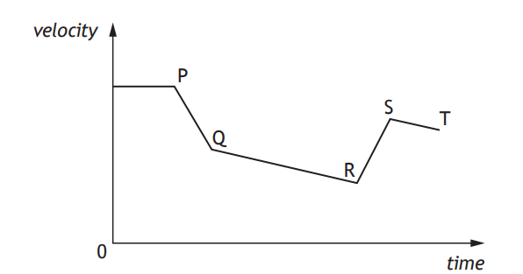  State where the kinetic energy of the cyclist is at its greatest and explain your answer.
5.9 |  | I can use Ek= ½ mv² to solve problems involving kinetic energy, mass and speed
5.9.1 |  | You are provided with an air track and vehicles, a light gate and timer and some elastic bands. Describe how you could use this apparatus to establish how kinetic energy depends on velocity. Include details of any measurements you would take and any additional measuring equipment needed.
5.9.2 |  | Calculate the kinetic energy of the following:  a) a 5.0 kg bowling ball moving at 4.0 ms⁻¹  b) a 50.0 kg skier moving at 20.0 ms⁻¹  c) a 0.020 kg bullet moving at 100.0 ms⁻¹.
5.9.3 |  | a) How much kinetic energy does an 800 kg car have at a velocity of 10.0 ms⁻¹?  b) If it doubles its velocity to 20.0 ms⁻¹, calculate its new kinetic energy?
5.9.4 |  | A cyclist who is pedalling down a slope reaches a speed of 15 ms⁻¹. The cyclist and her cycle together have a mass of 80 kg.  a) Calculate the total kinetic energy.  b) Name two sources of this kinetic energy.
5.9.5 |  | Calculate an approximate value for the kinetic energy of an Olympic 100 m sprinter as he crosses the line (time for race is about 10 s).
5.9.6 |  | What is the velocity of a stone of mass 2 kg if it has 36 J of kinetic energy?
5.9.7 |  | A motor cyclist and his bike have a total mass of 360 kg and kinetic energy of 87120 J. What is his speed?
5.9.8 |  | A car has a mass of 900kg and is moving at 30ms⁻¹, calculate its kinetic energy.
5.9.9 |  | Calculate the kinetic energy of a rifle bullet with a mass of 20g and a speed of 400ms⁻¹.
5.9.10 |  | A car has a kinetic energy of 100kJ and a mass of 800kg, calculate its speed.
5.10 |  | I can use Ew=Fd, Ep=mgh, Ek= ½ mv² to solve problems involving conservation of energy
5.10.1 |  | A gardener pushes a wheelbarrow with a force of 250 N over a distance of 20 m. Calculate the work done.
5.10.2 |  | A stone falls from a cliff, which is 80 m high  - If air resistance can be ignored, calculate the speed at which it enters the water at the bottom of the cliff.  - If air resistance cannot be ignored, state the effect this will have on the speed of the stone as it enters the water.  - In practice, not all of the initial gravitational energy is transformed into kinetic energy. Other than kinetic energy, state the main form of energy produced.
5.10.3 |  | A librarian is placing books on to the library shelf which is 2 metres from the ground. He does 80 joules of work lifting the books from the floor to the shelf. (a) Calculate the weight of the books.  (b) Calculate the mass of the books.  (c) If each book has an average mass of 400 g calculate how many books the librarian places on the shelf.
5.10.4 |  | A painter is painting the ceiling of a room. She fills her tray with paint and lifts it up the ladder. The weight of the full paint tray is 15.0 newtons and she lifts it a distance of 1.5 metres up the ladder.  - Calculate the work done lifting the paint.  - The painter drops the 0.64 kg roller to the floor from this height, calculate the gravitational potential energy it loses.  - If all the gravitational potential energy is converted to kinetic energy calculate the speed of the roller when it lands on the dust sheet.
5.10.5 |  | A car of mass 1000 kg is travelling at 20 ms⁻¹.  (a) Calculate the kinetic energy of the car.  (b) If the maximum braking force is 5 kN, calculate the minimum braking distance.  (c) If the driver has a reaction time of 0.7 s, calculate the distance the car travels during this ‘thinking time’.  (d) Determine the total stopping distance.
5.10.6 |  | A boy of mass 45 kg pulls a sledge of mass 15 kg up a slope at a constant velocity of 0·5 ms⁻¹. The boy then lies on the sledge and slides down the slope. When the boy and sledge are moving with a speed of 4·0 ms⁻¹, they run into a small snow drift which brings them to rest in a distance of 3·5 m.  - Calculate the kinetic energy of the boy and sledge together, when they are travelling at a speed of 4·0 ms⁻¹.  - Calculate the average force required to bring the sledge and the boy to rest in 3·5 m.
5.10.7 |  | A lorry of mass 5000 kg rolls down a hill 20m high. The lorry rolls a distance of 300m, and is initially stationary. The average force of friction on the lorry is 500N.  (i) Draw a diagram showing the journey of the lorry and mark on it the information given above.  (ii) Calculate the change in the gravitational potential energy of the lorry as it rolls down the hill.  (iii) State what happens to this energy as it rolls down the slope  (iv) Determine the work done against friction  (v) Determine the change in the kinetic energy of the lorry.  (vi) Calculate the speed of the lorry at the bottom of the hill.
5.10.8 |  | An arrow of mass 60g is fired vertically upwards with a speed of 30ms⁻¹. The arrow rises upwards, reaches its maximum height, and then falls straight downwards. Assuming there is no air resistance, calculate  (i) the initial kinetic energy of the arrow,  (ii) the kinetic energy of the arrow at its highest point,  (iii) the potential energy of the arrow at its highest point,  (iv) the position of the highest point.
5.10.9 |  | 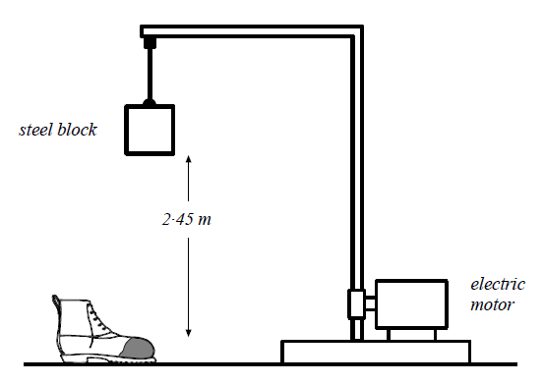  The toe protectors in safety boots are tested by dropping a 30 kg steel block through a height of 2·45 m onto the boots.  (a) Calculate the potential energy of the steel block just before it is released.  (b) Calculate the speed of the steel block as it hits the toe protector.
5.10.10 |  | A model train takes 30 seconds to travel along a 5m section of track, which rises by 0.3m. The train has a mass of 0.5kg and the motor has a power of 3W. The train is initially at rest, and has a final velocity of 0.5ms⁻¹. Calculate  (i) the energy supplied by the motor  (ii) the gain in kinetic energy  (iii) the gain in Ep.  (iv) the work done against friction, and  (v) the average force of friction.
5.10.11 |  | An apple of mass 100g is dropped from the top of the Eiffel Tower, a height of approximately 300m.  - Calculate the loss of potential energy as the apple falls through 300 m  - Calculate the expected kinetic energy it should have just before hitting the ground.  - Calculate the expected velocity as of the apple as it hits the ground.  - In reality explain if the speed is likely to be greater than/ less than / or the same as that expected, you must justify your answer.
5.10.12 |  | Int 2 2002  An observation wheel rotates slowly and raises passengers to a height where the can see across a large city. The passengers are carried in capsules.  - Each capsule is raised through a height of 122 m as it moves from P to Q. Each capsule with passengers has a total mass of 2750 kg. Calculate the gravitational potential energy gained by a capsule with passengers  - The wheel is rotated by a driving force of 200 kN For one revolution, the driving force is applied through the circumference of the wheel, a distance of 383 m.  Calculate the work done by the driving force for one revolution.
5.10.13 |  | SQA 2018  During a BMX competition, a cyclist freewheels down a slope and up a ‘kicker’ to complete a vertical jump.  The cyclist and bike have a combined mass of 75 kg.  At point X the cyclist and bike have a speed of 8·0 m s⁻¹.  - Calculate the kinetic energy of the cyclist and bike at point X.  - (i) Calculate the maximum height of the jump above point X.  (ii) Explain why the actual height of the jump above point X would be less than the height calculated in (b) (i).
5.10.14 |  | SQA SG CREDIT 2012 Q9  While repairing a school roof, workmen lift a pallet of tiles from  the ground to the top of the scaffolding.  This job is carried out using a motorised pulley system.  The pallet and tiles have a total mass of 230 kg.  - Calculate the weight of the pallet and tiles.  - State the minimum force required to lift the pallet and tiles.  - The pallet and tiles are lifted to a height of 12 m. Calculate the gravitational potential energy gained by the pallet and tiles.  - When the tiles are being unloaded onto the scaffolding, at a height of 12 m, one tile falls. The tile has a mass of 2·5 kg.  - Calculate the final speed of the tile just before it hits the ground. Assume the tile falls from rest.  - Explain why the actual speed is less than the speed calculated in (d)(i).
5.10.15 |  | Figure 1 shows a pendulum in its rest postion A. The pendulum bob has a mass of 0.3 kh. The bob is pulled to one side as shown in Figure 2 and held at position B, which is 0.8 m above the rest position.  The bob is released from position B and swings to and fro until it comes to rest.  - Calculate the gain in potential energy of the bob when it is moved from position A to position B.  - State in which position the bob has greatest kinetic energy.  - Estimate the maximum speed of the bob.  - Describe the energy changes which take place from the time the bob is released until it comes to rest.
5.10.16 |  | An object is dropped from a height of 0.75 m from the surface of the Earth. Calculate the velocity on landing. (No you don’t need to know the mass, but start with the two formulae)
Projectile Motion
6.1 | I can explain projectile motion
6.1.1 | Explain the term projectile.
6.1.2 | Explain what is special about the motion of a projectile.
6.1.3 | 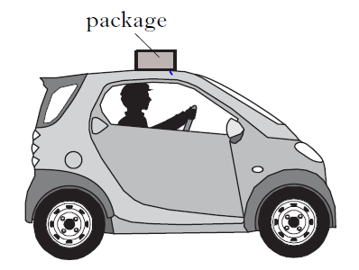  A driver accidentally leaves a package on the top of a vehicle . When he notices he brakes suddenly and the package falls off the car.  - Sketch the path taken by the package as it falls off the car.  - Describe both the horizontal and vertical motions of the package in as much detail as possible
6.2 | I can use appropriate relationships to solve problems involving projectile motion from a horizontal launch, including the use of motion graphs.
6.2.1 | A stone thrown horizontally from a cliff lands 24 m out from the cliff after 3.0 s. Find:  a) the horizontal speed of the stone  b) the vertical speed at impact.
6.2.2 | A ball is thrown horizontally from a high window at 6 m/s and reaches the ground after 2.0 s. Calculate  a) the horizontal distance travelled  b) the vertical speed at impact.
6.2.3 | An aircraft flying horizontally at 150 m/s, drops a bomb which hits the target after 8.0 s. Find:  a) the distance travelled horizontally by the bomb  b) the vertical speed of the bomb at impact  c) the distance travelled horizontally by the aircraft as the bomb fell  d) the position of the aircraft relative to the bomb at impact
6.2.4 | A ball is projected horizontally at 15 m/s from the top of a vertical cliff. It reaches the ground 5 s later. For the period between projection until it hits the ground, draw graphs with numerical values on the scales of the ball’s  a) horizontal velocity against time  b) vertical velocity against time  c) From the graphs calculate the horizontal and vertical distances travelled.
6.2.5 | A projectile is fired horizontally at 100ms⁻¹.  (i) How long will it take it to travel a horizontal distance of 50m?  (ii) What will its vertical velocity be when it hits the ground?  (iii) What will be its average vertical speed?  (iv) How far will it fall in the 50m?
6.2.6 | A ball rolls along a flat roof at 2ms⁻¹ and rolls off the edge.  (i) If the ball takes 1.5 seconds to fall what is the final vertical speed of the ball on landing?  (ii) How high is the roof from the ground?  (iii) How far away from the base of the building will it land?
6.2.7 | In the experimental set-up shown below, the arrow is lined up towards the target.  As it is fired, the arrow breaks the circuit supplying the electromagnet, and the target falls downwards from A to B.  a) Explain why the arrow will hit the target.  b) Suggest one set of circumstances when the arrow would fail to hit the target  (you must assume it is always lined up correctly).
6.3 | I can state what is represented by the area under v_{h}-t graph.
6.3.1 | State what is represented by the area under v_{h}-t graph
6.4 | I can make calculations from the area under a v_{h}-t graphs
6.4.1 | A bullet is fired from a gun and the horizontal velocity of the bullet is shown in the graph below. Calculate the range of the bullet.  t/s  v /ms⁻¹  800  0.2  0
6.4.2 | Draw a speed time graph to represent the following motion recorded for a train leaving a station.  Use the graph to calculate:  (a) describe the motion of the train during the 90 seconds  (b) the distance travelled by the train in 90 seconds.
  Time (s) | 0 | 10 | 20 | 30 | 40 | 50 | 60 | 70 | 80 | 90
  speed (m/s) | 0 | 5 | 10 | 15 | 20 | 25 | 25 | 25 | 30 | 30
6.4.3
  While driving along a motorway a driver spots an accident and brakes. The speed time graph below represents the motion of the car from the instant the driver sees the accident.
  25
  v/ms⁻¹ 15
  10
  5
  0 2 4 6 8 10 12 14 16 18 20 22 24 26 28 30 time in s
  (a) When did the driver brake?
  (b) Calculate how far the car travelled before braking.
  (c) Calculate how far the car travelled after the driver braked
6.4.4
  Time (s) | Speed (ms⁻¹)
  0 | 0
  20 | 10
  40 | 40
  60 | 70
  80 | 100
  100 | 100
  120 | 50
  140 | 0
  During a test run of a TACV (tracked air-cushioned vehicle or hovertain), its speed along a straight level track was recorded as shown in the table below.
      - Draw a graph of the train’s motion during the test run.
      - Calculate the distance travelled during the test run.
6.4.5
  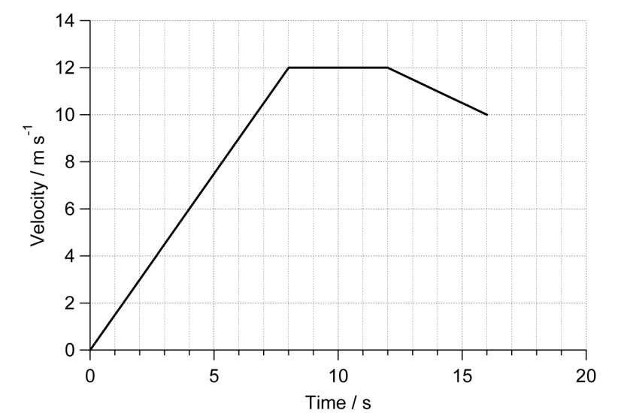
  The graph shows the speed of a runner during a race.
  - Describe the motion of the runner.
  - Calculate the distance covered by the runner in the first eight seconds of the race.
  - Calculate the distance she ran in the last four seconds.
  - Calculate the length of the race.
6.5 | I can state what can be found from the area under v_{v}-t graph.
6.5.1 | State what can be found from the area under v_{v}-t graph.
6.6 | I can calculate the height, and acceleration from v_{v}-t graphs
6.6.1
  A hot air balloon is released and accelerates upwards. During the lift, some sand bags are released, and the acceleration increases. The graph shows the vertical motion of the balloon during the first 50s of its flight.
  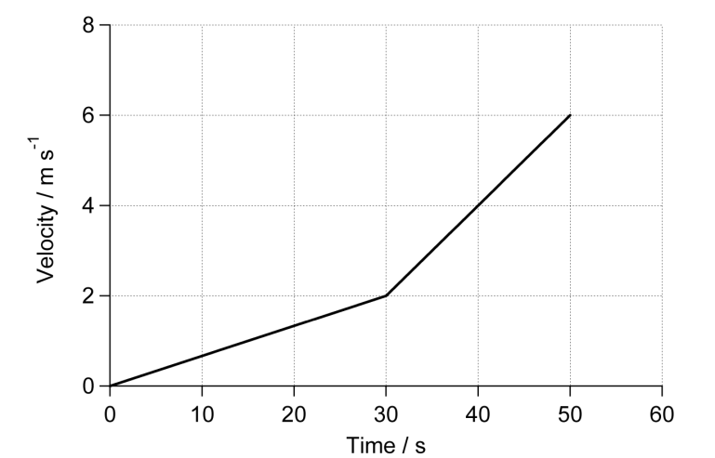
  (a) Calculate the height of the balloon when the sandbags are released.
  (b) Calculate the height of the balloon after 50 s.
6.6.2 | The graph below shows the motion of an object dropped just above the surface of a celestrial body.  - Calculate the acceleration due to gravity of the object.  - Using the data sheet find from which celestial body the object was dropped.  - Calculate the height above the surface from which the object was dropped
6.7 | I can state and use the relationships from v_{h}-t graphs and v_{v}-t graphs
6.7.1 | State the equations required to find out range, speed and time for the horizontal component of projectiles.
6.7.2 | State the equations required to calculate information for the vertical component of projectiles.
6.7.3 | A projectile is fired horizontally at 100 ms⁻¹.  - Determine the time it takes to travel a horizontal distance of 50 m.  - Calculate the vertical velocity when it hits the ground.  - Calculate its average vertical speed during the journey.  - Calculate the height it falls in the 50 m.
6.7.4 | A ball rolls along a flat roof at 2ms⁻¹ and rolls off the edge.  - If it takes 1.5 s to fall to the ground determine its speed on landing.  - Determine the height of the roof.  - Calculate the distance from the base of the building to where it lands.
6.7.5 | Jordan the goalkeeper punches a football which has been kicked across his goal mouth. The football leaves his glove with a horizontal velocity of 11.5 ms⁻¹ to the right and takes 0.80 s to land on the pitch.  - Describe the horizontal velocity of the football from the instant it is punched to the instant it lands.  - Show, by calculation involving horizontal motion, that the horizontal displacement travelled by the football during the 0.8 s is 9.2 m to the right.  - At the instant the football leaves Jordan's hand, the downward vertical velocity of the football is 0 ms⁻¹. Calculate the downward vertical velocity of the football as it lands.  - Calculate the height from which the ball was pitched.
6.7.6 | A rocket is fired horizontally from a cliff top at 40 ms⁻¹ to the right. The rocket hits the sea below after 4 s.  - State the rocket's horizontal component of velocity just before it hits the sea.  - Calculate the rocket's range (horizontal displacement).  - Calculate the rocket's vertical component of velocity just before it hits the sea.  - Sketch the velocity-time graph for the rocket's vertical motion.  - Use the graph to determine the rocket's vertical displacement (the height of the cliff).
6.7.7 | Ellis kicks a football off a cliff with a horizontal velocity of 5 ms⁻¹ to the right. The football lands on ground below the cliff 2.5 s later.  - Calculate the ball's horizontal component of velocity just before it hits the ground.  - Calculate the range of the ball (horizontal displacement).  - Calculate the vertical component of the ball's velocity just before it hits the ground.  - Sketch the velocity-time graph for the ball's vertical motion.  - Use the graph to determine the ball's vertical displacement (the height of the cliff).
6.8 | I can explain satellite orbits in terms of projectile motion, horizontal velocity and weight.
6.8.1 | Explain how gravity keeps a satellite in orbit.
6.8.2 | Explain why a satellite needs a horizontal motion and a vertical motion to stay in orbit.
6.8.3  OEQ | A group of students are watching a video clip of astronauts on board the  International Space Station (ISS) as it orbits the Earth.  One student states, ‘I would love to be weightless and float like the astronauts do on the ISS.’  Using your knowledge of physics, comment on the statement made by the student.

