ELECTRICITY

Quantities for the ELECTRICITY Unit
For this unit copy and complete the table.
Quantity | Symbol | Unit | Unit Symbol | Scalar / Vector
Charge
Current
Voltage
Resistance
Power
Energy
Time
Frequency

The ELECTRICITY unit in numbers
Quantity | Value
State the voltage of the mains supply.
State the frequency of the mains
State the usual maximum power for an appliance that can be fitted with a 3A fuse.
State the maximum power for an appliance that can be fitted with a 13A fuse.

No. | CONTENT
Electrical Charge Carriers
9.1 | I can define electrical current.
9.1.1 | Define the term electrical current.
9.1.2 | Define the term one ampere.
9.1.3 | 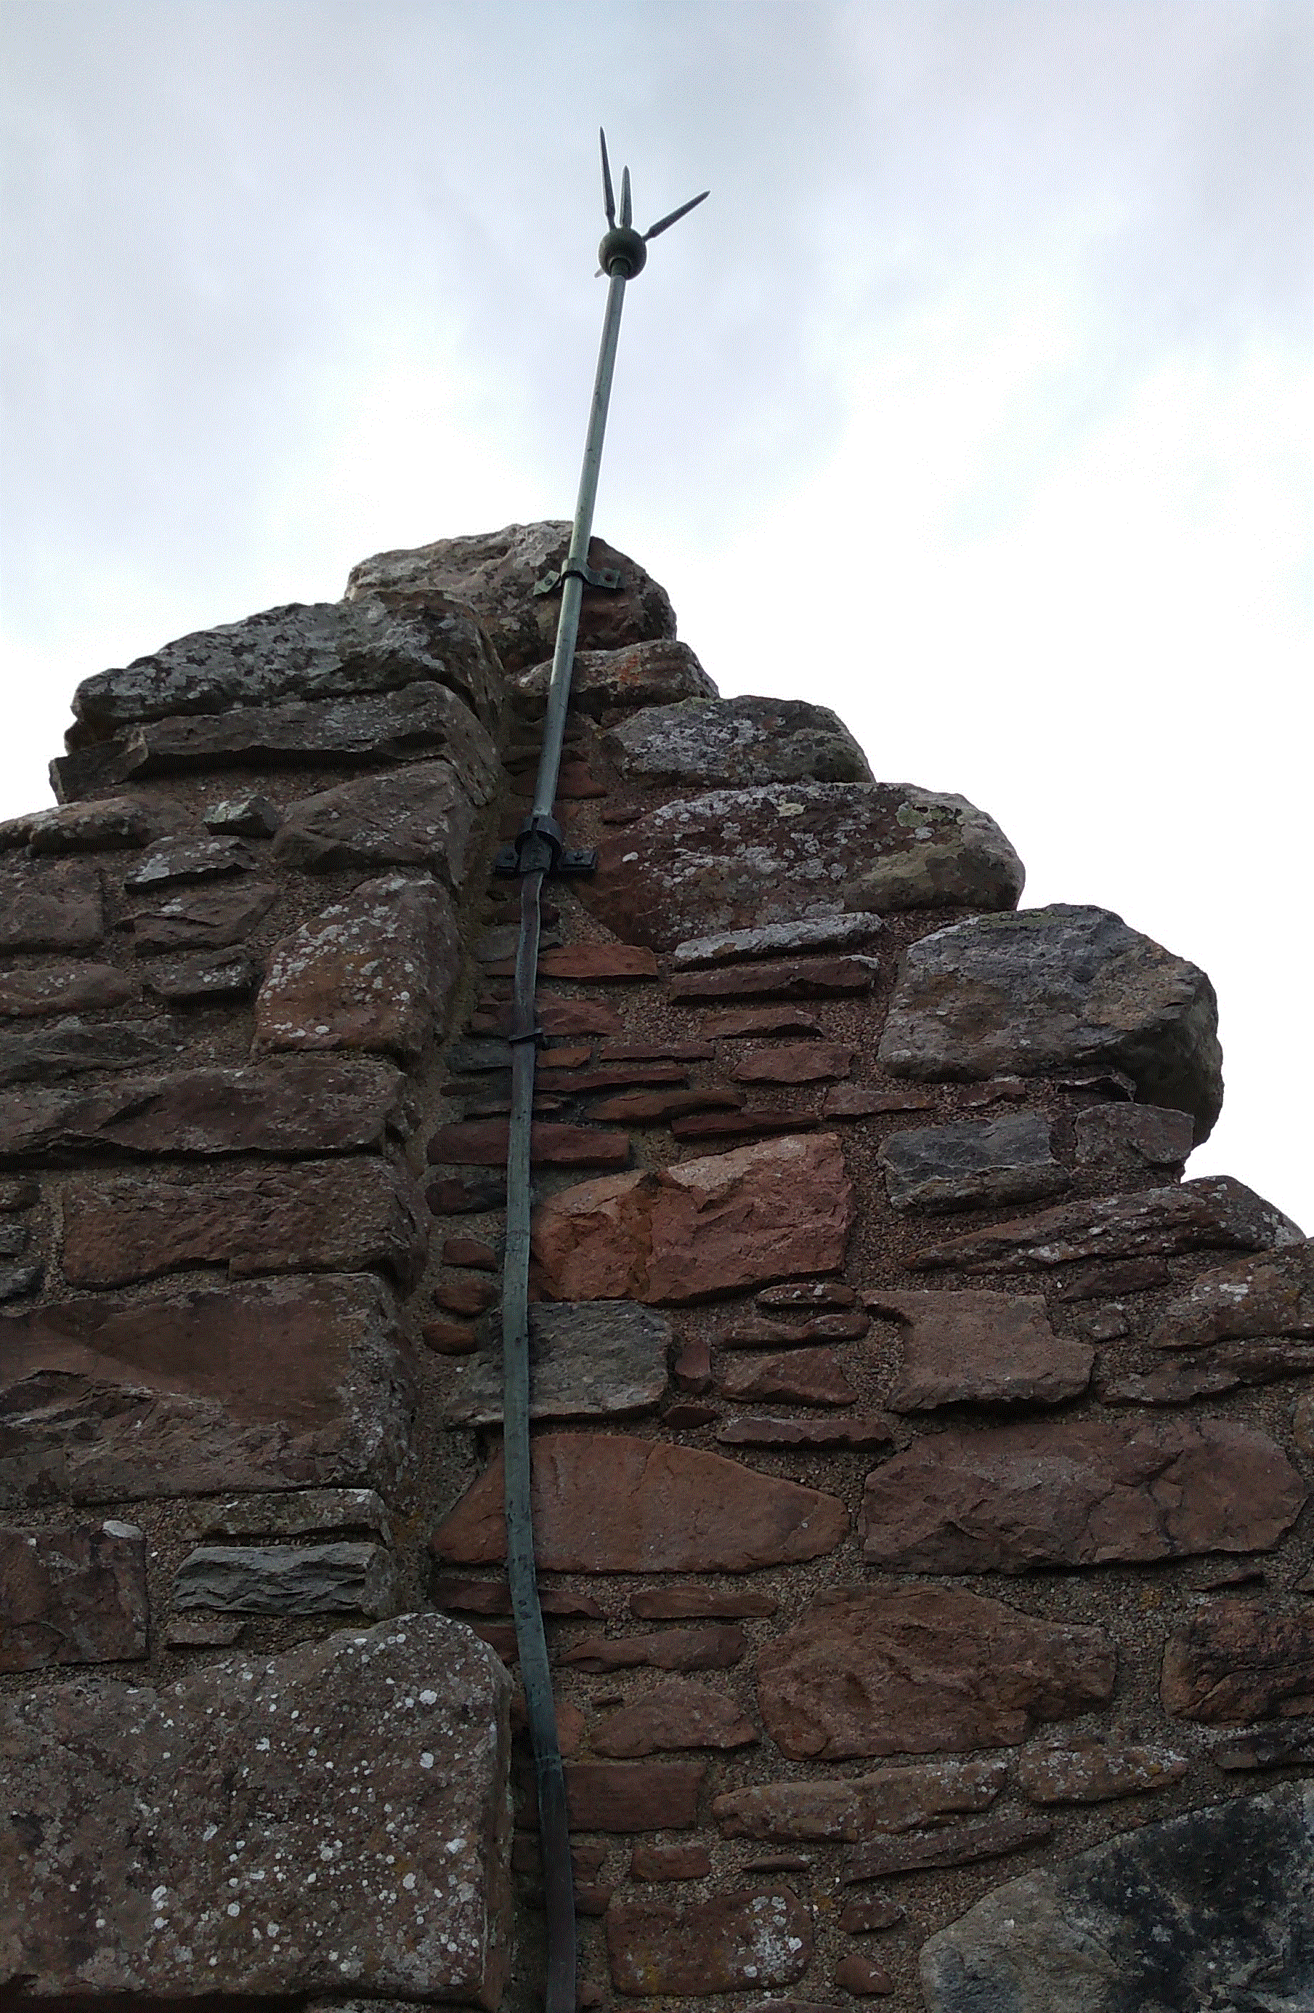  Many tall buildings have a thick strip of metal attached to the side of the building. This strip is used to protect the building from damage during electrical storms. Explain how this strip protects the building from damage.
9.2 | I can carry out calculations using the equation with charge, electric current and time.
9.2.1 | Write down the relationship between charge, electric current and time.  Write the symbols and units used for each.
9.2.2 | The current in a heater is 7.0 A, calculate the charge flowing through the heater in 30.0 seconds.
9.2.3 | A car headlamp uses a current of 2.0 A. Calculate the time the lamp must be switched on if 10.0 C of charge pass through it.
9.2.4 | Two Coulombs of charge pass through a lamp in 6.0 seconds, calculate the current in the lamp.
9.2.5 | A lightning strike lasts for 2.8 ms and delivers 50.4 C of charge. Calculate the current during the lightning strike.
9.2.6 | A hair drier is switched on for 5 minutes with a current of 3 A, calculate the charge flowing through the hair drier during this time.
9.2.7 | A switch is closed for 10 minutes. If 3600 C of charge pass through the switch in this time, calculate the current in the switch.
9.2.8 | Calculate the charge that flows along a wire when 25 μA passes for 2 hours.
9.2.9 | If a capacitor stores 20 mC of charge , calculate the time taken to discharge the capacitor if the average current in 0.4 μA.
9.2.10 |  | A circuit is set up as shown in the diagram. The reading on ammeter A1 is 5.0 A. The reading on ammeter A2 is 2.0 A. Calculate the charge passing through the lamp in 30 s
9.3 | I can explain the difference between A.C. and D.C.
9.3.1 | Explain, in terms of electron flow, the term alternating current.
9.3.2 | State if the mains supply is A.C. or D.C..
9.3.3 | State the frequency of the mains supply.
9.3.4 | (a) State the meaning of the term peak voltage.  (b) State how the peak voltage of the mains compares with the voltage you would read on a voltmeter. Draw a diagram to help you.
9.3.5 | A student makes the following statements about A.C. and D.C. circuits.  I. In an A.C. circuit the direction of the current changes regularly.  II. In a D.C. circuit negative charges flow in one direction only.  III. In an A.C. circuit the size of the current varies with time.  Copy out the correct statements.
9.3.6 | State the type of current do you get from  - batteries, and  - from the mains.
9.4 | I can compare the traces of A.C. with D.C. when viewed on an oscilloscope or data logging software.
9.4.1 | Copy these traces and determine if they show A.C. or D.C..  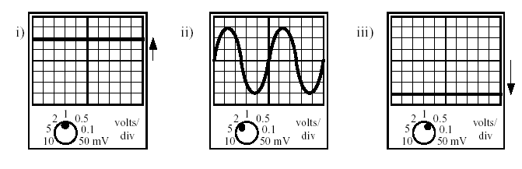
9.4.2 | An A.C. supply is labelled 12 V. The peak voltage is measured using an oscilloscope.  State which of the following is likely to be the measured peak voltage:  17 V, 12 V, 8.5 V, 6 V  Explain your answer.
9.4.3 | Calculate the peak voltages of the traces below using the Y-gain settings shown.
9.4.4 | The trace is produced from the mains supply. If the settings on the oscilloscope are not changed, sketch the trace that would be produced by the following A.C. supplies  - Peak voltage 5 V at a frequency of 25 Hz  - Peak voltage 20 V at a frequency of 75 Hz.
9.4.5 | The mains supply is quoted as 230 V. If connected to the mains supply, state which of the following devices would display a value of 230 V:  - an oscilloscope  - an A.C. voltmeter.
9.4.6 | Two identical bulbs are lit by the supplies shown below.  Explain which bulb will be the brighter.
Potential Difference (Voltage)
10.1 |  |  | I know that a charged particle experiences a force in an electric field.
10.1.1 |  |  | State the definition of an electrical field.
10.1.2 |  |  | State the causes of an electric field.
10.1.3 |  |  | Copy and complete the following  In an ________ field a ________ experiences a _________ . This causes the charge to accelerate (F=ma). If the charge is positive it will __________ the field lines, if the charge is negative the charge will move _______ from the field lines.
10.2 |  |  | I can describe the effect of electric fields on a charged particle
10.2.1 |  |  | Copy and complete these diagrams to show the direction of the electric field.  +  +  +  +  +  +  +  +  +  +  +  +  -  -  -  -  -  -  -  -  -  -  -  -
10.2.2 |  |  | A uniform electric field exists between plates Q and R.  The diagram shows the path taken by a particle as it passes through the field.  If the charge on R is positive, state the possible charge on P and Q
10.2.3 |  |  | Copy this diagram and add the paths of the following particles entering at right angles to the electric field:  - Electron (b) Proton (c) Neutron  +  +  +  +  +  +  +  +  +  +  +  +  -  -  -  -  -  -  -  -  -  -  -  -
10.2.4 |  |  | An alpha particle, a beta particle and a gamma ray enter an electric field at right angles to the field. Which letter shows the most likely position of the:  - Alpha particle (b) Beta particle (c) Gamma ray  +  +  +  +  +  +  +  +  +  +  +  +  -  -  -  -  -  -  -  -  -  -  -  -  Y  Z  X
10.2.3 |  |  | State what happens to a negatively charged particle moving parallel to a uniform electric field
10.2.4 |  |  | A magnet is moved through a coil of wire. (a) Describe what is seen on the analogue voltmeter  (b) State ways to increase the induced voltage.
10.3 |  |  | I know the path a charged particle takes between two oppositely charged parallel plate
10.3.1 |  |  | Draw a diagram of the electric field between two oppositely charged parallel plates.
10.3.2 |  |  | Copy the diagram of two parallel charged plates. Show the route taken by each of the following particles in the field  - an electron placed in the centre and initially not moving  - an electron moving from right to left as it approaches the plates.  + + + + + + + + + + + + + + + + + + +  - A proton moving from left to right  _ _ _ _ _ _ _ _ _ _ _ _ _ _ _ _ _ _ _  - A beta particle moving from left to right  - An alpha particle moving from left to right  - A neutron moving from left to right.  Explain the movement of each particle in the field.
10.3.3 |  |  | State the effect on a neutron moving from left to right between the parallel plates shown below.
10.4 |  |  | I know the path a charged particle takes near a single point charge
10.4.1 |  |  | State what the electric field lines indicate when drawn around a charge.
10.4.2 |  |  | Draw the field lines around the following charges, include the arrows.  - b)  -  +
10.4.3 |  |  | State the direction an electron would take if it was placed close to the charge shown below.  - b)  -  +
10.5 |  |  | I know the path a charged particle takes between two oppositely charged points
10.5.1 |  |  | Draw the field lines around the following charges, include the arrows.  +  -
10.5.2 |  |  | State the direction a negative charge would move in relation to the field lines around the following charges  -  +
10.6 |  |  | I know the path a charged particle takes between two like charged points
10.6.1 |  |  | Draw the field lines around the following charges, include the arrows.  a) b)  +  +  -  -
10.6.2 |  |  | State the direction a negative charge would take along the field lines around the following charges  a) b)  +  +  -  -
10.6.3 |  |  | State the direction a positive charge would take along the field lines around the following charges  a) b)  +  +  -  -
10.7 |  |  | I can define the potential difference (voltage) of the supply.
10.7.1 |  |  | Copy and complete the following definitions choosing the correct ending from the list below.  The voltage of an electrical supply is a measure of the  …..resistance of the circuit  …. speed of the charges in the circuit  ….power developed in the circuit  ….energy given to the charges in the circuit  ….current in the circuit.
10.7.2 |  |  | Copy and complete the following definition  1 volt is equivalent to  …..1 ampere per watt  …..1 coulomb per second  …..1 joule per coulomb  …..1 joule per second  …..1 watt per second.
10.7.3 |  |  | State what happens to the brightness of a bulb when the potential difference across it is increased.
Ohm’s Law
11.1 |  | I can make use of a V-I graph to determine resistance.
11.1.1 |  | State the meaning of the term resistance.
11.1.2 |  | State the name given to the ratio of V/I for a resistor.
11.1.3 |  | State the meaning of the term ohmic conductor
11.1.4 |  | The graph shows how the voltage across a resistor changes the current through it.  a) State what is found from the gradient of the graph shown.  b) Determine the gradient of the graph and give its correct units.
11.1.5 |  | The graph shows how the voltage across a resistor changes the current through it.  a) State what is found from the gradient of the graph shown.  b) Determine the gradient of the graph  c) Determine the resistance of the resistor used in this circuit.
11.1.6 |  | A student sets up the diagram as shown in the diagram to find out if Ohm’s Law holds for the resistor.  A  V  +  -  0 - 10V d.c  - Using the data below plot a graph of voltage across a resistor and the current through it.  - The student suspects one of the results was written down incorrectly, identify this point on your graph.  - Plot the gradient of the graph excluding the incorrect point.  - Calculate the resistance of the resistor from your graph.
  Voltage | Current
  (V) | (A)
  1.0 | 0.5
  1.6 | 0.7
  2.0 | 0.9
  2.5 | 1.2
  3.3 | 1.5
  4.2 | 1.9
  4.6 | 2.1
  5.2 | 3.2
11.1.7 |  | State the meaning of the term non-ohmic conductor?
11.2 |  | I can make use of an appropriate relationship to calculate potential difference (voltage), current and resistance  V = IR $V_{2}=\left(\frac{R_{2}}{R_{1}+R_{2}}\right)V_{s}$ $\frac{V_{1}}{V_{2}}=\frac{R_{1}}{R_{2}}$
11.2.1 |  | 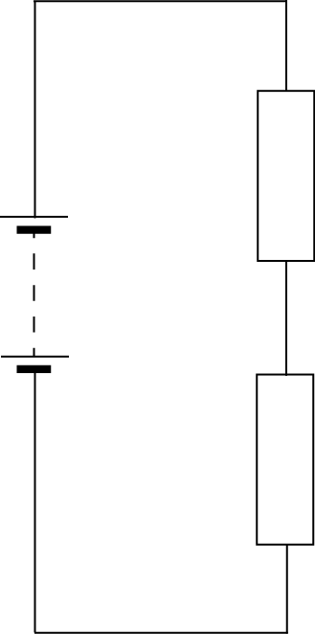  12 V  30 Ω  20 Ω  Calculate the p.d. across the 20 Ω resistor.
11.2.2 |  | 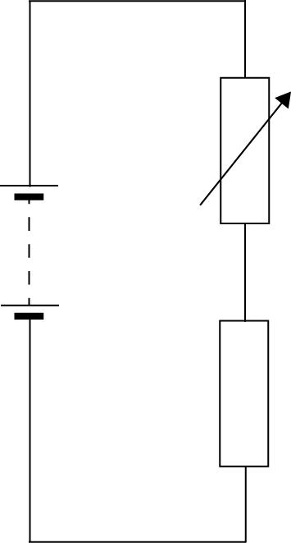  15 V  4.5 kΩ  The potential difference across the variable resistor should be 6 V. The variable resistor can be any value between 1 kΩ and 10 kΩ. Determine the resistance setting of the variable resistor.
11.2.3 |  | Calculate the missing resistance from the circuits below
  (i) | (ii) | (iii)
  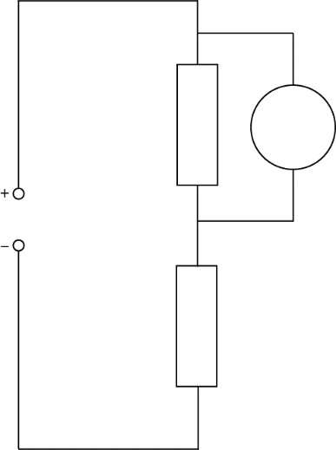  8 Ω  12 V  3 V  6 V  34 kΩ  5 V  2.3 V  2.4 V  4.8 kΩ | 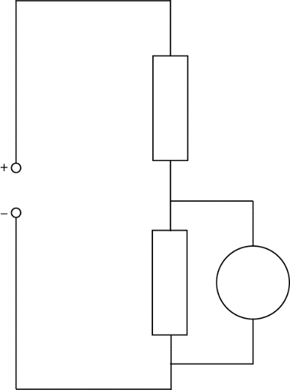 | 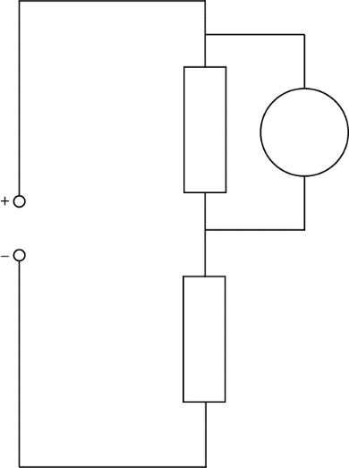
11.2.4 |  | A student sets up the circuit shown below.
  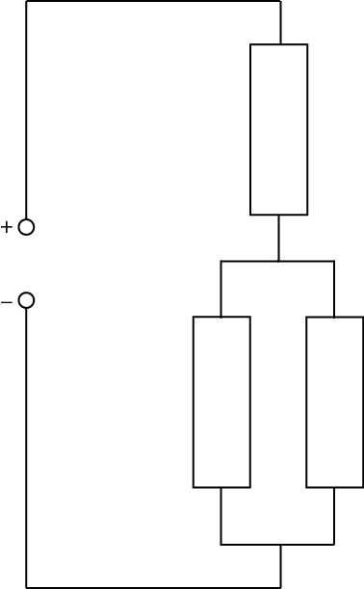  5 V  100 Ω  400 Ω  120 Ω | Calculate the current supplied to the circuit.  Calculate the potential difference across the parallel section of this circuit.  Calculate the current in the 100 Ω resistor.
11.2.5 |  | An LED can carry a current of 10 mA and has a voltage drop across it of 2 V  Calculate the resistance of the resistor that must be placed in series if placed in a circuit with a 12 V supply.  +  -  12 V  V_{LED}
11.2.6 |  | The variable resistor in the circuit below is set to 1050 Ω  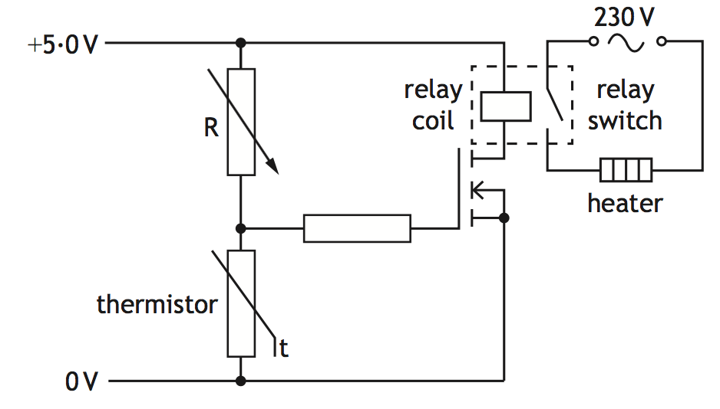  Explain how the circuit operates to switch on the heater when the temperature falls below a certain value (You must calculate the required voltage across the thermistor).
11.3 |  | I can describe the relationship between temperature and resistance of a conductor.
11.3.1 |  | State the meaning of the term resistance.
11.3.2 |  | Explain the difference between a conductor and an insulator
11.3.3 |  | State 6 materials that are conductors and 6 that are insulators. Display your answers in a table
11.3.4 |  | A circuit is shown with three gaps. For the lamp to light on state whether each gap should be filled with a conductor or an insulator.
11.3.5 |  | A student writes the following statements about electrical conductors.  I Only protons are free to move.  II Only electrons are free to move.  III Only negative charges are free to move.  Copy out the statements which is/are correct.
11.3.6 |  | Explain how the temperature affects the resistance of  - a resistor  - a wire  - a piece of metal, any conductor.
11.3.7 |  | State the relationship between temperature and resistance for a conductor.
11.4 |  | I can describe how increasing the temperature of a conductor changes the resistance of the conductor.
11.4.1 |  | Sketch a graph showing how the resistance of a resistor changes with the current through it, numerical values are not required.
11.4.2 |  | Sketch a graph showing how the current in a resistor varies with the voltage across it numerical values are not required.
11.4.3 |  | State the relationship between current and voltage for a resistor at constant temperature, numerical values are not required..
11.4.4 |  | 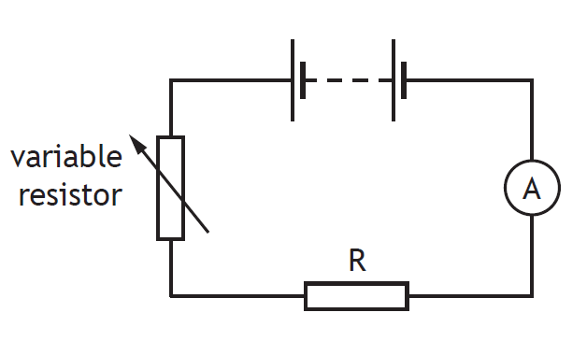  SQA Nat 5 2016  A student investigates the resistance of a resistor using the circuit shown.  - Copy and complete the circuit diagram to show where a voltmeter must be connected to measure the voltage across resistor R.  - Describe how the student obtains a range of values of voltage and current.  (c) The results of the student’s investigation are shown.  Use all these results to determine the resistance of resistor R.  (d) The student now replaces resistor R with a filament lamp and repeats the  investigation. A sketch graph of the student’s results is shown.  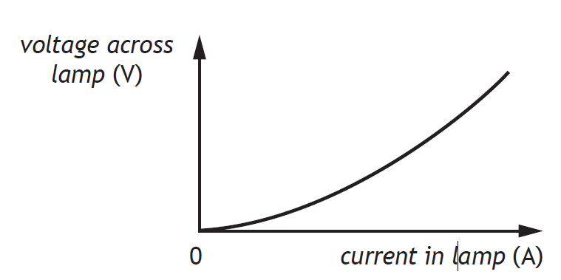  - State a conclusion that can be made about the resistance of the filament  lamp.  - Suggest a reason for the difference in resistance between the resistor and filament lamp.
  Voltage across resistor R (V) | Current in resistor R (A)
  1·0 | 0·20
  2·5 | 0·50
  3·2 | 0·64
  6·2 | 1·24
11.4.5 |  | A graph of the conductivity against temperature for a conductor is shown below.  Conductivity  Temperature  - From information in the graph state the effect of temperature on the conductivity of a conductor.  - State the effect of temperature on the resistance of a conductor.
11.4.6 |  | 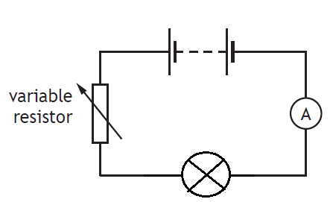  A student investigates the resistance of a filament lamp as shown in the diagram.  - Copy the diagram and add a voltmeter to show how the voltage across the filament lamp can be found.  - A sketch graph of the student’s results is shown.  - State a conclusion that can be made about the resistance of the filament lamp.  - Calculate the resistance of the filament lamp when the current is 0.4 A  - State what happens to the resistance of the filament lamp as the voltage across it increases. You must justify your answer.
11.5 |  | I can describe an experiment to prove Ohm’s Law.
11.5.1 |  | Draw out the circuit that can be used to show how the current through a resistor changes with voltage.
11.5.2 |  | Write down the formula giving the relationship between current voltage and resistance. Write what each letter stands for and the units of each quantity.
11.5.3 |  | (A) On graph paper, or in excel, plot a graph of voltage against current from the results given in the table below.  (B) Calculate the resistance of the resistor from the graph.
  V/V | I/A
  0.096 | 0.007
  0.821 | 0.056
  1.722 | 0.114
  2.664 | 0.176
  3.612 | 0.24
  4.58 | 0.303
  5.55 | 0.368
  6.56 | 0.433
  7.52 | 0.498
  8.52 | 0.562
11.5.4 |  | - Draw a circuit diagram to show how these results can be obtained of how a change in voltage affects the current in in.  - Determine the gradient of the graph.  - Calculate the resistance of the resistor.
11.5.5 |  | State whether the resistance changes when the current in a resistor changes. Explain your answer.
11.5.6 |  | A student sets up the following circuit to investigate the resistance of resistor R.  The variable resistor is adjusted and the voltmeter and ammeter readings are noted. The following graph is obtained from the experimental results.  - (i) Calculate the value of the resistor R when the reading on the voltmeter is 4.2 V.  (ii) Using information from the graph, state whether the resistance of resistor R, increases, stays the same or decreases as the voltage increases. Justify your answer.  - The student is given a task to combine two resistors from a pack containing one each of 33 Ω, 56 Ω, 82 Ω, 150 Ω, 270 Ω, 390 Ω  Show by calculation which two resistors should be used to give:  - The largest combined resistance;  - The smallest combined resistance.
11.5.7 |  | Calculate the current through a 5·6 kΩ resistor when it is connected to a 230 V supply.
11.5.8 |  | Calculate the voltage required to produce 10·9 A of current through a 3·3 x 10⁴ Ω resistor.
11.5.9 |  | If a 12 V supply produces a current of 15 μA through a resistor, calculate the resistance.
11.5.10 |  |  |  | A variable resistor can be adjusted from 10 Ω to 10 kΩ, and is connected to a mains supply. Calculate the maximum current.
Practical Electricity and Electronics
12.1 |  |  | I can make measurements of I, V and R using appropriate meters in simple and complex circuits.
12.1.1 |  |  | A circuit is set up as shown.  The reading on ammeter A1 is 5·0 A.  The reading on ammeter A2 is 2·0 A.  The reading on ammeter A4 is 1·0 A.  State the reading on ammeters A3 and A5.
12.1.2  A |  |  | A student investigates the resistance of a resistor using the circuit shown.  - State all the equipment required to build this circuit.  - Complete the circuit diagram to show where a voltmeter must be connected to measure the voltage across resistor R.
12.1.2 B |  |  | The results of the student’s investigation are shown.  Use all these results to determine the resistance of resistor R.
  Voltage across resistor (V) | Current in resistor (A)
  1·0 | 0·20
  2·5 | 0·50
  3·2 | 0⋅64
  6.2 | 1·24
12.1.3 |  |  | In the circuit shown, the current in each resistor is different.  State which resistor has the smallest current, you must justify your answer.
12.1.4 |  |  | A student suspects that ammeter A1 may be inaccurate. Ammeter A2 is known to be  accurate.  Copy out the circuit that should be used to compare the reading on A1 with A2
12.1.5 |  |  | 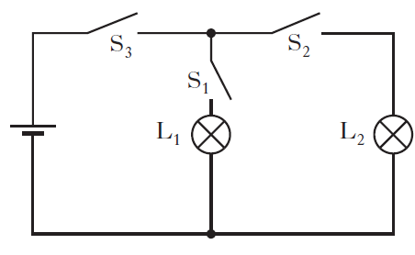  A circuit is set up as shown in the diagram. Copy the diagram and state which switch or switches must be closed to light bulb L1
12.2 |  |  | I can describe the symbol, function and application of standard electrical and electronic components including cell, battery, lamp, switch, resistor, variable resistor, voltmeter, ammeter, LED, motor, microphone, loudspeaker, photovoltaic cell, fuse, diode, capacitor, thermistor, LDR, relay and transistor
12.2.1 |  |  | - Produce a table with four columns and in the first column write the following components.  cell, battery, lamp, switch, resistor, variable resistor, voltmeter, ammeter, LED, motor, microphone, loudspeaker, photovoltaic cell, fuse, diode, capacitor, thermistor, LDR, relay and transistor  - In the second column draw the circuit symbols for each component.  - In the third column describe the function  - In the last column state the energy change in the component.  Ensure each column is properly titled.
12.2.2 |  |  | State the name of the electrical component represented by this symbol
12.2.3 |  |  | Four circuit symbols, W, X, Y and Z, are shown.  Draw and identify the components W, X, Y and Z,
12.2.4 |  |  | Two circuits are set up as shown.  Both circuits are used to determine the resistance of resistor R, identify meter X, meter Y and meter Z, you must justify your answer.
12.2.5 |  |  | 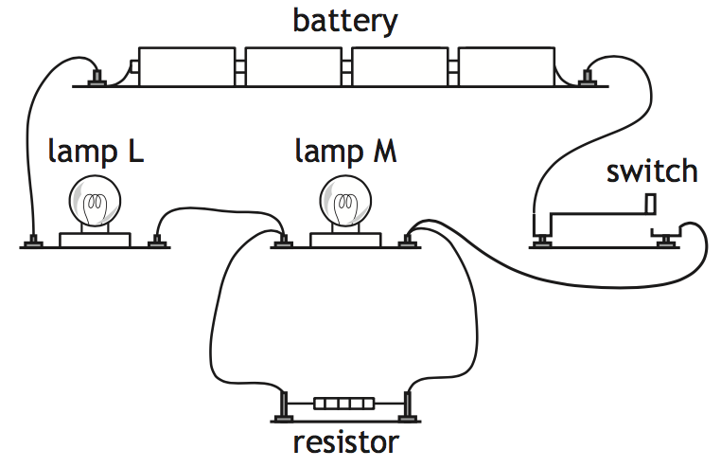  Redraw this circuit for these components using standard component symbols.
12.2.6 |  |  | The rating plate on a food blender is shown.  The plugs on all modern electrical appliances in the UK are fitted with fuses rated at either 3 A or 13 A.  (i) Draw the circuit symbol for a fuse.  (ii) State the purpose of the fuse fitted in the plug of an appliance.
12.2.7 |  |  | Copy the row in the table which shows the symbol for an LED and an NPN transistor.
12.2.8 |  |  | A student investigates the electrical properties of three different  components; a lamp, an LED and a fixed resistor.  Current-voltage graphs produced from the student’s results are shown.  Explain which graph X, Y or Z is obtained from the student’s results for  the LED.
12.2.9 |  |  | Describe, using a diagram, the use of two switches in series in the home. What has to be done to get the appliance to work in this case
12.2.10 |  |  | An LED is used as part of an alarm circuit. State which terminal P or Q should be positive to enable the LED to light.
12.2.11 |  |  | Copy out the circuit where both LEDs are lit.
12.2.12 |  |  | Light emitting dioders (LEDs) are often used as on/off indicators on television and computers. An LED is connected in a circuit with a resistor R.  - Explain the purpose of Resistor R.  - The LED is rated at 2 V, 100 mA. Calculate the resistance of resistor R.  - Calculate the power developed by resistor R when the LED is working normally.
12.2.13 |  |  | SQA SG C 2009  A digital camera is used to take pictures. When switched on, the flash on a digital camera requires some time before it is ready to operate. When ready, a green LED is illuminated.  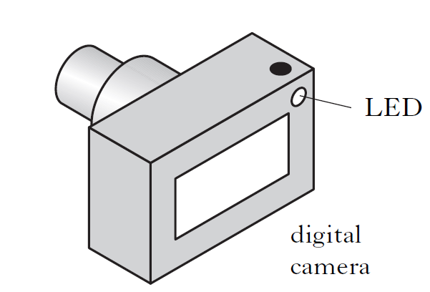  The part of the circuit used to control the LED is shown below. The voltage  at point X is initially 0 V.  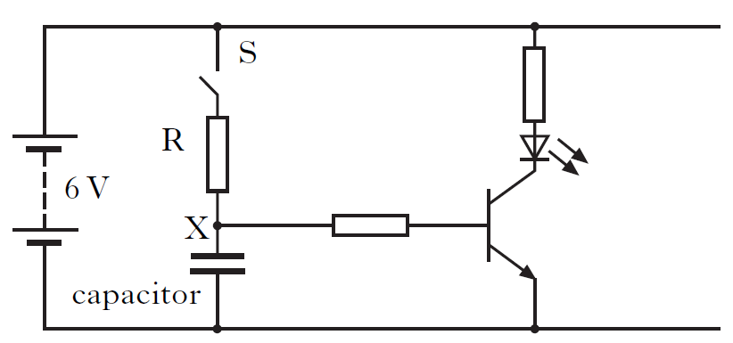  (a) Describe what happens to the voltage at point X when switch S is closed.  (b) The camera manufacturer wants to change the time taken for the flash to be ready to operate.  State two changes which could be made to the above circuit so that the time for the green LED to come on is reduced.
12.2.14 |  |  | SQA SG G 2010  The circuit below can be used to light an LED after a short time delay.  The capacitor is charged using the 5·0 volt supply.  (i) State what happens to the voltage across the capacitor when it charges.  (ii) Component Y is a transistor. Draw the symbol for a transistor.  (iii) State the function of the transistor in this circuit.  (b) The circuit is used to monitor temperature changes in a liquid.  The thermistor is immersed in the liquid.  - State what happens to the reading on the ohmmeter as the liquid cools.  (ii) The thermistor is now connected to a battery and an ammeter as shown.  Calculate the current in the circuit when the resistance of the thermistor is 1000 ohms.
12.2.15 |  |  | Draw the symbol for a Light Emitting Diode.
12.2.16 |  |  | State why a LED must be connected the correct way round in a circuit.
12.2.17 |  |  | State why a resistor must be used in series with a LED.
12.2.18 |  |  | Draw a diagram showing how a LED can be operated from a 12V battery.
12.2.19 |  |  | Calculate the size of resistor needed in the circuit operated from a 12V battery if the LED operates at 1.8V 15mA
12.2.20 |  |  | In terms of energy, what useful energy change happens in  (a) a microphone, (b) a thermocouple, and (c) a solar cell.
12.2.21 |  |  | - (i) State what the abbreviation LDR stands for.  (ii) State how the resistance of the LDR changes when more light reaches it.  (b) State how the resistance of a thermistor change when its temperature increases.
12.2.22 |  |  | State the purpose of a capacitor in a circuit.
12.2.23 |  |  | Draw the circuit symbol for a capacitor.
12.2.24 |  |  | Sketch a graph showing the potential difference across a capacitor against time as it charges from a 12V supply, numerical values are only required on the voltage axis.
12.2.25 |  |  | State the two quantities that affect the time for a capacitor to fully charge.
12.2.26 |  |  | (a) State how a capacitor can be quickly discharged.  (b)State whether rapidly discharging a capacitor can be dangerous, you must justify your answer.
12.2.27 |  |  | State the meaning of the terms  - open circuit b) short circuit
12.3 |  |  | I can draw and identify the symbols for an npn-transistor, and an n-channel enhancement MOSFET
12.3.1 |  |  | - Draw the circuit symbol for an npn-transitor.  - Draw the circuit symbol for an n-channel enhancement MOSFET.
12.3. |  |  | The diagrams opposite show two different types of transistors.  - Copy and name each symbol.  - Label points A, B and C on each symbol.
12.4 |  |  | I can explain the function of transistors
12.4.1 |  |  | A circuit is set up as shown below  Copy the circuit and identify the transistor.  State the function of the transistor in this circuit.
12.4.2 |  |  | State the switch on voltage for the following  - an npn-transitor and state its switch on voltage  - an n-channel enhancement MOSFET.
12.4.3 |  |  | (i) State the type of transistor used in this circuit.  (ii) State the function of the transistor in this circuit.
12.4.4 |  |  | SQA Int 2 2015  Part of an alarm system is shown in the circuit. Light from an LED strikes the LDR. When the light is blocked the transistor switches on and the buzzer sounds. Explain how the circuit operated to make the buzzer sound.
12.4.5 |  |  | A photographic darkroom has a buzzer that sounds when the light level in the room is too high. The circuit diagram for the buzzer system is shown below.  (a) (i) Name component X.  (ii) What is the purpose of component X in the circuit?  - The darkroom door is opened and the light level increases.  Explain how the circuit operates to sound the buzzer.  - The table shows how the resistance of the LDR varies with light level.  The variable resistor has a resistance of 570 Ω. The light level increases to 80 units. Calculate the current in the LDR.  (d) State the purpose of the variable resistor R in this circuit.
  Light level (units) | LDR Resistance (Ω)
  20 | 4500
  50 | 3500
  80 | 2500
12.4.6 |  |  | Water in a fish tank has to be maintained at a constant temperature. Part of the electronic circuit which controls the temperature is shown.  (a) Name components Y and Z.  (b) State what happens to the resistance of the thermistor as the temperature increases.  (c) When the voltmeter reading reaches 1·8V component Y switches on. Explain how the circuit operates when the temperature rises.  (d) Explain why a variable resistor chosen for component X rather than a fixed value resistor.
12.4.7 |  |  | A car has a temperature warning system which alerts the driver when the air temperature falls below 3 °C. The sensor is installed inside the passenger side wing mirror on the car. The diagram for the circuit is shown below.  12 V  t  X  Y  Z  (a) A thermistor is used as the sensor in the circuit. State what happens to the resistance of the thermistor as the temperature falls.  (b) Name component: (i) X; (ii) Y.1  (c) When operating normally, component Y has 2·0 V across it and 10 mA in it.  Calculate the resistance of resistor Z.  (d) The car manufacturer decides to redesign the circuit using a MOSFET.  (i) Draw the symbol for a n channel enhancement MOSFET.  (ii) State which component in the circuit shown above can be removed when the MOSFET is introduced.  (e) On the rear window of the car there is a heater that is used to remove any ice that forms on the glass.  (i) At a temperature of 0 °C a mass of 0·050 kg of ice forms on the rear window. Calculate the energy needed to melt this ice into water at 0 °C.  (ii) In practice more energy than the value calculated in part (e) (i) needs to be supplied to melt the ice. Explain why more energy is needed.
12.5 |  |  | I can apply the current and voltage relationships in a series circuit.
12.5.1 |  |  | State the equation to show  - Current in a series circuit  - Voltage in a series circuit.
12.5.2 |  |  | State how the current compares in components connected in series.
12.5.3 |  |  | 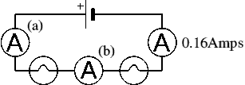  Determine the readings on meter (a) and (b).
12.5.4 |  |  | 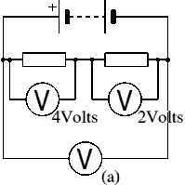  (i) State the reading on the Voltmeter (a)  (ii) State the supply voltage of this circuit.
12.5.5 |  |  | Two resistors are connected in series as shown in the diagram. The current in the 2 Ω resistor is 2.0 A  Calculate the current in the 4 Ω resistor and the voltage across the 4 Ω resistor
12.5.6 |  |  | In the potential divider circuit the value of the variable resistor is increased. State the effect on voltmeters, V₁ and V₂  V₁  V₂
12.5.7 |  |  | Calculate the total resistance for a 650 ohm, a 350 ohm, and a 1000 ohm resistor connected in series.
12.5.8 |  |  | Calculate the total resistance for ten 120 ohm resistors in series.
12.5.9 |  |  | A string of fifty 15 ohm Christmas tree lights are connected in series. One burns out, they all burn out. Calculate the total resistance.
12.5.10 |  |  | Two 100 ohm resistors are connected in series and they are connected to a 1.5 V DC battery. Determine the total current flowing in the circuit.
12.5.11 |  |  | Two resistors are connected in series. One resistor has a resistance of 50 Ω. The total resistance is 67 Ω, calculate the resistance of the second resistor
12.5.12 |  |  | The reading on the ammeter is 3·0 A.  The reading on the voltmeter is 4·0 V.  Determine the current in resistor R₂ and the voltage across resistor R₂
12.6 |  |  | I can apply the current and voltage relationships in a parallel circuit
12.6.1 |  |  | State the equation to show  - Current in a parallel circuit  - Voltage in a parallel circuit.
12.6.2 |  |  | - Calculate the total resistance for two 180 ohm resistors connected in parallel.  - If the resistors are connected to a 9.0 V power supply determine the voltage across each resistor.  - If the resistors are connected to a 9.0 V power supply determine the current in each resistor.  - Determine the total current in the circuit.
12.6.3 |  |  | A 10 ohm, 20 ohm, and 100 ohm resistors are connected in parallel.  - Calculate the total resistance of these three resistors.  - If the resistors are connected to a 12.0 V power supply determine the voltage across each resistor.  - If the resistors are connected to a 12.0 V power supply determine the current in each resistor.  - Determine the total current in the circuit.
12.6.4 |  |  | A string of fifty 15 ohm Christmas tree light are connected in parallel. One burns out, the rest will stay lit. Calculate the total resistance of the 49 resistors.
12.6.5 |  |  | State the rule for calculating the resistance of any two resisitors, with the same resistance when connected in parallel.
12.6.6 |  |  | Two 33 ohm resistors are connected in parallel followed by two more 33 ohm resistors connected in parallel. Calculate the value of a single resistor which would be used to replace these four resistors.
12.6.7 |  |  | A technician builds a test circuit containing a resistor and a motor, as shown  (i) State the voltage across the motor.  (ii) Calculate the combined resistance of the resistor and the motor.
12.6.8 |  |  | The resistor and the motor are now connected in series, as shown State how this affects the speed of the motor compared to Circuit 1.  Explain your answer.
12.6.9 |  |  | 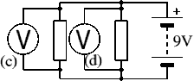  State the reading on voltmeters (c ) and (d)
12.6.10 |  |  | 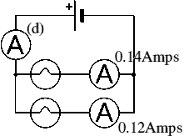  State the reading on Ammeter (d)
12.6.11 |  |  | A toy car contains an electric circuit which consists of a 12·0 V battery, an electric motor and two lamps.  The circuit diagram is shown.  Switch 1 is now closed.  Calculate the power dissipated in the motor when operating.  Switch 2 is now also closed.  - Calculate the total resistance of the motor and the two lamps  - One of the lamps now develops a fault and stops working. State the effect this has on the other lamp.
12.6.12 |  |  | The current in the lamp is 1·5 A.  The reading on the voltmeter is 6·0 V. Calculate power developed in the lamp.
12.6.13 |  |  | a) Calculate the total resistance  b) Calculate the total current  c) Calculate the voltage across the 20 Ω resistor  d) calculate the voltage across the parallel network  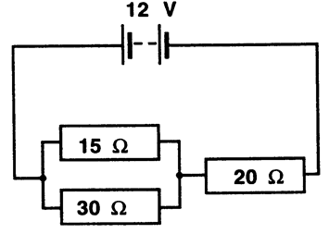  e) Calculate the current for each resistor in the parallel network.  f) Calculate the power dissipated by each resistor
12.7 |  |  | I can describe and explain practical applications of series and parallel circuits.
12.7.1 |  |  | To turn on a kettle, the kettle plug should be placed in a socket and the socket switched on and then the kettle switch must also be switched on before the kettle heats up. State how the switches are connected in this arrangement.
12.7.2 |  |  | Two headlights in a car can only be switched on when the ignition switch and the light switch are both on. Draw a circuit diagram to show how this circuit could be connected.
12.7.3 |  |  | The interior light in a car only lights when either the drivers or passenger door is open. Draw a circuit diagram to show this circuit arrangement.
12.7.4 |  |  | Brakes in a car only light when the ignition is switched on and the brake switch on the pedal is pressed. Draw a circuit diagram to show this circuit arrangement.
12.7.5 |  |  | State whether the sockets in your house connected in series or parallel, you must justify your answer.
12.7.6 |  |  | 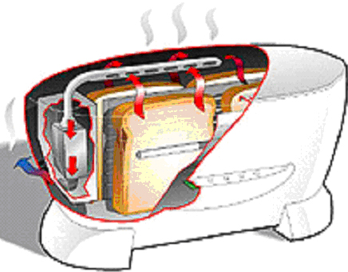  A state-of-the-art electric toaster uses radiation to produce the perfect slice of toast.  (a) State the main energy change in the toaster.  (b) State the most likely power rating for the toaster.  10 W 100 W 1000 W  (c) State the size of fuse required in the toaster.  (d) The toaster has a metal casing. How many wires does it have in its flex?
12.7.7 |  |  | An electrician is looking for a fault in the wiring of a house.  - He decides to make a continuity tester from a battery, a lamp and some insulated wires. Draw a circuit diagram of the continuity tester.  - A fault has been repaired the electrician uses a voltmeter to measure the voltage at different sockets around the house.  (i) State the value of the voltage measured at the sockets.  (ii) The electrician finds that the voltage at all of the sockets is the same. Describe the way in which the sockets are wired together.
12.7.8 |  |  | A circuit is set up as shown.  The initial reading on both voltmeters V₁ and V₂ is 2.5V.  The light shining on the LDR is made brighter.  Copy out the row in the table that shows possible new readings on voltmeters V₁ and V₂.
  Reading on V₁ (V) | Reading on V₂ (V)
  2.0 | 3.0
  2.5 | 2.0
  2.5 | 2.5
  2.5 | 3.0
  3.0 | 2.0
12.8 |  |  | I can solve problems involving total resistance of resistors in a series circuit.
12.8.1 |  |  | State the formula to calculate resistance in a series circuit.
12.8.2 |  |  | Calculate the resistance of the following circuit  35 Ω  22 Ω  60 Ω
12.8.3 |  |  | The total resistance of this circuit is 25 kΩ. Calculate the value of Resistor 2  500 Ω  R₂  12 kΩ
12.8.4 |  |  | Calculate the resistance of the following circuit  2.0 k Ω  500 Ω  500 Ω
12.9 |  |  | I can perform calculations involving current and voltage relationships in a parallel circuit.
12.9.1 |  |  | 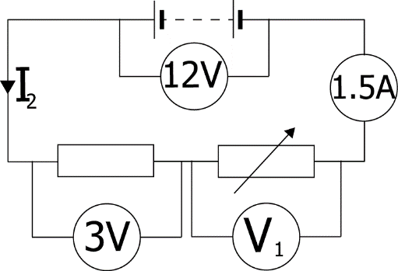  Determine the missing currents and voltages for this circuit.
12.9.2 |  |  | 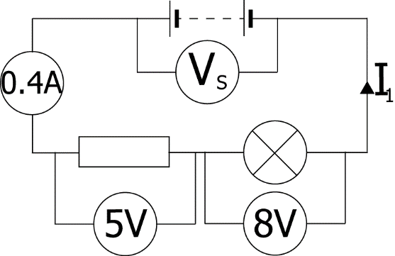  Determine the missing currents and voltages for this circuit.
12.9.3 |  |  | 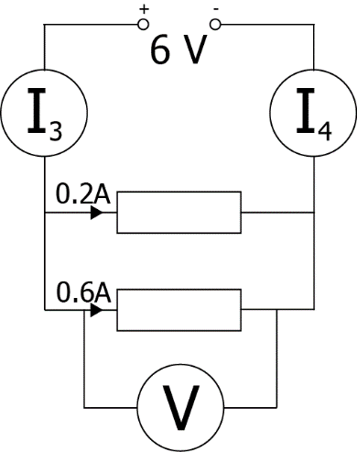  Find the missing currents and voltages for this circuit.
12.9.4 |  |  | 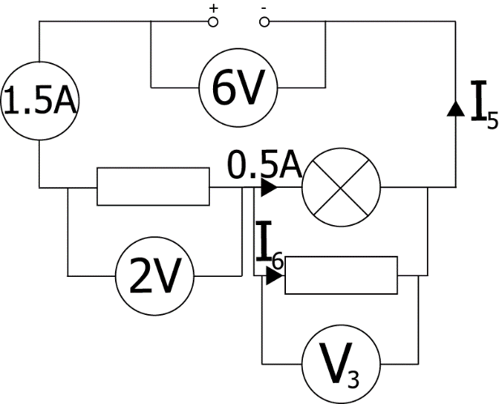  Find the missing currents and voltages for this circuit.
12.10 |  |  | I can calculate the resistance of resistors in parallel circuits
12.10.1 |  |  | Calculate the resistance of the circuit shown below  100 Ω  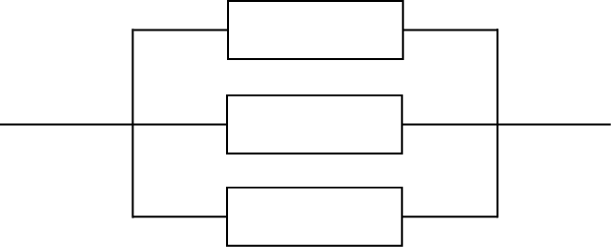  400 Ω  200 Ω
12.10.2 |  |  | The total resistance of this circuit is 100Ω. Calculate the value of Resistor 1  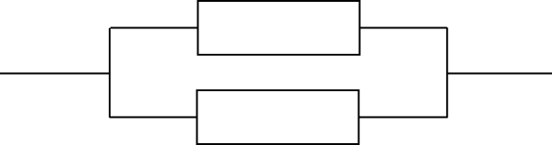  200 Ω  R₁
12.10.3 |  |  | Calculate the total resistance of these two resistors in parallel  20 kΩ  14 kΩ
12.10.4 |  |  | Calculate the total resistance of these resistors in parallel  300 Ω  600 Ω  900 Ω
12.10.5 |  |  | 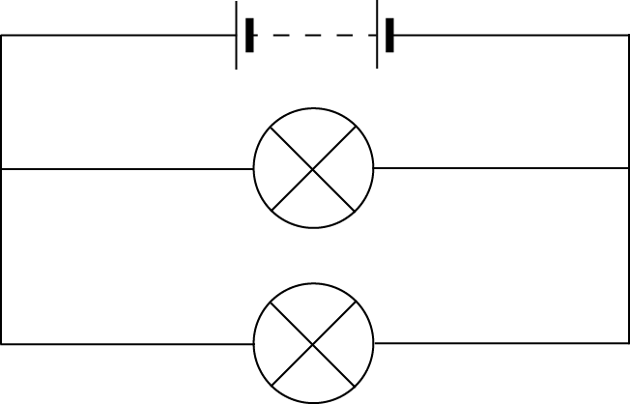  Calculate the total resistance of these lamps in parallel  4 Ω  6 Ω
12.11 |  |  | I can use the appropriate relationships to calculate the resistance of resistors in with circuits with combinations of resistors in series and parallel
12.11.1 |  |  | Calculate the total resistance between X and Y.
12.11.2 |  |  | Calculate the total resistance in each of these circuits.
  a. | 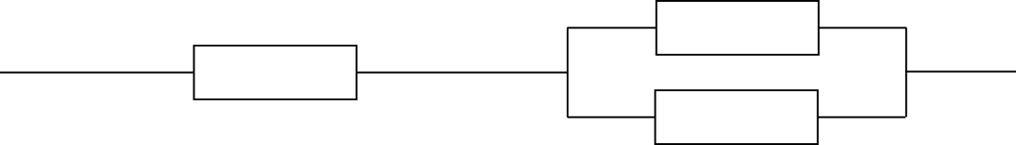  900 Ω  200 Ω  200 Ω  500 Ω  1 kΩ  1.2 kΩ  900 Ω  1.5 kΩ  1 MΩ  500 kΩ  2 MΩ  750 kΩ
  b. | 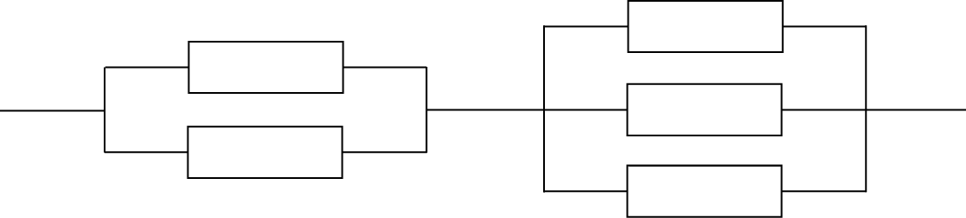
  c. | 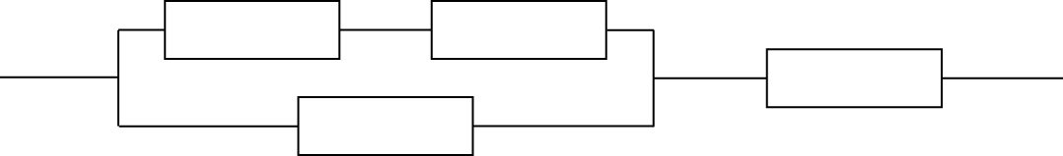
12.11.3 |  |  | Calculate the readings on the ammeter and voltmeter
12.11.4 |  |  | Part of a circuit is shown below.  - Calculate the total resistance between points Y and Z  - Calculate the total resistance between points W and X  - Calculate the voltage across the 2.0 Ω resistor when the current in the 4.0 Ω resistor is 0.10 A
12.11.5 |  |  | Collect a copy of the Resistor Network and try to find a total resistance for the network.  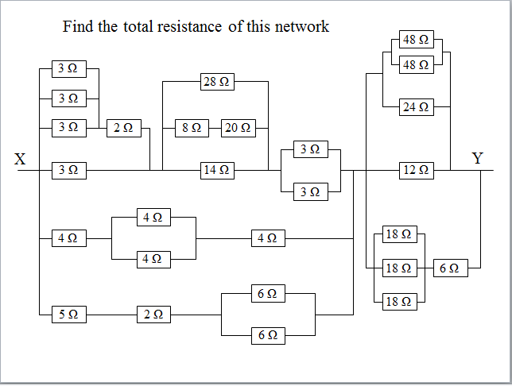
12.12 |  |  | I know what happens in a circuit when I increase the resistance in both series and parallel circuits.
12.12.1 |  |  | State what happens to the total resistance as resistors are added in a circuit in series.
12.12.2 |  |  | State what happens to the total resistance as resistors are added in a circuit in parallel.
12.12.3 |  |  | If the voltage remains constant state what happens to the current in a circuit as the resistance increases.
12.12.4 |  |  | If the voltage remains constant state what happens to the current in a circuit as the resistance decreases.
Electrical Power
13.1 |  |  | I can state the definition of electrical power.
13.1.1 |  |  | State the definition of electrical power.
13.1.2 |  |  | A student makes a statement: “The power of a light bulb is 15 W.” Explain what this statement mean, in terms of energy
13.1.3 |  |  | Dissipation is a term that is often used to describe ways in which energy is wasted. Any energy that is not transferred to useful energy stores is said to be wasted because it is lost to the surroundings.  Taking 3 separate appliances indicate ways in which the energy is dissipated.
13.1.4 |  |  | A kettle is rated as 2 KW.  - Explain what this term means.  - Does all the energy heat the water? You must justify your answer.
MrsPQ |  |  | What/ Watt is the unit of power?!
13.2 |  |  | I can use the word dissipated as it relates to power.
13.2.1 |  |  | Copy the sentence below and state the word to which the sentence refers.  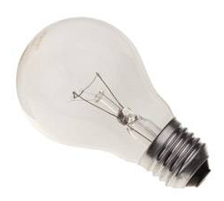  The process in which an electric or electronic device produces heat (other waste energy) as an unwanted by-product of its primary action.
13.2.2 |  |  | A 100 W light bulb transfers 20 W of light.  State what happens to the remaining power.
13.2.3 |  |  | State the formula to calculate the power dissipated in a circuit. State the meaning and units of each quantity.
13.3 |  |  | I am able to solve calculations relating to Power, Energy and time.
13.3.1 |  |  | State the equation that links Power, Energy and time. State the units of each quantity.
13.3.2 |  |  | - State the energy transformed each second by a drill rated at 800 W.  - From part a) state what you can infer about the energy used per second by an appliance and its power rating.
13.3.3 |  |  | Calculate the electrical energy transformed by the following appliances  - A 400 W drill used for 45 s.  - A 300 W food processor used for 20 s.
13.3.4 |  |  | Calculate the electrical energy transformed by an 800 W iron used for 40 minutes.
13.3.5 |  |  | Calculate the electrical energy transformed by a 2.4 kW kettle that takes 5 minutes to boil the water inside it.
13.3.6 |  |  | A miniature heater for making cups of tea is rated at 150 W. Calculate the time taken to boil the water if 45,000 J of energy are supplied.
13.3.7 |  |  | A 2.0 kW heater, a 150 W TV and a 100W light bulb are left on for 20 minutes. Calculate the total energy consumed by these appliances in this time.
13.3.8 |  |  | An electrical components is operated at 4·0 V with a current of 0·50 A for 60 seconds. Calculate the energy transferred to the component during this time.
13.3.9 |  |  | A MES lamp rated at 3.5 V and with a current of 0.25 A is switched on and consumes 87.5 J of energy. Calculate the time the bulb has been switched on for.
13.4 |  |  | I know the effect of potential difference (voltage) and resistance on the current in and power developed across components in a circuit. (complete section 13.5 before attempting this section)
13.4.1 |  |  | SQA SG C 2011.  A mains electric fire has two heating elements which can be switched on and off separately. The heating elements can be switched on to produce three different heat settings: LOW, MEDIUM and HIGH. The fire also has an interior lamp which can be switched on to give a log-burning effect.  The circuit diagram for the fire is shown.  (a) Switches S2 and S3 are closed.  (i) Calculate the combined resistance of both heating elements.  (ii) Calculate the total power developed in the heating elements when S2 and S3 are closed.  - State and explain which switch or switches would have to be closed to produce the LOW heat setting.
13.4.2 |  |  | Based on SG C 2005  A mains vacuum cleaner contains a motor that takes 3.0 s to reach full speed after being switched on. The graph shows how the current in the motor varies from the time the motor is switched on.  - Calculate the power of the motor when it first switched on.  - State the current when the motor has reached full speed.  - Calculate the power of the motor when it has reached full speed.  (c ) The vacuum cleaner is connected to the mains supply by a flex fitted with a fused plug. All the fuses shown are available.  State which one of these fuses is most suitable for fitting in the plug. You must justify your answer.
13.4.3 |  |  | SQA SG C 2009  A car fan uses a battery powered electric motor. The diagram below shows the apparatus used to investigate the effect of current on the speed of the electric motor.  - The graph shows the relationship between speed and current during the investigation.  - The current is changed using the variable speed control. State what happens to the current when the resistance of the variable speed controller is reduced.  - The settings of the variable speed control use different combinations of identical resistors, as shown. State to which position the variable speed control should be set to achieve maximum speed. You must justify your answer.
13.4.4 |  |  | SQA SG C 2012  A student sets up a circuit to operate two identical 12 V, 36 W lamps from a 48 V supply.  (a) When the switch is closed, the lamps operate at their correct power rating.  Calculate:  (i) the reading on the ammeter;  (ii) the reading on the voltmeter;  (iii) the resistance of the variable resistor.  - The student sets up a second circuit using a 12 V supply and the same lamps. Each lamp has a resistance of 4 Ω. The resistance of the variable resistor is set to 6 Ω.  (i) Calculate the total resistance of this circuit.  (ii) The variable resistor is now removed from the circuit.  (A) State what happens to the reading on the ammeter. You must justify your answer.
13.5 |  |  | I can use appropriate relationships to solve problems involving power, potential difference (voltage), current and resistance in electrical circuits
13.5.1 |  |  | State the relationship between current, voltage and power.
13.5.2 |  |  | (a)State the relationship between current, resistance, and power.  (b) Show that this relationship is found by combining P=IV and V=IR.
13.5.3 |  |  | (a)State the relationship between voltage, resistance, and power.  (b) Show that this relationship is found by combining P=IV and V=IR.
13.5.4 |  |  | A toaster is rated at 230V 1200W. Calculate the current in the toaster when it is operating normally.
13.5.5 |  |  | State the relationship between current, resistance, and power. Also write this as a triangle and say what each letter stands for
13.5.6 |  |  | Show that this relationship is found by combining P=IV and V=IR.
13.5.7 |  |  | A 12 V battery supplies a motor which has a resistance of 18 Ω, calculate the current in the circuit.
13.5.8 |  |  | An LED which is in series with a 1.2 kΩ resistor must be supplied with 5 mA of current to operate. When lit, the p.d. across the LED is 0.6 V.  Calculate the potential difference across the resistor.  Calculate the minimum supply voltage required.
13.5.9 |  |  | A vacuum cleaner is connected to the UK mains (rated at 230 V) and 8.9 A of current flows through the circuit. Calculate the power being transformed.
13.5.10 |  |  | A heater has a power of 1000W, and the current in it is 5A, calculate the resistance of the heater.
13.5.11 |  |  | The resistance of a kettle is 21Ω and its power is 2200W. Calculate the current in the kettle when it is working normally.
13.5.12 |  |  | A mains electric fire is rated at 2.0 kW.  - State the voltage across the electric fire.  - Calculate the current in the heating element when it is switched on.  - Calculate the resistance of the heating element
13.5.13 |  |  | SQA N5 2014  A toy car contains an electric circuit which consists of a 12·0 V battery, an electric motor and two lamps.  The circuit diagram is shown.  (a) Switch 1 is now closed.  Calculate the power dissipated in the motor when operating.  (b) Switch 2 is now also closed.  (i) Calculate the total resistance of the motor and the two lamps.
13.5.14 |  |  | A components is operated at 4·0 V with a current of 0·50 A for 60 seconds.  - Calculate the energy transferred to the component during this time.  - Calculate the power dissipated in the component
13.5.15 |  |  | The rating plate on an electrical appliance is shown.  Calculate the resistance of the appliance.
13.5.16 |  |  | A torch bulb is rated 12V, 60mA. Calculate the power dissipated in the bulb when it is operating normally.
13.5.17 |  |  | SQA N5 2017 SP  - A student sets up the following circuit.  (i) Determine the total resistance in the circuit.  (ii) Calculate the current in the circuit.  - Calculate the power dissipated in the 15 Ω resistor.  (b) The circuit is now rearranged as shown.  State how the power dissipated in the 15 Ω resistor compares to your answer in (a) (iii). You must justify your answer.
13.5.18 |  |  | The cables used in the National Grid are made of aluminium with a cross sectional area of 25 cm². These have a resistance of 10-5 Ωm⁻¹, and so a 50 km line has a resistance of 0.5 Ω.  (A) Calculate the power loss in the 50 km line if it has a current of 1200 A in it.  (B) The current is reduced to 100 A by using a transformer system at each end, calculate the power loss with this new arrangement.  (C) If the transformers lose 50 kW because they are not 100 % efficient, calculate the total power loss from both the line and the transformers.
13.5.19 |  |  | Based on SQA SG C 2007  Two groups of pupils are investigating the electrical properties of a lamp.  (a) Group 1 is given the following equipment:  ammeter; voltmeter; 12 V D.C. supply; lamp; connecting leads.  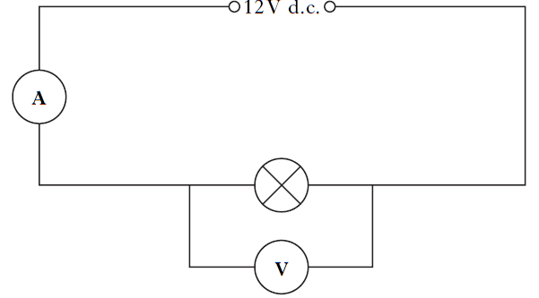  Group 2 uses the same lamp and is only given the following equipment:  lamp; ohmmeter; connecting leads.  - State what property of the lamp is measured by the ohmmeter.  - The results of both groups are combined and recorded in the table below.  - Use these results to complete the last two columns of the table.  - State the quantity represented by the last two columns of the table  - State the unit of this quantity
  I(A)) | V(V | R(Ω) | IV | I²R
  2 | 12 | 6
13.6 |  |  | I know when I would use a 3A fuse and when a 13A fuse for appliances.
13.6.1 |  |  | State the purpose of the fuse fitted in the plug of an appliance.
13.6.2 |  |  | Explain how a fuse work.
13.6.3 |  |  | Explain why different sizes of fuses are required in household appliances.
13.6.4 |  |  | - State the fuse value required in most appliances up to 720W.  - State the value of a fuse required in most appliance above 720W  - State the maximum power rating of an appliance that can be fitted with a 13A
13.6.5 |  |  | The mains supply voltage in the UK is quoted as 230 V.  State a value for the peak voltage and the mains and frequency in the UK?
13.6.6 |  |  | Explain why some appliances with a power rating below 720 W, (particularly those containing an electric motor) which you might expect to have a 3A fuse are actually required to have a fuse with a higher rating.
13.6.7 |  |  | Explain why it is important to fit the correct fuse in an appliance. (i.e. explain what can happen if the wrong fuse is placed in the appliance)
13.7 |  |  | I could select the appropriate fuse rating given the power rating of an electrical appliance
13.7.1 |  |  | The rating plate on a food blender is shown.  Determine the rating of the fuse fitted in the plug of the blender.
13.7.2 |  |  | Choose the correct size of fuse for appliances of 6W, 600W, 800W, 1000W, 2000W, and 2500W
13.7.3 |  |  | State the energy change in most appliances that have the greatest power rating.
13.7.4 |  |  | Explain, using the correct equation, how you would calculate the correct fuse for an appliance.
13.7.5 |  |  | The following electrical appliances are found in a kitchen.  kettle hand blender toaster  2500 watts 300 watts 1800 watts  (a) State a reason why you should not fill a kettle with water when it is plugged in and switched on.  (b) The hand blender does not have an earth wire. Draw the symbol on its rating plate which indicates it does not require an earth wire.  (c) State the colour of the live wire in the cord of an electrical appliance.  (d) Each appliance is fitted with either a 3 ampere or a 13 ampere fuse. State the correct value of fuse for:  (i) the kettle;  (ii) the hand blender.
13.7.6 |  |  | An electrician is looking for a fault in the wiring of a house.  (a) He decides to make a continuity tester from a battery, a lamp and some insulated wires. Draw a circuit diagram of the continuity tester.

