RADIATION

Quantities for the Radiation Unit
For this unit copy and complete the table.
Quantity | Symbol | Unit | Unit Symbol | Scalar / Vector
Time
Activity
Equivalent Dose
Absorbed Dose
Absorbed Dose Rate
Equivalent Dose Rate
Radiation weighting factor
Energy
Mass
Number of radioactive nuclei decaying

The RADIATION unit in numbers
Quantity | Value
State the charge on an alpha particle
State the charge on a beta particle
State the mass of an alpha particle
State the mass of a beta particle
State the average annual background radiation in the UK
State the average annual effective dose limit for a member of the public in the UK
State the average annual effective dose limit for radiation workers in the UK.
State the radiation weighting factor of an alpha particle
State the radiation weighting factor of a beta particle
State the radiation weighting factor of a gamma particle
State the radiation weighting factor of a fast neutron
State the radiation weighting factor of a slow neutron
State the speed of a gamma wave in air

No. | CONTENT
Nuclear Radiation
20.1 |  | I understand the nature of alpha, beta and gamma radiation: including the relative effect of ionization, their relative penetration.
20.1.1 |  | Copy the simple diagram of an atom and label the nucleus, proton, neutron and electron. State the charge on each particle.  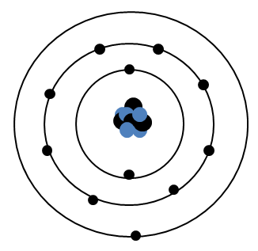
20.1.2 |  | Define the term ionisation
20.1.3 |  | State from where all ionizing radiations originate.
20.1.4 |  | Describe the following in as much detail as you can  - Alpha particle  - Beta particle  - Gamma radiation
20.1.5 |  | State what happens to radiation energy as it passes through the medium.
20.1.6 |  | State the approximate range through air, and absorption of alpha, beta and gamma radiation.
20.1.7 |  | Describe how one of the effects of radiation is used in a detector of radiation. The following web address might help.  http://www.darvill.clara.net/nucrad/detect.htm
20.1.8 |  | In an experiment, radiation from a sample of radium is passed through an electric field.  It is split into three different components (as shown in the diagram below).  (a) Name the radiations labelled (i), (ii) and (iii).  (b) Which radiation is deflected most by the electrostatic field?  (c) What is the function of the lead shield?  (d) Why is the experiment carried out in an evacuated chamber?  (e) What is the purpose of the photographic film?
20.1.9  OEQ |  | Alpha, beta and gamma are types of nuclear radiation, which have a range of properties and effects. Using your knowledge of physics, comment on the similarities and/or differences between these types of nuclear radiation.
20.2 |  | I can explain the term ‘ionisation’.
20.2.1 |  | Explain the term ionisation.
20.1.2 |  | State what remains after an atom has been ionised.
20.3 |  | I can state that which nuclear radiation is most ionising, and which is the least ionising.
20.3.1 |  | From the list of alpha, beta and gamma radiation,  - state which is least ionising  - state which is most ionising
20.3.2 |  | Give a piece of evidence to show that your answer to 20.3.1 is correct.
20.3.3 |  | State the effect radiation can have on living cells
20.4 |  | I can state the distances alpha, beta and gamma radiation can travel in air and the penetration through different materials.
20.4.1 |  | State the approximate distance (range) travelled in air by:  - alpha particles  - beta particles  - gamma rays
20.4.2 |  | State the minimum object, and the thickness that can stop:  - alpha particles  - beta particles  - gamma rays
20.4.3 |  | Copy and complete the table below to show if each type of radiation passes or is absorbed by each type of material.
  Type of radiation | Range in air | Effect of passing radiation through
  Type of radiation | Range in air | 0.1 mm paper | 3 mm aluminium | 3 mm lead | 10 m concrete
  Alpha
  Beta
  Gamma
  X-rays
20.4.4 |  | Describe one use of radiation based on the fact that radiation is easy to detect.
20.4.5 |  | The table below represents data obtained from an absorption experiment using three separate radioactive sources (background count = 20 counts per minute).  (a) What effect did paper have on each of the three sources?  (b) Use the data in the table to try to identify the type of radiation from each source.
  Type of radiation | Count rate (per minute)
  Type of radiation | Source A | Source B | Source C
  Air | 3125 | 900 | 420
  Paper | 3130 | 880 | 38
  1mm Aluminium | 3000 | 380 | 20
  10 mm lead | 1900 | 20 | 21
20.5 |  | I can state that Activity is the number of nuclear disintegrations per second.
20.5.1 |  | Explain the term activity of a radioactive source.
20.5.2 |  | State what happens to the Activity of a source with time.
20.5.3 |  | Describe an experiment to find the activity of a radioactive source using the following equipment:  Stopwatch, Geiger-Muller Tube, Counter.
20.6 |  | I can state the units of activity.
20.6.1 |  | State the units of the Activity of a source.
20.7 |  | I can use A=N/t to solve problems involving activity, number of nuclear disintegrations and time.
20.7.1 |  | Copy this table and calculate the missing numbers, there is no need to complete the table, just show the working underneath using IESSUU.
   | Activity / Bq | Number of Decays | Time / s
  (a) |  | 720 | 60
  (b) |  | 4500 | 180
  (c) | 1000 |  | 100
  (d) | 12 500 |  | 500
  (e) | 40 000 | 3.0 x 10⁷
  (f) | 2.5 x 10⁶ | 5.0 x 10⁸
20.7.2 |  | In a laboratory, the background activity is measured as 1.5 Bq. A Geiger-Muller tube is used to measure the activity of a source in the laboratory. In three minutes, 1440 counts are recorded. What is the activity of the source?
20.7.3 |  | Calculate the activity of a source that has 210 decays in a minute.
20.7.4 |  | A source has an activity of 2.0 kBq. Calculate the number of counts recorded from the source by a Geiger-Muller tube (and counter) in 30 seconds.
20.7.5 |  | Calculate the time it takes a source with an activity of 1.8 MBq to have 8.1 x 10⁸ radioactive decays.
20.7.6 |  | In an experiment, the number of decays from a radioactive source is recorded. The background count is then taken away. The results of this are shown.  Draw a line graph of these results, and use the gradient of the straight line to calculate the activity of the source.
  Time / minutes | Corrected Number of Decays
  0 | 0
  1 | 1800
  2 | 3600
  3 | 5400
  4 | 7200
  5 | 9000
20.8 |  | I can identify background sources of radiation.
20.8.1 |  | State what is meant by the term background radiation.
20.8.2 |  | Identify background sources of radiation.
20.8.3 |  | State three natural sources that contribute to background radiation.
20.8.4 |  | State three artificial sources (manmade) that contribute to background radiation.
20.9 |  | Knowledge of the dangers of ionising radiation to living cells and of the need to measure exposure to radiation
20.9.1 |  | State how the equivalent dose a person receives can be reduced.
20.9.2 |  | Explain why airline pilots and crews receive higher doses of radiation than the ground crew working in the airport.
20.9.3 |  | State three factors that can affect the biological harm of radiation.
20.9.4 |  | State three ways to reduce the biological harm on a person due to radiation.
20.9.5 |  | Several people have been poisoned by Polonium-210. Describe their symptoms prior to death.
20.10 |  | I can use appropriate relationships to solve problems involving absorbed dose and equivalent dose energy, mass and radiation weighting factor.  ($H = Dw_{R}$, $D= \frac{E}{m}$ )
20.10.1 |  | State the difference between am absorbed dose and an equivalent dose.
20.10.2 |  | State what is indicated by the radiation weighting factor for each radiation.
20.10.3 |  | Copy this table and calculate the missing numbers, there is no need to complete the table, just show the working underneath. Show all the working using IESSUU.
   | Absorbed Dose / Gy | Energy/ J | Mass / kg
  (a) |  | 6 x 10⁻⁶ | 0.5
  (b) |  | 3.5 x 10⁻⁵ | 0.25
  (c) | 8.8 x 10⁻⁵ |  | 0.05
  (d) | 6.5 x 10⁻⁵ |  | 0.26
  (e) | 1.1 x 10⁻⁵ | 3.3 x 10⁻⁶
  (f) | 1.2 x 10⁻⁵ | 1.8 x 10⁻⁶
20.10.4 |  | Calculate the equivalent dose absorbed by a person exposed to 5mGy of radiation with a radiation weighting factor of 6.
20.10.5 |  | The absorbed dose to a mass of skin is 10 μGy. Calculate the mass of skin exposed if the energy of the radiation is 4.2 μJ.
20.10.6 |  | An equivalent dose of 4µSv is received by a patient from radiation with a radiation weighting factor of 20, calculate the absorbed dose.
20.10.7 |  | Visitors to a nuclear reprocessing plant are informed that they have absorbed an equivalent dose of 2.0 µSv from a measured absorbed dose of 2.0 µGy.  - Calculate the radiation weighting factor of the radiation they were exposed to.  - Using tables in the notes identify possible types of radiation.
20.10.8 |  | In the course of his work an industrial worker receives an equivalent dose of 200 μSv. Determine the absorbed dose if he is exposed to alpha particles, with a radiation weighting factor of 20.
20.10.9 |  | Calculate the absorbed dose of a 400 g hand that absorbs 7 μJ of alpha particles.
20.10.10 |  | A tumour of mass 150 g is exposed to gamma rays. The absorbed dose from this exposure is 5.1 x 10⁻⁵ μGy. What is the energy of the gamma rays absorbed by the tumour?
20.10.11 |  | A sample of tissue is exposed to 15 μGy of alpha radiation and 20 μGy of gamma radiation. Calculate the total equivalent dose received by the tissue is
20.10.12 |  | A worker spends some time in an area where she is exposed to the following  radiations:  thermal neutrons = 8 mGy radiation weighting factor = 3  fast neutrons = 40 μGy radiation weighting factor = 10  (a) Calculate the equivalent dose for each type of neutron.  (b) Calculate the total equivalent dose for the exposure.
20.10.13 |  | An unknown radioactive material has an absorbed dose of 500 μGy and gives a dose equivalent of 1.0 mSv. Calculate the radiation weighting factor of the material.
20.10.14 |  | A patient receives a chest X-ray with an equivalent dose of 2.0 mSv. If the radiation weighting factor of the X-ray is 1, calculate the absorbed dose of the patient.
20.10.15 |  | A lady has a dental X-ray which produces an absorbed dose of 0.3 mGy. Calculate the equivalent dose of this X-ray.
20.10.16 |  | A nuclear worker is exposed to a radioactive material producing an absorbed dose of 10 mGy. She finds that the material emits particles with a radiation weighting factor of 3. Calculate the equivalent dose for this exposure.
20.10.17 |  | A physics teacher uses a gamma source in an experimental demonstration on absorption. The teacher receives an absorbed equivalent dose of 0.5 μSv. Calculate her absorbed dose if the radiation weighting factor for gamma radiation is 1.
20.10.18 |  | - Alpha particles produce an equivalent dose of 50 mSv from an absorbed dose of 2.5 mGy. Calculate the radiation weighting factor of the alpha particles.  - Explain why exposure to alpha radiation increases the risk of cancer more than X-rays or gamma rays.
20.10.19 |  | The unit for absorbed dose is the gray, Gy. Explain this term and give an equivalent unit for absorbed dose.
20.11 |  | I can state that the unit for absorbed dose, the unit for equivalent dose is the Sievert (Sv) and the radiation weighting factor has no unit
20.11.1 |  | State the symbol, unit, and unit symbol for the following  - Absorbed dose  - Equivalent dose  - Radiation weighting factor
20.11.2 |  | Write out the relationships for the dosimetry formula and for each one write them in words and symbols. Use the relationships sheet to help you
20.12 |  | I can use (H dot) =H/t to solve problems involving equivalent dose and time to calculate an equivalent dose rate.
20.12.1 |  | A sample of tissue receives an equivalent dose rate of 0·40 mSv h⁻¹ from a source of alpha radiation. Calculate the equivalent dose received by the sample in 30 minutes.
20.12.2 |  | A worker in a nuclear power plant is receives an annual equivalent dose of 6.10 mSv. Calculate the worker’s equivalent dose rate, in μSvh⁻¹
20.12.3 |  | Radiation workers can receive an average equivalent dose rate of 2.2μSvh⁻¹ to still be within limits for radiation workers. Calculate the annual equivalent dose a radiation worker can receive.
20.12.4 |  | SQA N5 2014  An airport worker passes suitcases through an X-ray machine.  (a) The worker has a mass of 80·0 kg and on a particular day absorbs 7·2 mJ of energy from the X-ray machine.  (i) Calculate the absorbed dose received by the worker.  (ii) Calculate the equivalent dose received by the worker.  - If this equivalent dose rate is received over a period of 10 hours, calculate the equivalent dose rate received by the worker.
20.12.5 |  | As a part of his job, an airport security guard has to expose her hand to X-rays  (w_{R} = 1) as she removes blockages from a baggage scanner. On average, each time she does this, the absorbed dose of her hand is 0.03 μGy.  - Calculate the equivalent dose of her hand each time she removes a blockage.  - The safety rules in the airport state that the maximum equivalent dose for his hand in one hour is 0.6 μSv. Determine how many times can the airport security guard safely put her hand in the scanner in an hour.  - If the security guard works for an 8 hour shift over a 24 hour period and puts her hand through the scanner 25 times during one shift, calculate the security guard’s equivalent dose rate per day.
20.12.6 |  | It is found that a radiation worker has received an equivalent dose of 500 μSv in the course of a 25-hour working week. Calculate the equivalent dose rate in μSv h⁻¹.
20.12.7 |  | The cosmic ray detector on board an aircraft indicates an equivalent dose rate of 15 μSvh⁻¹.  - Calculate the equivalent dose to those on board during a 4-hour flight.  - Calculate the number of these flights would a crew member have to make in a year to receive the maximum permissible equivalent dose of 5.0 mSv in a year?
20.12.8 |  | A worker receives the following absorbed doses:  - γ–radiation 150 μGy  - Thermal neutrons 240 μGy  - Fast neutrons 90 μGy.  - What is the equivalent dose for each radiation?  - Find the total equivalent dose.  - If the doses were received in 6 hours, calculate the equivalent dose rate in μSv h⁻¹.
20.12.9 |  | SQA Exam Questions  A patient’s thyroid gland is to receive an absorbed does of 500 Gy from a source so that the gland absorbs 15 J of energy. From this information what is the mass of the thyroid gland?
20.12.10 |  | The following graph shows how the effective equivalent dose rate due to background radiation varies with height above sea level.  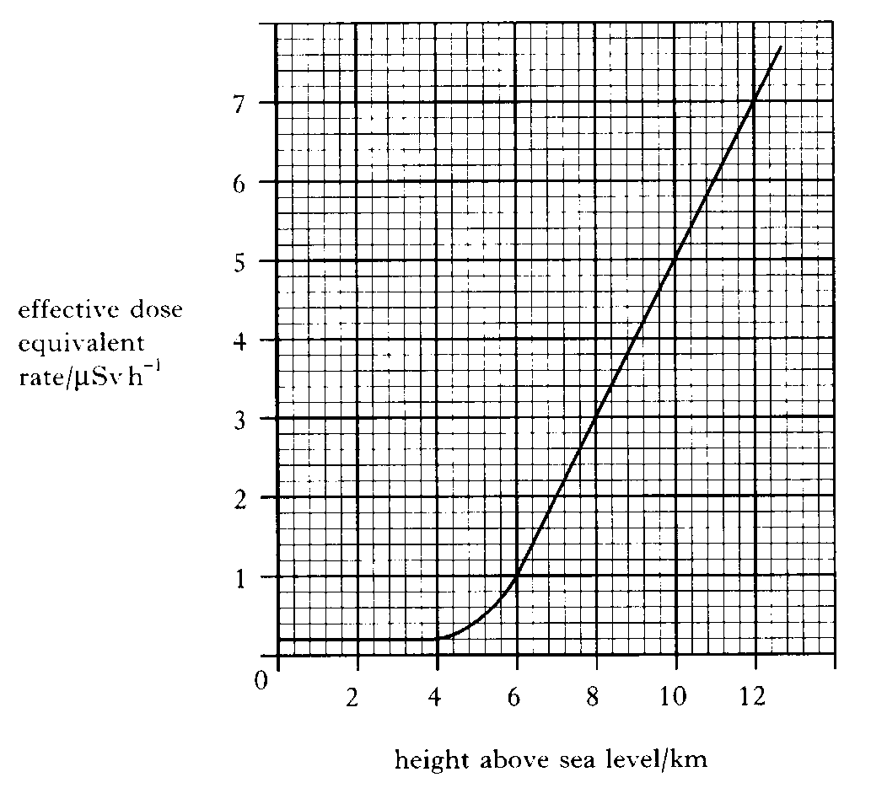  - Name two sources of background radiation 1  - The graph shows that there is an increase in effective equivalent dose rate at altitudes greater than 4 km. Suggest a reason for this increase. 1  - An aircraft makes a 7 hour flight at a cruising altitude of 10 km.  - Calculate the effective equivalent dose received by a passenger during this flight.  - A regular traveller makes 40 similar flights in one year and spends the rest of the year at sea level.  Calculate the effective equivalent dose of background radiation received by this traveller in that year.
20.12.11 |  | The radiology department in a hospital uses radioactive iodine to examine the functioning of the thyroid gland in a patient. The thyroid gland of the patient receives an absorbed dose of 750 μGy of radiation from the radioactive iodine.  - Calculate the total energy absorbed if the gland has a mass of 0.04 kg.  - The average equivalent dose rate for the gland is 12.5 μSv h⁻¹. The radioactive iodine is present in the gland of the patient for 120 hours. What is the quality factor of the radiation?
20.12.12 |  | Smoke detectors are important in giving early warning of fire starting in the home.  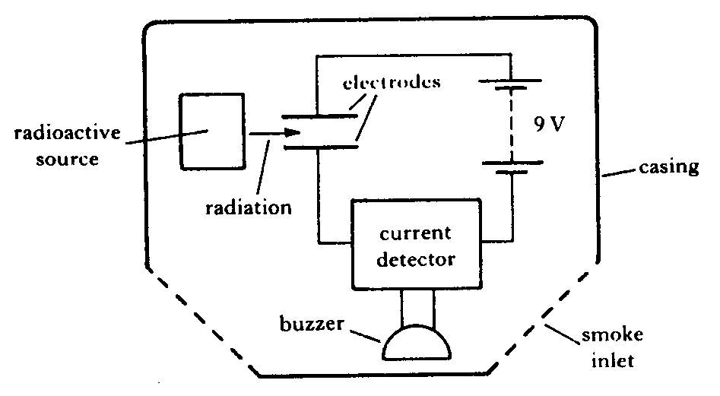  - The simplified layout of one type of smoke detector is illustrated below.  The following is an extract from the manufacturer’s data sheet.  ”The detector uses a low energy source of ionising radiation, 30 kBq Americium 241, which causes ionisation of the air molecules and hence a small current between the electrodes. When smoke particles enter the space between the electrodes they impede the flow of ions and the current is reduced. When the current falls below a certain value the buzzer sounds.”  - The symbol for the radioactive source used is .  What information is given by the numbers 95 and 241?  - What is meant by “30 kBq”?  - Explain what is meant by ionising radiation.  - The equation for decay of this source is  Identify the type of radiation emitted in this decay and explain why this particular type of radiation is used in the smoke detector.  The half-life of Americium 241 is 458 years.  Discuss the advantage of using this source compared to one with a half-life of 5 years.
20.13 |  | I can state the units of H dot.
20.13.1 |  | State the quantity, unit, and unit symbol for the term $\dot{H}$
20.14 |  | I can compare equivalent dose due to a variety of natural and artificial sources.
20.14.1 |  | A pie chart indicating the exposure of the Public to ionizing radiation is given below.  From data given in the pie chart create  - State the main source of public exposure to ionizing radiation  - create a table indicating sources originate naturally sources and which are artificial sources of radiation.  - Calculate the percentage exposure due to artificial sources.  - State the percentage exposure from naturally occurring sources.  As an aside…  Other sources <1% includes  - Occupational – 0.3%  - Fallout - <0.3%  - Nuclear fuel cycle – 0.1%  - Miscellaneous – 0.1%
20.14.2 |  | State if you are more likely to receive a more uniform dose of radiation from naturally occurring or man-made sources of radiation. You must justify your answer.
20.14.3 |  | SQA N5 2014  A sample of tissue is irradiated using a radioactive source.  A student makes the following statements about the sample.  I The equivalent dose received by the sample is reduced by shielding the sample with a lead screen.  II The equivalent dose received by the sample is increased as the distance from the source to the sample is increased.  III The equivalent dose received by the sample is increased by increasing the time of exposure of the sample to the radiation.  Copy out the correct statements.
20.14.4 |  | SQA N5 2015  A sample of tissue is irradiated using a radioactive source.  A student makes the following statements.  The equivalent dose received by the tissue is  I reduced by shielding the tissue with a lead screen  II increased as the distance from the source to the tissue is increased  III increased by increasing the time of exposure of the tissue to the radiation.  Copy out the correct statements
20.14.5 |  | SQA N5 2015  A paper mill uses a radioactive source in a system to monitor the thickness of paper.  Radiation passing through the paper is detected by the Geiger-Müller tube.  The count rate is displayed on the counter as shown. The radioactive source has a half-life that allows the system to run continuously.  - State what happens to the count rate if the thickness of the paper decreases.  - The following radioactive sources are available. State which radioactive source should be used. You must explain your answer.
  Radioactive Source | Half-life | Radiation emitted
  W | 600 years | alpha
  X | 50 years | beta
  Y | 4 hours | beta
  Z | 350 years | gamma
20.15 |  | I know the average annual background radiation in the UK.
20.15.1 |  | State the average annual background radiation in the UK.
20.16 |  | I know the average annual effective dose limit for a member of the public in the UK.
20.16.1 |  | State the average annual effective dose limit for a member of the public in the UK.
20.17 |  | I know that the average annual effective dose limit for radiation workers.
20.17.1 |  | State the average annual effective dose limit for radiation workers.
20.18 |  | I can give some applications of nuclear radiation.
20.18.1 |  | State some medical applications of nuclear radiation.
20.18.2 |  | Describe how electrical energy can be obtained from nuclear radiation.
20.18.3 |  | A nuclear reactor produces waste that emits nuclear radiation. State a use of nuclear radiation.
20.19 |  | I can define half-life.
20.19.1 |  | Sketch a graph showing how the activity of a radioactive source varies with time.
20.19.2 |  | State what is meant by the term half-life.
20.19.3 |  | State the units of half-life.
20.20 |  | I can use graphical and numerical data to determine the half-life.
20.20.1 |  | A radioactive material has a half-life of 5 days. If the original activity is 120 Bq, calculate the activity after 20 days.
20.20.2 |  | If a radioactive material has a half-life of 600 years. If the original activity was 80 Bq calculate the time it takes for the activity to fall to 10 Bq.
20.20.3 |  | A radioactive substance has a half-life of 4 hours. Calculate the fraction of the original activity left after one day.
20.20.4 |  | The activity of a source starts at 100 MBq. After 20 days it has fallen to 6.25 MBq. Calculate the half-life of the source.
20.20.5 |  | A radioactive source has an activity of 3072Bq. After 64 days its activity is measured again, and is found to be 48Bq. Calculate its half-life.
20.20.6 |  | Calculate the half-life of a radioactive source if the activity falls from 4000 kBq to 125 kBq in 40 days.
20.20.7 |  | The half-life of Cobalt-60 is 5 years. If the source, 25 years ago, had an activity of 500kBq, calculate the new activity.
20.20.8 |  | A radioactive material has a half-life of 5 days. If the original activity is 120 Bq, calculate the activity after 20 days.
20.20.9 |  | If a radioactive material has a half-life of 600 years. If the original activity was 80 Bq calculate the time it takes for the activity to fall to 10 Bq.
20.20.10 |  | A radioactive substance has a half-life of 4 hours. Calculate the fraction of the original activity left after one day.
20.20.11 |  | The data above was obtained from an experiment to determine the half life of a radioactive source:  (a) Describe how you could carry out this experiment.  (b) Determine the half-life of the radioactive source.
  Time | (mins) | 0 | 20 | 40 | 60 | 80
  Count rate | (c.p.m.) | 100 | 60 | 45 | 30 | 20
20.20.12 |  | The table of results below show how the count rate for a radioactive source varies with time. The background count was 60 counts per minute.  - Copy out the table and find the corrected count rate.  - Plot a graph of corrected count against time.  - Determine the half-life of the source from your graph.
  Time | (mins) | 0 | 5 | 10 | 15 | 20
  Count rate | (c.p.m.) | 1660 | 1100 | 750 | 510 | 350
20.20.13 |  | SQA H5 2018  A technician carries out an experiment, using the apparatus shown, to determine the half-life of a gamma radiation source.  (a) Before carrying out the experiment the technician measures the background count rate.  (i) Explain why this measurement is made.  (ii) State a source of background radiation.  - The technician’s results are shown in the table.  - Produce a graph of these results.  - Use your graph to determine the half-life of the gamma radiation source.  - The technician repeats the experiment with an alpha radiation source.  Suggest a change the technician must make to the experimental set-up to determine the half-life of the alpha radiation source. Justify your answer.
  Time  (minutes) | Corrected count rate  (counts per minute)
  0 | 680
  20 | 428
  40 | 270
  60 | 170
  80 | 107
  100 | 68
20.21 |  | I can describe an experiment to determine the half-life of a radioactive material.
20.21.1 |  | Describe an experiment to measure half-life. Make sure you include how you take background radiation into account, how you measure the activity and the time, and how you use the graph to calculate the half-life.
20.21.2 |  | An experiment is carried out in a laboratory to determine the half-life of a radioactive source. A Geiger-Müller tube and counter are used to measure the background radiation over a period of 10 seconds. This is repeated several times and an average value of 4 counts in 10 seconds is recorded.  The apparatus shown is used to measure the count rate over a period of time.  The readings are corrected for background radiation.  (a) Name two factors that affect the background count rate.  (b) Calculate the activity of the background radiation.  (c) Calculate the half-life of the radioactive source.
  Time (minutes) | Corrected count rate
  0 | 168
  2 | 120
  4 | 84
  6 | 60
  8 | 42
  10 | 30
  12 | 21
20.21.3 |  | A technician carries out an experiment to determine the half-life of a radioactive source.  - Use information from the graph to determine the half-life of the radioactive source.  - Determine the corrected count rate after 40 minutes.  Do not write in this book. Collect a copy of this graph for writing on
20.22 |  | I can provide a qualitative (info) description of fission chain reactions and their role in the generation of energy.
20.22.1 |  | Explain what is meant by the term nuclear fission.
20.22.2 |  | Nuclear fission can be spontanteous or induced.  - State the difference between these two types of fission  - State whether a nuclear reactor would use an isotope that undergoes spontanseously or induced fission, you must justify your answer.
20.22.3 |  | Explain what is meant by the term chain reaction.
20.22.4 |  | Describe the function of the following parts of a nuclear reactor  - Containment vessel  - Fuel rods  - Moderator  - Control Rods  - Coolant.
20.22.5 |  | State the common element used in nuclear fission to generate energy.
20.22.6 |  | SQA Int 2 2012  A student is researching information on nuclear reactors. The following diagram is found on a website. It illustrates a type of reaction that takes place in a reactor.  (i) State the type of nuclear reaction shown in the diagram.  (ii) The labels have been omitted at positions P, Q, R and S on the diagram.  Copy out the diagram and correctly name the parts labelled P,Q,R and S.  (b) Name the part of the reactor whose function is to prevent release of radiation beyond the reactor.  (c) Disposal of some types of radioactive waste from nuclear reactors is  particularly difficult.  Give a reason for this difficulty.  (d) Electricity can be generated using fossil fuels or nuclear fuel.  State one advantage of using nuclear fuel.
20.22.7 |  | 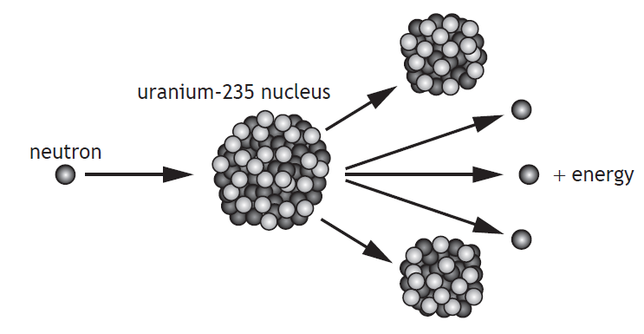  Explain how a single reaction can lead to the continuous generation of energy.
20.22.8 |  | The nuclear reactor produces waste that emits nuclear radiation.  State a use of nuclear radiation.
20.22.9 |  | SQA Int 2 2010  Many countries use nuclear reactors to produce energy. A diagram of the core of a nuclear reactor is shown.  (a) State the purpose of:  (i) the moderator; (ii) the control rods.  (b) One nuclear fission reaction produces 2·9 × 10–11J of energy. The power output of the reactor is 1·4GW. How many fission reactions are produced in one hour?  (c) State one advantage and one disadvantage of using nuclear power for the generation of electricity.
20.23 |  | I can provide a qualitative description of fusion, plasma containment, and their role in the generation of energy.
20.23.1 |  | Explain the term nuclear fusion.
20.23.2 |  | Nuclear fusion reactors are in the development stage.  - State an advantage of nuclear fusion over nuclear fission as a way of generating electrical energy.  - State a major difficulty with building fusion reactors  - State why this type of generator is not currently in use commercially.
20.23.3 |  | Nuclear fusion is the main way energy is generated in the Sun. State the simplified equation that shows this reaction.
20.23.4 |  | The diagram below shows a functioning nuclear fusion reactor.  - State the temperatures in the nuclear reactor required to allow fusion.  - State material in the reactor is a plasma, explain the term plasma  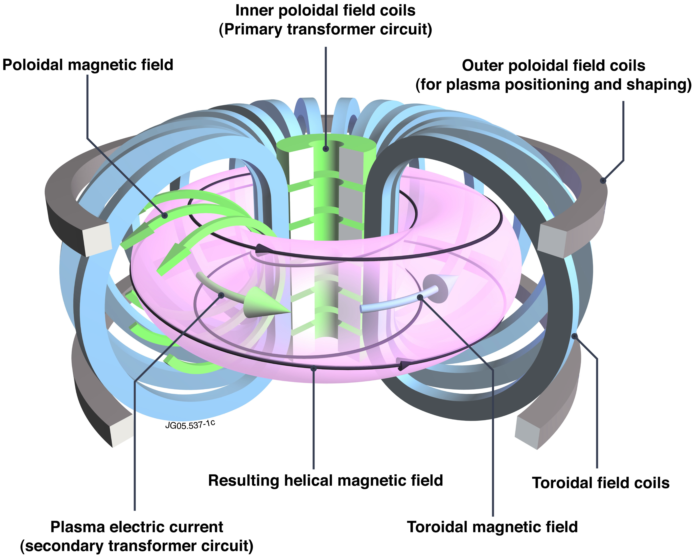
20.23.5 |  | State the potential advantages of nuclear fusion over nuclear fission.
20.23.6 |  | Summarise the video clip below, using bullet points.  https://www.bbc.co.uk/bitesize/clips/z4nwmp3
20.23.7 |  | Copy and complete  Nuclear _________ is the process by which ________ is released when a large _______ is hit by a _______, becomes unstable and splits into _____ or ______ smaller pieces, called ____________ ___________ plus two or three _________.  When fission occurs, some of the ________ of the _________ is 'lost' – it has been converted directly into ________. This energy is in the form of ________ which can be harnessed and used to generate ___________ in a nuclear power station.
20.23.8 |  | Copy and complete the following  Nuclear ____________ is the process by which _________ can be released when two ________ nuclei fuse together to form a __________ nucleus.
20.23.9 |  | Copy and complete the following passage..  During a nuclear _________ reaction two nuclei of smaller mass number combine to produce  a nucleus of larger mass number. During a nuclear ______ reaction a nucleus of larger mass number splits into two nuclei of smaller mass number. Both of these reactions are important because these processes can release ________ .
20.23.10 |  | State the requirements for a containment vessel used to contain a nuclear fusion reaction.

Notes

PHYSICS IN NUMBERS
Find the correct number from your notes, learn these numbers. Your syllabus could have many of the answers, so use it! Don’t forget to include relevant units or your answer is meaningless.
e.g State the height above the Earth of a satellite if placed in geostationary orbit. 36 000 km
- State the number of milliamps in an amp.
- State the number of metres in a kilometre.
- State the number of ohms in a megaohm.
- State the number of centimetres in a metre.
- State the number of Joules in a gigajoule.
- State the number of seconds in a minute.
- State the number of seconds in an hour.
- State the voltage of the mains supply in the UK.
- State the frequency of the mains supply in the UK.
- State the speed at which a electrical signals is transmitted along a wire at a speed.
- State the speed of light in air.
- State the speed of light in glass, eg in a fibre optic cable.
- State the speed of microwaves in air.
- State the speed of a television signal in air.
- State the speed of a radio signals in air.
- State the value of the gravitational field strength on the Earth.
- State the speed of X-rays in air.
- State the speed gamma radiation travels in air.
- State the two usual size of fuse that are usually fitted in a 13A plug.
- State the number of joules of energy in 1 kWh.
- State the initial acceleration of all objects when initially falling to Earth.
- State the weight of a 1kg object on the Earth
- State the mass of the 1kg object in space
- State the approximate speed of sound in air.
- State the approximate speed of ultrasound in air.
- State if sound travels faster or slower in solids than in air.

Variables & Exam Questions
Paper | Question
SQA  2018 | The energy of a water wave can be calculated using  $$E=\frac{ρgA^{2}}{2}$$  where:  E is the energy of the wave in J  ρ is the density of the water in kg m⁻³  g is the gravitational field strength in Nkg⁻¹  A is the amplitude of the wave in m.  A wave out at sea has an amplitude of 3·5 m. The density of the sea water is 1·02 × 10³ kgm⁻³ . Calculate the energy of the wave.
SQA N5  2019 | The table gives the distance from Earth, the approximate surface temperature and the age of five stars.  A student makes the following statements based on this information.  I As the distance from Earth increases, the age of a star decreases.  II As the age of a star increases, the approximate surface temperature of the star increases.  III There is no apparent relationship between the distance from Earth and the approximate surface temperature of a star  Copy out the table and the correct statements.
SQA  N5 2018 | A rain sensor is attached to the glass windscreen of a vehicle to automatically control the windscreen wipers. raindrop  LEDs rain sensor infrared detectors glass windscreen refracted light  Infrared light is emitted from LEDs and is received by infrared detectors.  The graph shows how the number of raindrops affects the percentage of  infrared light received by the infrared detectors.  The percentage of infrared light received by the infrared detectors from the LEDs controls the frequency with which the windscreen wipers move back and forth.  The table shows how the number of times the windscreen wipers move back and forth per minute relates to the number of raindrops.  At one point in time the infrared detectors receive 70% of the infrared light emitted from the LEDs. Show that the frequency of the windscreen wipers at this time is 0·90Hz
SQA N5  2014 | Catapults are used by anglers to project fish bait into water.  A technician designs a catapult for this use. Pieces of elastic of different thickness are used to provide a force on the ball.  Each piece of elastic is the same length.  The amount of stretch given to each elastic is the same each time.  The force exerted on the ball increases as the thickness of the elastic increases.  Which row in the table shows the combination of the thickness of elastic and mass of ball that produces the greatest acceleration?
  Thickness of elastic | Mass of ball
  (mm) | (kg)
  5 | 0.01
  10 | 0.01
  10 | 0.02
  15 | 0.01
  15 | 0.02
SEB O Level 1976 | Fig 1 shows a pendulum in its rest position A. The pendulum, bob has a mass of 0.3 kg. The bob is pulled to one side as shown in Figure 2 and held in position A which is 0.8 m above the rest position  The bob is released from position B and swings to and fro until it comes to rest.  - Find the gain in potential energy of the bob when it is moved from position A to position B.  - State the position of the bob when it has its greatest kinetic energy.  - Estimate the maximum speed of the bob.  - Describe the energy changes which take place from the time the bob is released until it eventually comes to rest.
SQA Int2 2012 | A resistor is labelled: “10 Ω ± 10%, 3 W”.  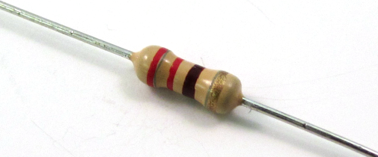  This means that the resistance value could actually be between 9 Ω and 11 Ω.  (a) A student decides to check the value of the resistance.  Draw a circuit diagram, including a 6 V battery, a voltmeter and an ammeter, for a circuit that could be used to determine the resistance.  (b) Readings from the circuit give the voltage across the resistor as 5·7 V and the current in the resistor as 0·60 A.  Use these values to calculate the resistance.  (c) During this experiment, the resistor becomes very hot and gives off smoke.  Explain why this happens.  You must include a calculation as part of your answer.  (d) The student states that two of these resistors would not have overheated if they were connected together in parallel with the battery.  Is the student correct? Explain your answer.
SQA N5 2015 | Craters on the Moon are caused by meteors striking its surface.  A student investigates how a crater is formed by dropping a marble into a tray of sand.  - Describe the energy change that takes place as the marble hits the sand.  The student drops the marble from different heights and measures the diameter of each crater that is formed.  The table shows the student’s results.  - Using the graph paper below, draw a graph of these results.  - Use your graph to predict the diameter of the crater that is formed when the marble is dropped from a height of 0·25 m.  - Suggest two improvements that the student could make to this investigation.  - Suggest another variable, which could be investigated, that may affect the diameter of a crater.
  height (m) | diameter (m)
  0·05 | 0·030
  0·10 | 0·044
  0·15 | 0·053
  0·35 | 0·074
  0·40 | 0·076
  0·45 | 0·076

