Literacy in Higher Physics
The following terms may appear in questions in the Higher Physics exam. A brief explanation is provided which will help you understand what you have to do when you see these terms appear.
Identify, name, give, or state – Usually worth one mark, an explanation of your answer is not required. State questions are often State what is meant by which have a precise definition.
Describe – You must provide a statement or structure of characteristics and/or features.
Explain –You need to provide details as to how something works or reasons as to why something is happening. You should relate the cause and effect and/or make the relationships between things clear. Sometimes this question will also include a phrase like “explain in terms of…” it is therefore vital that your explanation includes the words/terms mentioned.
Determine / Calculate – Your answer will be a numerical value with unit, calculated from given facts, figures or information usually awarded three marks. The first mark for selecting the correct formula, the second mark for correct substitutions and the third mark for the final answer with unit to an appropriate number of significant figures, correctly rounded. Do not copy down answers from your calculator that contain a large number of significant figures or use ellipses.
Sometimes a calculate question has more than three marks with a mark awarded for another calculation or for selecting a value(s) from a table or graph or analysing results of an experiment or previous calculation.
Estimate – Your answer is an approximate value for something. This estimate may be based upon a calculation, from a graph or be estimated by comparison to a previous response.
Justify – This term will often appear as a follow up to a state question. Here you must provide a reason for the statement/suggestion/conclusion you provided. This might be by identifying an appropriate relationship and the effect of changing variables. You can justify using a calculation but remember to also state your conclusion.
Must Justify - You must not only state or select the correct response, but also provide supporting justification to achieve any marks. If you provide no reason, then even if you have the correct statement you will receive no marks.
Show that – You should “show” a particular answer is correct, you must start your response with an appropriate relationship, show the correct substitutions, and end with the final answer as it is shown, including the correct unit, to obtain all the marks available. If you do not start with showing the correct relationship, there will be 0 marks, these are usually two-mark questions.
Predict – You must suggest what may happen based upon available information. This will involve some comparison of data and will often require you to get your answer by analysing a graph, a table or a set of results.
Suggest how/why – This is like an explain question, but is about applying knowledge and understanding to a new situation. Often it relates to providing a possible improvement to an experiment or a reason for why something hasn’t worked as well as it should. Often several responses are acceptable: marks will be awarded for any suggestions that are supported by knowledge and understanding of physics. Be aware if you put more than one response any incorrect one will prevent a mark for a correct one.
Using your knowledge of Physics, comment on…. - These are known as open-ended questions as they can have a range of different answers. You should make statements of relevant and correct physics at National 5 level. You can do this by providing explanations, calculations, justifications, suggestions and even drawings…… You will gain credit for the breadth and/or depth of your answer. You should answer in sentences and not in bullet points and making sure you refer to the question asked.
Draw – You need to draw something, it could be anything, but often a graph or line on a graph or circuit diagram etc. It is a good idea to use a ruler unless you are intentionally drawing a curve.
Compare – You will probably need to provide some numerical working as evidence for your final answer and compare it to another value (calculated or given).

Examples
Identify 2017 – Section 2 – Question 6 (a)
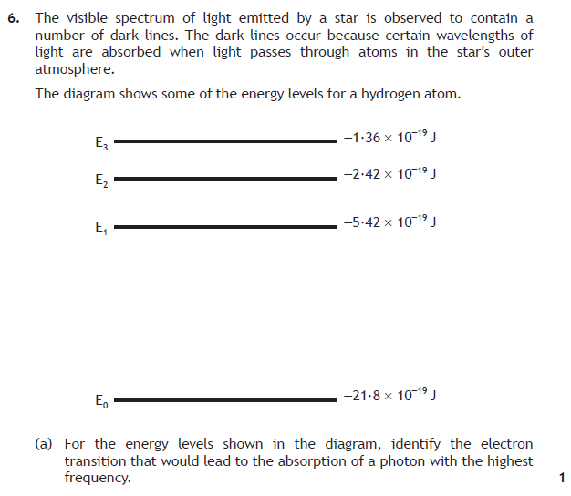
Answer
Acceptable answers would be:
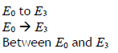
Additional Guidance
An arrow on the diagram could also get the marks however the direction must be correct (upwards).

State - 2017 – Section 2 – Question 1 (a) (i) and 7 (c) (i)
Answer
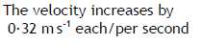
Additional Guidance
Also acceptable would be
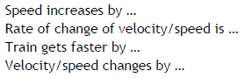
Answer
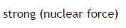
State - 2015 – Section 2 – Question 8 (a) and 10 (a) (i)

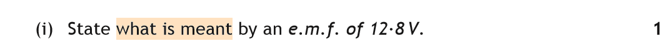

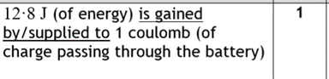

Describe 2019 – Section 2 – Question 9 (b)
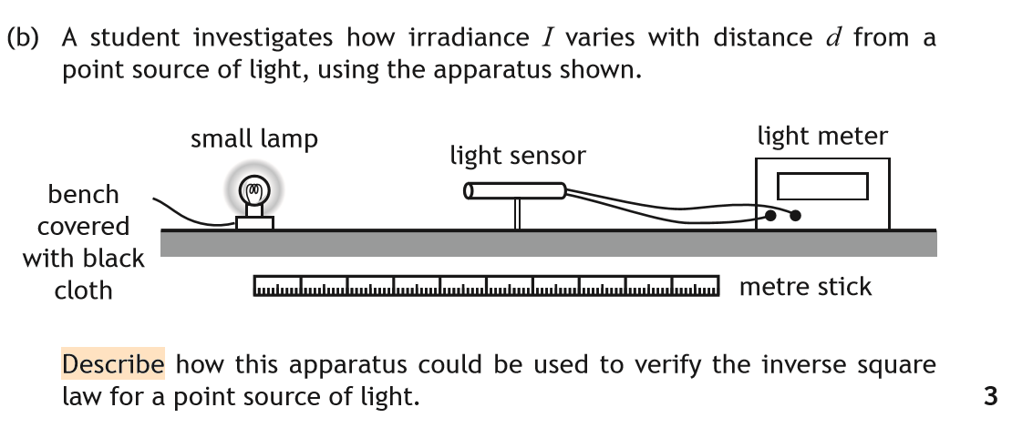

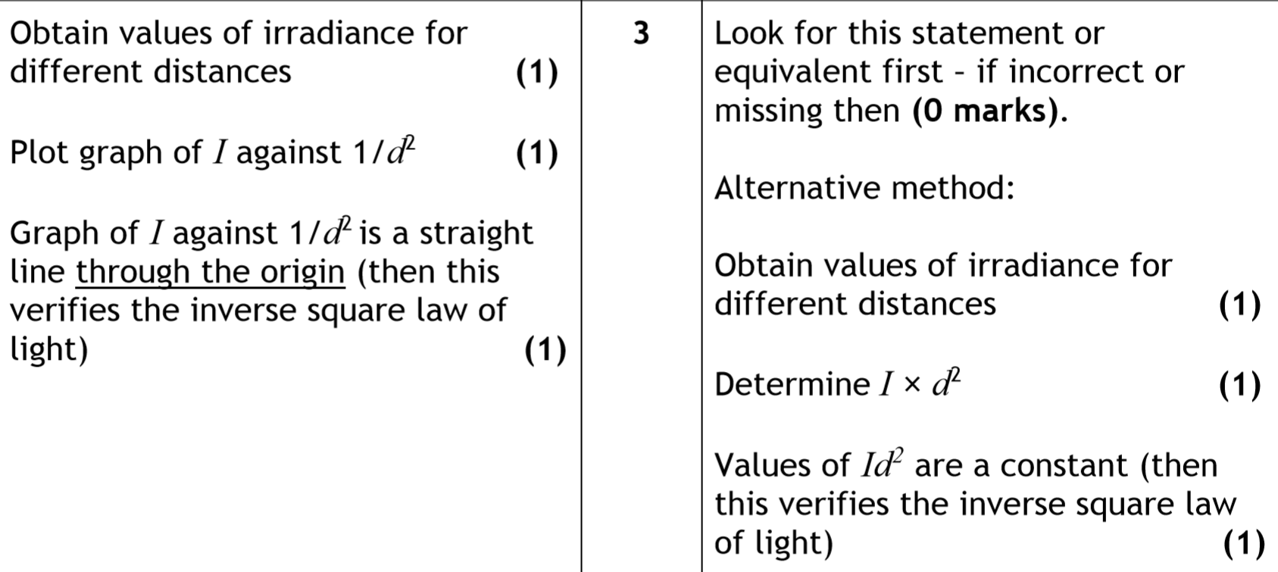

Show - 2017 – Section 2 – Question 12 b (i)
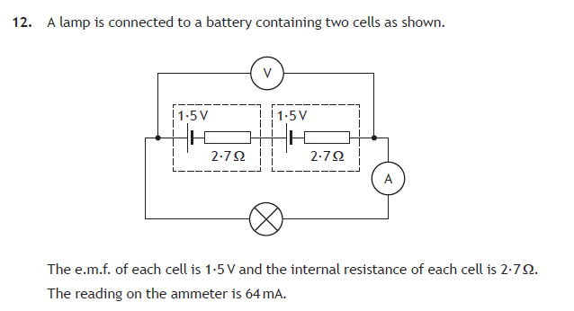
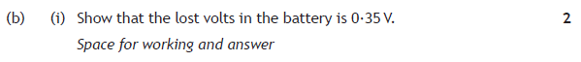
Answer
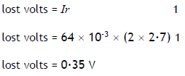 (no mark for final answer in “show” questions)
Additional Guidance
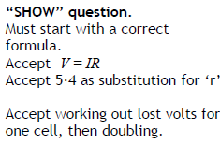

Determine and Justify – 2016 - Section 2 - Q4 (a) and (b)
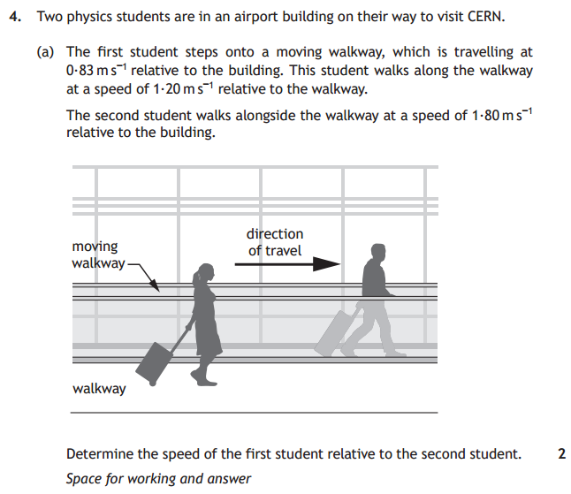
Answer
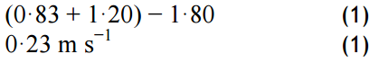
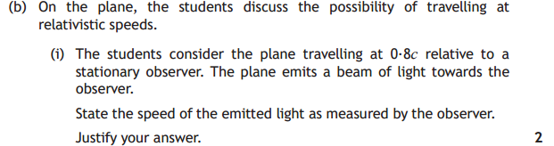
Answer
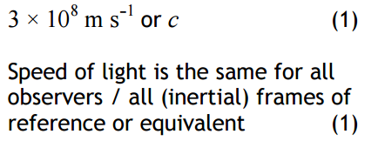
If the first statement is incorrect then zero marks. If statement 1 is correct on it’s own then 1 mark. If any wrong physics in justification then 1 mark can still be awarded for correct statement.

Must Justify 2019 Section 2 Q 11 (c)
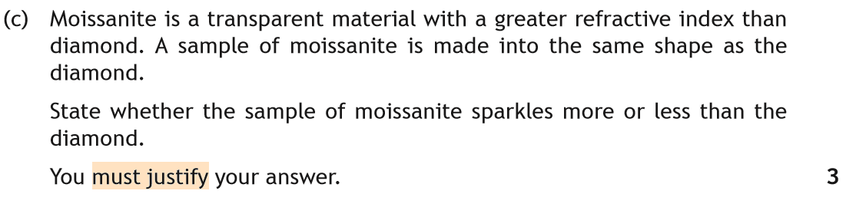
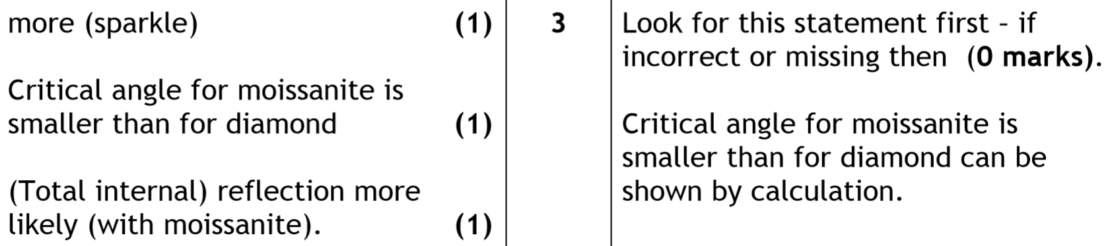
More with no justification 0 marks.
More with incorrect justification 1 mark

Explain – 2016 – Section 2 - Q 12 (b)
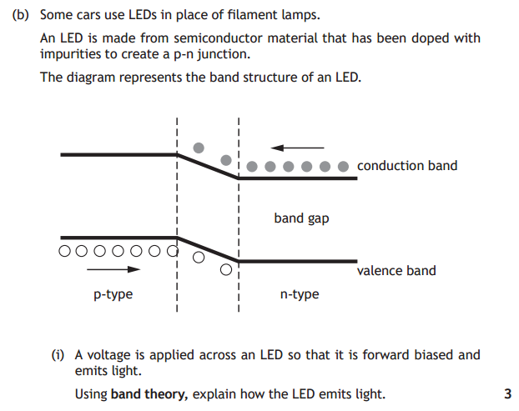
Answer
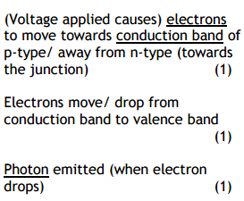
Additional Guidance
The underlined terms are important – it is difficult to get the marks without using them correctly. Any wrong physics then zero marks. Conduction or valence bands must be mentioned first, or zero marks as the physics would be wrong.

Explain in terms 2017 – Section 2 – Q10 (a)
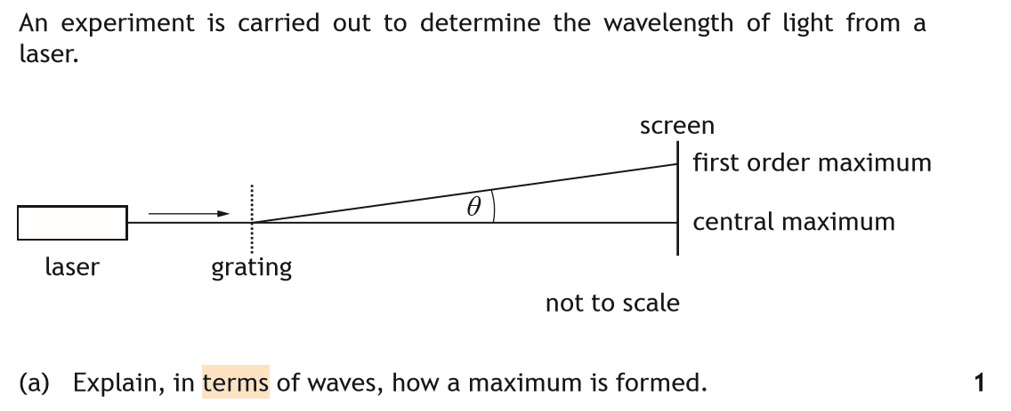
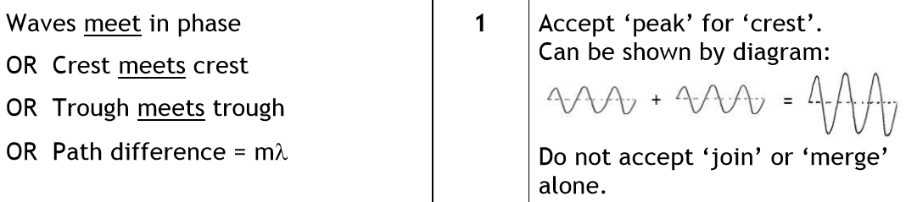

Determine (non-calculation type) - 2016 – Section 2 - 8(d)
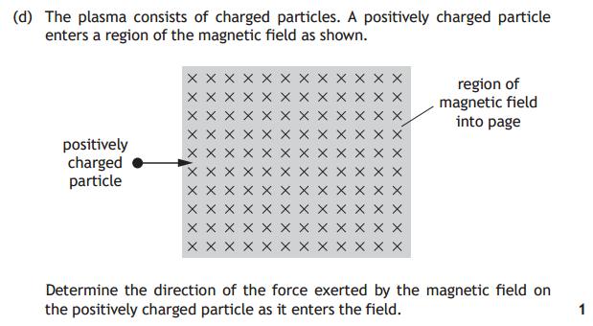
Answer
Additional Guidance
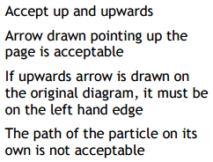

Suggest 2019 – Section 2 Q 13 (c)
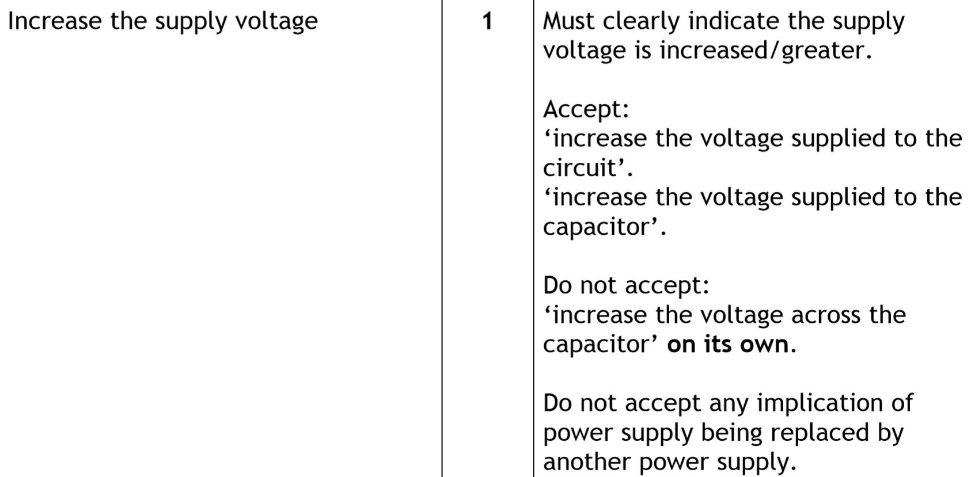
Compare - 2017 – Section 2 – Question 5 (a)
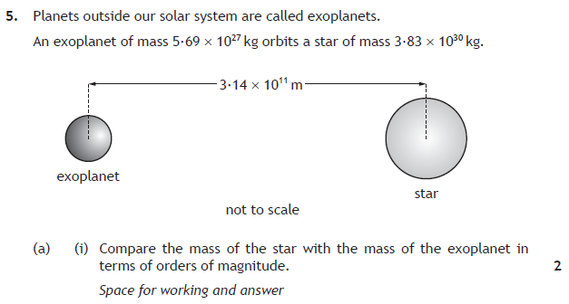
Answer
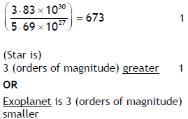
Additional Guidance
There are a variety of ways of correctly calculating this. See official marking scheme for all of them. If you state “greater” or “smaller” on its own, then 0 marks are awarded.

