ELECTRICITYANSWERS

Quantities for the ELECTRICITY Unit
For this unit copy and complete the table.
Quantity | Symbol | Unit | Unit Symbol | Scalar / Vector
Charge | Q | Coulombs | C | S
Current | I | Ampere | A | S
Voltage | V | Volt | V | S
Resistance | R | Ohm | Ω | S
Power | P | Watt | W | S
Energy | E | Joule | J | S
Time | t | Second | s | S
Frequency | f | Hertz | Hz | S

The ELECTRICITY unit in numbers
Quantity | Value
State the voltage of the mains supply. | 230 V
State the frequency of the mains | 50 Hz
State the usual maximum power for an appliance that can be fitted with a 3A fuse. | Up to 720 W
State the maximum power for an appliance that can be fitted with a 13A fuse. | Usually  720W- 2990W

No. | CONTENT
Electrical Charge Carriers
9.1 | I can define electrical current.
9.1.1 | Define the term electrical current.  An electric current is the rate of flow of electric charge. Or the electric charge that flows per second.
9.1.2 | Define the term one ampere.  There is a current of one ampere when a charge of one coulomb flows (past a point) per second.
9.1.3 | 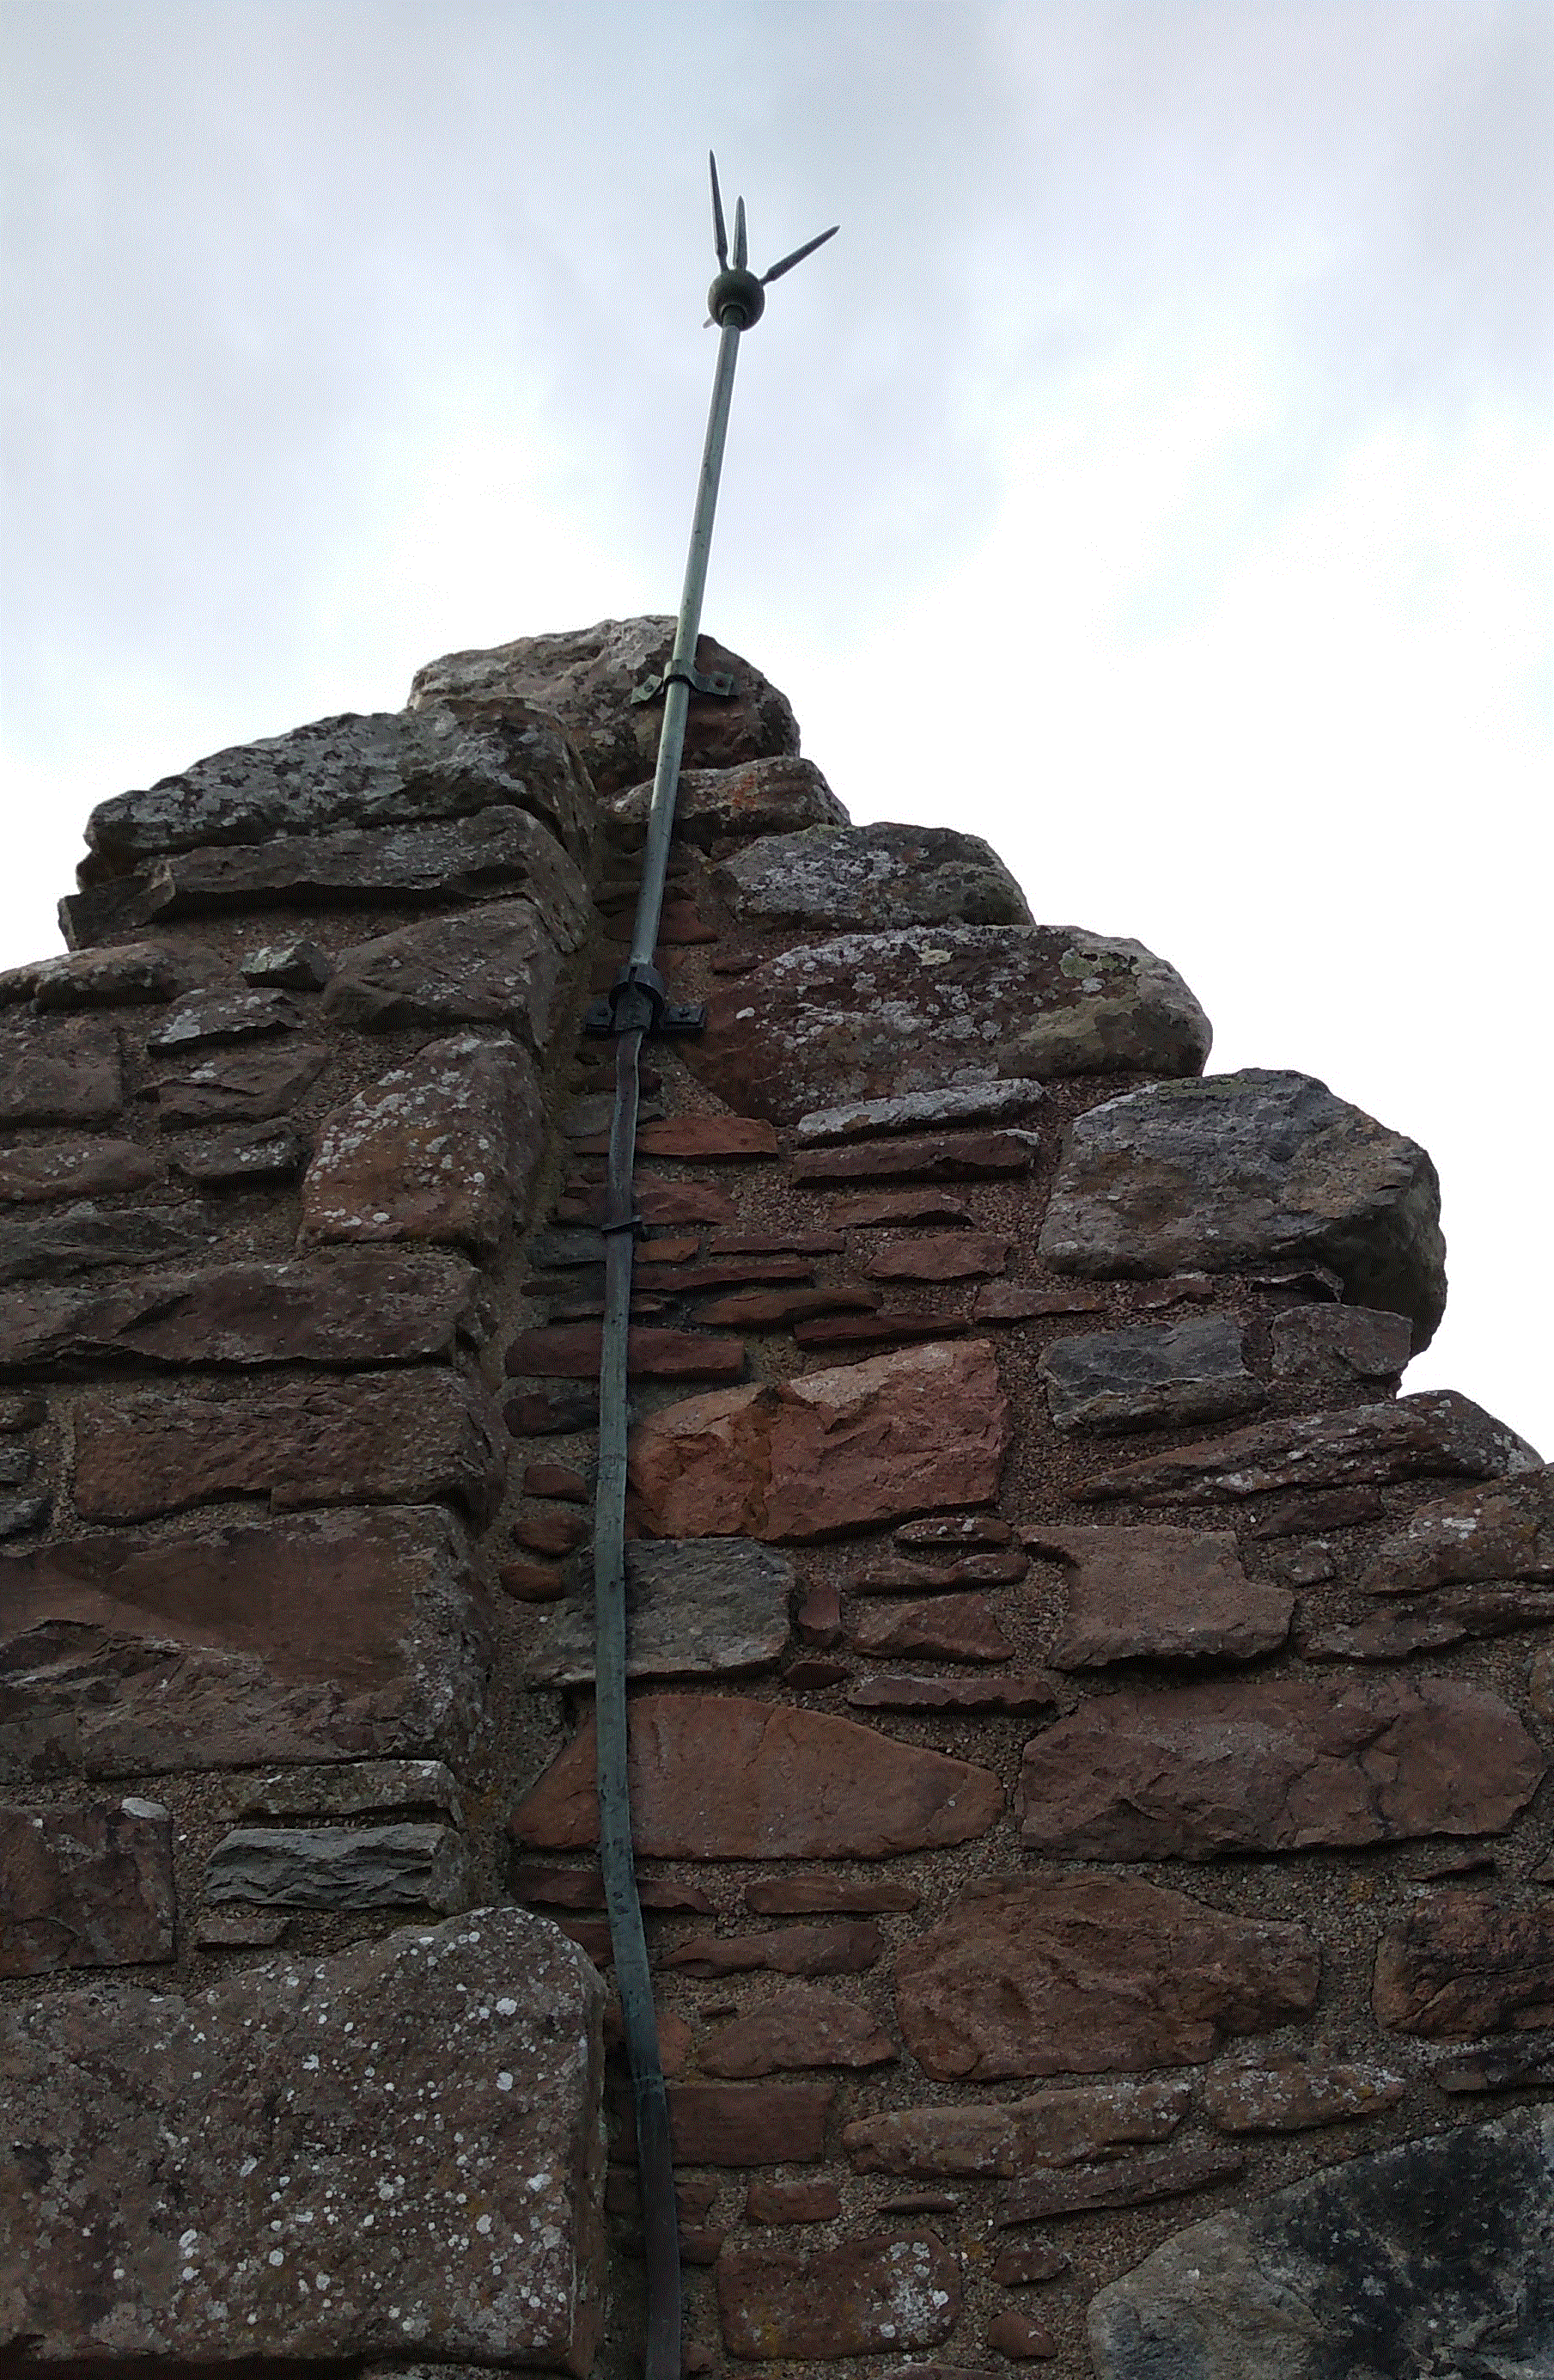  Many tall buildings have a thick strip of metal attached to the side of the building. This strip is used to protect the building from damage during electrical storms. Explain how this strip protects the building from damage.  Metal strip is a conductor.  More current will pass through (the strip than building).  Accept: ‘it conducts (electricity)’‘it has less resistance (than the building)’‘charge/electrons will pass through’ ‘less/no current will pass through the building’  Do not accept: ‘lightning/electricity will pass through’
9.2 | I can carry out calculations using the equation with charge, electric current and time.
9.2.1 | Write down the relationship between charge, electric current and time.  Write the symbols and units used for each.  $$Q=It$$  Q= charge (Coloumb), I=current (Ampere), t = time (second)
9.2.2 | The current in a heater is 7.0 A, calculate the charge flowing through the heater in 30.0 seconds.  $$Q=It$$  $$Q=7.0×30.0$$  $$Q=210 C$$
9.2.3 | A car headlamp uses a current of 2.0 A. Calculate the time the lamp must be switched on if 10.0 C of charge pass through it.  $$Q=It$$  $$10.0=2.0×t$$  $$t=5.0 s$$
9.2.4 | Two Coulombs of charge pass through a lamp in 6.0 seconds, calculate the current in the lamp.  $$Q=It$$  $$2=I×6.0$$  $$I=0.3 A$$
9.2.5 | A lightning strike lasts for 2.8 ms and delivers 50.4 C of charge. Calculate the current during the lightning strike.  t=2.8 ms =$2.8×{10}^{-3}$s  $$Q=It$$  $$50.4=I×2.8×{10}^{-3}$$  $$I=15 A$$
9.2.6 | A hair drier is switched on for 5 minutes with a current of 3 A, calculate the charge flowing through the hair drier during this time.  t= 5 mins= 5×60=300s  $$Q=It$$  $$Q=3×300$$  $$Q=900 C$$
9.2.7 | A switch is closed for 10 minutes. If 3600 C of charge pass through the switch in this time, calculate the current in the switch.  t= 10 mins= 10×60=600s  $$Q=It$$  $$3600=I×600$$  $$I=6.0 A$$
9.2.8 | Calculate the charge that flows along a wire when 25 μA passes for 2 hours  t= 2 hours= 2×60×60=7200s  I=25 μA=25×10⁻⁶A  $$Q=It$$  $$Q=2510^{-6}×7200$$  $$Q=0.18 C$$
9.2.9 | If a capacitor stores 20 mC of charge , calculate the time taken to discharge the capacitor if the average current in 0.4 μA.  Q=20 mC= 20×10⁻³ C  I=0.4 μA=0.4×10⁻⁶A  $$Q=It$$  $$2010^{-3}=0.410^{-6}×t$$  $$t=50 000 s$$  Which if you are interested using °’” button of 0°0’50000”= is 13 h 53 m and 20 s
9.2.10 |  | A circuit is set up as shown in the diagram. The reading on ammeter A1 is 5.0 A. The reading on ammeter A2 is 2.0 A. Calculate the charge passing through the lamp in 30 s  $$I_{t}=I_{1}+I_{2}$$  $$5.0=2.0+I_{2}, I_{2}=3.0 A$$  $$Q=It$$  $$Q=3.0×30$$  $Q=90 C$
9.3 | I can explain the difference between A.C. and D.C.
9.3.1 | Explain, in terms of electron flow, the term alternating current.  In A.C the. direction of movement of electrons/charges continually reverses (and the magnitude changes too)
9.3.2 | State if the mains supply is A.C. or D.C..  Mains is A.C.
9.3.3 | State the frequency of the mains supply. 50 Hz
9.3.4 | (a) State the meaning of the term peak voltage.  Peak voltage is the maximum voltage obtained during the A.C. cycle as shown in the diagram.  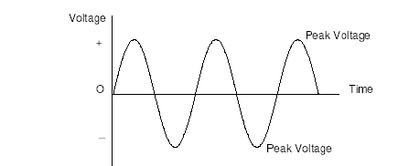  (b) State how the peak voltage of the mains compares with the voltage you would read on a voltmeter. Draw a diagram to help you.  Vp  The peak voltage of an A.C supply is ALWAYS greater than the quoted voltage (√2 or 1.414 × greater)
9.3.5 | A student makes the following statements about A.C. and D.C. circuits.  I. In an A.C. circuit the direction of the current changes regularly.  II. In a D.C. circuit negative charges flow in one direction only.  III. In an A.C. circuit the size of the current varies with time.  Copy out the correct statements. All correct so copy all statements
9.3.6 | State the type of current do you get from  - batteries, and D.C.  - from the mains. A.C.
9.4 | I can compare the traces of A.C. with D.C. when viewed on an oscilloscope or data logging software.
9.4.1 | Copy these traces and determine if they show A.C. or D.C..  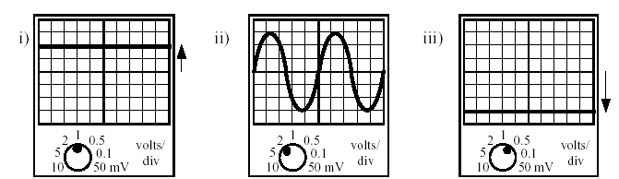  D.C A.C. D.C
9.4.2 | An A.C. supply is labelled 12 V. The peak voltage is measured using an oscilloscope.State which of the following is likely to be the measured peak voltage: 17 V, 12 V, 8.5 V, 6 V  Explain your answer. 17 V as it is greater than the quoted voltage
Calculate the peak voltages of the traces below using the Y-gain settings shown.
++
The peak voltage is the number of squares between top to bottom divided by two (or if it is central just from the middle to the top) multiplied by the volts/division value.
a) | b) | c)
Top to bottom= 4sq | Top to bottom= 8sq | Top to bottom= 6sq
Middle to top= 2sq | Middle to top= 4sq | Middle to top= 3sq
V/div=5V/div | V/div=0.1V/div | V/div=50 mV/div
V_{p}= 5 × 2 = 10 V | V_{p}= 0.1 × 4 = 0.4 V | V_{p}= 50 ×10⁻³×3 = 0.15V

9.4.4 | The trace is produced from the mains supply. If the settings on the oscilloscope are not changed, sketch the trace that would be produced by the following A.C. supplies  - Peak voltage 5 V at a frequency of 25 Hz  - Peak voltage 20 V at a frequency of 75 Hz.  Mains frequency is 50Hz,  - 25 Hz is half the frequency of the mains so there will be half the number of waves on the screen ie 2 waves  - 75 Hz is 1.5x mains voltage so that will be the 4 waves on the screen plus the 2 from the 25 giving 6 waves (or 1.5x4)
9.4.5 | The mains supply is quoted as 230 V. If connected to the mains supply, state which of the following devices would display a value of 230 V:  - an oscilloscope this would show the peak voltage so would show 325Hz  - an A.C. voltmeter. this would show 230V as long as it was on the A.C. setting.
9.4.6 | Two identical bulbs are lit by the supplies shown below.  Explain which bulb will be the brighter.  The quoted voltage on an A.C trace is equivalent to a D.C. voltage i.e. 5V D.C is equivalent to a quoted voltage of 5V A.C. Peak voltage is greater than the quoted voltage.  A peak voltage of 5V will be a quoted voltage of less than 5V (about 3.5V) so the bulb connected to the D.C.supply would be brighter.
Potential Difference (Voltage)
10.1 |  |  | I know that a charged particle experiences a force in an electric field.
10.1.1 |  |  | State the definition of an electrical field.  An electric field is a region where a charge experiences a force of electrical origin.
10.1.2 |  |  | State the causes of an electric field.  An electric field is caused by charge.
10.1.3 |  |  | Copy and complete the following  In an electric field a charge experiences a force . This causes the charge to accelerate (F=ma). If the charge is positive it will move in the opposite direction to the direction of the field lines, if the charge is negative the charge will move along the field lines.
10.2 |  |  | I can describe the effect of electric fields on a charged particle
10.2.1 |  |  | Copy and complete these diagrams to show the direction of the electric field.  +  +  +  +  +  +  +  +  +  +  +  +  -  -  -  -  -  -  -  -  -  -  -  -  The lines should be equidistant.The arrows must go from top to bottom.
10.2.2 |  |  | A uniform electric field exists between plates Q and R.  The diagram shows the path taken by a particle as it passes through the field.  If the charge on R is positive, state the possible charge on P and Q  If the charge on R is positive then Q is likely to be negative as the charge is moving suggesting a uniform field between the plates (see above). This would then mean that P is positive as it is attracted towards plate Q and away from plate R, which we know is positive.
10.2.3 |  |  | Copy this diagram and add the paths of the following particles entering at right angles to the electric field:  - Electron (b) Proton (c) Neutron  +  +  +  +  +  +  +  +  +  +  +  +  -  -  -  -  -  -  -  -  -  -  -  -  a)  c)  b)
10.2.4 |  |  | An alpha particle, a beta particle and a gamma ray enter an electric field at right angles to the field. Which letter shows the most likely position of the:  - Alpha particle (b) Beta particle (c) Gamma ray  Position Y Z X  +  +  +  +  +  +  +  +  +  +  +  +  -  -  -  -  -  -  -  -  -  -  -  -  Y  Z  X
10.2.5 |  |  | State what happens to a negatively charged particle moving parallel to a uniform electric field.  +  +  +  +  +  +  -  -  -  -  -  -  The negatively charged particle will not be deflected but will decelerate if it is heading for the negative plate or will be accelerated towards the positive plate. If the charge was going slow enough towards the negative plate and the field was great then the charge might slow down stop and travel in the opposite direction
10.2.6 |  |  | I don’t think this is on the course! It might be worth having a quick flaviour of what is happening  A magnet is moved through a coil of wire. (a) Describe what is seen on the analogue voltmeter  A changing voltage would be seen on the voltmeter ***** which will return to zero *****  - State ways to increase the induced voltage.  Move the magnet faster through the coil, increase the strength of the magnet and/or increase the number of coils.
10.3 |  |  | I know the path a charged particle takes between two oppositely charged parallel plate
10.3.1 |  |  | Draw a diagram of the electric field between two oppositely charged parallel plates.  +  +  +  +  +  +  -  -  -  -  -  -
10.3.2 |  |  | Copy the diagram of two parallel charged plates. Show the route taken by each of the following particles in the field. Explain the movement of each particle in the field.
(i) |  |  | - an electron placed in the centre and initially not moving.  _ _ _ _ _ _ _ _ _ _ _ _ _ _ _ _ _ _ _  + + + + + + + + + + + + + + + + + + +  The electron has no initial velocity. The force from the electric field causes it to accelerate towards the positive plate, as opposite charges attract.
(ii) |  |  | - an electron moving from right to left as it approaches the plates.  An electron is negatively charged so will be attracted towards the positive plate. However, it also has a horizontal velocity unaffected by this force. The parabola is the combination of these two motions.  _ _ _ _ _ _ _ _ _ _ _ _ _ _ _ _ _ _ _  + + + + + + + + + + + + + + + + + + +
(iii) |  |  | - A proton moving from left to right.  A proton is positively charged so will be attracted towards the negative plate. However, it also has a horizontal velocity unaffected by this force. The parabola is the combination of these two motions.  _ _ _ _ _ _ _ _ _ _ _ _ _ _ _ _ _ _ _  + + + + + + + + + + + + + + + + + + +
(iv) |  |  | - A beta particle moving from left to right  _ _ _ _ _ _ _ _ _ _ _ _ _ _ _ _ _ _ _  + + + + + + + + + + + + + + + + + + +  A beta particle is an electron originating from the nucleus of an atom is negatively charged so will be attracted towards the positive plate. However, it also has a horizontal velocity unaffected by this force. The parabola is the combination of these two motions.
(v) |  |  | (v) An alpha particle moving from left to right  _ _ _ _ _ _ _ _ _ _ _ _ _ _ _ _ _ _ _  + + + + + + + + + + + + + + + + + + +  An alpha particle is positively charged but 4 times more massive than a proton,so will be attracted towards the negative plate and due to it’s mass. ******** However, it also has a horizontal velocity unaffected by this force. The parabola is the combination of these two motions.
(vi) |  |  | A neutron moving from left to right.  _ _ _ _ _ _ _ _ _ _ _ _ _ _ _ _ _ _ _  + + + + + + + + + + + + + + + + + + +  A neutron is an uncharged particle so is unaffected by the charges between the two plates. It is not affected by the electric field/force.
10.3.3 |  |  | State the effect on a neutron moving from left to right between the parallel plates shown below.  A neutron is an uncharged particle so is unaffected by the charges between the two plates. It is not affected by the electric field/force.
10.4 |  |  | I know the path a charged particle takes near a single point charge
10.4.1 |  |  | State what the electric field lines indicate when drawn around a charge.  Electric field lines tell us about the direction and strength of an electric field within a region of space (the direction is represented by the arrows, and the strength/intensity by how close the field lines are apart). NB Field lines never touch or cross. They would also can give information about the way in which a charged particle will move.
10.4.2 |  |  | Draw the field lines around the following charges, include the arrows.  - b)
10.4.3 |  |  | State the direction an electron would take if it was placed close to the charge shown below.  In a) the electron would move in the opposite direction to the field lines shown in a). In b) the electron would move against the field lines.  - b)
10.5 |  |  | I know the path a charged particle takes between two oppositely charged points
10.5.1 |  |  | Draw the field lines around the following charges, include the arrows.
10.5.2 |  |  | State the direction a negative charge would move in relation to the field lines around the following charges  A negatively charged particle would move along a field line but in the opposite direction to the arrows shown on the field lines in the diagram above.
10.6 |  |  | I know the path a charged particle takes between two like charged points
10.6.1 |  |  | Draw the field lines around the following charges, include the arrows.
  a) | 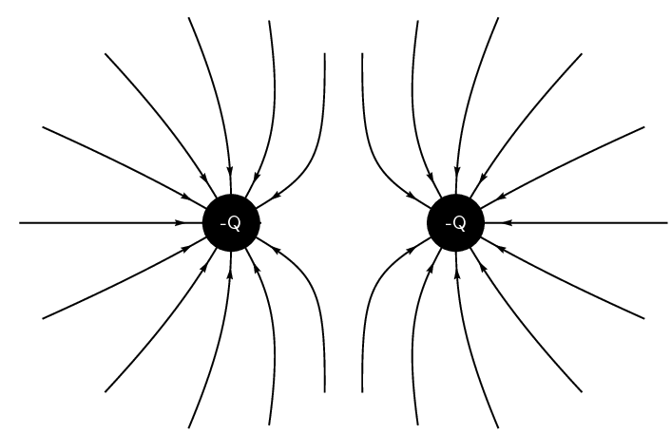 | b) | 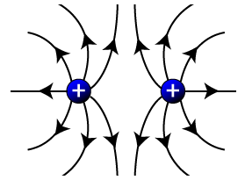
10.6.2  *** |  |  | State the direction a negative charge would take along the field lines around the following charges
  a) |  | b) | -Q
  A negative charge would move along a field line in the opposite direction indicated by the arrows.
10.6.3 |  |  | State the direction a positive charge would take along the field lines around the following charges
  a) |  | b) | 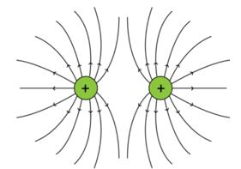
  A positive charge would move along a field line in the direction indicated by the arrows.
10.7 |  |  | I can define the potential difference (voltage) of the supply.
10.7.1 |  |  | Copy and complete the following definitions choosing the correct ending from the list below.  The voltage of an electrical supply is a measure of the  ….energy given to the charges in the circuit.
10.7.2 |  |  | Copy and complete the following definition  1 volt is equivalent to  …..1 joule per coulomb
10.7.3 |  |  | State what happens to the brightness of a bulb when the potential difference across it is increased.  The brightness of the bulb increases as each coulomb of charge is transferring more energy to the components (voltage is equivalent to energy per coulomb)
Ohm’s Law
11.1 |  | I can make use of a V-I graph to determine resistance.
11.1.1 |  | State the meaning of the term resistance.  Resistance is the opposition to the flow of charge. It is the ration of voltage across is to current through it R=V/I .
11.1.2 |  | State the name given to the ratio of V/I for a resistor  V/I= resistance (which is a constant value for a resistor).
11.1.3 |  | State the meaning of the term ohmic conductor.  An ohmic condictor is generally any conductor of which a graph of voltage against current produces a straight line passing through the origin.
11.1.4 |  | The graph shows how the voltage across a resistor changes the current through it.  - State what is found from the gradient of the graph shown.  The gradient is V/I which is R, so the gradient tells us the resistance.  - Determine the gradient of the graph and give its correct units.  - first ensure you know what each box on each axis represents (here each box on voltage axis = 0.4V, each box on the current axis = 0.05 A)  - Use the equation  $$m=\frac{y_{2}-y_{1}}{x_{2}-x_{1}}$$  - Calculate the gradient  $$m=\frac{8.0-2.0}{0.16-0.04}=\frac{6}{0.12}=50 {VA}^{-1} or Ω$$
11.1.5 |  | The graph shows how the voltage across a resistor changes the current through it.  - State what is found from the gradient of the graph shown.  Notice this graph is a plot of I against V so the gradient $=\frac{1}{R}$  b) Determine the gradient of the graph  - first ensure you know what each box on each axis represents (here each box on voltage axis = 0.2V, each box on the current axis = 0.4V)  - find two points that are on the line and cross both gridlines. Do not pick points that are marked with x as they won’t necessarily be on the line. Here you could pick points for a voltage reading of 3V or 8V as both these cross exactly on gridlines, you could also choose 0,0 as in this case the line goes through the origin.  - Then use the equation  $$m=\frac{y_{2}-y_{1}}{x_{2}-x_{1}}$$  - Calculate the gradient  $$m=\frac{1.48-0.56}{8-3}=\frac{0.92}{5}=0.18 {AV}^{-1} or Ω^{-1}$$  - Determine the resistance of the resistor used in this circuit.  $$R=\frac{1}{gradient}$$  $$R=\frac{1}{0.18}=5.6 Ω$$
11.1.6 |  | A student sets up the diagram as shown in the diagram to find out if Ohm’s Law holds for the resistor.  A  V  +  -  0 - 10V d.c  - Using the data below plot a graph of voltage across a resistor and the current through it.  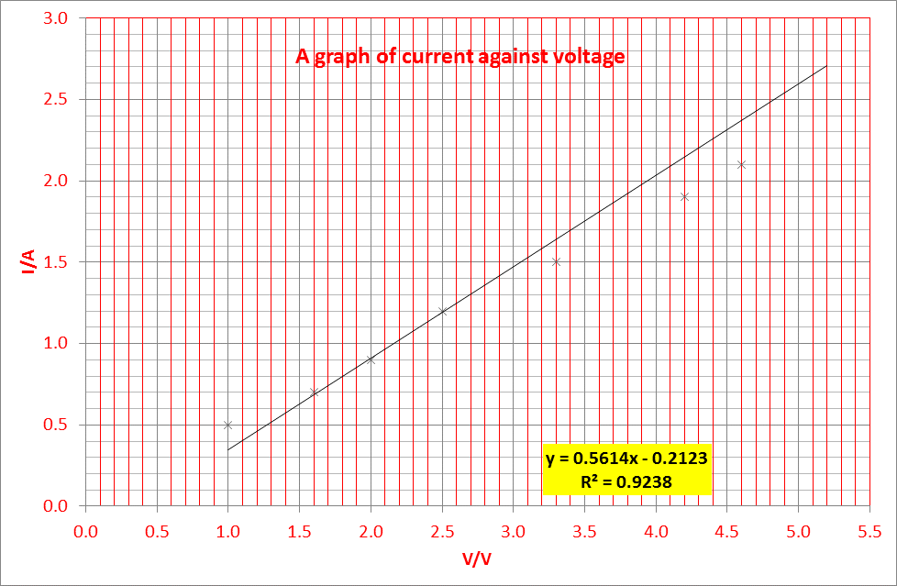  - The student suspects one of the results was written down incorrectly, identify this point on your graph.  Point 5.2V, 3.2V  By removing this point all the rest of the points line up in a line which is much closer to the line  - Plot the gradient of the graph excluding the incorrect point.  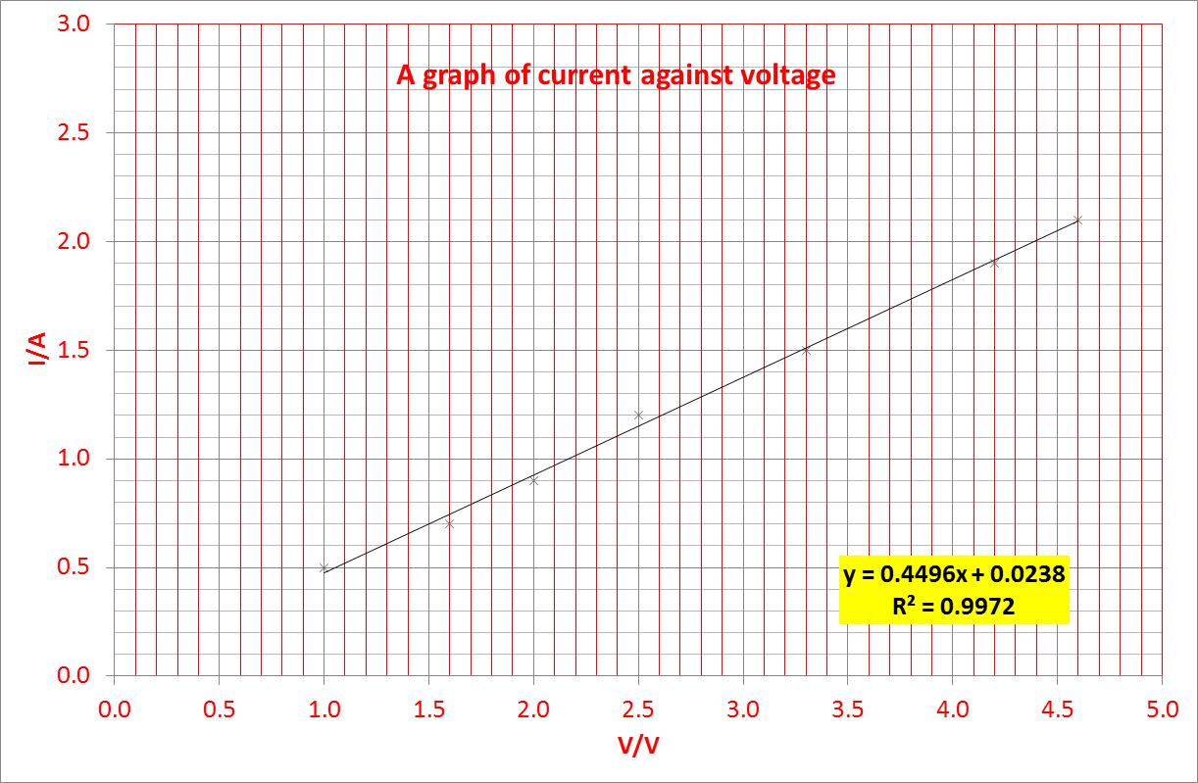  From the equation of the line gradient is 0.4496  - Calculate the resistance of the resistor from your graph.  $$resistance=\frac{1}{graient}=\frac{1}{0.4496}=2.2 Ω$$  $$or calculate the gradient from the line, NEVER THE POINTS$$
  Voltage | Current
  (V) | (A)
  1.0 | 0.5
  1.6 | 0.7
  2.0 | 0.9
  2.5 | 1.2
  3.3 | 1.5
  4.2 | 1.9
  4.6 | 2.1
  5.2 | 3.2
11.1.7 |  | State the meaning of the term non-ohmic conductor.  In a non ohmic conductor a graph of V against I does not produce a straight line graph, or V/I does not remain constant.
11.2 |  | I can make use of an appropriate relationship to calculate potential difference (voltage), current and resistance  V = IR $V_{2}=\left(\frac{R_{2}}{R_{1}+R_{2}}\right)V_{s}$ $\frac{V_{1}}{V_{2}}=\frac{R_{1}}{R_{2}}$
11.2.1 |  | 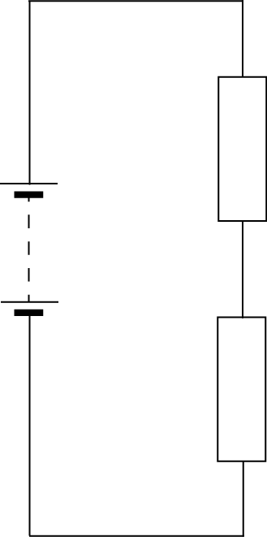  12 V  30 Ω  20 Ω  Calculate the p.d. across the 20 Ω resistor.  $$V_{2}=\left(\frac{R_{2}}{R_{1}+R_{2}}\right)V_{s}$$  $$V_{2}=\left(\frac{20}{30+20}\right)12$$  $$V_{2}=4.8 V$$
11.2.2 |  | 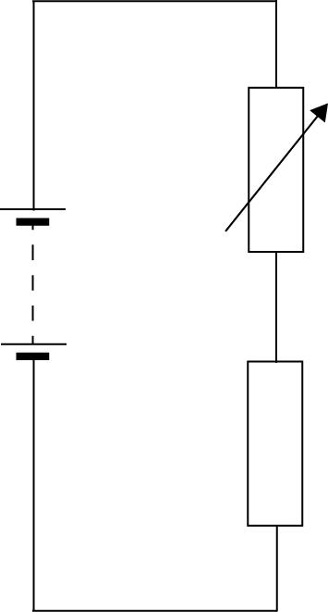  15 V  4.5 kΩ  The potential difference across the variable resistor should be 6 V. The variable resistor can be any value between 1 kΩ and 10 kΩ. Determine the resistance setting of the variable resistor.  $$\frac{V_{1}}{V_{2}}=\frac{R_{1}}{R_{2}}$$  $$\frac{6}{(15-6)}=\frac{R_{1}}{4.5 k}$$  $$\frac{6×4500}{(15-6)}=R_{1}$$  $$R_{1}=3000 Ω$$
11.2.3 |  | Calculate the missing resistance from the circuits below
  (i) | (ii) | (iii)
  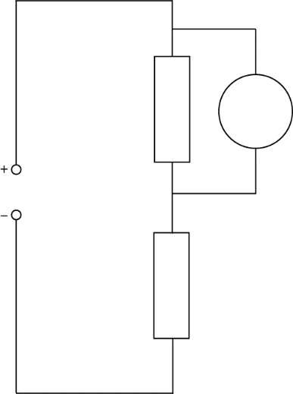  8 Ω  12 V  3 V  6 V  34 kΩ  5 V  2.3 V  2.4 V  4.8 kΩ | 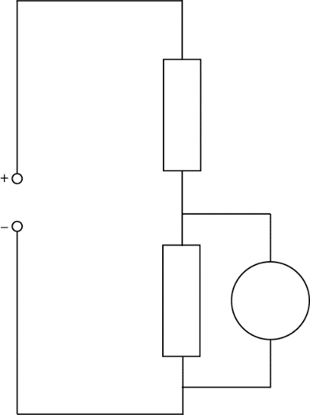 | 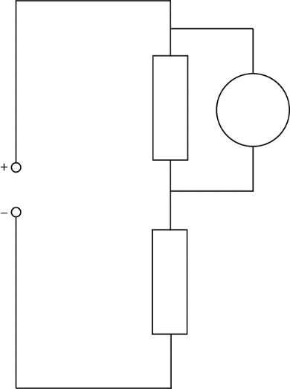
  $$V_{s}=V_{1}+V_{2}$$  $$12=2.4+V_{2}$$  $$V_{2}=9.6 V$$ | $$V_{s}=V_{1}+V_{2}$$  $$3=V_{1}+2.3$$  $$V_{1}=0.7 V$$ | $$V_{s}=V_{1}+V_{2}$$  $$6=5+V_{2}$$  $$V_{2}=1 V$$
  Either use this way around or rearrange it as in part c)  $$\frac{V_{1}}{V_{2}}=\frac{R_{1}}{R_{2}}$$  $$\frac{2.4}{9.6}=\frac{4.8 k}{R_{2}}$$  $$\frac{9.6}{2.4}=\frac{R_{2}}{4.8 k}$$  $$\frac{9.6×4800}{2.4}=R_{2}$$  $$R_{2}=19200 Ω or 192 kΩ$$ | $$\frac{V_{1}}{V_{2}}=\frac{R_{1}}{R_{2}}$$  $$\frac{2.3}{0.7}=\frac{{ R}_{2}}{34000}$$  $$\frac{2.3×34000}{0.7}=R_{2}$$  $$R_{2}=112 kΩ$$ | $$\frac{V_{1}}{R_{1}}=\frac{V_{2}}{R_{2}}$$  $$\frac{5.0}{R_{1}}=\frac{1.0}{8}$$  If what you want I on the bottom flip both sides upside down  $$\frac{R_{1}}{5.0}=\frac{8}{1}$$  $$R_{1}=5.0×\frac{8}{1}$$  $$R_{1}=40Ω$$
11.2.4
  A student sets up the circuit shown below.
  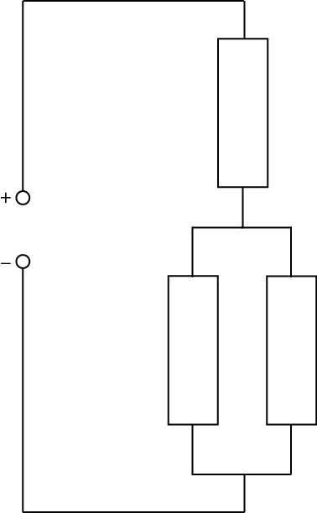  5 V  100 Ω  400 Ω  120 Ω | Calculate the current supplied to the circuit.  Think on this one, the first thing you need to do is work out the total resistance. It is a three stage calculation.  $$\frac{1}{R_{p}}=\frac{1}{R_{1}}+\frac{1}{R_{2}} \\ \frac{1}{R_{p}}=\frac{1}{400}+\frac{1}{100}= \frac{5}{400}$$  $$R_{p}=80Ω$$  Then find the total resistance  $$R_{t}=R_{1}+R_{p}=80+120=200Ω$$  Now you can find the current  $$V=IR$$  $$5=I×200$$  I=0.025 A
  Calculate the potential difference across the parallel section of this circuit.
  $$V_{p}=\frac{R_{P}}{R_{1}{+R}_{2}}× V_{s}$$
  $$V_{p}=\frac{80}{200}× 5$$
  $$V_{p}=2 V$$
  Calculate the current in the 100 Ω resistor
  $$V=IR$$
  $$2=I×100$$
  $$I=\frac{2}{100 }=0.02 A$$
  You can also check as if you do 2/400 (the other resistor in parallel it comes to 0.005A add this to the 0.02A and you get 0.025 A which is the total current in the circuit)
11.2.5 |  | An LED can carry a current of 10 mA and h as a voltage drop across it of 2 V  Calculate the resistance of the resistor that must be placed in series if placed in a circuit with a 12 V supply.  +  -  12 V  V_{LED}
11.2.6 |  | 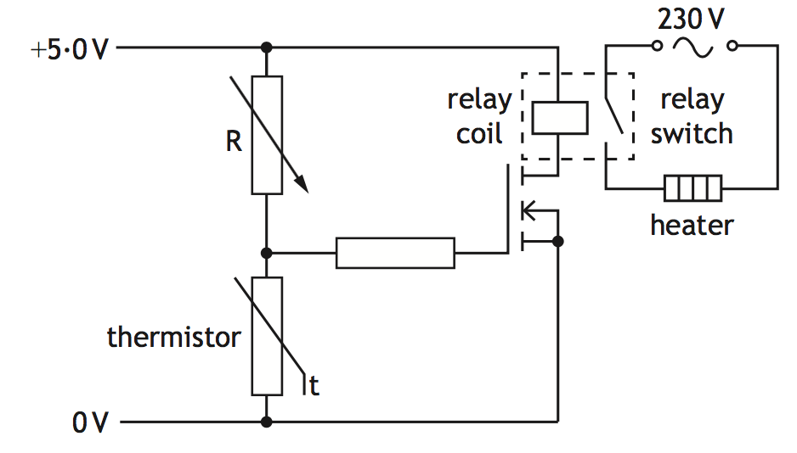  The variable resistor in the circuit below is set to 1050 Ω  Explain how the circuit operates to switch on the heater when the temperature falls below a certain value (You must calculate the required voltage across the thermistor).  The input device is a thermistor and its resistance changes with temperature. As temperature increase resistance across the thermistor decreases. This causes a decrease in voltage drop across the thermistor. This voltage across the gate drops below 2.0 V and the MOSFET switches OFF. This causes the relay coil to demagnetise and causes the relay switch to switch off.  In the original exam question you would be able to work out the voltage drop across the thermistor as there are more parts to the question.
11.3 |  | I can describe the relationship between temperature and resistance of a conductor.
11.3.1 |  | State the meaning of the term resistance. The opposition of a substance to the flow of electrons (current)
11.3.2 |  | Explain the difference between a conductor and an insulator  A conductor is a material with free electrons which allows electrons to flow through it.  An insulator is a material with no free electrons, so that electrons cannot flow through it.
11.3.3 |  | State 6 materials that are conductors and 6 that are insulators. Display your answers in a table
  Conductors | Insulators | NB do not include ITEMS such as chair, table, etc. These could be made of a selection of materials, some of which are conductors, come of which are insulators. Don’t forget some gases etc. Think periodic table from S1!
  (any metal)  – but state them | Rubber
  silver | Plastic
  Copper | Air
  Aluminium | Wood
  Brass | Granite
  Zinc / graphite | flax
11.3.4 |  | A circuit is shown with three gaps. For the lamp to light on state whether each gap should be filled with a conductor or an insulator.  The circuit is incomplete so for the lamp to light there must be a connection from the battery to the lamp and back. This would require gap 1 and gap 3 to be filled with a conductors. Gap 2 should not be filled with a conductor as this would short circuit the lamp and all the current would pass through the conductor in the gap. So gap 2 should be filled with an insulator. In summary
  Gap | Filling
  1 | Conductor
  2 | Insulator
  3 | conductor
11.3.5 |  | A student writes the following statements about electrical conductors.  I Only protons are free to move.  II Only electrons are free to move.  III Only negative charges are free to move.  Copy out the statement(s) which is/are correct.
11.3.6 |  | Explain how the temperature affects the resistance of  - a resistor a thermistor has a resistance that changes with temperature with a ceramic resistor they are able to dissipate the heat to the outside. Ohmic conductor resistance doesn’t change with temperature. If some can be raised to sufficient enough temperature where it does change, then it’s said to be non-ohmic at that point. Many ‘conductors’ are ohmic only within a specific temperature range.  A non-ohmic is one whose resistance will vary with temperature. Depending on the material its resistance can increase or decrease.  - a wire as temperature increases the resistance increases  - a piece of metal, any conductor. As temperature increases the resistance increases.
11.3.7 |  | State the relationship between temperature and resistance for a conductor.  Increasing the temperature of a conductor increases the resistance of the conductor. As temperature increases, resistance increases. (They are proportional)
11.4 |  | I can describe how increasing the temperature of a conductor changes the resistance of the conductor.
11.4.1 |  | Sketch a graph showing how the resistance of a resistor changes with the current through it, numerical values are not required.  current  resistance
11.4.2 |  | 0  Sketch a graph showing how the current in a resistor varies with the voltage across it numerical values are not required.
11.4.3 |  | State the relationship between current and voltage for a resistor at constant temperature, numerical values are not required.  0  See the diagram above
11.4.4 |  | SQA Nat 5 2016  A student investigates the resistance of a resistor using the circuit shown.  - Copy and complete the circuit diagram to show where a voltmeter must be connected to measure the voltage across resistor R.  Voltmeter across resistor R (1)  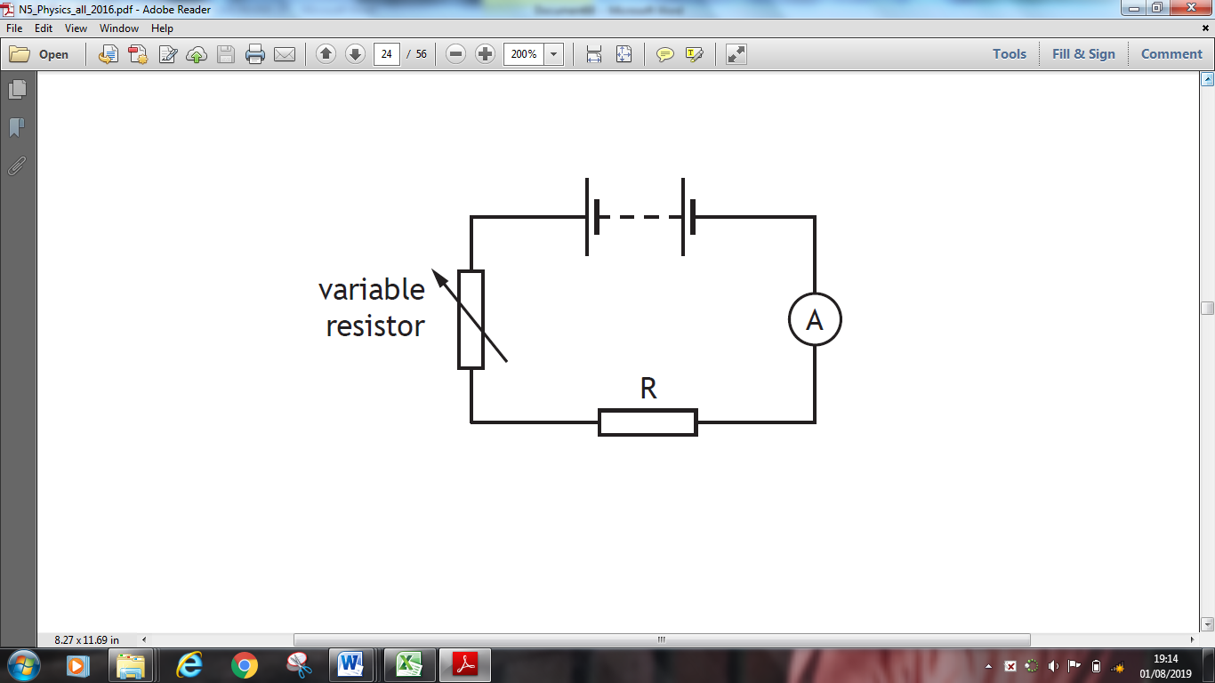  - Describe how the student obtains a range of values of voltage and current.  V  increase/decrease/vary/change the resistance of the variable resistor  Accept:  ‘change the number of cells/batteries’  ‘use batteries with different voltages’  Do not accept:  ‘change the voltage of the battery’  (c) The results of the student’s investigation are shown.  Use all these results to determine the resistance of resistor R.  (d) The student now replaces resistor R with a filament lamp and repeats the  investigation. A sketch graph of the student’s results is shown.  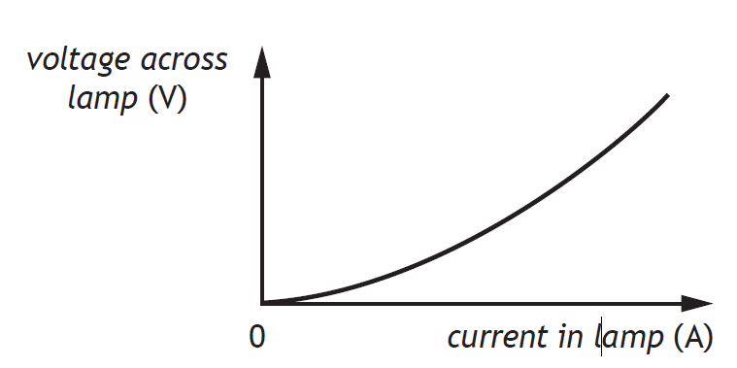  - State a conclusion that can be made about the resistance of the filament  lamp.  (Resistance is) changing/not constant/increasing.  Do not accept: ‘resistance is decreasing’  - Suggest a reason for the difference in resistance between the resistor and filament lamp.  The resistor will give a linear straight line as the resistor doesn’t change its resistance with temperature (unless it is a thermistor)
  Voltage across resistor R (V) | Current in resistor R (A)
  1·0 | 0·20
  2·5 | 0·50
  3·2 | 0·64
  6·2 | 1·24
11.4.5 |  | A graph of the conductivity against temperature for a conductor is shown below.  Conductivity  Temperature  - From information in the graph state the effect of temperature on the conductivity of a conductor.  As the temperature increases the conductivity of the conductor decreases.  - State the effect of temperature on the resistance of a conductor. As the temperature increase the resistance of a conductor increases.
11.4.6 |  | 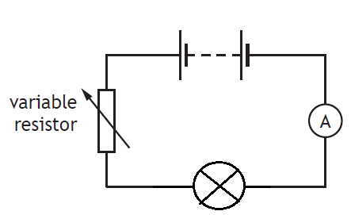  A student investigates the resistance of a filament lamp as shown in the diagram.  - Copy the diagram and add a voltmeter to show how the voltage across the filament lamp can be found.  V  - A sketch graph of the student’s results is shown.  - State a conclusion that can be made about the resistance of the filament lamp. (As the voltage increases the current increases by a greater amount,) suggesting an increase in the resistance of the lamp with increasing voltage. It is a non ohmic conductor  - Calculate the resistance of the filament lamp when the current is 0.4 A  When I= 0.4A V= 3.0 V (1 mark)  $$V=IR$$  $$3.0=0.4 ×R$$  $$R=7.5Ω$$  - State what happens to the resistance of the filament lamp as the voltage across it increases. You must justify your answer.  with increasing voltage there is an increase in the resistance of the lamp (unless you’ve done the calculation this gets no marks)  When I= 0.46A V= 6.0 V (1 mark)  $$V=IR= 6.0=0.46 ×R$$  $$R=13 Ω$$  Other points can be used on the graph providing I > 0.4 A
11.5 |  | I can describe an experiment to prove Ohm’s Law.
11.5.1 |  | Draw the circuit that can be used to show how the current through a resistor changes with voltage.  A  V  +  -
11.5.2 |  | Write down the formula giving the relationship between current voltage and resistance. Write what each letter stands for and the units of each quantity.  $$V=IR$$  V=voltage (Volt), I= current (Ampere), R= resistance (ohm)
11.5.3 |  | (A) On graph paper, or in excel, plot a graph of voltage against current from the results given in the table below.  This graph can also be plotted with voltage on the y axis and I on the x-axis  - Calculate the resistance of the resistor from the graph.  y = 0.0659x + 0.0011  Find the gradient= 1/R  R= 15 Ω
  V/V | I/A
  0.096 | 0.007
  0.821 | 0.056
  1.722 | 0.114
  2.664 | 0.176
  3.612 | 0.24
  4.58 | 0.303
  5.55 | 0.368
  6.56 | 0.433
  7.52 | 0.498
  8.52 | 0.562
11.5.4  REPEAT |  | - Draw a circuit diagram to show how these results can be obtained of how a change in voltage affects the current in in.  A  V  +  -  - Determine the gradient of the graph.  First ensure you know what each box on each axis represents (here each box on voltage axis = 0.2V, each box on the current axis = 0.4V)  find two points that are on the line and cross both gridlines. Do not pick points that are marked with x as they won’t necessarily be on the line. Here you could pick points for a voltage reading of 3V or 8V as both these cross exactly on gridlines, you could also choose 0,0 as in this case the line goes through the origin.  - Then use the equation  $$m=\frac{y_{2}-y_{1}}{x_{2}-x_{1}}$$  - Calculate the gradient  $$m=\frac{1.48-0.56}{8-3}=\frac{0.92}{5}=0.18 {AV}^{-1} or Ω^{-1}$$  - Calculate the resistance of the resistor.  $$R=\frac{1}{gradient}$$  $$R=\frac{1}{0.18}=5.6 Ω$$  $$Accept 5.3-5.6$$
11.5.5 |  | State whether the resistance changes when the current in a resistor changes. Explain your answer.  No, the resistance doesn’t change with current in a resistor, as it is an ohmic conductorso V/I remains constant=R
11.5.6 |  | A student sets up the following circuit to investigate the resistance of resistor R.  The variable resistor is adjusted and the voltmeter and ammeter readings are noted. The following graph is obtained from the experimental results.  - (i) Calculate the value of the resistor R when the reading on the voltmeter is 4.2 V.  When V= 4.2V, I = 0.75 A (1 mark)  $$V=IR$$  $$4.2=0.075 ×R$$  $$R=56 Ω$$  - Using information from the graph, state whether the resistance of resistor R, increases, stays the same or decreases as the voltage increases. Justify your answer.  As the resistance is a straight line graph through the origin the resistance stays the same as the voltage increases.  - The student is given a task to combine two resistors from a pack containing one each of 33 Ω, 56 Ω, 82 Ω, 150 Ω, 270 Ω, 390 Ω  Show by calculation which two resistors should be used to give:  - The largest combined resistance;  The largest combination will be adding the two largest resistors in series.  $R_{t}=R_{1}+R_{2}=270+390=660 Ω$  - The smallest combined resistance.  The smallest combined resistance will occur putting the resistors in parallel. Here you want to use the smallest resistors  $$\frac{1}{R_{t}}=\frac{1}{R_{1}}+\frac{1}{R_{2}}$$  $$\frac{1}{R_{t}}=\frac{1}{33}+\frac{1}{56}=\frac{89}{1848}$$  $$R_{t}=\frac{1848}{89}=21 Ω$$
11.5.7 |  | Calculate the current through a 5·6 kΩ resistor when it is connected to a 230 V supply.  $$V=IR$$  $$230=I×5.6×{10}^{3}$$  $$\frac{230}{5.6×{10}^{3}}=I=0.041 A$$
11.5.8 |  | Calculate the voltage required to produce 10·9 A of current through a 3·3 x 10⁴ Ω resistor.  $$V=IR$$  $$V=10.9×3.3×{10}^{4}$$  $$V=3.6 ×{10}^{5} V$$
11.5.9 |  | If a 12 V supply produces a current of 15 μA through a resistor, calculate the resistance.  $$V=IR$$  $$12=15×{10}^{-6}×R$$  $$\frac{12}{15×{10}^{-6}}=R=8.0×{10}^{5} Ω$$
11.5.10 |  |  |  | A variable resistor can be adjusted from 10 Ω to 10 kΩ, and is connected to a mains supply. Calculate the maximum current.  The current maximum will occur when the resistance is at a minimum as the formula is $V=IR$, so for a given V I will be maximum when R is minimum.  MAINS VOLTAGE = 230V  $$V=IR$$  $$230=I×5.6×{10}^{3}$$  $$\frac{230}{10}=I=23.0 A$$  I’ve no idea what this variable resistor is connected to but it can’t be plugged into the usually mains wiring as it would exceed the total current supplied to the ring. This might be the current to an electric shower or cooker.
Practical Electricity and Electronics
12.1 |  |  | I can make measurements of I, V and R using appropriate meters in simple and complex circuits.
12.1.1 |  |  | A circuit is set up as shown.  The reading on ammeter A1 is 5·0 A.  The reading on ammeter A2 is 2·0 A.  The reading on ammeter A4 is 1·0 A.  State the reading on ammeters A3 and A5.  Total current = 5.0 A so in EACH branch the current must add up to 5.0A  $$I_{t}=I_{2}+I_{3}$$  If A2= 2.0A,  $$I_{t}=I_{2}+I_{3}$$  $$5=2+I_{3}$$  $$5-2=I_{3}=3.0 A$$  If A4= 1.0A,  $$I_{t}=I_{4}+I_{5}$$  $$5.0=1.0+I_{5}$$  $$5-1=I_{5}=4.0 A$$
12.1.2  A |  |  | A student investigates the resistance of a resistor using the circuit shown.  - State all the equipment required to build this circuit.  Battery, variable resistor, ammeter, resistor, 4 leads/wires  - Complete the circuit diagram to show where a voltmeter must be connected to measure the voltage across resistor R.  OK I’ve moved the things around but you need to put the voltmeter across R
12.1.2 B |  |  | The results of the student’s investigation are shown.  Use all these results to determine the resistance of resistor R.  Use $$V=IR$$  If not all of the data is used then zero marks. You could plot a graph of V against I, but why would you want to? It would take so much time and you’d have to find the gradient which would equal 5.0 ohm!
  Voltage across resistor (V) | Current in resistor (A) | Resistance  (Ω)
  1·0 | 0·20 | 5.0
  2·5 | 0·50 | 5.0
  3·2 | 0⋅64 | 5.0
  6.2 | 1·24 | 5.0
12.1.3 |  |  | In the circuit shown, the current in each resistor is different.  State which resistor has the smallest current, you must justify your answer.  50 Ω  All current goes through the 100 Ω resistor, so although this is the largest resistor the current has only one route. You then look at the two parallel branches. In the first branch the current would split up in the ratio of 1:2 for the 20Ω to the 10Ω. In the other branch the current would split up in the ratio of 10:1, with most current passing through the 5 Ω resistor, so the smallest current is in the 50 Ω resistor
12.1.4 |  |  | A student suspects that ammeter A1 may be inaccurate. Ammeter A2 is known to be  accurate.  Copy out the circuit that should be used to compare the reading on A1 with A2
12.1.5 |  |  | 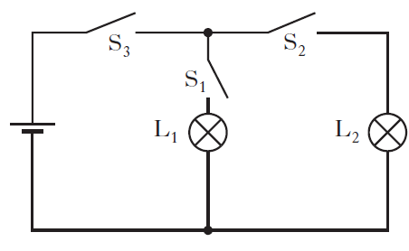  A circuit is set up as shown in the diagram. Copy the diagram and state which switch or switches must be closed to light bulb L1  To light L1 switches S3 and S1 need to be closed.  (S2 and S3 would switch on L2)
12.2 |  |  | I can describe the symbol, function and application of standard electrical and electronic components including cell, battery, lamp, switch, resistor, variable resistor, voltmeter, ammeter, LED, motor, microphone, loudspeaker, photovoltaic cell, fuse, diode, capacitor, thermistor, LDR, relay and transistor
12.2.1 |  |  | - Produce a table with four columns and in the first column write the following components.  cell, battery, lamp, switch, resistor, variable resistor, voltmeter, ammeter, LED, motor, microphone, loudspeaker, photovoltaic cell, fuse, diode, capacitor, thermistor, LDR, relay and transistor  - In the second column draw the circuit symbols for each component.  - In the third column describe the function  - In the last column state the energy change in the component.  Ensure each column is properly titled. See the sheet at the end of these answers. It ought to be stuck into your jotter and learn the symbols etc.
12.2.2 |  |  | State the name of the electrical component represented by this symbol  LED / light emitting diode.
12.2.3 |  |  | Four circuit symbols, W, X, Y and Z, are shown.  Draw and identify the components W, X, Y and Z,  W=lamp, X=voltmeter, Y=resistor, Z=fuse
12.2.4 |  |  | Two circuits are set up as shown.  Both circuits are used to determine the resistance of resistor R, identify meter X, meter Y and meter Z, you must justify your answer.  Meter X = ohmmeter (you can tell as there is no power supply)  Meter Z is in series so is an ammeter  Meter Y is in parallel so is a voltmeter
12.2.5 |  |  | 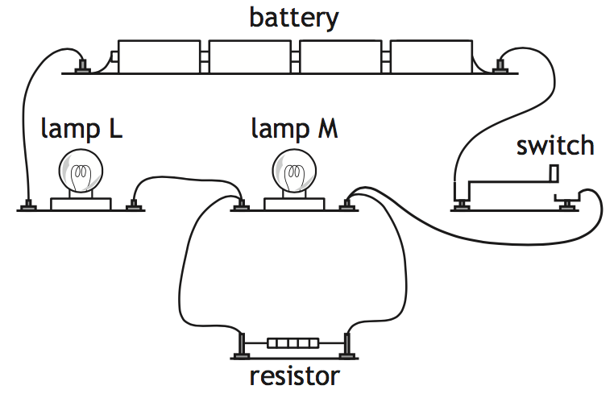  Redraw this circuit for these components using standard component symbols.
12.2.6 |  |  | The rating plate on a food blender is shown.  The plugs on all modern electrical appliances in the UK are fitted with fuses rated at either 3 A or 13 A.  - Draw the circuit symbol for a fuse.  (ii) State the purpose of the fuse fitted in the plug of an appliance. To protect the flex/wire/cable
12.2.7 |  |  | Copy the row in the table which shows the symbol for an LED and an NPN transistor.
12.2.8 |  |  | A student investigates the electrical properties of three different  components; a lamp, an LED and a fixed resistor.  Current-voltage graphs produced from the student’s results are shown.  Explain which graph X, Y or Z is obtained from the student’s results for  the LED.  Graph X is the correct graph as the current can only pass through in one direction. As the polarity is changed (it becomes negative) there is no current in the circuit.
12.2.9 |  |  | Describe, using a diagram, the use of two switches in series in the home. What has to be done to get the appliance to work in this case.  Here is a circuit with 2 switches in series with a lamp, one of the switches could be on the socket and one on the table lamp. To turn on the table lamp, BOTH switches must be closed. The lamp can be replaced by any component.  ∼
12.2.10 |  |  | An LED is used as part of an alarm circuit. State which terminal P or Q should be positive to enable the LED to light.  P should be the positive
12.2.11 |  |  | Copy out the circuit where both LEDs are lit.
12.2.12 |  |  | Light emitting dioders (LEDs) are often used as on/off indicators on television and computers. An LED is connected in a circuit with a resistor R.  - Explain the purpose of Resistor R.  Resistor R limits the current through the LED.  - The LED is rated at 2 V, 100 mA. Calculate the resistance of resistor R  $$V_{s}=V_{LED}+V_{R}$$  $$6=2+V_{R}$$  $$V_{R}=4.0 V$$  As it is a series circuit the current through the LED is the same as the current through the resistor, so the current through the resistor is 100 mA  $$V=IR$$  $$4=100 ×{10}^{-3}×R$$  $$\frac{4}{100 ×{10}^{-3}}=R=40 Ω$$  - Calculate the power developed by resistor R when the LED is working normally.  $$P=IV$$  $$P=100 ×{10}^{-3}×4=0.4W$$  Or you could use $P=I^{2}R$ and get the same answer.  $$P={\left(100 ×{10}^{-3}\right)}^{2}×40=0.4W$$
12.2.13 |  |  | SQA SG C 2009  A digital camera is used to take pictures. When switched on, the flash on a digital camera requires some time before it is ready to operate. When ready, a green LED is illuminated.  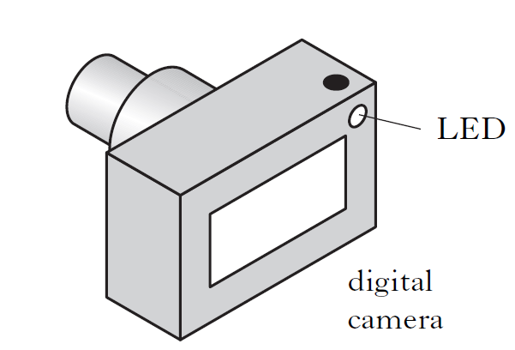  The part of the circuit used to control the LED is shown below. The voltage  at point X is initially 0 V.  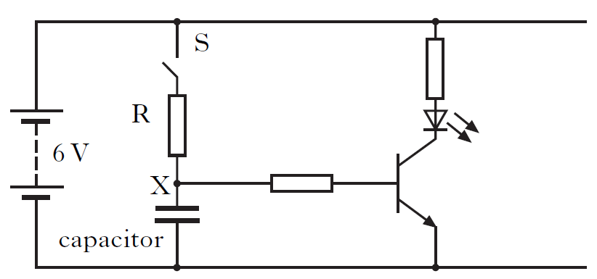  - Describe what happens to the voltage at point X when switch S is closed.  The voltage (gradually) rises until it reaches 6V  (b) The camera manufacturer wants to change the time taken for the flash to be ready to operate.  State two changes which could be made to the above circuit so that the time for the green LED to come on is reduced.  Reduce value of resistor (R)/reduce resistance  Reduce value of the capacitor/reduce capacitance  Do not accept the following  NOT ‘use ‘smaller’ capacitor/resistor’  NOT ‘reduce size of capacitor/resistor’  NOT ‘lower the capacitor/resistor’  NOT ‘remove the resistor’  NOT ‘decrease/reduce/change the voltage’
12.2.14 |  |  | SQA SG G 2010  The circuit below can be used to light an LED after a short time delay.  The capacitor is charged using the 5·0 volt supply.  (i) State what happens to the voltage across the capacitor when it charges.  (the voltage) increases DO NOT ACCEPT changes.  (ii) Component Y is a transistor. Draw the symbol for a transistor.  You can also draw an N Channel Enhancement MOSFET  (iii) State the function of the transistor in this circuit.  The transistor is acting as a switch.  (b) The circuit is used to monitor temperature changes in a liquid.  The thermistor is immersed in the liquid.  - State what happens to the reading on the ohmmeter as the liquid cools.  As temperature decreases the resistance the reading on the ohmmeter increases. (do not accept resistance increases- alone!)  (ii) The thermistor is now connected to a battery and an ammeter as shown.  Calculate the current in the circuit when the resistance of the thermistor is 1000 ohms.  $$V=IR$$  $$5.0=I× 1000$$  $$I=\frac{5.0}{1000}=0.005 A$$
12.2.15 |  |  | Draw the symbol for a Light Emitting  Diode.
12.2.16 |  |  | State why a LED must be connected the correct way round in a circuit.  An LED will not light if it is connected the other way around/ no current will pass through the LED  +ve  -ve  flow of electrons
12.2.17 |  |  | State why a resistor must be used in series with a LED.  To limit the current through the LED
12.2.18 |  |  | 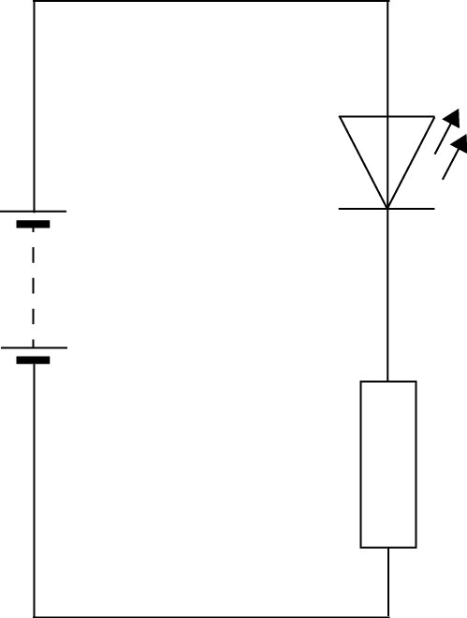  Draw a diagram showing how a LED can be operated from a 12V battery.  12 V
12.2.19 |  |  | Calculate the size of resistor needed in the circuit operated from a 12V battery if the LED operates at 1.8V 15mA  $$V_{s} =V_{LED}+V_{R}$$  $$12 =1.8+V_{R}{, V}_{R}=10.2V$$  $$V=IR$$  $$10.2=15×{10}^{-3}×R$$  $$\frac{10.2}{15×{10}^{-3}}=R=680 Ω$$
12.2.20 |  |  | In terms of energy, what useful energy change happens in  - a microphone, (b) a thermocouple, and (c) a solar cell  .
  Sound ⇒electrical | heat ⇒electrical | light⇒electrical
12.2.21 |  |  | - (i) State what the abbreviation LDR stands for.  Light dependent resistor  State how the resistance of the LDR changes when more light reaches it.  As light increases the resistance of the LDR decreases (for an NTC thermistor)  - State how the resistance of a thermistor change when its temperature increases.  As temperaure increases the resistance of the thermistor decreases
12.2.22 |  |  | State the purpose of a capacitor in a circuit.  A capacitor stores charge.  (It can be used with a resistor in time delay circuits.)
12.2.23 |  |  | Draw the circuit symbol for a capacitor.
12.2.24 |  |  | Sketch a graph showing the potential difference across a capacitor against time as it charges from a 12V supply, numerical values are only required on the voltage axis.  time  Voltage  V_{s}
12.2.25 |  |  | State the two quantities that affect the time for a capacitor to fully charge.  Resistance and capacitance
12.2.26 |  |  | (a) State how a capacitor can be quickly discharged. Connect a wire across the terminals, connect a low resistance across the terminals  (b)State whether rapidly discharging a capacitor can be dangerous, you must justify your answer. Rapidly discharging a capacitor can be dangerous as $Q=It$  There is a certain charge on the capacitor and the quicker capacitor is discharged the higher the current which can be dangerous.
12.2.27 |  |  | State the meaning of the terms
  - open circuit | - short circuit
  If there is a break in the circuit, there would be a large resistance. (OPEN CIRCUIT) | If there is a wire across a component, the resistance across the component would be very low (SHORT CIRCUIT)
12.3 |  |  | I can draw and identify the symbols for an npn-transistor, and an n-channel enhancement MOSFET
12.3.1 |  |  | - Draw the circuit symbol for an npn-transitor.  - Draw the circuit symbol for an n-channel enhancement MOSFET.
12.3. |  |  | The diagrams opposite show two different types of transistors.  NB This is not on the course so can be missed out, but know the name!  - Copy and name each symbol.  - Label points A, B and C on each symbol.
   | N channel enhancement MOSFET | npn transistor
  A | Gate | Base
  B | Source | Emitter
  C | Drain | collector
12.4 |  |  | I can explain the function of transistors
12.4.1 |  |  | A circuit is set up as shown below  Copy the circuit and identify the transistor.  State the function of the transistor in this circuit.  The npn transistor is a switch
12.4.2 |  |  | State the switch on voltage for the following  - an npn-transistor and state its switch on voltage >0.7V (across the base and emitter)  - an n-channel enhancement MOSFET. There must be a 2.0 V (applied to the gate of the) MOSFET
12.4.3 |  |  | (i) State the type of transistor used in this circuit.  N channel enhancement MOSFET  (ii) State the function of the transistor in this circuit.  The transistor acts as a switch.
12.4.4 |  |  | SQA Int 2 2015  Part of an alarm system is shown in the circuit. Light from an LED strikes the LDR. When the light is blocked the transistor switches on and the buzzer sounds. Explain how the circuit operated to make the buzzer sound.  (Light on LDR decreases) so R_{LDR} increases  V across LDR increases (to a level which switches on the transistor). The buzzer sounds
12.4.5 |  |  | A photographic darkroom has a buzzer that sounds when the light level in the room is too high. The circuit diagram for the buzzer system is shown below.  - (i) Name component X.  npn transistor  (ii)What is the purpose of component X in the circuit?  It acts as a switch  - The darkroom door is opened and the light level increases.  Explain how the circuit operates to sound the buzzer.  (Light on LDR increases when the door is opened) so R_{LDR} decreases  V across LDR decreases, V across the resistor increases (to a level which switches on the transistor). The buzzer sounds  - The table shows how the resistance of the LDR varies with light level.  The variable resistor has a resistance of 570 Ω. The light level increases to 80 units. Calculate the current in the LDR.  $$R_{total} =R_{LDR}+R_{R}$$  $$R_{total} =570+2500=3070 Ω$$  $$V=IR$$  $$5.0=I×3070$$  $$\frac{5.0}{3070}=I=0.0016 A or 1.6mA$$  - State the purpose of the variable resistor R in this circuit.  To adjust the light level that switches on the buzzer.
  Light level (units) | LDR Resistance (Ω)
  20 | 4500
  50 | 3500
  80 | 2500
12.4.6 |  |  | Water in a fish tank has to be maintained at a constant temperature. Part of the electronic circuit which controls the temperature is shown.  - Name components Y and Z.  X= variable resistor, Z= lamp (you must indicate which is which!)  - State what happens to the resistance of the thermistor as the temperature increases.  As temperature increases the resistance decreases  - When the voltmeter reading reaches 1·8V component Y switches on. Explain how the circuit operates when the temperature rises.  As the temperature increases the resistance of the thermistor decreases, the voltage across the thermistor decreases. The voltage across X increases, the voltage increases above 1.8V and the MOSFET switched on, causing the buzzer to sound and the lamp to light.  - Explain why a variable resistor chosen for component X rather than a fixed value resistor.  The variable resistor allows the temperature at which the buzzer sounds and lamp lights to be adjusted.
12.4.7 |  |  | A car has a temperature warning system which alerts the driver when the air temperature falls below 3 °C. The sensor is installed inside the passenger side wing mirror on the car. The diagram for the circuit is shown below.  12 V  t  X  Y  Z  - A thermistor is used as the sensor in the circuit. State what happens to the resistance of the thermistor as the temperature falls.  As the temperature decreases the resistance of the thermistor increases, the voltage across the thermistor increases. the voltage increases above 0.7 V across the base and emitter of the transistor and the transistor switches on, causing the LED to light.  (b) Name component: (i) X; npn transistor (ii) Y. LED  (c) When operating normally, component Y has 2·0 V across it and 10 mA in it. Calculate the resistance of resistor Z.  $$V_{s} =V_{LED}+V_{R}$$  $$12 =2.0+V_{R}{, V}_{R}=10.0V$$  $$V=IR$$  $$10.0=10×{10}^{-3}×R$$  $$\frac{10.2}{10×{10}^{-3}}=R=1000 Ω$$  (d) The car manufacturer decides to redesign the circuit using a MOSFET.  (i) Draw the symbol for a n channel enhancement MOSFET.  (ii) State which component in the circuit shown above can be removed when the MOSFET is introduced. The transistor, component X  (e) On the rear window of the car there is a heater that is used to remove any ice that forms on the glass.  (i) At a temperature of 0 °C a mass of 0·050 kg of ice forms on the rear window. Calculate the energy needed to melt this ice into water at 0 °C.  From the data sheet the value of the latent heat of fusion of water is 3·34 × 10⁵ Jkg⁻¹  $$E=ml$$  $$E=0.050×3·34 {10}^{5}=170000 J$$  $$(167000 )J$$  (ii) In practice more energy than the value calculated in part (e) (i) needs to be supplied to melt the ice. Explain why more energy is needed. Energy losses heating the glass window, and the air around the ice.
12.5 |  |  | I can apply the current and voltage relationships in a series circuit.
12.5.1 |  |  | State the equation to show  - Current in a series circuit  $$I_{t}=I_{1}=I_{2}$$  - Voltage in a series circuit.  $$V_{t}=V_{1}+V_{2}$$
12.5.2 |  |  | State how the current compares in components connected in series. The current is the same.
12.5.3 |  |  | 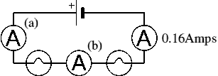  Determine the readings on meter (a) and (b).  Aa = 0.16 A  Ab = 0.16 A
12.5.4 |  |  | 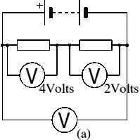  (i) State the reading on the Voltmeter (a)  6.0 V  $$V_{s}=\left(V_{1}+V_{2}\right)$$  $$V_{s}=(2+4)$$  (ii) State the supply voltage of this circuit.  6.0 V
12.5.5 |  |  | Two resistors are connected in series as shown in the diagram. The current in the 2 Ω resistor is 2.0 A  Calculate the current in the 4 Ω resistor and the voltage across the 4 Ω resistor  It is a series circuit so the current is also 2.0 A
12.5.6 |  |  | In the potential divider circuit the value of the variable resistor is increased. State the effect on voltmeters, V₁ and V_{2.}  The value of the variable resistance increases which will increase the value of V1, this will decrease the value on V2 as  V₁  V₂  $$V_{s}=V_{1}+V_{2}$$
12.5.7 |  |  | Calculate the total resistance for a 650 ohm, a 350 ohm, and a 1000 ohm resistor connected in series.  $$R_{t}=R_{1}+R_{2}+R_{3}$$  $$R_{t}=650+350+1000=2000$$
12.5.8 |  |  | Calculate the total resistance for ten 120 ohm resistors in series.  $$R_{t}=R_{1}+R_{2}+R_{3}$$  Adding 10 resistors of the same is the same as multiplying one resistor by 10  $$R_{t}=10×120=1200$$
12.5.9 |  |  | A string of fifty 15 ohm Christmas tree lights are connected in series. One burns out, they all burn out. Calculate the total resistance.  $$R_{t}=R_{1}+R_{2}+R_{3}$$  Adding 50 resistors of the same is the same as multiplying one resistor by 10  $$R_{t}=50×15=750$$
12.5. 10 |  |  | Two 100 ohm resistors are connected in series and they are connected to a 1.5 V DC battery. Determine the total current flowing in the circuit.  $$R_{t}=R_{1}+R_{2}+R_{3}$$  $$R_{t}=100+100=200$$  $$V=IR$$  $$1.5=I×200$$  $$\frac{1.5}{200}=I=0.0075 A=7.5 mA$$
12.5.11 |  |  | Two resistors are connected in series. One resistor has a resistance of 50 Ω. The total resistance is 67 Ω, calculate the resistance of the second resistor  $$R_{t}=R_{1}+R_{2}$$  $$67=50+R_{2}$$  $$67-50=R_{2}=17 Ω$$
12.5.12 |  |  | The reading on the ammeter is 3·0 A.  The reading on the voltmeter is 4·0 V.  Determine the current in resistor R₂ and the voltage across resistor R₂  $$V_{s} =V_{r1}+V_{R2}$$  $$12 =4.0+V_{R}{, V}_{R2}=8.0V$$  As it is a series circuit the current through R₁ is the same as the value through I_{R2} = 3.0 A  NB Don’t be tempted to work out the resistance of R2- this is not the question.
12.6 |  |  | I can apply the current and voltage relationships in a parallel circuit
12.6.1 |  |  | State the equation to show  - Current in a parallel circuit  $$I_{t}=I_{1}+I_{2}$$  - Voltage in a parallel circuit.  $$V_{t}=V_{1}=V_{2}$$
12.6.2 |  |  | - Calculate the total resistance for two 180 ohm resistors connected in parallel.  $$\frac{1}{R_{P}}=\frac{1}{R_{1}}+\frac{1}{R_{2}}$$  $$\frac{1}{R_{P}}=\frac{1}{180}+\frac{1}{180}=\frac{2}{180}$$  $$R_{P}=\frac{180}{2}=90 Ω$$  - If the resistors are connected to a 9.0 V power supply determine the voltage across each resistor.  The voltage across each branch is 9.0V  - If the resistors are connected to a 9.0 V power supply determine the current in each resistor.  $$V=IR$$  $$9=I×90$$  $$\frac{9}{90}=I=0.10 A$$  - Determine the total current in the circuit.  $$I_{t}=I_{1}+I_{2}$$  $$I_{t}=0.10 +0.10=0.20 A$$
12.6.3 |  |  | A 10 ohm, 20 ohm, and 100 ohm resistors are connected in parallel.  - Calculate the total resistance of these three resistors.  $$\frac{1}{R_{P}}=\frac{1}{R_{1}}+\frac{1}{R_{2}}+\frac{1}{R_{3}}$$  $$\frac{1}{R_{P}}=\frac{1}{10}+\frac{1}{20}+\frac{1}{100}=\frac{16}{100}$$  $$R_{P}=\frac{100}{16}=6 Ω$$  - If the resistors are connected to a 12.0 V power supply determine the voltage across each resistor.  As the resistors are in parallel the voltage across each resistor is 12.0 V  - If the resistors are connected to a 12.0 V power supply determine the current in each resistor.  - Determine the total current in the circuit.  $$I_{t}=I_{1}+I_{2}+I_{3}$$  $$I_{t}=1.2 +0.6+0.12=1.9 A$$
  $$V=IR$$  $$12=I×10$$  $$\frac{12}{10}=I=1.2 A$$ | $$V=IR$$  $$12=I×10$$  $$\frac{12}{20}=I=0.6 A$$ | $$V=IR$$  $$12=I×10$$  $$\frac{12}{100}=I=0.12 A$$
12.6.4 |  |  | A string of fifty 15 ohm Christmas tree light are connected in parallel. One burns out, the rest will stay lit. Calculate the total resistance of the 49 resistors.  $$\frac{1}{R_{P}}=\frac{1}{R_{1}}+\frac{1}{R_{2}}$$  $$\frac{1}{R_{P}}=49×\frac{1}{15}=\frac{49}{15}$$  $$R_{P}=\frac{15}{49}=0.31 Ω$$
12.6.5 |  |  | State the rule for calculating the resistance of any two resisitors, with the same resistance when connected in parallel.  $$\frac{1}{R_{P}}=\frac{1}{R_{1}}+\frac{1}{R_{2}}$$
12.6.6 |  |  | Two 33 ohm resistors are connected in parallel followed by two more 33 ohm resistors connected in parallel. Calculate the value of a single resistor which would be used to replace these four resistors.  $$\frac{1}{R_{P}}=\frac{1}{R_{1}}+\frac{1}{R_{2}}$$  $$\frac{1}{R_{P}}=\frac{1}{33}+\frac{1}{33}=\frac{2}{33}$$  $$R_{P}=\frac{33}{2}=17 Ω$$  The second branch of two 33 ohm resistors would have a resistance of 17 ohm. The total resistance is…  $$R_{t}=R_{1}+R_{2}$$  $$R_{t}=17+17=34$$
12.6.7 |  |  | A technician builds a test circuit containing a resistor and a motor, as shown  (i)State the voltage across the motor. 12.0 V  (ii)Calculate the combined resistance of the resistor and the motor.  $$\frac{1}{R_{P}}=\frac{1}{R_{1}}+\frac{1}{R_{2}}$$  $$\frac{1}{R_{P}}=\frac{1}{8}+\frac{1}{24}=\frac{4}{24}$$  $$R_{P}=\frac{24}{4}=6 Ω$$
12.6.8 |  |  | The resistor and the motor are now connected in series, as shown State how this affects the speed of the motor compared to Circuit 1.  The speed will decrease.  Explain your answer. The total resistance increases to 32Ω so the total current decreases which will slow down the motor.
12.6.9 |  |  | 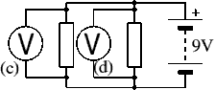  State the reading on voltmeters (c ) and (d)  - And d) are in parallel.  so the resistance across c)=9V and across d)=9V  $$V_{s}=V_{1}=V_{2}$$
12.6.10 |  |  | 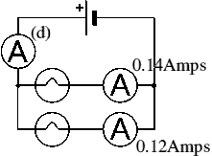  State the reading on Ammeter (d)  $$I_{t}=I_{1}+I_{2}$$  $$I_{t}=0.14+0.12=0.26 A$$
12.6.11 |  |  | A toy car contains an electric circuit which consists of a 12·0 V battery, an electric motor and two lamps.  The circuit diagram is shown.  Switch 1 is now closed.  Calculate the power dissipated in the motor when operating.  $$P=\frac{V^{2}}{R}=\frac{{12.0}^{2}}{100}=1.44 W$$  Switch 2 is now also closed.  - Calculate the total resistance of the motor and the two lamps  $$\frac{1}{R_{P}}=\frac{1}{R_{1}}+\frac{1}{R_{2}}+\frac{1}{3}$$  $$\frac{1}{R_{P}}=\frac{1}{100}+\frac{1}{50}+\frac{1}{50}=\frac{5}{100}$$  $$R_{P}=\frac{100}{5}=20 Ω$$  - One of the lamps now develops a fault and stops working. State the effect this has on the other lamp.  The other lamp will become less bright as the total resistance increases.  $$\frac{1}{R_{P}}=\frac{1}{R_{1}}+\frac{1}{R_{2}}+\frac{1}{3}$$  $$\frac{1}{R_{P}}=\frac{1}{100}+\frac{1}{50}=\frac{3}{100}$$  $$R_{P}=\frac{100}{3}=33 Ω$$
12.6.12 |  |  | The current in the lamp is 1·5 A.  The reading on the voltmeter is 6·0 V. Calculate power developed in the lamp.  Voltage across the lamp = 3.0 V  $$V_{s}=V_{1}+V_{2}$$  $$9.0=6.0+V_{2}$$  $$V_{2}=3.0 V$$  Find total current through the resistor  $$V=IR$$  $$6=I× 4.0$$  $$\frac{6}{4.0}=I=1.5 A$$  Find the power dissipated in the lamp  $$P=IV$$  $$P=1.5 ×3.0 =4.5 W$$
12.6.13 |  |  | - Calculate the total resistance  You need to do the parallel part first in this instance.  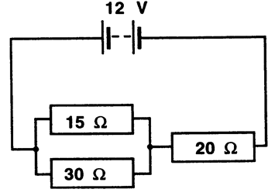  $\frac{1}{R_{P}}=\frac{1}{R_{1}}+\frac{1}{R_{2}}$  $$\frac{1}{R_{P}}=\frac{1}{30}+\frac{1}{15}=\frac{3}{30}$$  $$R_{P}=\frac{30}{3}=10 Ω$$  $$R_{t}=R_{1}+R_{2}$$  $$R_{t}=10+20=30$$  - Calculate the total current.  $$V=IR$$  $$12=I× 30$$  $$\frac{12}{30}=I=0.4 A$$  - Calculate the voltage across the 20 Ω resistor  This has to be done as a voltage divider, using the result of the total parallel resistance.  $$V_{p}=\frac{R_{p}}{R_{p}+R_{p}}×V_{s}$$  $$V_{p}=\frac{20}{30}×12=8.0 V$$  - calculate the voltage across the parallel network  Either  $$V_{p}=\frac{R_{p}}{R_{p}+R_{p}}×V_{s}$$  $$V_{p}=\frac{10}{30}×12=4.0 V$$  Or  $$V_{s}=V_{1}+V_{2}$$  $$12=8+V_{2}$$  $$V_{2}=4.0 V$$  - Calculate the current for each resistor in the parallel network.  $$V=IR$$  $$4=I× 30$$  $$\frac{4}{30}=I=0.13 A$$  $$V=IR$$  $$4=I× 15$$  $$\frac{4}{15}=I=0.27 A$$  When these are added together they should give the total current and the current that passes through the 20 Ω resistor (0.4A) which it does, suggesting you’ve got the answer correct.  f) Calculate the power dissipated by each resistor
  15 Ω | 20 Ω | 30 Ω
  $$P=I^{2}R$$  $$P={0.27}^{2}×15$$  $$P=1.09 W$$ | $$P=I^{2}R$$  $$P={0.40}^{2}×20$$  $$P=3.2 W$$ | $$P=I^{2}R$$  $$P={0.13}^{2}×30$$  $$P=0.51 W$$
  Or work it out through the equation below. The slight differences in the answers are due to rounding in the current phase.
  $$P=IV$$  $$P=0.27×4=1.08 W$$ | $$P=IV$$  $$P=0.40×8=3.2 W$$ | $$P=IV$$  $$P=0.13×4=0.52 W$$
12.7 |  |  | I can describe and explain practical applications of series and parallel circuits.
12.7.1 |  |  | To turn on a kettle, the kettle plug should be placed in a socket and the socket switched on and then the kettle switch must also be switched on before the kettle heats up. State how the switches are connected in this arrangement. The switches are connected in series.
12.7.2 |  |  | 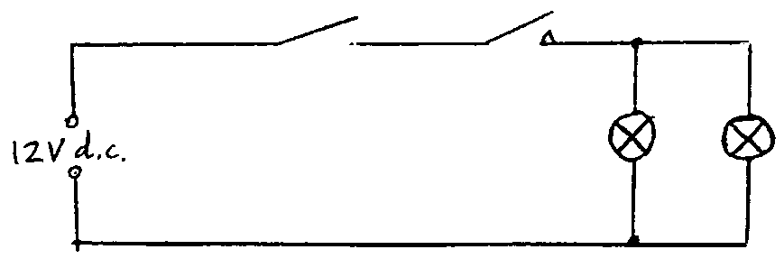  Two headlights in a car can only be switched on when the ignition switch and the light switch are both on. Draw a circuit diagram to show how this circuit could be connected.  Ignition light switch  switch
12.7.3 |  |  | 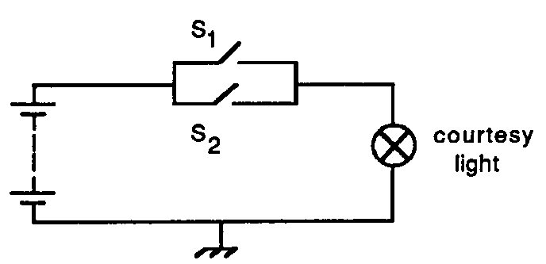  The interior light in a car only lights when either the drivers or passenger door is open. Draw a circuit diagram to show this circuit arrangement.
12.7.4 |  |  | Brakes in a car only light when the ignition is switched on and the brake switch on the pedal is pressed. Draw a circuit diagram to show this circuit arrangement.  Ignition pedal switch  switch
12.7.5 |  |  | State whether the sockets in your house connected in series or parallel, you must justify your answer.  Parallel- you can have the lights on individually, if they were in series, all sockets would need to be on to work any appliance.
12.7.6 |  |  | 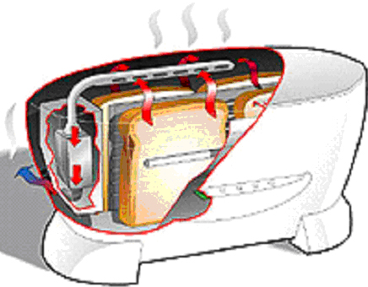  A state-of-the-art electric toaster uses radiation to produce the perfect slice of toast.  (a) State the main energy change in the toaster.electrical⇒heat  (b) State the most likely power rating for the toaster.1000W as most power is produced in appliances that produce heat  10 W 100 W 1000 W  (c) State the size of fuse required in the toaster.13 A (it has a power rating. 720 W)  (d) The toaster has a metal casing. How many wires does it have in its flex?  3
12.7.7 |  |  | An electrician is looking for a fault in the wiring of a house.  - He decides to make a continuity tester from a battery, a lamp and some insulated wires. Draw a circuit diagram of the continuity tester.  - A fault has been repaired the electrician uses a voltmeter to measure the voltage at different sockets around the house.  Test material  (i) State the value of the voltage measured at the sockets. 230V  (ii) The electrician finds that the voltage at all of the sockets is the same. Describe the way in which the sockets are wired together. wired in parallel as the voltage across each socket is the same.
12.7.8 |  |  | A circuit is set up as shown.  The initial reading on both voltmeters V₁ and V₂ is 2.5V.  The light shining on the LDR is made brighter.  Copy out the row in the table that shows possible new readings on voltmeters V₁ and V₂.  Light drops resistance, V₁ decreases so V₂ must increase, as before the total must be 5.0 V
  Reading on V₁ (V) | Reading on V₂ (V)
  2.0 | 3.0
  2.5 | 2.0
  2.5 | 2.5
  2.5 | 3.0
  3.0 | 2.0
12.8 |  |  | I can solve problems involving total resistance of resistors in a series circuit.
12.8.1 |  |  | State the formula to calculate resistance in a series circuit.  $$R_{t}=R_{1}+R_{2}+R_{3}$$
12.8.2 |  |  | Calculate the resistance of the following circuit  35 Ω  22 Ω  60 Ω  $$R_{t}=R_{1}+R_{2}+R_{3}$$  $$R_{t}=60+35+22=120$$  This is a sig fig answer and should be rounded to 2 sig fig!
12.8.3 |  |  | The total resistance of this circuit is 25 kΩ. Calculate the value of Resistor 2  500 Ω  R₂  12 kΩ  $$R_{t}=R_{1}+R_{2}+R_{3}$$  $$25000=12000+500+R_{2}$$  $$R_{2}=1250$$  $$R_{2}=1300$$  This is a sig fig answer and should be rounded to 2 sig fig!
12.8.4 |  |  | Calculate the resistance of the following circuit  2.0 k Ω  500 Ω  500 Ω  $$R_{t}=R_{1}+R_{2}+R_{3}$$  $$R_{t}=500+2000+500=3000$$
12.9 |  |  | I can perform calculations involving current and voltage relationships in a parallel circuit.
12.9.1 |  |  | 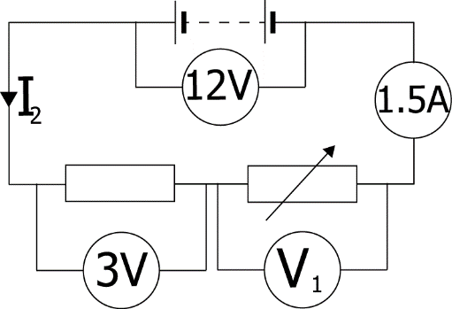  Determine the missing currents and voltages for this circuit.  Series circuit so I₂= 1.5 A  $$V_{s}=V_{1}+V_{2}$$  $$V_{1} =12-3=9V$$
12.9.2 |  |  | 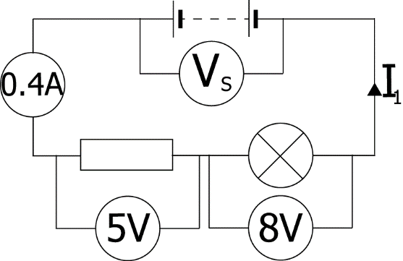  Determine the missing currents and voltages for this circuit.  Series circuit so I₁= 0.4 A  $$V_{s}=5+8$$  $$V_{s} =13 V$$
12.9.3 |  |  | 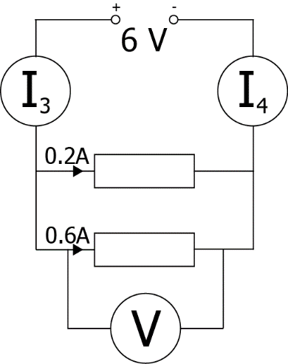  Find the missing currents and voltages for this circuit.  $$I_{3}=I_{4}=0.2A + 0.6 A= 0.8 A$$  Voltage in parallel is the same across each branch=6V
12.9.4 |  |  | 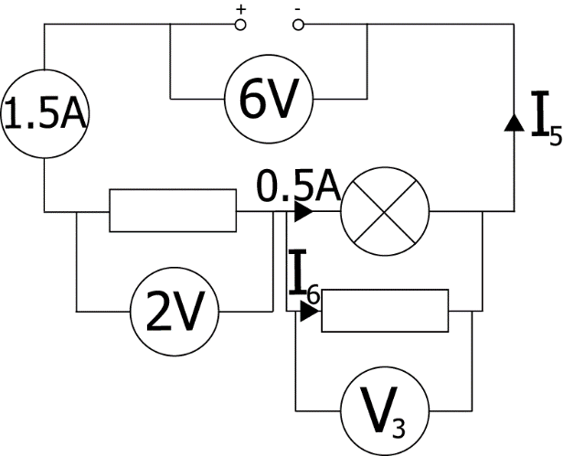  Find the missing currents and voltages for this circuit.  I₅=total=1.5A  I₅₌0.5+I₆  I₆= 1.5-0.5 A= 1.0 A  $$V_{s}=V_{1}+V_{2}$$  $$6=2+V_{2}$$  $$V_{2}=4V$$
12.10 |  |  | I can calculate the resistance of resistors in parallel circuits
12.10.1 |  |  | Calculate the resistance of the circuit shown below  $$\frac{1}{R_{P}}=\frac{1}{R_{1}}+\frac{1}{R_{2}}+\frac{1}{3}$$  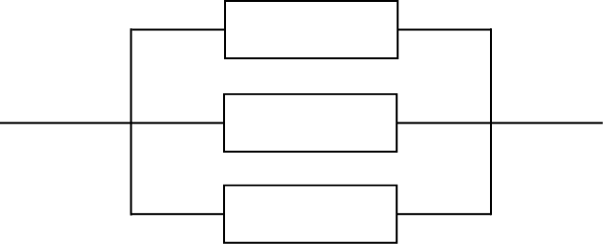  $\frac{1}{R_{P}}=\frac{1}{100}+\frac{1}{200}+\frac{1}{400}=\frac{7}{400}$  100 Ω  200 Ω  400 Ω  $$R_{P}=\frac{400}{7}=60 Ω$$  Although this comes out as 57Ω, this should be rounded to 60Ω, 1 sig fig.
12.10.2 |  |  | The total resistance of this circuit is 100Ω. Calculate the value of Resistor 1  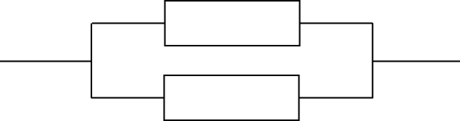  200 Ω  R₁  $$\frac{1}{R_{P}}=\frac{1}{R_{1}}+\frac{1}{R_{2}}+\frac{1}{3}$$  $$\frac{1}{100}=\frac{1}{200}+\frac{1}{R_{1}}$$  $$\frac{1}{100}-\frac{1}{200}=\frac{1}{R_{1}}=\frac{1}{200}$$  $$R_{1}=200 Ω$$
12.10.3 |  |  | Calculate the total resistance of these two resistors in parallel  20 kΩ  14 kΩ  $$\frac{1}{R_{P}}=\frac{1}{R_{1}}+\frac{1}{R_{2}}$$  $$\frac{1}{R_{P}}=\frac{1}{14000}+\frac{1}{20000}=\frac{17}{140000}$$  $$R_{P}=\frac{140000}{17}=8.2 kΩ$$
12.10.4 |  |  | Calculate the total resistance of these resistors in parallel  300 Ω  600 Ω  900 Ω  $$\frac{1}{R_{P}}=\frac{1}{R_{1}}+\frac{1}{R_{2}}+\frac{1}{3}$$  $$\frac{1}{R_{P}}=\frac{1}{300}+\frac{1}{600}+\frac{1}{900}=\frac{11}{1800}$$  $$R_{P}=\frac{1800}{11}=160 Ω$$  $$R_{P}=200 Ω$$  200 to 1 Sig fig
12.10.5 |  |  | 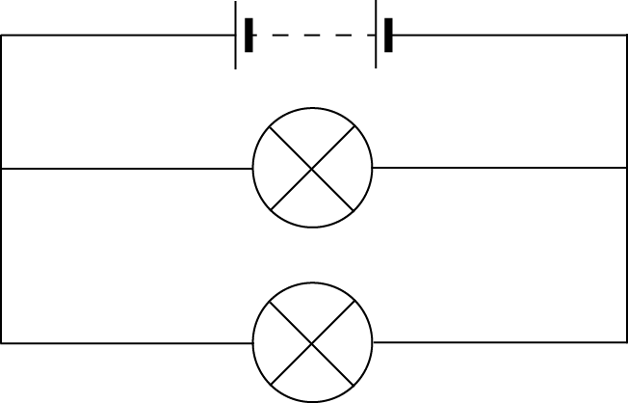  Calculate the total resistance of these lamps in parallel  4 Ω  6 Ω  $$\frac{1}{R_{P}}=\frac{1}{R_{1}}+\frac{1}{R_{2}}$$  $$\frac{1}{R_{P}}=\frac{1}{4.0}+\frac{1}{6.0}=\frac{5}{12}$$  $$R_{P}=\frac{12}{5}=2.4 Ω$$
12.11 |  |  | I can use the appropriate relationships to calculate the resistance of resistors in with circuits with combinations of resistors in series and parallel
12.11.1 |  |  | Calculate the total resistance between X and Y.  Here you need to find the resistance of the resistors in parallel first  $$\frac{1}{R_{P}}=\frac{1}{R_{1}}+\frac{1}{R_{2}}$$  $$\frac{1}{R_{P}}=\frac{1}{4.0}+\frac{1}{4.0}=\frac{2}{4.0}$$  $$R_{P}=\frac{4.0}{2}=2.0 Ω$$  $$R_{t}=R_{1}+R_{2}+R_{3}$$  $$R_{t}=4.0+2.0=6.0$$
12.11.2 |  |  | Calculate the total resistance in each of these circuits.
  a. | 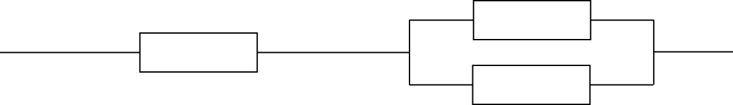  900 Ω  200 Ω  200 Ω  500 Ω  1 kΩ  1.2 kΩ  900 Ω  1.5 kΩ  1 MΩ  500 kΩ  2 MΩ  750 kΩ
  b. | 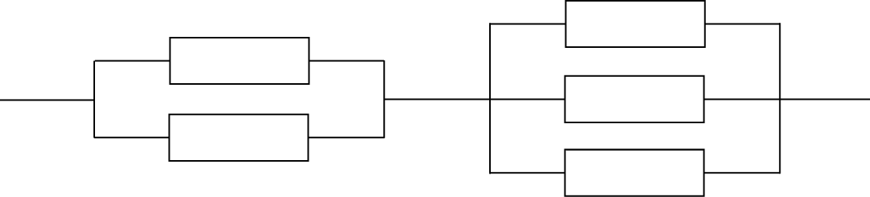
  c. | 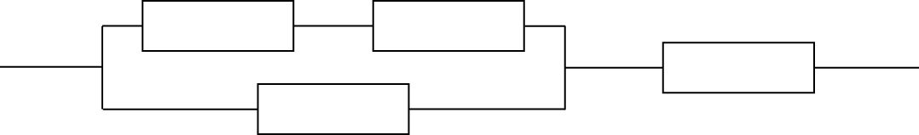
a | b | c
$$\frac{1}{R_{P}}=\frac{1}{R_{1}}+\frac{1}{R_{2}}$$  $$\frac{1}{R_{P}}=\frac{1}{200}+\frac{1}{200}$$  $$\frac{1}{R_{P}}=\frac{2}{200}$$  $$R_{P}=\frac{200}{2}=100 Ω$$  $$R_{t}=R_{1}+R_{2}+R_{3}$$  $$R_{t}=900+100$$  $$R_{t}=1000$$ | $$\frac{1}{R_{P}}=\frac{1}{R_{1}}+\frac{1}{R_{2}}$$  $$\frac{1}{R_{P}}=\frac{1}{500}+\frac{1}{1000}$$  $$\frac{1}{R_{P}}=\frac{3}{1000}$$  $$R_{P}=\frac{1000}{3}=333 Ω$$  $$\frac{1}{R_{P}}=\frac{1}{R_{1}}+\frac{1}{R_{2}}+\frac{1}{3}$$  $$\frac{1}{R_{P}}=\frac{1}{1200}+\frac{1}{1500}+\frac{1}{900}$$  $$\frac{1}{R_{P}}=\frac{47}{18000}$$  $$R_{P}=\frac{18000}{47}=383 Ω$$  $$R_{t}=R_{1}+R_{2}$$  $$R_{t}=333+383$$  $$R_{t}=716$$ | $$R_{t}=R_{1}+R_{2}$$  $$R_{t}=1M+2M$$  $$R_{t}=3 M$$  $$\frac{1}{R_{P}}=\frac{1}{R_{1}}+\frac{1}{R_{2}}$$  $$\frac{1}{R_{P}}=\frac{1}{{3×10}^{6}}+\frac{1}{500×{10}^{3}}$$  $$\frac{1}{R_{P}}={2.3×10}^{-6}$$  $$R_{P}={4.3×10}^{5}$$  $$R_{t}=R_{1}+R_{2}$$  $$R_{t}={4.3×10}^{5}+{750×10}^{3}$$  $$R_{t}=1.2 {×10}^{6}$$

12.11.3 |  |  | Calculate the readings on the ammeter and voltmeter.  Before you do this you need to work out total R as V-IR  $$\frac{1}{R_{P}}=\frac{1}{R_{1}}+\frac{1}{R_{2}}$$  $$\frac{1}{R_{P}}=\frac{1}{2}+\frac{1}{2}$$  $$\frac{1}{R_{P}}=\frac{2}{2}$$  $$R_{P}=\frac{2}{2}=1 Ω$$  $$R_{t}=R_{1}+R_{2}$$  $$R_{t}=1+2=3.0$$  $$V=IR$$  $$6=I× 3$$  $$\frac{6}{3}=I=2.0 A the reading on the ammeter$$  $$V_{2}=\frac{R_{2}}{R_{1}{+R}_{2}}×V_{s}$$  $$V_{2}=\frac{1}{3}×6=2V$$
12.11.4 |  |  | Part of a circuit is shown below.  - Calculate the total resistance between points Y and Z  $$\frac{1}{R_{P}}=\frac{1}{R_{1}}+\frac{1}{R_{2}}$$  $$\frac{1}{R_{P}}=\frac{1}{4.0}+\frac{1}{2.0}=\frac{3}{4.0}$$  $$R_{P}=\frac{4}{3}=1.3 Ω$$  - Calculate the total resistance between points W and X  $$R_{t}=R_{1}+R_{2}$$  $$R_{t}=1.3+6.0=7.3$$  - Calculate the voltage across the 2.0 Ω resistor when the current in the 4.0 Ω resistor is 0.10 A  The voltage across both the 2.0 Ω and the 4.0 Ω resistor is the same so therefore you can use  $$V=IR$$  $$V=0.10× 4.0=0.4 V$$
12.11.5 |  |  | Collect a copy of the Resistor Network and try to find a total resistance for the network.  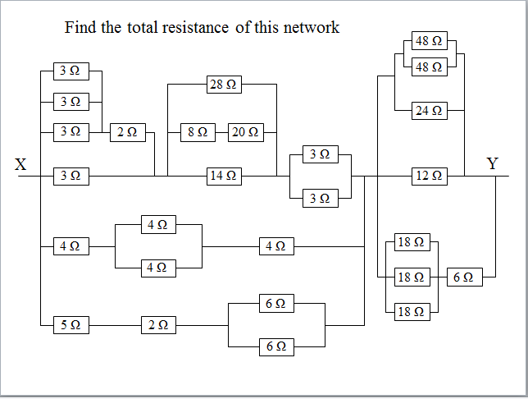  R total = 7.3 ohms (see the power point for the worked answers)
12.12 |  |  | I know what happens in a circuit when I increase the resistance in both series and parallel circuits.
12.12.1 |  |  | State what happens to the total resistance as resistors are added in a circuit in series. The total resistance increases
12.12.2 |  |  | State what happens to the total resistance as resistors are added in a circuit in parallel. The total resistance decreases
12.12.3 |  |  | If the voltage remains constant state what happens to the current in a circuit as the resistance increases. The current decreases
12.12.4 |  |  | If the voltage remains constant state what happens to the current in a circuit as the resistance decreases. The current increases
Electrical Power
13.1 |  |  | I can state the definition of electrical power.
13.1.1 |  |  | State the definition of electrical power. Power is the energy dissipated or produced per second, or the rate of using/producing energy
13.1.2 |  |  | A student makes a statement: “The power of a light bulb is 15 W.” Explain what this statement mean, in terms of energy. Every second the light bulb transforms 15J of energy (into light and heat)
13.1.3 |  |  | Dissipation is a term that is often used to describe ways in which energy is wasted. Any energy that is not transferred to useful energy stores is said to be wasted because it is lost to the surroundings.  Taking 3 separate appliances indicate ways in which the energy is dissipated.  e.g  Toaster energy is dissipated as heat with a small amount of light  Washing machine energy is dissipated as kinetic energy, and heat  TV the energy is dissipated as light and sound with heat given off as wasted energy.  (or any other response)
13.1.4 |  |  | A kettle is rated as 2 KW.  - Explain what this term means. Every second the kettle transforms 2000 J of energy.  - Does all the energy heat the water? You must justify your answer.  No, some of the energy will be used to heat the air and the kettle. You know this as the kettle gets hot when the kettle is on.
MrsPQ |  |  | What/ Watt is the unit of power?! YES!
13.2 |  |  | I can use the word dissipated as it relates to power.
13.2.1 |  |  | 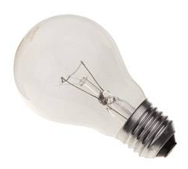  Copy the sentence below and state the word to which the sentence refers.  The process in which an electric or electronic device produces heat (other waste energy) as an unwanted by-product of its primary action. power-dissipation
13.2.2 |  |  | A 100 W light bulb transfers 20 W of light.  State what happens to the remaining power.  The remaining energy/power is dissipated as heat.
13.2.3 |  |  | State the formula to calculate the power dissipated in a circuit. State the meaning and units of each quantity.  $$P=I^{2}R$$  P= Power (Watt), I= current (Ampere), R=Resistance (ohm)
13.3 |  |  | I am able to solve calculations relating to Power, Energy and time.
13.3.1 |  |  | State the equation that links Power, Energy and time. State the units of each quantity.  $$E=Pt$$  E=energy (Joule), P= Power (Watt), I= current (Ampere), time (second)
13.3.2 |  |  | - State the energy transformed each second by a drill rated at 800 W.  $$E=Pt$$  In one second  $$E=800×1=800 J$$  - From part a) state what you can infer about the energy used per second by an appliance and its power rating. Energy used per second is power
13.3.3 |  |  | Calculate the electrical energy transformed by the following appliances  - A 400 W drill used for 45 s.  $$E=Pt$$  $$E=400×45=18000 J$$  - A 300 W food processor used for 20 s.  $$E=Pt$$  $$E=300×20=6000 J$$
13.3.4 |  |  | Calculate the electrical energy transformed by an 800 W iron used for 40 minutes.  t= 40 mins = 40×60=2400 s  $$E=Pt$$  $$E=800×2400=1920000 J=1.92×{10}^{6} J$$
13.3.5 |  |  | Calculate the electrical energy transformed by a 2.4 kW kettle that takes 5 minutes to boil the water inside it.  t= 5 mins = 5×60= 300 s  $$E=Pt$$  $$E=300×2400=1920000 J=7.2×{10}^{5} J$$
13.3.6 |  |  | A miniature heater for making cups of tea is rated at 150 W. Calculate the time taken to boil the water if 45,000 J of energy are supplied.  $$E=Pt$$  $$45 000=150×t=$$  $$t=\frac{45 000}{150}=300 s$$
13.3.7 |  |  | A 2.0 kW heater, a 150 W TV and a 100W light bulb are left on for 20 minutes. Calculate the total energy consumed by these appliances in this time.  Total power consumed=2000+150+100=2250 W  $$E=Pt$$  $$E=2250×\left(20×60\right)=2700000 J=2.7×{10}^{6} J$$
13.3.8  REPEAT |  |  | An electrical components is operated at 4·0 V with a current of 0·50 A for 60 seconds. Calculate the energy transferred to the component during this time.
  Either as one equation | Or using two equations
  $$E=IVt$$  $$E=0.50×4.0×60$$  $$E=120 J$$ | $$P=IV$$  $$P=0.50×4.0=2.0W$$  $$E=Pt$$  $$E=2.0×60=120 J$$
13.3.9 |  |  | A MES lamp rated at 3.5 V and with a current of 0.25 A is switched on and consumes 87.5 J of energy. Calculate the time the bulb has been switched on for
  Either as 1 equation | Or using two
  $$E=IVt$$  $$87.5=3.50×0.25×t$$  $$t=\frac{87.5}{(3.50×0.25)}=100 s$$ | $$P=IV$$  $$P=3.50×0.25=0.875W$$  $$E=Pt$$  $$87.5=0.875×t$$  $$t=100 s$$
13.4 |  |  | I know the effect of potential difference (voltage) and resistance on the current in and power developed across components in a circuit. (complete section 13.5 before attempting this section)
13.4.1 |  |  | SQA SG C 2011.  A mains electric fire has two heating elements which can be switched on and off separately. The heating elements can be switched on to produce three different heat settings: LOW, MEDIUM and HIGH. The fire also has an interior lamp which can be switched on to give a log-burning effect.  The circuit diagram for the fire is shown.  (a) Switches S2 and S3 are closed.  (i) Calculate the combined resistance of both heating elements.  (ii) Calculate the total power developed in the heating elements when S2 and S3 are closed.  - State and explain which switch or switches would have to be closed to produce the LOW heat setting.
13.4.2 |  |  | Based on SG C 2005  A mains vacuum cleaner contains a motor that takes 3.0 s to reach full speed after being switched on. The graph shows how the current in the motor varies from the time the motor is switched on.  - Calculate the power of the motor when it first switched on.  $$P = IV$$  $$As mains voltage V=230(V)$$  $$P= 9 × 230$$  $$P= 2070 W$$  - State the current when the motor has reached full speed. 4.0 A  - Calculate the power of the motor when it has reached full speed.  $$P = IV$$  $$As mains voltage V=230(V)$$  $$P= 4 × 230$$  $$P= 920 W$$  (c ) The vacuum cleaner is connected to the mains supply by a flex fitted with a fused plug. All the fuses shown are available.  State which one of these fuses is most suitable for fitting in the plug. You must justify your answer. 10 A fuse, as the initial current is high but below 10 A.
13.4.3 |  |  | SQA SG C 2009  A car fan uses a battery powered electric motor. The diagram below shows the apparatus used to investigate the effect of current on the speed of the electric motor.  - The graph shows the relationship between speed and current during the investigation.  - The current is changed using the variable speed control. State what happens to the current when the resistance of the variable speed controller is reduced.  (Current) increases  - The settings of the variable speed control use different combinations of identical resistors, as shown. State to which position the variable speed control should be set to achieve maximum speed. You must justify your answer.
  A (position) S  B This position gives maximum current  OR  this position gives least/minimum resistance (must be ‘least’ or equivalent, not ‘less’)  OR  This position gives greatest/maximum voltage ACROSS fan | (1) for correct position  (1) for correct justification  Accept a correct statement referring to  minimum resistance OR to maximum current  - even if answer to 4 (ii) (A) is wrong  NOT answers relating to power or energy  NOT voltage to/through fan
13.4.4 |  |  | SQA SG C 2012  A student sets up a circuit to operate two identical 12 V, 36 W lamps from a 48 V supply.  (a) When the switch is closed, the lamps operate at their correct power rating.  Calculate:  (i) the reading on the ammeter;  (ii) the reading on the voltmeter;  (iii) the resistance of the variable resistor.  - The student sets up a second circuit using a 12 V supply and the same lamps. Each lamp has a resistance of 4 Ω. The resistance of the variable resistor is set to 6 Ω.  (i) Calculate the total resistance of this circuit.  (ii) The variable resistor is now removed from the circuit.  - State what happens to the reading on the ammeter. You must justify your answer.
13.5 |  |  | I can use appropriate relationships to solve problems involving power, potential difference (voltage), current and resistance in electrical circuits
13.5.1 |  |  | State the relationship between current, voltage and power.  $$P=IV$$
13.5.2 |  |  | (a)State the relationship between current, resistance, and power.  $$P=I^{2}R$$  - Show that this relationship is found by combining P=IV and V=IR.  $P=IV$ and $V=IR$  $$Replace the V in P=IV$$  $P=I×I×R$  $$Collect the terms$$  $$P=I^{2}R$$
13.5.3 |  |  | (a)State the relationship between voltage, resistance, and power.  $$P=\frac{V^{2}}{R}$$  - Show that this relationship is found by combining P=IV and V=IR.  $P=IV$ and $V=IR$  $$Replace the I in P=IV$$  $$P=\frac{V×V}{R}$$  $$Collect the terms$$  $$P=\frac{V^{2}}{R}$$
13.5.4 |  |  | A toaster is rated at 230V 1200W. Calculate the current in the toaster when it is operating normally.  $$P=IV$$  $$1200=I×230$$  $$\frac{1200}{230}=I=5.2 A$$
13.5.5 |  |  | State the relationship between current, resistance, and power. Also write this as a triangle and say what each letter stands for  $$P=I^{2}R$$  P=Power, I= current, R=resistance  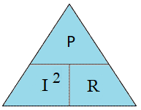
13.5.6 |  |  | Show that this relationship is found by combining P=IV and V=IR. REPEAT
13.5.7 |  |  | A 12 V battery supplies a motor which has a resistance of 18 Ω, calculate the current in the circuit.  $$V=IR$$  $$12=I×18$$  $$\frac{12}{18}=I=0.67 A$$
13.5.8 |  |  | An LED which is in series with a 1.2 kΩ resistor must be supplied with 5 mA of current to operate. When lit, the p.d. across the LED is 0.6 V.  Calculate the potential difference across the resistor.  $$V=IR$$  $$V=5×{10}^{-3}×1.2×{10}^{3}$$  $$V=6 V$$  Calculate the minimum supply voltage required.  $$V_{s}=V_{1}+V_{2}$$  $$V_{s}=6+0.6=6.6V$$
13.5.9 |  |  | A vacuum cleaner is connected to the UK mains (rated at 230 V) and 8.9 A of current flows through the circuit. Calculate the power being transformed.  $$P=IV$$  $$P=8.9×230=2047V$$  $$P=2000 V$$  Answer to 2 sig fig
13.5.10 |  |  | A heater has a power of 1000W, and the current in it is 5A, calculate the resistance of the heater.  $$P=I^{2}R$$  $$1000=5^{2}×R$$  $$\frac{1000}{25}=R=40$$
13.5.11 |  |  | The resistance of a kettle is 21 Ω and its power is 2200W. Calculate the current in the kettle when it is working normally.  $$P=I^{2}R$$  $$2200=I^{2}×21$$  $$\frac{2200}{21}=I^{2}$$  $$I=\sqrt{\frac{2200}{21}}=10.2 A$$
13.5.12 |  |  | A mains electric fire is rated at 2.0 kW.  - State the voltage across the electric fire. 230 V  - Calculate the current in the heating element when it is switched on.  $$P=IV$$  $$2000=I×230$$  $$\frac{2000}{230}=I=8.7 A$$  - Calculate the resistance of the heating element  $$Use V=IR or P=\frac{V^{2}}{R}$$  The difference in these two values is the rounding errors that occur
  $$V=IR$$ | $$P=\frac{V^{2}}{R}$$
  $$230=8.7×R$$  $$\frac{230}{8.7}=R=26$$ | $$2000=\frac{{230}^{2}}{R}$$  $$R=\frac{{230}^{2}}{2000}=24$$
13.5.13 |  |  | SQA N5 2014  A toy car contains an electric circuit which consists of a 12·0 V battery, an electric motor and two lamps.  The circuit diagram is shown.  (a) Switch 1 is now closed.  Calculate the power dissipated in the motor when operating.  (b) Switch 2 is now also closed.  (i) Calculate the total resistance of the motor and the two lamps.
13.5.14 |  |  | A components is operated at 4·0 V with a current of 0·50 A for 60 seconds.  - Calculate the energy transferred to the component during this time.  - Calculate the power dissipated in the component  $$P=IV$$  $$P=0.50×4.0=2.0W$$
  Either as 1 equation | Or using two equations
  $$E=IVt$$  $$E=0.50×4.0×60$$  $$E=120 J$$ | $$P=IV$$  $$P=0.50×4.0=2.0W$$  $$E=Pt$$  $$E=2.0×60=120 J$$
13.5.15 |  |  | The rating plate on an electrical appliance is shown.  Calculate the resistance of the appliance.  $$P=\frac{V^{2}}{R}$$  $$920=\frac{{230}^{2}}{R}$$  $$R=\frac{{230}^{2}}{920}=57.5$$  $$R=58$$
13.5.16 |  |  | A torch bulb is rated 12V, 60mA. Calculate the power dissipated in the bulb when it is operating normally.  $$P=IV$$  $$P=60×{10}^{-3}×12=0.72 W$$
13.5.17 |  |  | SQA N5 2017 SP  - A student sets up the following circuit.  (i) Determine the total resistance in the circuit.  (ii) Calculate the current in the circuit.  - Calculate the power dissipated in the 15 Ω resistor.  (b) The circuit is now rearranged as shown.  State how the power dissipated in the 15 Ω resistor compares to your answer in (a) (iii). You must justify your answer.
13.5.18 |  |  | The cables used in the National Grid are made of aluminium with a cross sectional area of 25 cm². These have a resistance of 10-5 μΩm⁻¹, and so a 50 km line has a resistance of 0.5 Ω.  - Calculate the power loss in the 50 km line if it has a current of 1200 A in it.  R_{T}=10.5 μΩ ×50×10³ = 0.5 Ω  $$P=I^{2}R$$  $$P={1200}^{2}×0.5=7.2×{10}^{5} W$$  - The current is reduced to 100 A by using a transformer system at each end, calculate the power loss with this new arrangement.  $$P=I^{2}R$$  $$P={100}^{2}×0.5=5.0×{10}^{3} W$$  - If the transformers lose 50 kW because they are not 100 % efficient, calculate the total power loss from both the line and the transformers.  Total power loss = $2 50 kW+5.0 kW=105 kW=1.1×{10}^{5} W$
13.5.19 |  |  | Based on SQA SG C 2007  Two groups of pupils are investigating the electrical properties of a lamp.  (a) Group 1 is given the following equipment:  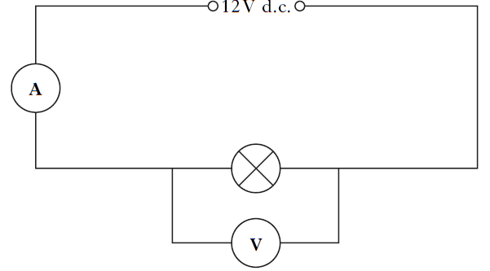  ammeter; voltmeter; 12 V D.C. supply; lamp; connecting leads.  Group 2 uses the same lamp and is only given the following equipment:  lamp; ohmmeter; connecting leads.  - State what property of the lamp is measured by the ohmmeter. Resistance  - The results of both groups are combined and recorded in the table below.  - Use these results to complete the last two columns of the table.  - State the quantity represented by the last two columns of the table. Power  - State the unit of this quantity Yes it is the WATT
  I(A)) | V(V | R(Ω) | IV | I²R
  2 | 12 | 6 | 24 | 24
13.6 |  |  | I know when I would use a 3A fuse and when a 13A fuse for appliances.
13.6.1 |  |  | State the purpose of the fuse fitted in the plug of an appliance. The fuse protects the wiring
13.6.2 |  |  | Explain how a fuse work. If a large current passes through the appliance the fuse melts cutting off the current, making the appliance safe.
13.6.3 |  |  | Explain why different sizes of fuses are required in household appliances. Faults can develop which could be dangerous, but could be under 13 A, using a fuse with too low a rating would cause it to melt each time the appliance was used.
13.6.4 |  |  | - State the fuse value required in most appliances up to 720W. 3A  - State the value of a fuse required in most appliance above 720W 13A  - State the maximum power rating of an appliance that can be fitted with a 13A Either 3120 W (based of the figures here or based on V=230V then 2990 W)
13.6.5 |  |  | The mains supply voltage in the UK is quoted as 230 V.  State a value for the peak voltage and the mains and frequency in the UK? 325V (it is greater than 230, actually 1.414 x greater)
13.6.6 |  |  | Explain why some appliances with a power rating below 720 W, (particularly those containing an electric motor) which you might expect to have a 3A fuse are actually required to have a fuse with a higher rating. The current at switch on could be high, and higher than 3A which would melt the fuse and the appliance would not work.
13.6.7 |  |  | Explain why it is important to fit the correct fuse in an appliance. (i.e. explain what can happen if the wrong fuse is placed in the appliance) The fuse should be the weakest link. A large current could pass through the appliance which could set the wiring/flex on fire. The fuse should melt before the current gets too large to melt the flex.
13.7 |  |  | I could select the appropriate fuse rating given the power rating of an electrical appliance
13.7.1 |  |  | The rating plate on a food blender is shown.  Determine the rating of the fuse fitted in the plug of the blender.  As the power rating is below 720 W a 3A fuse should be fitted to the blender.
13.7.2 |  |  | Choose the correct size of fuse for appliances of  Below 720W use a 3A fuse, above 720W use a 13 A fuse, unless a high switch on current at the start.
  6W | 600W | 800W | 1000W | 2000W | 2500W
  3A | 3A | 13A | 13A | 13A | 13A
13.7.3 |  |  | State the energy change in most appliances that have the greatest power rating.  Electrical ⇒heat
13.7.4 |  |  | Explain, using the correct equation, how you would calculate the correct fuse for an appliance.  $$P=IV$$  $$P=I×230$$
13.7.5 |  |  | The following electrical appliances are found in a kitchen.  kettle hand blender toaster  2500 watts 300 watts 1800 watts  (a) State a reason why you should not fill a kettle with water when it is plugged in and switched on. water can conduct and could cause a current through the water, causing an electric shock.  (b) The hand blender does not have an earth wire. Draw the symbol on its rating plate which indicates it does not require an earth wire.  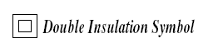  (c) State the colour of the covering of thelive wire in the cord of an electrical appliance.brown  (d) Each appliance is fitted with either a 3 ampere or a 13 ampere fuse. State the correct value of fuse for:  (i) the kettle; 13 A  (ii) the hand blender. 3A
13.7.6 |  |  | An electrician is looking for a fault in the wiring of a house.  Test material  - He decides to make a continuity tester from a battery, a lamp and some insulated wires. Draw a circuit diagram of the continuity tester.

INPUT, PROCESS, OUTPUT DEVICES AND THEIR USES

Name of device | Symbol | Function | Energy change
Loudspeaker |  | In CD Player, tannoy, public address system, karaoke machine | electrical→sound
Motor |  | washing machine, car wiper motor, food processor, vacuum cleaner | electrical→kinetic
Ammeter | 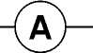
Voltmeter | 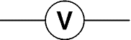
Relay |  | switching on high voltage equipment eg control panels | electrical→kinetic
Diode | 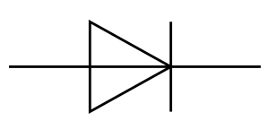
LED |  | analogue- tuner indicator on radio  digital-on/off power indicators | electrical→light
Lamp |  | analogue-atmospheric lighting,  digital-table lamp | electrical→  heat & light
Microphone |  | tannoy, public address system, karaoke machine | sound→electrical
Solar Cell |  | power supply for a calculator, solar powered torch | light→electrical
Thermistor |  | thermometer for an aquarium | heat→electrical
Light Dependent Resistor |  | burglar alarms, automatic drive lights | light→electrical
Capacitor |  | pedestrian crossing patrols
Potentiometer |  | volume control in a stereo, boost control in a vacuum cleaner
Switch |  | on a table lamp
Npn transistor |  | SWITCH  >0.7V  Acts as a switch when a voltage of 0.7 V is applied across the base and emitter | no energy change
N-channel enhancement MOSFET |  | Acts as a switch when a voltage of approximately 2 V is applied across the gate and the source.
cell | 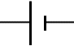 |  | Chemical energy →electrical
battery | 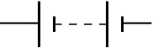 |  | Chemical energy →electrical
Resistor

LDR is short for Light Dependent Resistor- remember it as Light Drops Resistance

