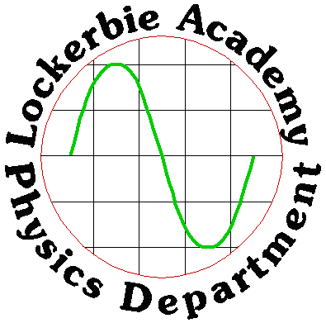

NAME: _____________________

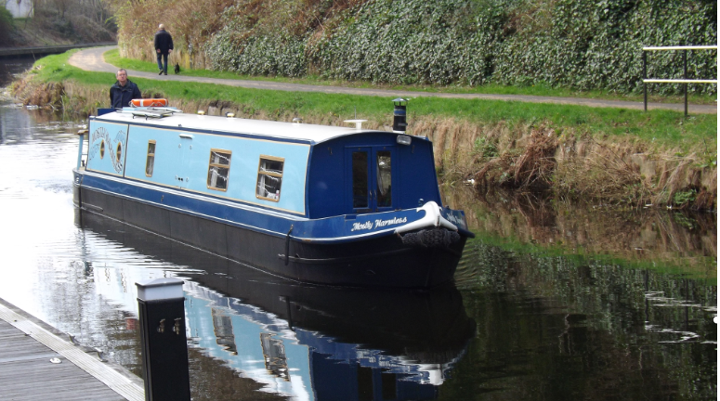
CLASS: _______
Producing good answers to these questions should give you a great set of revision notes for the N5 Physics course
2019+
AnDon’t Panic!
J A HARGREAVES | National 5  Learning Outcomes Questions

Data Sheet

Periodic Table

Relationships Sheet

PREFIXES
http://www.youtube.com/watch?v=N_9IBQ3Pxz0

Prefix | Symbol | Multiple | Multiple in full
Tera | T | x10¹² | x1 000 000 000 000
Giga | G | x10⁹ | x1 000 000 000
Mega | M | x10⁶ | x1 000 000
Kilo | k | x10³ | x1 000
Centi | c | x10⁻² | ÷100
Milli | m | x10⁻³ | ÷1 000
Micro | μ | x10⁻⁶ | ÷1 000 000
Nano | n | x10⁻⁹ | ÷1 000 000 000
Pico | p | x10⁻¹² | ÷1 000 000 000 000

Above is a table of prefixes, which you will commonly find in Physics.
NB THE STANDARD UNIT FOR MASS IS THE KILOGRAM. Do not try changing it to grammes!
Watch out for ms which is not metres per second but milli seconds

Tackling Mathematical Questions
Always set out maths problems using the structure given below. It may seem to take longer but it will save time in the long run as it makes the question clearer.

USE IESSUU

http://www.youtube.com/watch?v=u7akhlAS5Ck
- Information- Summarise the question by writing down what you know from the information given. Use the letter that goes with the quantity and this will help you be able to work out the correct formula
- Equation – write down the equation as it occurs in the data sheet. Do not attempt to rearrange it before substituting.
- Substitution – put the numbers into the equation as they appear in the formula. Use the magic triangle to rearrange the formula, only if you must!
- Solution – work out the answer. You are ALWAYS allowed to use a calculator. Write out the answer, but not to too many sig fig.
- Units- you will need to use the correct units so will need to learn these. No or wrong units no mark for the answer
- Underline – underline with 2 lines the answer to make it clear what your final answer will be

In short:
- (Information)- Summarise the question.
- Change any units that are not standard.
- (Equation) -Write out the formula.
- (Substitution) -Put the numbers in.
- (Solution)- Work out the answer.
- (Units) -Add units to your answer.
- (Underline) Underline the answer

ALL UNITS
No. | CONTENT
0.1. | I know the units for all of the physical quantities used in this course.
0.1.1 | Give the units and symbols for the following quantities  - Voltage ii) Current iii) Time iv) Resistance v) Power  vi) Energy vii) Force viii) Frequency ix) Gravitational Field Strength  x) Mass xi) Temperature xii) Weight xiii) Wavelength
0.2. | I can use the prefixes: nano (n), micro(μ), milli (m), kilo(k), Mega(M) & Giga (G)
0.2.1. | Convert the following to volts:  i) 5 kV ii) 23 mV iii) 7 μV  iv) 2.8 MV v) 67 nV vi) 389 μV
0.2.2. | Use the correct prefix to write the following in the shortest possible form:  i) 8000000 J ii) 0.000004 J iii) 6340 J  iv) 0.005 J v) 0.000063 J vi) 9806000 J
0.2.3. | Change the following to basic units:  i) 50 km ii) 30000 km iii) 57 mm  iv) 9 cm v) 8.31 km vi) 25 km 356 m 28 cm  vii) 5 mm viii) 3 h ix) 2 min 40 s  x) 8 min 22s xi) 7.45 mm xii) 7 h 25 min 30s  xiii) 500 g xiv) 7400000 g xv) 250 mg  xvi) 97.5 g xvii) 45 μg xviii) 3700 Mg
0.2.4. | Change the following to basic units:  i) 800 mA ii) 0.25 MA iii) 375 kA  iv) 35.6 μA v) 35.6 kA vii) 9 430 000 μA  viii) 750 mV ix) 4.7 MV x) 450 kV  xi) 53 μV xii) 281kV xiii) 10670000 μV
0.2.5 | Change the following to basic units:  i) 56 kJ ii) 78 mJ iii) 8000 MJ  iv) 0.3 μJ v) 0.0075 MJ vi) 3600 μJ
0.3. | I can give an appropriate number of significant figures when carrying out calculations
0.3.1 | Convert the following to 3 significant figures.  i) 23760000 V ii) 45.6783 A iii) 0.1023 m iv) 78945379.97 Hz  v) 7600043.7 m/s vi) 1254879 V vii) 67593268.0076 m viii) 1214687 A
0.4. | I can use scientific notation when large and small numbers are used in calculations.
0.4.1 | Write the following in scientific notation:  i) 370 000 000 ii) 20 050 000 000 iii) 930 000 000 000 000  iv) 0.000 23 v) 0.00000006 vi) 0.000 000 000 04
0.4.2 | Write out the following in full:  i) 3 × 10⁸ ii) 2.75×10⁴ iii) 7.004 × 10⁹  iv) 8.4 × 10⁻³ v) 4.2× 10⁸ vi) 9.08 × 10⁻⁵

DYNAMICS

Quantities for the Dynamics Unit
For this unit copy and complete the table.
Quantity | Symbol | Unit | Unit Symbol | Scalar / Vector
Time
Speed
Velocity
Acceleration
Distance
Displacement
Force
Weight
Friction
Gravitational Field Strength
Energy
Work
Heat Energy
Gravitational Potential Energy
Kinetic Energy
Height
Initial velocity
Final velocity
Average velocity
Mass

The DYNAMICS unit in numbers
Quantity | Value
State the number seconds in a minute.
State the number of seconds in an hour.
State the gravitational field strength on the surface of Earth.
State the number of metres in a kilometre.
State the number metres in a mile?
If 70 mph is equivalent to 31.29 ms⁻¹ and 30 mph is equivalent to 13.41 ms⁻¹, what is the conversion factor to convert mph into ms⁻¹?

No. | CONTENT
Vectors and scalars
1.1 | I can define scalar quantities and vector quantities.
1.1.1 | Define the term scalar quantity.
1.1.2 | Define the term vector quantity.
1.1.3 | Describe the difference between vector quantities and scalar quantities.
1.2 | I can identify vector and scalar quantities such as: force, speed, velocity, distance, displacement, acceleration, mass, time and energy.
1.2.1 | Copy and complete the following table placing the quantities in the correct part of the table. force, speed, velocity, distance, displacement, acceleration, mass, time and energy.
  Scalar | Vector
1.3 | I can calculate the resultant of two vector quantities in one dimension or at right angles.
1.3.1 | Define the term “resultant” in terms of two vector quantities.
1.3.2 | Explain how to calculate the resultant and direction of a pair of vectors at right angles.
1.3.3 | Determine the resultant of the following vectors  (b)  (c)
1.3.4 | (d)  (b)  (c)  Find the resultant of each of the pairs of vectors, remember to quote the direction.
1.4 | I can determine displacement and/or distance using scale diagram or calculation.
1.4.1 | Explain the term distance.
1.4.2 | Explain the term displacement.
1.4.3 | 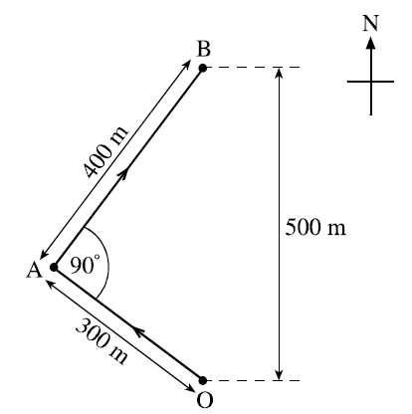  The diagram shows the course taken by a boat during a race.  The boat starts the race at O and sails to a marker buoy at A. The boat then turns through 90° and sails to a marker buoy at B.  (i) Calculate the total distance travelled by the boat in going from O to B.  (ii) On reaching the marker buoy at B, determine the displacement of the boat from O.
1.4.4 | An orienteer starts at A, runs to B, then C and finishes at D.  - Calculate the total distance travelled by the orienteer.  - State the final displacement of the orienteer from point A.
1.5 | I can determine velocity and/or speed using scale diagram or calculation.
1.5.1 | Define the terms  - distance b) displacement
1.5.2 | Define the terms  - Speed b) Velocity
1.5.3 | State the difference between speed and velocity.
1.5.4 | A cyclist travels 500 m in a straight line and then turns directly around and travels 300 m back.  - State the magnitude of the displacement of the cyclist from the start.  - If the cyclists takes 4 minutes and twenty seconds to travel the complete distance, calculate the magnitude of the cyclist’s  - speed and  - velocity.
1.5.5 | A sculler is rowing his boat at 3 ms⁻¹ through the water straight across a river which is flowing at 1 ms⁻¹.  - Draw a vector diagram of these two motions.  - Calculate the boat’s velocity relative to the bank.
1.5.6 | On an orienteering course, a girl runs due north from point A to point B, a distance of 3 km. She then heads in an easterly direction for 4 km to point C.  - Calculate the distance the girl ran from A to C.  - Calculate the girl’s displacement from point A when she reaches C.
1.5.7 | The distance between the wickets on a cricket pitch is 20.12 m. On one pitch, the wicket has a north-south orientation. A batsman scores three runs off one ball.  - Calculate the distance he ran.  - Calculate his final displacement if the wicket at which he batted is at the south end.  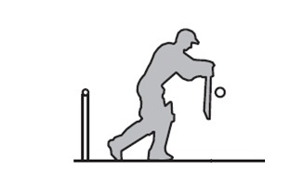
1.5.8 | Jen jogs around the centre circle of a football pitch.  - Calculate the distance she travelled.  - State her displacement from the start.  Chris walks one and a half times around the circle in the same time  - Calculate the distance Chris travelled.  - State Chris’ displacement from the start.  circumference  = 25 m
1.6 | I can perform calculations/ solve problems involving the relationship between speed, distance and time. (d = vt, and $d=\overline{v}t$)
1.6.1 | A car travels 100 miles in 2½hours. Calculate its speed in mph?
1.6.2 | A train travels 120 km in 45 minutes.  (i) Calculate the speed of the train in kmh⁻¹?  (ii) Calculate the speed of the train in ms⁻¹?
1.6.3 | A jet plane travels at an average speed of 300 ms⁻¹.  (i) Calculate the distance the plane travels in an hour.  (ii) Determine the time it would take to travel 500km from Edinburgh to London.
1.6.4 | A runner completes a 200 m race in 25 s. Calculate the runner’s average speed.
1.6.5 | An athlete takes 4 minutes 20 s to complete a 1500 m race. Calculate the average speed of the athlete in ms⁻¹.
1.6.6 | Bloodhound SSC is due to travel at 500 mph (approximately 230 ms⁻¹).  At this speed, calculate the distance Bloodhound could travels in 25 s.
1.6.7 | A girl can walk at an average speed of 2 ms⁻¹. Calculate the distance she walks in 20 minutes.
1.6.8 | Calculate the time it takes a cyclist to travel 40 km at an average speed of 5 ms⁻¹.
1.6.9 | Calculate the time (to the nearest minute) the Glasgow to London shuttle will take if it flies at an average speed of 220 ms⁻¹ for the 750 km flight.
1.6.10 | Calculate the time to the nearest minute, a car will take to travel 50 km if its average speed is 20 ms⁻¹?
1.7 | I can perform calculations/ solve problems involving the relationship between velocity, displacement and time ( $s=\overline{v}t$) in one dimension
1.7.1 | A person walks 25 metres west along a street before turning back and walking  15 metres east. The journey takes 50 seconds. Calculate the:  a) total distance travelled by the person  b) displacement of the person  c) average speed of the person  d) average velocity of the person.
1.7.2 | An Olympic runner runs one complete lap around an athletics track in a race.  The total length of the track is 400 metres and it takes 45 seconds for the runner to complete the race. Calculate the:  a) displacement of the runner at the end of the race  b) average speed of the runner during the race  c) average velocity of the runner during the race.
1.7.3 | A car drives 15 kilometres East for 12 minutes then changes direction and drives  18 kilometres West for 18 minutes.  a) Calculate the total distance travelled by the car.  b) Calculate the displacement of the car from the start of the journey.  c) Calculate the average velocity of the car, in metres per second.
1.7.4 | On a journey, a lorry is driven 120 kilometres west, 20 kilometres north then 30  Kilometres east. This journey takes 2 hours to complete.  a) Calculate the average displacement of the lorry, in km.  b) Calculate the average velocity of the lorry, in km/h.
1.8 | I can determine average and instantaneous speed.
1.8.1 | Explain the term average speed.
1.8.2 | Explain the term instantaneous speed.
1.8.3 | 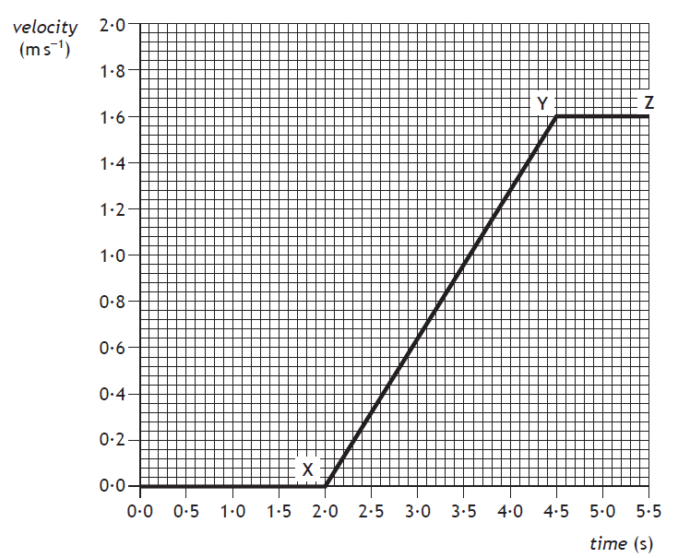  State the instantaneous speed of the vehicle at
   | 0.5 s |  | 3.0 s |  | 4.0 s
1.8.4 | A runner takes 35 seconds to run round 250 metres of a track, calculate her average speed.
1.8.5 | Calculate the average speed of a motor boat which takes 350 seconds to cover a 10 000 m course
1.8.6 | Calculate the distance a car travels in 300 seconds when it is travelling at a top speed of 30 ms⁻¹.
1.8.7 | Calculate the time it takes to walk to school if you walk at an average speed of 3 ms⁻¹ and you live 900 metres away?
1.8.8 | A train travels at 35 ms⁻¹ and takes 15 seconds to pass through a tunnel. Calculate the length of the tunnel.
1.8.9
  Calculate the average speed of Sammy Snail who slithers 0⋅005 m in 4.0 s.
1.8.10 | How long does the TGV take to travel 60 km given that it goes at an average speed of 30 ms⁻¹.
1.8.11 | A school bus takes 20 minutes to travel 15 km. Calculate it’s average speed in ms⁻¹
1.8.12 | A bird maintains an average speed of 11⋅2 ms⁻¹ for 5 minutes. Calculate the distance it travels.
1.8.13 | Calculate the time taken for a roller blader to travel 2 km if her average speed is 7 ms⁻¹
1.8.14 | A runner decides to analyze her track performance in order to improve her overall running time during the 400 m event. She sets up light gates at six points round the track so that she can work out her instantaneous speed at each point.  As the runner cuts the beam of light from the light gate the timer operates.  $$instantaneous speed= \frac{width of runner}{time to pass the point}$$  The results she recorded are shown below.  Use the results to calculate her instantaneous speed at each position and hence determine the point is she running:  (a) fastest (b) slowest.
  Position | width of runner (m) | time (s) | instantaneous speed (m/s)
  A | 0·2 | 0·025
  B | 0·2 | 0·026
  C | 0·2 | 0·030
  D | 0·2 | 0·029
  E | 0·2 | 0·025
  F | 0·2 | 0·024
1.8.15 | Civil engineers need to know the speed of a train as it enters a tunnel which they are planning to build. They set up their equipment to measure the length of a section of the train and time how long that section takes to pass the planned point of entry to the tunnel.  The length of train is 23.0 m and the time to pass the point of entry is recorded as 1·23 s. Calculate the instantaneous speed of the train.
1.8.16 | A coin is dropped from a height so that it passes through a light gate connected to a computer. The coin has a width of 0·02 m and it takes 0·005 seconds to pass through the light gate. Calculate the coin’s instantaneous speed.
1.8.17 | Two insulated wires are laid across the road 1.00 metres apart to test the instantaneous speed of cars as they travel between the wires. A Mondeo of wheelbase length 2.85 m takes 0.06 s to pass between the two wires. Calculate the instantaneous speed of the car.
1.9 | I can describe experiments to measure average and instantaneous speed.
1.9.1 | Describe how you can measure the average speed of a runner. Include a list of the apparatus you would use, the measurements you would take, how you would carry these out, and the calculation needed to obtain a final value for the speed. You may use a diagram to help you.
1.9.2 | (a) List various methods for measuring the instantaneous speed.  (b) State of these methods is most accurate, you must justify your answer.
1.9.3 | An arrow of length 0·8 m is shot from a bow.  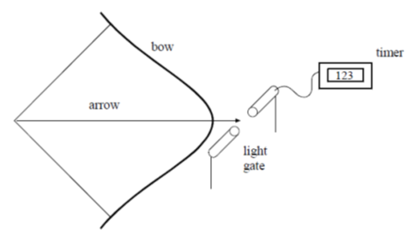  A student designs an experiment to measure the instantaneous speed of the arrow, as it leaves the bow. The student places a light gate connected to a timer, as shown below.  The student states that the speed of the arrow can be found from  $$speed of the arrow= \frac{length of arrown}{time on timer}$$  (i) Explain why the method used by the student does not give the correct value for the speed of the arrow as it leaves the bow.  (ii) Suggest how the experiment could be modified to enable the speed of the arrow as it leaves the bow to be found.
1.9.4 | 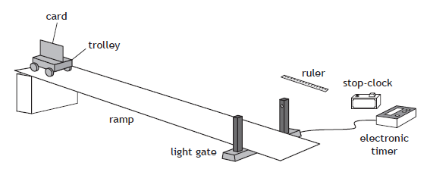  Copy and complete the diagram and state how the following can be determined:  - the instantaneous speed of the trolley at the bottom of the slope.  - the average speed of the trolley down the ramp  - the acceleration of the trolley as it rolls down the ramp.
1.9.5 | 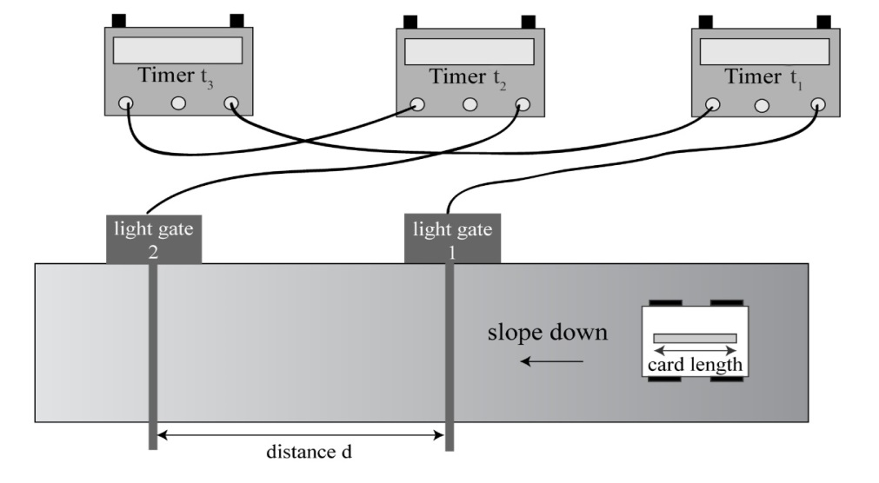  t₃  t₂  t₁  From the diagram above, state what measurements are required to find:  - the average speed of the vehicle as it passes down the slope?  - the instantaneous speed at the bottom of the slope?  State what pieces of equipment give the measurements to find:  - the average speed of the vehicle as it passes down the slope?  - the instantaneous speed at the bottom of the slope?  - What additional equipment is required to complete these measurements?
Velocity- time graphs
2.1 | I can draw velocity–time graphs for objects from recorded or experimental data.
2.1.1 | - On graph paper, draw a velocity-time graph of the race car’s journey.  - Using the graph, describe the motion of the race car over the 80 seconds.  - Using the graph you have drawn, calculate  - The acceleration between 10 and 40 s.  - The total distance travelled by the race car.  - The average speed during the 80 seconds.
  Time (s) | 0 | 10 | 20 | 30 | 40 | 50 | 60 | 70 | 80
  Speed (m/s) | 5 | 5 | 20 | 35 | 50 | 50 | 50 | 25 | 0
2.1.2 | Draw a labelled speed-time graph showing an object  (a) accelerating at 2 ms⁻²,  (b) travelling at a steady velocity of 6 ms⁻¹,  (c) accelerating at -5ms⁻².
2.1.4 | During a test run, a car starts from rest on a straight, flat track. For the first 2 s it has a constant acceleration. It then maintains a constant velocity for a further 3 s. Sketch a velocity–time graph to show how the velocity of the car varies during the test run. Numerical values are only required on the time axis.
2.2 | I can interpret velocity–time graphs to describe the motion of an object.
2.2.1 | Fully describe the motion of the vehicles.  Time (s)  Velocity (ms⁻¹)  Time (s)  Velocity /ms⁻¹  (b)  Velocity /ms¹  Time (s)  (c)  (a)  velocity / ms⁻¹  Time (s)  T  (d)
2.2.2 | - Describe the motion of the car during the 35 seconds  - Calculate the acceleration between 0 and 10 seconds  - Calculate the acceleration between 30 and 35 seconds  - Calculate the final displacement of the car from the starting position  - Calculate the average velocity during the 35 seconds.
2.1.3 | The velocity-time graph shown below describes the motion of a ball which has been thrown straight up into the air then allowed to fall to the ground.  From the graph below  - Determine the time the ball reaches its maximum height.  - Calculate the maximum height that the ball reaches.  - Calculate the height from maximum to the ground.  - Use your answers to ii. and iii. to calculate the height above the ground that the ball was thrown from.
2.2.4 | (i) For each of the graphs shown below, find  (a) the instantaneous speed at 10s  (b) the distance travelled over the 20 second period  (c) the average speed over the 20 second journey.  (NB time axis scale has each major unit = 5s, velocity axis major unit is 2 ms⁻¹)  (ii) Compare the average speed with the instantaneous speed at ten seconds and comment on the difference (if any).  (iii) In what situation will the instantaneous speed always be the same as the average speed?
2.2.5 | A car travels along a motorway.  A graph of the car’s motion is shown.  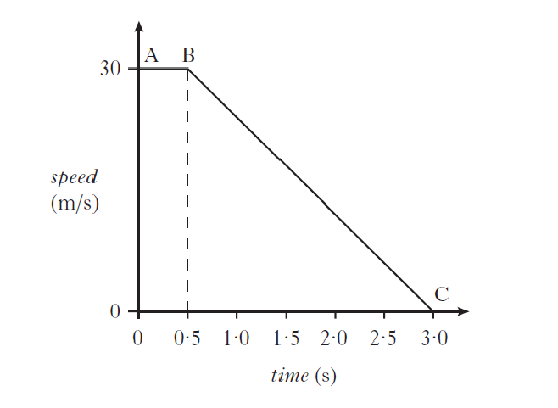  Describe the motion of the car:  (a) Between A and B  (a) Between B and C.
2.2.6 | 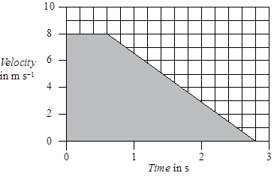  - State what quantity is found by calculating the area under the velocity time graph  - Determine the area under this graph.
2.2.7 | The graph below shows how the speed of a skier varies with time during the first 10 seconds of a downhill run.  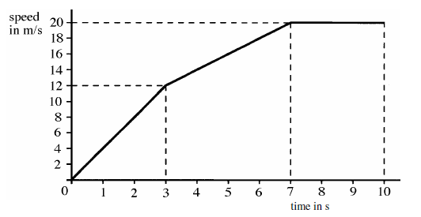  (a) Calculate the acceleration of the skier during the first 3 seconds of the run. 2  (b) Suggest a possible reason for the change in the skier’s acceleration after the first 3 seconds.  (c) Describe the motion of the skier between 7 seconds and 10 seconds.  (d) Show that the average speed of the skier during the first 7 seconds of the run is  11·7 ms⁻¹.
2.3 | I can find displacement from a velocity–time graph.
2.3.1 | State how you calculate the displacement from a velocity-time graph.
2.3.2 | Calculate the distance the train travels in the 150 seconds shown in the graph above.
2.3.3 | Use the velocity time graphs below to calculate the displacement travelled during each journey.  time in s  25  5  20  0  20  time in s  14  10  32  0  30  time in s  30  12  0  5  v/ ms⁻¹  2  5  0  time in s  30  12  0  v / ms⁻¹  t/s  10  18  50  0  v / ms⁻¹  v/ ms⁻¹  v/ ms⁻¹  v/ ms⁻¹
Acceleration
3.1 | I can define acceleration as the final velocity subtract the initial velocity divided by the time for the change
3.1.1 | State the meaning of the term “acceleration”.
3.1.2 | Explain what is meant by a uniform acceleration of 1.4 ms⁻²
3.2 | I can use the relationship involving acceleration, change in speed and time  (a = ∆v/t).
3.2.1 | A Jaguar can reach 27 ms⁻¹ from rest in 9.0 s, calculate its acceleration.
3.2.2 | The space shuttle reached 1000 ms⁻¹, 45 s after launch, calculate its acceleration.
3.2.3 | Starting from rest, a flea accelerates to 1·2 ms⁻¹ in a time of 0·001 s. Calculate the acceleration of the flea.
3.2.4 | A car reaches a velocity of 30 ms⁻¹ from a velocity of 18 ms⁻¹ in 6 s. Calculate its acceleration.
3.2.5 | A train moving at 10 ms⁻¹ increases its speed to 45 ms⁻¹ in 10 s. Calculate its acceleration.
3.2.6 | A bullet travelling at 240 ms⁻¹ hits a wall and stops in 0.2 s. Calculate its acceleration.
3.2.7 | A car travelling at 20 ms⁻¹ brakes and slows to a halt in 8 s. Calculate its acceleration.
3.3 | I can use appropriate relationships to solve problems involving acceleration, initial velocity (or speed) final velocity (or speed) and time of change.
3.3.1 | State the formula linking velocity and acceleration. Explain what each letter stands for and the units of each.
3.3.2 | A girl is riding a bicycle. She starts at rest, and accelerates to 20 ms⁻¹ in 8.0 seconds, calculate her acceleration.
3.3.3 | A car increases its velocity from 30 ms⁻¹ to 80 ms⁻¹ in 20 seconds. Calculate its acceleration.
3.3.4 | When you drop a stone, it accelerates downwards at 9.8 ms⁻².  If the stone is initially at rest, calculate its speed after falling for 1.5 seconds.
3.3.5 | A racing car can accelerate at 7 ms⁻², calculate the time taken to increase its velocity from 20 ms⁻¹ to 60 ms⁻¹.
3.3.6 | A rocket in orbit accelerates at 12 ms⁻² for 15 seconds. If its final velocity is 300 ms ⁻¹, calculate its initial velocity.
3.3.7 | On approaching the speed limit signs, a car slows from 30 m/s to 12 m/s in 5 s. Calculate its acceleration.
3.3.8 | A bowling ball is accelerated from rest at 3 ms⁻² for 1.2 s, calculate the final speed it will reach.
3.3.9 | Calculate the time it takes a car to increase its speed from 8 ms⁻¹ to 20 ms⁻¹ if it accelerates at 3 ms⁻².
3.3.10 | A cyclist can accelerate at 0.5 ms⁻² when cycling at 4 ms⁻¹. Calculate the time taken to reach 5.5 ms⁻¹.
3.3.11 | The maximum deceleration a car’s brakes can safely produce is 8 ms⁻², this is an acceleration of -8 ms⁻² Calculate the minimum stopping time if the driver applies the brakes when travelling at 60 mph (27 ms⁻¹).
3.3.12 | A car is stationary at a traffic light. When the light turns green the car accelerates, and reaches a speed of 30mph twenty seconds later.  (i) State the car’s initial velocity.  (ii) Calculate the car’s acceleration in miles per hour per second.
3.4 | I can find the acceleration as the gradient of a velocity–time graph.
3.4.1 | Use the velocity time graphs below to calculate the displacement travelled during each journey.  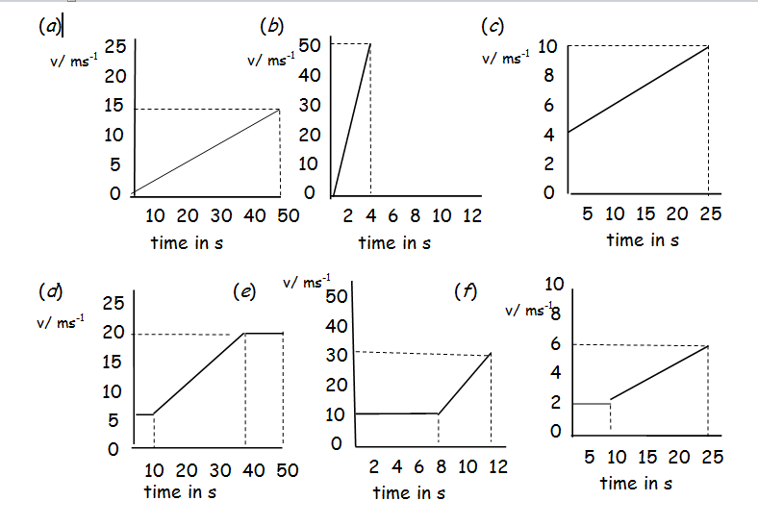
3.4.2 | This speed-time graph shows the changes in the speed of a train. Describe as fully as possible how the train is moving.  Using the graph above, calculate the acceleration of the train between  (a) 0 and 30 seconds, (b) 30 and 60 seconds, (c) 120 and 150 seconds.
3.4.3 | - Calculate the acceleration of the vehicle between X and Y.  - State the acceleration of the vehicle between Y and Z
3.4.4 | The speed-time graph below shows how the speed of the train changes from the instant its brakes are applied until it stops.  speed  in  m/s  20  0  0  100  time in s  Calculate the average acceleration of the train as it slows down.
3.4.5 | 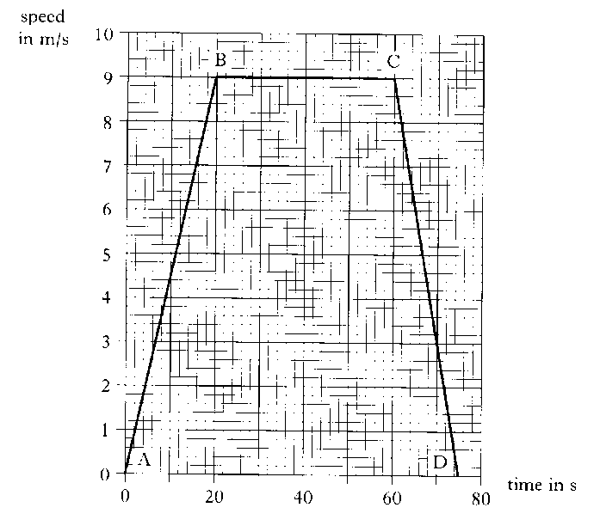  Exam Question  The graph below represents the motion of a cyclist travelling between two sets of traffic lights.  (a) Describe the motion of the cyclist  - between B and C  - between C and D.  - Calculate the acceleration between A and B.
3.4.6 | The graph shows how the speed of a car changes during a journey.  - Complete the following table  - Calculate the acceleration during the first 4 seconds.  The car travelled a total distance of 132 metres. Calculate the average speed of the journey.
  time in s | 0 | 2 | 4 | 6 | 8 | 10 | 12 | 14 | 16
  speed in ms⁻¹
3.5 | I can describe an experiment to measure acceleration
3.5.1 | Describe an experiment using two light gates to measure the acceleration of a vehicle as it rolls down a slope. Draw a diagram of the set-up, note what measurements you would need to make and how the acceleration will be calculated.
3.5.2 | Describe an experiment using one light gate to measure the acceleration of a vehicle as it rolls down a slope. Draw a diagram of the set-up, note what measurements you would need to make and how the acceleration will be calculated.
3.5.3 | The apparatus shown in the Figure above is used to find the acceleration of a vehicle moving along a linear air track.  State two ways of modifying the experiment to produce an acceleration which is double the acceleration.
Newton’s Laws
4.1 | I can give applications and use Newton’s laws and balanced forces to explain constant velocity (or speed), making reference to frictional forces of this.
4.1.1 | (a) State the meaning of the term force.  (b) State the effects a force have on an object.
4.1.2 | Describe how you can measure a force.
4.1.3 | (a) State what is meant by the term friction.  (b) State the effect of friction on movement?
4.1.4 | List ways of reducing the force of friction between two surfaces.
4.1.5 | State ways you increase the force of friction between objects.
4.1.6 | Explain some of the ways friction is used in motor racing. Include at least two examples of where friction is increased, and one where it is decreased.
4.1.7 | Explain, in terms of friction how basic brakes work.
4.1.8 | (a) If you increase the unbalanced force acting on an object while its mass remains constant, what happens to its acceleration?  (b) If you increase the mass of an object, while keeping the unbalanced force the same, what happens to its acceleration?
4.1.9 | State Newton’s First Law of Motion.
4.1.10 | State Newton’s Second Law of Motion.
4.1.11 | Use Newton's first law to explain why a passenger in a train appears to be pushed backwards when the train suddenly starts, and why they appear to be pushed forwards when the train brakes.
4.1.12 | A boy of mass 45 kg pulls a sledge of mass 15 kg up a slope at a constant velocity of 0·5 ms⁻¹. Are the forces acting on the sledge balanced or unbalanced? Explain your answer.
4.1.13 | A motor is used to apply a force of 120 N to a box of mass 30 kg.  The box moves at a constant speed across a horizontal surface.  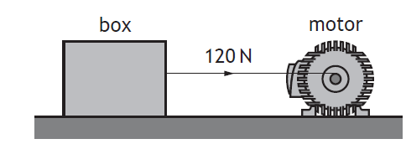  State what you can tell about the forces on this box.  State any other forces acting on the block.
4.1.14 | A weightlifter applies an upwards force of 1176 N to a barbell to hold it in a stationary position as shown.  Describe how the upward force exerted by the weightlifter on the barbell compares to the weight of the barbell
4.1.15 | Exam Question  A rowing team is taking part in a race on calm water.  A  B  C  D  finish line  The following graph shows how it is predicted that the speed of the boat will vary with time during the stages A, B, C and D of the race.  Time/ s  Speed/ ms⁻¹  15  168  150  180  5  7  0  0  A  B  C  D  The prediction assumes that the frictional force on the team’s boat remains constant at 800 N during the race.  (a)  (i) State the size of the forward force applied by the oars during stage B  (ii) Calculate the acceleration of the boat during stage C  (iii) The total mass of the boat and its crew is 500 kg.  calculate the size of the forward force applied by the oars during stage C  (iv) The boat crosses the line after 168 seconds.  Calculate the distance the boat travels from the instant it crosses the line until it comes to rest.  (b)  The frictional force acting on the boat during stage D becomes smaller as the speed decreases.  (i) State the effect of this smaller frictional force on the time taken for the boat to come to rest.  (ii) Sketch a graph of speed against time for stage D, assuming that the frictional force becomes smaller as the speed decreases.
4.1.16 | Exam Question  An air descender is a machine that controls the rate at which a climber drops from a platform at the top of a climbing wall.  A climber, attached to the air descender by a rope, steps off the platform and drops towards the ground and lands safely.  During part of the drop the forces on the climber are balanced. Copy the diagram below show all the forces acting vertically on the climber during this part of the drop.
4.2 | I can give applications of Newton’s laws and balanced forces to explain and or determine acceleration for situations where more than one force is acting, (F=ma)
4.2.1 | Explain the term balanced forces.
4.2.2 | Describe what happens to the speed of an object when there is  (a) no force acting on it,  (b) balanced forces acting on it.
4.2.3 | A passenger in a lift has a mass of 50 kg. As the lift starts its journey, it applies an upwards force of 600 N to the passenger.  (i) State the force of gravity on the passenger.  (ii) Draw a diagram showing the forces acting on the passenger as the lift starts to move.  (iii) State the unbalanced force on the passenger.  (iv) Calculate the acceleration of the passenger.  (v) State the direction of the acceleration
4.2.4 | A boat has a mass of 700 kg, and can accelerate at 3.0 ms⁻². If the engines produce a force of 7000 N, what is the size of  (i) the unbalanced force on the boat, and  (ii) the drag force of the water on the boat?
4.2.5 | (a) State the purpose of a seatbelt?  (b) Explain in terms of forces how a seatbelt fulfils this purpose.
4.2.6 | The unbalanced force acting on an 800 kg car is 1900 N. Calculate its acceleration.
4.2.7 | Calculate the unbalanced force needed to accelerate a 6000 kg lorry at 1.2 ms⁻².
4.2.8 | The unbalanced force on an object is 49 N, and it accelerates at 9.8 ms⁻², calculate the mass of the object.
4.2.9 | Exam Question  The length of runway required for aircraft to lift off the ground into the air is known as the ground roll.  The ground roll of an aircraft varies for each take-off.  Use your knowledge of physics to comment on why the ground roll of an aircraft varies for each take-off.
4.3 | I can use F=ma to solve problems involving unbalanced force, mass and acceleration for situations where more than one force is acting, in one dimension or at right angles.
4.3.1 | A rocket has a total mass of 500 kg and produces a thrust of 10 000 N.  - Calculate the initial acceleration of the rocket.  - State what happens to the mass of the rocket as it burns its fuel.  - If the thrust remains constant, state what happens to the acceleration of the rocket as the fuel is burnt.
4.3.2 | A space vehicle of mass 300.0 kg lifts off from the surface of Mars. At the instant of lift-off the acceleration of the vehicle is 6.0 ms⁻² vertically upwards.  (i) Calculate the unbalanced force acting on the space vehicle at lift-off from Mars.  (ii) Show that the force produced by the engine at lift-off is 3000 N. You must show clearly your working.
4.3.3 | At the corner of a field two fencing wires meet at right angles. Both wires are joined to a fence post.  The wires exert forces of 50 N and 120 N on the fence post as shown.  (i) Find by scale diagram or otherwise the magnitude of the resultant force exerted on the fence post by the wires and its direction with reference to the 50 N force.  (ii) At the corner of fields the fence posts usually have a support wire fitted as shown. The end of the support wire is pegged into the ground.  Referring to the forces acting on the fence post explain why the support wire is fitted.
4.3.4 | Exam Question  A ship of mass 5·0 × 10⁶ kg leaves a port. Its engine produces a forward force of 8·0 × 10³ N. A tugboat pushes against one side of the ship as shown. The tugboat applies a pushing force of 6·0 × 10³ N.  (a) (i) By scale drawing, or otherwise, determine the size of the resultant force acting on the ship.  (ii) Determine the direction of the resultant force relative to the 8·0 × 10³ N force.  (iii) Calculate the size of the acceleration of the ship. (iii) Calculate the size of the acceleration of the ship.
4.3.5 | Exam Question  A weightlifter applies an upwards force of 1176 N to a barbell to hold it in a stationary position as shown.  (a) Describe how the upward force exerted by the weightlifter on the barbell compares to the weight of the barbell. (see 4.1.14)  (b) Calculate the mass of the barbell.  (c) The weightlifter increases the upward force on the barbell to 1344 N in order to lift the barbell above their head.  Calculate the initial acceleration of the barbell.
4.3.6 | A passenger aircraft is flying horizontally.  At one point during the flight the aircraft engines produce an unbalanced force of 184 kN due south (180).  At this point the aircraft also experiences a crosswind. The force of the crosswind on the aircraft is 138 kN due east (090).  (i) By scale diagram, or otherwise, determine:  (A) the magnitude of the resultant force acting on the aircraft;  (B) the direction of the resultant force acting on the aircraft.  (ii) The mass of the aircraft is  6·8 × 10⁴ kg. Calculate the magnitude of the acceleration of the aircraft at this point.
4.4 | I can use W=mg to solve problems involving weight mass and gravitational field strength, including on different planets (where g is given on page 2 of section1 of the exam and in your compendium)
4.4.1 | Explain the difference between mass and weight.
4.4.2 | State the meaning of the phrase 'Gravitational Field Strength'.
4.4.3 | Mars, Jupiter and Earth  On which of the above planets would a 1.0 kg mass dropped near the surface of the planet have the greatest acceleration? Explain your answer.
4.4.4 | Calculate the weight of a person on Earth with a mass of 65.0 kg.
4.4.5 | Calculate the mass of an object which has a weight of 7200 N on Earth.
4.4.6 | 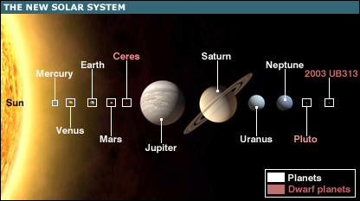  State where in the solar system would your mass be greatest.  State where in the solar system would your weight be greatest.
4.4.7 | On 12th November 2014, on a mission known as Rosetta, the European Space Agency successfully landed a probe on the surface of a comet.  The main structure of the Rosetta spacecraft consists of an orbiter, a lander and propellant.  Calculate the total weight of the spacecraft on Earth.
4.4.8 | SQA N5 2014  A helicopter is used to take tourists on sightseeing flights.  Information about the helicopter is shown in the table.  - The pilot and passengers are weighed before they board the helicopter. Explain the reason for this.  - Six passengers and the pilot with a combined weight of 6125 N board the helicopter. Determine the minimum upward force required by the helicopter at take-off.
  weight of empty helicopter | 13 500 N
  maximum take-off weight | 24 000 N
  cruising speed | 67 m s⁻¹
  maximum speed | 80 m s⁻¹
  maximum range | 610 km
4.5 | I can use Newton’s 3rd law and its application to explain motion resulting from a ‘reaction’ force.
4.5.1 | State Newton’s Third Law of Motion.
4.5.2 | In terms of Newton's third law, what is the 'equal and opposite force' in each of these situations:-  (i) A ship’s propeller pushes on the water,  (ii) A rocket pushes on the exhaust gases,  (iii) The earth's gravitational pull on the moon,  (iv) The Earth’s gravitational pull on an aeroplane.
4.5.3 | Draw the following diagrams and in each case mark and state the reaction force.  Skateboarder pushes wall to the left (action force)  Swimmer pushes water to right (action force)  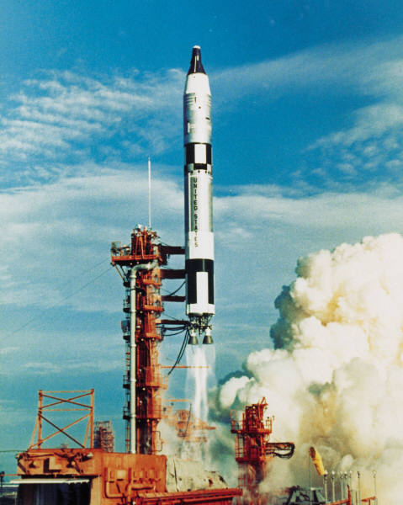  Cannon fires cannonball to the right (action force)  Rocket forces fuel downwards (action force)
4.5.4 | A person sits on a chair which rests on the Earth. The person exerts a downward force on the chair.  State the reaction force.
4.6 | I can use Newton’s laws to explain free-fall and terminal velocity.
4.6.1 | State the meaning of the term free-fall.
4.6.2 | State the meaning of the term terminal velocity.
4.6.3 | - State what happens to an object as it is dropped from a height above the Earth’s surface.  - State the cause of this.
4.6.4 | State the effects of an unbalanced (resultant) force on an object
4.6.5 | A car is travelling at a constant speed along a flat level road.  - State what you can say about the forces on the car.  - An unbalanced force is added to the car, state what happens to the motion of the car.
4.6.6 | A hot air balloon is falling at constant velocity to the ground.  - Draw a free body diagram and label the forces on the balloon.  - State what you can say about the forces on the balloon.  - A balloonist throws a sandbag over the side of the balloon basket, state what happens to the forces on the balloon  - Describe the motion of the balloon when the sandbag is thrown overboard.
4.6.7  A | This question related to question 4.1.16.  From the graph  - State during which times the forces on the climber are balanced.  - Explain your answer to part (i)
4.6.7  B | - Copy the diagram of the climber and label the forces on the climber
4.6.8 | Explain why a ship floats.
4.6.9 | D  V/m s⁻¹  C  B  A  E  t /s  F  The diagram above shows the velocity time graph for a parachutist during her fall from when she exits the plane to when she lands.  - Describe the motion of the parachutist at each point  - State at which points she has reached terminal velocity.  - Explain in terms of forces and Newton’s Laws of motion why the parachutist reaches terminal velocity.  - Explain how can there be two points where she reaches terminal velocity when the weight of the parachutist hasn’t changed.  - Explain which of Newton’s Laws of Motion explains the different parts of the graph.
4.6.10 | Copy and complete using the correct ending….  A spacecraft completes the last stage of its journey back to Earth by parachute, falling with constant speed into the sea.  The spacecraft falls with constant speed because  …the gravitational field strength of the Earth is constant near the Earth’s surface  …it has come from space where the gravitational field strength is almost zero  …the air resistance is greater than the weight of the spacecraft  …the weight of the spacecraft is greater than the air resistance  …the air resistance is equal to the weight of the spacecraft.
4.6.11 | Explain the results of these experiments:  (a) When released from the same height on Earth, a hammer will hit the ground before a feather.  (b) When released from the same height on the moon, a hammer and feather will hit the ground at the same time.
4.6.12 | The diagram shows the vertical motion of a skydiver as he returns from a parachute jump  0  v / m/s  t / s  15  53  30  45  60  A  B  C  D  6  - State the two vertical forces acting on the sky diver during the jump.  - State the value of the terminal velocity of the sky diver during the jump  - Explain, in terms of vertical forces, the motion of the sky diver at each of the points indicated on the graph.
Energy
5.1 |  | I can state the Law of Conservation of Energy.
5.1.1 |  | State the Law of Conservation of Energy.
5.2 |  | I can identify and explain energy conversions and transfer.
5.2.1 |  | Describe the energy conversions when a pendulum swings back and forth.
5.2.2 |  | Describe the energy conversions and transfers as a parachutist falls to Earth, from the time they jump from the plane to them safely landing on the ground
5.2.3 |  | Describe the energy transfers and conversions when a light bulb is connected to a cell and the switch closed.
5.2.4 |  | When an object is dropped from a height of 4.0 m it is found that not all its gravitational potential energy is transferred into kinetic energy. Explain this observation.
5.2.5 |  | Explain why all the electrical energy from a kettle element does not go in to heating the water in the kettle.
5.2.6 |  | State the energy transfer as four women row in an Olympic boat race.
5.3 |  | I can apply the principle of ‘conservation of energy’ to examples where energy is transferred between stores.
5.3.1 |  | In terms of energy, state what happens when a vehicle  (a) accelerates,  (b) moves at constant speed,  (c) brakes,  (d) goes up a slope,  (e) goes down a slope
5.3.2 |  | 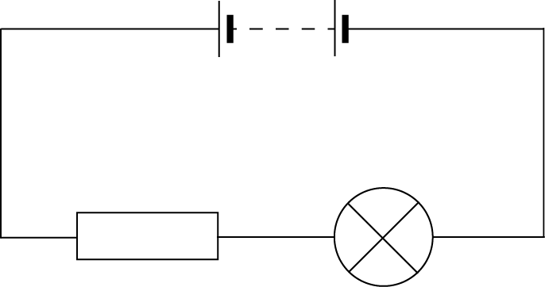  State the energy transfers in the circuit below
5.3.3 |  | An early method of crash testing involved a car rolling down a slope and colliding with a wall.  - State the energy changes as the car moves down the slope and collitdes with the wall.  - State why the mass of the car is not required for the calculation.
5.3.4 |  | Based on SQA N5 2014  A student is investigating the specific heat capacity of three metal blocks X, Y and Z. Each block has a mass of 1·0 kg. A heater and thermometer are inserted into a block as shown.  When the student calculates the energy provided to the block using $E=Pt$ and uses this energy value to calculate the expected specific heat capacity $=cmΔT$ .  - When checking the answer against the specific heat capacity of the material it is discovered the specific heat capacities. Explain whether the experimental value is likely to be higher or lower than the accepted value.  - The student decides to improve the set up in order to obtain a value closer to the accepted value for each block. Suggest possible improvements that are likely to result in a calculated value closer to the accepted value.
5.4 |  | I can use appropriate relationships to solve problems involving work done, unbalanced force, and distance or displacement. (Ew=Fd)
5.4.1 |  | State the appropriate relationship involving work done, unbalanced force, and distance or displacement.
5.4.2 |  |   State if work is done if a girl holds a set of weights above her head, you must explain your answer.
5.4.3 |  | A locomotive exerts a pull of 10000 N to pull a train a distance of 400 m.  How much work is done?
5.4.4 |  | A gardener does 1200 J pushing a wheelbarrow with a force of 100 N.  How far did she push the barrow?
5.4.5 |  | A man uses up 1000 J by pulling a heavy load for 20 m. What force did he use?
5.4.6 |  | A girl is pushing her bike with a force of 80 N and uses up 4000 J of energy.  How far did she push the bike?
5.4.7 |  | A man weighing 600 N climbs stairs in an office block which are 40 m high.  How much work does he do?
5.4.8 |  | A worker pushes a 4 kg crate along the ground for 3 m using a force of 20 N, then lifts the crate up to a ledge 1 m high. How much work does he do altogether?
5.4.9 |  | An average force of 120 N is used to push a supermarket trolley 30m. How much work is done?
5.4.10 |  | A force of 24 N is needed to pull open a drawer. If the drawer moves 35 cm, how much energy is used moving it?
5.4.11 |  | A girl does 900 kJ of work cycling to school. If she uses an average force of 200N, how far does she pedal?
5.4.11 |  | A boy does 5000 J of work climbing the stairs. If the distance climbed is 9m, calculate the force he is having to produce.
5.5 |  | I can identify and explain ‘loss’ of energy where energy is transferred.
5.5.1 |  | A lorry of mass 5000 kg rolls down a hill 20 m high. The lorry rolls a distance of 300 m, and is initially stationary. The average force of friction on the lorry is 500 N.  (i) Draw a diagram showing the journey of the lorry and mark on it the information given above.  (ii) What is the change in the gravitational potential energy of the lorry as it rolls down the hill?  (iii) State what happens to this energy.  (iv) Calculate the work done against friction.  (v) Calculate the change in the kinetic energy of the lorry.  (vi) Calculate the speed of the lorry at the bottom of the hil.?
5.5.2 |  | Explain why the kinetic energy of the lorry at the bottom of the slope is not equal to the gravitational potential energy at the top of the slope.
5.5.3 |  | State where energy “losses” occur in the circuit below
5.6 |  | I can define gravitational potential energy.
5.6.1 |  | Define the term gravitation potential energy.
5.6.2 |  | State the relationship used to calculate the gravitational potential energy, include what each term means and the units used to measure each term
5.7 |  | I can solve problems on involving gravitational potential energy, mass, gravitational field strength and height.
5.7.1 |  | A mass of 4kg is released from a height of 2m. Calculate the gravitational potential energy of the mass before it is released.
5.7.2 |  | An object has a gravitational potential energy of 502J. It is dropped from a height of 20m.
5.7.3 |  | A chairlift raises a skier of mass 60 kg to a height of 250 m.  Calculate the potential energy gained by the skier.
5.7.4 |  | A brick of mass 3 kg rests on a platform 25 m above the ground on a building site.  a) Calculate the potential energy stored in the brick.  b) If the brick falls 25 m to the ground, determine the potential energy it will lose.  c) State the form of energy gained by the brick as it falls.
5.7.5 |  | Estimate how much gravitational potential energy you would gain if you were lifted 30m up to the top of a fun-ride.
5.7.6 |  | An apple, mass 100 g, has 300 J of potential energy at the top of the Eiffel Tower. Calculate the height of the Eiffel Tower.
5.7.7 |  | An astronaut of mass 70 kg climbs to a height of 5 m on the moon and gains 560 J of gravitational potential energy.  - Determine the gravitational field strength on the moon.  - If the same experiment were carried out on Earth state whether the astronaut would gain less, more or the same gravitational potential energy, you must justify your answer.
5.8 |  | I can define kinetic energy as the energy an object has because of its speed.
5.8.1 |  | State the meaning of the term kinetic energy.
5.8.2 |  | State how the kinetic energy of an object changes when  (i) it's speed increases, and  (ii) it's mass increases.
5.8.3 |  | A cyclist is travelling along a straight road. The graph shows how the velocity of the cyclist varies with time.  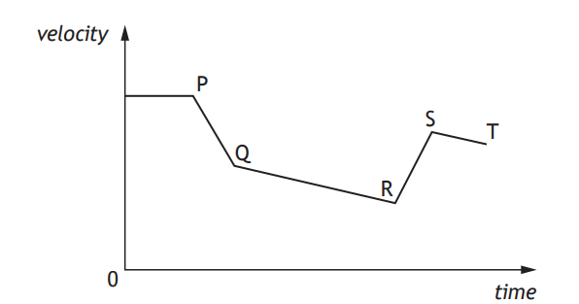  State where the kinetic energy of the cyclist is at its greatest and explain your answer.
5.9 |  | I can use Ek= ½ mv² to solve problems involving kinetic energy, mass and speed
5.9.1 |  | You are provided with an air track and vehicles, a light gate and timer and some elastic bands. Describe how you could use this apparatus to establish how kinetic energy depends on velocity. Include details of any measurements you would take and any additional measuring equipment needed.
5.9.2 |  | Calculate the kinetic energy of the following:  a) a 5.0 kg bowling ball moving at 4.0 ms⁻¹  b) a 50.0 kg skier moving at 20.0 ms⁻¹  c) a 0.020 kg bullet moving at 100.0 ms⁻¹.
5.9.3 |  | a) How much kinetic energy does an 800 kg car have at a velocity of 10.0 ms⁻¹?  b) If it doubles its velocity to 20.0 ms⁻¹, calculate its new kinetic energy?
5.9.4 |  | A cyclist who is pedalling down a slope reaches a speed of 15 ms⁻¹. The cyclist and her cycle together have a mass of 80 kg.  a) Calculate the total kinetic energy.  b) Name two sources of this kinetic energy.
5.9.5 |  | Calculate an approximate value for the kinetic energy of an Olympic 100 m sprinter as he crosses the line (time for race is about 10 s).
5.9.6 |  | What is the velocity of a stone of mass 2 kg if it has 36 J of kinetic energy?
5.9.7 |  | A motor cyclist and his bike have a total mass of 360 kg and kinetic energy of 87120 J. What is his speed?
5.9.8 |  | A car has a mass of 900kg and is moving at 30ms⁻¹, calculate its kinetic energy.
5.9.9 |  | Calculate the kinetic energy of a rifle bullet with a mass of 20g and a speed of 400ms⁻¹.
5.9.10 |  | A car has a kinetic energy of 100kJ and a mass of 800kg, calculate its speed.
5.10 |  | I can use Ew=Fd, Ep=mgh, Ek= ½ mv² to solve problems involving conservation of energy
5.10.1 |  | A gardener pushes a wheelbarrow with a force of 250 N over a distance of 20 m. Calculate the work done.
5.10.2 |  | A stone falls from a cliff, which is 80 m high  - If air resistance can be ignored, calculate the speed at which it enters the water at the bottom of the cliff.  - If air resistance cannot be ignored, state the effect this will have on the speed of the stone as it enters the water.  - In practice, not all of the initial gravitational energy is transformed into kinetic energy. Other than kinetic energy, state the main form of energy produced.
5.10.3 |  | A librarian is placing books on to the library shelf which is 2 metres from the ground. He does 80 joules of work lifting the books from the floor to the shelf. (a) Calculate the weight of the books.  (b) Calculate the mass of the books.  (c) If each book has an average mass of 400 g calculate how many books the librarian places on the shelf.
5.10.4 |  | A painter is painting the ceiling of a room. She fills her tray with paint and lifts it up the ladder. The weight of the full paint tray is 15.0 newtons and she lifts it a distance of 1.5 metres up the ladder.  - Calculate the work done lifting the paint.  - The painter drops the 0.64 kg roller to the floor from this height, calculate the gravitational potential energy it loses.  - If all the gravitational potential energy is converted to kinetic energy calculate the speed of the roller when it lands on the dust sheet.
5.10.5 |  | A car of mass 1000 kg is travelling at 20 ms⁻¹.  (a) Calculate the kinetic energy of the car.  (b) If the maximum braking force is 5 kN, calculate the minimum braking distance.  (c) If the driver has a reaction time of 0.7 s, calculate the distance the car travels during this ‘thinking time’.  (d) Determine the total stopping distance.
5.10.6 |  | A boy of mass 45 kg pulls a sledge of mass 15 kg up a slope at a constant velocity of 0·5 ms⁻¹. The boy then lies on the sledge and slides down the slope. When the boy and sledge are moving with a speed of 4·0 ms⁻¹, they run into a small snow drift which brings them to rest in a distance of 3·5 m.  - Calculate the kinetic energy of the boy and sledge together, when they are travelling at a speed of 4·0 ms⁻¹.  - Calculate the average force required to bring the sledge and the boy to rest in 3·5 m.
5.10.7 |  | A lorry of mass 5000 kg rolls down a hill 20m high. The lorry rolls a distance of 300m, and is initially stationary. The average force of friction on the lorry is 500N.  (i) Draw a diagram showing the journey of the lorry and mark on it the information given above.  (ii) Calculate the change in the gravitational potential energy of the lorry as it rolls down the hill.  (iii) State what happens to this energy as it rolls down the slope  (iv) Determine the work done against friction  (v) Determine the change in the kinetic energy of the lorry.  (vi) Calculate the speed of the lorry at the bottom of the hill.
5.10.8 |  | An arrow of mass 60g is fired vertically upwards with a speed of 30ms⁻¹. The arrow rises upwards, reaches its maximum height, and then falls straight downwards. Assuming there is no air resistance, calculate  (i) the initial kinetic energy of the arrow,  (ii) the kinetic energy of the arrow at its highest point,  (iii) the potential energy of the arrow at its highest point,  (iv) the position of the highest point.
5.10.9 |  | 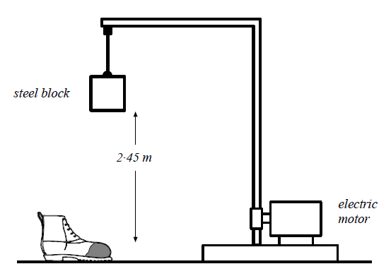  The toe protectors in safety boots are tested by dropping a 30 kg steel block through a height of 2·45 m onto the boots.  (a) Calculate the potential energy of the steel block just before it is released.  (b) Calculate the speed of the steel block as it hits the toe protector.
5.10.10 |  | A model train takes 30 seconds to travel along a 5m section of track, which rises by 0.3m. The train has a mass of 0.5kg and the motor has a power of 3W. The train is initially at rest, and has a final velocity of 0.5ms⁻¹. Calculate  (i) the energy supplied by the motor  (ii) the gain in kinetic energy  (iii) the gain in Ep.  (iv) the work done against friction, and  (v) the average force of friction.
5.10.11 |  | An apple of mass 100g is dropped from the top of the Eiffel Tower, a height of approximately 300m.  - Calculate the loss of potential energy as the apple falls through 300 m  - Calculate the expected kinetic energy it should have just before hitting the ground.  - Calculate the expected velocity as of the apple as it hits the ground.  - In reality explain if the speed is likely to be greater than/ less than / or the same as that expected, you must justify your answer.
5.10.12 |  | Int 2 2002  An observation wheel rotates slowly and raises passengers to a height where the can see across a large city. The passengers are carried in capsules.  - Each capsule is raised through a height of 122 m as it moves from P to Q. Each capsule with passengers has a total mass of 2750 kg. Calculate the gravitational potential energy gained by a capsule with passengers  - The wheel is rotated by a driving force of 200 kN For one revolution, the driving force is applied through the circumference of the wheel, a distance of 383 m.  Calculate the work done by the driving force for one revolution.
5.10.13 |  | SQA 2018  During a BMX competition, a cyclist freewheels down a slope and up a ‘kicker’ to complete a vertical jump.  The cyclist and bike have a combined mass of 75 kg.  At point X the cyclist and bike have a speed of 8·0 m s⁻¹.  - Calculate the kinetic energy of the cyclist and bike at point X.  - (i) Calculate the maximum height of the jump above point X.  (ii) Explain why the actual height of the jump above point X would be less than the height calculated in (b) (i).
5.10.14 |  | SQA SG CREDIT 2012 Q9  While repairing a school roof, workmen lift a pallet of tiles from  the ground to the top of the scaffolding.  This job is carried out using a motorised pulley system.  The pallet and tiles have a total mass of 230 kg.  - Calculate the weight of the pallet and tiles.  - State the minimum force required to lift the pallet and tiles.  - The pallet and tiles are lifted to a height of 12 m. Calculate the gravitational potential energy gained by the pallet and tiles.  - When the tiles are being unloaded onto the scaffolding, at a height of 12 m, one tile falls. The tile has a mass of 2·5 kg.  - Calculate the final speed of the tile just before it hits the ground. Assume the tile falls from rest.  - Explain why the actual speed is less than the speed calculated in (d)(i).
5.10.15 |  | Figure 1 shows a pendulum in its rest postion A. The pendulum bob has a mass of 0.3 kh. The bob is pulled to one side as shown in Figure 2 and held at position B, which is 0.8 m above the rest position.  The bob is released from position B and swings to and fro until it comes to rest.  - Calculate the gain in potential energy of the bob when it is moved from position A to position B.  - State in which position the bob has greatest kinetic energy.  - Estimate the maximum speed of the bob.  - Describe the energy changes which take place from the time the bob is released until it comes to rest.
5.10.16 |  | An object is dropped from a height of 0.75 m from the surface of the Earth. Calculate the velocity on landing. (No you don’t need to know the mass, but start with the two formulae)
Projectile Motion
6.1 | I can explain projectile motion
6.1.1 | Explain the term projectile.
6.1.2 | Explain what is special about the motion of a projectile.
6.1.3 | 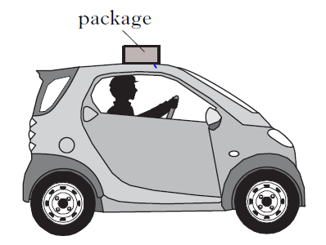  A driver accidentally leaves a package on the top of a vehicle . When he notices he brakes suddenly and the package falls off the car.  - Sketch the path taken by the package as it falls off the car.  - Describe both the horizontal and vertical motions of the package in as much detail as possible
6.2 | I can use appropriate relationships to solve problems involving projectile motion from a horizontal launch, including the use of motion graphs.
6.2.1 | A stone thrown horizontally from a cliff lands 24 m out from the cliff after 3.0 s. Find:  a) the horizontal speed of the stone  b) the vertical speed at impact.
6.2.2 | A ball is thrown horizontally from a high window at 6 m/s and reaches the ground after 2.0 s. Calculate  a) the horizontal distance travelled  b) the vertical speed at impact.
6.2.3 | An aircraft flying horizontally at 150 m/s, drops a bomb which hits the target after 8.0 s. Find:  a) the distance travelled horizontally by the bomb  b) the vertical speed of the bomb at impact  c) the distance travelled horizontally by the aircraft as the bomb fell  d) the position of the aircraft relative to the bomb at impact
6.2.4 | A ball is projected horizontally at 15 m/s from the top of a vertical cliff. It reaches the ground 5 s later. For the period between projection until it hits the ground, draw graphs with numerical values on the scales of the ball’s  a) horizontal velocity against time  b) vertical velocity against time  c) From the graphs calculate the horizontal and vertical distances travelled.
6.2.5 | A projectile is fired horizontally at 100ms⁻¹.  (i) How long will it take it to travel a horizontal distance of 50m?  (ii) What will its vertical velocity be when it hits the ground?  (iii) What will be its average vertical speed?  (iv) How far will it fall in the 50m?
6.2.6 | A ball rolls along a flat roof at 2ms⁻¹ and rolls off the edge.  (i) If the ball takes 1.5 seconds to fall what is the final vertical speed of the ball on landing?  (ii) How high is the roof from the ground?  (iii) How far away from the base of the building will it land?
6.2.7 | In the experimental set-up shown below, the arrow is lined up towards the target.  As it is fired, the arrow breaks the circuit supplying the electromagnet, and the target falls downwards from A to B.  a) Explain why the arrow will hit the target.  b) Suggest one set of circumstances when the arrow would fail to hit the target  (you must assume it is always lined up correctly).
6.3 | I can state what is represented by the area under v_{h}-t graph.
6.3.1 | State what is represented by the area under v_{h}-t graph
6.4 | I can make calculations from the area under a v_{h}-t graphs
6.4.1 | A bullet is fired from a gun and the horizontal velocity of the bullet is shown in the graph below. Calculate the range of the bullet.  t/s  v /ms⁻¹  800  0.2  0
6.4.2 | Draw a speed time graph to represent the following motion recorded for a train leaving a station.  Use the graph to calculate:  (a) describe the motion of the train during the 90 seconds  (b) the distance travelled by the train in 90 seconds.
  Time (s) | 0 | 10 | 20 | 30 | 40 | 50 | 60 | 70 | 80 | 90
  speed (m/s) | 0 | 5 | 10 | 15 | 20 | 25 | 25 | 25 | 30 | 30
6.4.3
  While driving along a motorway a driver spots an accident and brakes. The speed time graph below represents the motion of the car from the instant the driver sees the accident.
  25
  v/ms⁻¹ 15
  10
  5
  0 2 4 6 8 10 12 14 16 18 20 22 24 26 28 30 time in s
  (a) When did the driver brake?
  (b) Calculate how far the car travelled before braking.
  (c) Calculate how far the car travelled after the driver braked
6.4.4
  Time (s) | Speed (ms⁻¹)
  0 | 0
  20 | 10
  40 | 40
  60 | 70
  80 | 100
  100 | 100
  120 | 50
  140 | 0
  During a test run of a TACV (tracked air-cushioned vehicle or hovertain), its speed along a straight level track was recorded as shown in the table below.
      - Draw a graph of the train’s motion during the test run.
      - Calculate the distance travelled during the test run.
6.4.5
  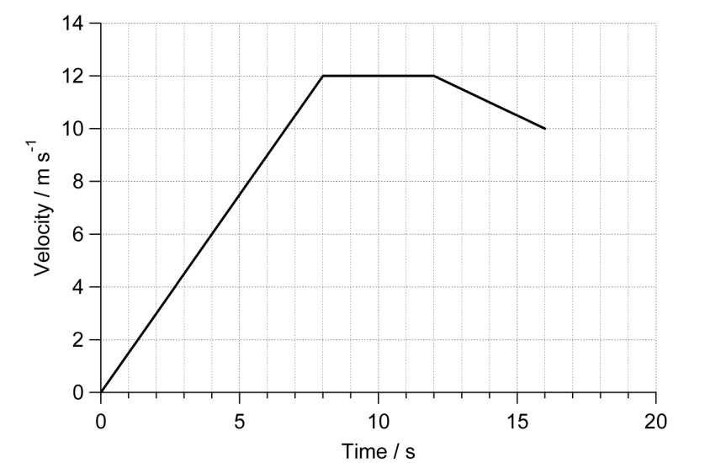
  The graph shows the speed of a runner during a race.
  - Describe the motion of the runner.
  - Calculate the distance covered by the runner in the first eight seconds of the race.
  - Calculate the distance she ran in the last four seconds.
  - Calculate the length of the race.
6.5 | I can state what can be found from the area under v_{v}-t graph.
6.5.1 | State what can be found from the area under v_{v}-t graph.
6.6 | I can calculate the height, and acceleration from v_{v}-t graphs
6.6.1
  A hot air balloon is released and accelerates upwards. During the lift, some sand bags are released, and the acceleration increases. The graph shows the vertical motion of the balloon during the first 50s of its flight.
  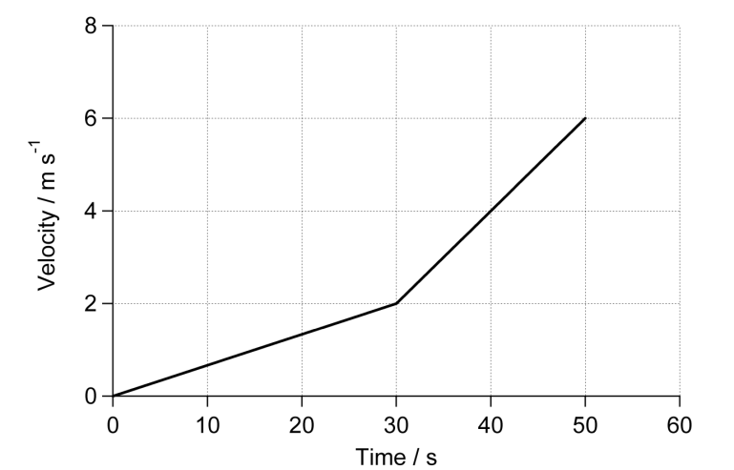
  (a) Calculate the height of the balloon when the sandbags are released.
  (b) Calculate the height of the balloon after 50 s.
6.6.2 | The graph below shows the motion of an object dropped just above the surface of a celestrial body.  - Calculate the acceleration due to gravity of the object.  - Using the data sheet find from which celestial body the object was dropped.  - Calculate the height above the surface from which the object was dropped
6.7 | I can state and use the relationships from v_{h}-t graphs and v_{v}-t graphs
6.7.1 | State the equations required to find out range, speed and time for the horizontal component of projectiles.
6.7.2 | State the equations required to calculate information for the vertical component of projectiles.
6.7.3 | A projectile is fired horizontally at 100 ms⁻¹.  - Determine the time it takes to travel a horizontal distance of 50 m.  - Calculate the vertical velocity when it hits the ground.  - Calculate its average vertical speed during the journey.  - Calculate the height it falls in the 50 m.
6.7.4 | A ball rolls along a flat roof at 2ms⁻¹ and rolls off the edge.  - If it takes 1.5 s to fall to the ground determine its speed on landing.  - Determine the height of the roof.  - Calculate the distance from the base of the building to where it lands.
6.7.5 | Jordan the goalkeeper punches a football which has been kicked across his goal mouth. The football leaves his glove with a horizontal velocity of 11.5 ms⁻¹ to the right and takes 0.80 s to land on the pitch.  - Describe the horizontal velocity of the football from the instant it is punched to the instant it lands.  - Show, by calculation involving horizontal motion, that the horizontal displacement travelled by the football during the 0.8 s is 9.2 m to the right.  - At the instant the football leaves Jordan's hand, the downward vertical velocity of the football is 0 ms⁻¹. Calculate the downward vertical velocity of the football as it lands.  - Calculate the height from which the ball was pitched.
6.7.6 | A rocket is fired horizontally from a cliff top at 40 ms⁻¹ to the right. The rocket hits the sea below after 4 s.  - State the rocket's horizontal component of velocity just before it hits the sea.  - Calculate the rocket's range (horizontal displacement).  - Calculate the rocket's vertical component of velocity just before it hits the sea.  - Sketch the velocity-time graph for the rocket's vertical motion.  - Use the graph to determine the rocket's vertical displacement (the height of the cliff).
6.7.7 | Ellis kicks a football off a cliff with a horizontal velocity of 5 ms⁻¹ to the right. The football lands on ground below the cliff 2.5 s later.  - Calculate the ball's horizontal component of velocity just before it hits the ground.  - Calculate the range of the ball (horizontal displacement).  - Calculate the vertical component of the ball's velocity just before it hits the ground.  - Sketch the velocity-time graph for the ball's vertical motion.  - Use the graph to determine the ball's vertical displacement (the height of the cliff).
6.8 | I can explain satellite orbits in terms of projectile motion, horizontal velocity and weight.
6.8.1 | Explain how gravity keeps a satellite in orbit.
6.8.2 | Explain why a satellite needs a horizontal motion and a vertical motion to stay in orbit.
6.8.3  OEQ | A group of students are watching a video clip of astronauts on board the  International Space Station (ISS) as it orbits the Earth.  One student states, ‘I would love to be weightless and float like the astronauts do on the ISS.’  Using your knowledge of physics, comment on the statement made by the student.

SPACE

Quantities for the SPACE Unit
For this unit copy and complete the table.
Quantity | Symbol | Unit | Unit Symbol | Scalar / Vector
Period
Distance
Time
Speed
Light-year
Force
Mass
Weight
Acceleration
Gravitational field strength

The SPACE unit in numbers
Quantity | Value
State the age of the universe.
State the distance represented by one light-year.
State the gravitational field strength on Earth.
State the height of a geostationary satellite above the Earth’s surface.
State the time for the Earth to spin once on its axis.
State the time taken for the Earth to orbit the Sun
State the speed of light in air.
State the speed of light across the vacuum of space.
State the initial acceleration of an object when dropped close to the Earth’s surface.
State the wavelength of red light
State the wavelength of violet light.

No. | Content
Space Exploration
7.1 | I have a basic understanding of the Universe https://map.gsfc.nasa.gov/universe/uni_life.html
7.1.1 | Write a paragraph explaining our current understanding of the Universe. Reference correctly any source used- DO NOT COPY, practice referencing and using sources for your assignment.
7.2 | I can use the following terms correctly and in context: planet, dwarf planet, moon, Sun, asteroid, solar system, star, exoplanet, galaxy, and universe.
7.2.1 | List the following in order of decreasing size:  planet, dwarf planet, moon, sun, asteroid, solar system, star, exoplanet, galaxy, universe.
7.2.2 | Define each of the following terms:  planet, dwarf planet, moon, sun, asteroid, solar system, star, exoplanet, galaxy, universe.
7.3 | I am aware of the benefits of satellites.
7.3.1 | Give some uses of satellites placed in orbit above the Earth.
7.3.2 | Explain how the force of gravity keeps a satellite in orbit.
7.3.3 | Two examples of satellites placed in space are the ISS and the Hubble Telescope.  For each of these satellites:  - State the purpose for it being placed in orbit.  - Describe when the satellite was placed in orbit  - How has our understanding of our Universe altered due to research from the satellite?
7.4 | I know the period and orbital height of a geostationary satellite.
7.4.1 | Define the term geostationary or geosynchronous orbit.
7.4.2 | State the height, above the Earth’s surface of a satellite placed in geostationary orbit.
7.4.3 | State the time taken for a geostationary satellite to orbit the Earth.
7.4.4 | State the period of a geostationary satellite.
7.4.5 | State above which part of the Earth’s surface geostationary satellites are placed.
7.5 | I know that the period of a satellite changes with altitude.
7.5.1 | Explain the term period of a satellite.
7.5.2 | Explain how the period of a satellite changes with the height above the Earth’s surface.
7.6 | I am aware of the challenges of space travel.
7.6.1 | Describe some of the challenges on space travel, including the following  - take off  - during flight  - being in “zero gravity”  - during re-entry  make sure you answer in terms of PHYSICS
7.6.2 | A meteorite has a mass of 1.45kg and enters the Earth’s atmosphere with a speed of 10kms⁻¹.  (i) Calculate the initial kinetic energy of the meteorite  (ii) A few seconds later its velocity is only 200 ms⁻¹. State what causes it to slow down.  (iii) Determine the new kinetic energy of the meteorite  (iv) The meteorite heats up from ­220°C to 3550°C in the process. If it has a specific heat capacity of 800Jkg⁻¹°C⁻¹, Calculate the heat energy produced  (v) State what happens to the rest of the kinetic energy as the meteorite passes through the atmosphere.
7.6.3 | During splashdown, the 350 kg Apollo space craft fell 500 m at a steady speed, supported by its parachute. Calculate  (i) the loss of gravitational potential energy,  (ii) the work done by the parachute, and  (iii) the force produced by the parachute.
7.6.4 | (a) Why do spacecraft heat up on re-entry?  (b) Where does the energy come from which causes this heating?
7.6.5  OEQ | Space exploration involves placing astronauts in difficult environments.  Despite this, many people believe the benefits of space exploration outweigh the risks.  Using your knowledge of physics, comment on the benefits and/or risks of space exploration.
7.7 | I am aware of potential space travel across large distances using ion drive.
7.7.1 | Explain the term “ion drive” in attaining high velocities in space craft
7.7.2 | Draw a labelled diagram to show an ion drive used to propel spacecraft over long distances.
7.7.3 | State which of Newton’s three laws of motion suggests that ion drive would work.
7.7.4 | Summarise the video clip  https://www.youtube.com/watch?v=6H0qsqZjLW0
7.8 | I have a basic awareness that travelling large distances through space using a ‘catapult’ method.
7.8.1 | Explain the term “catapult” method in terms of spacecraft. (watch the following to help you https://www.youtube.com/watch?v=xJmD_1kSa3I )
7.8.2 | Explain how the catapult method reduced the fuel requirements for the Voyager spacecraft as it left the Earth’s surface.
7.8.3 | Draw a diagram to show a spacecraft using the catapult method to increase velocity.
7.9 | I have a basic awareness of how astronauts manoeuvre a spacecraft in a zero friction environment, possibly to dock with the ISS
7.9.1 | Explain why a rocket motor does not necessarily need to be kept on during an interplanetary flight.
7.9.2 | OEQ: A student stated “If there is no friction in space, how do the thrusters work on space shuttle? Don't they have to push against something to move, like air?”  Use your knowledge of Physics comment on this statement.
7.9.3 | Explain the manoeuvres required by a supply craft docking with the ISS.
7.10 | I have a basic awareness of maintaining sufficient energy to operate life support systems in a spacecraft.
7.10.1 | List uses of energy to operate life with a human crew on a trip to Mars.
7.10.2 | In the future it is hoped that humans will be able to travel to Mars. One challenge of space travel to Mars is maintaining sufficient energy to operate life support systems.  Suggest one solution to this challenge.
7.10.3 | Explain the potential difficulties of supporting a crew on a trip to visit Pluto or other astronomical objects further out in our solar system.
7.11 | I can describe the risks associated with manned space exploration.
7.11.1 | State the challenges of space travel to Mars.
7.11.2 | Explain some potential solutions to the challenges listed above.
7.12 | I have knowledge of Newton’s second and third laws and their application to space travel, rocket launch and landing.
7.12.1 | a) State Newton’s second law of motion.  b) State Newton’s third law of motion.
7.12.2 | Explain, in terms of forces, how a rocket works.
7.12.3 | In terms of Newton's third law, what is the 'equal and opposite force' in each of these situations:-  (i) A ship’s propeller pushes on the water,  (ii) A rocket pushes on the exhaust gases,  (iii) The Earth's gravity pulls on the moon,  (iv) The Earth’s gravity pulls on a box sitting on the floor.
7.12.4 | A rocket has a total mass of 500kg and produces a thrust of 10000N.  - Calculate the initial acceleration of the rocket  - State what happens to the mass of the rocket as it burns its fuel.  - If the thrust remains constant, state what happens to the acceleration of the rocket.
7.12.5 | An astronaut uses a backpack called a Man Manoeuvring Unit, or MMU, to move her around when in space. This produces a thrust of 2.0 N in any direction. If the astronaut and her suit has a mass of 180kg,  (i) Calculate the initial acceleration the astronaut using this MMU.  (ii) The astronaut is initially at rest, calculate the astronaut’s final speed after firing the thruster for 10s.
7.13 | I can use W=mg to solve problems involving weight, mass and gravitational field strength, in different locations in the universe.
7.13.1 | State the weight of each 1kg near the earth.
7.13.2 | Calculate the weight on Earth of  (i) a 30kg dog,  (ii) a ½kg book,  (iii) a 23g bag of crisps,  (iv) a 2 tonne lorry? (1 tonne = 1000kg )
7.13.3 | Calculate the weight of a 10 kg bag of potatoes on Earth.
7.13.4 | Calculate the weight of a 250 g bag of sweets.
7.13.5 | A girl has a weight of 450 N on Earth, calculate the mass of the girl.
7.13.6 | Calculate the weight of a 10,000 kg spacecraft on  a) Earth b) Mars c) Venus.
7.13.7 | Calculate the weight of a 60 kg man on Jupiter.
7.13.8 | State the planet’s gravitational field strength most similar to our own.
7.13.9 | An astronaut who weighs 700 N on Earth goes to a planet where he weighs 266 N.  Calculate his mass and state which planet he was on.
7.13.10 | An astronaut on Venus weighs 528 N. Calculate the weight of this astronaut on Earth.
7.13.11 | - Draw a table showing the mass and weight of a 5.4 kg rock on Earth and Mars.  - If the rock was allowed to fall freely on Mars, state its initial acceleration close to the surface.
7.13.12 | A lunar rover has a weight of 240N when on the moon  Calculate is its mass and weight on the Earth.
7.13.13 | The weight of a 20 kg mass on Europa, a moon of Jupiter, is 26.4 N.  Calculate the gravitational field strength on Europa
7.13.14 | State what happens to the weight of a spacecraft as it moves further away from the Earth. You must justify your answer.
Cosmology
8.1 | I can correctly use the term light-year.
8.1.1 | Describe the term light-year.
8.1.2 | State the symbol and the unit of a light-year.
8.1.3 | Betelgeuse is 640 light-years away, explain what this means.
8.2 | I can convert between light-years and metres
8.2.1 | The star Proxima Centauri is about 4.5 light-years from the sun. Calculate this distance in metres.
8.2.2 | The Milky Way (our galaxy) is 105,700 light-years in diameter, calculate this distance in metres.
8.2.3 | The Canis Major Dwarf Galaxy is only 2.36× 10²⁰ m from the Sun, determine this distance in light-years.
8.2.4 | Betelgeuse is approximately 640 light-years from the sun. Determine this distance in metres.
8.2.5 | Within our solar system distances are often measured in astronomical units  (AU).1 AU = 1·50 × 10¹¹ m.  Mars orbits the Sun at an average distance of 1·52 AU.  Determine the average distance, in metres, at which Mars orbits the Sun.
8.3 | I can give a basic description of the Big Bang theory of the origin of the Universe.
8.3.1 | The term Big Bang has been use to described the origin of the Universe. Explain why this term appears appropriate.
8.3.2 | Summarise the following video clip. https://www.youtube.com/watch?v=wNDGgL73ihY
8.4 | I know the estimated age of the Universe.
8.4.1 | State the approximate age of the Universe.
8.4.2 | List and explain the evidence to support the age of the Universe?
8.5 | I can describe how different parts of the electromagnetic spectrum are used to obtain information about astronomical objects.
8.5.1 | List the parts of the electromagnetic spectrum in order of increasing wavelength
8.5.2 | State a detector for each part of the electromagnetic spectrum
8.5.3 | State what happens to the frequency of the radiation as the wavelength increases.
8.5.4 | State how each part of the electromagnetic spectrum can be used to learn about space, complete the following table
  Type of Radiation | Detector | Use
  Radio | Radio Telescope | Used to study naturally occurring radio light from stars, galaxies, black holes, and other astronomical objects. They can also be used to transmit and reflect radio light off of planetary bodies in our solar system.
8.6 | I can identify continuous and line spectra.
8.6.1 | State the type of spectrum shown in diagram below
8.6.2 | State the type of spectra shown in diagrams below.  (A)
8.6.3 | (B) 
8.6.4 | (C)
8.6.5 | (D) 
8.7 | I can use spectral data for known elements, to identify the elements present in stars.
8.7.1 | Light from a star is split into a line spectrum of different colours. The line spectrum from the star is shown, along with the line spectra of the elements calcium, helium, hydrogen and sodium.  State what elements are present in the star.
8.7.2 | 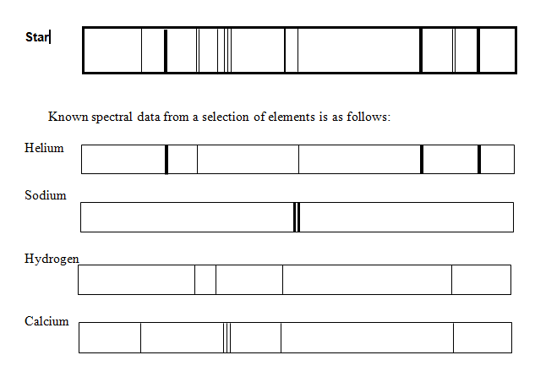  A distant star produced spectral lines, as shown above, when viewed through a spectroscope.  Identify the elements present in the star.
8.7.3 | Light from stars can be split into line spectra of different colours.  The line spectra from three stars, X, Y and Z, are shown, along with the line spectra of the elements helium and hydrogen.  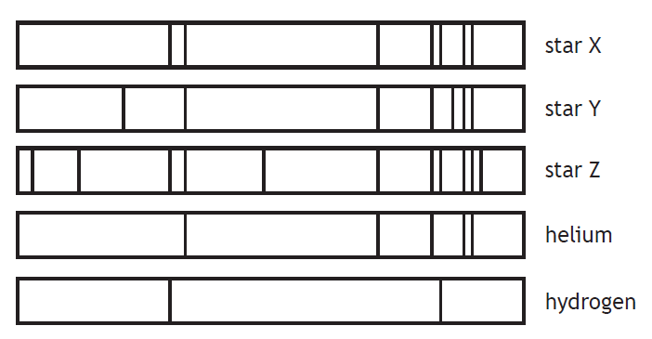  State the stars that contain both hydrogen and helium.

ELECTRICITY

Quantities for the ELECTRICITY Unit
For this unit copy and complete the table.
Quantity | Symbol | Unit | Unit Symbol | Scalar / Vector
Charge
Current
Voltage
Resistance
Power
Energy
Time
Frequency

The ELECTRICITY unit in numbers
Quantity | Value
State the voltage of the mains supply.
State the frequency of the mains
State the usual maximum power for an appliance that can be fitted with a 3A fuse.
State the maximum power for an appliance that can be fitted with a 13A fuse.

No. | CONTENT
Electrical Charge Carriers
9.1 | I can define electrical current.
9.1.1 | Define the term electrical current.
9.1.2 | Define the term one ampere.
9.1.3 | 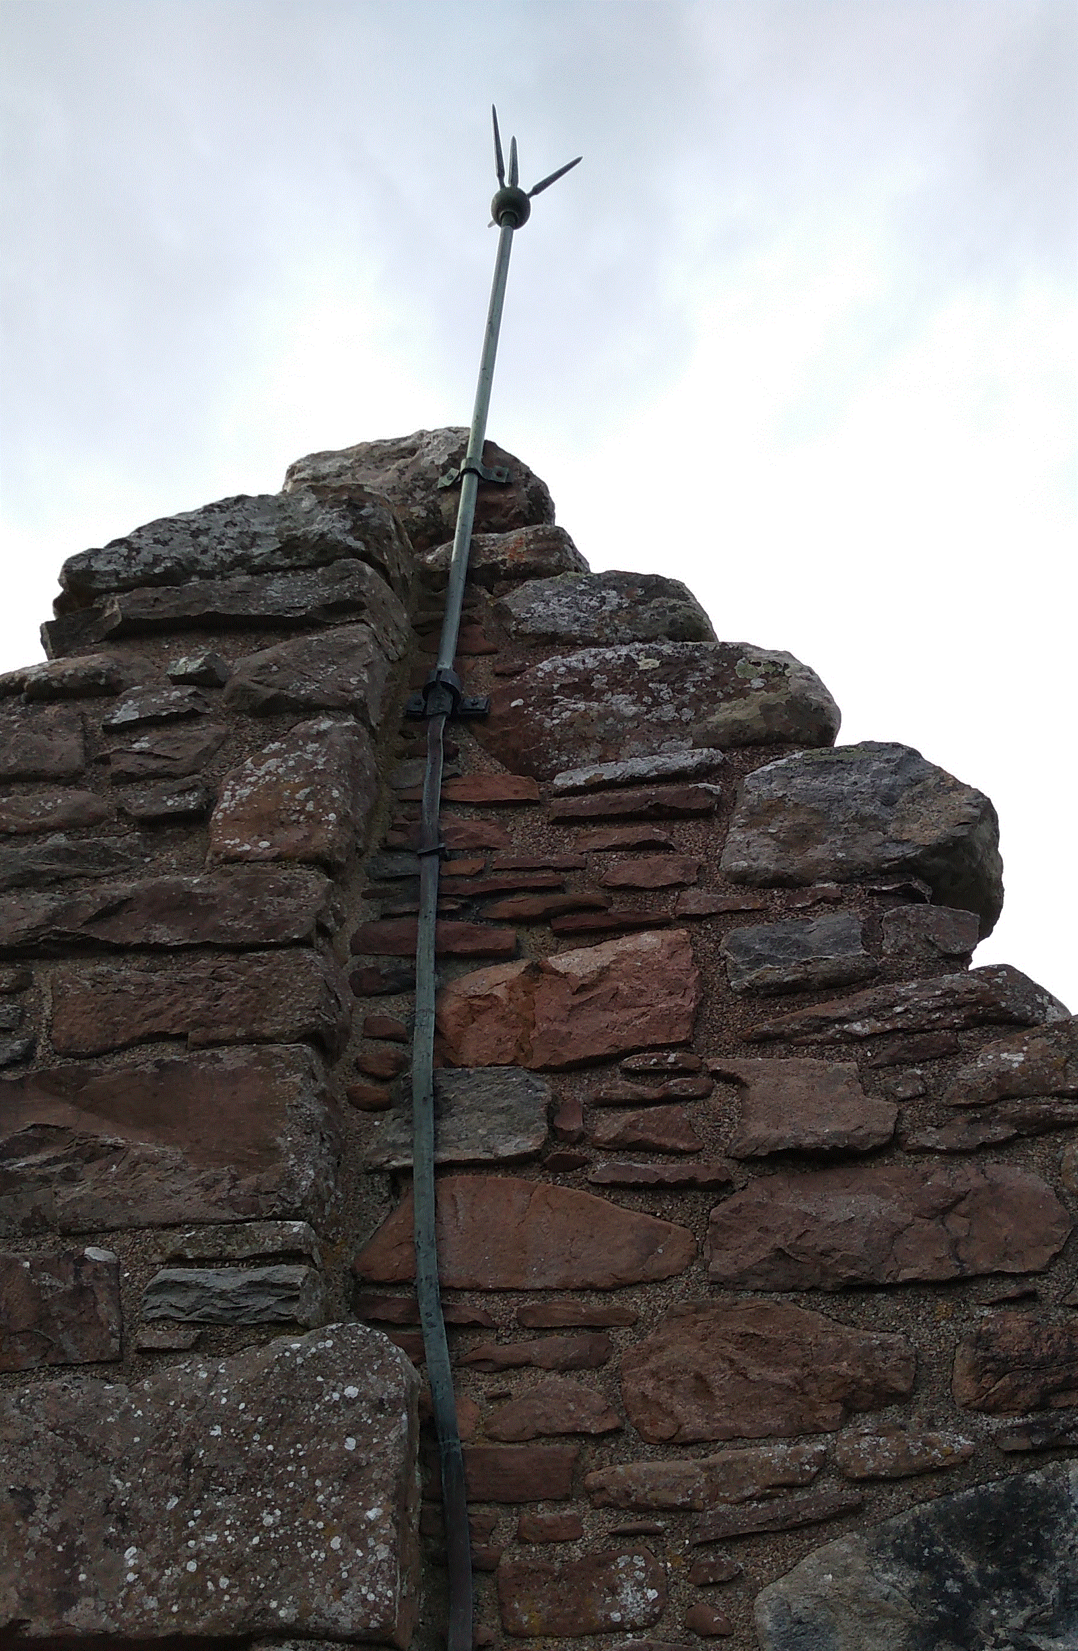  Many tall buildings have a thick strip of metal attached to the side of the building. This strip is used to protect the building from damage during electrical storms. Explain how this strip protects the building from damage.
9.2 | I can carry out calculations using the equation with charge, electric current and time.
9.2.1 | Write down the relationship between charge, electric current and time.  Write the symbols and units used for each.
9.2.2 | The current in a heater is 7.0 A, calculate the charge flowing through the heater in 30.0 seconds.
9.2.3 | A car headlamp uses a current of 2.0 A. Calculate the time the lamp must be switched on if 10.0 C of charge pass through it.
9.2.4 | Two Coulombs of charge pass through a lamp in 6.0 seconds, calculate the current in the lamp.
9.2.5 | A lightning strike lasts for 2.8 ms and delivers 50.4 C of charge. Calculate the current during the lightning strike.
9.2.6 | A hair drier is switched on for 5 minutes with a current of 3 A, calculate the charge flowing through the hair drier during this time.
9.2.7 | A switch is closed for 10 minutes. If 3600 C of charge pass through the switch in this time, calculate the current in the switch.
9.2.8 | Calculate the charge that flows along a wire when 25 μA passes for 2 hours.
9.2.9 | If a capacitor stores 20 mC of charge , calculate the time taken to discharge the capacitor if the average current in 0.4 μA.
9.2.10 |  | A circuit is set up as shown in the diagram. The reading on ammeter A1 is 5.0 A. The reading on ammeter A2 is 2.0 A. Calculate the charge passing through the lamp in 30 s
9.3 | I can explain the difference between A.C. and D.C.
9.3.1 | Explain, in terms of electron flow, the term alternating current.
9.3.2 | State if the mains supply is A.C. or D.C..
9.3.3 | State the frequency of the mains supply.
9.3.4 | (a) State the meaning of the term peak voltage.  (b) State how the peak voltage of the mains compares with the voltage you would read on a voltmeter. Draw a diagram to help you.
9.3.5 | A student makes the following statements about A.C. and D.C. circuits.  I. In an A.C. circuit the direction of the current changes regularly.  II. In a D.C. circuit negative charges flow in one direction only.  III. In an A.C. circuit the size of the current varies with time.  Copy out the correct statements.
9.3.6 | State the type of current do you get from  - batteries, and  - from the mains.
9.4 | I can compare the traces of A.C. with D.C. when viewed on an oscilloscope or data logging software.
9.4.1 | Copy these traces and determine if they show A.C. or D.C..  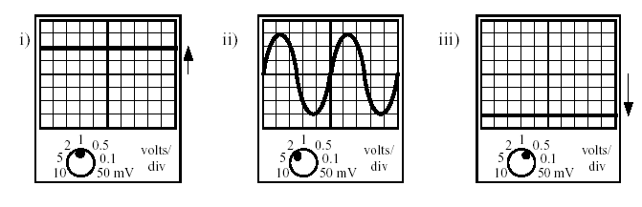
9.4.2 | An A.C. supply is labelled 12 V. The peak voltage is measured using an oscilloscope.  State which of the following is likely to be the measured peak voltage:  17 V, 12 V, 8.5 V, 6 V  Explain your answer.
9.4.3 | Calculate the peak voltages of the traces below using the Y-gain settings shown.
9.4.4 | The trace is produced from the mains supply. If the settings on the oscilloscope are not changed, sketch the trace that would be produced by the following A.C. supplies  - Peak voltage 5 V at a frequency of 25 Hz  - Peak voltage 20 V at a frequency of 75 Hz.
9.4.5 | The mains supply is quoted as 230 V. If connected to the mains supply, state which of the following devices would display a value of 230 V:  - an oscilloscope  - an A.C. voltmeter.
9.4.6 | Two identical bulbs are lit by the supplies shown below.  Explain which bulb will be the brighter.
Potential Difference (Voltage)
10.1 |  |  | I know that a charged particle experiences a force in an electric field.
10.1.1 |  |  | State the definition of an electrical field.
10.1.2 |  |  | State the causes of an electric field.
10.1.3 |  |  | Copy and complete the following  In an ________ field a ________ experiences a _________ . This causes the charge to accelerate (F=ma). If the charge is positive it will __________ the field lines, if the charge is negative the charge will move _______ from the field lines.
10.2 |  |  | I can describe the effect of electric fields on a charged particle
10.2.1 |  |  | Copy and complete these diagrams to show the direction of the electric field.  +  +  +  +  +  +  +  +  +  +  +  +  -  -  -  -  -  -  -  -  -  -  -  -
10.2.2 |  |  | A uniform electric field exists between plates Q and R.  The diagram shows the path taken by a particle as it passes through the field.  If the charge on R is positive, state the possible charge on P and Q
10.2.3 |  |  | Copy this diagram and add the paths of the following particles entering at right angles to the electric field:  - Electron (b) Proton (c) Neutron  +  +  +  +  +  +  +  +  +  +  +  +  -  -  -  -  -  -  -  -  -  -  -  -
10.2.4 |  |  | An alpha particle, a beta particle and a gamma ray enter an electric field at right angles to the field. Which letter shows the most likely position of the:  - Alpha particle (b) Beta particle (c) Gamma ray  +  +  +  +  +  +  +  +  +  +  +  +  -  -  -  -  -  -  -  -  -  -  -  -  Y  Z  X
10.2.3 |  |  | State what happens to a negatively charged particle moving parallel to a uniform electric field
10.2.4 |  |  | A magnet is moved through a coil of wire. (a) Describe what is seen on the analogue voltmeter  (b) State ways to increase the induced voltage.
10.3 |  |  | I know the path a charged particle takes between two oppositely charged parallel plate
10.3.1 |  |  | Draw a diagram of the electric field between two oppositely charged parallel plates.
10.3.2 |  |  | Copy the diagram of two parallel charged plates. Show the route taken by each of the following particles in the field  - an electron placed in the centre and initially not moving  - an electron moving from right to left as it approaches the plates.  + + + + + + + + + + + + + + + + + + +  - A proton moving from left to right  _ _ _ _ _ _ _ _ _ _ _ _ _ _ _ _ _ _ _  - A beta particle moving from left to right  - An alpha particle moving from left to right  - A neutron moving from left to right.  Explain the movement of each particle in the field.
10.3.3 |  |  | State the effect on a neutron moving from left to right between the parallel plates shown below.
10.4 |  |  | I know the path a charged particle takes near a single point charge
10.4.1 |  |  | State what the electric field lines indicate when drawn around a charge.
10.4.2 |  |  | Draw the field lines around the following charges, include the arrows.  - b)  -  +
10.4.3 |  |  | State the direction an electron would take if it was placed close to the charge shown below.  - b)  -  +
10.5 |  |  | I know the path a charged particle takes between two oppositely charged points
10.5.1 |  |  | Draw the field lines around the following charges, include the arrows.  +  -
10.5.2 |  |  | State the direction a negative charge would move in relation to the field lines around the following charges  -  +
10.6 |  |  | I know the path a charged particle takes between two like charged points
10.6.1 |  |  | Draw the field lines around the following charges, include the arrows.  a) b)  +  +  -  -
10.6.2 |  |  | State the direction a negative charge would take along the field lines around the following charges  a) b)  +  +  -  -
10.6.3 |  |  | State the direction a positive charge would take along the field lines around the following charges  a) b)  +  +  -  -
10.7 |  |  | I can define the potential difference (voltage) of the supply.
10.7.1 |  |  | Copy and complete the following definitions choosing the correct ending from the list below.  The voltage of an electrical supply is a measure of the  …..resistance of the circuit  …. speed of the charges in the circuit  ….power developed in the circuit  ….energy given to the charges in the circuit  ….current in the circuit.
10.7.2 |  |  | Copy and complete the following definition  1 volt is equivalent to  …..1 ampere per watt  …..1 coulomb per second  …..1 joule per coulomb  …..1 joule per second  …..1 watt per second.
10.7.3 |  |  | State what happens to the brightness of a bulb when the potential difference across it is increased.
Ohm’s Law
11.1 |  | I can make use of a V-I graph to determine resistance.
11.1.1 |  | State the meaning of the term resistance.
11.1.2 |  | State the name given to the ratio of V/I for a resistor.
11.1.3 |  | State the meaning of the term ohmic conductor
11.1.4 |  | The graph shows how the voltage across a resistor changes the current through it.  a) State what is found from the gradient of the graph shown.  b) Determine the gradient of the graph and give its correct units.
11.1.5 |  | The graph shows how the voltage across a resistor changes the current through it.  a) State what is found from the gradient of the graph shown.  b) Determine the gradient of the graph  c) Determine the resistance of the resistor used in this circuit.
11.1.6 |  | A student sets up the diagram as shown in the diagram to find out if Ohm’s Law holds for the resistor.  A  V  +  -  0 - 10V d.c  - Using the data below plot a graph of voltage across a resistor and the current through it.  - The student suspects one of the results was written down incorrectly, identify this point on your graph.  - Plot the gradient of the graph excluding the incorrect point.  - Calculate the resistance of the resistor from your graph.
  Voltage | Current
  (V) | (A)
  1.0 | 0.5
  1.6 | 0.7
  2.0 | 0.9
  2.5 | 1.2
  3.3 | 1.5
  4.2 | 1.9
  4.6 | 2.1
  5.2 | 3.2
11.1.7 |  | State the meaning of the term non-ohmic conductor?
11.2 |  | I can make use of an appropriate relationship to calculate potential difference (voltage), current and resistance  V = IR $V_{2}=\left(\frac{R_{2}}{R_{1}+R_{2}}\right)V_{s}$ $\frac{V_{1}}{V_{2}}=\frac{R_{1}}{R_{2}}$
11.2.1 |  | 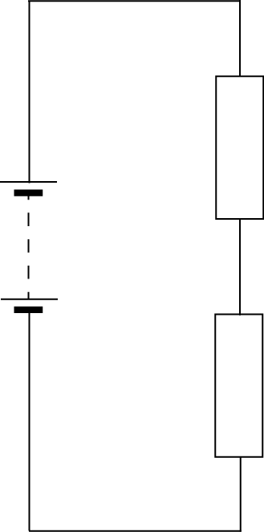  12 V  30 Ω  20 Ω  Calculate the p.d. across the 20 Ω resistor.
11.2.2 |  | 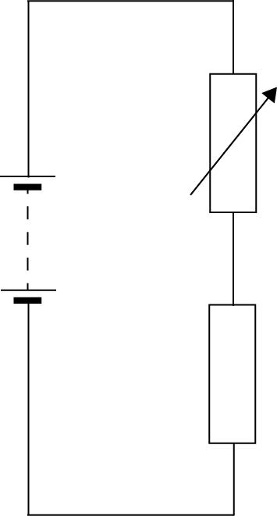  15 V  4.5 kΩ  The potential difference across the variable resistor should be 6 V. The variable resistor can be any value between 1 kΩ and 10 kΩ. Determine the resistance setting of the variable resistor.
11.2.3 |  | Calculate the missing resistance from the circuits below
  (i) | (ii) | (iii)
  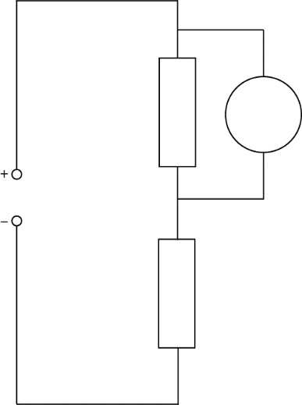  8 Ω  12 V  3 V  6 V  34 kΩ  5 V  2.3 V  2.4 V  4.8 kΩ | 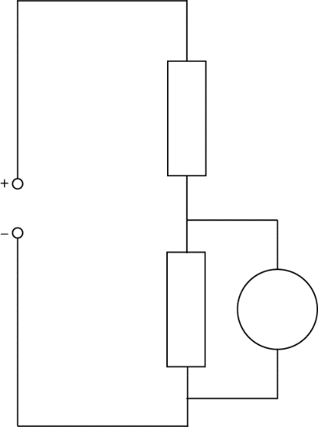 | 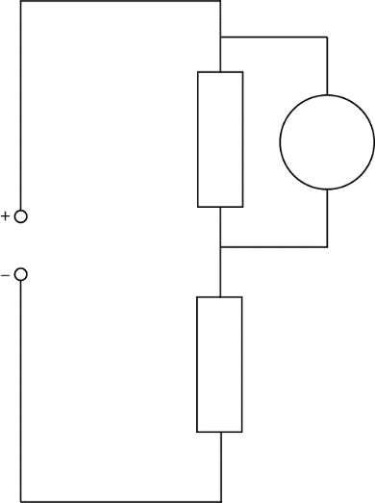
11.2.4 |  | A student sets up the circuit shown below.
  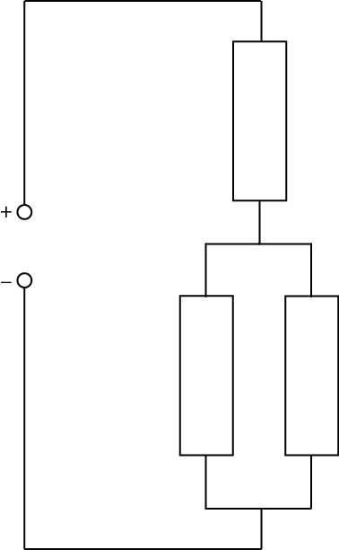  5 V  100 Ω  400 Ω  120 Ω | Calculate the current supplied to the circuit.  Calculate the potential difference across the parallel section of this circuit.  Calculate the current in the 100 Ω resistor.
11.2.5 |  | An LED can carry a current of 10 mA and has a voltage drop across it of 2 V  Calculate the resistance of the resistor that must be placed in series if placed in a circuit with a 12 V supply.  +  -  12 V  V_{LED}
11.2.6 |  | The variable resistor in the circuit below is set to 1050 Ω  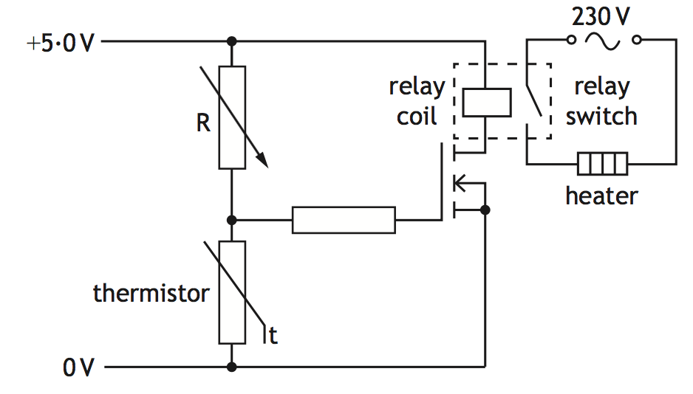  Explain how the circuit operates to switch on the heater when the temperature falls below a certain value (You must calculate the required voltage across the thermistor).
11.3 |  | I can describe the relationship between temperature and resistance of a conductor.
11.3.1 |  | State the meaning of the term resistance.
11.3.2 |  | Explain the difference between a conductor and an insulator
11.3.3 |  | State 6 materials that are conductors and 6 that are insulators. Display your answers in a table
11.3.4 |  | A circuit is shown with three gaps. For the lamp to light on state whether each gap should be filled with a conductor or an insulator.
11.3.5 |  | A student writes the following statements about electrical conductors.  I Only protons are free to move.  II Only electrons are free to move.  III Only negative charges are free to move.  Copy out the statements which is/are correct.
11.3.6 |  | Explain how the temperature affects the resistance of  - a resistor  - a wire  - a piece of metal, any conductor.
11.3.7 |  | State the relationship between temperature and resistance for a conductor.
11.4 |  | I can describe how increasing the temperature of a conductor changes the resistance of the conductor.
11.4.1 |  | Sketch a graph showing how the resistance of a resistor changes with the current through it, numerical values are not required.
11.4.2 |  | Sketch a graph showing how the current in a resistor varies with the voltage across it numerical values are not required.
11.4.3 |  | State the relationship between current and voltage for a resistor at constant temperature, numerical values are not required..
11.4.4 |  | 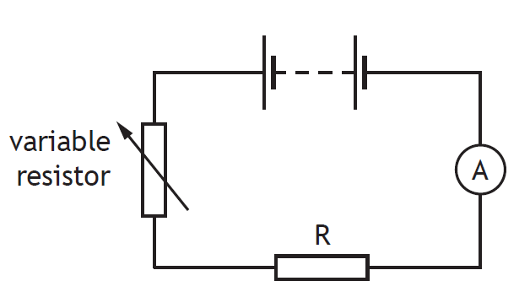  SQA Nat 5 2016  A student investigates the resistance of a resistor using the circuit shown.  - Copy and complete the circuit diagram to show where a voltmeter must be connected to measure the voltage across resistor R.  - Describe how the student obtains a range of values of voltage and current.  (c) The results of the student’s investigation are shown.  Use all these results to determine the resistance of resistor R.  (d) The student now replaces resistor R with a filament lamp and repeats the  investigation. A sketch graph of the student’s results is shown.  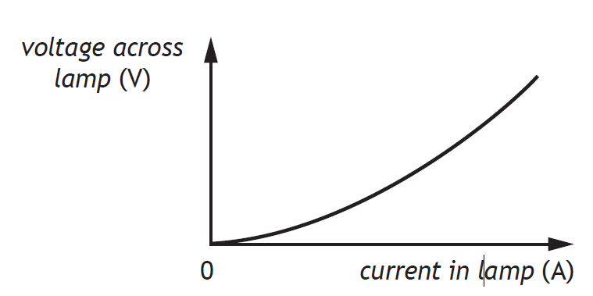  - State a conclusion that can be made about the resistance of the filament  lamp.  - Suggest a reason for the difference in resistance between the resistor and filament lamp.
  Voltage across resistor R (V) | Current in resistor R (A)
  1·0 | 0·20
  2·5 | 0·50
  3·2 | 0·64
  6·2 | 1·24
11.4.5 |  | A graph of the conductivity against temperature for a conductor is shown below.  Conductivity  Temperature  - From information in the graph state the effect of temperature on the conductivity of a conductor.  - State the effect of temperature on the resistance of a conductor.
11.4.6 |  | 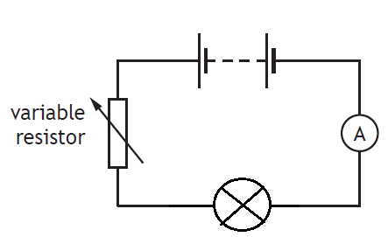  A student investigates the resistance of a filament lamp as shown in the diagram.  - Copy the diagram and add a voltmeter to show how the voltage across the filament lamp can be found.  - A sketch graph of the student’s results is shown.  - State a conclusion that can be made about the resistance of the filament lamp.  - Calculate the resistance of the filament lamp when the current is 0.4 A  - State what happens to the resistance of the filament lamp as the voltage across it increases. You must justify your answer.
11.5 |  | I can describe an experiment to prove Ohm’s Law.
11.5.1 |  | Draw out the circuit that can be used to show how the current through a resistor changes with voltage.
11.5.2 |  | Write down the formula giving the relationship between current voltage and resistance. Write what each letter stands for and the units of each quantity.
11.5.3 |  | (A) On graph paper, or in excel, plot a graph of voltage against current from the results given in the table below.  (B) Calculate the resistance of the resistor from the graph.
  V/V | I/A
  0.096 | 0.007
  0.821 | 0.056
  1.722 | 0.114
  2.664 | 0.176
  3.612 | 0.24
  4.58 | 0.303
  5.55 | 0.368
  6.56 | 0.433
  7.52 | 0.498
  8.52 | 0.562
11.5.4 |  | - Draw a circuit diagram to show how these results can be obtained of how a change in voltage affects the current in in.  - Determine the gradient of the graph.  - Calculate the resistance of the resistor.
11.5.5 |  | State whether the resistance changes when the current in a resistor changes. Explain your answer.
11.5.6 |  | A student sets up the following circuit to investigate the resistance of resistor R.  The variable resistor is adjusted and the voltmeter and ammeter readings are noted. The following graph is obtained from the experimental results.  - (i) Calculate the value of the resistor R when the reading on the voltmeter is 4.2 V.  (ii) Using information from the graph, state whether the resistance of resistor R, increases, stays the same or decreases as the voltage increases. Justify your answer.  - The student is given a task to combine two resistors from a pack containing one each of 33 Ω, 56 Ω, 82 Ω, 150 Ω, 270 Ω, 390 Ω  Show by calculation which two resistors should be used to give:  - The largest combined resistance;  - The smallest combined resistance.
11.5.7 |  | Calculate the current through a 5·6 kΩ resistor when it is connected to a 230 V supply.
11.5.8 |  | Calculate the voltage required to produce 10·9 A of current through a 3·3 x 10⁴ Ω resistor.
11.5.9 |  | If a 12 V supply produces a current of 15 μA through a resistor, calculate the resistance.
11.5.10 |  |  |  | A variable resistor can be adjusted from 10 Ω to 10 kΩ, and is connected to a mains supply. Calculate the maximum current.
Practical Electricity and Electronics
12.1 |  |  | I can make measurements of I, V and R using appropriate meters in simple and complex circuits.
12.1.1 |  |  | A circuit is set up as shown.  The reading on ammeter A1 is 5·0 A.  The reading on ammeter A2 is 2·0 A.  The reading on ammeter A4 is 1·0 A.  State the reading on ammeters A3 and A5.
12.1.2  A |  |  | A student investigates the resistance of a resistor using the circuit shown.  - State all the equipment required to build this circuit.  - Complete the circuit diagram to show where a voltmeter must be connected to measure the voltage across resistor R.
12.1.2 B |  |  | The results of the student’s investigation are shown.  Use all these results to determine the resistance of resistor R.
  Voltage across resistor (V) | Current in resistor (A)
  1·0 | 0·20
  2·5 | 0·50
  3·2 | 0⋅64
  6.2 | 1·24
12.1.3 |  |  | In the circuit shown, the current in each resistor is different.  State which resistor has the smallest current, you must justify your answer.
12.1.4 |  |  | A student suspects that ammeter A1 may be inaccurate. Ammeter A2 is known to be  accurate.  Copy out the circuit that should be used to compare the reading on A1 with A2
12.1.5 |  |  | 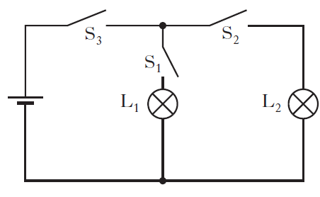  A circuit is set up as shown in the diagram. Copy the diagram and state which switch or switches must be closed to light bulb L1
12.2 |  |  | I can describe the symbol, function and application of standard electrical and electronic components including cell, battery, lamp, switch, resistor, variable resistor, voltmeter, ammeter, LED, motor, microphone, loudspeaker, photovoltaic cell, fuse, diode, capacitor, thermistor, LDR, relay and transistor
12.2.1 |  |  | - Produce a table with four columns and in the first column write the following components.  cell, battery, lamp, switch, resistor, variable resistor, voltmeter, ammeter, LED, motor, microphone, loudspeaker, photovoltaic cell, fuse, diode, capacitor, thermistor, LDR, relay and transistor  - In the second column draw the circuit symbols for each component.  - In the third column describe the function  - In the last column state the energy change in the component.  Ensure each column is properly titled.
12.2.2 |  |  | State the name of the electrical component represented by this symbol
12.2.3 |  |  | Four circuit symbols, W, X, Y and Z, are shown.  Draw and identify the components W, X, Y and Z,
12.2.4 |  |  | Two circuits are set up as shown.  Both circuits are used to determine the resistance of resistor R, identify meter X, meter Y and meter Z, you must justify your answer.
12.2.5 |  |  | 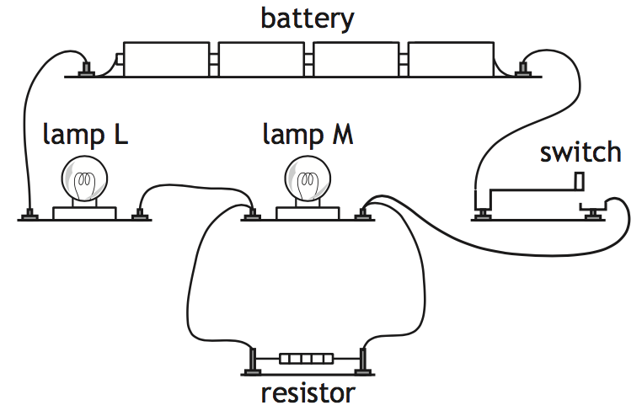  Redraw this circuit for these components using standard component symbols.
12.2.6 |  |  | The rating plate on a food blender is shown.  The plugs on all modern electrical appliances in the UK are fitted with fuses rated at either 3 A or 13 A.  (i) Draw the circuit symbol for a fuse.  (ii) State the purpose of the fuse fitted in the plug of an appliance.
12.2.7 |  |  | Copy the row in the table which shows the symbol for an LED and an NPN transistor.
12.2.8 |  |  | A student investigates the electrical properties of three different  components; a lamp, an LED and a fixed resistor.  Current-voltage graphs produced from the student’s results are shown.  Explain which graph X, Y or Z is obtained from the student’s results for  the LED.
12.2.9 |  |  | Describe, using a diagram, the use of two switches in series in the home. What has to be done to get the appliance to work in this case
12.2.10 |  |  | An LED is used as part of an alarm circuit. State which terminal P or Q should be positive to enable the LED to light.
12.2.11 |  |  | Copy out the circuit where both LEDs are lit.
12.2.12 |  |  | Light emitting dioders (LEDs) are often used as on/off indicators on television and computers. An LED is connected in a circuit with a resistor R.  - Explain the purpose of Resistor R.  - The LED is rated at 2 V, 100 mA. Calculate the resistance of resistor R.  - Calculate the power developed by resistor R when the LED is working normally.
12.2.13 |  |  | SQA SG C 2009  A digital camera is used to take pictures. When switched on, the flash on a digital camera requires some time before it is ready to operate. When ready, a green LED is illuminated.  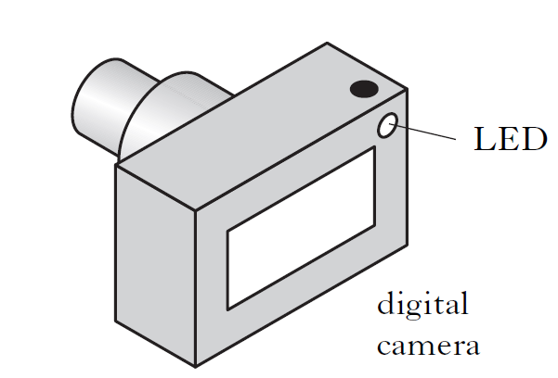  The part of the circuit used to control the LED is shown below. The voltage  at point X is initially 0 V.  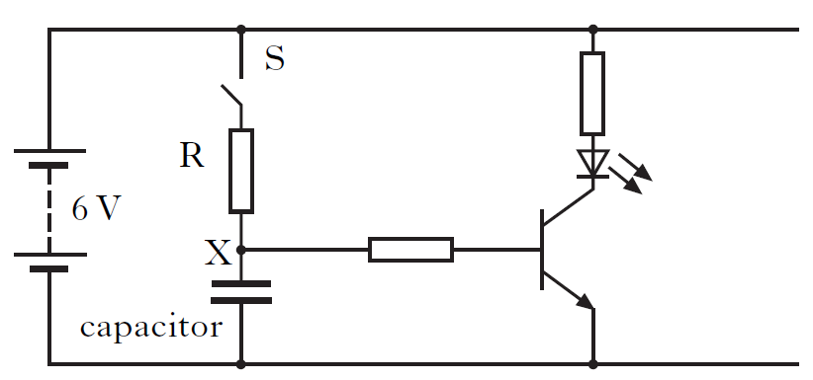  (a) Describe what happens to the voltage at point X when switch S is closed.  (b) The camera manufacturer wants to change the time taken for the flash to be ready to operate.  State two changes which could be made to the above circuit so that the time for the green LED to come on is reduced.
12.2.14 |  |  | SQA SG G 2010  The circuit below can be used to light an LED after a short time delay.  The capacitor is charged using the 5·0 volt supply.  (i) State what happens to the voltage across the capacitor when it charges.  (ii) Component Y is a transistor. Draw the symbol for a transistor.  (iii) State the function of the transistor in this circuit.  (b) The circuit is used to monitor temperature changes in a liquid.  The thermistor is immersed in the liquid.  - State what happens to the reading on the ohmmeter as the liquid cools.  (ii) The thermistor is now connected to a battery and an ammeter as shown.  Calculate the current in the circuit when the resistance of the thermistor is 1000 ohms.
12.2.15 |  |  | Draw the symbol for a Light Emitting Diode.
12.2.16 |  |  | State why a LED must be connected the correct way round in a circuit.
12.2.17 |  |  | State why a resistor must be used in series with a LED.
12.2.18 |  |  | Draw a diagram showing how a LED can be operated from a 12V battery.
12.2.19 |  |  | Calculate the size of resistor needed in the circuit operated from a 12V battery if the LED operates at 1.8V 15mA
12.2.20 |  |  | In terms of energy, what useful energy change happens in  (a) a microphone, (b) a thermocouple, and (c) a solar cell.
12.2.21 |  |  | - (i) State what the abbreviation LDR stands for.  (ii) State how the resistance of the LDR changes when more light reaches it.  (b) State how the resistance of a thermistor change when its temperature increases.
12.2.22 |  |  | State the purpose of a capacitor in a circuit.
12.2.23 |  |  | Draw the circuit symbol for a capacitor.
12.2.24 |  |  | Sketch a graph showing the potential difference across a capacitor against time as it charges from a 12V supply, numerical values are only required on the voltage axis.
12.2.25 |  |  | State the two quantities that affect the time for a capacitor to fully charge.
12.2.26 |  |  | (a) State how a capacitor can be quickly discharged.  (b)State whether rapidly discharging a capacitor can be dangerous, you must justify your answer.
12.2.27 |  |  | State the meaning of the terms  - open circuit b) short circuit
12.3 |  |  | I can draw and identify the symbols for an npn-transistor, and an n-channel enhancement MOSFET
12.3.1 |  |  | - Draw the circuit symbol for an npn-transitor.  - Draw the circuit symbol for an n-channel enhancement MOSFET.
12.3. |  |  | The diagrams opposite show two different types of transistors.  - Copy and name each symbol.  - Label points A, B and C on each symbol.
12.4 |  |  | I can explain the function of transistors
12.4.1 |  |  | A circuit is set up as shown below  Copy the circuit and identify the transistor.  State the function of the transistor in this circuit.
12.4.2 |  |  | State the switch on voltage for the following  - an npn-transitor and state its switch on voltage  - an n-channel enhancement MOSFET.
12.4.3 |  |  | (i) State the type of transistor used in this circuit.  (ii) State the function of the transistor in this circuit.
12.4.4 |  |  | SQA Int 2 2015  Part of an alarm system is shown in the circuit. Light from an LED strikes the LDR. When the light is blocked the transistor switches on and the buzzer sounds. Explain how the circuit operated to make the buzzer sound.
12.4.5 |  |  | A photographic darkroom has a buzzer that sounds when the light level in the room is too high. The circuit diagram for the buzzer system is shown below.  (a) (i) Name component X.  (ii) What is the purpose of component X in the circuit?  - The darkroom door is opened and the light level increases.  Explain how the circuit operates to sound the buzzer.  - The table shows how the resistance of the LDR varies with light level.  The variable resistor has a resistance of 570 Ω. The light level increases to 80 units. Calculate the current in the LDR.  (d) State the purpose of the variable resistor R in this circuit.
  Light level (units) | LDR Resistance (Ω)
  20 | 4500
  50 | 3500
  80 | 2500
12.4.6 |  |  | Water in a fish tank has to be maintained at a constant temperature. Part of the electronic circuit which controls the temperature is shown.  (a) Name components Y and Z.  (b) State what happens to the resistance of the thermistor as the temperature increases.  (c) When the voltmeter reading reaches 1·8V component Y switches on. Explain how the circuit operates when the temperature rises.  (d) Explain why a variable resistor chosen for component X rather than a fixed value resistor.
12.4.7 |  |  | A car has a temperature warning system which alerts the driver when the air temperature falls below 3 °C. The sensor is installed inside the passenger side wing mirror on the car. The diagram for the circuit is shown below.  12 V  t  X  Y  Z  (a) A thermistor is used as the sensor in the circuit. State what happens to the resistance of the thermistor as the temperature falls.  (b) Name component: (i) X; (ii) Y.1  (c) When operating normally, component Y has 2·0 V across it and 10 mA in it.  Calculate the resistance of resistor Z.  (d) The car manufacturer decides to redesign the circuit using a MOSFET.  (i) Draw the symbol for a n channel enhancement MOSFET.  (ii) State which component in the circuit shown above can be removed when the MOSFET is introduced.  (e) On the rear window of the car there is a heater that is used to remove any ice that forms on the glass.  (i) At a temperature of 0 °C a mass of 0·050 kg of ice forms on the rear window. Calculate the energy needed to melt this ice into water at 0 °C.  (ii) In practice more energy than the value calculated in part (e) (i) needs to be supplied to melt the ice. Explain why more energy is needed.
12.5 |  |  | I can apply the current and voltage relationships in a series circuit.
12.5.1 |  |  | State the equation to show  - Current in a series circuit  - Voltage in a series circuit.
12.5.2 |  |  | State how the current compares in components connected in series.
12.5.3 |  |  | 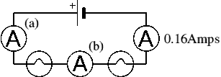  Determine the readings on meter (a) and (b).
12.5.4 |  |  | 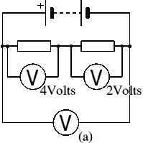  (i) State the reading on the Voltmeter (a)  (ii) State the supply voltage of this circuit.
12.5.5 |  |  | Two resistors are connected in series as shown in the diagram. The current in the 2 Ω resistor is 2.0 A  Calculate the current in the 4 Ω resistor and the voltage across the 4 Ω resistor
12.5.6 |  |  | In the potential divider circuit the value of the variable resistor is increased. State the effect on voltmeters, V₁ and V₂  V₁  V₂
12.5.7 |  |  | Calculate the total resistance for a 650 ohm, a 350 ohm, and a 1000 ohm resistor connected in series.
12.5.8 |  |  | Calculate the total resistance for ten 120 ohm resistors in series.
12.5.9 |  |  | A string of fifty 15 ohm Christmas tree lights are connected in series. One burns out, they all burn out. Calculate the total resistance.
12.5.10 |  |  | Two 100 ohm resistors are connected in series and they are connected to a 1.5 V DC battery. Determine the total current flowing in the circuit.
12.5.11 |  |  | Two resistors are connected in series. One resistor has a resistance of 50 Ω. The total resistance is 67 Ω, calculate the resistance of the second resistor
12.5.12 |  |  | The reading on the ammeter is 3·0 A.  The reading on the voltmeter is 4·0 V.  Determine the current in resistor R₂ and the voltage across resistor R₂
12.6 |  |  | I can apply the current and voltage relationships in a parallel circuit
12.6.1 |  |  | State the equation to show  - Current in a parallel circuit  - Voltage in a parallel circuit.
12.6.2 |  |  | - Calculate the total resistance for two 180 ohm resistors connected in parallel.  - If the resistors are connected to a 9.0 V power supply determine the voltage across each resistor.  - If the resistors are connected to a 9.0 V power supply determine the current in each resistor.  - Determine the total current in the circuit.
12.6.3 |  |  | A 10 ohm, 20 ohm, and 100 ohm resistors are connected in parallel.  - Calculate the total resistance of these three resistors.  - If the resistors are connected to a 12.0 V power supply determine the voltage across each resistor.  - If the resistors are connected to a 12.0 V power supply determine the current in each resistor.  - Determine the total current in the circuit.
12.6.4 |  |  | A string of fifty 15 ohm Christmas tree light are connected in parallel. One burns out, the rest will stay lit. Calculate the total resistance of the 49 resistors.
12.6.5 |  |  | State the rule for calculating the resistance of any two resisitors, with the same resistance when connected in parallel.
12.6.6 |  |  | Two 33 ohm resistors are connected in parallel followed by two more 33 ohm resistors connected in parallel. Calculate the value of a single resistor which would be used to replace these four resistors.
12.6.7 |  |  | A technician builds a test circuit containing a resistor and a motor, as shown  (i) State the voltage across the motor.  (ii) Calculate the combined resistance of the resistor and the motor.
12.6.8 |  |  | The resistor and the motor are now connected in series, as shown State how this affects the speed of the motor compared to Circuit 1.  Explain your answer.
12.6.9 |  |  | 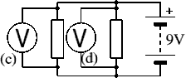  State the reading on voltmeters (c ) and (d)
12.6.10 |  |  | 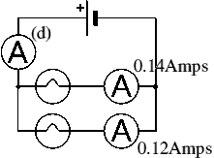  State the reading on Ammeter (d)
12.6.11 |  |  | A toy car contains an electric circuit which consists of a 12·0 V battery, an electric motor and two lamps.  The circuit diagram is shown.  Switch 1 is now closed.  Calculate the power dissipated in the motor when operating.  Switch 2 is now also closed.  - Calculate the total resistance of the motor and the two lamps  - One of the lamps now develops a fault and stops working. State the effect this has on the other lamp.
12.6.12 |  |  | The current in the lamp is 1·5 A.  The reading on the voltmeter is 6·0 V. Calculate power developed in the lamp.
12.6.13 |  |  | a) Calculate the total resistance  b) Calculate the total current  c) Calculate the voltage across the 20 Ω resistor  d) calculate the voltage across the parallel network  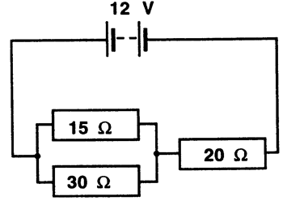  e) Calculate the current for each resistor in the parallel network.  f) Calculate the power dissipated by each resistor
12.7 |  |  | I can describe and explain practical applications of series and parallel circuits.
12.7.1 |  |  | To turn on a kettle, the kettle plug should be placed in a socket and the socket switched on and then the kettle switch must also be switched on before the kettle heats up. State how the switches are connected in this arrangement.
12.7.2 |  |  | Two headlights in a car can only be switched on when the ignition switch and the light switch are both on. Draw a circuit diagram to show how this circuit could be connected.
12.7.3 |  |  | The interior light in a car only lights when either the drivers or passenger door is open. Draw a circuit diagram to show this circuit arrangement.
12.7.4 |  |  | Brakes in a car only light when the ignition is switched on and the brake switch on the pedal is pressed. Draw a circuit diagram to show this circuit arrangement.
12.7.5 |  |  | State whether the sockets in your house connected in series or parallel, you must justify your answer.
12.7.6 |  |  | 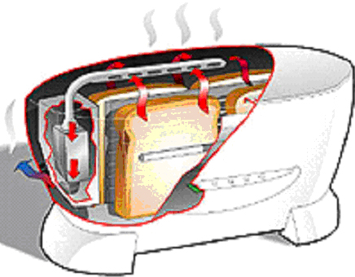  A state-of-the-art electric toaster uses radiation to produce the perfect slice of toast.  (a) State the main energy change in the toaster.  (b) State the most likely power rating for the toaster.  10 W 100 W 1000 W  (c) State the size of fuse required in the toaster.  (d) The toaster has a metal casing. How many wires does it have in its flex?
12.7.7 |  |  | An electrician is looking for a fault in the wiring of a house.  - He decides to make a continuity tester from a battery, a lamp and some insulated wires. Draw a circuit diagram of the continuity tester.  - A fault has been repaired the electrician uses a voltmeter to measure the voltage at different sockets around the house.  (i) State the value of the voltage measured at the sockets.  (ii) The electrician finds that the voltage at all of the sockets is the same. Describe the way in which the sockets are wired together.
12.7.8 |  |  | A circuit is set up as shown.  The initial reading on both voltmeters V₁ and V₂ is 2.5V.  The light shining on the LDR is made brighter.  Copy out the row in the table that shows possible new readings on voltmeters V₁ and V₂.
  Reading on V₁ (V) | Reading on V₂ (V)
  2.0 | 3.0
  2.5 | 2.0
  2.5 | 2.5
  2.5 | 3.0
  3.0 | 2.0
12.8 |  |  | I can solve problems involving total resistance of resistors in a series circuit.
12.8.1 |  |  | State the formula to calculate resistance in a series circuit.
12.8.2 |  |  | Calculate the resistance of the following circuit  35 Ω  22 Ω  60 Ω
12.8.3 |  |  | The total resistance of this circuit is 25 kΩ. Calculate the value of Resistor 2  500 Ω  R₂  12 kΩ
12.8.4 |  |  | Calculate the resistance of the following circuit  2.0 k Ω  500 Ω  500 Ω
12.9 |  |  | I can perform calculations involving current and voltage relationships in a parallel circuit.
12.9.1 |  |  | 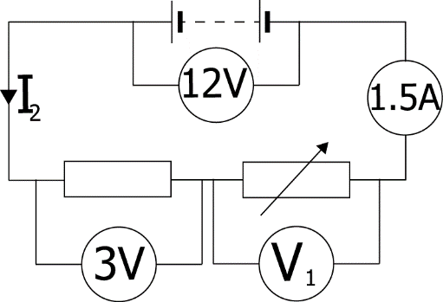  Determine the missing currents and voltages for this circuit.
12.9.2 |  |  | 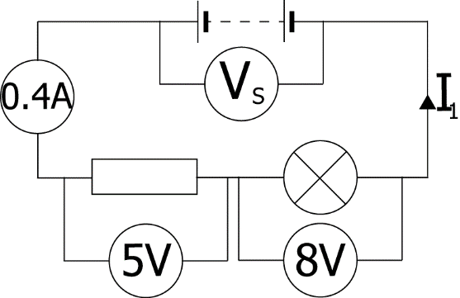  Determine the missing currents and voltages for this circuit.
12.9.3 |  |  | 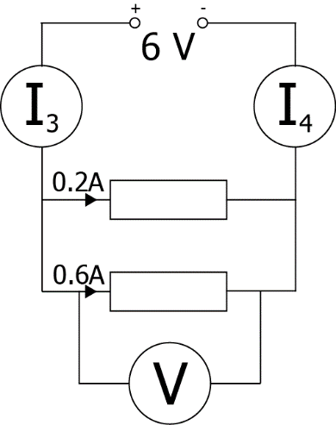  Find the missing currents and voltages for this circuit.
12.9.4 |  |  | 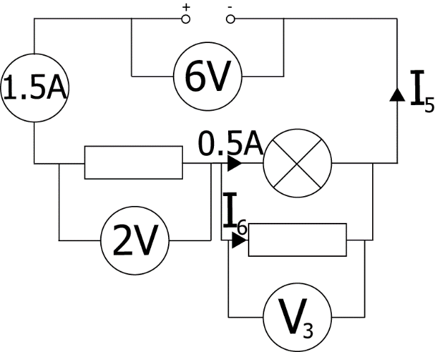  Find the missing currents and voltages for this circuit.
12.10 |  |  | I can calculate the resistance of resistors in parallel circuits
12.10.1 |  |  | Calculate the resistance of the circuit shown below  100 Ω    400 Ω  200 Ω
12.10.2 |  |  | The total resistance of this circuit is 100Ω. Calculate the value of Resistor 1  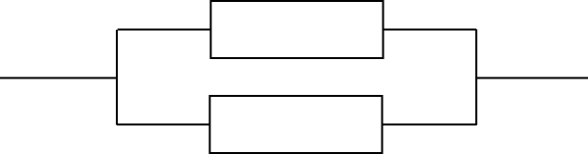  200 Ω  R₁
12.10.3 |  |  | Calculate the total resistance of these two resistors in parallel  20 kΩ  14 kΩ
12.10.4 |  |  | Calculate the total resistance of these resistors in parallel  300 Ω  600 Ω  900 Ω
12.10.5 |  |  | 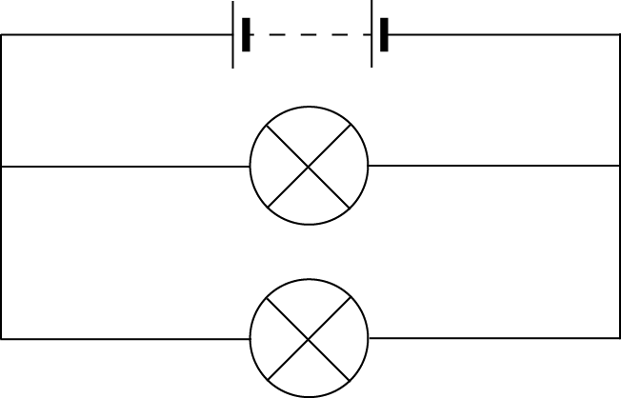  Calculate the total resistance of these lamps in parallel  4 Ω  6 Ω
12.11 |  |  | I can use the appropriate relationships to calculate the resistance of resistors in with circuits with combinations of resistors in series and parallel
12.11.1 |  |  | Calculate the total resistance between X and Y.
12.11.2 |  |  | Calculate the total resistance in each of these circuits.
  a. | 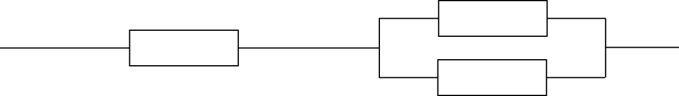  900 Ω  200 Ω  200 Ω  500 Ω  1 kΩ  1.2 kΩ  900 Ω  1.5 kΩ  1 MΩ  500 kΩ  2 MΩ  750 kΩ
  b. | 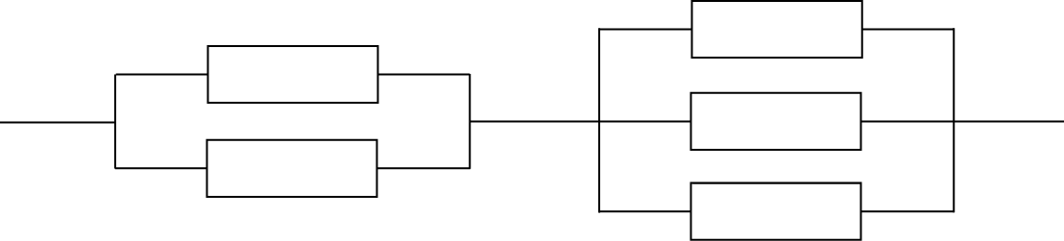
  c. | 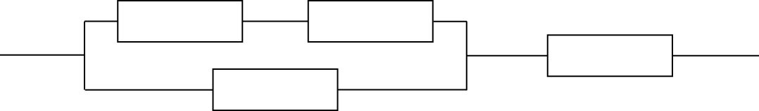
12.11.3 |  |  | Calculate the readings on the ammeter and voltmeter
12.11.4 |  |  | Part of a circuit is shown below.  - Calculate the total resistance between points Y and Z  - Calculate the total resistance between points W and X  - Calculate the voltage across the 2.0 Ω resistor when the current in the 4.0 Ω resistor is 0.10 A
12.11.5 |  |  | Collect a copy of the Resistor Network and try to find a total resistance for the network.  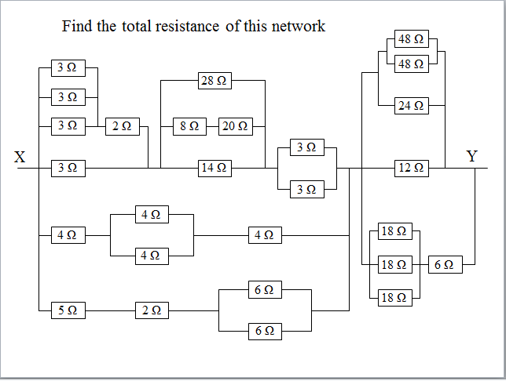
12.12 |  |  | I know what happens in a circuit when I increase the resistance in both series and parallel circuits.
12.12.1 |  |  | State what happens to the total resistance as resistors are added in a circuit in series.
12.12.2 |  |  | State what happens to the total resistance as resistors are added in a circuit in parallel.
12.12.3 |  |  | If the voltage remains constant state what happens to the current in a circuit as the resistance increases.
12.12.4 |  |  | If the voltage remains constant state what happens to the current in a circuit as the resistance decreases.
Electrical Power
13.1 |  |  | I can state the definition of electrical power.
13.1.1 |  |  | State the definition of electrical power.
13.1.2 |  |  | A student makes a statement: “The power of a light bulb is 15 W.” Explain what this statement mean, in terms of energy
13.1.3 |  |  | Dissipation is a term that is often used to describe ways in which energy is wasted. Any energy that is not transferred to useful energy stores is said to be wasted because it is lost to the surroundings.  Taking 3 separate appliances indicate ways in which the energy is dissipated.
13.1.4 |  |  | A kettle is rated as 2 KW.  - Explain what this term means.  - Does all the energy heat the water? You must justify your answer.
MrsPQ |  |  | What/ Watt is the unit of power?!
13.2 |  |  | I can use the word dissipated as it relates to power.
13.2.1 |  |  | Copy the sentence below and state the word to which the sentence refers.  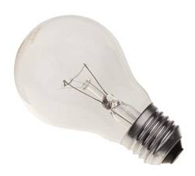  The process in which an electric or electronic device produces heat (other waste energy) as an unwanted by-product of its primary action.
13.2.2 |  |  | A 100 W light bulb transfers 20 W of light.  State what happens to the remaining power.
13.2.3 |  |  | State the formula to calculate the power dissipated in a circuit. State the meaning and units of each quantity.
13.3 |  |  | I am able to solve calculations relating to Power, Energy and time.
13.3.1 |  |  | State the equation that links Power, Energy and time. State the units of each quantity.
13.3.2 |  |  | - State the energy transformed each second by a drill rated at 800 W.  - From part a) state what you can infer about the energy used per second by an appliance and its power rating.
13.3.3 |  |  | Calculate the electrical energy transformed by the following appliances  - A 400 W drill used for 45 s.  - A 300 W food processor used for 20 s.
13.3.4 |  |  | Calculate the electrical energy transformed by an 800 W iron used for 40 minutes.
13.3.5 |  |  | Calculate the electrical energy transformed by a 2.4 kW kettle that takes 5 minutes to boil the water inside it.
13.3.6 |  |  | A miniature heater for making cups of tea is rated at 150 W. Calculate the time taken to boil the water if 45,000 J of energy are supplied.
13.3.7 |  |  | A 2.0 kW heater, a 150 W TV and a 100W light bulb are left on for 20 minutes. Calculate the total energy consumed by these appliances in this time.
13.3.8 |  |  | An electrical components is operated at 4·0 V with a current of 0·50 A for 60 seconds. Calculate the energy transferred to the component during this time.
13.3.9 |  |  | A MES lamp rated at 3.5 V and with a current of 0.25 A is switched on and consumes 87.5 J of energy. Calculate the time the bulb has been switched on for.
13.4 |  |  | I know the effect of potential difference (voltage) and resistance on the current in and power developed across components in a circuit. (complete section 13.5 before attempting this section)
13.4.1 |  |  | SQA SG C 2011.  A mains electric fire has two heating elements which can be switched on and off separately. The heating elements can be switched on to produce three different heat settings: LOW, MEDIUM and HIGH. The fire also has an interior lamp which can be switched on to give a log-burning effect.  The circuit diagram for the fire is shown.  (a) Switches S2 and S3 are closed.  (i) Calculate the combined resistance of both heating elements.  (ii) Calculate the total power developed in the heating elements when S2 and S3 are closed.  - State and explain which switch or switches would have to be closed to produce the LOW heat setting.
13.4.2 |  |  | Based on SG C 2005  A mains vacuum cleaner contains a motor that takes 3.0 s to reach full speed after being switched on. The graph shows how the current in the motor varies from the time the motor is switched on.  - Calculate the power of the motor when it first switched on.  - State the current when the motor has reached full speed.  - Calculate the power of the motor when it has reached full speed.  (c ) The vacuum cleaner is connected to the mains supply by a flex fitted with a fused plug. All the fuses shown are available.  State which one of these fuses is most suitable for fitting in the plug. You must justify your answer.
13.4.3 |  |  | SQA SG C 2009  A car fan uses a battery powered electric motor. The diagram below shows the apparatus used to investigate the effect of current on the speed of the electric motor.  - The graph shows the relationship between speed and current during the investigation.  - The current is changed using the variable speed control. State what happens to the current when the resistance of the variable speed controller is reduced.  - The settings of the variable speed control use different combinations of identical resistors, as shown. State to which position the variable speed control should be set to achieve maximum speed. You must justify your answer.
13.4.4 |  |  | SQA SG C 2012  A student sets up a circuit to operate two identical 12 V, 36 W lamps from a 48 V supply.  (a) When the switch is closed, the lamps operate at their correct power rating.  Calculate:  (i) the reading on the ammeter;  (ii) the reading on the voltmeter;  (iii) the resistance of the variable resistor.  - The student sets up a second circuit using a 12 V supply and the same lamps. Each lamp has a resistance of 4 Ω. The resistance of the variable resistor is set to 6 Ω.  (i) Calculate the total resistance of this circuit.  (ii) The variable resistor is now removed from the circuit.  (A) State what happens to the reading on the ammeter. You must justify your answer.
13.5 |  |  | I can use appropriate relationships to solve problems involving power, potential difference (voltage), current and resistance in electrical circuits
13.5.1 |  |  | State the relationship between current, voltage and power.
13.5.2 |  |  | (a)State the relationship between current, resistance, and power.  (b) Show that this relationship is found by combining P=IV and V=IR.
13.5.3 |  |  | (a)State the relationship between voltage, resistance, and power.  (b) Show that this relationship is found by combining P=IV and V=IR.
13.5.4 |  |  | A toaster is rated at 230V 1200W. Calculate the current in the toaster when it is operating normally.
13.5.5 |  |  | State the relationship between current, resistance, and power. Also write this as a triangle and say what each letter stands for
13.5.6 |  |  | Show that this relationship is found by combining P=IV and V=IR.
13.5.7 |  |  | A 12 V battery supplies a motor which has a resistance of 18 Ω, calculate the current in the circuit.
13.5.8 |  |  | An LED which is in series with a 1.2 kΩ resistor must be supplied with 5 mA of current to operate. When lit, the p.d. across the LED is 0.6 V.  Calculate the potential difference across the resistor.  Calculate the minimum supply voltage required.
13.5.9 |  |  | A vacuum cleaner is connected to the UK mains (rated at 230 V) and 8.9 A of current flows through the circuit. Calculate the power being transformed.
13.5.10 |  |  | A heater has a power of 1000W, and the current in it is 5A, calculate the resistance of the heater.
13.5.11 |  |  | The resistance of a kettle is 21Ω and its power is 2200W. Calculate the current in the kettle when it is working normally.
13.5.12 |  |  | A mains electric fire is rated at 2.0 kW.  - State the voltage across the electric fire.  - Calculate the current in the heating element when it is switched on.  - Calculate the resistance of the heating element
13.5.13 |  |  | SQA N5 2014  A toy car contains an electric circuit which consists of a 12·0 V battery, an electric motor and two lamps.  The circuit diagram is shown.  (a) Switch 1 is now closed.  Calculate the power dissipated in the motor when operating.  (b) Switch 2 is now also closed.  (i) Calculate the total resistance of the motor and the two lamps.
13.5.14 |  |  | A components is operated at 4·0 V with a current of 0·50 A for 60 seconds.  - Calculate the energy transferred to the component during this time.  - Calculate the power dissipated in the component
13.5.15 |  |  | The rating plate on an electrical appliance is shown.  Calculate the resistance of the appliance.
13.5.16 |  |  | A torch bulb is rated 12V, 60mA. Calculate the power dissipated in the bulb when it is operating normally.
13.5.17 |  |  | SQA N5 2017 SP  - A student sets up the following circuit.  (i) Determine the total resistance in the circuit.  (ii) Calculate the current in the circuit.  - Calculate the power dissipated in the 15 Ω resistor.  (b) The circuit is now rearranged as shown.  State how the power dissipated in the 15 Ω resistor compares to your answer in (a) (iii). You must justify your answer.
13.5.18 |  |  | The cables used in the National Grid are made of aluminium with a cross sectional area of 25 cm². These have a resistance of 10-5 Ωm⁻¹, and so a 50 km line has a resistance of 0.5 Ω.  (A) Calculate the power loss in the 50 km line if it has a current of 1200 A in it.  (B) The current is reduced to 100 A by using a transformer system at each end, calculate the power loss with this new arrangement.  (C) If the transformers lose 50 kW because they are not 100 % efficient, calculate the total power loss from both the line and the transformers.
13.5.19 |  |  | Based on SQA SG C 2007  Two groups of pupils are investigating the electrical properties of a lamp.  (a) Group 1 is given the following equipment:  ammeter; voltmeter; 12 V D.C. supply; lamp; connecting leads.  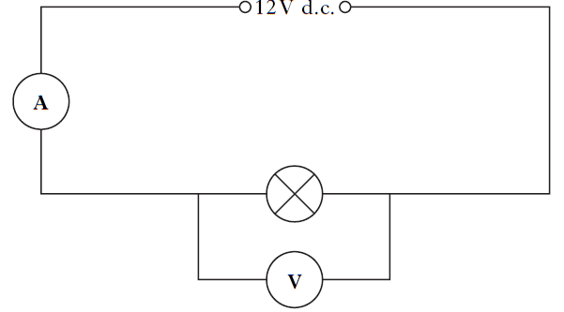  Group 2 uses the same lamp and is only given the following equipment:  lamp; ohmmeter; connecting leads.  - State what property of the lamp is measured by the ohmmeter.  - The results of both groups are combined and recorded in the table below.  - Use these results to complete the last two columns of the table.  - State the quantity represented by the last two columns of the table  - State the unit of this quantity
  I(A)) | V(V | R(Ω) | IV | I²R
  2 | 12 | 6
13.6 |  |  | I know when I would use a 3A fuse and when a 13A fuse for appliances.
13.6.1 |  |  | State the purpose of the fuse fitted in the plug of an appliance.
13.6.2 |  |  | Explain how a fuse work.
13.6.3 |  |  | Explain why different sizes of fuses are required in household appliances.
13.6.4 |  |  | - State the fuse value required in most appliances up to 720W.  - State the value of a fuse required in most appliance above 720W  - State the maximum power rating of an appliance that can be fitted with a 13A
13.6.5 |  |  | The mains supply voltage in the UK is quoted as 230 V.  State a value for the peak voltage and the mains and frequency in the UK?
13.6.6 |  |  | Explain why some appliances with a power rating below 720 W, (particularly those containing an electric motor) which you might expect to have a 3A fuse are actually required to have a fuse with a higher rating.
13.6.7 |  |  | Explain why it is important to fit the correct fuse in an appliance. (i.e. explain what can happen if the wrong fuse is placed in the appliance)
13.7 |  |  | I could select the appropriate fuse rating given the power rating of an electrical appliance
13.7.1 |  |  | The rating plate on a food blender is shown.  Determine the rating of the fuse fitted in the plug of the blender.
13.7.2 |  |  | Choose the correct size of fuse for appliances of 6W, 600W, 800W, 1000W, 2000W, and 2500W
13.7.3 |  |  | State the energy change in most appliances that have the greatest power rating.
13.7.4 |  |  | Explain, using the correct equation, how you would calculate the correct fuse for an appliance.
13.7.5 |  |  | The following electrical appliances are found in a kitchen.  kettle hand blender toaster  2500 watts 300 watts 1800 watts  (a) State a reason why you should not fill a kettle with water when it is plugged in and switched on.  (b) The hand blender does not have an earth wire. Draw the symbol on its rating plate which indicates it does not require an earth wire.  (c) State the colour of the live wire in the cord of an electrical appliance.  (d) Each appliance is fitted with either a 3 ampere or a 13 ampere fuse. State the correct value of fuse for:  (i) the kettle;  (ii) the hand blender.
13.7.6 |  |  | An electrician is looking for a fault in the wiring of a house.  (a) He decides to make a continuity tester from a battery, a lamp and some insulated wires. Draw a circuit diagram of the continuity tester.

PROPERTIES OF MATTER

Quantities for the Properties of Matter Unit
For this unit copy and complete the table.
Quantity | Symbol | Unit | Unit Symbol | Scalar / Vector
Pressure
Force
Specific Heat Capacity
Mass
Change in Temperature
Specific Latent Heat
Volume
Temperature
Area
Energy
Work done

The Properties of Matter unit in numbers
Quantity | Value
State the Specific Heat Capacity of Water.
State the specific Latent heat of fusion of ice.
State the specific latent heat of vaporisation of water.
State the average Atmospheric Pressure.
State the equivalent temperature of 0 °C in Kelvin.
State the temperature of 0 Kelvin in °C.
State the equivalent temperature of 100 °C in Kelvin.
State the equivalent of 100 Kelvin in °C.
State the equivalent temperature change in kelvin of a one degree Celsius temperature change
State the conversion factor to change °C into Kelvin.
State the conversion factor to change a temperature in Kelvin into °C
State the melting and boiling point of water.
State the melting and boiling point of alcohol.

No. | CONTENT
Specific heat capacity
14.1 | I know that the same mass of different materials require different quantities of heat energy to raise their temperature by 1 degree Celsius.
14.1.1 | Explain the term Specific Heat Capacity.
14.1.2 | When eating a cheese, pineapple, ham and tomato pizza the pineapple and tomato is much hotter when you bite into it than the ham, explain the reason for this.
14.1.3 | State the formula linking energy, mass, specific heat capacity, and change in temperature. State what each letter means.
14.1.4 | Using the data sheet, state the specific heat capacity of  - ice (b) copper (c) iron
14.1.5 | From the list of materials given in the Data sheet, state the material that would take  - most energy to heat up the material by 10 °C  - least energy to heat up the material by 10 °C
14.2 | I am able to use E_{h} = cm∆T to carry out calculations involving: mass, heat energy, temperature change and specific heat capacity.
14.2.1 | Explain the difference between temperature and heat.
14.2.2 | 10000 J of energy raises the temperature of 1 kg of liquid by 2 °C. Calculate the specific heat capacity of the material.
14.2.3 | The specific heat capacity of concrete is about 800 Jkg⁻¹°C⁻¹. Calculate the heat stored in a storage heater containing 50 kg of concrete when it is heated through 100 °C.
14.2.4 | 1.344 MJ of heat energy are used to heat from 20 °C to 100 °C. Calculate the mass of water.
14.2.5 | 9600 J of heat energy is supplied to 1 kg of methylated spirit in a polystyrene cup. Calculate the rise in temperature produced.  Take the specific heat capacity of methylated spirit to be the same as alcohol.
14.2.6 | When 2.0 x 10⁴ J of heat is supplied to 4.0 kg of paraffin at 10 °C in a container the temperature increases to 14 °C.  a) Calculate the specific heat capacity of the paraffin.  b) Explain why the result in part a) is different from the theoretical value of  2200 Jkg⁻¹°C⁻¹.
14.2.7 | Calculate the energy supplied to heat up 1.20 kg of water from 20.0°C to 100.0°C. Assume all the energy goes in to heating the water.
14.2.8 | If 5000J of energy is used to heat up 0.80 kg of iron,  (i) calculate the rise in temperature of the iron  (ii) If its initial temperature is 30°C, determine the final temperature of the iron.
14.2.9 | A kettle is used to heat up water from 20°C to boiling point. It has a power of 2000W and takes 120 seconds to boil.  (i) Calculate the energy supplied to the water.  (ii) If all of this energy is used to heat the water, Determine the mass of water in the kettle.
14.2.10 | If a kettle containing 2 kg of water cools from 40 °C to 25 °C, calculate the heat given out by the water.
14.2.11 | The temperature of a 0.8 kg metal block is raised from 27 °C to 77 °C when 4200 J of energy is supplied. Find the specific heat capacity of the metal.
14.2.12 | The tip of the soldering iron is made of copper with a mass of 30 g. Calculate how much heat energy is required to heat up the tip of a soldering iron by 400 °C.
14.2.13 | 5.0 kg of a plastic is heated from 10°C to 66°C using 36000 J of energy. Calculate the specific heat capacity of the plastic.
14.2.14 | The graph below represents how the temperature of a 2 kg steel block changes as heat energy is supplied. From the graph calculate the specific heat capacity of the steel.
14.3 | I am able to explain how temperature of a substance is related to kinetic energy
14.3.1 | Explain how the temperature of a substance relates to the particle speed.
14.3.2 | (a) If the speed of the particles in a substance increases state what happens to the kinetic energy of the particles in the substance.  (b) Hence, state the link between temperature of a substance and the kinetic energy of its particles.
14.4 | I can use the principle of conservation of energy to determine heat transfer.
14.4.1 | GG Energy Notes  A kettle works on the UK mains (230 V) and a current of 12.0 A flows when it is switched on.  - Calculate the power rating of the kettle.  - Calculate the energy transformed by the kettle if it was switched on for 2 minutes.  - Calculate the maximum mass of water at 20 °C which could be heated to 99 °C in this time.  - State any assumptions you made in part c.
14.4.2 | SQA SG C 2013  A child of mass 42.0 kg is playing on a water slide at a water park.  (a) The child climbs 7·50 m to the top of the slide.  Calculate the gain in potential energy of the child.  (b) When sliding down, an average frictional force of 15.0 N acts on the child. This causes 1050 J of heat energy to be produced. Calculate the length of the slide.  (c) Calculate the speed of the child at the end of the slide.
14.4.3 | SQA SG C 2013  An experimental geothermal power plant uses heat energy from deep underground to produce electrical energy. A pump forces water at high pressure down a pipe. The water is heated and returns to the surface. At this high pressure the boiling point of water is 180 °C.  The plant is designed to pump 82.0 kg of heated water, to the surface, each second. The specific heat capacity of this water is 4320 J kg⁻¹ °C⁻¹.  (a) The water enters the ground at 20 °C and emerges at 145 °C.  Calculate the heat energy absorbed by the water each second.  The hot water is fed into a heat exchanger where 60 % of this heat energy is used to vaporise another liquid into gas. This gas is used to drive a turbine which generates electrical energy. The specific latent heat of vaporisation for this liquid is 3·42 × 10⁵ Jkg⁻¹.  Calculate the mass of this liquid which is vaporised each second.
14.4.4 | SQA SG C 2012A  A manufacturer has developed an iron with an aluminium sole plate. A technician has been asked to test the iron. The technician obtains the following data for one setting of the iron.  Starting temperature of sole plate: 24°C  Operating temperature of the sole plate: 200°C  Time for iron to reach the operating temperature: 35 s  Power rating of the iron: 1·5 kW  Operating voltage: 230 V  Specific Heat Capacity of Aluminium: 902 J kg⁻¹ °C⁻¹  - Calculate how much electrical energy is supplied to the iron in this time.  - Calculate the mass of the aluminium sole plate.  - The actual mass of the aluminium sole plate is less than the value calculated in part (b) using the technician’s data. Give one reason for this difference.
14.4.5 | A steam cleaner rated at 2.0 kW is used to clean a carpet. The water tank is filled with 1.60 kg of water at 20.0 °C. This water is heated until it boils and produces steam. The brush head is pushed across the surface of the carpet and steam is released.  (a) Calculate how much heat energy is needed to bring this water to its boiling point of 100 °C.  (b) After the steam cleaner has been used for a period of time, 0.90 kg of boiling water has changed into steam.  (i) Calculate how much heat energy was needed to do this.  (ii) Calculate how long it would take to change this water into steam.
14.4.6 | SQA N5 2017  In a nuclear reaction a uranium-235 nucleus is split by a neutron to produce two smaller nuclei, three neutrons, and energy.  One nuclear reaction releases  3·2 × 10⁻¹¹ J.  In the reactor, 3·0 × 10²¹ reactions occur each minute.  Determine the maximum power output of the reactor.
Specific Latent Heat
15.1 | I know that different materials require different quantities of heat to change the state of unit mass.
15.1.1 | State what is meant by change of state.
15.1.2 | Define the term specific latent heat.
15.1.3 | State what is meant by latent heat of fusion .
15.1.4 | State what is meant by latent heat of vaporisation .
15.1.5 | Using the information in the data sheet, state the energy required to melt 1 kg of the following substances:  - ice b) copper c) aluminium
15.2 | I know that the same material requires different quantities of heat to change the state of unit mass from solid to liquid (fusion) and to change the state of unit mass from liquid to gas (vaporisation)
15.2.1 | State which requires more energy, melting 1 kg of ice or boiling 1 kg of water. You must justify your answer.
15.2.2 | State whether 1 kg of water or 1 kg of molten copper will give out more energy as they change to a solid, you must justify your answer.
15.2.3 | State what happens to the temperature of a substance when it changes from a solid to a liquid.
15.2.4 | Copy and complete this sentence:  When a substance changes state, its temperature . . ..
15.2.5 | State what you have to do to a material to make it turn from  (a) a liquid to a gas, and  (b) from a liquid to a solid.
15.2.6 | 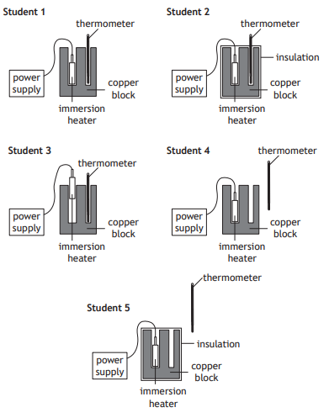  Draw the diagram of the student’s setup that would allow the most accurate value for the specific heat capacity of copper to be determined.
15.3 | I can solve problems involving mass, heat energy and specific latent heat.
15.3.1 | State the formula linking mass energy and specific latent heat.  State the units of each quantity.
15.3.2 | Calculate the specific latent heat of fusion of naphthalene given that 6 x 10⁵ J of heat is given out when 4.0 kg of naphthalene at its melting point changes to a solid.
15.3.3 | Calculate the mass of water changed to steam if 10.6 kJ of heat energy is supplied to the water at 100 °C.
15.3.4 | Ammonia is vaporised in order to freeze an ice rink.  a) Calculate the heat energy required to vaporise 1 g of ammonia.  b) Assuming this heat is taken from water at 0 °C, find the mass of water frozen for every gram of ammonia vaporised.  (Specific latent heat of vaporisation of ammonia = 1.34 x 10⁶ Jkg⁻¹  Specific latent heat of fusion of ice = 3.34 x 10⁵ Jkg⁻¹).
15.3.5 | (a) Explain how evaporation can be used to cool objects.  (b) Describe how  (i) evaporation and  (ii) melting can be used to keep things cool.
15.3.6 | Calculate the amount of heat energy required to melt 0.3 kg of ice at 0 °C.
15.3.7 | Calculate the specific latent heat of fusion of naphthalene given that 6 × 10⁵ J of heat are given out when 4.0 kg of naphthalene at its melting point changes to a solid.
15.3.8 | Calculate what mass of water can be changed to steam if 10.6 kJ of heat energy is supplied to the water at 100 °C.
15.3.9 | Ammonia is vaporised in order to freeze an ice rink.  a) Find out how much heat it would take to vaporise 1.0 g of ammonia.  b) Assuming this heat is taken from water at 0 °C, find the mass of water frozen for every gram of ammonia vaporised.(Specific latent heat of vaporisation of ammonia = 1.34 x 10⁶ Jkg⁻¹)
15.3.10 | State what is meant by Specific Heat Capacity  State the formula linking Energy, mass, specific heat capacity, and change in temperature. State what each letter means.
15.3.11 | Calculate the energy required to melt 4.0 kg of ice.
15.3.12 | Using the information in the data sheet, state the energy required to boil 1kg of the following substances:  - water b) alcohol c) glycerol
15.3.13 | The graph below shows how the temperature of a 2.0 kg lump of solid wax varies with time when heated.  a) Explain what is happening to the wax in the regions AB, BC and CD.  b) If a 200 W heater was used to heat the wax, calculate the specific latent heat of fusion of the solid wax.
15.3.14 | A heater transfers energy to boiling water at the rate of 1130 joules every second. Calculate the maximum mass of water converted to steam in 2 minutes.
15.3.15 | A kettle is rated at 230 V 10 A.  (a) Calculate the power rating of the kettle  (b) Calculate the time it will take to heat 1.3 kg of water from 10 °C to boiling point using the kettle, assume all the energy goes into the water.  (c ) The kettle in part (a) is faulty and does not switch its self off when it boils. If it boils the water for 5 minutes before it is noticed, determine the mass of water turned into steam.
15.3.16 | (i) From the data sheet, state the melting point of aluminium.  (ii) Calculate the energy needed to melt 5kg of aluminium at its melting point.
15.3.17 | A solid substance is placed in an insulated flask and heated continuously with an immersion  heater.  The graph shows how the temperature of the substance in the flask changes in time.  State in which state(s) the substance is after being heated for 5 minutes
Gas laws and the kinetic model
16.1 | I can explain pressure
16.1.1 | State the meaning of the term pressure.
16.1.2 | State the equation linking force and pressure, define each term.
16.2 | I am able to use the correct equation to calculate pressure, force and area
16.2.1 | A television has a length of 1.24 m, a height of 0.93 m and a depth of 0.080 m. If it has a mass of 30 kg.  (a) Calculate the maximum pressure that the television can exert on a surface  (b) Calculate the minimum pressure that the television can exert on a surface.  1.24 m  0.93 m  0.080 m
16.2.2 | The mass of a spacecraft is 1200 kg.  The spacecraft lands on the surface of a planet.  The gravitational field strength on the surface of the planet is 5·0 N kg⁻¹.  The spacecraft rests on three pads. The total area of the three pads is 1·5 m².  Determine the pressure exerted by these pads on the surface of the planet.
16.2.3 | The pressure of the air outside an aircraft is 0·40 × 10⁵ Pa.  The air pressure inside the aircraft cabin is 1·0 × 10⁵ Pa.  The area of an external cabin door is 2·0 m².  Calculate the outward force on the door due to the pressure difference.
16.2.4 | A 0.480 kg tin of baked beans is a cylinder with a radius of 0.032 m. It is placed on a kitchen counter. Calculate the pressure on the counter caused by the tin.
16.2.5 | A car of mass 1250 kg is driven on to a bridge. The pressure on the surface of the bridge when all four tyres are on the ground is 39.0 kPa. Calculate the contact area of one tyre on the bridge.
16.2.6 | By measuring your weight and the area of your feet, calculate the pressure that you exert on the floor when:  (a) You are standing normally.  (b) You are standing on one foot.
16.2.7 | Are you more likely to fall through an icy lake if you are on your tip toes or lying flat on your back with your arms and legs stretched out? Explain your answer.
16.2.8 | SQA N5 2014  A student is investigating the motion of water rockets. The water rocket is made from an upturned plastic bottle containing some water. Air is pumped into the bottle. When the pressure of the air is great enough the plastic bottle is launched upwards.  The mass of the rocket before launch is 0·94 kg.  - Calculate the weight of the water rocket.  - Before launch, the water rocket rests on three fins on the ground. The area of each fin in contact with the ground is 2·0 × 10⁻⁴ m². Calculate the total pressure exerted on the ground by the fins.
16.2.9  OEQ | An articulated lorry has six pairs of wheels.  One pair of wheels can be raised off the ground.  Using your knowledge of physics, comment on situations in which the wheels may be raised or lowered.
16.3 | I can describe the kinetic model of a gas.
16.3.1 | A syringe containing air is sealed at one end as shown.  The piston is pushed in slowly.  There is no change in temperature of the air inside the syringe.  Copy the statement which describes and explains the change in pressure of the air in the syringe.  A The pressure increases because the air particles have more kinetic energy.  B The pressure increases because the air particles hit the sides of the syringe more frequently.  C The pressure increases because the air particles hit the sides of the syringe less frequently.  D The pressure decreases because the air particles hit the sides of the syringe with less force.  E The pressure decreases because the air particles have less kinetic energy.
16.3.2 | State the properties of an ideal gas.
16.3.3 | Explain the kinetic theory of an ideal gas.
16.4 | I can describe the kinetic model of a gas and how this accounts for pressure
16.4.1 | Explain the term pressure.
16.4.2 | Explain how the kinetic model of a gas accounts for pressure.
16.4.3 | Explain what happens to the particles of a gas as the temperature of the gas increases.
16.5 | I can convert temperatures between kelvin and degrees Celsius and understand the term absolute zero of temperature.
16.5.1 | Convert the following temperatures into kelvin  - 0 °C, b) 20 °C, c) -273 °C , d)100 °C
16.5.2 | Convert the following temperatures into degrees Celsius  - 0 K, b) 20 K, c) 273 K d) 100 K, e) 500 K
16.5.3 | The average temperature of the surface of the Sun is 5778 K. Determine the average temperature of the surface of the Sun in degrees Celsius.
16.5.4 | A liquid is heated from 17 °C to 50 °C. Determine the temperature rise in kelvin.
16.5.5 | A solid at a temperature of −20 °C is heated until it becomes a liquid at 70 °C.  Calculate the temperature change in kelvin.
16.5.6 | State the freezing and boiling points of water at standard pressure on the degree Celsius scale and kelvin scale
16.6 | I know the link between kelvin and the degrees Celsius °C scale
16.6.1 | State the link between kelvin and the degree Celsius scale.
16.6.2 | Copy and complete this sentence  A change of temperature of 1°C is equal to a change of temperature of _____ K
16.6.3 | Copy and complete this sentence  To convert between kelvin and degrees Celsius _________________  To convert between degrees Celsius and kelvin _________________
16.6.4 | Explain in terms of moving particles what occurs at a temperature of zero kelvin.
16.7 | I can explain the relationship between the volume, pressure and temperature of a fixed mass of gas using qualitative (info) in terms of kinetic theory.
16.7.1 | Explain how the kinetic theory suggests that as the temperature of a fixed mass of gas increases the pressure increases.
16.7.2 | Explain how the kinetic theory suggests that as the temperature of a fixed mass of gas increases the volume increases for constant pressure.
16.7.3 | Explain how the kinetic theory suggests that as the volume of a fixed mass of gas increases the pressure decreases.
16.7.4 | When completing an experiment to find the relationship between volume and pressure, explain why it is important to change the volume slowly.
16.7.5  A | SQA N5 2017  A bicycle pump with a sealed outlet contains 4·0 × 10⁻⁴ m³ of air. The air inside the pump is at an initial pressure of 1·0 × 10⁵ Pa. The piston of the pump is now pushed slowly inwards until the volume of air in the pump is 1·6 × 10⁻⁴ m³ as shown.  Using the kinetic model, explain what happens to the pressure of the air inside the pump as its volume decreases.
16.7.5  B | (continued from above)  The piston is now released, allowing it to move outwards towards its original position. During this time the temperature of the air in the pump remains constant. Sketch a graph to show how the pressure of the air in the pump varies as its volume increases.  Numerical values are not required on either axis.
16.8 | I can use appropriate relationships to calculate the volume, pressure and temperature of a fixed mass of gas  p₁V₁/T₁(K)= p₂V₂/T₂(K) .  p₁V₁ =p₂V₂ p₁/T₁(K) = p₂/T₂(K) V₁/T₁(K) = V₂/T₂(K) pV/T(K)= constant
16.8.1 | The pressure of a fixed mass of gas is 150 kPa at a temperature of 27 ºC.  The temperature of the gas is now increased to 47 ºC.  The volume of the gas remains constant. Determine the new pressure of the gas.
16.8.2 | The pressure of a fixed mass of gas is 6·0 x 10⁵ Pa.  The temperature of the gas is 27 ºC and the volume of the gas is 2·5 m³.  The temperature of the gas increases to 54 ºC and the volume of the gas increases to 5·0 m³. Determine the new pressure of the gas.
16.8.3 | A mass of gas at a pressure of 20 kPa has a volume of 3.0 m³. Calculate the new volume if the pressure is doubled but the temperature remains constant.
16.8.4 | The volume of mass of a gas is reduced from 5.0 m³ to 2.0 m³. If the pressure was initially 40 Pa, calculate be the new pressure if the temperature remains constant.
16.8.5 | The pressure of a fixed volume of gas at 300 K is increased from 5.0 Pa to 10.0 Pa, calculate the new temperature.
16.8.6 | If pressure of a fixed volume of gas at 200 K is 50.0 Pa, calculate the pressure if the temperature is increased to 300 K?
16.8.7 | The temperature of 6.0 m³ of gas is increased from 27 °C to 127 °C, calculate the new volume of the gas if the pressure remains constant.
16.8.8 | The volume of a gas is increased from 10.0 m³ to 20.0 m³ at constant pressure. Calculate the new temperature if the initial temperature was 300 K.
16.8.9 | A mass of gas has a volume of 5.0 m³, a pressure of 20.0 Pa and a temperature of 27 °C. Calculate the new pressure if the volume is changed to 4.0 m³ and the temperature to 27 °C.
16.8.10 | A sealed bicycle pump contains 4·0 × 10⁻⁵ m³ of air at a pressure of 1·2 × 10⁵ Pa.  The piston of the pump is pushed in until the volume of air in the pump is reduced to 0·80 × 10⁻⁵ m³.  During this time the temperature of the air in the pump remains constant.  Calculate the new pressure of the air in the pump.
16.9 | I can describe an experiment to verify Boyle’s Law (pressure and volume)
16.9.1 | 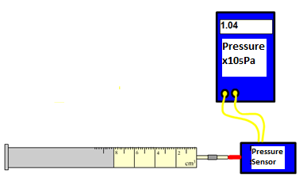  Explain how the following equipment can be used to show the relationship between pressure and volume. State the measurements required and how the variable will be altered. include any assumptions made.
16.9.2 | 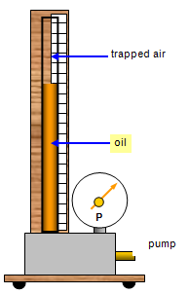  Explain how the equipment is different from that in 16.9.2 in collecting data to find the relationship between pressure and volume.
16.9.3 | SQA N5 2017 SP  A student carries out an experiment to investigate the relationship between the pressure and volume of a fixed mass of gas using the apparatus shown.  The pressure p of the gas is recorded using a pressure sensor connected to a computer. The volume V of the gas in the syringe is also recorded. The student pushes the piston to alter the volume and a series of readings is taken.  The temperature of the gas is constant during the experiment.  The results are shown.  (a) (i) Using square-ruled paper, draw a graph of p against 1/V.  You must start the scale on each axis from 0.  (ii) Explain how the graph confirms that pressure is directly proportional to 1/volume.
  p | (kPa) | 100 | 125 | 152 | 185 | 200
  V | (cm³) | 50 | 40 | 33 | 27 | 25
  1/V | (cm⁻³) | 0∙020 | 0∙025 | 0∙030 | 0∙037 | 0∙040
16.9.4  Bourdon Gauge  Mass  Syringe  Trapped Air | In an experiment, a mass with a weight of 1N is placed on top of a syringe filled with trapped air. A Bourdon Gauge is used to measure the air pressure inside the syringe. This is then repeated for different masses. The results are given in the table.  Use this data to construct a line graph of force against change in pressure, and use the gradient of the straight line to calculate the surface area of the syringe plunger inside the syringe.
  Force / N | Pressure / x 10⁵ Pa
  0 | 1.01
  1 | 1.03
  2 | 1.05
  3 | 1.07
  4 | 1.09
  5 | 1.11
16.9.5 | The end of a bicycle pump is sealed with a stopper so that the air in the chamber is trapped.  The plunger is now pushed in slowly causing the air in the chamber to be compressed. As a result of this the pressure of the trapped air increases. Assuming that the temperature remains constant, copy our the statements wich correctly explain why the pressure increases.  I The air molecules increase their avaerage speed.  II The air molecules are colliding more often with the walls of the chamber  III Each air molecule is striking the walls of the chamber with greater force.
16.9.6 | A student is training to become a diver.  (a) The student carries out an experiment to investigate the relationship between the pressure and volume of a fixed mass of gas using the apparatus shown.  The pressure of the gas is recorded using a pressure sensor connected to a computer. The volume of the gas is also recorded. The student pushes the piston to alter the volume and a series of readings is taken. The temperature of the gas is constant during the experiment. The results are shown.  (i) Using all the data, establish the relationship between the pressure and volume of the gas.  (ii) Use the kinetic model to explain the change in pressure as the volume of gas decreases.
  Pressure/kPa | 100 | 105 | 110 | 115
  Volume/cm3 | 20 | 19 | 18.2 | 17.4
16.10 | I can describe an experiment to verify Gay-Lussac’s Law (pressure and temperature)
16.10.1 | 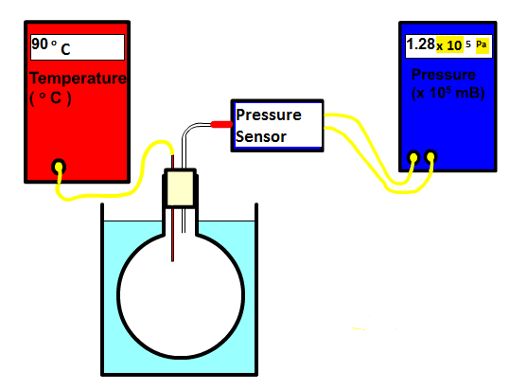  Explain how the following equipment can be used to show the relationship between pressure and temperature. State the measurements required and how the variable will be altered. include any assumptions made.
16.10.2 | Discuss whether the thermometer should be placed in the round bottom flask or in the water.
16.10.3 | Sketch a graph of the expected results of pressure against temperature on the degrees Celsius scale.
16.10.4 | Sketch a graph of the expected results of pressure against temperature on the kelvin scale.
16.10.5 | SQA N5 2018 Q9  A student sets up an experiment to investigate the relationship between the pressure and temperature of a fixed mass of gas as shown.  (a) The student heats the water and records the following readings of pressure and temperature.  - Using all the data, establish the relationship between the pressure and the temperature of the gas.  (ii) Predict the pressure reading which would be obtained if the student was to cool the gas to 253 K.  (b) State one way in which the set-up of the experiment could be improved to give more reliable results.
  Pressure (kPa) | 101 | 107 | 116 | 122
  Temperature (K) | 293 | 313 | 333 | 353
16.10.6 | A student carries out an experiment to investigate the relationship between the pressure and temperature of a fixed mass of gas. The apparatus used is shown.  The pressure and temperature of the gas are recorded using sensors connected to a computer. The gas is heated slowly in the water bath and a series of readings is taken.  The volume of the gas remains constant during the experiment.  The results are shown.  (a) Using all the relevant data, establish the relationship between the pressure and the temperature of the gas.  (b) Use the kinetic model to explain the change in pressure as the temperature of the gas increases.  (c) Explain why the level of water in the water bath should be above the bottom of the stopper.
  Pressure/kPa | 100 | 105 | 110 | 116 | 121
  Temperature/°C | 15·0 | 30·0 | 45·0 | 60·0 | 75·0
  Temperature/K | 288 | 303 | 318 | 333 | 348
16.11 | I can describe an experiment to verify Charles’ Law (volume and temperature)
16.11.1 | 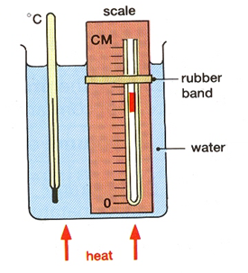  Explain how the following equipment can be used to show the relationship between pressure and temperature. State the measurements required and how the variable will be altered. include any assumptions made.
16.11.2 | A student is investigating the relationship between the volume and the kelvin temperature of a fixed mass of gas at constant pressure.  Sketch a graph to shows this relationship.
16.11.3 | Explain why the set up in 16.11.1 requires the thin tube to be open at one end.
16.11.4 | 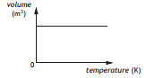  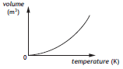  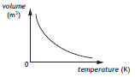  .  Copy the correct graph to show the relationship between volume and temperature.
16.11.5 | State what must be kept constant to allow a relationship between volume of a gas and its temperature.

WAVES

Quantities for the Waves Unit
For this unit copy and complete the table.
Quantity | Symbol | Unit | Unit Symbol | Scalar / Vector
Time
Period
Frequency
Wavelength
Amplitude
Distance
Speed
Velocity

The WAVES unit in numbers
Quantity | Value
What is the approximate speed of sound in air?
What is the approximate speed of ultrasound in air?
Does sound travel faster or slower in solids than in air?
How many seconds in a minute?
How many seconds in an hour?
What is the speed of light in air?
What is the speed of light in glass, eg in a fibre optic cable?
What is the speed of microwaves in air?
What is the speed of a television signal in air?
What is the speed of a radio signals in air?
At what speed do X-rays travel in air?
At what speed does gamma radiation travel in air?
What is the approximate critical angle for light in glass?
What is the smallest angle at which total internal reflection occurs in glass?

No. | CONTENT
Wave parameters and behaviours
17.1 | I can state what is transferred as waves.
17.1.1 | State what is transferred when a wave travels from one place to another.
17.1.2 | State the connection between waves and energy.
17.2 | I can define transverse waves.
17.2.1 | Draw and label a diagram showing a transverse wave.
17.2.2 | Mark on your diagram the wavelength, amplitude, direction of energy transfer and direction of movement of particles.
17.3 | I can define longitudinal waves.
17.3.1 | Draw and label a diagram showing a longitudinal wave.
17.3.2 | Mark on your diagram the wavelength, rarefaction, compression, direction of energy transfer and direction of movement of particles.
17.3.3 | What kinds of materials can sound travel through?
17.3.4 | What can sound not travel through?
17.4 | I can give examples of longitudinal and transverse waves.
17.4.1 | Copy and complete the table below and place the following waves into the correct section of the table.  e-m waves (write each member of this group out separately), sound, seismic p-waves, seismic s-waves,
  Transverse Waves | Longitudinal Waves
17.4.2 | Waves can be used to transmit signals. What type of waves would be used to  (a) tell competitors to start a race,  (b) broadcast TV signals,  (c) warn ships of shallow water,  (d) warn aircraft of high towers,  (e) pass down a fibre optic cable?
17.4.3 | 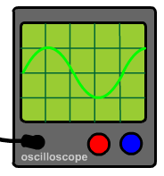  Explain how a sound wave be shown on an oscilloscope like in the diagram below although sound is a longitudinal wave..
17.5 | I can determine the frequency, period, wavelength, amplitude and wave speed for longitudinal and transverse waves.
17.5.1 | State what is meant by the frequency of a wave.
17.5.2 | State the link between period and frequency.
17.5.3 | If 20 crests pass a point in two seconds calculate the frequency of the wave.
17.5.4 | The diagram below represents a wave 0.2 s after it has started.  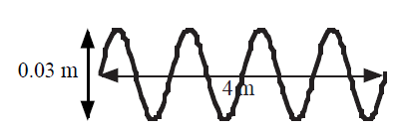  Determine the  a) wavelength  b) amplitude  c) frequency  d) speed.  for this wave:
17.5.5 | The following diagram gives the information about a wave.  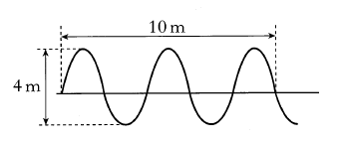  - Determine the amplitude of the wave.  - Determine the wavelength of the wave.
17.5.6 | 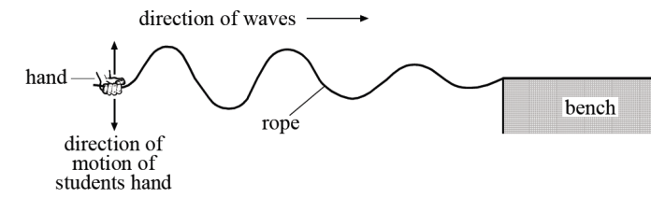  One end of a piece of rope is clamped to the end of a bench. A student produces transverse waves in the rope by moving the free end as shown below.  The student measures the frequency and wavelength of these waves.  State the relationship she would use to calculate the speed of the waves from this information.
17.5.7 A | 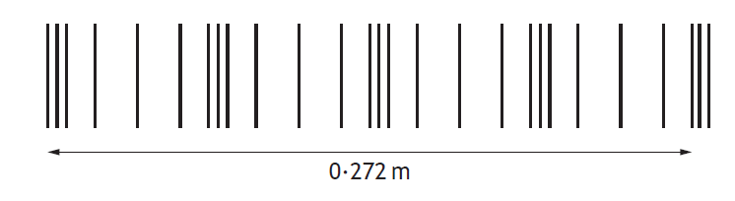  Sound produced by the speaker is represented by the diagram. Determine the wavelength of the sound wave
17.5.7 B | For the wave shown above, calculate the frequency of the sound wave in air
17.5.8 | The diagram represents a wave travelling from X to Y. 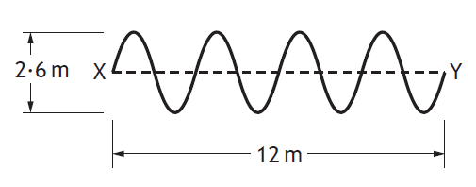  The wave travels from X to Y in a time of 0·5 s.  Determine the amplitude, wavelength , frequency and speed of this wave.
17.5.9 | Make sure you’ve answered the questions from the WAVES notes on this topic. Record the page number in your Learning Outcome notes.
17.6 | I can make use of the relationships between wave speed, frequency, wavelength, distance, number of waves and time (v = f λ) (d = vt)(f=1/T) (f=N/t) (λ=d/N.).
17.6.1 | State the link between frequency, Number of waves and time for that number of waves.
17.6.2 | A water wave travels 200m in 15s, calculate the speed of the wave.
17.6.3 | Calculate the time taken for the water wave given in 17.6.2 to travel a distance of 10 km?
17.6.4 | State the formula linking speed, wavelength, and frequency, state the letter for each term and the unit each is measured in.
17.6.5 | If the speed of sound is 340 ms⁻¹, what is the wavelength of a sound wave with a frequency of 2.0 kHz?
17.6.6 | Twenty water waves pass a point in 30 seconds. Each wave has a wavelength of 1.2 m  (A) Calculate the frequency of the waves.  (B) Calculate the speed of the waves.
17.6.7 | A sound wave has a frequency of 2.0 kHz, calculate the period of this wave.
17.6.8 | A radio wave has a frequency of 97.7 MHz, state the number of waves generated per second.
17.6.9 | State the time it would take one of the radio waves of frequency 97.7 MHz to pass a point
17.6.10 | The diagram represents the position of the crests of waves 3 seconds after a stone is thrown into a pool of still water.  Calculate the speed and the frequency of the waves.
17.6.11 | The period of vibration of a guitar string is 8 ms.  Calculate the frequency of the sound produced by the guitar string.
17.6.12 | (A) It takes 2.5µs for light to travel 500m down a fibre optic. Determine the speed of the light in the fibre?  (B) Calculate the time taken for light to travel along 500km of this fibre?
17.6.13 | An oscilloscope can be used to display the signal in a telephone line.  Draw diagrams showing what the pattern would be like for:  (a) a loud, low pitched sound,  (b) a loud, high pitched sound,  (c) a quiet, high pitched sound,  (d) a quiet, low pitched sound,  (e) speech.
17.6.14 | Make sure you’ve answered the questions from the WAVES notes on this topic. Record the page number in your Learning Outcome notes.
17.7 | I can describe diffraction and associated practical limitations.
17.7.1 | Explain what is meant by the term diffraction. You may use diagrams to help you.
17.7.2 | 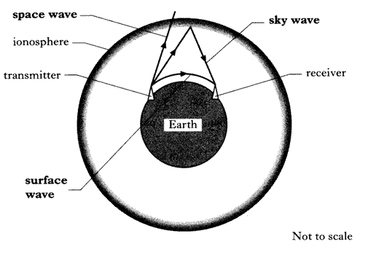  This diagram shows three types of signal in which radio waves can be sent between a transmitter and receiver.  State the signal with the longest wavelength. You musy justify your answer.
17.8 | I can make comparisons of long wave and short-wave diffraction.
17.8.1 | State which waves have the longer wavelength - those used for radio or TV.
17.8.2 | Explain in terms of diffraction, why radio reception in an area can be good, but TV reception poor.
17.9 | I know when diffraction of waves occurs.
17.9.1 | State examples when diffraction occurs.
17.9.2 | When waves diffract through a gaps state what happens to the  - wave speed  - frequency  - wavelength
17.10 | I can compare how long waves and short waves diffract.
17.10.1 | 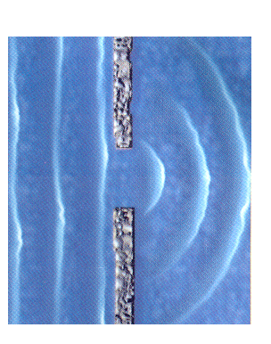  The diagram below shows water waves passing through a gap in a harbour wall.  The arrow shows the direction the wave is travelling.  Water waves with a shorter wavelength are now passed through the same gap.  What difference, if any, will this have after they have passed through?  A ship breaks into the harbour wall and breaks a piece off making the gap larger. What difference, if any, will this have after waves pass through the harbour?
17.10.2 | Copy and complete the diagram to show the difference between long waves and short waves as they diffract around a barrier.
17.10.3 | When waves pass through a gap, the width of the gap changes the way the waves emerge from the gap.  Draw a diagram  (a) to show how waves diffract when the gap is greater than one wavelength.  (b) to show how waves diffract when the gap is less than one wavelength.
17.11 | I can draw diagrams using wavefronts to show diffraction when waves pass through a gap or around an object.
17.11.1 | The diagram shows wavefronts arriving at a harbour wall. Copy and complete the diagram to show the wavefronts passing the harbour wall.  Harbour Wall
17.11.2 | Repeat the question above showing the same habour wall when waves of a longer wavelength arrive at it.
17.11.3 | Waves exit a gap as shown in the diagram below. For the waves to exit as semi-circular waves what can you state about the width of the gap compared to the wavelength of the waves.  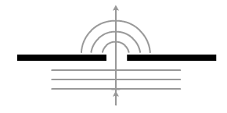
Electromagnetic Spectrum
18.1 | I can state the relative frequency and wavelength bands of the electromagnetic spectrum.
18.1.1 | List the members of the electromagnetic spectrum in order of increasing wavelength.
18.1.2 | As the wavelength of the radiation increases, state what happens to its frequency.
18.1.3 | State a member of the electromagnetic spectrum has a shorter wavelength than visible light and a lower frequency than X-rays.
18.1.4 | Radio waves have a wide range of frequencies.  The table gives information about different wavebands.  Coastguards use signals of frequency 500 kHz. State the waveband these signals belong to.
  Waveband | Frequency Range | Example
  Low frequency, (LF) | 30 kHz- 300 kHz | Radio 4
  Medium frequency, (MF) | 300 kHz – 3 MHz | Radio Scotland
  High frequency, (HF) | 3 MHz- 30 MHz | Amateur Radio
  Very High frequency, (VHF) | 30 MHz – 300 MHz | Radio 1 FM
  Ultra High frequency, (UHF) | 300 MHz – 3 GHz | BBC1 and ITV
  Very High frequency, (SHF) | 3 GHz – 30 GHz | Satellite TV
18.1.5 | A student makes the following statements about different types of electromagnetic waves.  I Light waves are transverse waves.  II Radio waves travel at 340 m s⁻¹ through air.  III Ultraviolet waves have a longer wavelength than infrared waves.  Copy each statement and mark a tick or a cross to indicate if each of the student’s statements are correct.
18.1.6 | Calculate the wavelength of a 88 MHz radio wave.
18.1.7 | A radio station has a wavelength of 252m determine the frequency of this wave.
18.1.8 | Calculate the time taken for a radio wave to travel 1.0 km
18.1.9 | Calculate the distance a TV signal travels in 1.25 seconds? (for comparison, the distance between the earth and the moon is 3.84 x 10⁸m)
18.1.10  OEQ | Using your knowledge of Physics explain why certain radio bands are used for particular things.
18.2 | I can make reference to typical sources, detectors and applications, of the electromagnetic spectrum.
18.2.1 | Draw a table listing a detector for each member of the electromagnetic spectrum. For each type of wave in the e-m spectrum give an example of the following  - typical source producing this type of waves  - detector  - A practical use for the radiation
18.3 | I can state whether radiations in the electromagnetic spectrum are transverse or longitudinal waves.
18.3.1 | Copy the sentence below inserting the correct type of wave.  Radiations in the electromagnetic spectrum are $\frac{\text{transverse}}{longitudinal}$ waves.
18.4 | I can state what all radiations in the electromagnetic spectrum have in common.
18.4.1 | List the electromagnetic waves in the electromagnetic spectrum in order of increasing frequency.
18.4.2 | Write out a mnemonic to remember the order of the waves in the electromagnetic spectrum
18.4.3 | State what all waves in the electromagnetic spectrum have in common.
18.4.4 | State the speed of light in air.
18.4.5 | State how the speed of light in air compares to the speed of light in glass.
18.4.6 | List these colours in terms of increasing wavelength:-  green, red, blue, orange, violet, yellow.
18.4.7 | Write out a mnemonic to remember the colours of the visible spectrum in order of decreasing wavelength.
18.4.8 | State how white light can be split up into different colours (it's spectrum)
18.4.9 | Draw a diagram to show how white light can be split up into different colours.
Refraction
19.1 | I know when refraction occurs.
19.1.1 | State what causes the refraction of light.
19.1.2 | State a cause of refraction in water waves at the beach.
19.2 | I can give a description of refraction.
19.2.1 | State what is meant by the term refraction.
19.2.2 | Copy and complete these diagrams showing how light passes from air to glass, and glass to air.
19.2.3 | On each of your completed diagrams above mark the following  (a) the angle of incidence,  (b) the angle of refraction,  (c) the normal line.
19.2.4 | Copy and complete the diagrams below to show the path of the rays.  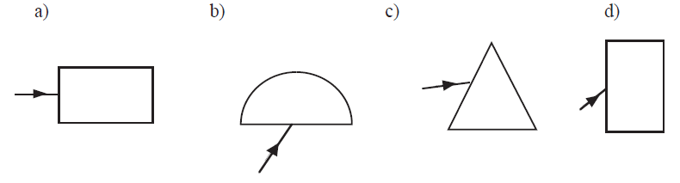
19.2.5 | A student looking from a pier into some calm water sees a fish. Copy and complete the diagram to show the path of a ray of light from the fish to the student. (diagrams available on the website and from your teacher)  You should include the normal in your diagram
19.2.6 | Copy out the correct diagram which represents the refraction of light waves after meeting a glass block as shown?  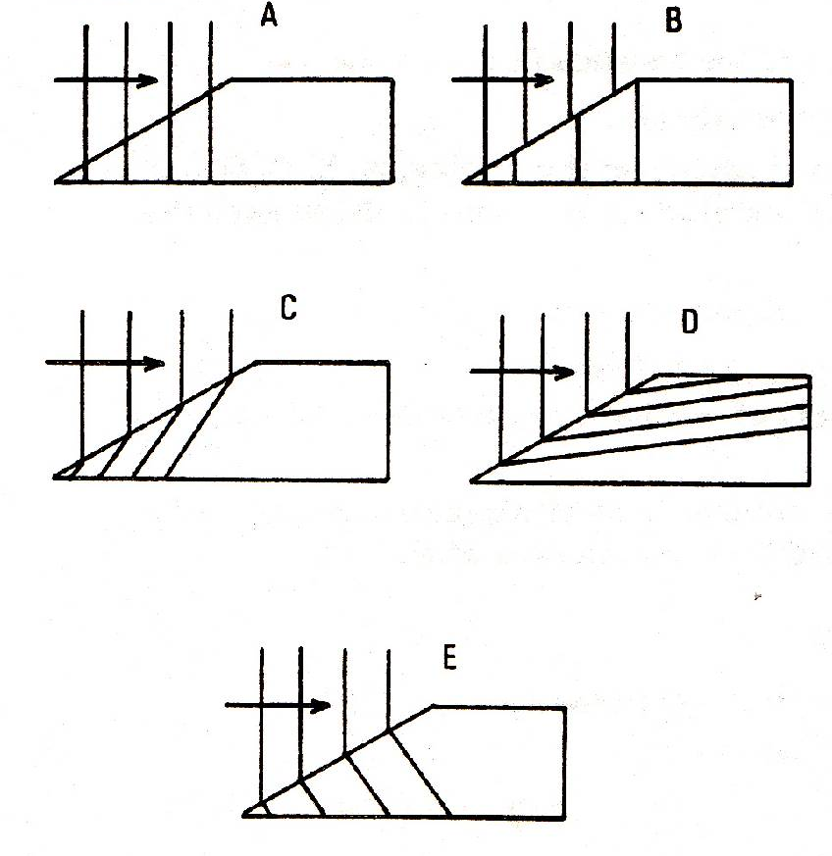
19.2.7 | 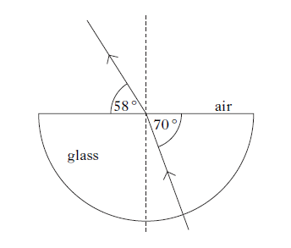  Copy the diagram below and state  - the angle of incidence  - the angle of refraction.
19.2.8 | Draw a diagram of white light passing through a prism. Mark on the colours exiting the prism in the correct order. (Rough angles are important)
19.3 | I can describe the qualitative (info) relationship between the frequency and the energy associated with a form of radiation.
19.3.1 | State the relationship between the frequency and the energy of waves.
19.3.2 | For electromagnetic waves, E=hf or Energy = Planck’s Constant x frequency.  - Find out the value of Planck’s constant, and  - Calculate the energy associated with a wave of frequency 6 x 10¹⁴ Hz
19.3.3 | State whether radio waves or infrared radiation have greater energies associated with them. You must justify your answer.
19.4 | I can identify the normal, angle of incidence and angle of refraction in ray diagrams showing refraction.
19.4.1 | 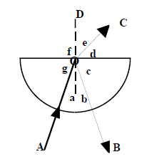  Identify the following from the diagram shown below.  - the incident ray  - the reflected ray  - the refracted ray  - the normal  - the angle of incidence  - the angle of refraction  - the angle of reflection.
19.4.2 | Explain why a ruler, placed in a beaker of water, appears to change as it enters the water.
19.4.3 | Draw a diagram to show this, by trying it for yourself

RADIATION

Quantities for the Radiation Unit
For this unit copy and complete the table.
Quantity | Symbol | Unit | Unit Symbol | Scalar / Vector
Time
Activity
Equivalent Dose
Absorbed Dose
Absorbed Dose Rate
Equivalent Dose Rate
Radiation weighting factor
Energy
Mass
Number of radioactive nuclei decaying

The RADIATION unit in numbers
Quantity | Value
State the charge on an alpha particle
State the charge on a beta particle
State the mass of an alpha particle
State the mass of a beta particle
State the average annual background radiation in the UK
State the average annual effective dose limit for a member of the public in the UK
State the average annual effective dose limit for radiation workers in the UK.
State the radiation weighting factor of an alpha particle
State the radiation weighting factor of a beta particle
State the radiation weighting factor of a gamma particle
State the radiation weighting factor of a fast neutron
State the radiation weighting factor of a slow neutron
State the speed of a gamma wave in air

No. | CONTENT
Nuclear Radiation
20.1 |  | I understand the nature of alpha, beta and gamma radiation: including the relative effect of ionization, their relative penetration.
20.1.1 |  | Copy the simple diagram of an atom and label the nucleus, proton, neutron and electron. State the charge on each particle.  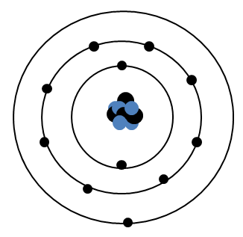
20.1.2 |  | Define the term ionisation
20.1.3 |  | State from where all ionizing radiations originate.
20.1.4 |  | Describe the following in as much detail as you can  - Alpha particle  - Beta particle  - Gamma radiation
20.1.5 |  | State what happens to radiation energy as it passes through the medium.
20.1.6 |  | State the approximate range through air, and absorption of alpha, beta and gamma radiation.
20.1.7 |  | Describe how one of the effects of radiation is used in a detector of radiation. The following web address might help.  http://www.darvill.clara.net/nucrad/detect.htm
20.1.8 |  | In an experiment, radiation from a sample of radium is passed through an electric field.  It is split into three different components (as shown in the diagram below).  (a) Name the radiations labelled (i), (ii) and (iii).  (b) Which radiation is deflected most by the electrostatic field?  (c) What is the function of the lead shield?  (d) Why is the experiment carried out in an evacuated chamber?  (e) What is the purpose of the photographic film?
20.1.9  OEQ |  | Alpha, beta and gamma are types of nuclear radiation, which have a range of properties and effects. Using your knowledge of physics, comment on the similarities and/or differences between these types of nuclear radiation.
20.2 |  | I can explain the term ‘ionisation’.
20.2.1 |  | Explain the term ionisation.
20.1.2 |  | State what remains after an atom has been ionised.
20.3 |  | I can state that which nuclear radiation is most ionising, and which is the least ionising.
20.3.1 |  | From the list of alpha, beta and gamma radiation,  - state which is least ionising  - state which is most ionising
20.3.2 |  | Give a piece of evidence to show that your answer to 20.3.1 is correct.
20.3.3 |  | State the effect radiation can have on living cells
20.4 |  | I can state the distances alpha, beta and gamma radiation can travel in air and the penetration through different materials.
20.4.1 |  | State the approximate distance (range) travelled in air by:  - alpha particles  - beta particles  - gamma rays
20.4.2 |  | State the minimum object, and the thickness that can stop:  - alpha particles  - beta particles  - gamma rays
20.4.3 |  | Copy and complete the table below to show if each type of radiation passes or is absorbed by each type of material.
  Type of radiation | Range in air | Effect of passing radiation through
  Type of radiation | Range in air | 0.1 mm paper | 3 mm aluminium | 3 mm lead | 10 m concrete
  Alpha
  Beta
  Gamma
  X-rays
20.4.4 |  | Describe one use of radiation based on the fact that radiation is easy to detect.
20.4.5 |  | The table below represents data obtained from an absorption experiment using three separate radioactive sources (background count = 20 counts per minute).  (a) What effect did paper have on each of the three sources?  (b) Use the data in the table to try to identify the type of radiation from each source.
  Type of radiation | Count rate (per minute)
  Type of radiation | Source A | Source B | Source C
  Air | 3125 | 900 | 420
  Paper | 3130 | 880 | 38
  1mm Aluminium | 3000 | 380 | 20
  10 mm lead | 1900 | 20 | 21
20.5 |  | I can state that Activity is the number of nuclear disintegrations per second.
20.5.1 |  | Explain the term activity of a radioactive source.
20.5.2 |  | State what happens to the Activity of a source with time.
20.5.3 |  | Describe an experiment to find the activity of a radioactive source using the following equipment:  Stopwatch, Geiger-Muller Tube, Counter.
20.6 |  | I can state the units of activity.
20.6.1 |  | State the units of the Activity of a source.
20.7 |  | I can use A=N/t to solve problems involving activity, number of nuclear disintegrations and time.
20.7.1 |  | Copy this table and calculate the missing numbers, there is no need to complete the table, just show the working underneath using IESSUU.
   | Activity / Bq | Number of Decays | Time / s
  (a) |  | 720 | 60
  (b) |  | 4500 | 180
  (c) | 1000 |  | 100
  (d) | 12 500 |  | 500
  (e) | 40 000 | 3.0 x 10⁷
  (f) | 2.5 x 10⁶ | 5.0 x 10⁸
20.7.2 |  | In a laboratory, the background activity is measured as 1.5 Bq. A Geiger-Muller tube is used to measure the activity of a source in the laboratory. In three minutes, 1440 counts are recorded. What is the activity of the source?
20.7.3 |  | Calculate the activity of a source that has 210 decays in a minute.
20.7.4 |  | A source has an activity of 2.0 kBq. Calculate the number of counts recorded from the source by a Geiger-Muller tube (and counter) in 30 seconds.
20.7.5 |  | Calculate the time it takes a source with an activity of 1.8 MBq to have 8.1 x 10⁸ radioactive decays.
20.7.6 |  | In an experiment, the number of decays from a radioactive source is recorded. The background count is then taken away. The results of this are shown.  Draw a line graph of these results, and use the gradient of the straight line to calculate the activity of the source.
  Time / minutes | Corrected Number of Decays
  0 | 0
  1 | 1800
  2 | 3600
  3 | 5400
  4 | 7200
  5 | 9000
20.8 |  | I can identify background sources of radiation.
20.8.1 |  | State what is meant by the term background radiation.
20.8.2 |  | Identify background sources of radiation.
20.8.3 |  | State three natural sources that contribute to background radiation.
20.8.4 |  | State three artificial sources (manmade) that contribute to background radiation.
20.9 |  | Knowledge of the dangers of ionising radiation to living cells and of the need to measure exposure to radiation
20.9.1 |  | State how the equivalent dose a person receives can be reduced.
20.9.2 |  | Explain why airline pilots and crews receive higher doses of radiation than the ground crew working in the airport.
20.9.3 |  | State three factors that can affect the biological harm of radiation.
20.9.4 |  | State three ways to reduce the biological harm on a person due to radiation.
20.9.5 |  | Several people have been poisoned by Polonium-210. Describe their symptoms prior to death.
20.10 |  | I can use appropriate relationships to solve problems involving absorbed dose and equivalent dose energy, mass and radiation weighting factor.  ($H = Dw_{R}$, $D= \frac{E}{m}$ )
20.10.1 |  | State the difference between am absorbed dose and an equivalent dose.
20.10.2 |  | State what is indicated by the radiation weighting factor for each radiation.
20.10.3 |  | Copy this table and calculate the missing numbers, there is no need to complete the table, just show the working underneath. Show all the working using IESSUU.
   | Absorbed Dose / Gy | Energy/ J | Mass / kg
  (a) |  | 6 x 10⁻⁶ | 0.5
  (b) |  | 3.5 x 10⁻⁵ | 0.25
  (c) | 8.8 x 10⁻⁵ |  | 0.05
  (d) | 6.5 x 10⁻⁵ |  | 0.26
  (e) | 1.1 x 10⁻⁵ | 3.3 x 10⁻⁶
  (f) | 1.2 x 10⁻⁵ | 1.8 x 10⁻⁶
20.10.4 |  | Calculate the equivalent dose absorbed by a person exposed to 5mGy of radiation with a radiation weighting factor of 6.
20.10.5 |  | The absorbed dose to a mass of skin is 10 μGy. Calculate the mass of skin exposed if the energy of the radiation is 4.2 μJ.
20.10.6 |  | An equivalent dose of 4µSv is received by a patient from radiation with a radiation weighting factor of 20, calculate the absorbed dose.
20.10.7 |  | Visitors to a nuclear reprocessing plant are informed that they have absorbed an equivalent dose of 2.0 µSv from a measured absorbed dose of 2.0 µGy.  - Calculate the radiation weighting factor of the radiation they were exposed to.  - Using tables in the notes identify possible types of radiation.
20.10.8 |  | In the course of his work an industrial worker receives an equivalent dose of 200 μSv. Determine the absorbed dose if he is exposed to alpha particles, with a radiation weighting factor of 20.
20.10.9 |  | Calculate the absorbed dose of a 400 g hand that absorbs 7 μJ of alpha particles.
20.10.10 |  | A tumour of mass 150 g is exposed to gamma rays. The absorbed dose from this exposure is 5.1 x 10⁻⁵ μGy. What is the energy of the gamma rays absorbed by the tumour?
20.10.11 |  | A sample of tissue is exposed to 15 μGy of alpha radiation and 20 μGy of gamma radiation. Calculate the total equivalent dose received by the tissue is
20.10.12 |  | A worker spends some time in an area where she is exposed to the following  radiations:  thermal neutrons = 8 mGy radiation weighting factor = 3  fast neutrons = 40 μGy radiation weighting factor = 10  (a) Calculate the equivalent dose for each type of neutron.  (b) Calculate the total equivalent dose for the exposure.
20.10.13 |  | An unknown radioactive material has an absorbed dose of 500 μGy and gives a dose equivalent of 1.0 mSv. Calculate the radiation weighting factor of the material.
20.10.14 |  | A patient receives a chest X-ray with an equivalent dose of 2.0 mSv. If the radiation weighting factor of the X-ray is 1, calculate the absorbed dose of the patient.
20.10.15 |  | A lady has a dental X-ray which produces an absorbed dose of 0.3 mGy. Calculate the equivalent dose of this X-ray.
20.10.16 |  | A nuclear worker is exposed to a radioactive material producing an absorbed dose of 10 mGy. She finds that the material emits particles with a radiation weighting factor of 3. Calculate the equivalent dose for this exposure.
20.10.17 |  | A physics teacher uses a gamma source in an experimental demonstration on absorption. The teacher receives an absorbed equivalent dose of 0.5 μSv. Calculate her absorbed dose if the radiation weighting factor for gamma radiation is 1.
20.10.18 |  | - Alpha particles produce an equivalent dose of 50 mSv from an absorbed dose of 2.5 mGy. Calculate the radiation weighting factor of the alpha particles.  - Explain why exposure to alpha radiation increases the risk of cancer more than X-rays or gamma rays.
20.10.19 |  | The unit for absorbed dose is the gray, Gy. Explain this term and give an equivalent unit for absorbed dose.
20.11 |  | I can state that the unit for absorbed dose, the unit for equivalent dose is the Sievert (Sv) and the radiation weighting factor has no unit
20.11.1 |  | State the symbol, unit, and unit symbol for the following  - Absorbed dose  - Equivalent dose  - Radiation weighting factor
20.11.2 |  | Write out the relationships for the dosimetry formula and for each one write them in words and symbols. Use the relationships sheet to help you
20.12 |  | I can use (H dot) =H/t to solve problems involving equivalent dose and time to calculate an equivalent dose rate.
20.12.1 |  | A sample of tissue receives an equivalent dose rate of 0·40 mSv h⁻¹ from a source of alpha radiation. Calculate the equivalent dose received by the sample in 30 minutes.
20.12.2 |  | A worker in a nuclear power plant is receives an annual equivalent dose of 6.10 mSv. Calculate the worker’s equivalent dose rate, in μSvh⁻¹
20.12.3 |  | Radiation workers can receive an average equivalent dose rate of 2.2μSvh⁻¹ to still be within limits for radiation workers. Calculate the annual equivalent dose a radiation worker can receive.
20.12.4 |  | SQA N5 2014  An airport worker passes suitcases through an X-ray machine.  (a) The worker has a mass of 80·0 kg and on a particular day absorbs 7·2 mJ of energy from the X-ray machine.  (i) Calculate the absorbed dose received by the worker.  (ii) Calculate the equivalent dose received by the worker.  - If this equivalent dose rate is received over a period of 10 hours, calculate the equivalent dose rate received by the worker.
20.12.5 |  | As a part of his job, an airport security guard has to expose her hand to X-rays  (w_{R} = 1) as she removes blockages from a baggage scanner. On average, each time she does this, the absorbed dose of her hand is 0.03 μGy.  - Calculate the equivalent dose of her hand each time she removes a blockage.  - The safety rules in the airport state that the maximum equivalent dose for his hand in one hour is 0.6 μSv. Determine how many times can the airport security guard safely put her hand in the scanner in an hour.  - If the security guard works for an 8 hour shift over a 24 hour period and puts her hand through the scanner 25 times during one shift, calculate the security guard’s equivalent dose rate per day.
20.12.6 |  | It is found that a radiation worker has received an equivalent dose of 500 μSv in the course of a 25-hour working week. Calculate the equivalent dose rate in μSv h⁻¹.
20.12.7 |  | The cosmic ray detector on board an aircraft indicates an equivalent dose rate of 15 μSvh⁻¹.  - Calculate the equivalent dose to those on board during a 4-hour flight.  - Calculate the number of these flights would a crew member have to make in a year to receive the maximum permissible equivalent dose of 5.0 mSv in a year?
20.12.8 |  | A worker receives the following absorbed doses:  - γ–radiation 150 μGy  - Thermal neutrons 240 μGy  - Fast neutrons 90 μGy.  - What is the equivalent dose for each radiation?  - Find the total equivalent dose.  - If the doses were received in 6 hours, calculate the equivalent dose rate in μSv h⁻¹.
20.12.9 |  | SQA Exam Questions  A patient’s thyroid gland is to receive an absorbed does of 500 Gy from a source so that the gland absorbs 15 J of energy. From this information what is the mass of the thyroid gland?
20.12.10 |  | The following graph shows how the effective equivalent dose rate due to background radiation varies with height above sea level.  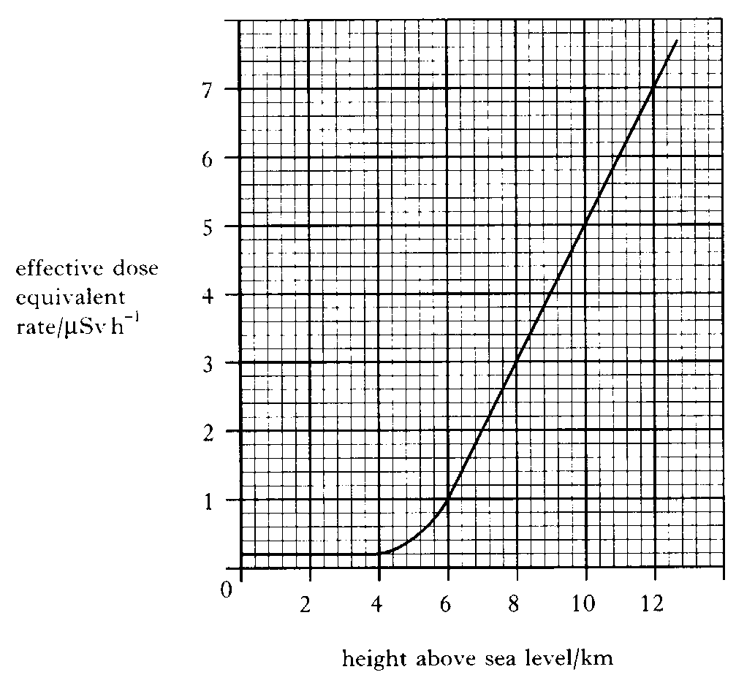  - Name two sources of background radiation 1  - The graph shows that there is an increase in effective equivalent dose rate at altitudes greater than 4 km. Suggest a reason for this increase. 1  - An aircraft makes a 7 hour flight at a cruising altitude of 10 km.  - Calculate the effective equivalent dose received by a passenger during this flight.  - A regular traveller makes 40 similar flights in one year and spends the rest of the year at sea level.  Calculate the effective equivalent dose of background radiation received by this traveller in that year.
20.12.11 |  | The radiology department in a hospital uses radioactive iodine to examine the functioning of the thyroid gland in a patient. The thyroid gland of the patient receives an absorbed dose of 750 μGy of radiation from the radioactive iodine.  - Calculate the total energy absorbed if the gland has a mass of 0.04 kg.  - The average equivalent dose rate for the gland is 12.5 μSv h⁻¹. The radioactive iodine is present in the gland of the patient for 120 hours. What is the quality factor of the radiation?
20.12.12 |  | Smoke detectors are important in giving early warning of fire starting in the home.  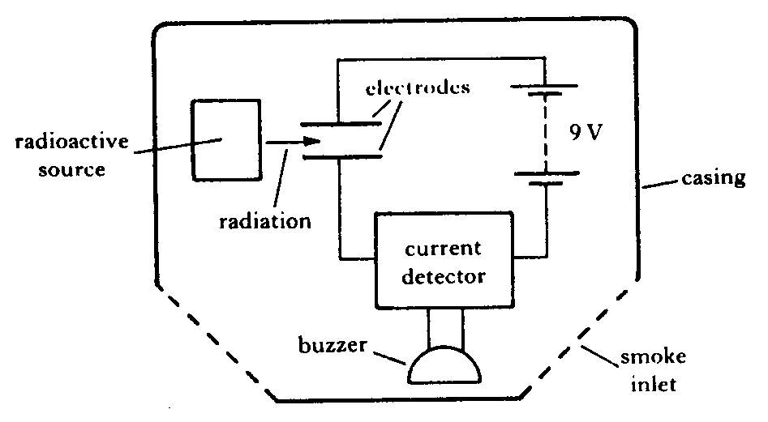  - The simplified layout of one type of smoke detector is illustrated below.  The following is an extract from the manufacturer’s data sheet.  ”The detector uses a low energy source of ionising radiation, 30 kBq Americium 241, which causes ionisation of the air molecules and hence a small current between the electrodes. When smoke particles enter the space between the electrodes they impede the flow of ions and the current is reduced. When the current falls below a certain value the buzzer sounds.”  - The symbol for the radioactive source used is .  What information is given by the numbers 95 and 241?  - What is meant by “30 kBq”?  - Explain what is meant by ionising radiation.  - The equation for decay of this source is  Identify the type of radiation emitted in this decay and explain why this particular type of radiation is used in the smoke detector.  The half-life of Americium 241 is 458 years.  Discuss the advantage of using this source compared to one with a half-life of 5 years.
20.13 |  | I can state the units of H dot.
20.13.1 |  | State the quantity, unit, and unit symbol for the term $\dot{H}$
20.14 |  | I can compare equivalent dose due to a variety of natural and artificial sources.
20.14.1 |  | A pie chart indicating the exposure of the Public to ionizing radiation is given below.  From data given in the pie chart create  - State the main source of public exposure to ionizing radiation  - create a table indicating sources originate naturally sources and which are artificial sources of radiation.  - Calculate the percentage exposure due to artificial sources.  - State the percentage exposure from naturally occurring sources.  As an aside…  Other sources <1% includes  - Occupational – 0.3%  - Fallout - <0.3%  - Nuclear fuel cycle – 0.1%  - Miscellaneous – 0.1%
20.14.2 |  | State if you are more likely to receive a more uniform dose of radiation from naturally occurring or man-made sources of radiation. You must justify your answer.
20.14.3 |  | SQA N5 2014  A sample of tissue is irradiated using a radioactive source.  A student makes the following statements about the sample.  I The equivalent dose received by the sample is reduced by shielding the sample with a lead screen.  II The equivalent dose received by the sample is increased as the distance from the source to the sample is increased.  III The equivalent dose received by the sample is increased by increasing the time of exposure of the sample to the radiation.  Copy out the correct statements.
20.14.4 |  | SQA N5 2015  A sample of tissue is irradiated using a radioactive source.  A student makes the following statements.  The equivalent dose received by the tissue is  I reduced by shielding the tissue with a lead screen  II increased as the distance from the source to the tissue is increased  III increased by increasing the time of exposure of the tissue to the radiation.  Copy out the correct statements
20.14.5 |  | SQA N5 2015  A paper mill uses a radioactive source in a system to monitor the thickness of paper.  Radiation passing through the paper is detected by the Geiger-Müller tube.  The count rate is displayed on the counter as shown. The radioactive source has a half-life that allows the system to run continuously.  - State what happens to the count rate if the thickness of the paper decreases.  - The following radioactive sources are available. State which radioactive source should be used. You must explain your answer.
  Radioactive Source | Half-life | Radiation emitted
  W | 600 years | alpha
  X | 50 years | beta
  Y | 4 hours | beta
  Z | 350 years | gamma
20.15 |  | I know the average annual background radiation in the UK.
20.15.1 |  | State the average annual background radiation in the UK.
20.16 |  | I know the average annual effective dose limit for a member of the public in the UK.
20.16.1 |  | State the average annual effective dose limit for a member of the public in the UK.
20.17 |  | I know that the average annual effective dose limit for radiation workers.
20.17.1 |  | State the average annual effective dose limit for radiation workers.
20.18 |  | I can give some applications of nuclear radiation.
20.18.1 |  | State some medical applications of nuclear radiation.
20.18.2 |  | Describe how electrical energy can be obtained from nuclear radiation.
20.18.3 |  | A nuclear reactor produces waste that emits nuclear radiation. State a use of nuclear radiation.
20.19 |  | I can define half-life.
20.19.1 |  | Sketch a graph showing how the activity of a radioactive source varies with time.
20.19.2 |  | State what is meant by the term half-life.
20.19.3 |  | State the units of half-life.
20.20 |  | I can use graphical and numerical data to determine the half-life.
20.20.1 |  | A radioactive material has a half-life of 5 days. If the original activity is 120 Bq, calculate the activity after 20 days.
20.20.2 |  | If a radioactive material has a half-life of 600 years. If the original activity was 80 Bq calculate the time it takes for the activity to fall to 10 Bq.
20.20.3 |  | A radioactive substance has a half-life of 4 hours. Calculate the fraction of the original activity left after one day.
20.20.4 |  | The activity of a source starts at 100 MBq. After 20 days it has fallen to 6.25 MBq. Calculate the half-life of the source.
20.20.5 |  | A radioactive source has an activity of 3072Bq. After 64 days its activity is measured again, and is found to be 48Bq. Calculate its half-life.
20.20.6 |  | Calculate the half-life of a radioactive source if the activity falls from 4000 kBq to 125 kBq in 40 days.
20.20.7 |  | The half-life of Cobalt-60 is 5 years. If the source, 25 years ago, had an activity of 500kBq, calculate the new activity.
20.20.8 |  | A radioactive material has a half-life of 5 days. If the original activity is 120 Bq, calculate the activity after 20 days.
20.20.9 |  | If a radioactive material has a half-life of 600 years. If the original activity was 80 Bq calculate the time it takes for the activity to fall to 10 Bq.
20.20.10 |  | A radioactive substance has a half-life of 4 hours. Calculate the fraction of the original activity left after one day.
20.20.11 |  | The data above was obtained from an experiment to determine the half life of a radioactive source:  (a) Describe how you could carry out this experiment.  (b) Determine the half-life of the radioactive source.
  Time | (mins) | 0 | 20 | 40 | 60 | 80
  Count rate | (c.p.m.) | 100 | 60 | 45 | 30 | 20
20.20.12 |  | The table of results below show how the count rate for a radioactive source varies with time. The background count was 60 counts per minute.  - Copy out the table and find the corrected count rate.  - Plot a graph of corrected count against time.  - Determine the half-life of the source from your graph.
  Time | (mins) | 0 | 5 | 10 | 15 | 20
  Count rate | (c.p.m.) | 1660 | 1100 | 750 | 510 | 350
20.20.13 |  | SQA H5 2018  A technician carries out an experiment, using the apparatus shown, to determine the half-life of a gamma radiation source.  (a) Before carrying out the experiment the technician measures the background count rate.  (i) Explain why this measurement is made.  (ii) State a source of background radiation.  - The technician’s results are shown in the table.  - Produce a graph of these results.  - Use your graph to determine the half-life of the gamma radiation source.  - The technician repeats the experiment with an alpha radiation source.  Suggest a change the technician must make to the experimental set-up to determine the half-life of the alpha radiation source. Justify your answer.
  Time  (minutes) | Corrected count rate  (counts per minute)
  0 | 680
  20 | 428
  40 | 270
  60 | 170
  80 | 107
  100 | 68
20.21 |  | I can describe an experiment to determine the half-life of a radioactive material.
20.21.1 |  | Describe an experiment to measure half-life. Make sure you include how you take background radiation into account, how you measure the activity and the time, and how you use the graph to calculate the half-life.
20.21.2 |  | An experiment is carried out in a laboratory to determine the half-life of a radioactive source. A Geiger-Müller tube and counter are used to measure the background radiation over a period of 10 seconds. This is repeated several times and an average value of 4 counts in 10 seconds is recorded.  The apparatus shown is used to measure the count rate over a period of time.  The readings are corrected for background radiation.  (a) Name two factors that affect the background count rate.  (b) Calculate the activity of the background radiation.  (c) Calculate the half-life of the radioactive source.
  Time (minutes) | Corrected count rate
  0 | 168
  2 | 120
  4 | 84
  6 | 60
  8 | 42
  10 | 30
  12 | 21
20.21.3 |  | A technician carries out an experiment to determine the half-life of a radioactive source.  - Use information from the graph to determine the half-life of the radioactive source.  - Determine the corrected count rate after 40 minutes.  Do not write in this book. Collect a copy of this graph for writing on
20.22 |  | I can provide a qualitative (info) description of fission chain reactions and their role in the generation of energy.
20.22.1 |  | Explain what is meant by the term nuclear fission.
20.22.2 |  | Nuclear fission can be spontanteous or induced.  - State the difference between these two types of fission  - State whether a nuclear reactor would use an isotope that undergoes spontanseously or induced fission, you must justify your answer.
20.22.3 |  | Explain what is meant by the term chain reaction.
20.22.4 |  | Describe the function of the following parts of a nuclear reactor  - Containment vessel  - Fuel rods  - Moderator  - Control Rods  - Coolant.
20.22.5 |  | State the common element used in nuclear fission to generate energy.
20.22.6 |  | SQA Int 2 2012  A student is researching information on nuclear reactors. The following diagram is found on a website. It illustrates a type of reaction that takes place in a reactor.  (i) State the type of nuclear reaction shown in the diagram.  (ii) The labels have been omitted at positions P, Q, R and S on the diagram.  Copy out the diagram and correctly name the parts labelled P,Q,R and S.  (b) Name the part of the reactor whose function is to prevent release of radiation beyond the reactor.  (c) Disposal of some types of radioactive waste from nuclear reactors is  particularly difficult.  Give a reason for this difficulty.  (d) Electricity can be generated using fossil fuels or nuclear fuel.  State one advantage of using nuclear fuel.
20.22.7 |  | 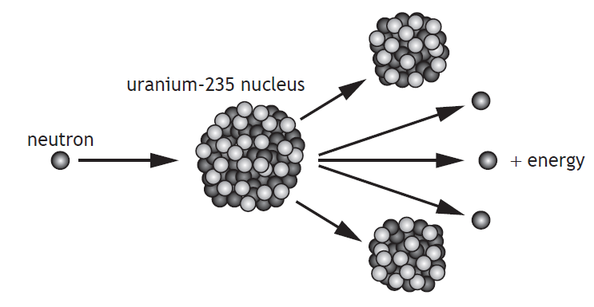  Explain how a single reaction can lead to the continuous generation of energy.
20.22.8 |  | The nuclear reactor produces waste that emits nuclear radiation.  State a use of nuclear radiation.
20.22.9 |  | SQA Int 2 2010  Many countries use nuclear reactors to produce energy. A diagram of the core of a nuclear reactor is shown.  (a) State the purpose of:  (i) the moderator; (ii) the control rods.  (b) One nuclear fission reaction produces 2·9 × 10–11J of energy. The power output of the reactor is 1·4GW. How many fission reactions are produced in one hour?  (c) State one advantage and one disadvantage of using nuclear power for the generation of electricity.
20.23 |  | I can provide a qualitative description of fusion, plasma containment, and their role in the generation of energy.
20.23.1 |  | Explain the term nuclear fusion.
20.23.2 |  | Nuclear fusion reactors are in the development stage.  - State an advantage of nuclear fusion over nuclear fission as a way of generating electrical energy.  - State a major difficulty with building fusion reactors  - State why this type of generator is not currently in use commercially.
20.23.3 |  | Nuclear fusion is the main way energy is generated in the Sun. State the simplified equation that shows this reaction.
20.23.4 |  | The diagram below shows a functioning nuclear fusion reactor.  - State the temperatures in the nuclear reactor required to allow fusion.  - State material in the reactor is a plasma, explain the term plasma  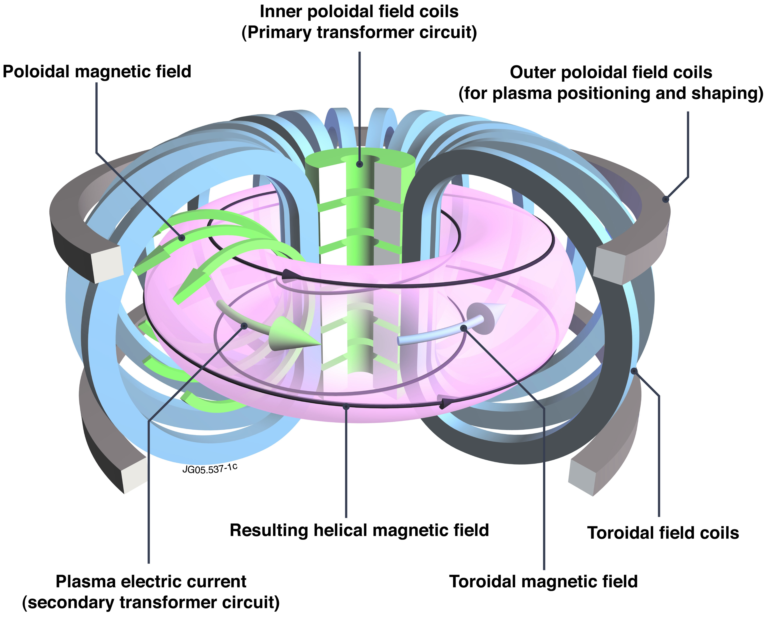
20.23.5 |  | State the potential advantages of nuclear fusion over nuclear fission.
20.23.6 |  | Summarise the video clip below, using bullet points.  https://www.bbc.co.uk/bitesize/clips/z4nwmp3
20.23.7 |  | Copy and complete  Nuclear _________ is the process by which ________ is released when a large _______ is hit by a _______, becomes unstable and splits into _____ or ______ smaller pieces, called ____________ ___________ plus two or three _________.  When fission occurs, some of the ________ of the _________ is 'lost' – it has been converted directly into ________. This energy is in the form of ________ which can be harnessed and used to generate ___________ in a nuclear power station.
20.23.8 |  | Copy and complete the following  Nuclear ____________ is the process by which _________ can be released when two ________ nuclei fuse together to form a __________ nucleus.
20.23.9 |  | Copy and complete the following passage..  During a nuclear _________ reaction two nuclei of smaller mass number combine to produce  a nucleus of larger mass number. During a nuclear ______ reaction a nucleus of larger mass number splits into two nuclei of smaller mass number. Both of these reactions are important because these processes can release ________ .
20.23.10 |  | State the requirements for a containment vessel used to contain a nuclear fusion reaction.

Notes

PHYSICS IN NUMBERS
Find the correct number from your notes, learn these numbers. Your syllabus could have many of the answers, so use it! Don’t forget to include relevant units or your answer is meaningless.
e.g State the height above the Earth of a satellite if placed in geostationary orbit. 36 000 km
- State the number of milliamps in an amp.
- State the number of metres in a kilometre.
- State the number of ohms in a megaohm.
- State the number of centimetres in a metre.
- State the number of Joules in a gigajoule.
- State the number of seconds in a minute.
- State the number of seconds in an hour.
- State the voltage of the mains supply in the UK.
- State the frequency of the mains supply in the UK.
- State the speed at which a electrical signals is transmitted along a wire at a speed.
- State the speed of light in air.
- State the speed of light in glass, eg in a fibre optic cable.
- State the speed of microwaves in air.
- State the speed of a television signal in air.
- State the speed of a radio signals in air.
- State the value of the gravitational field strength on the Earth.
- State the speed of X-rays in air.
- State the speed gamma radiation travels in air.
- State the two usual size of fuse that are usually fitted in a 13A plug.
- State the number of joules of energy in 1 kWh.
- State the initial acceleration of all objects when initially falling to Earth.
- State the weight of a 1kg object on the Earth
- State the mass of the 1kg object in space
- State the approximate speed of sound in air.
- State the approximate speed of ultrasound in air.
- State if sound travels faster or slower in solids than in air.

Variables & Exam Questions
Paper | Question
SQA  2018 | The energy of a water wave can be calculated using  $$E=\frac{ρgA^{2}}{2}$$  where:  E is the energy of the wave in J  ρ is the density of the water in kg m⁻³  g is the gravitational field strength in Nkg⁻¹  A is the amplitude of the wave in m.  A wave out at sea has an amplitude of 3·5 m. The density of the sea water is 1·02 × 10³ kgm⁻³ . Calculate the energy of the wave.
SQA N5  2019 | The table gives the distance from Earth, the approximate surface temperature and the age of five stars.  A student makes the following statements based on this information.  I As the distance from Earth increases, the age of a star decreases.  II As the age of a star increases, the approximate surface temperature of the star increases.  III There is no apparent relationship between the distance from Earth and the approximate surface temperature of a star  Copy out the table and the correct statements.
SQA  N5 2018 | A rain sensor is attached to the glass windscreen of a vehicle to automatically control the windscreen wipers. raindrop  LEDs rain sensor infrared detectors glass windscreen refracted light  Infrared light is emitted from LEDs and is received by infrared detectors.  The graph shows how the number of raindrops affects the percentage of  infrared light received by the infrared detectors.  The percentage of infrared light received by the infrared detectors from the LEDs controls the frequency with which the windscreen wipers move back and forth.  The table shows how the number of times the windscreen wipers move back and forth per minute relates to the number of raindrops.  At one point in time the infrared detectors receive 70% of the infrared light emitted from the LEDs. Show that the frequency of the windscreen wipers at this time is 0·90Hz
SQA N5  2014 | Catapults are used by anglers to project fish bait into water.  A technician designs a catapult for this use. Pieces of elastic of different thickness are used to provide a force on the ball.  Each piece of elastic is the same length.  The amount of stretch given to each elastic is the same each time.  The force exerted on the ball increases as the thickness of the elastic increases.  Which row in the table shows the combination of the thickness of elastic and mass of ball that produces the greatest acceleration?
  Thickness of elastic | Mass of ball
  (mm) | (kg)
  5 | 0.01
  10 | 0.01
  10 | 0.02
  15 | 0.01
  15 | 0.02
SEB O Level 1976 | Fig 1 shows a pendulum in its rest position A. The pendulum, bob has a mass of 0.3 kg. The bob is pulled to one side as shown in Figure 2 and held in position A which is 0.8 m above the rest position  The bob is released from position B and swings to and fro until it comes to rest.  - Find the gain in potential energy of the bob when it is moved from position A to position B.  - State the position of the bob when it has its greatest kinetic energy.  - Estimate the maximum speed of the bob.  - Describe the energy changes which take place from the time the bob is released until it eventually comes to rest.
SQA Int2 2012 | A resistor is labelled: “10 Ω ± 10%, 3 W”.  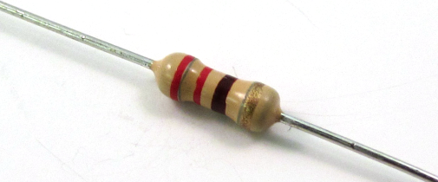  This means that the resistance value could actually be between 9 Ω and 11 Ω.  (a) A student decides to check the value of the resistance.  Draw a circuit diagram, including a 6 V battery, a voltmeter and an ammeter, for a circuit that could be used to determine the resistance.  (b) Readings from the circuit give the voltage across the resistor as 5·7 V and the current in the resistor as 0·60 A.  Use these values to calculate the resistance.  (c) During this experiment, the resistor becomes very hot and gives off smoke.  Explain why this happens.  You must include a calculation as part of your answer.  (d) The student states that two of these resistors would not have overheated if they were connected together in parallel with the battery.  Is the student correct? Explain your answer.
SQA N5 2015 | Craters on the Moon are caused by meteors striking its surface.  A student investigates how a crater is formed by dropping a marble into a tray of sand.  - Describe the energy change that takes place as the marble hits the sand.  The student drops the marble from different heights and measures the diameter of each crater that is formed.  The table shows the student’s results.  - Using the graph paper below, draw a graph of these results.  - Use your graph to predict the diameter of the crater that is formed when the marble is dropped from a height of 0·25 m.  - Suggest two improvements that the student could make to this investigation.  - Suggest another variable, which could be investigated, that may affect the diameter of a crater.
  height (m) | diameter (m)
  0·05 | 0·030
  0·10 | 0·044
  0·15 | 0·053
  0·35 | 0·074
  0·40 | 0·076
  0·45 | 0·076

